Joshua: Taking the Land
3 Victories; 2 Problems; War
On nature of heroes
Transition of Leadership difficulties
God: the ever-present hero
Leader’s need for encouragement
Joshua the leader
Josh 1:6f: be strong and very courageous
Comp Moses: as I was with Moses…
  - Splitting waters Josh. 4:14
  - God hardens hearts of enemies 11:20
  - Holds up javelin to win 8:18 Ai
  - Victories put side by side ch. 12
  - Meets angel, take off sandals 5:15
Unity of Israel
All Israel (Josh 1:12f; 4:12) Reuben/Gad/ Half-Manasseh go with; 12 stones
Jericho
Why was the taking of Jericho such a big deal?Location of Jericho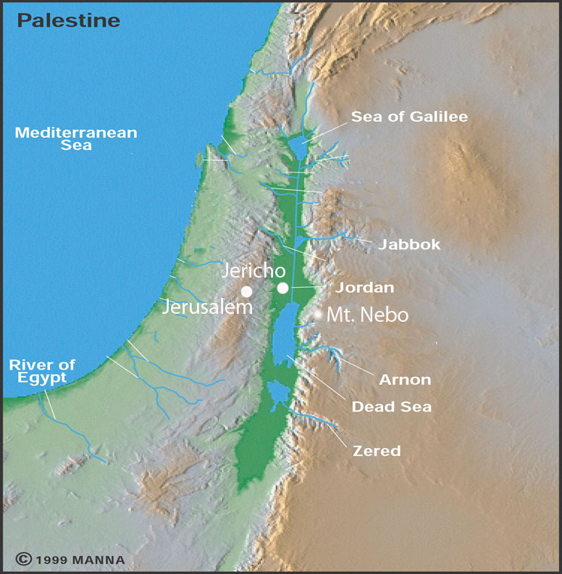
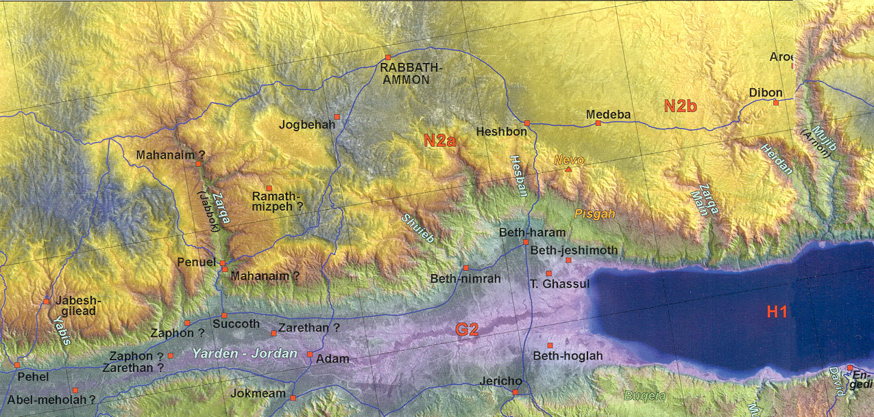

Jericho
Rahab: heroine: Josh. 2:1-5
Is it okay to lie if have good reason? Where else have we seen this?
Rahab’s confession, Josh. 2:9ff
What do we learn about women and war? 2:15f
Jordan River
Width/depth
Crossing: miracle or natural phenomena: Josh. 3:16
Why 12 stones?—unity 4:8
“There till this day”? (Josh 4:9; 6:25)
3 Gilgal things: Passover, circumcision, manna stopped—etiology (5:9)
Walls of Jericho
Garstang– yes LB --1930’s
Kenyon – no LB only EB—1960-70’s
Bryant Wood – yes LB—1990’s
Archaeology = truth ?
Mount Ebal altar: Josh 8:30 yes/no?
Southern Campaign
Gibeonites slickness (Josh. 9)
On marching all night and sun standing still (Josh. 10: 11ff)
What does the sun stood still mean?
  - Standing still --24 hrs extra (computer)
  - Silenced (cooled down)
  - Omen text (positioning)
What does it mean God listened to a man? (Josh. 10:14)
What is the book of Jasher?
Josh 10:13? Is the book of Jashar inspired? (cf. 2 Sam 1:18)
2 Problems:
Ai: Situation (Josh 7-8) Arrogance, First Loss (7:6f)
Problems: Achan’s sin—family sin? —social structure 7:14
Corporate Personality versus Individual
God predictable ... habituation rather than choice
“God is with us” assumption
They sin then Joshua blames God: 7:7
One sin effects community
Gibeonite deception
Situation—ruse 9:4f
Be careful of no-brainers 9:14 did not inquire of the Lord
  - Trust God in the uniqueness of each decision
Woodcutters and water bearers
Land division:
Four tribes to know
  - Ephraim, Benjamin, Judah, (Dan)
  - Six cities to know: Jericho, Gibeon, Jerusalem, Bethlehem, Hebron, Beersheba 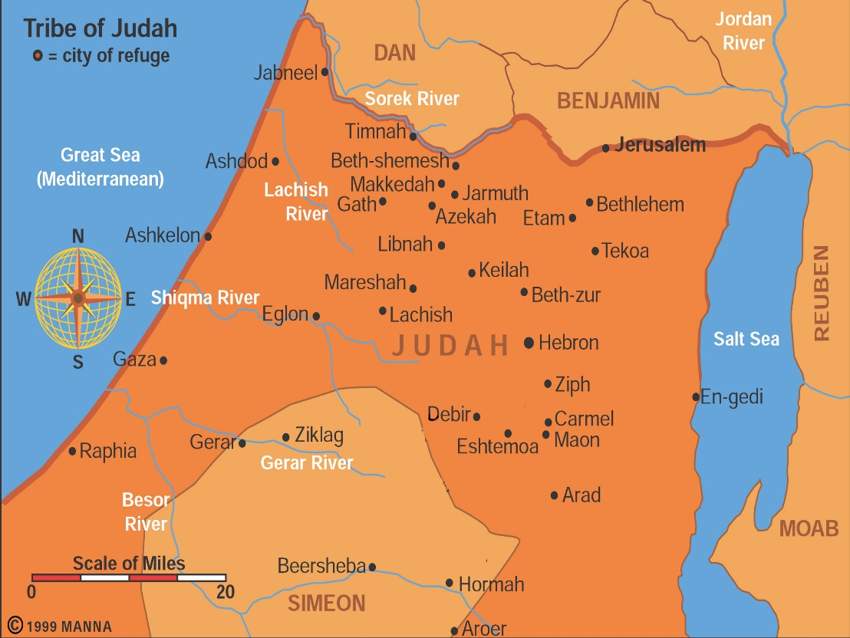
  - 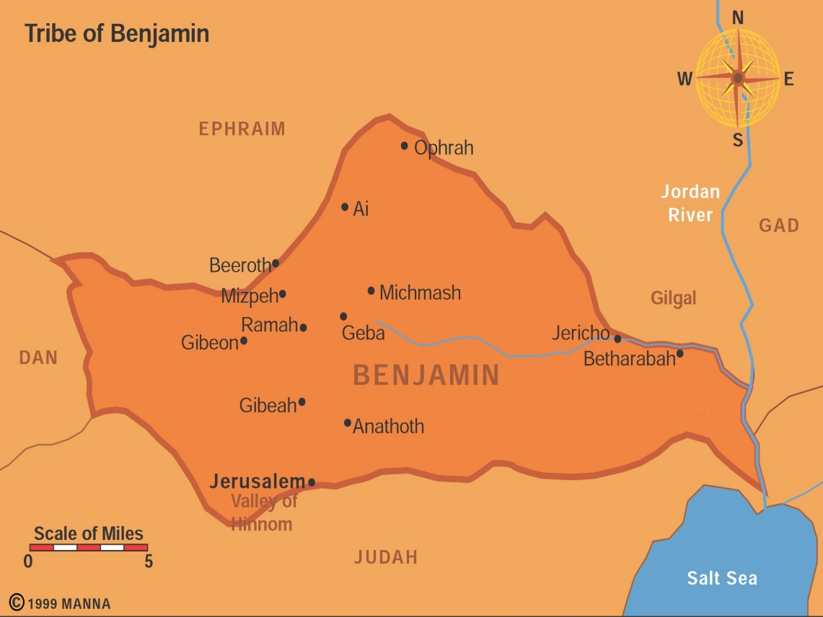

How can a holy God kill babies?
Holy War: Herem (Deut 7; 20:1-20; Josh 6:21)—
Give peace a chance Deut. 20:10
Judgment on sin of Amorites (Gen 15:16; Deut. 9:5)—Lord hardened hearts so no peace treaty Josh. 11:19f
Leaving them in land would lead Israel into sin a la Judges –Deut. 20:18
Victory Rhetoric and hyperbole Josh 11:15, 23
God’s life/death prerogative—innocent parties?
Rarely practiced: Jericho, Ai, Hazor…
Day of the Lord harbinger –warning
Not universal principle – special command by God
Prophet speaking for God directly

War: What is it good for? --- Joshua B
What do you think of war? Is it ever legitimate?
What would you be willing to die for?
For what would you kill someone?
Can academics decide this issue?
War 4 views: Non-resistance
Mat 5:39: turn the cheek;
Peter uses sword rebuked Mat 26:52-54;
Love neighbor not = killing (?) [murder]
Separation of church and state (Jn 18:36 If my kingdom were of this world my servants would fight)
Christ’s dying for others example
Problem with Non-resistance
Dualism: spiritual / natural world; do you eat?
Dual citizenship
Other Scriptural remarks: Matt 10:34; Lk 22:35-38—I did not come to bring peace but the sword…
What if you saw someone being raped, would you not act forcefully? Dialogue?
Pacifism:
Mic 4:3 beat swords into plowshares
Kingdom of God: lion laying down with calf (Isa 11:6-9) Shalom rules
Passive resistance: dying / self-sacrifice
Possibility of individual calling (diversity)
Beware of flag burners, spitting on Vets
Caution Prophets of Shalom: Jer 6:16/ 8:11; 23:17
Just War theory
Go to war for good cause
What constitutes a good cause?
Joshua – some wars are right—War is never the answer? Is that true?
Eccles 3:8 -- a time for war
God portraying himself as a warrior
(Exod. 15:3; Ps. 18:8ff.).
Jesus too (SM versus Revelation on Scripture
twisting, Rev. 19:15, 21 )
—sword out of mouth=justice/peace?
How does one fight a good war?
Biblical reasons for going to war:
land, --Og
divine command, --Jericho
moral violation, --Gibeah & concubine
insult, --Rabbah & David
defense, -- Sennacherib
oppression, -- Gideon
helping others – Gibeonites &Joshua
Preventive War
First strike to avoid latter conflict or prevent damage
What do you think?
Future problems: nukes in cities; blackmail, no national entity—ideological groups of individuals not nations
Final Thoughts
Do not let this book of the Law depart from your mouth; meditate on it day and night, so that you may be careful to do everything written in it. Then you will be prosperous and successful. 1:8
Beginning Prophets-Josh 1:8, Kethubim Ps. 1:2 same idea
Covenant renewal at Shechem 24:25f—adds to the Book of the Law-
Final call to decision: 24:15 as for me…

