Numbers
What is a Nazirite?
3 Rules: Numb 6
No dead body touching
No grape products
No razor
What was the function of the Nazirite?
Person separating himself to YHWH
God over one’s food, family & body
Visible memorial
Giving up things for God
Completion of Nazirite vow
Sacrifices
Shave head & burn hair
Samson, Samuel, Paul takes Nazirite vow (Acts 21:24ff)
Jesus not a Nazirite (Nazarene)
Oldest piece of Scripture ever found: Num 6:23ff; 600 BC not= P (450 BC)
Numbers Cycles
Problem
Peoples’ complaint
God’s response
Moses mediates
God relents
Lesson summarized
Mini-cycle: Numbers 11:1-2
Problem: Desert Hardships
People’s complaint:
God’s response: fire burned in outskirts of camp
Moses mediates: Moses prays to God
God relents: fire dies down
Summary: Place called Taberah because fire of LORD
Why is it the people complain & God judges
Moses complains and God helps him (Num 11:2,10; 11-15)
Complaint versus Lament distinction
Inability of Christians to verbalize lament
Are you supposed to discipline children in anger?
Why does God discipline Israel when He is angry? (Num 11:4ff)
Is anger always wrong? (conditions; justice issues)
Moses use of rhetorical questions
Can a Christian person ever long to die?
On workaholic Moses: sharing the load (11:16f)—70 elders → Sanhedrin (Eldad)
What do you think about inter-racial marriage?
What does the Bible say?
Moses and the Cushite wife
Moses and the prophetic function
Miriam and God’s ironic sense of humor
Why not Aaron?
Who wrote Num. 12:3?
Doesn’t this statement from the pen of Moses sound a little odd? Joshua?
Could a humble person write this?
Does humility really fit the context?
Another way of looking at it: “oppressed”
Can a human being have impact on God?
Can God change? Is He static or dynamic?
If He can’t change is it possible for Him to think and interact? How is relationship possible?
If He is dynamic in what sense or areas can He change? Is everything up for grabs?
Does God still experience choice?
Giants in the Land:
Was Moses wrong for sending out spies? (Num 13)
Report: Milk and honey -- grasshopper vision (Num 13:26-33)
Accusation against God (Num 14:3-4)
Joshua and Caleb: men of courage and vision (Num 14:5ff), contra majority
God’s response:
God’s response: I will strike them down (14:11f)
Real issue is belief (14:11) and holding God in contempt (14:11)
How does Moses argue with God? (14:13)
Lord’s reputation
Lord’s character
God doesn’t strike them down! (14:20)
“as you asked”
Is it possible to be forgiven and yet have to pay consequences? 40 yrs-->death
Korah rebellion: Num 16
On the demand to be special/separated (Num 16:3, 8f)
Moses gets angry (16:15)
Does God have a sense of humor (ironic)?
So you want to be holy?
Power struggles & projected motives of leaders (Num 16:13)
Moses new role: anti-mediator then mediator
Moses as prophet short term prophecy (vs. 28)
Separated permanently (16:33) Sheol=grave
Some people never learn: (Num 16:41)
Can people really change?
Moses hitting the rock: Num. 20
Chapter context: death of Miriam + Aaron
Why did God nail Moses so hard just for hitting a rock?
What’s so wrong with hitting a rock?
Real issue: not acting in trust/faith 20:12
  - God weighs thoughts and intents of heart
  - On the responsibility of leaders
  - On consequences for actions—actions matter
Bronze Pole Snake—Num. 21
Complaint 21:5→ snakes 21:6
Look and live 21:8
Jesus & Nicodemus: John 3:14
Numbers Lessons:
One person can make a difference for a nation, prayer changes things
Faithlessness of Israel // faithfulness of God
Forgiveness yet consequences
God is dynamic not static: relationally interactive
Complaint versus lament
Red Heifer – Numbers 19
Why did the Moabites hire Balaam? Numbers 22-24
What have Og and Sihon got to do with it?
Why did Balak send to Mesopotamia to get curser?
Were the Israelites the only ones who knew YHWH?
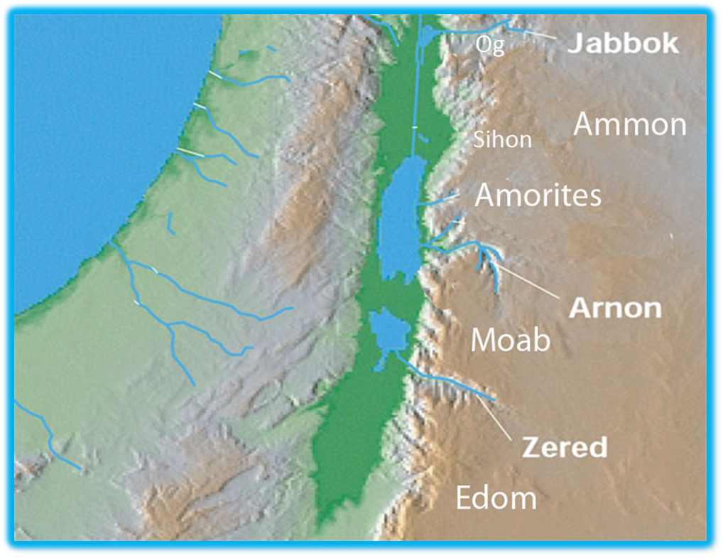
Balaam
Is Balaam good or bad, saint or sinner?
  - OT = Numbers = good (Num. 22:8, 13)
  - NT = major bad (Jude 11; Rev 2:14)
Did Balaam know God? .... 22:18
Is Balaam good or bad, saint or sinner?
  - OT = Numbers = good (Num. 22:8, 13)
  - NT = major bad (Jude 11; Rev 2:14)
Did Balaam know God? .... 22:18
Balaam outside the Bible
Name found: destroyer—Deir Alla, Jordan find 1967/1976 trans. dates 800 BC
“The misfortunes of the Book of Balaam, son of Beor. A divine seer was he.
The gods came to him at night.
And he beheld a vision in accordance with El’s utterance. They said to Balaam, son of Beor…”
Balaam’s major struggle: money or God’s word
Faithful to God’s word: Num 22:8, 18
Donkey narrative: 22:21ff
  - Why did God tell Balaam to go and then try to kill him?
Irony: donkey sees more than the seer,
who speaks, sword
Balaam’s 4 oracles
First oracle: Who can curse but Yahweh? (Num 23:7f)
Second oracle: God’s character and promises don’t change: Num 23:19
On God and change
How do you fit that with God changing his mind before
Promise keeper
Character: doesn’t lie
Interactive creative possibilities—different ways of speaking:
Balaam’s 4 oracles
Second oracle: God is their king (Num 23:21f)
Third oracle: Human king
  - On ecstatic prophets (24:4)
  - King imagery (24:7)
  - Dilemma of Divine / Human king
Fourth oracle: Messianic king (Num 24:17)
Balaam
Why was he portrayed so faithful in narrative?
Contrast to Israel’s unfaithfulness
Moabite link (Num 25:1ff) How to get Israel cursed --get them to sin
Balaam’s death—Num. 31:8, 16

