1 THESSALONIANS - PHILEMON

1 THESSALONIANS

1. Thessalonians' model
2. Paul's care for Thessalonians
3. Timothy sent, good report, Persecution, Prayer
4. Holy life, Rapture
5. Thief in the night, Instructions

2 THESSALONIANS

1. Persecutions, Reward, Punishment
2. Day of the Lord, Lawless one, Restrainer, Stand firm
3. Pray for us, No laziness

1 TIMOTHY

1. False teachers, Faithful law, God's grace to Paul
2. Pray for kings, Women and worship
3. Elders' qualifications
4. Liars, Godly training, Timothy's example
5. Widows, Elders' honor
6. Slavery, Money, Pursuing godliness

2 TIMOTHY

1. Timothy's background
2. Good soldier, Empty chatter
3. Ungodly end times, Persecuted, Godly Scripture
4. Preach the word, Finish the course, Mutual friends

TITUS

1. Ordain qualified elders
2. Sound doctrine
3. Grace and good works

PHILEMON

Slave Onesimus returns

Memory Verses: 1 Thess. 4:16, 17; 5:16-18, 22
2 Thess. 3:13
1 Tim. 1:15, 17; 2:5; 3:16; 4:12; 6:6, 10
2 Tim. 1:7; 2:2-4, 15; 3:5-7, 12; 3:16, 17
Tit. 2:13, 14; 3:5

1 Thessalonians

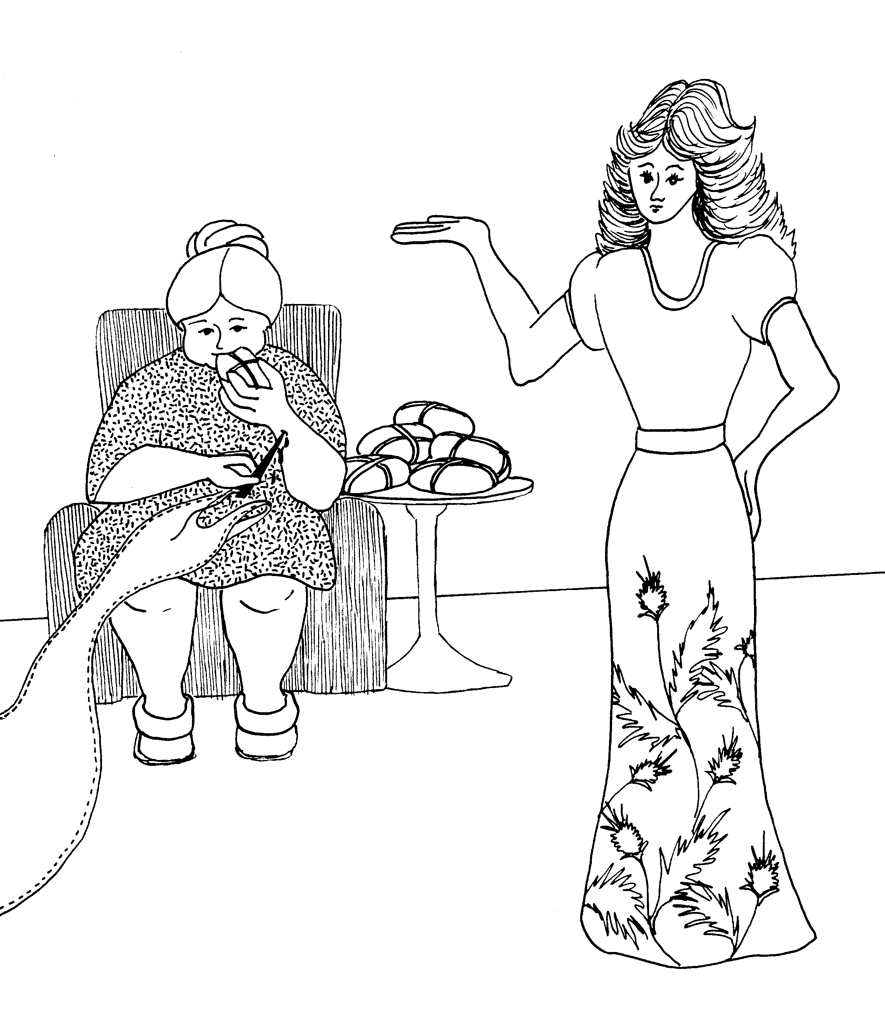 | 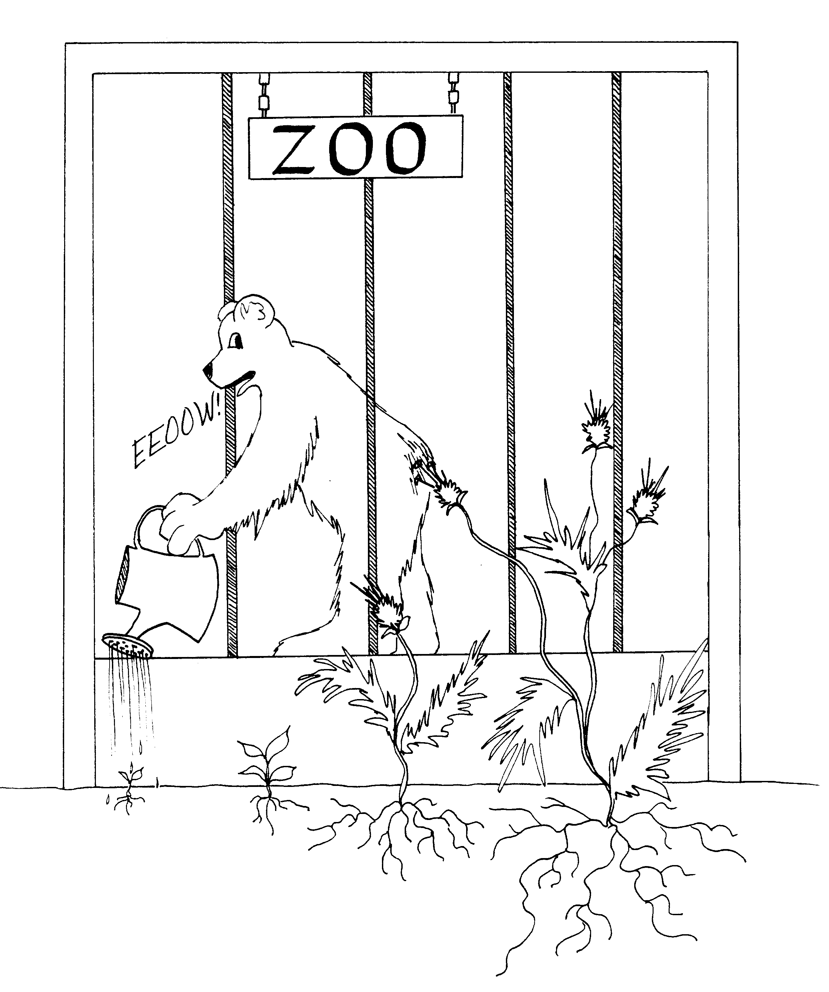
1 THESSALONIANS = THISTLE-ONIANS  1. THESSALONIANS' MODEL  1 = Bun (rhyme)  * THESSALONIANS' MODEL: beautiful model, lady eating buns while sewing thistle dress for the model | 2. PAUL'S CARE FOR THESSALONIANS  2 = Zoo (rhyme)  * PAUL'S CARE FOR THESSALONIANS: Paul (bear)  care for "Thistles" (Thessalonians) by watering them
1 Thessalonians 1 -2
© 2003 Do not reproduce
1 Thessalonians

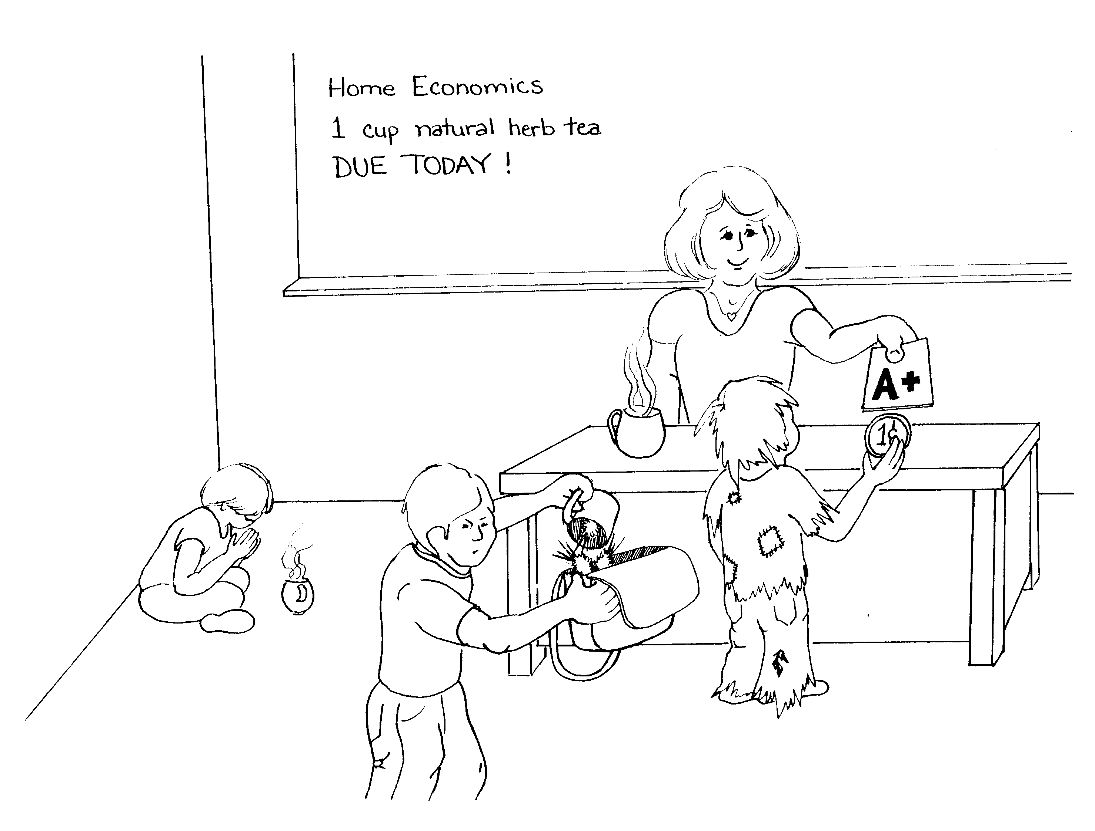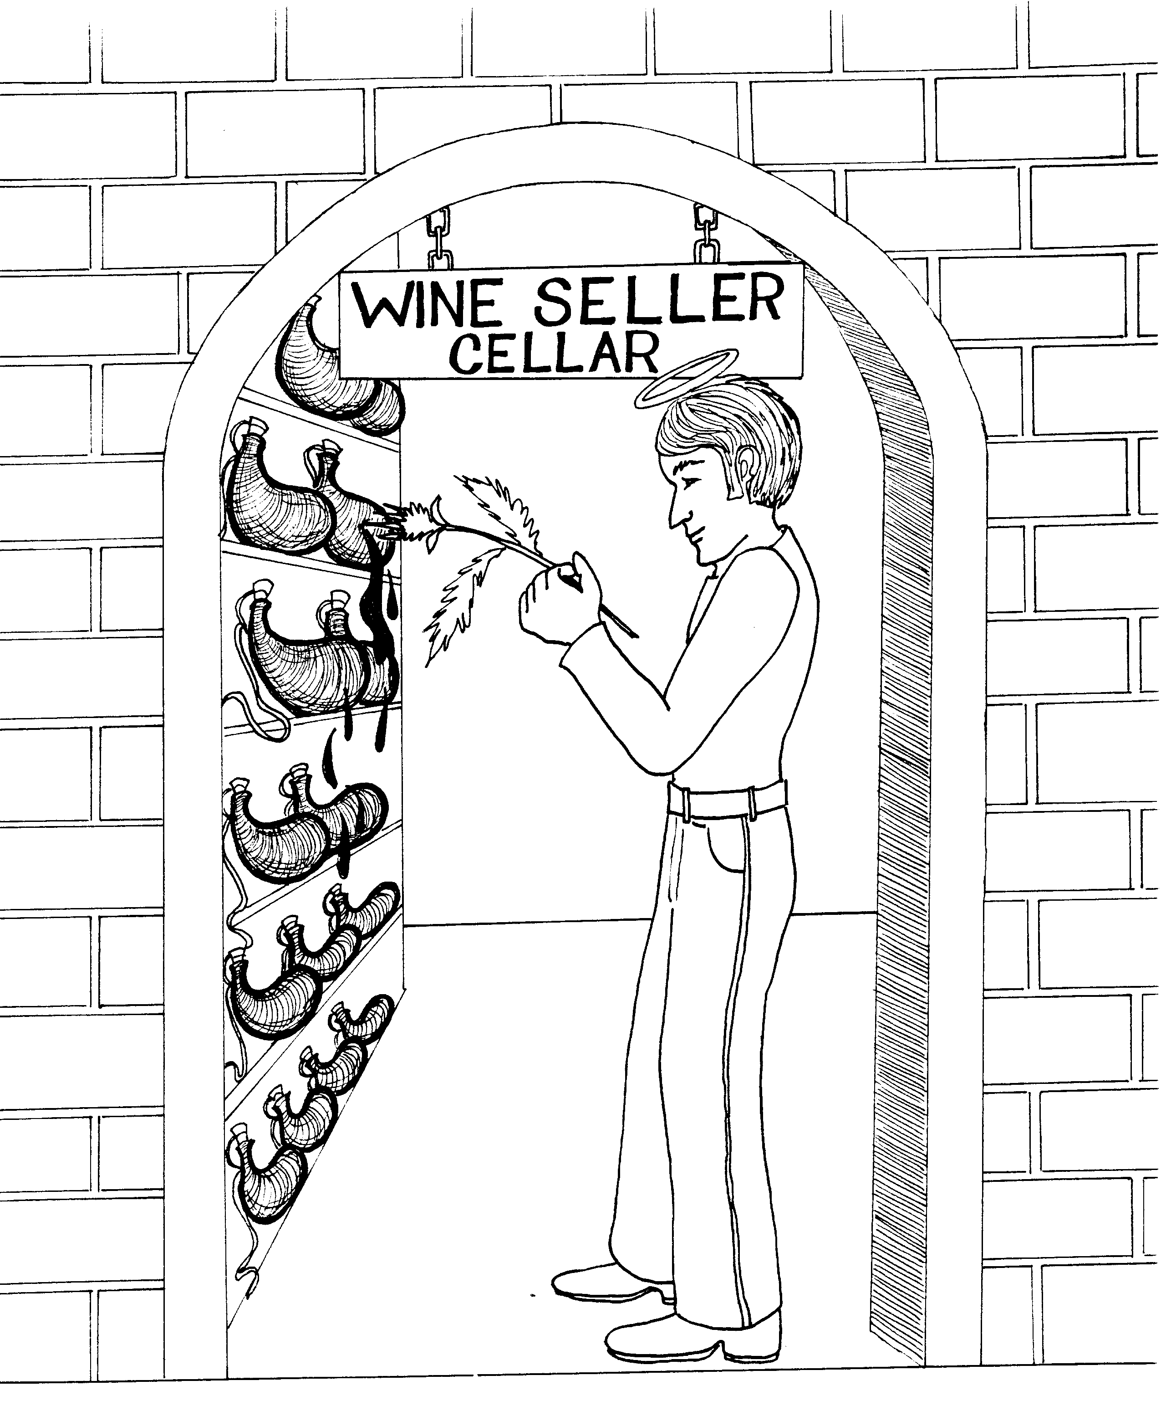

3. TIMOTHY SENT, GOOD REPORT, 4. HOLY LIFE, RAPTURE
PERSECUTION, PRAYER
4 = Store (rhyme)
3 = Tea (rhyme)
* TIMOTHY SENT: Tiny Tim with a penny (cent = sent) * HOLY LIFE: giving up wine to lead a 'holey' life by
poking them with the thistles
* GOOD REPORT: good report card A+
* RAPTURE: 'rupture' of wine sacks
* PERSECUTION: student pouring thistles from tea cup
into the teacher's 'purse'-ecution

* PRAYER: third student praying a blessing over his tea
c 1985 Do not reproduce
1 Thessalonians 3 -4
© 2003 Do not reproduce
1 Thessalonians

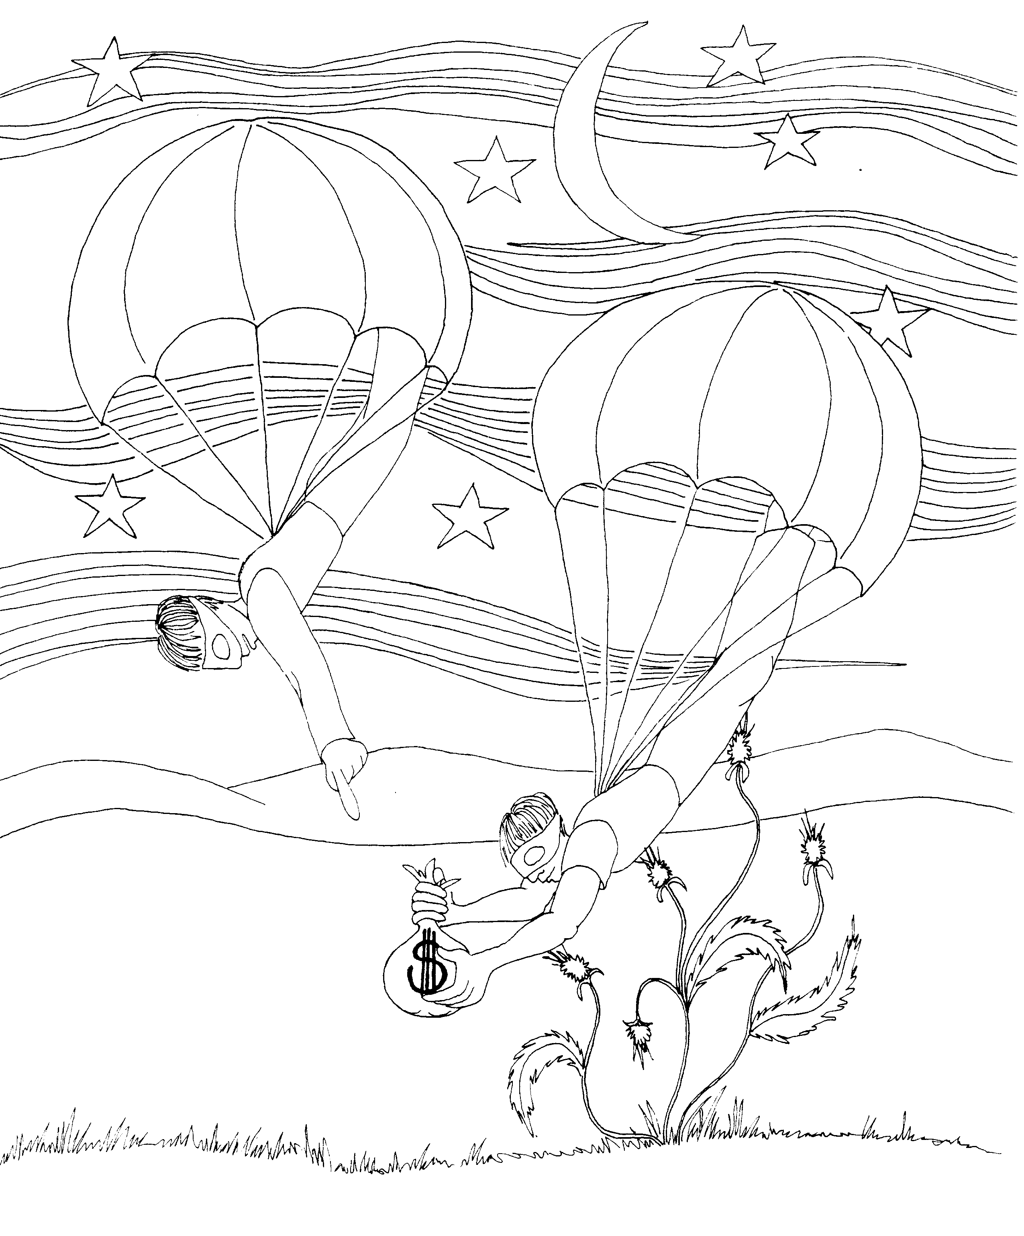
5. THIEF IN THE NIGHT, INSTRUCTIONS

5 = Dive (rhyme)

* THIEF IN THE NIGHT: hi-jacked airplane thieves
diving out of it

* INSTRUCTIONS: guy received instructions not to
dive into thistle bushes
1 Thessalonians 5
© 2003 Do not reproduce
2 Thessalonians

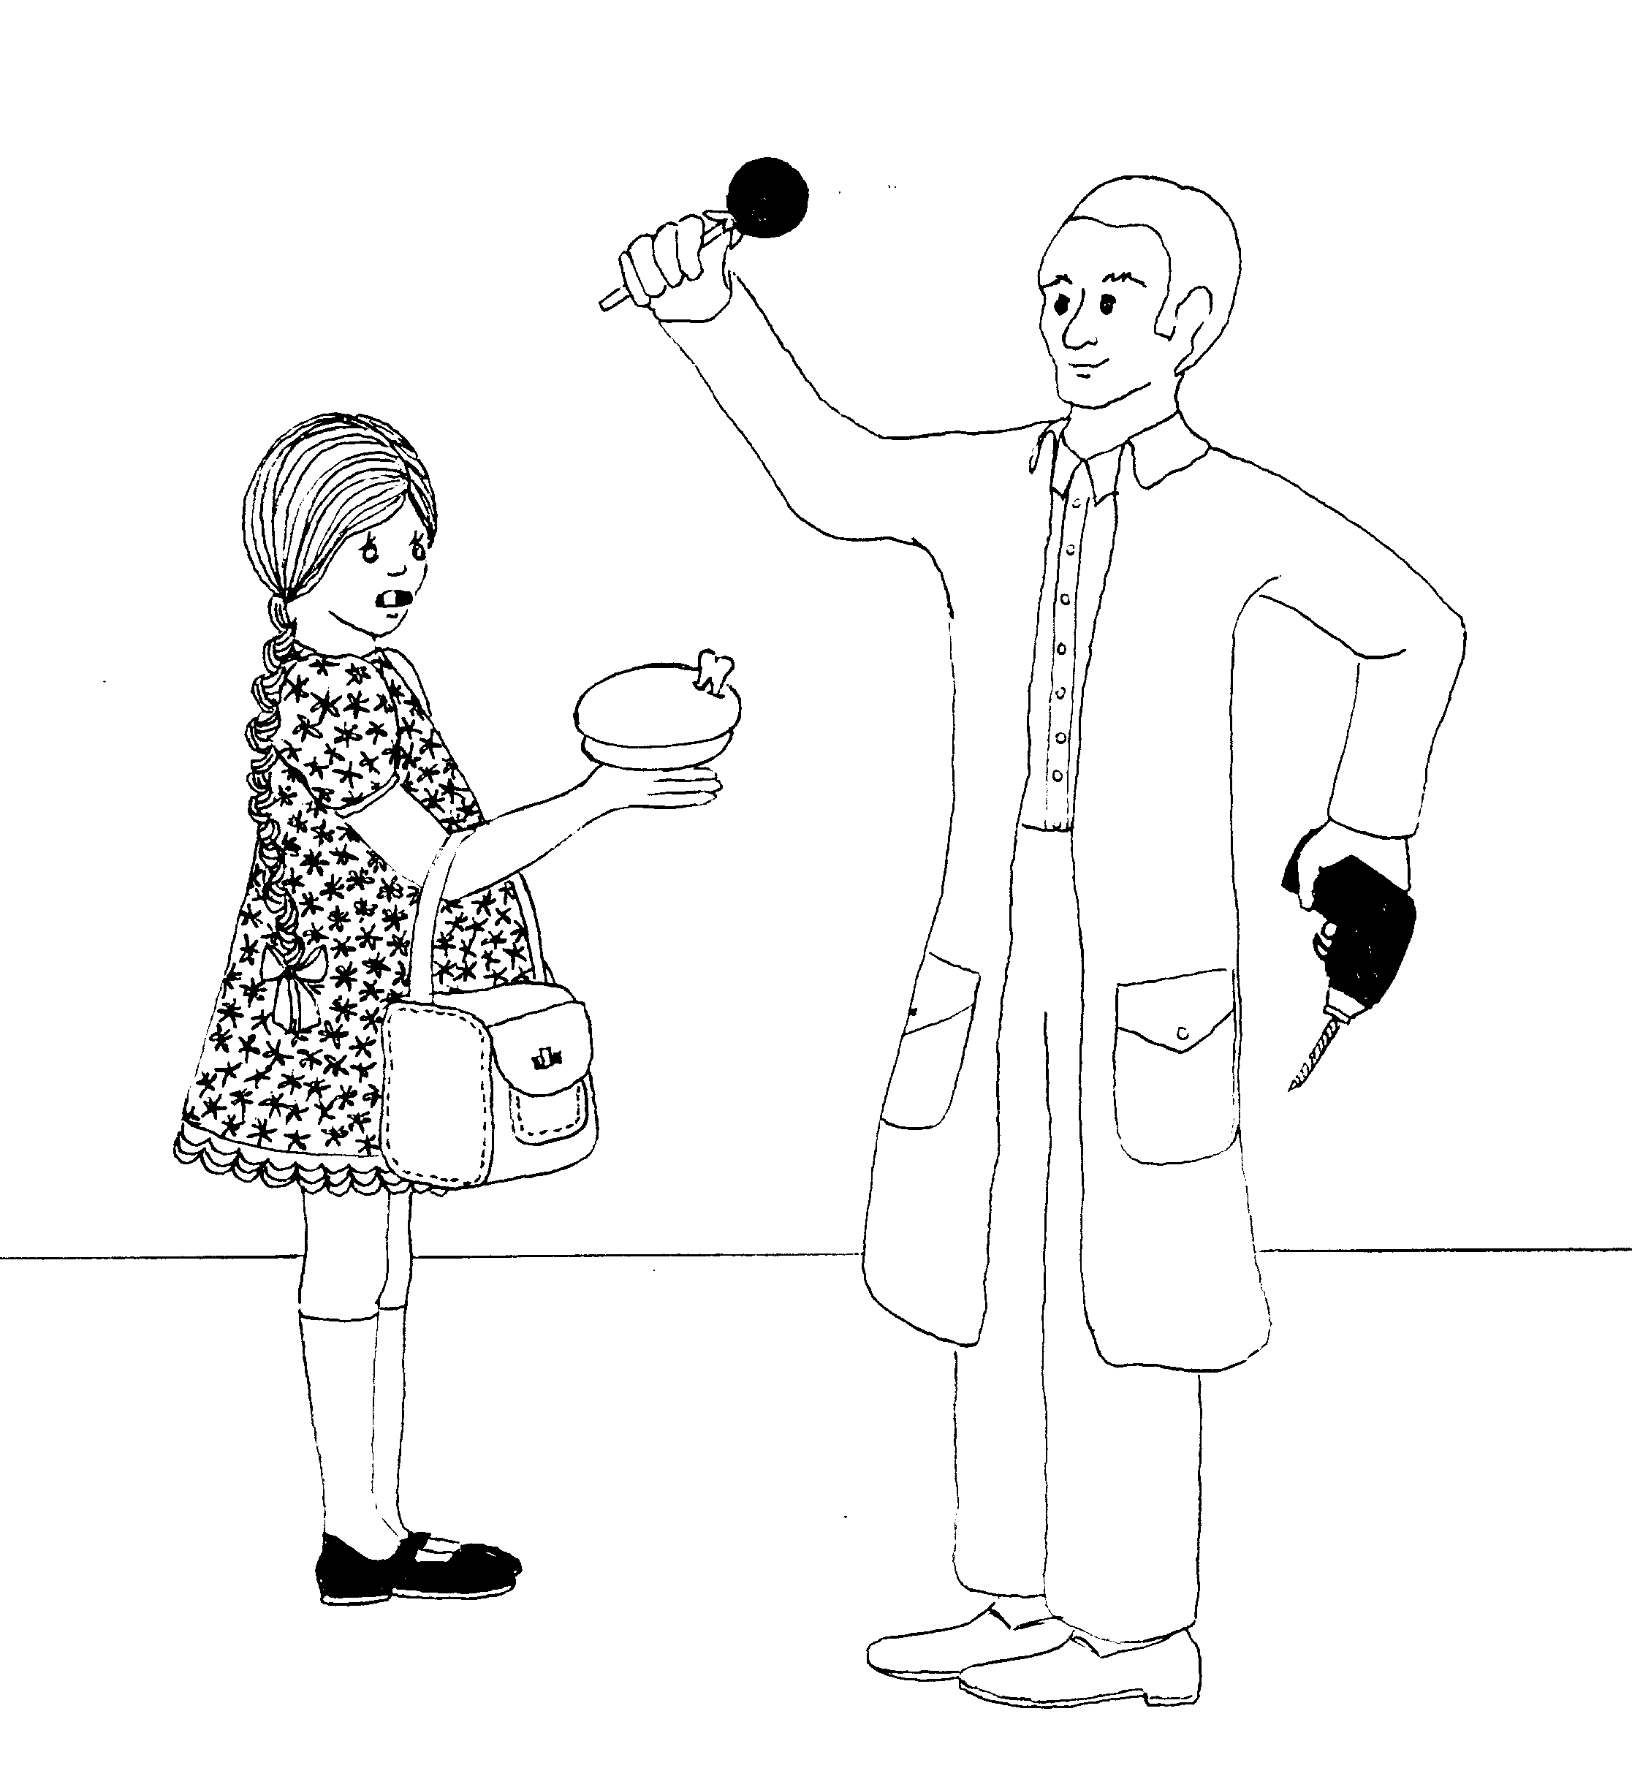 | 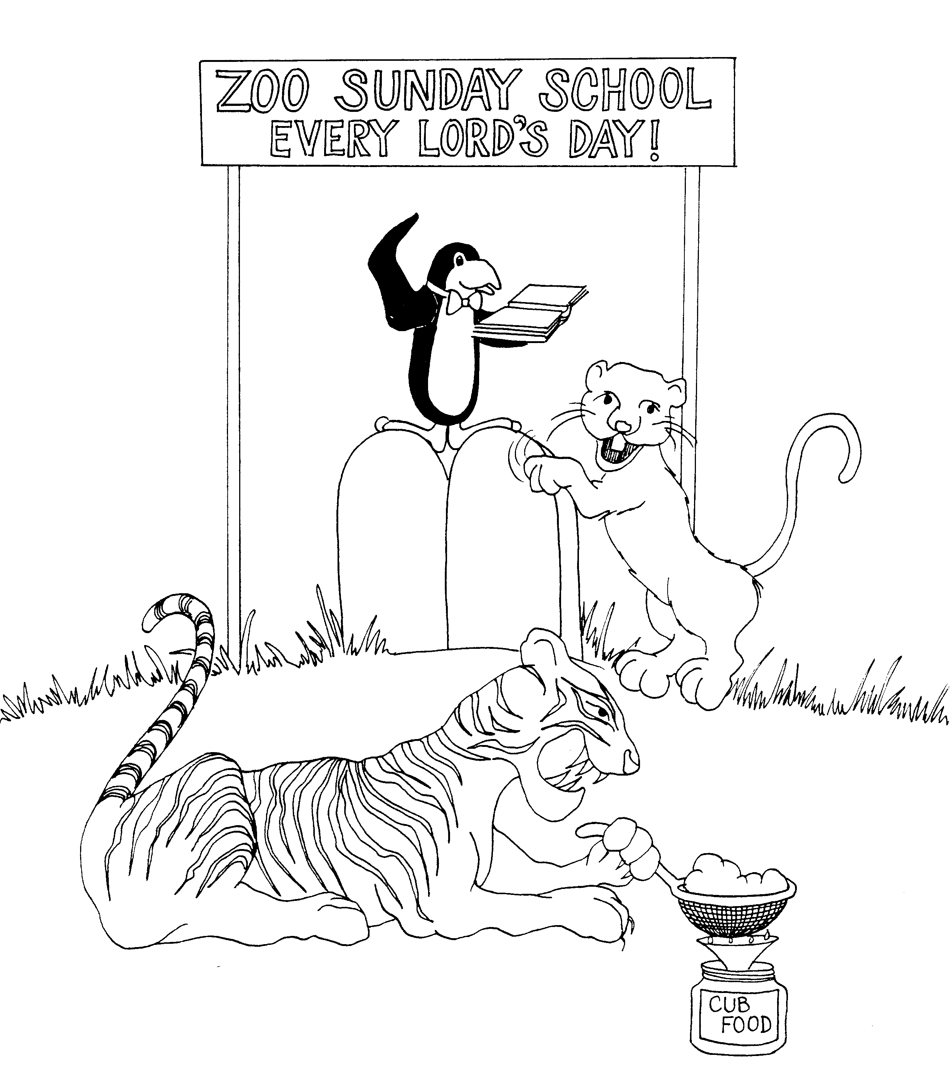
THESSALONIANS = "TOOTH" THESSALONIANS  1. PERSECUTIONS, REWARD, PUNISHMENT  1 = Bun (rhyme)  * PERSECUTIONS: 'purse' - ecutions  * REWARD: lollypop reward  * PUNISHMENT: dentist's drill | 2. DAY OF THE LORD, LAWLESS ONE, RESTRAINER  STAND FIRM  2 = Zoo (rhyme)  * DAY OF THE LORD: Sunday service on Lord's day  * LAWLESS ONE: clawless-cub (clawing law tablets)  * RESTRAINER: mama tiger re-straining the cub's food  * STAND FIRM: penguin standing firm on law tablets
2 Thessalonians 1 - 2
© 2003 Do not produce
2 Thessalonians

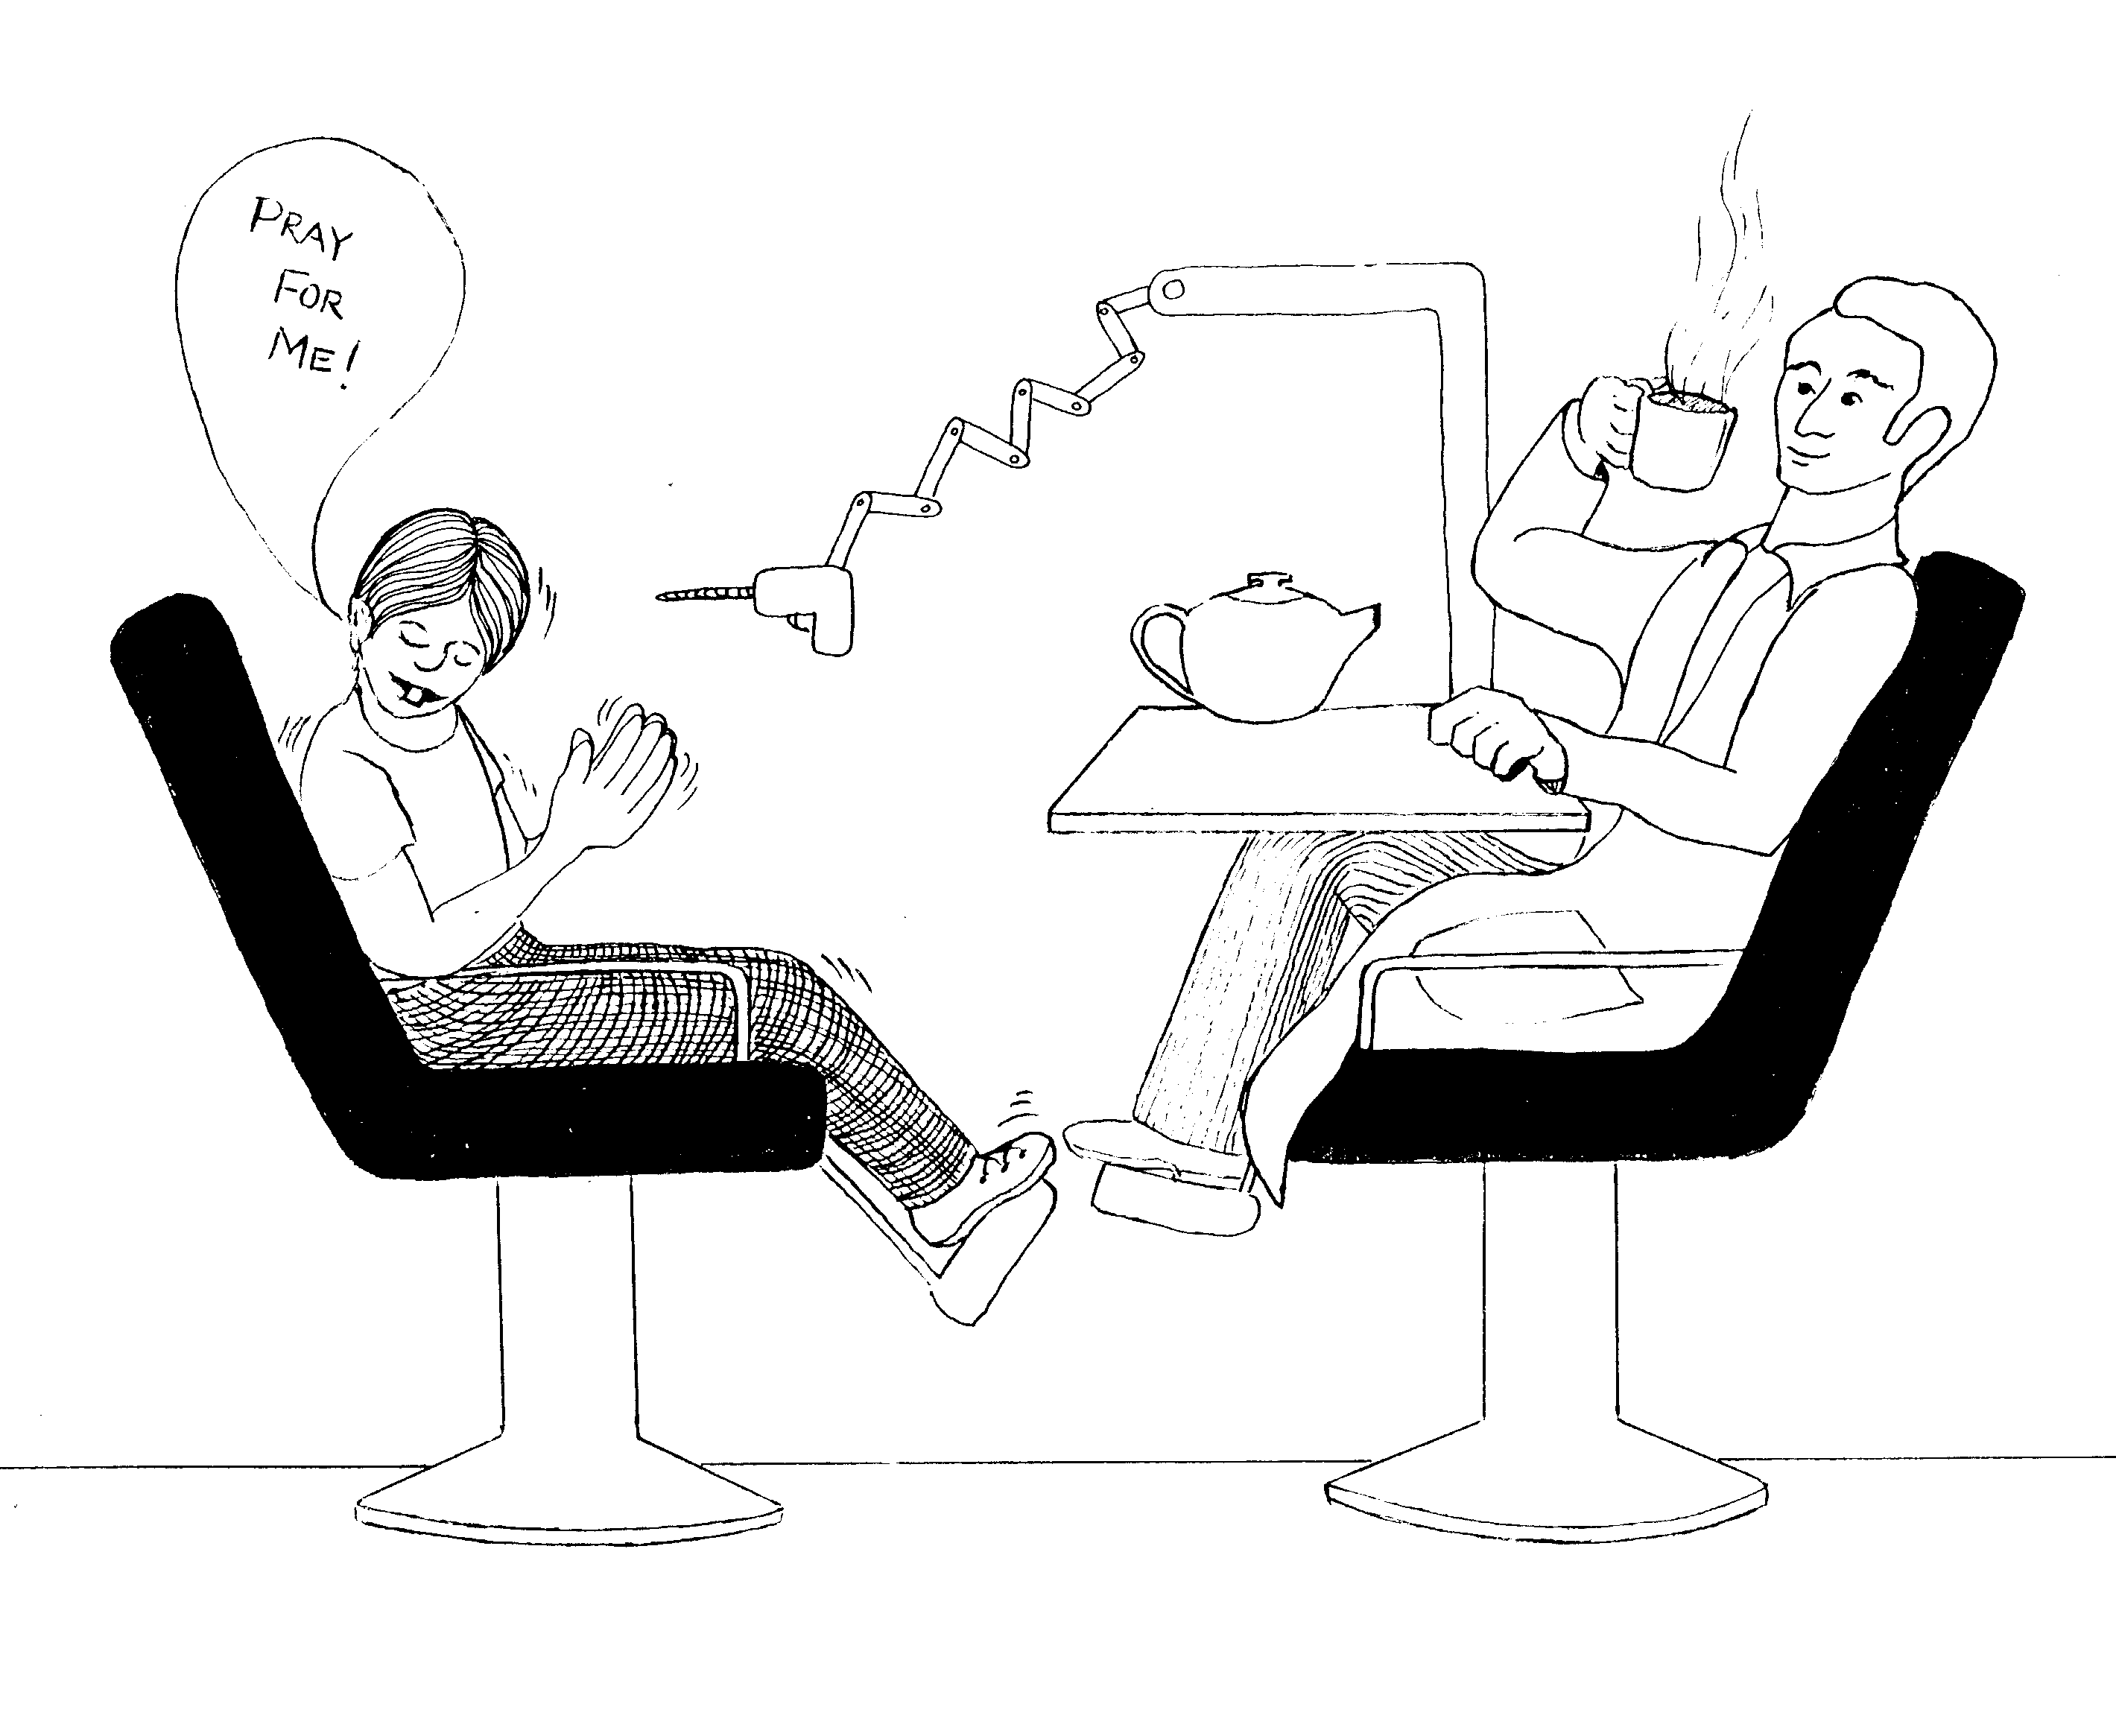

3. PRAY FOR US, NO LAZINESS

5 = Tea (rhyme)

* PRAY FOR US: boy scared, requesting for tooth
operation

* NO LAZINESS: lazy dentist taking a tea break on the job

2 Thessalonians 3
© 2003 Do not produce
1 Timothy

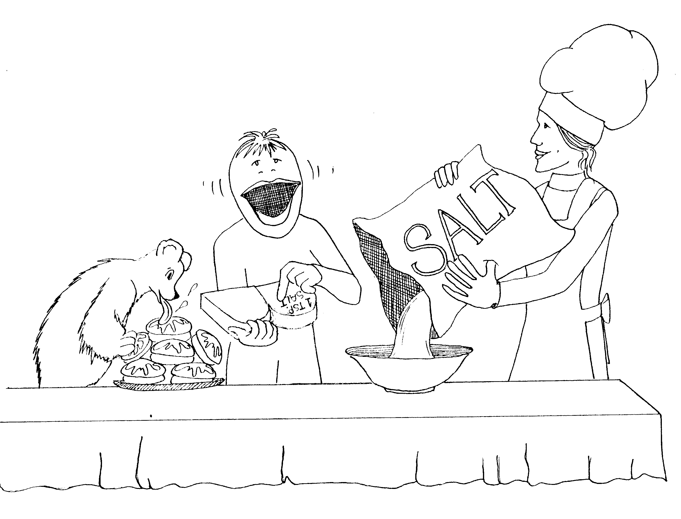 | 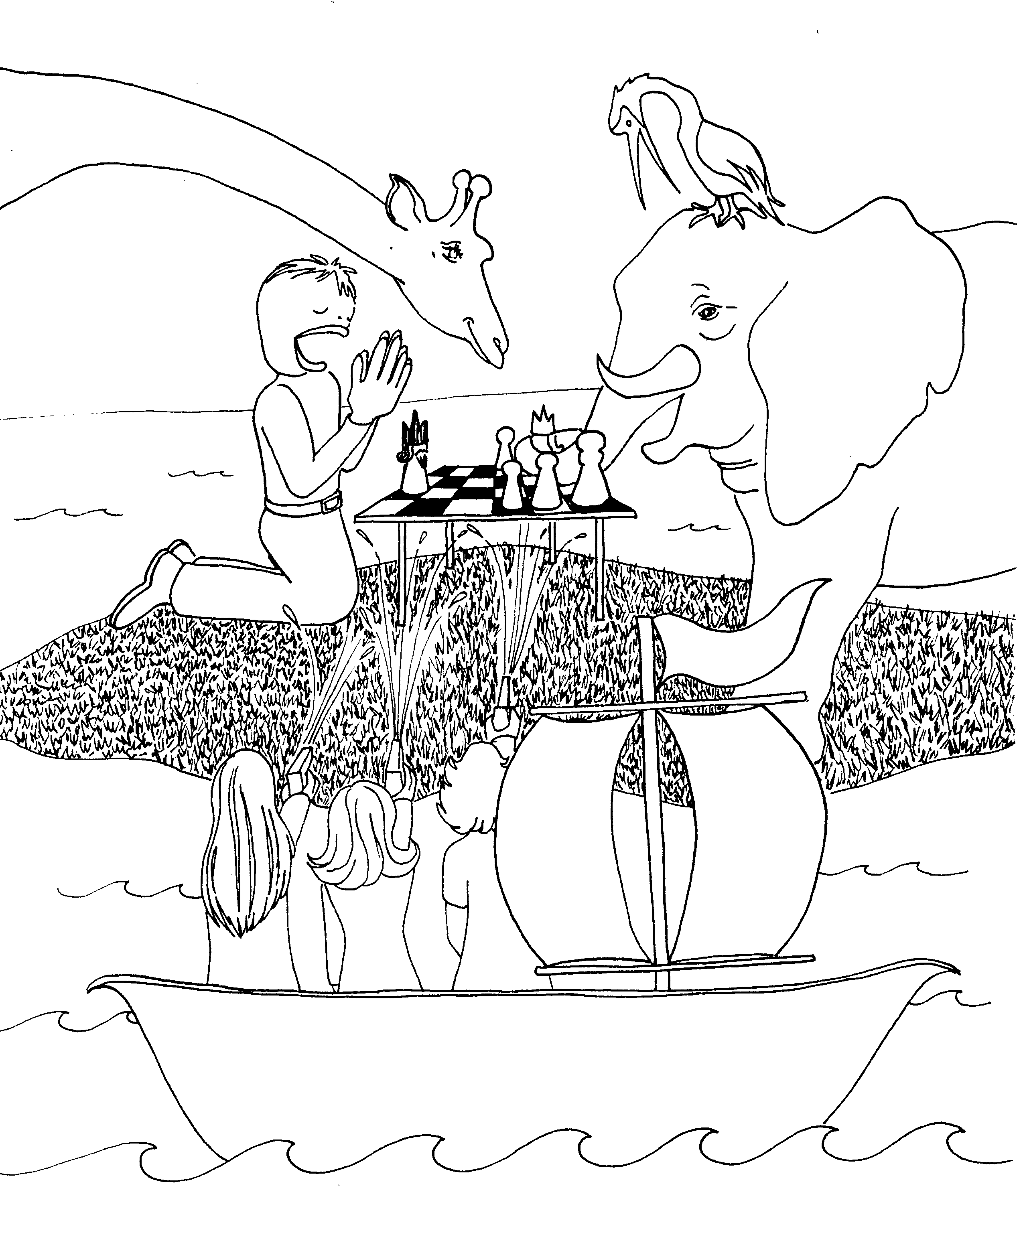
TIMOTHY = TOO-MOUTHY CHARACTER  1. FALSE TEACHERS, FAITHFUL LAW,  GOD'S GRACE TO PAUL  1 = Bun (rhyme)  * FALSE TEACHERS: cooking teacher misleading student putting too much salt into bun batter  * FAITHFUL LAW: "Too-mouthy" going by the faithful recipe book  * GOD'S GRACE TO PAUL: 'glaze' to Paul (bear) | 2. PRAY FOR KINGS, WOMEN AND WORSHIP  2 = Zoo (rhyme)  * PRAY FOR KINGS: Too-mouthy praying for his king  that is in checkmate  * WOMEN AND WORSHIP: women in a 'war-ship'
1 Timothy 1 - 2
© 2003 Do not reproduce
1 Timothy

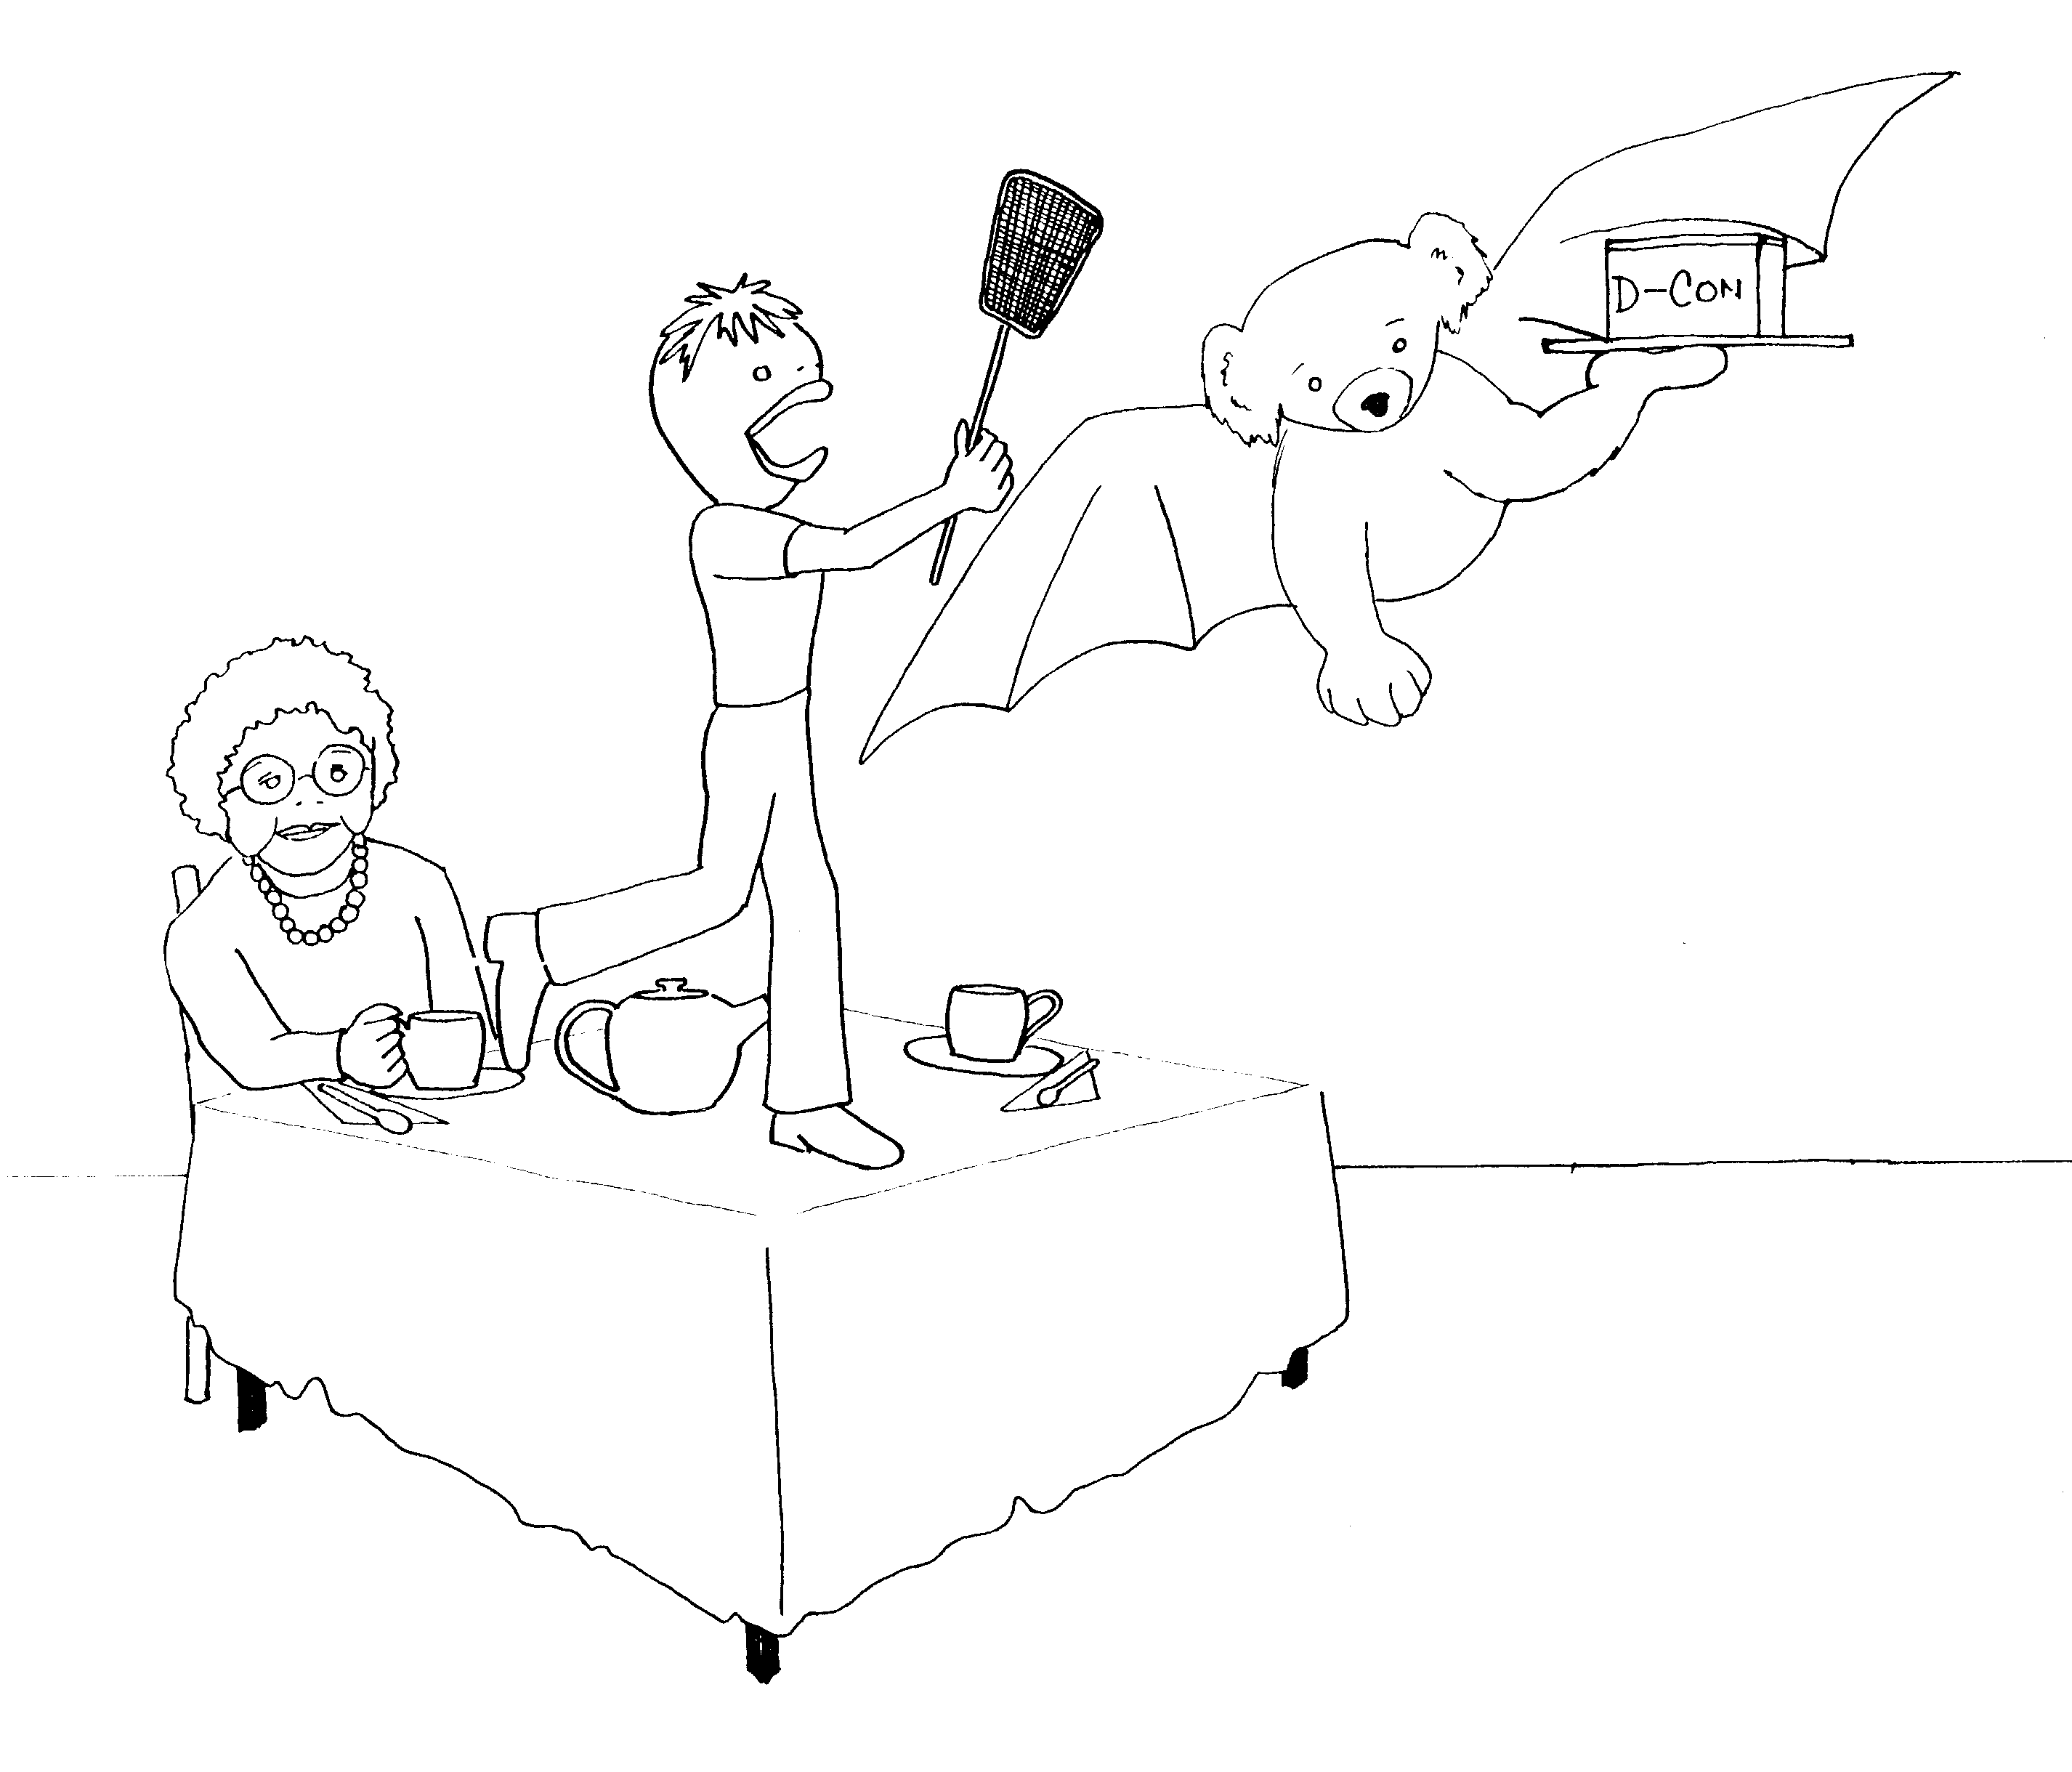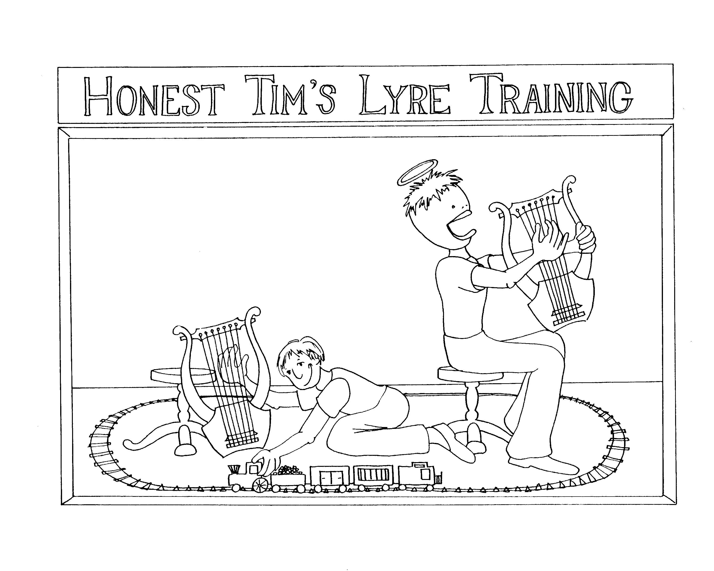

3. ELDER'S QUALIFICATIONS 4. LIARS, GODLY TRAINING, TIMOTHY'S EXAMPLE

3 = Tea (rhyme) 4 = Store (rhyme)

* ELDER'S QUALIFICATIONS: old woman is elder, * LIARS: lyres (harp like instruments being played)
'Koala-fly-cations' is the koala bear flying
* GODLY TRAINING: Halo on Too-mouthy,
training = train playing

* TIMOTHY'S EXAMPLE: Too-mouthy being an example
to his student

1 Timothy 3-4
© 2003 Do not reproduce
1 Timothy

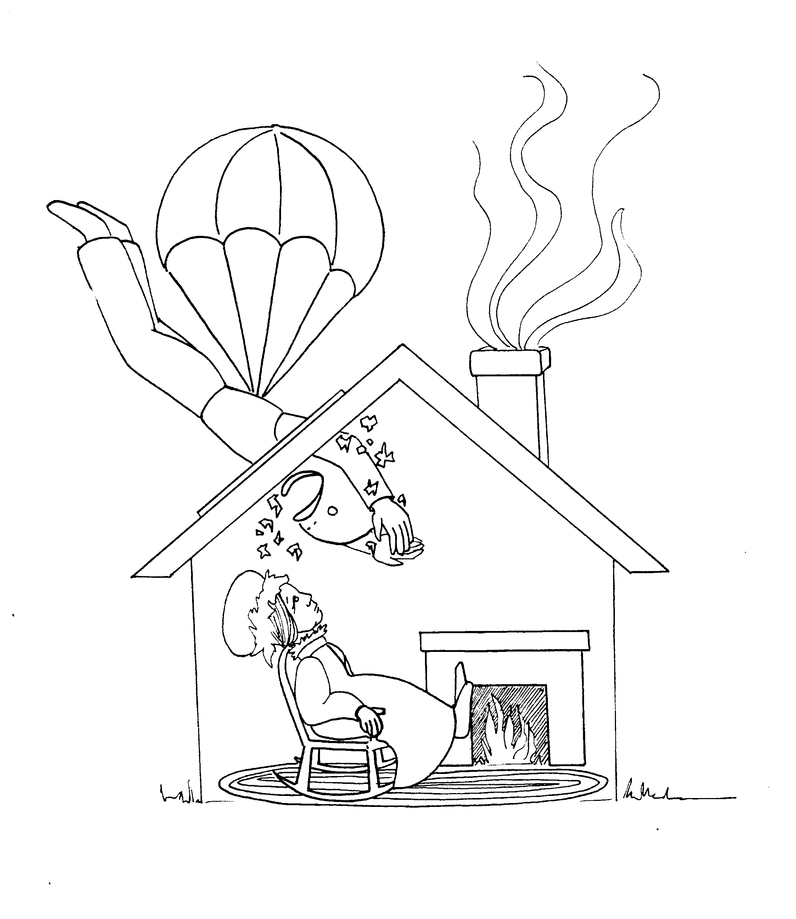 | 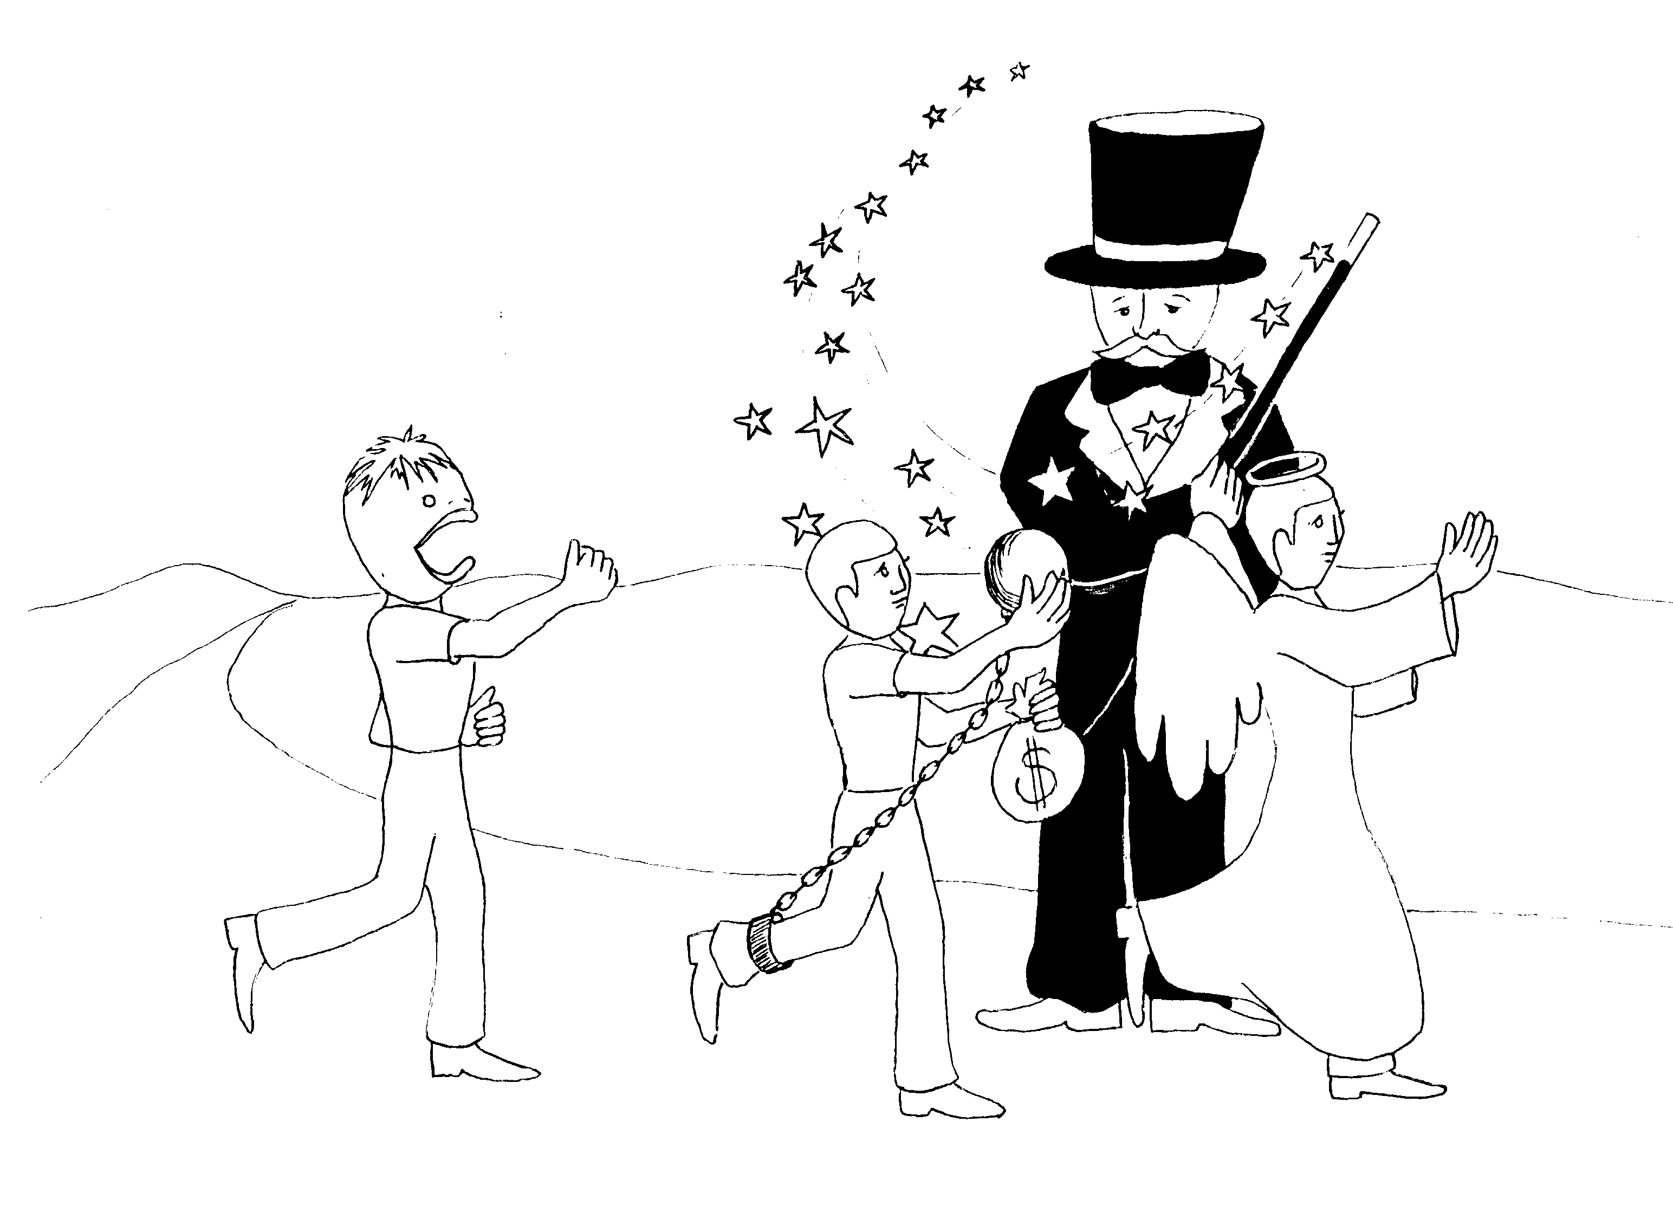
5. WIDOWS, ELDERS' HONOR  5 = Dive (rhyme)  * WIDOWS: old widow, Too-mouthy breaking through  window on to widow  * ELDERS' HONOR: lady is elderly he is diving 'on her'  for "honor" | 6. SLAVERY, MONEY, PURSUE GODLINESS  6 = Tricks (rhyme)  * SLAVERY: Too-mouthy's slave running away  * MONEY: slave staling money  * PURSUING GODLINESS: slave pursuing a godly angel  to catch reward, the magician taps his wonder wand  on guy running away
1 Timothy 5 - 6
© 2003 Do not reproduce
2 Timothy

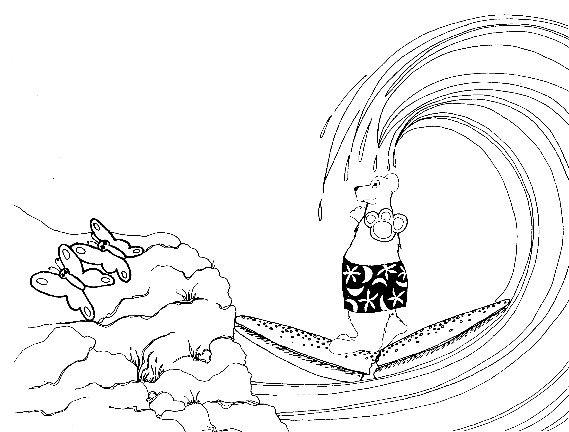 | 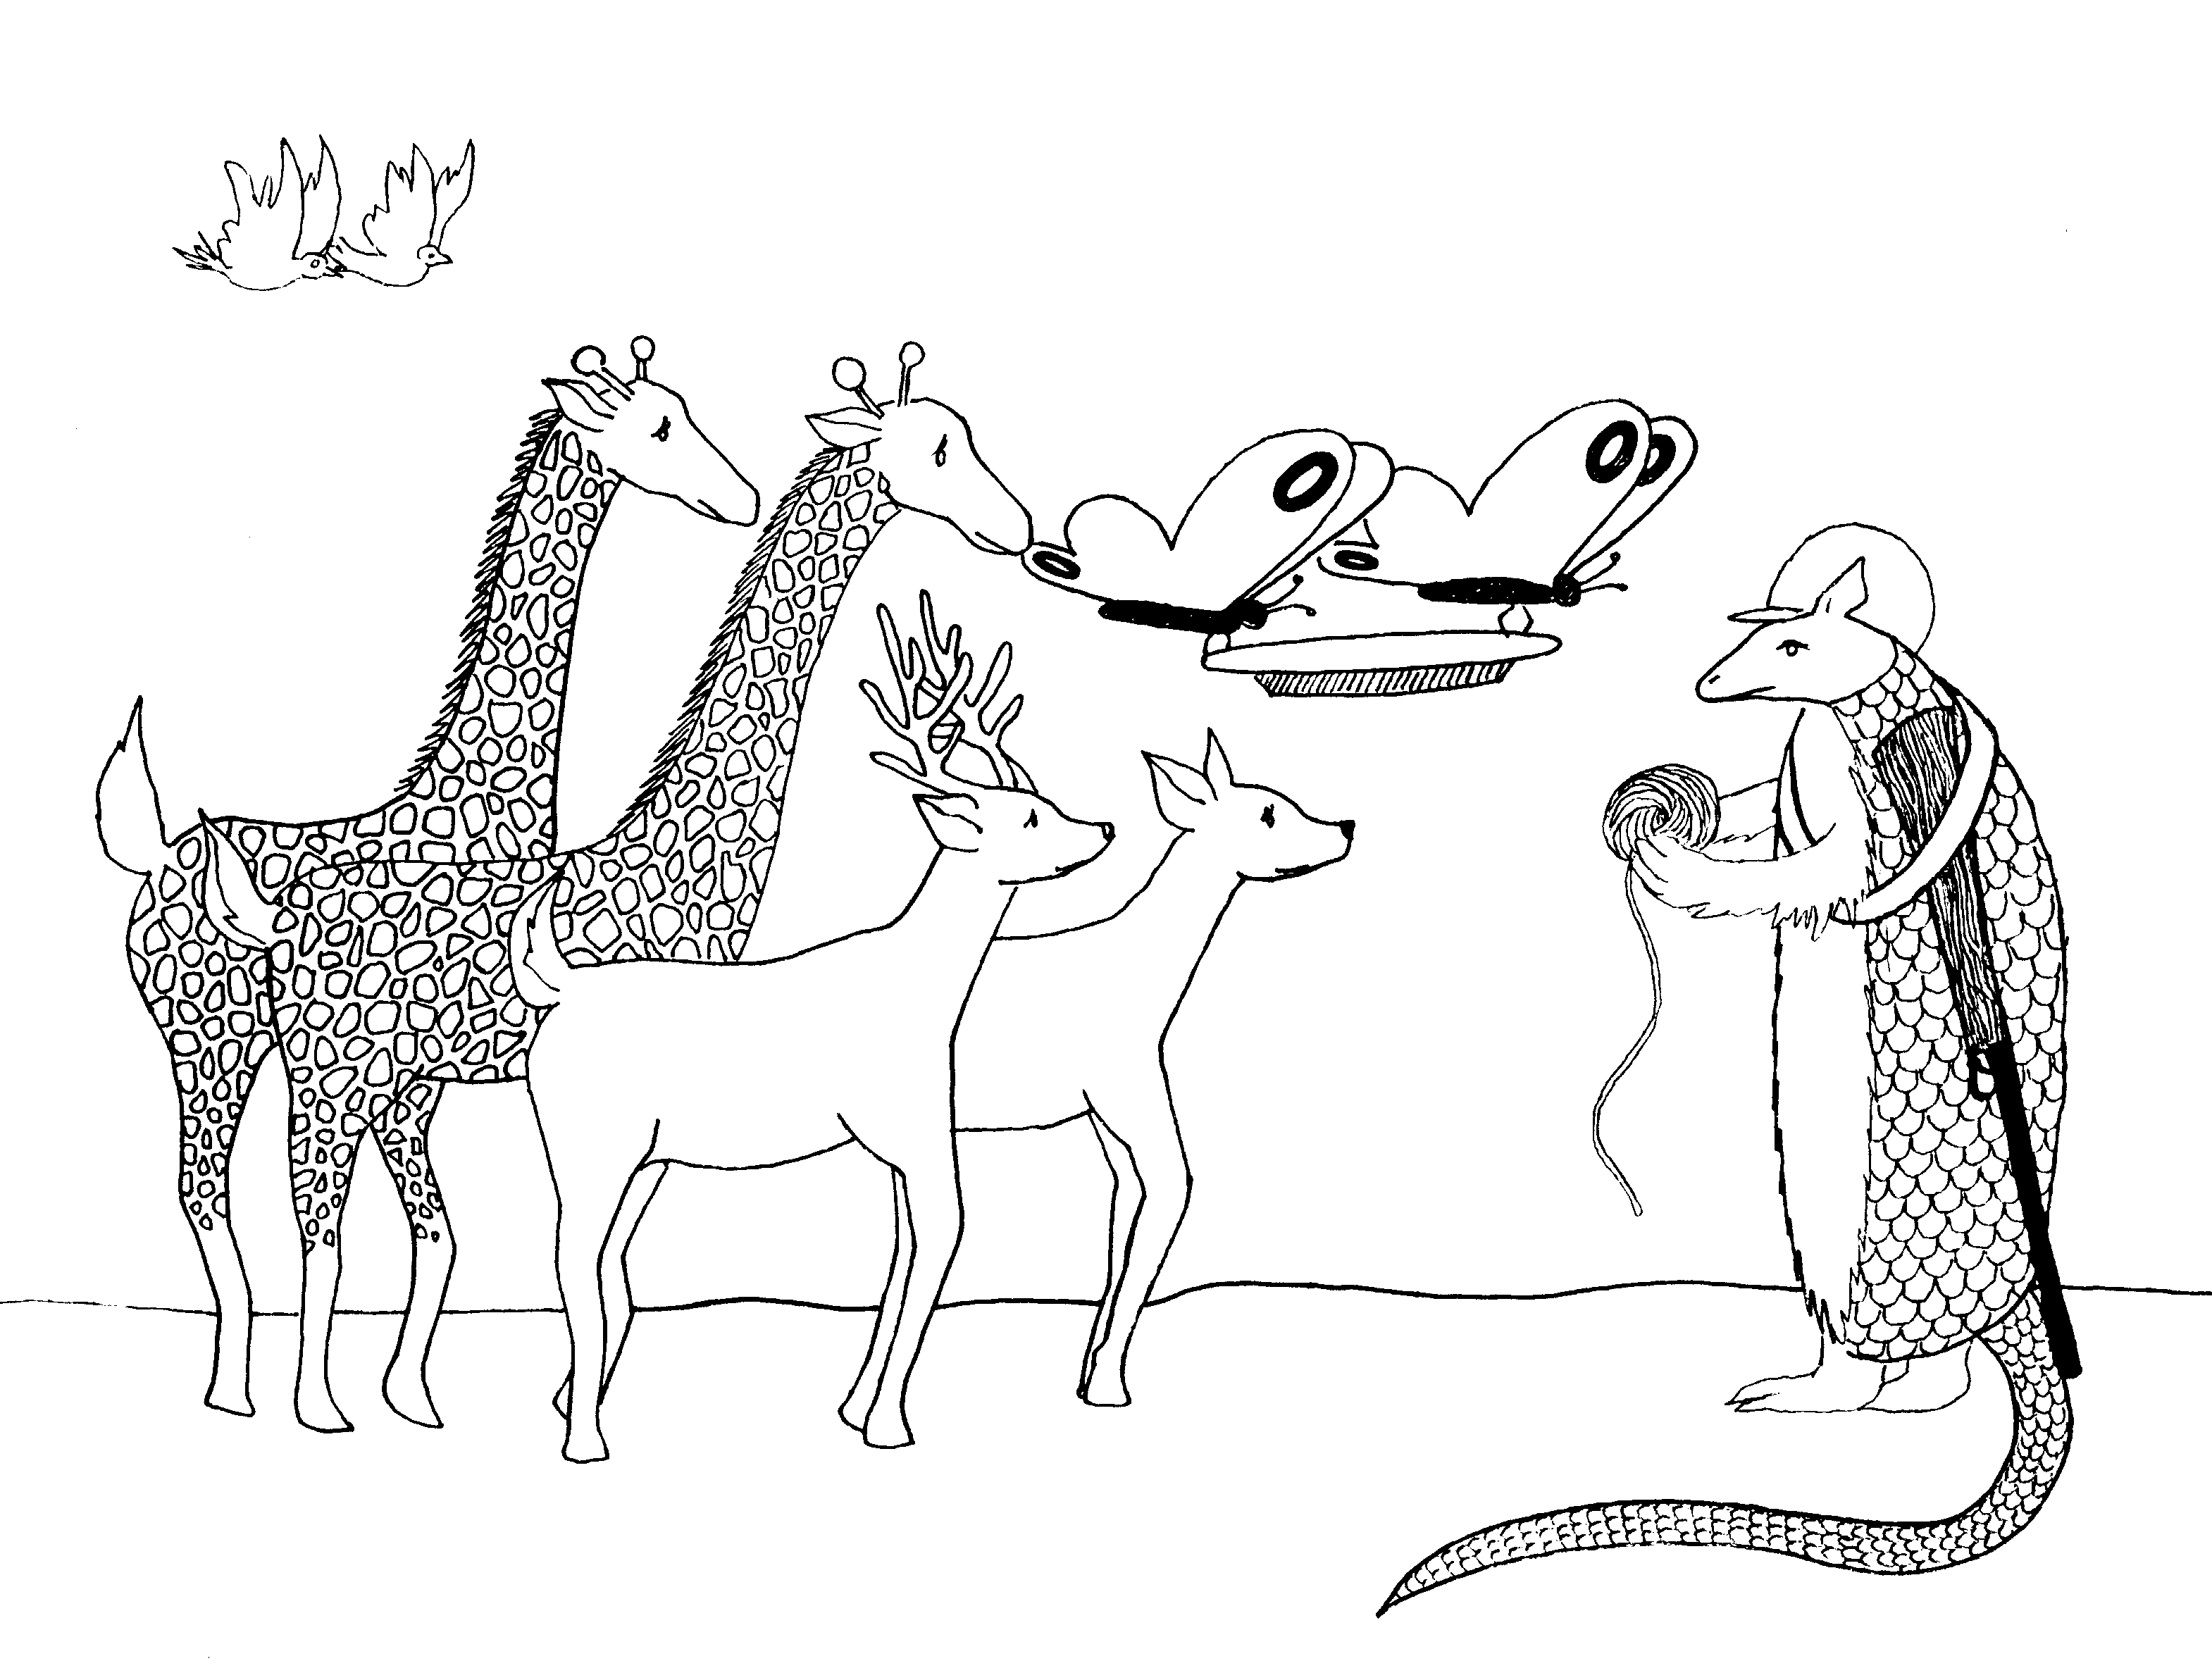
2 TIMOTHY = 2 MOTHY (2 MOTHS)  1. TIMOTHY'S BACKGROUND, PAUL’S LABOR  1 = Bun (rhyme)  * TIMOTHY'S BACKGROUND: Two-moths with 'backs to the ground' (background)  * PAUL'S LABOR: Paul (bear) sweeping up the litter | 2. GOOD SOLDIER, EMPTY CHATTER  2 = Zoo (rhyme)  * GOOD SOLDIER: armadillo soldier, feeding zoo animals  * EMPTY CHATTER: empty platter
2 Timothy 1 - 2
© 2003 Do not reproduce
2 Timothy

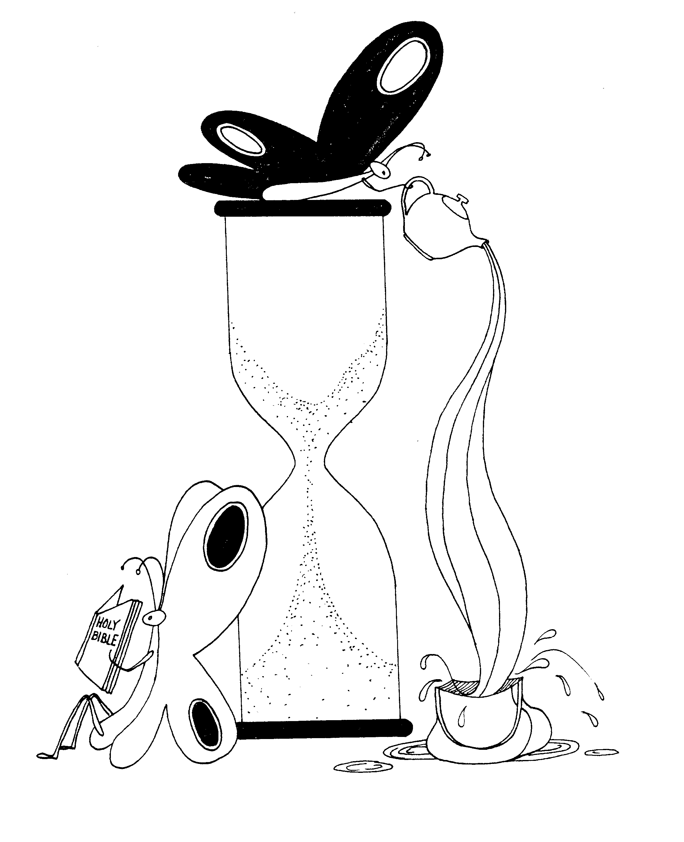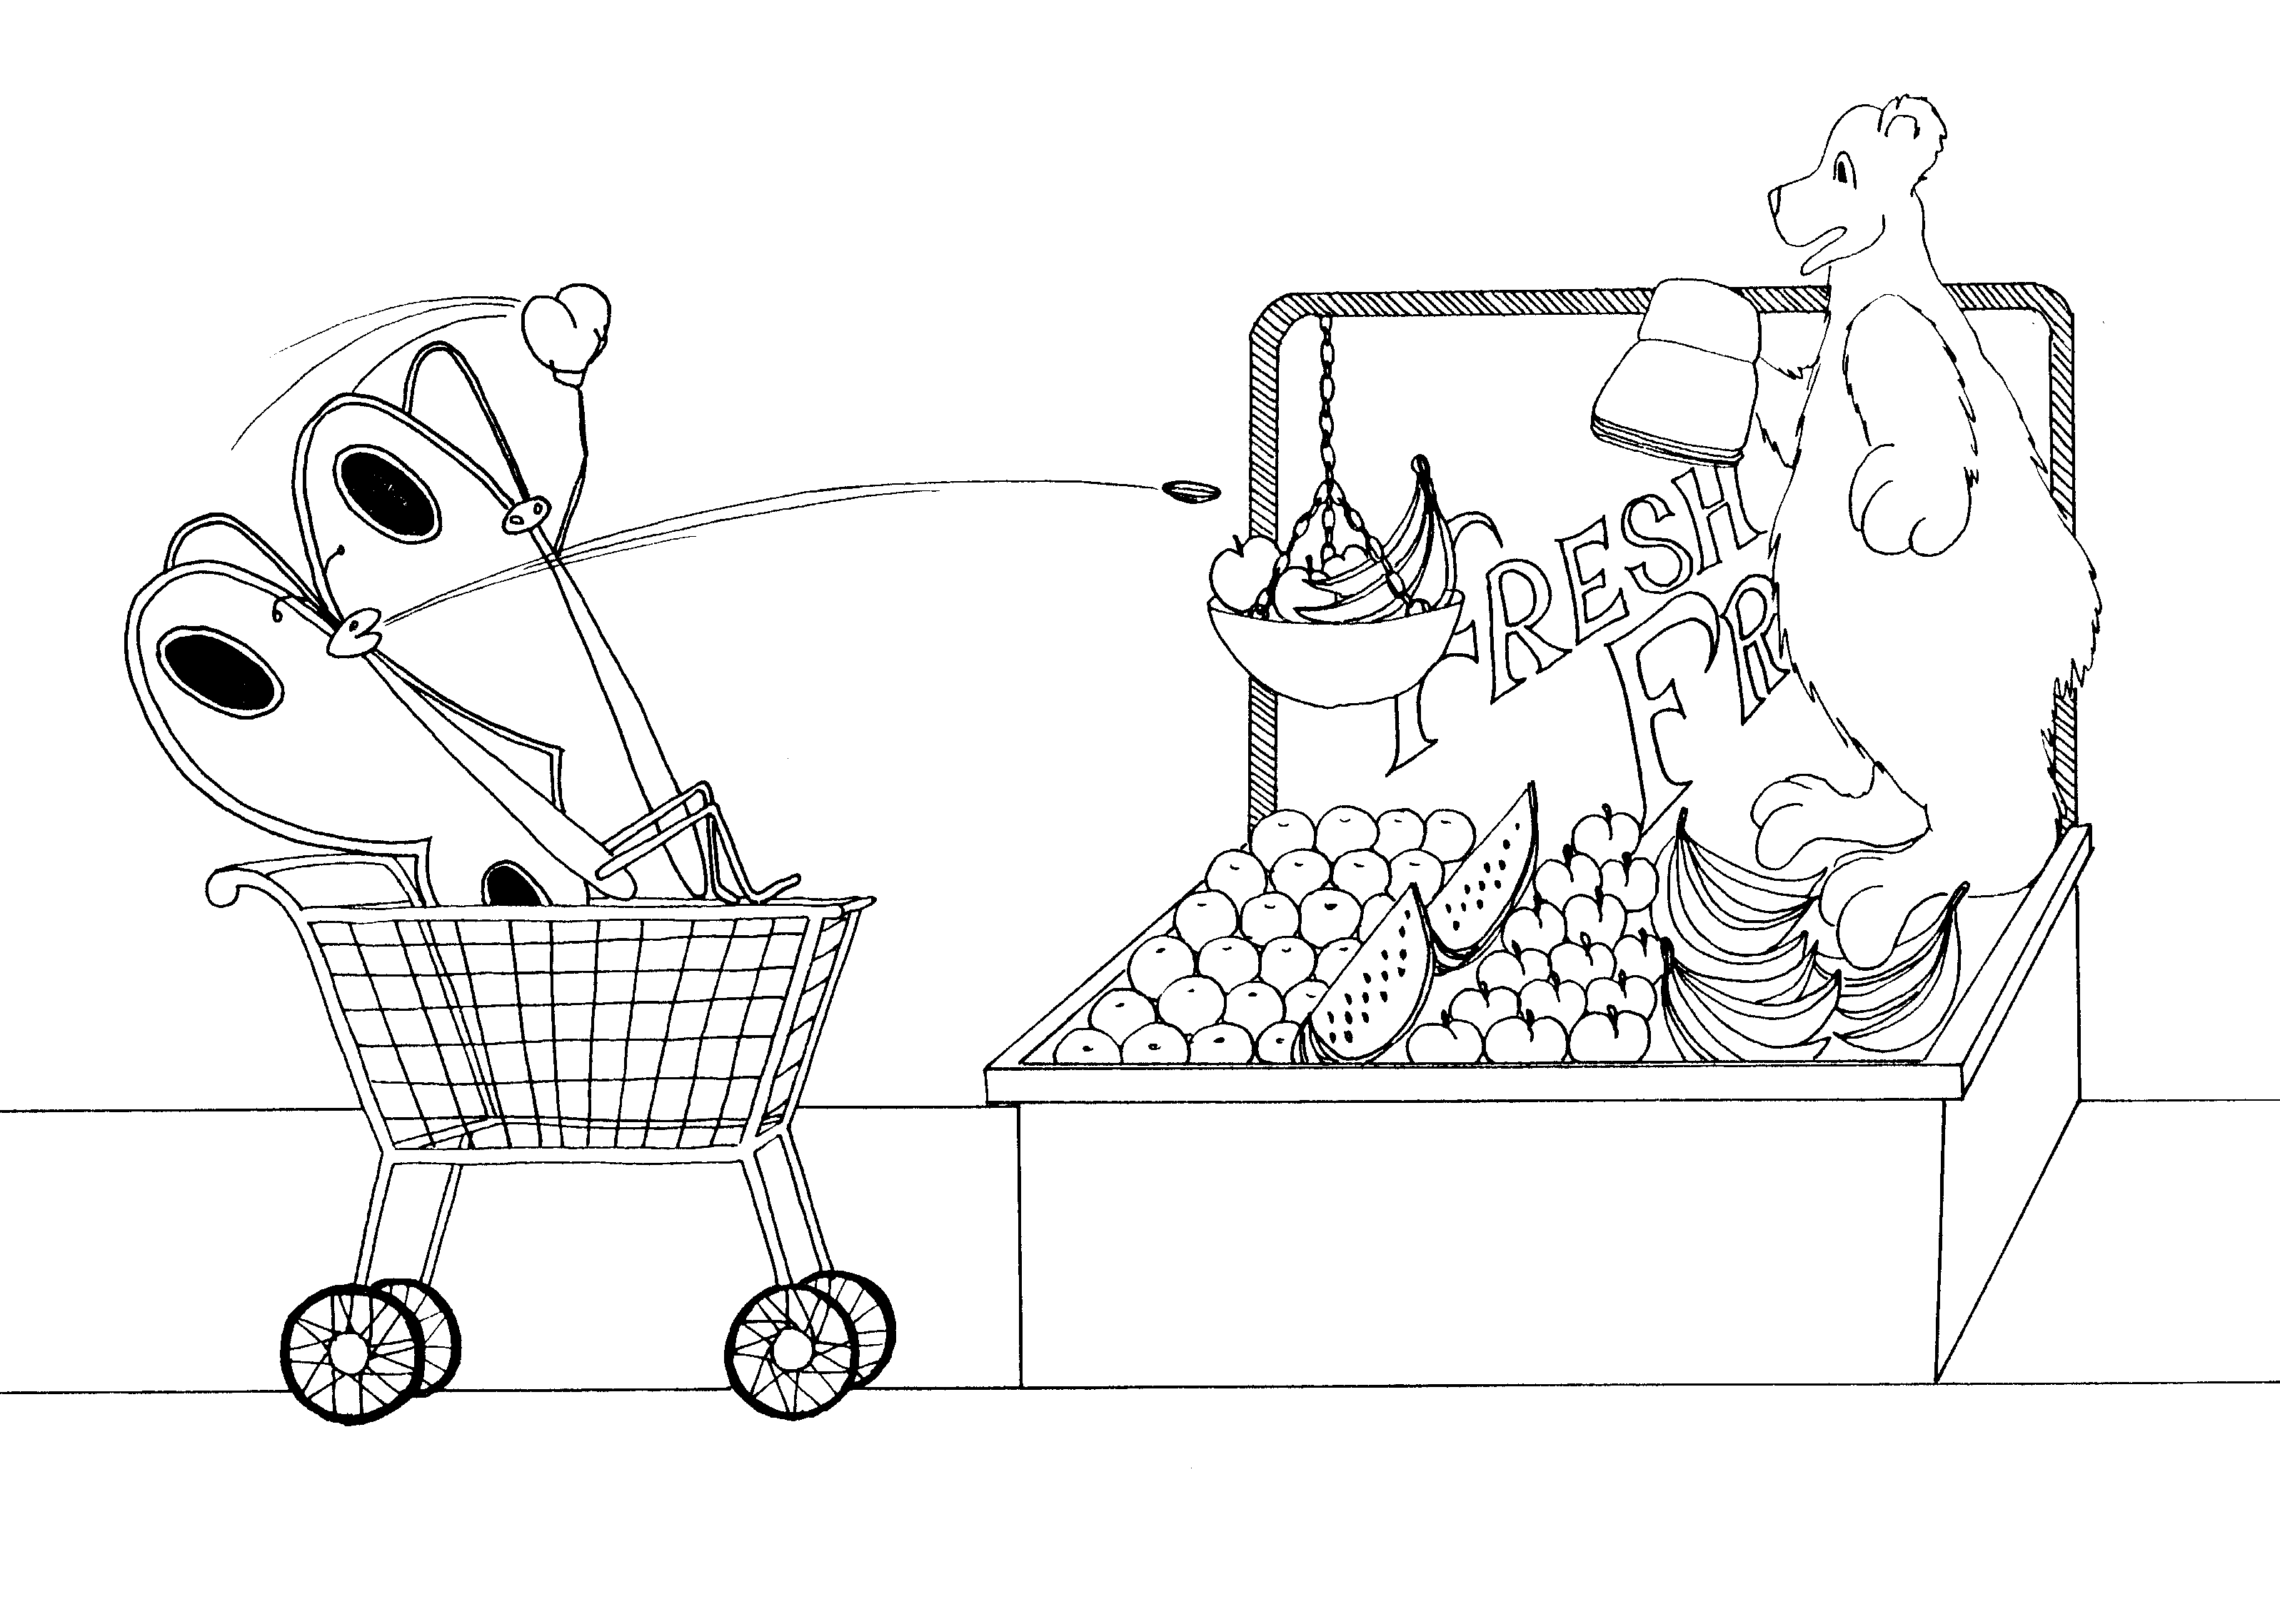

3. UNGODLY END TIMES, PERSECUTED, 4. PREACH THE WORD, FINISH THE COURSE,
GODLY SCRIPTURE MUTUAL FRIENDS

3 = Tea (rhyme) 4 = Store (rhyme)

* UNGODLY END TIMES: dark moth (ungodly) on * PREACH THE WORD: Paul (bear) preaching the word (Bible)
egg timer (end times)
* FINISH THE COURSE: finished 'cores' being thrown at Paul
* PERSECUTED: pouring tea into purse 'purse'-ecuted (bear)

* GODLY SCRIPTURE: godly moth reading Scripture * MUTUAL FRIENDS: moths holding hands as they eat and
throw the cores

2 Timothy 3 - 4
© 2003 Do not reproduce
Titus

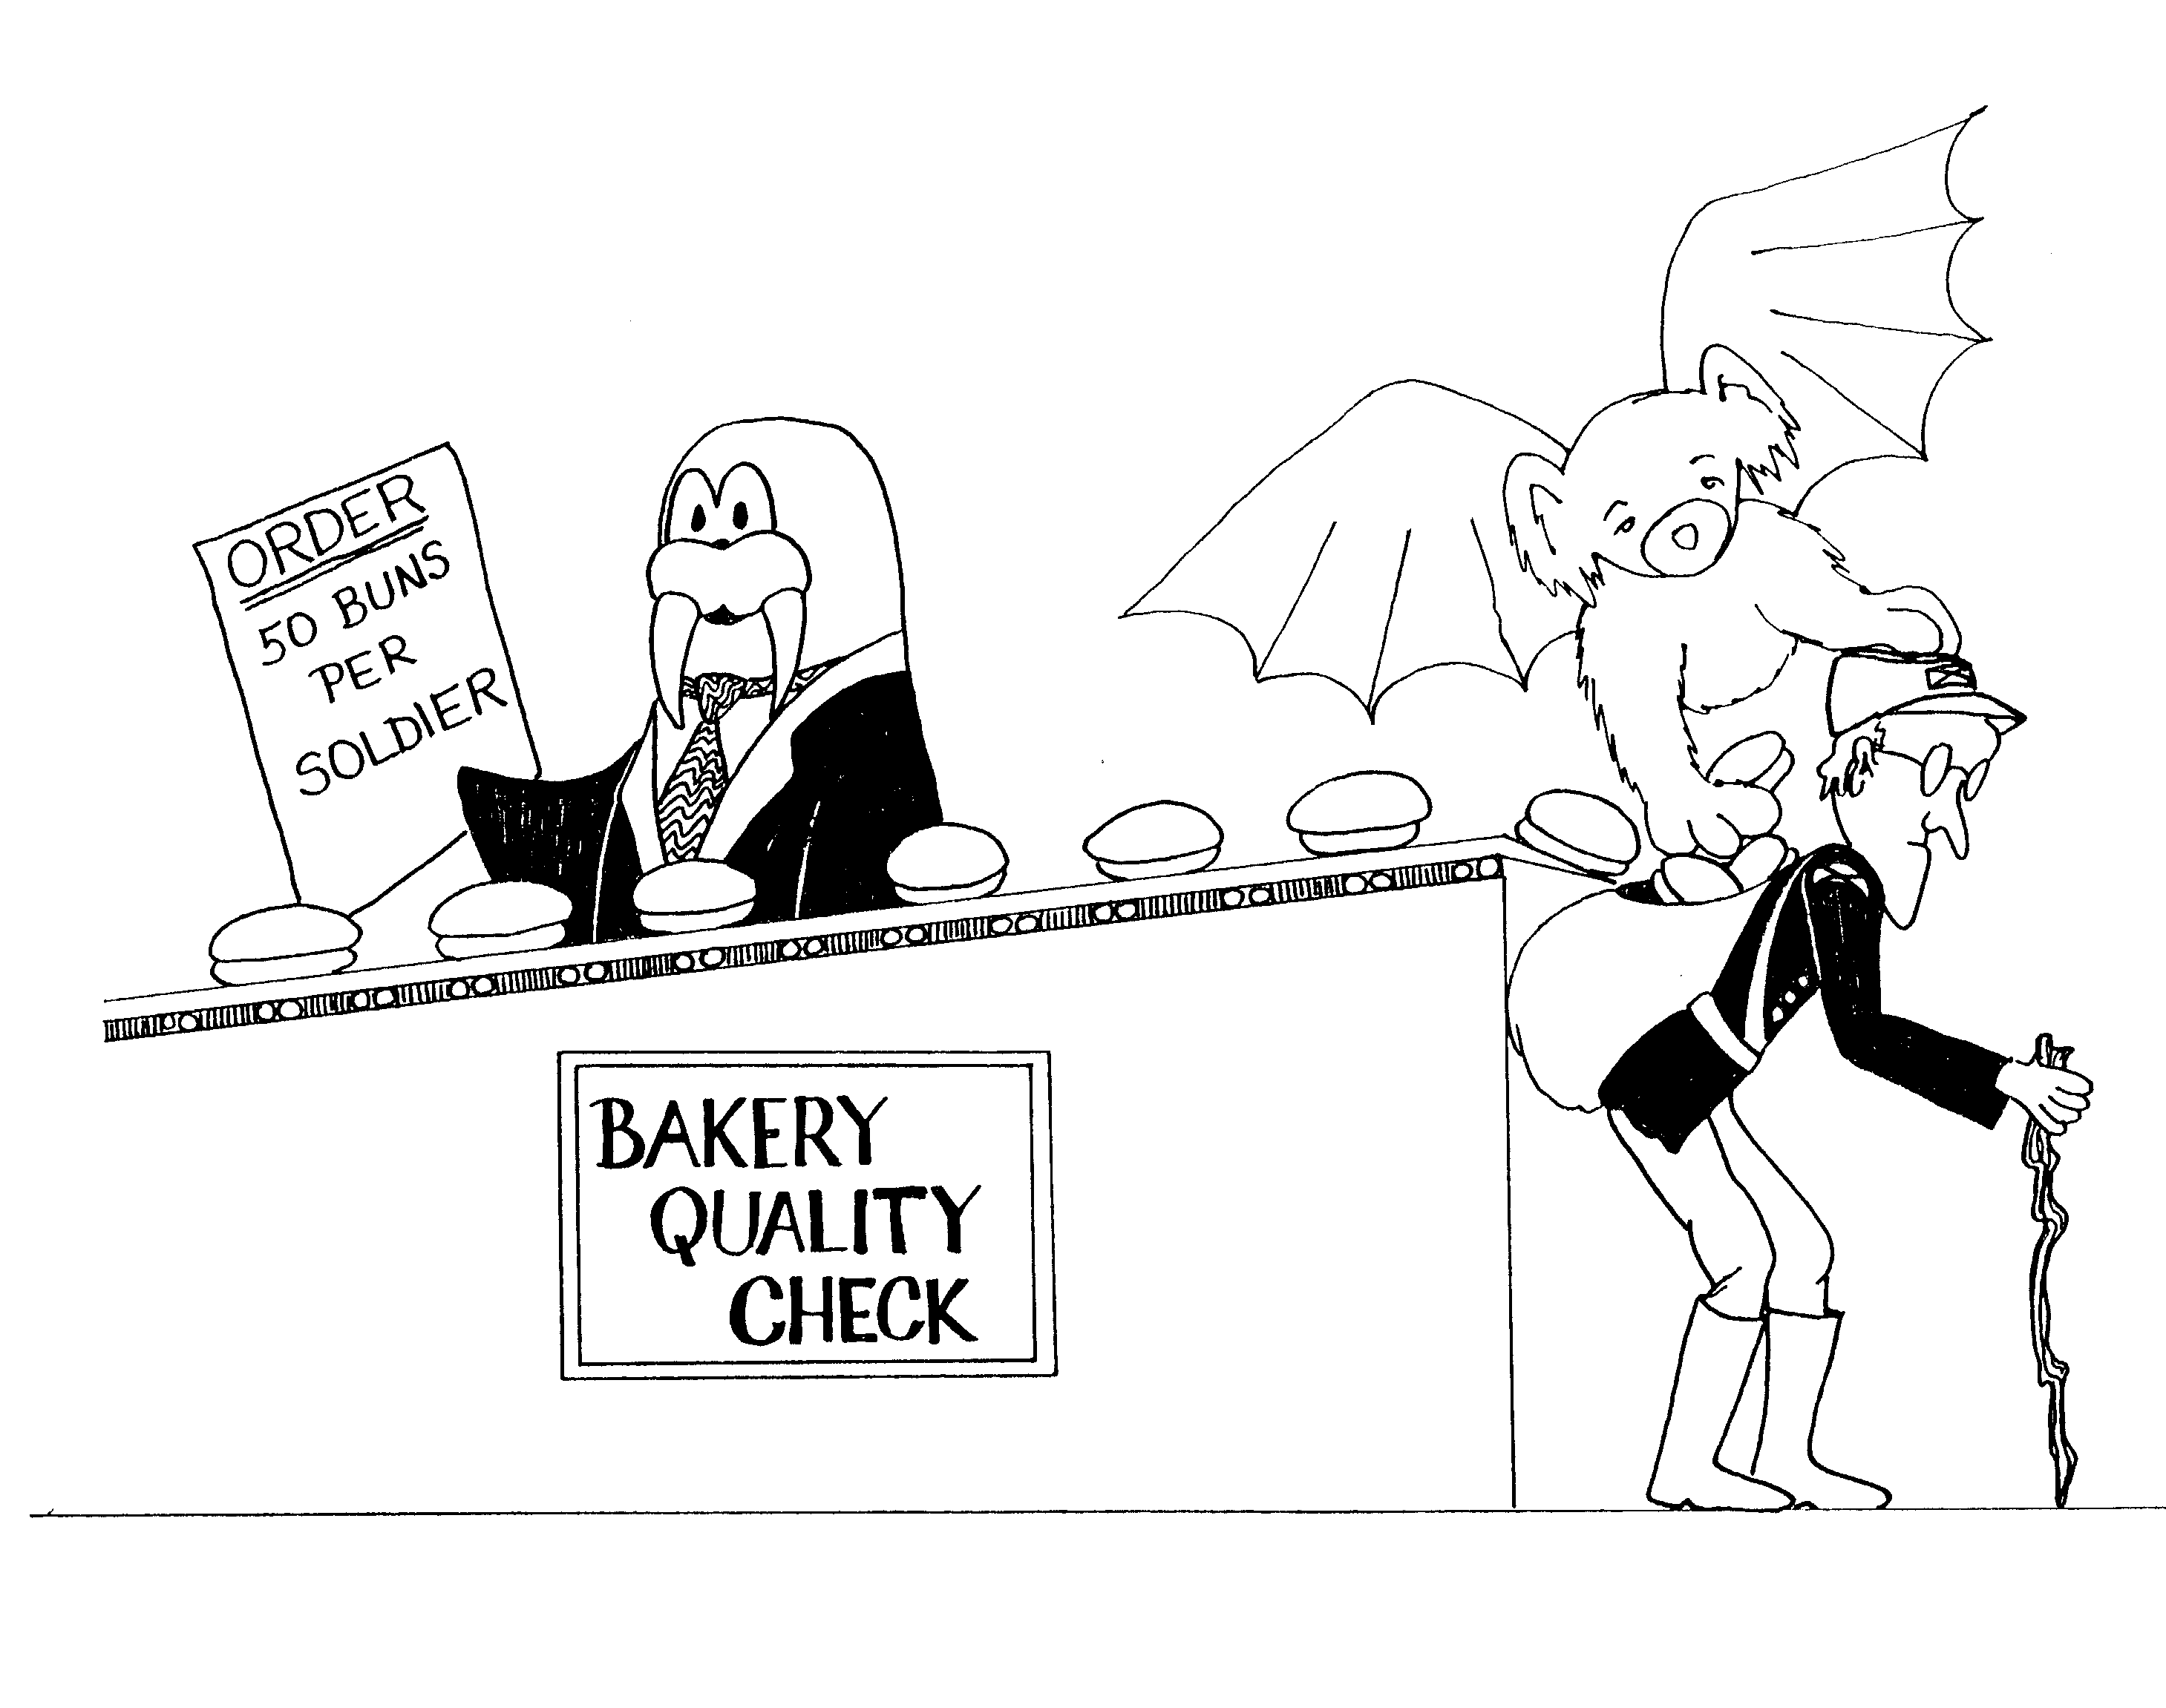 | 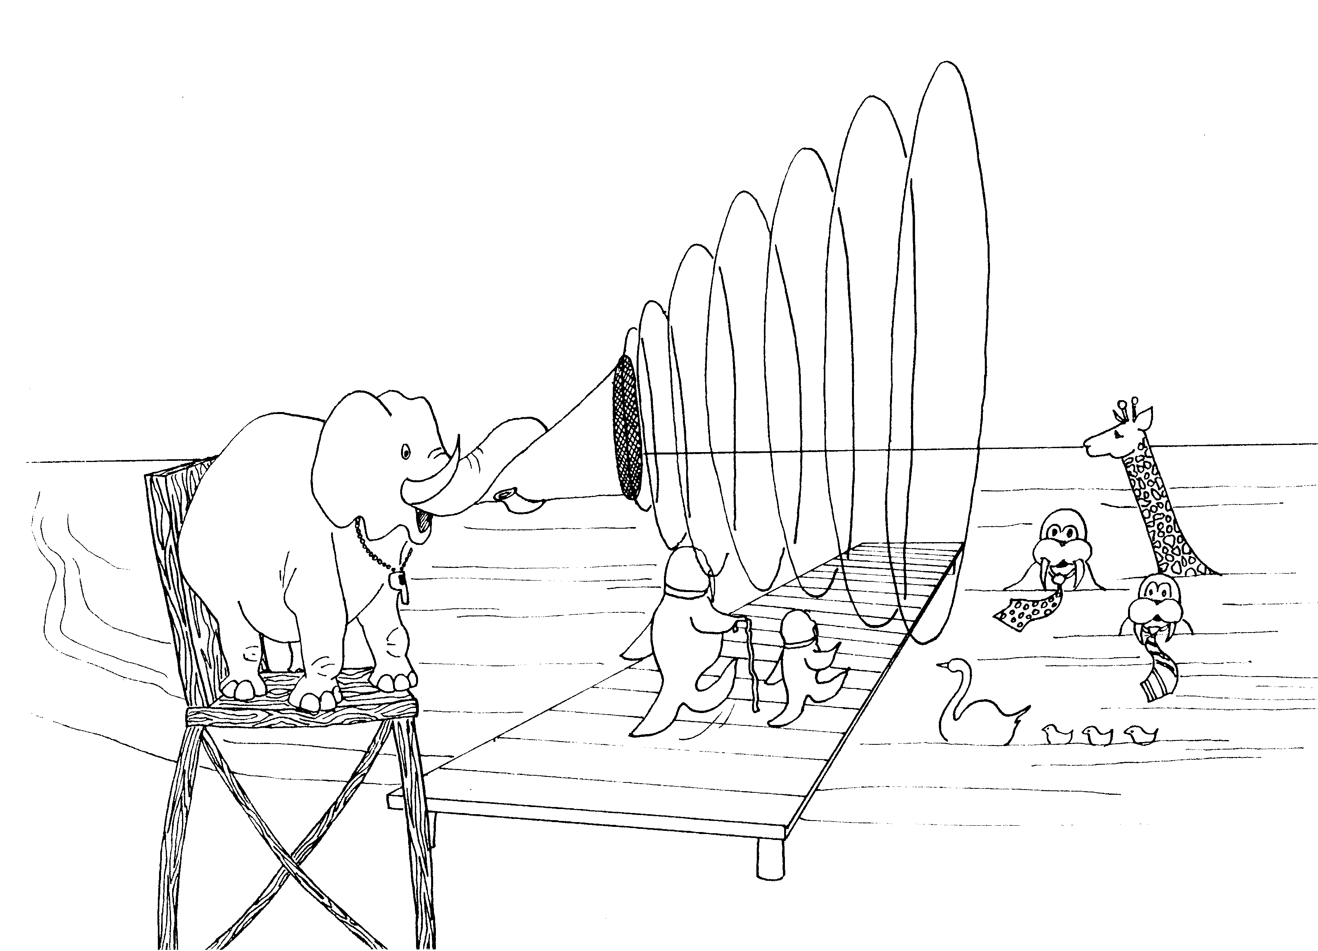
TITUS = TIE - TUSK (WALRUS)  1. ORDAIN QUALIFIED ELDERS  1 = Bun (rhyme)  * ORDAIN QUALIFIED ELDERS: order (ordain)  qualified (koala-flying), elders (old man) | 2. SOUND DOCTRINE  2 = Zoo (rhyme)  * SOUND DOCTRINE: Sound = trumpet,  dock-run (doctrine)
Titus 1 - 2
© 2003 Do not reproduce
Titus

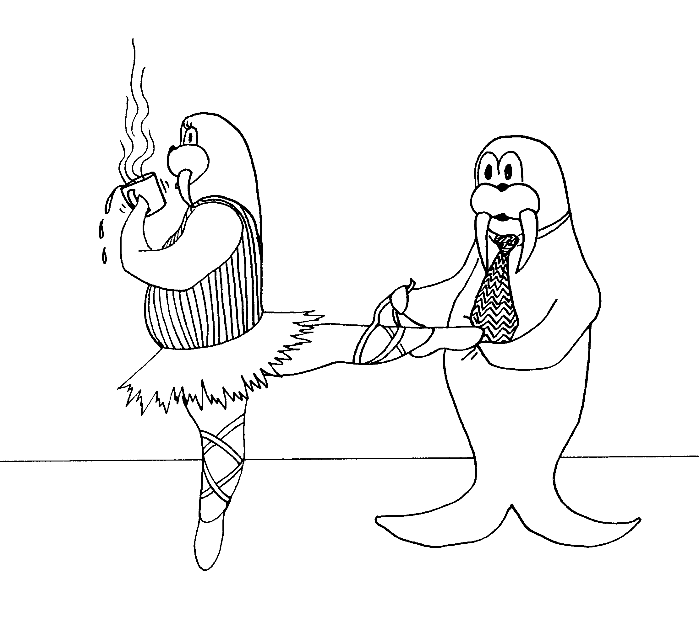

3. GRACE AND GOOD WORKS

3 = Tea (rhyme)

* GRACE AND GOOD WORKS: graceful ballerina,
Tie-tusk tying ballerina's slipper for her
(good works)

Titus 3
© 2003 Do not reproduce
Philemon

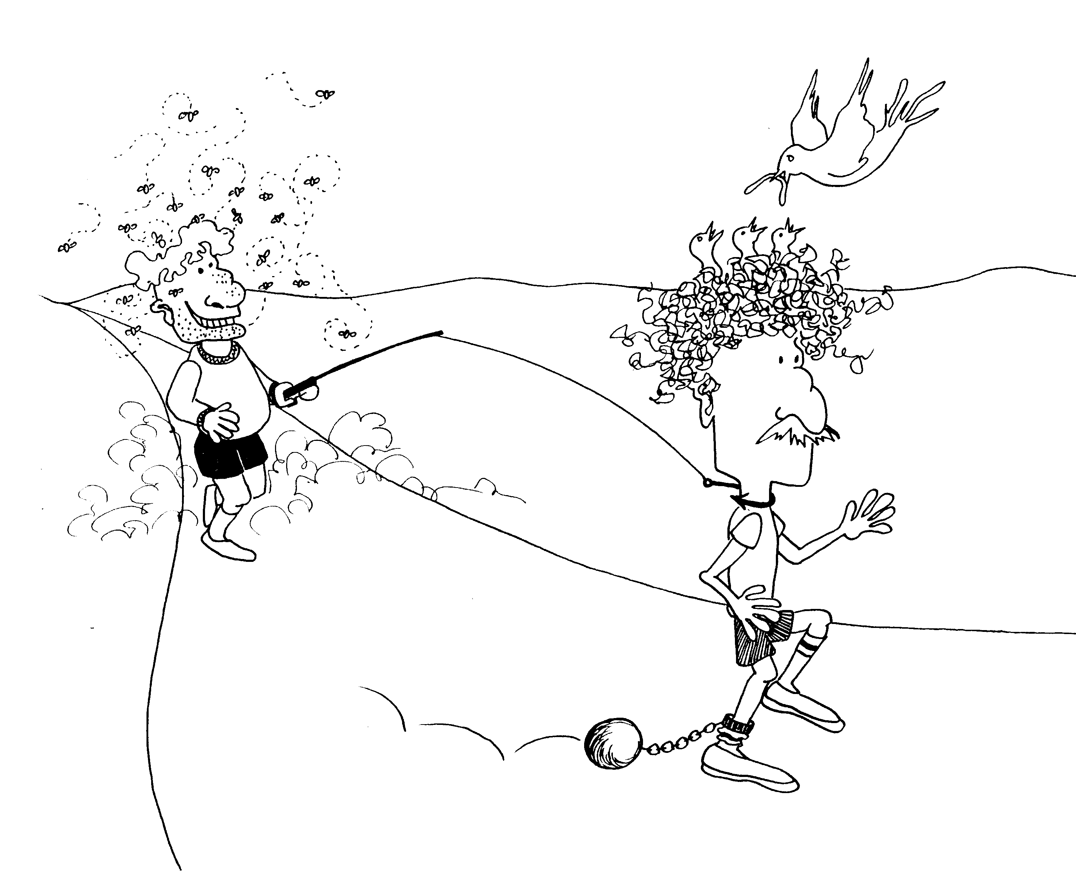
PHILEMON = FLEA MAN

SLAVE ONESIMUS RETURNS

* SLAVE ONESIMUS RETURNS: slave = ball and
chain, Onesimus = O-Nest-a-mess (nest in his
hair); Returns -- owner pulling him back with
a fish line
Philemon
© 2003 Do not reproduce

