MARK: THE ASTONISHING SERVANT

1. John the Baptist, Baptism, Disciples,
Peter's mother-in-law, Leper

2. Forgives sin, Matthew, Fasting, Lord of Sabbath

3. Paralyzed hand, Beelzebub, 12 Apostles,
My mother and brothers

4. Parables of the kingdom, Calms sea

5. Demoniac, Woman with an issue, Jairus' daughter

6. Hometown unbelief, Sends 12, Herod's banquet,
Christ's banquet, Walks on water

7. Washings, Canaanite woman

8. 4,000, Pharisees' yeast, Peter-(rock)-Satan

9. Transfiguration, Hard demon, Child is the greatest,
For and against us

10. Divorce, Children, Rich young ruler, James' and
John's request, Blind man

11. Palm Sunday, Temple cleansing, Fig, By what authority?

12. Wicked tenants, Tribute? Resurrection?
Greatest command, Widow's penny

13. Olivet Discourse on end times

14. Anointed, Last supper, Gethsemane, Arrest and trial,
Peter's denial

15. Pilate, Soldiers, Crucifixion, Joseph of Arimathea

16. Resurrection, Miracles

Mark: The Astonishing Servant

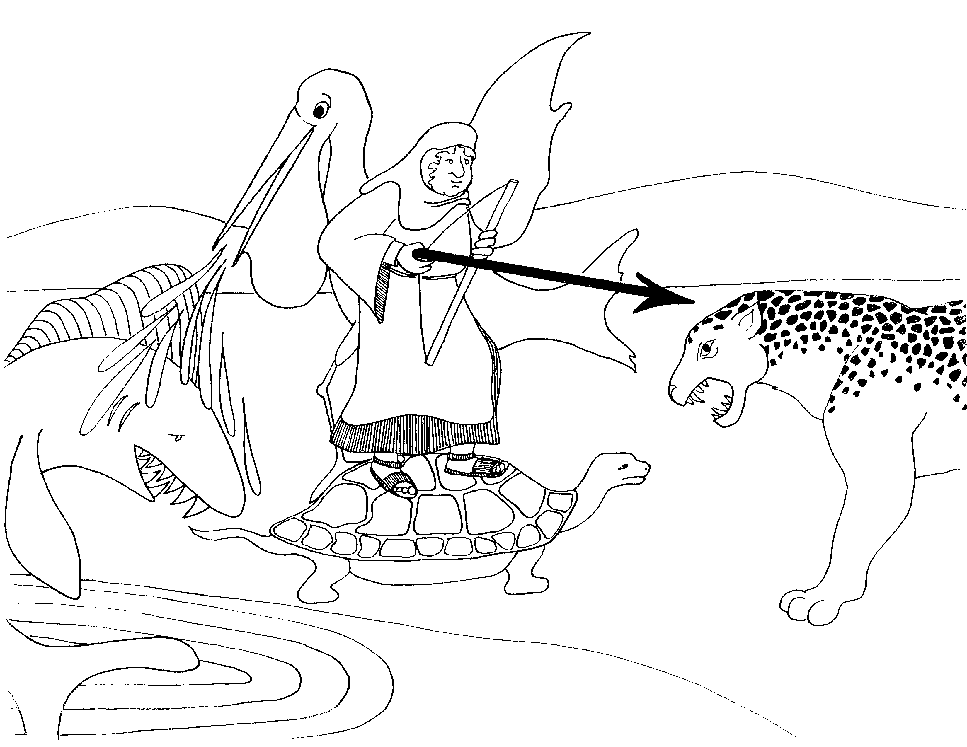 | 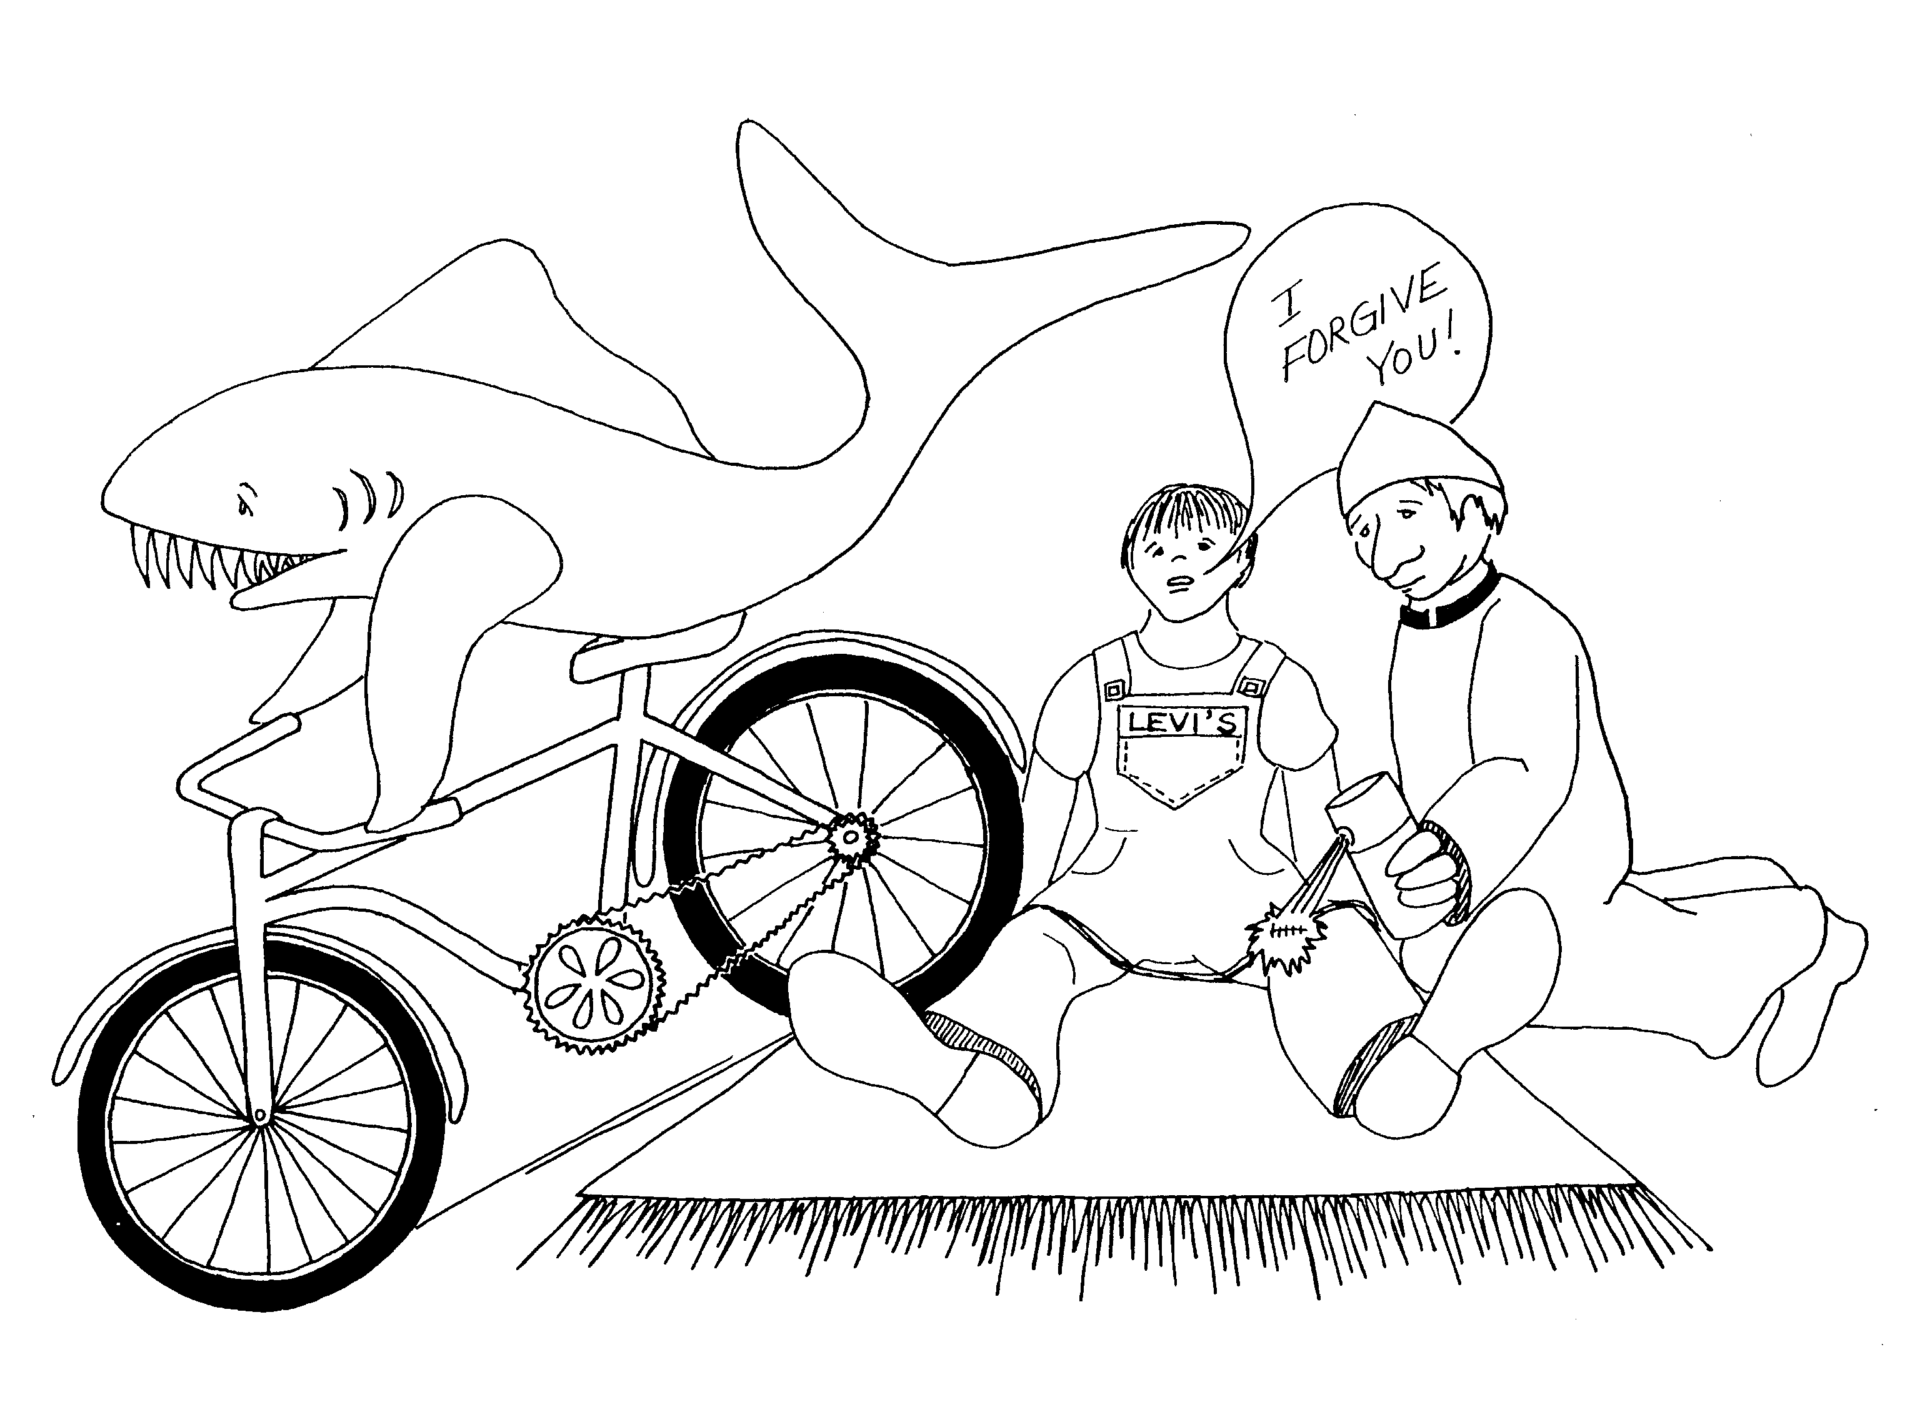
MARK = SHARK (Action book, rhyme)  1. JOHN THE BAPTIST, BAPTISM, DISCIPLES,  PETER'S MOTHER-IN-LAW, LEPER  1 = Arrow  * JOHN THE BAPTIST: pelican (got a baptistery in beak)  * BAPTISM: being sprayed with water  * DISCIPLES: turtles (slow to belief)  * PETER'S MOTHER-IN-LAW: lady in picture  * LEPER: leopard | 2. FORGIVES SIN, MATTHEW, FASTING,  LORD OF SABBATH  2 = Bicycle (2 wheels)  * FORGIVES SIN: boy forgiving shark (priest also has  idea of forgiveness)  * MATTHEW: boy in jeans sitting on a mat  * FASTING: fast sting of antiseptic put on his cut  * LORD OF SABBATH: priest
Mark 1 - 2
© 2003 Do not reproduce
Mark: The Astonishing Servant

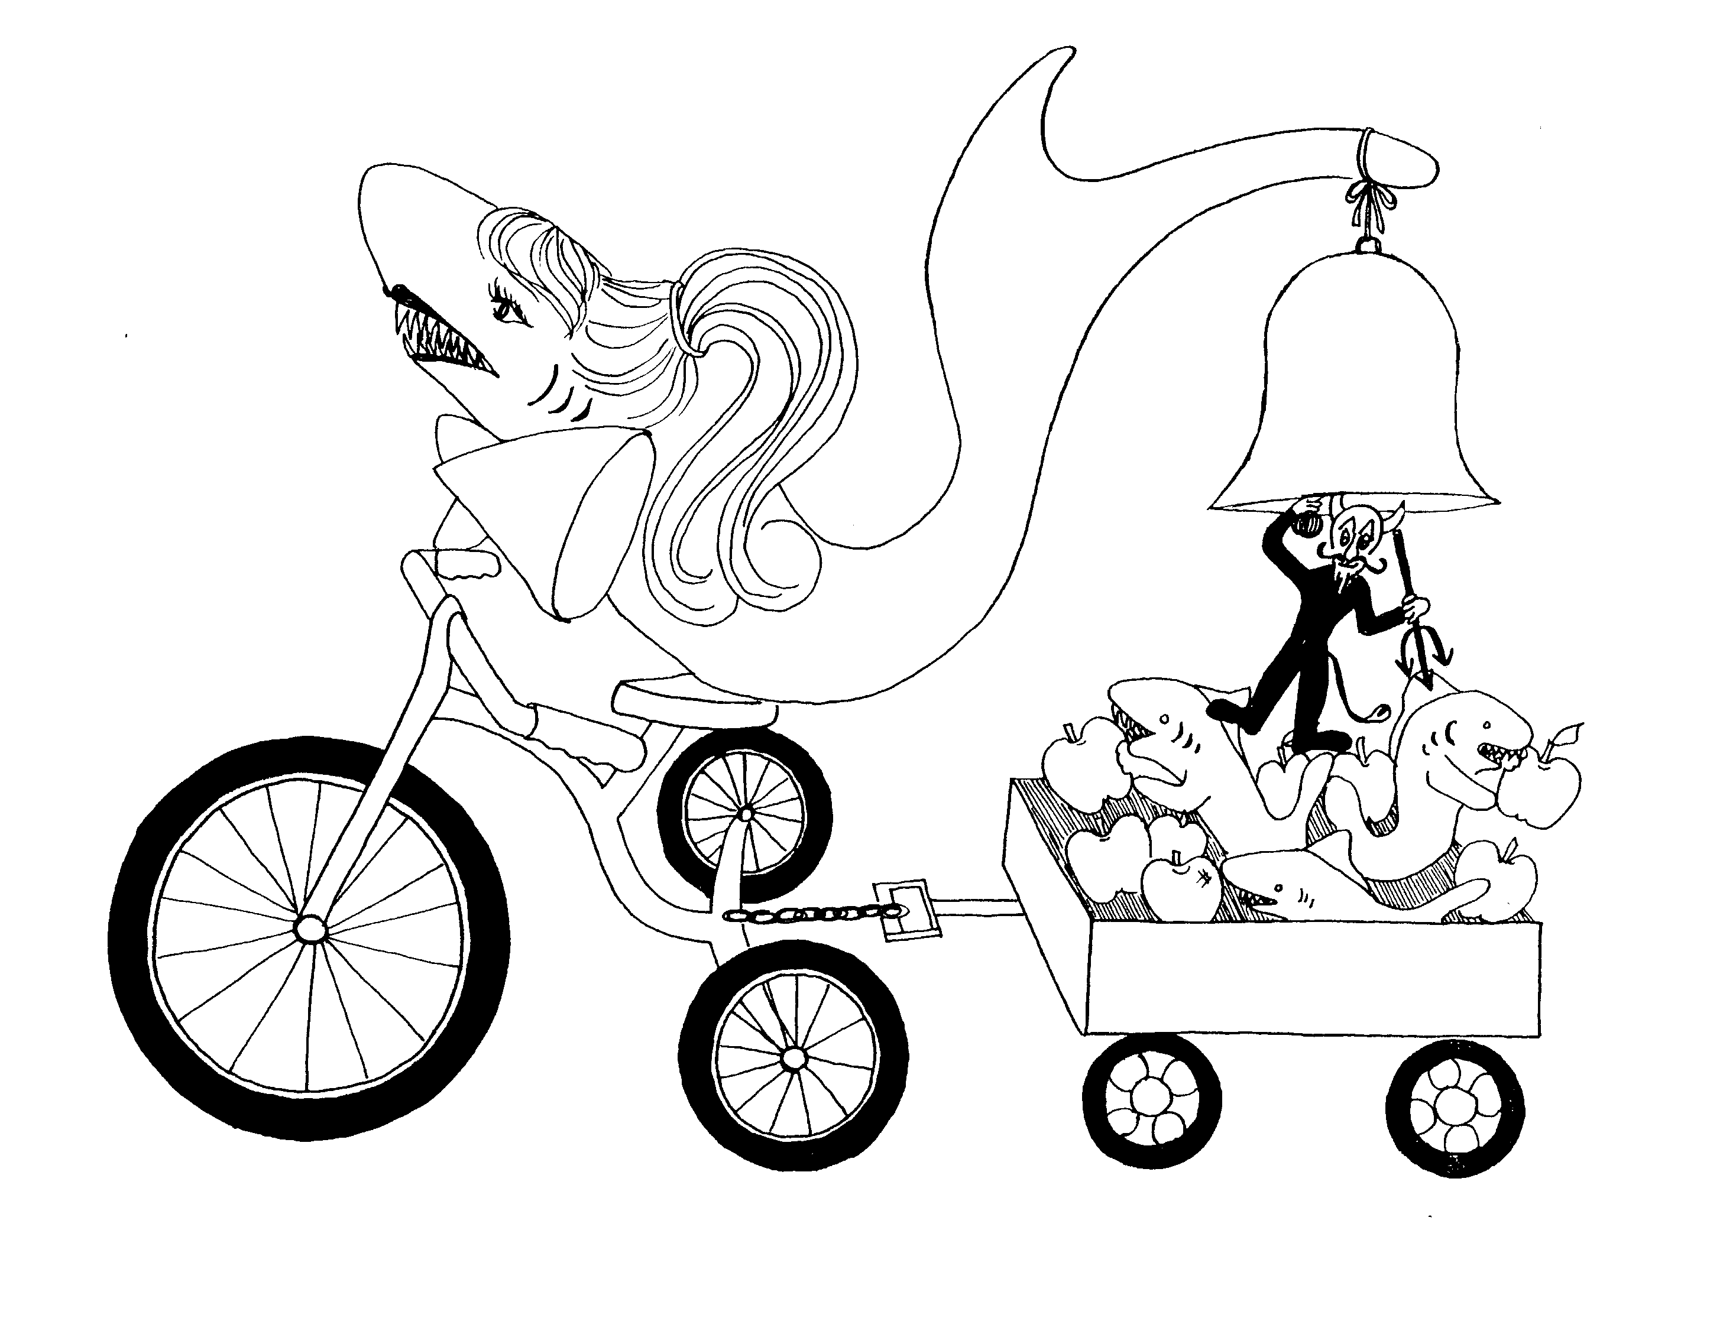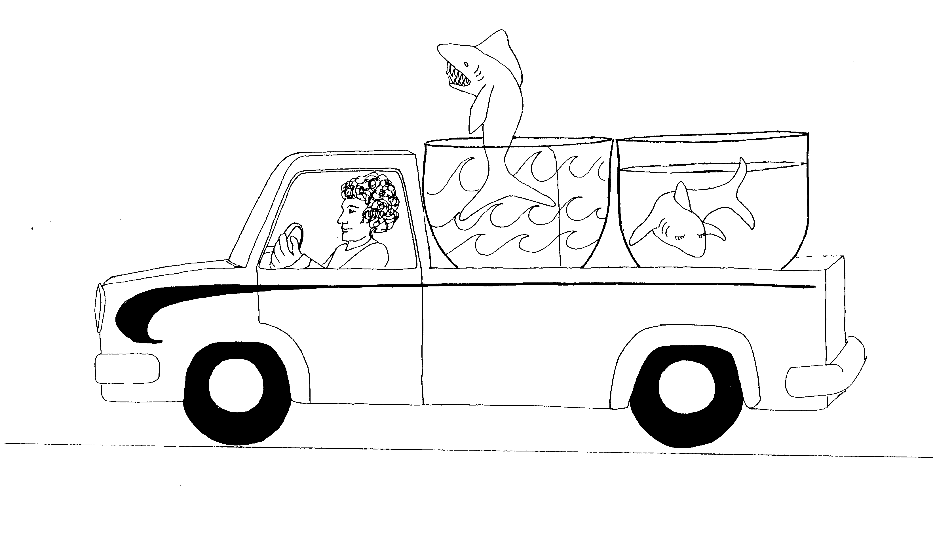

3. PARALYZED HAND, BEELZEBUB, 12 APOSTLES, 4. PARABLES OF THE KINGDOM, CALMS SEA
MY MOTHER AND BROTHERS
3 = Tricycle (three wheels) 4 = Car (4 wheels)

* PARALYZED HAND: shark with arm in sling * PARABLES OF THE KINGDOM: pair of bowls in truck

* BEELZEBUB: demon-like creature ringing bell * CALMS SEA: calm water in the back shark bowl

* 12 APOSTLES: 12 apples

* MY MOTHER AND BROTHERS: mom shark on
tricycle, brothers in the wagon

Mark 3 - 4
© 2003 Do not reproduce
Mark: The Astonishing Servant

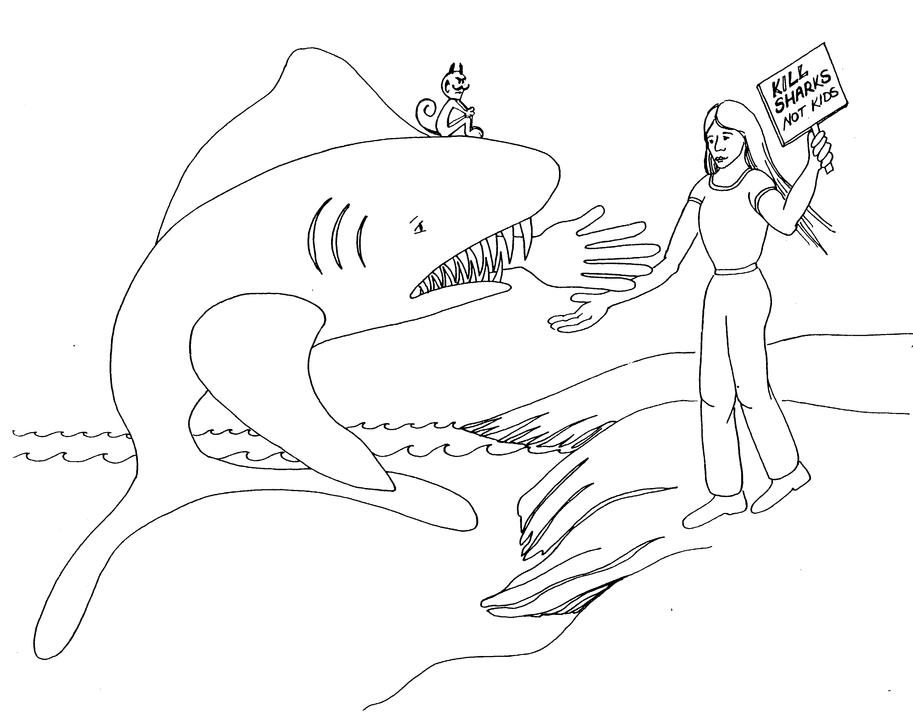 | 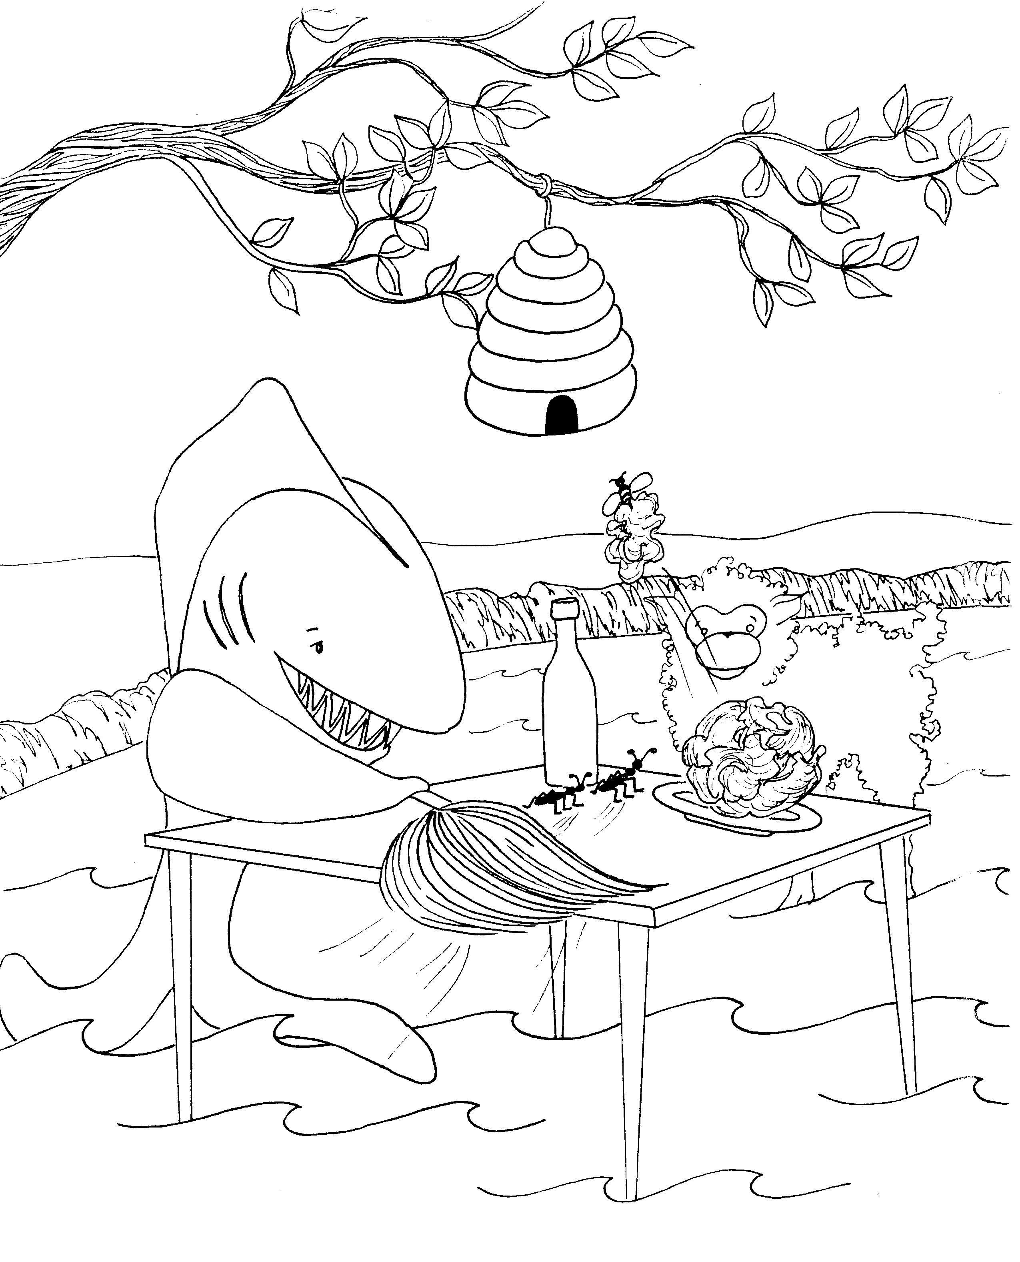
5. DEMONIAC, WOMAN WITH AN ISSUE,  JAIRUS' DAUGHTER  5 = Five fingers on hand (give me five)  * DEMONIAC: demon whispering to shark to eat her  * WOMAN WITH AN ISSUES: woman protesting because the shark ate her child  * JAIRUS' DAUTHER: is the woman's name | 6. HOMETOWN UNBELIEF, SENDS 12,  HEROD'S BANQUET, CHRIST'S BANQUET,  WALKS ON WATER  6 = Insects (6 legs on a bug - butterfly)  * HOMETOWN UNBELIEF: bee returning leaf to its home  hometown bee-leaf  * SENDS 12: 2 ants being sent across the table  (2 ants with 6 legs each)  * HEROD'S BANQUET: 'hay-rod' banquet, hay on a rod  * CHRIST'S BANQUET: lamb is Christ at the banquet (5,000)  * WALKS ON WATER: table on top of water
Mark 5 - 6
© 2003 Do not reproduce
Mark: The Astonishing Servant

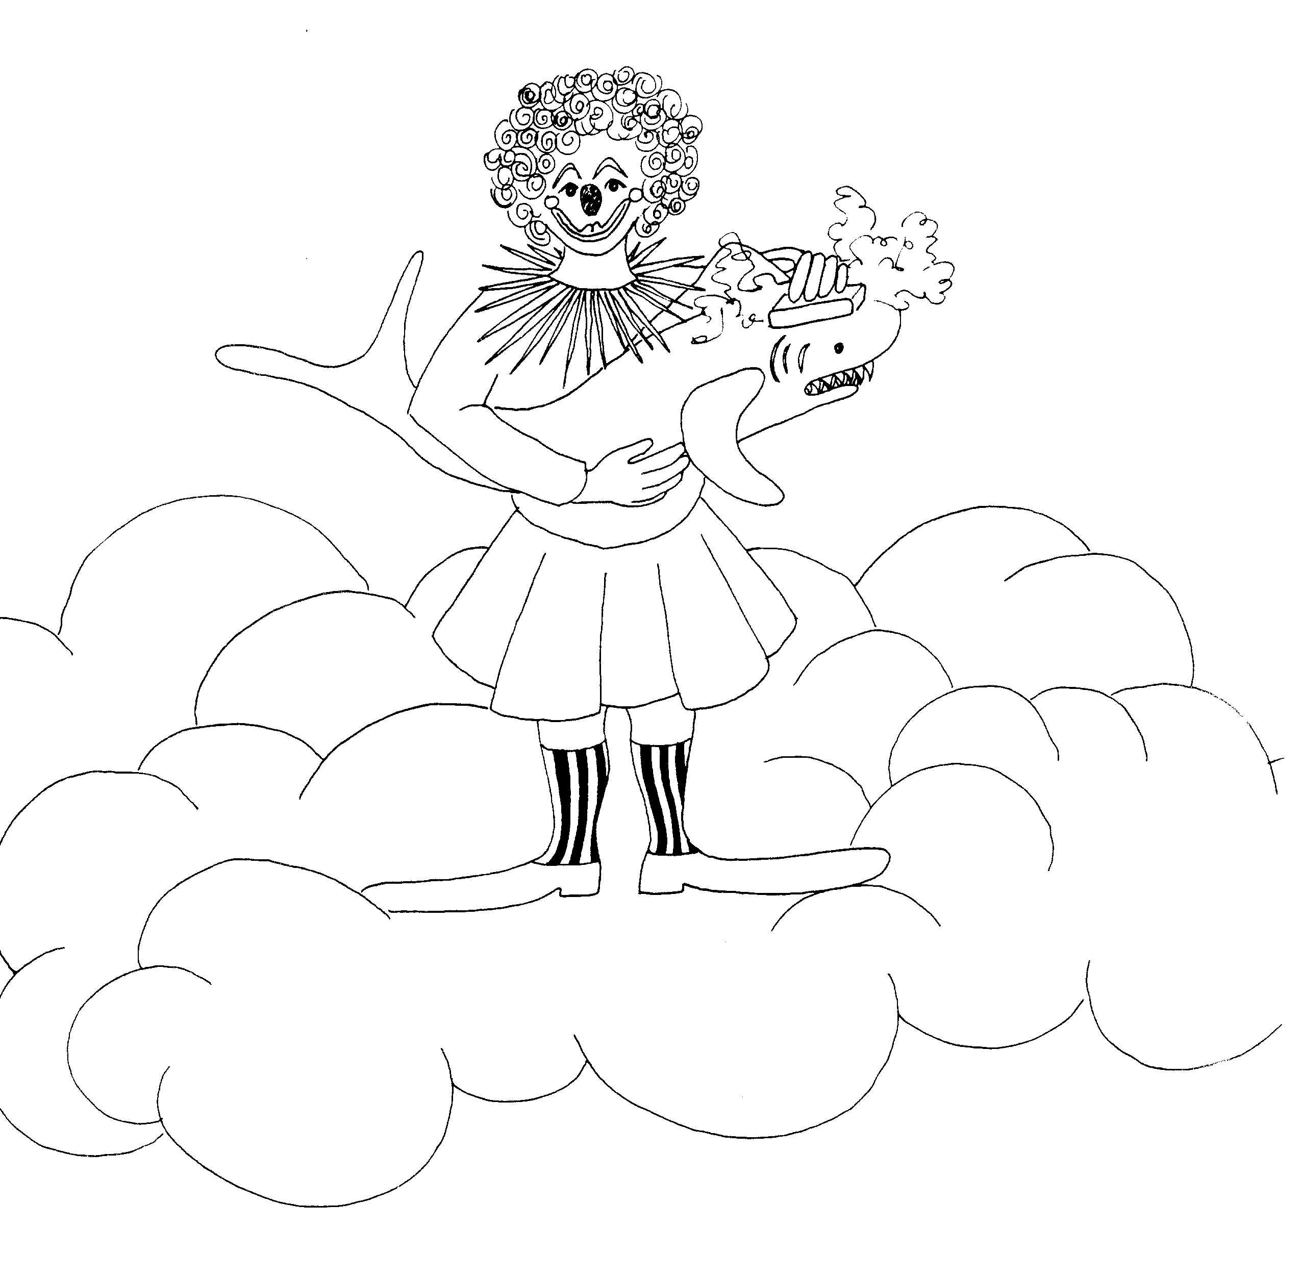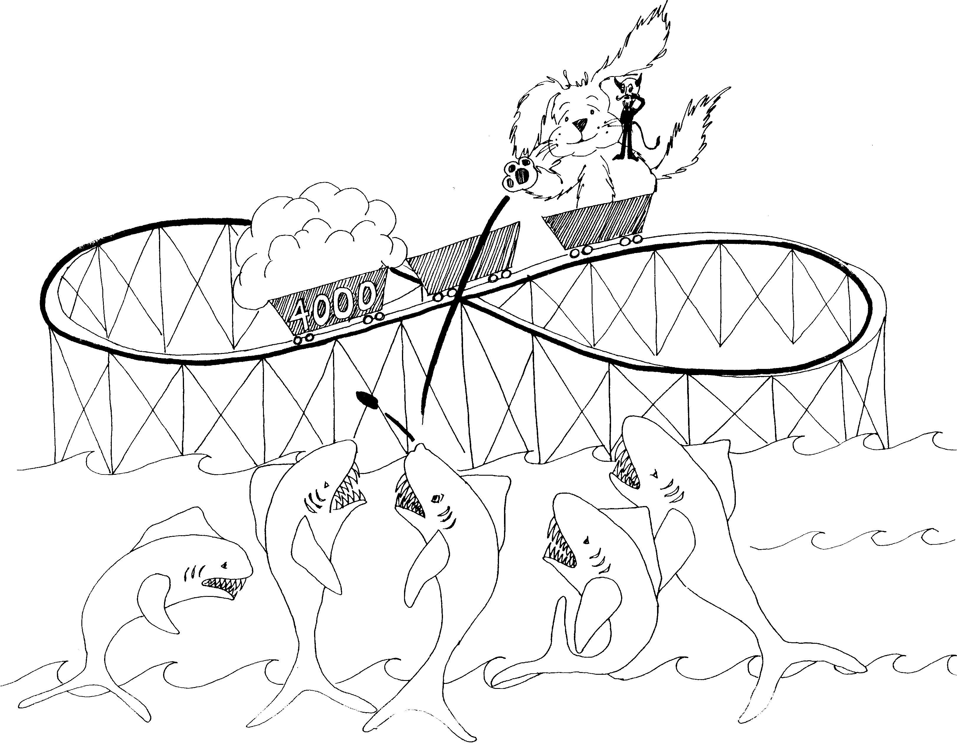

7. WASHINGS, CANAANITE WOMAN 8. 4,000, PHARISEES' YEAST, PETER-(ROCK)-SATAN

7 = Heaven (clouds) 8 = Roller coaster looks like an 8 sideways

* WASHINGS: washing her pet shark * 4,000: 4,000 pounds of dough in roller coaster car

* CANAANITE WOMAN: woman with candy cane * PHARISEES' YEAST: dough rising in car
stripped colored socks
* PETER-(ROCK)-SATAN: Satan telling Peter (dog) to
throw the rock at the sharks

Mark 7 - 8
© 2003 Do not reproduce
Mark: The Astonishing Servant

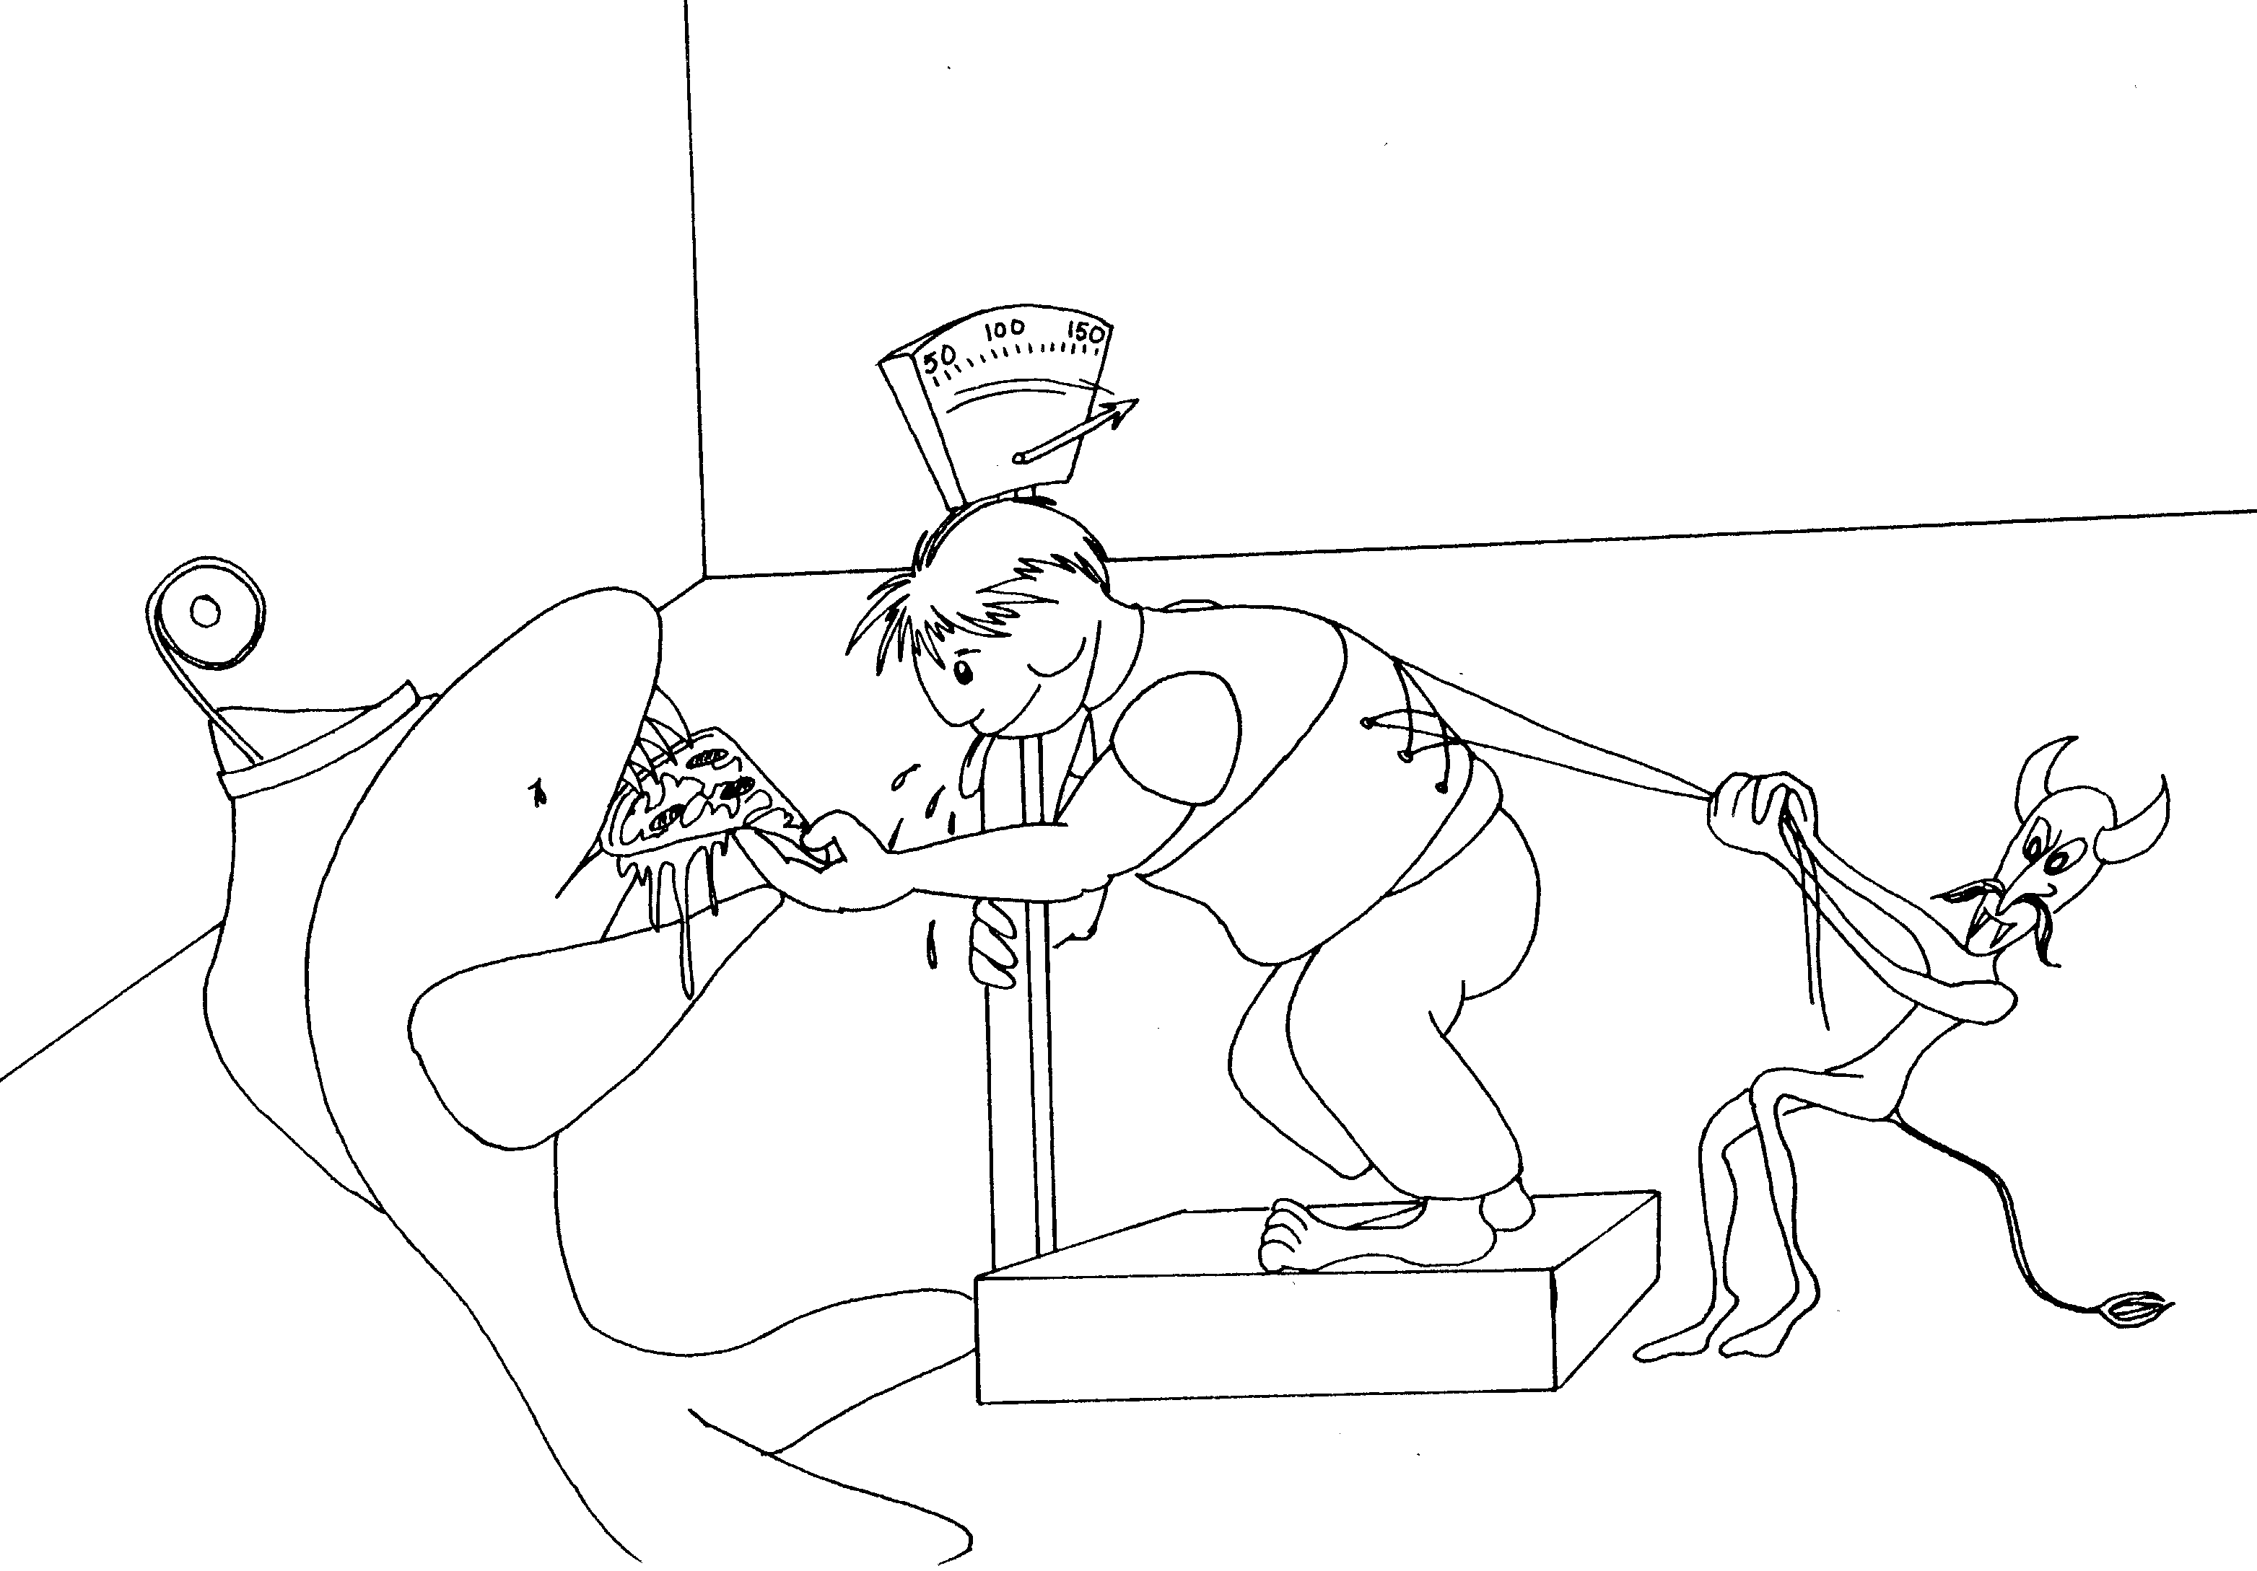 | 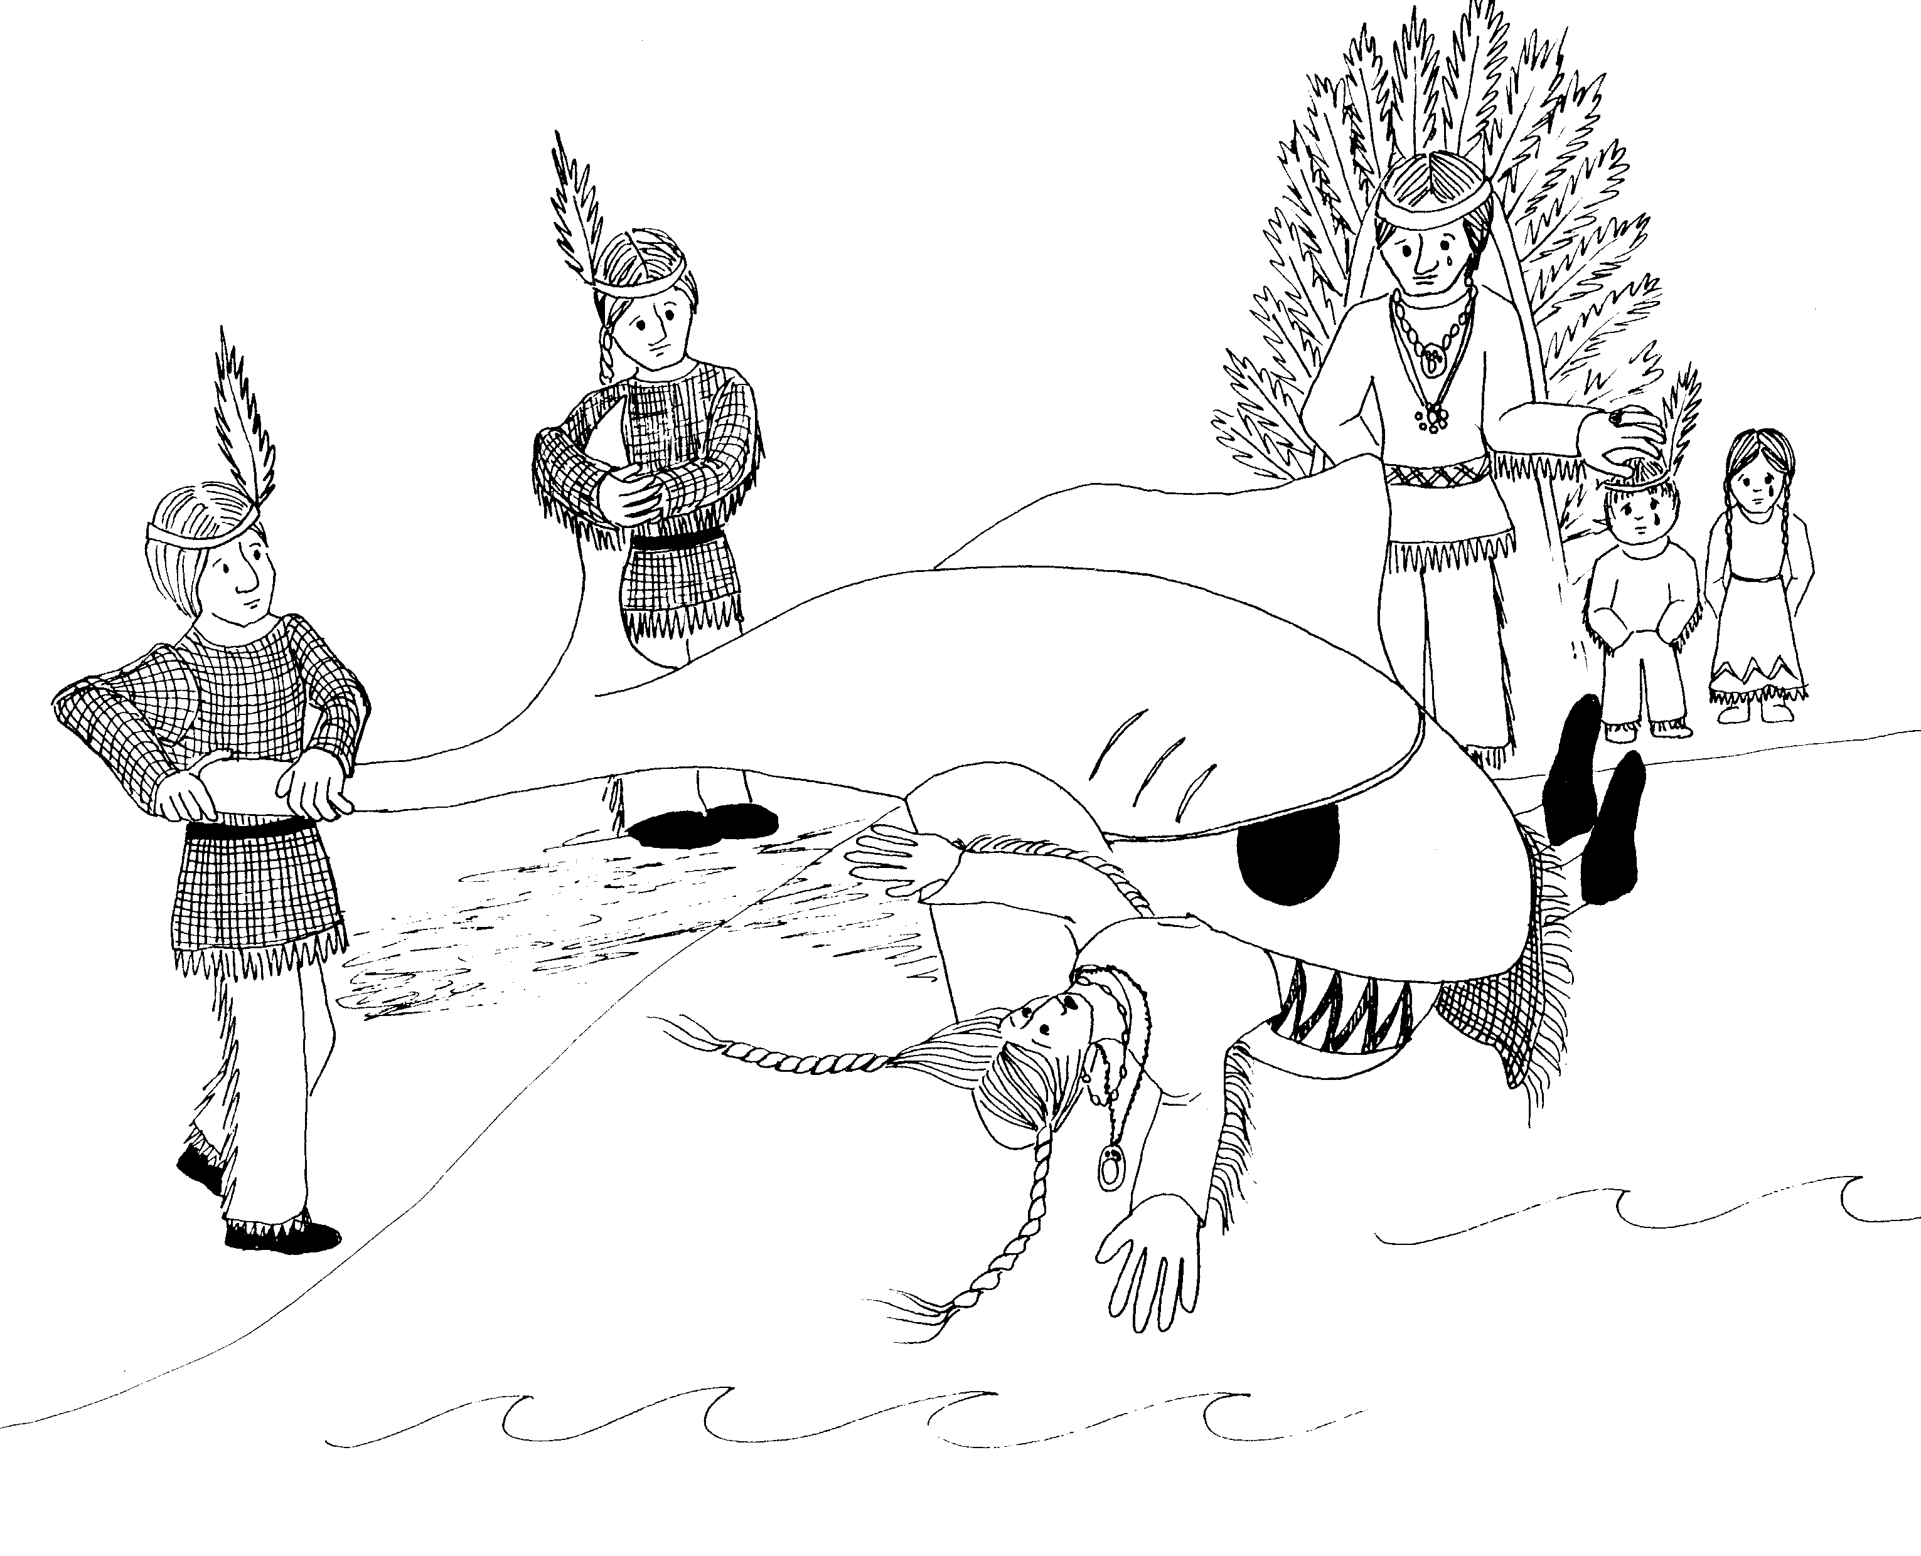
9. TRANSFIGURATION, HARD DEMON, CHILD IS  THE GREATEST, FOR AND AGAINST US  9 = Doctor's ophthalmoscope mirror  * TRANSFIGRUATION: transfiguration of overweight child by a girdle  * HARD DEMON: demon pulling girdle hard  * CHILD IS THE GREATEST: child is of largest  * FOR AND AGAINST US: shark against him giving  demon for him pulling him back | 10. DIVORCE, CHILDREN, RICH YOUNG RULER,  JAMES' AND JOHN'S REQUEST, BLIND MAN  10 = 10 little Indians  * DIVORCE: shark chops wife in two -- divided  * CHILDREN: Indian children crying over mother  * RICH YOUNG RULER: young Indian chief husband  * JAMES' AND JOHN'S REQUEST: 2 Indians hanging on  left and right side of the tail him pizza,  * BLIND MAN: shark's patched blind eye
Mark 9 - 10
© 2003 Do not reproduce
Mark: The Astonishing Servant

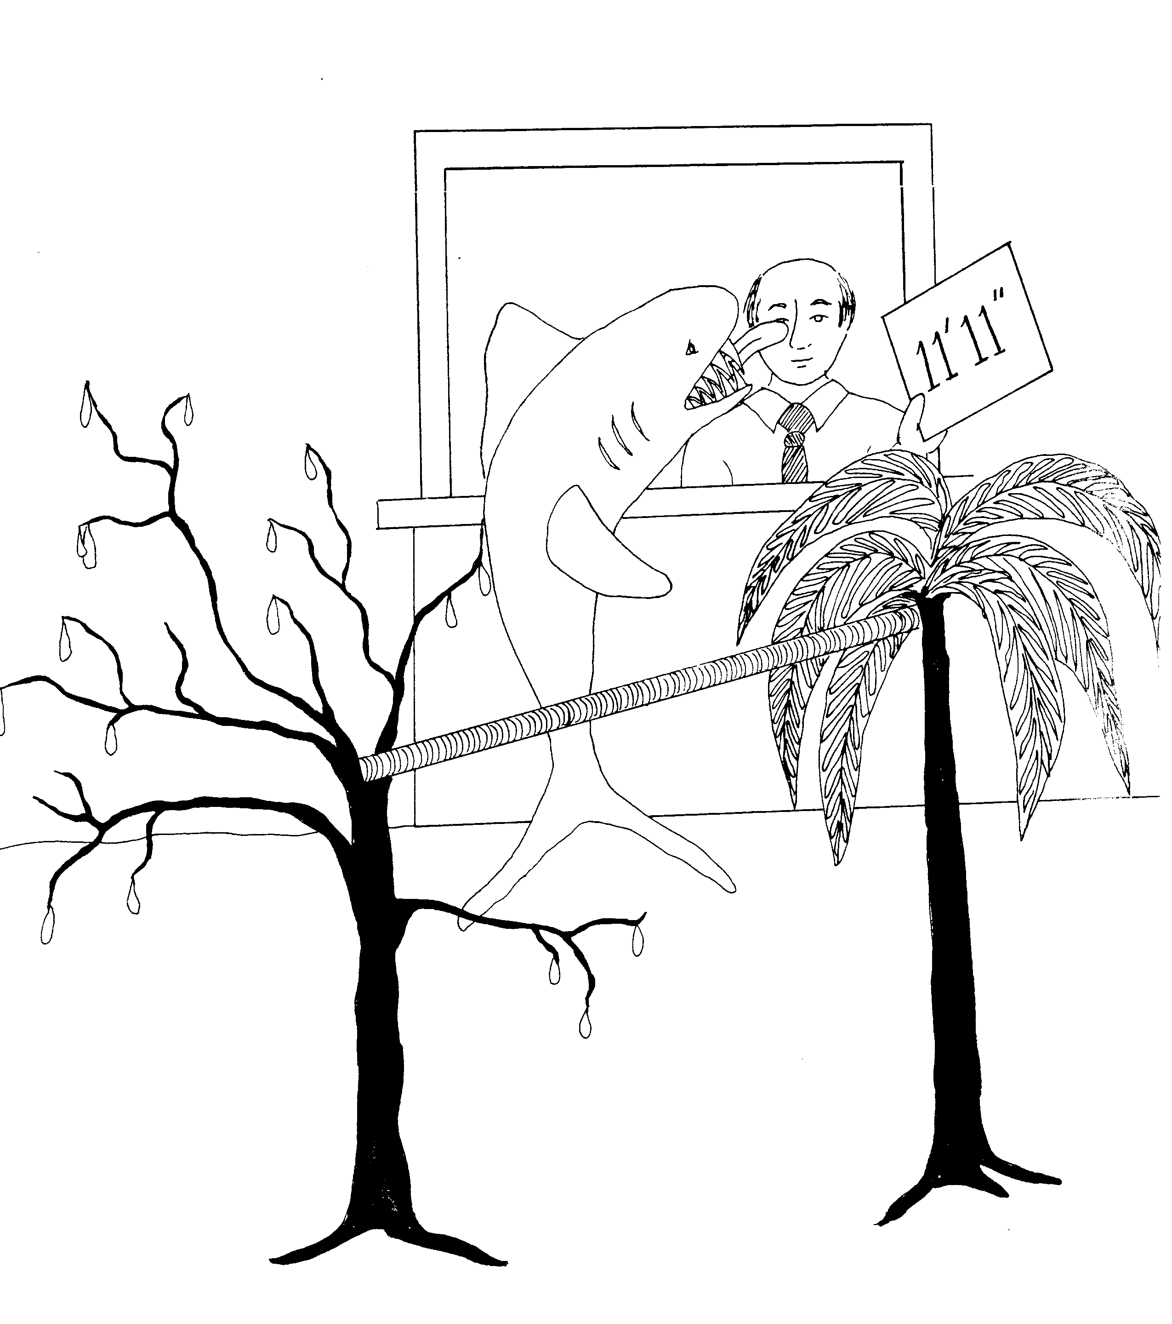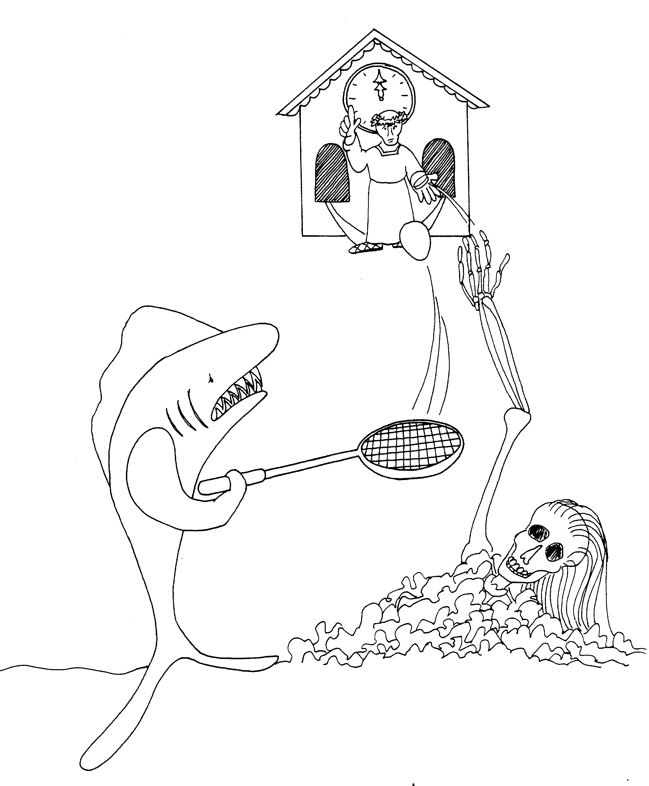

11. PALM SUNDAY, TEMPLE CLEANSING, 12. WICKED TENANTS, TRIBUTE? RESURRECTION?
FIG, BY WHAT AUTHORITY? GREATEST COMMAND, WIDOW'S PENNY

11 = Pole-vault bars which look like an 11 12 = 12 o'clock (clock = 12)

* PALM SUNDAY: palm tree on Sunday * WICKED TENANTS: wicked tennis player
* TRIBUTE?: Resurrecting woman paying Caesar's tax
* TEMPLE CLEANSING: shark licking temple of the * RESURRECTION? Woman (widow) coming up from grave
judge to pay Caesar's tax
* FIG: fig tree * GREATEST COMMAND: Caesar making a great command
* WIDOW'S PENNY: penny in widow's hand
* BY WHAT AUTHORITY? judge of the contest is the
authority
Mark 11 - 12
© 2003 Do not reproduce
Mark: The Astonishing Servant

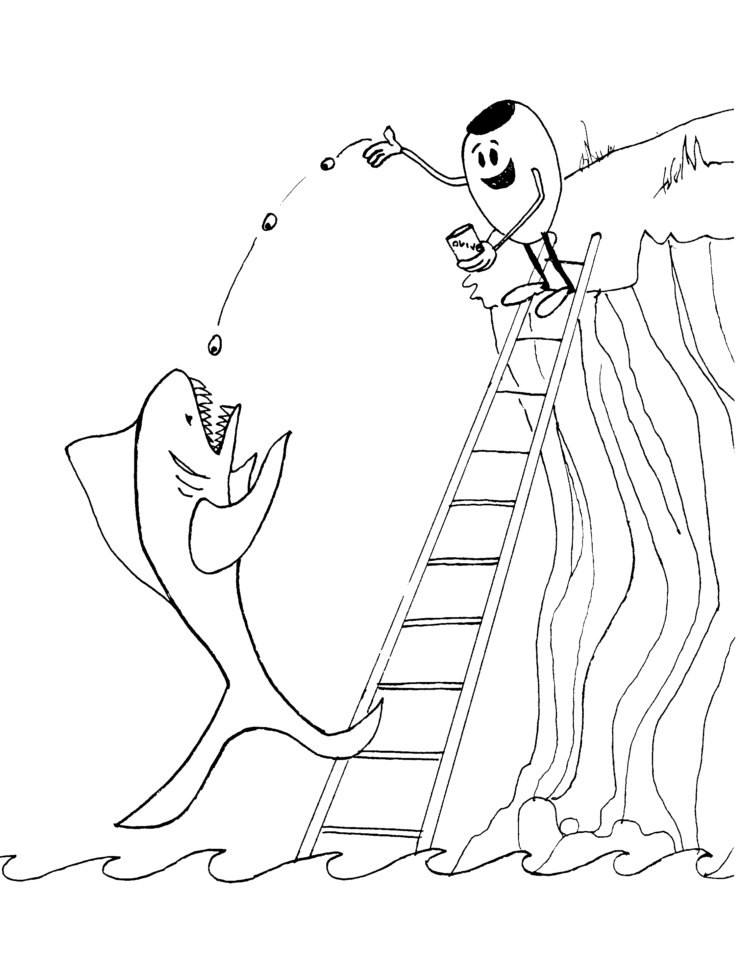 | 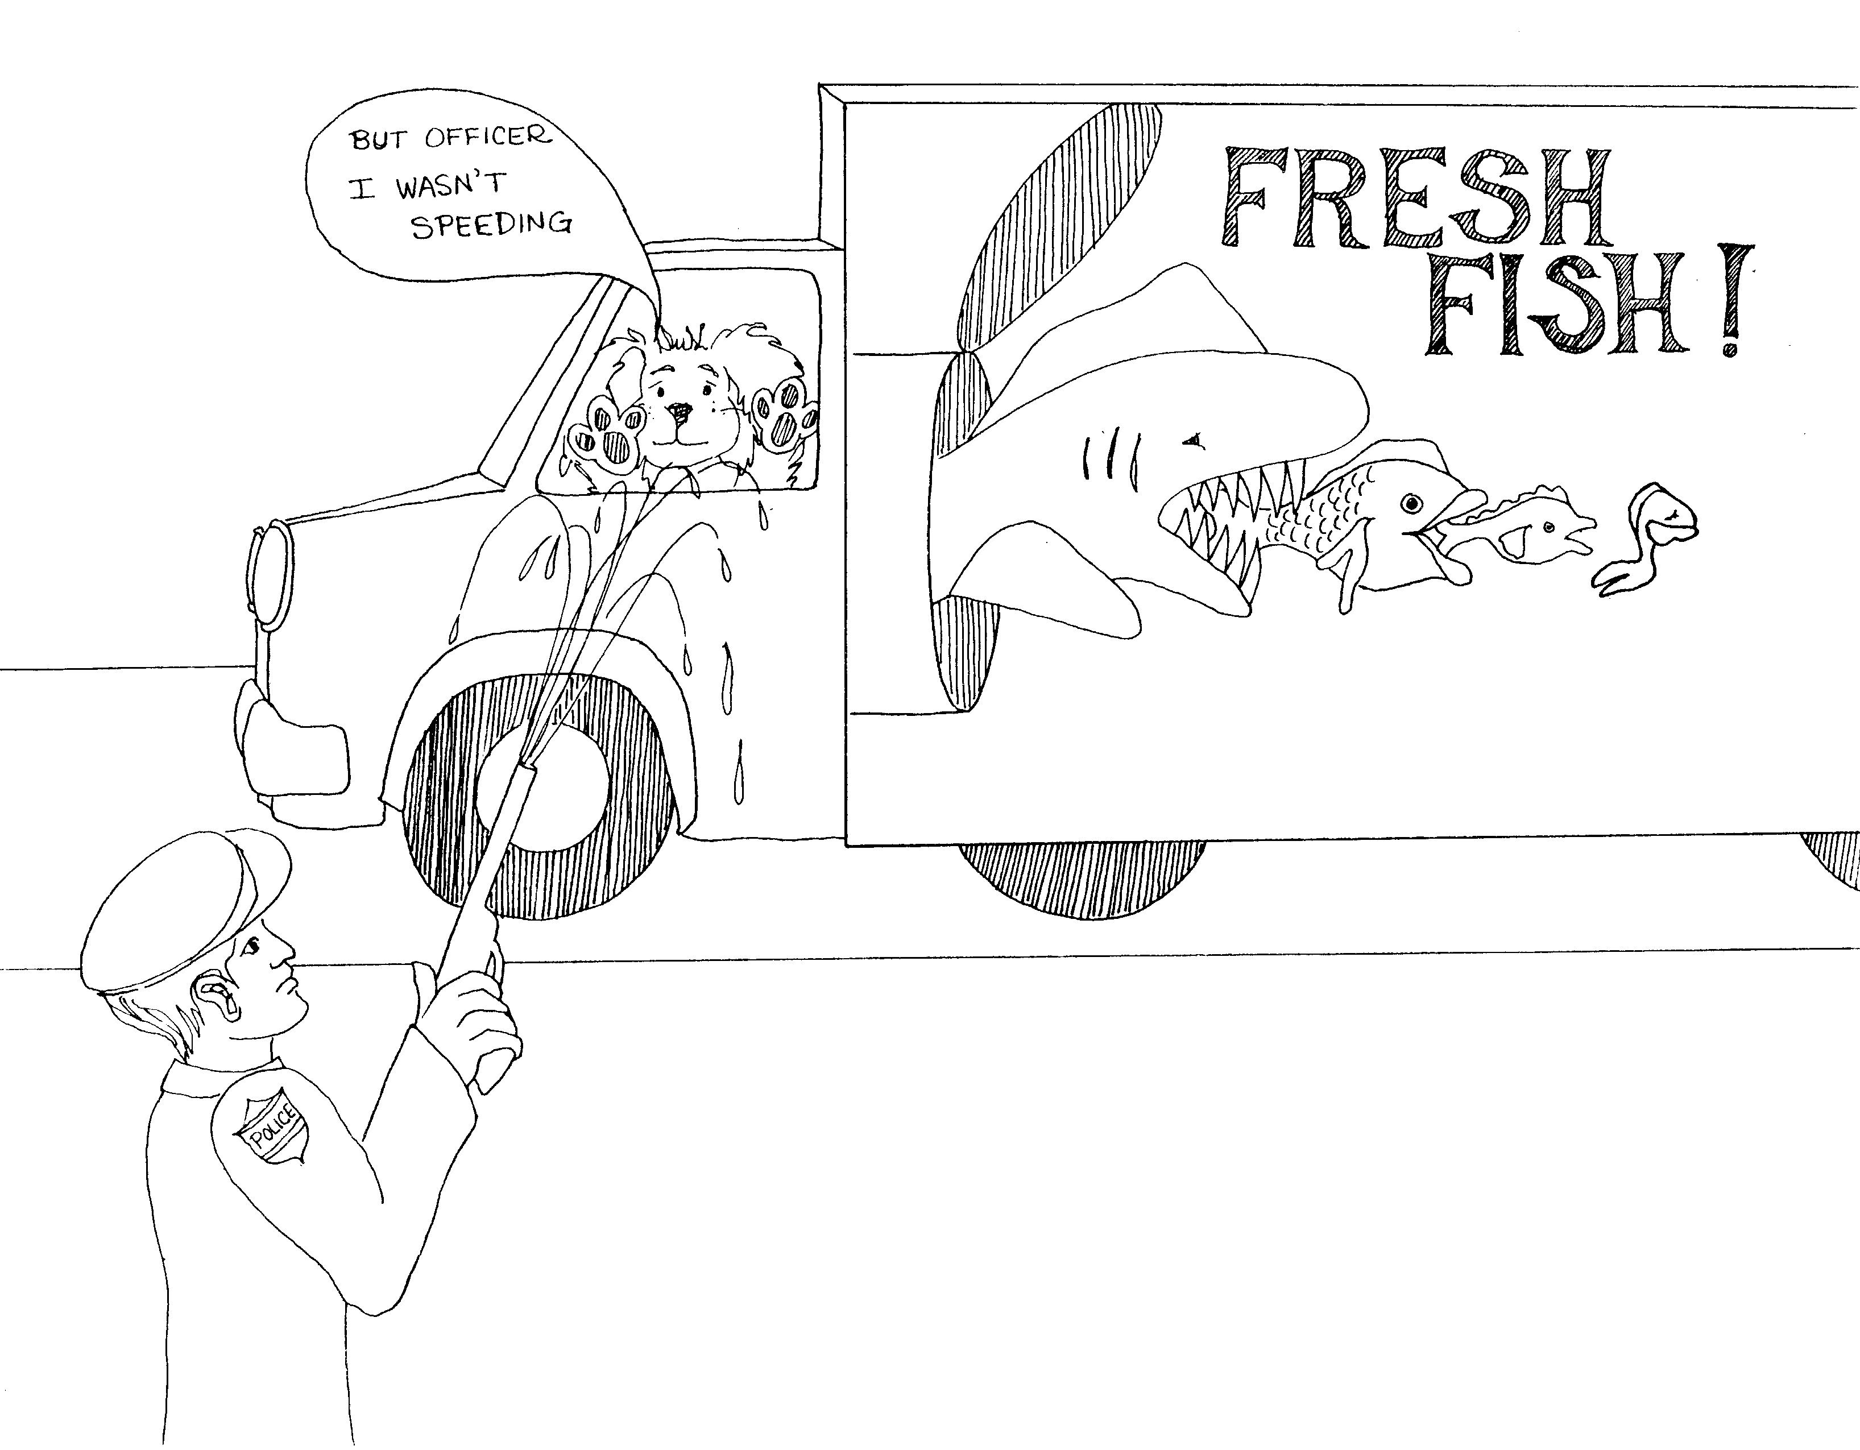
13. OLIVET DISCOURSE ON END TIMES  13 = Ladder (13 unlucky like walking under a ladder)  * OLIVET DISCOURSE ON END TIMES:  Olive on ladder throwing olives to the shark | - ANOINTED, LAST SUPPER, GETHSEMANE,  ARREST AND TRIAL, PETER'S DENIAL  14 = Semi-truck, 10-4 CB trucker talk  * ANOINTED: Peter 'anointed' with squirt gun  * LAST SUPPER: each fish eating last supper  * GETHSEMANE: last fish praying before death  * ARREST AND TRIAL: officer arresting  * PETER'S DENIAL: Peter (dog) denying he did it
Mark 13 - 14
© 2003 Do not reproduce
Mark: The Astonishing Servant

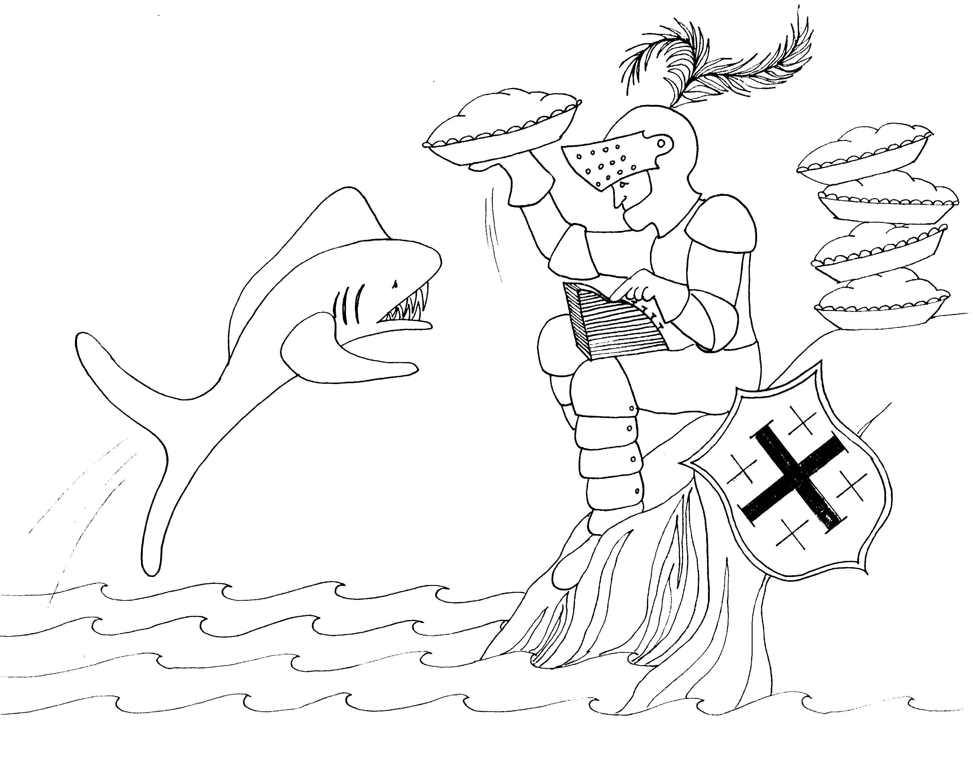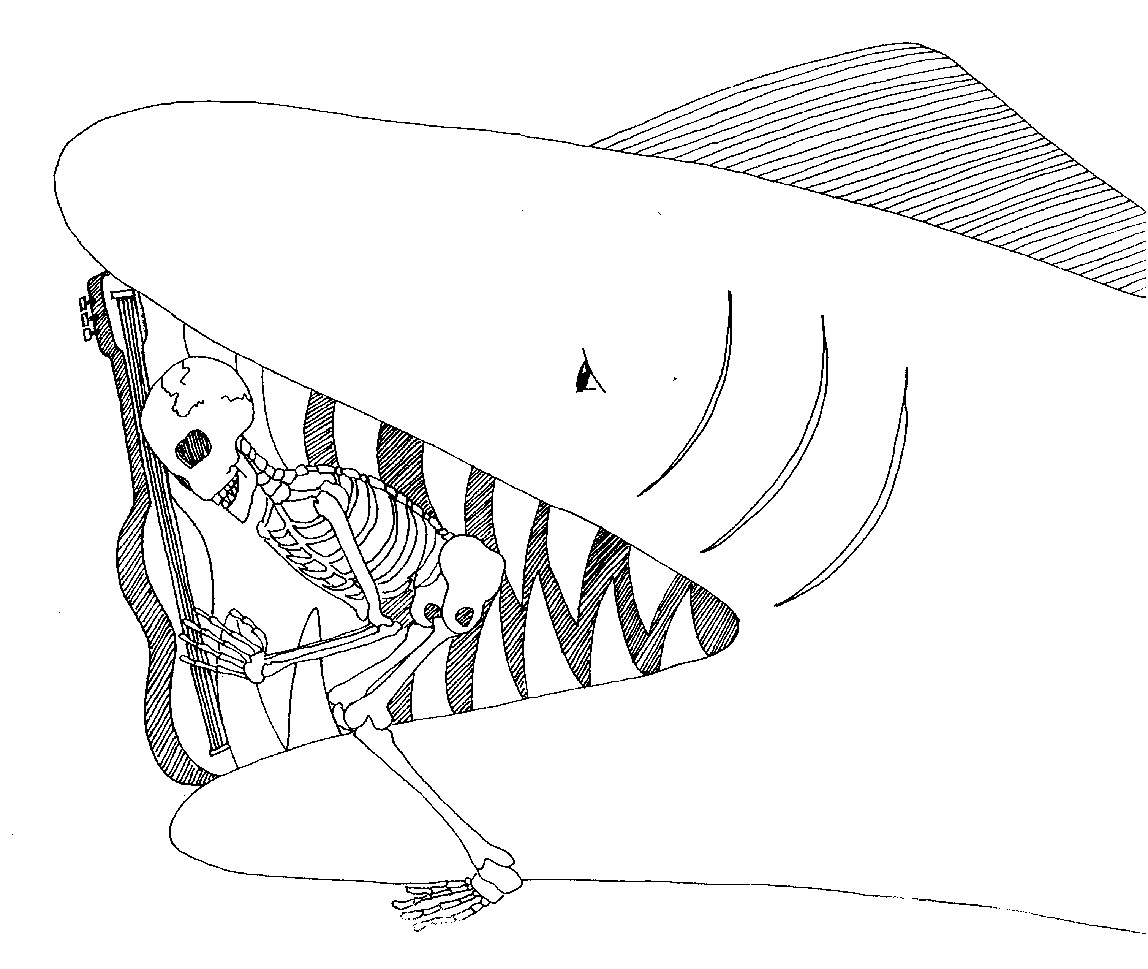

15. PILATE, SOLDIERS, CRUCIFIXION, 16. RESURRECTION, MIRACLES
JOSEPH OF ARIMATHEA

15 = Rhymes with "lifting" 16 = Six strings (on guitar)

* PILATE: pie - let * RESURRECTION: skeleton coming out from jaws of death

* SOLDIERS: soldier in armor so he doesn't get bitten * MIRACLES: miracle that the guitar holds the shark's mouth
open
* CRUCIFIXION: cross on the crusader's shield

* JOSEPH OF ARIMATHEA: "Joe Arithmetic" adding
machine counting pies

Mark 15 - 16
© 2003 Do not reproduce

