JOHN: CHRIST THE SON OF GOD

CHRIST & INDIVIDUALS 1-4

1. Word, John the Baptist, Disciples

2. Cana, Money changers, Destroy this temple

3. Nicodemus, John the Baptist about Jesus

4. Woman of Samaria, Noble's sick son

CHRIST & MULTITUDES 5-11

5. Bethesda, Healing on Sabbath, Father-son

6. 5,000, Walks on water, Bread of life

7. Jerusalem feast secretly, Living water

8. Adulterous woman, 2 witnesses: Father-son,
Abraham's sons, Satan's sons

9. Muddy blind man, Pharisees

10. Door and good shepherd, Father-son

11. Lazarus, Caiaphas' prediction

12. Mary anoints Jesus, Palm Sunday

CHRIST & THE DISCIPLES 13-17

13. Washing feet, Passover, Predicts betrayal

14. Father's house, Seeing the father, Comforter

15. The vine, Christ's commandment, In the world

16. Comforter's work, Asking

17. Christ's prayer

18. Betrayal, Peter and sword, Annas,
Peter's denial, Caiaphas, Pilate

19. Behold the man, Crucifixion, Garments,
Joseph of Arimathea

20. Mary Magdalene and the "Gardener," Doubting Thomas

21. Fishing in Galilee, Peter's love

Key verses: 1:1-3, 12, 14; 3:16, 19, 36;
4:24; 5:24; 11:25, 26; 13:34, 35; 14:1-6, 26;
15:7, 26; 16:13; 20:31; 21:25

John: Christ the son of God

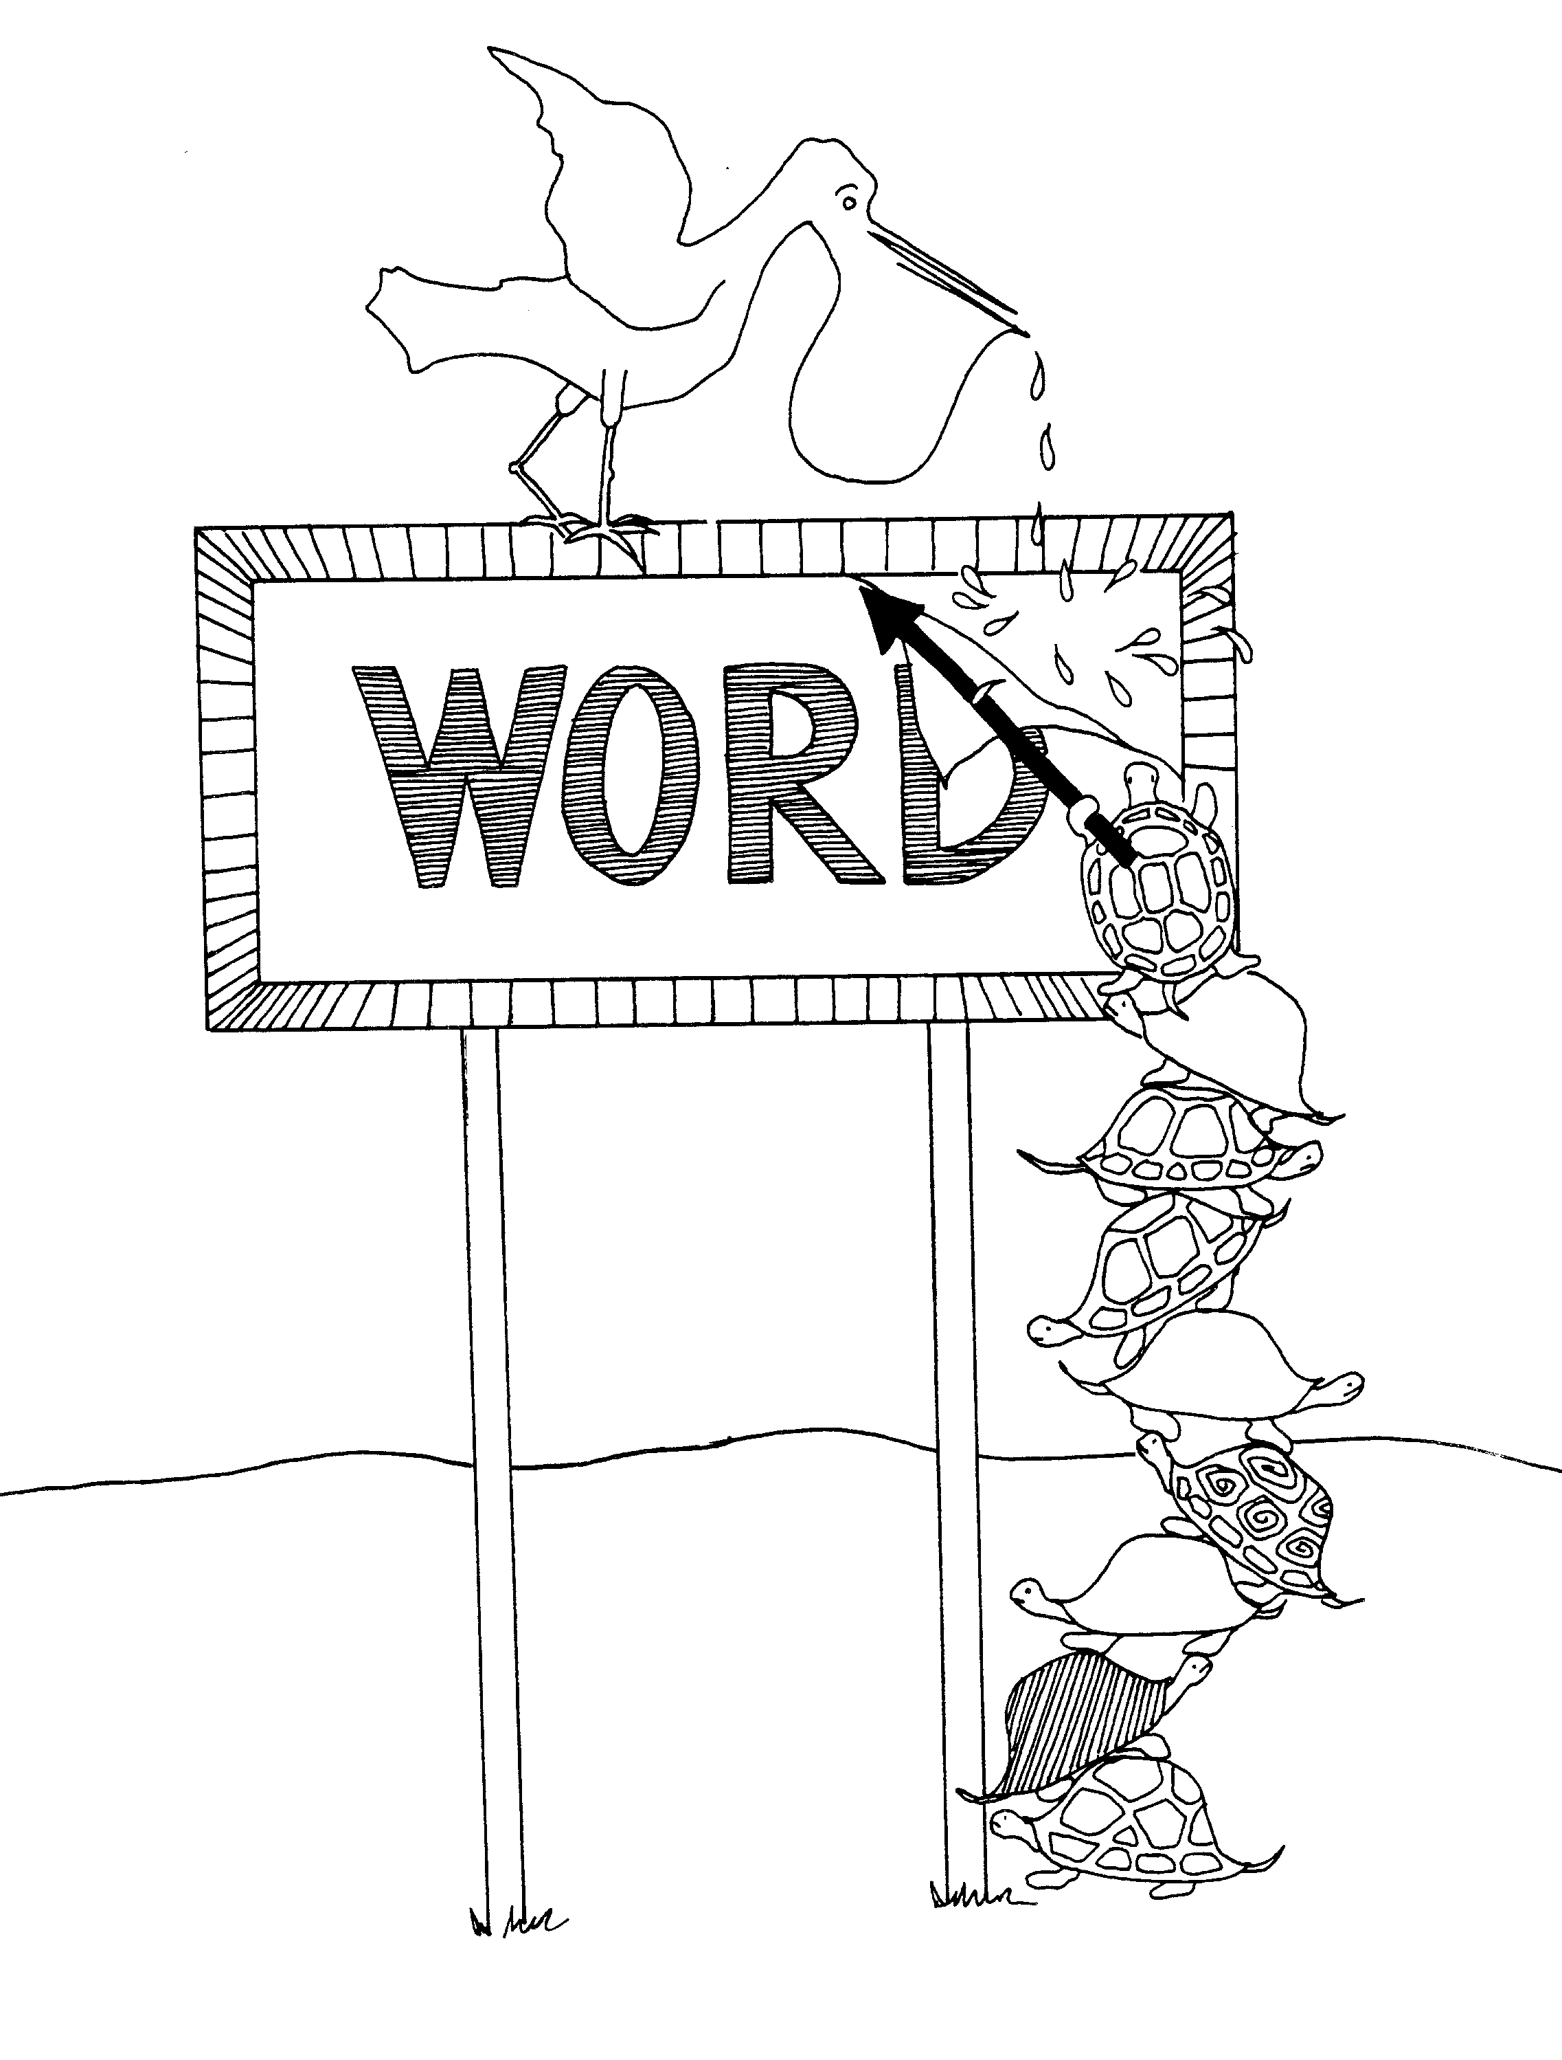 | 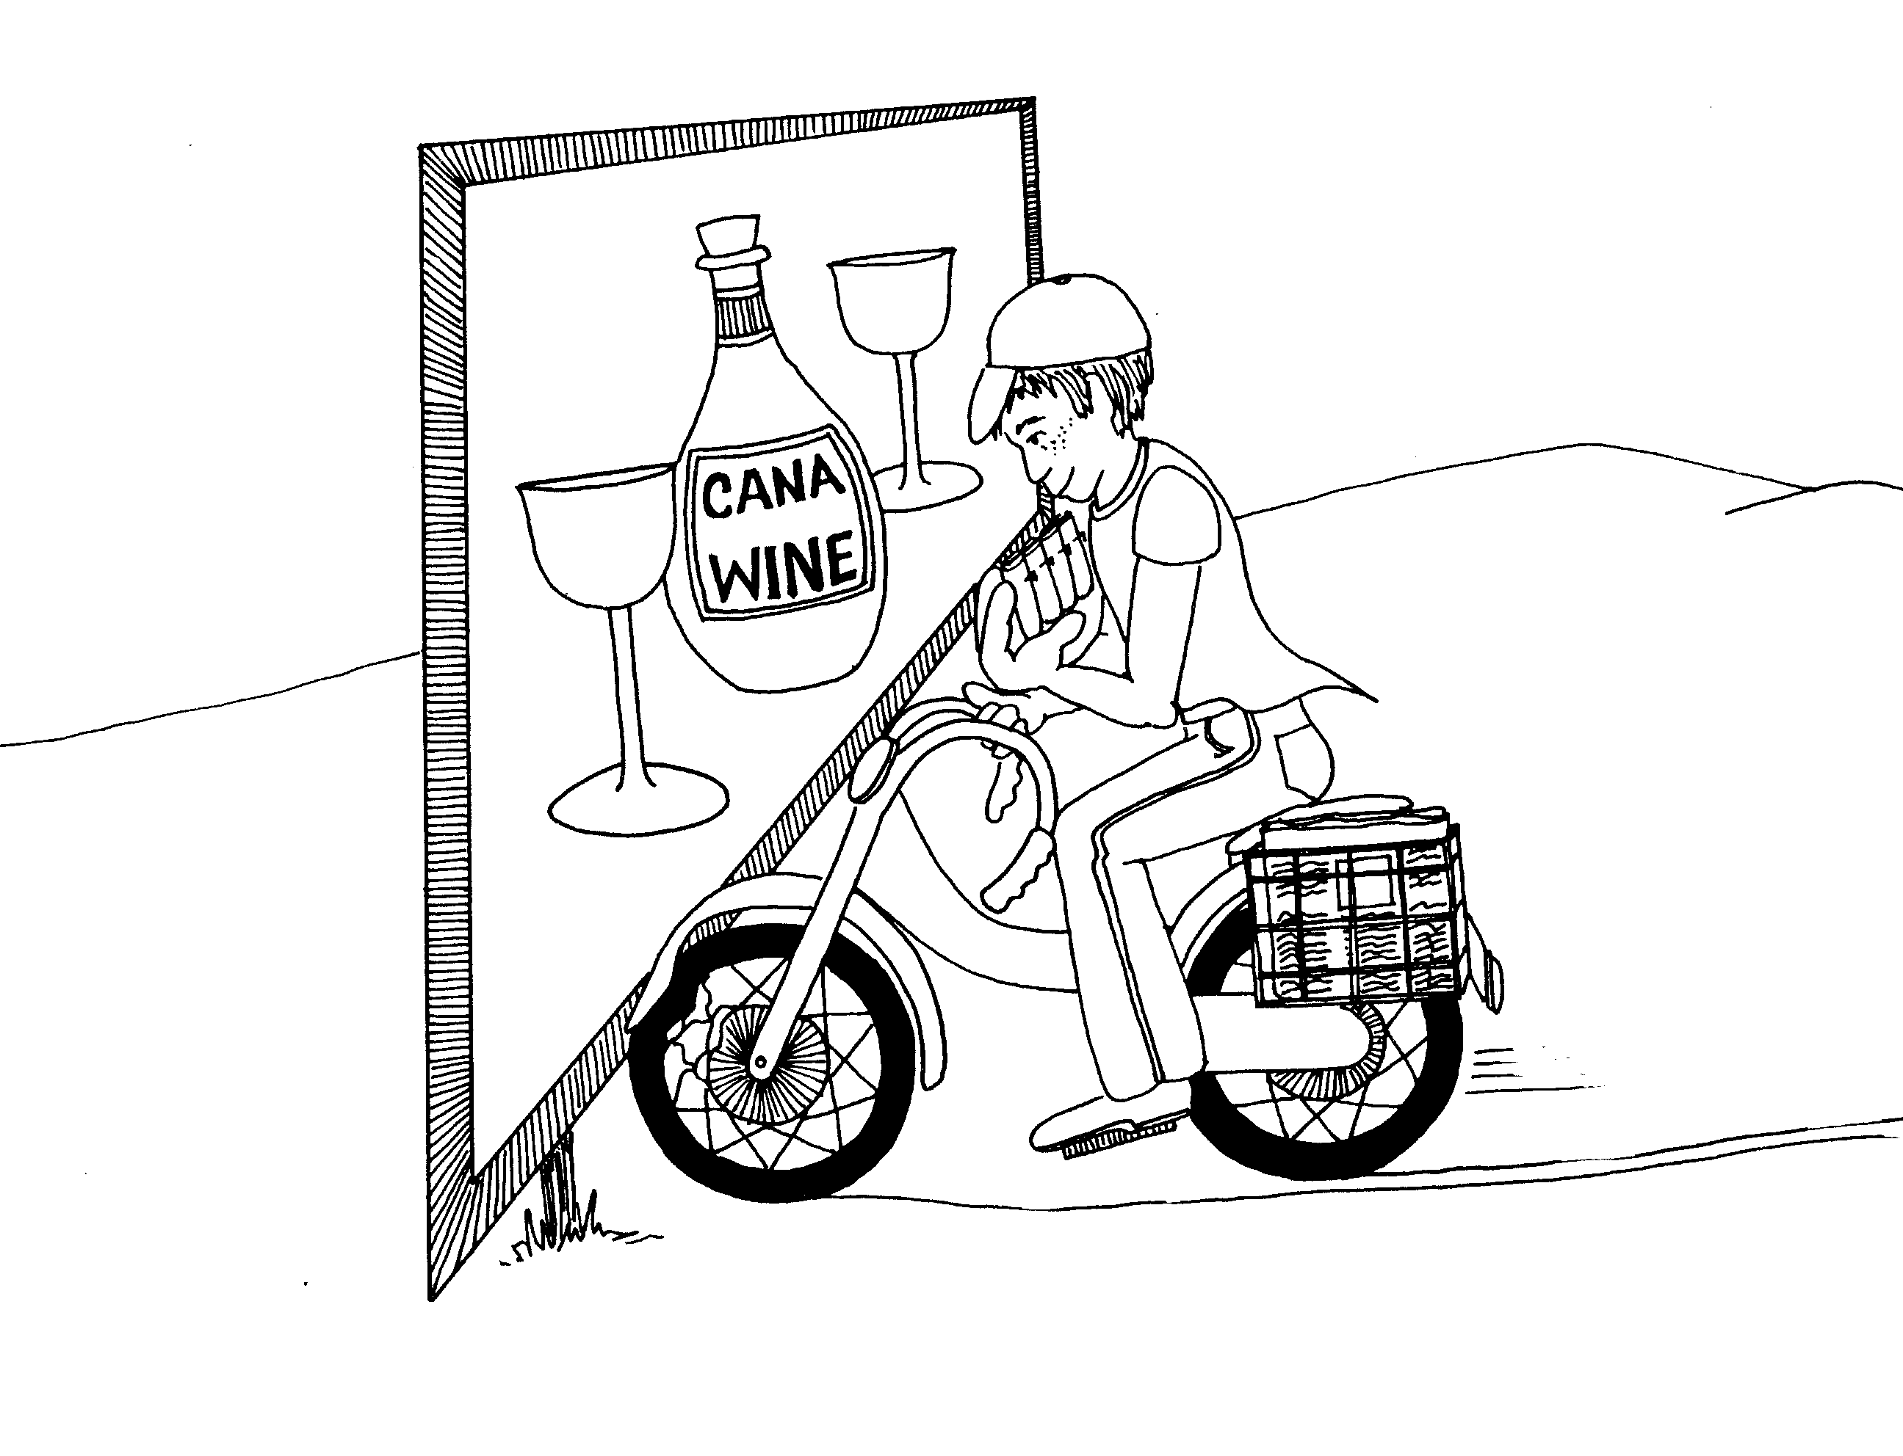
JOHN = BILLBOARD (sign witnesses in John)  1. WORD, JOHN THE BAPTIST, DISCIPLES  1 = Arrow  * WORD: is being plastered on the billboard  * JOHN THE BAPTIST: the Pelican is John because  he has a baptistery in his beak | 2. CANA, MONEY CHANGERS,  DESTROY THIS TEMPLE  2 = Bicycle (2 wheels)  * CANA: water to wine, advertising wine from Cana  * MONEY CHANGERS: paper boy doing money changing  * DESTROY THIS TEMPLE: boy not watching wrecks  his bike
John 1 - 2
© 2003 Do not reproduce
John: Christ the son of God

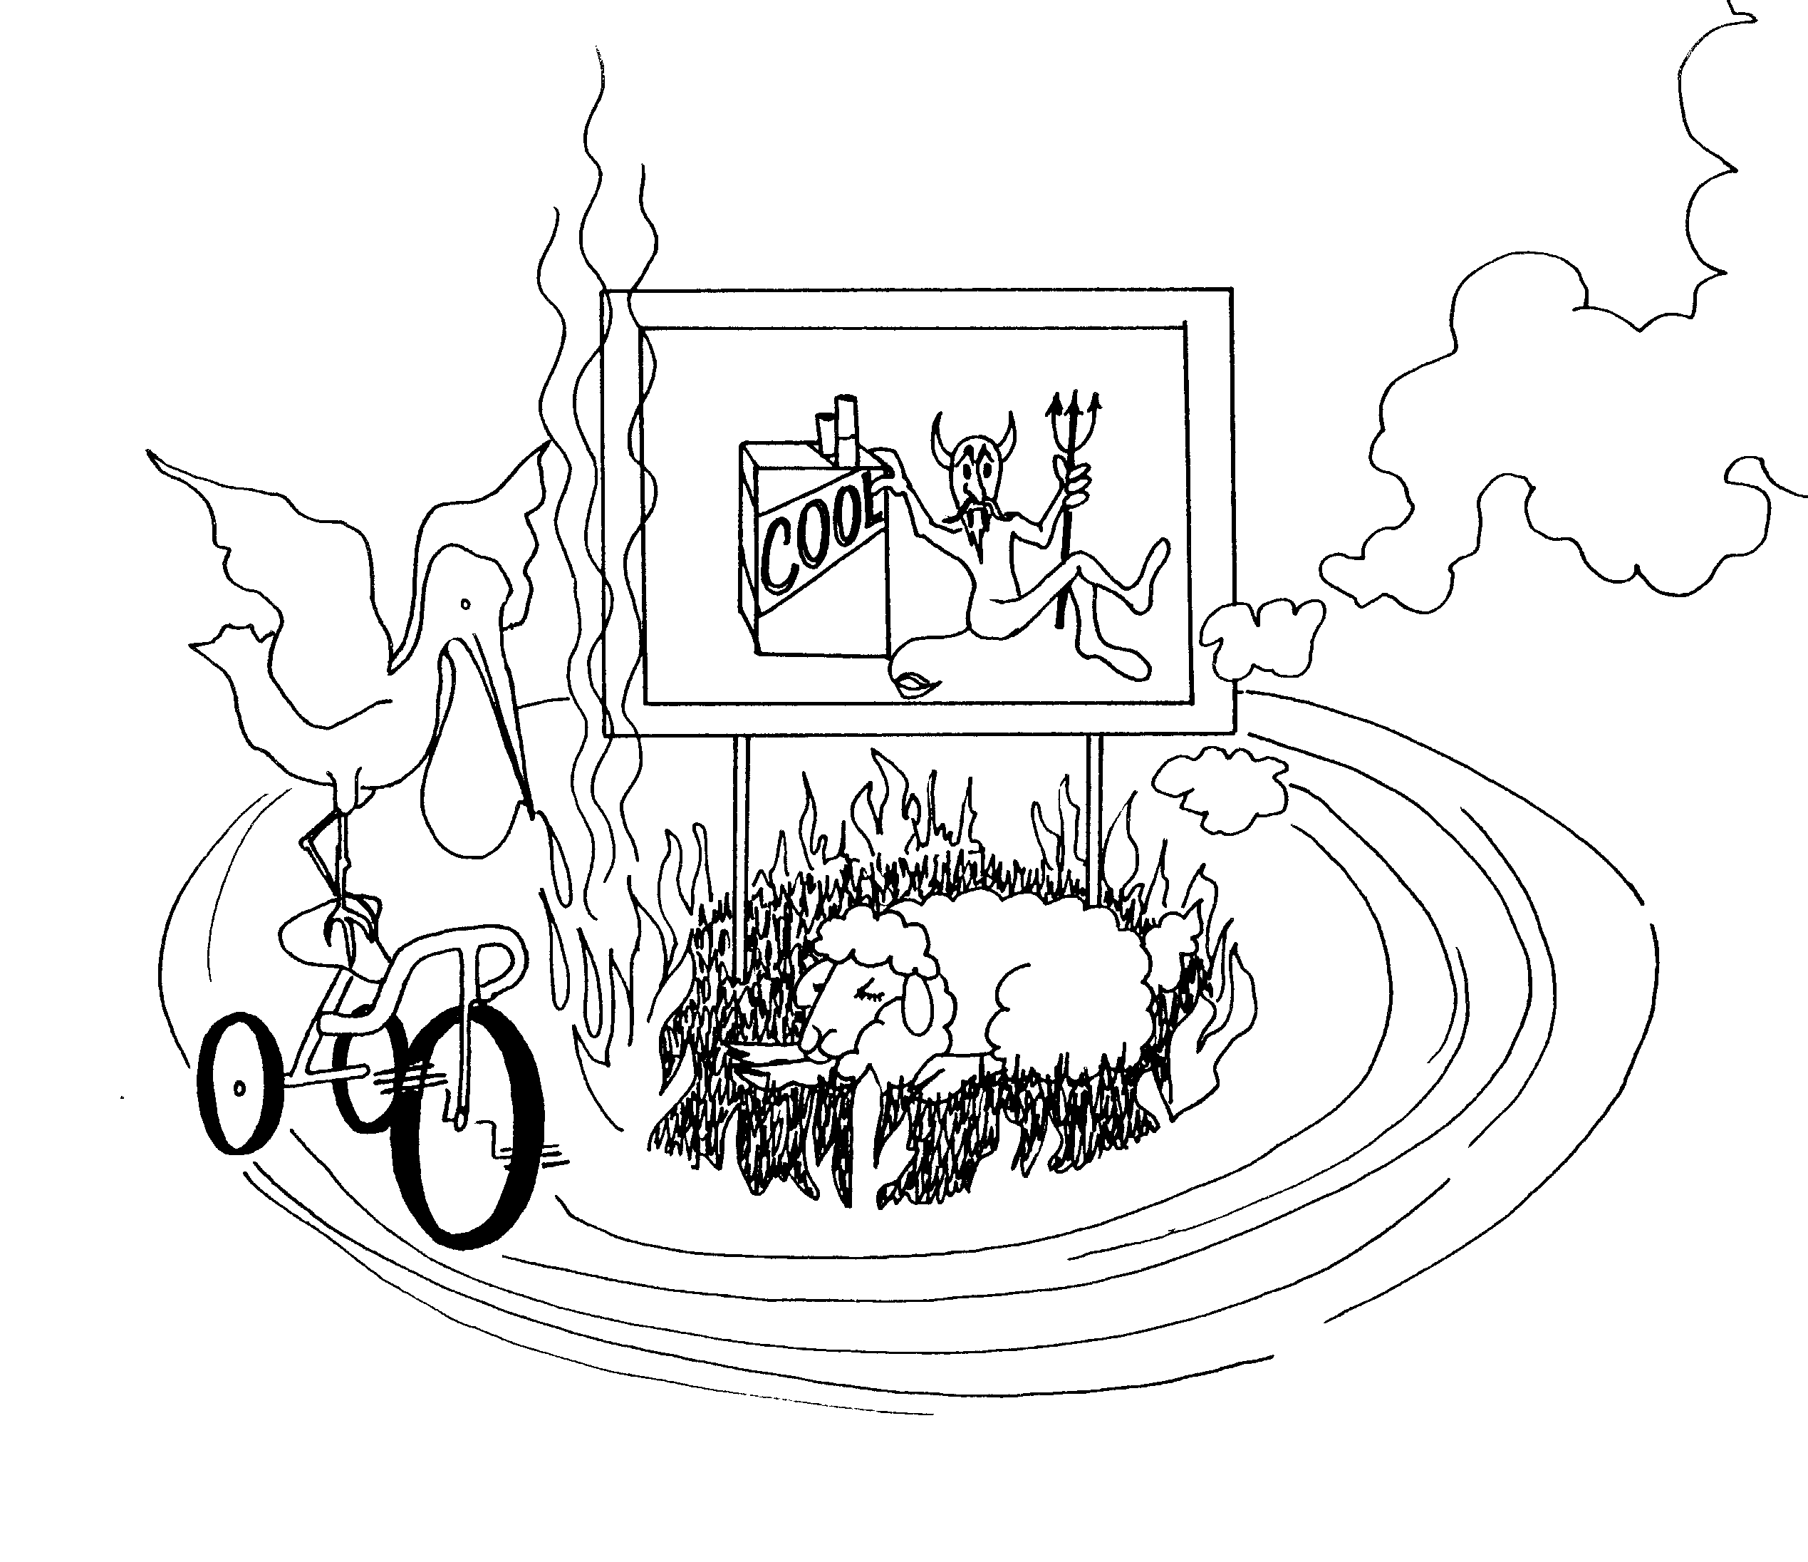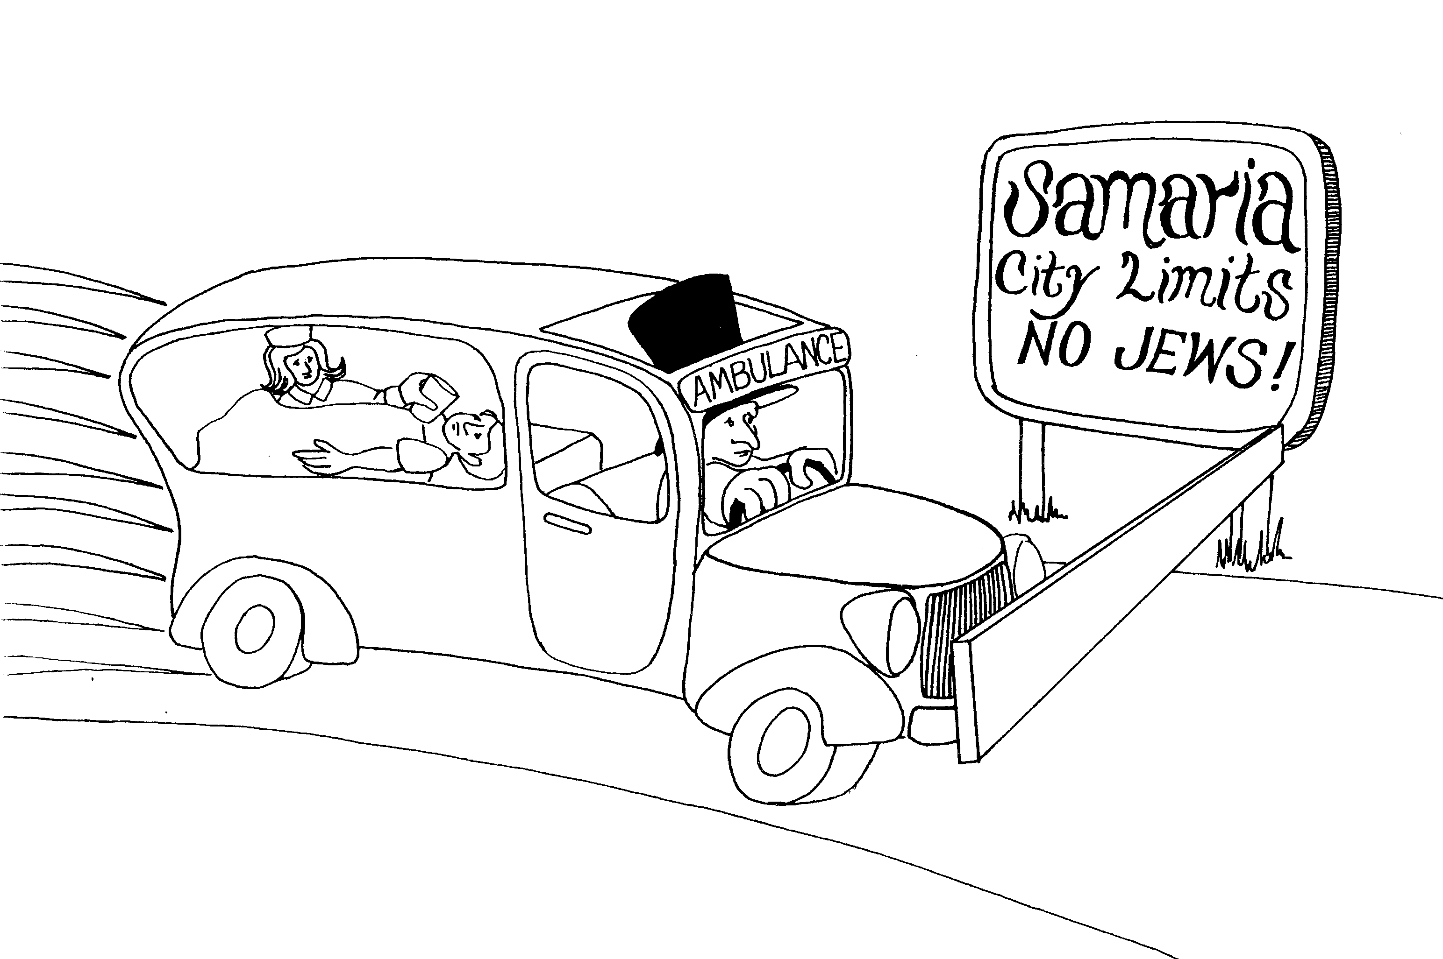

3. NICODEMUS, 4. WOMAN OF SAMARIA, NOBLE'S SICK SON
JOHN THE BAPTIST ABOUT JESUS

3 = Tricycle (three wheels) 4 = Car (4 wheels)

* NICODEMUS: "Nicotine Demos" (demon) * WOMAN OF SAMARIA: nurse from the Good Samaritan
hospital in ambulance helping sick boy
* JOHN THE BAPTIST ABOUT JESUS:
Pelican (John) riding tricycle around Jesus * NOBLE'S SICK SON: boy in ambulance, noble is father
(the lamb) trying to put out the fire driving the ambulance

Acts 1 - 4
c 1985 Do not reproduce
John 3 - 4
© 2003 Do not reproduce
John: Christ the son of God

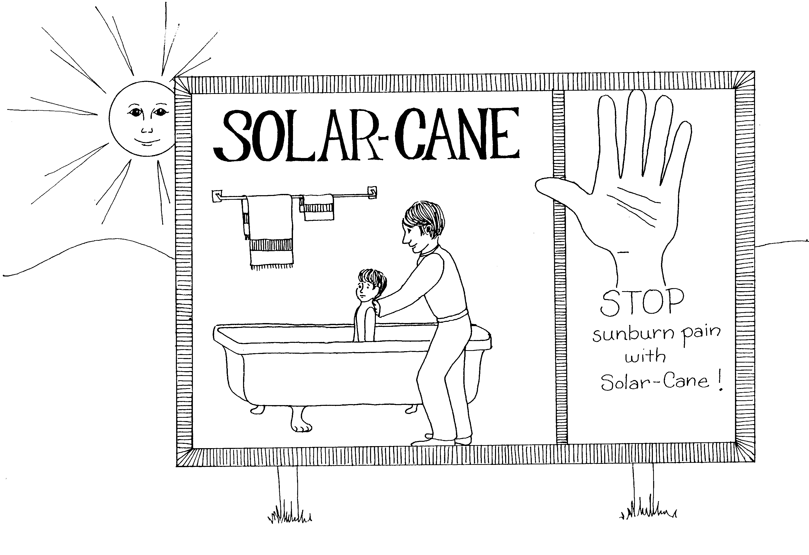 | 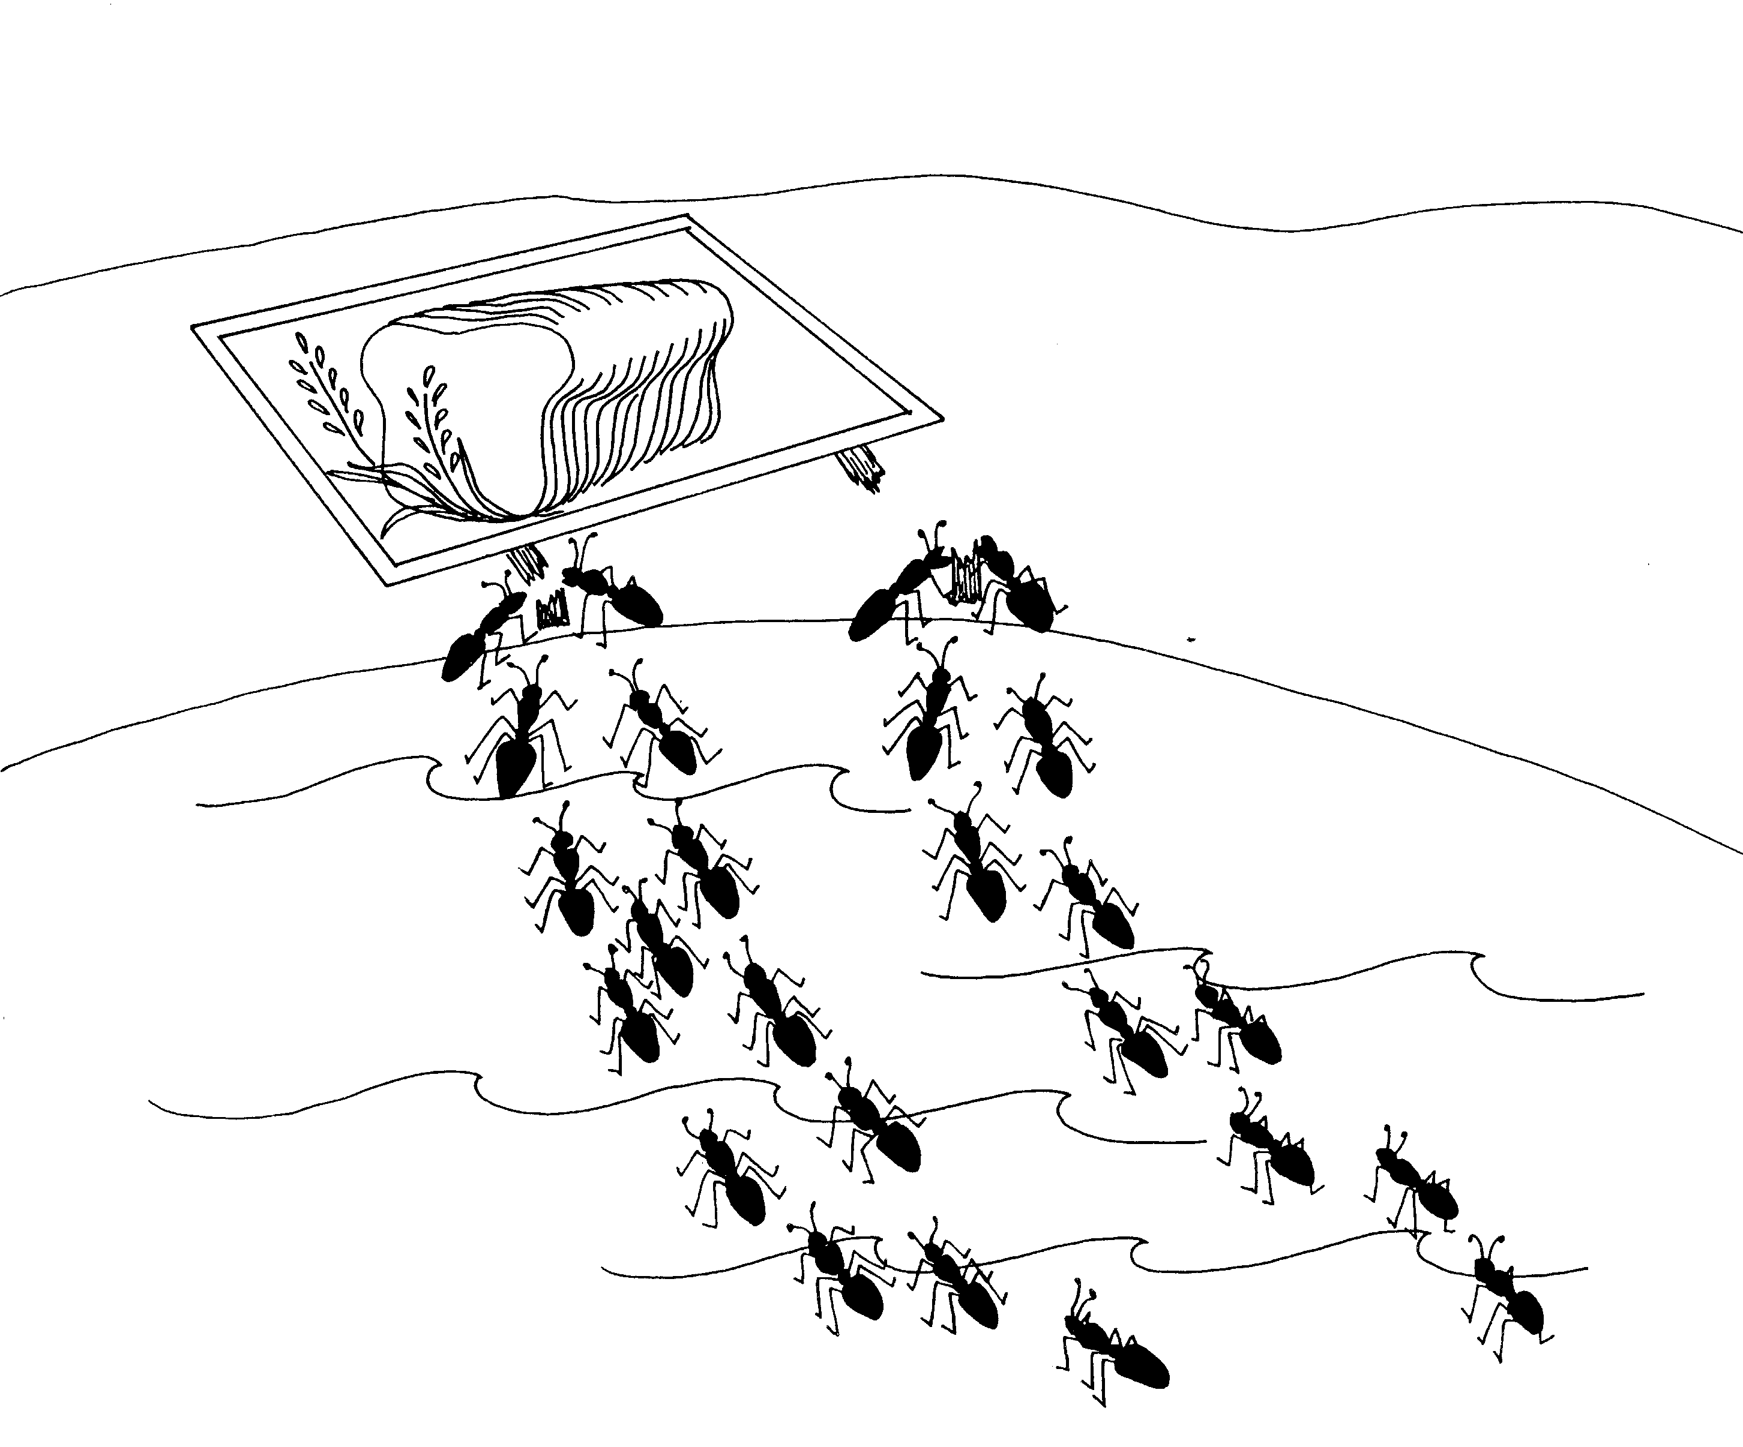
5. BETHESDA, HEALING ON SABBATH, FATHER-SON  5 = Five fingers on Mrs. HD's hand  * BETHESDA: taking a bath (bath-thesda)  * HEALING ON SABBATH: healing on ze-back lotion helps heal sunburn pain  * FATHER-SON: the father is putting lotion on the son's back | 6. 5,000, WALKS ON WATER, BREAD OF LIFE  6 = Insects (6 legs on a bug)  * 5,000: 5000 ants/termites attacking wooden sign  * WALKS ON WATER: ants/termites walking on top of water  * BREAD OF LIFE: termites/ants trying to eat bread on  the billboard
John 5 - 6
© 2003 Do not reproduce

John: Christ the son of God

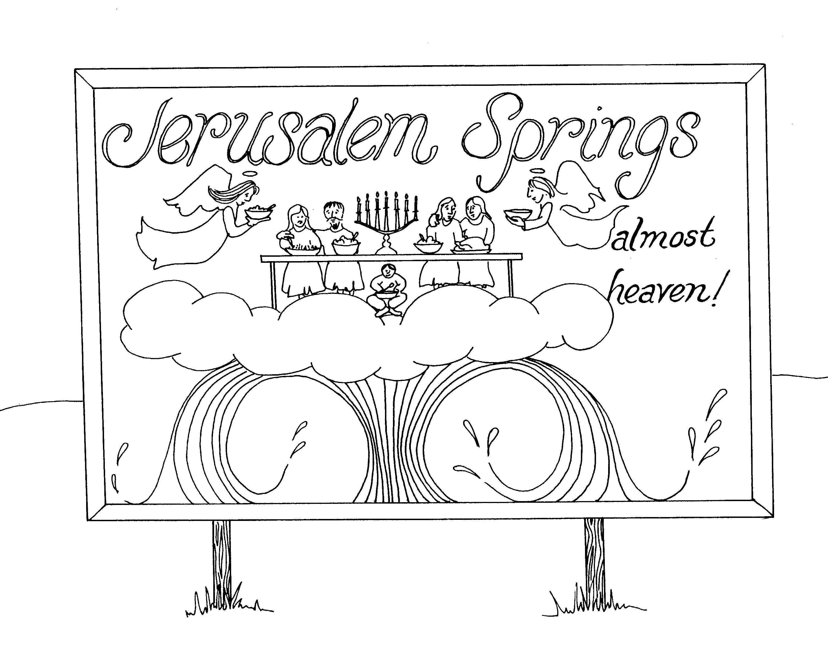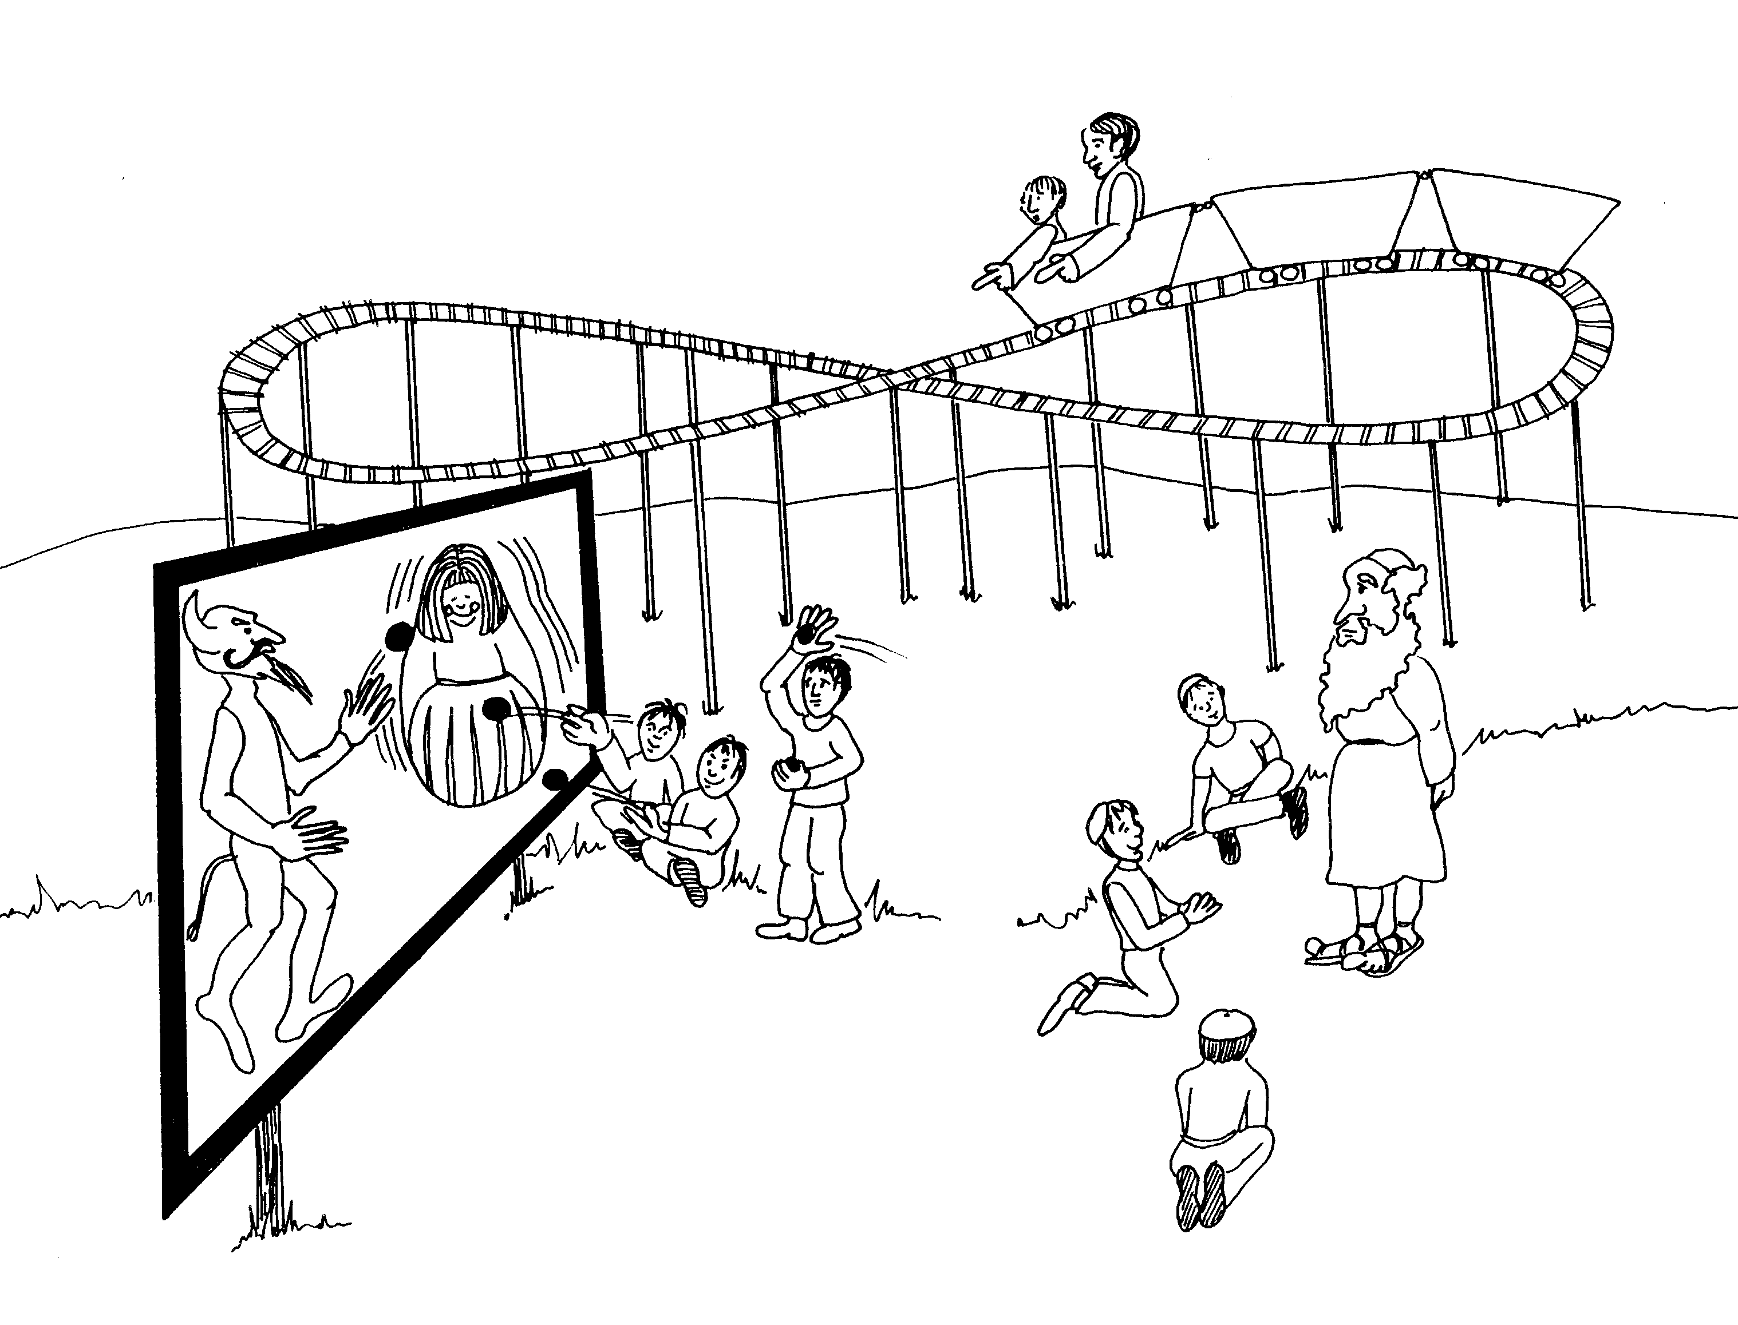

7. JERUSALEM FEAST SECRETLY, 8. ADULTEROUS WOMAN,
LIVING WATER 2 WITNESSES: FATHER-SON, ABRAHAM'S SONS,
SATAN'S SONS
7 = Heaven (perfect number-clouds) 8 = Roller coaster looks like an 8 sideways

* JERUSALEM FEAST SECRETLY: guy eating * ADULTEROUS WOMAN: kids throwing stones at her
secretly under the table
* 2 WITNESSES FATHER-SON: guys riding in roller coaster
* LIVING WATER: springs of moving (living) water
* ABRAHAM'S SONS: kids at feet of elderly Abraham

* SATAN'S SONS: stone-throwing kids

John 7 - 8
© 2003 Do not reproduce
John: Christ the son of God

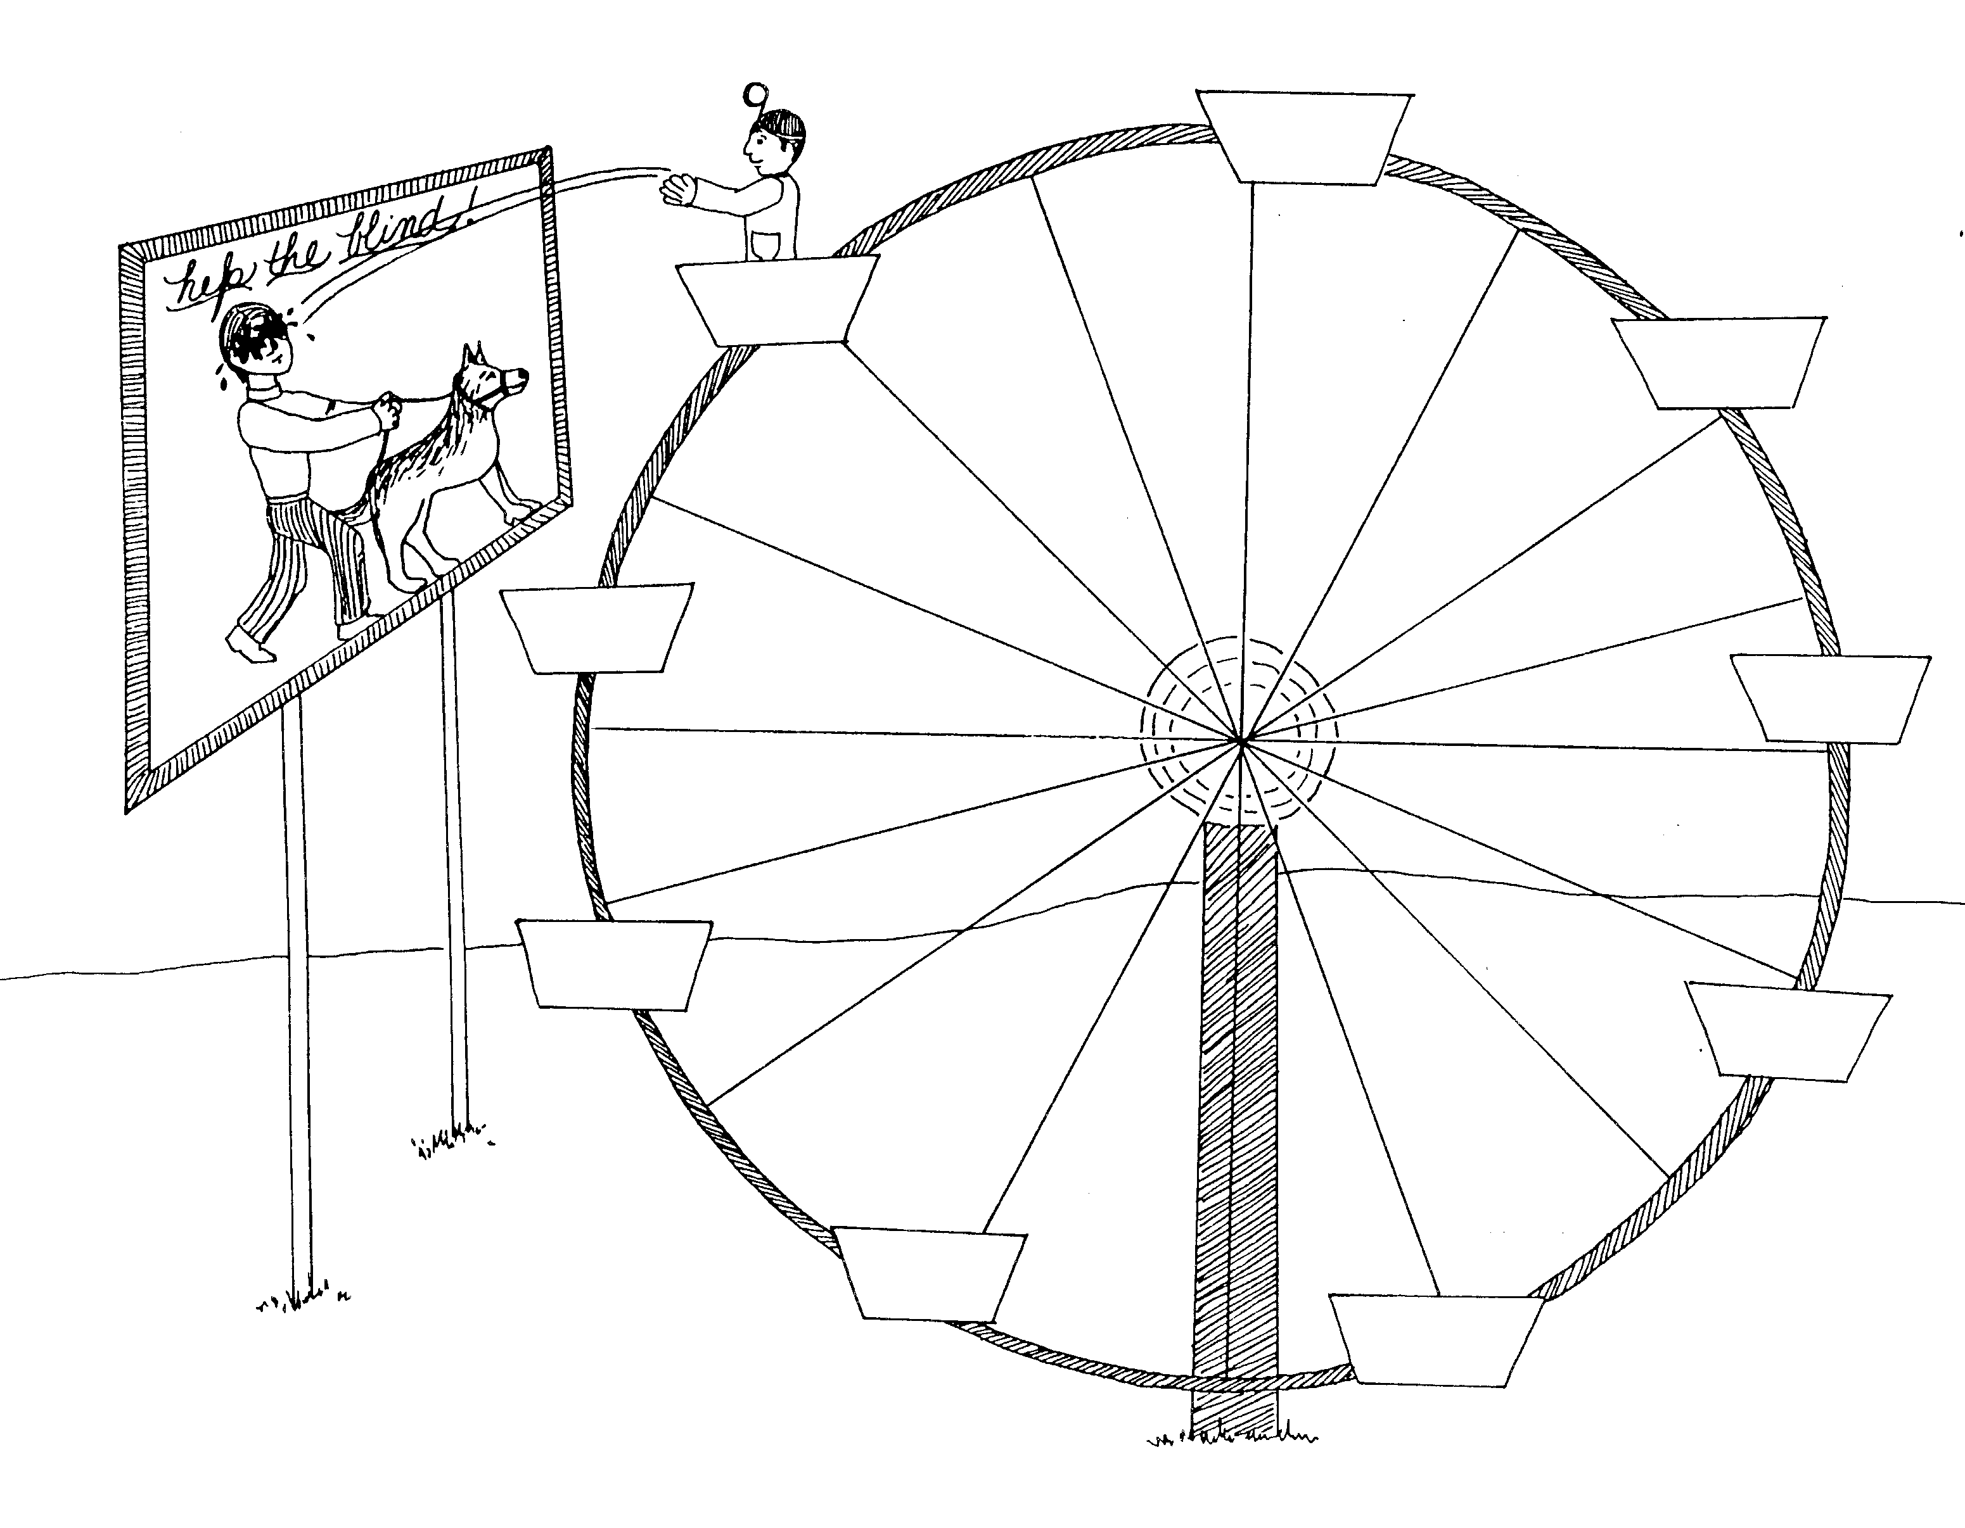 | 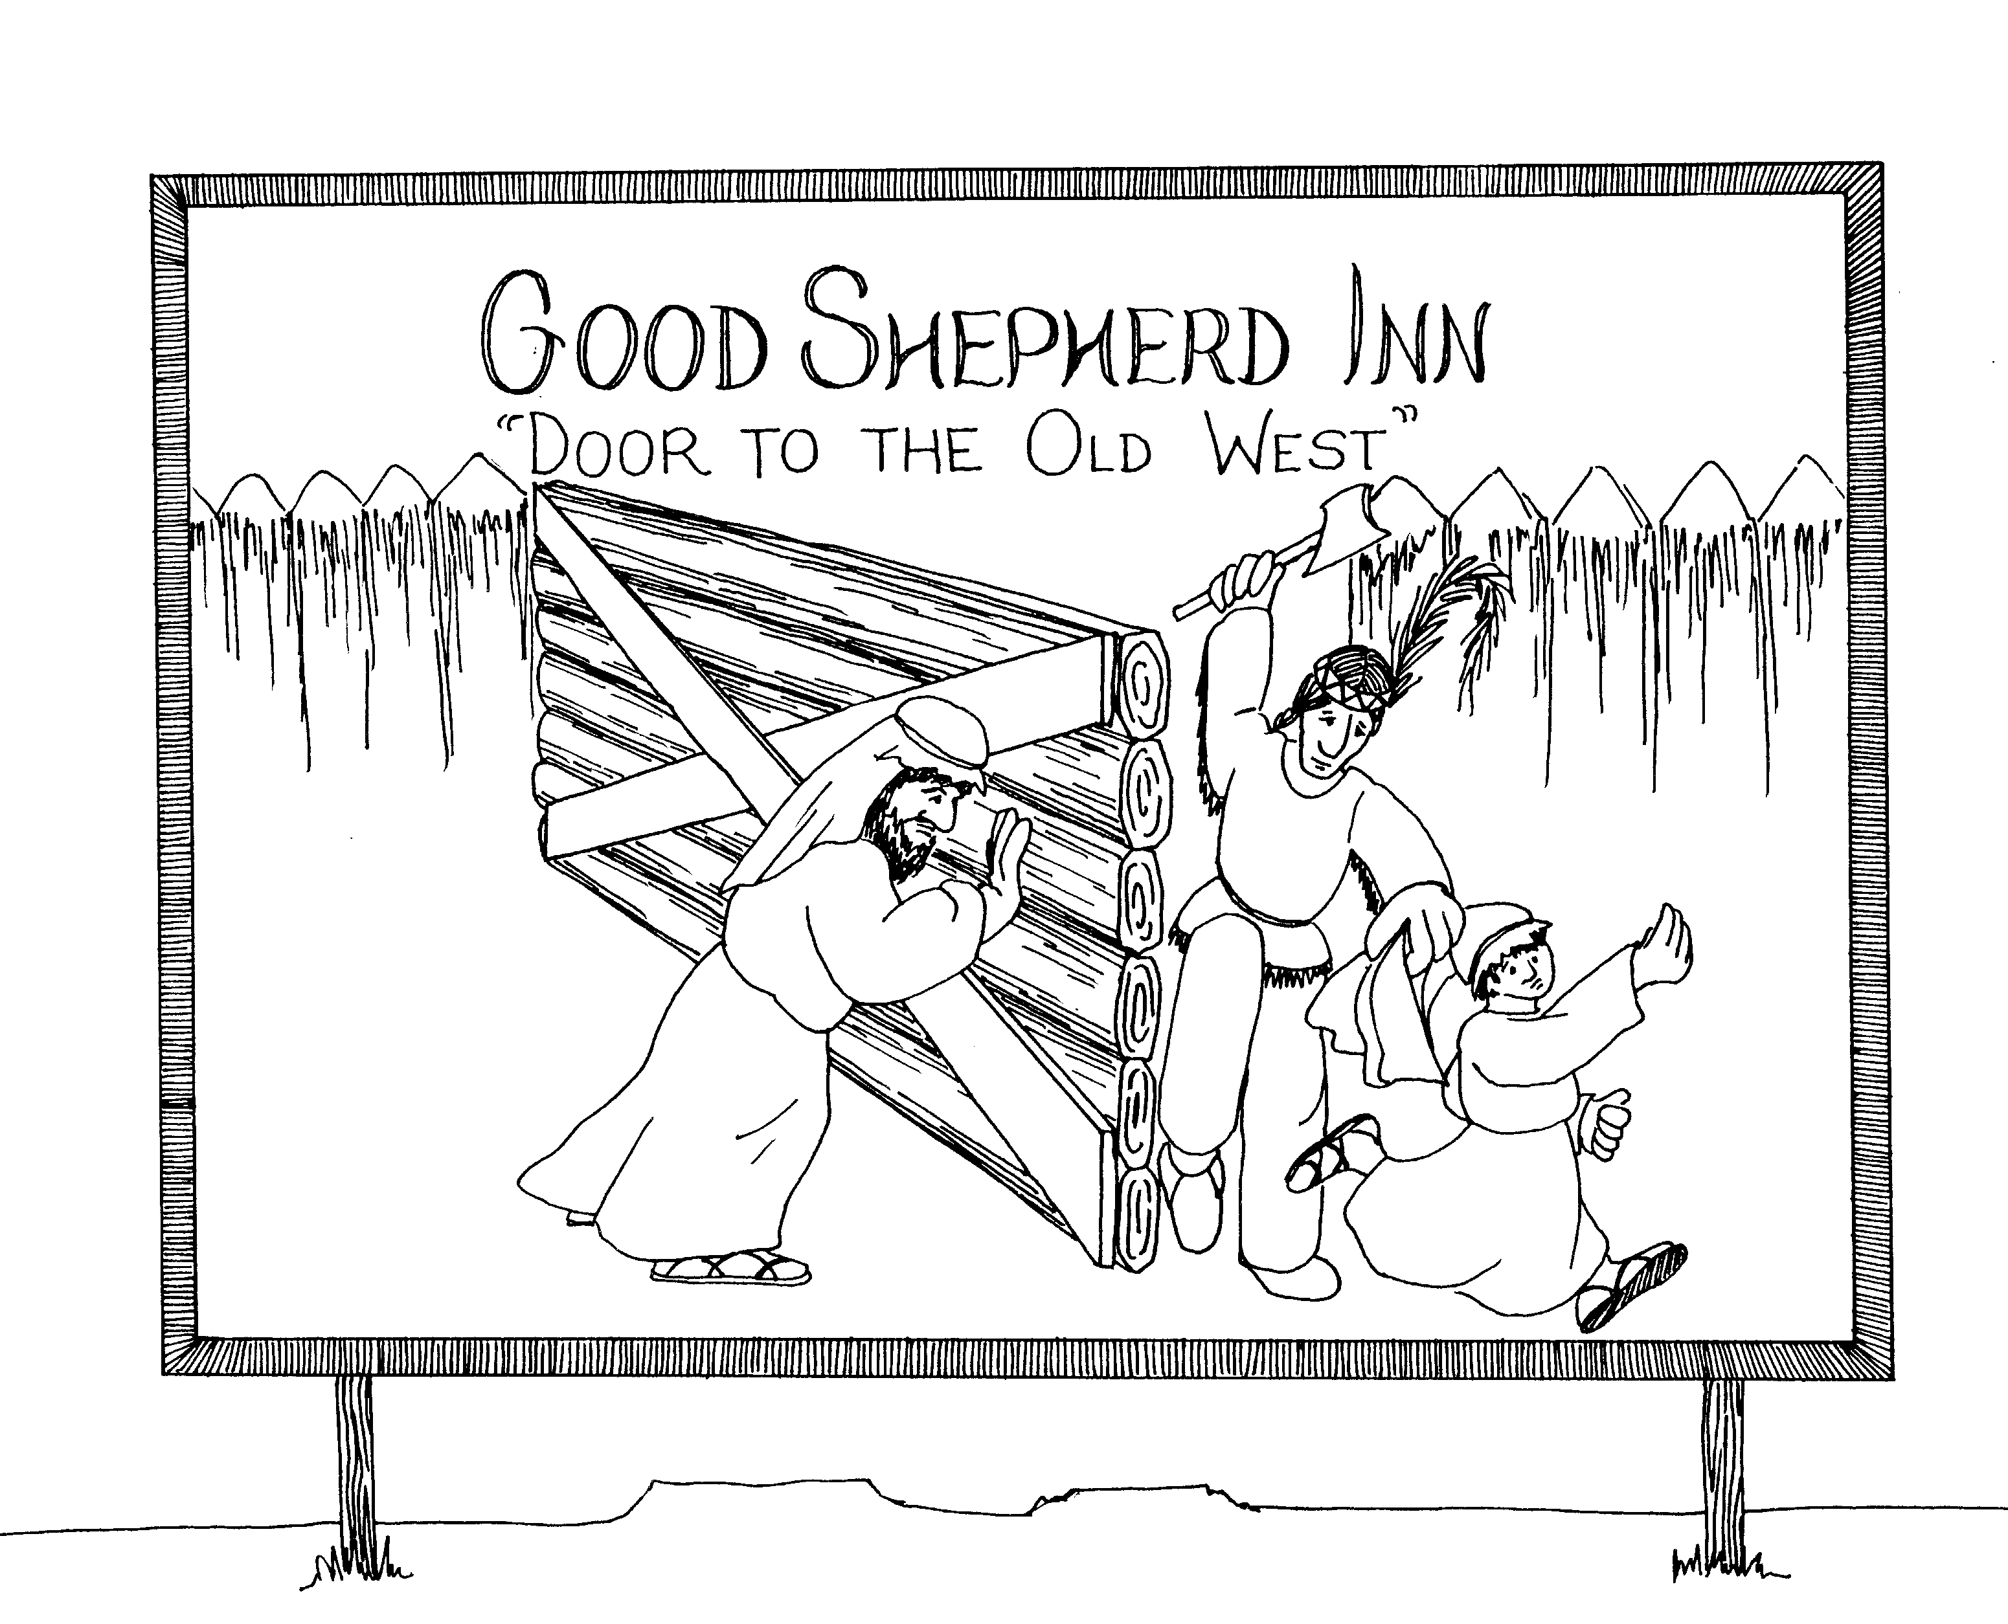
9. MUDDY BLIND MAN, PHARISEES  9 = Doctor's ophthalmoscope mirror  * MUDDY BLIND MAN: the blind man on the billboard trying to shut door to push Indian away from son  * PHARISEES: Ferris wheel | 10. DOOR AND GOOD SHEPHERD, FATHER-SON  10 = 10 little Indians  * DOOR AND GOOD SHEPHERD: good shepherd  has mud put on his eyes  * FATHER-SON: the father is the shepherd and the boy is his son
John 9 - 10
© 2003 Do not reproduce
John: Christ the son of God

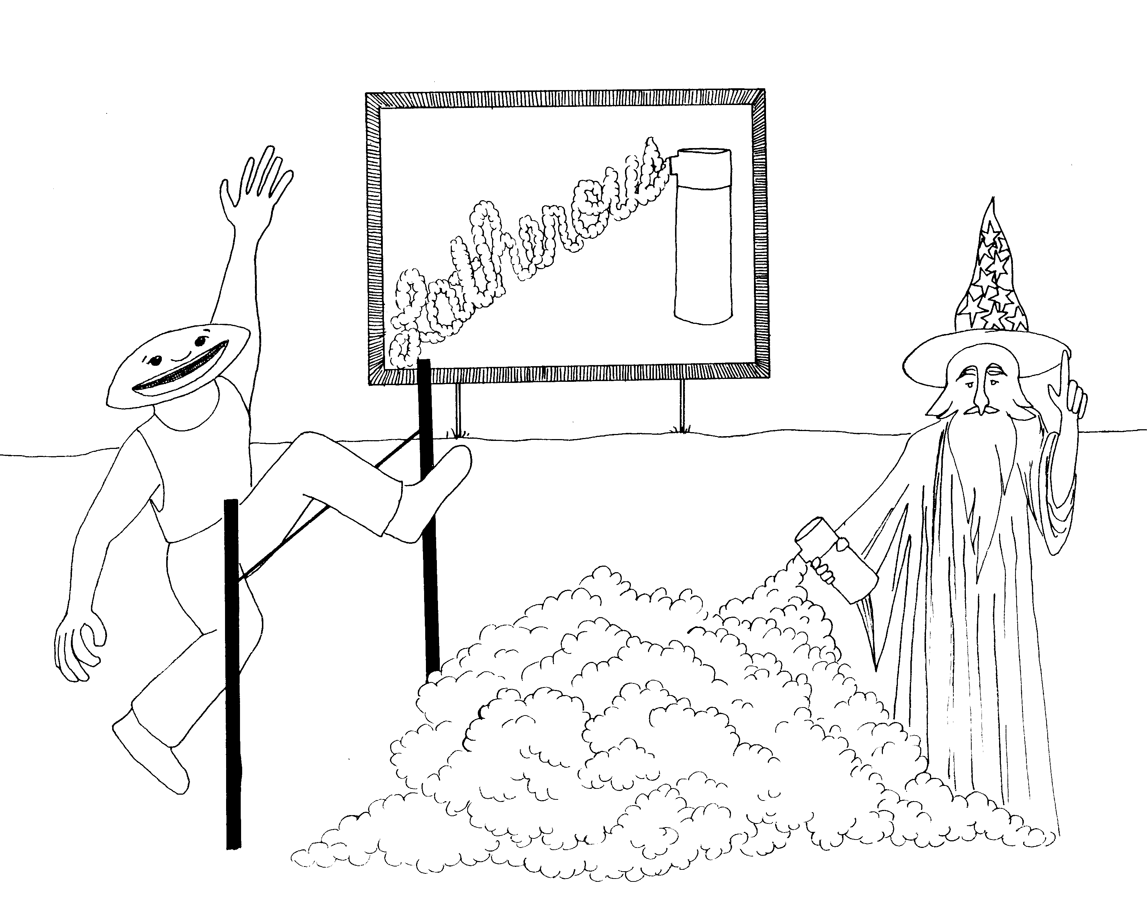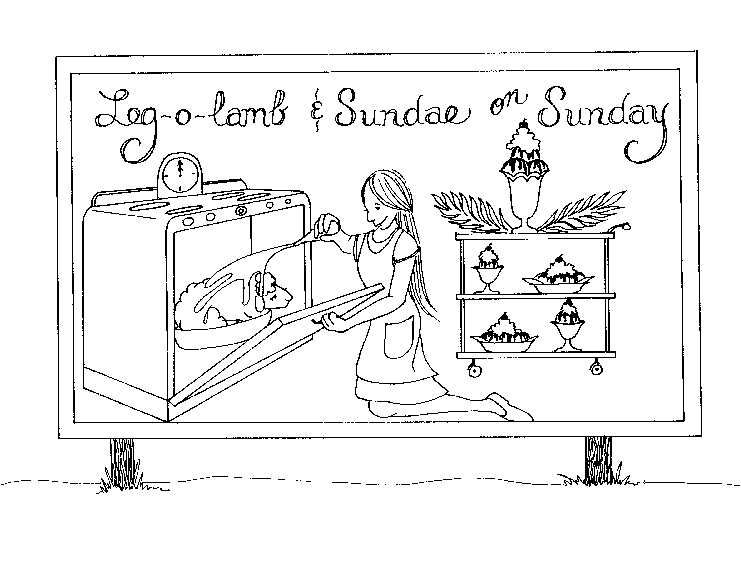

11. LAZARUS, CAIAPHAS' PREDICTION 12. MARY ANOINTS JESUS, PALM SUNDAY

11 = Pole-vault bars which look like an 11 12 = 12 o'clock (clock = 12)

* LAZARUS: shaving later in pole-vault pit * MARY ANOINTS JESUS: Mary = merry girl,
basting lamb (Jesus)
* CAIAPHAS' PREDICTION: "kayak-face" (shape of
his head) is guy jumping; prediction is * PALM SUNDAY: palm branch and a sundae
the wizard

John 11 - 12
© 2003 Do not reproduce
John: Christ the son of God

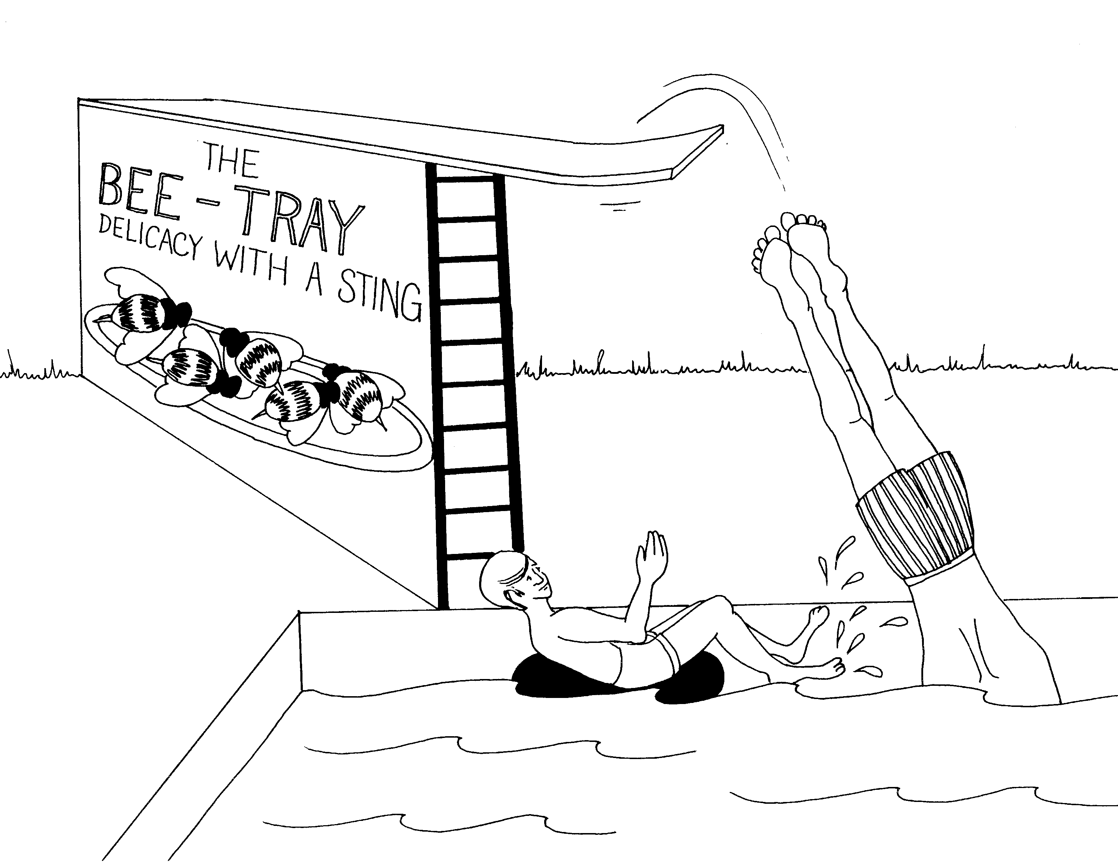 | 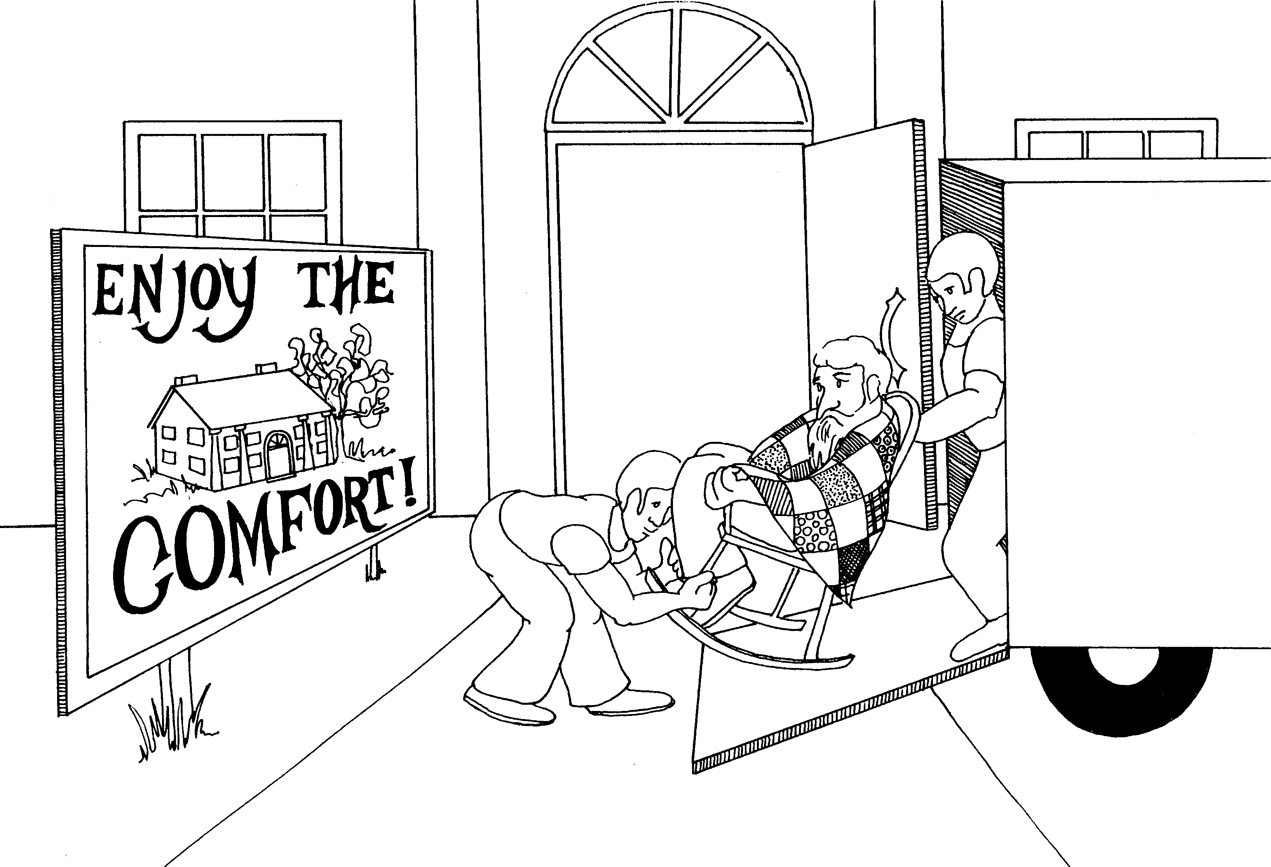
13. WASHING FEET, PASSOVER, PREDICTS BETRAYAL  13 = Ladder (13 unlucky like walking under a ladder)  * WASHING FEET: guy in pool kicking and washing his feet in the water  * PASSOVER: guy diving over feet kick (passing over)  * PREDICTS BETRAYAL: 'bee-tray' all | 14. FATHER'S HOUSE, SEEING THE FATHER,  COMFORTER  14 = Semi-truck, 10-4 CB trucker talk  * FATHER'S HOUSE: old father moving into a new house  * SEEING THE FATHER: old father in rocking chair  * COMFORTER: father wrapped in blanket or comforter
John 13 - 14
© 2003 Do not reproduce
John: Christ the son of God

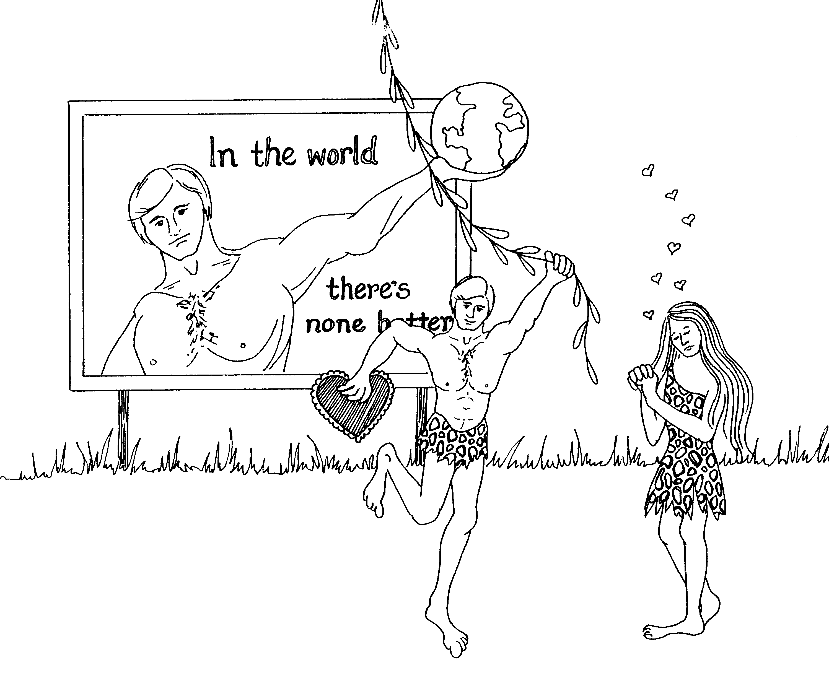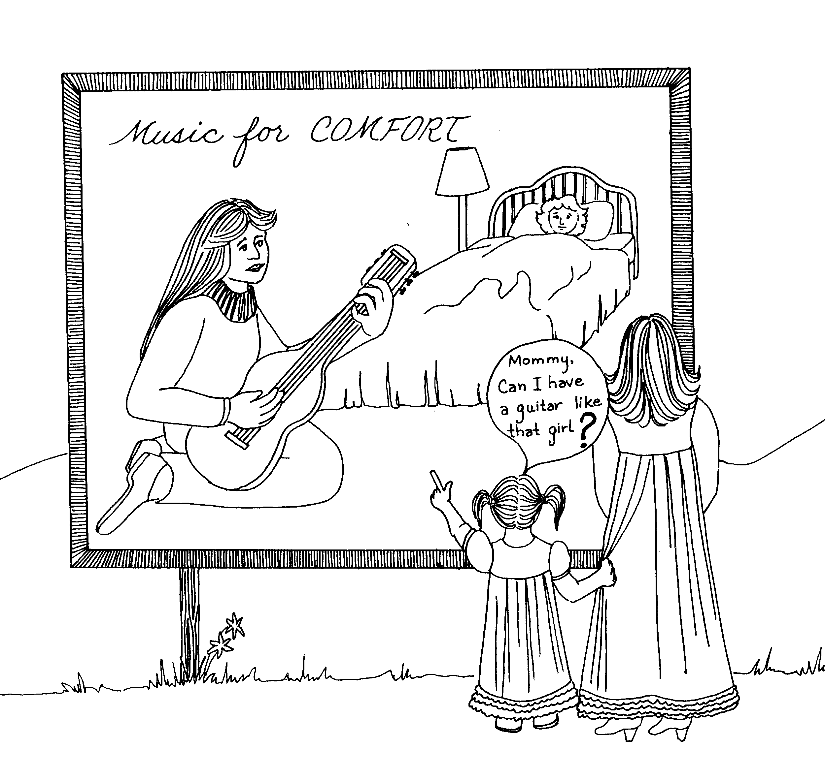

15. THE VINE, CHRIST'S COMMANDMENT, 16. COMFORTER'S WORK, ASKING

15 = Rhymes with "lifting" 16 = Six strings (on guitar)

* THE VINE: Tarzan swinging on the vine * COMFORTER'S WORK: serenading sick girl in bed is
comforting her
* CHRIST'S COMMANDMENT: love one another,
heart = love * ASKING: girl asking to have a guitar like that one

John 15 - 16
© 2003 Do not reproduce
John: Christ the son of God

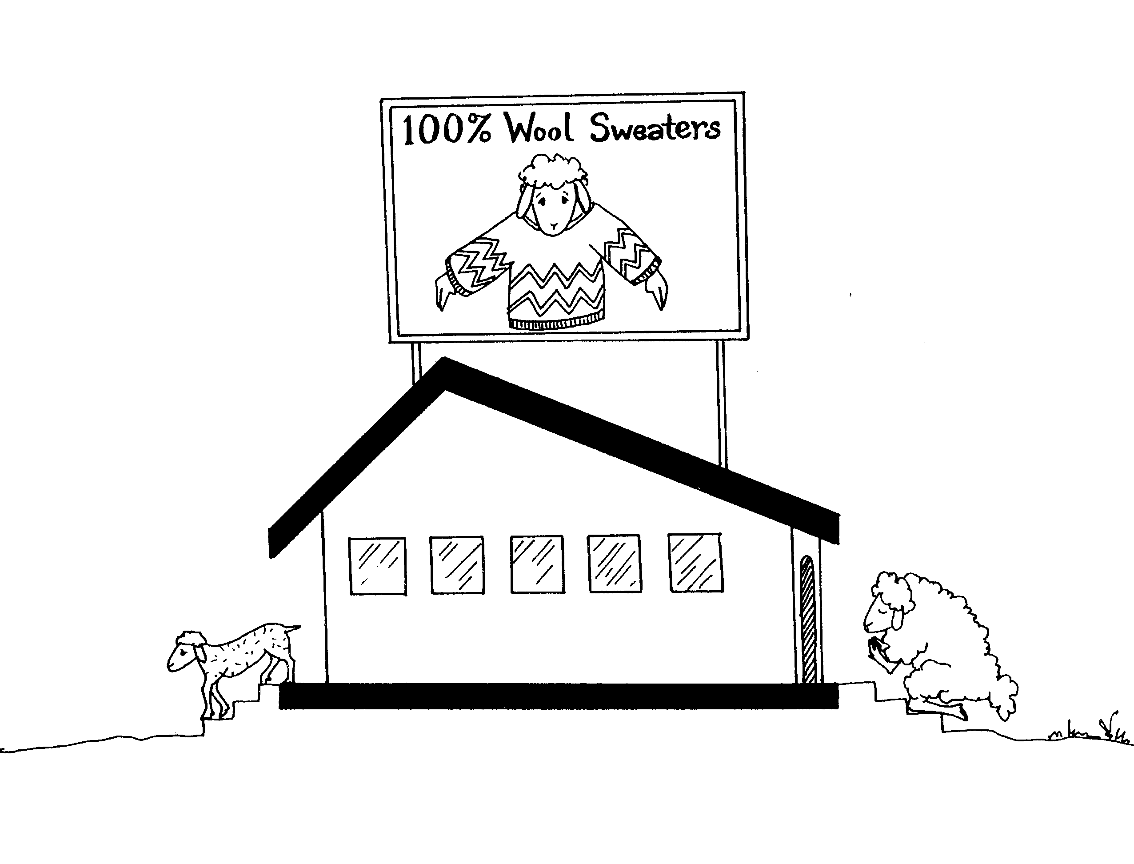 | 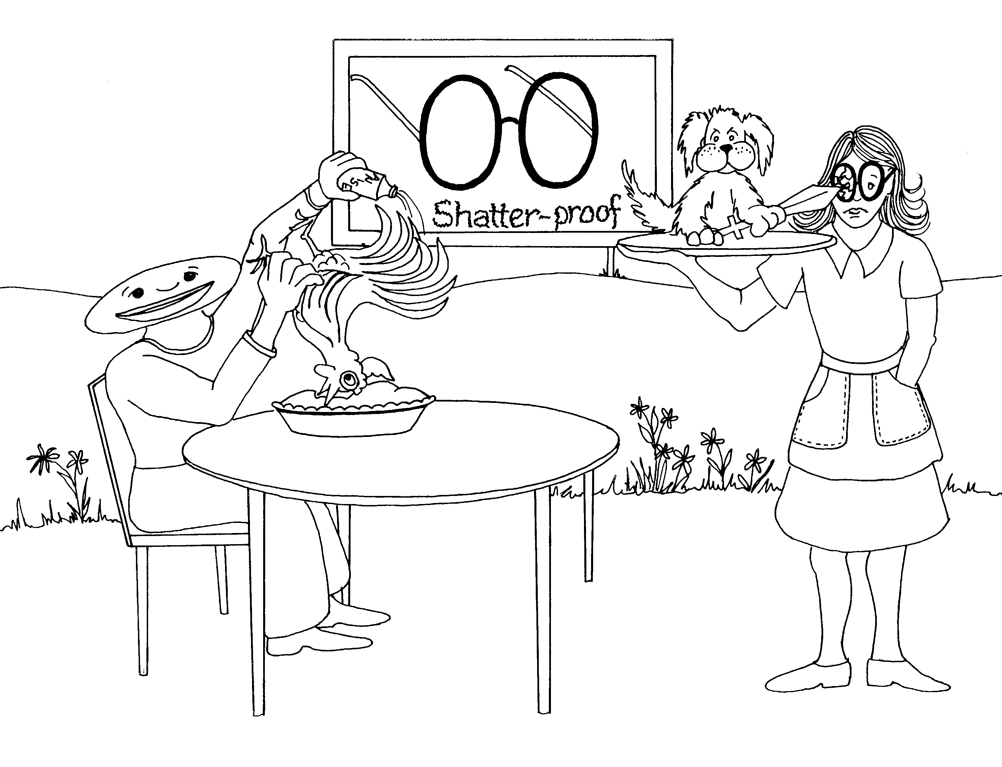
17. CHRIST'S PRAYER  17 = Building roof (7) and floor (1) for 17  * CHRIST'S PRAYER: Lamb (Christ) praying not to get sheered | 18. BETRAYAL, PETER AND SWORD, ANNAS,  PETER'S DENIAL, CAIAPHAS, PILATE  18 = Glasses (1 + 8) stem and eye pieces  written sideways  * BETRAYAL: Peter on a 'tray' jabbing  * PETER AND SWORD: Peter (dog) jabs glasses with sword  * CAIAPHAS: "Kayak-face" guy at the table  * PILATE: Cutting the pie open (pie-letting)
John 17 - 18
© 2003 Do not reproduce
John: Christ the son of God

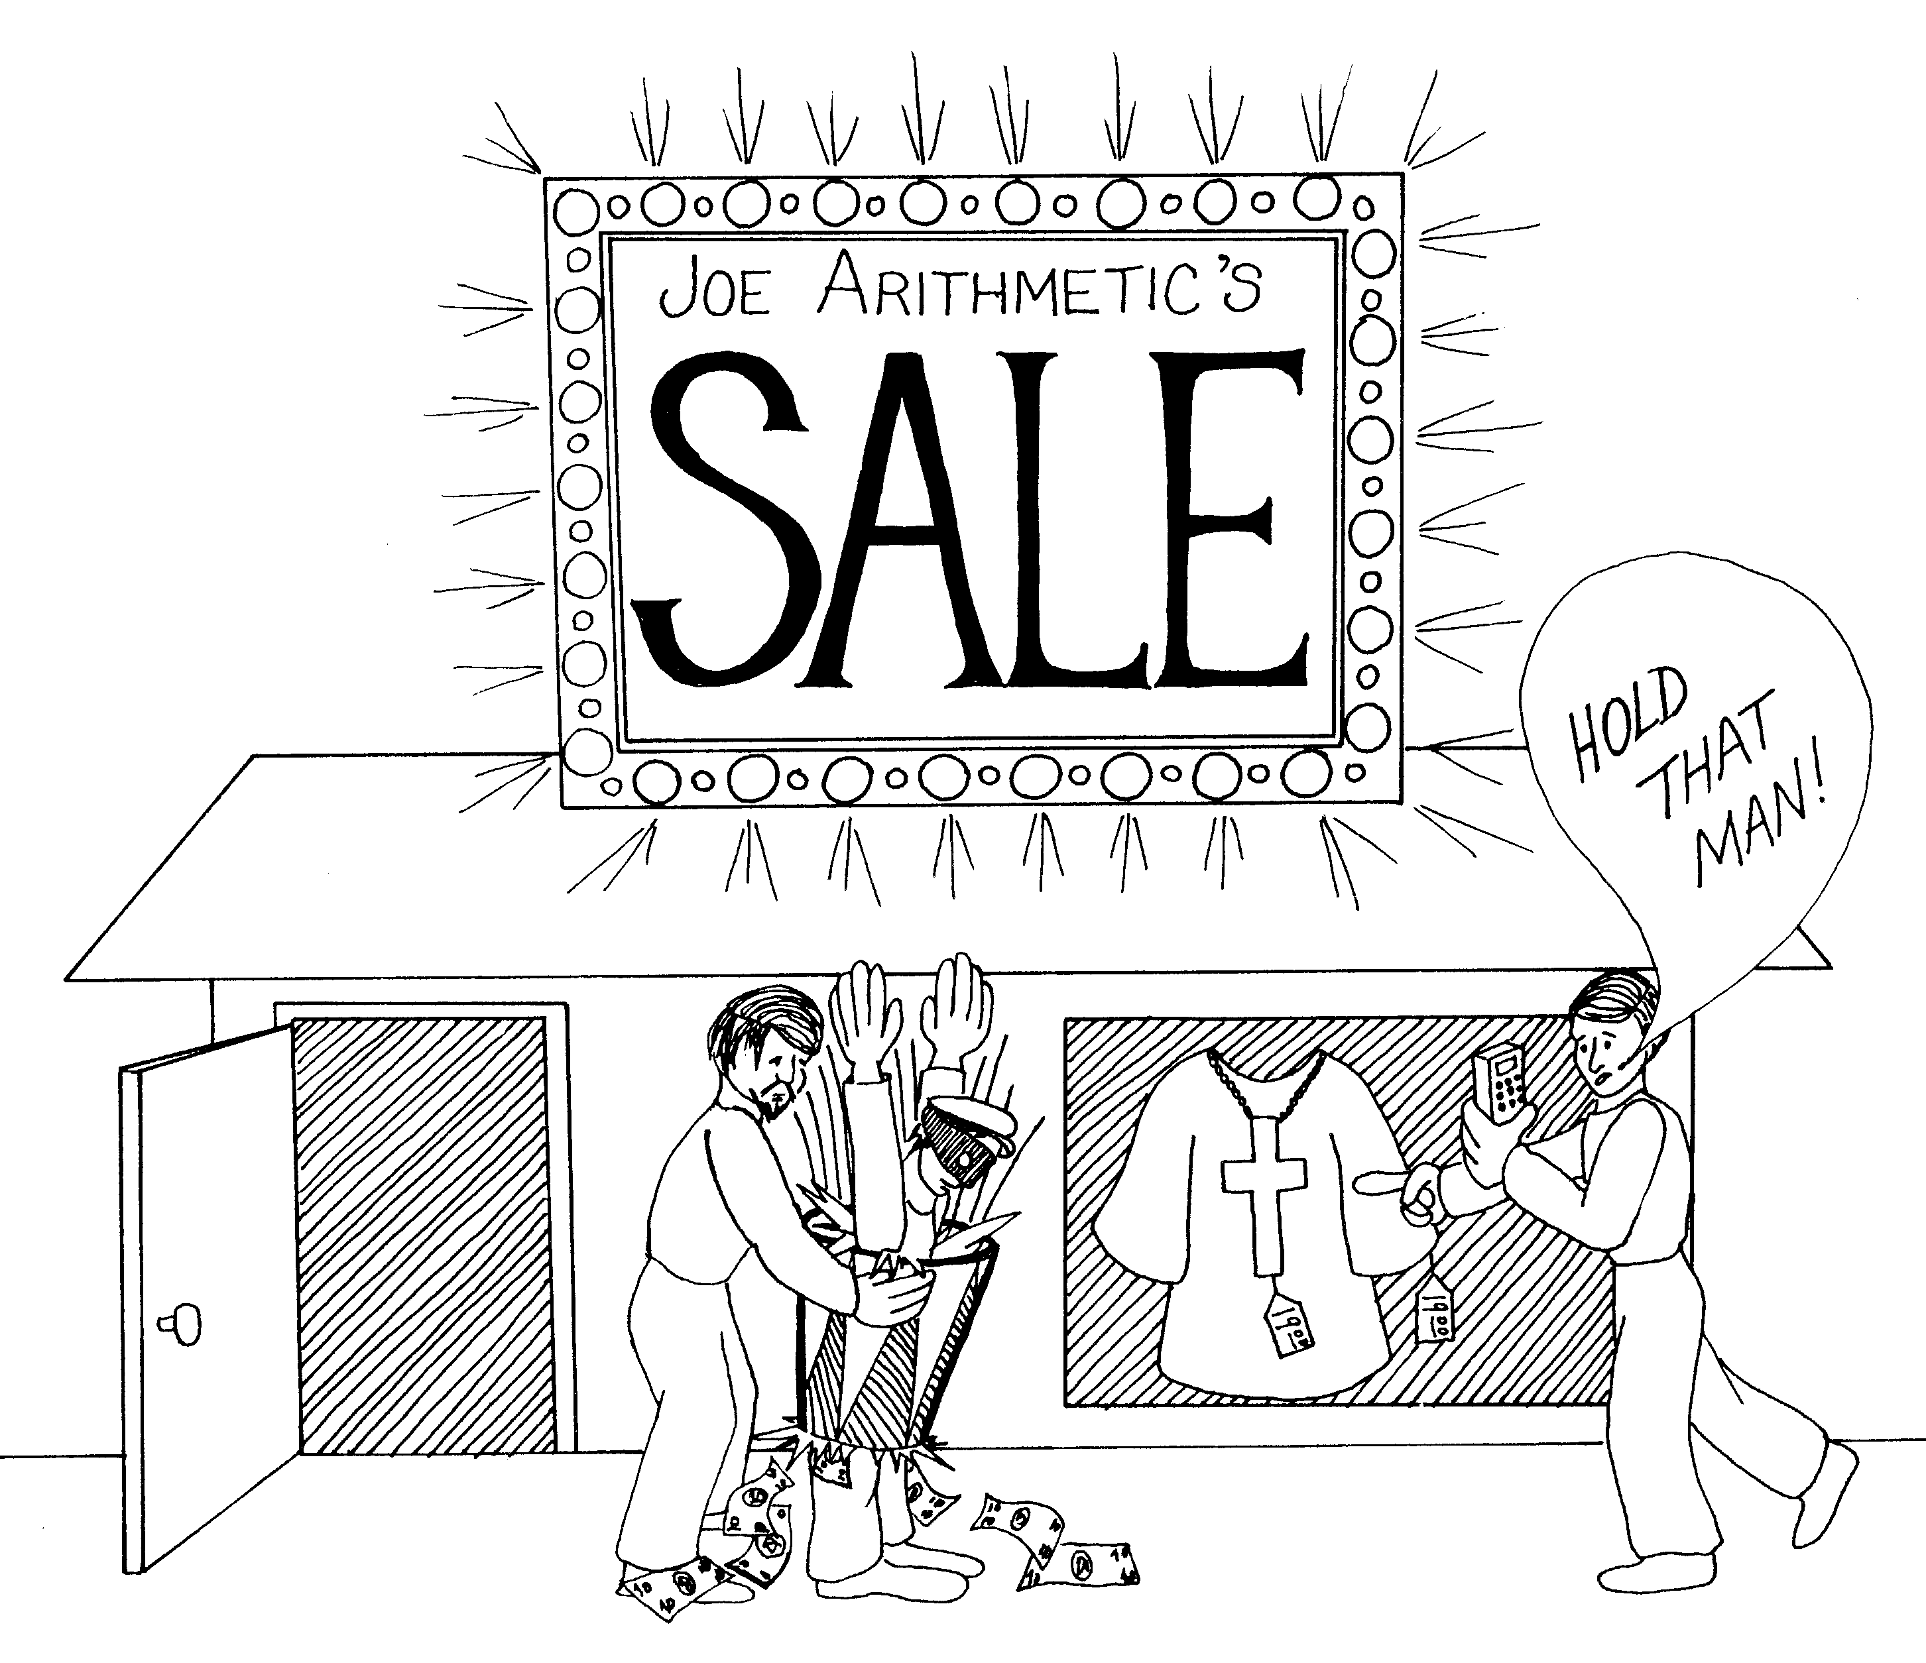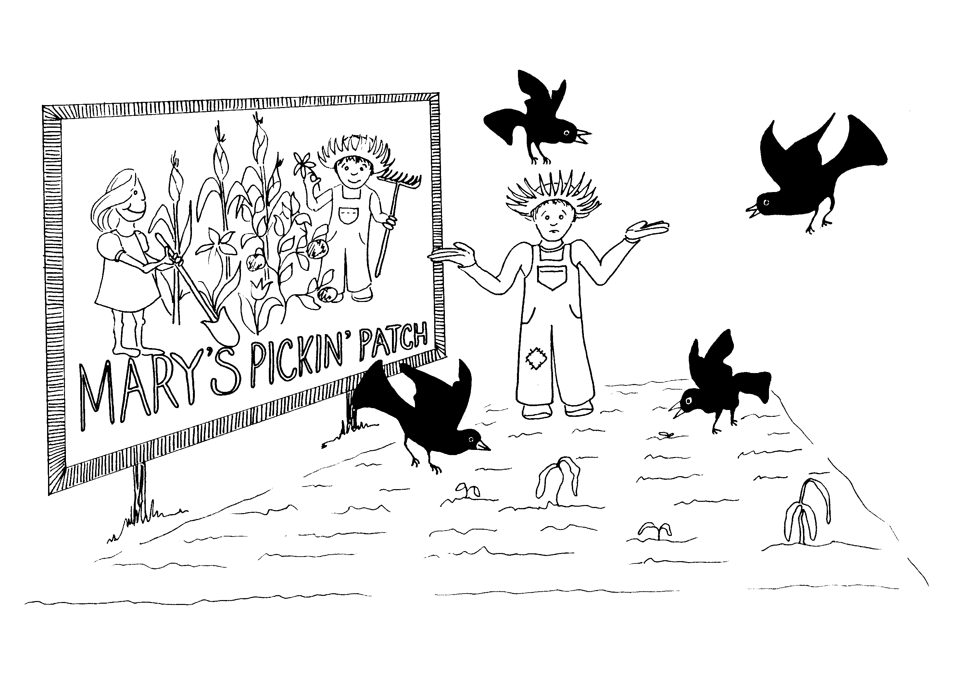

19. BEHOLD THE MAN, CRUCIFIXION, 20. MARY MAGDALENE AND THE GARDENER,
GARMENTS, JOSEPH OF ARIMATHEA DOUBTING THOMAS

19 = Bongo drum (1 + 9) 20 = 20 Blackbirds

* BEHOLD THE MAN: hold that man (thief) * MARY MAGDALENE AND THE GARDNER:
Mary's picking patch, the gardener is Mary's helper
* CRUCIFIXION: crucifix being sold in the store * DOUBTING THOMAS: guy trying to grow garden but
* GARMENTS: clothing being sold in the store doubts it will grow because of the birds

* JOSEPH OF ARIMATHEA: Joe Arithmetic guy with
the calculator
John 19 - 20
© 2003 Do not reproduce
John: Christ the son of God

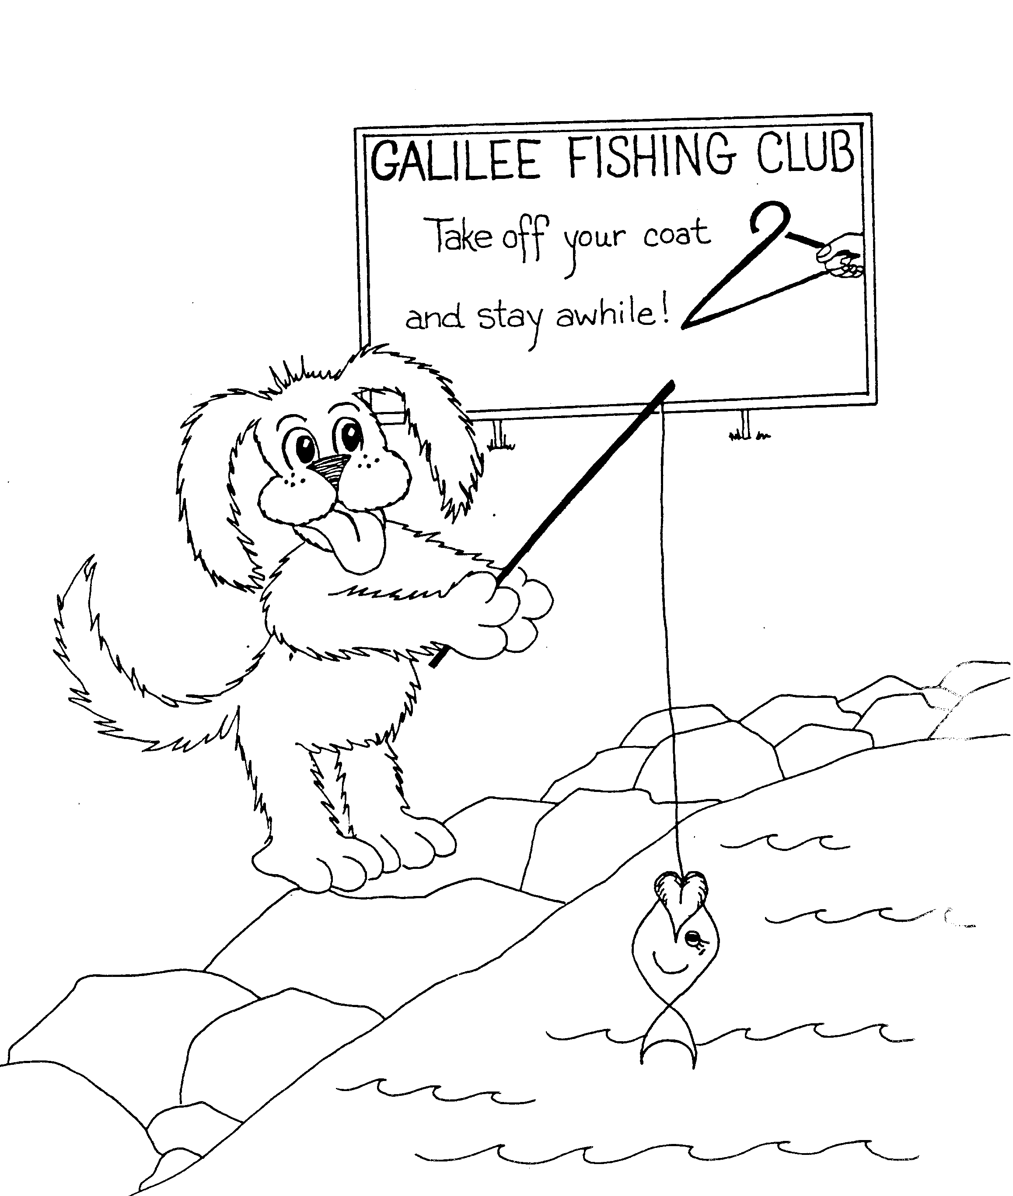
21. FISHING IN GALILEE, PETER'S LOVE

21 = Hanger in shape of 2 + 1 (fishing rod)

* FISHING IN GALILEE: dog fishing in Galilee

* PETER'S LOVE: dog (Peter) loves to eat fish,
lips of fish like a heart (love)
John 21
© 2003 Do not reproduce

