HEBREWS: THE SUPREMACY OF CHRIST

1. Word through the son, Christ and the angels

2. Escape? Christ like his brethren

3. Christ and Moses, Hardened hearts

4. Rest

5. Christ and Aaron, Melchizedek, Milk and Meat

6. Fall away? God's promise

7. Christ and Melchizedek

8. Tabernacle and New Covenant

9. Tabernacle, Christ's blood atonement

10. Christ and offerings, Turning away

11. Hall of faith

12. Endurance, Discipline of sons, Not refusal

13. Sacrifices of love

Memory Verses: 1:1, 2; 4:12, 15, 16; 9:27; 11:6; 12:6;
2:9; 5:12-14; 9:15; 10:23-25; 11:1, 25; 12:1

Hebrews: The Supremacy of Christ

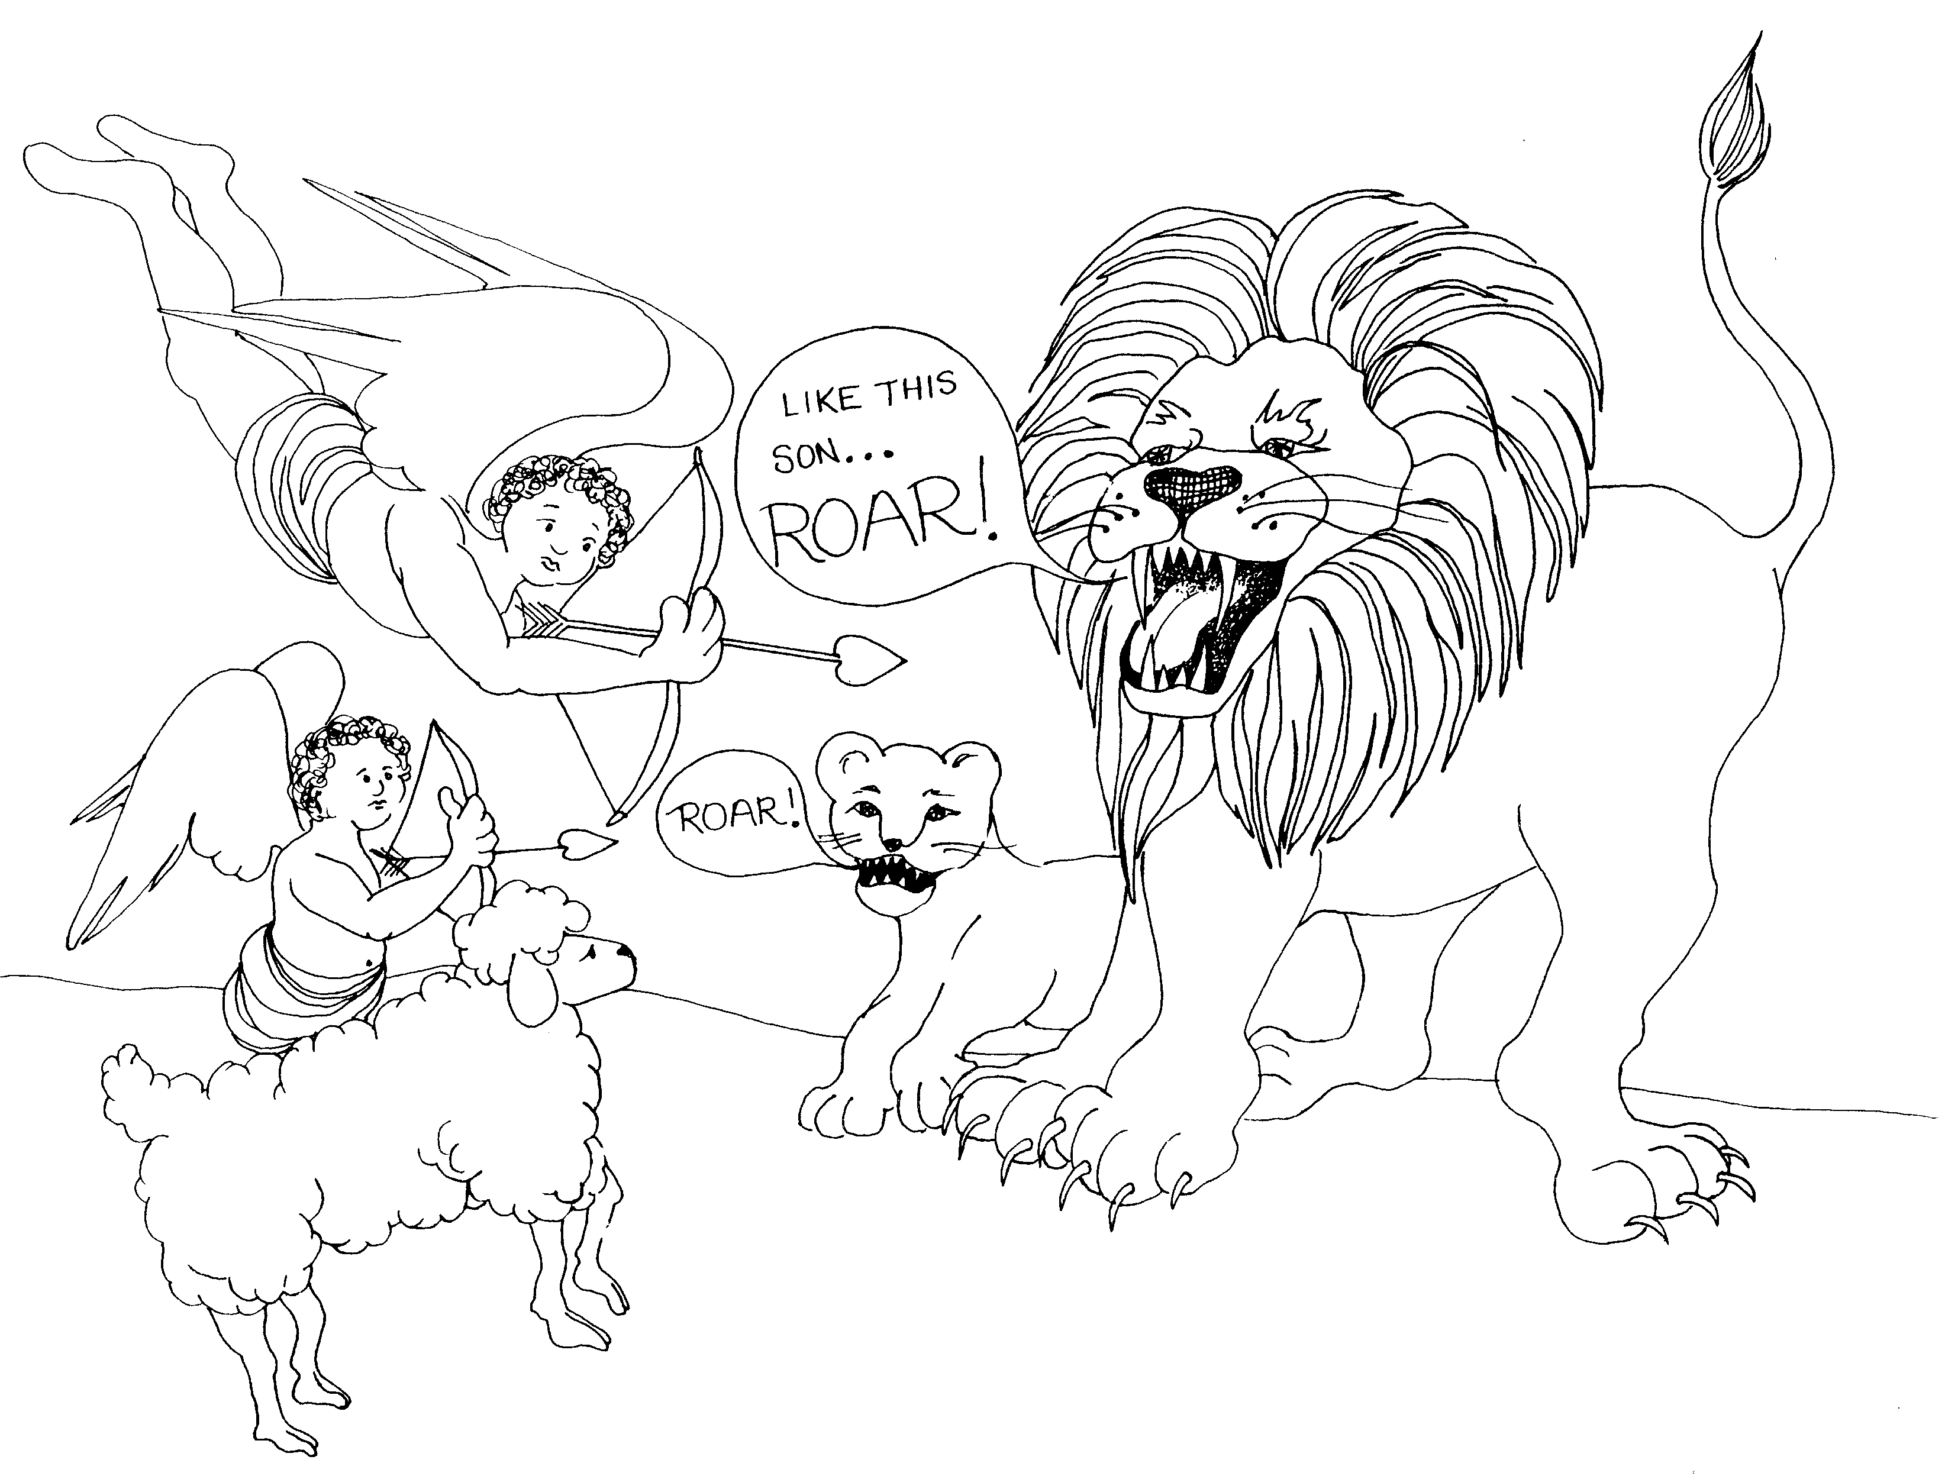 | 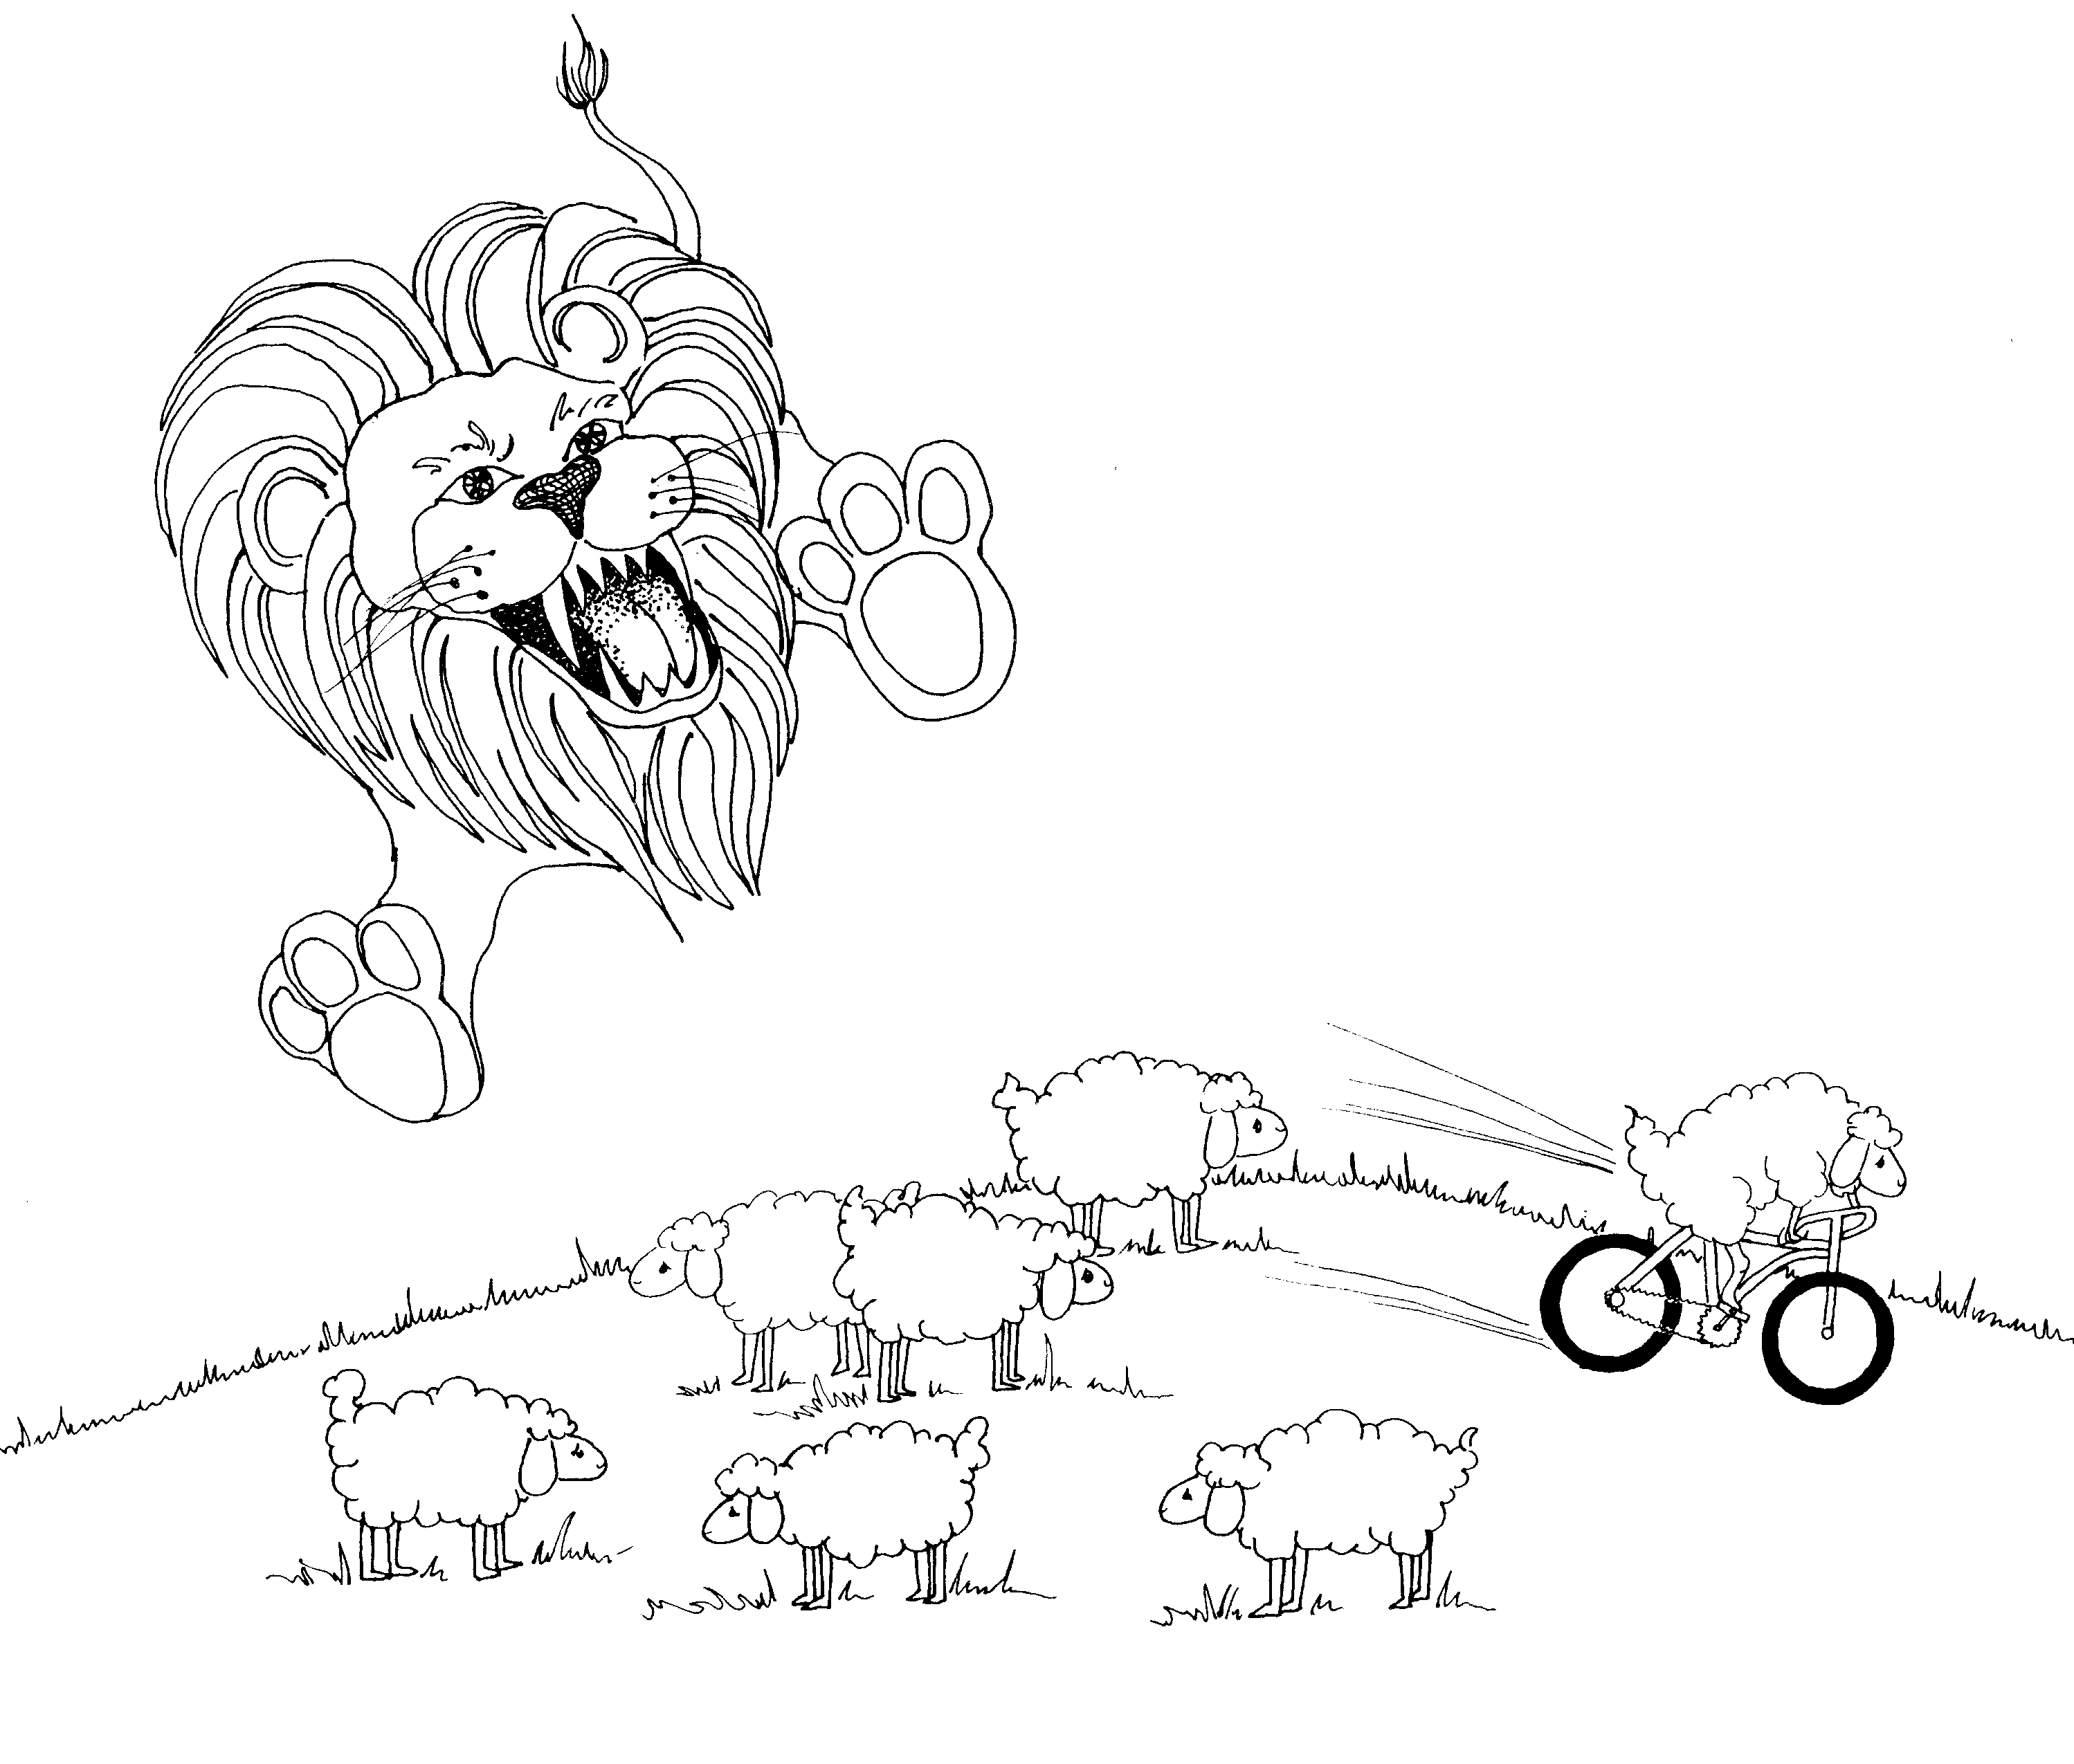
HEBREWS = LION (SUPREMACY OF CHRIST)  1. WORD THROUGH THE SON, CHRIST AND THE ANGELS  1 = Arrow  * WORD THROUGH THE SON: father lion teaching the cub to roar at the lamb  * CHRIST AND THE ANGELS: Cupid angels shooting  arrows at lion to make the lion fall in love with  the lamb (Christ) | 2. ESCAPE? CHRIST LIKE HIS BRETHREN  2 = Bicycle  * ESCAPE? lamb escaping from the lion on the bicycle  * CHRIST LIKE HIS BRETHREN: flock of sheep and  Christ (lamb)
Hebrews 1 - 2
© 2003 Do not reproduce
Hebrews: The Supremacy of Christ

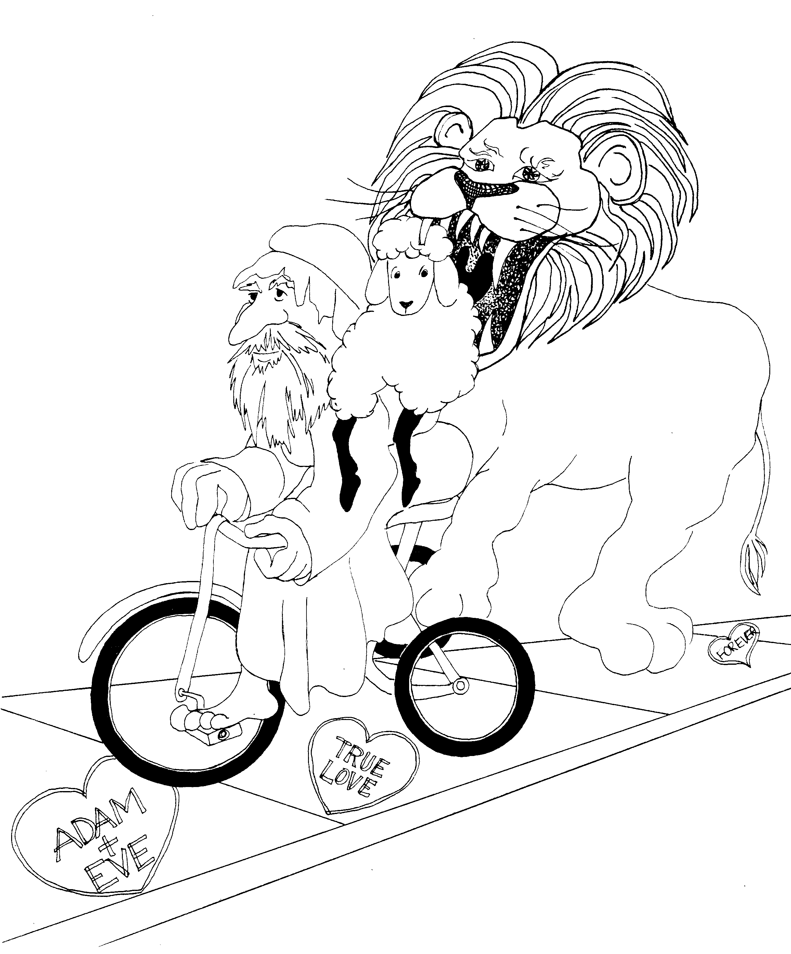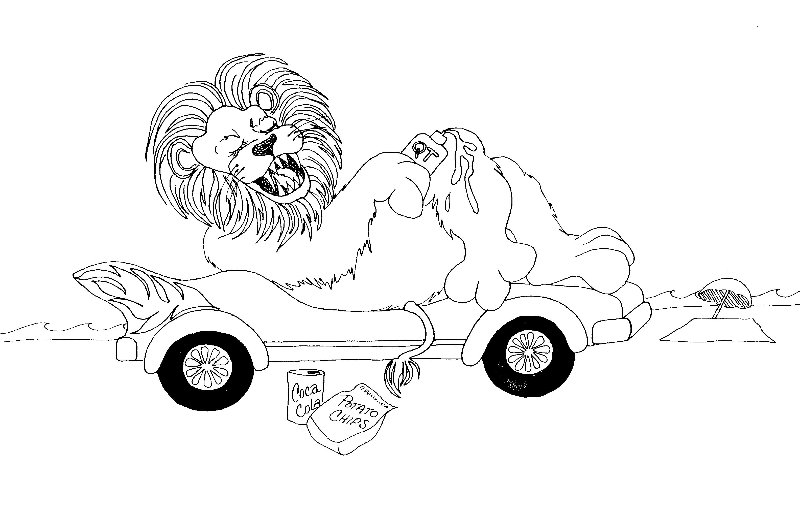

3. CHRIST AND MOSES, HARDENED HEARTS 4. REST

3 = Tricycle 4 = Car (4 wheels)

* CHRIST AND MOSES: Old Moses on tricycle, * REST: lion resting on his car at the beach
lamb (Christ) on his back

* HARDENED HEARTS: hearts drawn in cement on
the sidewalk now hard

Hebrews 3 - 4
© 2003 Do not reproduce
Hebrews: The Supremacy of Christ

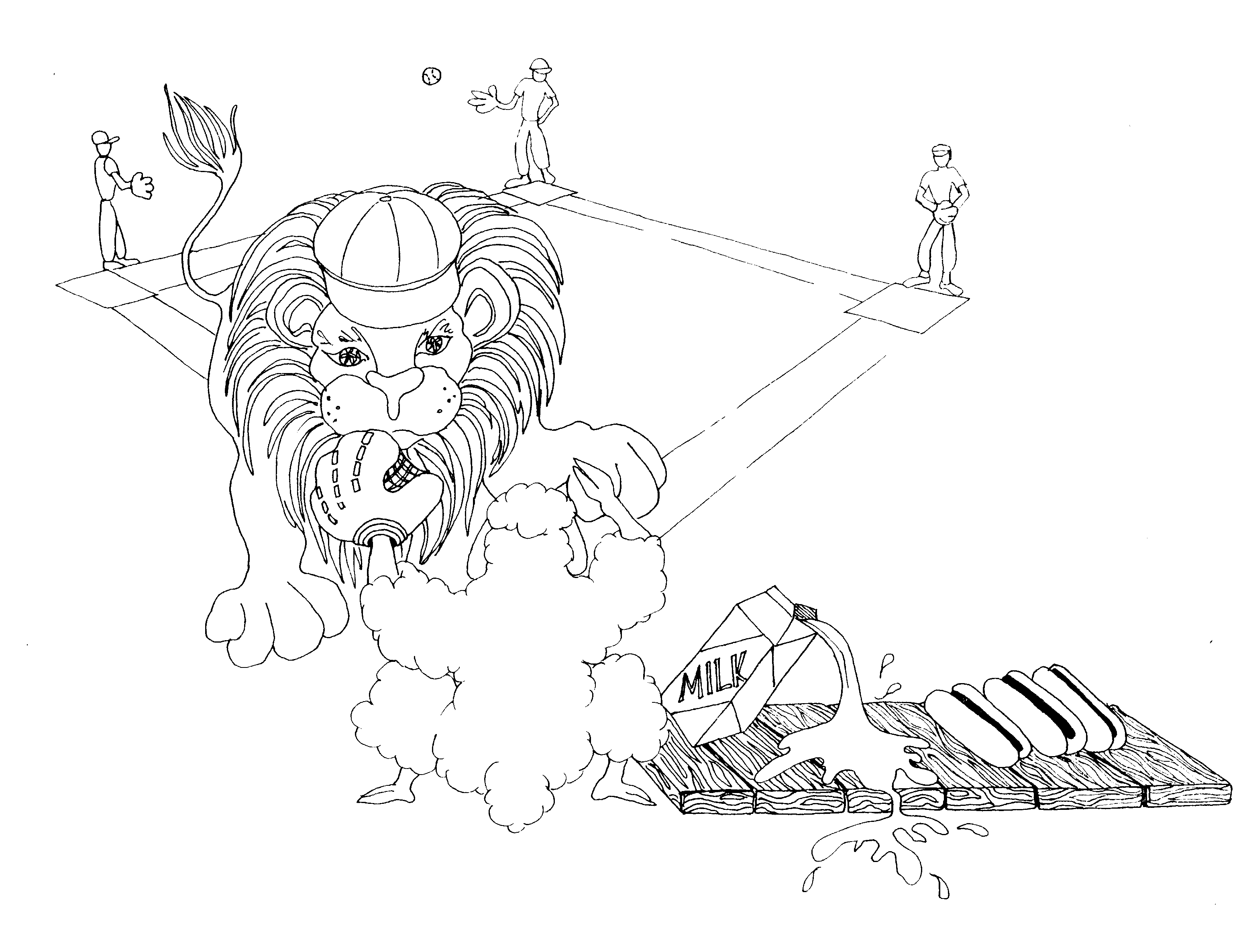 | 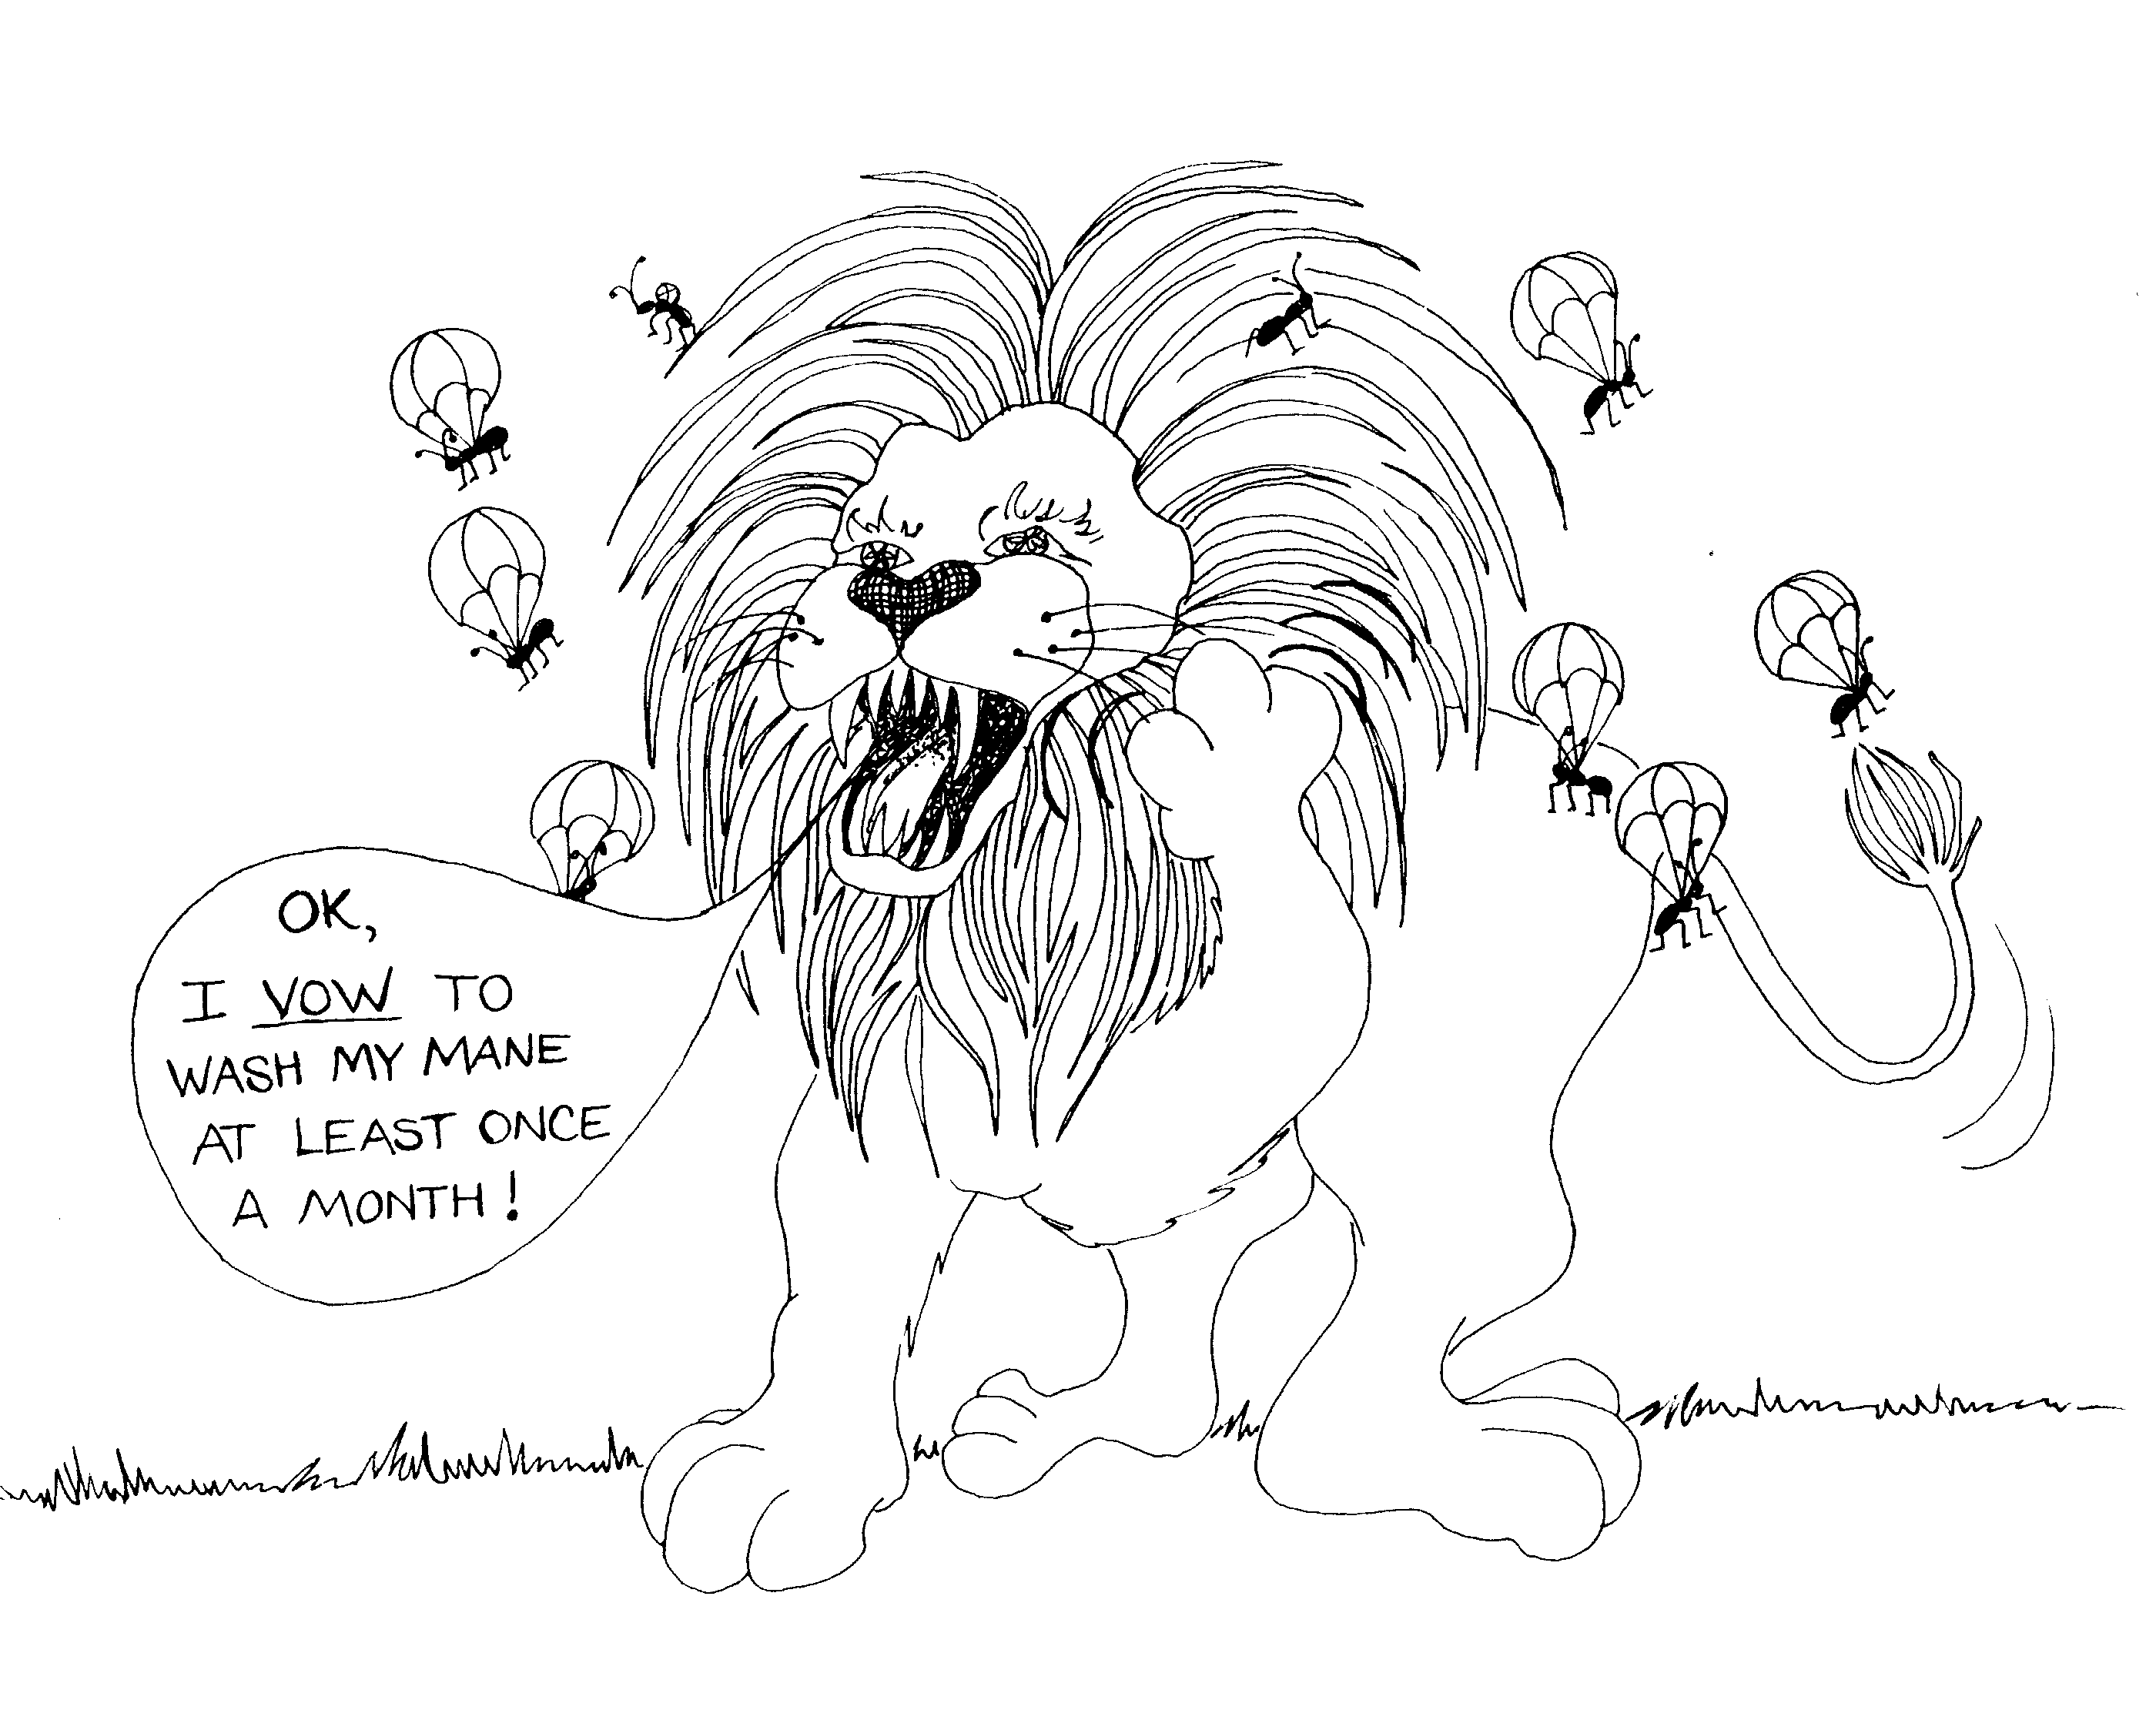
5. CHRIST AND AARON, MELCHIZEDEK,  MILK AND MEAT  5 = Hand (5 fingers)  * CHRIST AND AARON: lamb (Christ) the catcher, 'a run' (Aaron) scored by the lion  * MELCHIZEDEK: 'milk on ze-deck'  * MILK AND MEAT: milk and hotdogs (meat) | 6. FALL AWAY? GOD'S PROMISE  6 = Insect (6 legs)  * FALL AWAY? bugs falling out of the lion's mane  * GOD'S PROMISE: oath by lion that he will wash his mane
Hebrews 5 - 6
© 2003 Do not reproduce
Hebrews: The Supremacy of Christ

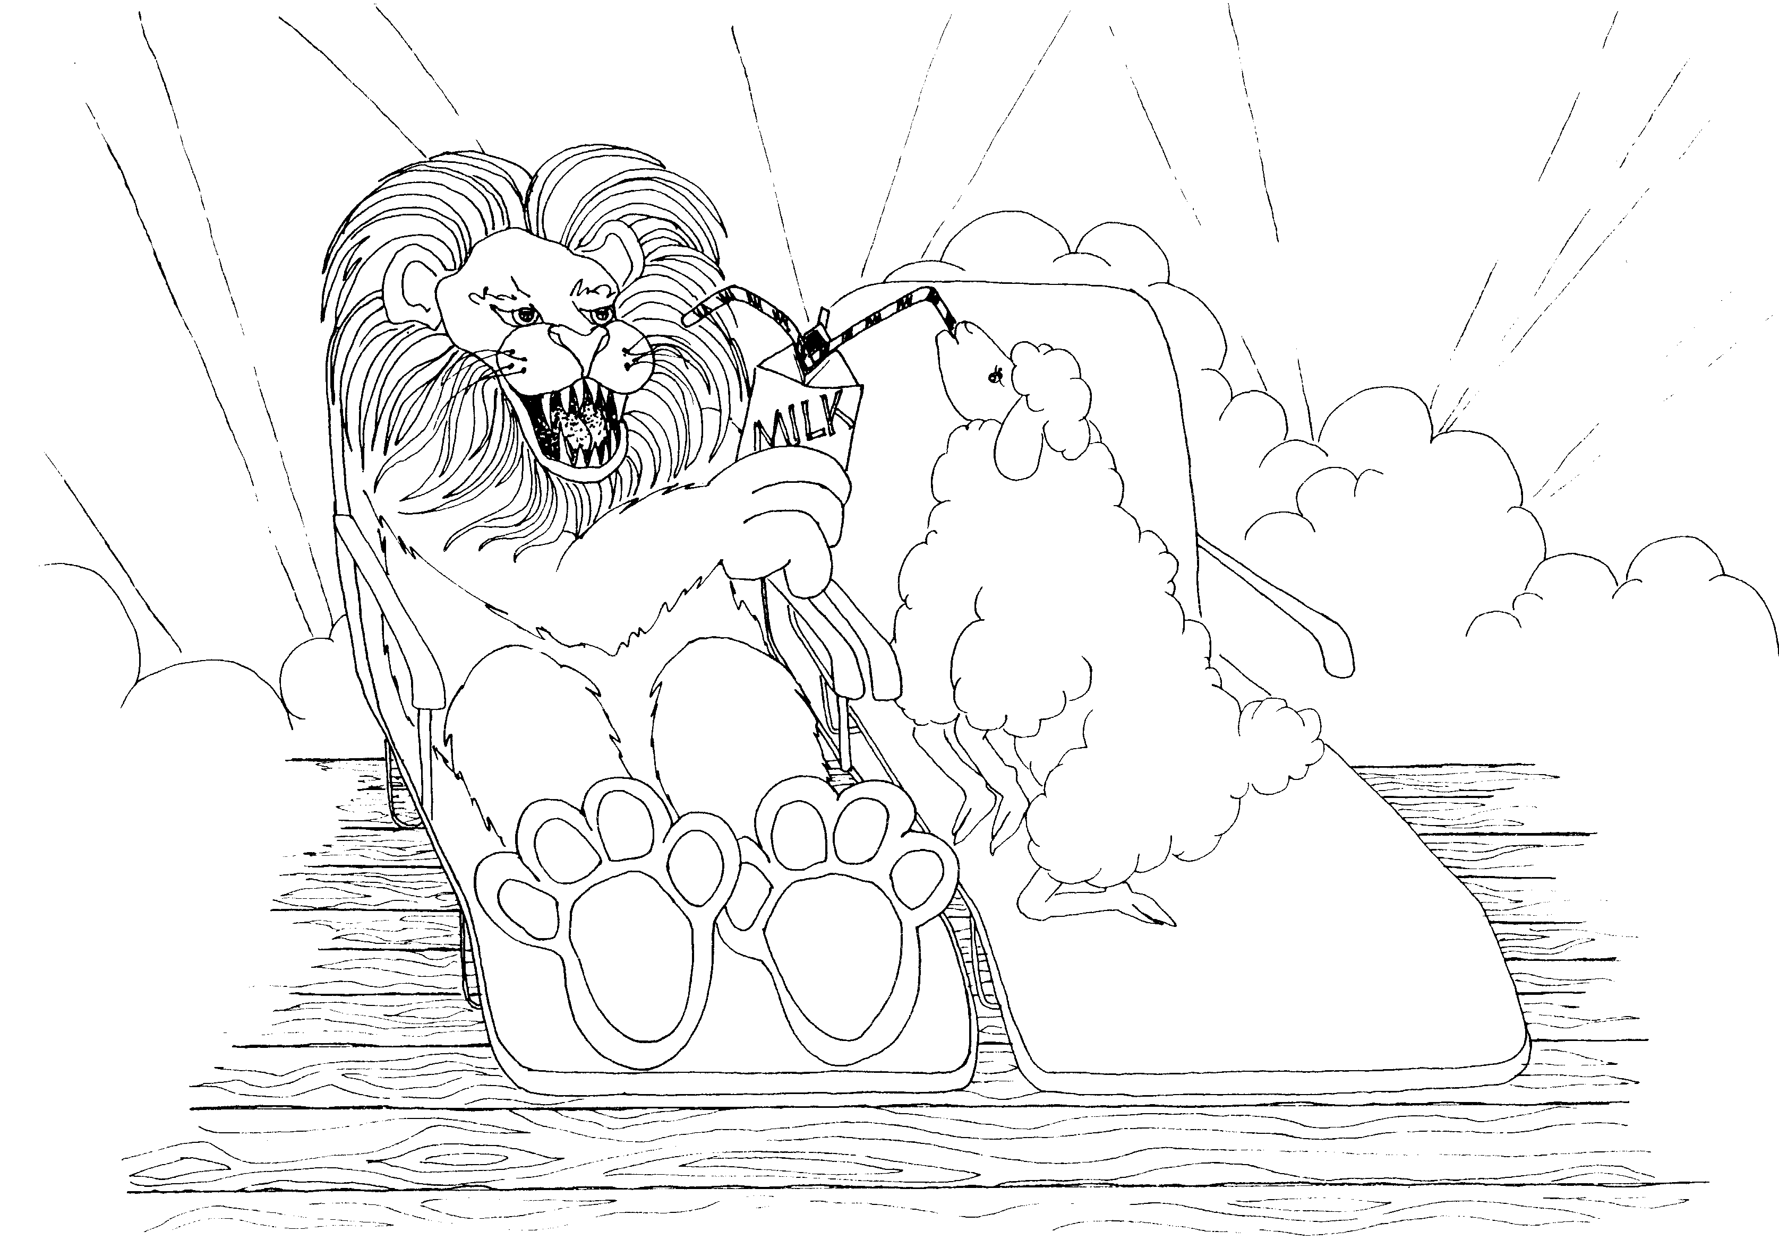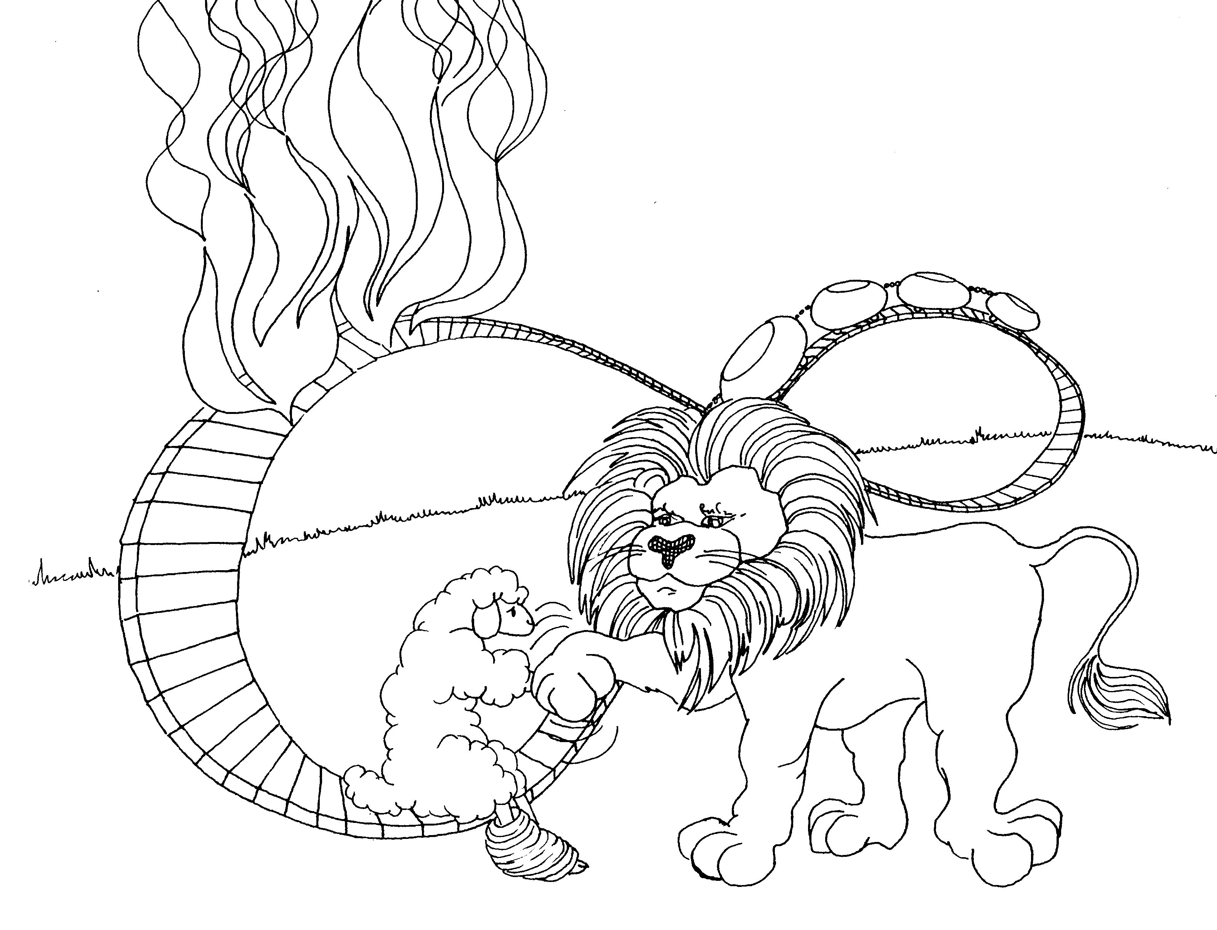

7. CHRIST AND MELCHIZEDEK 8. TABERNACLE AND NEW COVENANT

7 = Heaven (clouds) 8 = Roller coaster is an 8 sideways

* CHRIST AND MELCHIZEDEK: Christ having * TABERNACLE AND NEW COVENANT: 'taped burnt
'milk on ze deck' with the lion ankle' (tabernacle); lion and lamb making a
treaty or covenant to rebuild the roller coaster

Hebrews 7 - 8
© 2003 Do not reproduce
Hebrews: The Supremacy of Christ

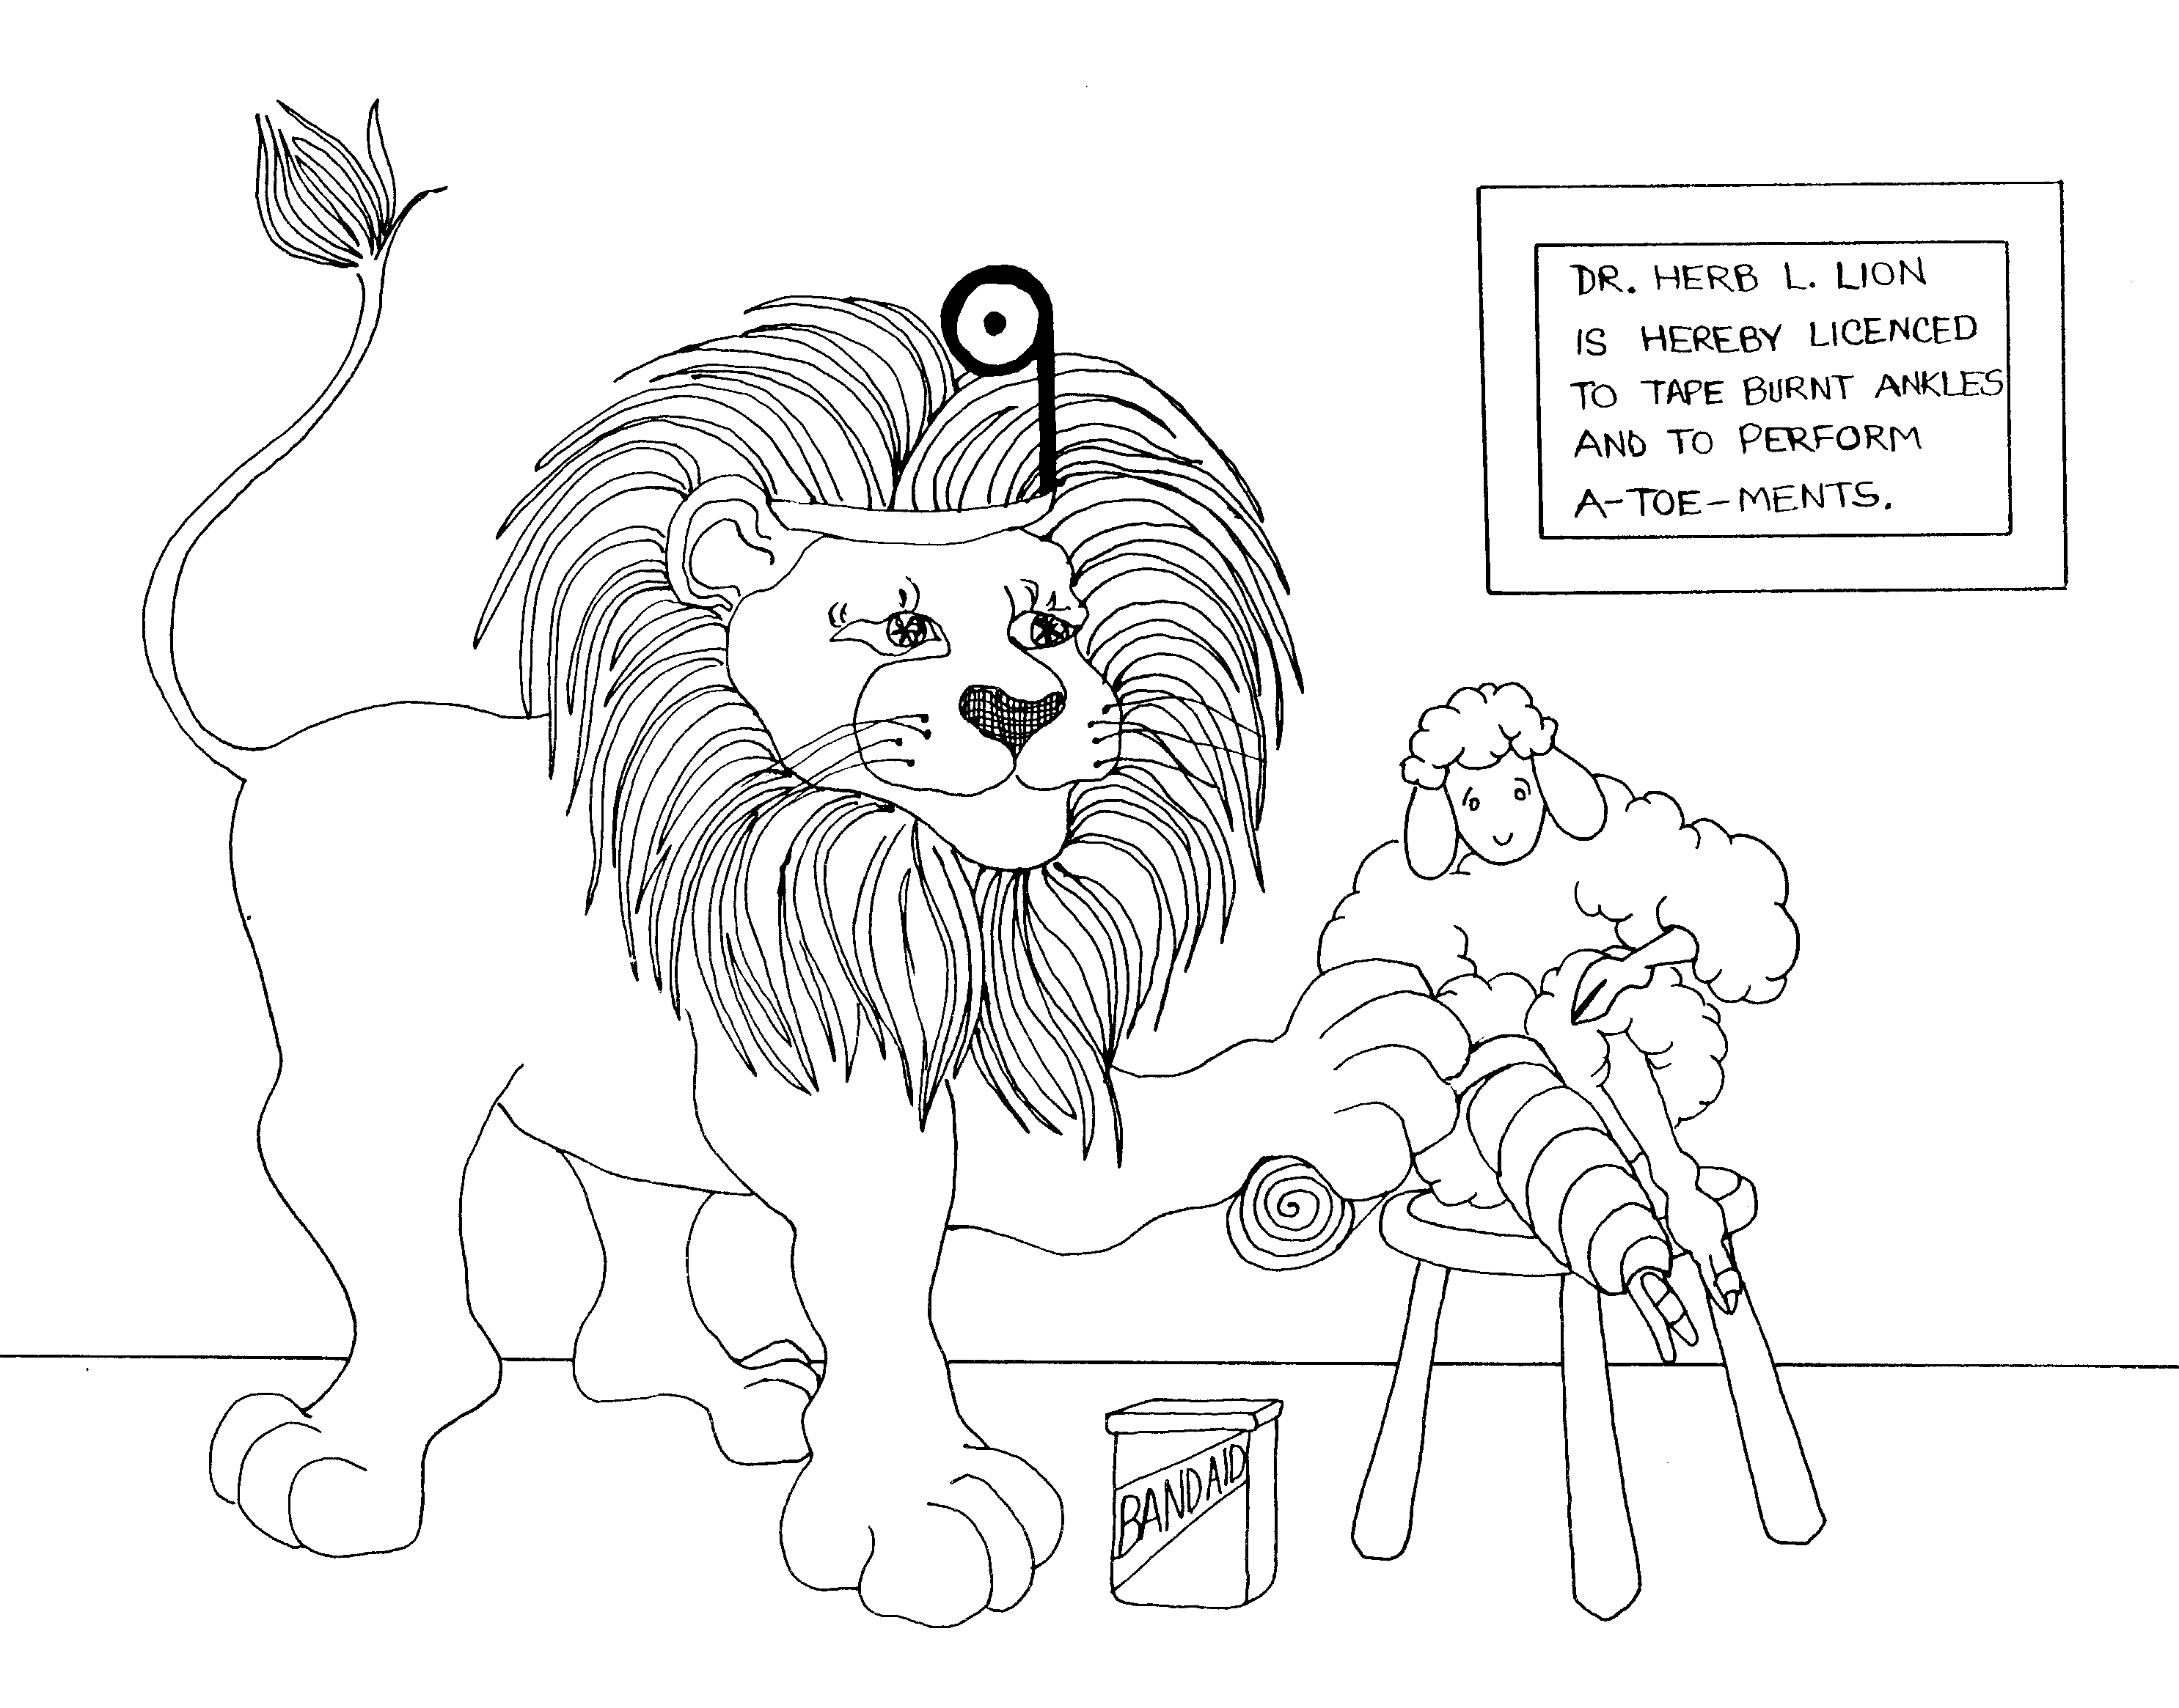 | 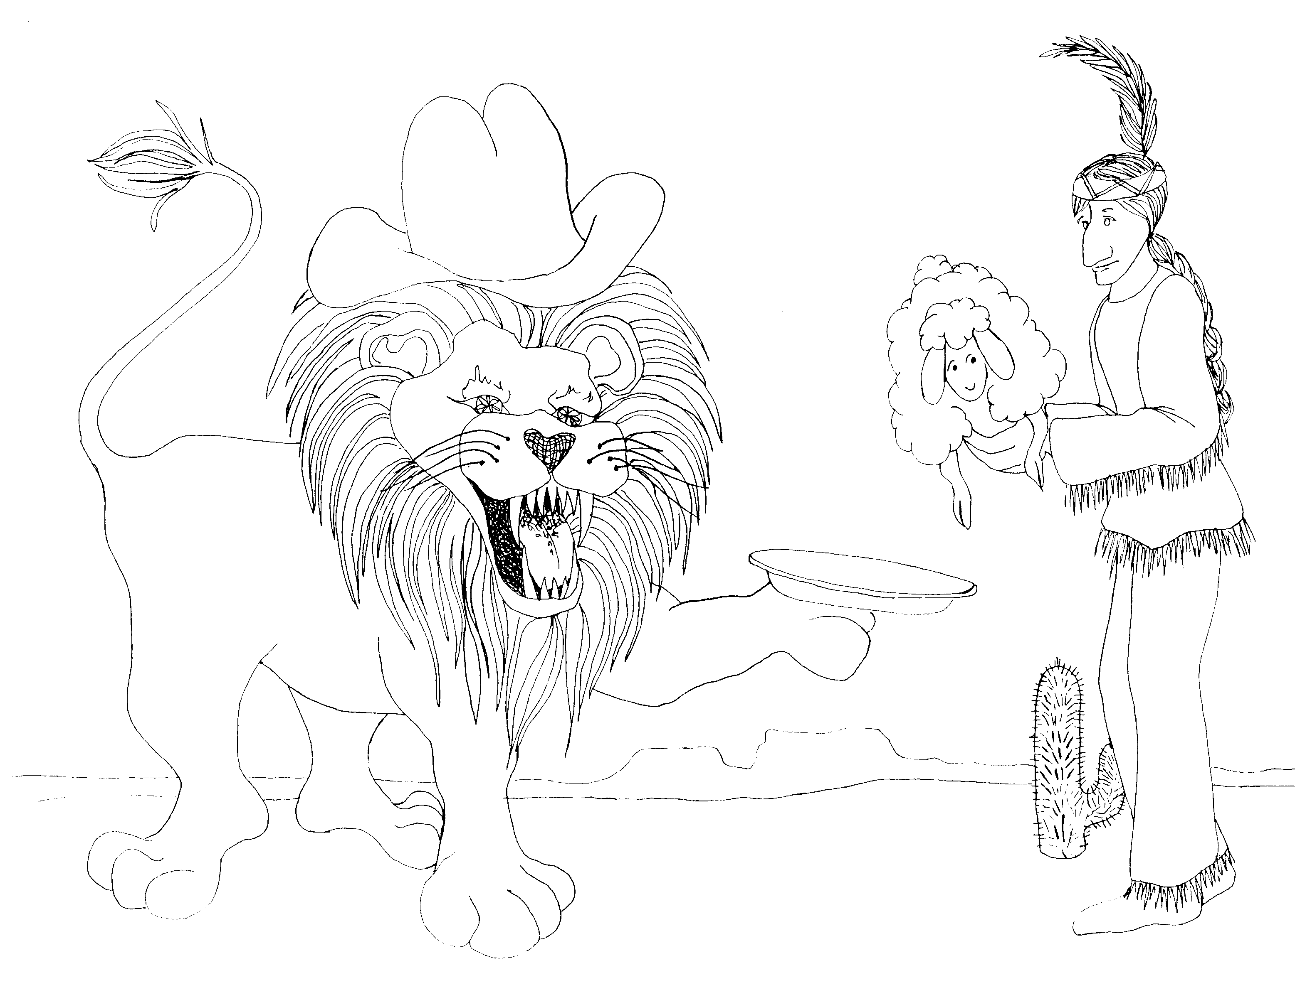
9. TABERNACLE, CHRIST'S BLOOD ATONEMENT  9 = Doctor's mirror looks like a 9  * TABERNACLE: 'taped burnt ankle' (tabernacle)  * CHRIST'S BLOOD ATONEMENT: blood from Christ's (lamb's) toe (a toe-ment) | 10. CHRIST AND OFFERINGS, TURNING AWAY  10 = Ten little Indians  * CHRIST AND OFFERINGS: Indian offering lamb (Christ)  * TURNING AWAY: Indian turning head away not wanting  to see the end of the lamb
Hebrews 9 - 10
© 2003 Do not reproduce
Hebrews: The Supremacy of Christ

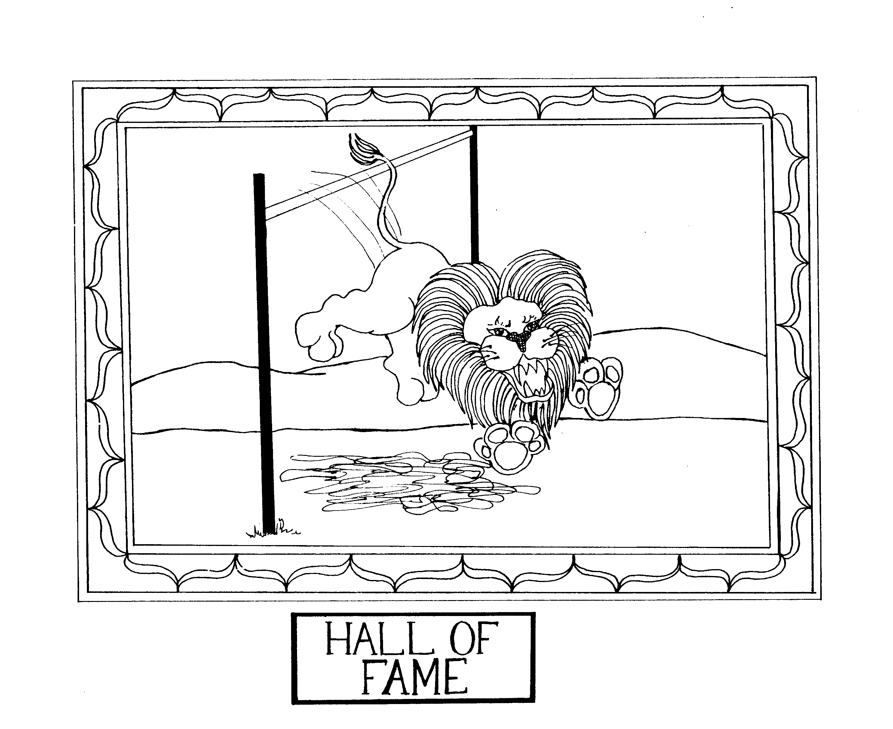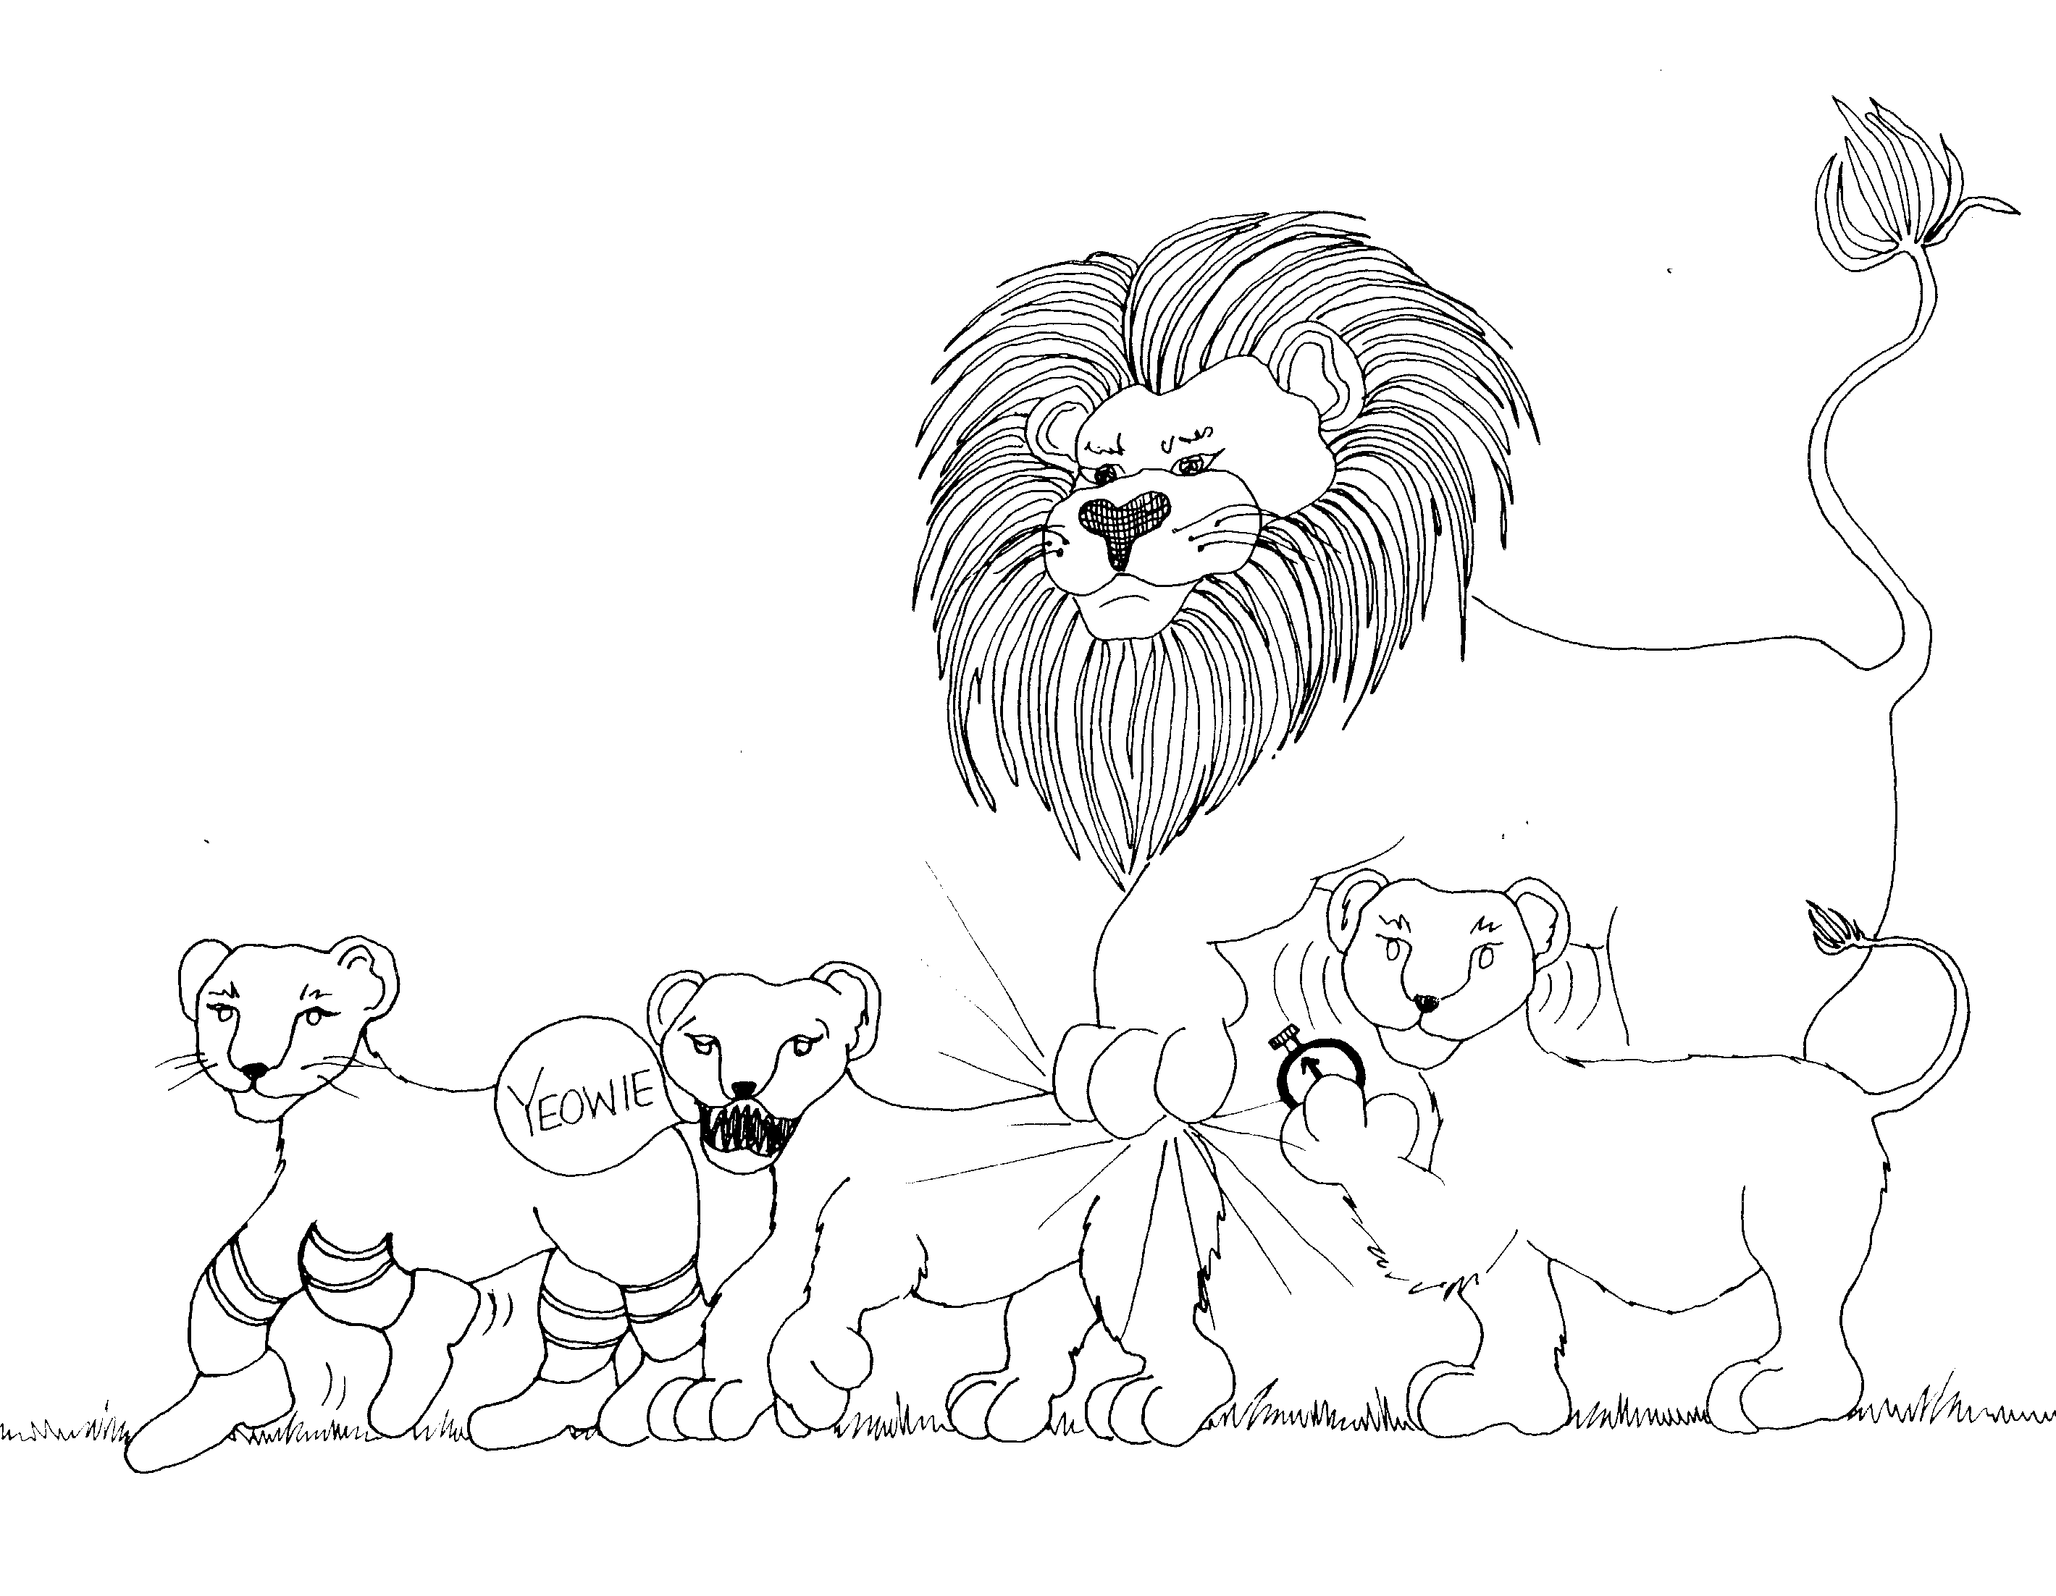

11. HALL OF FAITH 12. ENDURANCE, DISCIPLINE OF SONS, NOT REFUSAL

11 = Pole vault posts (two ones) 12 = clock (12 o'clock)

* HALL OF FAITH: hall of fame photo of the lion high * ENDURANCE: first cub in marathon race has endurance
jump
* DISCIPLINE OF SONS: Second cub being disciplined
by his father because he forgot his running shoes

* NOT REFUSAL: third cub refusing to run
(shaking head "no")

Hebrews 11 - 12
© 2003 Do not reproduce
Hebrews: The Supremacy of Christ

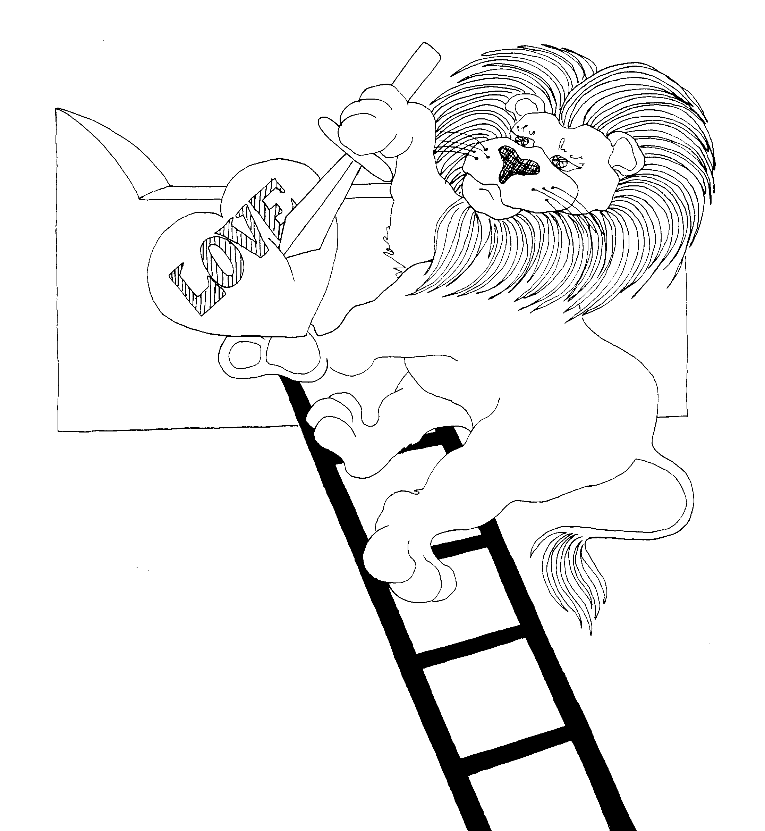
13. SACRIFICES OF LOVE
13 = Ladder (unlucky number)
* SACRIFCES OF LOVE: lion sacrificing his heart
on the altar

Hebrews 13
© 2003 Do not reproduce

