GALATIANS - COLOSSIANS

GALATIANS

1. Paul's call, Apostasy
2. Paul and the pillars, Conflict with Peter
3. Abraham's faith, Law: curse and promise
4. Servants and sons, Sarah and Hagar
5. Against circumcision, Fruit of the flesh, Fruit of the Spirit
6. Practicing liberty

EPHESIANS

1. Election, Spirit's guarantee, Christ's headship
2. Death to life by grace, Peace by cross, Christ - cornerstone
3. Church - mystery, Gentiles saved,
Understanding God's love
4. Unity, Church equipped, Old and new man
5. Deeds of darkness, Spirit filling, Husband and wife
6. Parent - child, Master - slave, Spiritual armor

PHILIPPIANS

1. Thanksgiving, Gospel chains
2. Christ's humility, Timothy and Epaphroditus sent
3. Paul's 'righteousness', Pressing for the prize
4. Unity, Rejoice, Philippians generosity

COLOSSIANS

1. Colossians' love, Christ's work, Paul's labor
2. Fullness in Christ, Against regulations
3. Old and new man, Family relations, Master - servant
4. Instructions, Greetings

Memory Verses: Gal. 3:24; 6:9
Eph. 2:8, 9; 4:14, 15
Phil. 1:21; 3:13, 14; 4:13
Col. 2:8,9; 3:16, 17

Galatians

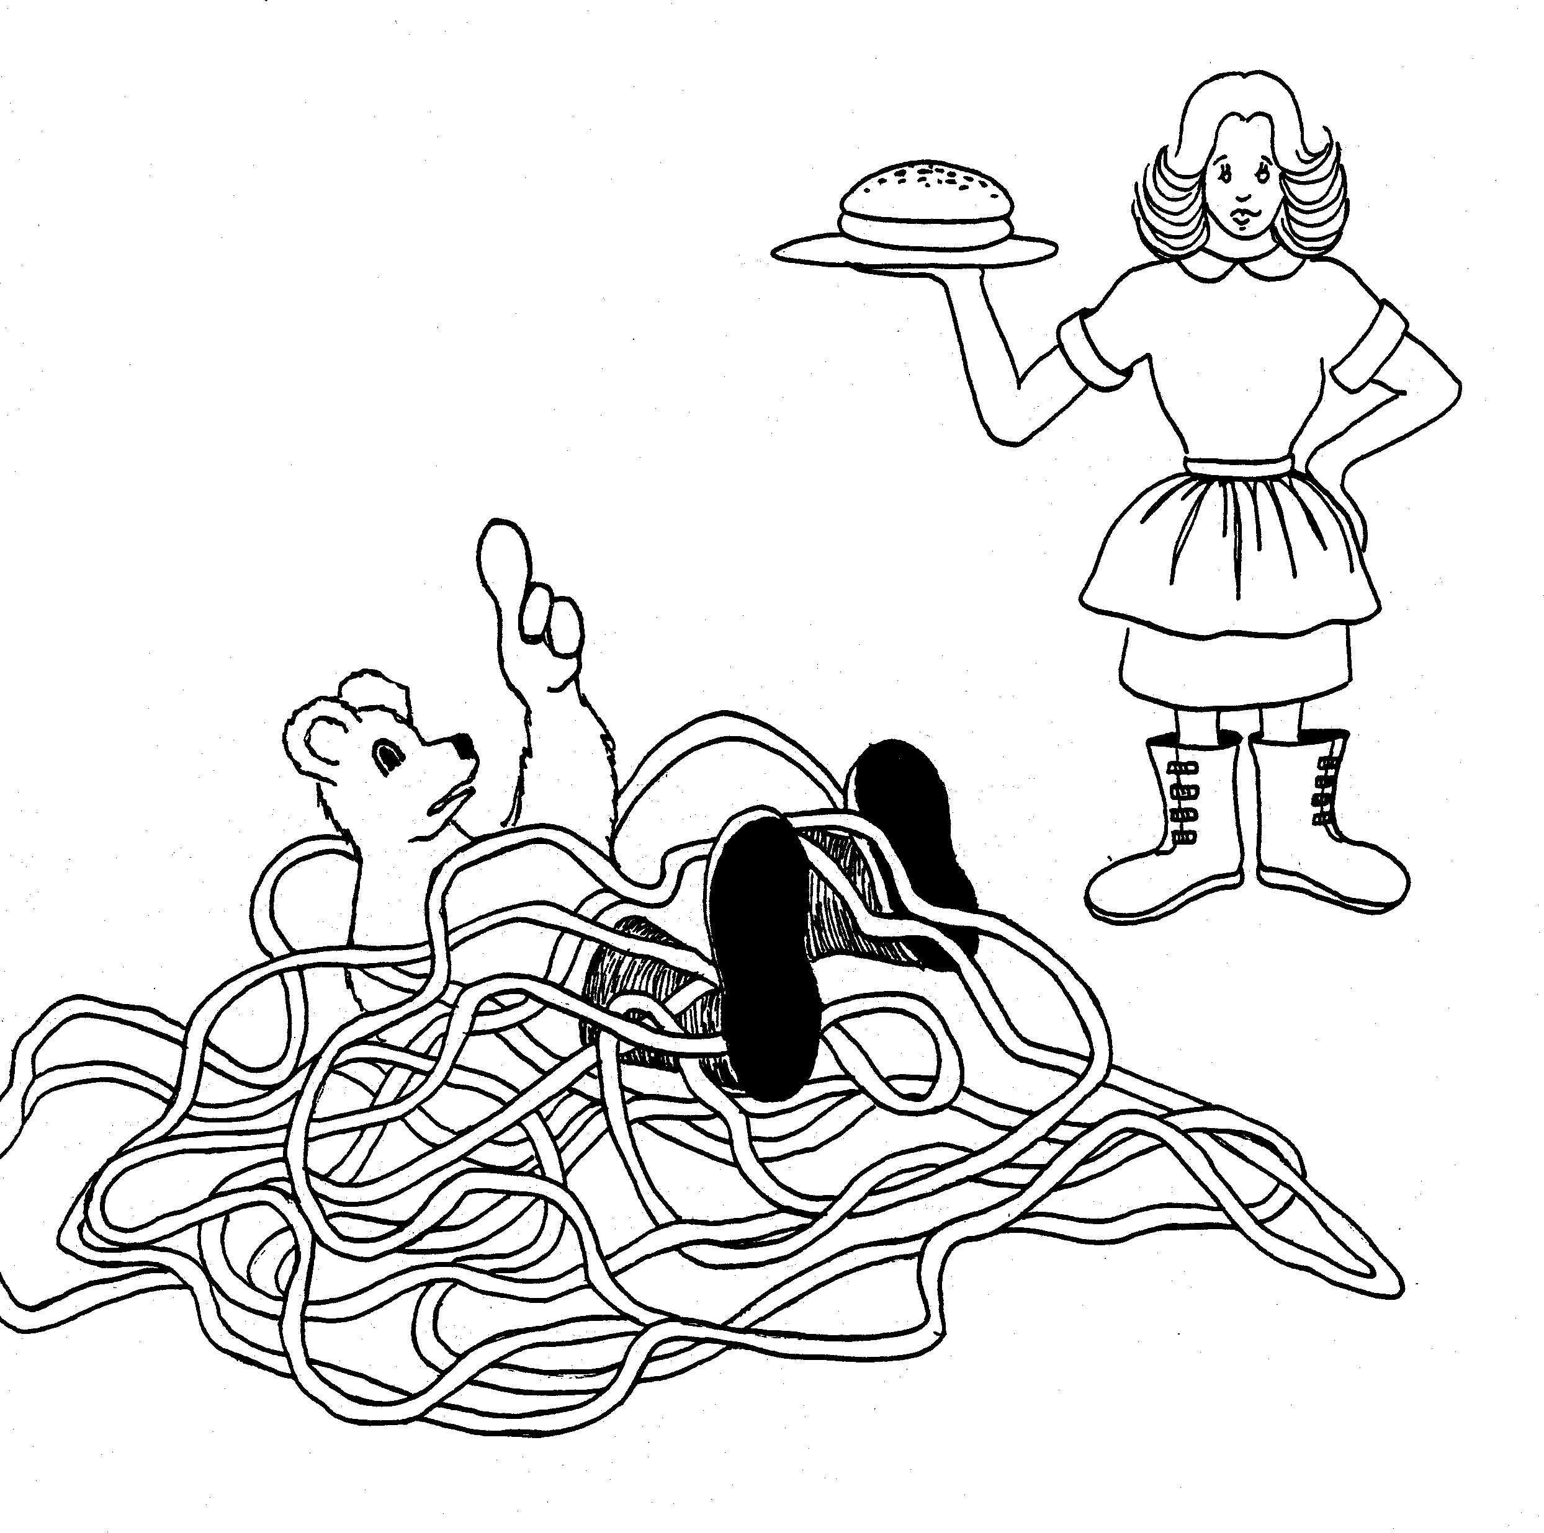 | 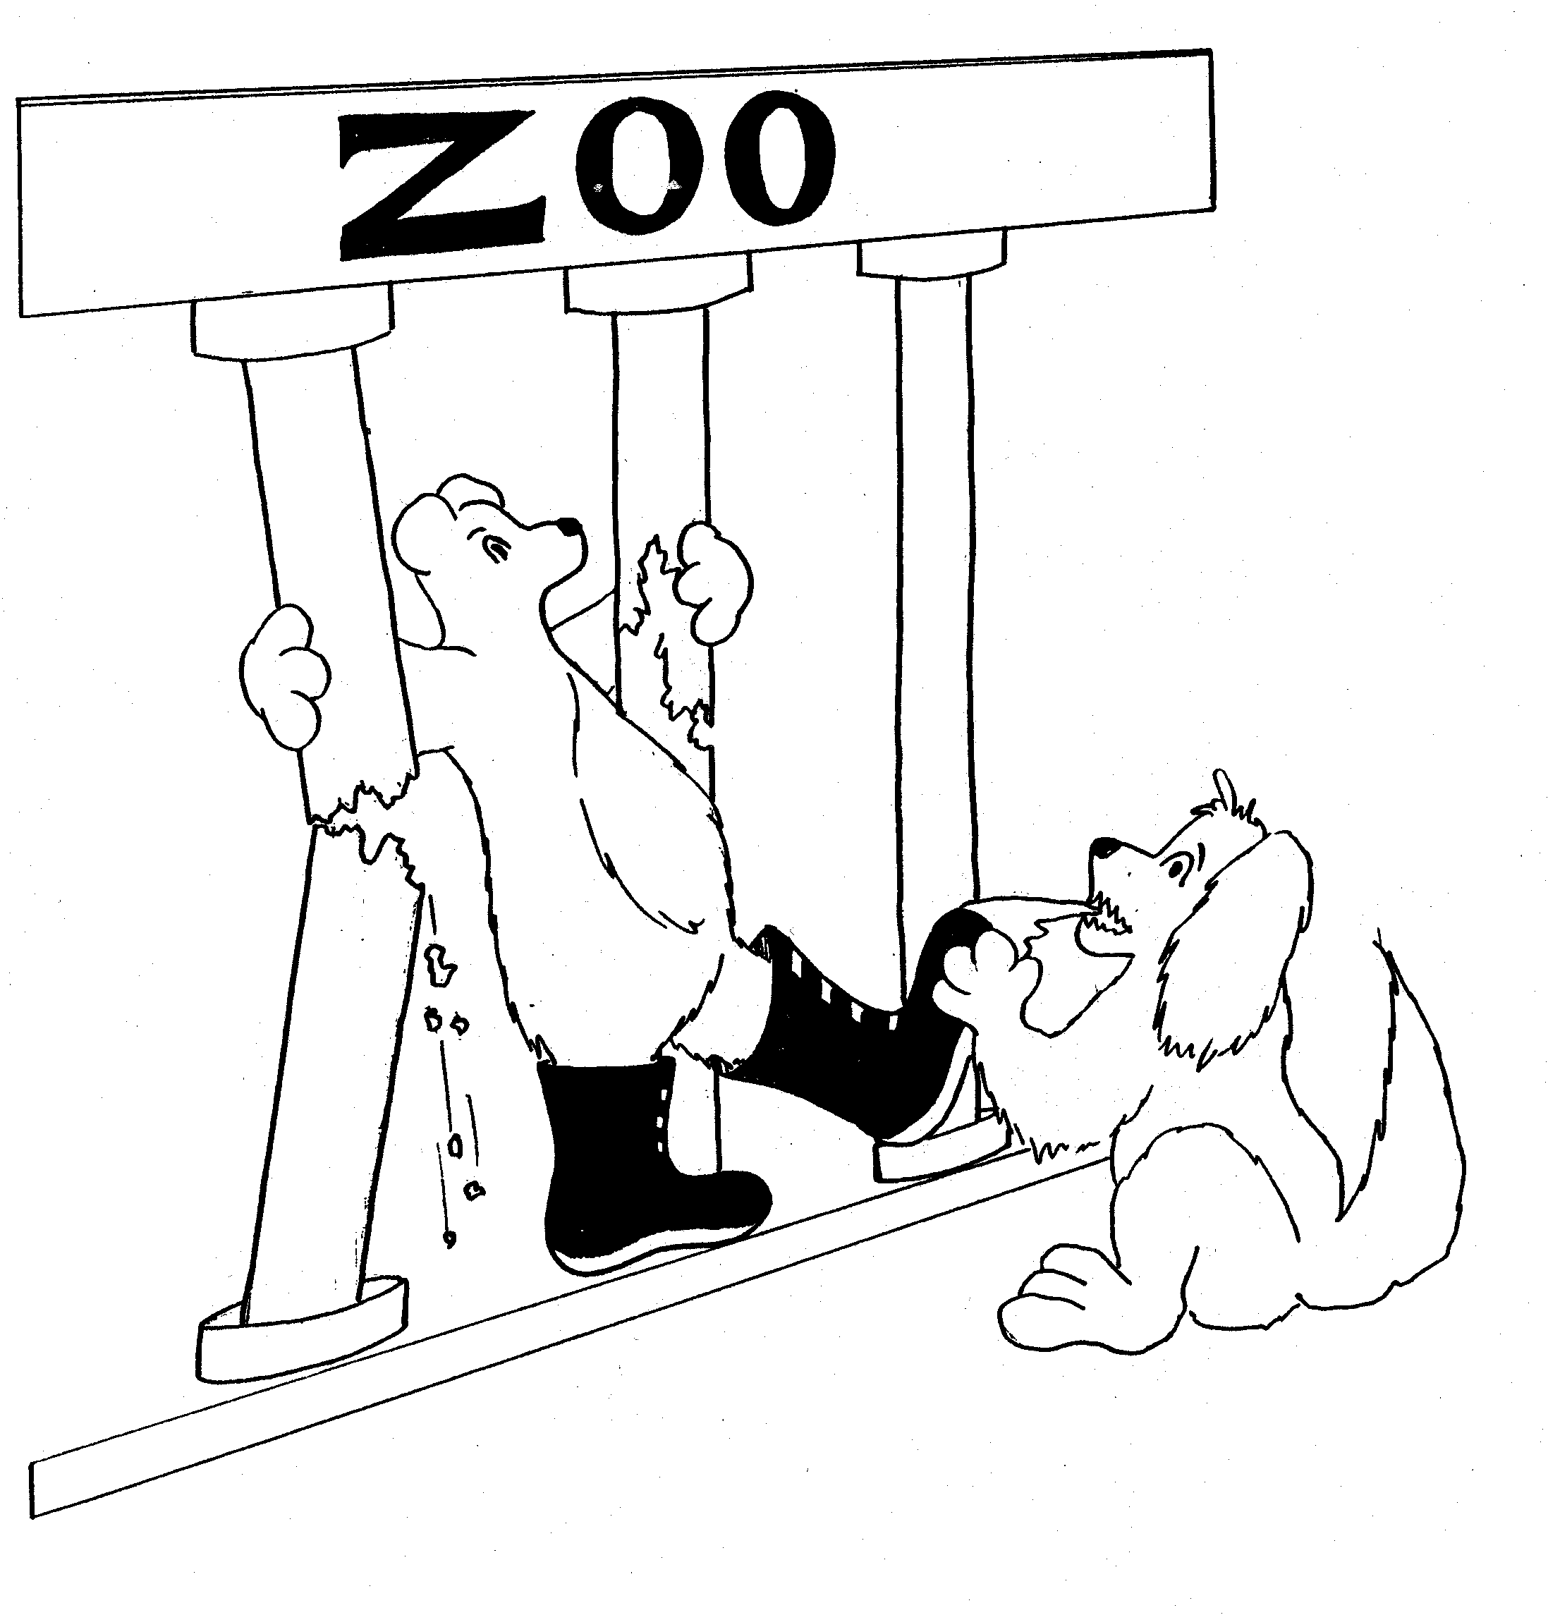
GALATIANS = GALOSHES BOOTS  1. PAUL'S CALL, APOSTASY  1 = Bun (rhyme)  * PAUL'S CALL: Paul (bear) calling waitress for a bun  * APOSTASY: a sea of pasta, (a pasta sea) | 2. PAUL AND THE PILLARS, CONFLICT WITH PETER  2 = Zoo (rhyme)  * PAUL AND THE PILLARS: Paul (hear) holding pillars  so he can brace himself  * CONFLICT WITH PETER: dog (Peter) pulling at  Paul's (bear) boot
Galatians 1 - 2
© 2003 Do not reproduce
Galatians

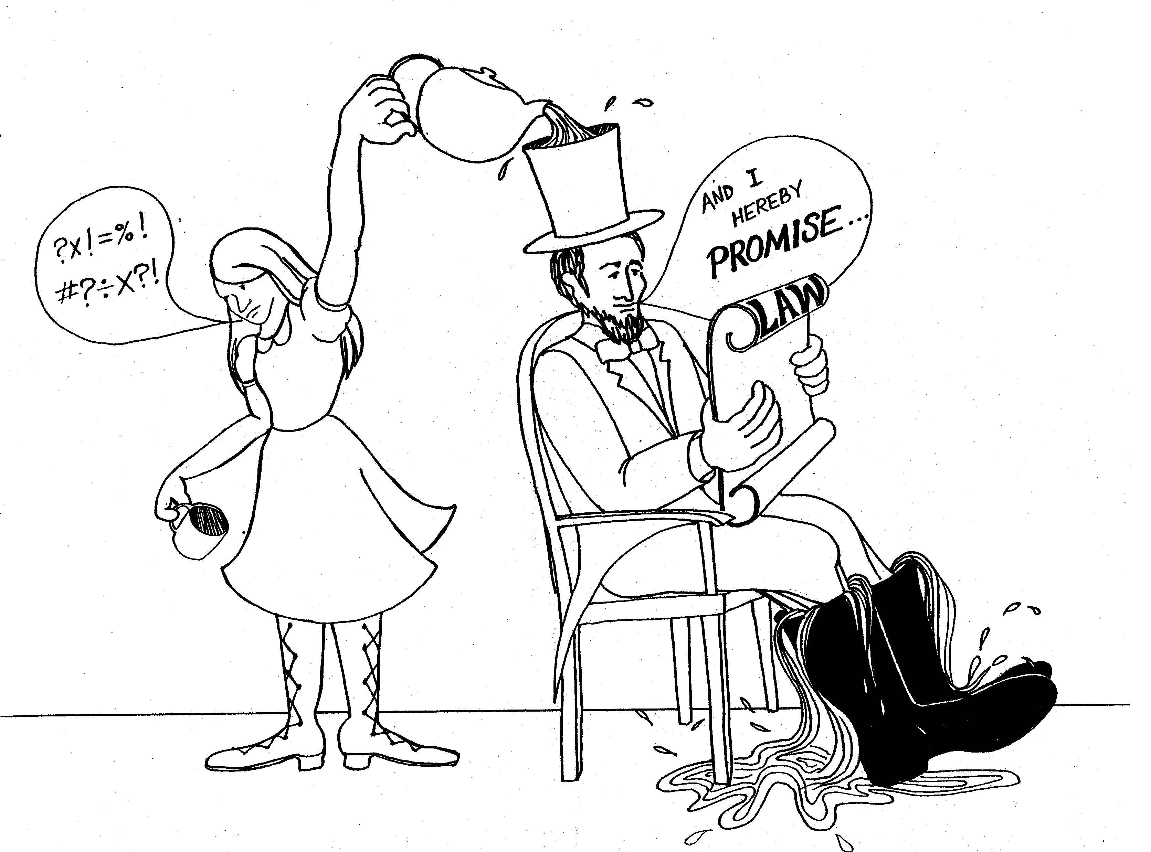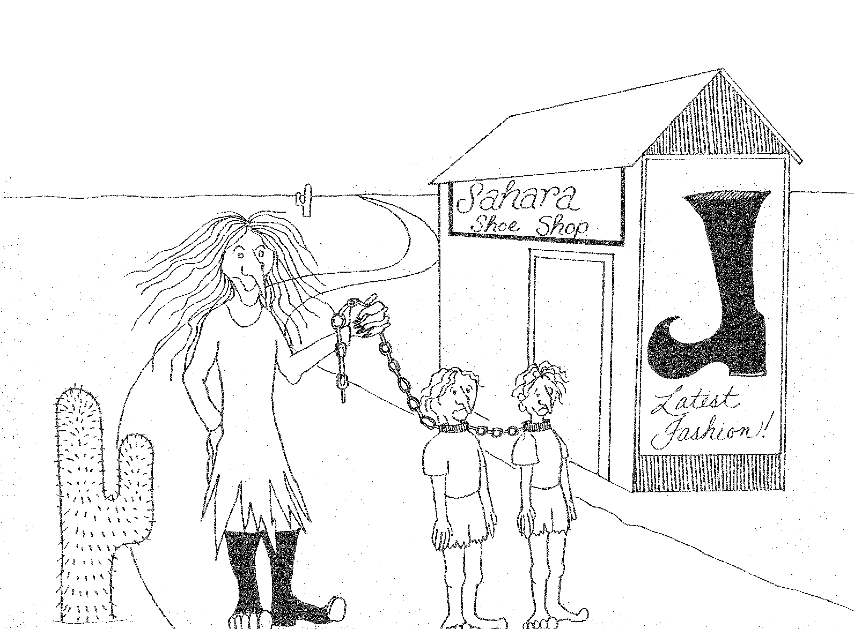

3. ABRAHAMS FAITH, LAW: CURSE AND PROMISE 4. SERVANTS AND SONS, SARAH AND HAGAR

3 = Tea (rhyme) 4 = Store (rhyme)

* ABRAHAM'S FAITH: Abraham Lincoln and his * SERVANTS AND SONS: 'Hag' has made her own sons
servant Faith slaves

* LAW: CURSE AND PROMISE: Abraham reading * SARAH AND HAGAR: Sahara desert scene, woman is
the law and making promises to Faith about a 'Hag' (Hagar), they've come for new shoes at
freeing her, she's cursing because he hasn't Sarah's Shoe shop (Sarah)
done it yet
Galatians 3-4
© 2003 Do not reproduce
Galatians

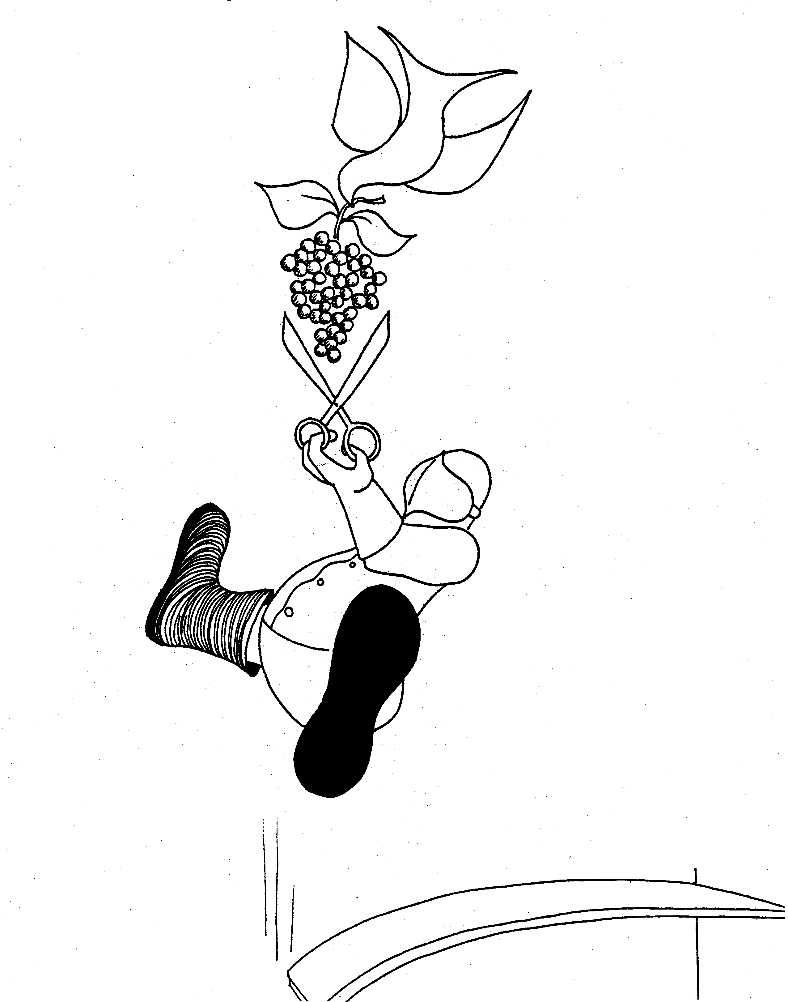 | 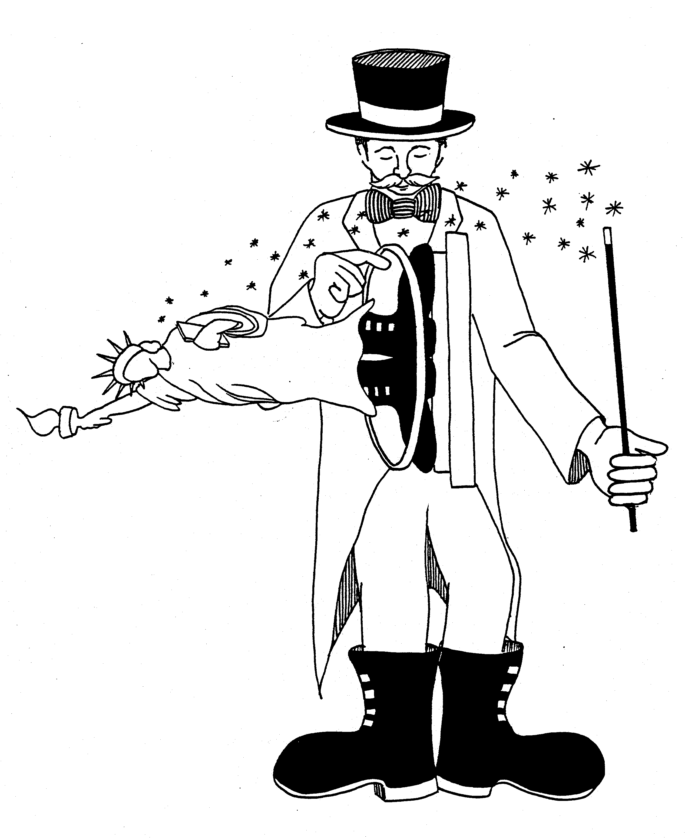
5. AGAINST CIRCUMCISION,  FRUIT OF THE FLESH, FRUIT OF THE SPIRIT  5 = Dive (rhyme)  * AGAINST CIRCUMCISION: dove against  "Sir-dumb-Cision" for grapes  * FRUIT OF THE FLESH: Sir-Dumb-Cision is fat  (fruit of the flesh)  * FRUIT OF THE SPIRIT: Grapes are fruit of the Spirit  (dove) | 6. PRACTICING LIBERTY  6 = Tricks (rhyme)  * PRACTICING LIBERTY: magician practicing levitation on  statue of liberty. Gets caught on his galoshes
Galatians 5 - 6
© 2003 Do not reproduce
Ephesians

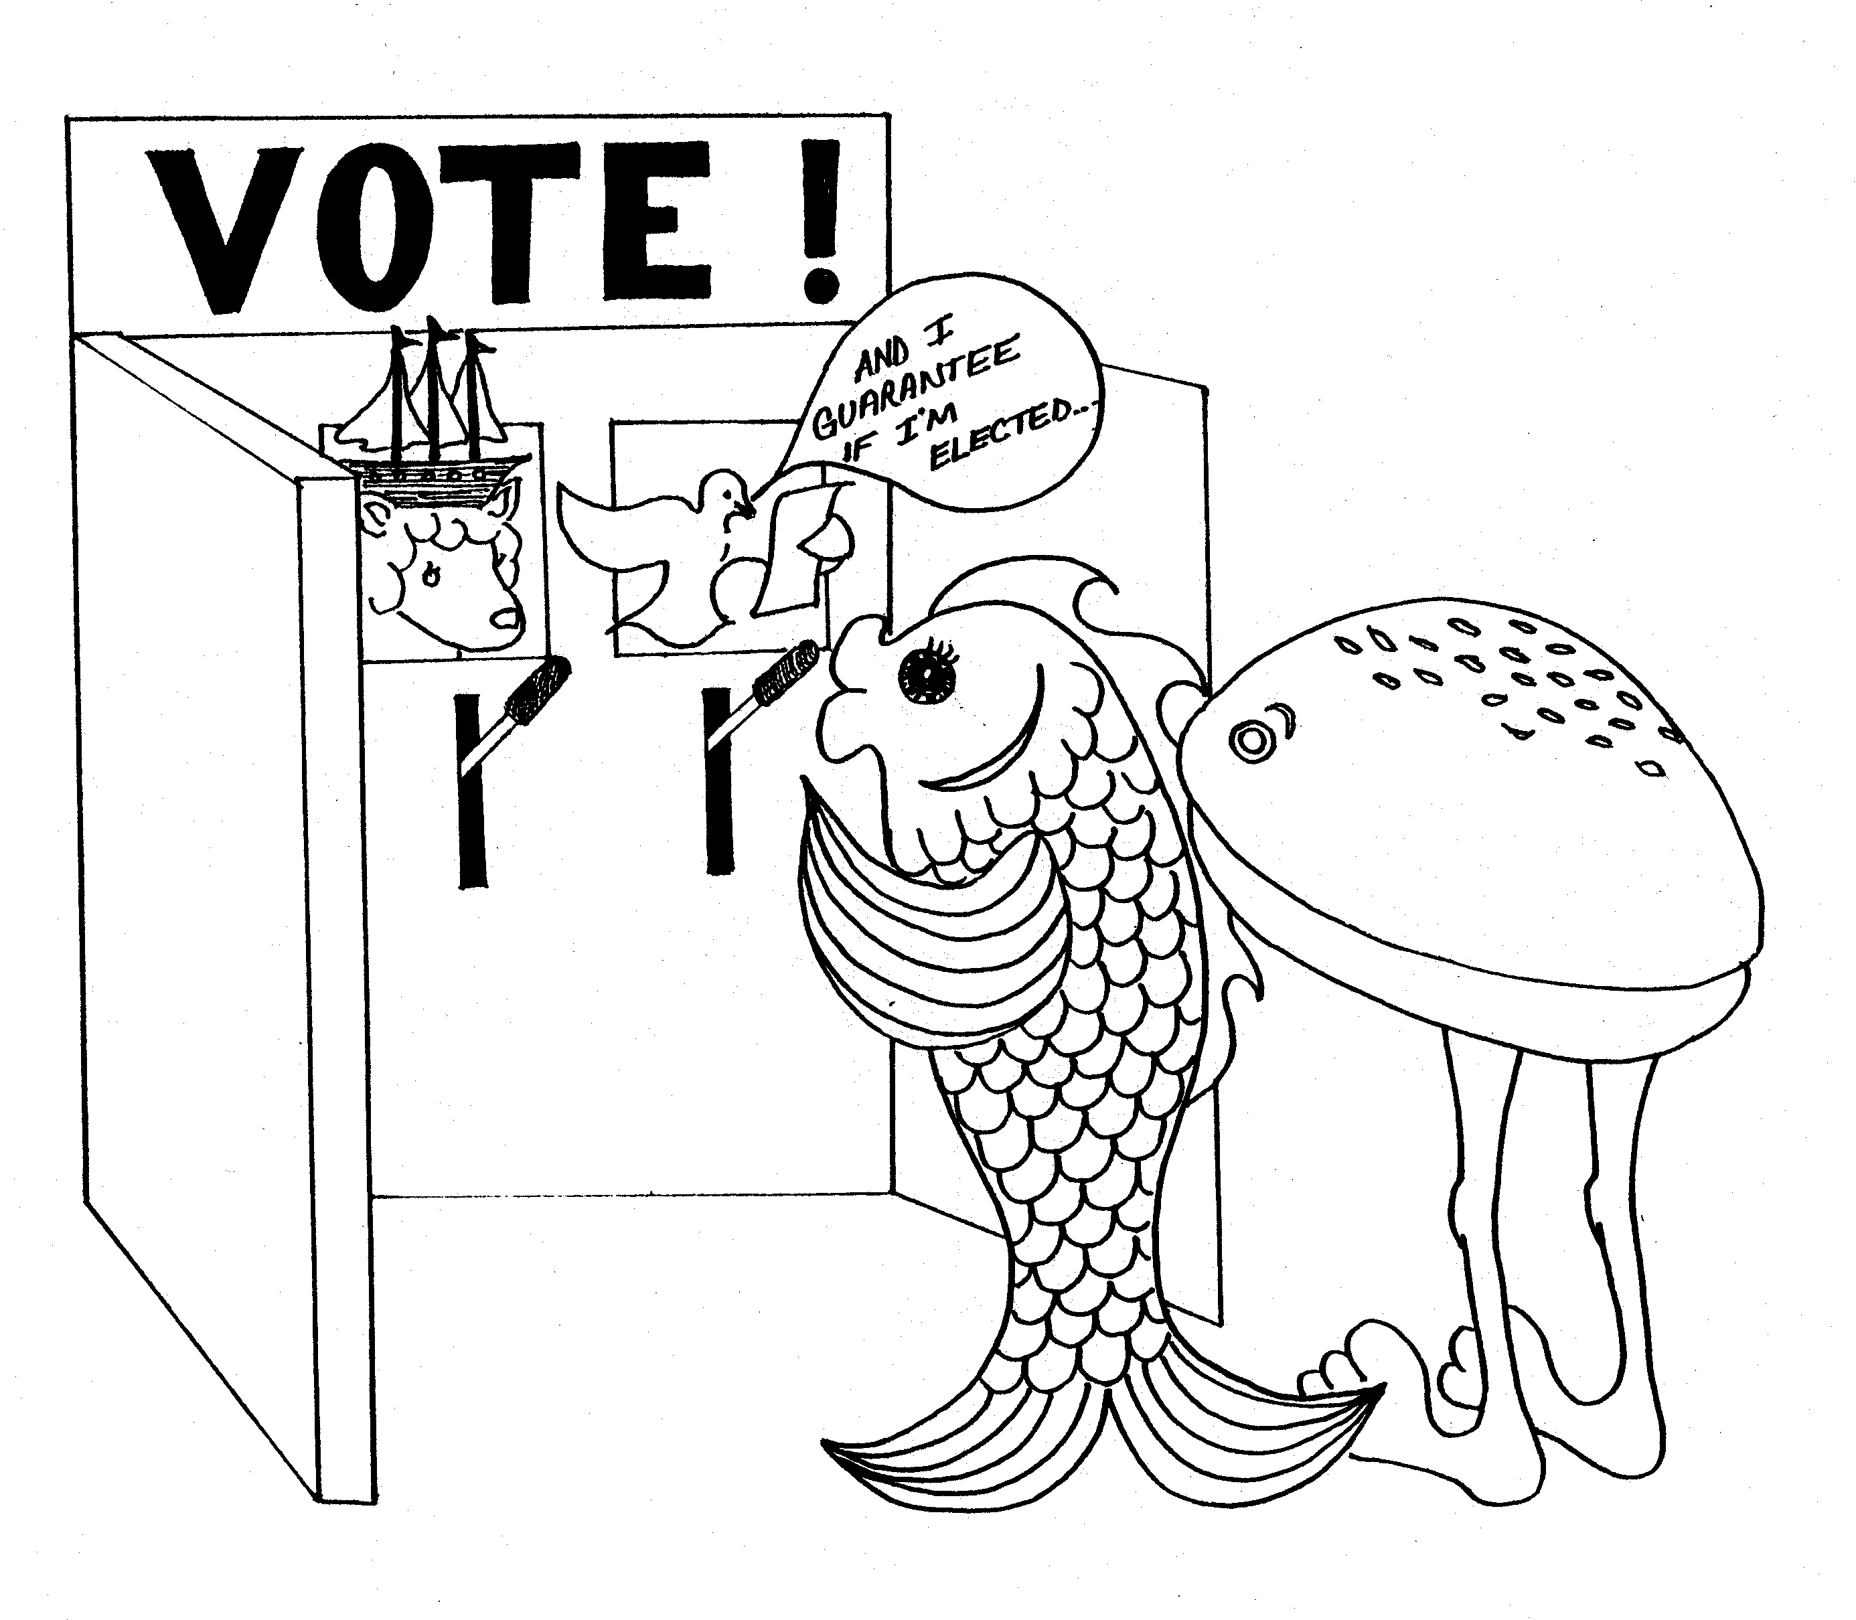 | 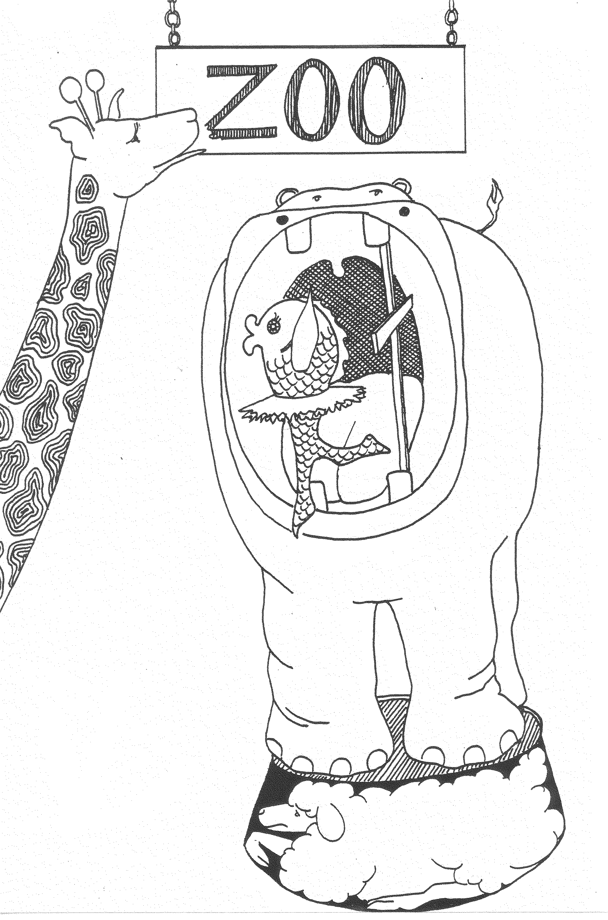
EPHESIANS = He-Fishians (Fish)  1. ELECTION, SPIRIT'S GUARANTEE,  CHRIST'S HEADSHIP  1 = Bun (rhyme)  * ELECTION: voting booth for foods, either lamb or dove  * SPIRIT'S GUARANTEE: Spirit (dove) making a  campaign promises or guarantee  * CHRIST'S HEADSHIP: lamb (Christ) wearing ship  as hat (head-ship) | 2. DEATH TO LIFE BY GRACE, PEACE BY CROSS,  CHRIST - CORNERSTONE  2 = Zoo (rhyme)  * DEATH TO LIFE BY GRACE: gracefully dancing right  out of hippo's mouth (death)  * PEACE BY CROSS: cross holding hippo's mouth open  stopping him from getting a "piece" (peace)  * CHRIST - CORNERSTONE: lamb (Christ) as the  cornerstone
Ephesians 1 - 2
© 2003 Do not reproduce
Ephesians

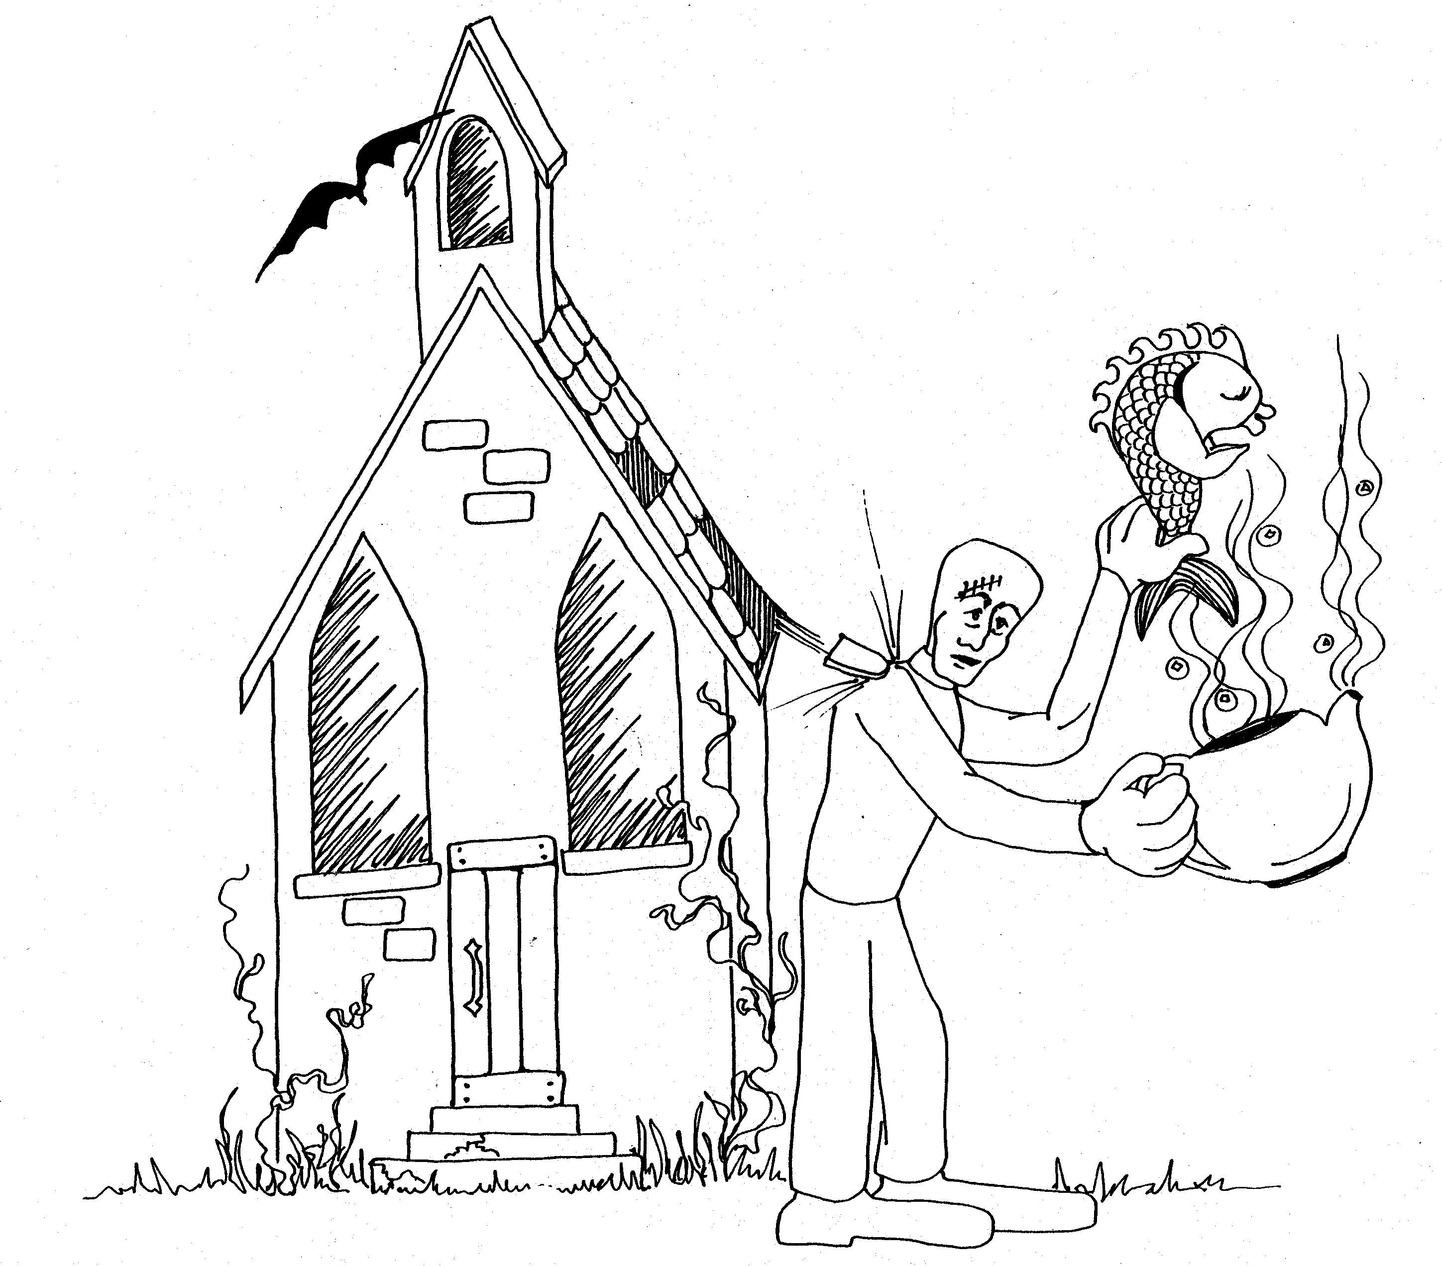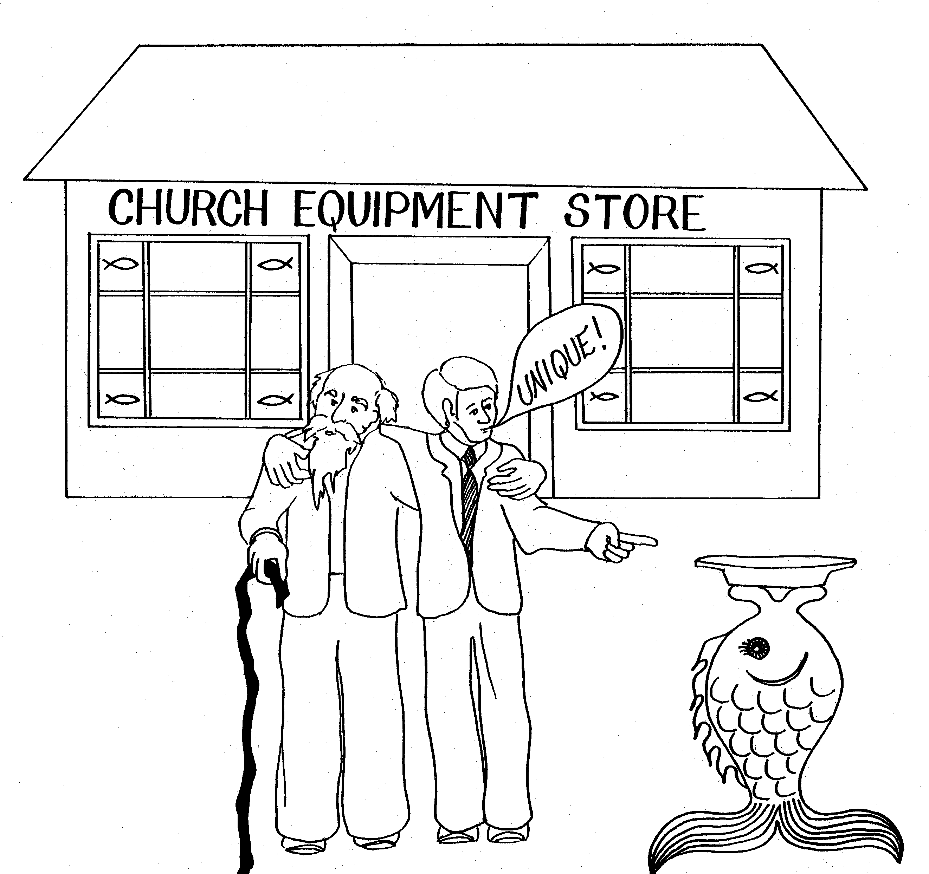

3. CHURCH-MYSTERY, GENTILES SAVED, 4. UNITY, CHURCH EQUIPPED, OLD AND NEW MAN
PRAYER FOR KNOWLEDGE

5 = Tea (rhyme) 4 = Store (rhyme)

* CHURCH - MYSTERY: haunted mysterious church * UNITY: old and young man together

* GENTILES SAVED: 'tites' (Gen-tiles) off roof hit * CHURCH EQUIPPED: store selling 'church equipment'
Frankenstein thereby saving the fish unique offering plate

* PRAYER FOR KNOWLEDGE: fish praying for * OLD AND NEW MAN: old and young (new) man
knowledge so he can escape being boiled alive
in pot
Ephesians 3 - 4
© 2003 Do not reproduce

Ephesians

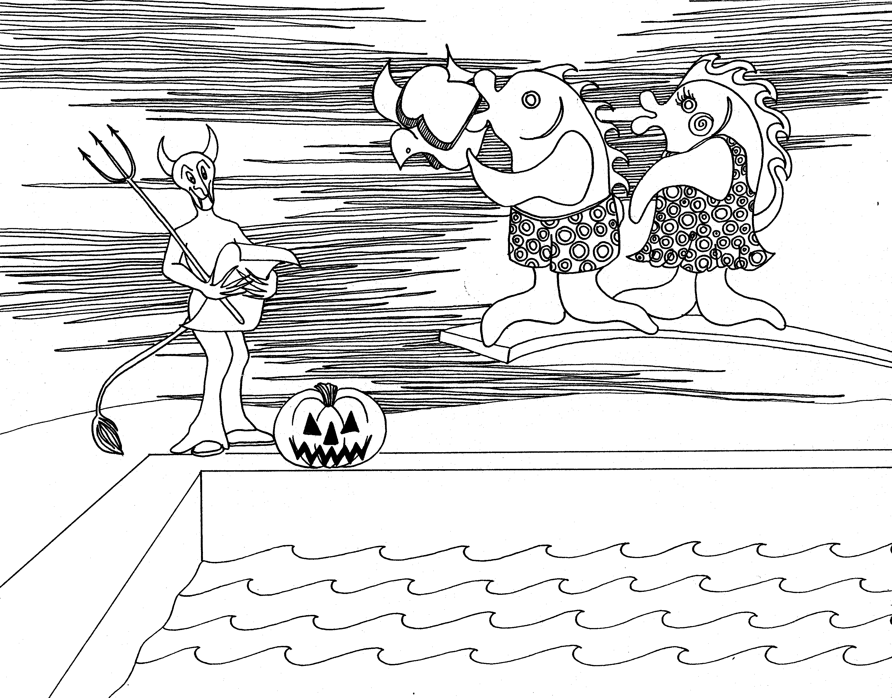 | 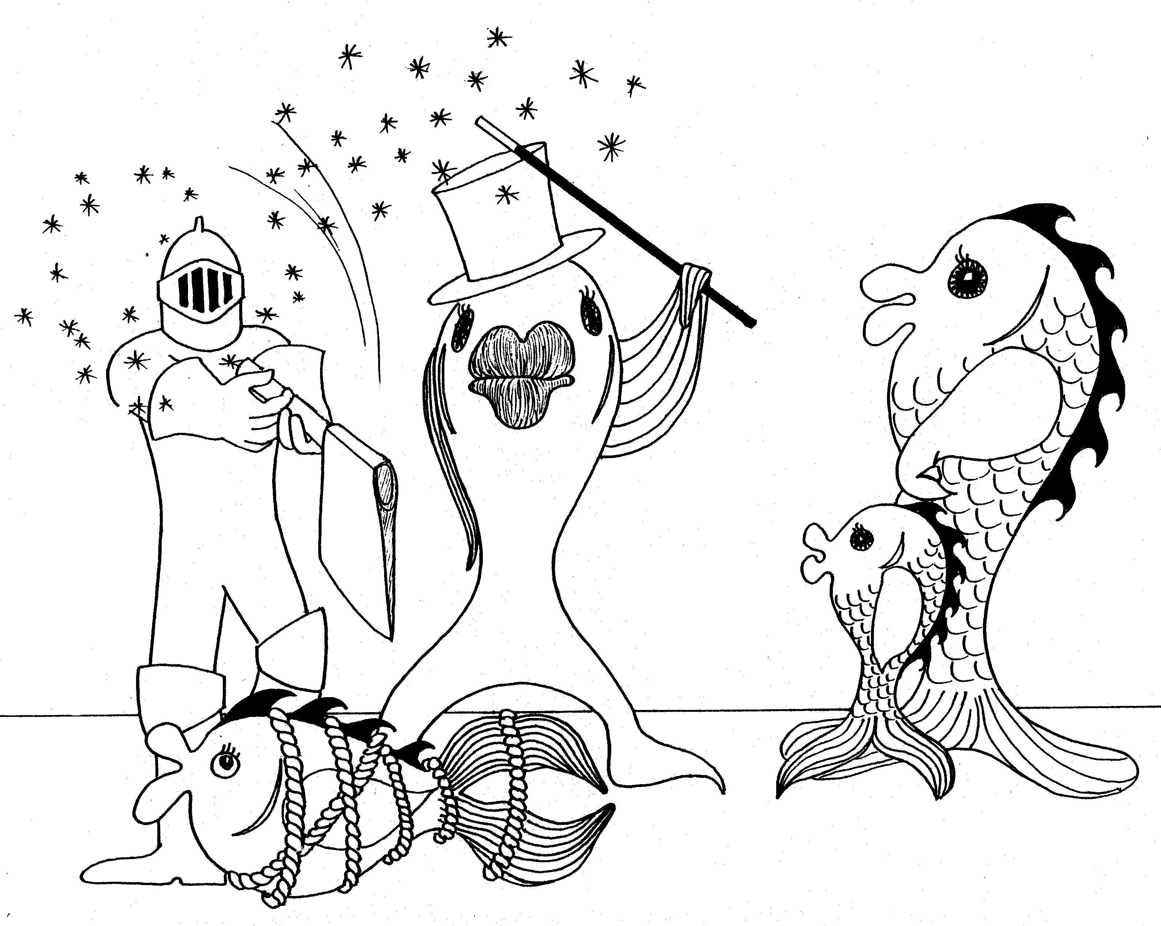
5. DEEDS OF DARKNESS, SPIRIT FILLING 5 = Dive (rhyme)  * DEEDS OF DARKNESS: Halloween night (Satan holding the 'deed' for their souls)  * SPIRIT FILLING: dove as a filling of the sandwich the fish are about to eat  * HUSBAND AND WIFE: Mr. and Mrs. Fish (dressed  for Halloween on diving board [5=dive]) | 6. PARENT - CHILD, MASTER - SLAVE,  HUSBAND AND WIFE, SPIRITUAL ARMOR  6 = Tricks (rhyme)  * PARENT - CHILD: parent & child fish watching magic  Houdini trick  * MASTER - SLAVE: fish bound like a slave  * SPIRITUAL ARMOR: armored man about to chop fish in  half
Ephesians 5 - 6
© 2003 Do not reproduce
Philippians

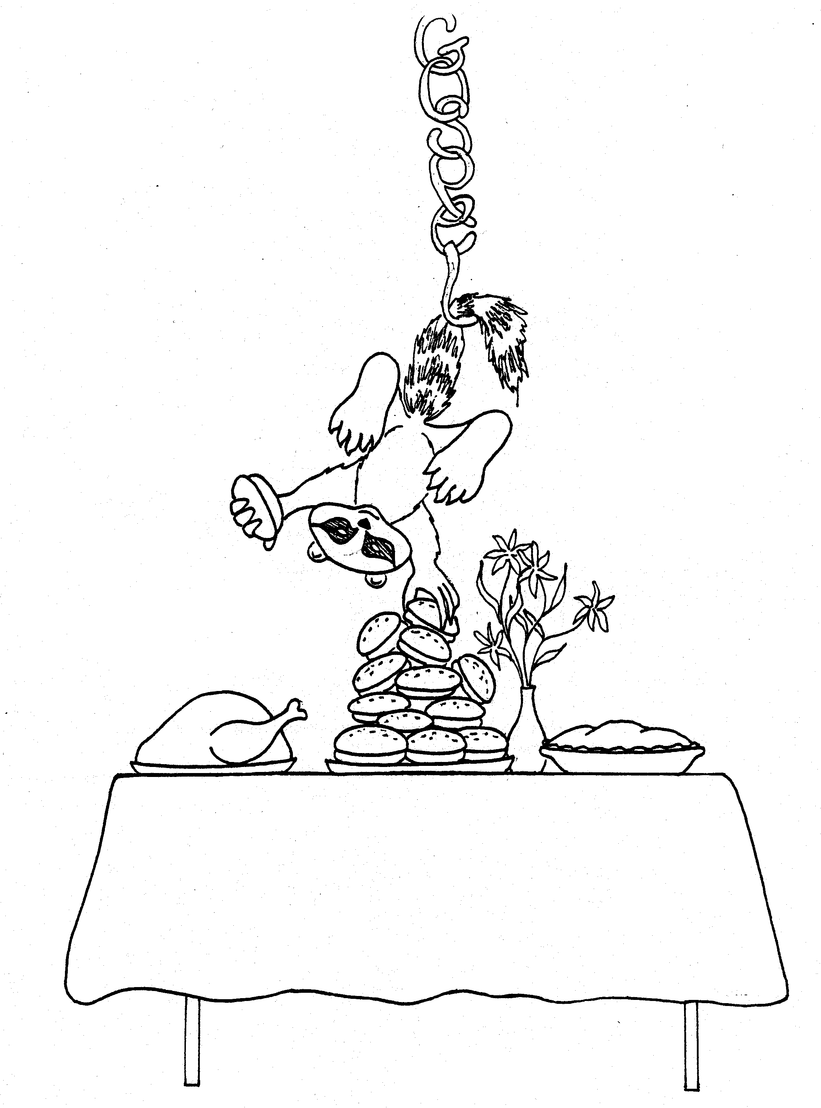 | 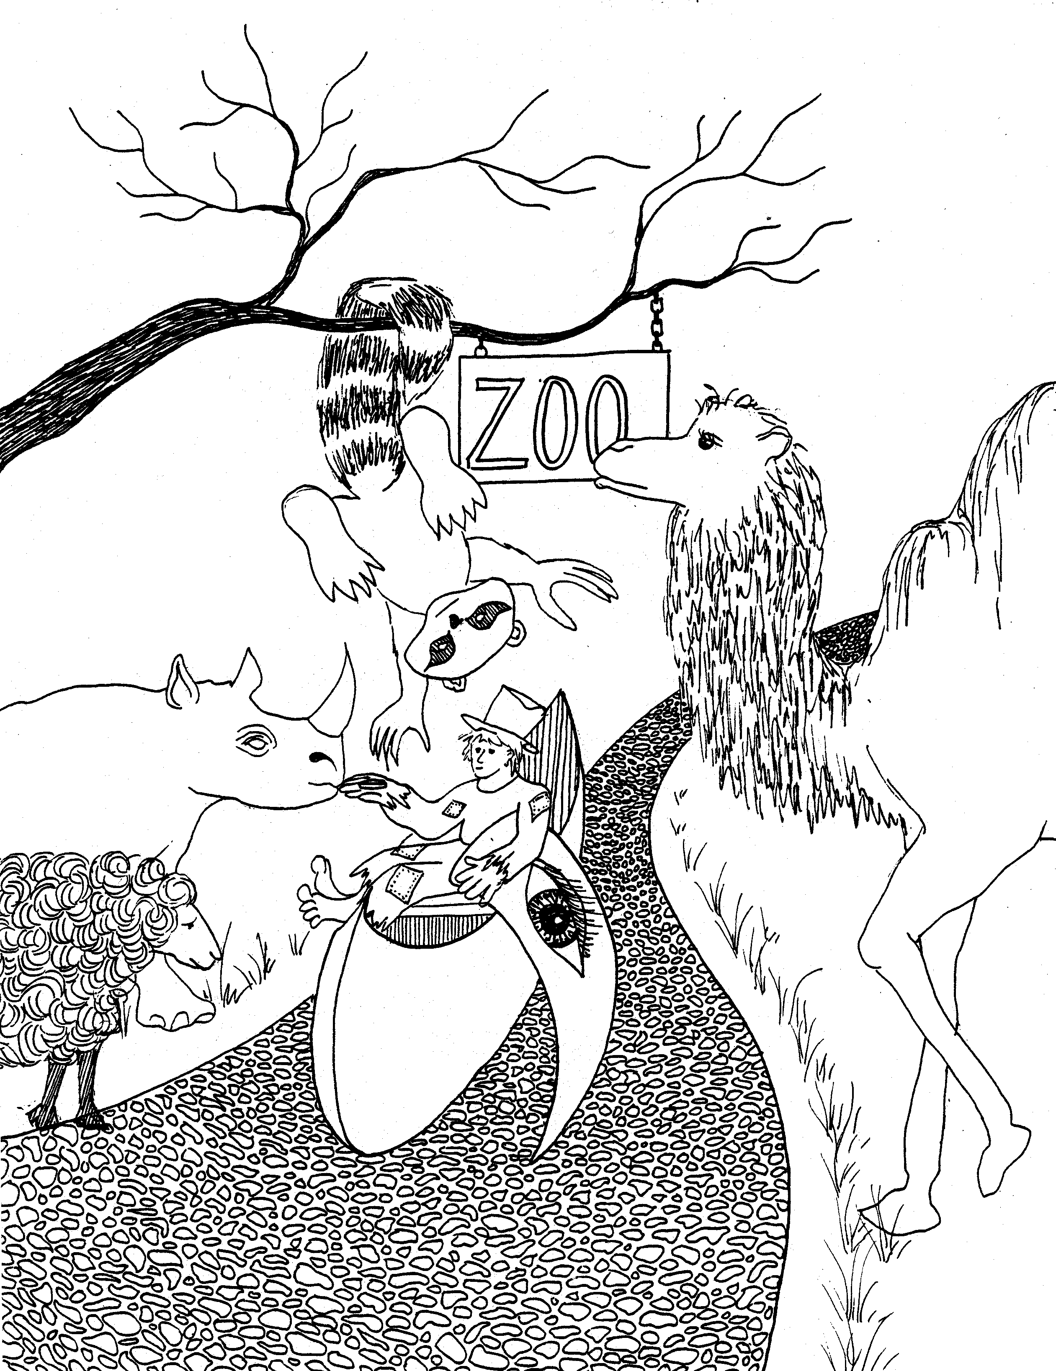
PHILIPPIANS = FLIPPING RACCOON  1. THANKSGIVING, GOSPEL CHAINS  1 = Bun (rhyme)  * THANKSGIVING: table set for thanksgiving turkey meal  * GOSPEL CHAINS: Flip (raccoon) hanging from a chain with the letters spelling gospel | 2. CHRIST'S HUMILITY,  TIMOTHY AND EPAPHRODITUS SENT  2 = Zoo (rhyme)  * CHRIST'S HUMILITY: lamb (Christ) standing by path  * TIMOTHY AND EPAPHRODITUS SENT: Tiny Tim  (Timothy), 'He path-row-eye-tusk' (Epaphroditus),  Timothy smelling camel 'scent' (sent)
Philippians 1 - 2
© 2003 Do not reproduce
Philippians

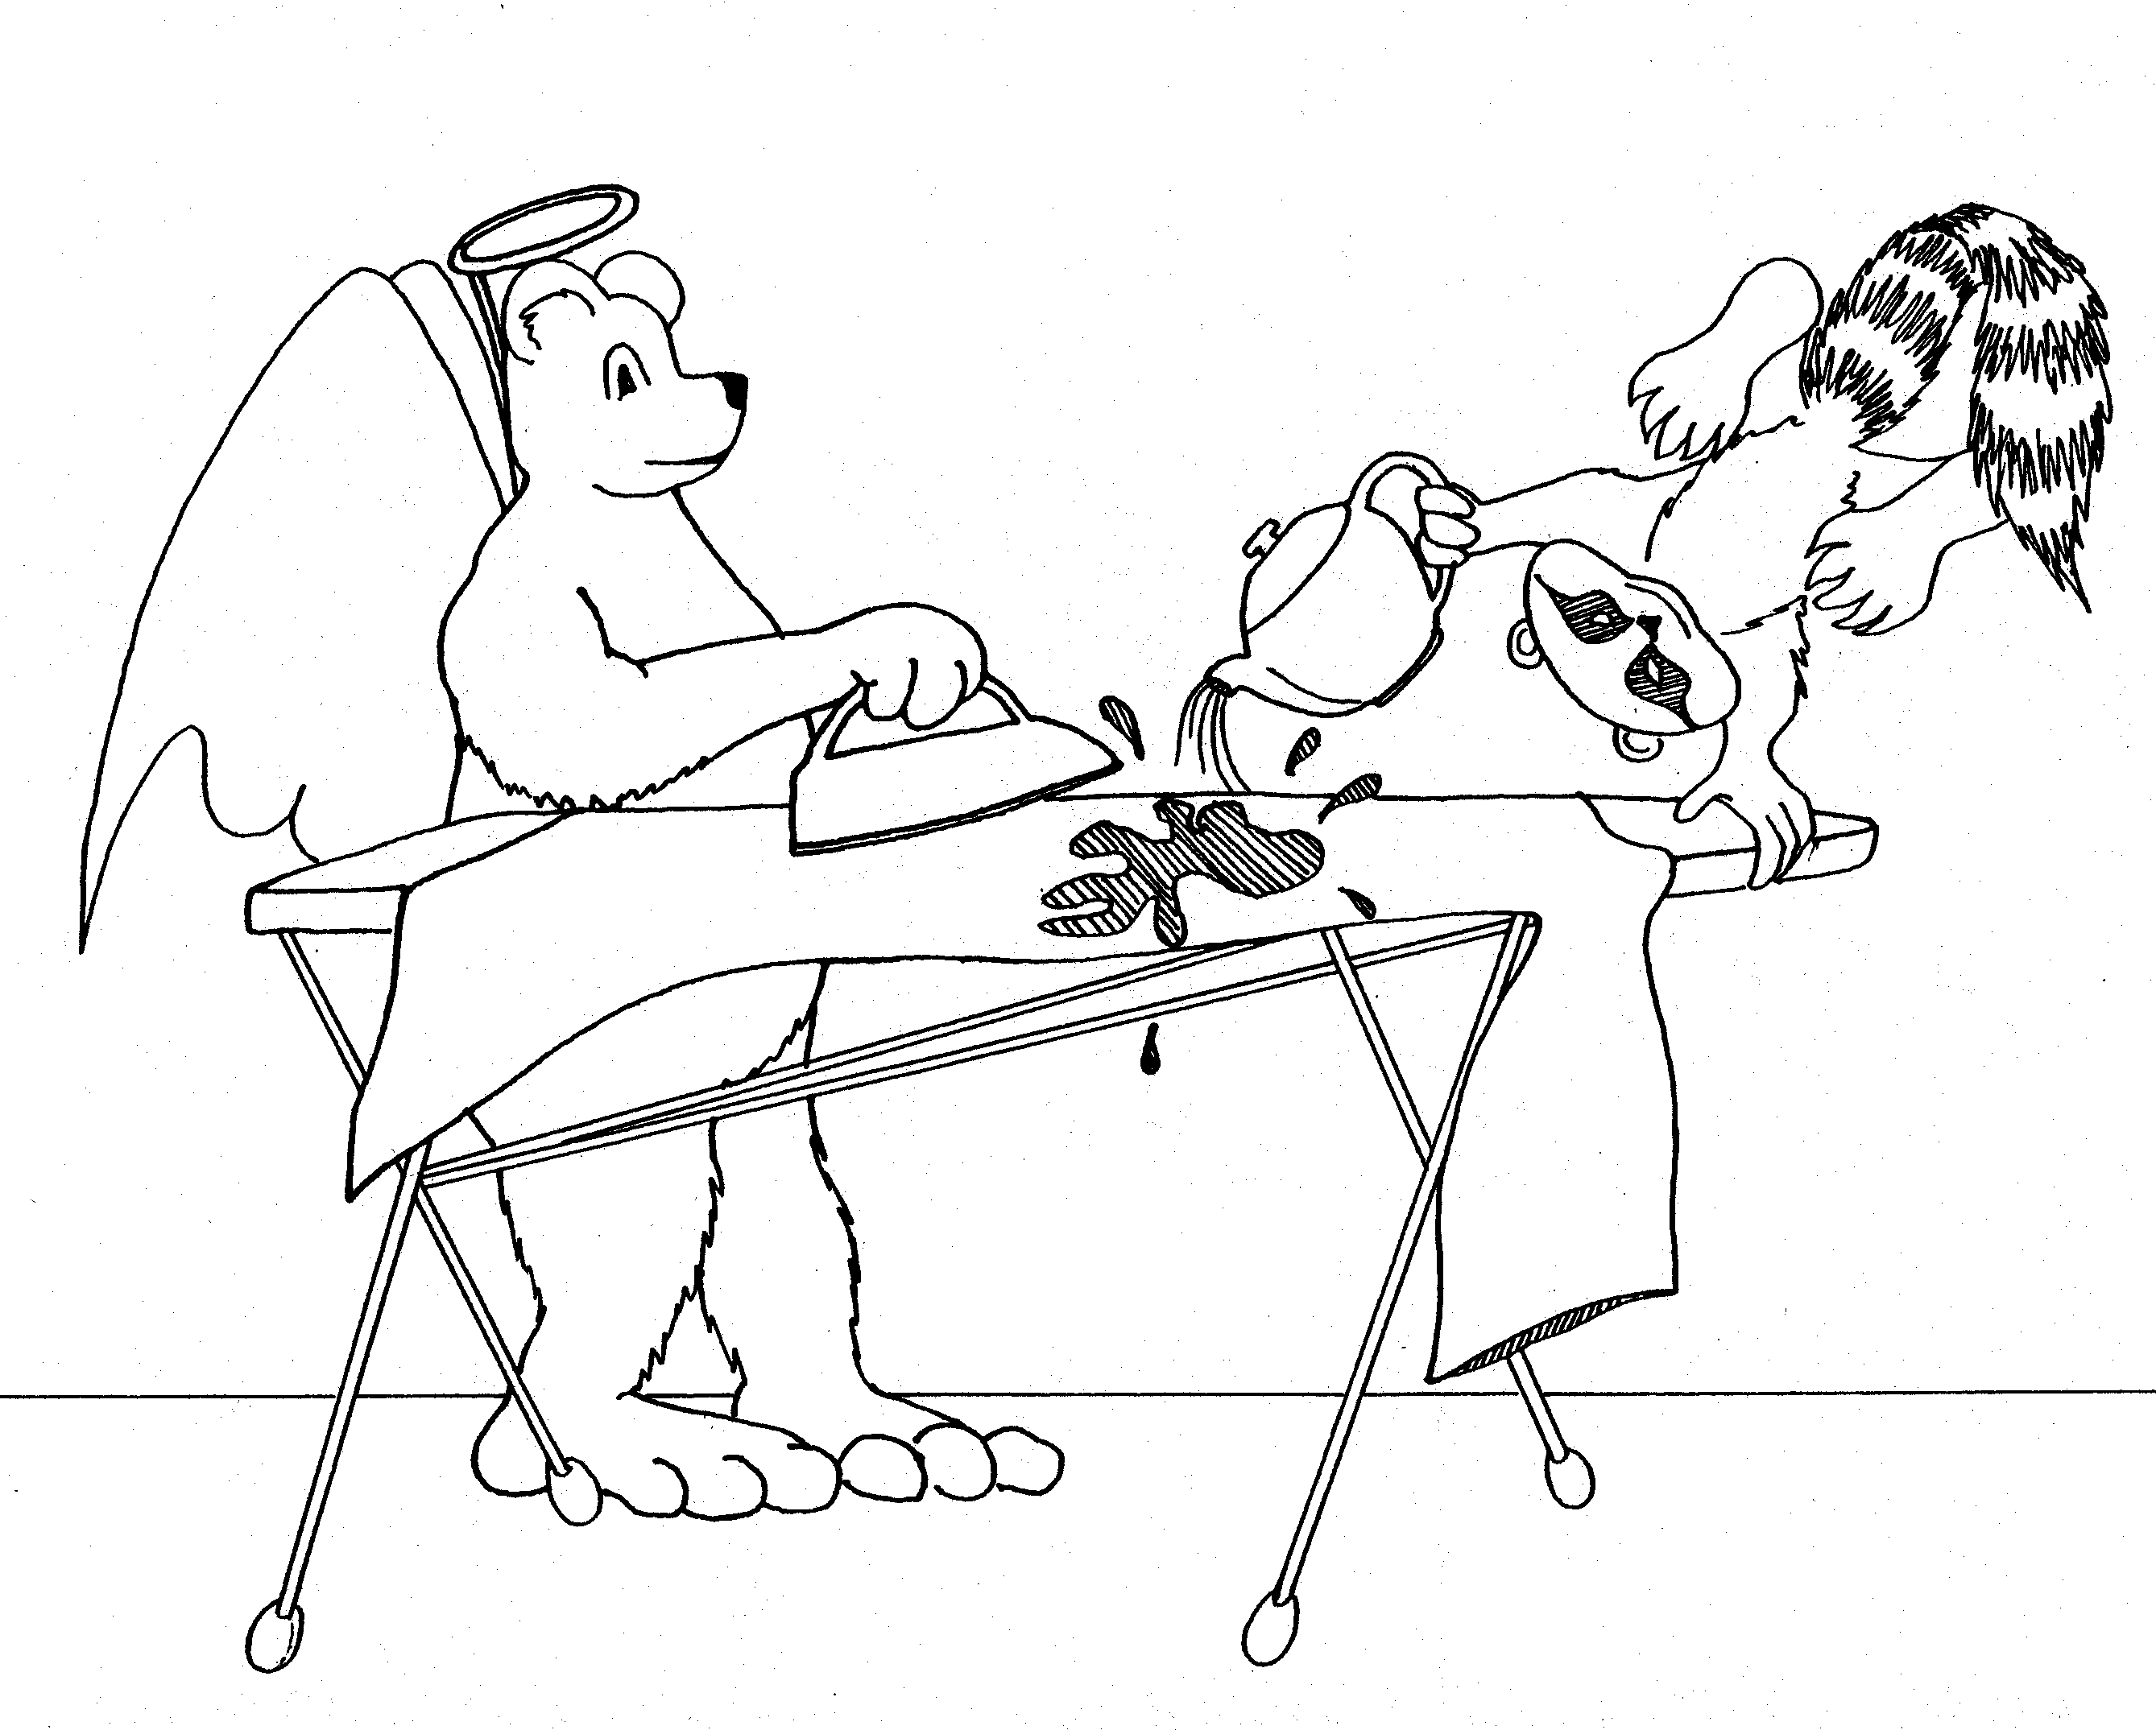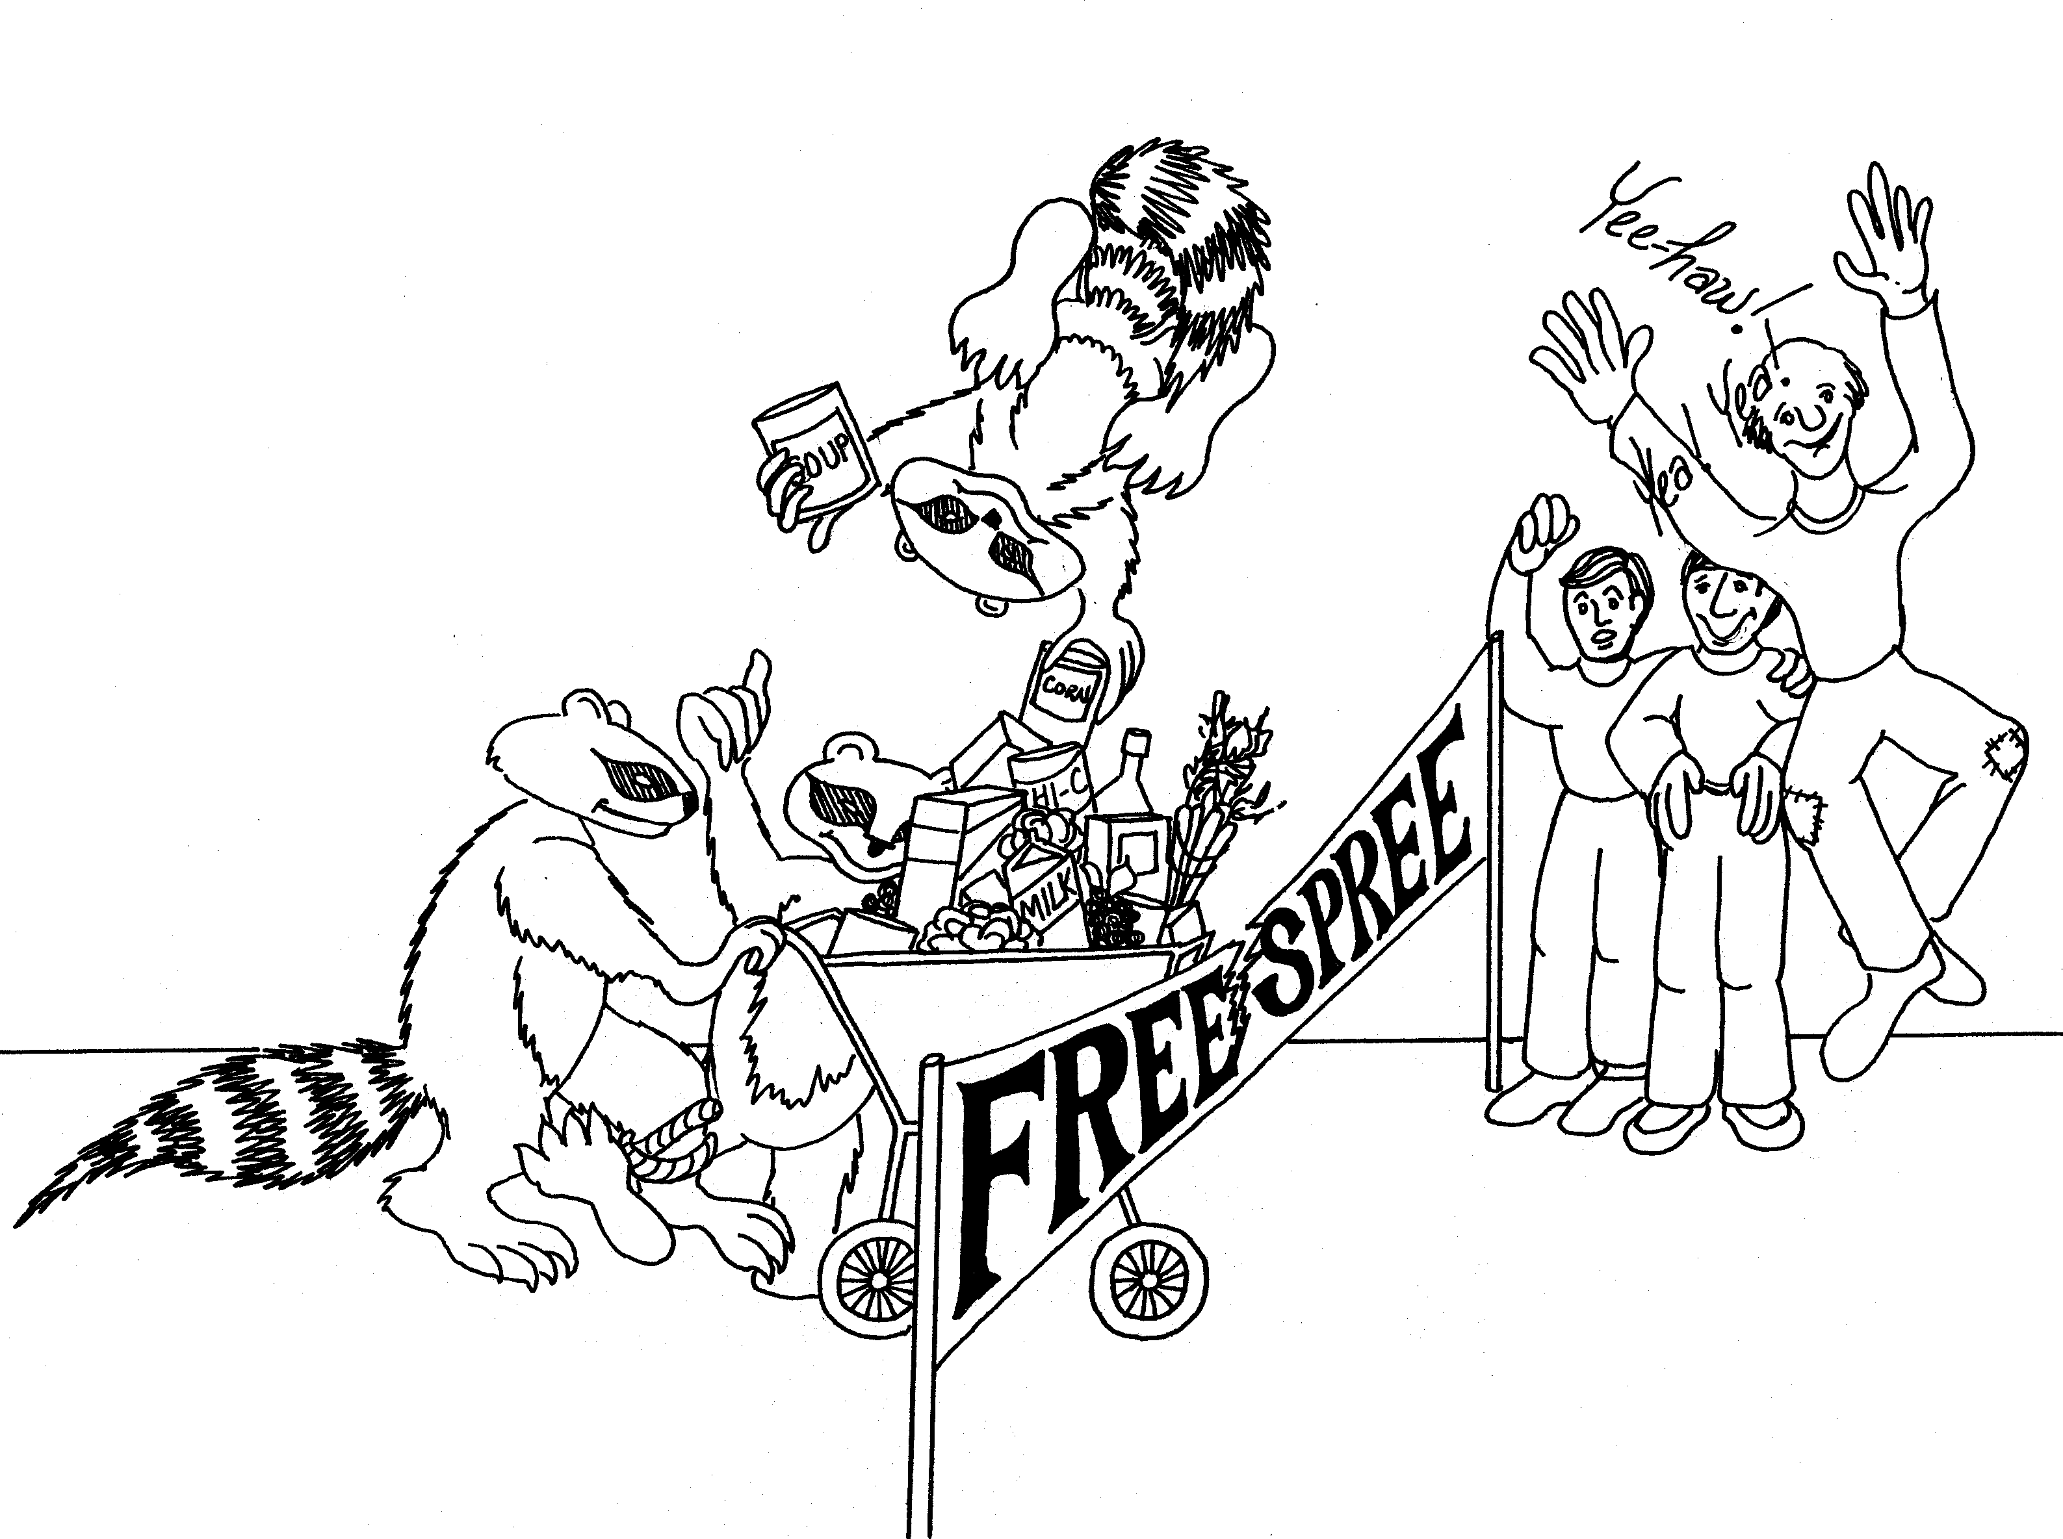

3. PAUL'S RIGHTEOUSNESS, 4. UNITY, REJOICE, PHILIPPIANS' GENEROSTIY
PRESSING FOR THE PRIZE

3 = Tea (rhyme) 4 = Store (rhyme)

* PAUL'S RIGHTEOUSNESS: Paul (bear) dressed as * UNITY: 3 legged race through grocery store, legs tied (unity)
an angel (righteousness)
* REJOICE: friends rejoice as Flip and family win race
* PRESSING FOR THE PRIZE: pressing (ironing) costume
to win the prize in the costume party * PHILIPPIANS' GENEROSITY: generosity of the store to
give a "Free Spree"; Flip's generosity putting another
can on top

Philippians 3 - 4
© 2003 Do not reproduce
Colossians

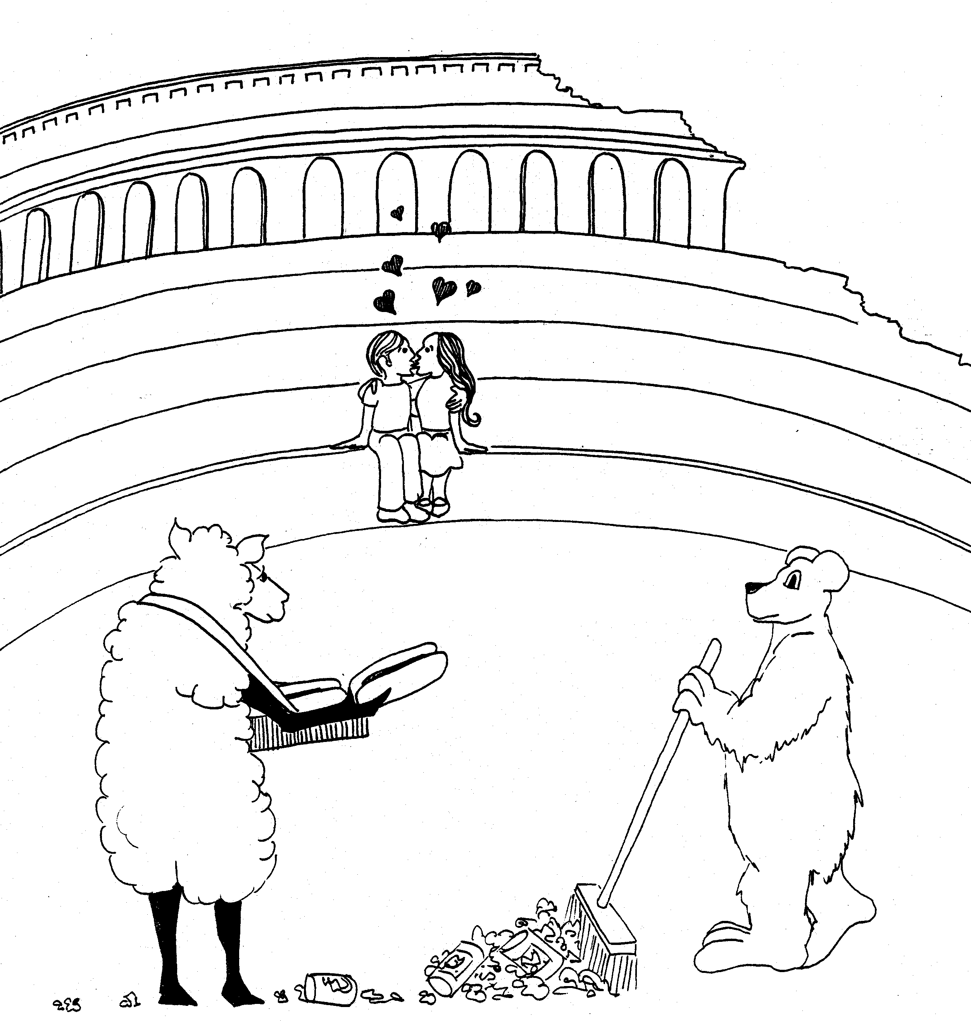 | 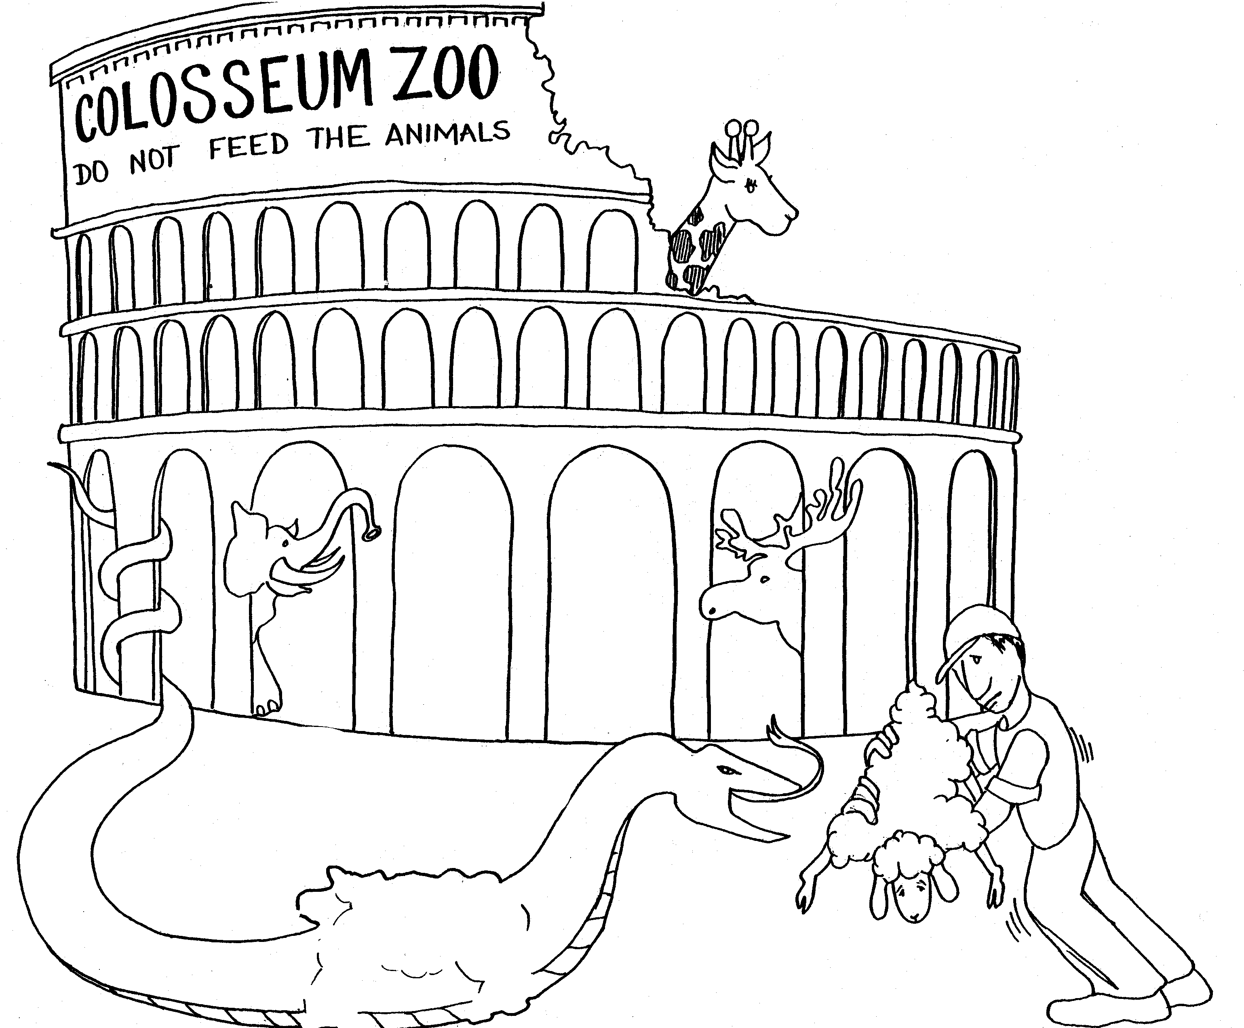
COLOSSIANS: COLISEUM  1. COLOSSIANS' LOVE, CHRIST'S WORK, PAUL'S LABOR  1 = Bun (rhyme)  * COLOSSIANS' LOVE: couple in 'love' in Coliseum  * CHRIST'S WORK: lamb (Christ) selling hot-dogs  * PAUL'S LABOR: Paul (bear) sweeping up the litter | 2. FULNESS IN CHRIST, AGAINST REGULATIONS  2 = Zoo (rhyme)  * FULNESS IN CHRIST: Christ (lamb) swallowed by a  snake, snake is full of Christ  * AGAINST REGULATIONS: man feeding snake another  lamb against the zoo's regulations
Colossians 1 - 2
© 2003 Do not reproduce
Colossians

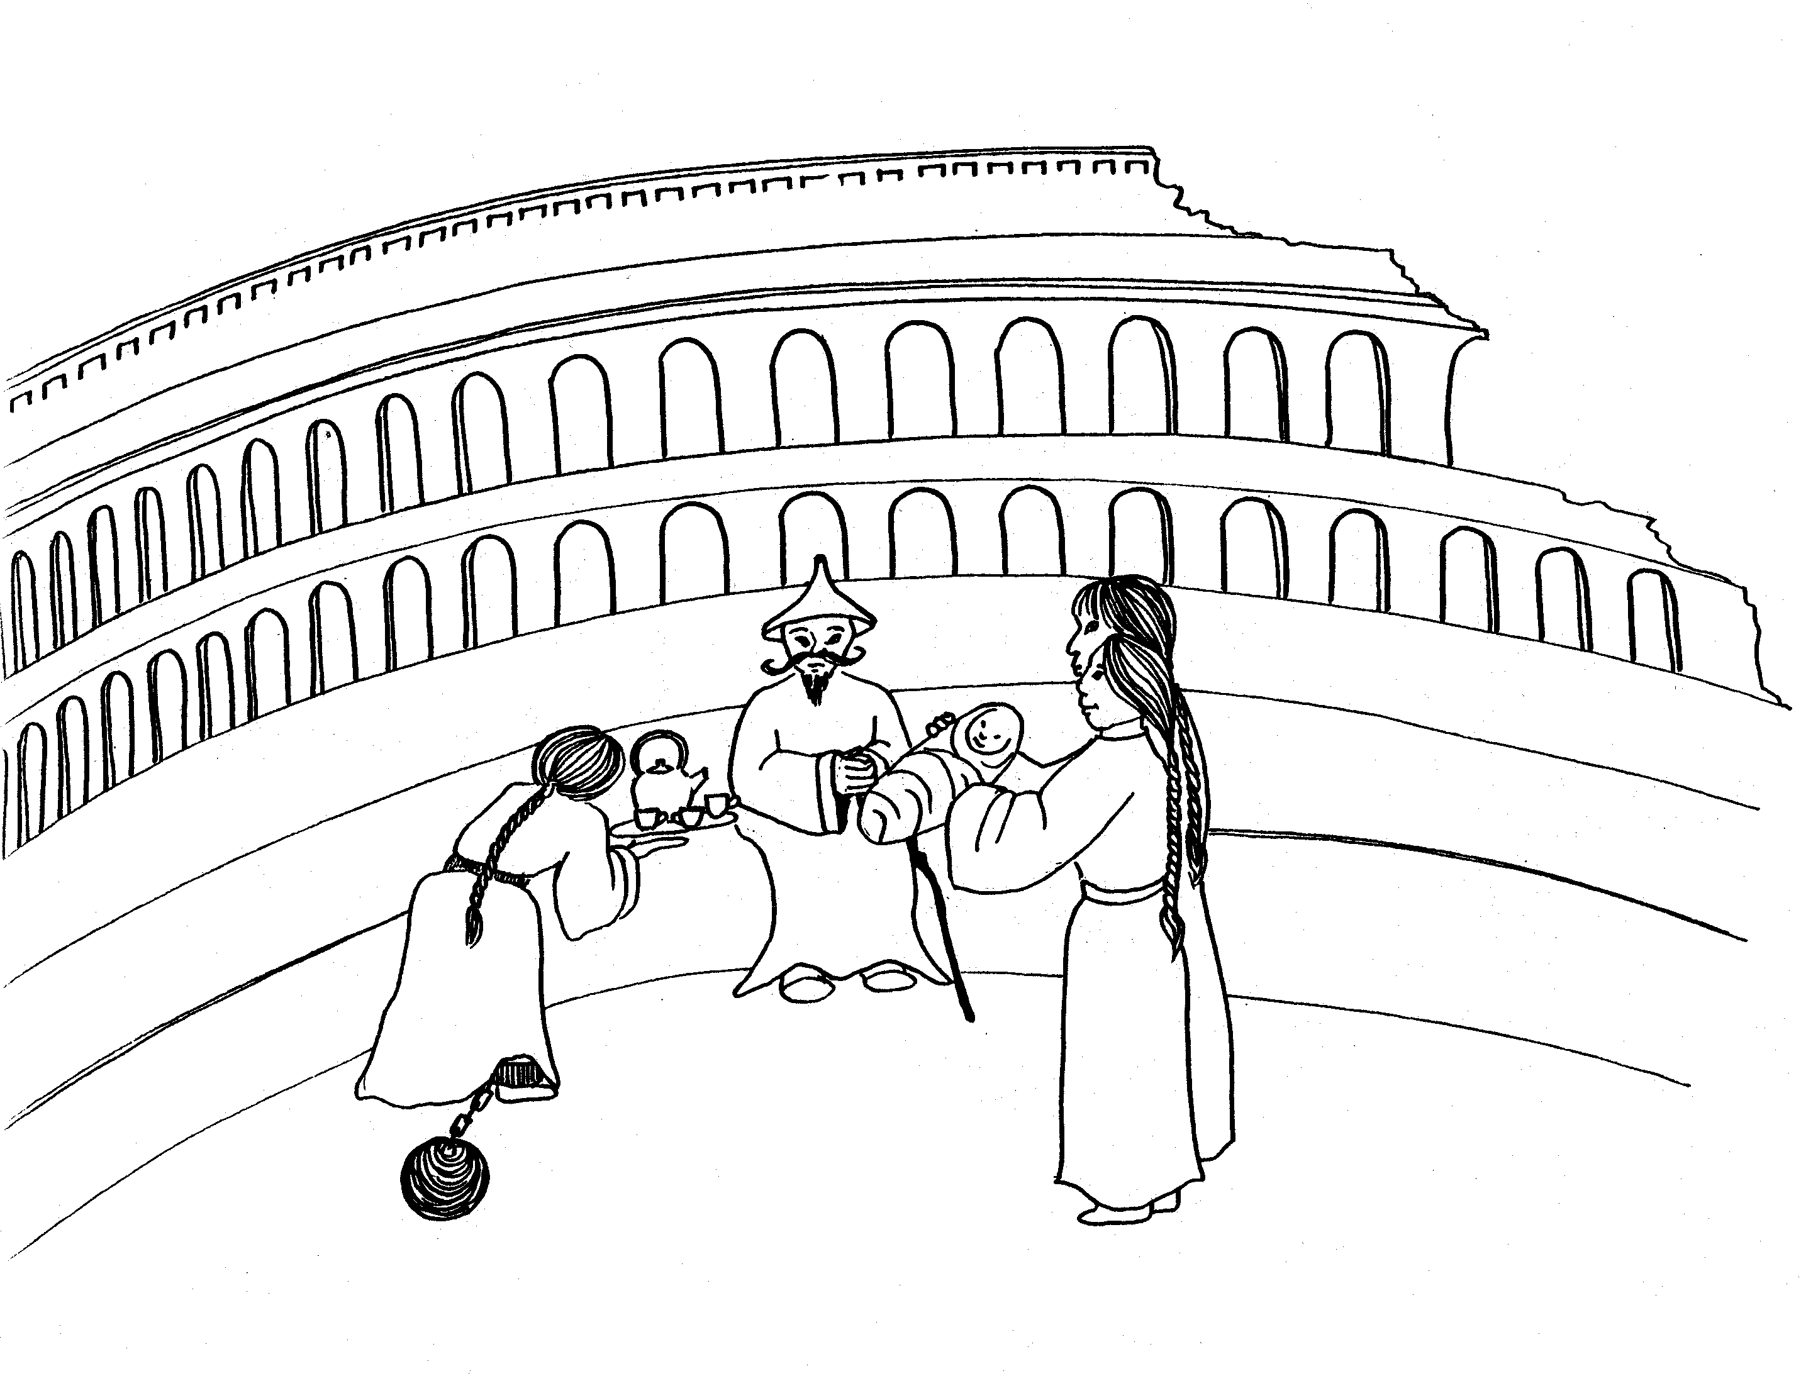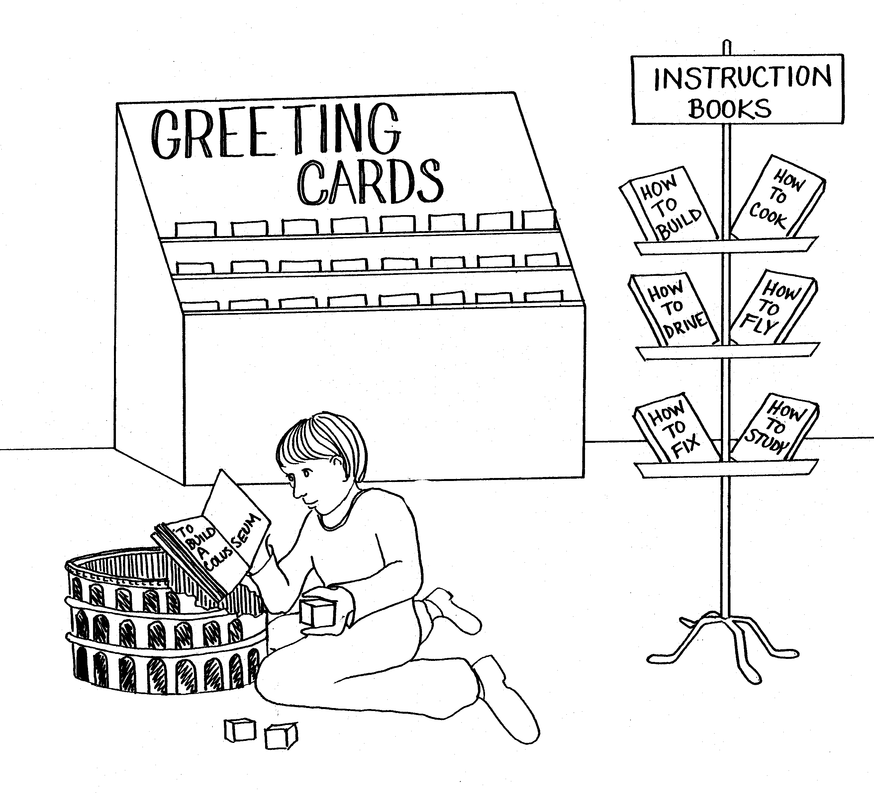

3. OLD AND NEW MAN, FAMILY RELATIONS, 4. INSTRUCTIONS, GREETINGS
MASTER - SERVANT

3 = Tea (rhyme) 4 = Store (rhyme)

* OLD AND NEW MAN: old man and baby (new man) * INSTRUCTIONS: reading 'How-to-book' of instruction on
how to build a model of the coliseum
* FAMILY RELATIONS: couple presenting baby to
grandfather * GREETINGS: greeting cards

* MASTER - SLAVE: slave bringing tea to his master

Colossians 3 - 4
© 2003 Do not reproduce

