I & II CORINTHIANS

I CORINTHIANS

1. Divisions, Foolish cross wisdom
2. Spirit's wisdom
3. Factions, Foundation is Christ
4. Apostle -servant
5. Immoral offender
6. Lawsuits, Body as temple
7. Married and unmarried
8. Idol - meat
9. Surrendering rights
10. Old Testament examples, Meat offered to idols
11. Heads and hair, Communion
12. Spirit's gifts, One body
13. Love
14. Prophecy and tongues, Orderly worship
15. Resurrection
16. Jerusalem collection, Coming visitors

II CORINTHIANS

1. Comforting, Visit rescheduled
2. Forgive the offender
3. Old and new Testament
4. Glory and Persecution
5. Heavenly house, Judgment seat, Reconciliation
6. Paul's pattern, Unequally yoked
7. Titus' report – joy, Sorrowful repentance
8. Please give, Receive Titus
9. Cheerful giving
10. Paul's defense
11. Super – apostles? Suffering
12. Paul's vision, Thorn in the flesh
13. Warnings

1 Corinthians

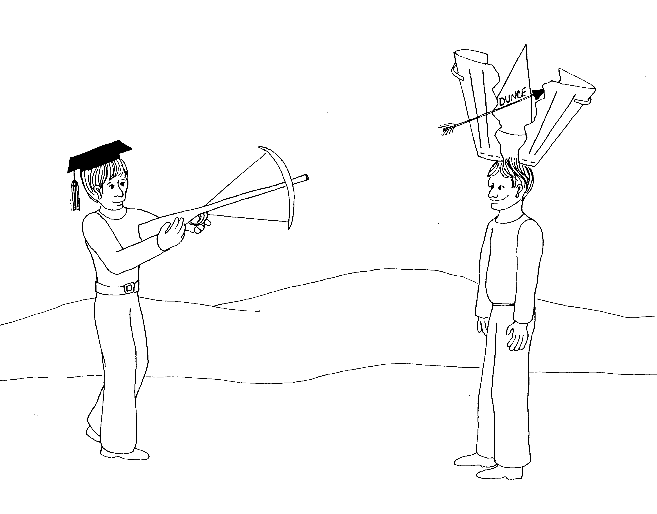 | 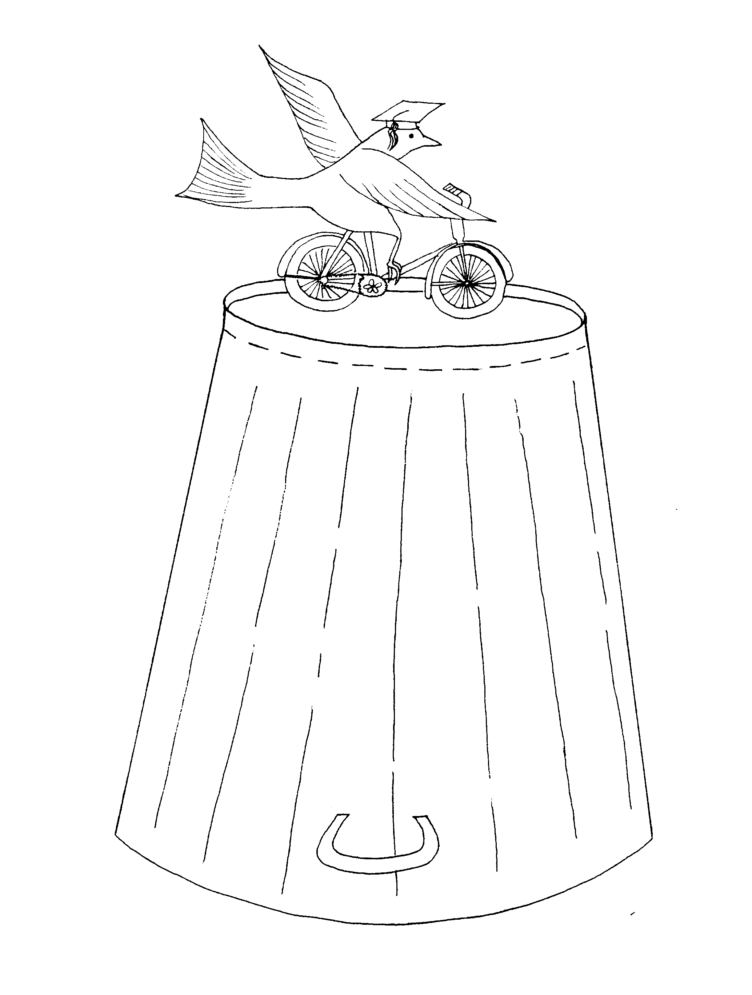
1 CORINTHIANS = 1 CAN (GARBAGE CAN)  1. DIVISIONS, FOOLISH CROSS WISDOM  1 = Arrow  * DIVISIONS: the arrow splitting the can in two  * FOOLISH CROSS WISDOM: foolish wise boy  (graduation cap) shooting 'cross' bow at other fellow | 2. SPIRIT'S WISDOM  2 = Bicycle (2 wheels)  * SPIRIT'S WISDOM: Spirit (dove), wisdom (graduation hat)
1 Corinthians 1 - 2
© 2003 Do not reproduce
1 Corinthians

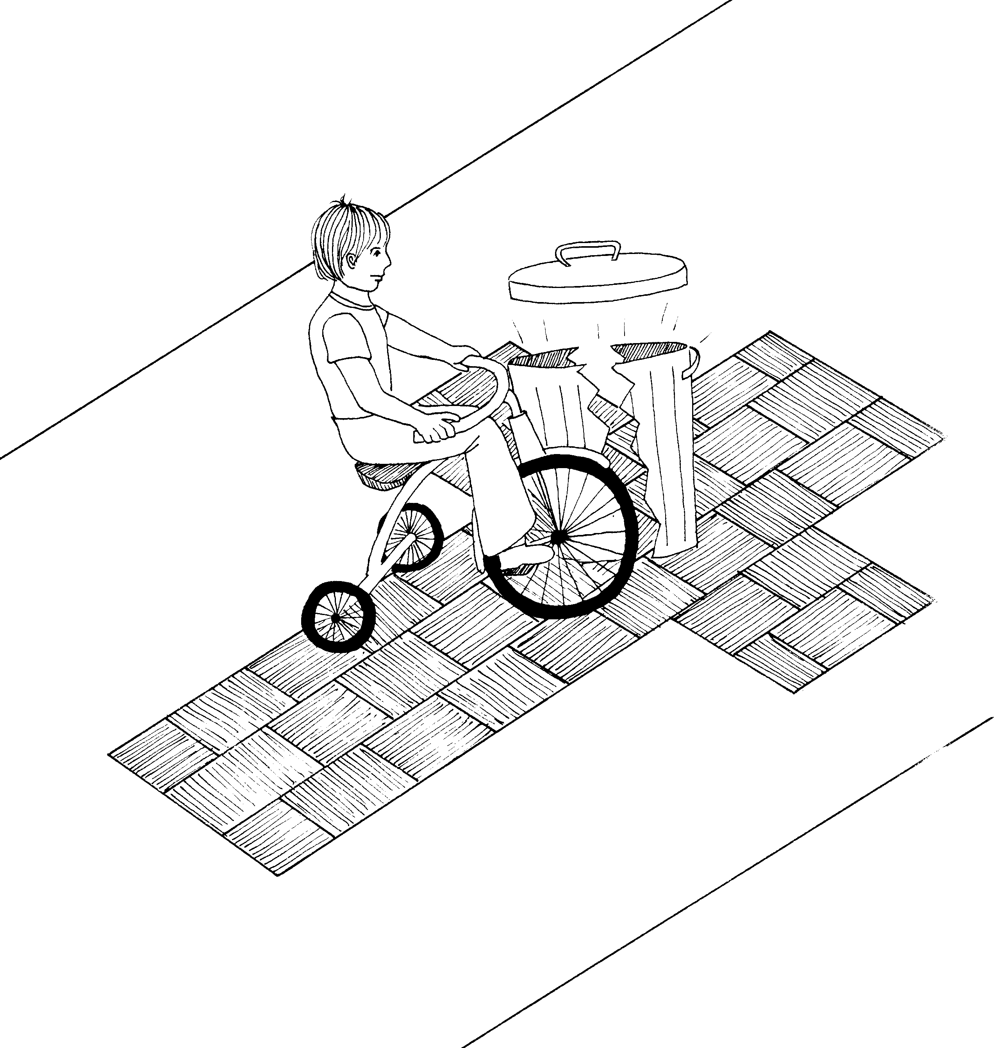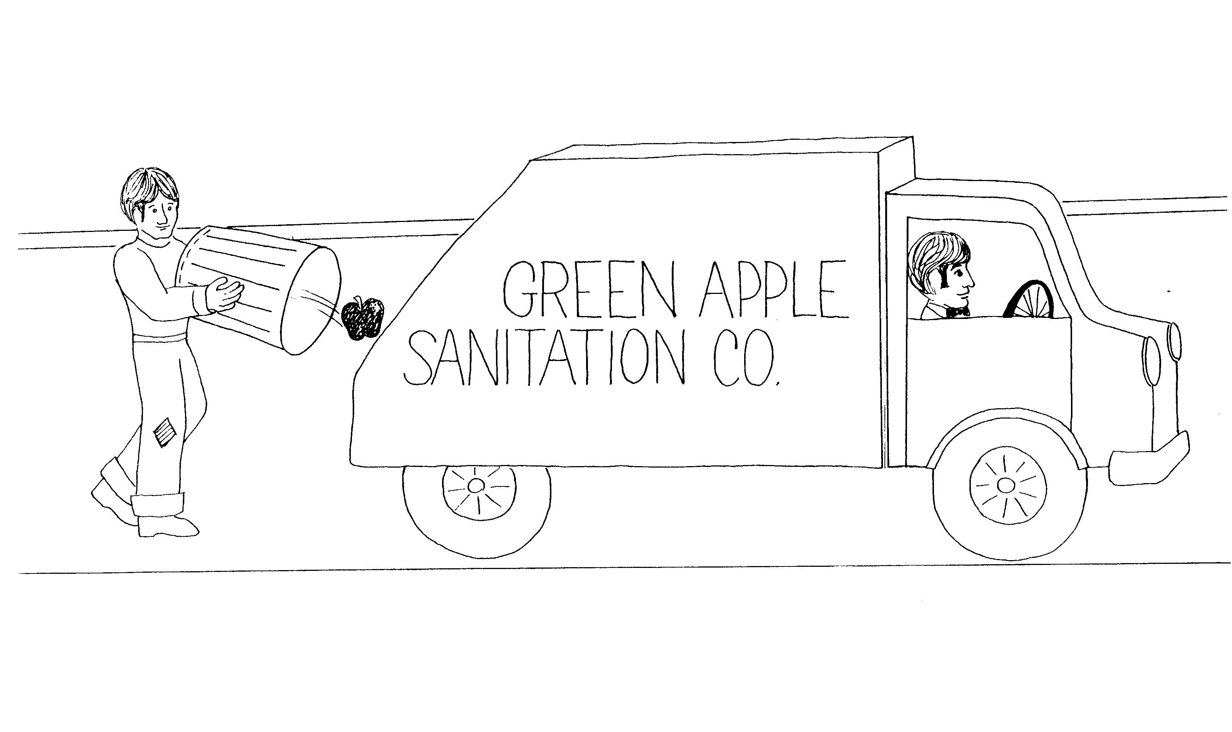

3. FACTIONS, FOUNDATION IS CHRIST 4. APOSTLE – SERVANT

3 = Tricycle (three wheels) 4 = Car (4 wheels)

* FACTIONS: boy splits the can * APOSTLE – SERVANT: Apostle = apple,
servant = guy working on cleaning up
* FOUNDATION IS CHRIST: riding on a cross
(= Christ)

1 Corinthians 3 - 4
© 2003 Do not reproduce
1 Corinthians

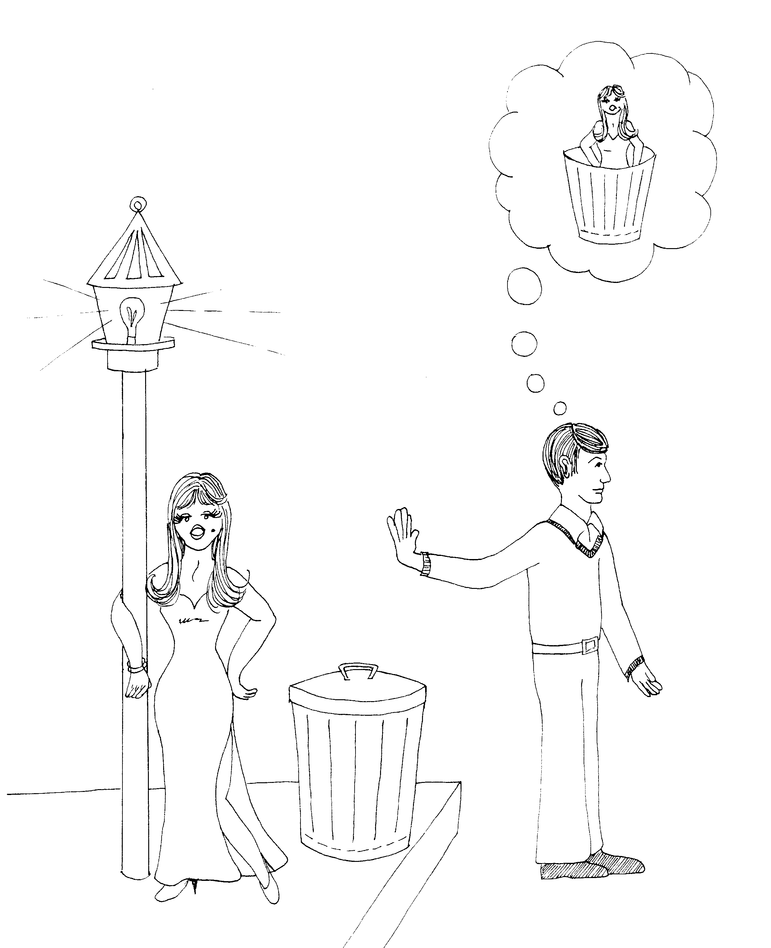 | 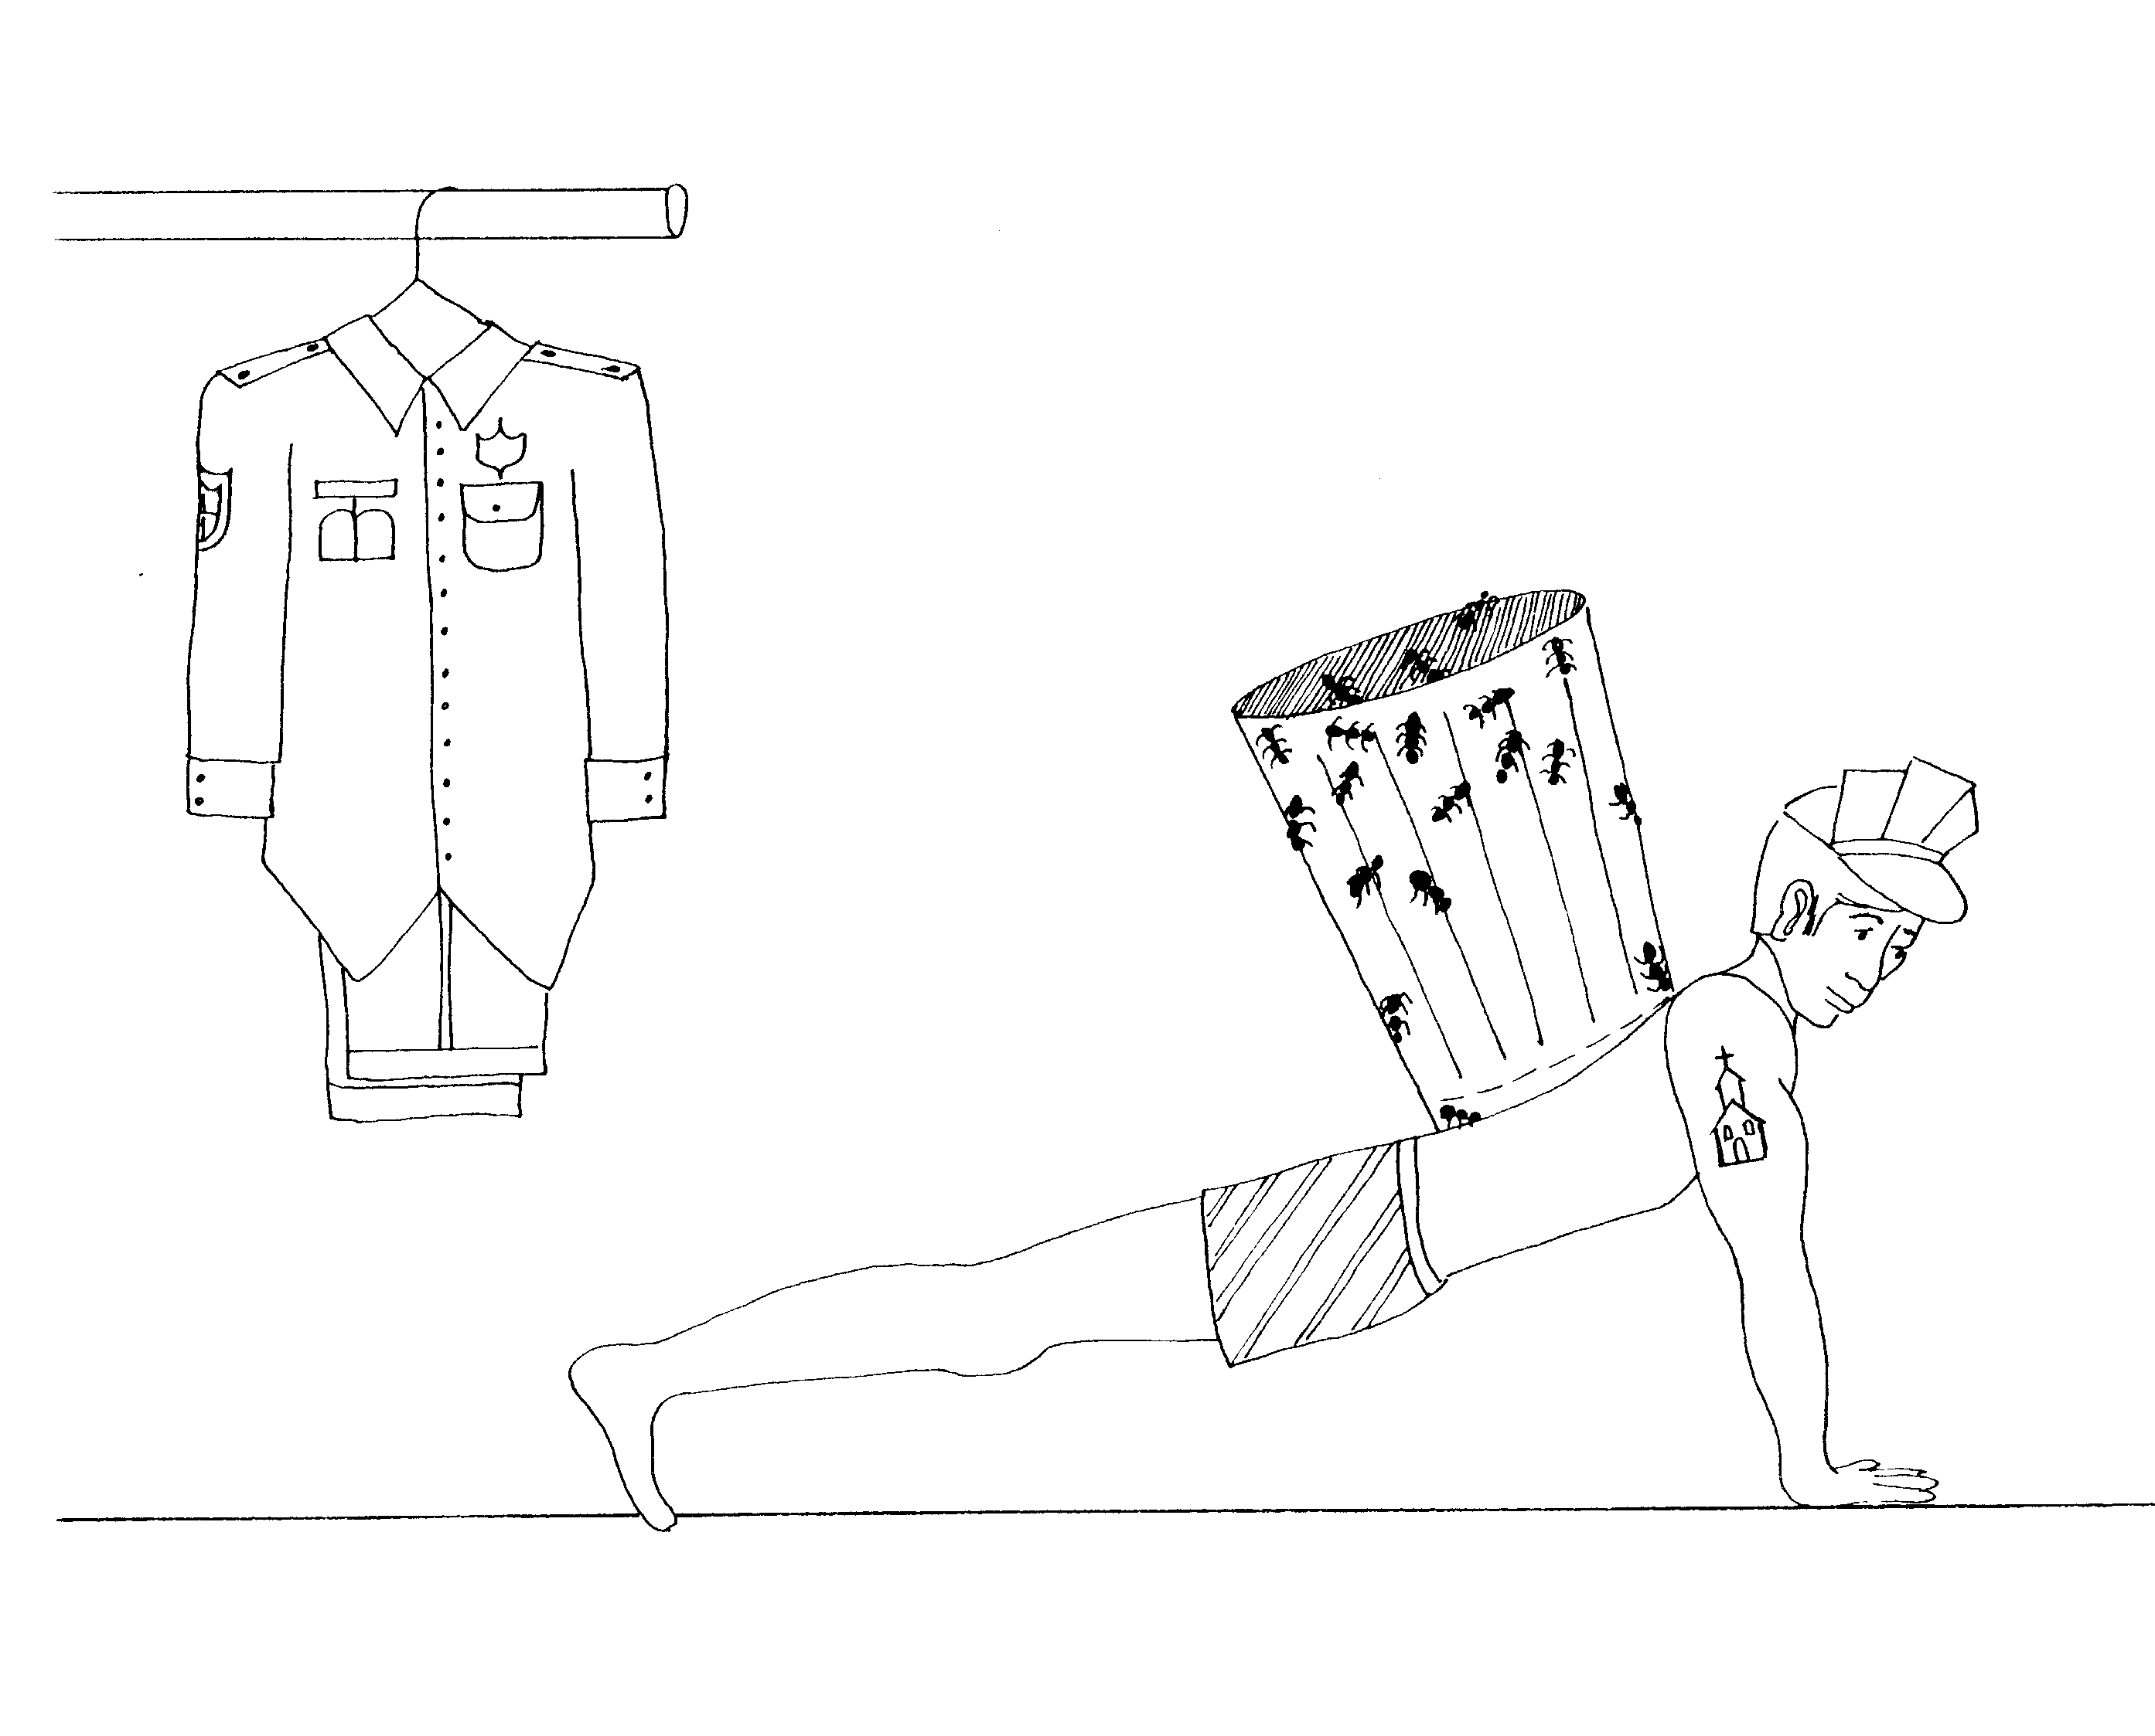
5. IMMORAL OFFENDER  5 = Five fingers (give me five)  * IMMORAL OFFENDER: man having lustful thoughts | 6. LAWSUITS, BODY AS TEMPLE  6 = Insects (6 legs on a bug)  * LAWSUITS: police person's 'lawsuit' hung up on rack  * BODIES AS TEMPLES: guy with a temple tattoo on his  arm (body building = temple)
1 Corinthians 5 - 6
© 2003 Do not reproduce
1 Corinthians

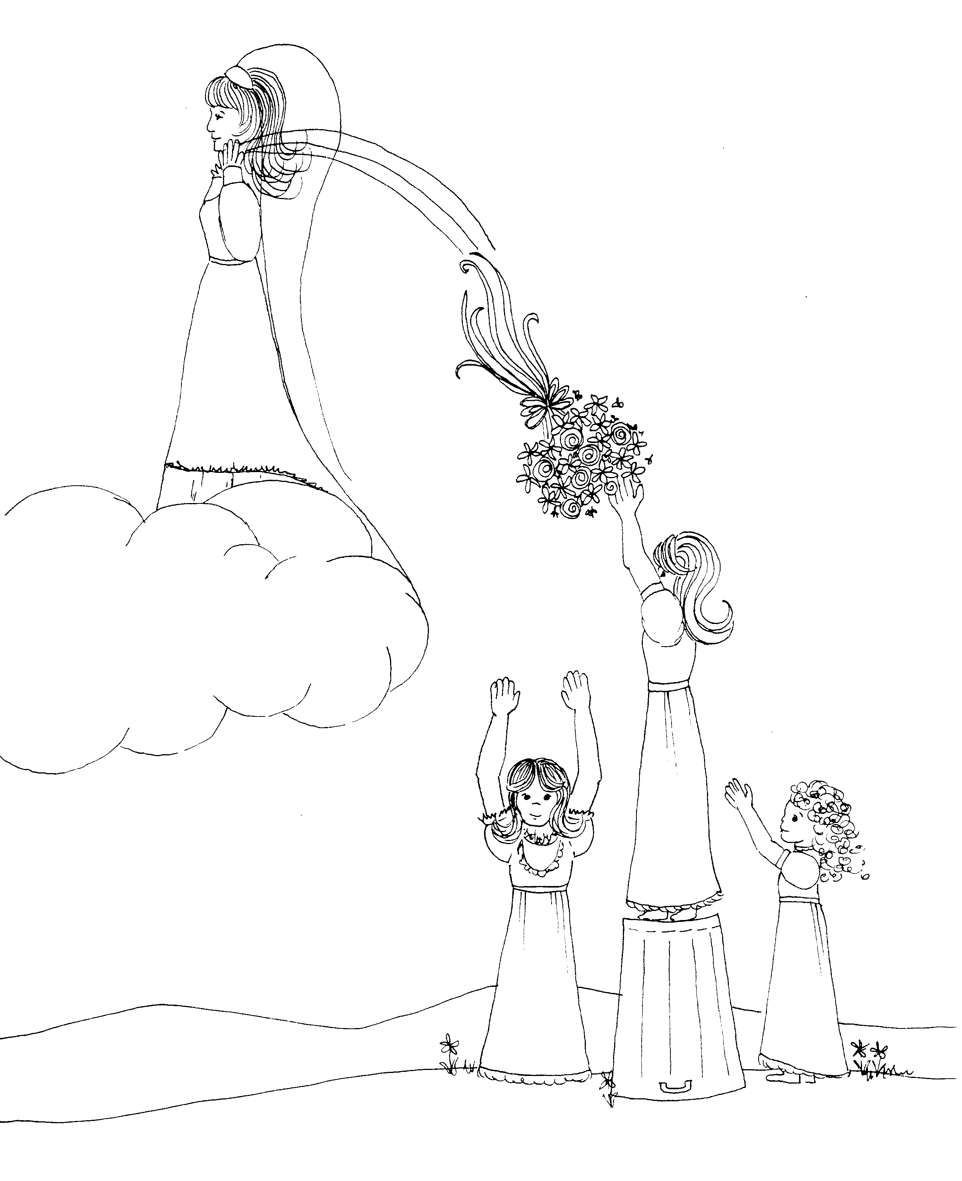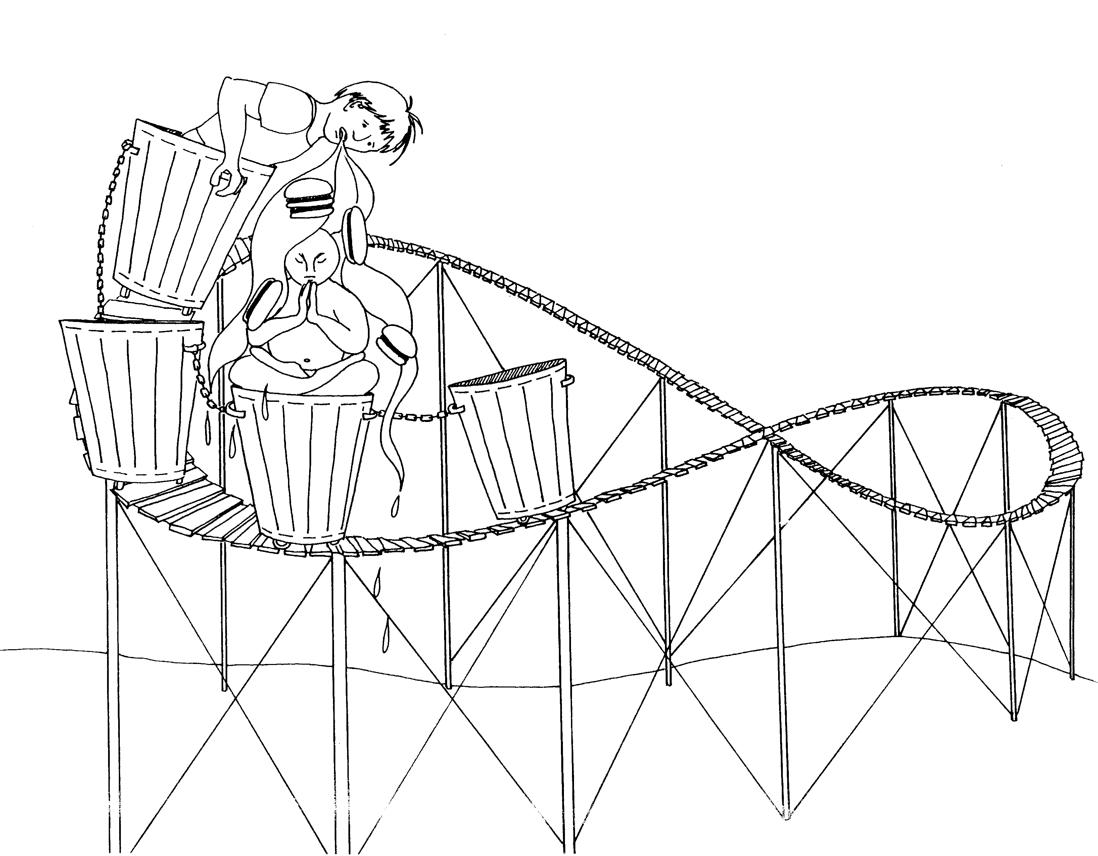

7. MARRIED AND UNMARRIED 8. IDOL - MEAT

7 = Heaven (clouds) 8 = Roller coaster looks like an 8 sideways

* MARRIED AND UNMARRIED: married girl throwing * IDOL – MEAT: meat burgers being regurgitated from boy
her bouquet and unmarried girls trying to catch it on the idol

1 Corinthians 7 - 8
© 2003 Do not reproduce
1 Corinthians

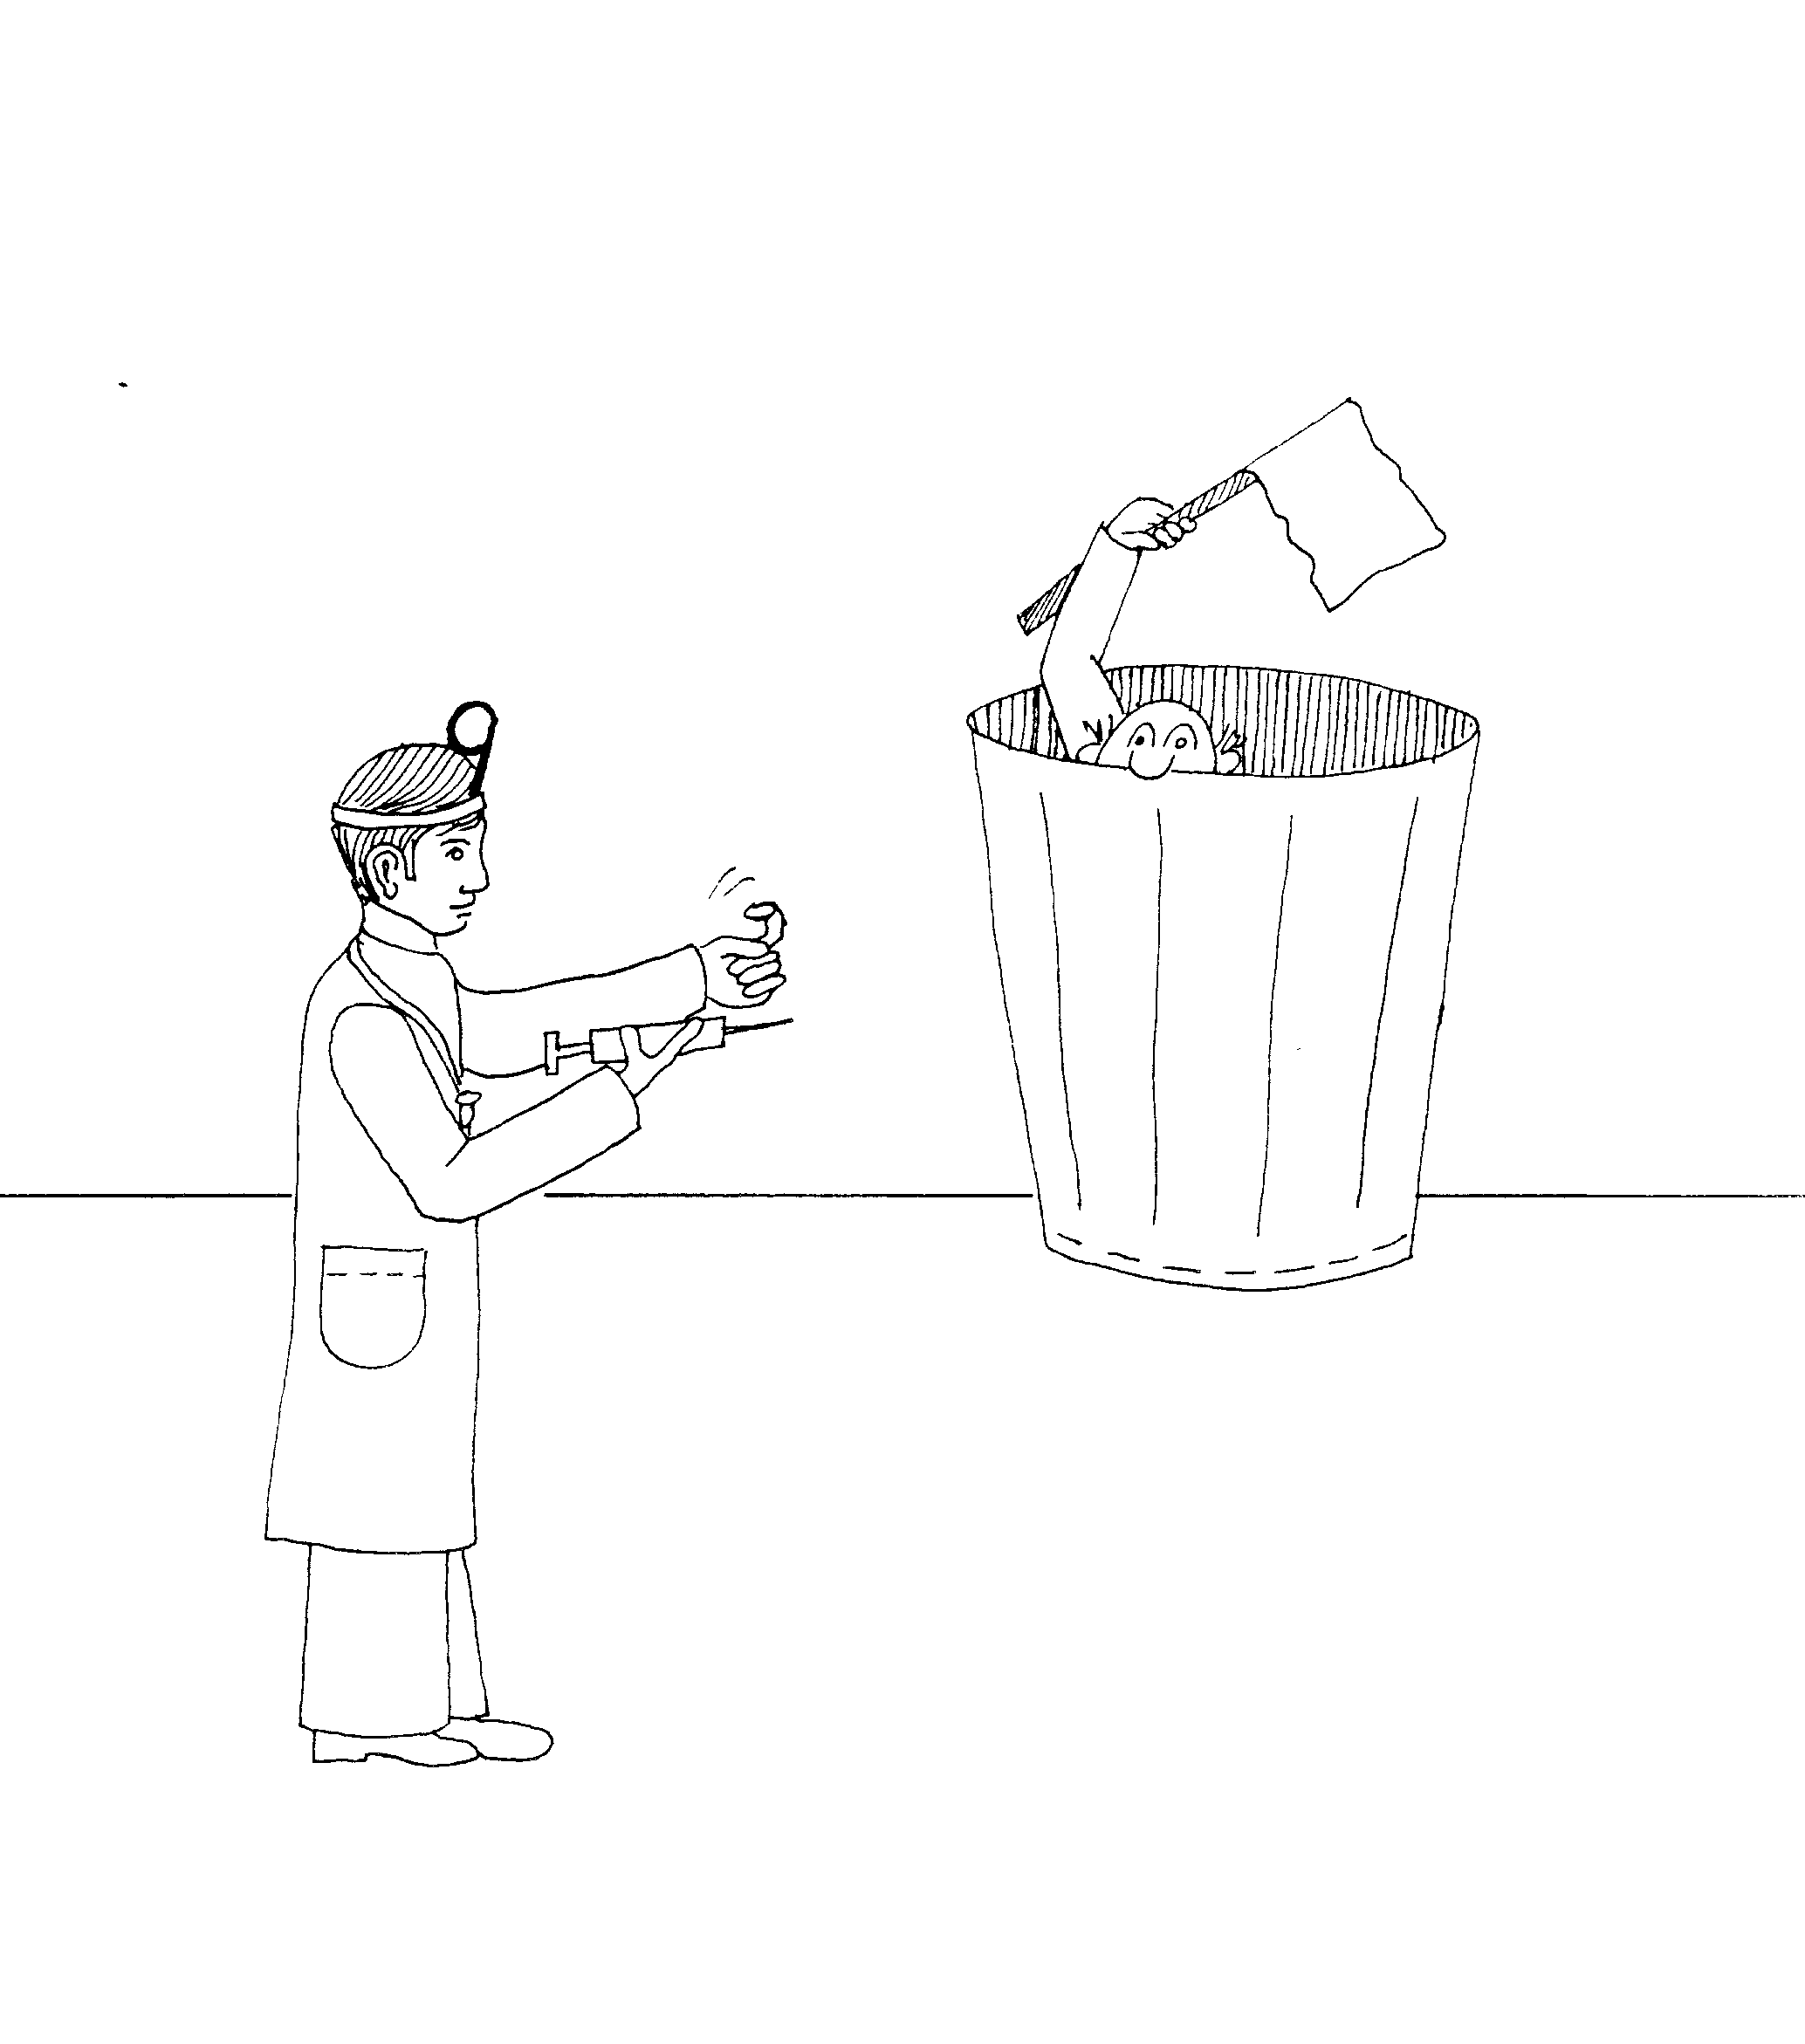 | 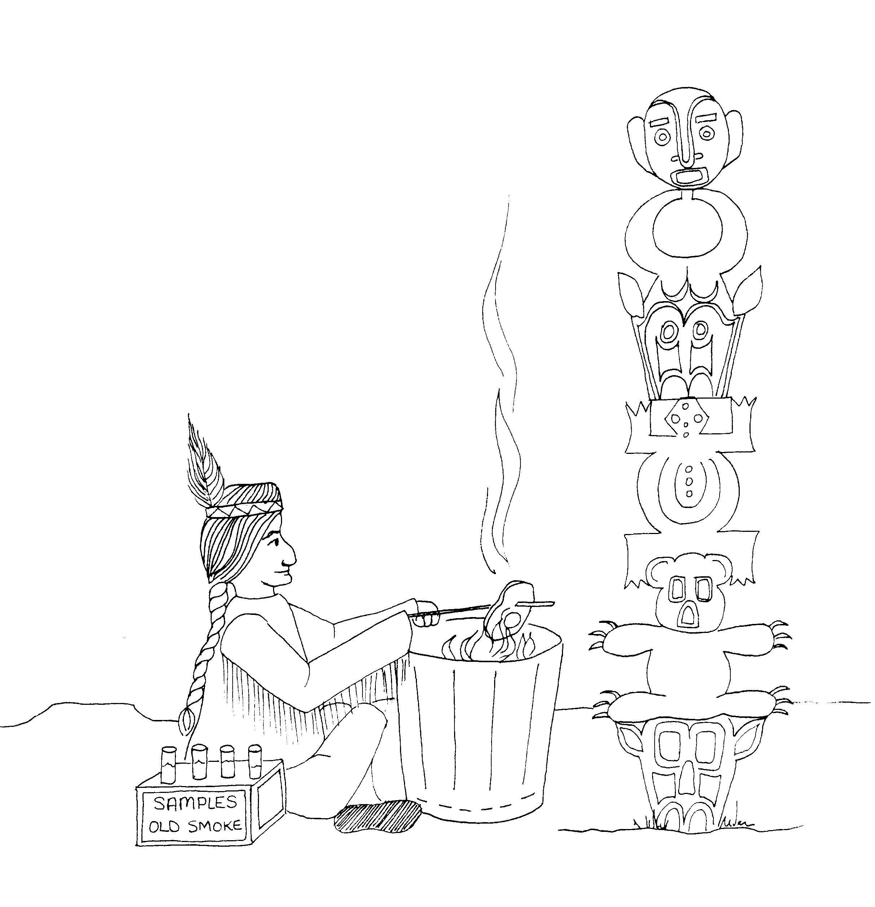
9. SURRENDERING RIGHTS,  9 = Doctor's ophthalmoscope mirror  * SURRENDERING RIGHTS: guy holding out rights so  he does not get the doctor's shot surrender flag | 10. OLD TESTAMENT EXAMPLES,  MEAT OFFERED TO IDOLS  10 = 10 little Indians  * OLD TESTAMENT EXAMPLES: Old test tube samples  * MEAT OFFERED TO IDOLS: meat being cooked by idol
1 Corinthians 9 - 10
© 2003 Do not reproduce
1 Corinthians

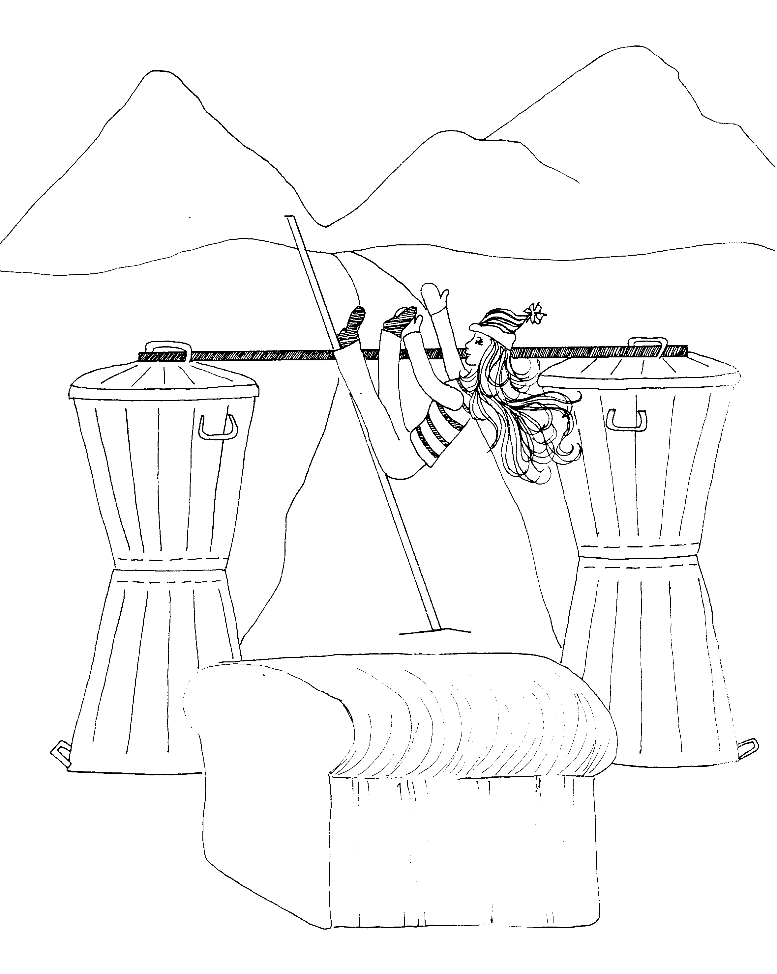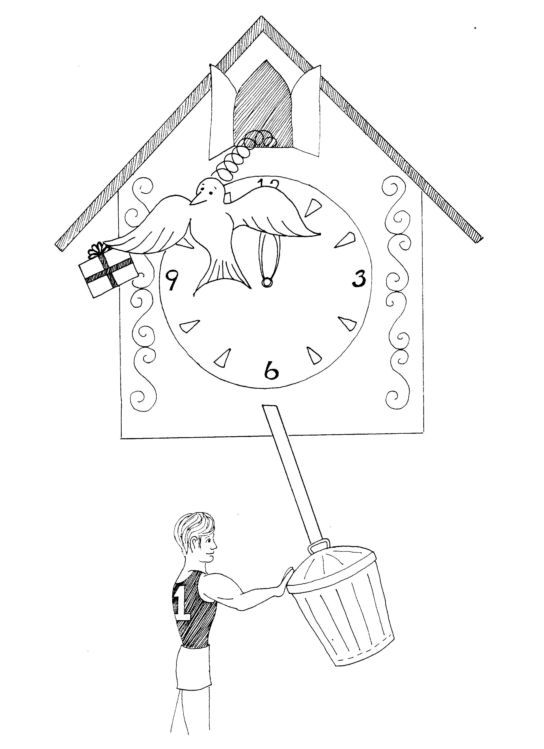

11. HEADS AND HAIR, COMMUNION 12. SPIRIT'S GIFTS, ONE BODY

11 = Pole-vault bars which look like an 11 12 = 12 o'clock (clock = 12)

* HEADS AND HAIR: girl with lots of hair and hat * SPIRIT'S GIFTS: gift comes out of the clock with dove
vaulting over the bar (Spirit)

* COMMUNION: bread as a symbol of communion * ONE BODY: No. 1 body, a body builder guy pumping iron pendulum of the clock

1 Corinthians 11 - 12
© 2003 Do not reproduce
1 Corinthians

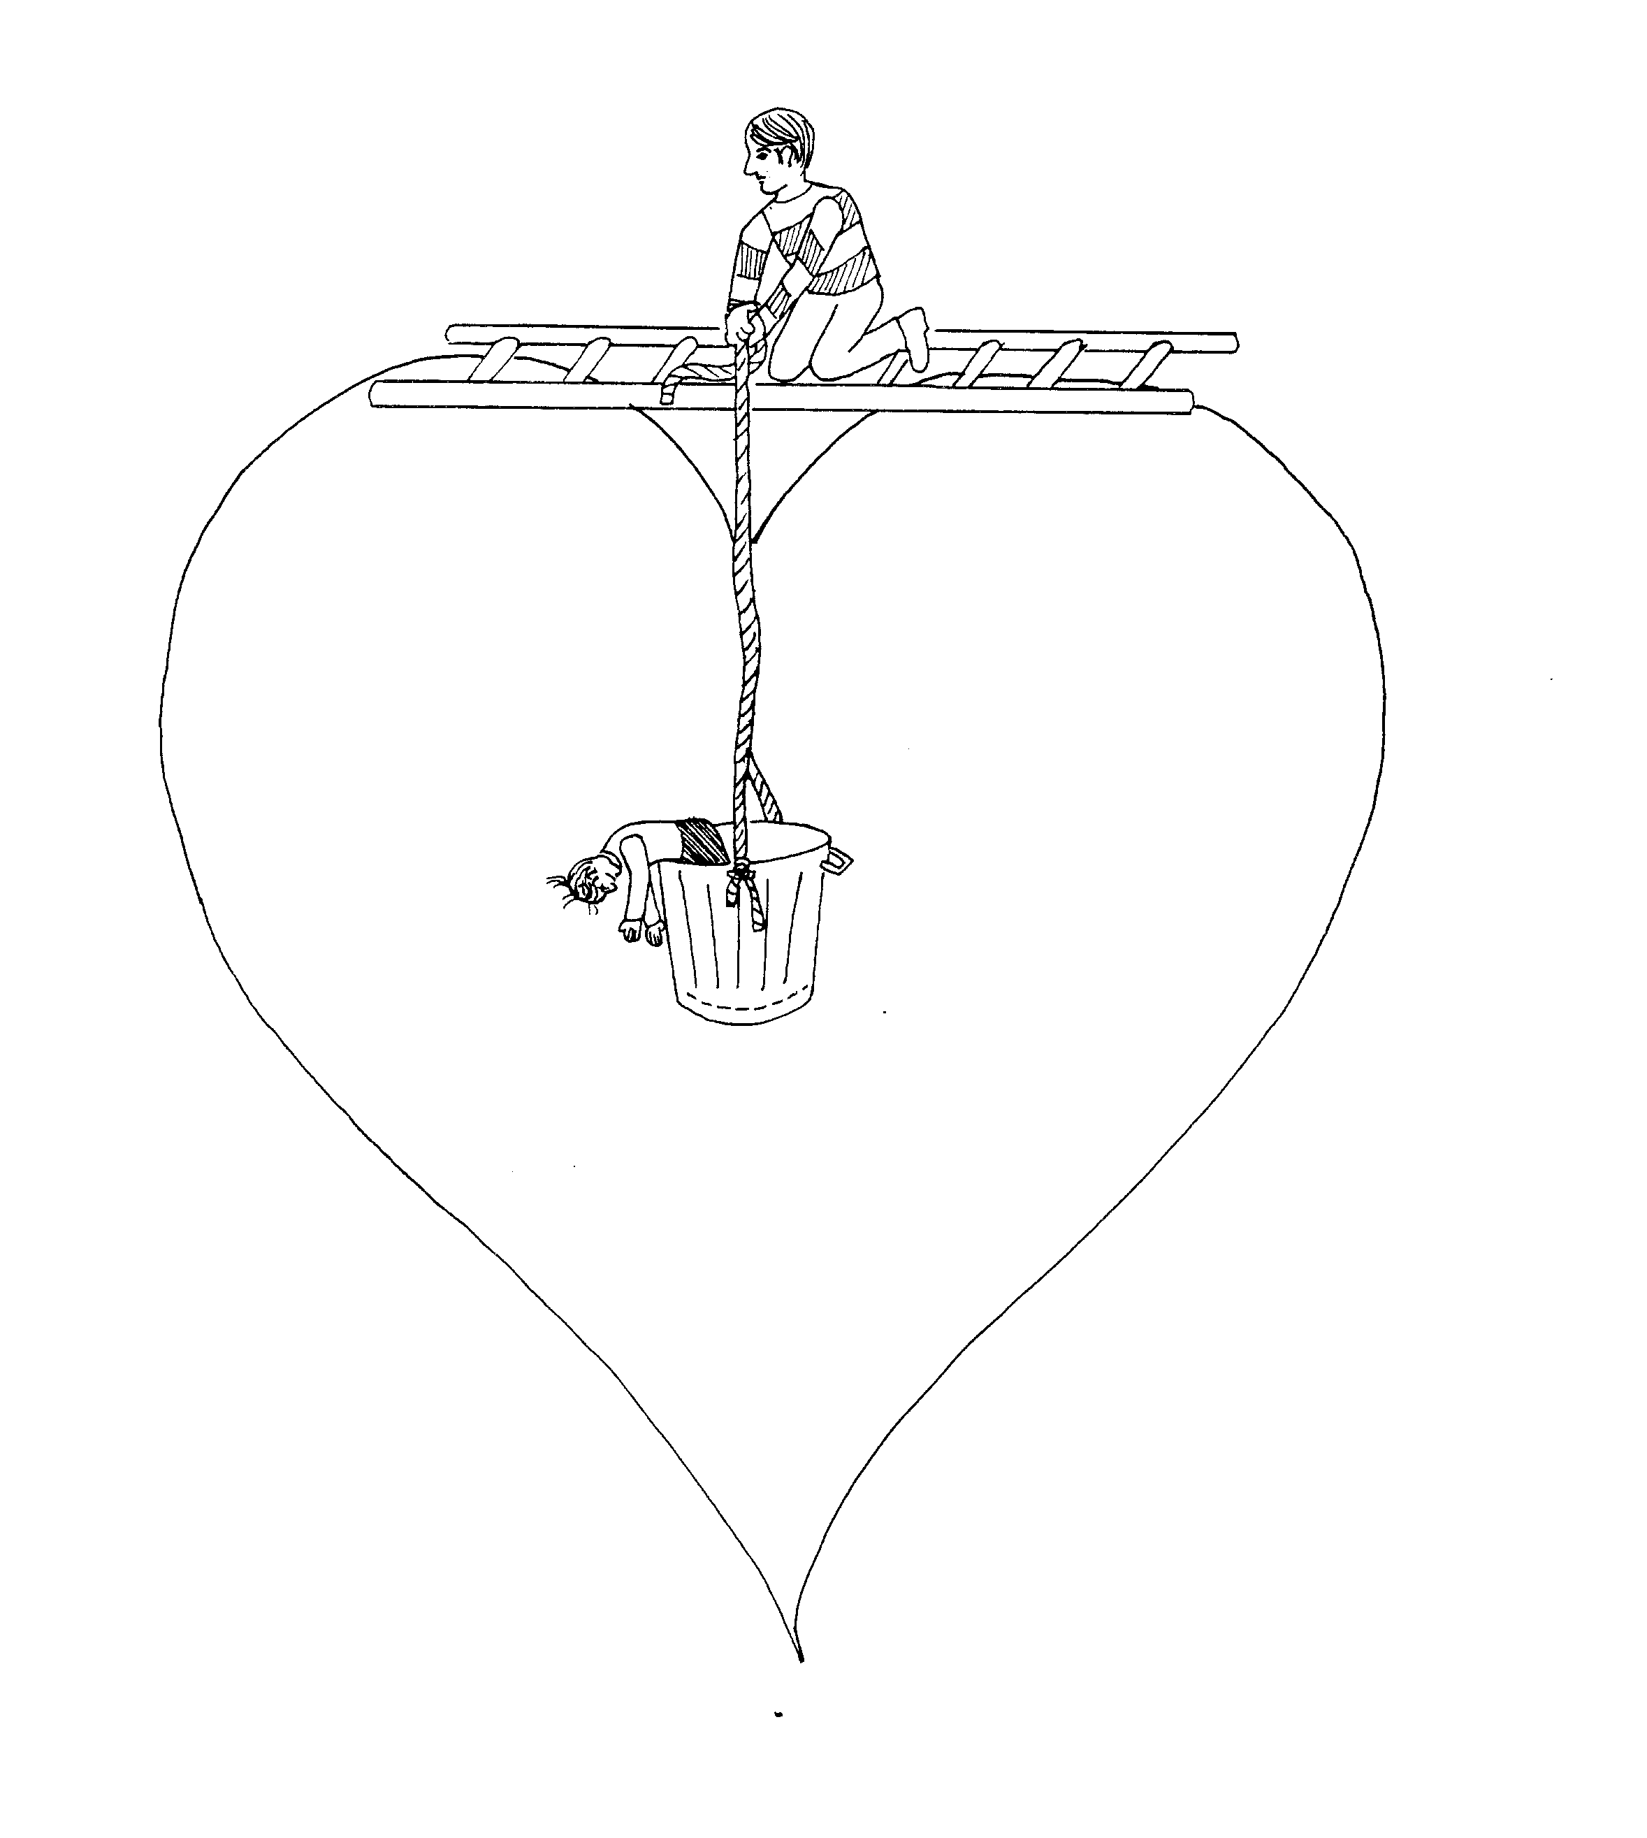 | 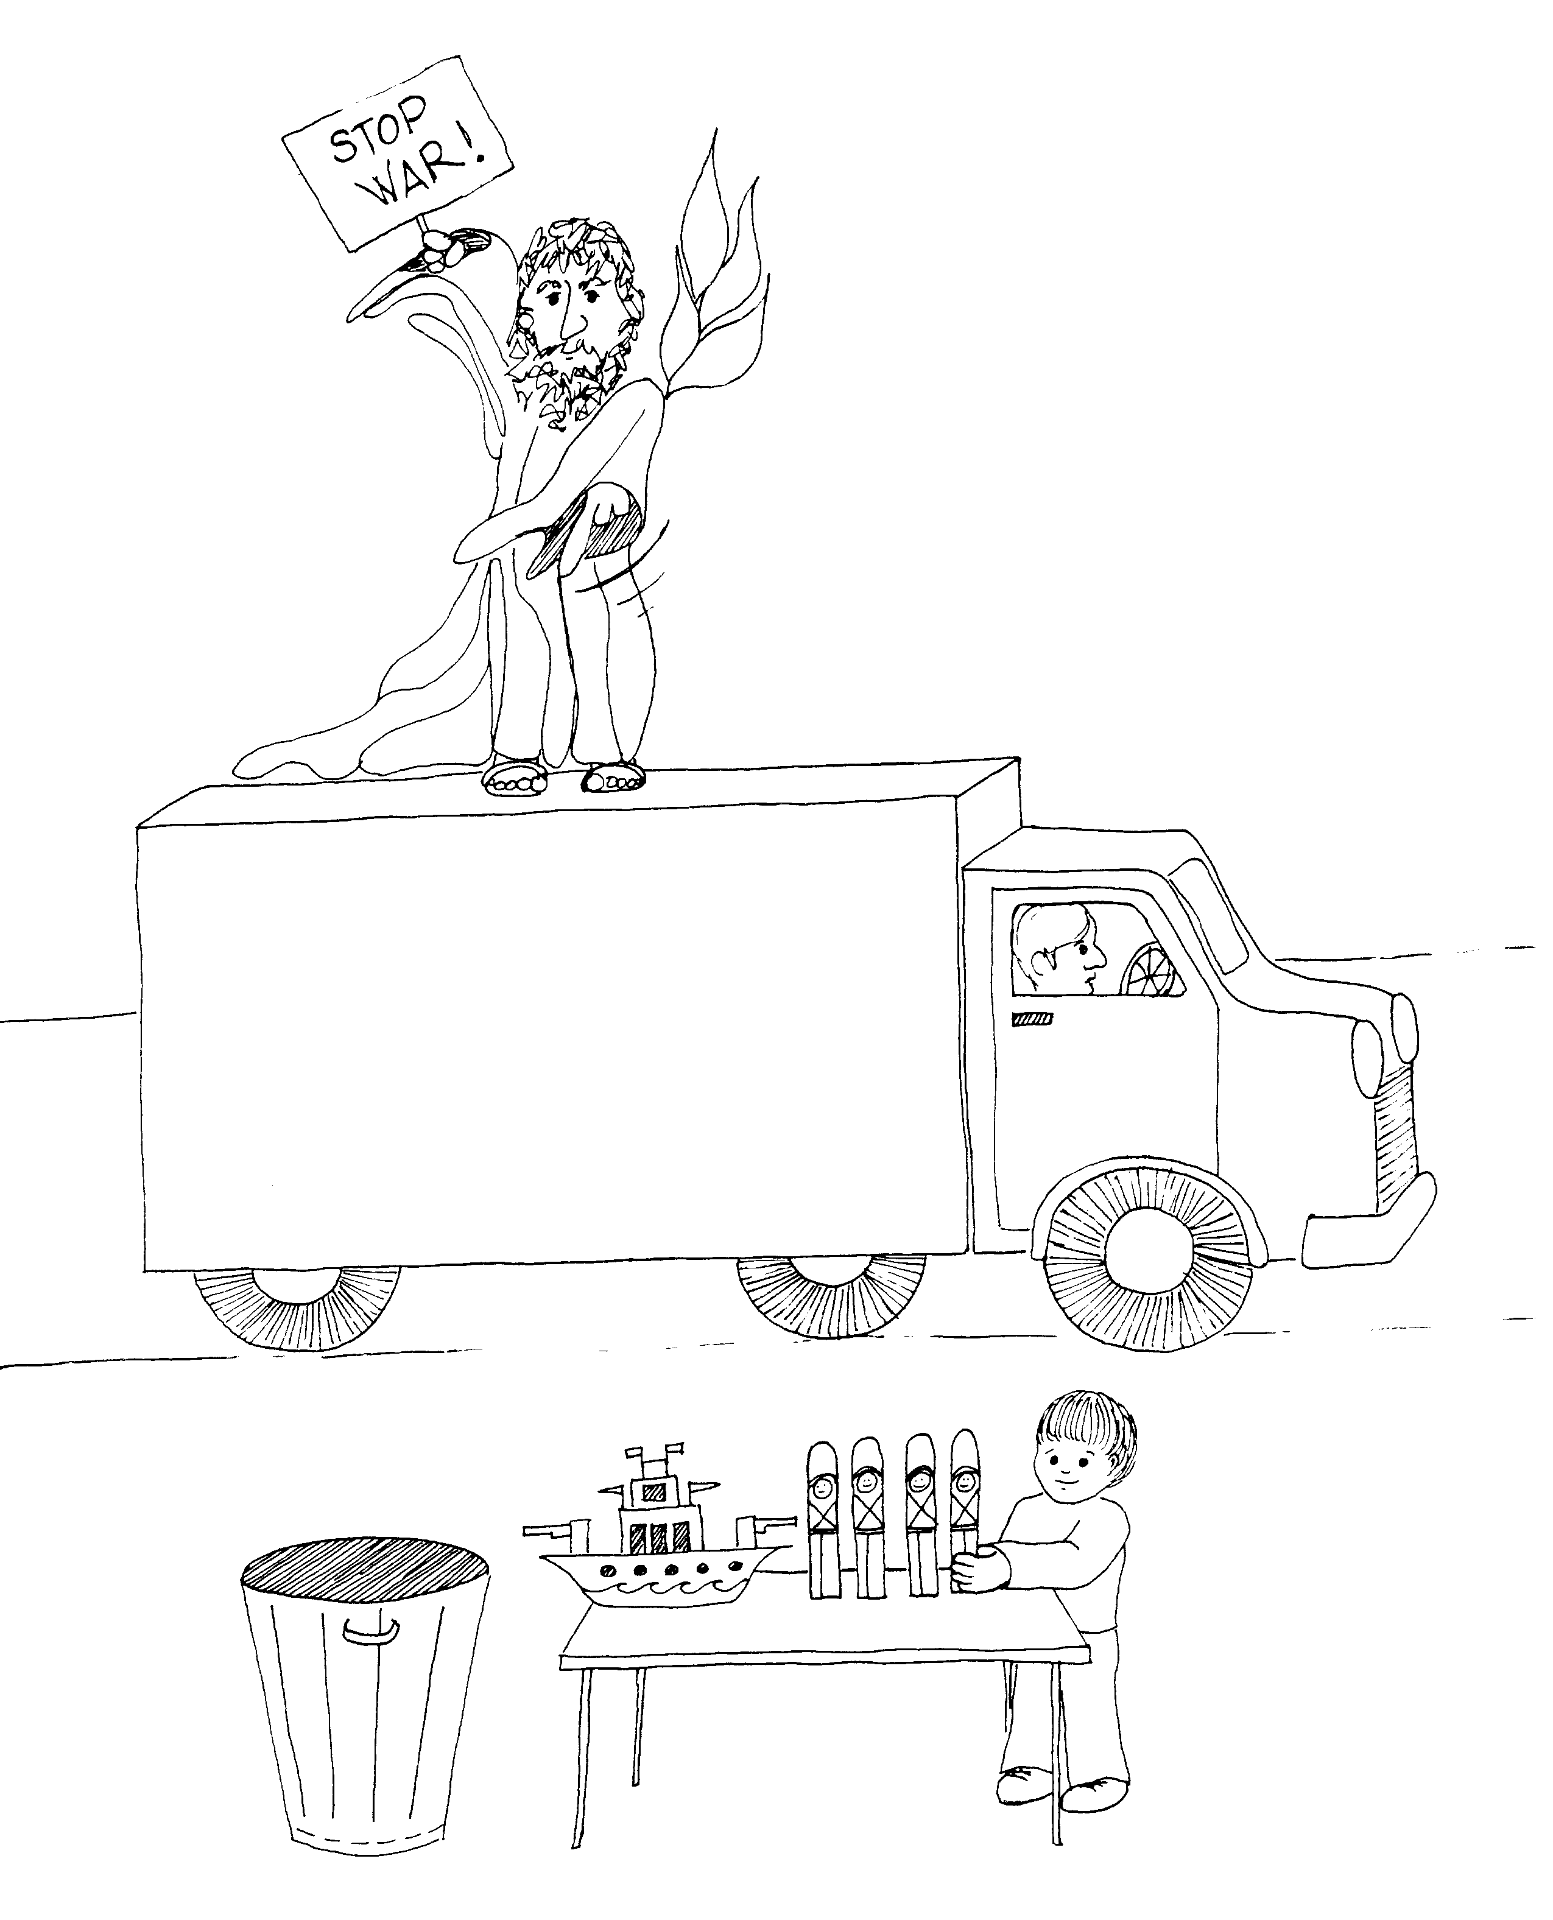
13. LOVE  13 = Ladder (13 unlucky like walking under a ladder)  * LOVE: heart ( = love) | 14. PROPHECY AND TONGUES, ORDERLY WORSHIP  14 = Semi-truck, 10-4 CB trucker talk  * PROPHECY AND TONGUES: prophet with tongue of fire  on his shoulder  * ORDERLY WORSHIP: orderly warships
1 Corinthians 13 - 14
© 2003 Do not reproduce
1 Corinthians

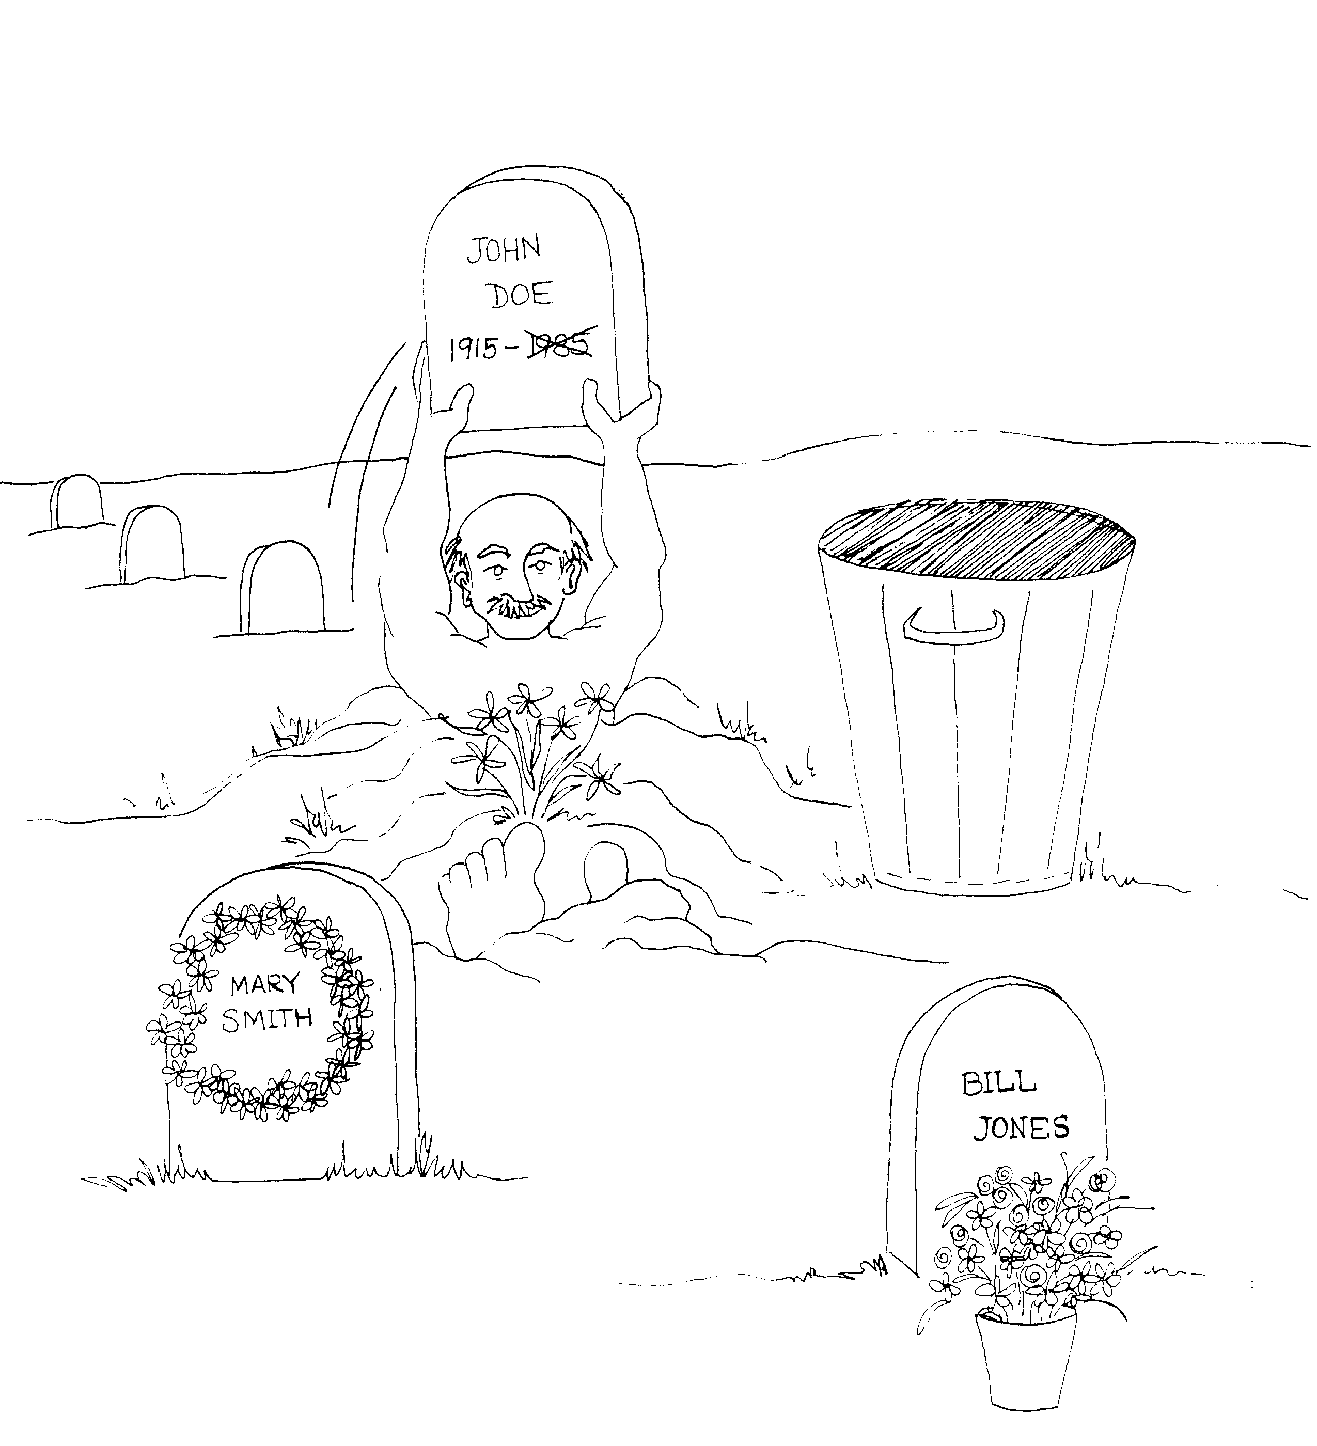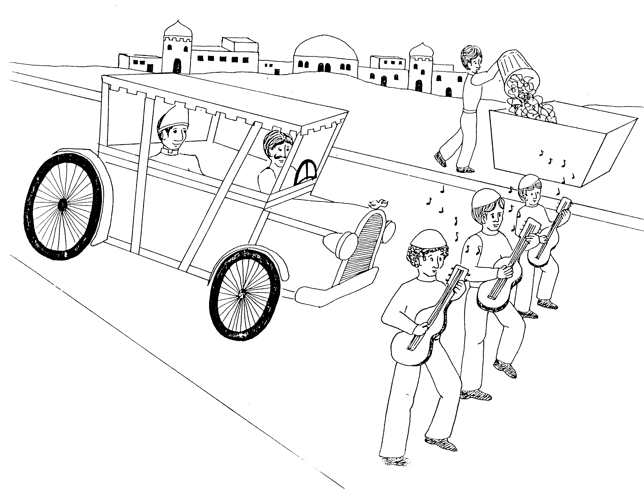

15. RESURRECTION 16. JERUSALEM COLLECTION, COMING VISITORS

15 = Rhymes with "lifting" 16 = Six strings (on guitar)

* RESURRECTION: guy coming out of grave, * JERUSALEM COLLECTION: garbage collection in
lifting to throw tombstone in garbage Jerusalem

* COMING VISITORS: famous people being escorted into
Jerusalem

1 Corinthians 15 - 16
© 2003 Do not reproduce
2 Corinthians

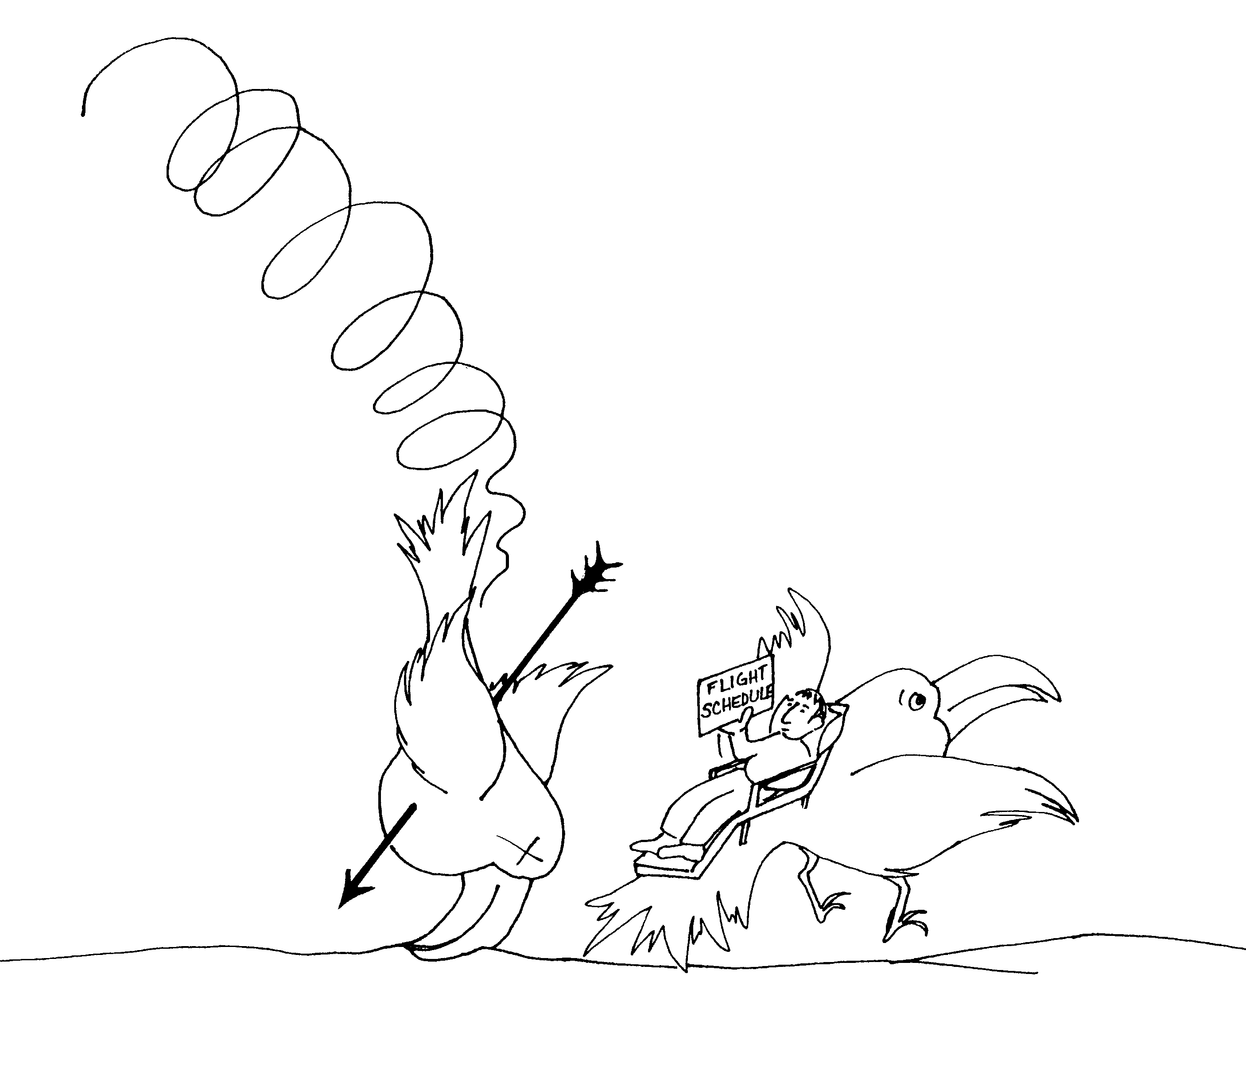 | 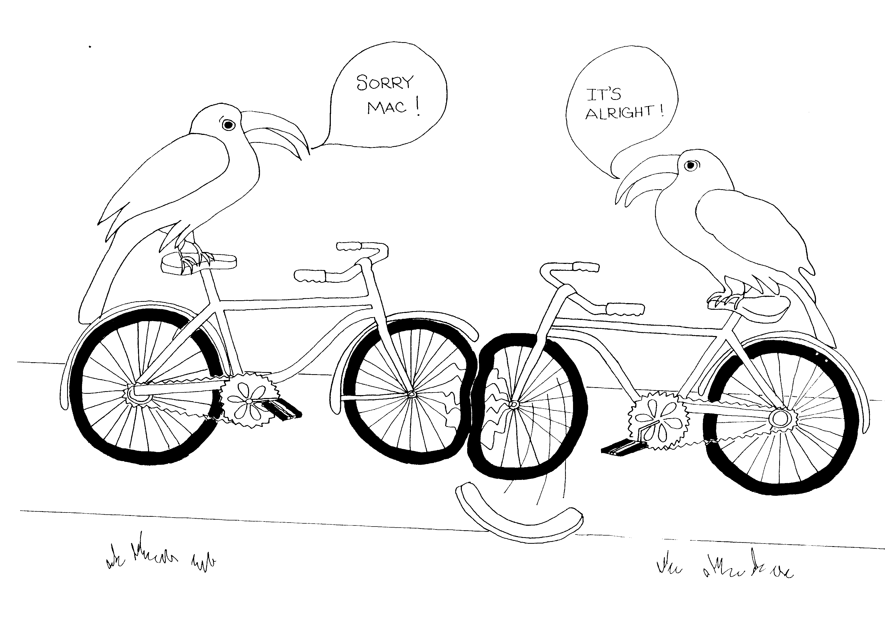
2 CORINTHIANS = TWO – CAN (BIRD TOUCAN)  1. COMFORTING, VISIT RESCHEDULED  1 = Arrow  * COMFORTING: one guy flying away in comfort  * VISIT RESCHEDULED: one plane shot down by arrow  must be rescheduled | 2. FORGIVE THE OFFENDER  2 = Bicycle (2 wheels)  * FORGIVE THE OFFENDER: 'off – fender' fender came off
2 Corinthians 1 – 2
© 2003 Do not reproduce
2 Corinthians

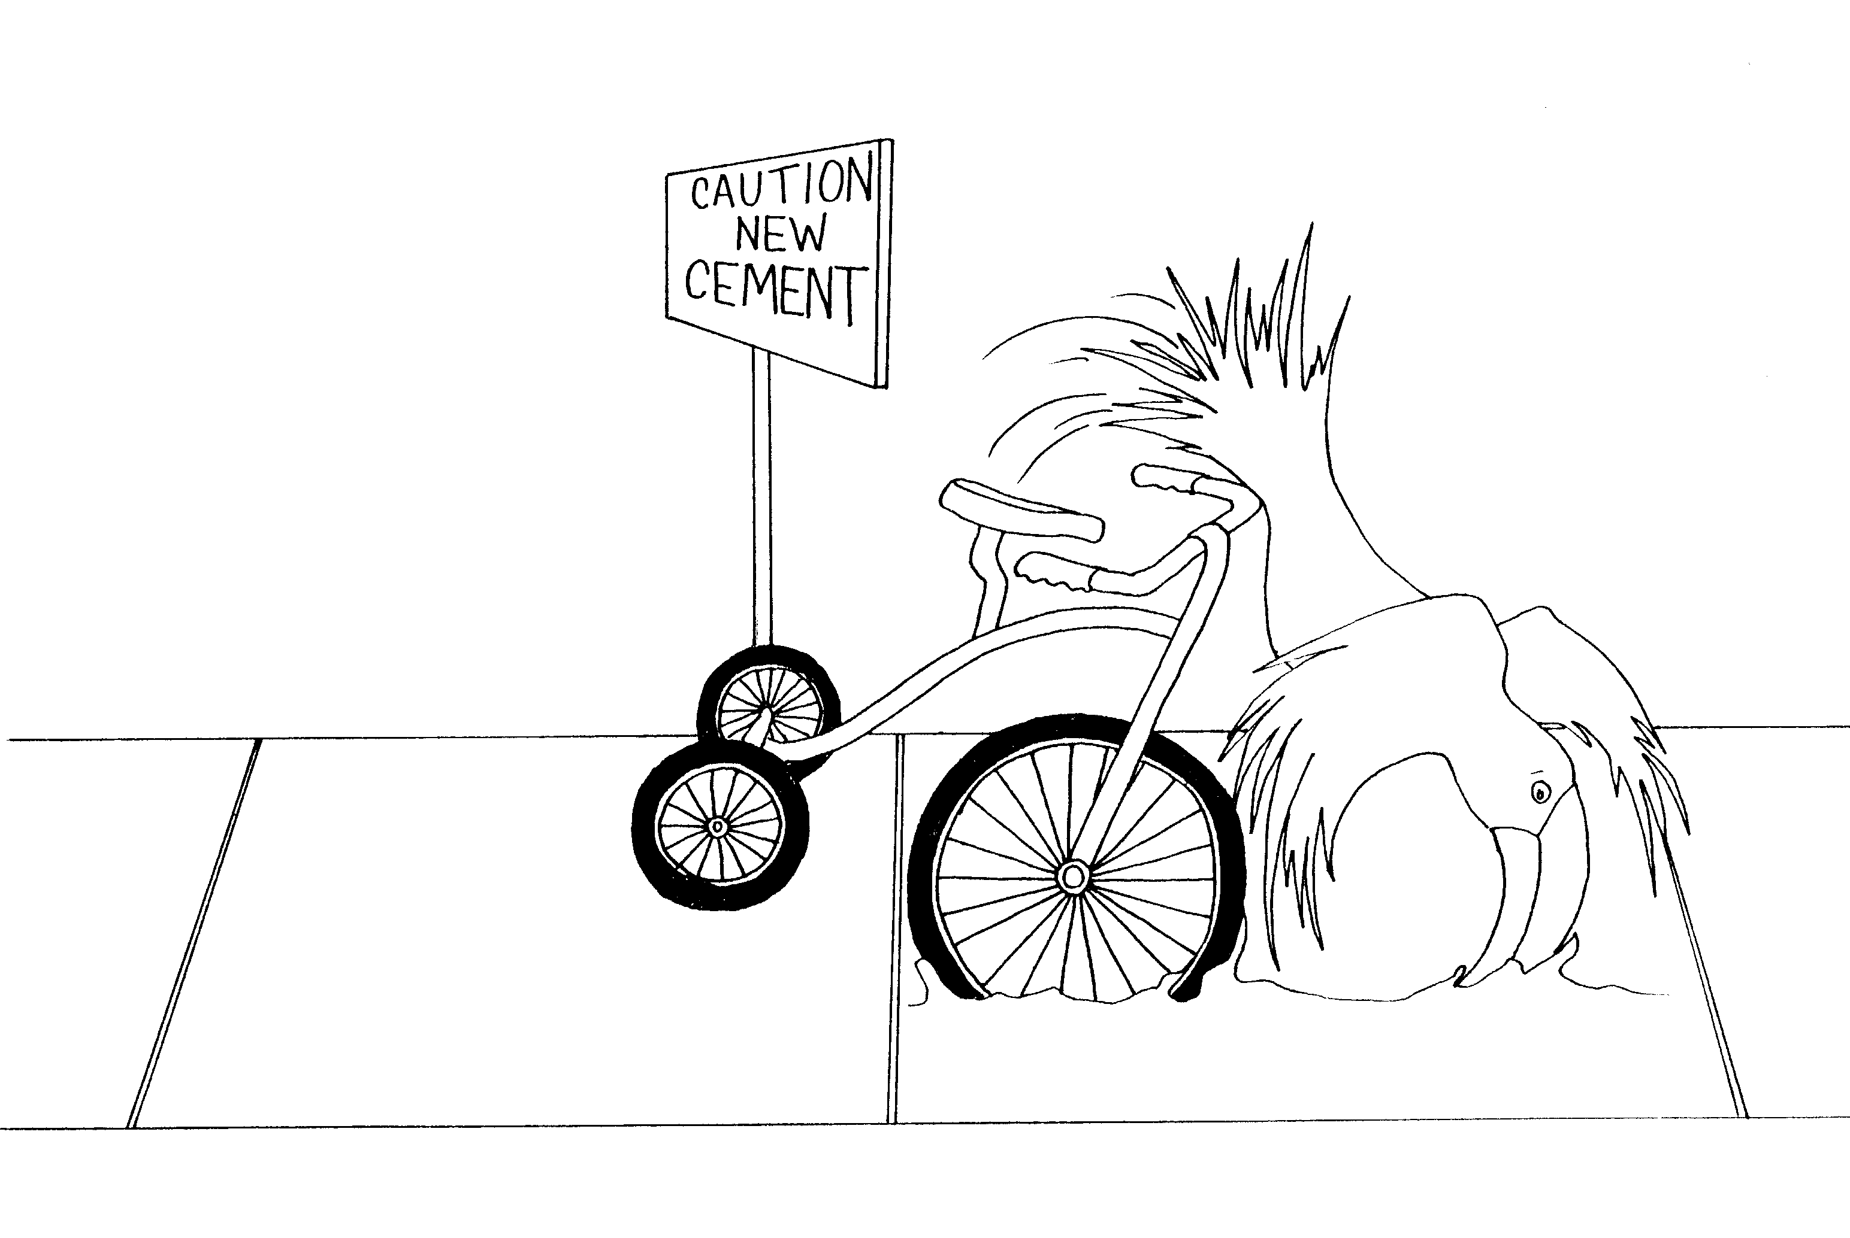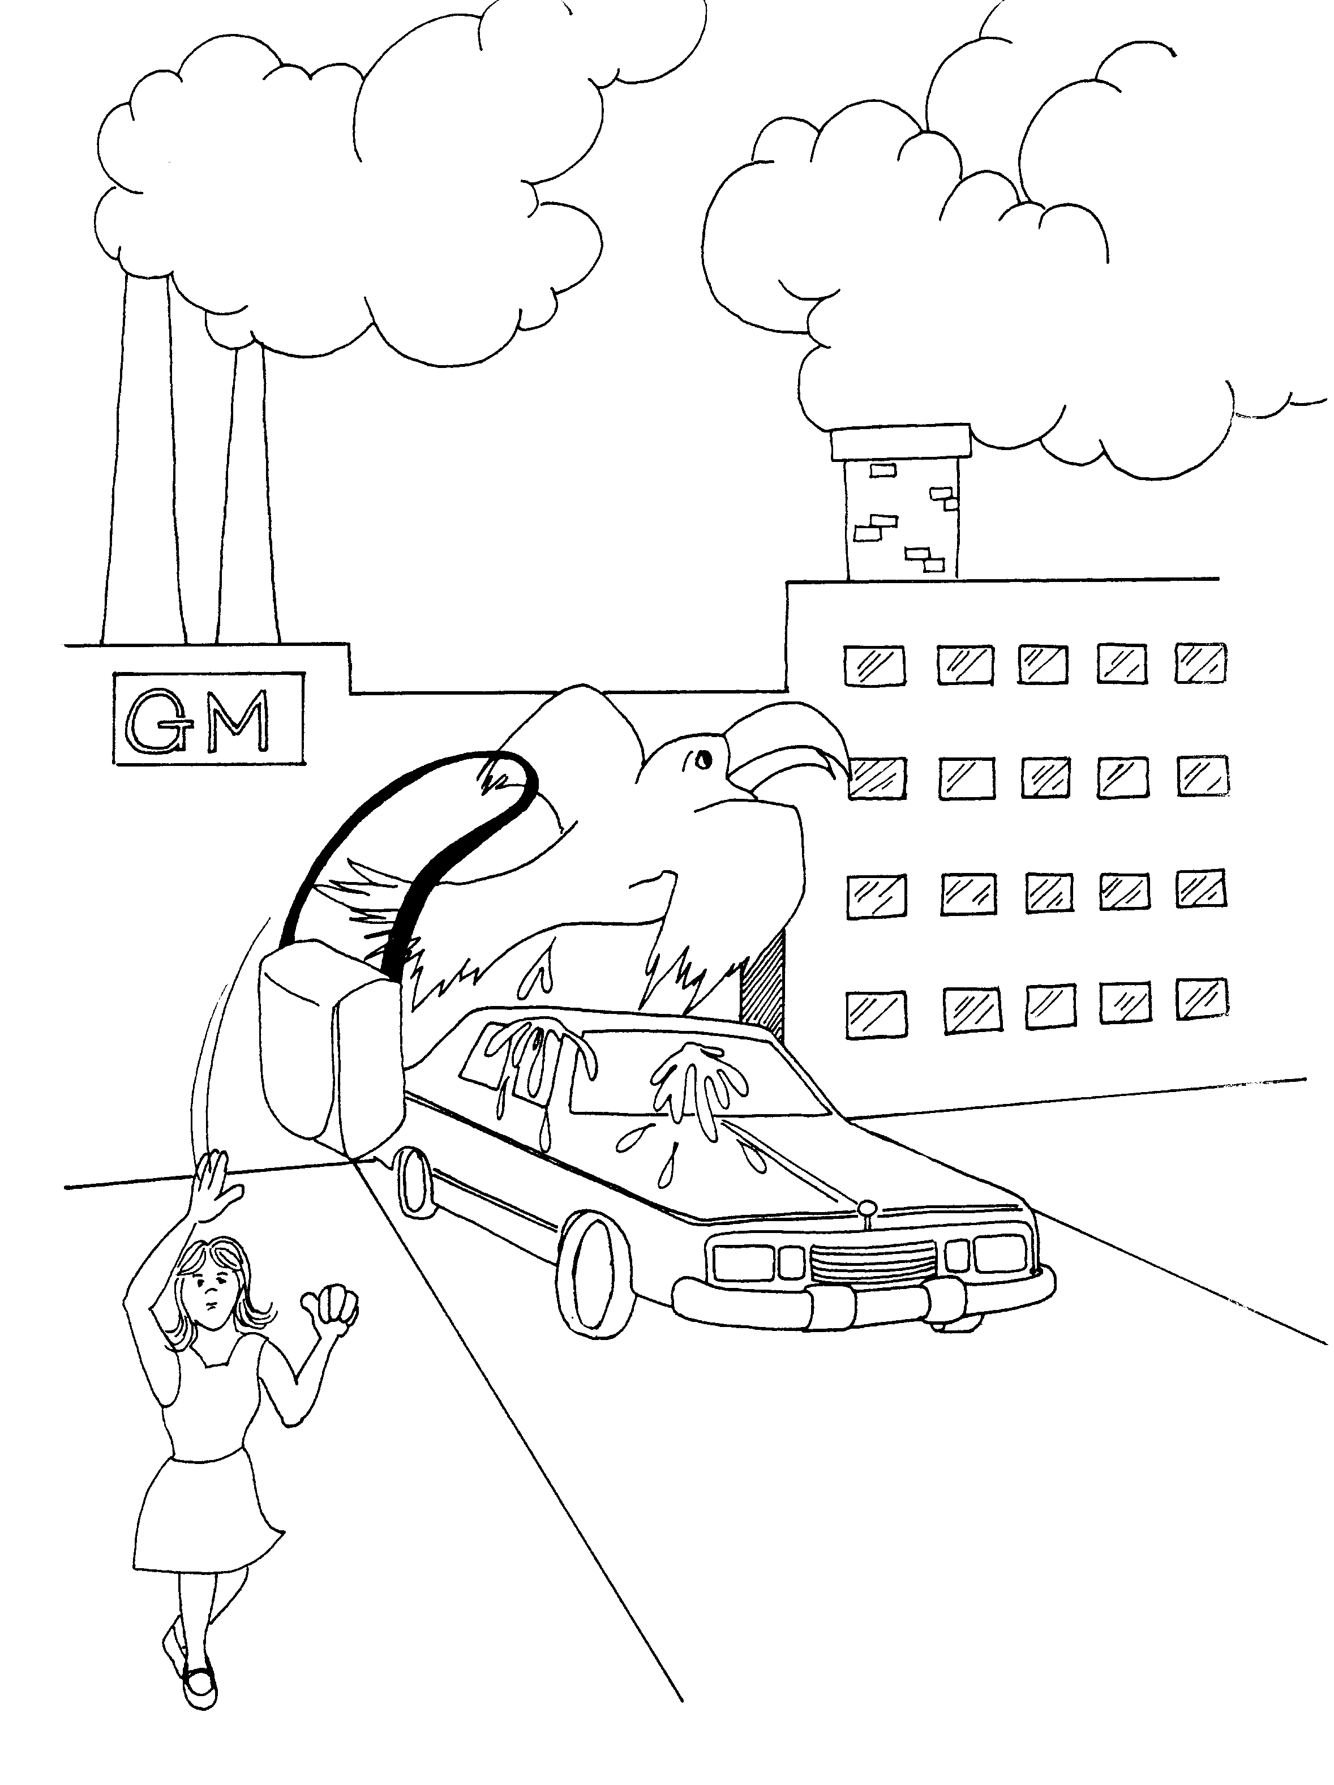

3. OLD AND NEW TESTAMENT 4. GLORY AND PERSECUTION

3 = Tricycle (3 wheels) 4 = Car (4 wheels)

* OLD AND NEW TESTAMENT: old (hard) and * GLORY AND PERSECUTION: shiny new car (glory) just
new (soft) 'test – cement' came out of factory, purse snatched by bird 'purse-ecution'

2 Corinthians 3 – 4
© 2003 Do not reproduce

2 Corinthians

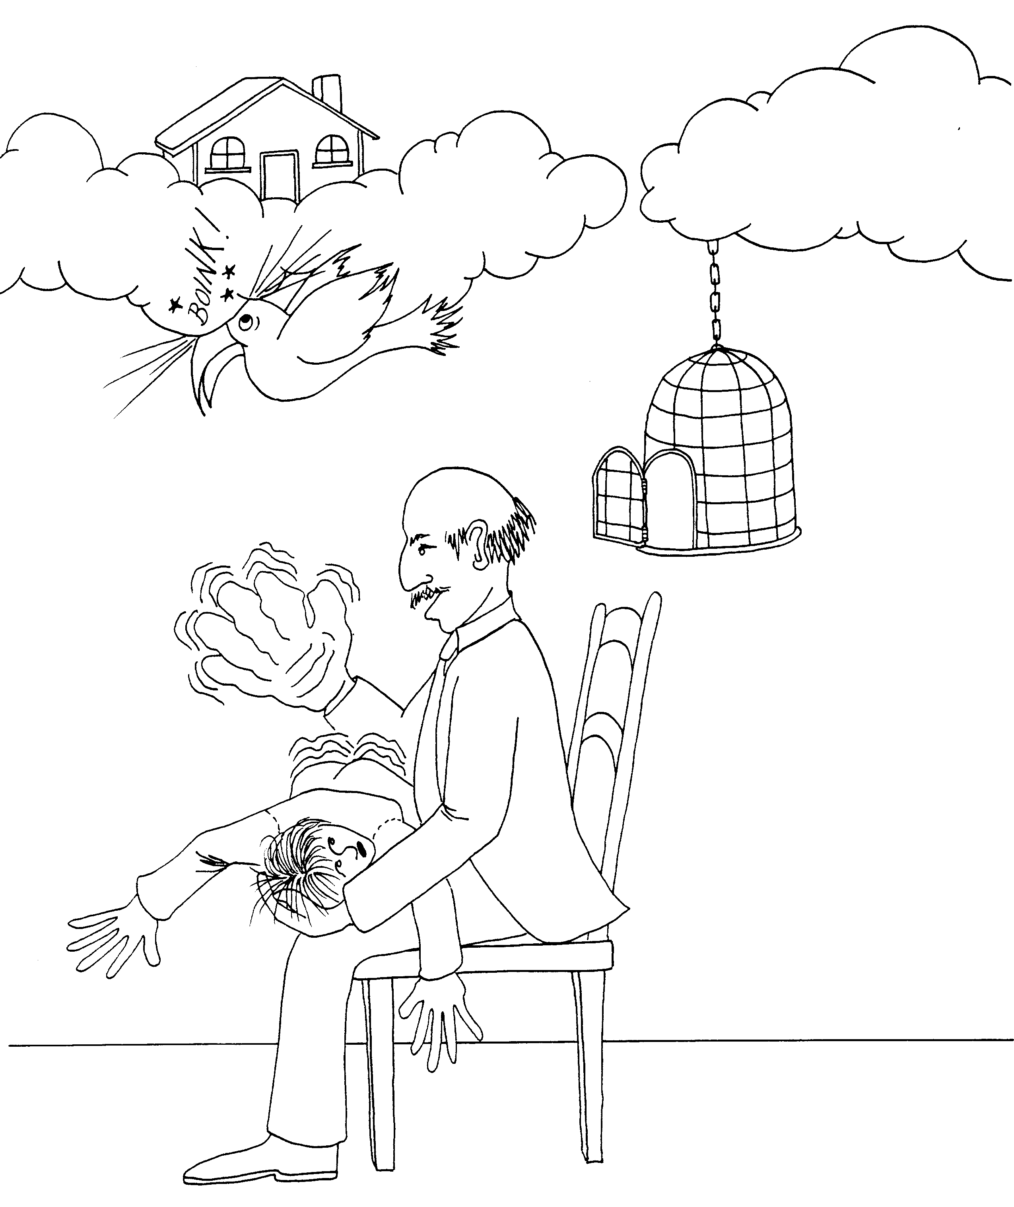 | 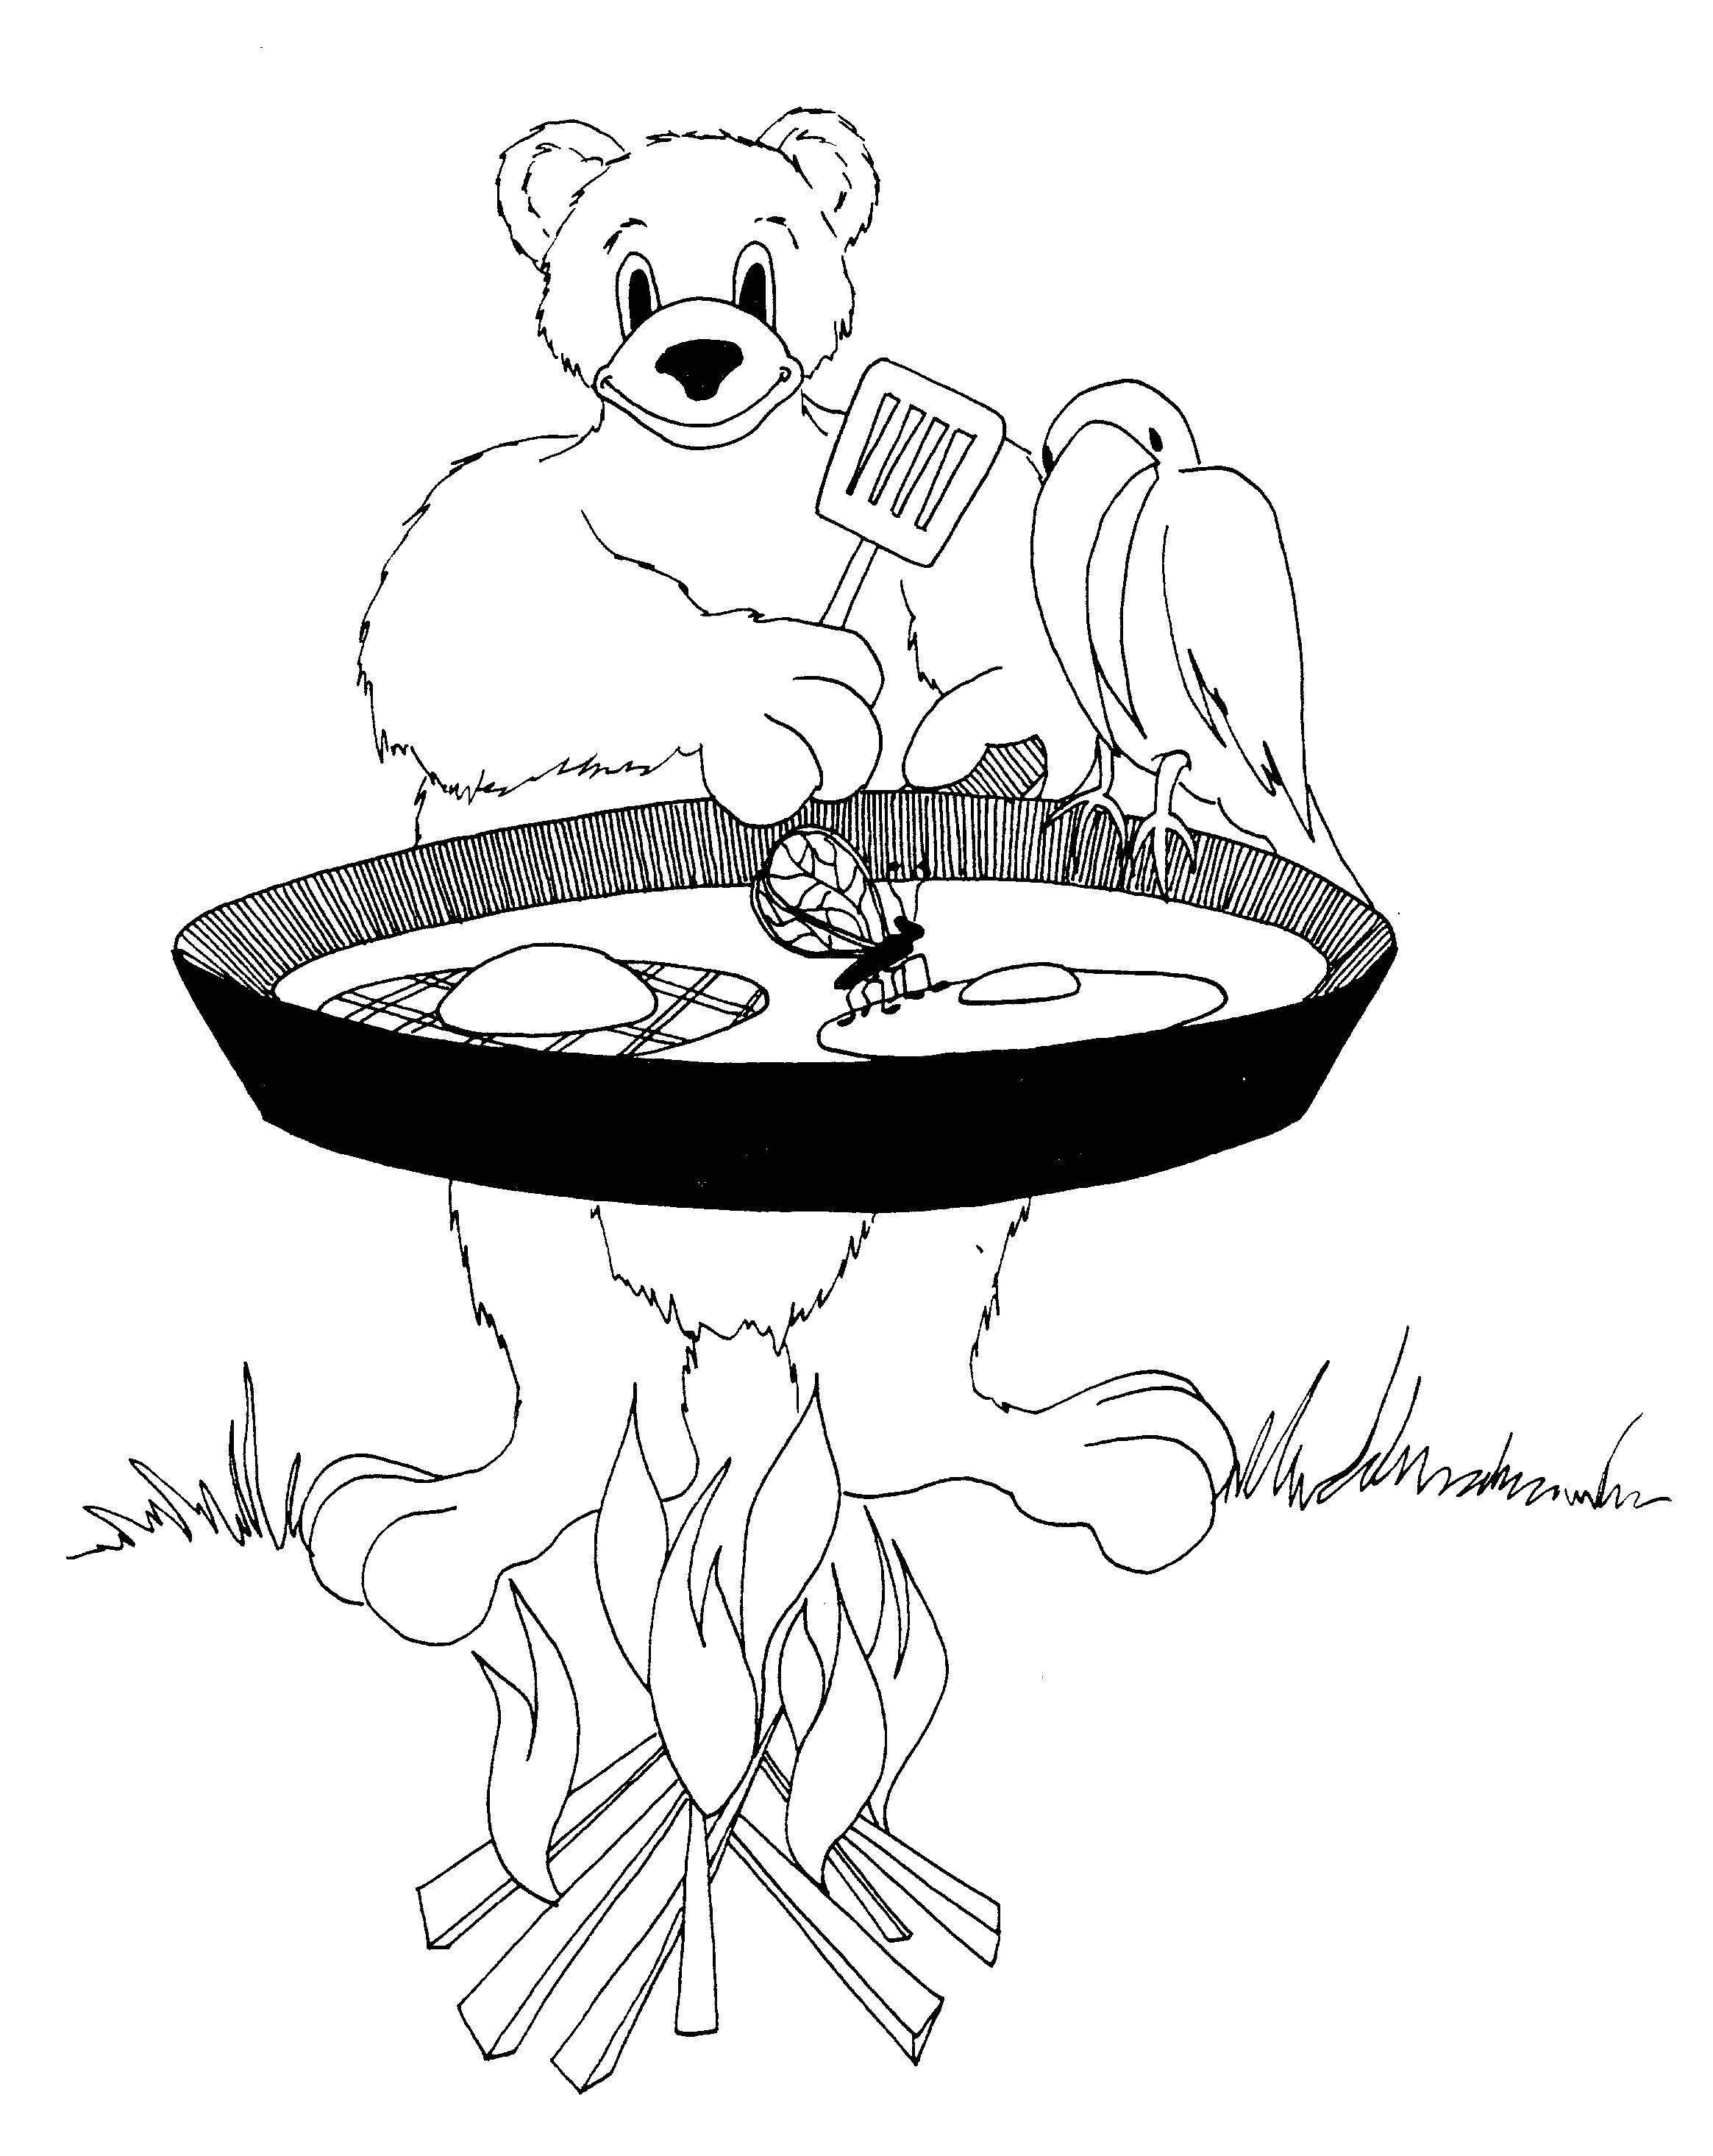
5. HEAVENLY HOUSE, JUDGMENT SEAT RECONCILIATION  5 = Hand (5 fingers, give me five)  * HEAVENLY HOUSE: house in clouds  * JUDGMENT SEAT: seat of boy being spanked  * RECONCILIATION: 'wreck-on-the-ceiling' | 6. PAUL'S PATTERN, UNEQUALLY YOKED  6 = Insect (6 legs on a bug)  * PAUL'S PATTERN: pattern on Paul's (bear's) egg  * UNEQUALLY YOKED: yokes of different size eggs
2 Corinthians 5 – 6
© 2003 Do not reproduce
2 Corinthians

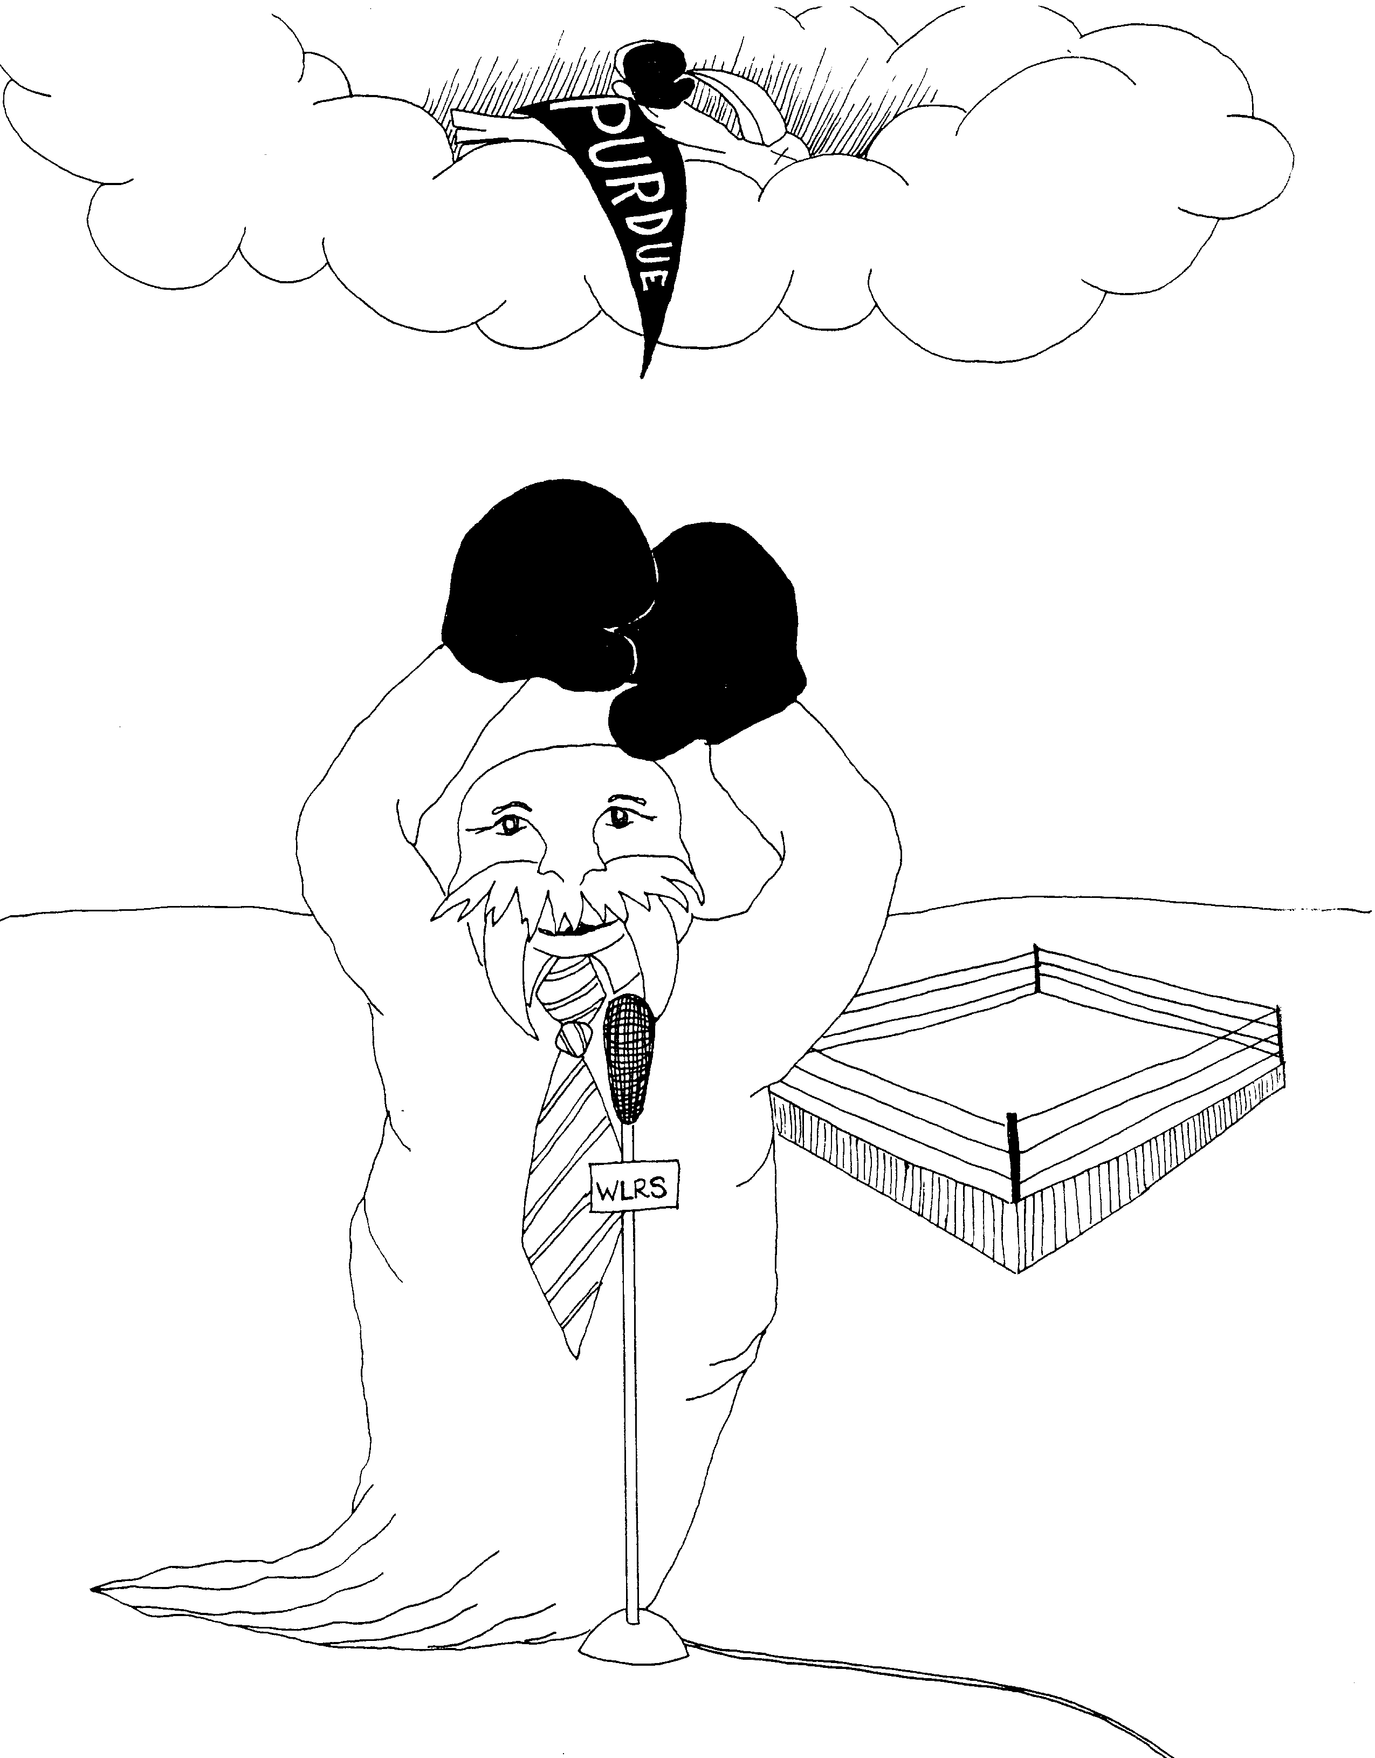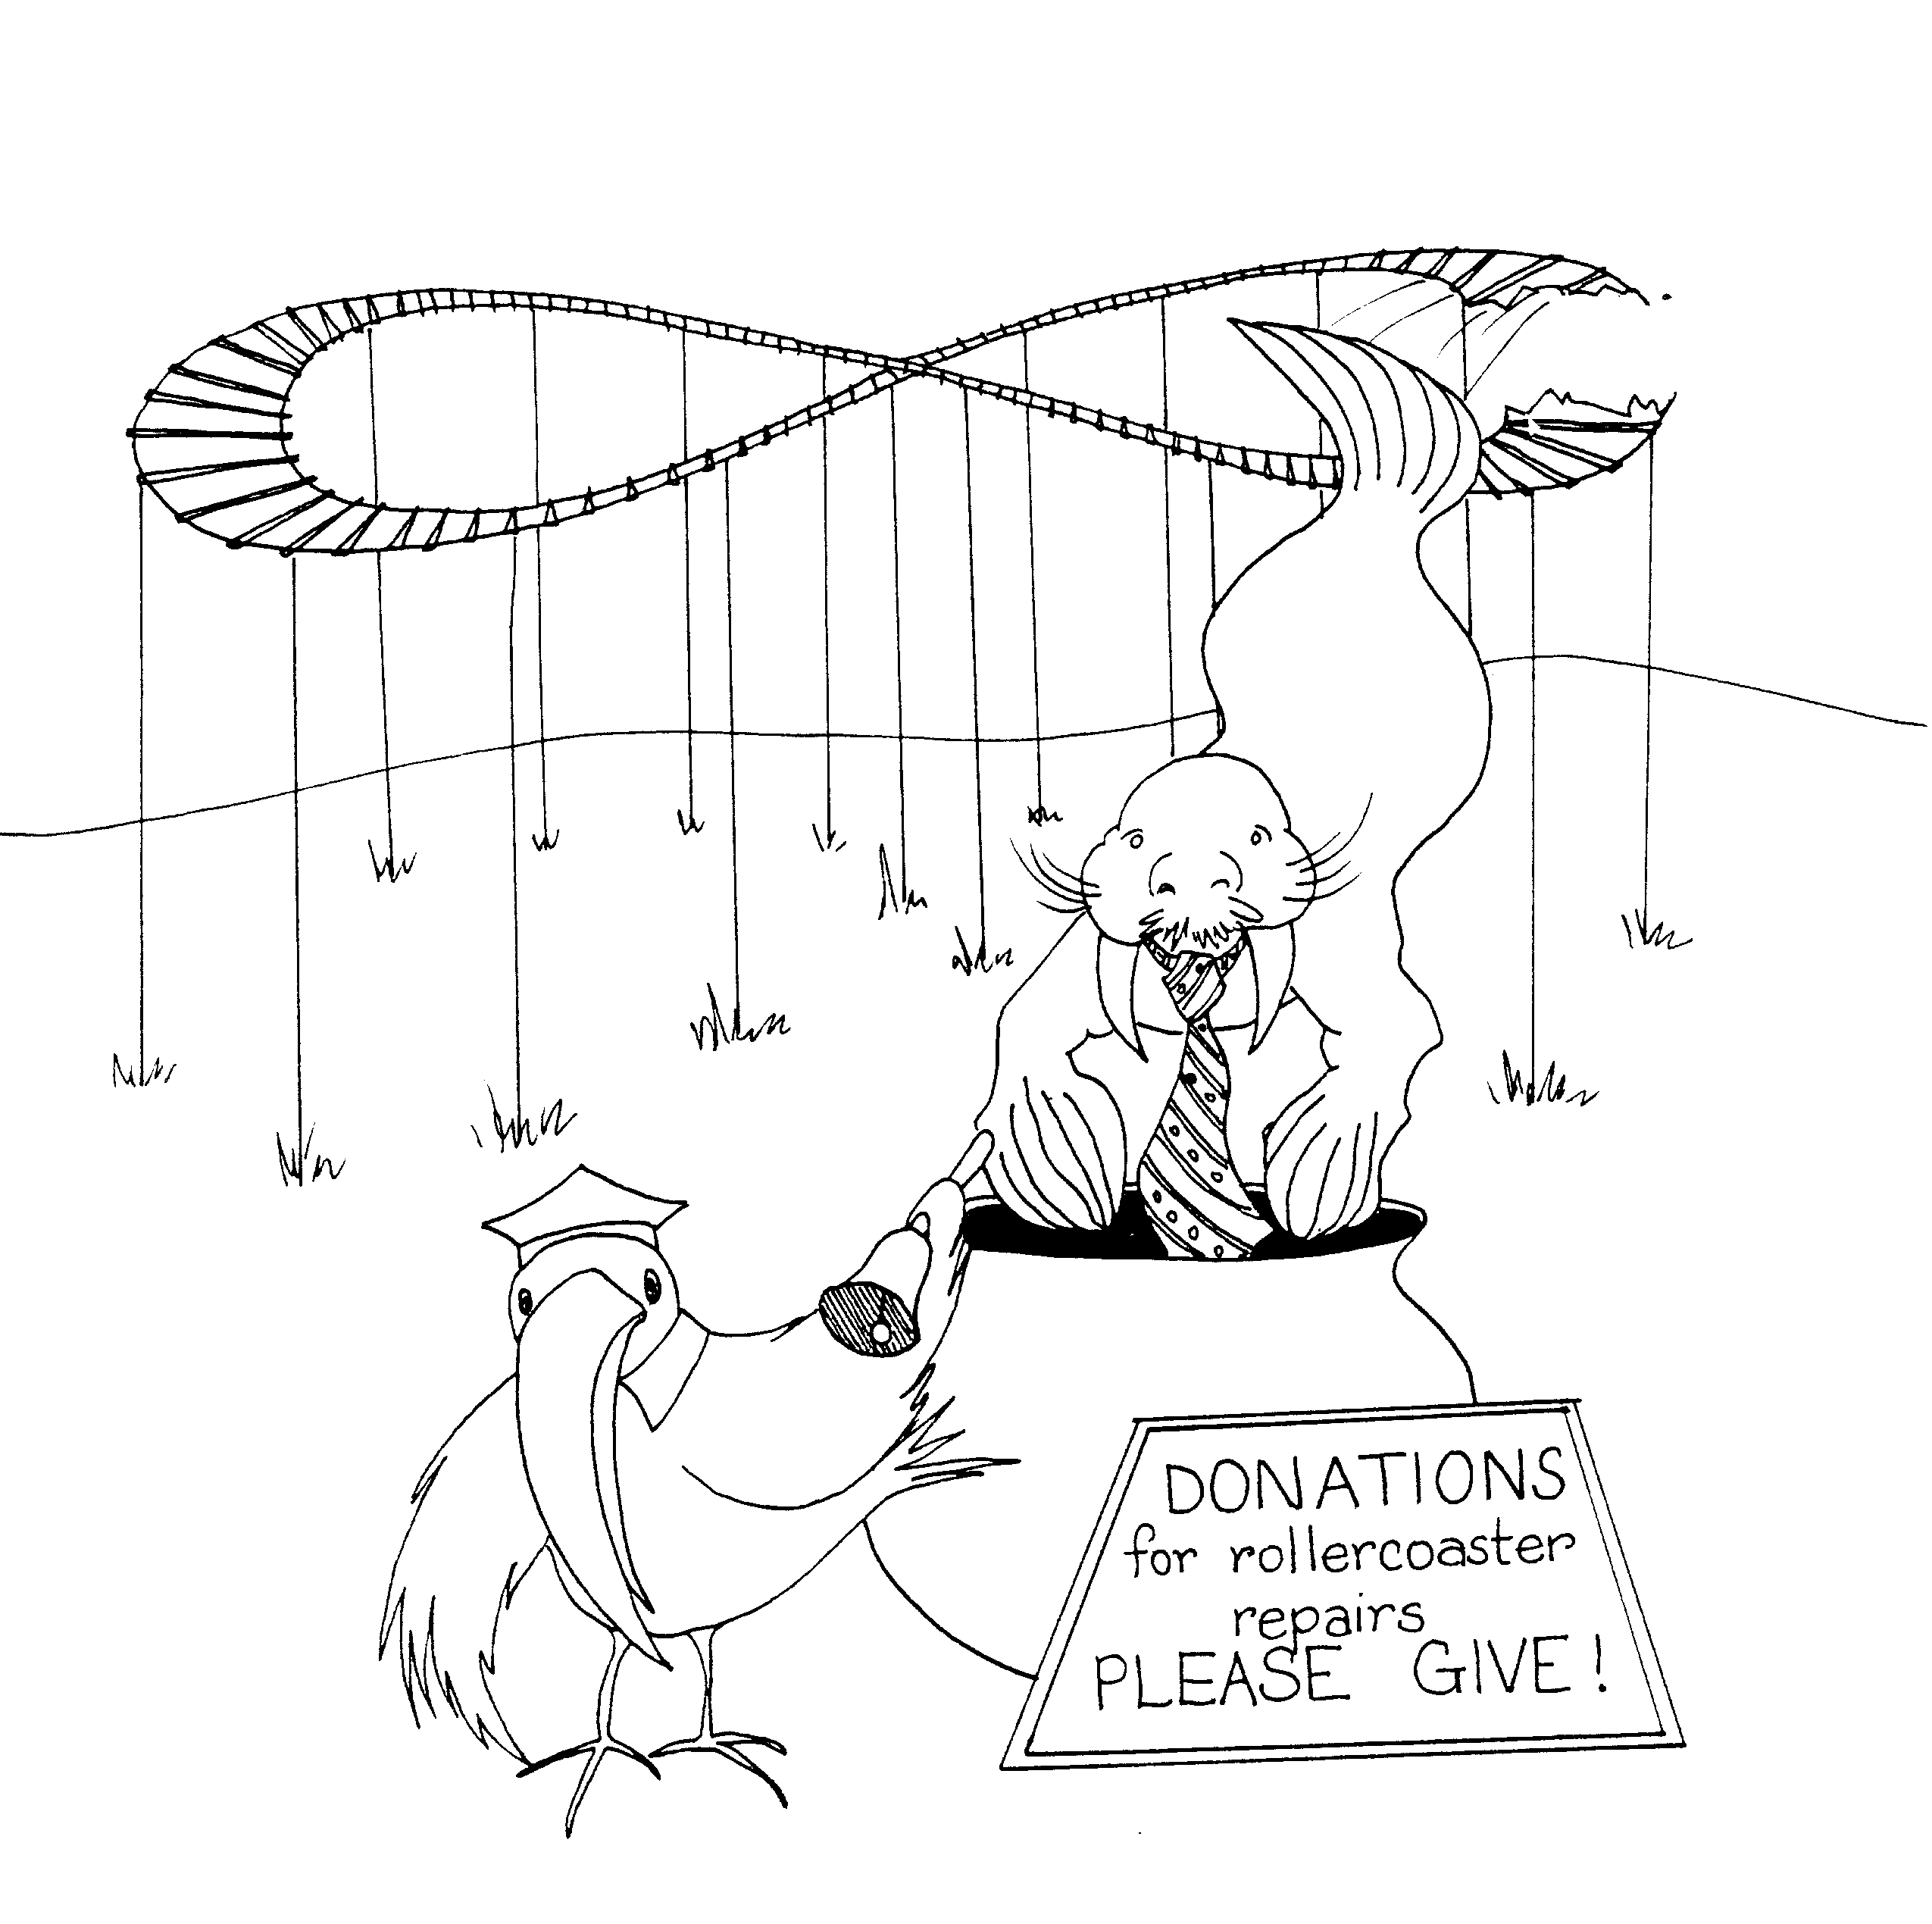

7. TITUS' REPORT – JOY, 8. PLEASE GIVE, RECEIVE TITUS
SORROWFUL REPENTANCE

7 = Heaven (clouds) 8 = Roller coaster is an 8 sideways

* TITUS' REPORT – JOY: Titus = Tie – tusk walrus, * PLEASE GIVE: roller coaster broke need money to fix it
report – joy is that he fought and defeated the
mighty Toucan * RECEIVE TITUS: Tie – tusk walrus (Titus) received by
flying down into the donation pot
* SORROWFUL REPENTANCE: Toucan killed need
sorrowful 'pennant' flag hung on him

2 Corinthians 7 – 8
© 2003 Do not reproduce
2 Corinthians

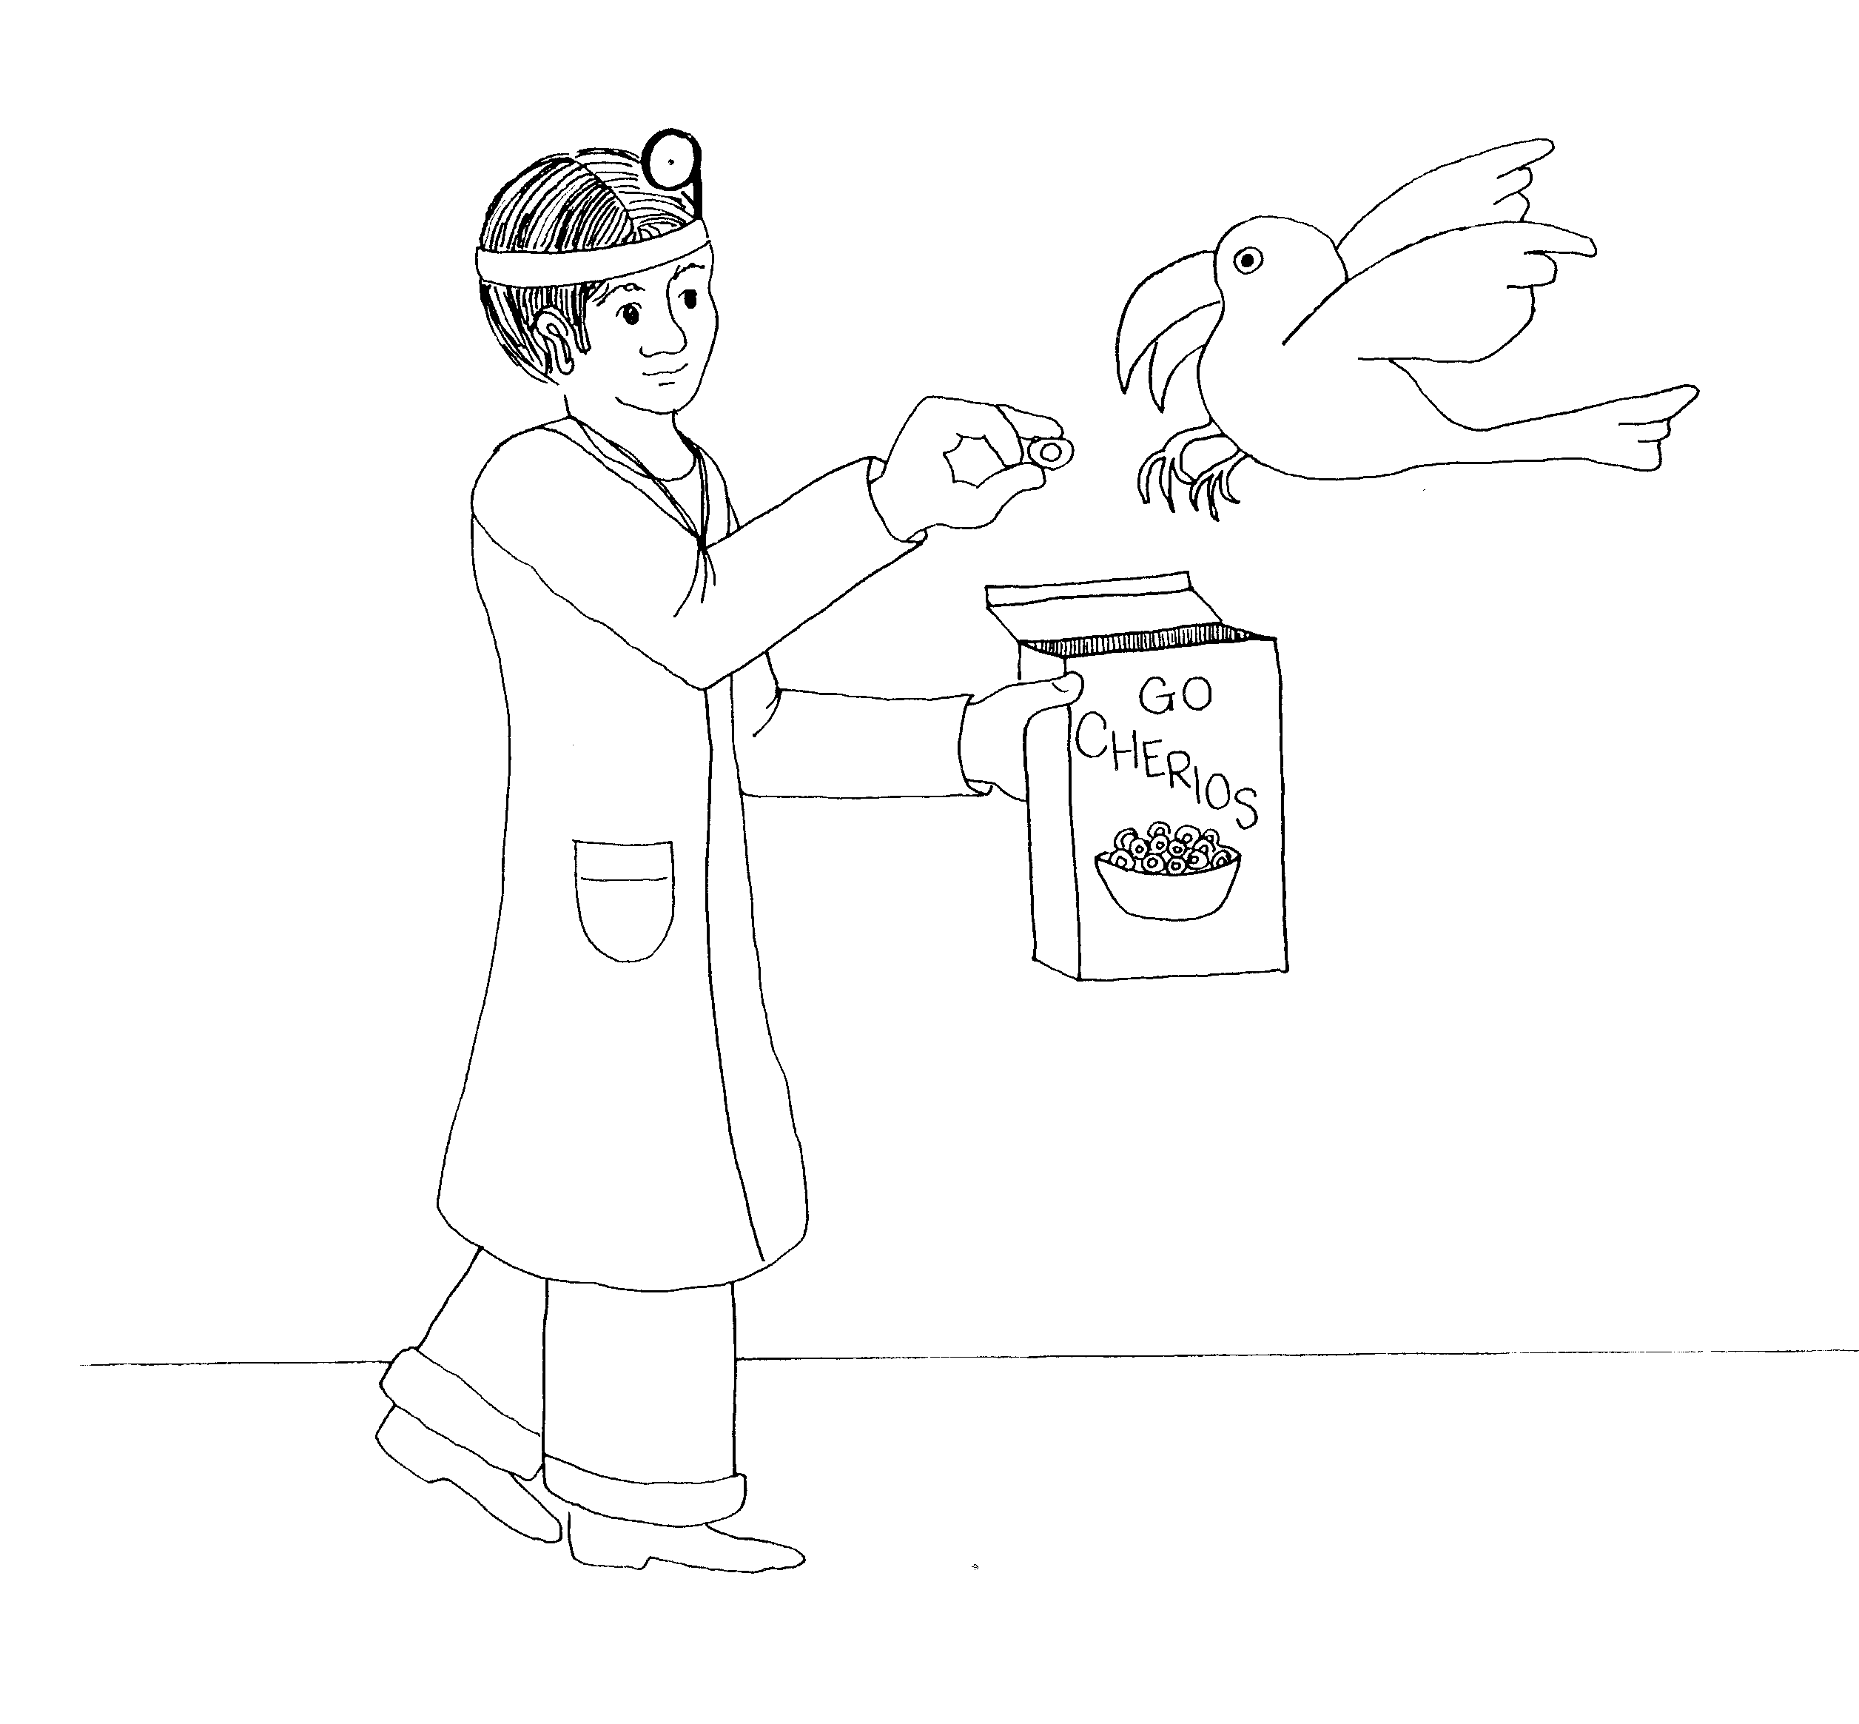  9. CHEERFUL GIVING  9 = Doctor's mirror looks like a 9  * CHEERFUL GIVING: doctor giving 'Cheerios' from the Indian 'cheerio-giving' | 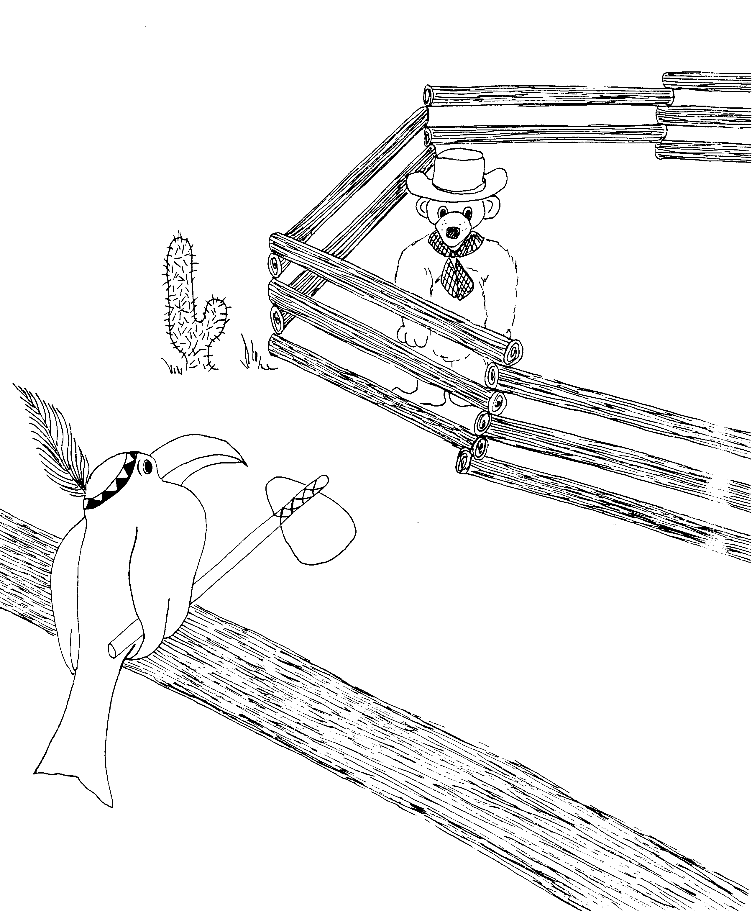  10. PAUL'S DEFENSE  10 = Ten little Indians  * PAUL'S DEFENSE: Paul (the bear) 'de-fence' hiding
2 Corinthians 9 – 10
© 2003 Do not reproduce
2 Corinthians

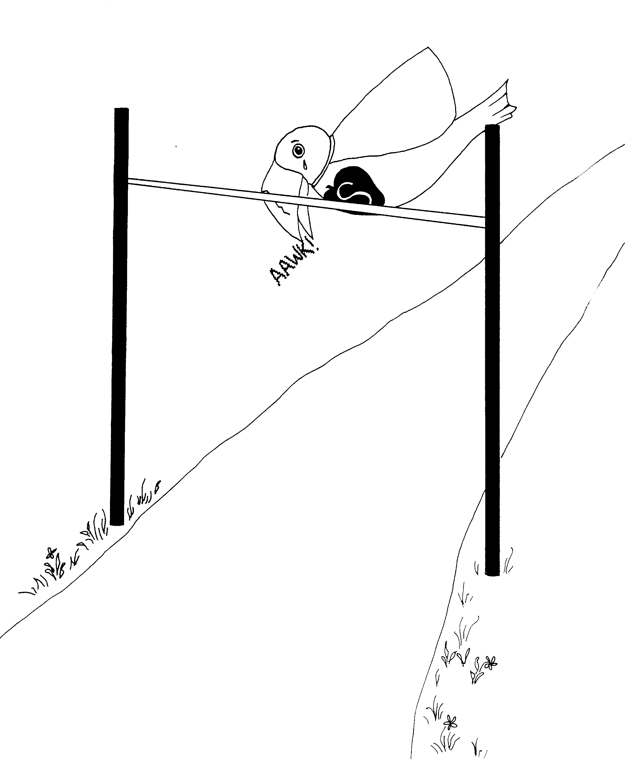 | 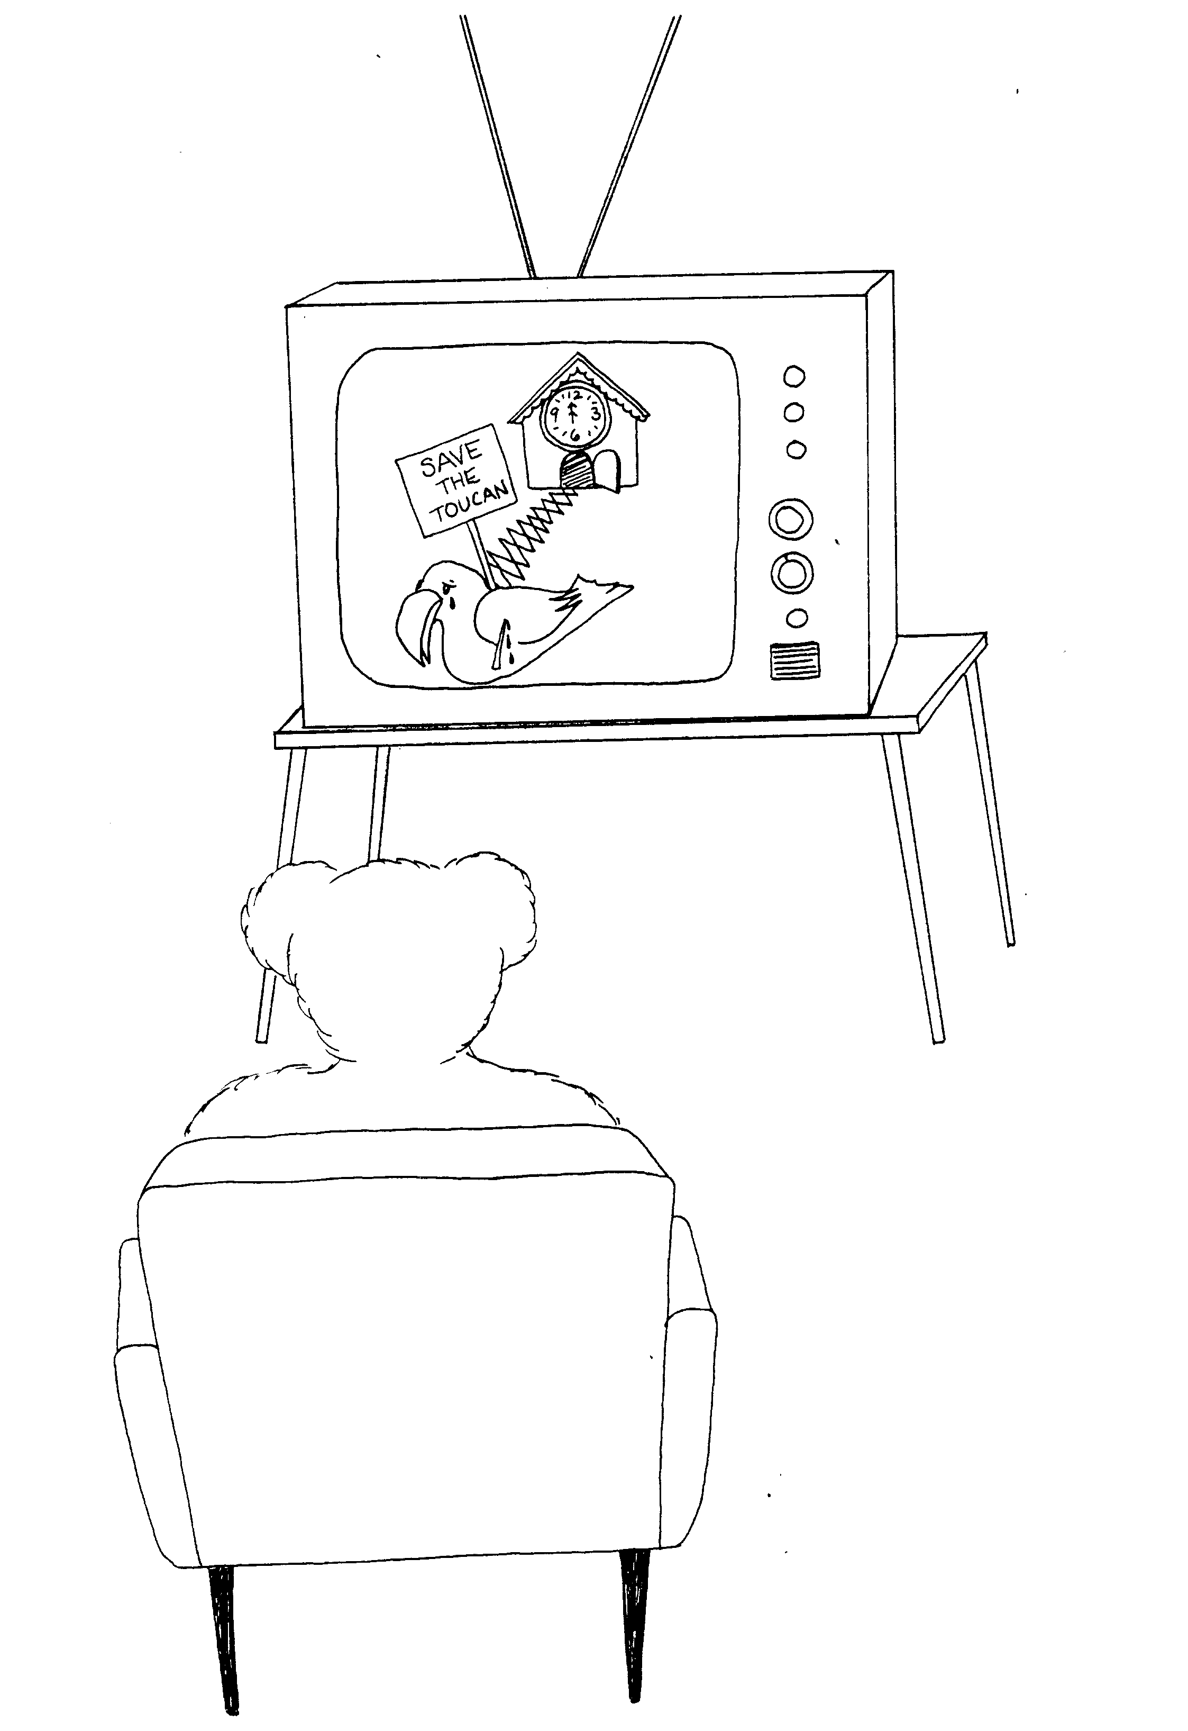
11. SUPER – APOSTLES? SUFFERING  11 = Pole – vault posts  * SUPER – APOSTLES? apple on toucan's chest makes  * SUFFERING: toucan bashes its beak on the bar | 12. PAUL'S VISION, THORN IN THE FLESH  12 = clock (12 o'clock)  * PAUL'S VISION: Paul (bear) tele-vision  him a super-apostle  * THORN IN THE FLESH: thorn in flesh of the toucan
2 Corinthians 11 – 12
© 2003 Do not reproduce
2 Corinthians

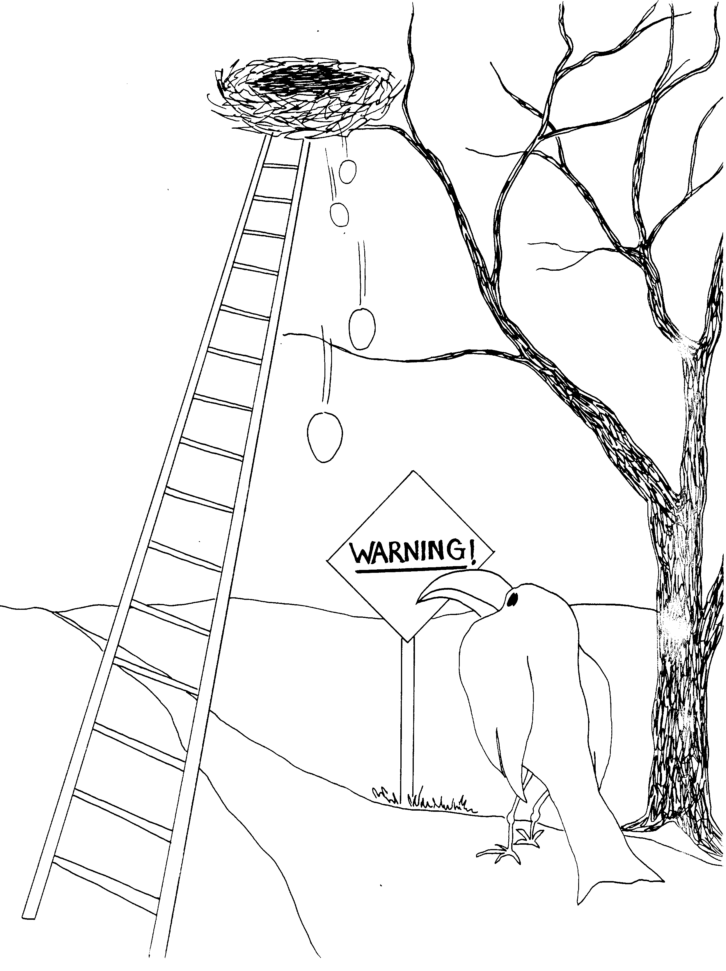
13. WARNINGS

13 = Ladder (unlucky)

* WARNINGS: warning sign about the falling eggs
if you walk under the ladder

2 Corinthians 13
© 2003 Do not reproduce

