Social Justice and Social Outliers in Ancient Israel, Part 4:

Widows, Orphans, and Resident Aliens Provisions

By Dr. Michael Harbin (Taylor University, emeritus, ©2022)

Thus far, we have looked at the overall structure of the social fabric of the nation of Israel following the giving of God’s Torah at Mt. Sinai. In the process, we have noted how they settled in villages surrounded by agricultural base of the community and discussed how that layout would have affected a number of aspects of their society especially with regard to work, family relationships, and social norms. We then defined the concept of social justice concluding that true social justice really is a balancing of benefits and burdens and noted that while today the emphasis is on benefits of being part of a given society, for the nation of Israel the emphasis was on the burdens of upholding society, basically asking the question, am I carrying my fair load? We then examined the nature of an extended family looking at it within an overall pattern of society in terms of relationships. However, social fabric is a dynamic structure that requires regular mending to retain its strength. Thus we noted how death especially could leave some individuals isolated without a supporting community. In the process we noted that the text specifically addresses three categories: widows, orphans (actually fatherless) and resident aliens which we collectively denoted WORA. At this point, we want to look at specific provisions that God provided to help those individuals.

We have suggested the basic issue the WORA had in common was that they lacked agricultural resources in a culture where most people were directly dependent upon them. Without those agricultural resources, the WORA required special social justice provisions. While incorporating a number of social justice provisions, the OT reveals four “programs” specifically intended for the WORA.

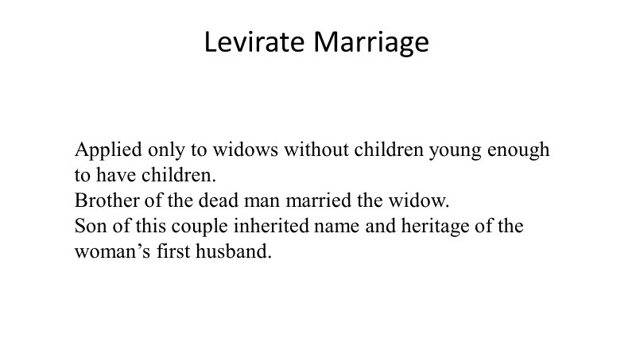
1. Levirate Marriage

We have already mentioned the first social justice program which was levirate marriage. However, levirate marriage applied uniquely to widows, and apparently specifically widows still of child-bearing age. The idea was that a relative would marry the widow with the specific intention of producing offspring who would take care of the widow in her old age. As such, it would seem that if she already had children, it was likely that a levirate marriage did not occur. Since the term “orphan” really points to being fatherless, it would seem that the widow would live with her offspring and take advantage of other provisions.

We see several examples of widows with offspring through the OT. For example, Hiram of Tyre, one of Solomon’s key workers in the construction of the temple, is described as the son of a widow (“widowed woman”) who as an adult became a skilled bronze worker (1 King 7:14). We are not told where he learned his skill but apparently he supported his mother as indicated by the declaration that he was a widow’s son.

In 2 Sam 14:5, a woman from Tekoa was brought in to confront David. Her story was that she had two sons, but her husband was dead, and the two sons were working in the field and had a falling out. One killed his brother, and thus was subject to execution since it was considered murder. Whether this is an actual or hypothetical situation is not clear, but even if hypothetical, David accepted it as plausible and made judgment, which would suggest that analogous situations existed in the land at the time. The woman’s concern was that entire “extended family” had risen up against her demanding justice for the deceased, and she feared losing her heir, which also would be the person who supported her in her old age.

A third example is in 1 Kings 17 where Elijah was told by God to go to Zarephath which was experiencing a drought where there was a widow (“widowed woman”). When he got there he found her gathering sticks to make a fire so as to bake her last flour into bread and that she and her son could “eat it and die.” It is unclear whether the son was too young to work to support his mother, or that she might have had land but could not work it because of the drought. In any case, through God’s direction, her bowl of flour and jar of oil remained full for the period of the drought. Subsequently, the boy became sick and died, and God, through Elijah, raised the boy.

The basic idea seems to be that if a widow had children, then it was expected that while she might care for her children when they are young, she in turn could expect them to care for her in her older age. The main premise here is the expectation that possession of the family land would be retained by the oldest son, and thus when he was old enough, he could work the land and support his mother.

The underlying principle of this directive seems to lie simply in the admonition that widows were to be provided for. In that culture, children were the primary source of support for the elderly as we noted in part 1. This provision applied only if a widow had no children and was still young enough. In that case, the expected action was that she would remarry with the hope of children for future support. Within this context, another factor of the remarriage was maintaining the family possession of the God-given inheritance.

Paul provides some commentary on this concept in 1Timothy 5. Writing to Timothy who was apparently in Ephesus, a large Greek city, he provides a more urban take on the principle. He does not address the question of the family land. Rather he begins with the adamant directive that the children or grandchildren of an elderly widow have primary responsibility for caring for her. Should she not have children or grandchildren then the church should pick up on some of those support obligations, what Paul calls “the list.” He does not seem to address situations where the widow has adequate support, but it may be inferred that where there was no need, the church had no obligation to fill it. Today, it would seem these same ramifications of that basic principle still apply. The family has first responsibility to support the elderly, especially the widows, followed by the church.

The other three provisions seem appropriate for all three groups: widows of whatever age who had not remarried, the fatherless (who were likely living with their widowed mothers), and unemployed resident aliens.
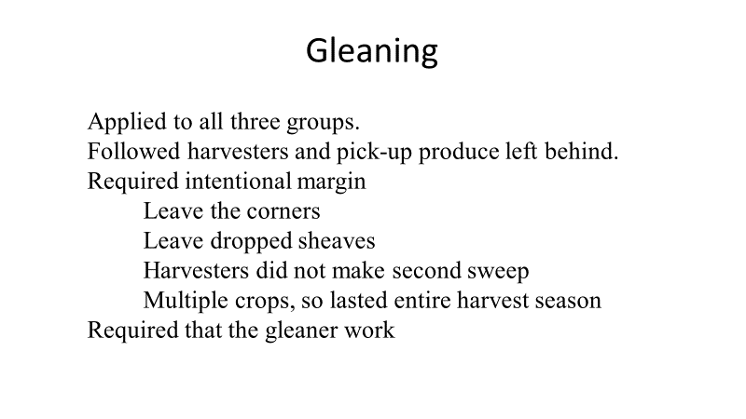
2. Gleaning.

The primary WORA provision was the process of gleaning. Gleaning entails going back through a field or orchard after it has been harvested to find produce which the harvesters had missed. While this would be a fraction of the harvested produce, it could be a sizeable amount. Although the only illustration we have of OT gleaning is Ruth in the grain fields, which is the image that comes to mind, the OT gives guidelines not just for grain but for all other crops mentioning vineyards (Lev 19:10) and olive trees (Deut 24:20) indicating that a person who gleaned would have multiple opportunities through the harvest season (assuming that the farmers were following the biblical guidelines).

The underlying principle seems to be that the framer planned on intentional margin in terms of production. While difficult to implement in any culture, Israel is generally deemed a subsistence culture which means that the farmer struggled to harvest enough to supply one family one year. However, Oded Brorowski argues in Agriculture in Iron Age Israel, that various innovations “resulted in a large surplus of foodstuffs.” Biblically, the underlying premise was that if the people demonstrated trust in God, he would provide the surplus. This may be indicated by the situation of Boaz who apparently remained in the village that Elimelech had left because of the famine, and prospered. While agricultural gleaning is far removed from most people today, the idea of developing intentional margin to provide for one’s personal future and to share with others would be readily accessible for most.

Israelite landowners are given guidelines in Lev 19:9-10; 23:22; and Deut 24:19-22, designed to provide the greatest possible opportunity for would-be gleaners. Succinctly, they are as follows.

- When landowners harvested grain, they were not to reap to the corners. The grain left standing was intended for the gleaners–that is, the WORA. The text does not indicate how much of a field was to be left unharvested, but the Mishnah indicates one-sixtieth of the harvest was considered the minimum although it also suggests provision depended on the factors such as the size of the field, the number of the poor, and how generous the farmer was.

- If a harvester dropped a sheaf, he or she was to leave it behind. In this case, the produce would already have been harvested and bound together. The harvester likely would be carrying it to where it would be gathered for threshing or subsequent storage when the loss occurred. In that case, the sheaf was to be left on the ground so it could be picked up by one of the gleaners.

- The harvesters were not to go back through looking for produce that had been missed. As noted, beyond grain, olive trees and vineyards are specifically mentioned, emphasizing how the gleaning directive covered the entire harvest and not just grain. In the case of vineyards the admonition was that any bunches of grapes which were missed or perhaps were not yet ripe were to be left. In the case of olives, the harvesters would use sticks to knock the ripe olives off. In this case, they were not to shake the boughs to get those they had missed.

- Given the scope of produce mentioned, it seems clear the gleaning directive covered the entire harvest. It would appear that the expectation was that a gleaner would be able to gather more than just the current need, but would have enough, although likely somewhat on the sparse side, to preserve for the off season. If so, the gleaner would have the same food preservation issues as the farmer.

The produce left behind provided an opportunity for the “needy” (cf. Lev 19:10) to gather the residue for their own use. It is significant that the gleaning process provided an opportunity for the WORA to gather food from land which they did not own, and for which they had not participated in the sowing and tending of the crops. But, they were required to put in the labor to gather this produce, as well as to thresh it, and then take it home to process. Given the scope of the crops listed, it would seem then, based on the example of Ruth, that one of the WORA would be able to follow the harvest which began with the barley harvest (April-May) on into the fall with the grape and olive harvests (October-November).

I see two underlying principle for consideration here. The first is the idea of planned margin in terms of production. There are two aspects to this. The first is that a person should live within his or her means. For Israelites living on a farm where they produced most of their food, this meant that they developed their dietary patterns based on what they had. At the same time, as they planned crops, they were to plan on crops adequate to cover their needs, and would provide a tithe that left that adequate amount, and allow them to leave some for the WORA to follow the harvesters. Today most of us do not live in agricultural communities, but we can still institute a similar practice. It might start with looking at what would it take to provide a reasonable lifestyle given our position in live (and here we need to recognize that we all tend to overestimate what we “need”), add in enough to tithe our income, and add extra for people in need. After comparing that with the income we have, we may have to make some hard choices such as paring off a couple of those need, or it might require exploring through God’s guidance ways to augment income.

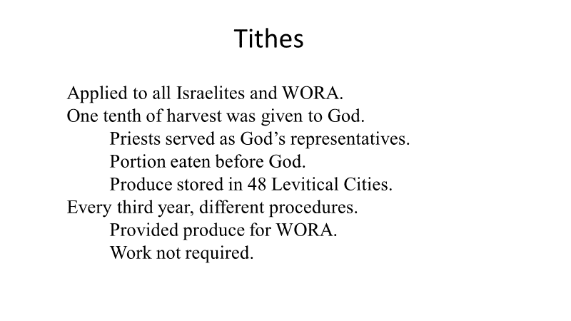

3. Tithes and Third Year Tithes.

The Israelites were directed to tithe all of their produce. By definition that meant they were to return to God one tenth of their harvest (Lev 27:30-33; Num 18:21-32; Deut 14:22-27). While the initial declaration of the tithe requirement in Leviticus 27 prescribed that the tithe belonged to the Lord, the subsequent clarification in Numbers 18 shows that the Levites represented the Lord in this case as their part of the national inheritance.

Numbers 18:21-32 states three times that the tithe was to be given to the Levites as their inheritance. This would explain why there were 48 Levitical cities scattered throughout the land. They essentially became store houses for the tithe. However, according to Lev. 18:26, a tithe of the portion given to the Levites was to be given as an offering to the Lord. It would seem likely that this was the portion that would be “eaten in God’s presence, although an option is given that it be sold and replacements purchased at “the place where [God] chooses to establish His name.” Given the amount of material a full corporate tithe would include, J. A. Thompson is likely correct when he suggests that a representative portion would be taken to the central sanctuary for a feast, and the rest stored in the local cities. If so, everything beyond the celebratory meal was to be given to the Levites, which would be deposited in the Levitical cities where the Levites would manage and use it. In fact, it would appear that the feast served as an encouragement for the Israelites to provide the overall tithe. Given that the Levites were not given land to farm, it would seem likely that they were expected to partake of at least part of the tithe which came in.

Every third year the tithe was to be handled differently. Instead of having the celebration before God and giving the rest to the Levites it was to be stored in the local “town” (Deut 14:28-29). The nature of this third year tithe is not clear, but it seems to be to provide produce for the WORA as well as Levites. Again, it would seem to be stored in each local city. Basically it would appear that these goods were to be available on an as-needed basis for the WORA in that region (as well as Levites).

The text states that it would be “reckoned as the grain from the threshing floor or the full produce from the wine vat” (Num 18:27), suggesting that the produce was processed before it was given, and thus was ready for storage. While not amplified, that could explain why this tithe was given only every third year; that is, its purpose was essentially to be a welfare pantry, for the Levite “and the alien, the orphan and the widow who are in your town” (Deut 14:29). Unlike gleaning, there does not seem to be any requirement that the recipient must work for what he or she is able to get through the third-year tithe. As such the distributions from the third-year tithe would seem to be rather minimal, giving just a short-term provision to bridge a temporary need. The gleaning already mentioned would then provide for a longer period, perhaps serving the same purpose as food storage in a regular household. If that is the case, this is an aspect of social justice that tends to get lost in the discussion.

The principle here is very straight-forward. God expected His people in Israel to return one tenth, that is a tithe. For the Israelites, this meant that a portion of the produce they grew was given to the Levites who apparently used it for themselves as teachers and guides of Israel and the WORA as needed. Interestingly the New Testament gives no guidance for the church in this regard. This may mean that it was felt that the OT teaching here was clear enough nothing further needed to be said. An alternative view is that giving was to be based on God’s leading. Regardless, the premise is that a portion of what we earn should be given to God’s representatives in an appropriate manner to support those doing God’s work, AND to support those in need.

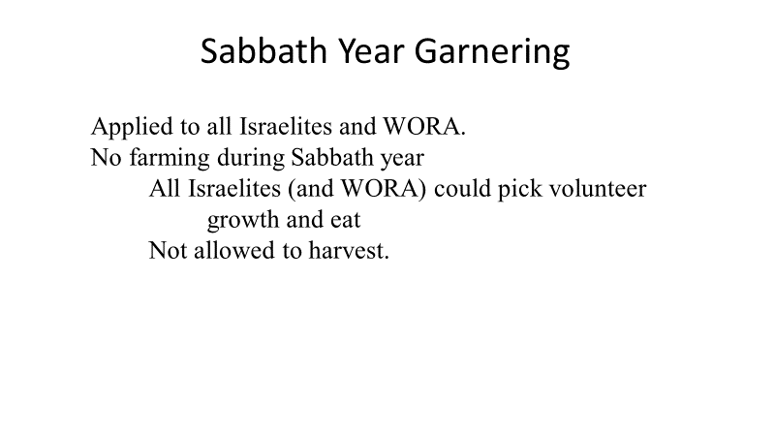

4. Sabbath Year Garnering.

The last provision involves the use of the land during the Sabbath year. The specifics of the Sabbath year are difficult to follow and highly debated. There are three primary issues which really are related. First, by definition and the explicit directions given in Lev 25:3-4, the Sabbath year was every seventh year (a six and seventh year cycle). But, how could subsistence farmers survive two years on one crop if no-one grew a crop? Second, was the purpose of the Sabbath year to let the land rest (Leviticus 25) or provide for the poor (Exod 23:10-11)? Third, tied into the second question, could Israelites eat from the Sabbath year volunteer produce? Leviticus 25:4-5 seems to say no, but then verses 6 and 7 seem to say yes.

With respect to the straightforward six and seventh year cycle various alternatives have been suggested. One proposal is that each individual farmer would let one portion (one seventh) of his land lay fallow each year, thus while each plot enjoyed a Sabbath, but the farmer still worked all seven years. Another perspective is that the concept was really just an ideal never practiced. A third approach is that farmers rotated each year so that only the land of certain farmers was fallow at any specific time. Probably the key argument against the universal seventh year Sabbath is the issue of practicality. Could all the farmers in a village last two years on one year’s crop? As one thinks this through, two other factors must be considered. First, Sabbath year directions in the Exodus passage are followed immediately by six and seventh day directions for the Sabbath day suggesting a correlation in the author’s mind. Second, 2 Chronicles 36:21 asserts that the failure to observe the Sabbath year was a cause factor for the exile, or at least in its length. Admittedly the traditional understanding is difficult and impractical, but that seems to be the point. The text warns the people not to be apprehensive in the seventh year because God would provide adequate provisions in the sixth year to get them through to the harvest in the eight (Lev 25:20-22). In other words, the people would be given the extra in advance. This could serve to reduce the apprehension when anticipating not sowing in the Sabbath year. Consequently, if they did not observe the Sabbath year, it was not just a lack of faith, but rather open defiance of God. Thus it would appear that Kiuchi is correct when he states that the Sabbath year is to be “universal and simultaneous, extending to all the fields in every seventh year.”

Regarding the last two questions, the purpose of the Sabbath year seems to have been primarily to give the land rest (Lev 25:4-5). This would have automatically provided rest to the farmer and his animals since they were not to plow or sow or reap. A key problem with understanding the Sabbath year as primarily providing for the needy is that it was just one year out of seven. However, although Exodus 23:10-11 indicates that any volunteer produce is primarily for the needy Leviticus 25:6 allows the farmer to participate as well, so it seems Wenham is correct that the key is organized harvesting is forbidden. As such, the apparent conflict between Lev 25:5 and 25:6-7 would be resolved by noting that the basic principle of the Sabbath year was not to be business as usual. Specifically, during the year the land rested, everyone was put on an equal basis of trust in God’s provision. The Sabbath year, like the Sabbath day (see Exod 20:11), served to remind the people that God was the creator and their provider. It also served as a periodic reminder to the landowners that the land was God’s as they returned it to Him in the Sabbath year.
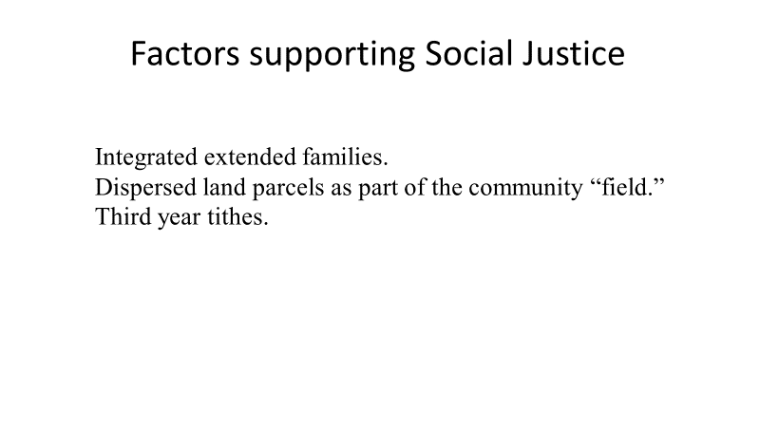

As we evaluate WORA provisions, it would appear that two key concepts noted in part 1 of the study which were embedded in the social structure and provided their foundation and gave them much of their strength. However, a third emerges from the common religious structure of the nation. They will be addressed individually.

1. Integrated extended family.

As discussed in part 1, the embryonic nation of Israel emerged from Egypt with a social structure based on thirteen tribes descended from the twelve sons of Jacob. When the exodus occurred approximately four hundred years later, that family structure was basically still intact, although with a couple of ramifications. While a mixed company came out of Egypt, by the time of the conquest, ethnic outliers apparently had been largely absorbed into the existing tribal units. We noted Caleb as a key example. While not as clear, it would seem that a similar process occurred subsequently with the native tribes who were not eradicated during the conquest. For example, through deceit the Gibeonites preserved their existence and became servants of the nation serving the altar of God (Josh 9:22-27). Under David, Ishmaiah the Gibeonite was a noted leader, and later Melatiah the Gibeonite is noted for assisting Nehemiah rebuild the wall after the exile. As such, there seems to have been a willingness on the part of Israel to allow assimilation, exemplified by Ruth.

However, with respect to assimilation as well as social justice, it would be the smaller units of the social hierarchy which would be important: what differentiated the two groups is not clear, Joshua 15-19 seems to show the basic division by “clan” which would see to incorporate “extended families.” This suggests that the settlement essentially placed kinship-groups within a given locations such as a “city and its villages.” While clearly that kinship structure would underlie the practice of levirate marriage, and the go’el responsibilities, it seems likely that it would also affect the practice of gleaning in terms of location and associated practices. For example, when Boaz gave generous instructions to his steward regarding Ruth’s gleaning, it is tempting to tie this to romantic interests, but it may be that he was aware of the go’el possibilities since he was cognizant of the closer relative (Ruth 3:12). Given the inter-relatedness of the entire village, family ties would likely have heightened social pressure in terms of conformity and provision.

This would seem to suggest that provision for the WORA needed to be done on a local level where there was adequate knowledge for discernment in fulfilling the needs they might have.

2. Integrated land parcels.

Part 1 noted how an individual “farm” in the modern village of Kufr Al-Ma consisted of several portions of land distributed throughout the “field” surrounding the housing area. It would appear that having smaller parcels intermingled throughout the tilled would promote (dare we say force) cooperation between farmers. At a minimum, given the fact that apparently there were no walls, the admonition not to harvest to the “corner” of their field (Lev 19:9) would have enhanced gleaning opportunities.

3. Third-Year Tithes.

The third-year tithe is our third undergirding concept which was not addressed in part 1. While the Israelites were expected to tithe each year (Lev 27:30-33; Num 18:21-32; Deut 14:22-27), during two of those years, the tithe was taken to the Levites in one of their forty-eight Levitical cities. This provision was to be kept locally for easy access. This special provision would be collect by the community at large drawing from its overall harvest. It is very interesting that this provision especially was to be administered by the Levites. While this might suggest that a religious system should be the framework around which social justice is built, it also should be noted that when set up, the Levite system was the only “national” system Israel had. During the third year the tithe was handled differently in that it was placed in a storage facility to be distributed to those who had special needs.

As the Torah sets up a governing process for the nation of Israel, a key portion is several strands of social justice. While summed up in the general statement “you shall love your neighbor as yourself” (Lev 19:18), the concept is spelled out in the last six of the Ten Commandments which govern relationships. But the Torah goes beyond this as it recognizes human frailties in a fallen world. Although its social fabric was designed to support all members of society through a network of relationships including extended families and inter-related communities it also provided Israel means by which the tragedies of life could be ameliorated. For the most part, this social fabric provides limits and protections for all of the Israelite society. But the Torah gives special note regarding outliers on the frayed edge of society who might have special needs providing a safety net for three categories of people who historically have tended to be abused, the WORA.

This study explored how several special provisions were made for the WORA against the backdrop of the social norms of that LBA agrarian society. In the process, we noted a balance in its provisions. Three provisions were applicable to all three groups, and two required that the recipient work to avail him- or herself of the assistance. In the case of gleaning, he or she had to get out into the field and labor to bring in the produce. The same is true of the case of Sabbath year garnering.

At the same time, a second observation is that provision needed to be made for short term emergency needs. The third-year tithe seemed to be a welfare pantry in the local city where food was stored for distribution to the needy by the Levites. There seem to be no obligations with respect to this provision, but since it would be the tithe of just one out of three years, it would seem that it was not designed for large distributions.

A third observation might be that a significant part of the social justice structure would require intentional margin on the part of the overall community, or to put it in contemporary terms, living below their means in order to have a surplus to share. For Israel, a farmer would need to plant enough grain, for example, so that a normal harvest would provide for him and his family, but at the same time there would be plenty left for whoever might glean. This would be a balance to the requirement that the WORA put in effort (burden) to accrue the benefit. But, it also anticipated that God would give a benefit to the farmer in response to his effort (or burden).

A fourth observation is that social justice provisions were embedded at a local level. In the case of a widow and orphan, the person would have been living in the village before the husband or father passed away, and it is unlikely the person left. It also is likely that the extended family had a significant role to play in addressing the situation. In the case of the third-year tithe, the local level was the nearest Levitical city. All of these factors indicate that in essence we see neighbors helping neighbors—not just somebody living next door, but someone they really knew.

The OT provisions for social outliers we have looked at were given for a particular social structure and historical context. Specifically, they were oriented towards an extremely homogeneous agrarian society, very different than our own. They focused on community action within a largely inter-related population. They also built on a single religious system in which the entire community was expected to participate. Still, keeping these provisos in mind, the underlying principles noted could serve as a springboard for developing contemporary social justice provisions.

