Social Justice for Social Outliers in Ancient Israel, Part 3:

What is Social Justice?
By Dr. Michael Harbin (Taylor University, emeritus, ©2022)
We began this study by looking at the culture of Israel for the period of time when God gave His Torah and the land to the nation what we call the late Bronze Age. In my forthcoming commentary on Leviticus, I conclude that God gave the material in the book to Moses to provide the newly created nation of Israel with guidelines on how the nation was to become unified as “a kingdom of priests.” As such, the book is divided into two parts. The first ten chapters give directions for corporate worship to replace the individual and family worship the descendants of Abraham had observed up to the Exodus. The last portion of the book gives guidelines on how the people of God were to live together forming what I call the social fabric of the nation.

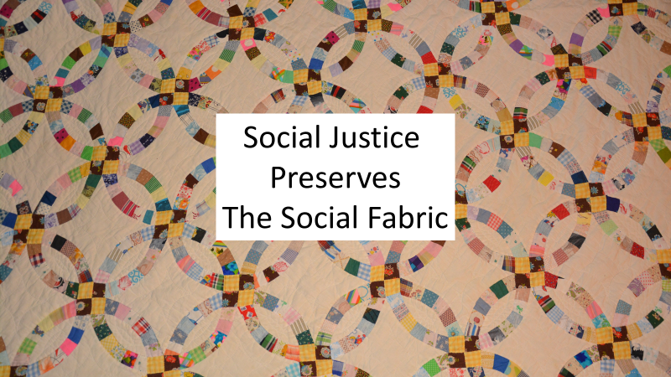
In anticipation of the land that God promised the nation, at Sinai God gave precepts that if followed would produce a strong social fabric which would preserve that national and social structure through rough times. Today, we often think of these collectively as “social justice.” While that term is not used in the OT, the concepts are there woven into the Torah or teaching that God was giving.
As we look at the OT, following the national failure at Kadesh Barnea and the subsequent 40 years of wandering through the wilderness, the nation settled in the land that God had promised. According to Joshua we find that that they settled into several hundred locations usually several miles apart in a culture where the primary means of transportation was by foot, and communication was face to face. As such, the nation of Israel during the time of the Judges and even during the early part of the kingdom was really a collection of several hundred small, rather socially isolated communities tied together partially by a common ancestry, but more importantly by a common experience in the Exodus resulting in a common worship system of the one true God, and a common teaching on how society was to function.

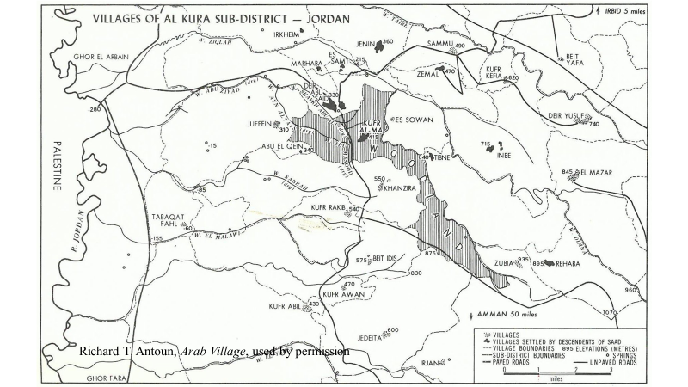

In part 1, we looked at how a single community might be structured, and we have examined some of the social norms that structure produced within the community. Our goal in this series of lectures is to derive principles out of that social structure which we might then be applied to today’s culture as guidelines for social justice. But as I began to study the idea of social justice in the OT almost 15 years ago, I discovered that there are a number of different understandings on what social justice is.

Consequently, we first need to clarify what we mean by social justice.

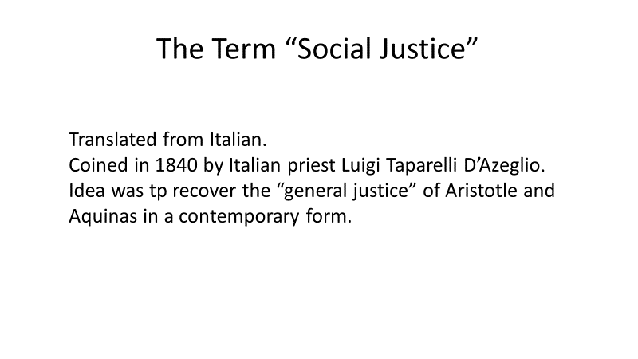
According to Friedrich Hayek, the term social justice is relatively modern, apparently translated from an Italian term coined by an Italian priest, Luigi Taparelli D’Azeglio in 1840. Michael Novak agrees with that assessment and both agree that the term is loosely defined. In a lecture he gave in 2009, Novak gives five different ways the phrase is used popularly, specifically: Distribution, Equality, Common Good, the Progressive Agenda, and Compassion. He defines these as follows:
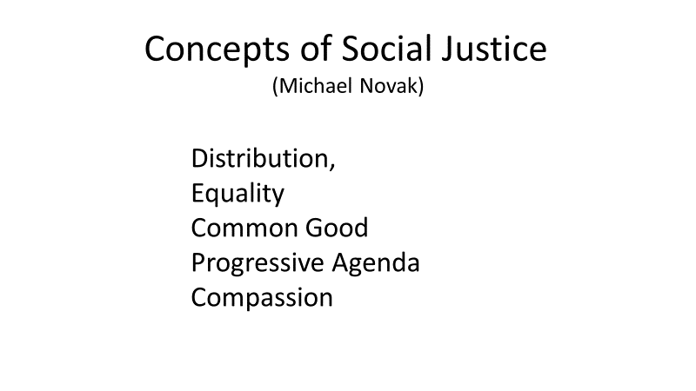

Distribution: This is a somewhat generic view which shows up in the dictionary where social justice is defined as “The distribution of advantages and disadvantages in society.” Novak objects to the addition to the term distribution because it seems to add “some extra-human force, ‘the visible hand’ [which] does the distribution.” In terms of instituting “social justice,” this is usually viewed as a powerful human agency, generally government.

Equality: This addresses the idea of advantages and disadvantages. It suggests that there is some “norm of equality” by which disadvantages may be measured. This view begins with the premise that “equality is good and ought to be enforced.” Novak goes on to note that this view actually distorts the idea of equality from “fairness, equity, or the equitable” to equal portions. This is basically the picture we have when kids argue over who has the bigger piece of cake when one kid is a five year old with little appetite while his brother is a teen-aged football player. Novak maintains that “what is equitable . . . is rather to give what is proportionate to the efforts of each.”

Common Good: The idea of common good is a term that goes back to Aristotle and it sounds worthwhile, but Novak observes that the hang-up is who decides what is the common good? In small communities, especially in the ancient world, this was often done by “the wisest and strongest person. Under modern governments, with the rise of the modern state, Novak suggests that this authority has been pre-empted by the bureaucratic state, and rather than a single individual who would be accountable, but organizations and red tape. He claims that “common good” is really an excuse for total state control and totalitarianism.

Progressive Agenda: Novak argues that the progressive agenda developed as Europe began to shift from an agrarian society to crowded commercial towns at the beginning of the industrial age. While those were not the first factories, it was the beginning of a mass migration to the cities and industrial centers. In essence, the progressive agenda was a reaction to what happened as the cultural transition cut off working people from their farms. They no longer grew their own food, but worked in the factory for money with which to buy food. Both farmers and factory workers work sunup to sunset. But there were differences in the nature of not only the work, but living conditions. In the agrarian society, the normal farmer had a home and food to eat. While they were not rich they were not poor. Because of the nature of the European society, they lived on or near the land they tended. In the city, circumstances were different, and were totally wage-dependent. While they also lived near their work place, the living conditions were much more crowded and unsanitary. The idea of the progressive agenda was to “right” some of the wrongs that came about as fallen human beings struggled to adjust to new conditions.

Compassion: Compassion seems to have become a catch phrase of anything that is done ostensibly to help the poor. This includes almost all modern revolutions. Novak states “more sins have been committed in the name of compassion in the last 150 years—by the Nazis, by the Communists, and by the African and Asian Despots who justify their regimes as ‘socialist’—than by any other force in history.”

The most common concept seems to be distribution. For example, we might note Novak’s dictionary definition: “The distribution of advantages and disadvantages in society.”

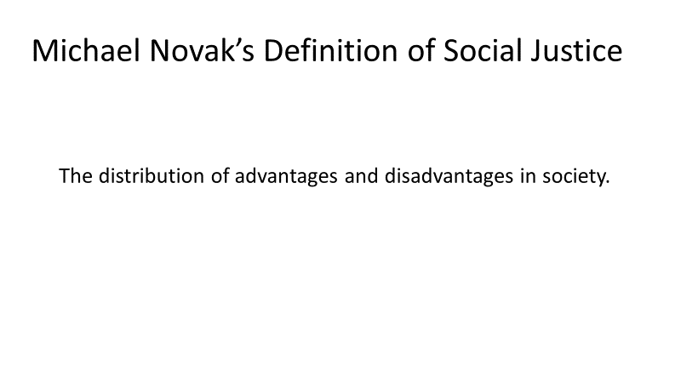

This is in essence to the meaning found on the popular web resource Wikipedia which begins its article on social justice with the following definition: “Social justice is ‘justice in terms of the distribution of wealth, opportunities, and privileges within a society.’ ”
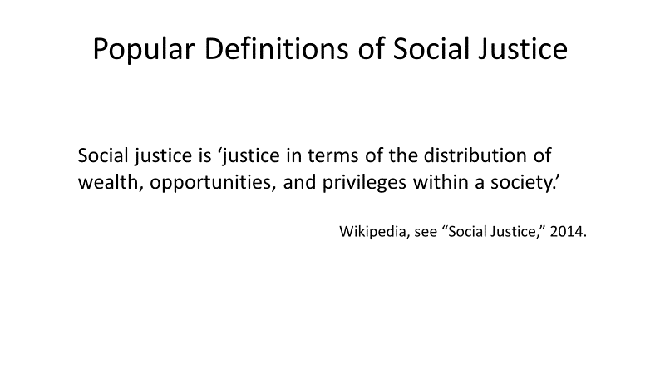
I have found this to be similar to other definitions I have found through various internet searches of organizations which advocate for social justice.
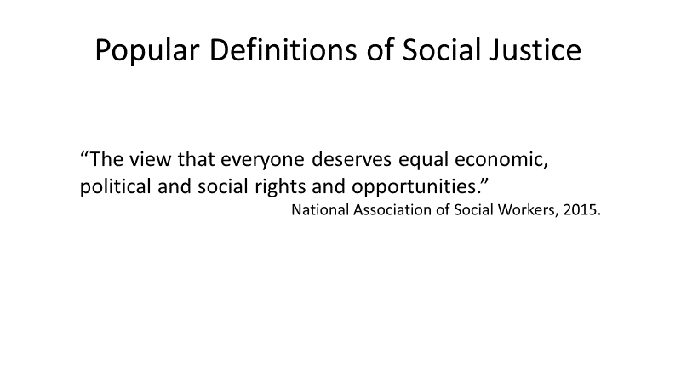
For example, the National Association of Social Workers defines social justice as “the view that everyone deserves equal economic, political and social rights and opportunities.”
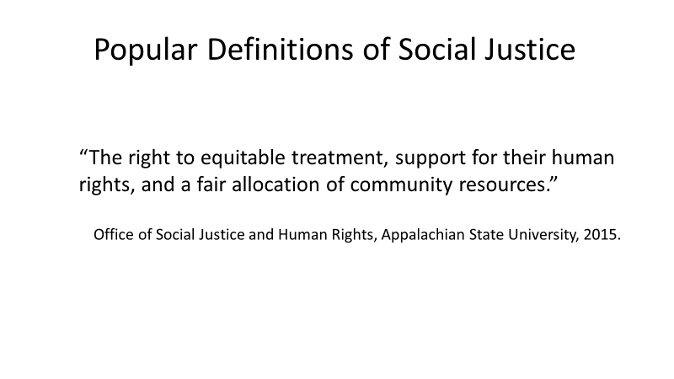
Matthew Robinson of the “Office of Social Justice and Human Rights” at Appalachian State University express a comparable understanding. As he develops a more extensive discussion, he states that social justice is when “people share a common humanity and therefore have a right to equitable treatment, support for their human rights, and a fair allocation of community resources.”

Like many other definitions that I have heard or have seen assumed, all three of these focus on what may be termed “rights and opportunities.” My immediate reaction to this is affirmation. After all, one of the basic foundational premises of the United States as expressed by the Declaration of Independence is that every individual has “certain unalienable Rights (sic)” which include “Life, Liberty, and the pursuit of Happiness (sic).” However, deeper consideration has raised several questions.

First, what constitutes a right?

More foundationally, we might ask who or what is the authority that delineates these as rights? Thomas Jefferson states that these rights were endowed by our Creator. Jefferson, like most of the founding fathers, expressed a Judeo-Christian perspective which is actually derived directly from the same OT text we will be looking at in this study. As such, contemporary Christians should have no problem with this since we would agree that our rights are inherent to the world which God created. However, for a non-Christian, especially one who claims to be agnostic or atheist, this raises a problem. If life is merely a product of time and chance, and the foundation of life is survival of the fittest, then the idea that everyone has equal rights contradicts their basic premise that everyone is competing with everyone else to survive. Within an evolutionary frameworks, there are no “rights.”

If we assume that we do have rights, whether or not we acknowledge the source, then a another question is, what happens when my rights conflict with someone else’s? For example, John Locke develops the “fair allocation” concept of Robinson that we just noted. Locke limits one’s rights to what he calls “fair share.” He illustrates this concept an analogy of gathering acorns and argues that one’s fair share is only what he or she can reasonably use, “before it spoils . . . . Whatever is beyond this is more than his share.” As I understand Locke then, if we have so much that it spoils because we can’t use it, then we really don’t have a “right” to it. But based on that description, Locke’s proposition about fair share of acorns really only applies to goods which spoil. He does not address how to determine “fair share” for non-perishable items. Further, even for perishable goods like acorns, it only works if the tree is in a forest where all have access; that is they are “community resources.” But what if that oak tree is in my back yard? If it produces so many acorns I cannot use them all before they spoil, have I lost the right to use my tree? Do I no longer have a right to property, or even privacy? And what if that oak tree matures to the point where its branches hang over my neighbor’s yard shading his garden so that his tomatoes don’t grow? To make it more complex, what about acorns from my oak tree that fall in his yard? While there are a number of issues we could discuss, or even debate, I would suggest that a clear point is that my rights are not an absolute at the expense of someone else’s.

A fourth question concerns opportunities. I find it interesting that so many of definitions of social justice use the term opportunity. What does it mean to say that all should have an equal opportunity?

Generally we view it as a proactive concept intended to eliminate barriers that preclude someone from a given activity or a direction. But what does that mean? We generally construe this to mean that there should be no arbitrary or artificial barriers such as race or gender or personal beliefs when the individual otherwise meets all of the qualifications. Sometimes, however, there is a fine line between an artificial barrier and a real one, and it would seem that today there is much confusion regarding that difference.

Many aspects of life are not barriers, per se, but they do affect our opportunities. It begins with who our parents are and how they raise us. It includes our siblings, where we live, where we go to school, what are our God-given abilities—and weaknesses, our likes and dislikes. All of us will face situations where we will not have an opportunity we would desire because of a multitude of limitations.

As an illustration, in Matt 19:12, Jesus noted a variety of “eunuchs,” individuals who will never have children. Jesus stated, “there are eunuchs who were born that way from their mother’s womb; and there are eunuchs who were made eunuchs by men; and there are also eunuchs who made themselves eunuchs for the sake of the kingdom of heaven.” While His point is that some people voluntarily chose not to have offspring for the kingdom of God, there will be some who do not have the opportunity to have children because they were born sterile. Others will not have an opportunity to have children because they were neutered.

Beyond limitations, as we go through life there are a wide variety of accidents which eliminate opportunities. Countless individuals have suffered setbacks because of accidents. As Ecclesiastes puts it, “the race is not to the swift and the battle is not to the warriors, and neither is bread to the wise nor wealth to the discerning nor favor to men of ability; for time and chance overtake them all” (Eccl 9:11).

Even if we have the opportunity, another factor that often gets overlooked is the matter of failure. Just because I am able to take an opportunity does not guarantee success. In the U.S., one area of opportunity open to everyone is establishing a new business. According to the Small Business Association, about 30% of new businesses fail within the first year and about half fail within the first five years. The reasons vary. While in some cases, it is the result of accidents, mostly they seem to come under the categories of preparation and resources. Either the new owner has not done adequate preparation to insure that he or she indeed has a viable market for the product. Or, the entrepreneur has not developed adequate financial resources to handle the costs of setting up a new business and weathering the generally slow start until the business is able to stand on its own.

A similar observation might be made regarding higher education, that is, college. Here, the failure rate is virtually the same as for business. Specifically, according to the U.S. Department of Education, “nearly half of all students who begin college do not graduate within six years.” There are a number of reasons for this but generally they come under the broad categories of preparation or resources. On one hand, a student may not be prepared for college work and there are many reasons why this may be the case. On the other hand, he or she may lack the resources. In some cases, it is financial needs (which may also be a preparation issue). However, most often it is a lack of desire or motivation, or to be honest, a matter of ability.

Many things can lead to failure. One that is not addressed adequately is that failure may be a result of mistakes most often in issues of morality. While they may not directly affect the job, they do affect character. As I prepared this lecture, I read about a sheriff who lost his job because he had propositioned a prostitute. Even as lax as our culture is, moral issues still matter.
Countless young men and women have been permanently derailed from success or have even died because of experimentation with drugs, alcohol, illicit sex, or a variety of misconducts.

The bottom line is that these modern definitions of social justice and many which are similar seem to present a truncated concept of social justice.

First, there is the problem of defining one’s “fair share?” While theorists seem to support the priority of the “fair share” concept, there are strong differences of opinion as to what a fair share constitutes.

The reality is that this is almost always used in conjunction with rights, that is, it addresses the benefits that I get from being in society. There is much that we could discuss on this, and it is something that I have wrestled with regularly since I have started exploring this issue, not only in terms of theory and cultural application, but in my own personal life. What IS my fair share? What is my basis of comparison?

The problem is that we do not have a good or even an agreed upon understanding of what is a fair share. While there seems to be an increased push toward the idea of equality much of that seems to come from jealousy and greed. Those who don’t have, resent those who do. And those who do have, resent what they perceive as attempts to take away what they do have.

This takes us back to our definitions. They all, in some way, address how physical goods are distributed. However, the word “distribution,” is really somewhat ambiguous. Used passively, it can suggest a random dispersion. An example might be the pattern of pellets in a shotgun blast. In the case of social justice it would reflect a dispersion of advantages or disadvantages where what one possesses is simply a matter of chance. Essentially they are items over which one has no control. Here we might think of the abilities or disabilities one is born with or the situation into which one is born.

Used actively, distribution suggests that the advantages or disadvantages that one receives throughout life, which may or may not be a result of one’s birth situation, are a result of social forces, whether intentional or accidental. Social justice literature generally uses the term in the latter sense, and attempts to change social forces to correct inequities. As Novak describes it, most people view distribution as a process whereby a society or culture distributes goods and services implying “that some extra-human force, ‘the visible hand’ does the distribution: that is, some very powerful human agency, usually the state.” While both advantages and disadvantages are factors, modern discussion has generally focused on disadvantages and much of the social justice endeavor seems to be an attempt to intentionally counteract that previous dispersion and artificially correct disadvantages. However, more recently there has been an overt effort to use social force to eradicate advantages, regardless of the origin.

There is another way in which the modern view of social justice is truncated, and this really is the foundation of the issues with distribution.
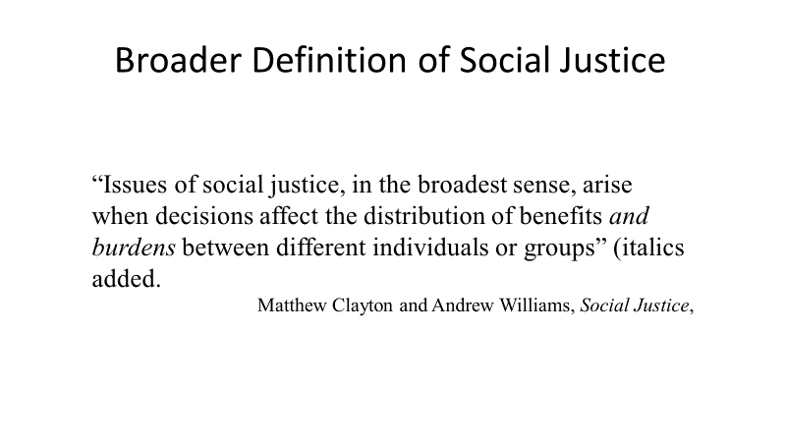
In the introduction to their textbook, Social Justice, Matthew Clayton and Andrew Williams give a broader definition which incorporates both advantages and disadvantages. They say, “[i]ssues of social justice, in the broadest sense, arise when decisions affect the distribution of benefits and burdens between different individuals or groups (italics added).” The inclusion of “burdens” is a crucial aspect of social justice that is omitted from much of the discussion.

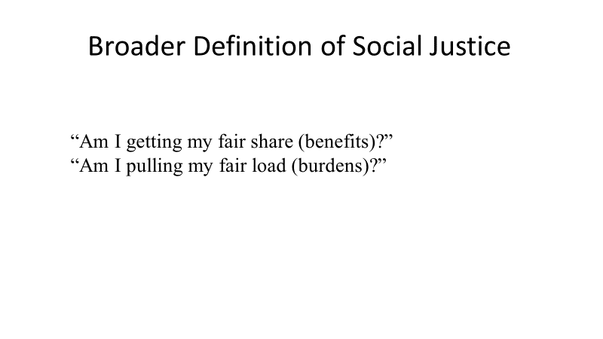

As such, true social justice includes not only the wealth, opportunities, and privileges, but also the production of wealth, dangers, and responsibilities within a society. Another way of putting this would seem to be that the basic concept of social justice derives from two questions which should be asked by and of every individual: “Am I getting my fair share (that is, the benefits)?” and “Am I pulling my fair load (that is the burdens)?” All too often, the second question is overlooked even though it has historically been an essential quality of understanding justice.

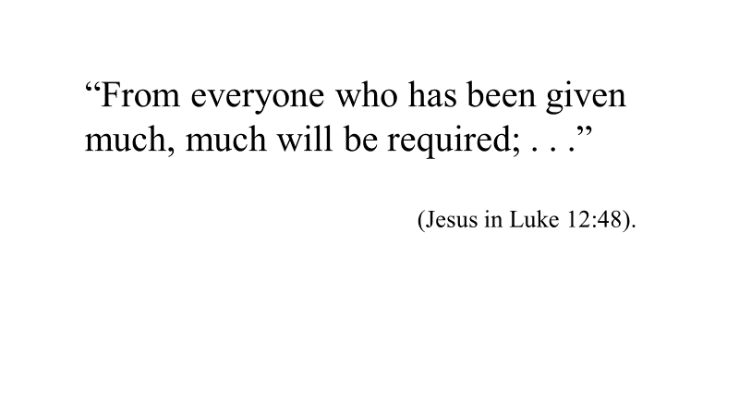
In fact, historically, these two questions seem to have been asked in tandem in the sense that fair share could vary based on the load one pulled, and vice versa. Or, in the words of Jesus, “From everyone who has been given much, much will be required; . . .” (Luke 12:48). In later history, this has been described in the French expression noblisse oblige.

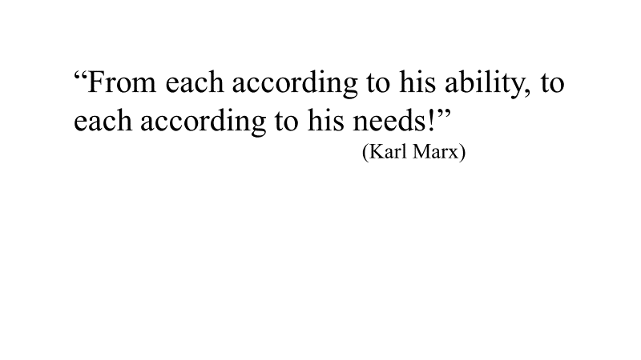
Even Karl Marx seems to have at one point held this view as he developed communism. In his Critique of the Gotha Programme, he raises the question, “What is ‘a fair distribution’?” In essence, his question is what is everyone’s fair share? His response there ties fair share into the issue of equal labor, or the question of what is everyone’s fair load? This is clear as he expresses his final or ideal goal expressed in the classic line: “From each according to his ability, to each according to his needs!”

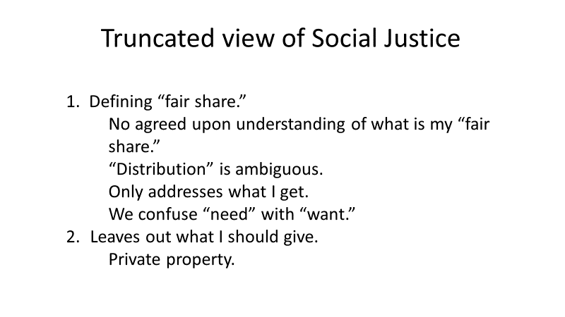
Further, when I start asking for my fair share, my perspective often confuses “needs” with “wants.” My wife and I joke about this, for example when I might say that I need a piece of pie.
As Marx develops this concept, he claims that this ideal would be present only in what he calls the “higher phase of communist society” when everyone is “only a worker like everyone else.” While it is not clear what this means, it seems to suggest that managers do not work. In the interim, the idea of “equal portions” and collective ownership has been presented as the standard, which really ignores the ability side (my fair load) of the equation—once more a truncated view (in this case, the so-called “progressive” view. The presumption is that if we do not have private property, then we eliminate greed which is viewed as the source of the oppression of so many—“the masses.” But this is based on a very naïve view of human nature whether one takes a biblical view or an evolutionary view. The biblical view is that humans are fallen with a self-centered nature that is in conflict with God and our fellow men. The evolutionary view is that human beings are fighting to be the most fit and thus survive and in the process express a self-centered natured that is in conflict with our fellow men, and has no room for God.

“Greed” then is just a strong manifestation of our human self-centeredness. It is not just the rich who possess greed—we all have it, and its presence becomes evident the moment we begin to utter that word “mine.” While Marx and his followers argue for communal property, that is no-one owns anything, unfortunately, the reality is that as the saying goes, if everyone owns it, no-one owns it, that is, no-one takes care of it. In essence, collective ownership and the loss of private property actually results in the loss of fair share since it removes motivation for working to the best of one’s ability and as a result, all suffer.

This was a lesson learned the hard way among the first settlers in America. When Plymouth Plantation was first settled, it languished under “common course and condition.” As William Bradford describes it in his work “Of Plymouth Foundation,” they thought “that the taking away of property and bringing in community into a commonwealth would make them happy and flourishing, is if they were wiser than God.” Instead they starved. When they abandoned this structure and gave each family its own parcel of land, the colony “had good success, for it made all hands very industrious . . .” Those hard lessons were important to our founding as David Barton points out in the book The American Story: The Beginnings.

In contrast to Marx, John Locke defends private property (my share) as a product of labor (my effort or load or “burden”). Like Marx, Locke recognizes the problem of greed, but suggests a different solution. He proposes limits. He argues that “my share” is only what I can reasonably use, “before it spoils . . . . Whatever is beyond this is more than [my] share.” This sounds good, but it raises two issues.

The first issue is what one should do with “surpluses” when one’s labor produces more than one can use. Using an analogy of gathering acorns, Locke claims that the extras should be left for others. As noted earlier, this only works for trees going in the woods or similar sources. Consequently this analogy does not translate easily into more complex economic systems where labor produces multiple commodities. Further, when gathering acorns, one could stop gathering when one has enough. The rest would lie under the tree where others could freely pick them up, or squirrels could gather them, or they could grow into new oak trees, or they would just decompose. In a complex economic system, one cannot readily turn his or her labor off. Locke misses two other factors in his illustration. First, he does not address preservation to allow for long-term provision of seasonal goods.
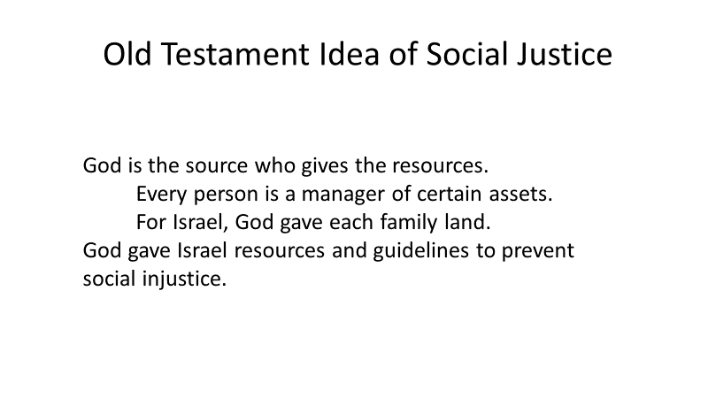
The second factor is that the person who gathers the acorns really didn’t produce them. They grew naturally on the oak tree, and as the poet said, “Only God can make a tree.”

Extrapolating this observation into a broader perspective, we can transition into the Old Testament view of social justice. First, God is the only Creator, and all that we have was made by Him. The biblical perspective is that we are stewards or managers of what He has created. When we look at Genesis 1-3, we note two critical facts that underlie this discussion. In Gen. 1:28-30, God declared that the newly created mankind, which according to Genesis 2 consisted of two individuals, a male and a female, were to multiply and fill the earth with fellow managers. Corporately they were to “subdue” the entire globe. The Hebrew word here might be construed to suggest that mankind was to bring the world under management. The second fact is that Gen. 2:8 notes that this original couple was placed in a garden which God had planted. This garden would have been a limited geographical location which was somehow differentiated from the rest of the created world. Given the limitations of two people who moved on foot, I would suggest it was likely very limited. The goal was that this first couple would expand in terms of population and control. In essence humans were to become “co-creators” as we converted the very good world that God had created into a global garden.

After the fall, God’s directions for the nation of Israel at Sinai somewhat echoed this process. The nation of Israel was to go into the land that God gave them, and become a kingdom of priests, that is, mediators between other nations and God. In the process, they would be stewards or managers of the land that God gave them. A stress throughout the OT is that the individual Israelites did not “own” the land on which they farmed. However, as we noted in the first part of this series, each extended family had a portion of land which was theirs to manage, and in that sense they possessed it.

It is within this context that as we study the Torah we see guidelines for the people to live together so that each would enjoy life to the fullest. Essentially we are talking about both corporate and individual social justice.

The primary emphasis was prescriptive, that is, it gives guidelines which are designed to prevent the development of social INjustice. The key to remember here is that the individuals entering the land were going to be given land which was farm ready—that is, they could move in and immediately start farming. Apparently the amount of land each family received would be adequate to support them but also was the right amount for the extended family to readily work it—not too much, and not too little.

The Torah (especially within the book of Leviticus) provided principles for living in a community which if followed would, if not eliminate, significantly alleviate social injustice. In addition, the text provides examples of how those principles should be carried out. But the Torah also provided significant remedial aspects designed to correct injustices which were tied specifically to the socio-economic system of the day.

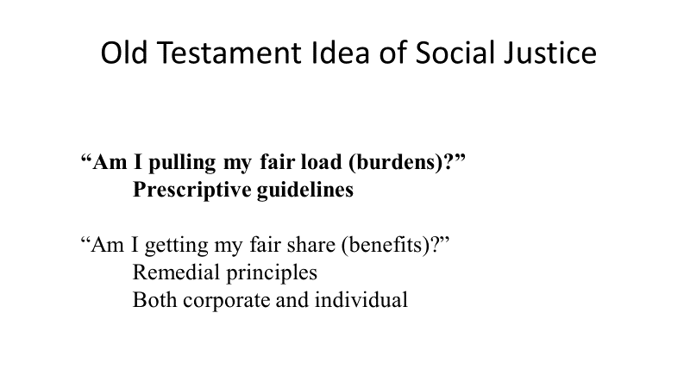

It is extremely important to note that the way the Torah sets forth its principles emphasizes the “Am I pulling my fair load?” question. This is shown in several ways. First, the Old Testament is very clear that individuals within the nation of Israel (indeed we would say all mankind) were not equal, whether in terms of the socio-economic or family status into which one was born or in terms of natural abilities. To use Rawls’ terminology, these are aspects of either the “social lottery” (my family status) or the “natural lottery” (my natural abilities). However, instead of a viewing these differences as random (the lottery concept), the Old Testament ties them to a sovereign, omnipotent God (Ps 139:13-16; Is 44:24). As such, rather than setting forth guidelines designed to offset differences in position or ability, the Old Testament standard seems to be that there would be different expectations (the load they bear) of individuals based on these various factors.

In essence, the expectation was that the individual had a specific position or ability for the good of the community. The office of priesthood might be a good example. In the nation of Israel, not everyone could be a priest. Rather, this office was limited to the tribe of Levi (an issue of family status) which was given the responsibility for taking care of the tabernacle and all of its equipment (Num 1:47-53, 8:14-26). But not even all Levites could be priests (the individuals who had specific responsibility for the sacrifices). While not absolutely clear, Exodus 28 and Leviticus 8 seem to indicate that the actual priesthood was limited to male descendants of Aaron. Sadly, Korah, a Levite of the Kohathites (who were responsible for upkeep of the tabernacle) was not satisfied with his role and demanded to be part of the priesthood (Num 16:10). Because of his rebellion, he and those who supported him died when the earth swallowed them alive (Num 16:32-33). It should also be noted that priests had certain higher standards (greater burdens). For example, priests could not marry divorced women or widows (Lev 21:14). Further, priests were expected to work on the Sabbath rather than have it as a day of rest (Matt 12:5).

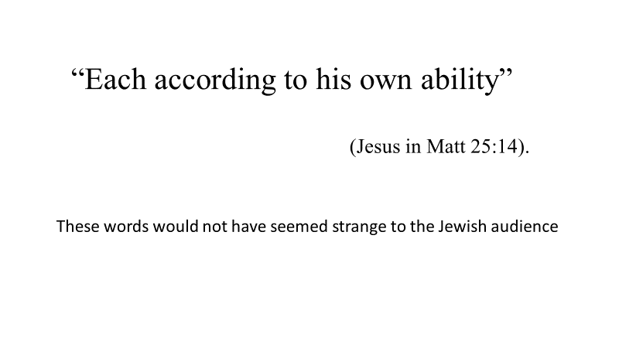

Given this background, the words of Jesus in the parable of the talents (“each according to his own ability”–Matt 25:14) would not have seemed strange or new to His Jewish audience. Biblically speaking, the proper evaluation of ability would seem to be God based. That is, whatever abilities I have were given to me by God, and His expectation was that I use it within the culture I was placed to bring glory to Him. This is something that is extremely unpopular today where it is assumed that should I so desire, I can ignore even basic physical properties determined by my DNA at conception.

A second observation is that within the Old Testament success and failure were viewed both in a corporate and an individual sense. Both corporate and individual success were contingent upon two items–maintaining a proper relationship of trust with God, and properly using what God has given the individual. First Samuel contrasts the first two kings of Israel, Saul and David, individually in this regard. Saul is viewed as a man who really did not understand who God is, and as a result did not use the abilities that God had given him. One of his early failures was the confrontation with Goliath. As king, Saul would have been expected to represent the nation in this type of conflict. Rather, he dawdled and then let the youth David take his place. Ultimately, Saul ended up a failure committing suicide on the battlefield. In contrast, David is viewed as a man after God’s own heart (1 Sam 13:14), and despite grievous mistakes is viewed as the greatest king the nation had. Corporately, the Old Testament perspective seems to be that if everyone in Israel is indeed trusting God (a corporate faith), and doing their jobs, God would bless the nation corporately, and each individual would share in that blessing. This is counter to the Dworkin’s idea that “luck” was a key element that determined outcomes.

As we look at these issues, we need to recall that the Old Testament also reflects a fallen world where flawed, sinful human beings struggle and run into problems not readily explained by a simplistic view of sin. That is, not every failure is viewed as a result of a mistake on the individual’s part. We have already noted that the book of Job points that out very powerfully as Job, a righteous man by everyone’s admission, faces unfathomable loss. Today we see similar issues. Buildings collapse. Storms wreak havoc. Tools break. Animals die. People get sick or hurt. And these all seem to occur at the most inconvenient times. The net result is that people do not necessarily prosper in accordance with their abilities and efforts, but as Ecclesiastes notes, “time and chance overtake them all” (Ecc 9:11).

Because of this, the Old Testament concept of social justice, while it begins with the premise that every individual needs to pull his or her fair load and because of that emphasizes prescriptive justice, recognizes that things happen and every individual does not get what he or she might expect from his or her labors. Life is not fair is a good description of that problem. Therefore, the Torah also lays out what we might call a safety net to catch individuals who encounter unexpected tragedies in life in order to allow them to get back on their feet. Because of the structure of society, these people might be called “social outliers.”

A number of these safety lines are interwoven into the specific stipulations of the Torah, which we will cover in part 4.

