Social Justice and Social Outliers in Ancient Israel, Part 2:

Widows, Orphans, and Resident Aliens Defined
By Dr. Michael Harbin (Taylor University, emeritus, ©2022)

In part 1, we looked at Israelite culture during the Late Bronze Age drawing from the OT text, archaeology, ethnoarchaeology, and somewhat from comparative cultures. We observed that the Israelite culture of that period primarily consisted of villages (called “cities” in the text) which we described as closely clustered dwellings surrounded by a common “field” or agricultural area which was divided into individually owned portions. Our premise was that the resulting social structure produced the cultural norms which underlie many of the OT narrative accounts, noting especially the account of Ruth.

While God promised to bless the nation so that it would prosper, he also made it clear from the beginning that the nation would never reach that status—there would be always be outliers who struggled economically. This tension is exemplified by Deuteronomy 15 and its discussion of the Sabbath year which both promises that “there will be no poor among you” (15:4), albeit with the caveat that the people had to obey, and warns that “the poor will never cease to be in the land” (15:11, italics original). This tension demonstrates a dichotomy between the ideal based on total obedience, and reality resulting from continued disobedience.

In his mercy God provided a social justice safety net in the Torah to assist individuals and families who face adversity regardless of the reason. However, given the strong family ties and extended family groupings living in the close proximity of a village which we noted in part 1, one wonders why the OT singles out widows and orphans for special social justice provisions. Likewise, given the strict separation commanded with respect to non-Israelites, one must also wonder not only that special social justice provisions were provided for them, but that they are regularly included with widows and orphans as a triad, which I have abbreviated as WORA. What did these three have in common that they should be given the same considerations? A variety of explanations are given.

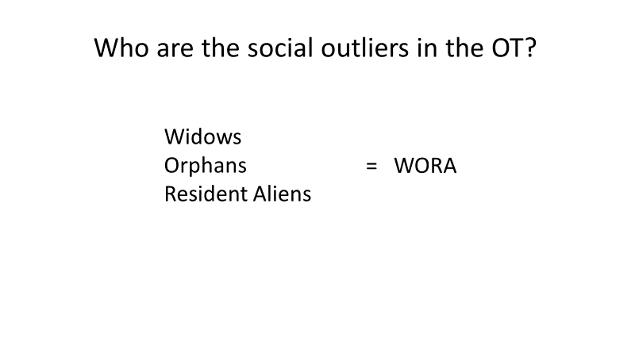

Richard Hiers includes the three groups with slaves as “classes of persons [who] were especially vulnerable because they lacked independent means of support.” While that sounds reasonable and we do see aspects of that such as the cases of Naomi and Ruth, as well as the widow of Zarephath associated with Elijah, it seems to look through a western cultural lens of nuclear families. In our Western Culture we think of nuclear families as basically two generations: parents and children as shown in this picture. For the sake of illustration I include one son and one daughter, although the number could range from one child to a half dozen or more, with a variety of males and females.
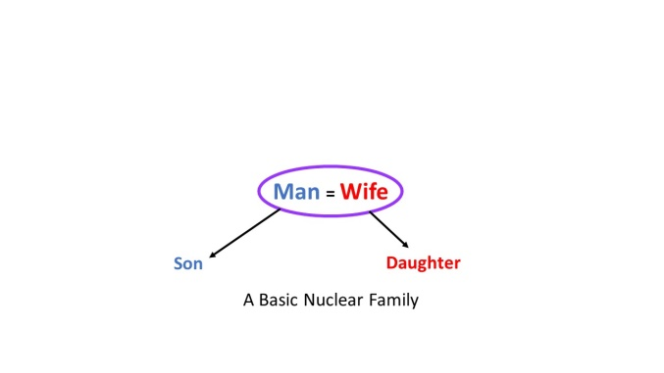
The Hebrew culture had a different perspective. First we must address a common conception that large families were the norm for Israel in that era. A key example is Jacob whose family consisted of 70 when he moved to Egypt (not including wives of his sons), however, that figure included multiple wives for Jacob and not only included children but also grandchildren (Gen 46:7). Another example is Gideon who is recorded in Judges 8:30 as having 70 sons. While the text does not explicitly mention “grandsons” the word translated “sons” there could include grandsons in this case as with Jacob. That passage also records that he had many wives, although the number is not stated.

When we look at this within a broader context, we find that these seem to be exceptions. Jacob’s father Isaac had one set of twins, Jacob and Esau. Isaac’s father Abraham had one son through his wife Sarah and a second through his concubine. Because of long life he did father six more sons through a third wife, Keturah, after Sarah died. And even when we consider Jacob, his first wife Leah had 6 sons and a daughter, while the other three had two sons each (and Rachel died in childbirth with the second), although we are not told how many daughters they had.

When we look at the judges who lived during the time period we are studying, we see extremes. Gideon had 70 offspring through many wives. But on the other hand, Samson had no children, although he died early. Jephthah had only a daughter, Elimelech, the husband of Naomi had only two sons, and neither of the sons had any children.

Philip King and Lawrence Stager in their Life in Biblical Israel estimate from the overall evidence that Israelite women averaged four live births. This would suggest a basic nuclear family of 6, but they suggest that child mortality lowered the family to 4, as we have in our diagram. Their premises seem to be high infant mortality and three to four years between conceptions because of nursing, combined with a shorter period of fertility. It would seem that the infant mortality rate of 50% is high and the last two figures as well as number of conceptions seem low. Personally I am more comfortable with a basic family consisting of 4 to 6 surviving children, which would give a typical “nuclear” family of 6-8 as seen here.

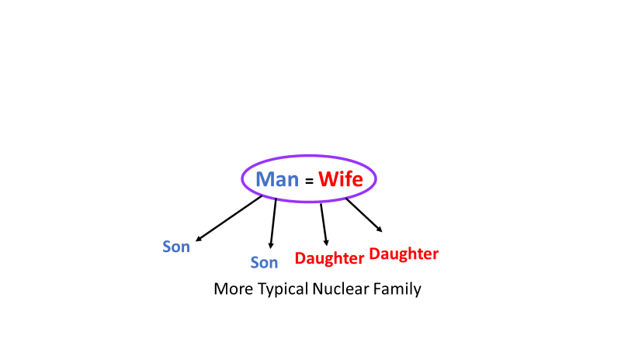

Another point of contrast for the Hebrew culture to our modern western culture is a norm that seems evident for this period that we have already alluded to. That item is that most often the family consisted of three generations as the grandparents (or surviving grandparent, most often the grandmother) lived with the son and his wife and their children. To contrast this with our concept of a two generation nuclear family, I have adopted the term “molecular” family to show a more typical structure for Israel.
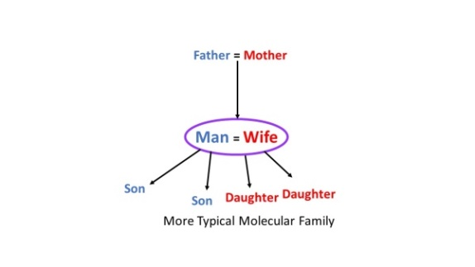
The social baseline developed in part 1 provides important background so let us remind ourselves of some basic observations. A number of studies indicate that a typical family would have consisted of a man growing up within a given village where he would have learned to work the land of his ancestors which for Israel was largely the land which God gave the nation at the time of the settlement.

He would have married a woman from the same kinship group, likely from either the same village or one nearby. The wife would have moved into the household of the husband. This arrangement seems to be what the OT calls “the house of the father” or the “father’s household.”

Initially, it seems likely the couple resided in the same compound house as his parents. Assuming both spouses survived to the point that their children reached adulthood and marriage with children of their own, there would have been a change in the relationship as the [grand]parents aged.

The transition for the might have been gradual if both parents survived but were no longer able to work as rigorously as earlier, or it might have been rather sudden with the death of one of the [grand]parents. Given what is viewed as a typical difference in ages between the spouses (many scholars suggest that the wife normally would have been ten to fifteen years younger), the surviving spouse was most likely the widow. In that case, if the oldest son was not already managing the farm, he would take that responsibility, and it would then be likely that we would find a molecular family like this.

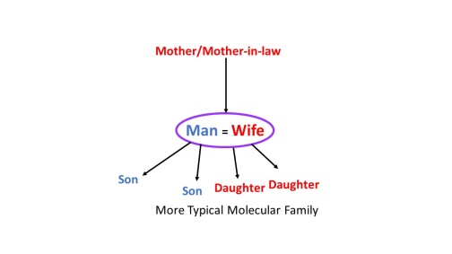
Beyond this, in the city or village, there would be many relationships with other families, and the situation could become very complex. This next level might be called the extended family.
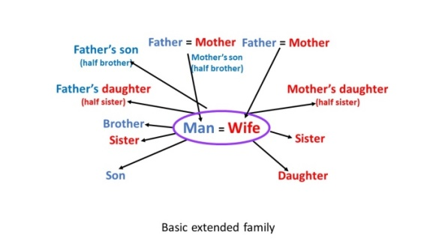

For our purposes, we might consider the inter-relationships between molecular families. This gets into aunts, uncles and cousins (at least first cousins), and may be called “extended families. This chart is based on the material in Leviticus 18 which lists different women that an Israelite man would be forbidden to have sexual relations with. In my forthcoming Leviticus commentary, I label this the extended family since it seems to denote certain relationships for which sexual relations, and thus marriage would be forbidden.

This chart takes us out to at least second cousins before marriage would be considered a viable option. Today, we think of social fabric as denoting a collection of family units, very often not even from the same parts of the world, let alone closely related. For OT Israel settled in the land, most of those relationships would have been either in the same village or other villages in the vicinity. From our perspective, this pattern gives a new emphasis on the concept of “blood” relative. Clearly the social fabric of that culture would have been closely knit producing a situation where a tear in the social fabric would have wide spread implications.

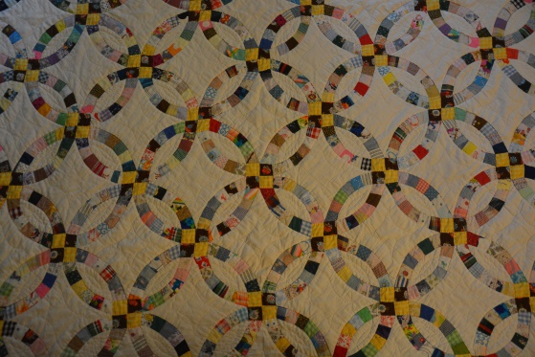

The model I like to use for this is a quilt, and as I thought about it, I chose a pattern that my mother made for each of her grandchildren as wedding gifts for when they got married. The pattern is called “wedding ring,” and I chose this because of the way that the various elements interweave to provide the overall pattern which can be extended indefinitely. The premise that I am working with, however is that social justice is intended to preserve the social fabric. We will look at this social fabric model in more detail in parts 3 and 4.

In the Israelite culture, there seems to have been two higher levels of social structure as part of the nation. These were a clan, and then the tribe. We will not go into those in this study since in terms of social justice it seems that most of the interactions would have been on the village/city level and thus aspects of the extended family.

Archaeologically, Uzi Avner suggests that some evidence of extended families of about 25 persons. This begins to create a complex social structure. This slide shows the various possible relationships involved.
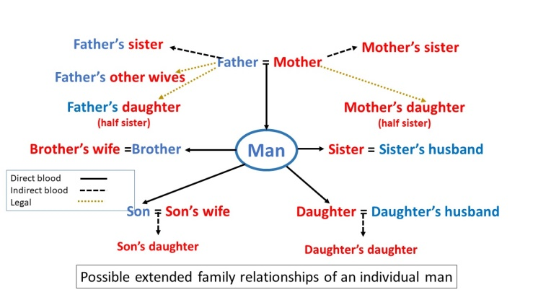

As we look at this complex chart, remember that there are many variations of this, especially if more siblings are involved at any level. Moreover, most likely all of these relatives would live in the same city or at least in some of the hamlets surrounding it. The point is that should a man die, the surviving widow should have a network of relatives in her community to provide support in a variety of ways.

When we begin to talk about widows, one thing that often is not considered is how old was she when she lost her husband. If she was younger, then remarriage was possible. If the Torah was followed, and if her husband had a brother, then the brother was expect to marry her (Levirate marriage)—if she didn’t have children already. If she had children, then it seems to have been expected that the children would provide her security in her older age. This would especially the case if her children were married.

In fact if the widow was older, then it may well have been that she was already living with her son. A number of studies suggest that to be the expected pattern: a widow would live with her married children who had inherited and were now working the family land.

Thus, for many Israelites, the family structure they would have experienced as they grew up would look like this.

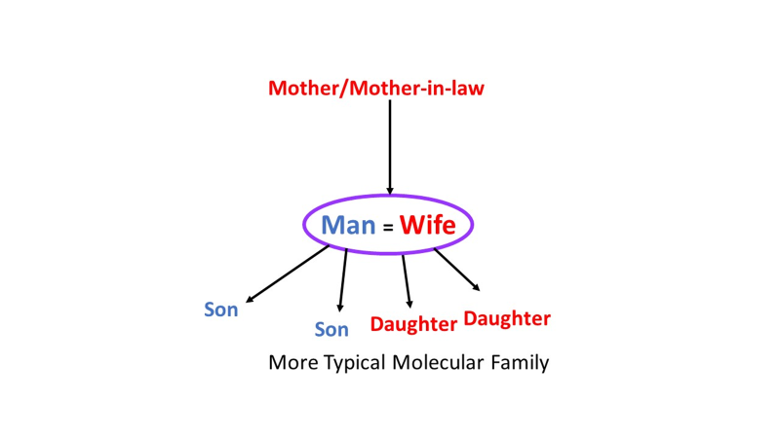
With that expansion on the material we have covered, let’s define the three key outlier groups.

1. The Widow.

Our first outlier is the widow. We have already noted how in most cases, a widow would be living with her adult son (of course, depending on her age). If that is the case, even though there were likely exceptions, why does the text give a blanket statement regarding widow provisions? And when one considers orphans, the issue is even more complicated. Given the close residential proximity and extended family ties presented in part 1, how could an orphan, “fall between the cracks,” so as to be entirely without support necessitating the provisions cited in the text?

Also, why do Victor Matthews and Don Benjamin in their study of Ancient Israel’s social world suggest that widows and orphans were “legally homeless, without any social, political, or economic status.” Actually, they categorize them with prostitutes as “liminal women.” This is problematic for several reasons. First, it seems to assume that all orphans were female. Second, they never address the third group, the resident aliens, who seem generally to have been males. Third, their categorization assumes all three were homeless.

As already noted, a widow likely lived with her adult children. Even if that were not the case, as noted in part 1, a widow was not necessarily homeless. The same is true of a Resident Alien. Further, the concept of homelessness itself is problematic. Homelessness was not unknown in the ancient world, but its characterization seems vastly different from how we understand it today. Modern homelessness seems to be a product of urban, somewhat industrial societies. In a predominantly agrarian society with large unpopulated regions, a “homeless” person could disappear into unsettled regions or wander from village to village working as an itinerant laborer. Biblical material suggests both occurred in ancient Israel. In fact, two key examples are ascribed to the period we are studying. The first would be David when he fled from Saul. He, along with his followers, “went wherever they could go . . . in the wilderness in the strongholds, and remained in the hill country in the wilderness of Ziph” (1 Sam 23:13-14). Today, we might say they were bivouacking, or perhaps “roughing it.” In essence they were living off of the land, often staying in caves, not bedding along streets in a city. Thus far, I have seen no evidence of an Israelite making a semi-permanent camp along a major street in Jerusalem during the Iron Age. The second example would be Jonathan ben Gershom, a Levite also from Bethlehem during the period of the Judges. Judges 17:8 relates how he left Bethlehem to “to stay wherever he might find a place” and ended up in the hill country of Ephraim where he was given a place to stay and a job serving as a priest for Micah. For these, in American culture, a hobo might be a modern analog. While not an alien, Jonathan does seem to exemplify the OT “resident alien” provisions.

J.A. Thompson simply categorizes widows, orphans, and resident aliens as “poor” which seems rather obvious since the provisions prescribed to ameliorate their status were economic. However this really does not address why they were poor. J.B. McConville presents a slightly different nuance when he states that “these are not strictly the same as the ‘poor,’ but rather those whose independent legal standing may not be recognized.”

While other suggestions have been made, the question remains: what did they have in common in Israelite culture that merited special consideration? To answer this, we will first define each group, and then evaluate what the three had in common.

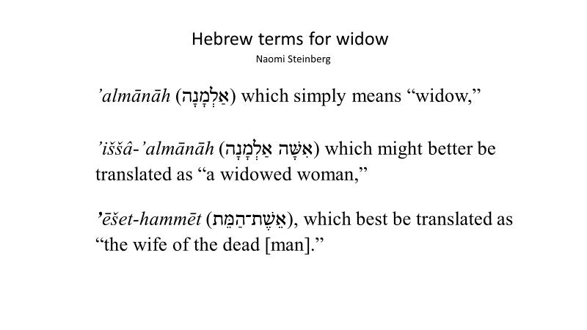

1. Widows. The first group is widows. By definition, the English word widow denotes a “woman who has lost her husband by death and has not remarried.” The Hebrew is more complex. While the English word widow is most commonly a translation of the Hebrew word ’almānāh (אַלְמָנָה), the situation is actually more complex. In a paper presented at Harvard University in 2003, Naomi Steinberg notes that actually three Hebrew terms are translated widow. They are:

’almānāh (אַלְמָנָה) which simply means “widow,”
’iššâ-’almānāh (אִשָּׁה אַלְמָנָה) which might better be translated as “a widowed woman,”
’ēšet-hammēt (אֵשֶׁת־הַמֵּת), which best be translated as the “wife of the dead [man].”

She distinguishes the three on the basis of property and economic resources. The last two are both categorized as indicating a widow who has “inherited” property over which she had control. She explains that status of the second two categories as follows:

According to Steinberg, the second category, a widowed woman, had “redemption rights in her husband’s ancestral estate which she exercise[d] through her son.”

The wife of the dead [man] had died “before fathering an heir to exercise the redemption rights to his ancestral holdings.”

This is an interesting concept which runs counter to our typical understanding of land ownership and the rights of women. While she seems to support the her distinctions, it is an area that could use more work, especially with a more nuanced understanding to the socio-economic background we have provided in part 1..

In contrast, an אַלְמָנָה is deemed a widow in destitution “who may have had living male adult relatives, either too poor or unwilling to offer her economic support” (italics added).
Hoffner argues that an אַלְמָנָה could own land which might be coveted or an object of fraudulent misappropriation.

Steinberg’s distinctions do not answer all of the questions. For example, what would one call a woman who had raised her family before she lost her husband and was now living with a married son and family, which seems to have been the social norm?

Further, if the widow had control of the family property (whether or not she had a grown son), why would there be such an imperative for the gleaning laws? If a widow did not have control of the family property after the loss of her husband, would she (and any young children with her) truly be homeless in a village where she was part of an extended family and even larger kinship group since it most likely had been an endogamous marriage?

In any case, the loss of a husband placed the family in a more precarious situation since the primary food staple of the Israelites was the cereals (wheat and barley), which demanded the arduous process of plowing and sowing, a process that demanded the greater physical strength of the male. Even if the widow had control of the land, if she was not able to plow the land, it was essentially useless. On the other hand, if the wife died first (perhaps in childbirth), then the husband would likely have remarried (how he would have provided for domestic needs otherwise is beyond this study).

One provision the OT law made if a man died and left his wife (here called the wife of the dead) without children was levirate marriage (Deut 25:5-10). We will discuss that in part 4. Because the purpose was to provide an heir, levirate marriage would not seem to be a factor if the widow did have children, or if the widow was past child bearing age. Rather, the older widow with an adult son would be part of the extended family. If the child was under age, then the widow provisions in Leviticus might be viewed as a bridge until the child was old enough to take care of his mother. If the childless widow was past child bearing age, this would be a different situation.

The book of Ruth addresses some of these issues, so it is worth reviewing some key aspects of the legal issues involved. Naomi was the widow of Elimelech, but because of age, Naomi would seem to be outside of the levirate marriage criteria and consequently not come under the widow provisions although the disposition of Elimelech’s land might be an open question.

Ruth’s case would be much more complicated. Although debated, it does appear that her situation was an example of levirate marriage. However, the actual widow of the land-owner was Naomi, who had not only had lost her husband, but both sons. Further, Naomi’s sons had married Moabitesses. Ruth, who had been married to Mahlon one of Naomi’s sons, was also a widow. Despite the declaration in Deut 23:3 that no Moabite could enter “the assembly of the Lord,” Ruth’s return to Bethlehem with Naomi apparently allowed unspecified legal rights. Tentatively, the land situation might be put together as follows. According to the English text in 4:3, Naomi was going to “sell” some of the land that had belonged to Elimelech, although what that means is not clear. In any case, according to the text, for Naomi to get the use of the land back, she had to “redeem” it. This would suggest that as Elimelech’s widow she had control of the land. In a practical sense, it really did not matter since they arrived in Bethlehem at the beginning of the barley harvest (Ruth 1:22), which meant that the land was basically useless to Naomi until the following planting season regardless of whether she would be able to till it.

In a legal sense, however, it would appear that since Elimelech had sons, they had a right of inheritance and subsequent passing the land on even though they were deceased. Although neither son had children, both had married. Thus, by returning to the land Ruth entered into the picture as the child-bearing aged widow of the legitimate heir. This would seem to be the reason that in this complicated situation Boaz asserted to the unnamed relative that while the land needed redemption (i.e., required a go’el), the go’el would also be required to marry Ruth. The normal expectation would be that through levirate marriage, he would need to marry Naomi, but apparently since she was beyond childbearing years the relative likely assumed that no longer to be the case, but Boaz asserts that the requirement then devolved on Ruth. When Boaz then agreed to buy the land, he acquired the estate of both Mahlon and Chilion, and Ruth as a wife “to raise up the name of the deceased on his inheritance.” It is this last statement that most strongly indicates that the marriage was functionally a levirate marriage in that Boaz was agreeing that the inheritance would be Elimelech’s.

It is suggestive that it is only after the birth of a son from Boaz and Ruth that Naomi is praised by the local residents because she now is “not . . . without a redeemer” (4:14). In essence, these neighbors point out that one of the functions of this son is to be “a sustainer of [her] old age.”

To this point, the assumption has been that the widow being addressed is an Israelite widow. As we have seen this presents problems with regard to the baseline situation which presumes that the widow would be supported by her son or relative who inherited the family land. We also noted that the separation of the domicile from the actual farm land produced the possibility that the widow would remain in the house of her husband regardless of the land status.

One alternative that is virtually ignored is the possibility that the widow (אַלְמָנָה) was not Israelite nor was her late husband. Mayer Sulzberger, in his study of labor in Israel, argues that the stranger or resident alien (ger) was a descendant of the resident Canaanites who remained in the land after the conquest. While the Israelites were not allowed to sell their land, the same did not hold true for the Canaanite remnant (although as they were assimilated into the Israelite culture that may have become the case). As such, he suggests that the widow (אַלְמָנָה) would be the widow of a landless Canaanite, which would put her in a truly economically precarious situation. If that were the case it would explain why this person did not fit the expected community support criteria. It would also make the admonition for the Israelites to provide the opportunity for economic support even more profound (and might even be suggestive regarding the acceptance of Ruth when she took advantage of those opportunities and gleaned).

2. Orphans.

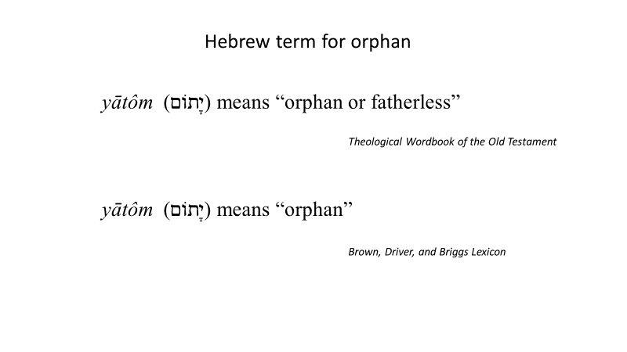
Our second category is orphan. While the term orphan seems straightforward, the English translation carries a different connotation than the Hebrew. The English word orphan normally denotes a child who has lost both mother and father, which is the connotation that many English commentators take. Consequently, while at first glance the situation seems obvious, there are several questions.

From a practical perspective if an Israelite child had lost both parents, where did that child live? If he or she was taken in by relatives, then why would those relatives not be expected to provide for the child instead of requiring the child to glean to procure food? Since one of the provisions for orphans was gleaning, at what age would a child be expected to perform that arduous work? Under those conditions, what hope did that child have in life should he or she ever reach adulthood? Given these questions, a deeper look is required.

The Hebrew word translated orphan is better understood as a child who has lost his or her father, a connotation which gets lost in translation. For example, TWOT translates יָתוֹם as “orphan, fatherless,” although its discussion does not address the difference and seems to view the term primarily as a child who had lost both parents. While BDB gives just the translation of “orphan” for יָתוֹם, at the end of its entry it states: “in no case [is it] clear that both parents are dead.” From a sociological perspective, in the ancient Israelite culture it seems “fatherless” and “orphan” would carry much the same weight–specifically referring to a child who has no-one to defend him or her. Contextually, it is interesting that orphan appears to be connected with widow. This suggests a situation where a woman had lost her spouse, but had minor aged children and was trying to raise them herself. In light of earlier discussion, this woman would technically not be eligible for levirate marriage since she had children who would be expected to care for her in her old age. Consequently, it is concluded that the consistent connection of orphans with widows indicates a single parent family (headed by the mother) working together to gather food to survive.

What is not clear in the issue of orphans is the matter of the land. It would seem that even if the father died, the land would remain in the family; likely under the legal control of the widow (such as was suggested above for Naomi). Zelophehad’s daughters provide a precedent (Num 27:1-11). Zelophehad had no son, and his daughters were concerned that their father not lose his inheritance in the land. The outcome was a directive from God that “If a man dies and has no son, then you shall transfer his inheritance to his daughter. If he has no daughter, then you shall give his inheritance to his brothers. If he has no brothers, then you shall give his inheritance to his father’s brothers. If his father has no brothers, then you shall give his inheritance to his nearest relative in his own family, and he shall possess it” (Num 27:8b-11a). In a case like that, the expectation would have been that when the “orphan” reached adulthood, he or she would inherit the land and continue to work it. However, if that was the case, then why would the orphan be gleaning?

Here may be evidence of how physical abilities affected matters such as gender roles within that culture. According to the Centre for Economic Policy Research, historically a factor in gender roles was the use of a “plough” to till soil which requires “significant upper body strength, grip strength, and burst of power, which are needed to either pull the plough or control the animal that pulls it.” It may be then that a single woman (i.e., widow) or a minor child was not expected to have the physical ability to prepare the fields for planting, thus requiring other assistance. Later we will see that one of the provisions for the widow and orphan was gleaning, or participating in the harvest. While certainly physically demanding, it did not require the same upper body strength that plowing required.

Deut 14:29 may contain another factor when it mentions “the orphan and the widow who are in your town” (literally, “in your gates”). That the two are mentioned together here seems to corroborate the conclusions above that the reference is to the fatherless as opposed to true orphans. The phrase “in your town” as opposed to “in your land” might anticipate a projected future, more complex culture where some elements of society no longer made their primary living by farming. If that were the case, then the orphan (and widow) being addressed might be from a family which had no land to farm.

3. Resident Aliens.

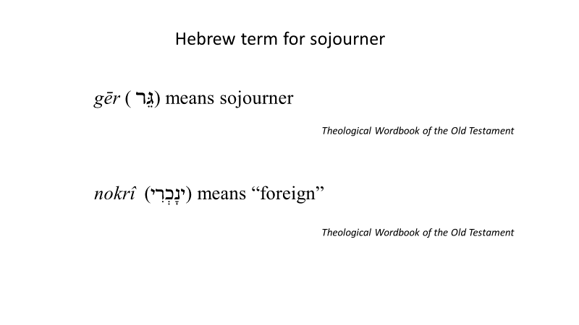

The last group addressed is that of the ger (גֵּר) translated variously as “stranger” (KJV); “sojourner” (ESV, RSV); or “alien”” (NASB, NIV). A resident alien should be distinguished from a “foreigner” (נָכְרִי, or נֵכָר) in that he or she would be residing in the land as opposed to visiting it; hence the term “resident alien” is preferable. Resident aliens have privileges and responsibilities beyond those of foreigners, but fewer than those of the natives. David Baker expands on this in his book Tight Fists or Open Hands stating, “the status of resident aliens is somewhere between that of natives and foreigners, and individual aliens may be incorporated into the community by becoming dependent members of an Israelite family, under the protection of the household head (cf. Exod 20:10; 23:12).” This may explain the situation of Ruth.

In terms of ethnicity, the OT presents several categories of individuals who permanently lived in the land but who were not descendants of Jacob. The first group was the mixed multitude that went up from Egypt (Exod 12:38). As Douglas Stuart puts it in his commentary, the verse in Exodus “confirms that the Israelites of the exodus (and thereafter) were actually a mixed people ethnically.” Other ethnic strands of the exodus included Egyptians (cf. Lev 24:10), Cushites (Num 12:1), and Kenizzites (Josh 14:6), and apparently others not named. While not descendants of Jacob, it would appear that these groups had been absorbed into the ethnic tribes at Sinai. They then shared in the land division after the conquest, and thus their descendants were included with the “native Israelites” in later citations. For example, Caleb is described as a Kenizzite, but also represents the tribe of Judah as part of the scouting party of Canaan at Kadesh Barnea (Num 13). Subsequently, in Joshua he has a key role in Judah acquiring its land and as such seems to model assimilation.

A second group would be the tribes which dwelt in the land at the time of the conquest. The OT clearly points out that, contrary to the common perception, the nation of Israel did not eradicate all of the inhabitants of the land during the conquest. The Gibeonites formed an alliance with Israel by deceit. They were consigned to a position of servitude–specifically, they were to be “hewers of wood and drawers of water” both for Israelites individually and for “the altar of the Lord” (Josh 9:21-27). There are indications that some of them inter-married with the Israelites. Other tribes did not form alliances, but were not driven out. For example, Benjamin could not drive out the Jebusites, and they continued to dwell with the Israelites. Other Canaanite tribes are noted as remaining in the regions of Manasseh, Ephraim, Zebulun, Asher, and Napthali (Judg 1:27-36). According to the early chapters of Judges those tribes were problematic for the nation subsequent to the conquest. Their ultimate fate is unknown although we find hints of intermarriage such as Samson marrying a Philistine woman (Judg 14). It may be that the bulk of the 153,600 resident aliens that Solomon numbered and conscripted to help build the temple descended from these tribes who occupied the land at the time of conquest (2 Chr 2:17-18). It seems likely that as Israel became more organized through the monarchy, those Canaanite tribes that remained became Hebrew speakers, intermarried, and ultimately lost their ethnic identity, i.e., assimilated like the mixed multitude. While likely at least some of those resident aliens were absorbed religiously, this diverse population may help explain the mixed archaeological message regarding worship (as well as the tension seen throughout the OT regarding other gods). With respect to the issue at hand, it would appear that these prior residents continued to live on the land that they had possessed prior to the conquest, and thus generally did not need the resident alien provisions. If that was the case, it also raises the possibility that a Canaanite might have sold land to a non-Israelite, perhaps a later immigrant, but it seems most later immigrants would have been landless.

Those future immigrants compose our third group. Noting the complexity of people movements throughout the Ancient Near East, it is likely that a significant number of these immigrants entered the land throughout the history of the nation. Torah guidelines prohibited Israelites from selling them their land so unless they were able to find work, they would be the resident aliens who needed these welfare provisions. Two primary types of work are suggested. First, they might be either skilled craftsmen or merchants who could perform jobs located in the larger communities or cities. Second, they might work anywhere as hired hands. Subsistence farming was arduous work and available manpower limited the amount of land a farmer could work. As noted elsewhere, hiring individuals to help the farmer manage the land he possessed was a common practice in the ANE.

Immigration is difficult in this context for several reasons. First, national boundaries were ambiguous as was “citizenship.” People could move around rather freely, but at the same time travel was difficult, generally on foot. Likely the biggest issue would be communication when entering a region which spoke a different language. Second, life was essentially lived on a local level, which means that in most cases, acceptance was determined within a village. An outsider who showed up in an Israelite village, whether he was Israelite or alien, would have to find work. It is likely through that means he would also find a place to stay. Likely the migrant would be homeless for some time, but as noted above, it meant that he generally would be sleeping and foraging in the wild, as opposed to begging on the street in the city. Third, an alien would likely go someplace where he or she could find work in order to support himself or his family. Generally, that would involve manual labor.

There would be a variety of reasons why these immigrants might not have work, such as they had just arrived, or the farmer he worked for let him go, or there was a famine. Whatever the reason, these social justice provisions provided a means by which they could survive.

4. Summation.

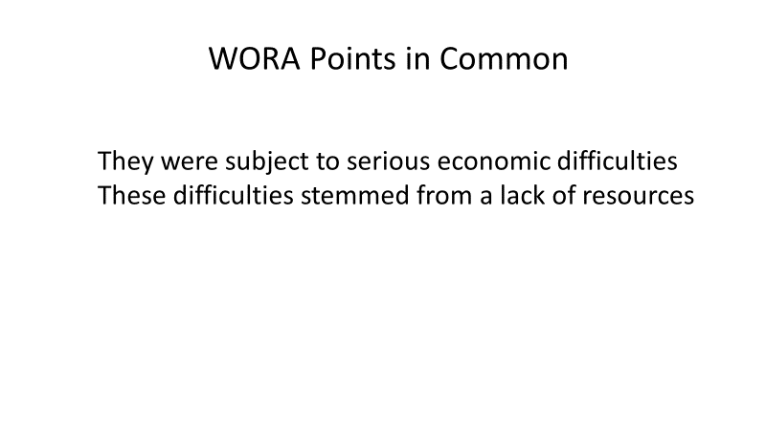
These three groups seemed to have two points in common. First, they were subject to serious economic difficulties. Second, these economic difficulties seemed to stem from a lack of resources, which in that culture would primarily be agricultural land. While we often view the situation as lack of land, we noted that in the case of widows, the issue may have been the inability to till it. The same might be true of orphans. In the case of resident aliens, the lack of land seems to be a result of the prohibition against Israelites selling their inheritance. While a resident alien may have worked as a laborer, this made him vulnerable to unemployment. Having explored what we suggested might be social norms, and evaluated how these outlier groups lay outside of those norms, we now need to evaluate the directed provisions designed to serve as a safety net for those outliers.

