Social Justice for Social Outliers in Ancient Israel, Part 1:

Ancient Israel’s Cultural Background
By Dr. Michael Harbin (Taylor University, emeritus, ©2022)
The Bible provides principles given by God which appear to be applicable to all people in all cultures in all times. However, many of those principles must be extracted from the particular cultures in which they were embedded. Those cultures were vastly different than ours, especially in terms of Israel in the Old Testament. When we read the OT, we see a culture that was rural, agrarian, low-tech, locally oriented, and slow paced. Ours is largely urban, post-industrial, high-tech, globally oriented, and fast paced. While we can and should try to derive principles from the culture that God designed for Israel, we need to make sure that we understand that culture. For example, as we will see, rural in Ancient Israel was very different than rural in the modern world. This is especially true of the Torah or the Pentateuch where God’s cultural guidelines are found.

While scholars debate the origin of the Pentateuch, they seem to generally agree that it was written for a culture tied to the land. Joseph Blenkinsopp (200) asserts that it “presupposes a peasant agrarian society.” Roland de Vaux (143) argues that that the purpose of the legal material was to govern “a community of shepherds and peasants.” But there are nuances to those descriptions that can trip us up unless we analyze the nature of that community, and I would suggest that one area that needs careful examination is the matter of relationships.

In this study, we will follow the traditional understanding that, as presented in the text, the material of the Pentateuch that describes how the Israelites were expected to relate to each was either given at Mt. Sinai (the last half of Exodus and Leviticus) or during the journey into the land of Canaan (Numbers and Deuteronomy). Collectively these materials were intended to provide advance guidance to the nation on how they were to live once they settled into the land. However, as shown in subsequent, after the settlement, OT books, it is likely that if the nation ever followed God’s guidance; it was only done partially and only for a short time.

Regardless of the date that scholars claim for the text of the Pentateuch, they generally agree that it is oriented towards a Late Bronze Age society. Given the huge cultural gap between an agricultural culture that worked the soil with bronze tools and our contemporary, Western, post-industrial culture, any attempt to apply directives contained in this material to our own world encounter a number of significant problems. Our goal in this presentation is to look at specific aspects of that complex body of legal material which address issues of social justice which pertain to three outlier groups, widows, orphans, and resident aliens, a group I give the
title of WORA. In part 3 we will define those three groups more closely and evaluate their position in the ancient Israelite agrarian culture as well as their commonalities. Here, we first need to clarify some of the agrarian practices of that historical-cultural period to establish a cultural baseline.
Archaeological evidence presents the typical Israelite farming community, like that of the Canaanite contemporaries and predecessors, as a cluster of houses built in close proximity to each other, even to the point of having common walls, a pattern still evident today. This village structure, especially with regard to the relationship of the village with its farmland would profoundly affect community relations. I would contend that there would be very significant implications with respect to issues of social justice, and yet surprisingly it is largely overlooked. A source that I have found very helpful in understanding some of those social issues was a study of a modern village in the highlands east of Galilee, conducted by anthropologist Richard Antoun with the title of Arab Village: A Social Sttructural Study of a Transjordanian Peasant Community published in 1960. According to Antoun’s report, the farming techniques he observed were very similar to those presented in the OT. However, his study was also very revealing with regard to how the social structure and physical layout of the village affected community relationships, which will be the main focus of this study with regard to social justice.

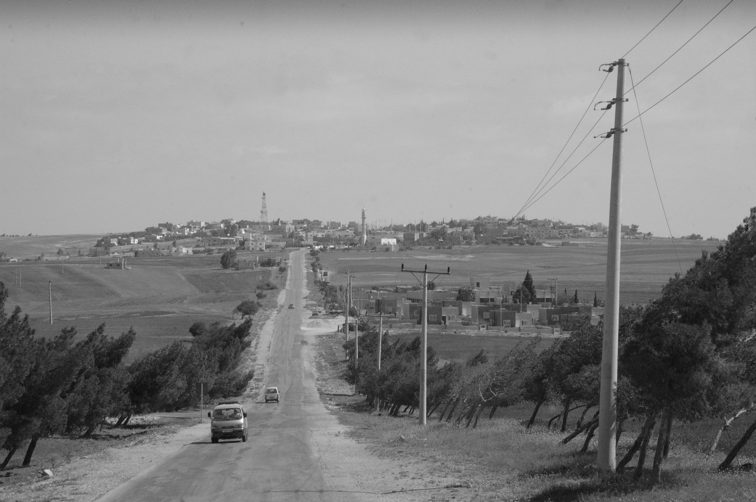

This picture is a typical (unnamed) Jordanian village we went through on one of my trips to Jordan. As can be seen, the closely built village housing ends abruptly with unfenced fields stretching out in all directions. This is the same layout archaeologists have noted as typifying Israelites villages during the Late Bronze Area. Those two factors, the close village housing and the unfenced fields help explain several aspects of OT social justice issues.

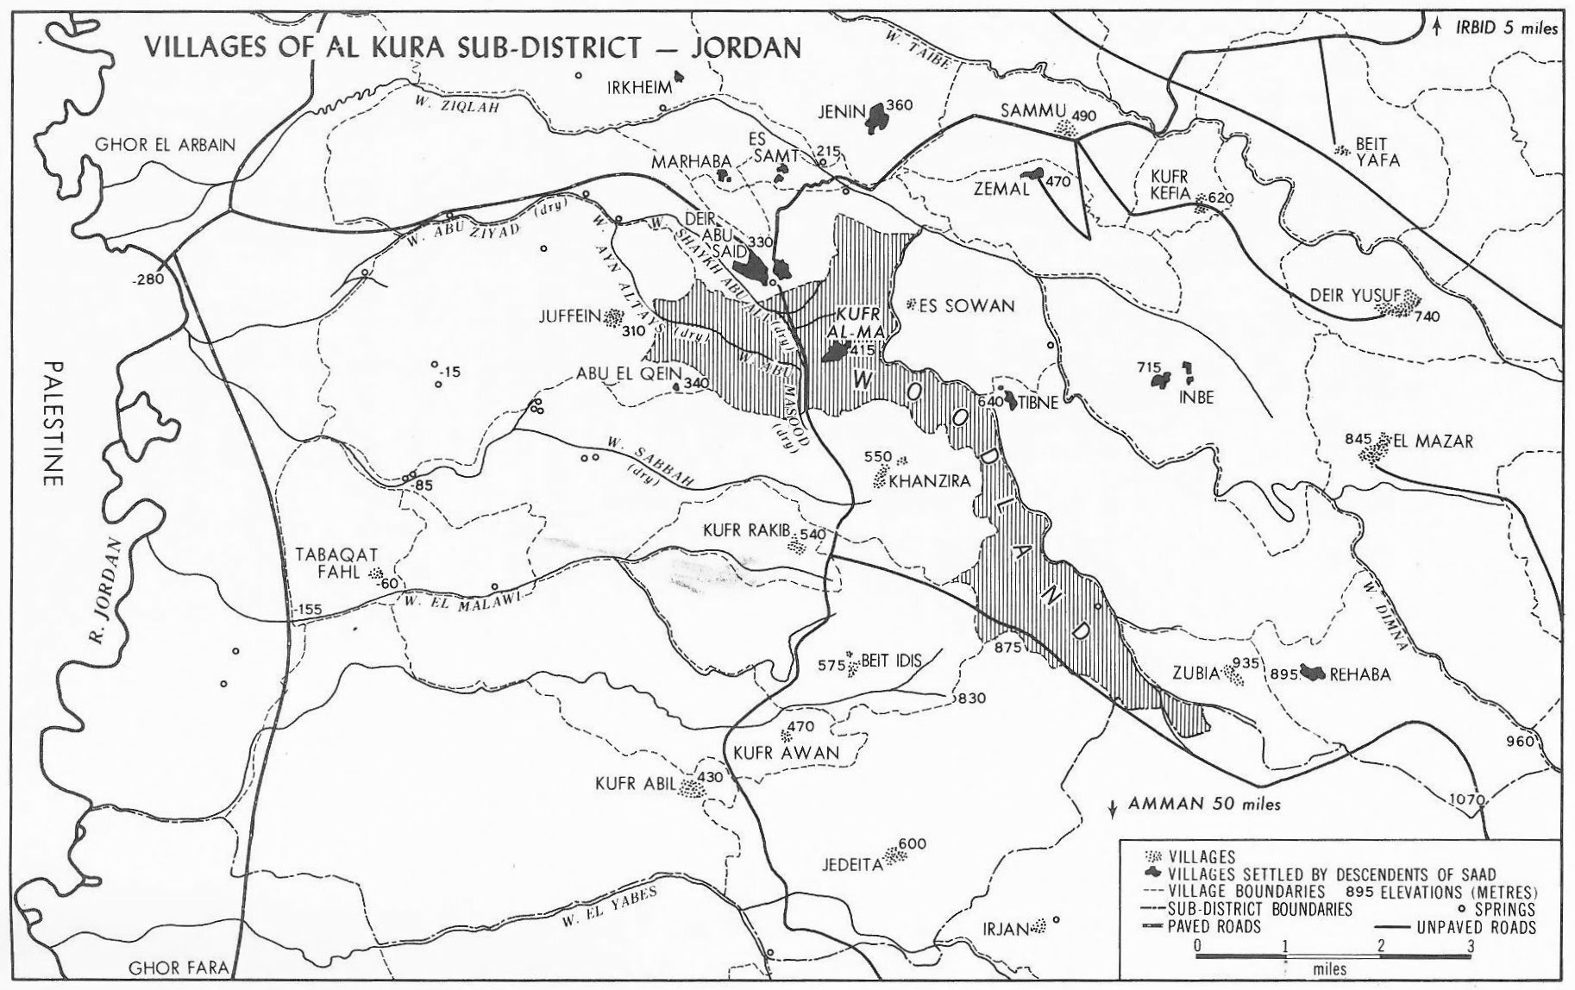

This is a map that Antoun created during his 1960 study of the Jordanian village Kufr Al-Ma which lies about eight miles east of the Jordan River. Note that the “village” is the entire region highlighted on the map. Embedded somewhat in the center is the housing area which is the black diamond shape in the upper middle. This is a surprising identification from a western perspective. Antoun describes Kufr Al-Ma as one of about 200 “cereal-growing villages of the Ajlun district of northwestern Transjordan” at the time of his study. At that time, this “village” had a population of approximately 2000. This map covers part of the Ajlun district, encompassing approximately 170 square miles (approximately 440 square kilometers. Antoun identified at that time about twenty-five “villages” in this area. Like Kufr Al-Ma, each “village” was really a larger geographical region with a cluster of houses as a nucleus similar to the example which we saw in the previous picture. As shown in this picture, Kufr Al-Ma, the village of Antoun’s study, really consisted of two parts determined by the topography. The housing area lies within the roughly triangular northern portion.

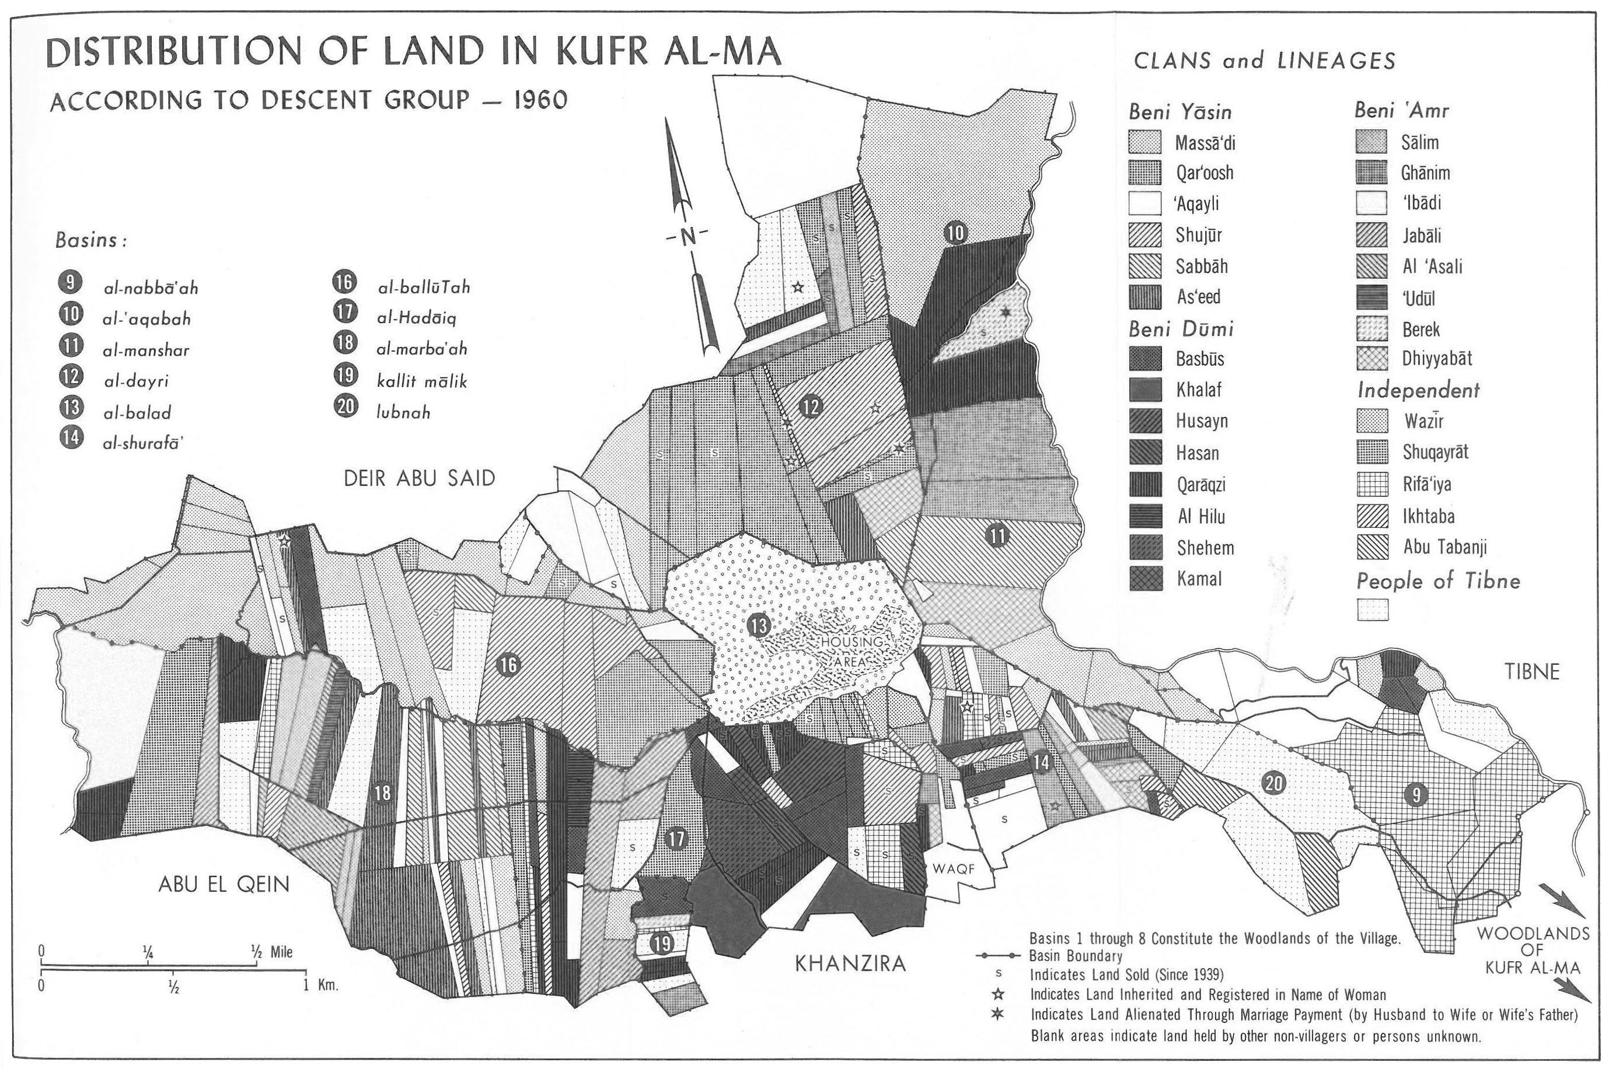

As shown on this diagram that roughly triangular northern portion of the “village” had a long axis of about three miles and a cross axis of about a mile and a half. On this diagram, Antoun marks the various fields of the villagers where they farmed, broken up by the various clans and lineages which possessed them as indicated by the various colors. Additionally, in the center you can see the housing area. This is the more darkly shaded portion of the section labeled 13. The hatched area around the housing area was used for gardens where various fruits, vegetables and herbs were raised.

The remainder of the overall village is marked on the first map as “woodlands” suggesting that the farming region was restricted to this northern portion of the village. Since the “woodlands” was described as secondary growth of evergreen oak shrubs, it would appear that the area was also used for grazing.

While the larger village area concept is important for understanding the context, for our present purposes we will focus on the northern triangle which includes the habitations. As diagrammed, the habitation area was a portion of the al balad basin (area 13). Antoun described this basin as roughly circular, approximately a kilometer (a little over a half mile) in diameter. The main point to note here is how the agricultural area surrounds the housing area as we saw in our first picture.

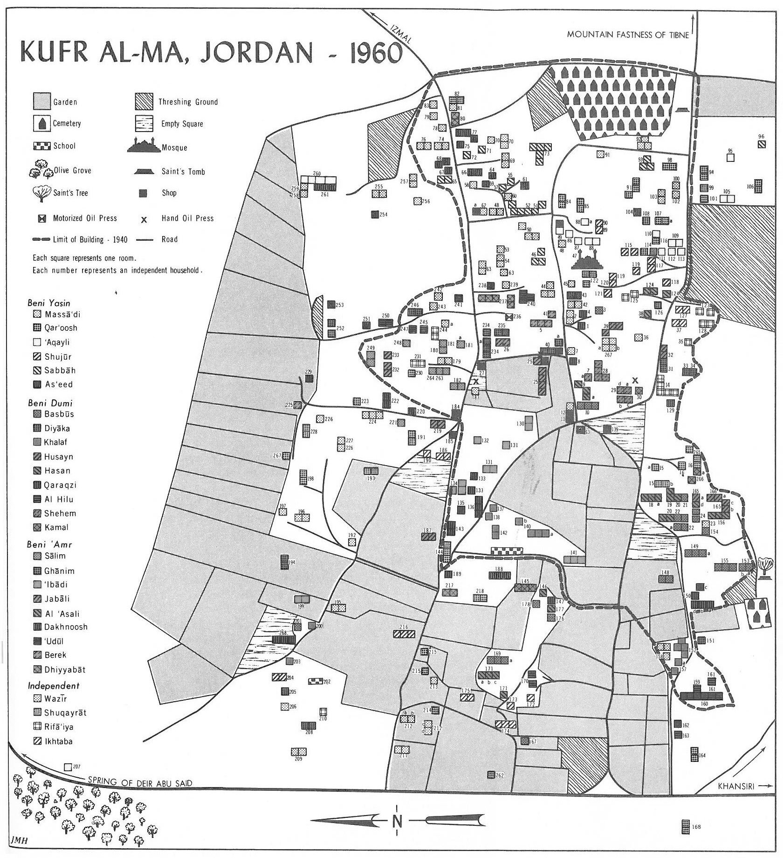

This larger scale map of the habitation area shows Kufr Al-Ma surrounded by both gardens and olive groves. Three items should be noted. First, this diagram does not include all of the houses since its purpose was to support Antoun’s social structural study (i.e., the relations between clans and lineages). Second, the actual housing area was densely populated with the estimated population of about 2000 people domiciled in a region of less than a tenth of a square mile (approximately .13 square kilometers or 64 acres). In this diagram, Antoun labeled approximately 270 “households” most of which seemed to occupy one room houses. Third, the shaded regions on this map are the gardens divided in the same manner as the fields according to extended families. Note that this map is rotated 90 degrees counter-clockwise (N is to the left). If we compare the last two pictures, we can visualize a village structure of houses clustered tightly together, surround by gardens, and just beyond the gardens the olive groves. Then, beyond these two areas, we find the tilled fields where grain was grown.

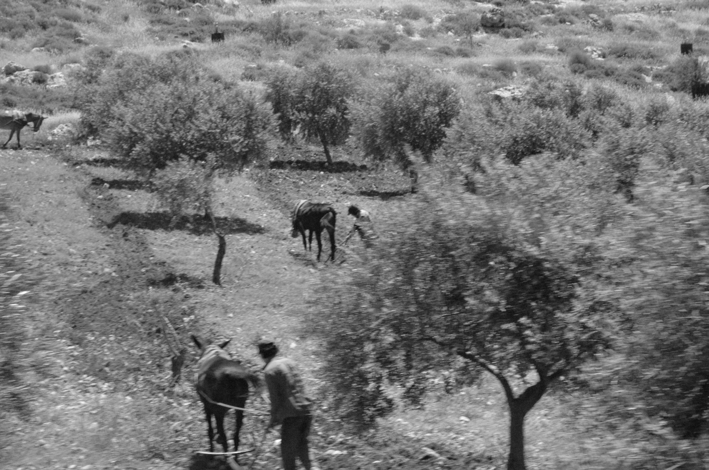

As seen in this picture, my experiences in the Middle East indicate that at least in some cases, farmers tilled around the olive trees. Some sources I have read indicate this to be a practice dating back to the OT period.

This modern layout illustrated in these pictures with a cluster of houses surrounded by the fields of the villagers is very similar to the standard village structure an Israelite in the LBA would have experienced. These visual images help the western reader to understand better various aspects of the culture of ancient Israel.

In his encyclopedia article, Frank Frick points out that “village,” “town,” and “city” tend to be used interchangeably in archaeological literature. He claims that the key difference between a city and a village was a level of administration—that is, a city would be surrounded by various “villages” and served to help regulate agricultural surplus. A city also was normally (but not necessarily always) walled. Another difference might be the number of “lineages” among its inhabitants. As the Israelite culture developed we could also add what some call “industrial areas,” at this time he delineates threshing floors and wine presses.

If this model of a cluster of houses surrounded by the fields of the villagers was also the standard village structure of Israel in the Late Bronze and Early Iron Ages, that is, the period presented as the time of the Judges and the early monarchy, then it would seem that there should have been implications with respect to routine life for the typical Israelite. While there have been a number of studies covering families over this period, generally they focus on individual family situations rather than the more complex relationships of a village. It is suggested that the implications of the larger village culture are both evident in and significant for the biblical material, particularly in the book of Ruth.

While the author of Ruth is unknown, the account is presented as taking place late in the period of the Judges and it seems to give a glimpse into the agricultural system of that time. Ruth is presented as both a widow, and then a resident alien. As the author traces Ruth’s redemption process, he touches on several social justice provisions which we will address in part 4. At this point, however, we would note that the text also presents several details which suggest social norms determine by the community structure. For example, when Ruth goes out to glean in Ruth 2, the model of a village surrounded by farmland best portrays the text.

Twice Ruth 2:2-3 talk about Ruth going to “the field” (singular) where the harvesters are at work. Verse 3 notes that a portion of that field (again singular) belonged to Boaz. This suggests that while certain portions of the agricultural land surrounding the village belonged to different individuals, the totality of the tilled land was viewed as a collective whole belonging to the village.

Verse 3 also notes that Ruth “happened to come on the portion of the field belonging to Boaz who was of the family of Elimelech.” This language seems to reflect the “ownership” of various tracts of the field, not only of Boaz, but of his lineage, which was seen in Antoun’s study. It also suggests that there were no fences between the fields as seen in this picture even in modern times.

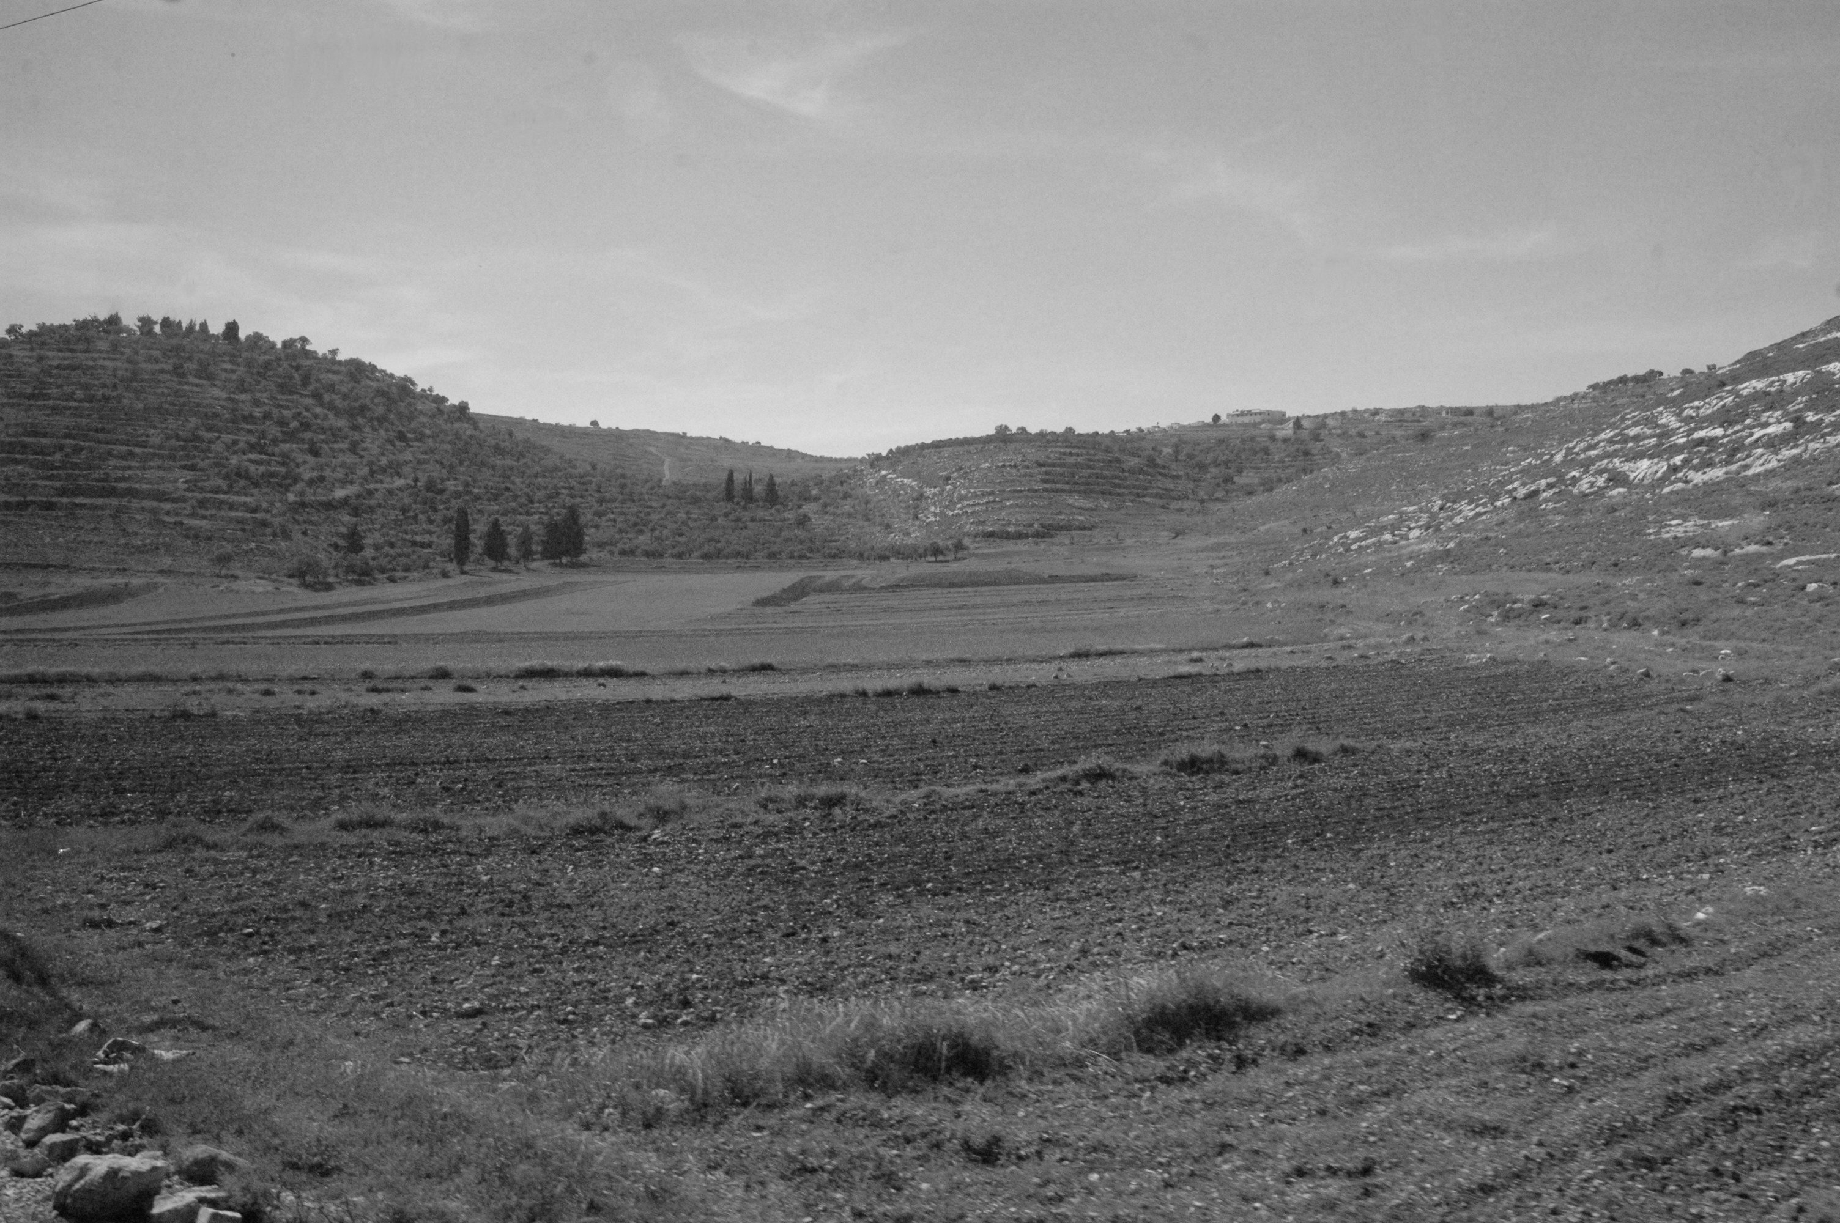

If the farmers and harvesters in Ruth were following the guidelines of the Mosaic law, as presented in Lev 19:9, they were “not reap[ing] to the corner of [the] field” as translated by the NASB. The word translated corner is not clear. Other translators use “edge.” So is it a corner, a single edge, or possibly the outer most section? If the harvests in two adjoining portions both left behind the requisite “corner” and there were no fences, then a gleaner could easily “happen to come to,” that is, pass inadvertently from the standing residue in the portion of the field belonging to one individual to that belonging to another. The lack of fences is somewhat surprising given the ubiquitous stones found in farmland throughout the region, which would need to be removed to prepare the field for agriculture.

Lucian Turkowski notes that when preparing virgin soil, first larger stones would be removed to “mark the boundary of the plot.” At first glance this suggests stone fences; however, Deut 19:14 warns against moving the boundary markers suggesting something more easily shifted as seen in this picture.

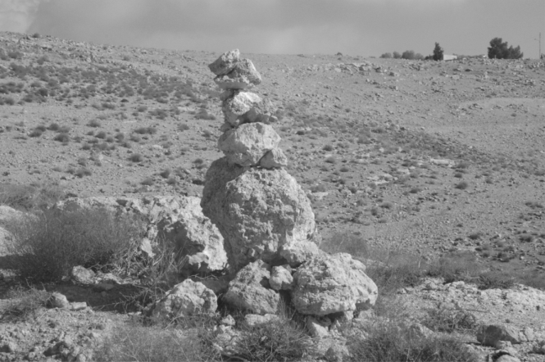

This does raise the question regarding what happened to the stones which were removed beyond those needed for boundary markers. One possibility might be for houses. Another might be that they were used to develop terraces, although that innovation likely came later.

Another aspect of the Ruth account is the description of the threshing floor in chapter 3. Two points are relevant here. After threshing, the grain and chaff need to be separated and the grain cleaned.

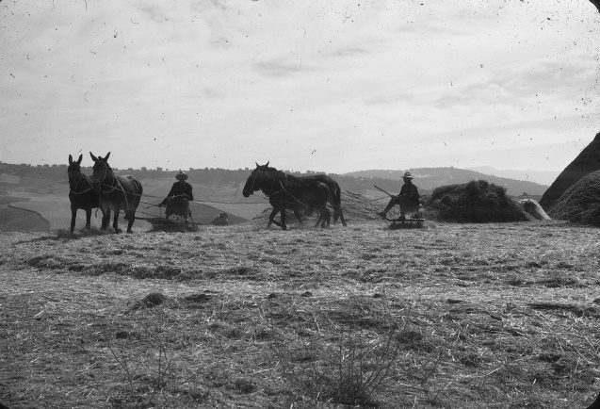

This process normally took place on an elevated spot exposed to the wind as seen in this photo of a threshing floor I located in the mountains of southern Spain while living there in the 1970’s. In Israel, a threshing floor might be privately owned as in the case of Ornan the Jebusite who sold his threshing floor to David after the pestilence was stopped (1 Chron 21). Or, the threshing floor could be communal under the responsibility of larger social units such as the lineage or even the overall clan. While transportation limitations suggest that threshing floors would be located near grain-producing fields, the village layout described above as well as my personal experience might suggest that a typical location would be away from the village to allow the chaff to blow away from the houses.

The threshing/winnowing process was a several day process involving several steps, usually all done at the threshing floor. Given the distances involved, the amount of work required for threshing/winnowing, and the subsequent need to transport the processed grain back to the village, it apparently was a common practice to collectively spend the night on the threshing floor as seen in Ruth 3:3-7.

We noted earlier how the “woodlands” extended beyond the cultivated fields, and suggested that this region would be used for the grazing of the village’s sheep and goats. If so, this would be in contrast to the more familiar and more recent Bedouin pattern which is at least semi-nomadic. The village layout described above would suggest that these pasture regions would be the most distant portions within the “village” region from the habitation portion, but clearly part of the community. In fact a number of studies suggest that after the harvest, the sheep would be brought in closer to the village to graze in the harvested grain field similar to the sheep in this picture near Ramoth Gilead.

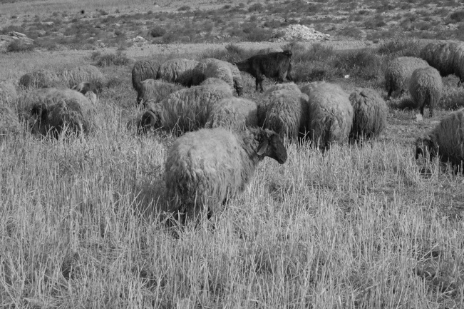

If so, it would make sense that livestock would be allowed to remain in the pasture land overnight when the weather was better (which gives background to Luke 2:8). While far enough from the houses that the animals might not be driven to and from the fields on a daily basis, it would still be close enough to the houses that shepherds could work shifts returning home at least part time.

The social norms of the pre-monarchal period would be a interweaving of several centuries of tradition traced back to Abraham and beyond, and the teaching or Torah given by God primarily at Sinai and then fleshed out through the settlement process conducted under Joshua. While the people brought many traditions and practices with them from Egypt, as God set up a new nation, he gave the Torah to refine and replace as necessary to standardize those traditions and practices so the people conformed to God’s standards of justice. As such, there would be some carryover from what other cultures had developed, but also innovations. Our task here is not to sort out which was which but to look at the final product as a divinely ordained system that would provide a socially just culture in a world populated by fallen human beings. For Israel, the expectation was that when they came into Canaan, they would be divided up not only by tribes, but by smaller groups, and as those smaller groups settled in cities and villages, they would implement local governance for routine issues.

The basic demographics described in settlement process likely were somewhat similar to what the previous several generations had experienced in Egypt. As such, the Torah modified the social mores the nation was expected to follow, likely to raise the bar in terms of social justice. One example might be the prohibition on selling the land God gave to each family as a product of the distribution following the settlement. While material such as the incident between Ahab and Naboth [1 Kings 21] suggests that some tried to adhere to those standards, the overall prophetic message indicates that the people largely ignored them.

The demographics of the settlement would have affected significantly the social structure in a culture where the primary means of transportation was on foot. The layout of a community as discussed above affected community relationships, work practices, and with the distances between communities even matters such as marriage. We will address the issues of marriage in part 3. Here we want to look at how the village structure affected work and family dynamics.

Joshua 13-21 outlines the division of the land between the tribes primarily by defining the boundary lines between the tribal areas but also by listing the “cities” contained within each tribal area along with their “villages” or outlying settlements. The text does not explain the process by which smaller units, that is a clan (or a portion of a clan) might have settled a “city” or how the various “extended families” might settle both the city and the surrounding “villages.” This regional or local distribution through clans and extended families would have been more important to the average Israelite on a daily basis since these produced the social organizations that determined both burden and benefit once the Israelites were settled in the land, and thus provided the foundation of social justice. Consequently our present concern is to evaluate the final step where the local village or city elders divided the collective field (as discussed above) into what we might call nuclear family holdings.

1. Tribal Distribution. The conquest narratives assert that each Israelite tribe was given a portion of the overall piece of land from which they were to live. According to Joshua, this was done by “casting lots.” This seems to be a generic expression which describes any of a variety of methods used to make decisions that were from a human perspective essentially unbiased. Today we have flipping coins, and drawing straws as examples. For Israel, the presumption was that God controlled the outcome although it appeared to be random.

Because Reuben, Gad, and half of Manasseh had opted for land in the region on the east side of the Jordan river, the land on the western side was divided into 10 regions, the other half of Manasseh, and the remaining 9 tribes. The land divisions are described in the last part of Joshua, but we are not told how those divisions were determined. What we are told is that each tribe had a territory that included all of the clans or extended families are in a contiguous relationship. The book of Joshua also asserts that the land was divided lots in proportion to tribal size, more territory to bigger tribes (Josh 14:1-5).

But Joshua gives little information about the actual process focusing on the result. Specifically it gives several lists of specific “cities” within general outlines of each tribe’s portion (Josh 15-19) and even those lists vary in detail from tribe to tribe. Although those cities (along with their villages) are listed, they are not described and in many cases are not named elsewhere. What is important is that each tribe was given its portion “according to its families” (Josh 15:1) which the directions that God gave through Moses in Num 26:53-56 that the land was to be divided “according to the number of names.”

One thing that tends to get overlooked is that as the text presents it, all of the families which settled the land were coming out of the same forty year wilderness experience during which their needs had been taken care of by God (Deut 29:5). Now, all were given resources for a new start (Josh 24:13) but it would be a difficult one. First, while there would have been elders who had lived in Egypt before the Exodus they would largely have been children in Egypt, and have little memory of how to farm. Second, farming in the new land would be a different practice than Egypt. In Egypt, agriculture depended on irrigation and the annual Nile flood. In Israel it would depend on rainfall.

2. Who Received Land? In theory, the individuals receiving the land were the physical descendants of Jacob, the third to inherit the covenant which originally gave the land to Abraham. In reality, the group that came out of Egypt as part of the Exodus was a mixed company (Exod 12:38). As will be seen below, these also received land. The names referenced in Num 26:53 are the males who had been counted in the just completed census. The vague reference to “larger group” and “smaller group” in verse 54 likely refers to the two groups specified in the first census in Num 1:2, which directed that census to be done “by their families, by their fathers’ households” as translated by the NASB.

What those two terms mean is not clear and is debated. As we will address in part 3, we will use the terms as “clan” and “extended family” for the larger and small groups seeing both as intermediate steps between the tribe and the nuclear family. Likely clan was the larger unit, although we recognizing several uncertainties involved. In contrast, an extended family, seems to have been a family unit containing three generations including grandparent[s], a married child (a son), and then grandchildren, one generation beyond our understanding of a nuclear family. However, the “extended family” may have included a wider scope of descendants from an individual who was no longer alive, which is evident even today in the Middle East. In that regard, if an “extended family” in this broader sense settled in a village, this could include several “extended families” in the narrower sense—related, but more distantly so, getting into second and third cousins and beyond. The specific names given in Numbers 1:2 are probably the clans.

The way that the cities are named in Josh 15-19, including boundaries and named cities, seems to imply that the lots divided the land by specific areas at least to the clan level. This would mean that a given clan was given a specific city (analogous to Antoun’s description of a village). It is possible that two or more clans were given the same city, although it seems more likely that in the future some clans would divide. The division of the land by the clan leader within the city region may have been primarily by lot, but it seems he also had an option to give specific land to specific families.

How much land was given to each extended family (in the narrow sense) is unknown. A limiting factor would be how much could a family realistically farm. I have calculated elsewhere that it would seem that a typical inheritance could have been about five acres per adult male. While this size of a farm seems small by modern western standards, it does seem to fit what we know about agriculture in the ancient world and even today in parts of the Far East. One other factor to consider is that it generally seems to be assumed that all the families were primarily engaged in agriculture without anyone living in cities plying more specialized skilled trades. By the Iron Age, which began about 1200 BC, Philip King and Lawrence Stager propose that there were specialists whose primary vocation was in various skills. These included weavers, potters, tanners, and smiths, but that is beyond the scope of this study.

As reconstructed, each clan listed in Num 26 received a region based on lots. The clan area would have then been divided based on extended family lineages, most likely producing rather homogeneous villages. That is, in a sense everyone in the village would have been related to everyone else, at least as “distant” cousins. This relationship would seem to be very important in terms of widows and orphans in particular as outliers in that they would be related to varying degrees to everyone else in the “village.”

3. Social Norms. The biblical text does not really address the rather mundane process of settlement. Nor does it provide much information regarding daily life, as already noted. Still, the village layout that we have presented suggests several practical implications which would affect daily life. These in turn would have impacted social justice provisions which we will discuss in part 4. The following are specific deductions regarding daily family life in an Israelite village.

- Given the proximity of the houses and the extended relationships, families would have been aware of each other’s struggles and joys. It seems also that there would have been significant peer pressure (face to face instead of facebook), that would have affected all relationships with the community.

- In terms of daily work, when planting, tending fields, or harvesting, the typical Israelite farmer would have left the housing cluster in the morning to walk to the particular portions of the single common field he owned. As a matter of practicality, it would be unlikely that he would have returned home until the daily work was done. Thus, as noted in Ruth 2:14, the workers ate lunch on site. At the same time, on days that he was not working in the field, the farmer would have been in the village, most likely at home, or sitting in the “gate.”

- Field portions were limited in size based on how much a person could effectively maintain working by hand and with animal pulled equipment, although it appears that each person may have had multiple portions. These individual portions likely were in the half-acre to acre range.

- Since everyone walked to his portion[s] of the field this would put a practical limit both on the size of the agricultural community and how far out from the community the actual tilled part of the collective field extended. An hour-long trek might be the effective maximum extent of the daily commute. This would suggest a maximum tilled radius of about radius of about 2-3 miles [about 3-5 kilometers]). Probably a tilled radius of about a mile (about one and a half kilometers) or less from the city “gates” would be more typical.

- As shown by Frank Frick, it is likely that there would have been a cluster of satellite hamlets or villages ringing a given city. He suggests that the primary function of a city was “to extract and invest” agricultural surplus and provide social leadership. He does not address the function of a satellite village, but the model developed suggests that it might be a small community intended to provide mutual support for a small group of farmers whose fields were further from the central settlement. If this structure is correct, then it would seem that, as noted under point 2, the overall territory for a given urban cluster (that is, a city and its villages) might have a diameter of about six miles (about 10 kilometers), or an area of about 25-30 square miles (about 65 to 78 square kilometers).

- When looking at the overall society, it seems likely that there would have been stretches of untilled territory between the villages which Israelites moved into at the time of the settlement. Much of that territory may still have been uncleared of the original forest such as was the case of the tribe of Ephraim in Joshua 17:15.

- The model of Caleb in Judges 1:14-15 indicates that the extended family (or possibly clan) leader had the prerogative of granting particular portions of territory to specific individuals or nuclear families.

- While the Caleb example is presented as part of the conquest, it would seem that even after the land was divided (whether by lot or by grant), there were still portions of ‘the field’ of a given city which were non-appropriated. This may have had implications in terms of fallow land during Sabbath years, but that is beyond this study.

- Continuing with the model of Caleb, the text notes that his daughter asked for springs in addition to the land she had already been given. It then seems likely that a farmer’s various portions of the collective field could lie in different directions from the community center. Travel through the Middle East today suggests that a typical separate single field portion might be in the one half acre to an acre range. If a typical Israelite had a total inheritance in the range of three to five acres, then he likely had several portions located in different parts of the field. It is likely that different crops were grown on the different portions (e.g., barley and wheat) with all of the field portions in a certain area growing the same crop which would be significant in terms of sowing and harvesting, although even in this case, various portions of the “field” might differ in productivity in terms of “micro-ecology.” In this situation, it might also be possible that a farmer who needed to “sell” land would only “sell” a portion of what he possessed, having implications with regard to Jubilee provisions.

- The grazing portions of community’s land likely would have been beyond the plowed fields. Given the further distances from the housing clusters, it seems likely that the flocks and herds would have normally remained in their pastures both day and night when they were grazing, although after the fields were harvested they would have been brought closer and as the animals grazed they would both clear up the stubble , and naturally fertilize the field.

- Since the residences were located in the community centers separate from the field, even if a person leased all of his land under the Jubilee stipulations, he likely would still have had a place to live. This might explain the situation of Naomi and Ruth in Ruth 2 after they came to Bethlehem from Moab; that is, they were able to move back into Elimelech’s house in the village or city.

- The biblical text sets forth a standard that the land which was inherited could not be sold but would pass on from a father to his son. However, this did not preclude dividing a farm since the right of the first born was for a double portion, not the entire farm.

- This is an area that is open to question, but it would seem that for some time second sons might be granted new portions (see item 8). I noted earlier that the limitation on the amount of land a family was given during the original distribution was how much land they could farm given their equipment. It is then likely that there were portions of the field which initially were not tilled, probably those which were less desirable (generally we might say further out). This would allow for a situation in future generations where a younger son might start a new family and be granted a new farm so to speak. We will discuss family sizes later.

- If King and Stager’s model of a typical family is valid, then as land passed from generation to generation the members of the older generation, most likely widows, would live with their married sons. In that context, they would be supported in their old age by the adult children although it is likely that as long as they were able they provided some labor to the family pool. This particular implication is most significant in terms of a baseline for widows which will be addressed in part 3.

Joshua continually cites a number of cities, and their villages (cf. Josh 19:8). While it has been suggested that cities and villages were distinguished because cities were walled and villages were not, as noted above, this was not always the case although it likely was the norm. More importantly, this model shows how the biblical villages would serve as satellite communities which allowed farmers to live within a reasonable daily walk from their portion of the field–at least in times of peace. As such, the sphere of influence of a city would incorporate a number of villages which surrounded the larger city center. If the cities were indeed walled, then in times of unrest, these farmers could flee there for protection. However, a more basic function of a city would seem to be that these larger population centers also provided locations for commercial development where skilled craftsmen and artisans might set up shops and focus on non-agricultural careers—signs of a maturing and complex culture.

As noted, previous studies have provided a good picture of life in ancient Israel but they have focused on individual families and residences. In part 1 of this study, we have expanded that picture to provide some insight into how that family likely fit within the culture of the local city or village. This expanded picture might suggest that the extended family was expected to provide support for others within the family lineage. This raises several questions in terms of social justice that we will explore in subsequent parts including:

How did the provisions set forth in the Torah especially apply to a widow?

While emphasis is on the case of a widow, how does an orphan fit into the picture?

More debatable is the question regarding the resident alien?

Furthermore, given the disparate circumstances surrounding the three groups, why are they regularly addressed collectively in terms of this aspect of social justice?

It is with this picture and these questions in mind that in part 3 we will evaluate what constituted each of these three groups of social outliers and how the social justice provisions might apply to them.

But first, in part two, we will look at the concept of social justice and contrast our understanding of social justice with that of Old Testament.

