Grace Theological Journal 8.1 (1987) 115-129.
[Copyright © 1987 Grace Theological Seminary; cited with permission;
digitally prepared for use at Gordon College for biblicalelearning.org]

A COMPUTER AID FOR
TEXTUAL CRITICISM

JAMES D. PRICE

Several basic principles of NT textual criticism have been em-
ployed in designing a computer program that groups manuscripts
into probable genealogical relationships, constructs a resulting gene-
alogical tree diagram, and identifies the statistically most likely
reading of a text. The program has been initially applied to the books
of Philippians, 1 Timothy, and Jude using the variants listed in
UBSGNT². The results indicate that the program has potential as an
aid to NT textual criticism.
* * *

INTRODUCTION
THE use of computers in biblical studies is viewed by many with
considerable skepticism. Computer studies in literary criticism
have led some scholars to reject Pauline authorship of certain epistles,^{l}
and others to reject the traditional authorship of portions of some OT
books.² These studies are based on debatable presuppositions and
methodology, the criticism of which is beyond the scope of this work.
Such use of computers to provide mathematical proof or disproof of
authorship led Bonifatius Fischer to question whether this was "char-
latanry or scholarship.”³
However, after discussing many limitations of the use of com-
puters in biblical studies, Fischer wrote favorably of their use in the
field of textual criticism:

¹ A. Q. Morton and J. McLeman, Christianity and the Computer (London: Hodder
and Stoughton, 1964); and Paul, The Man and the Myth (New York: Harper and Row,
1966); for further examples see J. R. Moore, "Computer Analysis and the Pauline
Corpus," BSac 130 (1973) 41-49.
² Y. T. Radday and D. Wickmann, "Unity of Zechariah Examined in the Light of
Statistical Linguistics," ZAW 87 (1975) 30-55.
³ B. Fischer, "The Use of Computers in New Testament Studies, with Special
Reference to Textual Criticism," JTS 21 (1970) 297-308.

116 GRACE THEOLOGICAL JOURNAL

After so much pessimism we come at last to a field where the
computer is of great importance to the student of the New Testament,
indeed where it opens up a new dimension and makes possible what
hitherto the scholar had not even dared to dream of: that is, in textual
criticism.⁴

PROPER THEORY AND METHODOLOGY

Fischer further discussed the importance of proper theory and
methodology in creating a computer program as an aid for textual
criticism, and the vanity of expecting a computer to reconstruct the
exact history of a text and its manuscript copies. However, he con-
cluded that the manuscript relationships that could be discovered
through the use of a computer would be of great value to the textual
critic in reconstructing the transmissional history of a text. He visual-
ized two stages in the process--a mathematical stage and an evalua-
tive stage:
Two stages must be distinguished. In the first the relations between
the manuscripts and the texts are defined on the basis of all their
readings, irrespective of whether these readings are true or false: this
stage is a purely mathematical process which can be done by a
computer--indeed in so complicated a case as the New Testament it
should be done by a computer. Then follows the second stage, the
proper task of the textual critic, the judgment of the truth or falsity of
the readings, the recension of the original text and perhaps also of its
more important subsequent forms, and the reconstruction of the his-
tory of its transmission. This is a task that only a man can perform: it
is beyond the capacities of a computer. But it rests on the firm basis
that the computer supplies.⁵

COMPUTERS AND THEORIES OF TEXTUAL CRITICISM
Several studies have been made of various theories that might be
suitable for computer application to NT textual criticism. G. P. Zarri
studied the stemmata codicum theories of Don H. Quentin.⁶ After
expressing skepticism about expecting quick solutions, he concluded
that Quentin's theories may help to clear up some difficult problems.
John G. Griffith experimented with the method of R. R. Sokal,
known as numerical taxonomy,⁷ which Sokal used in arranging bio-
logical classes into family trees. Griffith adapted the methodology to

⁴ Ibid., 304.
⁵ Ibid., 306.
⁶ G. P. Zarri, "Algorithms, Stemmata Codicum and the Theories of Don H.
Quentin," in The Computer and Literary Studies (Edinburgh: Edinburgh University,
1973) 225-37.
⁷ I. G. Griffith, "Numerical Taxonomy and Some Primary Manuscripts of the
Gospels," JTS 20 (1969) 389-406.
PRICE: A COMPUTER AID FOR TEXTUAL CRITICISM 117

textual criticism and experienced some success in classifying a number
of the biblical manuscripts into near-neighbor clusters that approxi-
mate family tree relations. He concluded that this method achieved "a
sorting of material which proves refractory to the conventional logic
of the stemma. It can be tested quantitatively in a way that the
stemma cannot, and does not beg any questions about the merits of
the material being handled.”⁸
W. Ott experimented with a matrix containing percentages of
agreement among the manuscripts.⁹ The percentage of agreement was
a test of close relationship--the closer the agreement, the closer the
relationship. The method succeeded in revealing some group relation-
ships among manuscripts.
Extensive research has been conducted at the Claremont Gradu-
ate School to develop a method for classifying Greek manuscripts
into genealogical groups. This method, known as the Claremont
Profile Method, makes use of a selected set of readings that define a
unique profile for each of several manuscript groups. Each manu-
script is then classified into one of these groups by means of its level
of agreement with the profile of the group. This sampling method is
being used to prepare a new comprehensive apparatus for the NT.
Most of the work has been done manually, but recently W. L.
Richards used a computer to assist the classification of manuscripts
for the Johannine epistles.¹⁰
Kurt Aland and his associates at the Munster Institute have
developed the Munster Fragment Identification Program which em-
ploys a computer to piece together papyrus fragments, to collate the
readings of many manuscripts,¹¹ and to define manuscript groups and
large manuscript complexes.¹²

⁸ Ibid., 405.
⁹ W. Ott, "Computer Applications in Textual Criticism," in The Computer and
Literary Studies (Edinburgh: Edinburgh University, 1973), 199-223.
¹⁰ W. L. Richards, The Classification of the Greek Manuscripts of the Johannine
Epistles (SBLDS 35; Missoula, MT: Scholars Press, 1977);E. J. Epp, "The Claremont
Profile-Method for Grouping New Testament Minuscule Manuscripts," in Studies in
the History and Text of the New Testament, eds. B. L. Daniels and M. J. Suggs, vol.
29 of Studies and Documents (Salt Lake City: University of Utah, 1967) 27-38; E. C.
Colwell et al., "The International Greek New Testament Project: A Status Report,"
JBL 87 (1968) 187-97; P. McReynolds, "The Value and Limitations of the Claremont
Profile Method," in Society of Biblical Literature, Book of Seminar Papers (Sept.
1972) 1.1-7; F. Wisse, The Profile Method for the Classification and Evaluation of
Manuscript Evidence, as Applied to the Continuous Greek Text of the Gospel of Luke
(Grand Rapids: Eerdmans, 1982); W. L. Richards, "A Critique of a New Testament
Text-Critical Methodology-The Claremont Profile Method," JBL 96 (1977) 555-56.
¹¹ E. J. Epp, "A Continuing Interlude in New Testament Textual Criticism," HTR
73 (1980) 133-34.
¹² Ibid., 142.

118 GRACE THEOLOGICAL JOURNAL

Although these methods have mapped general genealogical rela-
tionships among manuscripts, none has succeeded in producing spe-
cific genealogical tree diagrams of manuscript history. It is widely
held that the task is too complex, the manuscripts are of mixed
parentage, and the genealogical history of biblical texts is beyond
recovery .

A NEW COMPUTER METHOD
For several years I have experimented with computer techniques
for reconstructing the genealogical history of a NT text by using the
variant readings and dates of the extant manuscripts. The research
has resulted in a computer program that groups manuscripts into
probable genealogical relationships, constructs a resulting genealogical
tree diagram of an approximate textual history, and identifies the
most likely readings of the original text based upon this reconstruc-
tion. For numerous test problems, the program has yielded results
similar to those that have been obtained through conventional means.
The problems approximate the complexity and difficulty of the
biblical text. The program provides good solutions when the textual
evidence is statistically adequate; it provides a good approximation
when the evidence is sparse. If the manuscript shows signs of mixed
parentage, it indicates so; if they appear to have no genealogical
relationships, it indicates so; and if they exhibit the relationships
defined by Zane Hodges's textual model,¹³ it indicates so.
The program is designed as a research aid for the textual scholar.
At key points in the computing process, the program displays the
results of its decisions, the statistical validity of the decisions, the
source of the data, and the specific rules employed to reach the
decision. In case the decision is statistically weak, or otherwise ques-
tionable, the scholar may interact with the program to improve its
performance by human insight. Experience has revealed that this
interaction is needed, but not often. As Fischer predicted, the results
of the computer analysis must be evaluated, edited, and optimized;
but the final result is indeed a probable reconstruction of the gene-
alogical history of the text.

¹³ Hodges's textual model is understood to view all manuscripts as primary wit-
nesses to the text of the original autograph, and to view them as exhibiting essentially
no genealogical relationships among themselves. That is, at any place in the text where
a variant reading occurs, the majority of manuscripts contain the reading of the
autograph, and the non-original readings are genealogically random (see Z. C. Hodges,
"Modern Textual Criticism and the Majority Text: A Response," JETS 21 [1978] 143-
56). However, in his later work Hodges acknowledges the existence and importance of
genealogical relationships and advocates the necessity of studying the genealogical
history of every book in the NT (see Z. C. Hodges and A. L. Farstad, The Greek New
Testament According to the Majority Text [Nashville: Thomas Nelson, 1982]).

PRICE: A COMPUTER AID FOR TEXTUAL CRITICISM 119

BASIC PRINCIPLES
As a result of my experimental research, several basic principles
have been developed for reconstructing the genealogical history of a
text. Most of the principles are self-evident upon examination.

Each Book Is Independent
Because the early history of each biblical book was different,
each book should be studied independently. Failure to do this could
result in unnecessary confusion.

Each Manuscript Is a Copy or a Recension
Each manuscript is a copy of its exemplar (usually containing all
of the variants of the exemplar) or a recension. Recensions are
determined by evidence of two or more parents. Therefore, a manu-
script bears witness to a set of variants, not simply to individual
variants. Viewing the data of the manuscripts as sets of variants
reduces confusion. The manuscripts are regarded as having a type of
genetic profile that bears witness to its genealogical descent. This
agrees in principle with the Claremont view, and disagrees with Aland
who seems to regard each variant as having an independent gene-
alogical history.

Fathers and Versions Used
The quotations of a church father are evidence for the Greek text
used by him. Where the evidence is sufficiently complete, the set of
variants supported by a church father may be treated as a Greek
manuscript.¹⁴ The same is true for the ancient versions. It may be
assumed that each version was translated from a single Greek manu-
script containing the variants supported by the version. The scholar
must take this into account when interacting with the decisions of the
program, recognizing the uncertainties associated with patristic quota-
tions and translations.

Primary Witness Takes Priority
A manuscript bears primary witness to the readings of its imme-
diate parent exemplar, and secondary witness to more remote ances-
tors and relatives. The computing procedure should make use of
primary witnesses throughout, and should use the primary witness of
each manuscript to define its place in the genealogical tree.

¹⁴ It is recognized that some church fathers quoted from more than one ancient
text. Although the procedure is complicated, the program usually can differentiate
multiple ancient texts of this kind.

120 GRACE THEOLOGICAL JOURNAL

Similarity Defines Siblings
A small group of manuscripts more like one another than those
outside the group may be assumed to be immediate sibling descen-
dants of a common parent exemplar. Such a group exhibits a high
percentage of agreement and has one or more readings unique to
itself. Siblings bear primary witness to the readings of their parent
exemplar and may be used to identify the parent. A large set of
manuscripts that are genealogical descendants of a common original
text may be expected to have numerous small groups of siblings (or
near siblings) of this type. When a set of manuscripts fails to exhibit
this condition, the manuscripts are of hopelessly mixed parentage or
not genealogically related.

How Exemplars Are Identified
Sibling descendants bear primary witness to the readings of their
immediate parent exemplar. Within a sibling group, majority vote
usually identifies the parent readings. When majority vote fails for a
given variant, then near relatives--such as uncles or cousins¹⁵--
usually share the parent reading and may resolve the uncertainty.
When this fails, any unique reading may be eliminated; it will lack
confirmation by any witness outside the group. When all these fail to
determine the most likely reading, the scholar may resolve the uncer-
tainty by internal evidence. In any case, the scholar may overrule the
computer's decision on the basis of evidence not available to the
computer.

Exemplars More Authoritative
Once a parent exemplar is identified it replaces the witness of its
descendants, being the authority that accounts for their existence. If
an exemplar so identified is extant, it is allowed to bear further
witness to its own immediate parent. If the exemplar so identified is
not extant, the program creates the exemplar and allows It to bear
witness in place of its descendants; its existence is justified by the
witness of its descendants, although some uncertainty may be intro-
duced for readings with weak support.

Iteration Required
An ordered iteration of these principles produces a tree diagram
of the genealogical relationships among the manuscripts traced back

¹⁵ A near relative is a manuscript outside the sibling group, but more like the group
than any other manuscript in the data base.

PRICE: A COMPUTER AID FOR TEXTUAL CRITICISM 121

to one common ancestor. The resultant tree diagram represents an
approximation of the genealogical history of the text. The tree dia-
gram must be studied, optimized, and interpreted by textual scholars.
The final result is a reconstruction of the history of the text and a list
of the most likely readings of the autograph, together with the statis-
tical probability for each reading.

INITIAL RESULTS
To date, the program has been applied to three small books of
the NT,¹⁶ making use of the textual data available in the UBSGNT².¹⁷
Figures 1, 2, and 3 are slightly simplified diagrams of the preliminary
reconstruction of the textual history of the books.¹⁸ The results have
been what would be expected, indicating the validity of the program's
logic.

Simple Descent Confirmed
Most manuscripts were found to exhibit simple descent from
only one parent exemplar. A few were found to descend from two
parents, a still smaller number from three or more; few if any were of
hopelessly mixed parentage. Table 1 summarizes the manuscript
parentage for the three books. Genealogical descent was found to
be consistent with historic chronology--late manuscripts exhibited
descent from earlier ones (occasionally a late manuscript exhibited
descent from a very early one);¹⁹ early manuscripts fit into the early
branches of the tree diagram, and late manuscripts fit into late
branches. Although the computer program makes use of the date of
the manuscripts, it has no logical mechanism that predetermines
chronological consistency in the genealogical tree diagram. This
chronological consistency would not be expected if the genealogical
groupings found by the computer had no correspondence with the

¹⁶ Philippians, I Timothy, and Jude.
¹⁷ The UBS text was selected because it lists more manuscripts in its apparatus than
others. This advantage was offset somewhat by the smaller number of variants. Better
results are expected from a more complete set of data.
¹⁸ A complete textual commentary on these books based on the computer analysis
of the data in the UBSGNT will be produced at a later date.
¹⁹ For example in Philippians, MSS 81 and 1241 appear to descend from an early
form of the Alexandrian text; group 330, 451,1962,2127, and 2492 appears to descend
from another early form of the Alexandrian text; group D^{c}, 326, and 1877 appears to
descend from an early form of the Antiochan text; and MS Y appears to descend from
an early form of the Western text. In 1 Timothy, group 81, 1739, and 1881 appears to
descend from an early form of the Alexandrian text; and group Y, 104,330,451, 1877,
and 2492 appears to descend from an early form of the Antiochan text. In Jude, group
A, 81, and 1739 appears to descend from a very early form of the Alexandrian text.
122 GRACE THEOLOGICAL JOURNAL

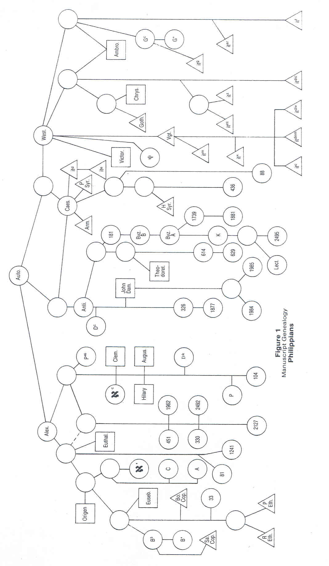

PRICE: A COMPUTER AID FOR TEXTUAL CRITICISM 123

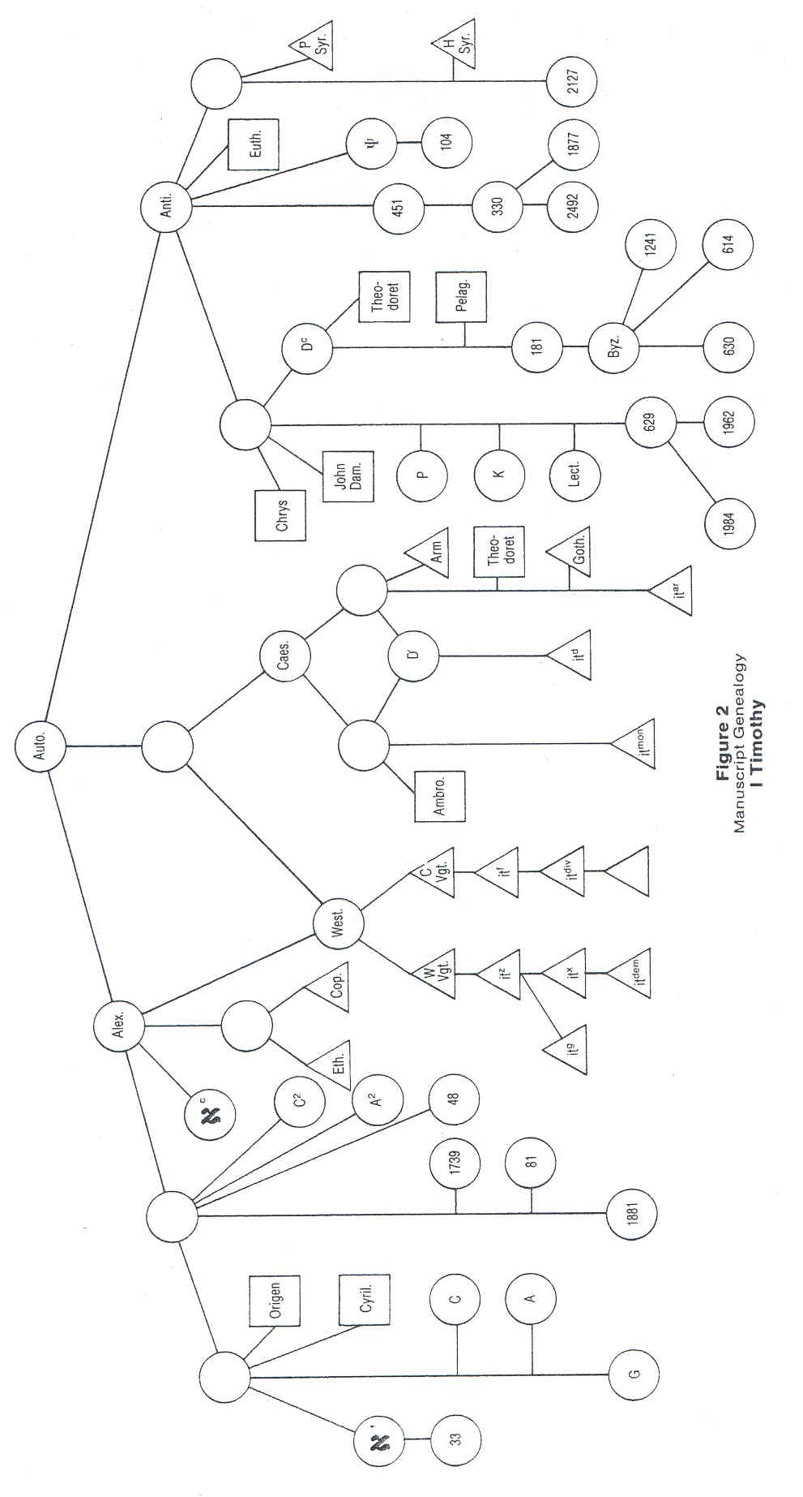
124 GRACE THEOLOGICAL JOURNAL

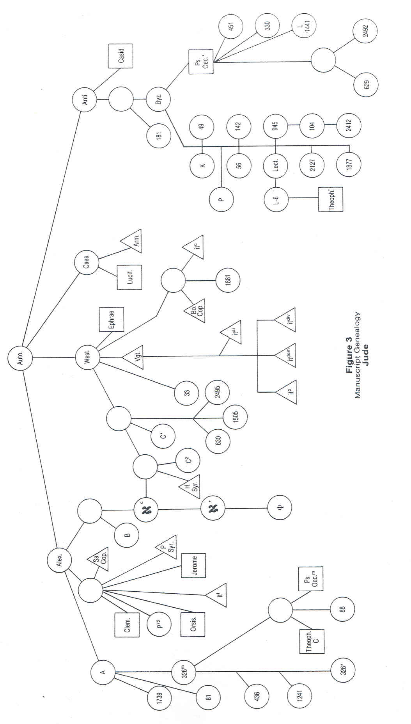
PRICE: A COMPUTER AID FOR TEXTUAL CRITICISM 125

TABLE 1
Summary of Parentage*
Book 1 Parent 2 Parents 3 or More Total
Philippians 51 MSS 12 MSS 7 MSS 70 MSS
I Timothy 61 MSS 4 MSS 1 MSS 66 MSS
Jude 34 MSS 15 MSS 0 MSS 49 MSS
Total 146 MSS 31 MSS 8 MSS 185 MSS
% of total 78.9% 16.7% 4.4% 100.0%

*Data include only extant MSS, not created exemplars.

TABLE 2
Summary of Text Degradation*
Number of variants introduced by a MS
Book 0 1 2 3 More Total
Philippians 25 34 18 12 8 97
I Timothy 42 34 11 1 1 89
Jude 38 30 6 2 0 76
Total 105 98 35 15 9 262
% of total 40.1% 37.4% 13.3% 5.7% 3.5% 100.0%

*Data include extant MSS and created exemplars.

history of the text. If the genealogical groupings were unrelated to
history, one would expect the distribution of the manuscripts in the
genealogical tree to be chronologically random rather than ordered.
Therefore, the existence of chronological consistency in the gene-
alogical tree diagrams produced by the computer suggests the validity
of the program's logic.

Simple Degradation Confirmed
Most variants were found to be introduced simply, that is, only
once, and only one or two at a time. When a variant appeared again
in another branch it was generally due to multiple parentage. When
several variants arose in the same manuscript, it was usually due to a
recension, an infrequent occurrence. Table 2 summarizes the text
degradation as indicated by the number of variants introduced by the
manuscripts. (A variant is understood here to mean a reading differ-
ing from that of the immediate parent exemplar.)
126 GRACE THEOLOGICAL JOURNAL

Text-types Confirmed
The reconstructed genealogical history confirmed four basic
ancient text-types more like one another than like their own remote
descendants: the Alexandrian,²⁰ the Western,²¹ the Antiochan,²² and a
fourth that may correspond with the Caesarean.²³ Nothing in the logic
of the program could have predetermined this reconstruction. Each
text-type exhibits an early form with several subsequent branches.²⁴
The Antiochan text exhibits an early form that is related to the Syriac
(though not in Jude) with several subsequent branches. The Byzan-
tine text is located in one of the later branches. Nothing in the logic
of the program could have predetermined this late secondary descent
of the Byzantine text.

Ancient Versions
The ancient versions exhibit genealogical descent from Greek
texts usually current in the locality of the version. The Vulgate was
consistently from an early form of the Western text. There were
several independent Old Latin versions, usually made from early
forms of the Western text. A few Old Latin versions were non-
Western; it^{d} was consistently Caesarean; it^{ar} was Caesarean in
1 Timothy; and it^{t} was Alexandrian in Jude. The Armenian version
was consistently Caesarean. The Coptic and Ethiopic versions were
consistently Alexandrian, except that the Boharic Coptic version was
Western in Jude. On the other hand, the Syriac version appears to be
Caesarean in Philippians, Antiochan in 1 Timothy, and Alexandrian
in Jude. The Gothic version is Caesarean in 1 Timothy and Western
in Philippians.

The Church Fathers
Not many church fathers offered sufficient evidence to identify
their underlying Greek texts. Of those whose texts could be identified,

²⁰ The Alexandrian text-type consistently included א*, א^{c}, A, B, (C*), C2, 81,
Origen, Clement, Coptic (Sa), and Ethiopic. Ms א^{c} was usually close to the earliest
form.
²¹ The Western text-type consistently included the Vg, it^{c}, it^{dem}, it^{div}, it^{f}, it^{g}, it^{x}, and
it^{z}. A few Greek MSS were classified in Western branches, but not consistently. The Vg
was usually close to the earliest form.
²² The Antiochan text-type consistently included D^{c}, K, 181,629, 1877, 1984, 1985,
Byz, Lect, Theodoret, and John of Damascus. D^{c} and 181 were usually close to the
early form of the Byzantine branch, whereas witnesses to the earliest form varied from
book to book.
²³ The Caesarean text-type consistently included the Armenian, it^{d}, and it^{e}; other
witnesses varied from book to book.
²⁴ The Western text appears to have mixed parentage for I Timothy.
PRICE: A COMPUTER AID FOR TEXTUAL CRITICISM 127

TABLE 3
Number of Statistically Probable Readings
Philippians 1 Timothy Jude Total
No. of variants 16 11 6 33
Alexandrian 14 (87.5%) 10 (90.9%) 6 (100.0%) 30 (90.9%)
Western 12 (75.0%) 9 (81.8%) 5 (83.3%) 26 (78.8%)
Caesarean 12 (75.0%) 9 (81.8%) 5 (83.3%) 26 (78.8%)
Antiochan 13 (81.2%) 10 (90.9%) 4 (66.6%) 27 (81.8%)

several consistently agreed with a local text, and some differed from
book to book. Origen and Clement were consistently Alexandrian;
Theodoret and John of Damascus were consistently Antiochan.
Several had sufficient data to be used for only one of the three books
studied. But it appears that the church fathers usually made use of a
form of the text current in their locality.

Evidence of Recensions
If it is assumed that the earliest form of each ancient text-type
was the result of a local recension, then this study suggests that the
recensions were fairly successful in standardizing the text in each
area. For the books covered in this study, the Alexandrian text-type
is the most consistent, with statistically probable readings for 100% of
the variants in Jude, 90.9% in 1 Timothy, and 87.5% in Philippians
(for an overall average of 90.9%). The Antiochan text-type for the
three books yielded statistically probable readings for 81.8% of the
variants, whereas the percentage for the Western and Caesarean text-
types was 78.8% (see table 3).
In addition, the study suggests that a few subsequent recensions
were made, some of more consequence than others. One interesting
occurrence of recensions appears to be associated with the rise of the
versions. There seems to have been a recension made in preparation
for the translation of some of the versions. For example, in Philip-
pians and 1 Timothy, the Ethiopic and Coptic versions appear to
have been made from recent recensions.²⁵ In Philippians, the Gothic

²⁵ In 1 Timothy, the Coptic and Ethiopic were made from a mild recension of the
earliest form of the Alexandrian text of which א^{c} was a direct descendant. In Philip-
pians, the Ethiopic and Boharic Coptic were made from texts close to the one used by
Eusebius, of which MS 33 is a late copy. In fact, MS B³ appears to be a major recension
of the same text, with six variants introduced by mixed parentage; B³ evidently was the
recension made for translating the Sahidic Coptic, with B* as a copy of B³, differing in
only one reading. This does not seem to be the case in other of the Pauline epistles.
128 GRACE THEOLOGICAL JOURNAL

version appears to have been made from a recension known to
Chrysostom.²⁶
In Philippians and 1 Timothy, the Old Latin version it^{g} appears
to be translated from a recension; MS G^{c} is near the text of this
recension in Philippians²⁷ and related to it in a more complex way in
1 Timothy. A similar recensional background must account for the
Old Latin it^{d} and it^{e}, its copy.²⁸
In all three books, the Armenian version, although clearly a
descendant of the Caesarean text, exhibits evidence of being trans-
lated from a recension. Something similar must be true for the text
behind the Syriac versions. In Philippians, the text is derived from
the Caesarean; in 1 Timothy it is derived from the early Antiochan;
and in Jude it is derived from the Alexandrian.

Recovering the Original Text
If it can be assumed that the earliest form of each ancient text-
type was an independent witness to the original text, then their
mutual agreement would provide convincing identification of original
readings.²⁹ For each of the three books studied, the procedure recon-
structed four ancient text-types more like one another than like their
own remote descendants. For the thirty-three readings identified by
the program to be most probably original in the three books studied,
sixteen readings (48.5%) had the full support of all four ancient text-
types; seven readings (21.2%) had the support of three against one;
six readings (18.2%) had the support of two ancient text-types against
one each supporting different readings; only four (12.1%) had the
support of two ancient text-types against two supporting another.
That is, 87.9% of the readings had good statistical support; only
12.1 % had uncertainties that statistical analysis could not resolve.
The readings of the reconstructed original text frequently were
those selected by the editors of UBSGNT²; but a number of them

²⁶ The exemplar for the Gothic version was a descendant of an early form of the
Western text, but it was of mixed parentage and introduced five variants. The text of
Chrysostom differed from this recension in only two readings.
²⁷ Ms G^{c} is a descendant of an early form of the Western text; but it was of mixed
parentage and introduced seven variants; the text of its differs from G^{c} in only three
readings. MS G* is a copy of G^{c}.
²⁸ In I Timothy MS D appears to be a recension bringing together two early forms
of the Caesarean text; D seems to be the Greek text from which it^{d} was translated.
However, D does not appear to be the text of it^{d} in Philippians, but rather the early
form of the Caesarean text itself was the text of it^{d}.
²⁹ This conclusion is limited by the uncertainties associated with reconstructing the
text-types. Although the logic of the program employs primary witnesses and chooses
readings with the greatest statistical probability, some degree of uncertainty accumu-
lates in the reconstruction process. More needs to be known about how uncertainties
accumulate.
PRICE: A COMPUTER AID FOR TEXTUAL CRITICISM 129

were different.³⁰ More study and experience with the program are
needed before its use may produce decisions more reliable than
theirs.³¹

CONCLUSIONS
This computer program has provided some thought-provoking
observations. Contrary to current opinion, it appears that the manu-
scripts of the Greek NT may really have simple genealogical relation-
ships, and that the text may have experienced simple degradation. It
appears that some reconstruction may be made of an approximate
transmissional history of the text, using the computer program as a
research tool in the hands of a textual scholar.
The present study was made using a limited number of manu-
scripts³² and a limited number of variants.³³ However, the manuscripts
generally are regarded as the best representatives of the larger corpus.³⁴
With such a good representative sample to work with, it is reasonable
to expect that the larger corpus of data will exhibit similar character-
istics without much greater complexity. A recent computer study of
the text of Romans with Richard Young has been completed. The
data consists of 64 manuscripts and 91 variants. The larger number of
variants made the solution a little more complex, but the results and
conclusions were essentially the same.³⁵ This provides confidence that
the results are not accounted for merely on the basis of overly simple
problems. The computer is capable of handling much larger problems.
It is expected that further study and research with the computer
program will provide valuable insight into the history and text of the
Greek NT.

³⁰ For Jude, five out of six readings were in agreement with the critical editors; for
Philippians it was eight out of sixteen; and for 1 Timothy, six out of eleven.
³¹ See my forthcoming article, "A Textual Commentary on the Book of Philippians,"
³² Philippians, seventy MSS; 1 Timothy, sixty-six MSS; Jude, forty-nine MSS.
³³ Philippians, sixteen variants; 1 Timothy, eleven variants; Jude, six variants.
³⁴ Some scholars doubt that the manuscripts in the UBSGNT² represent a good
sample of the textual history. Our own study supports that conclusion for the book of
Revelation.
³⁵ A textual commentary on Romans based on this study will be produced at a
later date.

This material is cited with gracious permission from:
Grace Theological Seminary
200 Seminary Dr.
Winona Lake, IN 46590
www.grace.edu
Please report any errors to Ted Hildebrandt at: ted.hildebrandt@gordon.edu
for biblicalelearning.org.

