Grace Theological Journal 5.2 (1984) 163-179.
[Copyright © 1984 Grace Theological Seminary; cited with permission;
digitally prepared for use at Gordon College from biblicalelearning.org]

THE CLASSIFICATION
OF PARTICIPLES:
A STATISTICAL STUDY

JAMES L. BOYER

Understanding participles is a major requisite for the NT scholar.
This study surveys the many ways participles are used in the Greek
NT and the frequency of occurrence of each functional type. Attention
is given to the structural patterns involved and the significance of
these classifications. Eighteen categories are distinguished, nine of
adjectival uses and nine of verbal uses. The special feature of this
study is the statistical information provided, which points out the
relative importance of the various types; more detailed discussion of
the adverbial, the genitive absolute, the periphrastic, and the impera-
tival categories is provided.
* * *

INTRODUCTION
THIS article does not present a new and different approach to
participles in the NT. It is, rather, an attempt to use a new
avenue of study via computer analysis to supply information pre-
viously not easily available. This information concerns the relative
frequencies of the various uses of participles in the NT, and some of
the patterns these uses take. The first step in this process was to
prepare an in-order list of all participles occurring in the Greek NT,
together with a grammatical identification of each. Next, an in-context
study was made in order to determine the usage classification of
each. Finally, a class-by-class study of these occurrences was con-
ducted in order to note any special features or peculiarities which
might be helpful to the NT Greek student. The classification system
used is for the most part the traditional one, though the purpose is
not to defend this manner of treatment. In fact, in some cases a very
different treatment is advocated.
The definition of a participle as a verbal adjective sets a pattern
for the classification of its uses. As an adjective it stands in gender,

164 GRACE THEOLOGICAL JOURNAL

number and case agreement with a noun or other substantive (ex-
pressed or unexpressed), and in some way modifies, describes, or
limits that substantive. As a verbal, while still attached by agreement
to a substantive, it affects also the action or predication of the
sentence.

ADJECTIVAL USES
Just as the position of the adjective in relation to the article gives
the clue to its adjectival function (attributive or predicate), it is also
important to understand whether the same is true of the participle.
Thus the position of the adjectival participle in relation to its govern-
ing noun's article was made the basis for the classification. The first
four categories show the article in "attributive position," that is, im-
mediately following the article. The fifth category shows the participle
in "predicate position," that is, not following the article. The last four
categories are ambiguous since the governing noun (if there is one)
does not have the article and this positional distinction is thus not
present.

A P N (Article + Participle + Noun)
A glance at the statistical table will show that the placing of the
participle before the noun (APN and PN) is relatively rare. Most
frequently it occurs when the participle has no modifiers; sometimes
the participle has become almost an adverb, such as "existing," "near-
by," "coming," "present." Often the participle's own modifiers are
very brief, consisting of an adverb, a short prepositional phrase, or a
direct or indirect object; when the modifiers are more extended they
often are separated from it and stand after the noun. In all the in-
stances the participle seems to be purely attributive and usually can
best be translated as a relative clause.

A N A P (Article + Noun + Article + Participle)
This so-called "second attributive position" is far more frequent
with participles.^{l} Characteristically it is used where the participial
modifiers are extensive (although certainly not all instances are such;
e.g., ὁ πατὴρ ὁ ζῶν which occurs frequently), or where more than
one participle is so used coordinately. Like the preceding category
the function is purely attributive, best translated as a relative clause.

¹ Of the participles identifiable by position as attributive the ratio of first to second
attributive position is 1:2.7. Among adjectives the ratio is 1:0.7

BOYER: THE CLASSIFICATION OF PARTICIPLES 165

N A P (Noun + Article + Participle)
In sharp contrast with adjectives² this pattern is quite frequent
with participles. By far the majority of instances occur when the
noun is a proper name (68 times), which is then identified as "the one
called (λέγομενος, καλούμενος, ἐπιλεγόμενος, ἐπικαλούμενος)" by
another proper name (23 times), or by a characteristic or customary
action or condition when the participle is present tense (21 times) or
perfect tense (4 times), or by a particular past action when the parti-
ciple is aorist (20 times). This pattern occurs less frequently with
common nouns (23 times), usually indefinite or general in nature,
which the participle identifies more precisely by stating some specific
act or condition.
It is noteworthy that one idiom belonging prominently to this
category, the "proper name + ὁ λεγόμενος + proper name" also
occurs with the first proper name showing an article, the A N A P
category, and with both names anarthrous, the N P category. Many
of the examples classified in this category also might well be listed
with the A P category, as a substantival participle in apposition to
the noun it follows. Such a situation will serve to warn against press-
ing these differing patterns as rigid categories. Rather, they serve
merely as convenient methods of systematizing patterns. All these are
simply attributive.

A P (Article + Participle)
By far the most frequently used³ pattern of attributive participles
is the article and the participle standing alone without a noun ex-
pressed, the "substantive use" of the participle. A person or thing is
sufficiently identified as "the one who. . ." or "that which. . . ," where
the generic term is identified by a participle which states its character,
its condition, or its action. Again the participle functions purely as an
attributive adjective. Usually, it is translated as a relative clause, but
in many cases it is the full equivalent of a noun; ὁ πιστεύων is simply
"the believer."
While it is beyond the scope of this article to deal with the
significance of tense in participles, it is worthwhile to note that these
substantival participles demonstrate rather dramatically a characteris-
tic difference. Present participles identify by some characteristic or
customary action or condition, and frequently are equivalent to a

² In comparison with the 97 instances found in participles there are only 18 ex-
amples with adjectives. All but five of these are with nouns which are proper names,
like βαβυλών ἡ μεγάλη.
³ 1467 examples; see the statistical chart.
166 GRACE THEOLOGICAL JOURNAL

name or title. So ὁ στείρων "a sower," ὁ κλέπτων is "a thief," o[
δαιμονιζόμενος is "the demon-possessed person" (cf. Mk 5:15-16; it
is used after the demon was cast out, a title which identified the man,
not a description of his present state), ὁ βαπτίζων is "the baptizer"
(or "the Baptist"), ὁ κρίνων is "the judge," ὁ ἀκούων "a hearer,"
ὁ παραδιδούς is "the betrayer," the infamous title of Judas most fre-
quently used, before (Matt 26:48), during (John 18:2), and after (Matt
27:3) the act itself. Some of these seem actually to have become
nouns, listed as such in the lexicons; e.g., ὁ ἄρχων is "the ruler." The
matter is different, however, with the substantival participle in the
aorist and future tenses. Here the identification seems always to be
specific, not general. An aorist participle identifies by referring to
some specific act in past time; the future by a specific future act: so
τὸ ῤηθέν "that which was spoken by the prophet Isaiah, etc." (very
many times); τὰ γενόμενα, "the things which had happened"; ὁ κτίσας,
"the One who created them male and female," not "the Creator";
ὁ παραδοῦς, "the one who betrayed him" (John 19:11; also Matt 10:4,
apparently from the viewpoint of the author's time); ὁ παραδώσων,
"the one who will betray him" (John 6:64).

A N P (Article + Noun + Participle)
This pattern is the only one which places the participle in a
clearly "predicate position. " This, along with its extreme rarity,⁴ raises
the question whether this distinction is valid for participles. Or, to
put it differently, are we justified in looking for a different meaning
in these few instances solely on the basis of the analogy of the
adjective? Some examples seem similar to those adjectives which are
found in predicate position but are found with a sentence which
already has its predication, and hence become in effect a secondary
or parenthetic predication.⁵ So in Mark 6:2 at αἰ δυνάμεις . . . γινόμεναι
the sense is not merely an identification or description of the miracles,
but rather an added admission that they really were happening. Often,
however, it is difficult to see any distinction.

⁴ Only 20 were so catalogued in this study; 17 are certain (Matt 6:30 twice, Matt
27:37; Mark 6:2; Luke 11:21, 12:28 twice, 16:14; John 2:9, 8:9,14:10; Acts 13:32; 1 Cor
8: 12; 2 Cor 4: 15; Eph 5:27; I Pet 3:20, 4: 12) and 3 are so catalogued with some
hesitation (John 4:39; Eph 2:4; Heb 3:2). There were other instances where a participle
followed an articular noun, but they were adjudged to be verbal rather than adjectival,
functioning as an adverb or as a supplement to the verb.
⁵ For example, 2 Pet 1:19 βεβαιότερον; not "the more sure word" (which would
require the attributive position), but rather "we have the prophetic word, which is more
sure."
BOYER: THE CLASSIFICATION OF PARTICIPLES 167

N P (Participle following Noun; no article with either)
P N (Participle preceding Noun; no article with either)
Like adjectives, when a participle stands in agreement with an
anarthrous noun it is not possible to tell by position whether it is
attributive or predicate. This does not mean that such functions are
not present; it only means that they cannot be determined by posi-
tion. No attempt is made in this study to ascertain the function of
these participles. The statistical chart will show that the N P pattern
is more common; the P N pattern is extremely rare.

P (Participle alone, functioning substantively)
Usually a participle standing alone is verbal (see below), but a
considerable number of instances show that it can also be adjectival
or substantival, even without the article. Most of these function as
anarthrous nouns. Some stand in agreement with some other sub-
stantive word in the sentence, such as a pronoun, a numerical adjec-
tive, or with the subject implied in the person and number inflection
of the verb. Anarthrous participles are placed in this category only if
the sense of the sentence demands it--only if it is difficult to make
sense by considering it a verbal usage.

P: Pred. Adj. (Participle alone, as a predicate adjective)
This is a normal and proper use for a participle, although it is
not often singled out as a separate category. It is clearly the predicate
use and as such does not use the article. The predicating verb is either
εἰμί or γίνομαι, or is left unexpressed. It most often is in the nomina-
tive case, although when the predicative verb is an infinitive the parti-
ciple agrees in case with the accusative subject. Also, verbs which
take an accusative object and a predicate complement (καλέω, ποιέω)
have the predicate complement in agreement with the object.
It sometimes is a problem to decide whether a participle belongs
to this category, or to another to be discussed below, the periphrastic
participle. There are obvious similarities; both agree in gender, num-
ber and case with the subject of the verb, the same verbs are involved
(εἰμί, perhaps γίνομαι), and the sense is similar. Two considerations
have been used to help decide. First, those places where the verbal
sense seemed to be primarily in the participle, where the connecting
verb was "semantically empty,"⁶ were classified as periphrastic. Those
in which the copulative verb seemed to be predicating to the subject

⁶ A term taken from R. W. Funk, A Beginning-Intermediate Grammar of Hellenis-
tic Greek, vol. 3 (Missoula: Scholar's Press, 1973) 430.
168 GRACE THEOLOGICAL JOURNAL

some quality, act or state expressed by the participle were classified as
predicate adjectives. This factor also explains why the periphrastic
construction is made a part of the "verbal" uses of the participle, for
in such instances the participle does in fact express "the verb" of the
clause. Second, where the participle appears in a list of predications
along with predicate adjectives or predicate complements, its parallel-
ism with the other predicates was taken to indicate its own predicate
nature, even when it could well have been taken as periphrastic if it
had stood alone.

VERBAL USES
This second general category is more frequent than the first,⁷ and
it is here that the versatility of the Greek participle is especially
demonstrated. Here, too, the exegete faces the more puzzling alterna-
tives. These participles never have the article; they stand in gender-
number-case agreement with some noun or other substantive in the
sentence, yet not as a "modifier" but as a connecting point for some
element in some subordinating relation to the verb of the sentence.
Whereas the adjectival participle is the equivalent of a relative clause,
the verbal participle is the equivalent of an adverbial clause or is
involved as an integral part of the principal "verb phrase."

Adverbial Participles
There are two main categories of verbal participles, the first and
most frequent being the adverbial, which includes the first three cate-
gories in my tabulation. The first of these is a general one and properly
should include those listed here in the second and third category. For
convenience these subclasses are listed separately because of some
special considerations.

Adverbial (General)
Adverbial participles "modify the verb," hence the term. They
describe the circumstances,⁸ or "set the stage," under which the action

⁷ 61.2% of the total.
⁸ There is some confusion over the use of the term circumstantial by the gram-
marians. W. W. Goodwin, Greek Grammar, rev. by C. B. Gulick (Boston: Ginn, 1930)
329-33, and most of the classical grammars as well as some NT grammars, use the
term for the entire category which I have called Adverbial, and indeed it makes a very
appropriate name for it. E. D. Burton, Syntax of Moods and Tenses in New Testament
Greek (Chicago: University of Chicago, 1897) 169, 173, followed by Dana and Mantey,
A Manual Grammar of the Greek New Testament (New York: Macmillan, 1927) 226,
and many others, use this term to designate one sub-division of this group (the one
called by Goodwin Any attendant circumstance) and the term Adverbial for the entire
group. To avoid this confusion, I have chosen to used Adverbial as the general title.
BOYER: THE CLASSIFICATION OF PARTICIPLES 169

of the verb takes place. These circumstances may be practically any
which may be expressed by true adverbs, answering to such questions
as when? where? in what way? by what means? why? under what
circumstances? Grammarians have usually summed up these adverbial
uses as time, cause, manner, means or instrument, purpose, condi-
tion, concession, and attendant circumstances.
The present study has made no attempt to sub-classify these
adverbial participles under these headings, for several reasons. The
size of the task (almost 3,500 instances), the subjectivity of the task
(each one must be decided on the implications of the context alone,
and frequently several choices seem equally plausible), and the limita-
tions of publication (a mere listing would probably fill a whole issue
of this Journal) have, at least for the present, made it impractical, in
spite of the conviction that such a study would be very useful.
Only rarely is it possible to translate a Greek adverbial participle
into an English participle. When it is not possible to do so, then the
alternative becomes the use of a subordinate adverbial clause. To
make this translation it is necessary (1) to decide what adverbial idea
is being expressed (time, cause, manner, condition, etc.), (2) to choose
the proper conjunction to express that idea (when, while, since, if,
etc.), (3) to make the substantive with which the participle agrees the
subject of the clause, and (4) to select the proper English tense to use.
These are not always easy choices, and they demand a hermeneutical
sensitivity as well as a rather sophisticated understanding of the Greek
tense system.
Adverbial participles use the aorist tense slightly more frequently
than the present (52% compared with 44%; this is the only category of
participles where the present is not more frequent than the aorist).
The case used is most commonly the nominative (85%), but the other
cases (except vocative) are all used. The case, of course, is determined
not by its adverbial character but by its agreement with its governing
substantive, which may stand in any case relationship to the sentence.

Genitive Absolute
A genitive absolute is simply an adverbial participle, and all that
has been said about adverbial participles in the preceding section is
applicable here. Although usually temporal, they may express any of
the adverbial ideas already described and their meaning must be ap-
proached in the same manner. A separate category has been made
only because of a peculiar explanation for the choice of the case used.
Normally the participle relates the adverbial quality it expresses to
some noun or other substantive in the sentence. Its agreement with
that noun determines its case. When, however, the adverbial quality is
related to some substantive which is not a part of the main sentence,
170 GRACE THEOLOGICAL JOURNAL

and thus has no "case relation" to it (such a structure is called "abso-
lute" in the grammars), the Greek idiom arbitrarily uses the genitive
case for such a disconnected noun and the participle agreeing with it.⁹
In the classical period it would be used only when this was the situa-
tion. But in later Greek, including the New Testament, this limitation
was not always observed, and there are instances where a genitive
absolute is used when the reference is to a word which is present in
the sentence and has a case of its own. In most instances this occurs
where the genitive absolute precedes the main clause, thus the word
to which the participle refers would not yet be obvious to the hearer
or reader.¹⁰
Not all adverbial participles in the genitive case are "absolute,"
however; they may simply be related to a word which has a proper
genitive relationship to the sentence.¹¹
This special class of adverbial participles occurs frequently in the
Gospels, Acts, and Revelation and is commonly agreed to reflect
Semitic influence. As the term is used in this paper, it applies only to
the participles λέγων and ἀποκριθείς when they are used with verbs
which in themselves also express in some way the concept of speech,
such as "he taught saying," "he cried out saying," and "he answered
saying." Λέγων occurs with a great variety of such words expressing
speech, including ἀποκρίνομαι and even λέγω. Ἀποκριθείς occurs
only with εἶπον. The two occur often together, even combined.¹²
Not all occurrences of λέγων are pleonastic, only those which
actually repeat an expression of speech. To illustrate, in Luke 1:67
ἐπροφήτευσεν λέγων is classified as pleonastic because λέγων repeats
the idea of speech involved in the verb προφητεύω. But in the preced-
ing verse λέγοντες is classified simply as adverbial, because its use
with ἔθεντο does not involve any redundancy.
Redundancy or pleonastic are terms which speak of style rather
than grammar. When these participles are so classified, it simply
means that they reflect a style of speaking which was probably quite
native to the early Christians with Semitic background, whose first
language was probably Hebrew. But such Greek style would probably
have sounded strange to most Greek-speakers of that time, much the

⁹ Compare the ablative absolute in Latin, the nominative absolute in English.
¹⁰ For a fuller discussion, with examples, cf. A. Buttman, A Grammar of the New
Testament Greek (Andover: Warren F. Draper, 1891) 315-16.
¹¹ Examples found are 13: Matt 26:7; Luke 2:13 (twice); Acts 17:16, 19:34; 1 Cor
8:10; 2 Cor 7:15; 2 Thes 1:8; Heb 11:12; 1 Pet 1:7; 2 Pet 2:4; Rev 1:15, 17:8.
¹² Cf. Luke 14:3, ἀποκριθεὶς ὁ Ἰησοῦς εἶπεν...λέγων . . . . Such expression un-
doubtedly reflects Hebrew: ויאמר. . . ויען or some similar construction.
BOYER: THE CLASSIFICATION OF PARTICIPLES 171

same as Elizabethean English occasionally sounds strange to present-
day speakers of English. There is nothing in this idiom that is "ungram-
matical," but it is unidiomatic and simply embodies a literalistic formal
translation style from Hebrew to Greek. As it stands it is an adverbial
participle, probably of manner.

Supplementary Participles
The second type of verbal participle is involved directly with the
main verb and in effect with it forms a verb-chain. Robertson says,
"the term supplementary or complementary is used to describe the
participle that forms so close a connection with the principle verb
that the idea of the speaker is incomplete without it. . . . It fills out
the verbal notion.”¹³ Turner compares it with the adverbial or cir-
cumstantial use: "The circumstantial ptc. differs from a supplemen-
tary ptc. in that the latter cannot without impairing the sense be
detached from the main verbal idea, whereas the circumstantial is
equivalent to a separate participial clause.”¹⁴ They occur in conjunc-
tion with specific verbs and types of verbs; frequently they are the
same verbal ideas as use the participle in English, although certainly
not always. For convenience I shall use the categories listed by
Robertson.¹⁵

Periphrastic Participle
Construction of tenses and moods by using a participle with an
"auxiliary" verb, thus producing a periphrastic or "round-about" ex-
pression, was always a part of the Greek verb system, but by classical
standards it became much more common in Hellenistic Greek. The
tendency seems to be a natural one, occurring in other languages as
well (compare English). In fact, to an English-speaking student of NT
Greek, ἦν διδάσκων seems much more natural for "he was teaching"
than the inflected form, ἐδίδασκεν. Mark and Luke use this peri-
phrastic construction much more commonly than the other NT
writers.¹⁶ It may be another reflection of Hebrew grammar formally
translated into Greek since היה plus the participle is common in second
temple Hebrew.

¹³ A. T. Robertson, A Grammar of the Greek New Testament in the Light of
Historical Research (Nashville: Broadman, 1934) 1119.
¹⁴ Nigel Turner, A Grammar of New Testament Greek, vol. 3: Syntax (Edinburgh:
T. & T. Clark, 1963) 153.
¹⁵ Robertson, Grammar, 1119-24.
¹⁶ The rate per 1000 words of text is: Luke, 3.49; Acts, 3.14; Mark, 2.48; John,
2.04; Matt, 1.31, Heb, 1.21; Paul, 1.19; General epistles, 1.05; Rev, 1.01.
172 GRACE THEOLOGICAL JOURNAL

The auxiliary verb is almost always the present or imperfect of
εἰμί. Some grammarians tentatively list γίνομαι and ὑπάρχω as also
involved, but to the present writer a participle occurring with these
verbs seems more probably to be understood as supplementary (see
below).
Participles used in this construction are the present (153 times)
and perfect (115 times), perhaps also the aorist (two very doubtful
instances).¹⁷ The case used is almost always the nominative, since the
participle is in a sense a subjective complement of the copulative verb,
requiring that the case be the same as that of the subject. The two
instances where the periphrastic participle is accusative¹⁸ are actually
following that rule; in one case the auxiliary is an infinitive, which
has its "subject" in the accusative; in the other the auxiliary is itself a
participle which modifies (and therefore has as its "subject") an ac-
cusative pronoun.
Usually the participle follows the auxiliary; it precedes in only 28
instances. In a few cases a participle has been identified as periphrastic
when an auxiliary is not present but seems to be implied by the sense
of the context or by parallels where the same construction has the
auxiliary.¹⁹
There is necessarily some ambivalence between the periphrastic
participle and a participle functioning as a predicative adjective, al-
ready discussed above. Indeed, N. Turner says, "In the same way as
the ordinary adj. the ptc. may fulfill the role of a predicate and
answers either to the subject or the direct complement of the preposi-
tion. In this way, with εἶναι and γίνεσθαι the ptc. forms a peri-
phrastic tense.”²⁰ It is hard to see how ἦν ἀσθενῶν (John 11:1) would
be different if it were ἦν ἀσθενής; or ἵνα ἡ χαρὰ ἡμῶν ᾖ πεπληρω-

μένη (I Jn 1:4) if it were ᾖ πλήρης. Especially is this true when the
participle occurs in a list of parallel predications alongside an adjective
or other descriptive phrase.²¹
In meaning, the periphrastic tenses seem in many instances to be
no different from their inflected counterparts. Perhaps the most that
can be said is that, while the simple present tense, for example, is

¹⁷ Luke 23:19, βληθείς; 2 Cor 5: 19, θέμενος. The strangeness of the first of these is
underscored by the textual variants which occur; one changing the form to perfect,
βεβλημένος, the other omitting the participle altogether. The other example is com-
plicated by differing interpretations of the first two participles (are they periphrastic or
circumstantial?) and the parallelism in sense between this clause and the final clause of
the preceding verse.
¹⁸ Luke 9:18, Col l:21.
¹⁹ Cf. ἐξὸν ἦν (Matt 12:4) with ἐξόν (Acts 2:29); also with other similar words,
such as δέον, παρόν, πρέπον, συμφέρον.
²⁰ Turner, Grammar, 158.
²¹ Cf. Luke 1:7, Rom 15:4, Eph 2:12, Rev 1:18, etc.
BOYER: THE CLASSIFICATION OF PARTICIPLES 173

capable of a variety of meanings, the periphrastic seems always to
require or to emphasize the continuing action sense.

"Imperatival" Participles
Some grammarians distinguish another use of the participle in
which it seems to stand as the main verb of the sentence in a context
which requires that it be understood as imperative; others strongly
disagree.²² The instances cited may easily be explained as depending
on some other verb present, or by understanding an ellipsis of an
imperative copula. The present writer would in every case adopt the
latter alternative, leaving no examples to present as imperatival parti-
ciples. However, in recognition of this situation, I have chosen to list it
some of the most likely examples in this special category for compari-
son and study.
The most notable examples are found in the list of admonitions
in Romans 12:9-19. Beginning three verses earlier (v 6), this series
proceeds without a governing verb expressed. The first eight admoni-
tions seem to require a verb to be supplied with the sense, "Let us do
it . . . " ("If it is a prophecy which has been given to us, [let us
prophesy] according to . . ."), a simple ellipsis of a verb easily supplied
from the context. The pattern changes in v 9a, where the verb to be
supplied is the imperative of the copulative verb, ἔστω. In vv 9b-13
the series continues with fourteen more exhortations, twelve of which
have a participle and two have an adjective expressing the content of
the exhortation. It would seem most logical that these also be con-
sidered elliptical, either as periphrastic imperative verbs or as predi-
cate adjectives, in either case with the imperative copulative verb²³ to
be supplied. The series ends (vv 19b-21) with seventeen more admo-
nitions, seven of which are again participles, interspersed with nine
regular imperative verbs and one infinitive which probably should
supplied with a governing verb such as παρακαλῶ (cf. v 1). This
cluster of participles seem most naturally to be understood as depend-
ing on an imperative supplied from the context, rather than an ex-
ample of a distinct class of participles.
This situation is similar in the other examples listed. In 2 Cor
8:23, 24 a long sentence is without a single finite verb; v 23 requires

²² Supporting this "main verb" use of the participle is J. H. Moulton, A Grammar
of New Testament Greek, vol. I: Prolegomena (Edinburgh: T. & T. Clark, 1908) 180-
84. Opposing it is Buttman, Grammar, 290-94. Robertson, Grammar, 1132-35, takes a
mediating position; he shows that these uses can be understood as anacoluthon or
ellipsis, but awkwardly. In practice he recognizes them.
²³ The plural nominative participle and the pattern of speech in vv 14, 16, 19-21
point to the second person plural imperative ἔστε (or perhaps γίνεσθε). ἔστε (impera-
tive) is never found in the NT.
174 GRACE THEOLOGICAL JOURNAL

supplying a main verb (one which is not very obvious) and the copula-
tive verb twice; v 24 seems most naturally to require the imperative
ἔστωσαν with the participle ἐνδεικνύμενοι. In 1 Pet 2:18, 3:1, 7 three
participles seem to be in parallel structure, all depending on a main
verb in 2:13, the imperative ὑποτάγητε. This subject of submission
continues throughout the section and includes three specific groups;
each is introduced by a participle agreeing in number and case with
the subject of that governing verb. Thus they are not standing apart
as separate finite verbs (i.e., imperatival participles), but are simply
amplifications applying the main verb to three groups. English idiom
finds it much easier to make three distinct sentences.

Complementary Participle
Robertson uses this narrower designation to include a variety of
verbs which sometimes take a supplementary participle,²⁴ but he does
so without assigning a descriptive name to the type of verb involved.
Blass-Debrunner labels them "verbs denoting a modified sense of 'to
be' or 'to do’.”²⁵ They are verbs which in classical Greek used the
supplementary participle mostly in the nominative case, but this use is
greatly diminished in NT Greek. Here this group includes such verbs
as (a) ὑπάρχω (twice) = to be, exist; προϋπάρχω (3 times) = to be
first; to be continually; διατελέω (once), ἐπιμένω (twice) and μένω
(once); (b) to stop, to cease, to finish, to grow weary; παύομαι (12
times), διαλείπω (once), τελέω (once), ἐγκακέω (twice): (c) to be
hidden, to be manifest = λανθάνω (once), φαίνω (twice); (d) to come
before, anticipate = προφθάνω (once); (e) a modified sense of "to
do" = καλῶς ποιέω (4 times), τί ποίειτε (twice).

Verbs of Emotion
Extremely rare in the NT, this study has listed only two examples,
one each with ἀγαλλιάζω (Acts 16:34) and τρέμω (2 Pet 2:10). Three
instances with χαίρω are sometimes cited as examples, but they seem
more probably to be adverbial (for example, John 20:20, "they re-
joiced when they saw the Lord" rather than "rejoiced at seeing" or
"rejoiced to see" or "saw him gladly").

Verbs of Perception and Cognition
This most frequently occurring type of supplemental participle is
sub-divided into (a) verbs of physical perception (seeing, hearing) and

²⁴ Robertson, Grammar, 1120-21.
²⁵ F. Blass and A. DeBrunner, A Greek Grammar of the New Testament and Other
Early Christian Literature, trans. and rev. by Robert Funk (Chicago: University of
Chicago, 1961) 213.
BOYER: THE CLASSIFICATION OF PARTICIPLES 175

(b) verbs of mental perception or cognition (knowing, recognizing,
finding, confessing, etc.). The verbs showing this construction in the
NT, with the number of occurrences, are: βλέπω (15), εἶδον (89),
θεάομαι (5), θεωρέω (22), ὁράω (and ὀπ-) (12), ἀκούω (34), παρακούω
(1), εὑρισκω (51), δείκνυμι (2), δοκιμάζω (1), "γέομαι (1), and ἕχω
when it means "to consider" (2).
Since the participle in this construction goes with the object of
the main verb, it is usually in the accusative case. The genitives here
are all with the verb ἀκούω, which takes the genitive when it speaks
of physical perception. The few instances where this participle is in
the nominative case are due to the passive voice of the governing
verb, where the object of the action has become the subject in the
nominative and the participle agrees.²⁶

Participle in Indirect Discourse
Closely related to the last group, but worthy of separate con-
sideration, is the use of the participle in indirect discourse. It is rare in
the NT, being replaced largely by the infinitive and the ὅτι clause.
The participle is so used with ἀκούω (6 times), εἶδον (once), and
ὁράω (once) from those listed in the last category, plus other verbs of
mental perception, γινώσκω (3), ἐπιγινώσκω (1), ἐπισταμαι (1), κατα-
νοές (1), and ὁμολογέω (2). The contrast in meaning between ἀκούω
used with a supplementary participle and ἀκούω with a participle in
indirect discourse will serve to illustrate the distinction.ἥκουσαν . . .
αὐτοῦ λαλαοῦντος (John 1:37 and frequently) clearly refers only to the
physical perception; it says nothing about the content of what was
heard. But ἀκούσας . . . ὅντα σιτία εἰς Αἵγθπτον (Acts 7:12) is not
physical perception, he did not hear the grain being there. Rather, he
heard "that there was grain. . . ." The latter is clearly indirect dis-
course; the direct would be "There is grain. . . ."
The participle modifies the object of the verb of perception and
as such is in the accusative case.
Appended to this discussion are three statistical tables. Tables 1
and 2 give the total number of occurrences for each of the eighteen
patterns or functions described, as well as a breakdown count by
tense and case for each. This information may be useful to the NT
Greek student in pursuing these studies further, for purposes of com-
parison and evaluation of their magnitude and relative importance.
Table 3 gives additional statistical information relating to one cate-
gory, the periphrastic participle.

²⁶ Matt 1:18, 17:30; Phil 3:9; Rev 20:15. The other is Rev 5:12, where the ellipsis
makes it difficult to account for the case.
176 GRACE THEOLOGICAL JOURNAL

The fact that about one word in every twenty in the Greek NT is
a participle, together with the oft-heard comment from students that
participles are one of the most difficult parts of the language to
master, underscores the importance and need for any help available.
If this study meets any part of that need its purpose will be realized.
BOYER: THE CLASSIFICATION OF PARTICIPLES 177

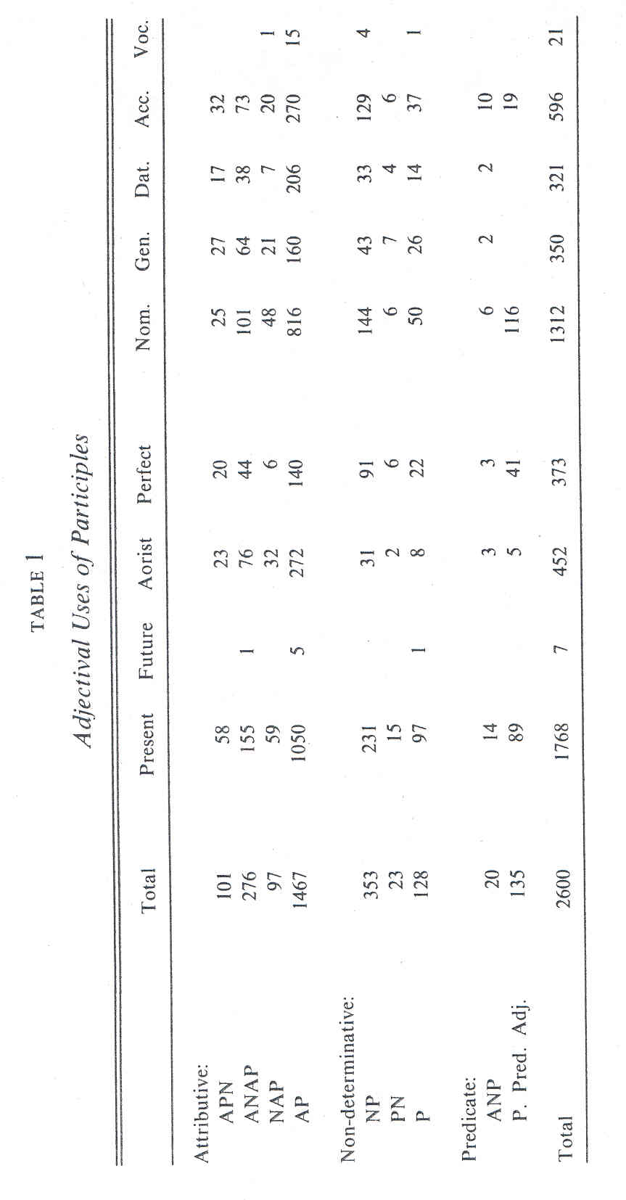
178 GRACE THEOLOGICAL JOURNAL

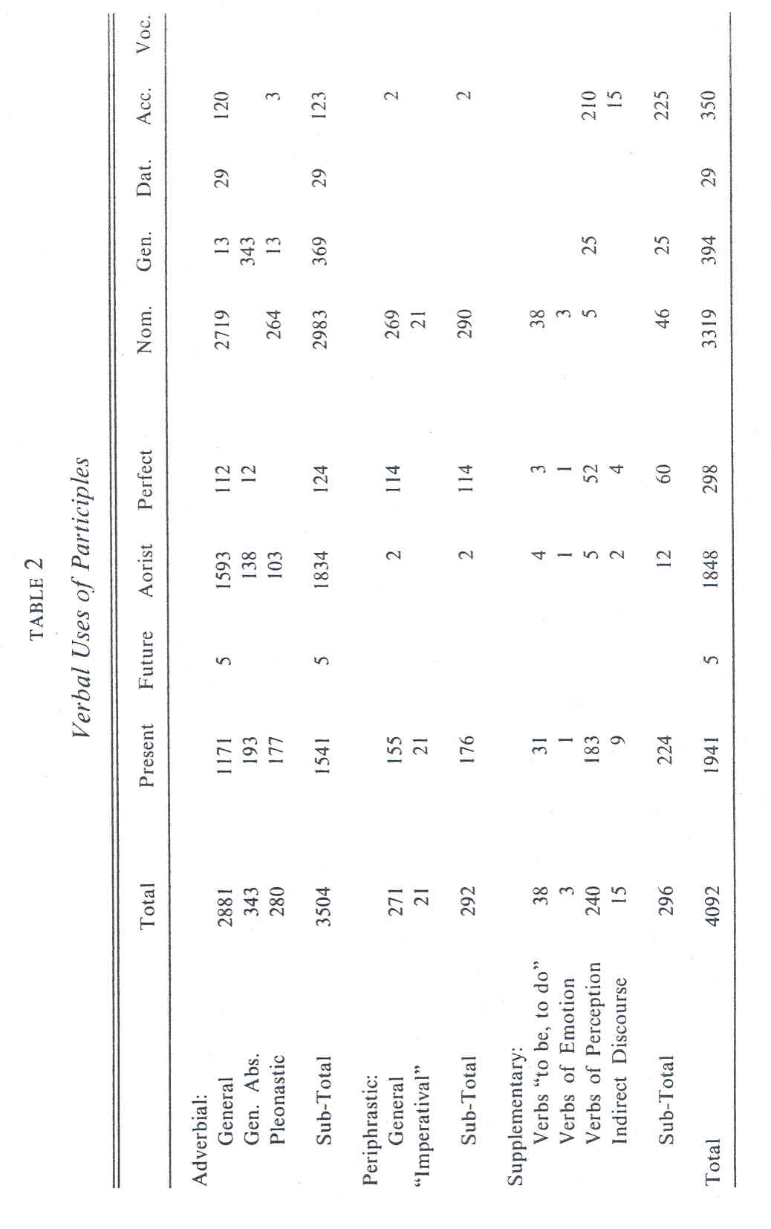

TABLE 3
Composition of Periphrastic Tenses

with Present with Perfect with Aorist
Auxiliary Verb Participle Participle Participle
Present
Indicative:
εἰμί 1 2
ἐστί(ν) 12 18
[ ἐστί(ν)] 3
ἐσμέν 3
[ἐσμέν] 1
ἐστέ 6
εἰσί(ν) 1 7
[ εἰσὶ(ν)] 1 1
___ ___
19 Periphrastic 37 Periphrastic
Present Present Ind. Perfect Ind.
Subjunctive:
ᾗ 7
[ ᾗ] 1
ὦμεν 1
ἦτε 2
ὦσι(ν) 2
____ ____
1 Periphrastic 12 Periphrastic
Present Subj. Perfect Subj.
Present
Infinitive:
εἶναι 1 Periphrastic
Present Inf.
Present
Participle:
ὦν 2 Periphrastic
Perfect Part.
Imperfect
Indicative:
ἤμην 8 1
ἦν 67 36 2 (?)
[ἦν] 2 1
ἦμεν 1 l
ἦμεθα l
[ἦμεν] 3
ἦτε 1
ἦσαν 34 15
[ἦσαν] 2 1
___ ___
118 Periphrastic 56 Periphrastic 2 Periphrastic
Imperfects Pluperfects Aorists
Future
Indicative:
ἔσομαι 1
ἔσῃ 3
ἔσται 2 4
ἔσεσθε 5
ἔσονται 3 1
13 Periphrastic 6 Periphrastic
Futures Future Perfects
* Bracketed forms indicate probable examples of ellipsis, the bracketed word to be
supplied to complete the sense.

This material is cited with gracious permission from:
Grace Theological Seminary
200 Seminary Dr.
Winona Lake, IN 46590
www.grace.edu
Please report any errors to Ted Hildebrandt at: thildebrandt@gordon.edu
for biblicalelearning.org

