JOHN ELIOT AND THE INDIANS

1652-1657

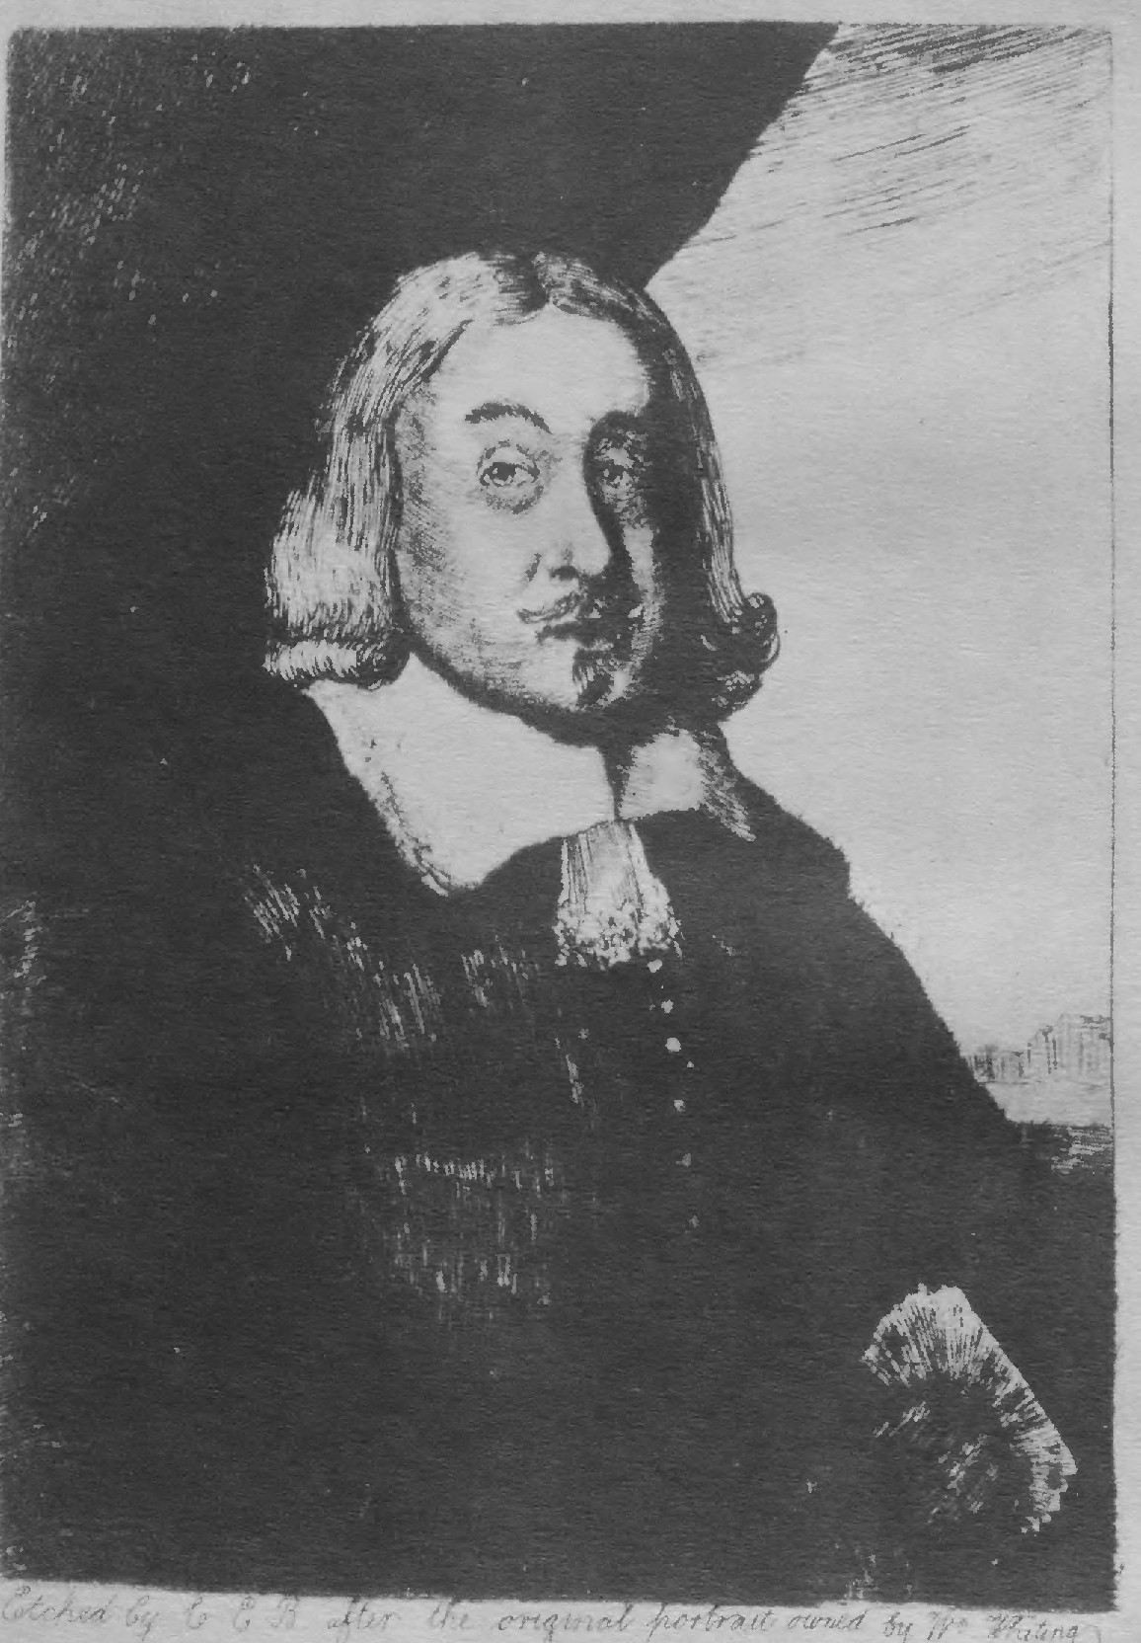

l '

JOHN ELIOT AND THE INDIANS
1652 – 1657

Being Letters Addressed to
Rev. Jonathan Hanmer of Barnstaple, England

Reproduced from the Original Manuscripts in the possession of Theodore N. Vail Edited by Wilberforce Eames

NEW YORK MCMXV
[1915]

ONE HUNDRED AND FIFTY COPIES PRINTED

COPYRIGHT 1915 BY GEORGE D. SMITH
ALL RIGHTS RESERVED

THE ADAMS & GRACE PRESS, NEW YORK

LIST OF ILLUSTRATIONS

Portrait of John Eliot
Facsimile Title of the Indian New Testament 1661
Facsimile of Letter of July 19, 1652 Facsimile of Endorsement of the same Facsimile of Letter of Oct. 7, 1652 Facsimile Title of the Indian Bible 1663
Facsimile Title of Bayly's Practice of Piety 1665
Facsimile of the Invoice of 16.53
The Ship May-Flower
Facsimile of Letter of Aug. 29, 1654 Facsimile of Endorsement of the same Facsimile Title of the Indian Grammar 1666 Facsimile of Letter of May 5, 1657
Facsimile Titles of the Indian Primer 1669 and Logick Primer 1672 Facsimile Titles of Dying Speeches (1685) and Indian Dialogues 1671 Facsimile Title of Baxter's Call 1688
Facsimile Title of Shepard's Sincere Convert 1689 Facsimile Title of Glorious Progress 1649 Facsimile Title of Tears of Repentance 1653
Facsimile Title of Late and Further Manifestation 1655
Facsimile Title of A Further Account 1660
Facsimile Title of a Brief Narrative 1671

Facsimile Title of Eliot's Translation of The New Testament 1661

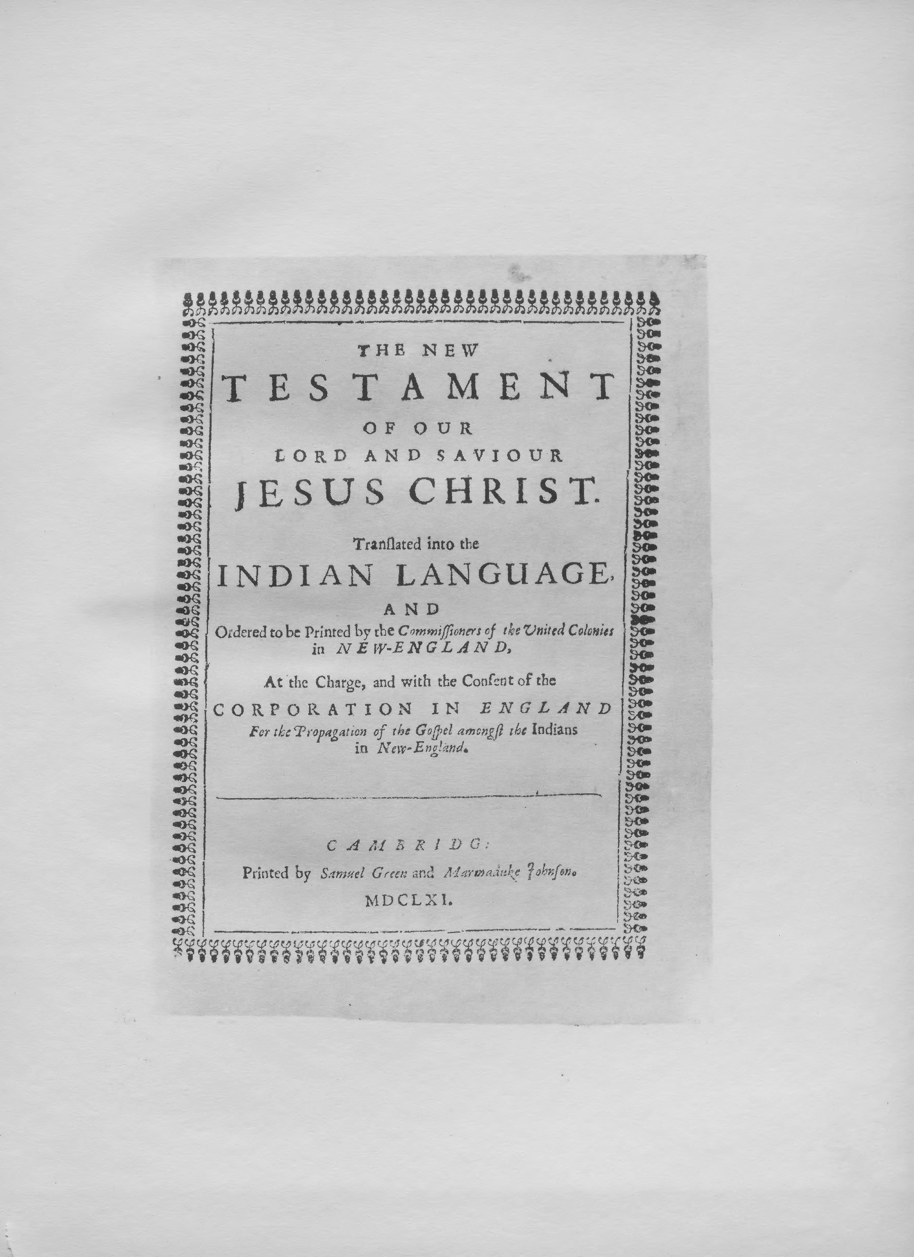

PROLOGUE

The letters of John Eliot here printed belong to the period when he was most actively engaged in his work among the Massachusetts In­ dians. They were addressed to the Rev. Jonathan Hanmer,* minister of the church at Barnstaple in Devonshire, whose interest in Mr. Eliot's labors had been enlisted by mutual friends.
John Eliot had come to New England in November, 1631; was or­ dained teacher of the church at Roxbury in 1632; and had taken up
the study of the Indian language in 1643. In 1646 he began to preach to the Indians in their own tongue, at Nonantum; and in 1650 he selected a site and laid out the plan for an Indian town at Natick. Accounts of the progress of this work were published at London in 1643, 1647, 1648 and 1649, in four of the so-called "Eliot Tracts;" and the in­ terest aroused thereby resulted in the creation by Act of Parliament,

*Mr. Hanmer was born in 1606 and died in 1687. He was minister in the church at Barnstaple from 1646 to 1662, and was the author of several books. See Dictionary of National Biography, vol.
xxiv, pp. 295-297, and authorities there quoted.

4

July 27, 1649, of the Corporation for the Propagation of the Gospel among the Indians in New England.
The efforts of the new Corporation were at once directed to the raising off unds for the purchase of tools and other necessaries required in the building of the new town. It was at this stage of affairs that
Mr. Hanmer wrote to Mr. Eliot, on March 12th, 1652, announcing that an unnamed gentleman (Mr. Speacot) had made a liberal gift of £50, which would be laid out in such commodities as were most desired. Mr. Eliot replied in two letters, dated July 19 and October 7, 1652, as follows:

5

Facsimile of Letter of July 19, 16 52

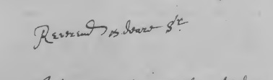\
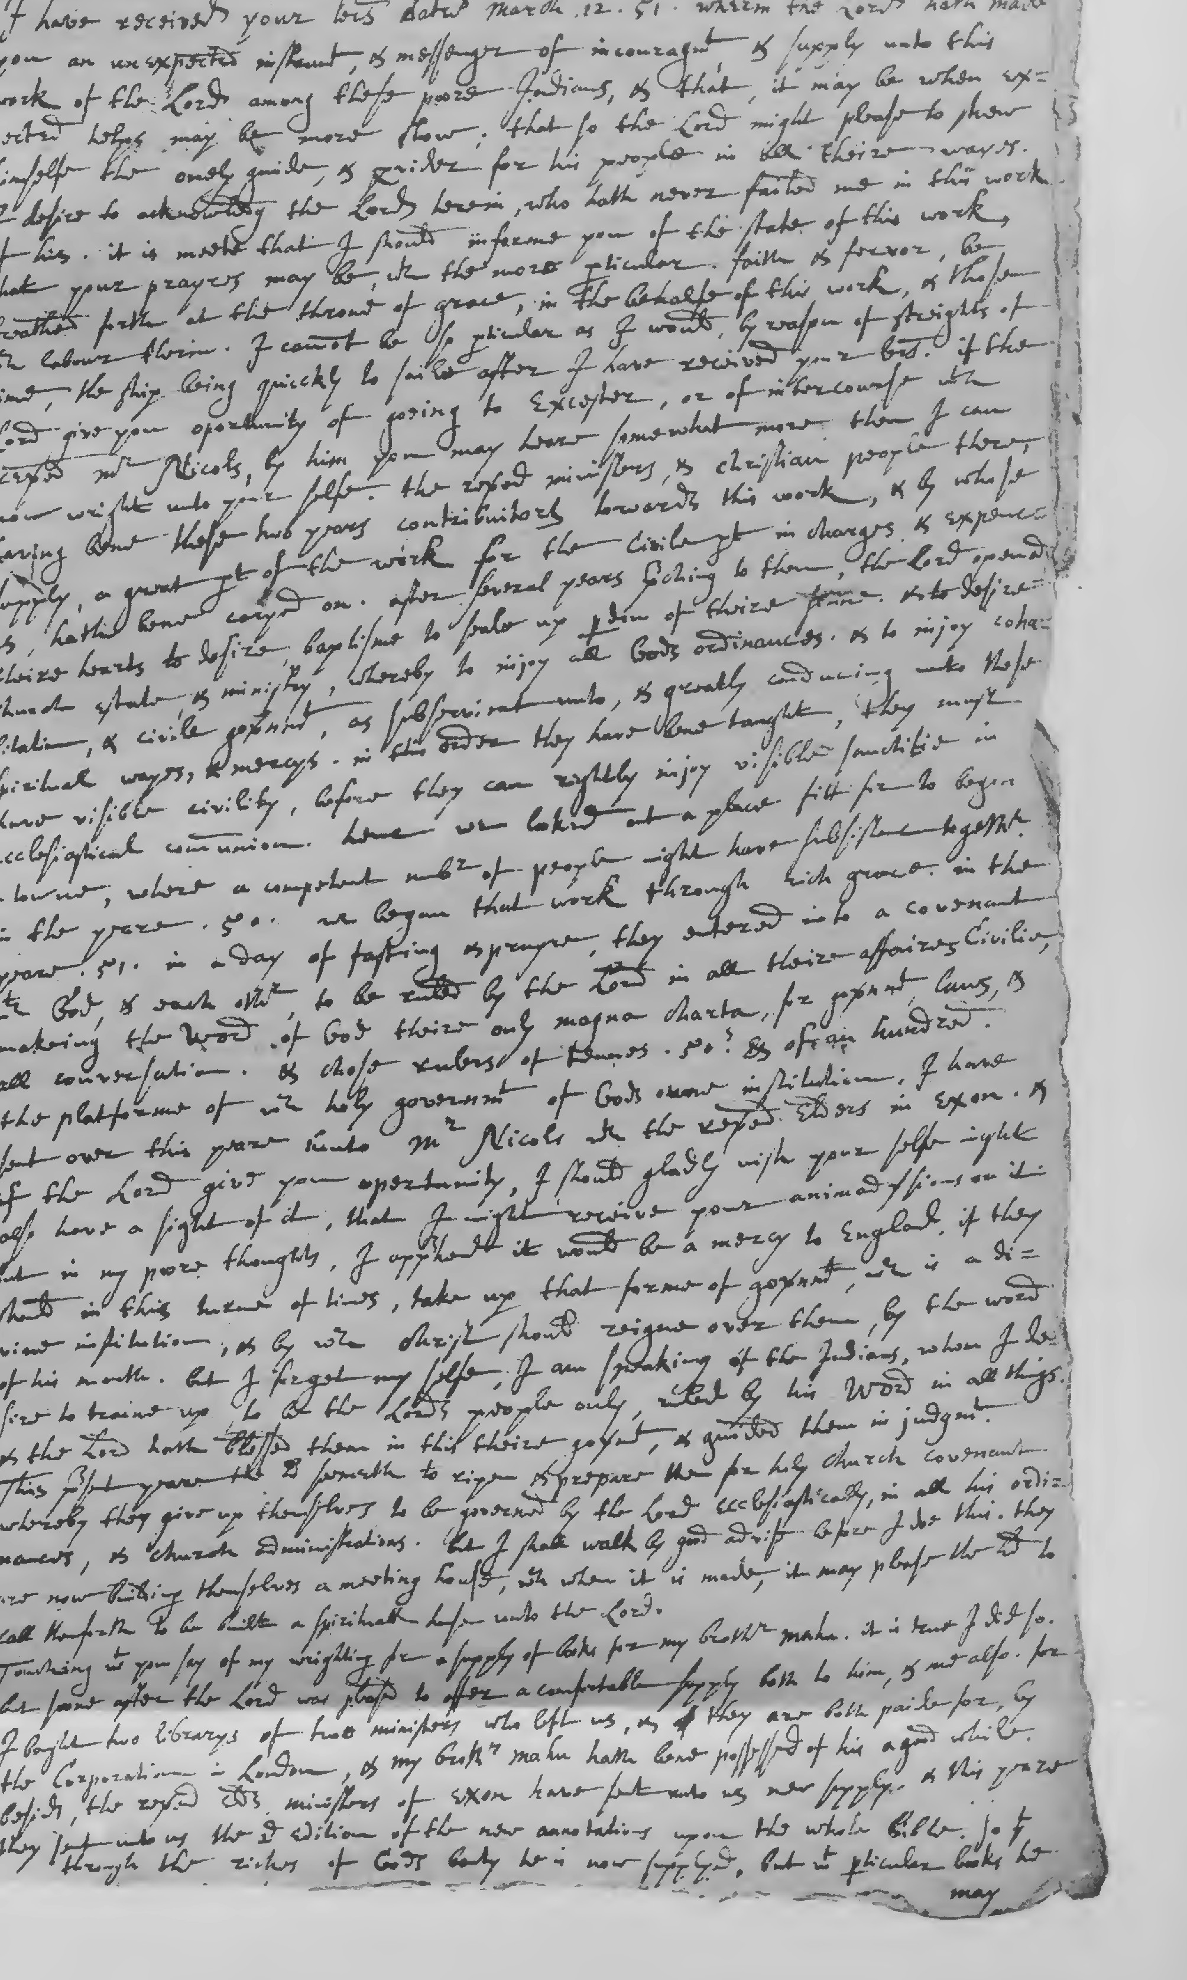
'

what more then I can now wright unto your selfe. The reverend min­ isters, and christian people there, having bene these two years contrib­ uitors towards this work, and by whose supply, a great part of the work for the civile part in charges and expenccs, hath bene caryed on. After several years preching to them, the Lord opened theire hearts to desire baptisme to seale up pardon of theire sinne, and to desire church estate, and ministry, whereby to injoy all Gods ordinances, and to injoy cohabitation, and civile government, as subservient unto, and greatly conducing unto these spiritual wayes, and 1nercys. In this order they have bene taught, they must have visible civility, before they can rightly injoy visible sanctitie in ecclesiastical co1nmunion. Henc we looked out a place fitt for to begin a towne, where a competent number of people might have subsistenc together. In the yeare 1650 we began that work through rich grace. In the yeare 1651 in a day of fasting and prayre, they entered into a covenant with God, and each other, to be ruled by the Lord in all theire affaires civilie, makeing the Word of God theire only magna charta, for govern111ent, laws, and all conversation. And chose rulers of tennes, fifties, and of an hundred. The platforme of which holy government of Gods owne institution, I have sent over this yeare unto Mr. Nicols with the reverend elders in Exon. And if the Lord give you opertunity, I should gladly wish your selfe might also have a sight of it, that I might receive your animadver­ sions on it. But in my poore thoughts, I apprehend it would be a mercy to England, if they should in this terme of lines, take up that forme of government, which is a divine institution, and by which
7

Christ should reigne over them, by the word of his mouth. But I forget myselfe, I am speaking of the Indians, whom I desire to traine up, to be the Lords people only, ruled by his Word in all things. And
the Lord hath blessed them in this theire government, and guided them in judg1nent. This present yeare the Lord seemeth to ripen and prepare them for holy church covenant whereby they give up them­ selves to be governed by the Lord ecclesiastically, in all his ordinances,
and church administrations. But I shall walk by good advise before I doe this. They are now building the1nselves a meeting house, which when it is made, it may please the Lord to call them forth to be built a spirituall house unto the Lord.
Touching what you say of my wrighting for a supply of books for my brother Mahu, it is true I did so. But soone after the Lord was pleased to offer a comfortable supply both to him, and me also. For I bought two librarys of two ministers who left us, and they are both paide for, by the corporation in London, and my brother Mahu hath bene possessed of his a good while. Besides, the reverend elders, ministers of Exon have sent unto us new supply, and this yeare they sent unto us the second edition of the new annotations upon the whole bible, so that through the riches of Gods bounty he is now supplyed, but what particular books he may further want, I cannot tell. Sir you make mention of a liberal gift of a religious gentleman, whose name I hope I shall hereafter know, that I mayexpresse my thankfull­ nesse in a few lines unto him. And wheras you require to know in what com1nodity, it may be most suitably laid out, I answer in two
8

commoditys chiefly. First in strong linnen cloth, canvas and other good hempen cloth, and lockroms, because in the hot sun1mers, the Indians delight to goe in linnen, and work, if in any garment, only a linnen garment, if they can get it. Secondly in red, blew, or white cottons, course and thik, some call it trading cloth, which is the coursest, and some better. Only these two soorts of commoditys are best for the present. The way of sending, may be by ships from Bar­ stable, who have often recourse hither, or by some Bristol ships, who also trade hither. If by London, then there is a faithfull freind of
mine Mr. Bulcher who will conveigh any such things to me. But it may
be the goods had better be taken up in your country, then to be
bought in London. Sir I doe also request this, that if any ships come from Barstable, you would please to appoynt some or other discreete and Godly man, able to judg wisely, and discerne, to set apart so much time, as to see with his eyes, and heare with his owne eares, how the matters are here caryed, and what is done among the Indians. And should he have a good allowanc for his paines, it would tend much to the furtheranc of our work, and comfort of your hearts. And may you please to communicate this my motion to reverend Mr. Nicols and consider what were wisdome to be done in that case. Nay if some of the churches should send forth a minister, and other faithfull breth­ ren, on purpose to visit and comfort and incourage such a work, I see not but it were a worthy work and well becomeing the spirit of the gospel. But I can now goe no further. I doe humbly blesse the Lord for the prayres that are made in all the churches, in the behalfe of
9

Endorsement of Letter of July 19, 1652

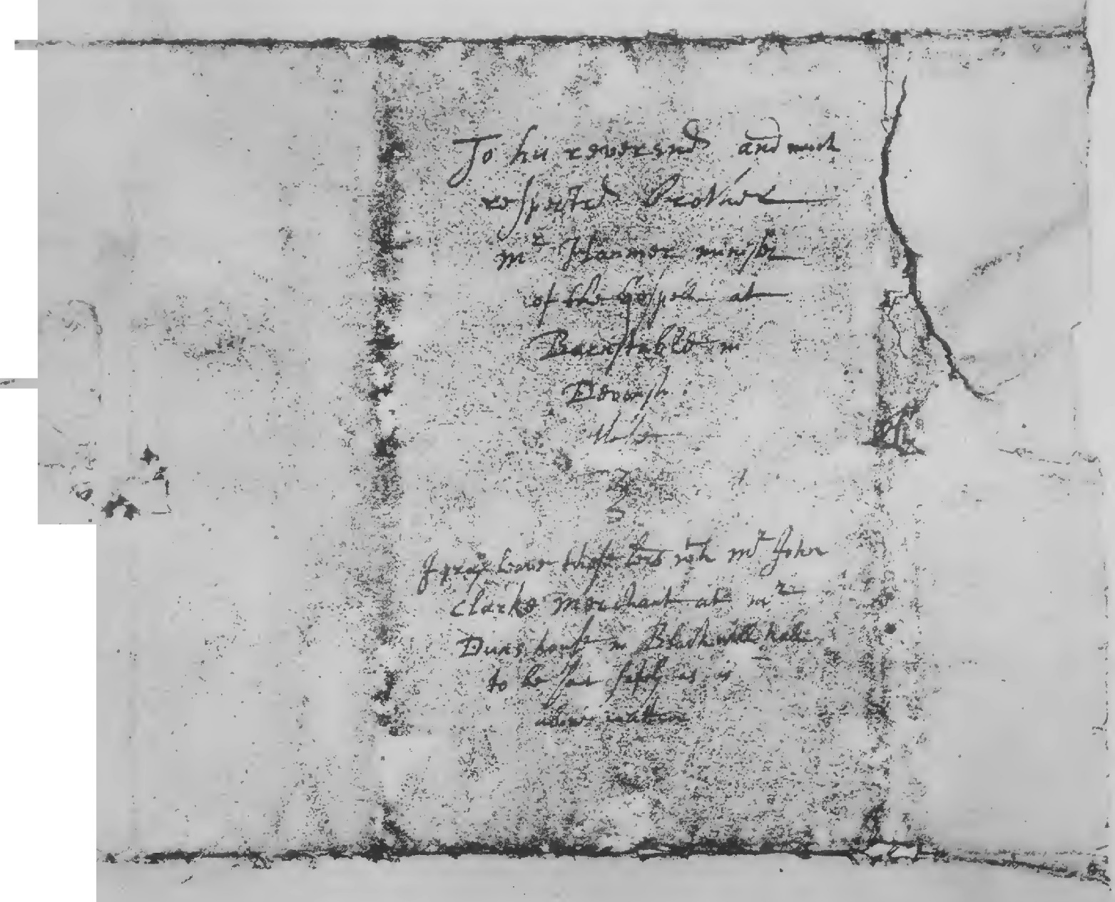
.."'-....

this work, and us that labour in it. I beg for the continuane thereoff, and so commending you and all your holy labours unto the Lord, and to the blessing of his grace I rest.

Roxbury this 19th of the 5th, 1652.
Your unworthy fellow labourer in the gospell of Christ,
John Eliot.

[Addressed:]
To his reverend and much respected brother
Mr. Hanmer minister of the gospell at Barnstable in Devonshire,
these.
I pray leave these letters with Mr. John Clarke merchant at Mr.
Duns house in Blackwell hall to be sent safely as is
above written.

10

Facsimile of Letter of October 7, 1652

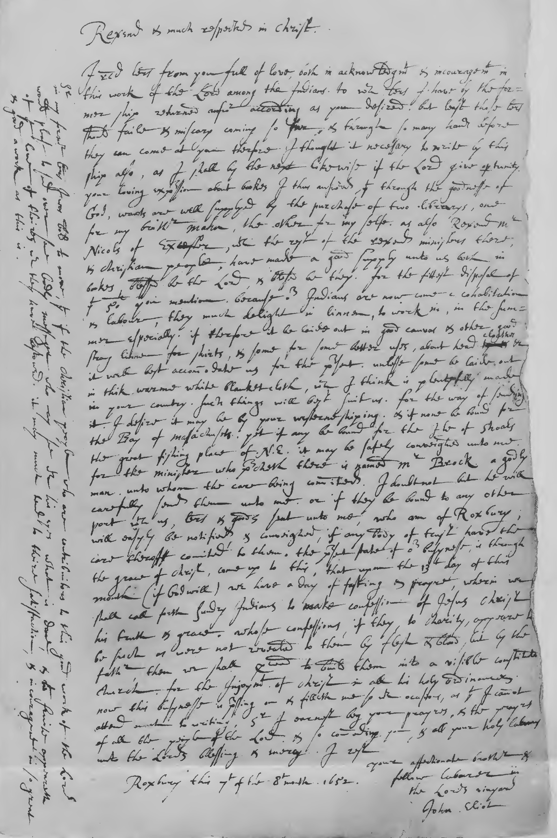

[Roxbury, October 7, 1652.]

Reverend and much respected in Christ.
I received letters from you full of love, both in acknowledgment and incouragement in this work of the Lord among the Indians, to which letters I have by the former ship returned answer according as you desired. But least these letters should faile and miscary coming so far, and through so many hands before they can come at you ther­ fore I thought it necessary to write by this ship also, as I shall by the next likewise if the Lord give opertunity. Your loving expression about bookes I thus answered, that through the goodnesse of God, wants are well supplyed by the purchase of two librarys, one for my brother Mahu, the other for my selfe. As also Reverend Mr. Nicols of Excester, with the rest of the reverend ministers there, and christian people, have made a good supply unto us both in bookes, blessed be the Lord, and blessed be they. For the fittest disposal of that fifty pounds you mention, because our Indians are now come in cohabita­ tion and labour, they much delight in linnen, to work in, in the sum­ mer especially. If therfore it be laide out in good canvas and other good strong linnen for shirts, and some for some better uses, about head cloathes etc. it will best accommodate us for the present, unlesse some be laide out in thik warme white blanket cloth, which I think is plentyfully made in your country. Such things will best suit us.

11

For the way of sending it, I desire it may be by your westerne shiping, and if none be bound for the Bay of Massachusets, yet if any be bound for the Ile of Shoals the great fishing place of New England, it may be safely conveighed unto me. For the minister who preacheth there is named Mr. Brock, a godly man, unto whom the care being commited, I doubt not but he will carefully send them unto me. Or if they be bound to any other port with us, letters and goods sent unto me, who am of Roxbury, will easyly be notified, and conveighed, if any body of trust have the care theroff comited to them. The present state of our busynesse, is through the grace of Christ, come up to this, that upon the 13th day of this month (if God will) we have a day of fasting and prayre, wherin we shall call forth sundry Indians to make con­ fession of Jesus Christ his truth and grace. Whose confessions, if they, to charity, appeare to be such as were not revealed to them by flesh and blood, but by the father, then we shall proceed to build them into a visible constituted church, for the lnjoyment of Christ and all his holy ordinances. Now this busynesse is pressing on and filleth me so with ocasions, as that I cannot attend much to writing. Sir I earnest beg your prayres, and the prayres of all the people of the Lord, and so commending you, and all your holy labours unto the Lords blessing and mercy, I rest.
Your affectionate brother and
fellow labourer in the Lords vinyard

Roxbury this 7th of the 8th month, 1652.
J2
John Eliot.

Sir
[Postscript:)

In my former letters I was bold to move, that if the christian people

who are contribuitors to this good work of the Lord would please to send over soine Godly messenger who may see with his eyes what is done, and what fruite appeareth of that love of theires which they have bestowed, it may much tend to theire satisfaction, and incourage­ ment in so great and good a work as this is.

13

Facsimile Title of Eliot's Translation of the Whole Bible 1663

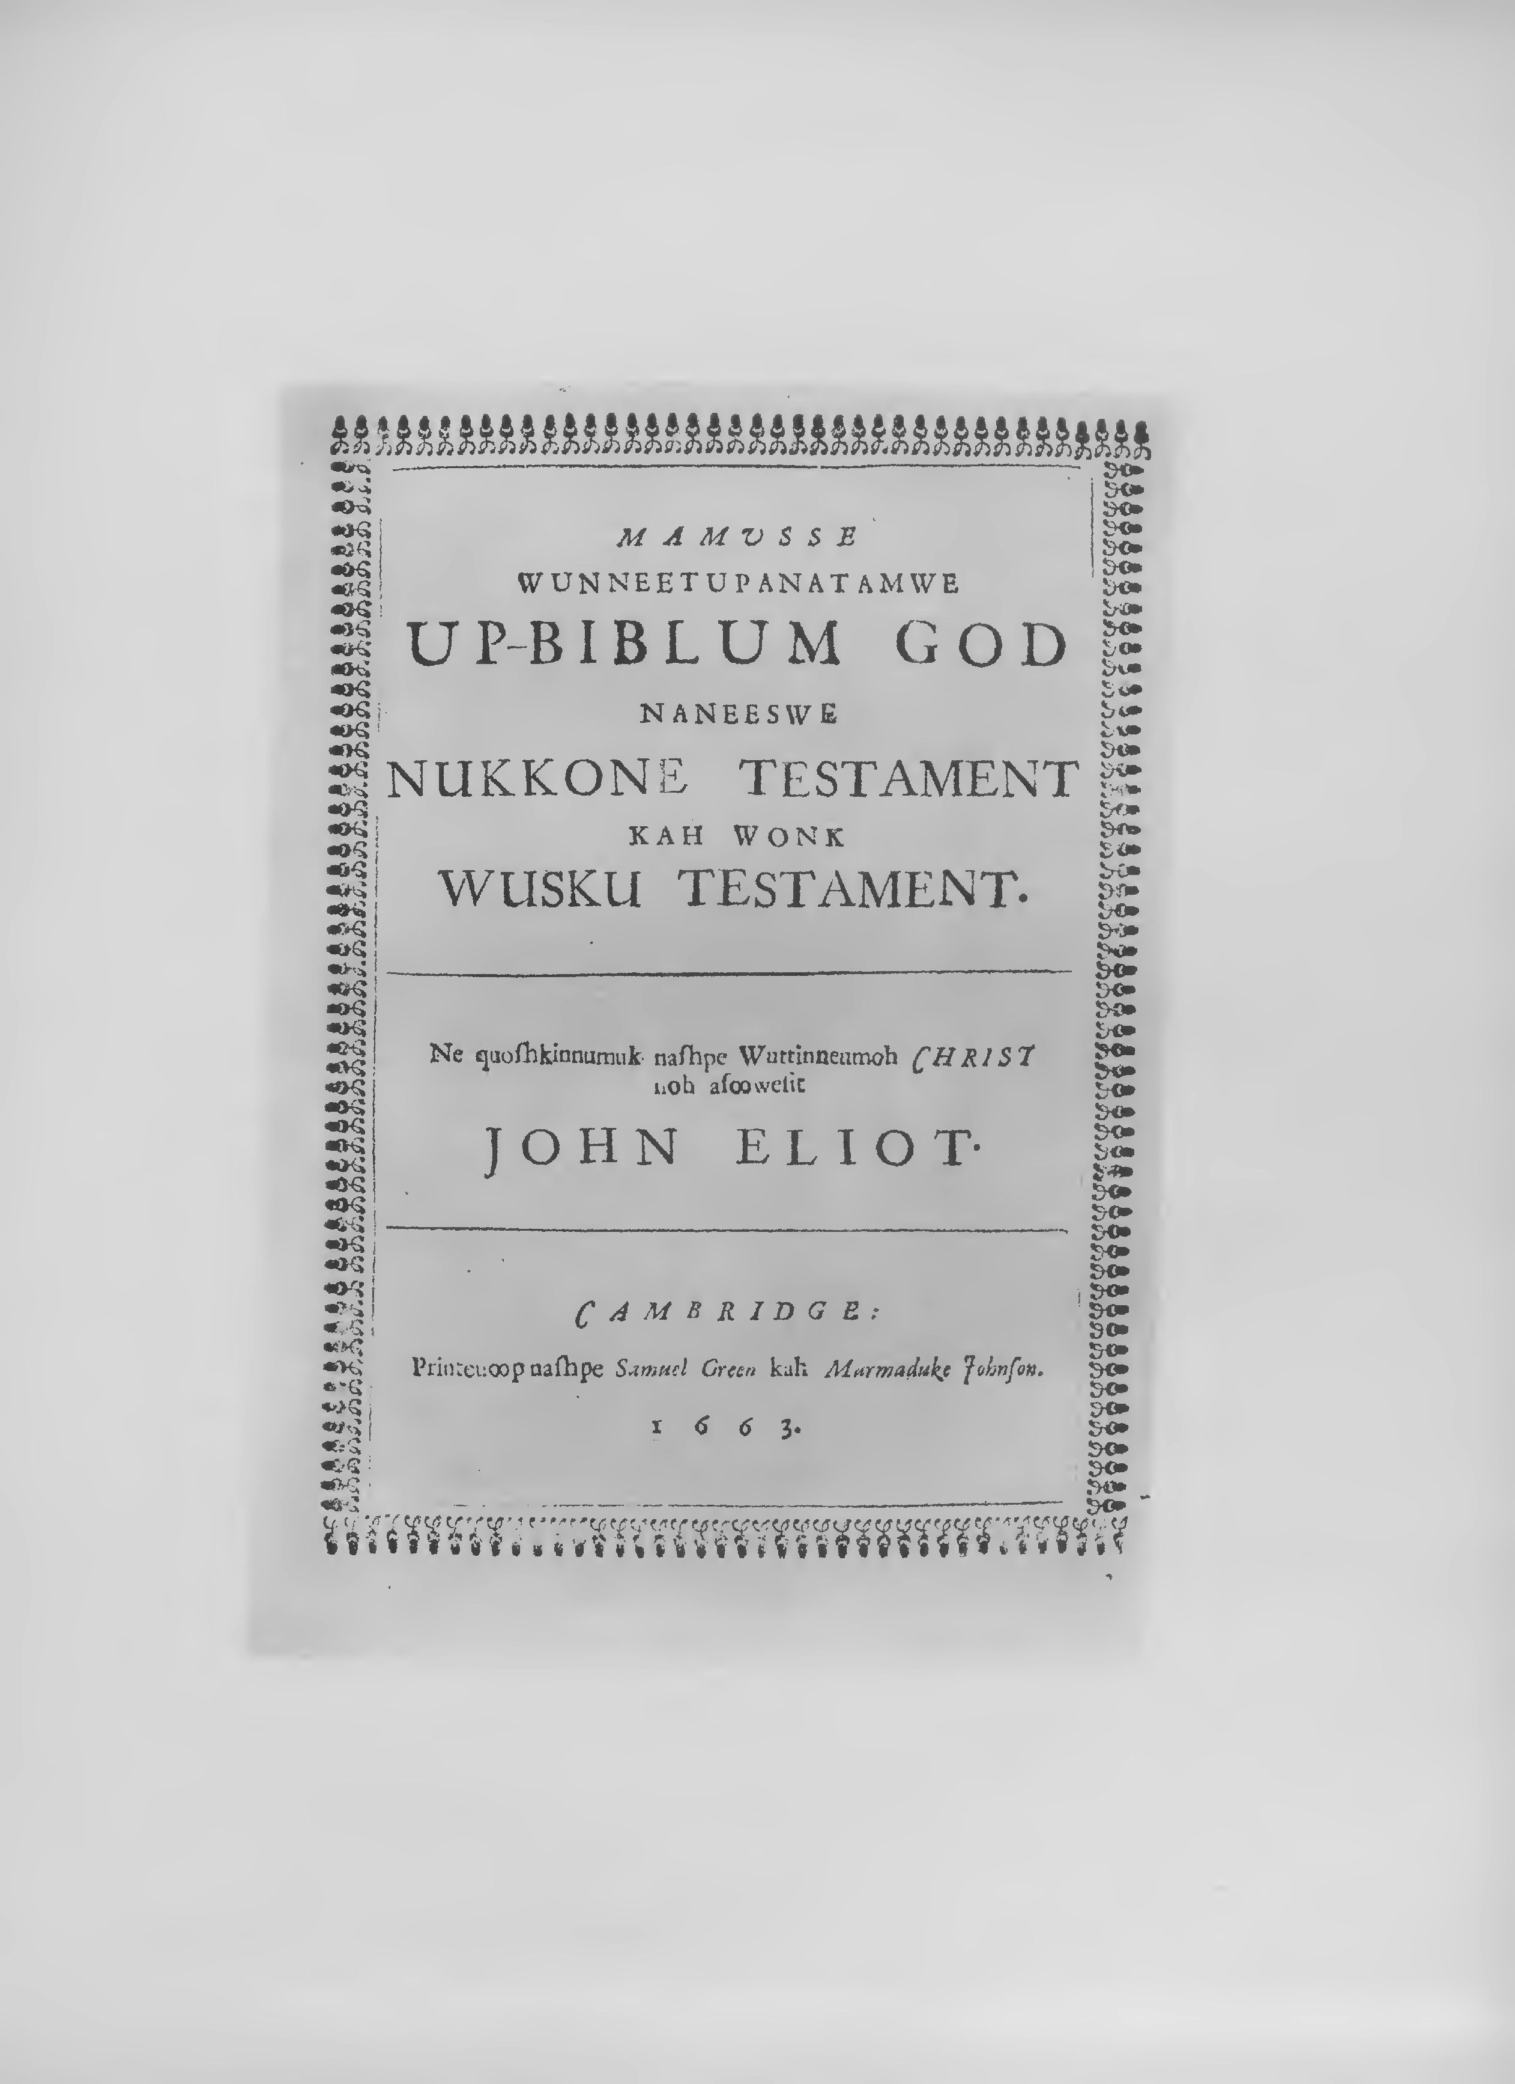

From these letters we learn that a part of the funds for carrying on the Indian work during 1650 and 1651 had been contributed by friends in Exeter, chief among whom was the Rev. Ferdinando Nicolls (b. 1598, d. 1662), who was rector of St. Mary Arches there since 1634. To him Mr. Hanmer is several times referred for fuller information. Mr. Eliot then proceeds to tell how, after several years preaching to the Indians, they had selected a place to begin the town of Natick, in 1650, and had organized a plan for self government in 1651. For further particulars concerning this plan, or platform, he refers Mr. Hanmer to the accounts sent over to Mr. Nicolls to be published in the tract called Strength out of Wealcnesse, London, 1652.
Mr. Eliot then mentions that he had written to Mr. Hanmer, some time before, about a supply of books for Rev. Thomas Mayhew, who ministered to the Indians on the island of Martha's Vineyard; and that in the meantime the want had been supplied by the purchase of the libraries of two ministers who had gone away. These were the libraries of Rev. Thomas Jenner, formerly of Weymouth, and Rev. Thomas Weld, formerly of Roxbury; the former of which was bought (in part) for Mr. Mayhew at £30, and the latter for Mr. Eliot at £34. He also mentions having received from England, among other books sent over to him by his friends at Exeter, the second edition of the
14

New Annotations upon the Whole Bible. The full title of the work is as follows:

ANNOTATIONS || upon all the || BOOKS || of the || Old and New Testament:II This Second Edition soenlarged, II As they make an entire Commentary on the sacred Scripture: II The like never before published in English. II Wherein II The Text is Explained, Doubts Resolved, Scriptures Par­ allelled, II and Various Readings observed. II By the Labour of certain Learned Divines thereunto II appointed, and therein employed, As is expressed in the II PREFACE. I!
. . . II LONDON, II Printed by John Legatt, 1651. II
Two volumes, folio.

The first edition appeared in 1645, and the third edition in 1657.
Copies of all three are in the New York Public Library.
The most interesting information derived from these letters, however, is that concerning the outlay to be made of the £50 given by Mr. Speacot. It was to be expended entirely in linen and canvas goods, to be used for wearing apparel by the Indians. In the directions for sending, Mr. Eliot names his London friend Mr. Bulcher, and also
15

Facsimile Title of Eliot's Translation of Bayly's Practice of Piety 1665

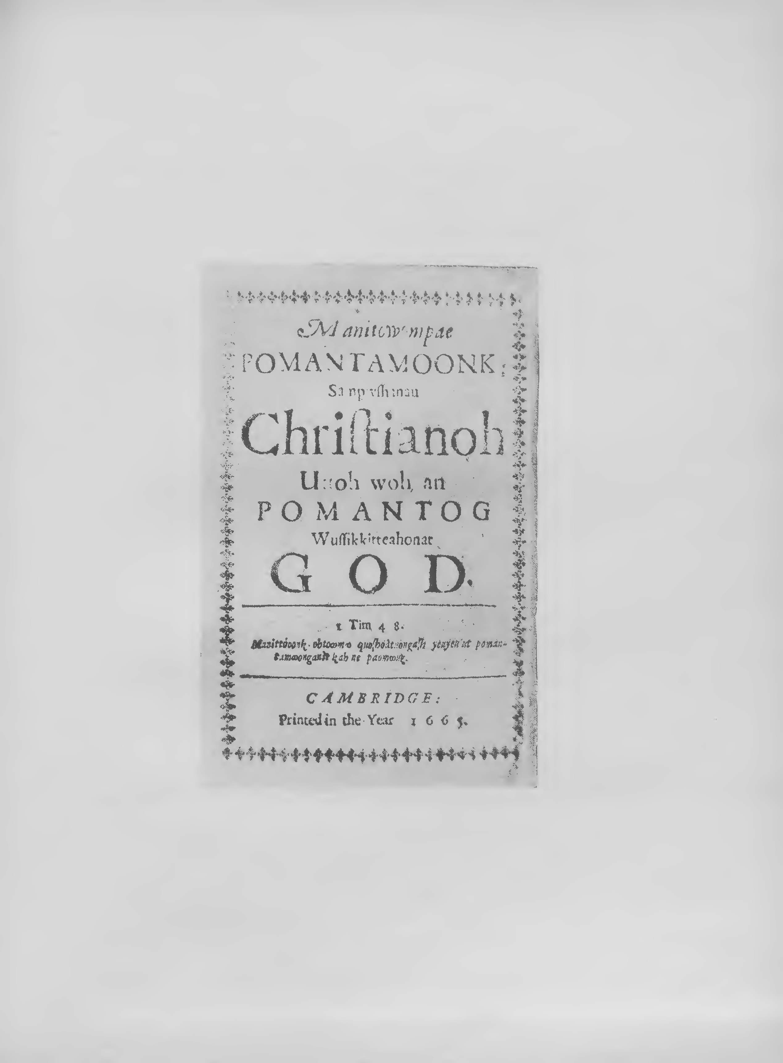

the Rev. John Brock, minister on the Isles of Shoals, either of whom he says would take care of any goods consigned to him. These in­ structions were faithfully carried out by Mr. Hanmer, and the goods were purchased and forwarded to Mr. Eliot the next year, by the ship May-Flower of Boston, Thomas Webber master. A copy of the in­ voice follows.

16

Facsimile of Invoice of 1653

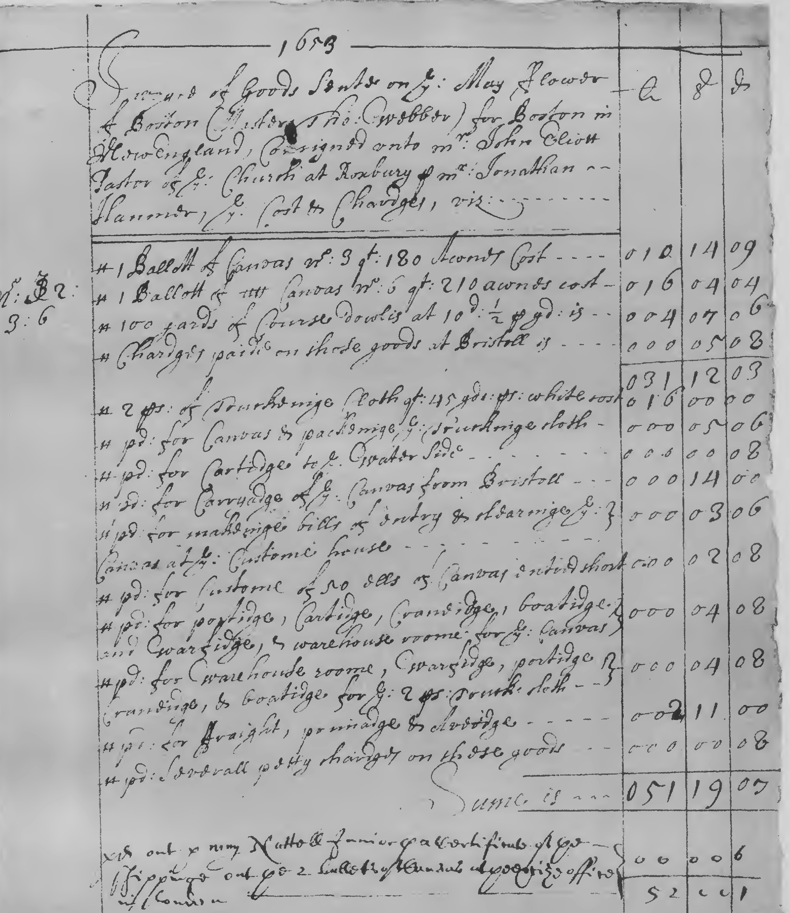

--------------1653,-----------------

Invoyce of Goods sente on the May fflower of Boston £ s d

(Master Tho: Webber) for Boston in New England, consigned unto Mr.John Eliott Pastor of the Church at Roxbury per Mr. Jonathan Hanmer, the Cost and Chardges, viz:................................

Item 1 Ballott of Canvas no: 3 qt: 180 Awnes Cost ...... | 010 | 14 | 09
Item 1Ballott of Canvas no: 6 qt: 210 awnes cost ...... | 016 | 04 | 04
Item 100 yards of Course dowlis at 10d:½ per yd: is .... | 004 | 07 | 06
Item Chardges paide on those goods at Briston is ...... 000 05 08
 | 031 | 12 | 03
Item 2 ps: of TruckeingeClothqt:45yds:ps:whitecost | 016 | 00 | 00
Itern pd: forCanvas.and packeinge the Truckinge cloth | 000 | 05 | 06
Item pd:for Cartidge to the water side ............... | 000 | 00 | 08

17

Itern pd: for Carryadge of the Canvas from Bristoll ....  Item pd: for makeinge bills of entry and clearinge the | 000 | 14 | 00
Canvas at the Custome house...................... | 000 | 03 | 06
Item pd:for Custome of 50 ells of Canvas entred short. | 000 | 02 | 08
Item pd: for portidge, Cartidge, Craneidge, boatidge,
and warfidge, and warehouse roome for the Canvas .. | 000 | 04 | 08
Item pd: for warehouse roome, warfidge, portidge,
Craneidge, and boatidge for the 2 ps: truck: cloth .. . | 000 | 04 | 08
Item pd: for ffraight, primadge and Averidge ......... | 002 | 11 | 00
Itern pd: Severall petty chardges on these goods....... | 000 | 00 | 08
Sume is......... .  pd out per [ ] Nuttell Junior per a certificate of | 0511 | 19 | 107
the shippinge out the 2 ballets of canvas at the excise
office in London ................................... | 000 | 00 | 06

18

52 I oo I 01

With regard to the ship May-Flower, on which the goods were shipped, all that is known of her history is related in Dr. Azel Ames's
May-Flower and her Log, second edition, Boston, 1907, pp. 94-98. About twenty vessels of that name are there recorded, between the years 1587 and 1657. The genuine May-Flower, it appears, was of only 180 tons burden, and the last known of her with certainty, was her arrival in the harbor of Charlestown, New England, on July 1, 1630. On October 6, 1652, "Thomas Webber, Mr. of the good shipp called the MAYFLOWER of the burden of Two hundred Tuns or there abouts
. . . Rideing at Ancor in the Harber of Boston," sold one-sixteenth of the ship "for good & valluable Consideracons to Mr. John Pinchon of Springfield Mrchant." The next day, October 7, 1652, the same "Thomas Webber, Mr. of the good Shipp called the MAYFLOWER of Boston in New England now bound for the barbadoes and thence to London," acknowledges an indebtedness to Theodore Atkinson, a
wealthy "hatter, felt-maker," and merchant of Boston, and the same day (October 1, 1652), the said "Thomas Webber, Mar. of the good shipp called the MAYFLOWER of the burthen of Two hundred tuns or thereabouts," sold "unto Theodore Atkinson felt-maker one-six­ teenth part as well of said Shipp as of all & singular her masts Sails Sail-yards Ancors Cables Ropes Cords Gunns Gunpowder Shott Artil-

19

The Mayflower in Plymouth Harbor

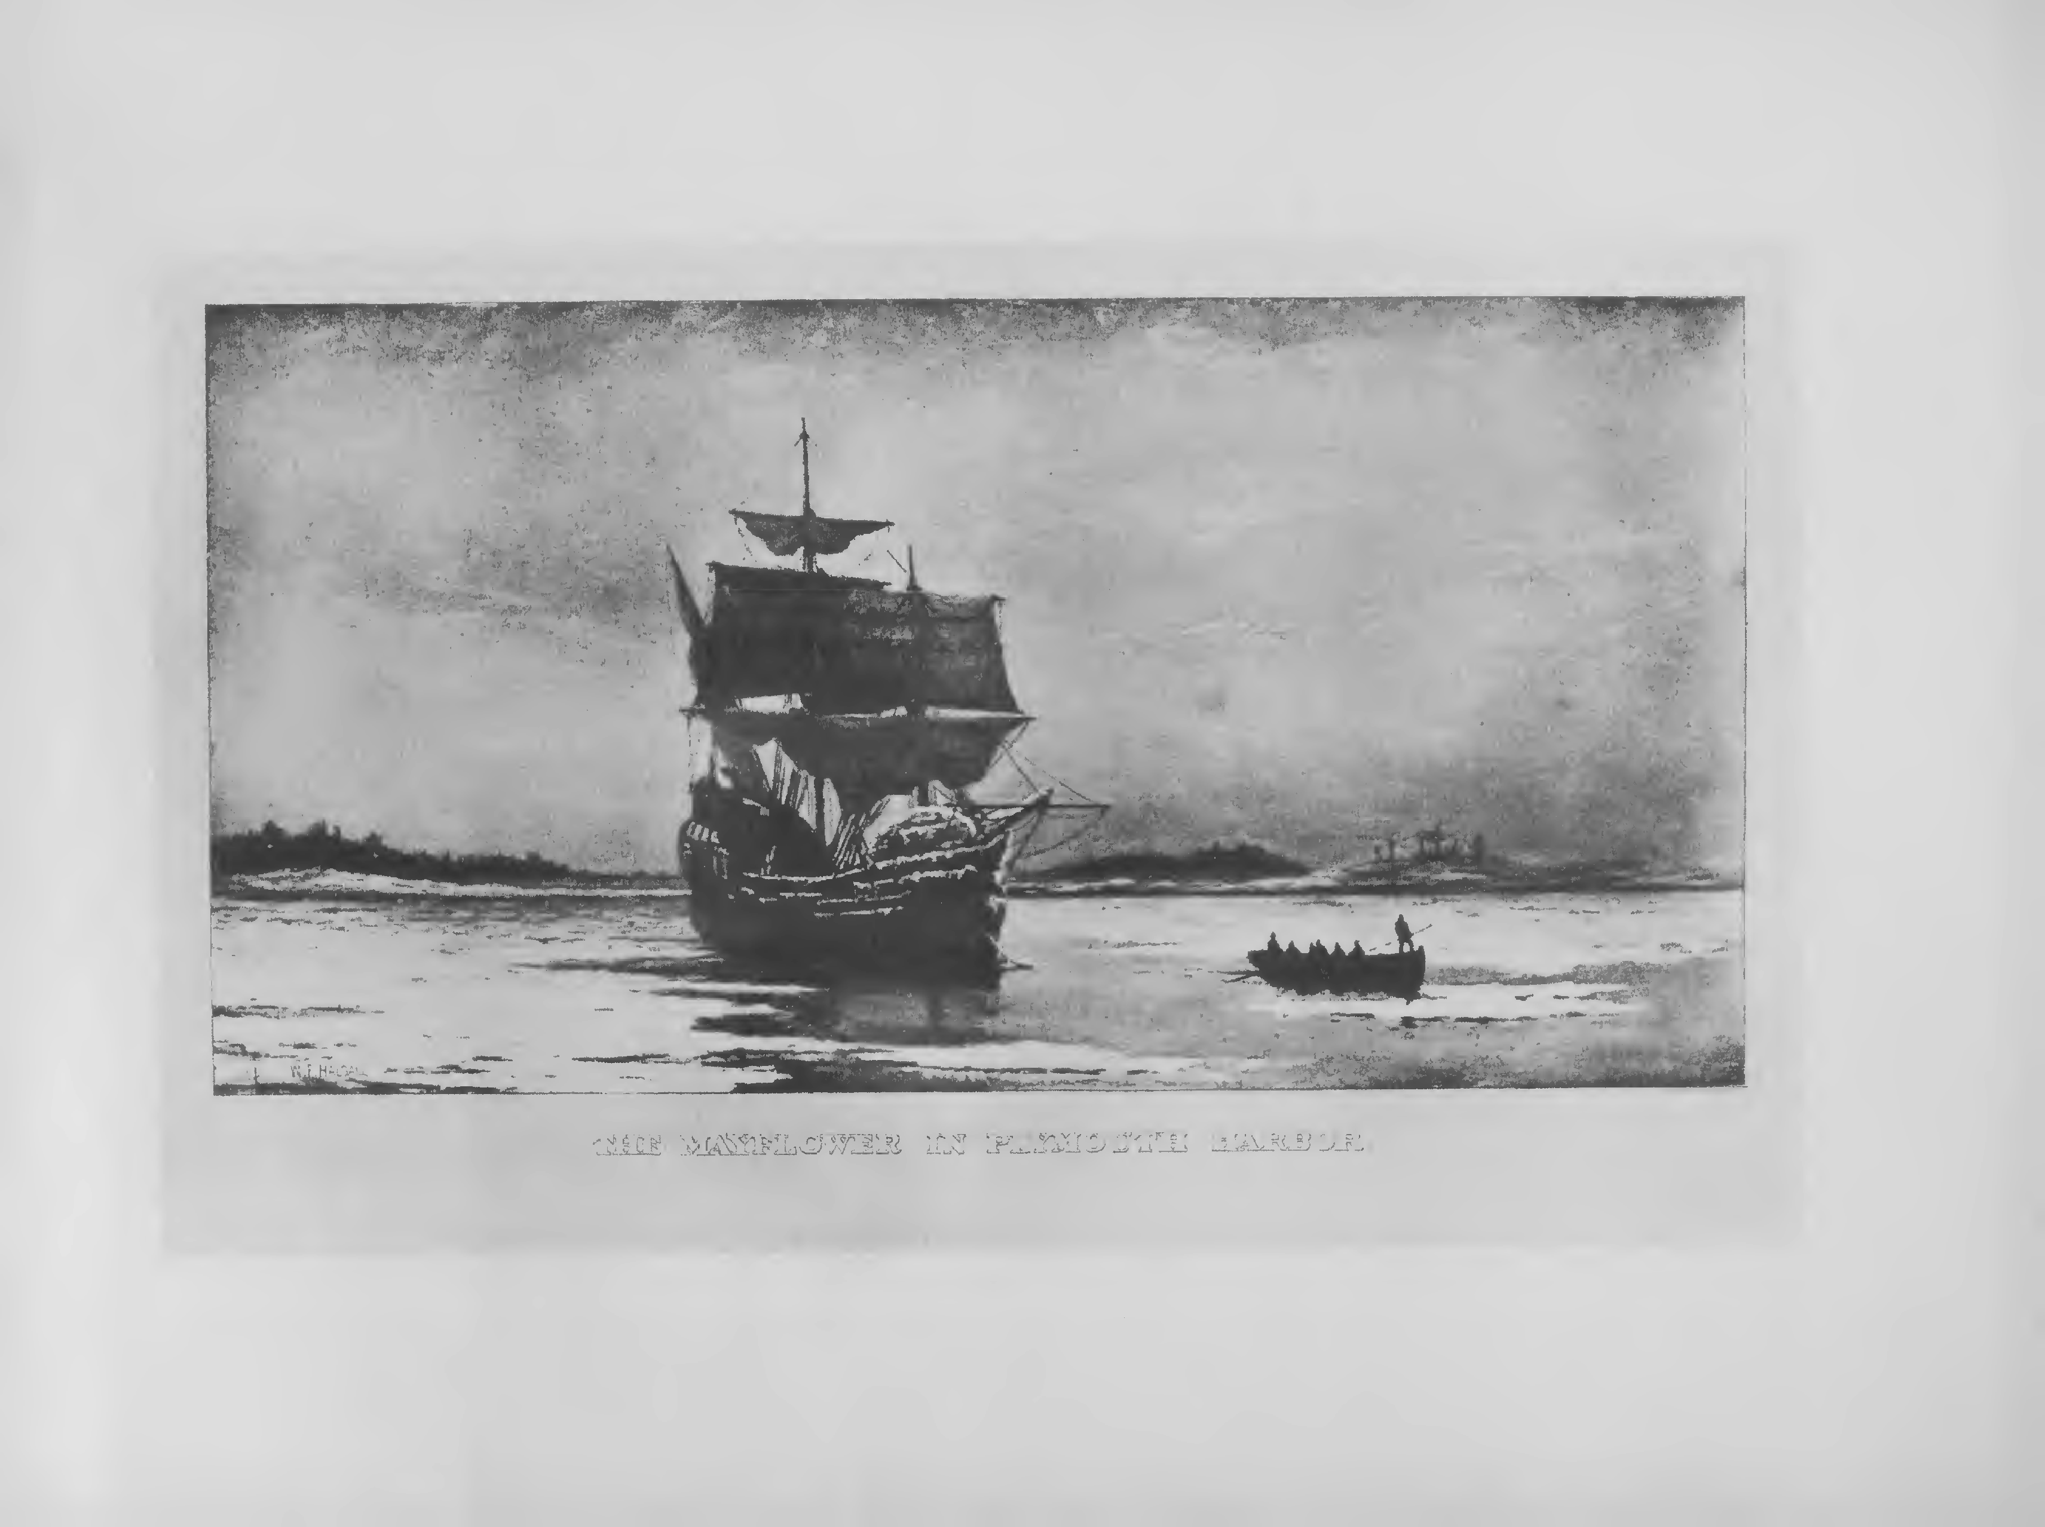

lery Tackle Munition apparell boate skiffe and furniture to the same belonging." It is of course possible that this was the historic ship, though, if so, reappearing twenty-two years after her last known voy­ age to New England. If the same, she was apparently under both new master and owner. From the fact that she is called "of Boston in New England" and was trading between that port, "the Barbadoes" and London, it is not impossible that she may have been built at Boston-a sort of namesake descendant of the historic ship-and was that MAY-FLOWER mentioned as belonging, in 1657, to Mr. Samuel Vassall, as he had large interests alike in Boston, Barbadoes, and London.
The shipment of linen and canvas goods reached Mr. Eliot towards the end of the year 1653, and their receipt was acknowledged in the letter next following.

20

Facsimile of Letter of August 29, 1654

._ .
......

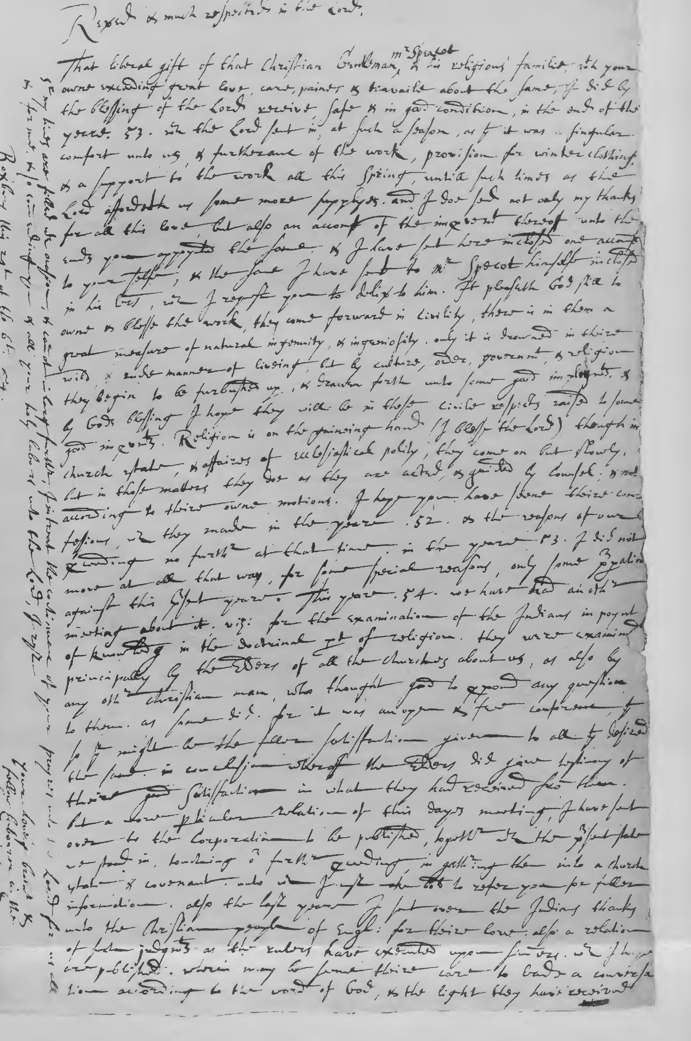

[Roxbury, August 29, 1654.]

Reverend and much respected in the Lord.
That liberal gift of that Christian gentleman Mr. Speacot and his religious familie, with your owne exceeding great love, care, paines and travaile about the same, I did by the blessing of the Lord receive, safe and in good condition, in the end of the yeare 1653, which the Lord sent in, at such a season, as that it was a singular comfort unto us, and furtheranc of the work, provision for winter clothing, and a support to the work all this spring, untill such times as the Lord affordeth us some more supplyes, and I doe send not only my thanks for all this love, but also an accompt of the improvement theroff unto the ends you appoynted the same, and I have sent here inclosed one accompt to your selfe, and the same I have sent to Mr. Specot him­ selfe inclosed in his letters, which I request you to deliver to him. It pleaseth God still to owne and blesse the work, they come forward in civility, there is in them a great measure of natural ingenuity, and ingeniosity, only it is drowned in theire wild, and rude manner of liveing, but by culture, order, government, and religion they begin to be furbushed up, and drawen forth unto some good imployments, and by Gods blessing I hope they will be in these civile respects raised to forme good improvements. Religion is on the gaineing hand (I

21

blesse the Lord) though in church estate, and affaires of ecclesiastical polity, they come on but slowly, but in those matters they doe as they are acted, and guided by counsel, and not according to theire owne motions. I hope you have seene theire confessions, which they made in the yeare 1652, and the reasons of our proceeding no further at that time. In the yeare 1653, I did not move at all that way, for some special reasons, only some preparations against this present yeare. This yeare 1654, we have had another meeting about it, viz: for the examination of the Indians in poynt of knowledg in the doc­ trinal part of religion. They were examined principally by the Elders of all the churches about us, as also by any other christian man, who thought good to propound any question to them, as some did, for it was an open and free conferenc, that so there might be the fuller sat­ isfaction given to all that desired the same. In conclusion wheroff the Elders did give testimony of theire good satisfaction in what they had received from them. But a more particular relation of this dayes meeting, I have sent over to the Corporation to be published, together with the present state we stand in, touching our further proceeding, in gathering them into a church estate and covenant, unto which I must make bold to ref er you for fuller information. Also the last yeare I sent over the Indians thanks unto the Christian people of England for theire love, also a relation of such judgments as the rulers have executed upon sinners, which I hope are published, wherin may be seene theire care to leade a conversation according to the word of God, and the light they have received.

22

Endorsement of Letter of August 29, 1654

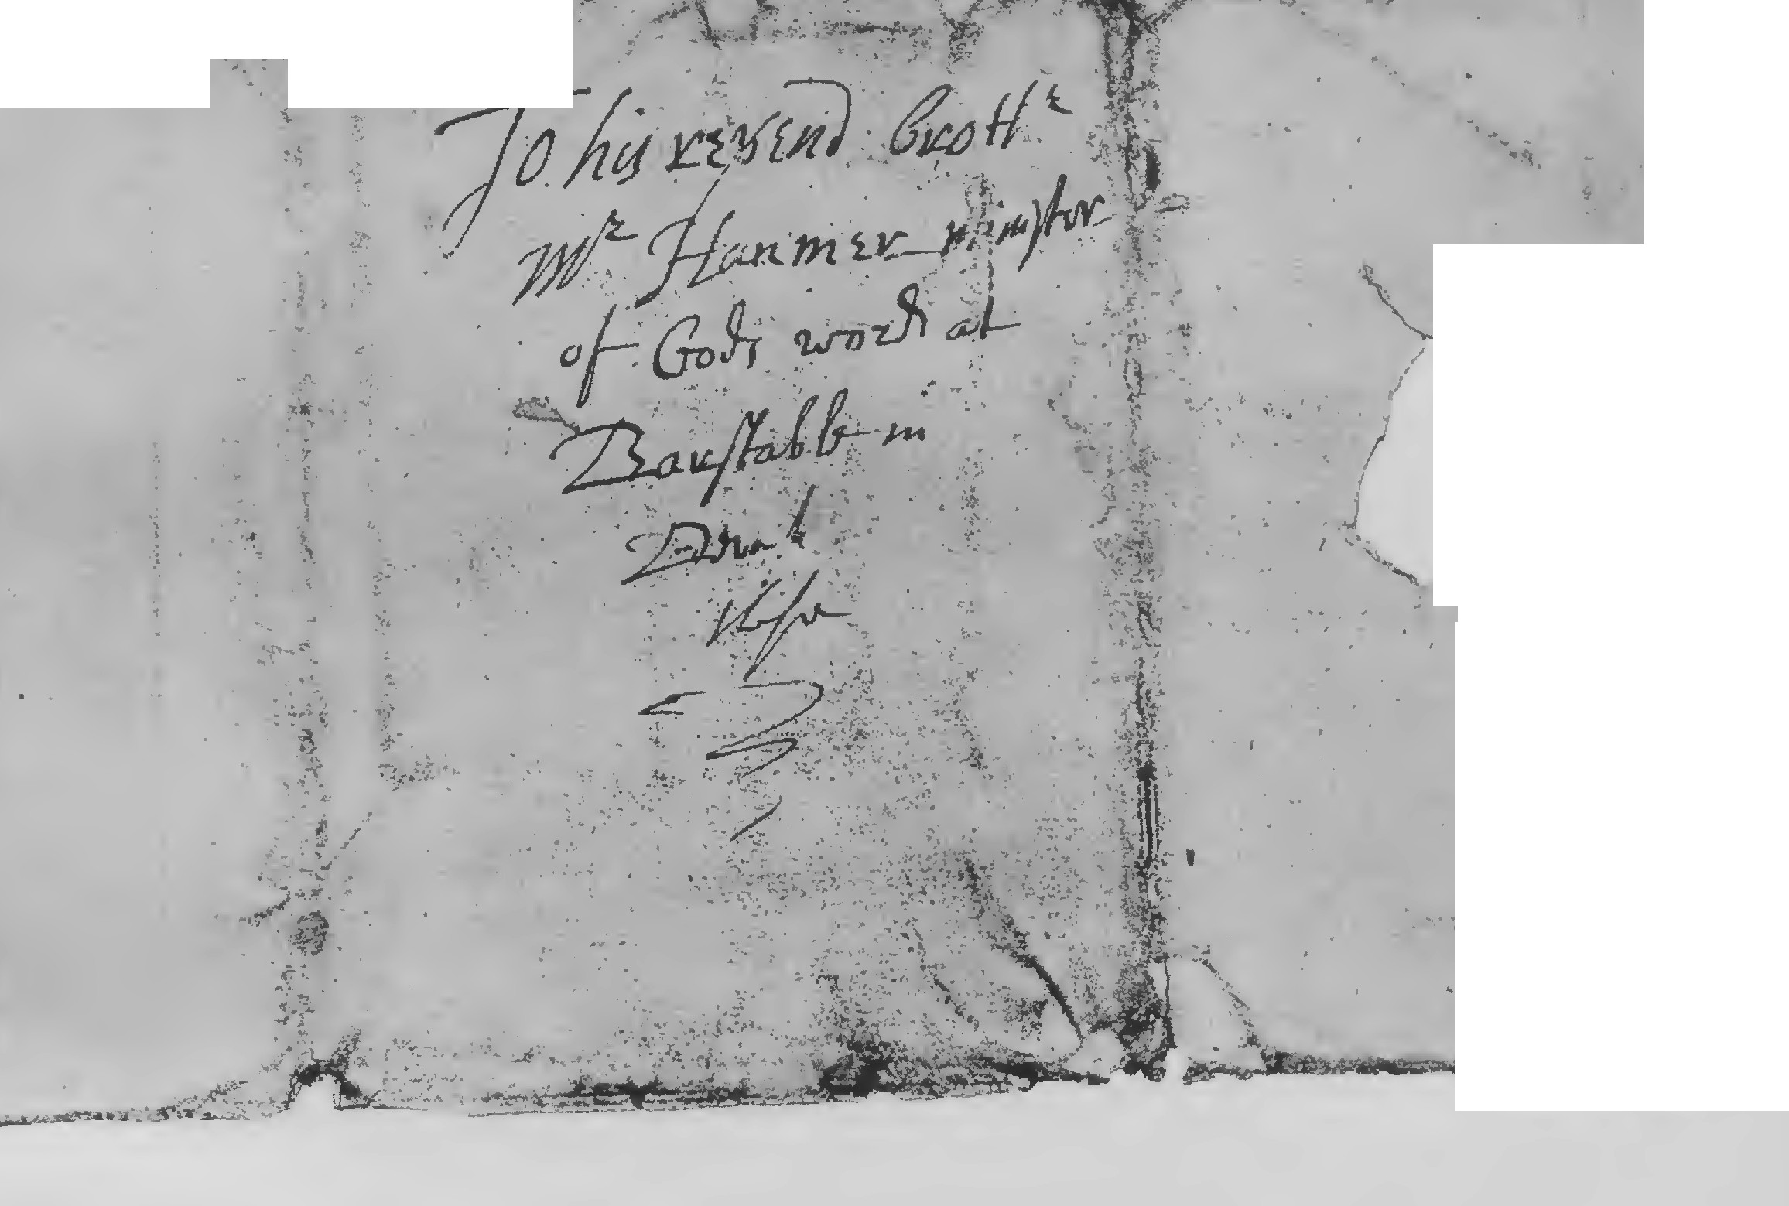

Sir my lines are filled with ocasion, and cannot inlarg further. I intreat the continuanc of your prayres unto the Lord for us all and for me, and so commending you and all your holy labours unto the Lord, I rest.

Roxbury this 29th of the 6th, 1654.
Your loveing brother and
fellow labourer in the
Lords vinyard John Eliot.

[Addressed:] To his reverend brother Mr. Hanmer minister
of Gods word at Barstable in Devonshire these.

23

Facsimile Title of Eliot's Indian Grammar 1666

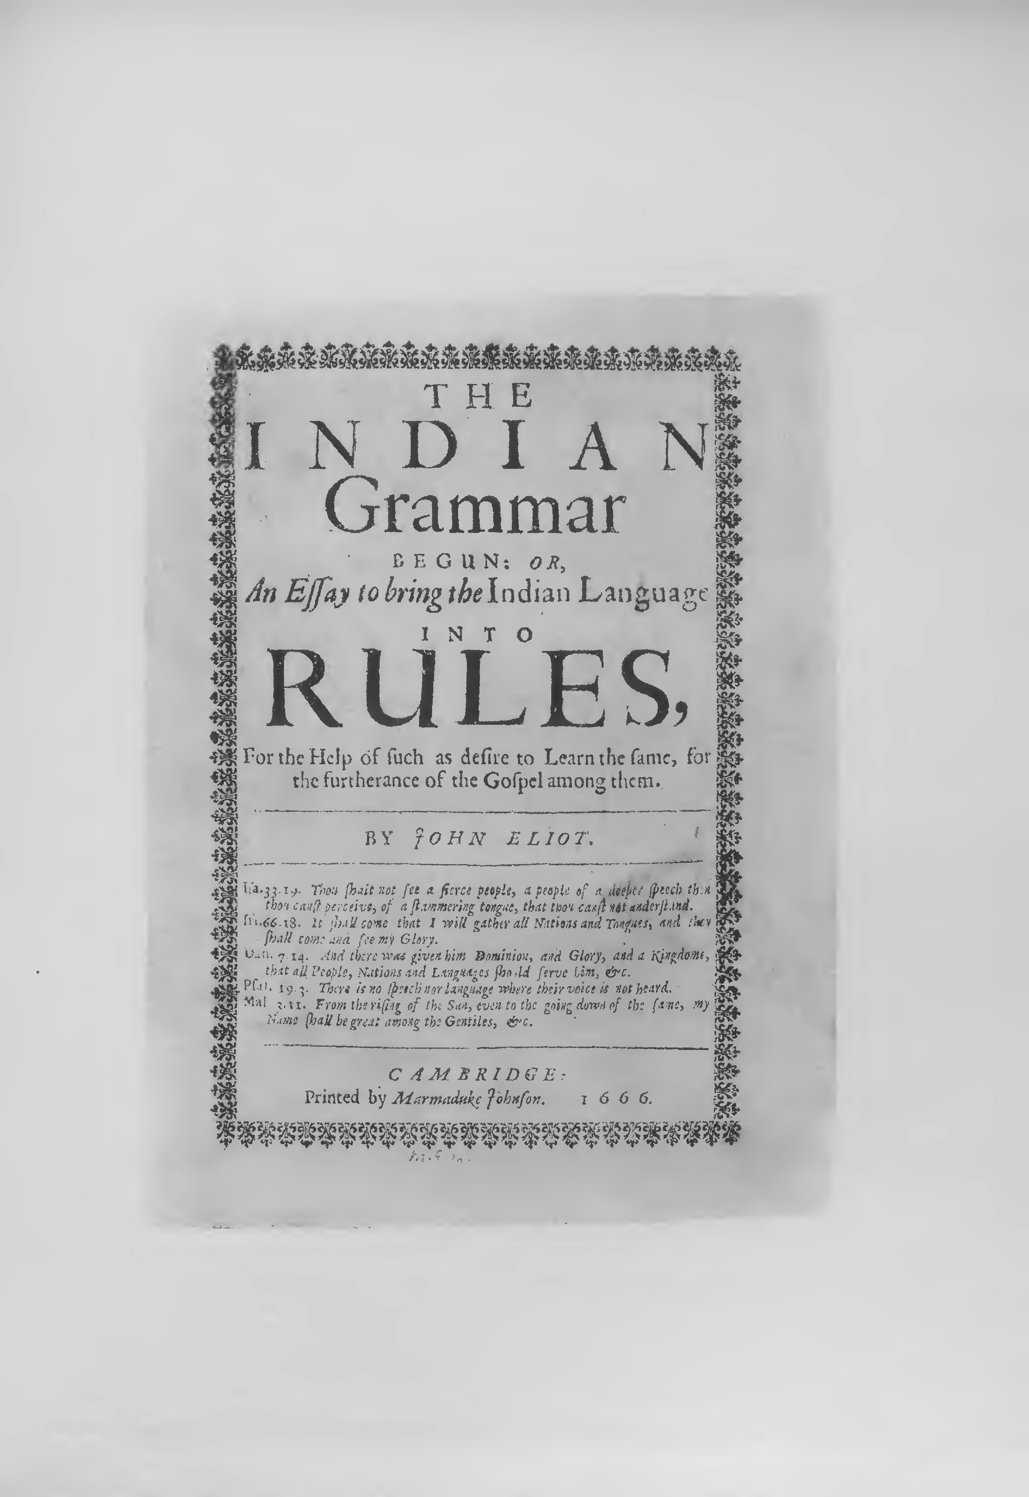

In this letter Mr. Eliot repeats his thanks to Mr. Speacot and Mr. Hanmer for their gifts and encouragement, and continues his account of progress in the Indian work at Natick, with special reference to the Indian confessions of faith printed in the tract entitled Tears of Re­ pentance, London, 1653, and to the examination of the Indians by the Elders at a meeting in 1654, a relation of which he says had been sent over to the Corporation to be printed. This relation appeared in print the next year, under the title of A Late and Further Manifestation of the Progress of the Gospel amongst the Indians in New-England, London, 1655.
After an interval of three years Mr. Eliot wrote again, in 1657;'the delay being partly explained by his long illness in 1656. During this period he had been closely occupied with his translation of the Bible into the Indian language. In 1654, his Indian primer or catechism was printed, and in 1655 the book of Genesis and the Gospel of Matthew passed through the press. In the letter which follows he mentions that Mr. Blinman and Mr. Newman, together with his eldest son John Eliot, had been appointed to help him in the Indian work.

24

Facsimile of Letter of May 5, 1657

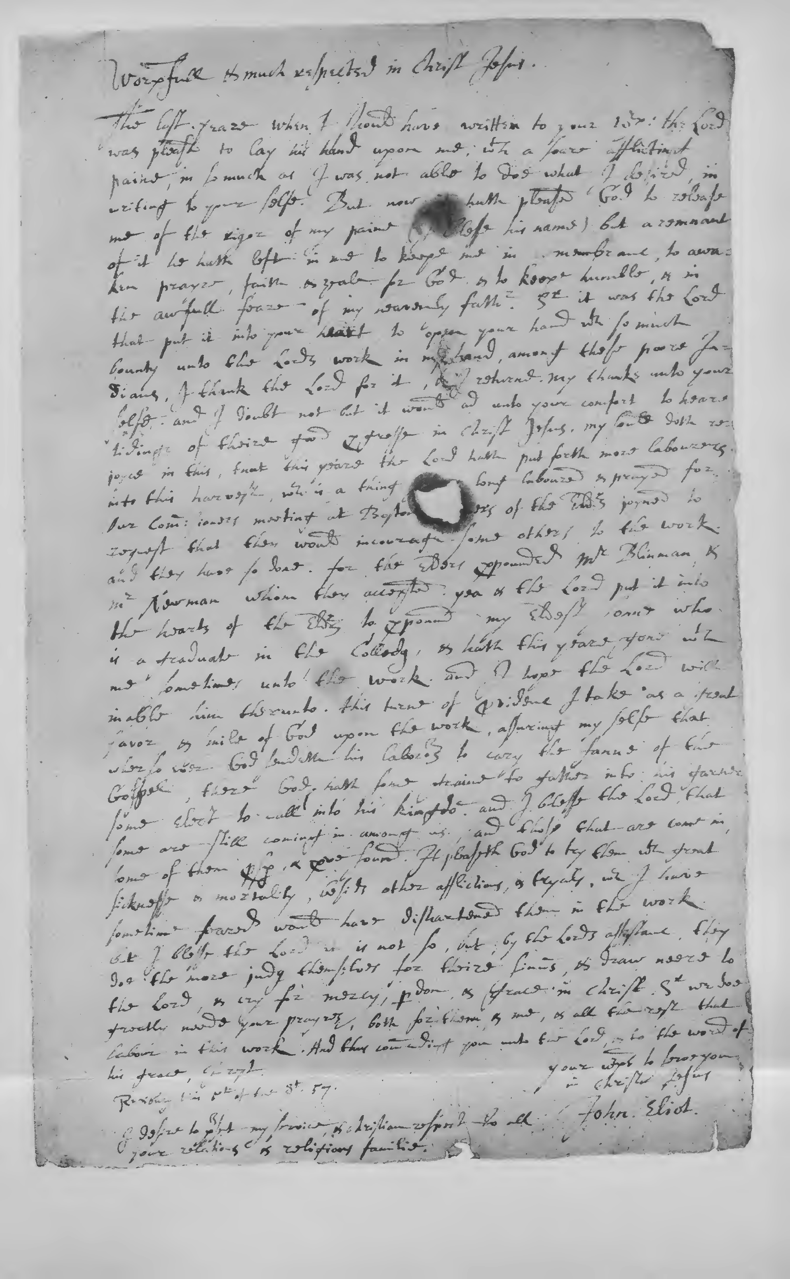

[Roxbury, May 5, 1657.]

Worshipfull and much respected in Christ Jesus.
The last yeare when I should have written to your Worship, the Lord was pleased to lay his hand upon me, with a soare afflicting paine, in so much as I was not able to doe what I desired, in writing to your self e. But now it has pleased God to release me of the rigor of my paine (I blesse his name) but a remnant of it he hath left in me to keepe me in remembranc, to awaken prayre, faith and zeale for God, and to keepe humble, and in the awfull feare of my heavenly father. Sir it was the Lord that put it into your heart, to open your hand with so much bounty unto the Lords work in my hand, amongst these poore Indians. I thank the Lord for it, and I returne my thanks unto your self e, and I doubt not but it would ad unto your comfort to heare tid­ ings of theire good progresse in Christ Jesus. My soule doth rejoyce in this, that this yeare the Lord hath put forth more labourers unto this harvest, which is a thing I have long laboured and prayed for. Our Commissioners meeting at Boston, divers of the Elders joyned to request that they would incourage some others to the work, and they have so done, for the Elders propounded Mr. Blinman, and Mr. New­ man, whom they accepted. Yea and the Lord put it into the hearts of the Elders to propound my eldest sonne who is a graduate in the

25

Colledg, and hath this yeare gone with me sometimes unto the work, and I hope the Lord will inable him therunto. This turne of provi­ denc I take as a great favor, and smile of God upon the work, assuring my selfe that wherso ever God sendeth his laborours to cary the fanne of the Gospel, there God hath some graine to gather into his garner, some elect to call into his kingdom, and I blesse the Lord that son1e are still coming in among us, and those that arecome in, some of them prosper, and prove sound. It pleaseth God to try them with great sicknesse and mortality, besids other afflictions, and tryals, which I have sometime feared would have dishartened them in the work. But I blesse the Lord it is not so, but, by the Lords assistanc, they doe the more judg themselves for theire sinnes, and draw neere to the Lord, and cry for mercy, pardon, and grace in Christ. Sir we doe greatly neede your prayres, both for them, and me, and all the rest that labour in this work. And thus commending you unto the Lord, and to the word of his grace, I rest.

Roxbury this 5th of the 3d, 1657.
Your worships to serve you
in Christ Jesus John Eliot.

I desire to present my service, and christian respect to all your relations, and religious familie.

26

Facsimile Titles of Eliot's Indian Primer 1669 and
Logick Primer 1672

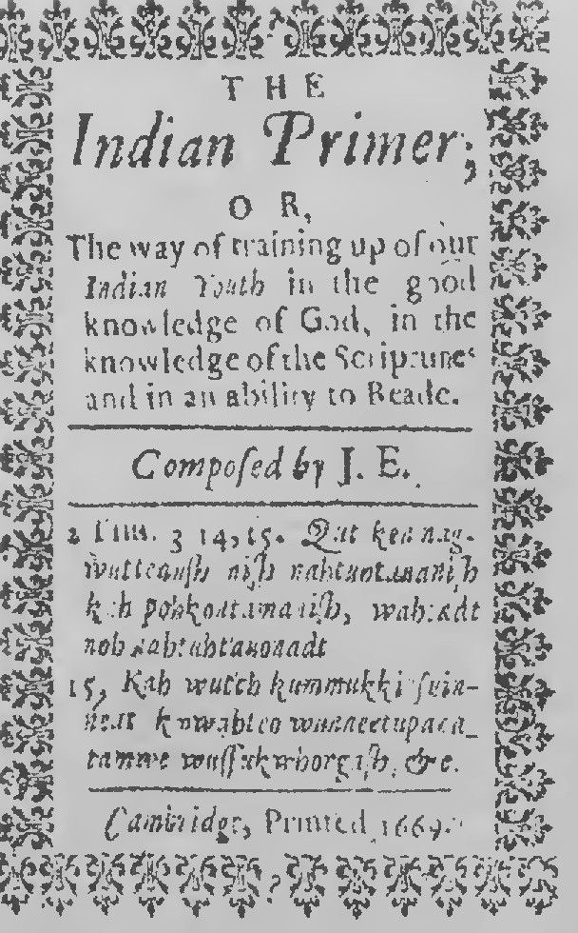
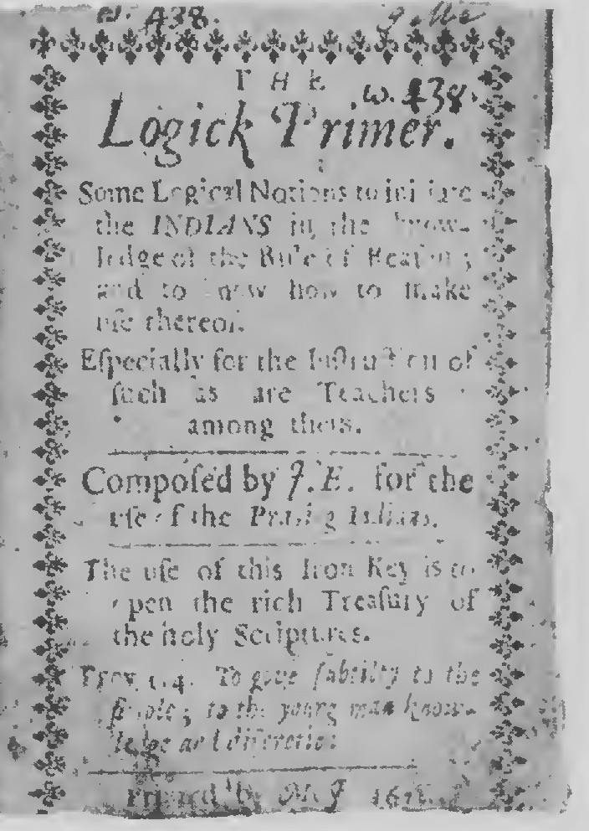

Facsimile Titles of Dying Speeches (61685) and
Eliot's Indian Dialogues 1671

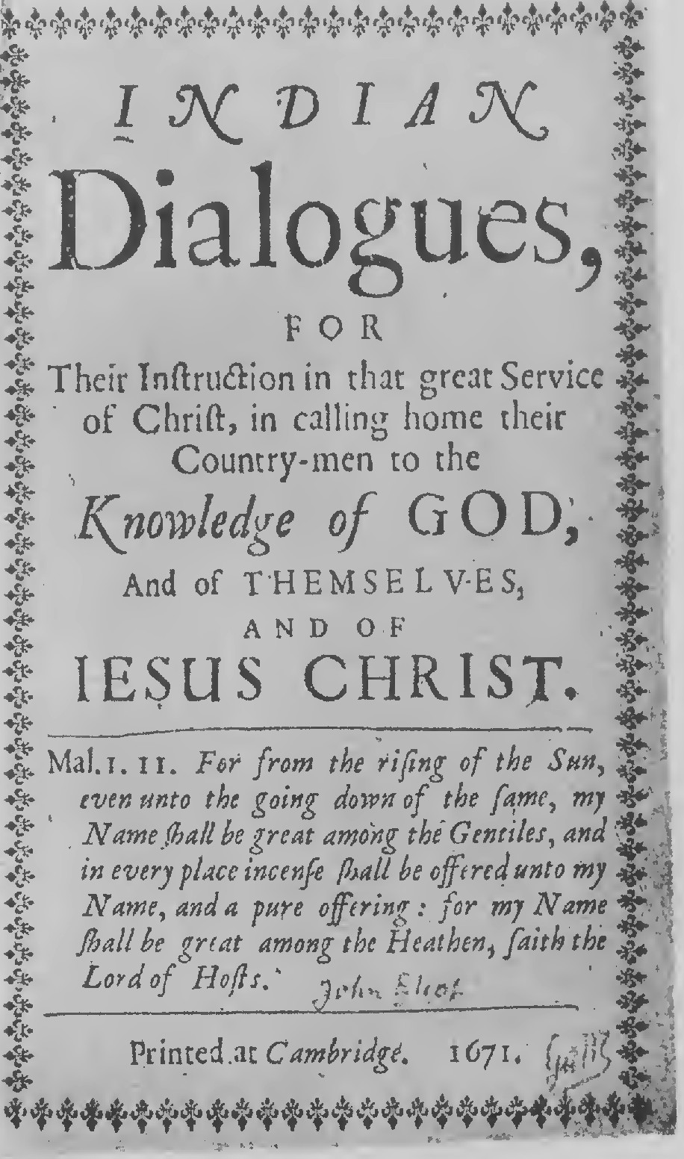
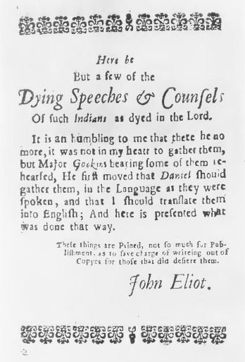
•

The foregoing letters furnish a nearly continuous narrative of the first period of Mr. Eliot's missionary labors among the Indians, from the laying out of the new town at Natick in 1650, to the summer of 1657. They are interesting exa1nples of his epistolary style, and they show his devotion to the great work he had undertaken. They also supply several new facts of interest which seem not to have been pub­ lished before.
The subsequent progress of Mr. Eliot's work in translation and printing for the Indians may be briefly outlined. In 1658, having finished his translation of the Bible, he petitioned the Corporation in England to have it printed. In the latter part of 1659 the printing of the New Testament was begun, and in 1661 it was finished. The whole Bible was con1pleted at the press in 1663. In 1664, a translation into Indian of Baxter's Call to the Unconverted was published, and in 1665 a translation of Bayly's Practice of Piety. In 1666, .Mr. Eliot printed his Indian Grammar, and in 1669, the Indian Primer. In 1671, the Indian Dialogues appeared, and in 1672, the Logick Primer. In 1680 a new edition of the Indian Bible went to press, which was completed in 1685. A second edition of Bayly's Practice of Piety also came out in 1685, and in the same year or the year following, the little tract called The Dying Speeches of several Indians. In 1688, the Indian version of Baxter's Call

27

Facsimile Title of Eliot's Translation of Baxter's Call to the Unconverted 1688

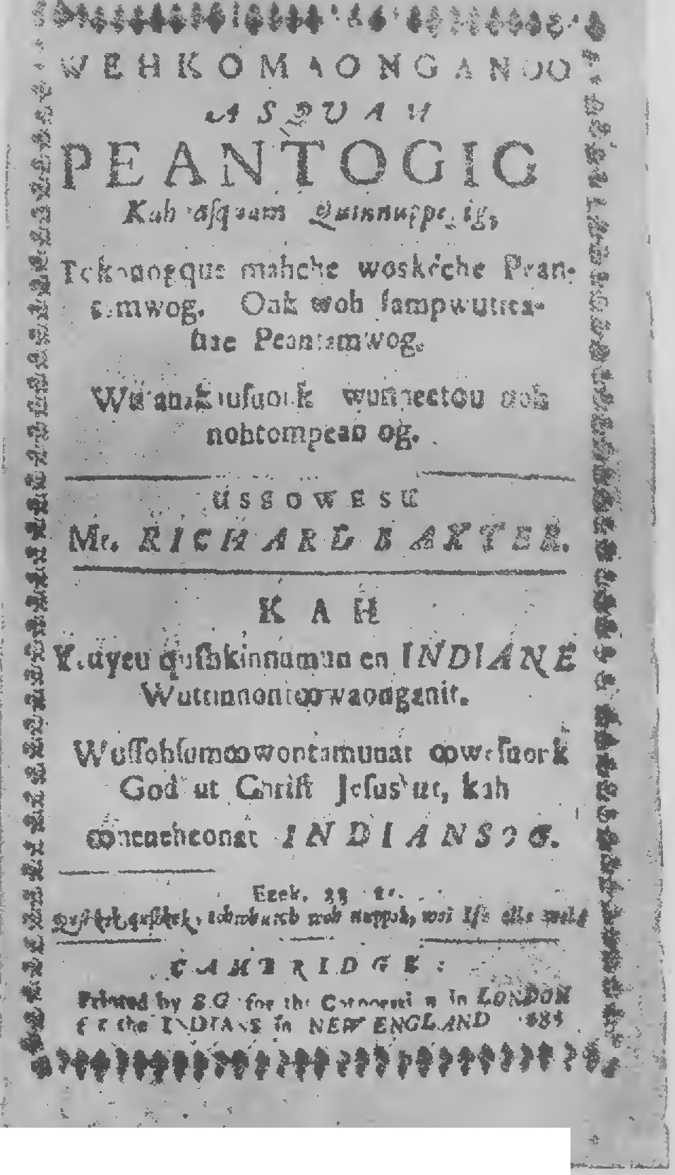
.
.:i
. .
..e........- ,. ,... ....... l,.,1. ,,

Facsimile Title of Eliot's Translation of

Shepard's Sincere Convert 1689

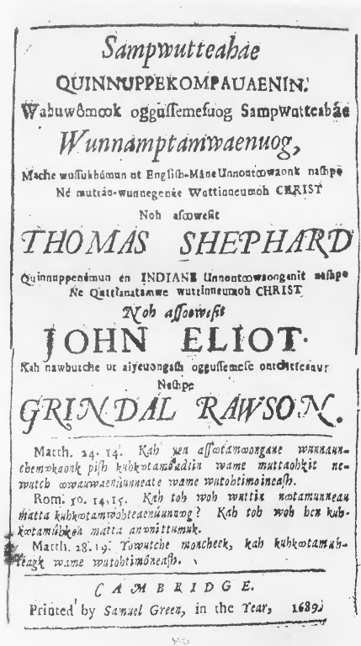

to the Unconverted was reprinted, and in 1689 a translation of Shepard's Sincere Convert. This was the last of Mr. Eliot's publications. He died at Roxbury, May 21, 1690, in the eighty-sixth year of his age.
Further details about Mr. Eliot's labors among the Indians, and the earlier attempts to convert them, will be found in the series of eleven narratives published in London from 1643 to 1671, and generally known as the ELIOT INDIAN TRACTS. Their titles are as follows:

- New Englands First Fruits; in respect, First of the Conversion of some, Conviction of divers, Preparation of sundry of the Indians.
2. Of the progresse of Learning, in the Colledge at Cambridge in Massacusets Bay . . . London, Printed by R. 0. and G. D. for Henry Overton, 1643. Quarto, pp. (2), 26, (1).

- The Day-Breaking, if not the Sun-Rising of the Gospel with the Indians in New-England. London, Printed by Rich. Cotes, for Fulk Clifton, 1647. Quarto, pp. (2), 25.

- The Clear Sun-shine of the Gospel breaking forth upon the In­ dians in New-England . . . By Mr. Thomas Shepard Minister
. . . at Cambridge in New-England. London, Printed by R.
Cotes for John Bellamy, 1648. Quarto, pp. (14), 38.

28

Facsimile Title of Glorious Progress 1649

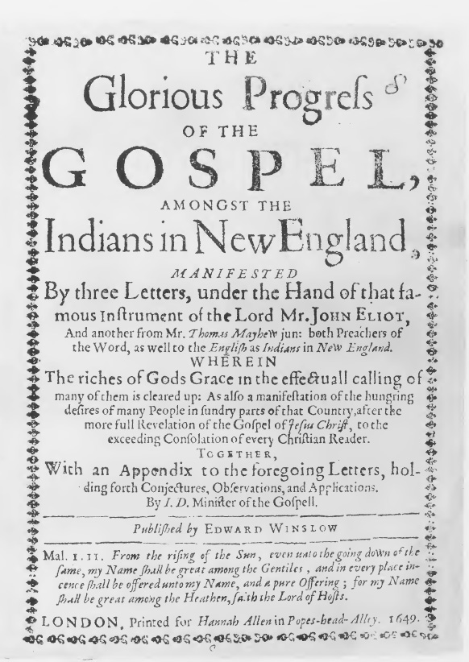

- The Glorious Progress of the Gospel, amongst the Indians in New England. Manifested By three Letters, under the Hand of that famous Instrument of the Lord Mr. John Eliot, And another from Mr. Thomas Mayhew jun. both Preachers of the Word, as well to the English as Indians in New England . . . Published by Edward Winslow. London, Printed for Hannah Allen, 1649. Quarto, pp. (8), 28.

- The Light appearing more and more towards the perfect Day. Or, A farther Discovery of the present state of the Indians in New­ England, Concerning the Progresse of the Gospel amongst them. Manifested by Letters from such as_preacht to them there. Pub­ lished by Henry Whitfield, late Pastor . . . at Gilford in New­ England, who came late thence. London, Printed by T. R.& E. M. for John Bartlet, 1651. Quarto, pp. (8), 46. Two editions or issues, with title variation.

- Strength out of Weaknesse; or a Glorious Manifestation of the further Progresse of the Gospel among the Indians in New-Eng­ land. Held forth in Sundry Letters from divers Ministers and others to the Corporation established by Parliament for promoting the Gospel among the Heathen in New-England . . . Pub­ lished by the aforesaid Corporation. London; Printed by M. Simmons for John Blague and Samuel Howes, 1652. Quarto, pp. (16), 40. Four editions were printed.
29

Facsimile Title of Tears of Repentance 16 5 3

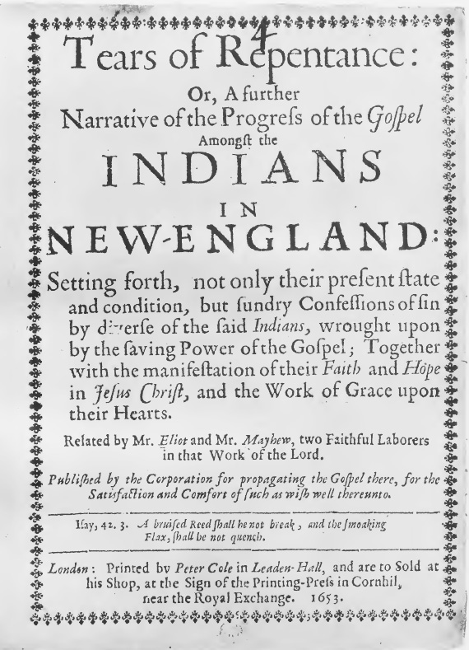

Facsimile Title of
Late and Further Manifestation 165 5

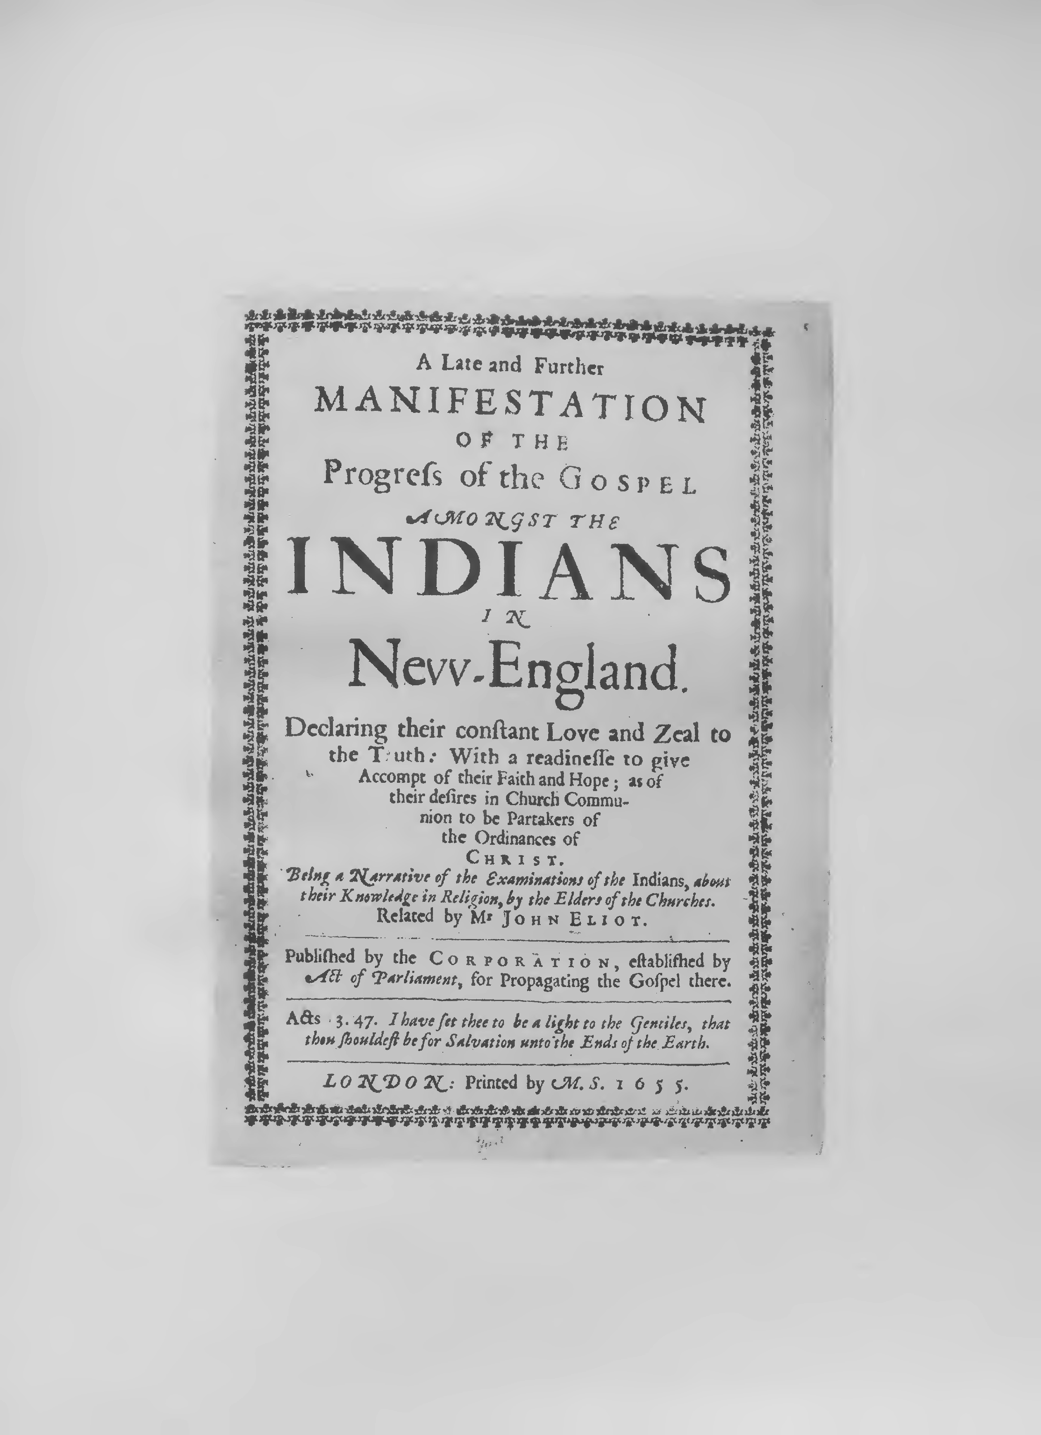

- Tears of Repentance: Or, A further Narrative of the Progress of the Gospel Amongst the Indians in New-England: Setting forth, not only their present state and condition, but sundry Confessions of sin by diverse of the said Indians . . . Related by Mr. Eliot and Mr. Mayhew, two Faithful Laborers in that Work of the Lord. Published by the Corporation for propagating the Gospel there . . . London: Printed by Peter Cole, 1653. Quarto, pp. (36), 47. Two editions.

- A Late and Further Manifestation of the Progress of the Gospel amongst the Indians in New-England . . . Being a Narrative of the Examinations of the Indians, about their Knowledge in Re­ ligion, by the Elders of the Churches. Related by Mr. John Eliot. Published by the Corporation, established by Act of Parliament, for Propagating the Gospel there. London: Printed by M. S., 1655. Quarto, pp. (8), 23.

- A further Accompt of the Progresse of the Gospel amongst the Indians in New-England and of the means used effectually to ad­ vance the same. Set forth in certaine Letters sent from thence declaring a purpose of Printing the Scriptures in the Indian Tongue into which they are already Translated. . . . . London, Printed
by M. Simmons for the Corporation of New-England, 1659. Quar­ to, pp. (11), 35, (1).
30

Facsimile Title of
A Further Account 1660

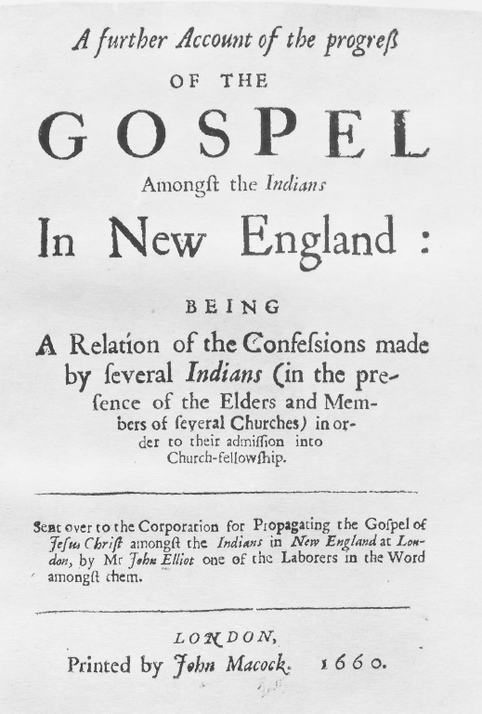

Facsimile Title of

Brief Narrative 1671

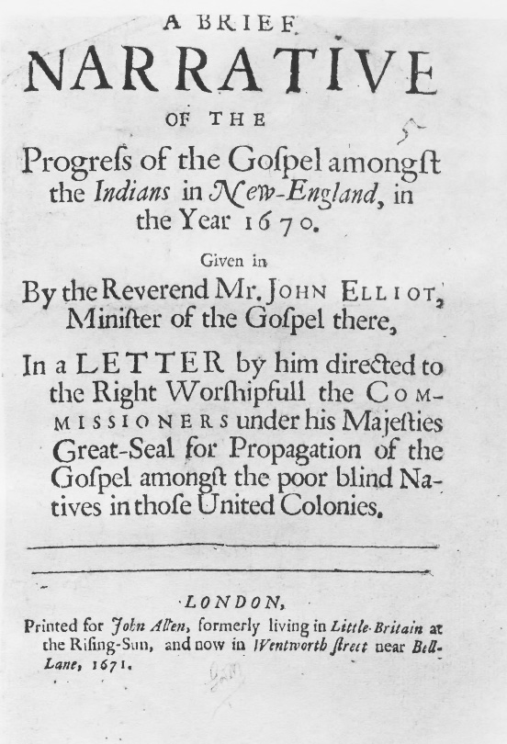
-

- A further Account of the progress of the Gospel Amongst the In­ dians In New England: being A Relation of the Confessions made by several Indians (in the presence of the Elders and Members of several Churches) in order to their admission into Church-fellow­ ship. Sent over to the Corporation for Propagating the Gospel of Jesus Christ amongst the Indians in New England at London, by Mr. John Elliot one of the Laborers in the Word amongst them. London, Printed by John Macock, 1660. Quarto, pp. (8), 76, (2).

- A Brief Narrative of the Progress of the Gospel amongst the In­ dians in New-England, in the Year 1670. Given in By the Rever­ end Mr. John Elliot, Minister of the Gospel there. In a Letter by him directed to the Right Worshipfull the Commissioners under his Majesties Great-Seal for Propagation of the Gospel amongst the poor blind Natives in those United Colonies. London, Printed for John Allen, 1611. Quarto, pp. 11.

31

