A CONTEXTUAL ANALYSIS OF PSALMS 107-118

by

Barry Craig Davis

B.A., University of Hawaii, 1968
M.Div., Western Conservative Baptist Seminary, 1971
Ph.D., University of Southern California, 1976
Th.M., Talbot School of Theology, 1989

A DISSERTATION

Submitted to the Faculty
in partial fulfillment of the requirements
for the degree of
DOCTOR OF PHILOSOPHY
at Trinity Evangelical Divinity School

Deerfield, Illinois
June 1996

ABSTRACT

Psalms research has undergone many changes in recent years.
One method of analysis that has been on the ascendency is the
literary method, especially as it applies to the structure and
context of groups of psalms. This dissertation fits into that
classification.
Specifically, this study seeks to demonstrate that there
are intentional--and not just accidental or random--lexical and
thematic links among the psalms of the Psalms 107-118 corpus and
that the corpus as a whole exhibits a coherent and unified
structure. This dissertation compares the lexemes of each psalm
with those of the other 11 psalms, in order to differentiate
among key-lexeme links, thematic-lexeme links, and incidental-
lexeme links. This study also traces the 3 primary thematic
threads that run throughout the corpus--the need for God's
people to honor Him, God's ability to deliver His people from
distress, and God's dominion over the created order.
This dissertation reveals that, within the Psalms 107-118
corpus:

iii

1. Psalms that are closer to each other tend to share a
greater number of key- and thematic-lexeme links than do psalms
that are farther apart;
2. Key- and thematic-lexeme links occur primarily in 3
areas: praise, distress and deliverance, and God's character;
3. Two of the major themes--God deserves praise and God
delivers His people from distress--appear in at least 10 psalms;
the third--God dominates over the created order--appears in a
minimum of 6 psalms; and
4. The structure of the corpus is tightly knit, with
Psalms 107 and 118 forming an inclusio of thanksgiving around
the corpus, with Psalms 108-110 being linked by Davidic
superscriptions, with Psalm 114 linking the hallelujah (hy vllh)
rubric psalms (Psalms 111-113) to the hallelujah (hy-vllh)
colophon psalms (Psalms 115-117), and with Psalms 113-118
comprising a sequence of psalms known as the Egyptian Hallel
used in Israel's worship.
In conclusion, this dissertation demonstrates that the
literary approach is a valid method by which to study a series
of psalms in order to assess the significance of lexical,
thematic, and structural linkages.

iv

TABLE OF CONTENTS

ABSTRACT iii
LIST OF ILLUSTRATIONS xi
ACKNOWLEDGEMENTS xii
Chapter
1. INTRODUCTION 1
Importance of the Study 1
Problem of the Study 6
Scope of the Study 7
Text of the Study 11
Assumptions of the Study 13
Overview of the History of Psalm-Sequence
Analysis 16
Methodology of the Study 22
General Analyses 23
Structural Analysis 37
Plan of the Study 28
2. THE TEXTS IN CONTEXT 29
Psalm 107 in Context 31
Introduction to Psalm 107 31
Psalms 107 and 108 33
Psalms 107 and 109 40
Psalms 107 and 110 45
Psalms 107 and 111 47
Psalms 107 and 112 50
Psalms 107 and 113 53

v

Psalms 107 and 114 55
Psalms 107 and 115 57
Psalms 107 and 116 59
Psalms 107 and 117 62
Psalms 107 and 118 63
Psalm 107--A Retrospective 67
Psalm 108 in Context 76
Introduction to Psalm 108 76
Psalms 108 and 109 78
Psalms 108 and 110 83
Psalms 108 and 111 85
Psalms 108 and 112 87
Psalms 108 and 113 90
Psalms 108 and 114 91
Psalms 108 and 115 93
Psalms 108 and 116 95
Psalms 108 and 117 97
Psalms 108 and 118 99
Psalm 108--A Retrospective 102
Psalm 109 in Context 109
Introduction to Psalm 109 119
Psalms 109 and 110 110
Psalms 109 and 111 113
Psalms 109 and 112 115
Psalms 109 and 113 119
Psalms 109 and 114 121

vi
Psalms 109 and 115 123
Psalms 109 and 116 126
Psalms 109 and 117 129
Psalms 109 and 118 131
Psalm 109--A Retrospective 136
Psalm 110 in Context 143
Introduction to Psalm 110 143
Psalms 110 and 111 148
Psalms 110 and 112 150
Psalms 110 and 113 152
Psalms 110 and 114 155
Psalms 110 and 115 156
Psalms 110 and 116 158
Psalms 110 and 117 159
Psalms 110 and 118 160
Psalm 110--A Retrospective 162
Psalm 111 in Context 169
Introduction to Psalm 111 169
Psalms 111 and 112 170
Psalms 111 and 113 177
Psalms 111 and 114 179
Psalms 111 and 115 181
Psalms 111 and 116 185
Psalms 111 and 117 187
Psalms 111 and 118 189
Psalm 111--A Retrospective 192

vii

Psalm 112 in Context 198
Introduction to Psalm 112 198
Psalms 112 and 113 199
Psalms 112 and 114 201
Psalms 112 and 115 203
Psalms 112 and 116 207
Psalms 112 and 117 209
Psalms 112 and 118 210
Psalm 112--A Retrospective 216
Psalm 113 in Context 223
Introduction to Psalm 113 223
Psalms 113 and 114 224
Psalms 113 and 115 226
Psalms 113 and 116 230
Psalms 113 and 117 234
Psalms 113 and 118 236
Psalm 113--A Retrospective 237
Psalm 114 in Context 244
Introduction to Psalm 114 244
Psalms 114 and 115 245
Psalms 114 and 116 248
Psalms 114 and 117 250
Psalms 114 and 118 251
Psalm 114--A Retrospective 253
Psalm 115 in Context 259
Introduction to Psalm 115 259

viii

Psalms 115 and 116 260
Psalms 115 and 117 266
Psalms 115 and 118 268
Psalm 115--A Retrospective 273
Psalm 116 in Context 281
Introduction to Psalm 116 281
Psalms 116 and 117 282
Psalms 116 and 118 283
Psalm 116--A Retrospective 286
Psalm 117 in Context 291
Introduction to Psalm 117 291
Psalms 117 and 118 291
Psalm 117--A Retrospective 293
Psalm 118 in Context 297
Introduction to Psalm 118 297
Psalm 118--A Retrospective 298

3. SUMMARY, CONCLUSIONS, AND IMPLICATIONS 306
Summary 306
Conclusions 308
General Findings 308
Lexical Findings 309
Thematic Findings 311
Structural Findings 314
Structural and Thematic Development 320
Overall Conclusion 335

ix
Implications 336
Doctrine of Inspiration 336
Psalms Research 344

Appendix
A. FREQUENCY OF POTENTIALLY SIGNIFICANT
LEXEMES FOUND IN PSALMS 107-118 354
B. PSALMS 107-118: LEXEME FREQUENCY TABLES 356
Psalm 107 357
Psalm 108 395
Psalm 109 408
Psalm 110 436
Psalm 111 444
Psalm 112 455
Psalm 113 465
Psalm 114 475
Psalm 115 482
Psalm 116 504
Psalm 117 525
Psalm 118 529
C. PSALMS 107-118: SUMMARY OF LEXEME
FREQUENCY DATA BY PSALM 565
D. PERCENTAGE OF DISCRETE LEXICAL UNITS OF
A GIVEN PSALM REPLICATED IN AT LEAST
ONE OTHER PSALM OF THE PSALMS 107-118
CORPUS 568
BIBLIOGRAPHY 569

x

LIST OF ILLUSTRATIONS

Figure Page
1. Identification of psalms containing one or
more of the primary themes of the
Psalms 107-118 corpus 312
2. Overall structure of the Psalms 107-118 corpus 315
3. Internal connections between the hallelujah
(hy vllh) rubric psalms and the hallelujah
(hy-vllh) colophon psalms 316
4. Psalm 110 as a thematic unifier of Psalms 107-113 319

xi

ACKNOWLEDGEMENTS

God is gracious. He brings into our lives all that is
required to meet our needs--and then He blesses us still more.
In regard to this dissertation, He has more than met my needs.
He has given me the opportunity to study His Word and He has
brought alongside of me many people who have been gracious like
their heavenly Father in helping me to complete this work. The
following is but a meager way to acknowledge the contribution
that those chosen servants of God have made.
No dissertation would be complete without a first reader--
someone willing to take the brunt of faulty thinking and poor
writing, while managing to maintain sanity in his own life and
to give structure to the dissertation itself. In the case of
this dissertation, Dr. David M. Howard, Jr., made that
sacrifice. Fortunately, Dr. Howard not only understands the
rigors of dissertation work, but also has the compassion to
offer encouragement and much needed help--a rare combination, to
be sure. Dr. Howard, moreover, went beyond the call of duty,
returning draft copies of the dissertation with amazing speed
and yet, at the same time, with insightful comments regarding
content, organization, style, and grammar. Without his

xii

guidance, this dissertation would have been a far poorer
composition.
Dissertations also require second readers. Dr. Dennis R
Magary graciously volunteered for that role. His support and
encouragement have also helped to move this dissertation along
to its conclusion.
Within the Ph.D. office of Trinity Evangelical Divinity
School, three people also deserve to be recognized: Dr. Douglas
J. Moo, Director, Ph.D. in Theological Studies, who gave
guidance to the overall dissertation process and who presided at
the dissertation defense; Dr. James Moore, who oversaw the
scheduling and formatting of the dissertation; and Mr. (soon-to-
be Dr.) Gunther H. Juncker, who read through the dissertation to
ensure that it complied with the Ph.D. office guidelines.
Finally, there are my family and my friends. These have
helped me in ways--in good ways--that are beyond words to
express.
My sincerest thanks go out to all of these wonderful
people.

To the one who declared:
ytxrb hylf Mdxv Crx ytyWf yknx
:ytyvc Mxbc-lkv Mymw vFn ydy ynx
(Isa 45:12)
and yet who has shown an interest in my life
--to Him be all glory, praise, and honor.

xiii

CHAPTER 1

INTRODUCTION

Importance of the Study

Throughout the years, interest in the study of the Hebrew
Psalter has risen and waned as new theories and methods for
analysis are proposed, applied, and then set aside when newer
approaches are developed and tried. According to Stek, this
lack of consistent commitment to the study of the Psalms may be
due “on the one hand, to overriding devotional, homiletical,
theological and religious (history of religions, comparative
religions) interests in this literature; and, on the other hand,
to the fact that professional students of the OT texts, while
receiving (more or less adequate) training in languages,
history, theology, and religion, have not been trained in the
aesthetic aspect of OT literature--or any literature, for that
matter.”¹
_________________
¹John H. Stek, "The Stylistics of Hebrew Poetry: A
(Re)New(ed) Focus of Study," Calvin Theological Journal 9 (April
1974): 15. Stek's lament is made as a general reference to the
field of Hebrew (OT) poetry--"its prosody, rhetoric (including
rhetorical conventions), and architectonic forms"--but may,
quite logically, be applied to the study of the Hebrew Psalter,
the most extensive gathering of Hebrew poetry in the Old
Testament. Broadribb concurs that, generally speaking, there
has been a fragmented approach to the study of Hebrew poetry
with few significant discoveries and "little attempt at a
systematic analysis of Hebrew poetry as a whole, such as
1
2
Yet, despite the inconsistent appreciation that scholars
have exhibited toward the Psalms, the value of interacting with
the words of the ancient Hebrew poets cannot be denied. Wilson
makes that point abundantly clear when, in regard to Psalm 1
(which many agree functions as an introductory psalm to set the
tenor for the reading of the entire Psalter),² he declares
that "[t]he whole chiastic and antithetical structure of Psalm 1
points up the absolute seriousness with which one should
approach the Psalter. It is a matter of life and death, not
casual acquaintance. It calls for a lifetime of study, not
casual acquaintance."³
Despite the importance of the Psalter as a guide for living
and even simply as an ancient literary work worthy of study,
there is a dearth of materials of a critical nature that address
certain significant segments of the Psalter. For example, few
technical works of an extensive nature exist on the various
_________________
characterized the work of Lowth." He continues: "In
consequence, it can be said that general agreement on the
structure of Hebrew poetry is little more advanced than it was
two or three centuries ago." Donald Broadribb, "A Historical
Review of Studies of Hebrew Poetry," Abr-Nahrain 13 (1972-73):
84. Fortunately, however, subsequent to Broadribb's review,
numerous book-length works--both technical and popular--on the
Psalter have found their way into print, as the bibliography to
this treatise reveals.
²Brevard S. Childs, Introduction to the Old Testament as
Scripture (Philadelphia: Fortress Press, 1979), 512-13; Hans-
Joachim Kraus, Psalms 1-59: A Commentary, trans. Hilton C.
Oswald (Minneapolis: Augsburg Publishing House, 1988), 113-14.
³Gerald H. Wilson, "The Shape of the Book of Psalms,"
Interpretation 46 (April 1992): 137.

3
psalms of Book V (i.e., Psalms 107-150); and of those that do
exist, very few expound the psalms that form the basis of this
study (i.e., Psalms 107-118).
A current search for works on psalms and psalms-related
topics reveals little interest in the content, much less on the
structure, of any of the psalms in the Psalms 107-118 corpus,
apart from a focus on the Messianic issue associated with Psalm
110 and a general concern with the contents of Psalm 118.
Furthermore, although certain studies assess the structure of
individual psalms throughout the Psalter,⁴ few have sought to
discover whether or not literary or thematic structures reveal
any evidence of editorial activity between 2 juxtaposed
psalms.⁵ Recently, however, a ground-breaking effort by
_________________
⁴See for example Robert L. Alden, "Chiastic Psalms (III):
A Study in the Mechanics of Semitic Poetry in Psalms 101-150,"
Journal of the Evanaelical Theological Society 21 (1978): 199-
210; Pierre Auffret, The Literary Structure of Psalm 2, trans.
David J. A. Clines, Journal for the Study of the Old Testament:
Supplement Series 3 (Sheffield: JSOT, 1977); numerous articles
in Pierre Auffret, La Sagesse a Bâti sa Maison: Études de
Structures Littéraires dans l'Ancien Testament et Spécialement
dans les Psaumes (Fribourg: Éditions Universitaries, 1982);
David Noel Freedman, Pottery, Poetry, and Prophecy (Winona Lake,
Ind.: Eisenbrauns, 1980); David Noel Freedman and C. Franke
Hyland, "Psalm 29: A Structural Analysis," Harvard Theological
Review 66 (1973): 237-56; Walter Vogels, "A Structural Analysis
of Ps 1," Biblica 60 (1979): 410-16; Dennis Pardee, "Structure
and Meaning in Hebrew Poetry: The Example of Psalms 23," in
Sopher Mahir: Northwest Semitic Studies Presented to Stanislav
Segert, ed. Edward M. Cook (Winona Lake, Ind.: Eisenbrauns,
1990), 239-80.
⁵There is a growing (though not yet extensive) body of
literature that addresses the question of editorial impact on
the Psalter. See David M. Howard, Jr., "Editorial Activity in
the Psalter: A State-of-the-Field Survey," in The Shape and
4
Howard on Psalms 93-100 offers an in-depth structural analysis
of a group of psalms larger than a dyad.⁶ His work in Book IV
of the Psalter has been the impetus for a dissertation by Suhany
on the psalms of Book III (i.e., Psalms 73-89), as well as for
this current study.⁷
Only 1 published work to date attempts an in-depth,
comparative analysis the literary structure of 1 psalm in Psalms
107-118 with that of another psalm in the same corpus. That
work, by Pierre Auffret, which is an analysis of Psalms 111-112
(the 2 acrostic psalms of the corpus), emphasizes the
_________________
Shaping of the Psalter, ed. J. Clinton McCann, Journal for the
Study of the Old Testament Supplement Series, 159 (Sheffield:
JSOT, 1993), 52-70. Brennan's work on Book V of the Psalter
(Psalms 107-150) provides an overview of the basic thematic
interrelationships among the various psalms. Joseph P. Brennan,
"Some Hidden. Harmonies in the Fifth Book of Psalms," in Essays
in Honor of Joseph P. Brennan, ed. Robert F. McNamara
(Rochester, N.Y.: Saint Bernard's Seminary, 1976), 126-58.
⁶David Morris Howard, Jr., "The Structure of Psalms 93-
100" (Ph.D. diss., University of Michigan, 1986), forthcoming as
The Structure of Psalms 93-100, University of California at San
Diego Biblical and Judaic Series 5 (Winona Lake, Ind.:
Eisenbrauns). Subsequent to his dissertation, Howard has
completed additional work on Psalms 90-94. David M. Howard,
Jr., "A Contextual Reading of Psalms 90-94," in The Shape and
Shaping of the Psalter, ed. J. Clinton McCann (Sheffield: JSOT,
1993), 108-23.
The term "dyad" (here and passim in this dissertation) is
used simply to reference any set of 2 psalms, whether or not
those psalms occur sequentially in the text. The term does not
convey any further meaning, as might be the case in various of
the other sciences.
⁷Alan Michael Suhany, "Unity and Theme in the Third Book
of the Psalter" (Ph.D. diss., Trinity Evangelical Divinity
School, in progress).
5
interconnections between the 2 psalms based on an assessment of
the significant words that are repeated within and across those
2 psalms.⁸ Auffret draws the following conclusion: "Ainsi les
deux psaumes manifestent-ils leur complémentarité en attribuant
aux mots récurrents qui à chacun appartiennent en propre des
fonctions très comparables comme indices de leurs structures
littéraires respectives."⁹
This study, therefore, seeks to provide an additional piece
of information to the recently begun effort to close the
knowledge gap that exists relative to a structural and an
exegetical understanding of Psalms 107-118.

_________________
⁸Pierre Auffret, "Essai sur la Structure Littéraire des
Psaumes CXI et CXII," Vetus Testamentum 30 (July 1980): 257-79.
To date, not even Auffret, who has executed extensive structural
analyses of numerous psalms in the Psalter, has focused any
attention on Psalms 107-118 (apart from the work just cited).
See Pierre Auffret, La Saaesse a Bâti sa Maison. Lohfink,
however, does provide a brief comparison between Psalm 114 and
Psalm 115 as the 2 psalms are presented by the MT and the LXX
and then discusses the lexical and semantic connections between
the 2 psalms. Norbert Lohfink, "Ps 114/115 (M und G) und die
deuteronomische Sprachwelt," in Freude an der Weisuna des Herrn:
Beiträge zur Theologie der Psalmen: Festgabe zum 70. Geburststag
von Heinrich Groß, eds. Ernst Haag and Frank-Lothar Hossfeld
(Stuttgart: Katholisches Bibelwerk GmbH, 1986), 199-205.
⁹"Thus the 2 psalms manifest their complementarity while
attributing to the recurring words which belong to each in its
own right the very comparable functions as indices of their
respective literary structures." Auffret, "Essai sur la
Structure Littéraire des Psaumes CXI et CXII," 279.
This translation and all others within this dissertation
are mine unless otherwise specified.
6
Problem of the Study
The primary purpose of this study is to demonstrate that
there are intentional--and not just accidental or random--
lexical and thematic links among the psalms of the Psalms 107-
118 corpus and that the corpus as a whole exhibits a coherent
and unified structure. In doing so, this dissertation traces
the 3 primary thematic threads that run throughout the corpus--
the need for God's people to offer Him praise and thanksgiving
for who He is and for what He has done, God's ability to deliver
His people from their distress, and God's dominance over the
created order. This study identifies those themes by means of
lexical, structural, and contextual analyses. As a
consequence, this study generates several important results:
1. An identification of the textual context of the various
psalms severally and jointly;
2. A picture of the lexical and thematic contours across
the face of the Psalms 107-118 corpus;
3. Data regarding structural, content, and thematic
relationships among the psalms under study; and
4. Information regarding possible editorial activity in
the arrangement of the psalms in question.
The findings of such a study should be beneficial in
understanding both the meaning of the individual psalms of the
Psalms 107-118 corpus and the function of each psalm within the
first segment of Book V of the Psalter. Furthermore, the

7
determination of the presence of editorial activity would
suggest an underlying intent that guided the development of the
final product, i.e., the canonical text. The recognition of the
existence of such an intent would have far-reaching implications
on the exegesis of Psalms 107-118. Even greater than the impact
that the compilation of the psalms into their present order has
on how these psalms are to be understood, the imprint of an
editorial hand would signify that the canonical psalms need to
be understood in their literary context rather than as a product
of some historical event. The psalms then should be read
sequentially as chapters in a book, their contextual meaning
being derived from their association with the Psalter as a whole
and, in particular, with the remaining psalms in the corpus of
which they are a part.
Scone of the Study
The present study focuses specifically on the first 12
psalms of Book V of the Psalms, i.e., Psalms 107-118. The
grouping of these psalms together, however, runs counter to
Wilson's position that Psalm 118 belongs with the subsequent
corpus that ranges from Psalm 118 to Psalm 135.¹⁰ Wilson bases
his argument on the presence of vdvh (give thanks) at the
beginning of Psalm 118, which he maintains functions within Book
_________________
¹⁰Whether the Psalms 118-135 (or even Psalms 119-135)
grouping is correct is a matter of debate which goes beyond the
scope of this paper.

8
V as an editorial marker to identify the first psalm of a
corpus.¹¹
In contrast to Wilson's strong argument for the exclusion
of Psalm 118 from the corpus under study, the following 4
arguments are posited. Taken together, these arguments outweigh
Wilson's view:
1. Psalm 118:29 forms an inclusio with Ps 107:1 to
delimit the boundaries of the corpus.¹² Both verses contain
_________________
¹¹Wilson maintains that Psalm 118 does not belong to the
Psalms 107-118 corpus but rather is the first psalm in the
following corpus, which he understands to run from Psalm 118 to
Psalm 135. Wilson, summarizes the thrust of his reasoning in the
following statement:
A single qualification needs to be made apropos the
evidence of MT. Taking Pss 104-105-106-107 as the point of
departure, it becomes clear that MT makes a slightly
different use of hllwyh and hwdw pss at the conclusion of a
segment of MT Psalter. With the addition of Ps 107, however,
the picture changes considerably.
104 hllwyh
105 hllwyh
106 hllwyh-hwdw doxology-hllwyh
107 hwdw
Here we have the addition of another ps beginning with
the characteristic hwdw phrases. One would expect this ps to
form part of the conclusion to the preceding segment. But
the doxology at the end of Ps 106, marking the end of Book
Four, clearly makes this impossible. Does this supply the
key to understand the position of Pss 118 and 136 as well?
Both immediately follow hllwyh groupings. The situation with
Ps 107 would seem to indicate that these pss (118 and 136) do
not form part of the conclusion, but introduce the segment
which follows.
Gerald Henry Wilson, The Editing of the Hebrew Psalter
(Chico, Calif.: Scholars, 1985), 129.
¹²Psalm 118:29 forms an obvious inclusio with Ps 118:1.
This fact does not negate the possibility of Ps 118:29 having
double-duty responsibility as the concluding component of an
9
exactly the same words: nom vdsH Mlvfl yk bvF-Yk hvhyl vdh¹³
(Give thanks to the LORD because He is good--because His
lovingkindness is forever!).
2. Psalm 118 has a history of being combined (though not
exclusively) with psalms that precede rather than follow it--in
the so-called "Egyptian Hallel" (Psalms 113-118)¹⁴ and in
connection with what are termed the hallelujah (hy vllh) psalms
(Psalms 111-118).¹⁵
_________________
inclusio with Ps 107:1. If anything, the existence of 2 verses
in Psalm 118 that parallel Ps 107:1 should arrest the attention
of astute readers of the Psalter, drawing their thoughts back to
that earlier verse.
¹³There is, however, a spelling variation that occurs
between the first word of each of the 2 verses. Psalm 107:1
reads vdh (using the simple holem) whereas Ps 118:29 follows
the plene (or full) reading of holem waw, i.e., vdvh. Such a
variation, however, in no way affects the present argument.
¹⁴Psalms 113-118 are traditionally read in connection with
the Festival of Passover. Craigie accords to them an equal
status as a collection of psalms as he does to those psalms that
are grouped together by author as a consequence of their
superscriptions, e.g., the Psalms of David, of Asaph, and of the
Sons of Korah. Peter C. Craigie, Psalms 1-50, Word Biblical
Commentary 19, ed. David A. Hubbard and Glen W. Barker
(Aylesbury, UK: Word [UK] Ltd., 1986), 28-29.
¹⁵Wilson acknowledges the existence of both of these
groupings. Yet, he observes from various Qumran Codices that
Psalm 118 is at times paired with Psalm 117 and at times with
Psalm 119. Wilson, The Editing of the Hebrew Psalter, 134, 135,
179, 220. In this regard, Skehan finds a Qumran manuscript, 4Q
Ps^{b}, to contain in canonical order portions of psalms beginning
at 91:5 and ending with 118:26 (with a space indicator
suggesting that the psalm originally contained the now missing
verses, 27-29), but giving no indication that Psalm 119 had also
been attached (note, however, that from this manuscript, Psalms

10
3. Although Psalms 107, 118, and 119 make extensive use of
the term dsH (lovingkindness), Psalms 107 and 118 utilize the
term differently than does Psalm 119.¹⁶ The 2 psalms of the
present corpus recognize God's dsH (lovingkindness) as a reason
for giving praise and thanks to God. Psalm 119, however,
presents God's dsH (lovingkindness) as the way in which the
individual speaker in the psalm desires to be dealt with by God,
rather than as a grounds for his praising God.
4. The subject matter of Psalms 107-118 is significantly
different from that of Psalm 119. The corpus under study
focuses on God's ability to deliver His people from distress and
on the importance of God receiving honor from the individual,
the community, and the world. By contrast, Psalm 119 emphasizes
_________________
104-111 are also missing). Patrick W. Skehan, "A Psalm
Manuscript from Qumran (4Q Ps^{b})," The Catholic Biblical
Quarterly 26 (July 1964): 313-22. Furthermore, BHS notes that
many manuscripts combine Psalms 117 and 118 into 1 psalm, but
makes no similar reference for the combination of Psalms 118 and 119.
Westermann, however, argues (without manuscript support)
that the Psalms 120-134 collection "was later added to the
collection framed by Pss. 1 and 119." Claus Westermann, Praise
and Lament in the Psalms, trans. Keith R. Crim and Richard N.
Soulen (Atlanta: John Knox Press, 1981), 255.
Interestingly, Zunz notes that the Midrash Tehillim was
edited in its present form through Psalm 118 during the second
half of the 9th century, C.E., and that the rabbinic
incorporation of the remaining psalms (i.e., Psalms 119-150)
into that work occurred at a much later date. Zunz-Albeck, Die
gottesdienstliche Vorträge der Juden, 2d ed. (Frankfurt: n.p.,
1982), 375. See also the Introduction to The Midrash on Psalms,
2 vols., trans. William G. Braude, Yale Judaica Series 13, ed.
Leon Nemoy (New Haven: Yale University, 1959), xxvii-xxviii.
¹⁶Psalms 107:1, 8, 15, 21, 31; 118:1, 2, 3, 4, 29; 119:41,
64, 76, 88, 124, 149, 159.
11
the importance of the Word of God. In order to convey its basic
theme, Psalm 119 makes extensive use of such terms as hrvt
(law), hdf (testimony), Mydvqp (precepts), qH (statute), hvcm
(commandment), Fpwm (ordinance), and tmx-rbd (word of truth).
For the most part, these lexemes or phrases are missing from the
Psalms 107-118 corpus.¹⁷

Text of the Study
The current study is a literary analysis of Psalms 107-118,
from the perspective of the Masoretic Text (MT) itself. As
such, the study does not attempt to reconstruct either the
actual historical events described in the psalms themselves
(except as those events may be portrayed within the texts) or
the factors that may have motivated the authors, editors, or
compilers of the various psalms to proceed with the shaping of
these literary compositions.¹⁸
_________________
¹⁷The frequency of occurrence of the terms used in Psalm
119 as descriptive of the Word of God is as follows--the first
number being the total of instances in the Psalms 107-118 corpus
(which consists of 200 verses), the second number being the
total number of incidences in Psalm 119 (which consists of 176
verses): hrvt--0, 25; hdf--0, 14; Mydvqp--1, 21; qH--0, 21;
hvcm-1, 22; Fpwm--2, 23; and tmx-rbd--0, 1 (see also Ps
119:160 in which God's word is called tmx [truth]).
¹⁸Only 3 of the psalms in the corpus under study (Psalms
108, 109, and 110) contain superscriptions that provide any
information regarding the development of the psalms. None of
those superscriptions, however, reveals much regarding the
generation of those psalms, other than that all 3 were written
by David (dvdl) and that Psalm 109 was written for the
12
Being restricted to the canonical Masoretic Text, moreover,
this study does not concern itself with any texts that may or
may not have been used in the development of individual psalms,
nor does it focus any extended attention on the materials from
Qumran.¹⁹ This study, therefore, derives its findings from an
analysis of the MT which is, as Howard points out, "at the very
least . . . a legitimate and old canonical tradition, one which
certainly reflects the official Pharisaic . . . canon of the
turn of the Christian era."²⁰ Childs accords to the MT still
further importance, stating that the MT is "the vehicle both
for recovering and for understanding the canonical text of the
Old Testament."²¹ The MT, moreover, is the text tradition that
has exerted the greatest influence over the community of
believers.

_________________
choir director (Hcnml). There is, therefore, no indication
whatsoever for any of the psalms in the corpus under study as to
what event or events formed the contextual backdrop for the
writing of those psalms.
¹⁹Wilson notes a lack of standardized sequential
arrangement of the individual psalms in the Qumran materials,
particularly in Book V of the Psalter. Gerald H. Wilson, "The
Qumran Psalms Manuscripts and the Consecutive Arrangement of
Psalms in the Hebrew Psalter," The Catholic Biblical Quarterly
45 (1983): 377, 378, 387.
²⁰Howard, "The Structure of Psalms 93-100," 31.
²¹Childs, Introduction to the Old Testament as Scripture,
97.
13
This study, however, does not accept the Masoretic Text
uncritically. When appropriate, as required by textual
analysis, textual variations are adopted that reflect a
tradition more closely approximating the original Hebrew
manuscripts than does the Masoretic Text. Yet, only 1 of those
accepted emendations has an impact on the results of this study.
That emendation is the addition of the construct noun tyb (house
of) immediately prior to the noun lxrWy (Israel) in Ps 115:9.
This emendation increases the frequency total of the lexeme tyb
(house) by 1.
Assumptions of the Study
Contemporary exegesis has been influenced by at least 3
major movements: historicism, existentialism, and
structuralism.²² As methods of understanding the Scripture,
historicism (including form criticism, tradition criticism, and
redaction criticism) and existentialism have tended to ignore
the canonical text itself, preferring to be preoccupied either
with historical and developmental trends (in the case of
historicism) or with anthropocentric concerns (in the case of
existentialism).

_________________
²²François Bovon, "French Structuralism and Biblical
Exegesis," in Structural Analysis and Biblical Exegesis:
Interpretational Essays, R. Barthes and others, trans. Alfred M.
Johnson, Jr. (Pittsburgh: Pickwick, 1974), 7.
14
By contrast, structuralism (together with its allied
disciplines of canon criticism and rhetorical criticism) focuses
its exegetical attention on the text itself. As Armerding
indicates, structuralism eschews historical and diachronic
research and finds "in the writing itself, in the relationship
of words and themes, the key to interpretation."²³ Thus the
structural critic looks at synchronic truth, locating the
meaning of Scripture in the text itself, not in the pre- or
post-history of the text.²⁴ Because of its very nature as a
structural analysis and because (as noted above) there is a lack
of historical information provided by the psalms under study
regarding their origins, this study de-emphasizes the analysis
of the history of the development and transmission of the text.
This study therefore presents a literary analysis of the various
psalms in the Psalms 107-118 corpus.²⁵

_________________
²³Carl Armerding, "Structural Analysis," Themelios 4
(April 1979): 96.
²⁴Robert Martin-Achard, "An Exegete Confronting Genesis
32:23-33," in Structural Analysis and Biblical Exegesis:
Interpretational Essays, R. Barthes and others, trans. Alfred M.
Johnson, Jr. (Pittsburgh: Pickwick, 1974), 35.
²⁵Wilson comments that the shaping of the Psalter into its
final canonical form resulted in "a collection of psalms
loosened from their 'historical moorings' and allowed to
continue to speak with power in an almost unlimited series of
circumstances in the lives of the reader." Wilson, "The Shape
of the Book of Psalms," 138. Separating the text from its
historical origins, however, does not imply that meaning is to
be sought in the horizon of the reader. Meaning (in this study)
is found in the text itself which provides sufficient clues for
understanding authorial intent.
15
Although the present study identifies itself, in part, as a
structural analysis of Psalms 107-118, it does not place itself
in the stream of contemporary French structuralism which (under
the leadership of de Saussure, Levi-Strauss, and Barthes),
emphasizes the psychological, ethnological, or mythological
understanding of the text.²⁶ Instead, the approach which this
study follows is more in the line of the rhetorical or literary
criticism advanced by such individuals as Freedman, Howard, and
Auffret.²⁷
In essence, the nature of this contextual study is part
structural, part literary. The study seeks to find in the text
of Psalms 107-118 those relationships of lexemes and themes that
are key to the interpretation of each individual psalm and to
the understanding of the interconnections of each psalm to every
other psalm in the corpus.

_________________
²⁶Bovon, "French Structuralism and Biblical Exegesis," 9-
19; Roland Barthes, "The Struggle with the Angel: Textual
Analysis of Genesis 32:23-33," in Structural Analysis and
Biblical Exegesis: Interpretational Essays, R. Barthes and
others, trans. Alfred M. Johnson, Jr. (Pittsburgh: Pickwick,
1974), 21-33.
²⁷David Noel Freedman, Pottery, Poetry, and Prophecy;
Howard, "The Structure of Psalms 93-100" and "A Contextual
Reading of Psalms 90-94," 108-23; Auffret, "Essai sur la
Structure Littéraire des Psaumes CXI et CXII," 257-79; and La
Sagesse a Bâti sa Maison.

16
Overview of the History of Psalm-Sequence
Analysis
Throughout history, many scholars have treated the Psalter
as a compilation of individual psalms that are to be exegeted
independently of each other. Typically, that exegesis centered
its efforts either in a given psalm's historical context or in
an allegorical conceptualization of the interpreter. In more
recent years, other students of Scripture have analyzed the
various psalms of the Psalter based on an assumed liturgical
function of a psalm.²⁸ Generally, these 3 approaches exhibited
minimal concern for the order in which individual psalms
appeared in the canonical text, that order being understood to
be entirely random or at best to reflect a random compilation of
smaller ordered collections with few or no interrelationships
between the individual psalms themselves.
History also records a less well-known yet significant
tradition of scholarship dating back to the time of the Church
_________________
²⁸Hermann Gunkel, Einleitung in die Psalmen: die Gattungen
der religiösen Lyrik Israels, 2d ed. (Göttingen: Vandenhoeck &
Ruprecht, 1966); Sigmund Mowinckel, The Psalms in Israel's
Worship, 2 vols. (New York: Abingdon, 1962). Tur-Sinai argues
against the traditional liturgical position, stating "this view
and the interpretation based on it can be shown to be
fundamentally wrong." N. H. Tur-Sinai, "The Literary Character
of the Book of Psalms," vol. 8, Oudtestamentische Studien, P. A.
H. De Boer (Leiden: E. J. Brill, 1950), 264. Tur-Sinai
concludes that the psalms are primarily songs drawn from
historical books (in which they originally functioned as
poetical insertions) to meet the cultural and cultic needs of
Israel in its post-exilic rebirth. Tur-Sinai, "The Literary
Character of the Book of Psalms," 265, 280-81.
17
Fathers that acknowledges a purposeful ordering to the contents
of the Psalter. Exegesis based on this perspective tends to
identify interconnections between the various psalms and often
places a greater emphasis on the literary context than on either
the historical or the functional context of a given psalm.
In the earlier centuries of the Common Era, there was
disagreement as to whether each of the psalms stood alone as
independent entities or whether the sequence of the individual
psalms held some importance relative to the understanding of the
Psalter. On the one hand, Jerome (347-419 C.E.) declared:
"Psalterium ita est quasi magna domus, quae unam quidem habet
exteriorem clavem in porta, in diversis vero intrinsecus
cubiculis proprias claues habet. . . . [S]ic singuli paslmi
quasi singulae cellulae sunt, habentes proprie claves suas."²⁹
Cassiodorus Senator (ca. 487-ca. 580 C.E.), viewing the
individual psalms as prophecies regarding the coming Christ,
maintained a similar position of the independence of individual
psalms. Doing so, allowed him the freedom to apply a different
hermeneutic to given psalms. As P. G. Walsh comments,
Cassiodorus Senator saw "no need to maintain consistency between

_________________
²⁹"The Psalter is like a spacious mansion which in fact
has one exterior key for the entrance, by contrast, however,
each separate room has its own key. Similarly, an individual
psalm is like an individual room having its own personal key."
Jerome, S. Hieronvmi Presbvteri Opera: Part II: Opera
Homiletica, S. Hieronvmi Presbvteri Tractatus siue Homiliae in
Psalmos, in Marci, Euanaelium Aliaque Uaria Argumenta, ed. D.
Germanus Morin (Turnholti: Typographi Brepols Editores
Pontificii, 1958), 3.
18
a concept or image recurring in different passages; in one
context 'arrows' may represent apostles or evangelists, but in
another, diabolical powers."³⁰
On the other hand, Hippolytus, Bishop of Rome (170-236
C.E.), recognizing that the psalms do not occur in a regular
historical order, suggested that the reason for such a
discrepancy "is to be found in the numbers according to which
the psalms are arranged."³¹ Augustine (354-430 C.E.) also
perceived the order of the psalms to be significant, although he
was unable to determine what that significance was.³²
_________________
³⁰P. G. Walsh, "Introduction to Cassiodorus, Flavius
Magnus Aurelius," Cassiodorus: Explanation of the Psalms, trans.
and annotated by P. G. Walsh, vol. 1, Psalms 1-50 (Psalms 1-
51(50)1. Ancient Christian Writers: The Works of the Fathers in
Translation, ed. Walter Burghardt and Thomas Comerford Lawler,
51 (New York: Paulist Press, 1990), 10.
³¹Hippolytus, The Extant Works and Fragments of
Hippolytus, trans. S. D. F. Salmond, in vol. 5 of The Ante-
Nicene Fathers: Translations of the Writings of the Fathers down
to A.D. 325, ed. Alexander Roberts and James Donaldson (reprint,
New York: Charles Scribner's Sons, 1925), 200. Hippolytus
concluded that the numbering of the psalms held spiritual
significance. He was not specifically concerned, however, with
making an exegetical interface between various psalms.
³²Augustine writes: "Quamvis ordo Psalmorum, qui mihi
magni sacramenti videtur continere secretum nondum mihi fuerit
revelatus; tamen quia omnes centum quinquaginta numerantur,
etiam nobis qui totius ordinis eorum altitudinem adhuc acie
mentis non penetravimus, insinuant aliquid, unde non impudenter,
quantum Dominus adiuvat, disputare possimus." Which is
translated: "Although the order of the Psalms, which to me
contains the secret of a great mystery, has not yet to me been
revealed, nevertheless, because they number one hundred fifty,
they suggest even to us who thus far have not penetrated with
the eye of the mind the depth of their entire order, whereon we
19
During medieval times, various rabbis carried on heated
debates regarding the nature of the relationship that exists
between individual psalms. Abraham Ibn Ezra argued that there
are no consistent chronological or thematic connections between
psalms, thus each psalm stood alone. Simon summarizes Ibn
Ezra's view, noting that "he [Ibn Ezra] does not see the Book of
Psalms as a single unified work like the Pentateuch, but as five
collections of psalms, which were gathered, assembled, and
written down by the Men of the Great Assembly many years after
their composition."³³
In direct contrast to the view espoused by Ibn Ezra, rabbis
such as Saadiah Gaon, Salmon ben Yeruham, Yefet ben 'Ali Halevi,
and David Kimhi (RaDaK) defended the view that there are
interconnections (primarily at the thematic level) between the
various psalms, most particularly between adjacent psalms.³⁴

_________________
may, without being impudent, as far as God assists, be able to
speak." Augustine, Sancti Aurelii Augustini Hipponensis
Episcopi Opera Omnia. Enarrationes in Psalmos: Contenta in
Ouato Tomo: Lars Altera, vol. 37, Patriologiae Cursus Completus,
ed. J. P. Migne (Paris: n.p., 1845), 1960.
³³Uriel Simon, Four Approaches to the Book of Psalms: From
Saadiah Gaon to Abraham Ibn Ezra, trans. Lenn J. Schramm
(Albany, N.Y.: State University of New York, 1991), 218.
³⁴Ibid., 29, 71, 96. See also David Kimhi, The Longer
Commentary of R. David Kimhi on the First Book of Psalms (I-X,
XV-XVII, XIX, XXII, XXIV), trans. R. G. Finch, Introduction by
G. H. Box (London: SPCK, 1919), 12, 21.
20
The Reformers, by contrast to the medieval rabbis,
generally speaking, left the issue of psalm-interrelationship
untouched.³⁵
Unlike for the Reformation Era, the 19th and 20th centuries
have brought forth numerous scholars committed to the belief
that the Psalter is a unified literary work, whose
interpretation must be derived partly or solely from a literary
perspective.³⁶ Most of the work has been done either at the
thematic level (cf. Brennan, Brueggemann, Mays, McCann,
Wilson)³⁷ or at the level of adjacent psalms (cf. Alexander,
_________________
³⁵Calvin, however, noted the introductory function of
Psalm 1 in the present collection of the Psalter: "He who
collected the Psalms into one volume . . . appears to have
placed this Psalm at the beginning, by way of preface, in which
he inculcates upon all the godly the duty of meditating upon the
law of God." John Calvin, Commentary on the Book of Psalms,
vol. 1 [Psalms i.-xxxv.], trans James Anderson (Edinburgh: The
Calvin Translation Society, 1845), 1. Calvin does not suggest
how the psalms were to be understood, whether in their literary
context or otherwise. Furthermore, he makes no attempt, at
least in his analysis of Psalms 107-118, to relate those psalms
to each other or to suggest a specific purpose behind their
ordering.
³⁶For a comprehensive presentation of the history of
literary and structural approaches to the Psalter see Howard,
"Editorial Activity in the Psalter: A State-of-the-Field
Survey," 52-70.
³⁷In his introductory comments on the various psalms in
rabbinic commentary on the psalms, Tehillim: A New Translation
with a Commentary Anthologized from Talmudic, Midrashic and
Rabbinic Sources, Avrohom Chaim Feuer frequently makes thematic
connections from the present psalm to a previous psalm. The
commentators themselves, however, do not regularly do so. See
also Howard, "Editorial Activity in the Psalter: A State-of-the-
Field Survey," 52-70.
21
Auffret, Delitzsch, Freedman). As noted above, Howard's
dissertation on Psalms 93-100 and his article on Psalms 90-94
are the most extensive technical works to date dealing with the
interrelationships among a group of psalms.³⁸ Howard, in his
dissertation, analyzing the psalms from the syllabic through
lexical and thematic levels, concludes that "Psalms 93-100 form
a logically coherent unit within Book IV of the Psalter. . .
[and even though] [t]hey did not likely exist as a separate
collection after the fashion of Psalms 120-134, . . . a clear

_________________
³⁸In the late 1800's, John Forbes completed a commentary
on the Psalter which highlights throughout various
interconnections among the psalms. In the following he
summarizes his central thesis for the understanding of the
psalms:
we must not regard the Psalms merely as isolated productions,
but that in the order in which we now possess them they have
been arranged and connected together with very great care, so
as to bring out and enforce certain truths with a clearness
and distinctiveness not to be mistaken. So long as each
Psalm is viewed as a separated and unconnected composition,
it is easy to explain away its meaning, and to put upon its
language very diverse and conflicting interpretations,
according to the author, the occasion, and the age to which
each critic may refer it. But when the Psalms are seen, in
the form in which we now possess them, to have been grouped
together as parts of a connected series, in order to bring
out and give expression to some definite idea or important
truth, we gain a certainty, not otherwise to be attained, of
the meaning to be put upon the whole series, as well as upon
individual expressions in each Psalm, which might otherwise
be ambiguous.
John Forbes, Studies on the Book of Psalms: The Structural
Connection of the Book of Psalms. both in Single Psalms and in
the Psalter as an Organic Whole, ed. James Forrest (Edinburgh:
T. & T. Clark, 1888), 2-3.
22
structure for the section is visible."³⁹ Regarding Psalms 90-
94, Howard notes that "[s]ignificant links can be seen between
every consecutive psalm in Psalms 90-94, and between many non-
adjacent psalms as well."⁴⁰

Methodology of the Study
The purpose of this study is to analyze each of the psalms
in the Psalms 107-118 corpus in order to observe how each
functions within the context of the other psalms of the corpus.
To accomplish this end, this study focuses its attention
primarily on the lexical and thematic interconnections that
exist within the 66 psalm dyads that comprise the corpus.
Specifically, this study does the following:
1. Identifies for each psalm dyad the key-lexeme links,
the thematic-lexeme links, and the incidental-lexeme links;
2. Uncovers the thematic flow among the various psalms of
the corpus; and

_________________
³⁹H oward, "The Structure of Psalms 93-100," 216-17.
⁴⁰Howard, "A Contextual Reading of Psalms 90-94," 123.
Howard concludes (p. 123), pondering the wider significance of
his findings for the understanding of Book IV of the Psalter:
"It may well be, then, that the structure of Book IV is
dependent upon the series of three groups mentioned above--90-
94, 95-100, and 101-106--each with a relative internal coherence
and significant subgroupings within it, and each also relating
in significant ways to the others."
23
3. Assesses the sequential role that each psalm plays
relative to the overall structure of the Psalms 107-118 corpus.

General Analyses
The findings from the following 2 methodological
approaches--lexeme frequency analysis and thematic analysis--
provide the core content for the dissertation. They are used to
compare each psalm with every other psalm in the Psalms 107-118
corpus and to determine whether or not valid connections can be
made between any 2 given psalms. Furthermore, they supply data
that offer insight into the extent to which the corpus as a
whole is homogeneous.

Lexeme Frequency Analysis
The function of lexeme frequency analysis is to identify
the presence of significant lexical word-group units.⁴¹ In
this study, lexeme units are deemed to be important if (1) they
contribute to the development of the theme or the motifs of a
_________________
⁴¹For the purposes of the lexeme frequency analysis
performed in this dissertation, the following word forms are
excluded from analysis: conjunctions (attached or detached),
prepositions (attached or detached), particles, negative
adverbs, and personal pronouns. The fact that such linguistic
units are not assessed does not imply that they do not
contribute to the meaning of a given psalm, rather that they
typically do not function either as major determinants of the
theme of a specific psalm or as vital links that interconnect 2
or more psalms. The remaining terms are by definition declared
to be significant, i.e., they are the terms that are to undergo
investigation within this dissertation.
24
given psalm and are repeated within that psalm at a higher
frequency rate than normally would be expected for a psalm of
its size or (2) they are repeated in adjacent or in non-adjacent
psalms within the corpus in greater numbers than the size of the
corpus (relative to the size of the Psalter) anticipates.
A computer scan of the Psalter reveals that the 150 Psalms
of the Psalter contain 29,783 words.⁴² Based on that same
computer search, the 12 psalms of the Psalms 107-118 corpus
house 2131 words, i.e., the present corpus has 8.0% of the total
number of psalms of the Psalter and approximately 7.0% of its
words.
Certain lexemes occur within the Psalms 107-118 corpus at a
frequency rate higher than might be expected for a corpus of
this size.⁴³ There are 5 lexemes in the 12 psalms under study

_________________
⁴²The word count data in this paragraph only (unless
otherwise indicated) is taken from acCordance: Software for
Biblical Studies, Version 1.1, Oak Tree Software Specialists,
Altamonte Springs, Fla. These figures are to be used for their
relative value because of the different manner in which
acCordance and this dissertation define the term "word."
acCordance is a tagged software program which includes as part
of its understanding of "word" the attached conjunctions,
articles, prepositions, and pronouns. By contrast, this thesis
(see above) does not separate out those attached morphemes in
its determination of what is to be identified as a word. The
assumption being made here, therefore, is that the relative
number of attached morphemes does not generally vary from psalm
to psalm and that over the 150 psalms of the Psalter, any minor
variations would be cancelled out. Thus the percentages of
"words" in this thesis (even though being drawn from a different
measurement system) should closely approximate those percentages
shown here for the acCordance data.
⁴³See Appendix A
25
that surface 10 times or more in the corpus and total 15% or
more of all the occurrences of those lexemes within the Psalter:
hdy (to thank), tyb (house), hyh (to be), jrb (to bless), and
llh (to praise). This clustering of terms (in their context
within the corpus) suggests that a theme of the corpus may
relate to the expression of gratitude to God either for who He
is or for what He has done.⁴⁴ In addition, there are 11
lexemes in the corpus that encompass a minimum of 25% of all the
occurrences of those lexemes in the book of the Psalms. Several
of these lexemes seem to be linked directly or by their context
in some way to the concept of suffering, either that of the
people of God or of their enemies.⁴⁵ The combination of these
2 groupings of lexemes lends support for a view that one focus
of the Psalms 107-118 corpus is on the praise of God who

_________________
⁴⁴Curiously, of the 3 most frequently used terms in this
corpus that express gratitude to God (i.e., hdy--to thank, jrb-
-to bless, and llh--to praise), none occurs in either Psalms
110 or 114. Those 2 psalms, however, are themselves, in
essence, declarations of God's greatness and power. As such,
those psalms may be classified as encomia themselves, thereby
supporting the overall theme of gratitude to God as found in
this corpus.
⁴⁵Those terms are as follows: lvm (to cut off), hqvcm
(distress), NFW (accuser), fvn (to shake, waver), bfr (hungry),
bbs (to turn about, surround), Nvybx (affliction), and Ffm (few,
to be little). Note that not all of these terms are always used
within a context of suffering, but all of them at one time or
another within this corpus relate in some way to the issue of
suffering.
26
is needed in the midst of distress or who is in some manner
connected to the affliction of those who do not follow Him.
This dissertation, moreover, categorizes all of the lexemes
that overlap between 2 or more psalms into 3 types: key-lexeme
links, thematic-lexeme links, and incidental-lexeme links. Key-
lexeme links are defined as either rarely used words or words
used in unique ways that may have led an editor or a compiler of
the Psalter to place the psalms (in which the terms occur) in
the positions within the corpus in which the psalms are found.
Thematic-lexeme interconnections are classified as those terms
(other than key-lexeme links) that directly advance the
development of a theme that appears within the psalms of which
those terms are a part. Incidental-lexeme linkages, by default,
are identified as all other significant lexeme family groups
that do not function either as key-lexeme links or as thematic-
lexeme links. The primary focus the lexeme frequency analysis
portion of Chapter 2 presents an assessment of the function of
these 3 groups (mainly of key-lexeme links and thematic-lexeme
links) as they reveal the interrelationships among the psalms of
the corpus.

Thematic Analysis
This dissertation also performs a thematic analysis of each
of the psalms of the Psalms 107-118 corpus. The dissertation
then traces the various themes across the boundaries of a given
27
psalm in order to discover whether or not those themes function
as linkages among the psalms of the corpus.
Determination of the theme of a psalm depends, among other
considerations, on understanding the poet's use of (1) lexical
units (presence and frequency of word groups as well as
deployment of terms that fall within a given semantic range),
(2) grammatical and structural techniques to convey emphasis
(e.g., refrains, chiasm, inclusio, pattern shifts, doubling of
words, and "redundant" terminology), and (3) content flow.
"Theme," as herein understood, is the essential content or
subject-matter of a psalm.⁴⁶

Structural Analysis
In order to determine the overall composition of the
corpus, this study compares each psalm to every other psalm as
they are related sequentially within the Psalms 107-118 corpus.
This study does so, in part, by assessing the impact that the
above-mentioned lexical, thematic, and structural patterns have
on the corpus as a whole. This study also seeks to discover
transitional techniques that may have been used to ensure a flow
of thought between adjacent psalms.⁴⁷
_________________
⁴⁶Watson, Classical Hebrew Poetry: A Guide to its
Techniques, 81.
⁴⁷H. Van Dyke Parunak, "Transitional Techniques in the
Bible," Journal of Biblical Literature 102 (1983): 525-48.

28
Plan of the Study
Chapter 2, the heart of this study, compares each psalm to
every other psalm in the corpus at the level of the lexical and
thematic interconnections that exist among those psalms.
Chapter 2, moreover, describes each psalm in its textual context
within the Psalms 107-118 corpus.
Chapter 3 presents the summary, conclusions, and
implications of the study.

CHAPTER 2
THE TEXTS IN CONTEXT

Chapter 2 describes the significant interconnections that
exist between the various psalms of the Psalms 107-118 corpus.
To do so, this chapter compares each psalm with every other
psalm of the corpus, resulting in a total of 66 separate
assessments.¹ The chapter analyzes those inter-psalm
relationships according to the 2 primary research methods
described in Chapter 1 above, i.e., according to lexeme
frequency analysis and thematic analysis.²

_________________

¹In other words, Chapter 2 first analyzes Psalm 107 in
relation to Psalm 108, then it assesses Psalm 107 in comparison
to Psalm 109, after which it compares Psalm 107 with Psalm 110,
and so on through Psalm 118. Next, the chapter compares Psalm
108 in relation to each individual psalm from Psalm 109 through
Psalm 118. The chapter applies a similar procedure to each of
the remaining psalms of the corpus (through Psalm 117) as each
psalm relates to each of the psalms subsequent to it. Since
there are no psalms within the corpus subsequent to Psalm 118,
the chapter does not include a similar assessment for Psalm 118.
The inter-psalm relationships for Psalm 118, however, are
included within the assessments for each of the psalms previous
to it. Furthermore, this chapter presents for each of the 12
psalms of the corpus a summary analysis of the various
interconnections.
²The data from which the inter-psalm lexeme connections
are drawn are recorded in Appendix B.

29
30
A given lexeme or theme, however, does not necessarily
elicit a connection between every pair of psalms being compared.
Due to space considerations, therefore, this presentation
focuses only on those lexical or thematic components that
suggest the possibility of the existence of an interconnection
between any 2 given psalms.³
By taking the above-cited approach to the analysis of
inter-psalm relationships, this dissertation seeks to provide a
comprehensive analysis of 2 important literary components which
the authors or editors of the psalms of the Psalter appear to
have taken into consideration as they implemented their craft.
The systematic approach of this dissertation, therefore, is
designed to be thorough in its search for lexical and thematic
connections between psalms that previously may have been
undiscovered.⁴

_________________
³See "Lexeme Frequency Analysis" in Chapter 1 for a
discussion of the lexeme search parameters within this
dissertation.
⁴Few studies have provided a comprehensive assessment of
an extended sequence of psalms beyond that of a dyad. Howard's
dissertation on Psalms 93-100, however, provides a notable
exception to this general rule. David Morris Howard, Jr., "The
Structure of Psalms 93-100" (Ph.D. diss., University of
Michigan, 1986), forthcoming as The Structure of Psalms 93-100,
University of California at San Diego Biblical and Judaic Series
5 (Winona Lake, Ind.: Eisenbrauns).
31
Psalm 107 in Context

Introduction to Psalm 107
Psalm 106 concludes Book IV of the Psalter on less than a
joyous note, having just surveyed Israel's history of rebellion;
by contrast, Psalm 107, as it introduces Book V, offers hope for
those who turn to God.⁵ Psalm 107, furthermore, presents
God's response to the desperate cry of His people in Ps 106:47--
vnyhlx hvhy vnfywvh ("deliver us, O LORD our God") --for Psalm 107
describes God's compassion toward His people in delivering them
from their distress.

_________________
⁵Hengstenberg understands Psalm 107 to have been composed
after the exile "when the whole of Israel were assembled at
Jerusalem, and sacrifices were offered to the Lord upon the
newly-erected altar" but before the rebuilding of the temple was
begun. The psalm was then appended to Psalms 101-106 "and thus
completed the number seven, the first and last word of which
is the mercy of the Lord." E. W. Hengstenberg, Commentary on,
the Psalms, vol. 3, trans. John Thomson and Patrick Fairbairn,
Clark's Foreign Theological Library, vol. 12 (Edinburgh: T. & T.
Clark, 1848), 286-87. Technically, dsH (lovingkindness),
translated by Hengstenberg as "mercy," is not the last Hebrew
word of Ps 107:43 (hvhy—the LORD--is the last word) and is only
the first Hebrew word of Ps 101:1 after the superscription
(rvmzm dvdl--a psalm of David) is removed from consideration.
32
Psalm 107 divides into 2 main sections.⁶ First, vv. 1-32
picture God's positive response to His people's plea for
deliverance primarily in 4 different situations (each of which
is concluded with a refrain that issues a challenge to God's
people to give Him thanks for His lovingkindness and for His
great works on their behalf). Second, vv. 33-42 present God's
control over creation and how He exercises that power to bless
those who are downtrodden. This final section concludes,
moreover, with an echo (in reverse order to the challenges found
in the refrains of vv. 8, 15, 21, 31) for all who would be wise
to consider God's great works and His lovingkindness.
Section one (vv. 1-32) begins with 3 verses of general
praise for redemption from exile followed by 4 segments in which
a different special circumstances of rescue are described. In
vv. 4-9, God delivers people from a wilderness journey in which
they had been wandering aimlessly; in vv. 10-16, from a time of
bondage and imprisonment; in vv. 17-22, from the face of death

_________________
⁶Regarding these 2 sections, Anderson labels the first
section (vv. 1-32) "a Thanksgiving" and the second section (vv.
33-42) either "a Praise to Yahweh" or a "Wisdom Hymn". A. A.
Anderson, The Book of Psalms: Vol. II: Psalms 73-150, New
Century Bible Commentary, ed. Ronald E. Clements and Matthew
Black (Grand Rapids, Mich.: Eerdmans, 1972), 749.
33
(due to illness?), and in vv. 23-32, from the "natural"
disasters experienced by those who do business on the seas.⁷
Section two (vv. 33-42) divides into 2 subsections. The
first (vv. 33-38) describes God's ability to alter climatic and
geological conditions in order to judge wickedness and to help
those who are in need. The second subsection (vv. 39-42)
focuses on God's ability to turn upside down the power
structures established by humans in order to bring down from
positions of power those who oppress others and to lift up those
who previously had been helpless.

Psalms 107 and 108

Lexical Interconnections
A comparison of the lexemes studied in Psalms 107 and 108
produces the following frequency-of-occurrence data, separated
into key-lexeme links, thematic-lexeme links, and incidental-
lexeme links:⁸
_________________
⁷The storm that impacts the sailors and tradesmen on the
sea in vv. 25-27 is, in fact, a supernatural disaster, brought
about by God Himself.
⁸See Chapter 2 above for a definition of what qualifies
here and passim in this chapter as a significant lexeme, a
"key-lexeme link," a "thematic-lexeme link," and an "incidental-
lexeme link."
34
Key-Lexeme Links
rrc⁹ (107:2, 6, 13, 19, 28--108:13, 14)--adversary, distress

Thematic-Lexeme Links
hdy¹⁰ (107:1, 8, 15, 21, 22, 31--108:4)--give thanks,
thanksgiving
hvhy¹¹(107:1, 2, 6, 8, 13, 15, 19, 21, 24, 28, 31, 43--108:4)--LORD
dsH (107:1, 8, 15, 21, 31, 43--108:5)--lovingkindness
Myhlx¹² (107:11--108:2, 6, 8, 12[2x], 14)--God
rzf¹³ (107:12--108:13)—help

_________________
⁹The rrc lexical family includes rc (adversary,
distress), hrc (terror, distress), and rcm (distress) here and
passim in this chapter.
¹⁰The hdy lexical family includes hdy (give thanks) and
hdvt (thanksgiving) here and passim in this chapter.
¹¹The hvhy lexical family includes hy (LORD) and hvhy,
(LORD) here and passim in this chapter. Although according to
Brown, Driver, and Briggs, both hy and hvhy are subsets of hvh
(be), for the purposes of this dissertation the 2 divine names
are subsumed under the title "hvhy lexeme family." The lexeme
family of hyh (be), therefore, is treated as a separate unit.
BDB, 217-19.
¹²The Myhlx lexical family includes lx (God), hvlx (God),
and Myhlx (God) here and passim in this chapter.
¹³The rzf, lexical family includes both the noun (hrzf) and
verb (rzf) forms of the term translated "help" here and passim
in this chapter.
35
fwy¹⁴ (107:13, 19--108:7, 13)--save, deliver¹⁵
Mvr (107:25, 32--108:6)--exalt, lift up
hHn: (107:30--108:11)--lead, guide

Incidental-Lexeme Links
Crx (107:3, 34, 35--108:6)--earth, land
ryf (107:4, 7, 36--108:11)--city
Mdx (107:8, 15, 21, 31--108:13)--man
bl (107:12--108:2)--heart
xcy(107:14, 28--108:12)--go forth
lk (107:18, 27, 42--108:6)--all
rbd (107:20--108:8)--word, speak
hWf¹⁶(107:22, 23, 24, 37--108:14)--work, do, make
Mymw (107:26--108:5, 6)--heavens
Mf (107:32--108:4)--people
Nvk (107:36--108:2)--establish
The 20 lexeme families cited above represent 13% (20 of 153) of
the separate lexemes of Psalm 107 and 30% (20 of 67) of the
lexemes of Psalm 108.¹⁷
_________________
¹⁴The fwy lexical family includes fwy (save, deliver),
hfvwy (salvation), and hfvwt (deliverance) here and passim in
this chapter.
¹⁵The fwy lexeme thematically links not only Psalms 107
and 108 but also Psalms 106 and 109 in a quadruple grouping of
psalms that crosses the boundary between Books IV and V of the
Psalter.
¹⁶The hWf lexical family includes hWf (do, make) and
hWfm (work) here and passim in this chapter.
¹⁷For the percentage data related to the lexical frequency
analysis of psalm dyads, here and passim in this chapter, see
Appendix C which summarizes (both as raw data and as percentage
36
The key connecting lexeme family identified above--rrc
(adversary, distress)--occurs 7 times within these 2 psalms.
That figure is approximately 9% of the 82 occurrences of the
lexeme family in the Psalter, i.e., a frequency that is nearly 4
times greater than is to be expected for any 2 psalms whose
verse totals equal those of Psalms 107 and 108.¹⁸ Furthermore,
the usage of rrc in Pss 107:2 and 108:13, 14 functions as an
inclusio emphasizing the fact that God gives victory over the
rc, the adversary.
The 8 thematic lexical connections noted above center
around 2 primary themes: the praise of the LORD and the LORD's
deliverance or guidance of His people. These 2 themes play
important roles in both Psalms 107 and 108.¹⁹
_________________
data) the lexeme frequency data for the various psalms of the
corpus.
¹⁸These statistics are especially instructive in light of
the frequency of the lexeme family rrc in the 4 sequential
psalms of 105-108. Those 4 psalms together contain 10 of the 82
occurrences in the Psalter (i.e., 12%). In addition, 50% (11 of
22) of all the occurrences of the rrc lexeme family in Book V
of the Psalter are found in the Psalms 107-118 corpus. The 7
instances found here in Psalms 107-108, therefore, account for
nearly 1/3 (32%) of those Book V occurrences.
¹⁹ Mays identifies these 2 themes in Psalm 107: "Two
patterns unite the psalm. The first is that of the imperative
hymn in verse 1 with its summons to thankful praise supported by
a statement of the basis and content of the praise (God's
goodness, loyal love). . . .
"The second pattern is that of the narrative of deliverance
from the prayer of thanksgiving . . . James Luther Mays,
Psalms, Interpretation: A Bible Commentary for Teaching and
37
Both psalms point out that thanks (hdy) is to be given to
the LORD (hvhy)²⁰ because of His lovingkindness (dsH). He is,
moreover, to be exalted (Mvr).
Furthermore, if God (Myhlx) is not to be found, either
because His people have rebelled against Him or because He has
rejected them (as a consequence of their sin?), then there is no
true help (rzf) for His people. Yet, if they turn to Him, He
_________________
Preaching, ed. James Luther Mays (Louisville: John Knox, 1994),
345.
Hengstenberg finds parallel themes in Psalm 108: "The
Psalmist . . . expresses . . . confidence in . . . God, and
praises him because of the fulness of his mercy and truth, ver.
2-6; entreats him to impart his salvation [i.e., deliverance],
and founds this prayer upon the firm ground of the word and
promise of God by which Israel is assured of perpetual possession
of his land, and victory over the neighboring nations, ver. 7-10."
Hengstenberg, Commentary on the Psalms, vol. 3, 299.
²⁰Assuming that Psalm 108 is in fact a compilation of Pss
57:8-12 and 60:7-14, then the presence of the lexeme hvhy (LORD)
in Ps 108:4 is instructive. The original rendering of that
verse (Ps 57:10) included yndx (Lord) rather than hvhy (LORD).
In Psalms 107-118, the lexeme yndx (Lord) occurs in only 4
verses (Pss 109:21; 110:1, 5; 114:7) but never once in the
context of being the recipient of thanks. That context within
the corpus under study is reserved all but once for the lexeme
hvhy (LORD--Pss 107:1, 8, 15, 21, 31; 108:4; 109:30; 111:1;
[116:17]; 118:1, 19, 29). The only other verse in the corpus
that refers to deity as being the recipient of thanks is Ps
118:28 where the lexeme Myhlx (God) occurs. The fact that the
lexeme yndx (Lord) in Ps 57:10 is altered to read hvhy (LORD) in
Ps 108:4 suggests the hand of an editor that worked to revise an
earlier psalm to fit into a later context where the preferred
appelation for deity is the lexeme hvhy (LORD). Including its
use in Ps 108:4, the lexeme family hvhy (LORD) occurs 99 times
in the corpus.
38
delivers (fwy) them from their distress and guides (hHn) them to
safety.

Thematic Interconnections
Psalms 107 and 108 hold numerous thematic concepts in
common. For example, both psalms emphasize (either by means of
direct commands or by indirect suggestions) the need to praise
hvhy (the LORD) or to give Him thanks (Pss 107:1, 8, 15, 21;
108:2, 3,²¹ 4²²). The 2 psalms also highlight the fact that
the LORD is able to deliver from distress or from adversaries
those who call upon Him (Pss 107:2, 3, 6, 7, 9, 13, 14, 16, 19,
20, 30; 108:7, 13, 14).²³
Furthermore, according to Brennan, Ps 108:4-5 "respond to
the invitation expressed so insistently in 107, 1-3, 8-9, 15-16,
21-22, 31-32, but the thanksgiving of 108 is tempered by the
realization that the danger is not yet over, nor is redemption
_________________
²¹Compare Ps 150:3 regarding instruments used in praise of
God.
²²Delitzsch points out that "[t]he j~r;Ox in ver. 4 and the
whole contents of the Psalm [108] is the echo to UdOh of the
preceding Psalm [107]." Franz Delitzsch, Biblical Commentary on
The Psalms, trans. Francis Bolton, vol. 3 (Grand Rapids, Mich.:
Eerdmans, 1968), 173.
²³In Psalm 107, the nation itself or different groups of
people who are in distress cry out for help (Ps 107:6, 13, 19,
28), whereas in Psalm 108, the speaker in that psalm cries out
for deliverance, sometimes speaking for himself (Ps 108:7) and
sometimes for the nation (Ps 108:13, 14).
39
yet fully achieved."²⁴ Thus, as Brennan concludes, "it is not
surprising that 108, 13-14 prays for deliverance from
oppression, as 107, 2. 6. 13. 19 had given thanks for it."²⁵
Allen also observes this interconnection between the 2
psalms when, in reference to Psalm 108, he states: "Its position
after Ps 107 reflects not only the shared divine attribute of
dsH 'loyal love' (v. 5), but also its historical and
theological setting: after return to the land, the hope of total
repossession and of vindication of God's sovereignty by means of
Edom's conquest remains as the goal of his people."²⁶
In addition, both Psalms 107 and 108 present the case
against the enemies of God and of His people by alternating
between singular and plural grammatical forms. Psalm 107 begins
its discussion with the singular rc (adversary--v. 2), shifts to
the plural Mybydn (princes--v. 40), and returns to the singular
hlvf (unrighteousness--v. 42).²⁷ Psalm 108 utilizes the
_________________
²⁴Joseph P. Brennan, "Some Hidden Harmonies in the Fifth
Book of Psalms," in Essays in Honor of Joseph P. Brennan, ed.
Robert F. McNamara (Rochester, N.Y.: Saint Bernard's Seminary,
1976), 130.
²⁵Brennan, "Some Hidden Harmonies in the Fifth Book of
Psalms," 130.
²⁶Leslie C. Allen, Psalms 101-150, Word Biblical
Commentary 21 (Milton Keynes, England: Word [UK], 1983), 66.
²⁷The singular forms, rc and hlvf, however, undoubtedly
represent plural concepts, i.e., generic groups.
40
reverse order: plural, singular, and plural. Ps 108:8-10 cite a
group of nations as the enemies of God, Ps 108:13 an individual
adversary (rc), and Ps 108:14 multiple adversaries (Myrc).

Psalms 107 and 109
Lexical Interconnections
An analysis of the lexemes studied in both Psalms 107 and
109 generates the following results:
Key-Lexeme Links
dsH (107:1, 8, 15, 21, 31, 43--109:12, 16, 21, 26)--
lovingkindness
Thematic-Lexeme Links
hdy (107:1, 8, 15, 21, 22, 31--109:30)--give thanks,
thanksgiving
hvhy (107:1, 2, 6, 8, 13, 15, 19, 21, 24, 28, 31, 43--
109:14, 15, 20, 21, 26, 27, 30)--LORD
bvF (107:1, 9--109:5,21)--good
wpn (107:5, 9[2x], 18, 26--109:20, 31)--soul
lcn (107:6--109:21)--deliver
ynf²⁸ (107:10, 17, 41--109:16, 22)--affliction
lwk (107:12--109:24)--stumble
rzf (107:12--109:26)--help
fwy (107:13, 19--109:26,31)--save, deliver
Nvf (107:17--109:14)--iniquity
hfr (107:26, 34, 39--109:5)--evil, misery
_________________
²⁸The lexeme ynf (affliction) is used (here and passim in
this chapter) in place of the root lexeme hnf, (be afflicted) to
represent the lexical family that includes hnf (be afflicted)
and ynf (affliction) and to distinguish that group of lexemes
from the lexical family that is represented elsewhere in the
corpus (Pss 108:7; 118:5, 21) by the root lexeme hnf (answer).
41
fvn (107:27--109:10, 25[2x])--stagger
HmW (107:30, 42--109:28)--joyful, rejoice, be glad
llh (107:32--109:30)--praise²⁹
jrb (107:38--109:28)--bless, knee
Nvybx (107:41--109:16, 22, 31)--needy
hp (107:42--109:2[2x], 30)--mouth

Incidental-Lexeme Links
dy (107:2--109:27)--hand
Crx (107:3, 34, 35--109:15)--earth, land
jlh (107:7--109:23)--go, walk
Nb (107:8, 15, 21, 31--109:9, 10)--son, (pl.) children
Myhlx (107:11--109:1, 26)--God
bl (107:12--109:22)--heart
xcy (107:14, 28--109:7)--go forth
lk (107:18, 27, 42--109:11)--all
tvm (107:18--109:16)--death, die
rbd (107:20--109:2, 3, 20)--word, speak
hWf (107:22, 23, 24, 37--109:16, 21, 27)--work, do, make
Mym (107:23, 33, 35[2x]--109:18)--water
br (107:23--109:30)--many
hxr (107:24, 42--109:25)--see
dmf (107:25--109:6, 31)--stand
Mvq (107:29--109:28)--rise
CpH (107:30--109:17)--delight, desire
MyW (107:33, 35, 41--109:5)--set
dxm (107:38--109:30)--greatly
Ffm (107:38,39--109:8)--decrease
These 38 lexemes equal 25% (38 of 153) of the total lexeme
population of Psalm 107. The 38 lexemes, moreover, represent
30% (38 of 126) of the lexical families of Psalm 109.
_________________
²⁹Praise in both psalms is to occur in public--in the presence
of the elders in Ps 107:32 and in the midst of many in Ps 109:30.
42
The key-lexeme link identified above for Psalms 107 and
109--dsH (lovingkindness)--occurs a total of 10 times in the 2
psalms. That number is approximately 8% of the 130 occurrences
of the term dsH in the Psalter, i.e., nearly 4 times as often
as would normally be expected to be found in any given pair of
psalms containing the same verse total as that found in Psalms
107 and 109. In Psalm 107, God's dsH is presented as a reason
for giving praise and thanksgiving to God. That dsH
(lovingkindness), moreover, is understood in relation to God's
deliverance of those in need. To a lesser extent, dsH in Psalm
109 also occurs in relation to God's act of deliverance.
Furthermore, in both psalms (Pss 107:1; 109:21), dsH is brought
into close proximity with the concept of "good" (bvF).³⁰
The multitude of thematic lexical connections between
Psalms 107 and 109 center around 3 foci.³¹ First, God is to be
thanked or praised (hdy--give thanks, thanksgiving; hvhy--LORD;
_________________
³⁰Although the term dsH (lovingkindness) at times occurs
in the context of bvF (good), the term dsH, in Ps 109:16,
provides a contrast to that which is good when the failure of
the wicked to show dsH to others is deemed to be a grounds for
judgment.
³¹Note that the same lexeme may be used to convey more
than 1 thematic concept.
43
bvF--good; HmW--joyful, rejoice, be glad; llh--praise, and
hp³²—mouth).
Second, God delivers those who are in distress (who have
placed their trust in Him) and provides for them (hvhy—LORD,
wpn--soul; lcn--deliver; rzf--help; fwy--save, deliver; jrb--
bless, knee; and Nvybx--needy).
Third, those who are out of God's will are seen to exhibit
an ungodly character or are pictured as facing serious problems
(hvhy--LORD; wpn--soul; ynf--affliction; lwk--stumble; Nvf--
iniquity; hfr--evil, misery; fvn stagger; and hp—mouth).

Thematic Interconnections
Both Psalms 107 and 109 address the need for the LORD to
rescue those in distress who cry out to Him for help. Psalm 107
cites 4 examples (vv. 4-5, 10-12, 17-18, 23-27) of those who are
in desperate need of deliverance from extremely difficult
situations (sometimes as a result of their own actions,
sometimes not). Psalm 109, in its entirety, essentially is a
plea for deliverance from an oppressive situation. Similar
_________________
³²The lexeme hp (mouth) links in a dual sense across the
2 psalms. In Ps 107:42, the ungodly person is so overwhelmed at
what God does that he cannot even open his mouth to say
anything. Yet, in Ps 109:2, when wicked people do not see God
at work, when He is seemingly silent (Ps 109:1), they boldly
open their mouths (described as wicked and deceitful) to attack
God's servant (cf. Ps 109:3-4). By contrast, the righteous
person (in this case, the speaker in this psalm), after he has
observed God's actions on his behalf, will use his mouth to
offer thanks and praise to God (Ps 109:30).
44
terminology and expressions of thought arise in both psalms to
describe the person in need and the desperate situation that
that individual faces: affliction or suffering (Pss 107:17, 41;
109:22); a desperate need (Pss 107:41; 109:16, 22, 31); a sense
of impending death (Pss 107:10, 14, 18; 109:23); a feeling of
reeling, staggering, tottering, or faltering (Pss 107:27;
109:24); and a sense of hungering, thirsting, or fainting (Pss
107:5; 109:24).
The 2 psalms, moreover, proclaim that true deliverance
(salvation) from distress comes from the LORD. The LORD's
willingness to rescue those in need is couched in His
lovingkindness (Pss 107:1-2, 6-8, 13-15, 19-21, 28-31; 109:21,
26). Furthermore, those who are delivered from such a distress
need to offer thanksgiving and praise to the LORD (Pss 107:2, 8,
15, 21, 31; 109:30-31).
Psalm 107 concludes with the wicked being unable to say
anything because God has done such a wonderful work for His
people (v. 42). Psalm 109 may be keying off that reality when
the psalm records a plea for God, once again, to do His great
work on behalf of the one who trusts God, because the wicked are
no longer silent, but are speaking out boldly against that
righteous individual (v. 2).
Psalm 107 also ends with the thought that God provides for
the needy, setting him in a secure place away from affliction
45
(v. 41). This thought reverberates in the ending of Psalm 109
when the psalm declares that God once more protects the needy,
keeping him safe from the attacks of the enemy (v. 31).
Both Psalms 107 and 109, furthermore, alternate between
singular and plural grammatical forms to present the case
against the enemies of God and of His people. Psalm 107
exhibits the following order: singular rc (adversary--v. 2),
plural Mybydn (princes--v. 40), and singular hlvf
(unrighteousness--v. 42).³³ Psalm 109, however, utilizes the
opposite order--plural (vv. 2-5), followed by singular (vv. 6-
19), followed by plural (vv. 20, 25, 27-29, 31).

Psalms 107 and 110
Lexical Interconnections
Psalms 107 and 110 only rarely exhibit lexical duplication,
as the following reveals:
Key-Lexeme Links
none
Thematic-Lexeme Links
hvhy (107:1, 2, 6, 8, 13, 15, 19, 21, 24, 28, 31, 43--110:1, 2, 4)--
LORD
Incidental-Lexeme Links
Mlvf (107:1--110:4)--forever
Crx (107:3, 34, 35--110:6)--earth, land
_________________
³³The singular forms, rc and hlvf, however, undoubtedly
represent plural concepts, i.e., generic groups.

46
jrd (107:4, 7[2x], 17, 40--110:7)--way
xlm (107:9--110:6)--fill
bwy (107:10, 34, 36--110:1)--sit, dwell
Hlw (107:20--110:2)--send
Mvr (107:25, 32--110:7)--exalt, lift up
Mf (107:32--110:3)--people
hbr (107:38--110:6)--broad, increase
The 10 lexemes held in common by Psalms 107 and 110 account for
7% (10 of 153) of the total number of lexemes in Psalm 107 and
21% (10 of 47) of the lexical families of Psalm 110.
There are no key-lexeme interconnections between the 2
psalms under consideration.
The primary thematic-lexical linkage between Psalms 107 and
110 is the divine name hvhy (LORD). In both psalms, hvhy is
understood to be the one who is in charge of that which is
taking place. This lexeme, moreover, is the most frequently
occurring lexeme in each of the 2 psalms.

Thematic Interconnections
The primary theme that extends across both Psalms 107 and
110 is that the God is more than capable of securing victory in
the face of any difficulty, whether a distressing situation or a
powerful enemy (Pss 107:6-7, 13-14, 19-20, 28-30, 33-38, 39-41;
110:5-6).
To express this theme, both psalms make extensive use of a
disinterested narrational style of presentation as opposed to a
first-person account of events. Psalm 110 utilizes the
47
narrational style exclusively. Psalm 107, however, intersperses
personal commentary throughout its narration by means of the
jussive form (Ps 107:2, 8, 15, 21-22, 31-32, 43).

Psalms 107 and 111

Lexical Interconnections
Lexical replication between Psalms 107 and 111 occurs, as
follows:
Key-Lexeme Links
hWf (107:22, 23, 24, 37--111:2, 4, 6, 7, 8, 10)--work, do, make

Thematic-Lexeme Links
hdy (107:1, 8, 15, 21, 22, 31--111:1)--give thanks,
thanksgiving
hvhy (107:1, 2, 6, 8, 13, 15, 19, 21, 24, 28, 31, 43--111:1[2x],
2, 4, 10)--LORD
Mlvf (107:1--111:5, 8, 9)--forever
xlp (107:8, 15, 21, 24, 31--111:4)--wonderful work
llh (107:32--111:1)--praise³⁴

Incidental-Lexeme Links
bvF (107:1, 9--111:10)--good
dy (107:2--111:7)--hand
rwy (107:7, 42--111:1,8)--straight, upright
lk (107:18, 27, 42--111:1,2,7,10)--all
Hlw (107:20--111:9)--send
dmf (107:25--111:3, 10)--stand
hmkH (107:27--111:10)--wisdom
_________________
³⁴Praise, according to both psalms, is offered in public,
in the midst of God's people--specifically at the seat of the
elders in Ps 107:32 and in the company of the upright and in the
assembly in Ps 111:1.
48
CpH (107:30--111:2)--delight, desire
Mf (107:32--111:6, 9)--people
As the above list indicates, there are 15 lexemes of Psalm 107
(10% of the 153 lexemes of the psalm) that are also extant in
Psalm 111. Those 15 terms represent 31% (i.e., 15 of 48) of the
lexeme families of Psalm 111.
A key-lexical link between the 2 psalms is a subset of the
general category hWf (work, do, make), namely, the term hWfm
(work--Pss 107:22, 24; 111:2, 6, 7).³⁵ What makes this seemingly
common³⁶ term a significant link between the psalms in question
is the fact that all 5 usages are identified as being the action
the LORD (e.g., His work, the work of the LORD) as opposed to
those of man.³⁷ Such is not the case for the 2 immediately
antecedent usages of hWfm (work) in the Psalter (Ps 106:35, 39)
and for the immediately subsequent occurrence (Ps 115:4)--all 3
_________________
³⁵The remaining uses of hWf itself, however, are deemed
to be incidental-lexeme links.
³⁶The lexeme hWfm (work), a subset of the lexeme family
of hWf (work, do, make), occurs 234 times in the Hebrew
Scriptures, but only 39 times in the Psalter, 15 of which are
found in Book V. Of those 15 instances, 7 are located in the
Psalms 107-118 corpus, with 5 being present in these 2 psalms
(i.e., approximately 6 times the number of instances to be
expected within the Psalter for 2 psalms the size of Psalms 107
and 111).
³⁷All 5 instances of hWfm in Psalms 107 and 111 are
plural forms. The next occurrence of the term (Ps 115:4), by
contrast, is singular.
49
of which refer to the activity of man. The hWfm (work) of
the LORD (as it is presented in these 2 psalms), moreover, is
viewed in a positive light by those who experience it.
There are 2 primary themes captured by the thematic-lexical
interconnections between Psalms 107 and 111: (1) the LORD is
great and performs marvelous works on behalf of His people and
(2) the LORD is worthy of honor. The LORD (hvhy) is the prime
mover in both psalms; He is understood to be a doer of wonderful
works (xlp) that remain forever (Mlvf). He is therefore to be
thanked (hdy) and praised (llh).

Thematic Interconnections
Written for the most part from the perspective of a
narrator--as opposed to being a first-person expression of
personal thoughts and feelings--Psalms 107 and 111 present the
wondrous works of the LORD as an important theme.³⁸ The
wonders and works of the LORD in Psalm 107 center around His
control over the elements that allows Him to deliver those who
turn to Him in the midst of their distress (Ps 107:6-9, 13-16,
19-22, 28-31, 33-36, 38-41). Those wonders and works, moreover,
are a cause for joyful thanksgiving by God's people (Ps 107:8,
15, 21, 22, 24, 31). Likewise in Psalm 111, God's works are
_________________
³⁸As noted above, Psalm 107 makes use of the jussive form
in vv. 2, 8, 15, 21-22, 31-32, and 43. Psalm 111, by contrast,
begins with ,a first-person account (v. 1) and then develops and
concludes its contents by means of a narrational style of
presentation (vv. 2-10).
50
viewed in a positive light by His people--among other things,
they are great, desired, delighted in, splendid, majestic, and
powerful (Ps 111:2, 3, 4, 6, 7).
Both psalms begin with a declaration of thanksgiving to the
LORD (Pss 107:1; 111:1). Both psalms end, moreover, with a
wisdom motif (Pss 107:43; 111:10).

Psalms 107 and 112
Lexical Interconnections
Psalms 107 and 112 exhibit the following key-lexeme,
thematic-lexeme, and incidental-lexeme links:
Key-Lexeme Links
none
Thematic-Lexeme Link
hvhy (107:1, 2, 6, 8, 13, 15, 19, 21, 24, 28, 31, 43--112:1[2x], 7)
--LORD
rrc (107:2, 6, 13, 19, 28--112:8)--adversary, distress
jwH (107:10, 14--112:4)--darkness
hfr (107:26, 34, 39--112:7)--evil, misery
jrb (107:38--112:2)--bless, knee
Nvybx (107:41--112:9)--needy
Incidental-Lexeme Links
bvF (107:1, 9--112:5)--good
Mlvf (107:1--112:6[2x])--forever
Crx (107:3, 34, 35--112:2)--earth, land
rwy (107:7, 42--112:2,4)--straight, upright
bl (107:12--112:7, 8)--heart
rbd (107:20--112:5)--word, speak
hxr (107:24, 42--112:8,10)--see
51
rmf (107:25--112:3, 9)--stand
Mvr (107:25, 32--112:9)--exalt, lift up
CpH (107:30--112:1)--delight, desire
llh (107:32--112:1)--praise
Nvk (107:36--112:7)--establish
frz (107:37--112:2)--sow, seed
dxm (107:38--112:1)--greatly
This list of 20 lexemes recorded in both Psalms 107 and 112
amounts to 13% (20 of 153) of the lexeme families of Psalm 107
and 36% (20 of 55) of the lexemes of Psalm 112 included within
the present analysis.
Although there are no key-lexeme interconnections between
Psalms 107 and 112, there are 6 thematic-lexeme linkages—hvhy
(LORD), rrc (adversary, distress), jw (darkness), hfr (evil,
misery), jrb (bless, knee), and Nvybx (needy). These thematic-
lexeme links highlight 3 important themes in the 2 psalms: (1)
the LORD is the controller of life, (2) those who are out of
God's will face serious problems, and (3) God blesses those who
are in need.

Thematic Interconnections
Both psalms make extensive use of a narrational style (in
contrast to a first-person account of matters) to present their
respective concerns.³⁹
_________________
³⁹As noted previously, Psalm 107 intersperses the jussive
form (vv. 2, 8, 15, 21-22, 31-32, 43) throughout what otherwise
is a narrative account of events. Psalm 112, by contrast,
begins with an imperative (v. la) and then completes its
52
In Psalm 107, God establishes the righteous on secure
ground and blesses them greatly (Ps 107:33-42). In Psalm 112,
that security and blessing is presented in some detail (Ps
112:1-9). At the same time, and at the end of both psalms, the
unrighteous find themselves unable to take effective action
against those who have been so honored by the LORD (Pss 107:42;
112:10).⁴⁰
Both psalms, moreover, make use of the picture of darkness
as being that which is descriptive of disaster or distress--a
situation out of which the repentant are brought or out of which
light arises for the upright (Pss 107:10, 14; 112:4). Defeat,
therefore, is not the end for those who serve God.
Both Psalms 107 and 112 alternate between singular and
plural grammatical forms to record their respective cases
against the enemies of God and of His people. The psalms,
however, follow a different sequence. Psalm 107 follows a
singular-plural-singular pattern: rc (adversary--v. 2), Mybydn
(princes--v. 40), hlvf (unrighteousness--v. 42).⁴¹ By
_________________
contents by means of a narrational style of presentation (vv.
lb-10).
⁴⁰Interestingly, the imagery used in both of these verses
regarding the wicked makes reference to the mouth area. In
107:42, the unrighteous shuts his mouth; in 112:10, he gnashes
his teeth.
⁴¹The singular forms, rc and hlvf, however, undoubtedly
represent plural concepts, i.e., generic groups.
53
contrast, Palm 112 adheres to the opposite pattern: plural
(Myrc--adversaries—v. 8); singular (fwr--wicked--v. 10a-b);
plural (Myfwr--wicked--v. 10c).
Psalms 107 and 113
Lexical Interconnections
Numerous inter-psalm lexeme connections exist between
Psalms 107 and 113, as the following indicates:
Key-Lexeme Links
none
Thematic-Lexeme Links
hvhy (107:1, 2, 6, 8, 13, 15, 19, 21, 24, 28, 31, 43--113:1[3x],
2, 3, 4, 5, 9)--LORD
Mlvf (107:1--113:2)--forever
Myhlx (107:11--113:5)--God
HmW (107:30, 42--113:9)--joyful, rejoice, be glad
llh (107:32--113:1[3x],3,9)--praise
jrb (107:38--113:2)--bless, knee
Nvybx (107:41--113:7)--needy
Incidental-Lexeme Links
Crx (107:3, 34, 35--113:6)--earth, land
Hrzm (107:3--113:3)--east
Nb (107:8, 15, 21, 31--113:9)--son, (pl.) children
bwy (107:10, 34, 36--113:5, 8, 9)--sit, dwell
lk (107:18, 27, 42--113:4)--all
hxr (107:24, 42--113:6)--see
Mvr (107:25, 32--113:4,7)--exalt, lift up
Mymw (107:26--113:4, 6)--heavens
Mvq(107:29--113:7)--rise
Mf (107:32--113:8)--people
bydn (107:40--113:8[2x])--prince
54
These 18 lexemes equal 12% (18 of 153) of the lexical families
of Psalm 107. These replicated lexemes also comprise just more
than half (18 of 35, i.e., 51%) of the lexemes of Psalm 113.
The lack of key-lexeme interconnections is made up for by
the presence of the 7 thematic-lexeme linkages noted above.
These thematic-lexemes emphasize the ideas that the
characteristics of God (hvhy--LORD; Myhlx--God) are eternal
(Mlvf), that God is to be praised (llh) for what He has done
(i.e., for bringing the joy (HmW) of release and deliverance
into people's lives), and that He is a God who blesses (jrb)
those who are unable to help themselves (i.e., the needy--
Nvybx).

Thematic Interconnections
Both psalms stress the fact that God is a God to be honored
for who He is and for what He has done (Pss 107:1, 8, 15, 21-22,
31-32; 113:1-3, 9). Both psalms, moreover, declare that God
blesses those who are in distress, especially those who turn to
Him for help, (Pss 107:2-3, 6-7, 9, 13-14, 16, 19-20, 28-30, 36-
42; 113:7-9). In particular, God takes care of those in
55
desperate need,⁴² and He does so in the context of the rich,
i.e., the princes (Pss 107:40-41; 113:7-8).

Psalms 107 and 114
Lexical Interconnections
Although there are no key-lexeme links between Psalms 107
and 114, there are 3 thematic-lexeme links and 7 incidental-
lexeme links, as the following reveals:
Key-Lexeme Links
none
Thematc-Lexeme Links
xcy (107:14, 28--114:1)--go forth
Mym (107:23, 33, 35[2x]--114:8[2x])--water
Mgx (107:35--114:8)--reedy pool
Incidental-Lexeme Links
Crx (107:3, 34, 35--114:7)--earth, land
My (107:3--114:3, 5)--sea
Nb (107:8, 15, 21, 31--114:4, 6)--son, (pl.) children
Myhlx (107:11--114:7)--God
hxr (107:24, 42--114:3)--see
Mf (107:32--114:1)--people
Nxc (107:41--114:4, 6)--flock
_________________
⁴²Allen argues that God's actions here are examples of His
"providential_ intervention in the lives of individuals." Allen,
Psalms 101-150, 101. They may also be examples of God's direct
intervention.

56
These 10 lexical interconnections which Psalm 107 holds jointly
with Psalm 114 represent 7% (10 of 153) of the lexemes of Psalm
107 and 29% (10 of 34) of the lexemes of Psalm 114.
The first thematic-lexical link of both psalms (xcy--go
forth--Pss 107:14, 28; 114:1) highlights the fact that God
causes His people who are in trouble to go forth out of their
distress. The second and third thematic-lexical links (Mym--
water--Pss 107:23, 33, 35[2x]; 114:8[2x]; Mgx--reedy pool--Pss
107:35; 114:8) focus on God's control over the elements of the
earth. They emphasize the fact that He is able to do with them
as He sees fit.

Thematic Interconnections
Both Psalms 107 and 114 also proclaim thematically the
power God has over creation that allows Him to do whatever He
pleases to accomplish His will. In the 2 psalms, God is seen to
change water in to dry ground and dry ground into water (Pss
107:33-35; 114:3, 8). Psalms 107 and 114, moreover, in their
quests to convey the truth about God's power, utilize
extensively geological motifs⁴³ and, to a lesser degree,
_________________
⁴³The term "geological" is used here in the broad sense to
include not only the physical components of the earth but also
those of the universe and the heavens.
Of the 12 psalms of the Psalms 107-118 corpus, Psalms 107
and 114 make far more use of geological references than do any
of the remaining psalms in the corpus. The geological
references convey, moreover, at times a literal sense and at
times a metaphorical sense.
57
zoological Motifs.⁴⁴ Of the 43 verses of Psalm 107, 13 (vv. 3-
4, 23-26, 29, 32-35, 37, 40) include at least 1 geological
reference while 2 (vv. 38, 41) present their contents with the
help of a reference to animals. Of the 8 verses of Psalm 114, 6
(vv. 3-8) contain a reference to some geological formation while
2 (vv. 4, 6) make mention of some form of animal life.

Psalms 107 and 115

Lexical Interconnections
Psalms 107 and 115 share numerous lexemes in common, as the
following details:
Key-Lexeme Links
none
Thematic-Lexeme Links
hvhy (107:1, 2, 6, 8, 13, 15, 19, 21, 24, 28, 31, 43--
115:1, 9, 10, 11[2x], 12, 13, 14, 15, 16, 17, 18[2x])--LORD
dsH (107:1, 8, 15, 21, 31, 43--115:1)--lovingkindness
Mdx (107:8, 15, 21, 31--115:4,16)--man
Myhlx (107:11--115:2, 3)--God
rzf (107:12--115:9, 10, 11)--help
llh (107:32--115:17, 18)--praise
jrb (107:38--115:12[3x],13, 15, 18)--bless, knee
Incidental-Lexeme Links
Mlvf (107:1--115:18)--forever
rmx (107:2, 11, 25--115:2)--say
_________________
⁴⁴Although neither Psalm 107 nor Psalm 114 makes extensive
use of references to animals, they are the only 2 psalms in the
Psalms 107-118 corpus which make any use of a zoological
reference.
58
dy (107:2--115:4, 7)--hand
Crx (107:3, 34, 35--115:15, 16)--earth, land
jlh (107:7--115:7)--go, walk
Nb (107:8, 15, 21, 31--115:14, 16)--son, (pl.) children
lk (107:18, 27, 42--115:3, 8, 17)--all
tvm (107:18--115:17)--death, die
rbd (107:20--115:5)--word, speak
hWf (107:22, 23, 24, 37--115:3, 4, 8, 15)--work, do, make
dry(107:23, 26--115:17)--go down
hxr (107:24, 42--115:5)--see
Mymw (107:26--115:3, 15, 16[2x])--heavens
CpH (107:30--115:3)--delight, desire
hp(107:42--115:5)--mouth⁴⁵
This group of interconnecting lexemes adds up to 14% (22 of 153)
of the lexemes of Psalm 107 and 42% (i.e, 22 of 52) of the
primary lexical families of Psalm 115.
There are no key-lexeme links that join Psalms 107 and 115
together.
The thematic-lexeme interconnections between the 2 psalms
identify the LORD (hvhy) as being the central thrust of both
psalms. He is, moreover, worthy of praise (llh) because of His
lovingkindness (dsH) and because of the help (rzf) He gives to
the sons of man (Mdx) whom He blesses (jrb).
_________________
⁴⁵Interestingly, in Psalm 107, the unrighteous person
finds his mouth (hp) useless; in Psalm 115 the idol made by the
unrighteous person possesses a useless mouth (hp).
59
Thematic Interconnections
Both Psalms 107 and 115 point to the fact that God is to
receive honor, an honor that is based in part on God's
lovingkindness (Pss 107:1, 8-9, 15-16, 21-22, 31-31; 115:1, 18).
Both psalms moreover, present the fact that God helps those who
turn to Him (Pss 107:2-3, 6-7, 13-14, 19-20, 28-30; 115:9-11).
In addition, these 2 psalms indicate that God is a God who
blesses His people (Pss 107:36-41; 115:12-15).

Psalms 107 and 116
Lexical interconnections
The lexical interconnections indicated below are those
which exist between Psalms 107 and 116:
Key-Lexeme Links
hvhy(107:1, 2, 6, 8, 13, 15, 19, 21, 24, 28, 31, 43--116:1,
4[2x],5, 6, 7, 9, 12, 13, 14, 15, 16, 17, 18, 19[2x])--
LORD
rrc (107:2, 6, 13, 19, 28--116:3[2x])--adversary, distress
fwy (107:13, 19--116:6, 13)--save, deliver
tvm (107:18--116:3, 8, 15)--death, die
Flm (107:20--116:4)--deliver
Hbz⁴⁶(107:22[2x]--116:17[2x])--sacrifice

_________________
⁴⁶Note that the basic clause--to offer a sacrifice of
thanksgiving (which incorporates both this lexeme and the
following)--occurs in similar forms in Ps 107:22 ("let them
offer sacrifices of thanksgiving" and in Ps 116:17 ("I will
offer a sacrifice of thanksgiving").
60
hdy (107:22--116:17)--thanksgiving
llh⁴⁷ (107:32--116:19)—praise
Incidental-Lexeme Links
rmx (107:2, 11, 25--116:11)--say
Crx (107:3, 34, 35--116:9)--earth, land
xcm (107:4--116:3)--find
wpn (107:5, 9[2x],18, 26--116:4, 7, 8)--soul
jlh (107:7--116:9)--go, walk
Nb (107:8, 15, 21, 31--116:16)--son, (pl.) children
Mdx (107:8, 15, 21, 31--116:11)--man
ynf (107:10, 17, 41--116:10)--affliction
Myhlx (107:11--116:5)--God
lk (107:18, 27, 42--116:11, 12, 14, 18)--all
rbd (107:20--116:10)--word, speak
Mf (107:32--116:14, 18)--people
dxm (107:38--116:10)--greatly
Nvgy (107:39--116:3)--sorrow
rmw (107:43--116:6)--keep
As the above reveals, 23 lexemes of Psalm 107 (i.e., 15% of the
153 lexemes of the psalm) are replicated in Psalm 116. Those 23
interconnections represent 34% (23 of 68) of the lexical
families of Psalm 116.
There are no key-lexeme linkages between Psalm 107 and
Psalm 116.
The thematic-lexical interconnections between the 2 psalms
express 2 basic thoughts: (1) the LORD rescues those who are in
need and who turn to Him and (2) He is to be rightly honored.
_________________
⁴⁷Psalm 107:32 notes that praise is to occur openly before
the elder council. Psalm 116:19 confirms the necessity of
praising God in the open, formal assembly of God's people.
61
Specifically, the LORD (hvhy), who is a primary figure in both
psalms, delvers (fWy and Flm) His people from situations of
extreme distress (rrc), even from death (tvm). They, in turn,
are to offer (Hbz) Him a sacrifice (Hbz) of thanksgiving (hdvt)
and to praise (llh) Him.

Thematic Interconnections
The thematic interconnections between the 2 psalms are
essentially the same as those themes which are revealed by an
analysis of the thematic-lexeme links above. Both Psalms 107
and 116 contain as an important theme the fact that God is able
to deliver from the terrors of distress, even from the face of
death, those who in total desperation call out to (xrq), cry
out to (qfc or qfz), or beseech (xnx) Him (Pss 107:2-3, 6-7,
13-14, 19-20, 28-30; 116:1-4, 6-9, 16). These psalms,
furthermore emphasize the need for God's people whom He
delivers to give thanks (hdy) to Him, to offer a sacrifice of
thanksgiving (hdvt Hbz Hbz) to Him, to declare His works with
joyful singing (hnrb vyWfm rps) , to extol (Mvr) Him, to praise
(llh) Him, to lift up the cup of salvation (tvfvwy-svk xWn) to
Him, to call upon the name of the LORD (hvhy Mwb xrq) , or to pay
vows (rdn Mlw) to Him (Pss 107:1, 8, 15, 21-22, 31-32; 116:13-
14, 17-19).
62
Psalms 107 and 117
Lexical Interconnections
The key-lexeme, thematic-lexeme, and incidental-lexeme
links between Psalms 107 and 117 are cited below:
Key-Lexeme Links
none
Thematic-Lexeme Links
hvhy (107:1, 2, 6, 8, 13, 15, 19, 21, 24, 28, 31, 43--117:1, 2[2x])
--LORD
Mlvf (107:1--117:2)--forever
dsH (107:1, 8, 15, 21, 31, 43--117:2)--lovingkindness
llh (107:32--117:1, 2)--praise
Incidental-Lexeme Links
lk (107:18, 27, 42--117:1[2x])--all
The 5 lexemes of the longest psalm of the corpus (Psalm 107)
that are replicated in the shortest psalm of the corpus (Psalm
117) total only 3% (5 of 153) of the lexemes of Psalm 107 but
represent 5 % (5 of 10) of Psalm 117.
Although there are no key-lexeme links between Psalms 107
and 117, there are 4 terms that function as thematic-lexeme
interconnections between the 2 psalms. Those thematic-lexical
links suggest that (1) the LORD (hvhy) is the center of both
psalms; (2) He demonstrates great care (dsH) for His people;
(3) His characteristics, moreover, are eternal (Mlvf); and (4)
He, in turn, is deserving of praise (llh).
63
Thematic Interconnections
The 2 psalms present as an important component of their
respective contents the concept that God is to be honored. This
honoring is much deserved, to a great extent, because of the
lovingkindness which He extends to His people (Pss 107:1, 8, 15,
22, 31; 117:1-2).

Psalms 107 and 118
Lexical Interconnections
Analysis of the lexical interconnections between Psalms 107
and 118 generates the following findings:
Key-Lexeme Links
hdy (107:1, 8, 15, 21, 22, 31--118:1, 19, 21, 28, 29)--give
thanks, thanksgiving
hvhy (107:1, 2, 6, 8, 13, 15, 19, 21, 24, 28, 31, 43--118:1, 4,
5[2x], 6, 7, 8, 9, 10, 11, 12, 13, 14, 15, 16[2x], 17, 18, 19, 20,
23, 24, 25[2x], 26[2x], 27, 29)--LORD
bvF (107:1, 9--118:1, 8, 9, 29)--good
Mlvf (107:1--118:1, 2, 3, 4, 29)--forever
dsH (107:1, 8, 15, 21, 31, 43--118:1, 2, 3, 4, 29)--
lovingkindness
Thematic-Lexeme Links
rmx (107:2, 11, 25--118:2, 3, 4)--say
rrc (107:2, 6, 13, 19, 28--118:5)--adversary, distress
xlp (107:8, 15, 21, 24, 31--118:23)--wonderful work
rzf (107:12--118:7,13)--help
fwy (107:13, 19--118:14, 15, 21, 25)--save, deliver
rps (107:22--118:17)--tell
hWf (107:22, 23, 24, 37--118:6, 15, 16, 17, 24)--work, do,
make
64
hnr (107:22--118:15)--joyful singing
Mvr (107:25, 32--118:16, 28)--exalt, lift up
HmW (107:30, 42--118:24)--joyful, rejoice, be glad
jrb (107:38--118:26[2x])--bless, knee
bydn (107:40--118:9)--prince
Incidental-Lexeme Links
Mdx (107:8, 15, 21, 31--118:6, 8)--man
Myhlx (107:11--118:27, 28[2x])--God
lk (107:18, 27, 42--118:10)--all
rfw (107:18--118:19, 20)--gate
tvm (107:18--118:17, 18)--death, die
hxr (107:24, 42--118:7)--see

The 23 lexemes of Psalm 107 that find a match in Psalm 118
account for 15% (23 of 153) of the total searched lexeme
population of Psalm 107 and represent 32% (23 of 72) of the
lexemes of Psalm 118.
Psalm 107:1 is repeated in Ps 118:1, 29, thereby giving
rise to the list of key-lexical links⁴⁸ noted above.⁴⁹ The
repetition of 107:1 in 118:1 arrests the reader's attention,
suggesting that the psalms are interconnected in some fashion.
_________________
⁴⁸The key-lexeme links--hdy (give thanks), hvhy (LORD),
bvF (good), Mlvf (forever), and dsH (lovingkindness)--also
function as thematic-lexeme links.
⁴⁹The verses read: :ODs;Ha MlAOfl; yKi bOF-yKi hvAhyla UdHo-- "Give
thanks to the LORD for He is good, for His lovingkindness is
everlasting." The only variation among the 3 verses is the
spelling of the word "give thanks" which reads Udho in 107:1 but
UdOh in 118:1, 29. This variation has no impact on the
significance of these interconnections.
65
The repetition of 107:1 in 118:29, furthermore, functions as an
inclusio to surround and define the scope of the entire corpus
under study.⁵⁰
The thematic-lexical links between Psalms 107 and 118
identify 2 important themes: (1) God’s great work of rescuing
those who realize the need to rely upon Him rather than upon
humans and who, in fact, turn to Him in their need and (2) the
importance of praising God for who He is and for the marvelous
work that He has done. First, when God's people realize that
human (bydn-- prince) help (rzf) is inadequate and they turn to
the LORD (hvhy) for help (rzf). He delivers (fwy) them from
their distress (rrc) and performs wonderful works (xlp) on
their behalf. Second, God's people, as a consequence, are to
speak out about (rmx), to tell of (rps), to sing joyfully about
(hnr), to extol (Mvr), to rejoice in (Hmw), and to bless (jrb)
God for His goodness (bvF), His kindness (dsH), or His great
acts (hWf).
Thematic Interconnections
A primary theme presented by both Psalms 107 and 118 is the
importance giving thanks to the LORD for His character, His
goodness, His eternal lovingkindness, and His acts of
deliverance (Pss 107:1, 8, 15, 21, 31; 118:1-4, 19, 21, 28-29).
_________________
⁵⁰For further discussion regarding the importance of the
thanksgiving inclusio as a defining component in the decision
to extend the corpus from Psalm 107 through Psalm 118, see in
Chapter 1 the section titled "Scope of the Study."
66
An additional theme common to the 2 psalms is that God is able
to deliver from distress or even from death those who turn to
Him (Pss 107:6-7, 13-14, 19-20, 28-30; 118:5-14, 17-18).
Both psalms also suggest that God severely disciplines His
people (Pss 107:10-12, 17; 118:18) but that He also rescues them
when they call upon Him for help (Pss 107:13-14, 19-20; 118:5,
17-18, 21).
In addition, the 2 psalms speak about the inadequacy of
trusting in human resources, whether one's own or those of
someone else (Pss 107:4-5, 10-12, 18, 26-27; 118:8-9).
Both Psalms 107 and 118 use the jussive to make a
pronouncement relative to God's lovingkindness--either to offer
thanks to God for that lovingkindness (Ps 107:8, 15, 21, 31), to
consider that lovingkindness (Ps 107:43), or to declare the
eternality of that lovingkindness (Ps 118:2-4).
Furthermore, Psalms 107 and 108 present the arguments
against the enemies of God and of His people by means of
switching back and forth between singular and plural grammatical
forms. Psalm 107 shifts twice; Psalm 118 3 times. Psalm begins
with the singular rc (adversary--v. 2), follows up with the
plural Mybydn (princes--v. 40), and then returns to the singular
hlvf (unrighteousness--v. 42).⁵¹ Psalm 118 also begins with a
_________________
⁵¹The singular forms, rc and hlvf, however, undoubtedly
representaral concepts, i.e., generic groups.

67
singular form (Mdx--man--v. 6), changes to the use of plural
forms (MyxnW--those who hate and Myvg)--nations—vv. 7, 10-12),
reverts to singular form (hHd--you[sg.] pushed--v. 13), and
then concludes with a plural form (Mynvb--v. 22⁵²).

Psalm 107--A Retrospective
Location within the Psalms 107-118 Corpus
As the initial psalm of Book V of the Psalter, Psalm 107 is
the initial psalm of the corpus under study. As such, it sets
the thematic stage for the psalms which follow. In addition,
due in part to its thematic content--various components of which
run through remaining 11 psalms of the corpus--and due in
part to its size,⁵³ Psalm 107 exhibits in straight numerical
data a great number of lexemes that are duplicated in the
other psalms of the corpus than do any of the remaining psalms
of the Psalms 107-118 corpus.⁵⁴
_________________
⁵²The assumption is being made here and passim in this
chapter that the builders (Mynvbh) of Ps 118:22 are those who
are opposed to God's will--they reject that which God chooses.
As such, they are functioning as the enemies of God.
⁵³By any physical measure, Psalm 107 is the largest psalm
in the Psalm 107-118 corpus.
⁵⁴Psa1m 107 ranks in first place (of all the psalms in the
corpus) in the number of lexeme interconnections that it has
with 6 of the remaining 11 psalms in the corpus. Psalm 107 also
ranks in a tie for first place in the number of lexemes it holds
in common with 3 additional psalms of the Psalms 107-118 corpus.
Only in reference to Psalms 111 and 117 does Psalm 107 rank
68
Furthermore, Psalm 107 functions together with Psalm 118 to
form an inclusio around the rest of the psalms of the corpus.
This inclusio, which is specifically observed in Pss 107:1 and
118:29, emphasizes 3 points which are similar to the 3 primary
themes which pervade the corpus. First, people (in particular,
God's people) are to give thanks (hdy) to the LORD (hvhy).
Second, a significant reason for people to honor God is because
of what He is, in this case, good (bvF). Third, people are to
demonstrate gratitude to God for how He has treated them,
namely, with lovingkindness (dsH). This lovingkindness,
moreover, is portrayed in both Psalms 107 and 118 as being
observed in God's protection and deliverance of His people.
Although historically recognized as the first psalm of Book
V of the Psalter and therefore regarded to be in a separate
grouping of psalms from that in which Psalm 106 is found, Psalm
107 displays definite points of interconnection with Psalm 106.
For example, the beginning 3 verses of Psalm 107 echo lexically
and respond thematically to the terminology and issues presented
in the concluding 5 verses of Psalm 106 (i.e., vv. 44-48). Of
the 15 lexeme families of Ps 107:1-3, 7 (47%) are replicated in
Ps 106:44-48; hdy, (give thanks--Pss 107:1; 106:47), hvhy (LORD--
Pss 107:1, 2; 106:47, 48[2x]), Mlvf (forever--Pss 107:1;
106:48[2x]), dsH (lovingkindness--Pss 107:1; 106:45), rmx
_________________
lower than first or tied for first of all the psalms of the
corpus that exhibit lexeme links with those 2 psalms.
69
(say--Pss 107:2; 106:48), rrc (adversary, distress--Pss 107:2;
106:44), and Cbq (gather--Pss 107:3; 106:47). Furthermore, 3
additional lexemes of Ps 107:1-3 are paralleled by similar terms
in those concluding 5 verses of Psalm 106: bvF (good--Ps 107:1)
by br (greatness--Ps 106:45), lxg (redeem--Ps 107:2[2x]) by fwy
(save, deliver--Ps 106:47), and Crx (earth, land--Ps 107:3) by
yvg (nation- Ps 106:47).
The fist verse of Psalm 107, moreover, repeats all but the
hallelujah (hyvllh) rubric of Ps 106:1.⁵⁵ In doing so, Ps
107:1 also reflects the command to give thanks (hdy) of Ps
106:47 and, at the same time, initiates a series of thanksgiving
commands in Psalm 107 (vv. 8, 15, 21, 31).
The beginning of Psalm 107 also provides a thematic
response to the plea recorded in Ps 106:47 for the LORD to
deliver (fwy) His people from distress (rrc—cf. Ps 106:44) and
to gather (Cbq) them from exile from among the nations (yvg).
Psalm 107:2 reports that the people of God have been redeemed
(lxg) out of their disastrous situation (i.e., from the hand of
_________________
⁵⁵The lack of the repetition of the hallelujah (hy vllh)
rubric in Ps 107:1 may be due to the presence of a hallelujah
(hy-vllh) colophon at the end of the final verse of Psalm 106
(i.e., v. 48). The Septuagint, in fact, places the hallelujah
colophon of Psalm 106 (105 LXX) at the beginning of Psalm 107
(106 LXX). There is, however, no other manuscript support for
such an emendation. The location of the clause in the LXX is
not to be accepted since it is not a necessary emendation.
70
the adversary--rrc) and gathered (Cbq⁵⁶) from the lands (Crx)
to which they had been dispersed.
The concluding verses of Psalm 107, furthermore, show both
lexical and thematic concatenation with the early verses of
Psalm 108. Psalm 107:43 issues a challenge for those who claim
to be wise to consider the hvhy dSH (lovingkindness of the
LORD); Ps 108:5 contains a declaration of an individual who has
considered greatness of that dsH.
The thematic linkage between the conclusion of Psalm 107
and the beginning of Psalm 108 is seen most clearly through a
comparison of Pss 107:42-43 and 108:1-5. First, Ps 107:42
portrays the righteous as being glad and the unrighteous as
closing their mouths when both groups observe the wonderful work
of the LORD Psalm 108:2-4 follows immediately with a picture
of a righteous person exhibiting gladness through the singing of
praises to God and through the offering of thanksgiving to Him--
2 activities that are performed with an open mouth. Second, the
theme of lovingkindness--as noted above in reference to the
mutual use of the lexeme dsH (lovingkindness) by both psalms--
also bridge the border between the Psalms 107 and 108.
_________________
⁵⁶The lexeme Cbq (gather) occurs in only 4 passages
within the Psalter: Pss 41:6; 102:22; 106:47; 107:3. The fact
that the term is utilized as it is in Pss 106:47 and 107:3 is,
at the very least, interesting, and more probably suggestive of
an intentional linking of the 2 psalms that contain the word
Cbq or of the editing of 1 or the other of the 2 psalms to
include that term.
71
Lexical Interconnections
Psalm 107 contains 153 lexical families that fit the search
parameters of this dissertation. Of those 153 lexemes, 48% (73
of 153) are replicated at least on 1 other occasion within the
Psalms 107-118 corpus.⁵⁷ The remaining 52% (80 of 153),
therefore, categorized as being hapax legomena within the
corpus.⁵⁸
Based a straight numerical tabulation, Psalm 107
exhibits a greater number of lexeme family interconnections with
the following psalms (in descending order of frequency) in the
Psalms 107-118 corpus than with those not listed: Psalms 109
(38), 116 (23), 118 (23), 115 (22), 108 (20), and 112 (20).
When the tabulations are converted to percentage data (i.e.,
percentage of a given psalm's total lexeme family population
that is replicated by the Psalm 107 lexemes), the sequence of
interconnection takes the following shape (in descending
order): Psa 113 (51%), 117 (50%), 115 (42%), 112 (36%), 116

_________________
⁵⁷The figures for the percentage of replication of the
lexemes for each psalm of the Psalms 107-118 corpus that are
cited separately in the individual retrospective sections for
each psalm, here and passim in this chapter, are gathered
together, in Appendix D, for comparative purposes.
⁵⁸There are 13 lexemes in Psalm 107 that are hapax
legomena within the Psalter, 1 of which (zvHm—shipyard, haven,
city--Ps 107:30) is also a hapax legomenon within the Hebrew
Scriptures.
72
(34%), 118 (32%), 111 (31%), 109 (30%), and 108 (30%).⁵⁹ No
percentage figure for any of the remaining psalms of the corpus,
moreover, drops below 20%. This high percentage of replication
of other psalms within the corpus by the lexical families of
Psalm 107 is that Psalm 107 functions as an introductory
psalm to the Psalms 107-118 corpus to spearhead the lexical and
thematic development of the entire corpus.⁶⁰
There are, moreover, 15 lexeme families of Psalm 107 that
are duplicated in a minimum of 5 of the other psalms of the
corpus under study.⁶¹ Those lexemes are as follows: hdy (give
_________________
⁵⁹The percentage data, here and passim in the various
retrospective sections of this chapter, account for the
potential influence that the lexemes of a given psalm may exert
on the other psalms of the corpus. The data for a given psalm
intentionally do not show the reverse percentages, i.e., the
extent to which the lexemes of other psalms link to the given
psalm under study. That information may be drawn from the
retrospective sections for each of the remaining psalms. For a
complete listing of both sets of percentage figures, see
Appendix C.
⁶⁰The declaration of Psalm 107 as a well-placed
introductory psalm to the corpus is confirmed in the analyses of
the various other psalms below. At least 1, if not both, of the
primary lexical groupings of Psalm 107 related to distress and
the need for help or to thanksgiving and praise permeate the
remaining psalms of the corpus as well. So too, the 3 major
themes of Psalm 107--God's ability to deliver His people, the
greatness of God, and the gratitude that is to be offered to
Him--are developed to varying degrees, individually or
severally, in the remaining 11 psalms of the Psalms 107-118
corpus.
⁶¹The arbitrary minimum number of 5 has been selected here
and passim throughout this chapter because that number of
psalms, together with the individual psalm under study at any
73
thank, thanksgiving), hvhy (LORD), Mlvf (forever), dsH
(lovingkindness), Crx (earth, land), Nb (son, [pl.] children),
Myhlx (God), lk (all), rbd (speak), hWf (work, do, make), hxr
(see), Mvr (exalt, lift up), Mf (people), llh (praise), and jrb
(bless, knee). More significantly, of the 74 lexemes that are
duplicated elsewhere in the corpus, there are 12 lexemes that
function as either key-lexeme or thematic-lexeme links between
Psalm 107 and 3 or more other psalms in the corpus: rrc
(adversary, distress), hdy (give thanks, thanksgiving), hvhy
(LORD) dsH (lovingkindness), Myhlx (God), rzf (help), fwy
(save, deliver), HmW (joyful, rejoice, be glad), llh (praise),
jrb (bless), Nvybx (needy), and Mlvf (forever). These 12
lexemes depict God as a God who cares about His people and who
acts mightily to deliver them from desperate situations which
they face. He is, therefore, as these lexemes reveal, to
receive honor from His people who themselves rejoice at having
been rescued from their distress.

Thematic Interconnections
There are 3 important themes that Psalm 107 holds in common
with the majority of the other psalms in the Psalms 107-118
corpus. The first is that God is able to deliver from distress
_________________
given time, adds up to a minimum of 1/2 of the psalms of the
entire corpus which suggests that the psalm being studied
potentially may exert a strong lexical influence throughout the
corpus.
74
(even from death) those who turn to Him. This theme, or a
variation on it, is found not only in Psalm 107 but also in
Psalms 108-109, [110], 111, [112], [113], 114-116, and 118. The
second jointly held theme is that those to whom God extends His
care, lovingkindness, or deliverance are to praise, honor, or
give thanks to Him. This theme of the need to show gratitude to
God which appears in Psalm 107 also occurs in Psalms 108-109,
[110], 111-113, and 115-118. The third theme that Psalm 107 and
essentially every other psalm of the corpus declares is that God
is a great God and a God of wondrous works. Psalm 107, as well
as Psalms 198-109, 111-113, 115-116, and 118, moreover, portrays
a confident belief that God blesses those who place their trust
in Him.

Strongest Linkages within the Corpus⁶²
Quite understandably, being the introductory and defining
psalm of corpus, Psalm 107 exhibits strong lexical and
thematic ties to the remaining psalms of the Psalms 107-118
corpus. In fact, with every other psalm of the corpus, Psalm
107 displays either important lexical or thematic links.
_________________
⁶²As noted above (earlier in this section, i.e., within
"Psalm 107--A Retrospective"), external to the corpus, Psalm 107
also displays important linkages to Psalm 106--the concluding
psalm of Book IV of the Psalter. Psalm 107:1 is repeated in its
entirety (with 1 minor orthographic variant) in Ps 106:1. Psalm
107:2-3, moreover, reveals that God responded favorably to the
plea in Ps 106:47 for deliverance from exile.
75
Specifically, as noted above, Psalm 107 begins with a
command to give thanks to God because of His goodness and
lovingkindness (vdsH Mlvfl yk bvF-yk hvhyl vdh). That verse is
repeated, with 1 minor orthographic change, in Ps 118:1 and in
Ps 118:29. The interconnection between Pss 107:1 and 118:29, in
particular, forms an inclusio around the corpus. This
inclusio no only helps to establish the physical parameters of
the corpus, but it also functions in such a way as to establish
the general thematic boundaries of the corpus. Based on this
inclusio, the corpus focuses on (1) the need for God's people
to praise Him, (2) the recognition that God is a great God, and
(3) the realization that God demonstrates a compassion for His
people.
Apart from the just-mentioned connection based on the
thanksgiving inclusio, Psalm 107 shares its greatest lexical
linkages with Psalm 109--a psalm in many ways just like Psalm
107 because of the strong emphasis that both psalms place on
deliverance from distress. Psalms 107 and 109 make 38 lexical
connections with each other, i.e., 25% (38 of 154) and 30% (38
of 126) of the total number of each psalm, respectively. Those
38 lexeme links, moreover, occur primarily along 3 thematic
lines: praise of God, deliverance from distress, and disaster
for those outside of God's will.
76
From a strictly thematic standpoint, Psalm 107 shows its
strongest ties with its neighbor psalm, Psalm 108. Both psalms
depict God's deliverance of His people and His sovereignty over
the created world. Both psalms also speak of the praise that
God's people are to give (Psalm 107) or actually give (Psalm
108) to Him.⁶³

Psalm 108 in Context
Introduction to Psalm 108
Psalm 108--a psalm which most scholars⁶⁴ agree is a
compilation of Ps 57:8-12 (Ps 108:2-6) and Ps 60:7-14 (Ps 108:7-
14)--stands as an important psalm in its own right, and should
be treated as such.⁶⁵ Psalm 108, moreover, fits appropriately
_________________
⁶³To a lesser degree, Psalm 107 makes all 3 of these
thematic interconnections with Psalm 115.
⁶⁴Dahood's view of the origins of Psalm 108 runs contrary
to the generally accepted position of most scholars. In
reference to Psalm 108, Dahood writes: "This psalm was probably
compiled for liturgical purposes from ancient religious poems
that are also used in Pss lvii 8-11 and lx 7-14. To describe
the psalm as a compilation from the two other psalms . . . goes
beyond the available evidence." Dahood, Psalms III (101-150),
93.
⁶⁵Unfortunately, many commentators do not recognize the
uniqueness of this "compiled" psalm in its context and say
little or nothing about it in their commentaries other than to
refer the reader back to their descriptions regarding Psalms 57
and 60. For example, see Charles Augustus Briggs and Emilie
Grace Brigg , A Critical and Exegetical Commentary on the Book
of Psalms (Edinburgh: T. & T. Clark, 1907; reprint, 1960), 364;
77
and meaningfully into the Psalms 107-118 corpus, making an
significant contribution to structure and flow of this
corpus.⁶⁶
Following immediately after a psalm that both openly
demonstrate, God's ability to deliver those who call upon Him
and urges people to contemplate those works as well as God's
lovingkindness, Psalm 108 begins (vv. 2-7)⁶⁷ with a declaration
of praise to God, a proclamation that God's lovingkindness is
great, and plea to the LORD for a mighty deliverance. The psalm
continues (Vv. 8-10) with God responding by declaring His
intention to defeat and rule over the nations. Psalm 108 then
concludes (vv 11-14) with a renewed cry to God for help and
with an expression of confidence that God, in fact, will bring
victory over the adversaries of His people.
Psalm 108 is the first of 3 sequential psalms (including
Psalms 109 and 110) that are linked into a sub-unit of the
_________________
Hans Schmidi, Die Psalmen (Tübingen: J. C. B. Mohr [Paul
Siebeck], 1934), 199. Even Kraus, who writes very briefly
regarding Psalm 108, comments that "[i]t is difficult to
understand that the significance is of the combination in Psalm
108 of two completely different pieces." Hans-Joachim Kraus,
Psalms 60-150: A Commentary, trans. Hilton C. Oswald
(Minneapolis: Augsburg, 1989), 333.
⁶⁶See 108--A Retrospective," below.
⁶⁷ Psalm 108:1 is a superscription that indicates that this
psalm is "A Song, a Psalm of David" (rvdl rvmzm ryw).
78
corpus by presence of superscriptions identifying each as
being Davidic in origin.

Psalms 108 and 109
The lexical Interconnections
The lexical linkages between Psalms 108 and 109 appear, as
follows:
Key-Lexeme Links
rvmzm (108:1--109:1)--psalm
rvd (108:1--109:1)--David
Myhlx (108:2, 6, 8, 12[2x], 14--109:1, 26)--God
Thematic-Lexeme Links
hdy (108:4--109:30)--give thanks, thanksgiving
hvhy (108:4--109:14, 15, 20, 21, 26, 27, 30)--LORD
dsH (108:5--109:12, 16, 21, 26)--lovingkindness
fwy (108:7, 13--109:26, 31)--save, deliver
Nymy (108:7--109:6, 31)--right hand"
rzf (108:13--109:26)—help
Incidental-Lexeme Links
bl (108:2--109:22)--heart
lk (108:6--109:11)--all
Crx (108:6--109:15)--earth, land
rbd (108:8--109:2, 3, 20)--word, speak
wxr (108:9--109:25)--head
_________________
⁶⁸There are 42 examples of Nymy in the Psalter--17 of
which occur in Book V and 8 of which appear in the Psalms 107-
118 corpus. Of the 8 incidences located in Psalms 107-118, 5
occur in the 3 Davidic psalms of the corpus (Pss 108:6; 109:6,
31; 110:1, 5). The remaining 3 occur in Psalm 118 (vv. 15,
16[2x]).
79
xcy (108:12--109:7)--go forth
hWf (108:14--109:16, 21, 27)--work, do, make
These 16 matching lexemes represent 24% (16 of 67) of the
lexemes of Psalm 108 and 13% (16 of 126) of those found in Psalm
109.
The first 2 key-lexeme links (rvmzm--psalm and dvd--David)
which are located in the superscriptions of the 2 psalms⁶⁹
reveal a logical and perhaps intentional linkage between the 2
psalms. Prior to the presence to these 2 psalms in the Psalter,
David is identified as the author of a given psalm on 58
occasions, 55 of which occur in Books I and II. Moreover, in
Books III and IV, there are only 3 psalms identified as Davidic
in origin (Psalms 86, 101, and 103). Thus the psalms currently
under analysis (i.e., Psalms 108 and 109) are the first dyad of
Davidic psalms since Psalms 69-70.⁷⁰ The next grouping of
Davidic psalms outside of the corpus under study occurs in
Psalms 138- 45.⁷¹
_________________
⁶⁹The order of the 2 terms is reversed in the 2
superscriptions. The order in Ps 108:1 is dvdl rvmzm, whereas
in Ps 109:1 it is rvmzm dvdl.
⁷⁰The significance of the Davidic interconnection in
Psalm 108 and 109 is strengthened by the fact that the next
psalm in sequential order, i.e., Psalm 110, is also a Davidic
psalm.
⁷¹In addition to Psalms 108-110 and 138-145, 4 other
psalms within Book V of the Psalter are identified by their
80
The third key-lexeme link--the Myhlx (God) lexeme family--
occurs with a high degree of frequency throughout the Hebrew
Scriptures and 445 times within the Psalter. The term, however,
appears on only 43 occasions within Book V of the Psalter,
whereas 124 instances would be anticipated for a grouping of
psalms the size of Book V.⁷² Of the number of actual
occurrences of the word Myhlx in Book V (43), nearly 19% (8)
occur in the 45 verses of Psalms 108-109. This is the largest
grouping of the term Myhlx for any 2 consecutive psalms within
Book V of Psalter.
The interconnecting thematic lexemes align themselves among
3 related categories: (1) the greatness of the LORD (hvhy)--His
lovingkindness (dsH) is great, good, and a basis on which an
individual can be saved; (2) the work of the LORD--His strong
right hand (Nymy) is able to deliver (fwy) those who seek His
help (rzf); and (3) the public declaration of thanksgiving to
the LORD—the thanks (hdy) offered to God will be both verbal
and boldly claimed in the midst of many people.
_________________
superscriptions as being Davidic in origin: Psalms 122, 124,
131, and 133.
⁷²Based on a verse-count analysis, the Psalter has 2527
verses of which 704 (27.9%) are found in Book V and 200 (7.9%)
in the Psalms 107-118 corpus.
81
Thematic Interconnections
Both Psalms 108 and 109 present a strong entreaty to God to
rescue His people from their adversaries (Ps 108:7: fwy--save,
hnf--answer hrzf bhy--give help; Ps 109:21, 26: lcn--deliver,
rzf--help, fwy--save).⁷³
The adversary motif, moreover, links the 2 psalms together.
Psalm 108 (v. 12) concludes with a declaration of confidence
that God will overcome the adversaries of His people; Psalm 109
(vv. 2-5) begins with a description of who those adversaries are
and what they (one adversary in particular has) have done to
deserve God’s wrath.
The 2 psalms also execute number shifts from plural to
singular and back again to plural to present the adversarial
motif--whether those enemies are viewed primarily in conjunction
with God or with God's people. Psalm 108 begins its discussion
of the adversary by listing a group of nations which God
overcomes (vv. 8-10). The psalm continues by recording a plea
to God for help for His people against the rc (adversary--
singular--v. 13); the psalm then concludes by declaring that God
will strike down the the Myrc (adversaries--plural--v. 14) of
_________________
⁷³Brennan points out that "[v]erses 22 and 31 make it
clear that it is still the same ‘poor and needy' post-exilic
community [as in Psalm 108] which prays this lament [i.e., Psalm
109], although now their heart is no longer 'steadfast' (as in
108,2), but 'pierced' and broken (109,22)." Brennan, "Some
Hidden Harmonies in the Fifth Book of Psalms," 130.

82
His people. Likewise, Psalm 109 begins by recording a
multiplicity of enemies (vv. 2-5), shifts thereafter to an
extended passage about an individual foe (vv. 6-19), and then
concludes by referencing a plurality of adversaries (vv. 20, 25,
27-29, 31).
In addition, both psalms reveal the intent to give full
praise to God (Pss 108:1-6; 109:30) in a public setting (Ps
108:3--among the peoples and among the nations; Ps 109:30--in
the midst of many).⁷⁴
Furthermore, the 2 psalms have a propensity to utilize
terminology related to vocal declaration: Ps 108:2--ryw (sing),
rmz (sing paises); Ps 108:4--hdy (give thanks, thanksgiving),
rmz (sing praises); Ps 108:7--Nnf (answer); Ps 108:8--rbd
(spoken); Ps 108:10--fvr (shout aloud); Ps 109:1--wdH lx (do
not be silent); Ps 109:2--Htp... yp (have opened the mouth), rbd
_________________
⁷⁴Some commentators interpret ytlht yhlx (God of my
praise) in Ps 109:1 to indicate that God is the object (not the
subject) of the praise. If this view is correct, then both
Psalms 108 and 109 begin with a statement that expresses a
reverence toward Myhlx (God). In light of the second half of Ps
109:1 (wrHt-lx--do not be silent) and the context of the entire
psalm (the speaker in this psalm is under attack and in need of
a defender of his cause), however, this interpretation does not
appear to be as strong as the position which understands the
speaker in the psalm to be the one who is honored by God. John
Calvin, Commentary on the Book of Psalms, vol. 4 [Psalms xciii.-
cxix.], trans. James Anderson [Psalms c., ci., cvi.-cxix., 61st
verse, of this volume, trans. John Hunter] (Edinburgh: The
Calvin Translation Society, 1847), 269-70; Delitzsch, Biblical
Commentary on the Psalms, vol. 3, 176; Kraus, Psalms 60-150: A
Commentary, 339; Hengstenberg, Commentary on the Psalms, vol. 3,
305-06.
83
(spoken), Nvwl (with a tongue); Ps 109:3--tbd (with words); Ps
109:4--NFW (accusers); Ps 109:4--hlpt (prayer); Ps 109:6--NFW
(accuser); Ps 109:17--hllq (cursing), hkrb (blessing); Ps
109:18--hllq (cursing); Ps 109:20—NFW (accusers); Ps 109:20--
Myrbdh (those who speak); Ps 109:25--hprH (reproach); Ps
109:28--llq (curse), jrb (bless); Ps 109:29--NFW (accusers);
and Ps 109:30—hdy (give thanks, thanksgiving), ypb (with my
mouth), and llh (praise).

Psalms 108 and 110
Lexical Interconnections
The lexical linkages between Psalms 108 and 110 appear, as
is indicated below:
Key-Lexeme Links
rvmzm (108:1--110:1)--psalm
dvd (108:1--110:1)--David
Thematic-Lexeme Links
Nymy (108:7--110:1, 5)--right hand⁷⁵
Incidental-Lexeme Links
Mf (108:4--110:3)--people
hvhy (108:4--110:1, 2, 4)--LORD
Mvr (108:6--110:7)--exalt, lift up
Crx (108:6--110:6)--earth, land
_________________
⁷⁵Note that Nymy (right hand) functions as a lexical link
to tie together Psalms 108-110, the 3 Davidic psalms of the
Psalms 107-118 corpus.

84
wdq (108:8--110:3)--holy, holiness, sanctuary
wxr (108:9--110:6, 7)--head
lyH (108:14--110:3)--power, valiantly
Although there are few lexical interconnections between Psalms
108 and 110, those that do exist equal 15% (10 of 67) of the
lexical families of Psalm 108 and slightly more than 1 out of
every 5 of the lexemes of Psalm 110 (21%, i.e., 10 of 47).
The 2 key-lexical linkages occur in the superscriptions of
both psalms. Those interconnections identify the 2 psalms as
being Davidic in origin.⁷⁶ These 2 psalms thus surround Psalm
109 to form a 3-psalm sub-unit of the larger corpus.
The primary thematic-lexical interconnection between Psalms
108 and 110 is the term Nymy (right hand). This term is used to
suggest the power of the LORD as that power is exercised against
the enemies of God.

Thematic Interconnections
A primary theme which both Psalms 108 and 110 hold jointly
is that of defeat of the enemies of God. Psalm 108 records
God declaration of His intent to secure victory over those
nations who surround Israel (vv. 7-9). The psalm then echoes
that thought by affirming that God truly will destroy the
adversaries of His people (v. 13) and that, as a consequence,
_________________
⁷⁶ The order of presentation of the duplicated terms,
however, is reversed with Ps 108:1 reading rvdl rvmzm and Ps
110:1 reading rvmzm rvdl. Psalm 110 completes the trilogy of
Davidic psalms that encompasses Psalms 108, 109, and 110.
85
His praises will be sung amid the nations (presumably, among
those whom God has defeated--v. 3). Likewise, throughout Psalm
110, God is seen to secure victory over enemies (vv. 1-2), kings
(v. 5), nations (v. 6), and a broad country (v. 6). Both
psalms, moreover, exude a confidence that God's victory over His
enemies is sure; the possibility of defeat is nowhere even
contemplated.
In addition, within both psalms, God Himself is seen to
speak, and speech that He gives relates to His commitment to
exercise control over His adversaries (Pss 108:8-10; 110:1-3).
These are the only 2 psalms within Book V⁷⁷ of the Psalter that
make reference to God speaking or to a speech given by Him.

Psalms 108 and 111
Lexical Interconnections
There are relatively few lexical connections between Psalms
108 and 111. Those that exist are listed below:
Key-Lexeme Links
none
_________________
⁷⁷Base on a cross-matching of the following terms--rmx
(say); rdb (speak); Mxn (declare); hnf (answer); hvhy (LORD); hy
(LORD) Nvdx (Lord); Myhlx (God); lx (God); and ynx (I--when used
in reference to God)--Psalms 108 and 110 are, in fact, the only
2 psalms in the Psalter after Psalm 85:9 that make even a
general reference to God speaking.
86
Thematic-Lexeme Links
hdy (108:4--111:1)--give thanks, thanksgiving
hvhy (108:4-111:1[2x], 2, 4, 10)--LoRD
Incidental-Lexeme Links
Mf (108:4--111:6, 9)--people
lvdg (108:5--111:2)--great
tmx (108:5--111:7, 8)--truth
lk (108:6--111:1, 2, 7, 10)--all
hWf (108:14--111:2, 4, 6, 7, 8, 10)--work, do, make
The 7 lexemes of Psalm 108 (i.e., 10% of the 67 lexemes of the
psalm) that are replicated in Psalm 111 represent 15% (7 of 48)
of the lexemes of that latter psalm.
None of the lexemes mutually held by Psalms 108 and 111 are
sufficiently unique to be called key-lexeme interconnections.
By means of thematic-lexeme replication, both psalms (in
Pss 108:4; 111:1) express a wholehearted determination for
thanks (hdy) to be offered to the LORD in a public arena. In
Psalm 108, that thanks is to take place among the peoples
(Mymfb); in Psalm 111, among the upright (Mywry rvsb) and in the
assembly (hdf).
Furthermore, through the mutual use of the term hvhy
(LORD), the LORD is pictured as the central figure of the both
psalms. The term hvhy, moreover, occurs--solely in Psalm 108
and frequently in Psalm 111--in the context of a discussion of
the attributes of the LORD.
87
Thematic Interconnections
A mutually held theme of both Psalms 108 and 111 is that of
the surpassing excellence of God which is a source of
wonderment. Psalm 108 depicts an awe of God's lovingkindness,
of His truth, of God Himself, and of His glory--all of which
cannot be contained by this earth (Ps 108:4-5). Psalm 111,
likewise, portrays an amazement with God in relation to time--
past (Ps 111:9), present or non-temporal (Ps 111:2; cf. Ps
108:5), and future (Ps 111:3-4, 8; cf. Ps 108:4). God's works
are great, delightful to behold, and beautiful (Ps 111:2-3); His
very essence, furthermore, is holy and awesome (Ps 111:9).

Psalms 108 and 112
Lexical Interconnections
The fo1lowing list identifies those lexemes that Psalms 108
and 112 hold in common:
Key-lexeme Links
Nvk (108:2--112:7)--steadfast, establish
bl (108:2--112:7, 8)--heart
Thematic-Lexeme Links
rrc (108:13,14--112:8)--adversary, distress
Incidental-Lexeme Links
dvbk (108:2,6--112:9)--glory
hvhy (108:4--112:1[2x], 7)--LORD
Mvr (108:6--112:9)--exalt, lift up
88
Crx (108:6--112:2)--earth, land
rbd (108:8--112:5)--word, speak
There are a total of 8 interconnecting lexemes between the 2
psalms under study. Those 8 lexemes comprise 12% (8 of 67) of
the lexemes of Psalm 108 and 15% (8 of 55) of the lexeme groups
of Psalm 112.
The speaker in Psalm 108 is presented as being a righteous
individual. As such, and by using the 2 key lexical terms noted
above, he delares: ybl Nvkn (my heart is steadfast--v. 2).
According to the context of the psalm, his steadfastness is a
result of his confidence in the LORD. In a similar manner, the
speaker in Psalm 112 utilizes the key-lexical links between the
2 psalms to indicate that the individual who fears the LORD
(i.e., the righteous person) is an individual who possesses a
heart that is steadfast (vbl Nvkn) due to his relationship to the
LORD.⁷⁸
The 1 thematic-lexical interconnection between Psalms 108
and 112 is the rrc (adversary, distress) lexical family. This
term appears in Ps 108:12, 13 to reveal that the adversaries of
_________________
⁷⁸The clause bl Nvk (heart is steadfast--or--to establish
a heart) appears only 8 times in the entirety of the Hebrew
Scriptures: Pss 10:17; 57:8(2x); 78:8; 108:2; 112:7; Job 11:13;
2 Chr 12:14. The rarity of the clause, the close proximity in
which the clause appears within these 2 psalms (i.e., Psalms 108
and 112), and the similarity of semantic usage of the clause by
which it is used to describe the internal condition of the
righteous individual makes this clause an important linkage
between Psalms 108 and 112.
89
God's people are dangerous but, despite that fact, God tramples
down those foes in order to give success to His people. In Ps
112:8, the individual who serves God is able to look down with
confidence in a powerless rc (adversary)--powerless in the
presence of the one who trusts in the LORD.

Thematic Interconnections
The person who is rightly related to God finds a sense of
security in the midst of present and future troubles. Psalm 108
describes such an individual as having a steadfast heart (v. 2)
and being successful (v. 14). Similarly, Psalm 112 declares
that the righteous individual will never be shaken (v. 6), will
not be afraid of difficult times (vv. 7-8), has a steadfast
heart (v. 7), and has a heart which is upheld (v. 8).
The 2 psalms, moreover, present the enemies of God or of
His people as being both singular and plural in number. Psalm
108 identifies as adversaries, first of all, a group of nations
(vv. 8-10). The psalm next puts the spotlight on an individual
enemy (v. 13) and then concludes by showing that God will defeat
the adversaries (plural) of His people (v. 14). In a similar
fashion, Psalm 112 introduces the theme of the adversary by a
reference to a group of people (v. 8). The psalm continues its
discussion in v. 10a-b by highlighting a singular foe (fwr—the
wicked--followed by 3 singular verbs) and then finishes its
90
treatment of the subject by reverting to a plural form (Myfwr--
the wicked ones) in v. 10c.

Psalms 108 and 113
Lexical Interconnections
Despite the fact that there are no key-lexeme
interconnections between Psalms 108 and 113, there are both
thematic-lexeme links and incidental-lexeme links, as seen
below:
Key-Lexeme Links
dvbk (108:2,6--113:4)--glory
Myhlx (108:2, 6, 8, 12[2x], 14--113:5)--God
hvhy (108:4--113:1[3x], 2, 3, 4, 5, 9)--LORD
Mymw (108 : 5, 6--113 : 4, 6) --heavens
Incidental-Lexeme Links
Mf (108:4--113:8)--people
Mvr (108:6--113:4, 7)--exalt, lift up
lk (108:6--113:4)--all
Crx (108:6--113:6)--earth, land
The 8 lexemes of Psalm 108 that are also identified as occurring
in Psalm 11 total 12% (8 of 67) of the lexemes of Psalm 108 and
23% (8 of 3 ) of the major lexeme families of Psalm 113
The thematic-lexemes tie the 2 psalms together in relation
to the them of God's greatness--He Himself is superior to His
91
creation; His glory also is far more important than any element
of that creation (i.e., it is above the earth [108:6] and the
heavens [113:4]).

Thematic Interconnections
Psalm 108:2-7 parallel in thought much of Psalm 113. Both
psalms declare that God is worthy of praise. His greatness
reaches beyond the creation (Ps 108:5-6--heavens, skies,
heavens, earth; Ps 113:4-6--heavens, on high, heaven, earth).
In both psalms, moreover, the praise that is to be offered to
God is to be lifted up early in the morning (Ps 108:3--at dawn;
Ps 113:3--at the rising of the sun).
In addition, both psalms conclude their respective praise
sections by statements concerning God's relationship to those in
need. Psalm 108:7 notes that an individual--God's beloved--is
the one who is in need--in need of deliverance (from his
adversaries) by the hand of God. Psalm 113:7-9, however,
presents groups of individuals as being those who require God's
help. Those groups are the poor, the needy, and the barren
woman--people whose needs God more than sufficiently meets.

Psalms 108 and 114
Lexical Interconnections
As is the case with the relationship of many of the psalms
in the Psalms 107-118 corpus to Psalm 114,⁷⁹ there are
_________________
⁷⁹See the section titled "Psalm 114--A Retrospective,"
below.
92
relatively few lexical ties between Psalms 108 and 114.
Analysis of the 2 psalms uncovers the following 5 mutually
utilized lexemes:
Key-Lexeme Links
none
Thematic-Lexeme Links
Myhlx (108:2, 6, 8, 12[2x], 14--114:7)--God
Crx (108:6--114:7)--earth, land
hdvhy (108:9--114:2)—Judah
Incidental-Lexeme Links
Mf (108:4--114:1)--people
wdq (108:8--114:2)--holy, holiness, sanctuary
xcy (108:12--114:1)--go forth
These 6 lexemes represent 9% (6 of 67) of the lexeme families of
Psalm 108 and 18% (6 of 34) of those of Psalm 114.
There no key-lexeme interconnections between Psalms 108
and 114.
The 3 thematic-lexeme links (Myhlx--God; Crx--earth, land;
hdvhy--Judah) between the 2 psalms under consideration are used
in the development of themes related to God's dominance over the
creation and to His relationship to His people.
93
Thematic Interconnections
Psalms 108 and 114 coincide thematically in 2 significant
arenas. First, both psalms acknowledge God's control over the
nations and over His chosen people (Pss 108:7-9; 114:1-2).
Second, the 2 psalms denote that God secures victory for His
people--a victory which His people were incapable of effecting
on their own and a victory which required supernatural
intervention to ensure its reality (Pss 108:12-13; 114:1-8).

Psalms 108 and 115
Lexical Interconnections
As the following displays, although there are no key-lexeme
links between Psalms 108 and 115, there are a number of strong
thematic-lexeme interconnections between the 2 psalms:
Key-Lexeme Links
none
Thematic-Lexeme Links
Myhlx (108:2, 6, 8, 12[2x], 14--115:2, 3)--God
hvhy (108:4--115:1, 9, 10, 11[2x], 12, 13, 14, 15, 16, 17,
18[2x])--LORD
Mymw (108:5,6--115:3, 15, 16[2x])--heavens
Crx (108:6--115:15, 16)--earth, land
rzf (108:13--115:9, 10, 11)--help
Incidental-Lexeme Links
dvbk (108:2,6--115:1)--glory
lvdg (108:5--115:13)--great
dsH (108:5--115:1)--lovingkindness
94
tmx (108:5--115:1)--truth
lk (108:6--115:3, 8, 17)--all
rbd (108:8--115:5)--word, speak
Mdx (108:13--115:4, 16)--man
hWf (108:14--115:3, 4, 8, 15)--work, do, make
The 13 lexemes identified above comprise 19% (13 of 67) of the
lexemes of Psalm 108. They also reflect 25% (13 of 52) of the
lexeme families of Psalm 115.
The thematic-linking terms identify God (Myhlx) the LORD
(hvhy) as being the one who is capable of controlling the
affairs of humanity. Those interconnecting words, moreover,
recognize Him as being superior to the greatest elements of the
creation, i.e., the heavens (=Mymw) and the earth (Crx).
Furthermore, His help (rzf) is needed by man and is far superior
to that which is offered by man.

Thematic Interconnections
The primary themes projected by Psalms 108 and 115 are
similar to each other in 2 important ways. (1) Both psalms
evidence a concern for God to receive the honor that is due to
Him--thanks, praise, and glory belong to God (Pss 108:2-5;
115:1, 18). (2) Both psalms also acknowledge the inadequacy of
the work of man to control his own ends. Deliverance that comes
by the hands of man is useless (Ps 108:12). So too the so-
called gods which are created by man are useless (Ps 115:4-7).
95
The true God of Israel alone is the one who is able to bring
about the success or victory desired by His people.

Psalms 108 and 116
Lexical Interconnections
The lexeme families of Psalms 108 and 116 exhibit linkages
to each other on 11 occasions with 6 of those incidences being
at the level of thematic interconnection, as the following
listing reveals:
Key-Lexeme Links:
none
Thematic-Lexeme Links
Myhlx (108:2, 6, 8, 12[2x], 14--116:5)--God
hdy (108:4--116:17)--give thanks, thanksgiving
Mf (108:4--116:14, 18)--people
hvhy (108:4--116:1, 4[2x], 5, 6, 7, 9, 12, 13, 14, 15, 16, 17, 18,
19[2x])--LORD
ClH (108:7--116:8)—rescue⁸⁰
fwy (108:7, 13--116:6, 13)--save, deliver
Incidental-Lexeme Links
lk (108:6--116:11, 12, 14, 18)--all
Crx (108:6--116:9)--earth, land
rbd (108:8--116:10)--word, speak
rrc (108:13,14--116:3[2x])--adversary, distress
Mdx (108:13--116:11)--man
_________________
⁸⁰These 2 references are the only examples of the use of
ClH (rescue) in the Psalms 107-118 corpus. There are only 4
cases of the term found in Book V, 12 in the Psalter, and 49 in
the Hebrew Scriptures.
96
The 11 lexemes identified above represent approximately 16% of
the lexemes of each of the psalms under consideration--11 of 67
for Psalm 108 and 11 of 68 for Psalm 116.
None of the interconnecting lexemes in Psalms 108 and 111
is deemed be a key-lexeme link between those 2 psalms.
The 6 thematic-lexical interconnections between the 2
psalms draw attention to 2 different but interrelated themes.
The first concerns the desire that God would be honored in the
public forum either by the rendering of thanks (hdy) to the LORD
(hvhy) among the peoples (Mf--Ps 108:4) or by the paying of vows
to the LORD (hvhy) in the presence of all His people (Mf--Ps
116:14, 18) The second lexically-identified theme of the 2
psalms centers around the realization that God (Myhlx)--the LORD
(hvhy)--is capable of rescuing (ClH) or delivering (fwy) His
people who are in distress (Pss 108:7, 13; 116:6, 8, 13).

Thematic Interconnections
In both Psalms 108 and 116 the thematic interconnections
supplement thematic-lexical links just made. The public
nature of declaration of honor to God occurs not only in
relation to Mf (the people--Ps 108:4; His people--Ps 116:14, 18)
but also among the nations (Mymx-lb--Ps 108:4), in the courts of
97
the house of the LORD (hvhy tyb tvrcHb--Ps 116:19), and in the
midst of Jerusalem (Mlwvry ykkvtb--Ps 116:19).
The public honoring of God, moreover, includes many related
elements. In Psalm 108 it involves singing (v. 2--hrywx),
singing praises (vv. 2, 4--hrmzx), awaking harp and lyre (v. 3--
rvnkv lbnh hrvf), awaking the dawn (v. 3—rHw hryfx), giving
thanks (v. 4—hvhy... jrvx), and exalting God (v. 6--
Myhlx... hmvr). In Psalm 116 the honoring of God encompasses the
lifting up of the cup of salvation (v. 13—xWx tvfvwy-svk), the
calling upon the name of the LORD (vv. 13, 17—xrqx hvhy Mwb),
the paying of vows (vv. 14, 18—yrdn Mlwx hvhyl), and the
offering of a sacrifice of thanksgiving (v. 17—hdvt Hbz Hbzx).

Psalms 108 and 117
Lexical Interconnections
Psalms 108 and 117 share 4 lexemes in common with each
other. The following listing identifies 3 of those mutually
held lexemes as exhibiting commonality on the thematic level
with the remaining lexeme functioning across the 2 psalms only
as an incidental connector:
Key-Lexeme Links
none
98
Thematic-Lexeme Links
hvhy (108:4-117:1, 2[2x])--LORD
dsH (108:5--117:2)--lovingkindness
tmx (108:5--117:2)--truth
Incidental-Lexeme Links
lk (108:6--117:1[2x])--all
These 4 lexemes add up to only 6% (4 of 67) of the total number
of lexical groups of Psalm 108. Those lexemes, however,
represent 40% (4 of 10) of the lexemes of Psalm 117.
There are no key-lexeme links between these 2 psalms.
The thematic-lexeme links between Psalms 108 and 117
highlight the fact that the LORD (hvhy) is the one who is to be
honored (thanked in 108:4; praised and lauded in 117:1). That
worship, moreover, is due to Him (Pss 108:5; 117:2) because of
His lovingkindness (dsH) and His truth (tmx).

Thematic Interconnections
The primary thematic interconnection between the 2 psalms
is that of the international scope of the praise that is to be
offered by God. Psalm 108:4 records an intent to give thanks to
the LORD among the peoples (hvhy Mymfb jdvx) and to sing His
praises among the nations (Mymx-lb jrmzx) . In addition, Psalm
117:1 declares that the nations themselves are to praise the
LORD (Myvg-lk hvhy-tx vllh) and that all peoples are to extol Him
(Mymxh-lk vhvHbw).
99
Psalms 108 and 118
Lexical Interconnections
There are strong thematic-lexeme ties between Psalms 108
and the final psalm of the Psalms 107-118 corpus as the
following presentation of key-lexeme links, thematic-lexeme
links, and incidental-lexeme links indicates:
Key-Lexeme Links
none
Thematic-Lexeme Links
Myhlx (108:2, 6, 8, 12[2x], 14--118:27, 28[2x])--God
hdy (108:4--118:1, 19, 21, 28, 29)--give thanks,
thanksgiving
hvhy (108:4-118:1, 4, 5[2x], 6, 7, 8, 9, 10, 11, 12, 13, 15,
16[2x], 17, 18, 19, 20, 23, 24, 25[2x], 26[2x], 27, 29)--LORD
dsH (108:5--118:1, 2, 3, 4, 29)--lovingkindness
Mvr (108:6--118:16, 28)--exalt, lift up
fwy (108:7,13--118:14, 15, 21, 25)--save, deliver
Nymy (108:7--118:15, 16[2x])--right hand
hnf (108:7--118:5, 21)--answer
rzf (108:13--118:7, 13)--help
Mdx (108:13--118:6, 8)--man
hWf (108:14--118:6, 15, 16, 17, 24)--work, do, make
lyH (108:14--118:15, 16)--power, valiantly
Incidental-Lexeme Links
lk (108:6--118:10)--all
wxr (108:9--118:22)--head
rrc (108:13, 14--118:5)--adversary, distress
100
The 12 thematic-lexeme links together with the 3 incidental-
thematic links are responsible for 22% (15 of 67) of the lexical
groups of Psalms 108 and 21% (15 of 72) of those of Psalms 118.
The lack of key-lexeme linkages between Psalms 108 and 118
does not impact negatively the interrelationship between the 2
psalms since there are 12 vital thematic-lexeme interconnections
that unite the psalms.
Those thematic-lexeme linkages point to several themes held
in common by Psalms 108 and 118. The focus of both psalms is
God (Myhlx) the LORD (hvhy). He is the one to whom thanks (hdy)
are to be offered, in particular for His surpassing
lovingkindness (dsH). He is also deserving of exaltation
(Mvr). He is, moreover, a God of power (Nymy--right hand, lyH--
power, valiantly) who does (hWf) what He sets out to do, in
particular, the deliverance (fwy) of His people. The LORD
answers (hnf) His people's cry from the midst of their
situations of distress--His help (rzf) being far more effective
than any that man (Mdx) can offer.

Thematic Interconnections
Numerous themes interwoven throughout both Psalms 108 and
118 are held in common by the 2 psalms. (1) God is to be the
object of exultation and praise (Pss 108:2-4; 118:1-4, 19, 21,
28-29). (2) Righteous individuals project a joyful relationship
to the LORD, recognizing their knowledge or relationship to God
101
to be a reason for singing (Pss 108:2; 118:14-15). (3) The
defeat of the nations is accomplished through the LORD (Pss
108:8-10; 118:10-12). (4) Dependence on God is far better than
dependence upon man (Pss 108:13; 118:8-9). (5) When God is
defending the cause of His people, they have full confidence of
success (Ps 108:14; 118:6).
An additional connection between the 2 psalms arises from
the use of singular and plural descriptions of the enemy. In
Psalm 108, the identification of the adversary begins with a
list of nations (vv. 8-10), followed by the notation of a single
foe (v. 13), and concluded by a reference to a group of enemies
(v. 14). Psalm 118 varies this pattern slightly. The psalm
begins with word Mdx (man--v. 6) which, although it is in
the singular form, references a plural concept and might
logically be translated "men." Psalm 118 then utilizes plural
forms--nouns, verbs, and suffixed pronouns--in vv. 7, 10-12.
Next, the psalm alternates back to the singular form in v. 13 by
means of a singular verb (hHd⁸¹--push). Finally, the psalm
shifts once again to the plural form (utilizing metaphoric
language) in v. 22.
_________________
⁸¹The LXX, Syriac, and Vulgate understand this verb to be
a first person singular passive form. That emendation does not
appear to be necessary in light of the fact that various psalms
exhibit a comfort in shifting back and forth between plural and
singular forms to describe the enemies of God and of His people
(cf. Psalms 108, 109, 112).
102
Psalm 108--A Retrospective⁸²
Location within the Psalms 107-118 Corpus
Psalm 108 is the first of 3 sequential Davidic psalms
(Psalms 108-110) which are linked together by means of their
superscriptions. All 3 psalms are designated rvmzm (a psalm)
and all 3 are identified as being Davidic (dvd) in origin.
Furthermore, Psalm 108 relates to these 2 other psalms (and to
Psalm 118) by means of various references to Nymy (right hand), a
term that is found nowhere else within the Psalter in such a
concentrate frequency across 3 sequential psalms.
Whereas Psalm 107 sets forth the distress that God's people
face in generic is terms (i.e., without a specific reference to
human enemies), Psalm 108 begins a trilogy of psalms that
identify certain nations, an individual, or groups of
individuals as being the enemies of God's people or of God (Pss
108:8-10; 109:2-29; 110:5-6).⁸³
The contents of Psalm 108 flow naturally after those of
Psalm 107. Psalm 108:2-7 not only respond to the concluding
_________________
⁸²This retrospective compares Psalm 108 not only to the
subsequent 10 psalms of the Psalms 107-118 corpus but also to
the preceding psalm, i.e., Psalm 107.
⁸³Psalm 111 reverts back to a generic reference to the
enemy of God's people and, in fact, only makes an indirect
reference to the nations as being the problem faced by God's
people (v. 6).
103
remarks of psalm 107 but also parallel the 4 cries-for-
deliverance refrains (vv. 6, 13, 19, 28) and the 4 call-to-
thanks refrains (vv. 8, 15, 21, 31) of that psalm.
First, as noted in "Psalm 107--A Retrospective" above, the
final 2 verses of Psalm 107 (vv. 42-43) indicate that God's
people rejoice at the work of the LORD whereas the ungodly are
struck dumb and that person who desires to be wise needs to
contemplate God's lovingkindness. Psalm 108:2-6 present a
picture of righteous individual declaring his intention to
praise God and then actually offering that praise to God.
Furthermore, these verses (in particular, vv. 2-4) delineate
what the joy of the righteous person looks like--singing,
singing praises, playing musical instruments, giving thanks, and
praising God. Psalm 108:5, moreover, highlights God's great
lovingkindness as a reason why He is worthy of praise.
Second, there is perhaps a subtle interconnection that may
be made between Pss 107:41 and 108:2. The former verse states
that God sets the needy person securely on high (bgw). The
latter verse declares that the beloved of God himself is
securely established, his heart is steadfast (Nvk). Whether
these 2 verses are meant to complement one another in this way
is difficult at best to determine. The 2 main lexemes do not
appear elsewhere in combination as a word pair, and only rarely
within the same chapter of the text of the Hebrew Scriptures
104
(cf. Isa 2:2, 11, 17; 9:7, 11; 30:13, 33; Pss 59:1, 4; 107:36,
41; Prov 29:14, 25).
Third, Psalm 108, in reverse order to that which exists
between the need-for-help refrains and the thanksgiving refrains
of Ps 107 (vv. 6, 8, 13, 15, 19, 21, 28, 31), expresses
gratitude to God (Ps 108:2-6) and then pleads for God's
deliverance (Ps 108:7).⁸⁴
The concluding 2 verses of Psalm 108 link together
thematically with the initial verses of Psalm 109; they also
become a springboard for most of the contents of Psalm 109. In
Ps 108:13, God's help is sought against the adversary
(adversaries in v. 14) of His people. Psalm 109:2-5 then
describes what the adversaries have done. The psalm continues
by detailing what the servant of God hopes that God would do to
one particular adversary in order to punish that individual's
wrongdoings (vv. 6-20) and then what the servant of God desires
God to do his accusers as a group (vv. 26-29). The conclusion
of Psalm 108 and the beginning of Psalm 109, moreover, express a
_________________
⁸⁴The order may be reversed between the 2 psalms to
emphasize the difference between the way people who are not
fully serving God respond to a desperate situation and the way a
righteous person does. Whether all 4 situations of Psalm 107
refer to non-righteous people, however, is debatable. Definite
statements are made to characterize the second and third groups
(vv. 10-16 and 17-22, respectively) as being rebellious (vv. 11,
17). Yet nothing is specifically stated regarding as to whether
or not the first and fourth groups (vv. 4-9 and 23-32,
respectively ) are also ungodly. Neither of these last 2 groups,
however, is declared to be righteous.
105
realization that God's intervention is needed on behalf of God's
servant who appears unable by himself to thwart the efforts of
his oppressor(s).
Of the 67 lexemes of Psalm 108, 32 (48%) are replicated
elsewhere in the Psalms 107-118 corpus. There are, therefore,
25 (52%) lexemes that are hapax legomena for the corpus.⁸⁵
The following psalms have a greater frequency of lexical
interconnection to Psalm 118 than do the remaining psalms of the
Psalms 107-118 corpus: Psalms 107 (20), 109 (16), 118 (15), 115
(13), 116 (11), and 110 (10). The strongest numerical ties that
Psalm 108 has with any of the other 11 psalms is with its 2
neighbor psalms, i.e., Psalms 107 and 109. When the numerical
data are transformed into percentage data (i.e., percentage of
the total number of lexeme families of a given psalm), however,
the order changes significantly: Psalms 117 (40%), 115 (25%),
113 (23%), 10 (21%), and 118 (21%). Based on a percentage
analysis, Psalms 107 and 109 which have the greatest frequency
of lexical interconnections with Psalm 108 have, in fact, the
lowest percentage of lexical linkage with that psalm--just under
13% each.
_________________
⁸⁵There are no lexical families that are hapax legomena
for either the Psalter or the Hebrew Scriptures.
106
Within Psalm 108, there are 10 lexeme families that also
occur in 5 or more other psalms in the Psalms 107-118 corpus:
Myhlx (God), hdy (give thanks, thanksgiving), Mf (people), hvhy
(LORD), dsH (lovingkindness), Mvr (exalt, lift up), lk (all),
Crx (earth, land), rbd (speak), and hWf (work, do, make).
These terms in general convey the idea that the LORD God is
committed to the well being of His people and that they, as a
consequence, are to glorify Him with the words of their mouths.
Perhaps even more important that the list of lexemes just
presented is the delineation of those terms that function as
either key-lexeme links or thematic-lexeme links between Psalm
108 and a minimum of 3 other psalms in the corpus. That group
of 7 terms is as follows: hdy (give thanks, thanksgiving), hvhy
(LORD), dsH (lovingkindness), Myhlx (God), rzf (help), fwy
(save, deliver), and Nymy (right hand). An analysis of these
terms reveals that they are used primarily to depict God as
being the one who cares about His people so much so that He
protects and rescues them from their trouble, offering them help
that is unmatched by any other source.

Thematic Interconnections
The most significant lexical and thematic interconnection
that Psalm 108 makes with the other psalms in the Psalms 107-118
corpus relates to the nature and work of God. Together with
various of the other psalms of the corpus, Psalm 108 proclaims
107
that LORD is wonderful in His ways and far greater than His
creation. His lovingkindness, for example, is everlasting,
worthy of contemplation and praise, beyond the heavens in
greatness, and the basis for the deliverance of His people (cf.
Psalms 107, 109, 115, 118). God Himself is exalted above the
heavens and the earth (cf. Psalms 113-115); He is, moreover,
capable of redeeming His people from their adversaries, even if
those adversaries are powerful nations (cf. Psalms 107, 109-112,
114-116, 118).
A second level linkage from Psalm 108 to a number of other
psalms in the corpus is that of the need or desire for God's
people who are the recipients of God's benefits to praise or
thank Him for who He is and for what He has done. Psalm 108
specifically declares the determination of the beloved of God to
honor God with joyful expressions in the public arena--offering
that praise often in the midst of the enemies of God's people
(cf. Psalms 107, 109, 111-113, 115-118).

Strongest Linkages within the Corpus
The most direct linkage that Psalm 108 makes to other
psalms within the Psalms 107-118 corpus is that which arises as
a consequence of its superscription. Psalm 108 is identified as
a psalm (rvmzm) of David (dvdl). So too are Psalms 109 and 110.
These 3 psalms are the only psalms within the corpus that are so
identified. These 3 psalms, moreover, are linked together by
108
the thematic thread that speaks of God's ability to overcome the
enemies of His people. In addition, these 3 psalms are linked
through the use of the lexeme Nymy (right hand)--a term used in
all 3 psalm as a reference to God's power⁸⁶--a term that also
occurs with this same meaning in Psalm 118, thereby linking that
psalm to these 3 psalms.⁸⁷
The most significant lexical linkage (apart from those
associated with the superscription) that Psalm 108 makes with
any of the other psalms of the corpus is the interconnection it
has with Psalm 109 based on the lexeme Myhlx (God). The mutual
use of the term Myhlx (God) is, as noted above, the largest
grouping of the lexeme for any 2 consecutive psalms within Book
V of the Psalter. The second most important lexical
interconnection that Psalm 108 makes with any of the remaining
11 psalms of the corpus is that which it makes with Psalm 112 by
means of the clause bl Nvk (heart is steadfast). Both psalms
Pss 108:2; 112:7) use that clause to portray the settled
internal state of the person who honors God.
_________________
⁸⁶Psa1 109:6 also uses this term to indicate a place of
power at which an accuser stands to judge the wicked.
⁸⁷There are only 42 examples of the use of (right hand)
within the Psalter, 8 of which are captured in this corpus.
Those 8 citations account for more than twice as many
occurrences as are expected for a psalms corpus the size of the
present corpus under study.
109
Thematically, Psalm 108 links most closely to Psalm 107
with both psalms addressing the issues of God's ability to
deliver His people, God's dominance over creation, and the
praise which God is to receive. There is concatenation between
these 2 psalms, moreover, as Ps 108:4 contemplates the dsH
(lovingkindness) of hvhy (LORD) as Ps 107:43 directs those who
are MkH (wise) to do.

Psalm 109 in Context

Introduction to Psalm 109

Psalm 109 divides easily into 4 major sections. In vv. 1-
5, the God's servant pleads to God for Him to speak on his
behalf since his adversaries have unleashed a furious verbal
attack on him without cause. The servant of God then (vv. 6-20)
implores the LORD to enact the full force of His judgment
against one specific unnamed adversary. Following that strong
imprecation, the servant of God, who declares himself to be
afflicted and needy (v. 21), asks the LORD (vv. 21-29) to show
special kindness toward him in order to counteract the work of
his many adversaries (plural, once again). Finally (vv. 30-31),
he states that he will open his mouth to give thanks and praise
to the LORD for His willingness to protect and deliver those who
are in desperate straits.
110
Psalms 109 and 110
Lexical Interconnections
The frequency of lexical interconnections between Psalms
109 and 110 may be few, but those that do exist suggest
important connections between the 2 psalms. The following list
identifies those mutually held lexemes:
Key-Lexeme Links
dvd (109 :1--110: 1) --David
rvmzm (109 :1--110: 1) --psalm
Nymy (109 : 6, 31--110 : 1, 5 ) --right hand
Thematic-Lexeme Links
hvhy (109:14, 15, 20, 21, 26, 27, 30--110:1, 2, 4)--LORD
Crx (109:15--110:6)--earth, land
Nvdx⁸⁸ (109:21--110:1, 5)--Lord
wxr (109:25--110:6, 7)—head
Incidental-Lexeme Links
Mvy (109:8--110:3, 5)--day
brq (109:18, 22--110:2)--inward part, body, midst
The 9 lexemes that cross between the boundaries of Psalms 109
and 110 represent 7% (9 of 126) of the lexemes of Psalm 109 and
19% (9 of 47) of the lexeme families of Psalm 110.
As is true for Psalms 108 and 109, so too the same 3
lexemes--dvd (David), rvmzm (psalm), and Nymy (right hand)--
function as key-lexical links between Psalms 109 and 110. The
_________________
⁸⁸The Nvdx lexical family includes Nvdx and yndx—both of
which are translated "Lord"--here and passim in this chapter.
111
superscriptions of both Psalms 109 and 110 include in the same
order a declaration that the writings are Davidic in origin and
psalmic in nature (rvmzm dvdl). The third lexeme--Nymy (right
hand)--unites these latter 2 psalms with 2 citations in each.
There is, however, a difference in the usage of the lexeme in
the 2 psalms. In Psalm 109 Nymy is used in relation to
humankind, whereas in Psalm 110 in relation to deity.⁸⁹
Several terms also extend thematic considerations across
the 2 psalms. The first lexeme, hvhy (LORD), is utilized in
both psalms to reveal God's greatness and His power over the
adversary. The second term, Crx (earth, land), occurs in the
context of the destruction of the enemy. The memory of the
adversary is to be removed from the earth in Ps 109:15 and
leader of the wicked is to be scattered across the earth in
defeat in Ps110:6. The third lexical family group, Nvdx
(Lord), also arises in the context of the enemy, either focusing
on the deliverance of the righteous out of the hand of the
adversary on the humiliation of the wicked. The final
thematic-lexeme link between the 2 psalms is wxr (head)--the
_________________
⁸⁹In commenting on Ps 109:31, Delitzsch appears to suggest
that Nymy (right hand) in Ps 110:5 is used to refer to the needy
when he states: "Jahve comes forward at the right hand of the
poor, contending for him (cf. cx.5), to save (him) from those
who judge (xxxvii.33), i.e. condemn, his soul." Delitzsch,
Biblical Commentary on The Psalms, vol. III, 182. This
interpretation, however, does not fit the context of that
passage.
112
last thing the adversaries do in Ps 109:25 before the man of God
is delivered is to shake their wxr (head) in reproach regarding
the God's servant; the last thing God does in after defeating
the wxr (head or chief) of His enemies (Ps 110:6) is to lift
His wxr (head) in victory (Ps 110:7).

Thematic Interconnections
The most prominent theme mutually advanced by both of the
psalms study is that of the defeat of the enemy. The
servant of hopes for the downfall of the adversary in Psalm
109; in Psalm 110, God shows what the reality of that downfall
looks like. Among other components of that destruction,
judgment (Fpw⁹⁰) is desired in Ps 109:7; judgment (Nyd is
promised in Ps 110:6. Furthermore, the thorough degradation of
the enemy which is hoped for in Ps 109:6-20 is presented in
Psalm 110 by the declaration that the enemy will be made into a
footstool (v. 1), shattered (vv. 5, 6), and filled with corpses
(v. 6).
In addition, contrasting but related concepts unite Psalms
109 and 110. First, Ps 109:8 depicts an office (17b) or
responsibility being taken away from the wicked; Ps 110:1-2, 4
show the offices of King and Priest being given to the Righteous
One, i.e., the Lord. Second, whereas Ps 109:8, 13 record the
temporary nature of the wicked, Ps 110:4 reveals the eternality
_________________
⁹⁰The Fpw lexical family includes Fpw (judge) and Fpwm
(judgment) here and passim in this chapter.
113
of God. Third, the imagery of water (Mym) defines a contrast.
Psalm 109:18 proclaims that cursing flows through the body of
the adversary like water, whereas Ps 110:7 declares that water
drunk from a brook after a battle refreshes the one who defeats
the adversary.

Psalms 109 and 111
Lexical Interconnections
Although there are no key-lexeme links between Psalms 109
and 111, there are 6 thematic-lexeme links and 10 incidental-
lexeme link, as the following reveals:
Key-Lexeme Links
none
Thematic-Lexeme Links
rkz (109:14, 15, 16--111:4, 5)--remember
hvhy (109:14, 15, 20, 21, 26, 27, 30--111:1[2x], 2, 4, 10)--LORD
hWf (109:16, 21, 27--111:2, 4, 6, 7, 8, 10)--work, do, make
dy (109:27--111:7)--hand
hdy (109:30--111:1)--give thanks, thanksgiving
llh (109:30--111:1)--praise
Incidental-Lexeme Links
hlht (109:1--111:10)--praise
bvF (109:5, 21--111:10)--good
Fpw (109:7, 31--111:7)--judgment, judge
dmf (109:6, 31--111:3, 10)--stand
wrd (109:10--111:2)--seek
lk (109:11--111:1, 2, 7, 10)--all
NnH (109:12--111:4)--gracious
114
Mw (109:13, 21--111:9)--name
bbl (109:16--111:1)--heart
CpH (109:17--111:2)--delight, desire
The 16 lexemes identified above represent 13% of the 126 lexemes
of Psalm 109 and 33% of the 48 lexical families of the shorter
Psalm 111.
There is a sense of remembrance (rkz) conveyed by a
thematic-lexeme linkage between the 2 psalms, albeit a
significantly different elements are to be remembered. In Psalm
109, there is a call to remember the enemy's iniquity to the
LORD (v. 14), a hope that the memory (remembrance) of the wicked
would be eradicated (v. 15), and a declaration of the failure of
the wicked to remember to do good (v. 16). In Psalm 111, God's
works are to be remembered (v. 4) and God remembers His works
(v. 5).
In both Psalms 109 and 111, the lexeme LORD (hvhy) is used
to indicate the one who is at work (hWf) for His people. This
work is understood to be performed by the hand (dy--Pss 109:27;
111:7) of the LORD. As a consequence for all that the LORD has
done, He is to be openly honored--thanked (hdy) and praised
(llh)--by those who receive His benefits (Pss 109:30; 111:1).

Thematic Interconnections
In the earlier of the 2 psalms, the LORD is called upon to
deliver His people (Ps 109:26); in the latter, He is noted as
having provided that deliverance for them (Ps 111:9).
115
Psalms 109 and 112
Lexical Interconnections
The following list presents the lexical interconnections
that exist between Psalms 109 and 112
Key-Lexeme Links
none
Thematic-Lexeme Links
rkz (109:14, 15, 16--112:6)--remember
Crx (109:15--112:2)--earth, land
Nvybx (109:16, 22, 31--112:9)--needy
Incidental-Lexeme Links
fwr (109:2, 6, 7--112:10[2x])--wicked, guilty
rbd (109:2, 3, 20--112:5)--word, speak
hfr (109:5--112:7)--evil, wickedness, misery
bvF (109:5, 21--112:5)--good
dmf (109:6, 31--112:3,9)--stand
Fpw (109:7, 31--112:5)--judgment, judge
hyh (109:7, 8, 9, 12[2x], 13, 15, 19, 25--112:2, 6)--be
NnH (109:12--112:4, 5)--gracious
rvd (109:13--112:2)--generation
hvhy (109:14, 15, 20, 21, 26, 27, 30--112:1[2x], 7)--LORD
wyx (109:16--112:1, 5)--man
CpH (109:17--112:1)--delight, desire
bl (109:22--112:7, 8)--heart
jrb (109:24, 28--112:2)--bless, knee
hxr (109:25--112:8, 10)--see
dxm (109:30--112:1)--greatly
llh (109:30--112:1)--praise
116
There are 20 lexemes that occur in both Psalms 109 and 112.
These 20 lexemes represent 16% of the 126 lexemes of Psalm 109.
The 20 lexemes also comprise more than 1 out of every 3 words of
Psalm 112 (20 of 55, i.e., 36%).
There are no key-lexeme linkages between Psalm 109 and
Psalm 112.
Memory (rkz) in Psalm 109 is viewed in a negative context,
as it is used to describe the wicked--sin is to be remembered by
God for the purposes of judgment (v. 14); because of their
iniquity, the things the wicked do are not to be remembered
positively through time (v. 15); and the wicked person does not
remember to show lovingkindness to those in need (v. 16). In
Psalm 112, however, rkz is used to present the contrasting
picture of the righteous who are to be remembered (rkz) always
(v. 7).
A second linking lexeme between Psalms 109 and 112 also
highlights the contrast between the wicked (Psalm 109) and the
righteous (Psalm 112). That term is Crx (earth, land). The
memory of the wicked is to be cut off from the earth (Crx--Ps
109:15), whereas the descendants of the righteous will be
powerful on the earth (Crx--Ps 112:2).
Still one further contrast appears in the thematic-lexical
interconnections between the 2 psalms. This contrast is
observed in relation to the difference between the way the

117
wicked and the righteous treat those who are Nvybx (needy).
Both halves of the contrast are presented initially within Psalm
109 itself; the second half of the contrast is then continued in
Psalm 112. In Ps 109:16, the needy individual (Nvybx) is
persecuted by the wicked. In Ps 109:22, the servant of God
identifies himself as one of those needy (Nvybx) who is
undergoing persecution. Psalm 109 concludes (v. 31), however,
with a declaration that the LORD protects the needy (Nvybx) from
the persecution of the wicked. Psalm 112 carries forward that
contrasting attitude toward the needy by showing, in v. 9, that
the righteous gives freely to those who are in need (Nvybx).
Interestingly, another contrast appears in this same context of
the difference between the work of the wicked (Ps 109:16) and
that of the righteous (Ps 112:9) toward the needy. The outcomes
of the lives of those 2 diametrically opposite groups are
different. On the one hand, the memory of the wicked who
persecutes the needy is to be cut off (Ps 109:15-16). On the
other hand, the righteousness of the individual who helps the
needy endures forever (Ps 112:9).

Thematic Interconnections
Expanding on the contrasting lexical linkages described
above, the 2 psalms contain contrasting thematic
interconnections--a description of the nature and acts of the
wicked (Psalm 109) and a description of the nature and acts of
118
the righteous (Psalm 112). In Psalm 109, the wicked⁹¹ are
self-absorbed, seeking the harm and destruction of those who are
downtrodden (Ps 109:2-5, 16-18, 25, 28). The evil of the wicked
ultimately results in judgment and in the cutting off of that
which is dear to them (Ps 109:6-15, 19-20, 29). By contrast, in
Psalm 112, the righteous individual trusts in the LORD and is
committed to the well-being of others, especially those who are
downtrodden (Ps 112:1, 4, 7, 9). The outcome of the righteous
life is security, prosperity, and an eternal continuance of the
good which the righteous individual has done (Ps 112:2-3, 5-6,
8).
What brings these contrasting pictures together in the 2
psalms is that each psalm provides its own sub-contrast, i.e.,
an undercurrent of what characterizes the opposing individual
(i.e., the righteous in Psalm 109 and the wicked in Psalm 112).
In the former psalm, the righteous person is an individual who
trusts in LORD, exhibits confidence despite adverse
circumstances, and honors God openly (Ps 109:4, 28, 30). In the
latter psalm, the wicked abhor the well-being of the righteous;
ultimately the hopes of the wicked are shattered (Ps 112:10).
These 2 psalms, moreover, are linked together by a
stylistic device that both use to describe the enemy. Both
_________________
⁹¹The plural form of the term "wicked" is used here, but
the singular form could be used just as well to present the
content of Psalm 109. See below for an explanation of the shift
back and forth between the plural and the singular forms within
the text itself.
119
Psalms 109-112 introduce the enemy by means of plural
grammatical forms (Pss 109:2-5; 112:8). The 2 psalms then
change the form to the singular (Pss 109:6-19; 112:10a-b) and
finally conclude, once again, with plural forms (Pss 109:20, 25,
27-29, 31; 12:10c).

Psalms 109 and 113
Lexical Interconnections
The key-lexeme, thematic-lexeme, and incidental-lexeme
links between Psalms 109 and 113 appear below:
Key-Lexeme Links
none
Thematic-Lexeme Links
Nb (109:9, 10--113:9)--son, (pl.) children
hvhy (109:14, 15, 20, 21, 26, 27, 30--113:1[3x], 2, 3, 4, 5, 9)--
LORD
Mmx⁹²(109:14--113:9)--mother, people
Nvybx (109:16, 22, 31--113:7)--needy
llh (109:30--113:1[3x], 3, 9)--praise
Incidental-Lexeme Links
Myhlx (109:1, 26--113:5)--God
hyh (109:7, 8, 9, 12[2x], 13, 15, 19, 25--113:2)--be
lk (109:11--113:4)--all
Mw (109:13, 21--113:1, 2, 3)--name
Crx (109:15--113:6)--earth, land
_________________
⁹²The Mmx lexical family includes Mx (mother) and hmx
(people [but not handmaid--found within the corpus only in Ps
116:16]) here and passim in this chapter.
120
jrb (109:24, 28--113:2)--bless, knee
hxr (109:25--113:6)--see
Mvq (109:28--113:7)--rise
dbf (109:28--113:1)--servant
HmW (109:28--113:9)--joyful, rejoice, be glad
The 5 thematic-lexeme links coupled with the 10 incidental-
lexeme links between the 2 psalms account for 12% (15 of 126) of
the lexemes of Psalm 109. They account, however, for 43% (15 of
35) of the lexemes of Psalm 113.
Although there are no key-lexeme links between Psalms 109
and 113, there are 5 thematic-lexeme interconnections which
Psalms 109 and 113 use to express a number of ideas that are
held in common by the 2 psalms.
Those psalms make use of 2 of those terms to present
different views of the family situations of the wicked (Ps
109:9, 10, 14) and of the righteous (Ps 113:9). In Psalm 109
the Nb (son, [pl.] children) of the wicked is to become
fatherless and a nomadic beggar (Ps 109:9, 10); the sins of the
Mmx⁹³ (mother, people) of the wicked are to brought before the
LORD for judgment (Ps 109:14).
The lexeme hvhy (LORD) occurs frequently in both psalms--7
times in Psalm 109 and 8 times in Psalm 113. The LORD is the
one who oversees the lives and destinies of both the wicked and
the righteous (Pss 109:14, 15, 20, 21; 113:5). He is the one,
_________________
⁹³The lexical family of Mmx (mother, people) is
relatively rare within the Psalter, occurring only 13 times.

121
moreover, who, in particular, demonstrates a care for those who
do not typically have a human advocate to defend their cause
(Pss 109:31; 113:7-9).
Both psalms exhibit a concern for the Nvybx (needy--Pss
109:16, 22, 31; 113:7). Both psalms, moreover, specifically
reveal the LORD's concern for the needy (Pss 109:31; 113:7).
The final significant thematic-lexical interconnection
between the 2 psalms is the term llh (praise). Psalms 109 and
113 use this term to express a desire that the LORD receive
honor from the lips of humans (Pss 109:30; 113:1[3x], 3, 9).

Thematic Interconnections
Both Psalms 109 and 113 teach that God is able to provide
much-needed help to those who are unable to control their own
situations. In Psalm 109, God is close at hand to the needy and
the afflicted (vv. 21-22, 31). In Psalm 113, God elevates those
who are in desperate straits--He raises them to a level equal to
that of the leaders of their people (vv. 7-8). He also brings
blessed joy to the barren woman, giving her children (v. 9).

Psalms 109 and 114

Lexical Interconnections
There are few lexical links between Psalms 109 and 114.
Those lexical interconnections that do exist are only
122
incidental-lexeme links. There are no key-lexeme or thematic-
lexeme links between the 2 psalms, as the following list
indicates:
Key-Lexeme Links
none
Thematic-Lexeme Links
none
Incidental-Lexeme Links
Myhlx (109:1, 26--114:7)--God
bbs (109:3--114:3, 5)--turn around, surround
xcy (109:7--114:1)--go forth
hyh (109:7, 8, 9, 12[2x], 13, 15, 19, 25--114:2)--be
Nb (109:9,10--114:4, 6)--son, (pl.) children
Crx (109:15--114:7)--earth, land
Mym (109:18--114:8[2x])--water
Nvdx (109:21--114:7)--Lord
hxr (109:25--114:3)--see
The relatively few interconnecting lexemes between the 2 psalms
represent 7% (9 of 126) of the lexical families of Psalm 109.
They also comprise more then 1 out of every 4 lexemes of Psalm
114 (9 of 34, i.e., 26%).

Thematic Interconnections
The primary thematic linkage between Psalms 109 and 114
concerns the matter of the response that people should exhibit
when they recognize the demonstration of God's power. In Psalm
109, that response--on the part of the wicked--is one of
123
dishonor and shame (vv. 27-29). In Psalm 114, that response is
one of trembling on the part of the whole earth (v. 7).

Psalms 109 and 115
Lexical Interconnections
There are numerous lexeme linkages between Psalms 109 and
115, as the list below reveals:
Key-Lexeme Links
none
Thematic-Lexeme Links
Myhlx (109:1, 26--115:2, 3)--God
hvhy (109:14, 15, 20, 21, 26, 27, 30--115:1, 9, 10, 11[2x], 12, 13,
14, 15, 16, 17, 18[2x])--LORD
jrb (109:24, 28--115:12[3x], 13, 15, 18)--bless, knee
rzf (109:26--115:9, 10, 11)--help
dy (109:27--115:4, 7)--hand
llh (109:30--115:17, 18)--praise
Incidental-Lexeme Links
hp (109:2[2x], 30--115:5)--mouth
rbd (109:2, 3, 20--115:5)--word, speak
hyh (109:7, 8, 9, 12[2x], 13, 15, 19, 25--115:8)--be
Nb (109:9,10--115:14, 16)--son, (pl.) children
lk (109:11--115:3, 8, 17)--all
dsH (109:12, 16, 21, 26--115:1)--lovingkindness
Mw (109:13, 21--115:1)--name
rkz (109:14, 15, 16--115:12)--remember
Crx (109:15--115:15, 16)--earth, land
hWf (109:16, 21, 27--115:3, 4, 8, 15)--work, do, make
tvm (109:16--115:17)--death, die
CpH (109:17--115:3)--delight, desire

124
jlh (109:23--115:7)--go, walk
hxr (109:25--115:5)--see
There are 20 lexical interconnections between Psalms 109 and
115. Those interconnections comprise 16% (20 of 126) of the
lexemes of Psalm 109. They also represent 38% (20 of 52) of the
lexical families of Psalm 115.
There are no key-lexeme links between Psalm 109 and Psalm
115.
A component of the thematic-lexical interconnections is the
use of Myhlx (God) relates to His hiddenness. In Ps 109:1, the
servant of God pleads to God that He not remain silent. The
enemy has been speaking against God's servant, but God has not
yet taken up that individual's defense. Seemingly, Myhlx (God)
is nowhere to be found. In Ps 115:2, the adversary also
questions the existence or presence of God. Where is He? Once
again, and this time from the perspective of the adversary,
Myhlx (God) is nowhere to be found.
When the hvhy (LORD) does make His presence known, however,
He is more than capable of providing rzf (help) to those in
trouble (Pss 109:21, 26; 115:9-11).
This God, both psalms note, is the one who blesses (jrb)
His people, whether they are as few in number as an individual
servant of the LORD (Ps 109:28) or they are as great in number
as the entirety of His people (Ps 115:12-13).
125
The final thematic-lexical interconnection focuses on the
fact that God is to be praised. In Ps 109:30, the afflicted
servant of the LORD declares that he will praise the LORD. In
addition, Ps 115:18 commands its readers (i.e., Israel, the
house of Aaron, and those who fear the LORD--vv. 9-11) to offer
praise to the LORD. Thus, the combination of the contexts of
the previous thematic-lexical linkage (jrb--bless) and the
current interconnection (llh--praise) suggest that whomever the
LORD blesses should be the one(s) who break(s) forth in praise
to the Him.

Thematic Interconnections
Both Psalms 109 and 115 state that the LORD is the one to
whom to turn for help and protection (Pss 109:21, 26; 115:9-11).
The 2 psalms, moreover, pronounce the LORD as the one from whom
blessing comes (Pss 109:28; 115:12-15).
Both psalms also express a confidence that the true God is
able to defeat the works of the hands of the enemies of His
people (Pss 109:6-20, 26-29; 115:3-8).
The 2 psalms, furthermore, each conclude with a declaration
of a commitment to honor God (Ps 109:30--hdy [give thanks] and
llh (praise]; Ps 115:18--jrb [bless] and llh [praise]) openly
in the public arena.
126

Psalms 109 and 116

Lexical Interconnections
There are numerous lexemes that are used jointly by Psalms
109 and 116. Those lexemes are cited below:
Key-Lexeme Links
none
Thematic-Lexeme Links
Myhlx (109:1, 26--116:5)--God
hvhy (109:14, 15, 20, 21, 26, 27, 30--116:1, 4[2x], 5, 6, 7, 9, 12,
13, 14, 15, 16, 17, 18, 19[2x])--LORD
tvm (109:16--116:3, 8, 15)--death, die
wpn (109:20, 31--116:4, 7, 8)--soul
fwy (109:26, 31--116:6)--save, deliver
hdy (109:30--116:17)--give thanks, thanksgiving
jvt (109:30--116:19)--midst
llh (109:30--116:19)--praise
Incidental-Lexeme Links
Htp (109:2--116:16)--open
rbd (109:2, 3, 20--116:10)--word, speak
Mvy (109:8--116:2)--day
Nb (109:9, 10--116:16)--son, (pl.) children
lk (109:11--116:11, 12, 14, 18)--all
NnH (109:12--116:5)--gracious
Mw (109:13, 21--116:4, 13, 17)--name
Crx (109:15--116:9)--earth, land
ynf (109:16, 22--116:10)--be afflicted,
bhx (109:17--116:1)--love
hFn (109:23--116:2)--stretch out, bend,
jlh (109:23--116:9)--go, walk
dbf (109:28--116:16[2x])--servant
dxm (109:30--116:10)--greatly
127
The 22 co-utilized lexeme groups just mentioned total 17% (22 of
126) of the lexemes of Psalm 109. They also add up to 32% of
the 68 lexical families of Psalm 116.
There are no key-lexeme interconnections between Psalms 109
and 116, but there are 8 thematic-lexeme links that are
described in the next several paragraphs.
God (Myhlx) is a God, according to both psalms, who
exhibits a caring nature--lovingkindness (dsH) in Ps 109:26,
compassion (MHr) in Ps 116:5.
Both psalms use the term hvhy (LORD) in similar ways.
First, they use the lexeme as a vocative of address to make a
declarative statement regarding the LORD (Pss 109:27; 116:16) or
to seek the LORD's help (Pss 109:21, 26; 116:4). Second, the 2
psalms also record the word hvhy (LORD) to indicate the one who
is to be honored (Pss 109:30; 116:14, 18, 19).
Another thematic lexeme occurring in both psalms is the
term bvm (death, die). Psalm 116 declares that the servant of
the LORD came close to death (v. 3) but that God delivered him
from that death (v. 8). The psalm does not depict that near
death experience as coming to the servant of the LORD naturally,
but rather at the hands of those who afflicted him greatly (vv.
10-11). Psalm 109 sets a similar backdrop for a death-related
encounter that parallels the event described in Psalm 116. The
servant of God in Psalm 109 states that his adversary persecuted
128
an afflicted and needy man--a despondent man--to put him to
death (Ps 109:16).
Likewise, the use of the term wpn (soul) in Psalm 109 sets
a springboard for its use in Psalm 116. In Ps 109:20 the
accusers speak evil against the wpn (soul) of the servant of
God. In Ps 109:31, the LORD stands beside the needy to rescue
him from those who judge his wpn. In Ps 116:4 the servant of
God calls upon the LORD to save his wpn (soul)--which the LORD
does with the result that his wpn (soul) can rest in confidence
in the blessing of the LORD (Ps 116:7-8).
Closely tied to this use of the term wpn (soul) is the
contextual development of the lexeme fwy (save, deliver). In Ps
109:26, the servant of the LORD pleads to Him to fwy (save,
deliver) him. He then acknowledges that fact that the LORD does
fwy (save, deliver) those who are in trouble but does not
indicate that the LORD had saved him. In Ps 116:6, the servant
of the LORD in that psalm proclaims that the LORD, in fact, did
fwy (save, deliver) him from seemingly hopeless position in
which he found himself.
The final 2 thematic-lexeme links between Psalms 109 and
116--jvt (midst) and llh (praise) --occur near the end of each
psalm. Both terms are present in the same verses (Pss 109:30;
116:19). The servant of the LORD in both psalms desires to make
his expression of gratitude to the LORD in the public forum, in
129
the midst (jvt) of many. He also desires that the LORD would
receive praise (llh).
Thematic Interconnections
Two primary themes extend across the 2 psalms under study.
Both psalms declare that God is a deliverer of those who are
facing life-threatening situations (Pss 109:1, 26-27, 31; 116:3-
7, 8-11). Both psalms also reveal the desire that God be
honored (Pss 109:30; 116:2, 13-14, 17-19)--and that that honor
be expressed openly before many people (Pss 109:30; 116:14, 18-
19).

Psalms 109 and 117
Lexical Interconnections
Although Psalm 117 is the smallest psalm in the Psalms 107-
118 corpus, it registers 3 thematic-lexeme links and 2
incidental-lexeme link with Psalm 109, as the following reveals:
Key-Lexeme Links
none
Thematic-Lexeme Links
dsH (109:12, 16, 21, 26--117:2)--lovingkindness
hvhy (109:14, 15, 20, 21, 26, 27, 30--117:1, 2[2x])--LORD
llh (109:30--117:1, 2)--praise
Incidental-Lexeme Links
lk (109:11--117:1[2x])--all
Mmx (109:14--117:1)--mother, people

130
The 5 lexemes that occur in both Psalms 109 and 117 account for
only 4% of the 126 lexemes of Psalm 109 but 50% of the 10 lexeme
families of Psalm 117.
There are no key-lexeme links between Psalms 109 and 117.
The first mutually held thematic lexeme is dsH
(lovingkindness). This term is used in both psalms in relation
to the LORD to show that the LORD is good to His people (Pss
109:21, 26; 117:2).
The final 2 jointly utilized lexemes--hvhy (LORD) and llh
(praise)--are tied together in both psalms. The LORD is the one
to be praised because of His actions toward His people (Pss
109:30-31; 117:1-2).

Thematic Interconnections
The conclusion of Psalm 109 (vv. 30-31) and the entirety of
Psalm 117 (vv. 1-2) focus on essentially the same issue--the
praise of the LORD. Psalm 109 indicates that LORD is to be
thanked (hdy—Ps 109:30) and praised (llh—Ps 109:30); Psalm
117, that He is to be praised (llh--Ps 117:1-2) and extolled
(Hbw--Ps 117:1). Both psalms, moreover, declare all (Psalm
109) or part (Psalm 117) of the reason that God is to be honored
is His work in relation to humans.
131
Psalms 109 and 118
Lexical Interconnections
There are numerous thematic-lexeme and incidental-lexeme
interconnections between Psalms 109 and 118, as is recorded in
the list below:
Key-Lexeme Links
none
Thematic-Lexeme Links
bbs (109:3--118:10, 11[2x], 12)--turn around, surround
bvF (109:5, 21--118:1, 8, 9, 29)--good
dsH (109:12, 16, 21, 26--118:1, 2, 3, 4, 29)--lovingkindness
Mw (109:13, 21--118:10, 11, 12, 26)--name
hvhy (109:14, 15, 20, 21, 26, 27, 30--118:1, 4, 5[2x], 6, 7, 8, 9,
10, 11, 12, 13, 14, 15, 16[2x], 17, 18, 19, 20, 23, 24, 25[2x],
26[2x], 27, 29)--LORD
hz⁹⁴ (109:20, 27--118:20, 23, 24)--this
hxr (109:25--118:7)--see
rzf (109:26--118:7,13)--help
fwy (109:26, 31--118:25)--save, deliver
hdy (109:30--118:1, 19, 21, 28, 29)--give thanks,
thanksgiving
Incidental-Lexeme Links
Myhlx (109:1, 26--118:27, 28[2x])--God
Htp (109:2--118:19)--open
Nymy (109:6, 31--118:15, 16[2x])--right hand
hyh (109:7, 8, 9, 12[2x], 13, 15, 19, 25--118:14, 21, 22, 23)--be
Mvy (109:8--118:24)--day
lk (109:11--118:10)--all
_________________
⁹⁴The hz lexical family includes hz (this [m.]) and txz
(this [f.]) here and passim in this chapter.
132
hWf (109:16, 21, 27--118:6, 15, 16, 17, 24)--work, do, make
tvm (109:16--118:17, 18)--death, die
xvb (109:17, 18--118:19, 20, 26)--come, enter
wxr (109:25--118:22)--head
jrb (109:24, 28--118:26[2x])--bless, knee
HmW (109:28--118:24)--joyful, rejoice, be glad
These 22 jointly utilized lexemes represent 17% (22 or 126) of
the lexical families of Psalm 109 and 31% (22 of 72) of the
lexemes of Psalm 118.
No key-lexeme links exist between Psalms 109 and 118.
There are, however, numerous thematic-lexeme links which are
discussed in the following paragraphs.
Both psalms express the feelings of an individual being
closed in, i.e., bbs (surrounded), by his enemies. In Ps
109:3, the adversaries' words of hatred that overwhelmed that
individual, even though he was innocent of their charges. In Ps
118:10-12, the speaker in that psalm bemoans the fact the
nations had swarmed around him (to do him harm).
The thematic-lexemes of bvF (good) and dsH
(lovingkindness) are used once in Psalm 109 and twice in Psalm
118 (vv. 1, 29) within the same general thematic context of
God's greatness. In Ps 109:21, God's dsH (lovingkindness) is
bvF (good); in Ps 118:1, 29, God Himself is bvF (good) and His
dsH (lovingkindness) is everlasting.
In addition, both psalms present God's Mw (name) as being
important in the context of deliverance. In Ps 109:21, the
133
servant of the LORD seeks God's help to extricate him from an
oppressive situation for the sake of God's Mw (name).
Likewise, the speaker in Ps 118:10-12 declares that the Mw
(name) of the LORD is the basis on which he defeats the enemies
who surround him.
The lexeme hvhy (LORD) permeates both psalms. It occurs 8
times (in 8 verses) in Psalm 109 and 28 times (in 24 verses) in
Psalm 118. In both psalms this lexeme occurs in at least 3
mutually shared contexts--in the deliverance of the distressed
individual (Pss 109:21, 26; 118:5-12, 14, in the demonstration
of God's power (Pss 109:27 ; 118:15-17), and in the honoring of
the LORD by those who recognize God's character or good work
(Pss 109:30; 118:1, 19, 29).
Although normally one does not expect the term hz (this) to
be a significant contributor to the thematic development of a
portion of Scripture, yet the lexeme occurs only 21 times within
the Psalter and only 8 times within Book V. The relative rarity
of the term within poetic settings suggests, then, that, when
the term does appear in poetry (such as in Psalms 109 and 118),
its function within the poem should be considered closely. Both
Psalms 109 and 118 use the term hz in the context of the LORD's
work on behalf of His people in order to emphasize that the LORD
has accomplished a special work despite the opposition of the
enemy (Pss 109:27; 118:23).
134
The verb hxr (see) is used in both Psalms 109 and 118 in
the context of one person looking down on another person--in a
way that disparages the person in the lower position. In Ps
109:25, the adversary looks down on the servant of God with an
attitude of disgust and reproach; in Ps 118:7, the speaker looks
down upon his enemies in triumph (gloating?) over them.
In addition, both psalms take notice of the fact that help
(rzf)--Pss 109:26; 118:7,13) in the face of the enemy comes from
the LORD and that the LORD is the one who provides deliverance
(fwy--Pss 109:26, 31; 118:25) in such desperate situations. As a
consequence, both psalms convey an understanding that there is a
need to give thanks (hdy--Pss 109:30; 118:1, 19, 21, 28, 29) to a
God who is so gracious.

Thematic Interconnections
Both Psalms 109 and 118 are concerned with a righteous
individual's deliverance from a difficult situation--a
deliverance that can be effected only by the LORD. In Psalm
109, the servant of God invokes an imprecation against his
adversaries, and in particular against one person who oppressed
not only the servant of God, but others as well (Ps 109:2-20,
29). He, therefore, seeks God's help to extricate him from an
otherwise hopeless situation (Ps 109:26-28). The speaker in
Psalm 118 declares that, in the past, after he had called upon
God, God delivered him from his distress (Ps 118:5). He now
135
anticipates that, once more, with the LORD's help, he would
succeed---this time, in the face of other enemies (Ps 118:7, 10-
14, 25).
The righteous individuals of both Psalms 109 and 118,
moreover, proclaim their commitment to honoring their Deliverer
openly (Pss 109:30; 118:17, 19, 21, 28).
In addition, both psalms recognize the importance of God's
character as being an underlying component in His actions on
behalf of His people. In particular, both psalms point to the
dsH (lovingkindness) of the LORD (Pss 109:21, 26; 118:1-4, 29).
Both psalms also focus on the LORD's ability to protect His
people and to accomplish His ends (Pss 109:21, 26-28, 31; 118:5-
9, 13-16).
In addition, Psalms 109 and 118 utilize linguistic shifts,
back and forth, from plural to singular or from singular to
plural, to describe the enemies of God or of His people. Psalm
109 begins with the plural (vv. 2-5), continues with the
singular (vv. 6-19), and concludes with the plural (vv. 20, 25,
27-29, 31). By contrast, Psalm 118 varies that pattern
slightly, beginning with the singular form (v. 6--a form which
in context may be understood as descriptive of a generic group),
shifting to plural forms (vv. 7, 10-12), alternating back to the
singular (v. 13), and then concluding with a plural (v. 22).
136
Psalm 109--A Retrospective⁹⁵

Location within the Psalms 107-118 Corpus
Psalm 109 is the middle of 3 sequential Davidic psalms.
Together Psalms 108, 109, and 110 present a chiastic structure
to their organization, with Psalm 109 functioning as the central
point. Both Psalms 108 and 110 focus primarily on God's work
against the enemies of His people on a national level (Pss
108:8-10; 110:5-6). Psalm 109, however, also presents God's
action in relation to the His servant's personal adversary or
adversaries (Ps 109:2-29).
This chiastic structure, moreover, is strengthened by the
use of the lexeme Nymy (right hand) in these 3 psalms. In Psalms
108 and 110, Nymy (right hand) occurs within the sphere of deity
(Pss 108:6; 110:1, 5). Here, in Psalm 109, the middle psalm,
Nymy (right hand) is used to focus on the realm of humanity--
first on the wicked and then on the righteous, i.e., the needy
(Ps 109:6, 31).
The beginning of Psalm 109 looks backward to the concluding
verses of Psalm 108 in 2 ways--through the continuance of the
theme of the adversary and through the use of the lexeme family
of Myhlx (God). First, in Ps 109:2-5, oppressors have acted
_________________
⁹⁵This retrospective compares Psalm 109 not only to the
subsequent 9 psalms of the Psalms 107-118 corpus but also to the
preceding 2 psalms.
137
aggressively against the servant of the LORD and he appears to
be powerless to stop them. Yet, he knows that God is able to
speak on His behalf, if He chooses to do so (Ps 109:1). This
thought reflects that which is projected in Ps 108:13-14, in
which the speaker in that psalm acknowledges the hopeless
condition he faces against his enemies--hopeless, that is, apart
from God's help.
Second, both Psalms 108 and 109 use the term Myhlx (God)
in a syntactic function that is unique to these 2 psalms within
the Psalms 107-118 corpus. In both psalms, Myhlx (God) is used
as a vocative of address.⁹⁶ This form occurs at the conclusion
of Psalm 108--twice in v. 12--and at the beginning of Psalm 109-
-once in v. 1. Interestingly, this syntactical use also occurs
near the beginning of Psalm 108 (vv. 2, 6) and near the
conclusion of Psalm 109 (v. 26).
The concluding verses of Psalms 109 (i.e., vv. 26-31),
moreover, make numerous connections with the first 3 verses of
Psalm 110. Lexically, both hold in common 2 terms: hvhy (LORD--
Pss 109:26, 27, 30; 110:1, 2) and Nymy (right hand--Pss 109:31;
110:1). In both sections, hvhy (LORD) is seen as the central
_________________
⁹⁶Psalm 109 uses the term Myhlx (God) exclusively as a
vocative of address. By contrast, although Psalm 108 makes
extensive use of the term Myhlx (God) as a vocative of address,
this psalm does not use Myhlx (God) solely as a vocative of
address. Psalm 108:8 records the term as the subject of its
sentence, whereas Ps 108:14 utilizes this word as an object of a
preposition.
138
figure who either is urged to take action (Ps 109:26-29) or who
declares His intent to take action (Ps 110:1-2). Furthermore,
the positional idea of Nymy (right hand) comes into consideration
in the last verse of Psalm 109 and in the first verse of Psalm
110. In both cases, the LORD operates for the benefit of the
one in relation to whom the lexeme Nymy (right hand) is
mentioned. In Ps 109:31, the LORD Himself is at the right hand
of the needy and from that vantage point He ensures the
deliverance of that downtrodden individual from those who
oppress him. In Ps 110:1-2, the LORD (hvhy) has the Lord (Nvdx)
sit at His (hvhy's) Nymy (right hand) until the time when He
(hvhy) subdues His (Nvdx' s) enemies.
In addition, both Pss 109:26-31 and 110:1-3 link together
thematically around 2 issues. First, both sets of verses make
reference to the abasing of enemies--an abasing which is the
work of the LORD. Second, both passages present a picture of
the godly person as one who turns to the LORD to honor Him (with
words in Ps 109:30-31 and with deeds in Ps 110:3).

Lexical Interconnections
Psalm 109, the second largest psalm in the Psalms 107-118
corpus (based on the number of lexical families each psalm
contains), contains 126 lexemes, of which 51% (64 of 126) are
139
oberved to occur also in at least 1 other psalm in the corpus
and 49% (62 of 126) are hapax legomena to the corpus.⁹⁷
The 64 duplicated lexemes appear in varying numbers among
each of the other 11 psalms of the corpus. The psalms which
contain the larger number jointly held lexemes are as follows:
Psalms 107 (38), 118 (22), 116 (21), 112 (20), and 115 (20).
When all of the figures are recalculated to show a percentage of
the total lexeme population of each of the psalms, the order of
the degree of coincidence (for those containing 30% or more
duplication) then becomes Psalms 117 (50%), 113 (43%), 115
(38%), 112 (36%), 111 (33%), 116 (31%), and 118 (31%). Thus the
lexemes of Psalm 109 exhibit a high degree of interconnection
with the lexemes of most of the remaining 11 psalms of the
corpus.
There are 11 lexeme families in Psalm 109 that also appear
in 5 or more of the other psalms of the corpus. Those lexemes
are Myhlx (God), rbd (speak), hyh (be), lk (all), Mw (name),
hvhy (LORD), Crx (earth, land), hWf (work, do, make), hxr
(see), hdy (give thanks, thanksgiving), and llh (praise). In
addition to these general linkages, there are 7 terms (some the
same, some different) that function as either key-lexeme
linkages or thematic-lexeme linkages between Psalm 109 and 3 or
_________________
⁹⁷There are 9 lexeme families in Psalm 109 which are also
hapax legomena for the Psalter. None, however, is a hapax
logomenon for the Hebrew Scriptures.
140
more of the remaining 11 psalms of the Psalms 107-118 corpus:
dsH (lovingkindness), hdy (give thanks, thanksgiving), hvhy
(LORD), rzf (help), fwy (save, deliver), llh (praise), and
Myhlx (God). These important lexemes work together to present
the LORD as a compassionate God who helps (far more effectively
than any human does) and delivers His people. He is, therefore,
to be honored by the sacrifices of thanksgiving and praise of
His people.

Thematic Interconnections
Psalm 109 connects lexically and thematically with various
of the psalms of the Psalms 107-118 corpus. The central thrust
of the psalm which is replicated in numerous ways elsewhere
reads as follows: the LORD is (1) the judge of the enemy, (2)
the blesser and deliverer of His people, and (3) the one who is
deserving of abundant praise.
First, hvhy (the LORD) rules over His adversaries and the
adversaries of His people. He functions in Psalm 109 as a
knowledgeable judge who is cognizant of the misdeeds of people
(v. 14). He also has the power and ability to carry out a
sentence of judgment against those who are found guilty (vv. 15,
20). Likewise, in Psalms 107, 108, and 110, hvhy controls the
destinies of the wicked. In Ps 107:40, He demonstrates outrage
at those who oppress the downtrodden, causing those who act
unjustly to be stripped of their wealth and security.
141
Furthermore, He dictates judgment against the nations (Pss
108:8-10; 110:6), treads down or destroys the enemies of His
people (Pss 108:14; 110:5-6), and rules over those defeated
adversaries (Ps 110:2).
Second, the LORD is a God who brings joy to His people; He
is also capable of rescuing them from their adversaries. The
LORD both blesses (jrb--Pss 109:29--107:38; [112:2]; 115:12,
13, 15) and gladdens (HmW--Pss 109:29--107:30, 42; 113:9;
118:24) His people. He is, moreover, able to help (rzf--Pss
109:26--115:9, 10, 11; 118:13), deliver (lcn--Pss 109:21--
107:6), and save (fwy--Pss 109:26, 31--107:13, 19; 108:6; 116:6;
118:25) them from any oppressive situation in which they find
themselves.
Third, the LORD is worthy of public honor from His people.
The Psalm 109 declares that in the midst of many people, the
servant of God will give abundant thanks and praise to the LORD
(v. 30).⁹⁸ Various of the other psalms of the Psalms 107-118
corpus also record that the LORD is deserving of praise or honor
or exaltation in the public forum (Pss 107:32; 108:4; 111:1;
113:3; 116:19; 117:1).
In addition, the servant of the LORD in Psalm 109 expresses
high praise and respect (Ps 109:21, 26) when he utilizes the
_________________
⁹⁸Brennan states: "The Psalm ends on the usual note of
confidence and thanksgiving (vv. 30-31) in words which re-echo
108,4 and respond to 107,1.8.15.21-22.31." Brennan, "Some
Hidden Harmonies in the Fifth Book of Psalms," 130.
142
term dsH (lovingkindness) in relation to the LORD. Similar
expressions can be found as well in Pss 107:1, 8, 15, 21, 31,
43; 108:4; 115:1; 117:2; and 118:1, 2, 3, 4, 29.

Strongest Linkages within the Corpus
Psalm 109 is the second of 3 psalms headed by
superscriptions designating David as the author of those psalms.
As such, it links backward to Psalm 108 and forwards to Psalm
109. Psalm 109 also connects with those 2 psalms (and to Psalm
118) by means of the lexeme Nymy (right hand) which emphasizes in
those psalms the power of God. In addition, as cited
previously, there is a strong concatenation between the lexemes
that begin Psalm 109 and those that conclude Psalm 108 and
between those that conclude Psalm 109 and those that begin Psalm
110.
Furthermore, although Psalm 109 is of a different genre
than Psalm 110 (an imprecatory psalm versus a messianic
psalm,⁹⁹ respectively), Psalm 109 finds in Psalm 110 a
particularly close thematic yokefellow. What Psalm 109 begins,
Palm 110 completes. On the one side, Psalm 109 cries out to
the LORD for the total destruction of the enemy. On the other
_________________
⁹⁹See below, in the section titled "Introduction to Psalm
110," for a discussion for a discussion of the messianic
character of Psalm 110. Whether or not the position of this
dissertation can be maintained regarding the specific genre of
Psalm 110, the fact remains that Psalm 109 and Psalm 110 are
significantly different relative to their individual genres.
143
side, Psalm 110 depicts the thoroughness of such a devastation
as the LORD tramples down the enemy like grist in a mill.

Psalm 110 in Context
Introduction to Psalm 110
Psalm 110:1-4 transports the reader into a heavenly venue
where hvhy (LORD) announces to yndx (Lord) that He (hvhy) will
defeat His (yndx's) enemies and cause Him (yndx) to rule as King
over a people receptive to His (yndx's) authority. Then, in Ps
110:4, hvhy (LORD) declares yndx (Lord) to be a priest according
to the order of Melchizedek--a position which yndx (Lord)
maintains eternally. Psalm 110 concludes (vv. 5-7) with a
proclamation that yndx (Lord) will gain victory over the
numerous powerful enemies that He (yndx) encounters and then
rest.
Without assessing in depth all of the controversy
surrounding this psalm, this dissertation supports the messianic
view of Psalm 110 rather than either the argument that
understands the psalm to be set in the context of an Autumnal
Festival or the position that espouses as the Sitz im Leben of
the psalm the enthronement of an earthly ruling king.¹⁰⁰
_________________
¹⁰⁰A. A. Anderson, The Book of Psalms, vol. 2, Psalms 73-
150, New Century Bible Commentary, eds. Ronald E. Clements and
Matthew Black (Grand Rapids, Mich: Eerdmans, 1972), 767; and M.
J. Paul, "The Order of Melchizedek (Ps 110:4 and Heb 7:3),"
Westminster Theological Journal 49 (1987): 195.
144
The Autumnal Festival view, which is advocated by fewer
scholars than is the enthronement position, argues, in Gammie's
words, that "the setting of the psalms in relation to natural
phenomena, and especially the autumnal rainfall, is as important
as their setting in the cult."¹⁰¹ This view maintains that the
ancients attached great significance to natural phenomena due to
their belief that when they "heard the thunder of the heavens
and saw the lightning, . . . Yahweh, in the heavenly realm, was
sitting in judgment on the gods of the nations."¹⁰²
Furthermore, the supposed purpose of the Autumnal Festival
(which was assumed to have convened during October and November)
was to ensure that God would respond kindly to His people and
end the drought season. Gammie, therefore, argues that the
occasion of Psalm 110 "seems to have been a drought" and that,
because Ps 110:7 states that the king will drink from a torrent
along the way, "water was sparse."¹⁰³
A weakness of the Autumnal Festival position is that it
concludes on the basis of the 1 reference to water in Ps 110:7
that Psalm 110 finds its Sitz im Leben in the Autumnal
Festival--without adequately accounting for the numerous other
_________________
¹⁰¹John G. Gammie, "A New Setting for Psalm 110," Anglican
Theoloaical Review 51 (1969): 4.
¹⁰²Gammie, "A New Setting for Psalm 110," 7.
¹⁰³Gammie, "A New Setting for Psalm 110," 11.
145
promises made within the psalm itself. Another weakness of this
view is that there is no biblical evidence that directly
supports the existence of such a festival in ancient Israel.
By contrast to the Autumnal Festival view, the enthronement
position understands Psalm 110 to be a hymn used in the
ceremonies surrounding the coronation of an earthly king--with
or without allusion to a messianic king.¹⁰⁴
In presenting the enthronement position, Driver identifies
8 stages which comprised the ancient ritual of coronation:
(i) mounting the future king on the royal mule . . .;
(ii) escorting him to Gihon . . . to drink of its water
. . .;
(iii) the anointing of a prophet or a priest, accompanied by
sacrifices . . .;
(iv) the acclamation . . .;
(v) naming him . . .;
(vi) the presentation 'by' (or 'on') the pillar . . .;
(vii) putting the crown and the 'testimony' on his head
. . .;
(viii) drawing up a 'covenant' between the king and the
people . . . .¹⁰⁵
Two primary difficulties regarding the position that
identifies Psalm 110 as an enthronement psalm should be noted.
First, Psalm 110 contains no more than half of Driver's 8 stages
of the enthronement ceremony (perhaps only ii, iii, iv, and vii,
_________________
¹⁰⁴ Allen, Psalms 101-150, 83; G. R. Driver, "Psalm CX: Its
Form[,] Meaning and Purpose," in Studies in the Bible, ed. J. M.
Grintz and J. Liver (Jerusalem: Kiryat Sepher, 1964), 28-29; and
Kraus, Psalms 60-150: A Commentary, 346-47.
¹⁰⁵Driver, "Psalm CX: Its Form[,] Meaning and Purpose," 28-
29.
146
some of those are disputed).¹⁰⁶ With so many steps missing,
one wonders whether the ancient Israelite would have recognized
the psalm as a psalm to be used in the coronation of an earthly
king. Second, and perhaps more devastating to the enthronement
position, is the argument contained in Kissane's statement that
"as far as the evidence goes, the ritual of the coronation
ceremony was a really summary affair; and for the practice of
commemorating the king's ascension by an annual festival there
is no Biblical evidence whatsoever."¹⁰⁷
Does Psalm 110, then, refer at all to an earthly king or
does it refer to a messianic king, or to both? Much of the
controversy among these views hinges on the understanding of the
term yndxl, in Ps 110:1 which is pointed as ynidoxla (to my Lord).
This pointing does not indicate whether "Lord" should be written
with an upper case "L" (i.e., a reference to deity) or with a
lower case "1" (i.e., a reference to a human master).¹⁰⁸ The
determination of which of those 2 understandings is correct
_________________
¹⁰⁶Even Driver admits that "the Psalmist ignores some
elements in it [the coronation ritual]; he passes, over the
secular elements, such as riding on the royal mule, the
acclamation and presentation, the crowning, the protocol and the
‘Covenant’. . . ." Driver, "Psalm CX: Its Form[,] Meaning and
Purpose," 30.
¹⁰⁷E. J. Kissane, "The Interpretation of Psalm-11Q," Irish
Theological Quarterly 21 (1954): 104.
¹⁰⁸Contrast, in Ps 110:5, the pointing of the term as ynAdoxE
(Lord) which consistently refers to deity.
147
depends upon the context in which the term is found. In Ps
110:1, the defining context is the pronoun "my." If "my" refers
to a citizen of the realm (as opposed to the king himself), then
yndx indicates an earthly king. If, however, "my" denotes the
earthly king of Israel, then the term yndx is a reference to
God, i.e., the King of the king. In regard to Psalm 110, the
superscription of this psalm identifies the "my" as being David,
the King of Israel. Thus, if the superscription is accepted as
being an inspired portion of the Word of God or, at the least,
an accurate reflection of the origin of the psalm, then the term
yndx is a reference to God.
Further support for the view that Psalm 110 is a messianic
psalm is found in the realization that (1) no earthly king of
Israel is ever observed seated at God's right hand (Ps 110:1),
(2) no earthly king of Israel has ever filled the role of an
eternal priest (Ps 110:4),¹⁰⁹ and (3) (if wxr [head] in Ps
110:6 is, in fact, a reference to Satan) no earthly king is ever
seen to be able to defeat Satan as does the King of this psalm.

_________________
¹⁰⁹There are those who convincingly argue that no king of
Israel ever functioned as a priest to any greater degree than
any other Israelite. See Paul, "The Order of Melchizedek (Ps
110:4 and Heb 7:3)," 195-99.
148
In addition, Ps 110:1, 4 are used by various New Testament
writers to support their understanding that Jesus is the
Messiah.¹¹⁰
Based on the above-stated arguments, this dissertation
accepts a messianic understanding of Psalm 110. The following
analysis of Psalm 110, therefore, reflects that messianic
orientation.

Psalms 110 and 111
Lexical Interconnections
Of the 7 lexical interconnections between Psalms 110 and
111, none function as key-lexeme links, but 2 do operate as
important thematic links, as is indicated below:
Key-Lexeme Links
none
Thematic-Lexeme Links
Mf (110:3--111:6, 9)--people
yvg (110:6--111:6)--nation
Incidental-Lexeme Links
hvhy (110:1, 2, 4--111:1[2x], 2, 4, 10)--LORD
Hlw (110:2--111:9)--send
rdh (110:3--111:3)--splendor
_________________
¹¹⁰See, for example, as citations of Ps 110:1, Matt 22:44;
Mark 12:36; 16:19; Luke 20:42-43; Acts 2:34-36; 1 Cor 15:25-28;
Eph 1:20, 22; and Heb 1:13; 10:13; 12:2. Psalm 110:4 is used in
Heb 5:6, 10; 6:20; and 7:17, 21.
149
MHr¹¹¹(110:3--111:4)--womb, compassionate, to have
compassion
Mlvf (110:4--111:5, 8, 9)--forever
The 7 lexeme interconnections between the 2 psalms comprise 15%
(7 of 47) of the lexemes of Psalm 110 and 15% (7 of 48) of the
lexeme families of Psalm 111.
In both psalms, God's people (Mf) observe His power (lyH--
Ps 110:3; Hk--Ps 111:6) as He exercises it over those who are
opposed to Him, in particular, in relation to the nations (yvg--
Pss 110:6; 111:6).

Thematic Interconnections
Three basic concepts are common to both Psalms 110 and 111:
(1) a gathering of people (Pss 110:3; 111:1), (2) God's special
relationship to His people (Pss 110:3; 111:9), and (3) the
defeat of nations (Pss 110:6; 111:6).
First, the context of the gathering of God's people in
Psalm 110 is that of a battle scenario--the people join with the
LORD against their mutual enemies (v. 3). The context of the
Psalm 111 gathering is that of testimony meeting--a time for the
people to hear the speaker in that psalm praise God for who He
is and for what He has accomplished (particularly for the
deliverance He has provided for His people--vv. 6, 9).
_________________
¹¹¹The MHr lexical family includes MHr (womb, to have
compassion) and MvHr (compassionate) here and passim in this
chapter.
150
Second, God has a special relationship with His people.
Having a covenant relationship with His people (Ps 111:5, 9), He
centers His base of operations in their midst (in Zion) from
which He exhibits His power against the adversary (Pss 110:2;
111:6). They, in turn, rally around Him (Ps 110:3), praising
Him for the redemption which He secures for them (Ps 111:6, 9).
Third, God is more than able to defeat His enemies. He
shatters them and offers them as a present to His people--a
people whom He has redeemed from the grip of the enemy (Pss
110:1-2, 5-6; 111:6, 9).

Psalms 110 and 112
Lexical Interconnections
There are few lexical interconnections between Psalms 110
and 112, none of which are either key-lexeme links or thematic-
lexeme links, as the following depicts:
Key-Lexeme Links
none
Thematic-Lexeme Links
none
Incidental-Lexeme Links
hvhy (110:1, 2, 4--112:1[2x], 7)--LORD
MHr (110:3--112:4)--womb, compassionate, to have
compassion
Mlvf (110:4--112:6[2x])--forever
151
Crx (110:6--112:2)--earth, land
Mvr (110:7--112:9)--exalt, lift up
The 5 mutually held lexemes represent only 11% (5 of 47) and 9%
(5 of 55) of the lexemes of Psalms 110 and 112, respectively.
The lexeme hvhy (LORD) offers the only possibility of being
legitimate thematic-lexeme interconnection between the 2
psalms. Yet a close inspection of the 2 psalms reveals that
this term does not qualify for such a title. In Psalm 110, God,
described not only as hvhy (LORD) but also as yndx (Lord),¹¹² is
the primary actor, the primary achiever of results (vv. 1-2, 5-
6). In Psalm 112, by contrast, the person who fears hvhy, is the
focus of the psalm. That individual, however, defers to hvhy as
being the one in whom the righteous individual places his trust
and from whom he gains his confidence (vv. 1, 7-8).

Thematic Interconnections
Two thematic motifs cross the boundaries of Psalms 110 and
112. First, God's people yield to the LORD in order to secure
victory (Pss 110:3; 112:1, 7-8). They offer themselves to the
LORD as freewill offerings to do His work in opposition to the
enemy (Ps 110:3). Furthermore, they fear or reverence the LORD,
fixing their hearts on Him (Ps 112:1, 7). Second, God
_________________
¹¹²See in the introduction to the section titled “Psalm 110
in Context” the discussion relative to the use of the term yndx
(Lord) in Psalm 110.
152
frustrates His enemies (Pss 110:1-2, 5-6; 112:7-8, 10). He
rules over them (Ps 110:1-2). Furthermore, He breaks their
leaders, He judges their nations, and He slaughters them in
battle (Pss 110:5-6; 112:8). He also is the ultimate reason why
the enemies of His people act in rage, agonize over life, and
finally lose hope (Ps 112:10).

Psalms 110 and 113
Lexical Interconnections
The key-lexeme, thematic-lexeme, and incidental-lexeme
links between Psalms 110 and 113 are identified below:
Key-Lexeme Links
none
Thematic-Lexeme Links
hvhy (110:1, 2, 4--113:1[3x], 2, 3, 4, 5, 9)--LORD
bwy (110:1--113:5, 8, 9)--sit, dwell
Mlvf (110:4--113:2)--forever
yvg (110:6--113:4)--nation
Incidental-Lexeme Links
Mf (110:3--113:8)--people
Crx (110:6--113:6)--earth, land
Mvr (110:7--113:4, 7)--exalt, lift up
As observed above, there are 7 lexical linkages between the 2
psalms. Those interconnections add up to 15% (7 of 47) of the
lexemes of Psalm 110 and 20% (7 or 35) of the lexical entities
of Psalm 113.
153
Although there are no key-lexeme links between Psalms 110
113, there are 4 thematic-lexeme interconnections: hvhy
(LORD), bwy (sit, dwell), Mlvf (forever), and yvg (nation).
Both psalms utilize the lexeme hvhy (LORD) in the context
of revealing God's greatness. This hvhy (LORD), in Psalm 110,
gives honor to God, i.e., to hvhy (Lord). He is able to give a
position of authority, a right to rule, and a functional title
(vv. 1-2, 4). In Psalm 113, the greatness of hvhy (LORD) is
understood through the statements of the speaker of that psalm
in which he praises and gives blessing to hvhy (LORD--vv. 1-2).
That individual also describes hvhy (LORD) as being far beyond
the creation who of necessity has to humble Himself to become
involved in the affairs of humans (vv. 4-5).
Another thematic-lexical interconnection between the 2
psalms—bwy (sit, dwell)--occurs in the context of the term
hvhy. This term suggests that God inhabits heaven. In Ps
110:1, "the LORD" (hvhy) tells "my Lord" (yndx) to "sit" (bwy
at His (the LORD's) "right hand."113 In Ps 113:5, is seated
(bwy) on high, i.e., above the nations and above the heavens (v. 4).
An additional lexeme--Mlvf (forever)--also works in
coordination with hvhy (LORD) in both Psalms 110 and 113. In Ps
110:4, hvhy (LORD) bestows upon Nvdx (the Lord) an eternal
_________________
¹¹³The assumption being made here is that hvhy is in heaven
when He makes this statement.
154
priesthood, thereby suggesting that hvhy (LORD) Himself is
eternal. Furthermore, in Ps 113:2, the lexeme Mlvf (forever) is
used to indicate that hvhy (LORD) is to be blessed throughout
all eternity, thereby, once again, suggesting that hvhy (LORD)
lives forever.
The final thematic-lexical linkage between Psalms 110 and
113 is the term yvg (nation). Both psalms (Pss 110:6; 113:4)
describe God as ruling over the nations (Myvg)--still one more
indication of the greatness of God.

Thematic Interconnections
The primary thematic linkage between Psalms 110 and 113 is
that God is truly ruler over all. As such, He is able to
accomplish whatever He chooses to do, irrespective of the
circumstances. First, He is in a high position of authority--a
position that encompasses the entirety of the earth (Pss 110:5-
6; 113:3-6). Second, He takes down or lifts up whomever He
chooses to humble or exalt (Pss 110:5-6; 113:7-9).¹¹⁴
_________________
¹¹⁴The 2 psalms almost suggest the exact opposite
operations as they describe the actions of the LORD. In Psalm
110, He first "lifts up" Himself (Nvdx—the Lord), then He
brings down (the enemy, i.e., Myklm—kings, Myvg—nations, and
wxr--leaders). In Psalm 113, He first comes down (lpw—humbles
Himself), then He lifts up (those who are downtrodden, i.e.,
ld--the poor, Nvybx—the needy, and rqf--the barren woman).
155

Psalms 110 and 114

Lexical Interconnections
Mutually held, lexeme linkages between Psalms 110 and 114
are rare, as the following indicates:
Key-Lexeme Links
none
Thematic-Lexeme Links
Nvdx (110:1, 5--114:7)--Lord
Incidental-Lexeme Links
Mf (110:3--114:1)--people
wdq (110:3--114:2)--holy, holiness, sanctuary
Crx (110:6--114:7)--earth, land
These 4 lexical families comprise 9% (4 of 47) of the lexemes of
psalm 110 and 12% (4 of 34) of the lexemes of Psalm 114.
Although there are no key-lexeme linkages between Psalms
110 and 114, both psalms (Pss 110:1-2, 5-6; 114:1-8) utilize the
thematic-lexeme link (Nvdx--Lord) to make abundantly clear
that nothing on the earth can succeed or even merely stand
against God.

Thematic Interconnections
The strength of the earth--social and physical--is no match
for God. In Psalm 110, He makes His enemies as a footstool (v.
1). He rules over them, shattering, judging, and destroying
156
them (vv. 5-6). In Psalm 114, God dominates the sea and the
land, causing each to respond as He wishes (vv. 3-6, 8).
Both psalms, moreover, highlight God's special relationship
to His people. In Ps 110:2, God makes Zion His base of
operations. In Ps 114:2, God makes His people His sanctuary and
dominion.

Psalms 110 and 115
Lexical Interconnections
The following presents the lexemes mutually held by Psalms
110 and 115:
Key-Lexeme Links
none
Thematic-Lexeme Links
Mlvf (110:4--115:18)--forever
Incidental-Lexeme Links
hvhy (110:1, 2, 4--115:1, 9, 10, 11[2x], 12, 13, 14, 15, 16,
17, 18[2x])--LORD
lgr (110:1--115:7)--foot
Jx (110:5--115:6)--wrath, nose
yvg (110:6--115:2)--nation
Crx (110:6--115:15,16)--earth, land
The 6 lexemes noted above account for 13% (6 of 47) of the
lexemes of Psalm 110 and 12% (6 of 52) of the lexical families
of Psalm 115.
There are no key-lexeme links between the 2 psalms.
157
The 1 thematic-lexical interconnection between the 2 psalms
is the term Mlvf (forever). God is understood to be eternal--to
an eternal responsibility--in Ps 110:4. He is, moreover,
to be blessed forever (Ps 115:18). What argues in favor of this
being a thematic-lexeme link is that it occurs in the
contrastive context of the enemies of God having either a short-
term future (Ps 110:5-6) or of not being real at all (Ps 115:4-
8).¹¹⁵

Thematic Interconnections
Both Psalms 110 and 115 accentuate the truth that God is
able to accomplish whatever He chooses to do. He rules over His
enemies and defeats them at will (Ps 110:2, 5-6). Furthermore,
unlike man-made idols which are incapable of even managing their
own affairs, the true God is able to protect and bless His
people (Ps 115:3, 9-15).
In addition, both psalms stress the fact that God is worthy
of the trust of His people (Pss 110:3; 115:9-11).

_________________
¹¹⁵The lexeme Mlvf (forever) also is contrasted to the dead
Ps 115:17.
158

Psalms 110 and 116
Lexical Interconnections
All 6 lexical interconnections between Psalms 110 and 116
deemed to be incidental in nature, as is observed in the
following list:
Key-Lexeme Links
none
Thematic-Lexeme Links
none
Incidental-Lexeme Links
hvhy (110:1, 2, 4--116:1, 4[2x], 5, 6, 7, 9, 12, 13, 14, 15,
16, 17, 18, 19[2x])--LORD
lgr (110:1--116:8)--foot
Mf (110:3--116:14, 18)--people
Mvy (110:3, 5--116:2)--day
MHr (110:3--116:5)--womb, compassionate, to have
compassion
Crx (110:6--116:9)--land
The 6 lexical interconnections represent 13% (6 of 47) of the
lexemes of Psalm 110 and 9% (6 of 68) of those of Psalm 116.
Nothing of importance can be made regarding the lexical
linkages between the 2 psalms.

Thematic Interconnections
God is the central figure of both Psalms 110 and 116. He
gives victory to His people (Pss 110:3, 5-6; 116:1-9).
159
Psalms 110 and 117
Lexical Interconnections
The lexical linkages between Psalms 110 and 117 are
below--none of which, however, are either key-lexeme
thematic-lexeme interconnections:
Key-Lexeme Links
none
Thematic-Lexeme Links
none
Incidental-Lexeme Links
hvhy (110:1, 2, 4--117:1, 2[2x])--LORD
Mlvf (110:4--117:2)--forever
yvg (110:6--117:1)--nation
The 3 lexical interconnections between the 2 psalms approximate
only 6% (3 of 47) of the lexemes of Psalm 110 but 30% (3 of 10)
of the lexeme families of Psalm 117.
The 1 connecting term that may have a possible direct link
between the 2 psalms as a thematic-lexeme interconnection is the
term Mlvf (forever). This lexeme occurs in both psalms in
relation to God and convey the idea that He has a function that
continues forever (Nhk--a priesthood--Ps 110:4) and a personal
characteristic that is eternal (tmx--truth or faithfulness--Ps
117:2). This possible connection, however, is not sufficiently
close to justify labeling it as a thematic-lexeme link.
160
Thematic Interconnections
Both psalms, in different ways, declare the greatness of
God. In Psalm 110, His greatness is evidenced through His
defeat of His enemies (vv. 5-6). In Psalm 117, that greatness
is seen in His relationship to His people and in His inherent
character (v. 2).

Psalms 110 and 118
Lexical Interconnections
The lexical linkages between Psalms 110 and 118 take the
form of 3 thematic-lexeme links and 6 incidental-lexeme links,
as the following list reveals:
Key-Lexeme Links
none
Thematic-Lexeme Links
Nymy (110:1, 5--118:15, 16[2x])--right hand
lyH (110:3--118:15, 16)--power, valiantly
yvg (110:6--118:10)--nation
Incidental-Lexeme Links
hvhy (110:1, 2, 4--118:1, 4, 5[2x], 6, 7, 8, 9, 10, 11, 12, 13,
14, 15, 16[2x], 17, 18, 19, 20, 23, 24, 25[2x], 26[2x], 27, 29)
--LORD
zf (110:2--118:14)--strong, strength
Mvy (110:3, 5--118:24)--day
Mlvf (110:4--118:1, 2, 3, 4, 29)--forever
wxr (110:6, 7--118:22)--head
Mvr (110:7--118:16, 28)--exalt, lift up

161
These various lexical interconnections add up to 19% (9 of 47)
of the lexemes of Psalm 110 and 13% (9 of 72) of the lexical
families of the final psalm of the Psalms 107-118 corpus, i.e.,
Palm 118.
None of the 9 interconnecting lexemes functions as a key-
lexeme link between Psalms 110 and 118.
The thematic-lexeme linkages between Psalms 110 and 118
present God as a powerful being who overcomes or who provides
the ability to His people to overcome the might of the nations
that oppose Him or His people. In Psalm 110, the LORD (hvhy)
has the Lord (Nvdx) take a position of authority at His (hvhy)
right hand (Nymy--v. 1) from which the Lord (Nvdx) goes forth in
power (lyH--v. 3). From that right-hand position (v. 5-6), the
Lord (Nvdx) defeats the nations (Myvg) with ease. Similarly, in
Psalm 118, when the nations (Myvg) surround the speaker in that
psalm, that individual finds in the LORD (hvhy) the strength to
overcome them (v. 10). Furthermore, in Ps 118:15-16, he then
proclaims his joy at his victory declaring that the right hand
(Nymy) of the LORD (hvhy) does valiantly (lyH).

Thematic Interconnections
Both psalms agree that God is the deliverer of His people.
In Psalm 110, He rules in the midst of His enemies, He brings
down their leadership, and defeats them (vv. 1-2, 5-6). In
Psalm 118, the speaker finds his refuge, victory, and

162
deliverance in God (vv. 5-14, 21, 25). God, moreover, according
to both psalms, has a special relationship to His people (Pss
110:2; 118:2-4).

Psalm 110--A Retrospective¹¹⁶
Location within the Psalms 107-118 Corpus¹¹⁷
Psalm 110 is a linchpin psalm of the first 7 psalms of Book
V of the Psalter. More than being merely the center psalm of
Psalms 107-113, Psalm 110 provides a transition between the 2
groups of psalms. To a great extent, the contents of Psalms
107-109 depict God's people in the midst of distress and convey
the anguished pleas of those people for deliverance from their
misery. Psalms 111-113, however, focus far more on the joy of
_________________
¹¹⁶This retrospective compares Psalm 110 not only to the
subsequent 8 psalms of the Psalms 107-118 corpus but also to the
preceding 3 psalms.
¹¹⁷Brennan, pointing out the "generally considered" view
that Psalm 110 is a "pre-exilic Royal Accession Psalm, composed
for one of the Davidic Kings," queries why Psalm 110 is placed
in the midst of Book V of the Psalter about which "there is
little doubt that the actual compilation of the collection took
place after the end of the Babylonian Captivity." He then
offers a plausible explanation: "this ancient and obscure text
was incorporated into Book V in order to keep alive the post-
exilic community's faith in Yahweh's promises"--that "Psalm 110,
originally composed to celebrate a royal accession, now embodies
the faith of the post-exilic community that the promises made to
David are not void, but only waiting for their fulfillment."
Brennan, "Some Hidden Harmonies in the Fifth Book of Psalms,"
127, 131. The following discussion offers additional
explanations, from the vantage point of lexical and thematic
analysis to account for the position of Psalm 110 within the
Psalms 107-118 corpus.
163
being related to a God who delivers His people. Psalm 110, the
connector psalm, presents the reason why these groups of psalms
are juxtaposed to each other. Psalm 110 declares that God is
able to secure victory against powerful enemies. Thus (as all
of the 7 psalms state or imply), because He more than answers
the grief-stricken cries of His people, God is deserving of the
glory and the honor expressed in the 3 psalms that immediately
follow Psalm 110.
In addition, Psalm 110 is the third of a Davidic trilogy
that begins with Psalm 108. Each of these 3 psalms is
designated as a psalm (rvmzm) of David (dvdl). As has been
noted previously, in the retrospective sections for Psalms 108
and 109, the 3 psalms work together to describe God's power to
overcome nations and individuals who are opposed to God's
people.
The beginning 3 verses of Psalm 110 carry forward important
elements of the conclusion of Psalm 109 (i.e., vv. 26-31). As
noted previously in "Psalm 109--A Retrospective," the psalms are
linked by the lexemes hvhy (LORD) and Nymy (right hand),¹¹⁸ as
well as by the topics of the abasing of the enemy and of the
people of God honoring Him with their mouths or their actions.
_________________
¹¹⁸As a consequence of God being "located" at the right
hand (Nymy), victory comes to His people who are in need (Pss
109:31; 110:2). Note also the presence of the term Nymy (right
hand) in Ps 110:5, where the outcome of that situation is again
victory for God's people.
164
In addition, Ps 110:1-3 links back to Ps 109:26-31 by means
of a series of parallel but somewhat contrasting ideas. First,
in Ps 110:1, there is a command (invitation) for the Lord (Nvdx)
to sit (bwy) until the enemies are overcome. Even with the
opposite action in Ps 109:28, when the enemies arise (Mvq) on
their own, the same result occurs--they themselves are overcome.
Second, in Ps 110:3, God's people are clothed in holy array
(wdq-yrdhb). The accusers of God's people, however, are
dressed in reproach (hmlk) and in shame (twb). Third, the
servant of God in Ps 109:27, in essence, says to God: "Let the
enemies see Your hand (dy) of strength." In Ps 110:1, the LORD,
in essence says: "[My hand?] I will show them the feet (lgr) of
the Lord, for the enemy will become a footstool."
Psalm 110:4-7, the final 4 verses of Psalm 110, contain
both lexical and thematic elements that bridge the border
between that psalm and the beginning of subsequent psalm, i.e.,
Ps 111:1-6. Three lexeme families help to link the 2 psalms:
hvhy (LORD--Pss 110:4; 111:1[2x], 2, 4), Mlvf (forever--Pss
110:4; 111:5), and yvg (nation--Pss 110:6; 111:6). In both
psalms, the LORD (hvhy) is recognized as performing a great
work, and what He does has eternal (Mlvf) consequences.
Furthermore, God overcomes the nations (yvg), judging them and
giving them as an inheritance to His people.
165
Building off the lexical linkages between the end of Psalm
110 and the beginning of Psalm 111, the thematic links
strengthen the ties between the 2 psalms. In particular, in
Psalm 110, God powerfully defeats His enemies (Ps 110:5-6); in
Psalm 111, works such as the defeat of nations are deemed to be
great, splendid, majestic, and powerful, and are works that are
to be remembered and praised (Ps 111:1-4, 6).

Lexical Interconnections
Although one of the shorter psalms of the Psalms 107-118
corpus, Psalm 110 possesses 47 lexeme families. Of those
lexemes, 55% (26 of 47) also occur in at least 1 of the other 11
psalms, whereas 45% (21 of 47) are hapax legomena to the
corpus.¹¹⁹
Psalm 110, moreover, exhibits its strongest lexical ties--
based on frequency of occurrence--with Psalms 107 (10), 108
(10), 109 (9), 118 (9), 111 (7), and 113 (7). The frequency of
occurrence data may also be calculated as a percentage of the
number of lexemes of a given psalm. When that calculation is
made, the sequence of the stronger lexical linkages between
Psalm 110 and the remaining psalms of the corpus changes to the
following: Psalms 117 (30%), 113 (20%), 108 (15%), 111 (15%),
_________________
¹¹⁹Of the 21 lexeme families that are hapax legomena
within the Psalms 107-118 corpus, 4 are hapax legomena within
the Psalter, none of which, however, is a hapax legomenon
within the Hebrew Scriptures.
166
and 118 (13%). Based on a straight numerical tabulation,
therefore, Psalm 110 tends to make stronger lexical
interconnections with the psalms closer to it than with those
farther away. Based on the above-stated percentage analysis,
however, no clear pattern of lexical linkage is discernible
between Psalm 110 and the other psalms of the corpus.
There are 6 lexemes contained within the text of Psalm 110
that occur in 5 or more of the other psalms of the Psalms 107-
118 corpus: hvhy (LORD), Mf (people), Mlvf (forever), yvg
(nation), Crx (earth, land), and Mvr (exalt, lift up). In
addition to these lexemes which make broad interconnections
across the Psalms 107-118 corpus, there are 3 lexeme groups that
function as either key-lexeme links or thematic-lexeme links
between Psalm 110 and at least 3, other psalms under study: hvhy,
(LORD), Nymy (right hand), and yvg (nation). The use of these 3
lexemes indicates that the LORD is a central focus of thought;
He is, moreover, a powerful being who acts on behalf of His
people against the nations. In addition, the application of the
term Nymy, (right hand) in its various contexts consistently
projects a sense of power or authority that the LORD is capable
of exercising.

Thematic Interconnections
Two themes emphasized by Psalm 110 permeate numerous of the
other psalms of the Psalms 107-118 corpus. The first theme
167
expresses the fact that God has a special relationship with His
people. In Psalm 110, He rules from their midst (i.e., from
Zion--v. 2) and they, in turn, place their confidence in Him (v.
3). Likewise, other psalms in the corpus reveal the need for
God's special people to seek Him, to rely upon Him, or to
recognize their unique position in relation to Him (Pss 107:43;
108:1-7, 14; 109:21, 26, 30; 111:5, 9; 112:1, 7-8; 115:9-13;
116:19; 118:2-4).
The second themes highlights that fact that God overcomes
the enemies of His people, bringing down even those who are
powerful (Ps 110:1-2, 5-6). Similarly, in various of the other
psalms under study, a picture is drawn that portrays God as
easily defeating those of high status, those who are proud, and
those who possess mighty armies (Pss 107:40; 108:8-10; 109:6-20,
31; 111:6, 9; 112:7-8, 10; [114:1] 120; 115:9-11; 116:3-11;
118:5-14, 21, 25).

Strongest Linkages within the Corpus
Within the Psalms 107-118 corpus, Psalms 110 and 114 appear
to exhibit a kindred spirit to each other.¹²⁰ In one sense, both
psalms are different from the psalms that immediately surround
them. Neither psalm emphasizes praise or thanksgiving to God,
_________________
¹²⁰Although Ps 114:1 does not directly identify God as the
one who brings the Israelites out of Egypt, it does act as a
reminder of the time when the LORD actively defeated the
powerful Egyptian army, against whom the Israelites on their own
could do little or nothing (cf. Exodus 3-14).
168
unlike all of the remaining psalms of the corpus. Although
Psalm 110 does tie strongly back to Psalms 108 and 109 by means
of the Davidic superscriptions that all 3 psalms bear,¹²¹ Psalm
110 functions even more significantly as a bridge that links the
plea for deliverance, as found in Psalms 107-109, to the praise
for having been delivered, as found in Psalms 111-113.
Similarly, Psalm 114, which does not possess a single lexeme
that conveys the idea of praise or thanksgiving (although, as
observed above, the entirety of the psalm may rightly be called
a psalm of praise), is the anchor psalm around which the
hallelujah (hy vllh) rubric psalms (Psalms 111-113) and the
hallelujah (hy-vllh) colophon psalms (Psalms 115-117) are
anchored.¹²²
Psalm 110, moreover, exhibits strong thematic ties to Psalm
114. Both psalms display in dramatic fashion the awe-inspiring
_________________
¹²¹The linkage among the 3 psalms by means of the Davidic
superscription is an important linkage in its own right, as is
attested above, in this chapter, in the sections titled "Psalms
108 and 109," "Psalms 108 and 110," "Psalms 108--A
Retrospective," and "Psalms 109--A Retrospective," as well as
earlier in this section titled "Psalms 110--A Retrospective."
¹²² As is discussed below, in this chapter, in the sections
titled "Psalm 113--A Retrospective" and "Psalm 118--A
Retrospective," the contents of Psalm 114 provide the
inspiration for the title for the liturgical group of psalms
known as the Egyptian Hallel (i.e., Psalms 113-118).
See below, also, in this chapter, in the sections titled
"Introduction to Psalm 111" and "Psalm 114--A Retrospective."
169
power of God, who is able, with no difficulty whatsoever, to
destroy the mightiest armies the world has to offer.

Psalm 111 in Context
Introduction to Psalm 111
Psalm 111--a psalm which combines a hallelujah (hy vllh)
rubric¹²³ with an acrostic format--declares the greatness of God
_________________
¹²³The phrase "hallelujah (hy vllh) rubric," as used in
this dissertation, indicates the presence of the Hebrew clause
hy vllh (Praise the LORD) at the beginning of a given psalm. It
is a type of superscription.
Waltke points out that "biblical superscripts concern
themselves mostly with matters of composition: authorship, genre
classification, historical circumstance, cultic performance, and
function or purpose of the psalm." Bruce K. Waltke,
"Superscripts, Postscripts, or Both," Journal of Biblical
Literature 110 (1991): 584. The hallelujah (hy vllh) rubric,
however, appears not only to identify the psalms which it heads
as being praise psalms, but also to convey a semantic intent,
namely, that people are to offer praise to the LORD. The
hallelujah (hy vllh) rubric, moreover, may flow naturally into
the body of the text (as seems to be the case at the beginning
of Psalm 113) or it may be set apart from the rest of the text,
possibly as an addendum to the text as it appears to be in Pss
111:1 and 112:1. Sawyer comments on this phenomenon, when he
writes in reference to psalm-headings: "In the Psalm-headings
the linguistic context of a term brings it into two sets of
relations. On the one hand, the term is related to other terms
in the same heading. . . . On the other hand, there is the
relation between a term in the heading of the Psalm to which it
refers." John F. A. Sawyer, "An Analysis of the Context and
Meaning of the Psalm-Headings," in Transactions: Volume XXII:
Years 1967 to 1968, ed. William McKane (Glasgow: Glasgow
University. Oriental Society, 1970), 29-30.
Wilson, writing in general concerning both the hallelujah
(hy vllh) rubrics and the hallelujah (hy-vllh) colophons (which
function similarly to the hallelujah (hy vllh) rubrics to
170
and the wonders of His marvelous acts toward His people. Psalm
111 begins (v. 1) with the speaker of that psalm announcing that
he will offer thanks to God in public. Verses 2-9 then suggest
the reasons for this encomium: God's works are amazing and He
Himself is a God who is gracious, compassionate, holy, and
awesome. The psalm concludes (v. 10) with the acknowledgment
that true wisdom lies in having a right attitude toward the LORD
and in doing His will; God's praise, moreover, lasts forever.

Psalms 111 and 112
Lexical Interconnections
The lexical interconnections between Psalms 111 and 112 are
numerous and significant.¹²⁴ To some extent they may all be
_________________
conclude various psalms), maintains that "it is best to view
these hllwyh [hy vllh] elements not as editorial comments
appended for organizational purposes but as liturgical notes
associated with their performance . . . ." Gerald H. Wilson,
The Editing of the Hebrew Psalter, (Chico, Calif.: Scholars,
1985), 141.
There is no certainty as to whether any of the 3 hallelujah
(hy vllh) rubrics of the Psalms 107-118 corpus (i.e., those
found in Pss 111:1; 112:1; and 113:1) were recorded at the time
the text was first written or were added at some later date.
¹²⁴Even a number of phrases and clauses of Psalm 112 are
seen to repeat verbatim or in a close paraphrase those of Psalm
111. Brennan briefly highlights various elements of that
phenomenon: "Thus 111,3 is repeated in 112,3 ('his justice
stands firm for ever') and 111,4 appears in 112,4 ('gracious and
compassionate'). Psalm 111,10 echoes 111,3 in a variant form
('His praise stands firm for ever'), but 112,9 repeats the
expression exactly as it is in 111,3 and 112,3 [i.e., 'His
righteousness stands firm for ever']." Brennan, "Some Hidden
Harmonies in the Fifth Book of Psalms," 132.
171
deemed key-lexeme links since the 2 psalms parallel each other
very closely. In addition, many of the interconnecting lexical
terms occur in the same relative position within the 2
psalms.¹²⁵ The following listing, however, reveals that the
lexeme interconnections that tie together Psalms 111 and 112 may
appropriately be separated into the 3 categories of key-lexeme
links, thematic-lexeme links, and incidental-lexeme links:

Key-Lexeme Links
llh (111:1--112:1)--praise
hvhy (111:1[2x], 2, 4, 10--112:1[2x], 7)--LoRD
CpH (111:2--112:1)--delight, desire
qdc¹²⁶ (111:3--112:3, 4, 6, 9)--righteous, righteousness
dmf (111:3, 10--112:3, 9)--stand
df¹²⁷ (111:3, 8, 10--112:3, 9)--forever
NnH (111:4--112:4, 5)--gracious
jms (111:4--112:4)--compassionate, to have
compassion
jms (111:8--112:8)--uphold
_________________
¹²⁵Although technically not considered to be strictly a
lexical interconnection between Psalms 111 and 112, the acrostic
design of both psalms operates an important (and certainly the
most visible--in Hebrew) linkage between the 2 psalms. The
acrostic structure of a psalm, however, is a function of word
selection. See below for further discussion regarding the
acrostic interconnection between Psalms 111 and 112.
¹²⁶The qdc lexical family includes qdc (righteousness),
hqdc (righteousness), and qydc (righteous) here and passim in
this chapter.
¹²⁷The lexeme df (unto) also occurs as a preposition in
Pss 107:18; 108:4, 10; 110:1; 112:8; 113:2, 3; 115:18; 118:27.
Prepositions, however, are excluded from consideration in this
dissertation.
172
Thematic-Lexeme Links
Ntn (111:5, 6--112:9)--give
xry (111:5, 9, 10--112:1, 7, 8)--fear, awesome
Incidental-Lexeme Links
rwy¹²⁸ (111:1, 8--112:2, 4)--straight, upright
rkz (111:4, 5--112:6)--remember
Mlvf¹²⁹ (111:5, 8, 9--112:6[2x])--forever
Fpw (111:7--112:5)--judgment, justice
bvF (111:10--112:5)--good
These 16 interconnected lexemes represent approximately 33% (16
of 48) of the lexemes of Psalm 111 and 29% (16 of 55) of the
lexemes of Psalm 112.
Psalms 111 and 112 begin with the hallelujah (hy vllh--
praise the LORD) rubric, which is recognized as being separate
_________________
¹²⁸Although the term rwy (straight, upright) occurs only 30
times within the Psalter, with 4 of those occurrences being
found in Psalms 111 and 112, this term is declared to be an
incidental-lexeme link because its various occurrences arise in
different contexts within the 2 psalms.
¹²⁹Whether this term should be deemed a key-lexeme link or
an incidental-lexeme link is debatable. In any other comparison
of 2 separate psalms, there would most likely be no doubt that
the interconnection is of an incidental nature; yet here in
Psalms 111 and 112, with so many other interconnecting terms,
this lexeme may very well be labelled as a key-lexeme link. For
the purposes of this analysis, however, Mlvf (forever) is
identified as an incidental-lexeme link for 2 reasons: (1) the
word Mlvf (forever) is extremely common occurring 143 times in
the Psalter with nearly half (68, i.e., 48%) of those
occurrences being located in Book V of the Psalter (15 of which
occur in the corpus under study); and (2) the term is used in
Psalm 111 in the context of God's covenant and precepts, whereas
in Psalm 112 in relation to individuals who are considered to be
righteous.
173
from the acrostic portions of the psalms.¹³⁰ These key linking
terms are the first 2 sets of linking hallelujah (hy vllh)
rubrics in a series of 3 that concludes with Psalm 113.
The term CpH (delight, desire) proves to be a key-lexical
link, due to its infrequent utilization within Book V of the
Psalter, since it occurs only 8 times therein. In both Psalms
111 and 112, the lexeme CpH is used descriptively of the
righteous individual in relation to 2 different aspects of what
God has done. In Ps 111:2, the man of God delights (CpH) in
the study of God's works; in Ps 112:1, the committed believer
delights (CpH) in God's commandments.
The sequence of 3 terms dfl tdmf vtqdc (his righteousness
endures forever), which is first seen in Ps 111:3, is repeated
twice in Psalm 112 in verses 3 and 9. This lexical sequence
occurs nowhere else within the Hebrew Scriptures. This unique
clause interestingly appears in Psalm 111 in relation to hvhy
(the LORD) but, in Psalm 112, in relation to hvhy-tx xry wyx (the
man who fears the LORD).

_________________
¹³⁰The presence of a hallelujah (hy vllh) rubric prior to
each of these acrostic psalms (and not part of the acrostic
schema) suggests the possibility that the rubrics are editorial
insertions. The existence of the hallelujah rubrics at the
beginning of Psalms 111 and 112, moreover, makes these psalms
appropriate for inclusion here in the Psalms 107-118 corpus by
an editor or by a compiler who specifically intends that they be
considered as psalms of praise.
174
The phrase MvHrv NvnH (gracious and compassionate) is rare,
occurring only 8 times in the Hebrew Scriptures.¹³¹ The fact
that MvHrv NvnH occurs in sequential acrostic psalms suggests
that the individual terms should be considered key-lexeme links
between the 2 psalms.
The final key-lexical interconnection between Psalms 111
and 112 is the term jms (uphold). Although it occurs in 2
different contexts (in relation to God's precepts in Ps 111:8
and in relation to the heart of the one who trusts God in Ps
112:8), jms appears in the same relative position within the 2
psalms (as the fifteenth acrostic header for both psalms). No
other acrostic headers are repeated in both psalms.¹³² The term
_________________
¹³¹The phrase (in the exact form and order that it appears
here) occurs only in Joel 2:13; Jonah 4:2; Pss 111:4; 112:4;
145:8; Neh 9:17, 31; 2 Chr 30:9. In each of these verses,
except in Ps 112:4, the phrase describes God. In Ps 112:4, the
phrase is used in relation to the individual who is upright.
The 2 lexeme families are brought together in the same verse,
either in the current order or in reverse order, either
contiguous or separated within a given verse, on only 9 other
occasions in the Hebrew Scriptures: Ex 33:19; 34:6; 2 Kgs 13:23;
Is 27:11; 30:18; Pss 86:15; 102:13; 103:8; 116:5.
¹³²There exists an alternative term to jms (uphold) that
is both a synonym to and begins with the same letter as jms
(uphold). That term is dfs (sustain, uphold). The lexeme jms
(sustain, uphold) appears within the Psalter (as well as
elsewhere within the Hebrew Scriptures) and hence provides an
optional acrostic header for the s-acrostic colon in both Psalms
111 and 112. The fact that the alternate term does not occur in
either of these 2 psalms, whereas the term jms (uphold) does
appear, lends strength to the lexical linkage that exists
between Ps 111:8 and Ps 112:8.
175
jms also occurs only infrequently within the Psalter (11
times),¹³³ thus making the juxtaposing of these 2 occurrences to
be all the more significant.
Along with the above-mentioned key-lexical linkages, there
are 2 thematic-lexeme interconnections: Ntn (give) and xry,
(fear, awesome). Both psalms record the term Ntn (give) in the
context of God giving His blessing to those in need--to His
people in Ps 111:5, 6, and to the poor in Ps 112:9.
Furthermore, both psalms utilize the term xry (fear, awesome) on
at least 1 occasion each to designate the righteous individual,
i.e., the one who fears (or reverences) God (Pss 111:5;
112:1).¹³⁴

Thematic Interconnections
Forbes, recognizing the fact that Psalm 111 focuses on the
works and attributes of God whereas Psalm 112 presents the
character and work of those who honor God, records the thematic
connection between the 2 psalms as follows:
_________________
¹³³Of the 11 occurrences, 10 are directly related in one
way or another to a human being. The unique application of jms
in relation to the precepts of God is found in Ps 111:8.
¹³⁴The lexeme xry (fear) is also used in these psalms to
speak of the awesomeness of the name of the LORD (Ps 111:9), the
fear of the LORD as the beginning of wisdom (Ps 111:10), and the
fact that the one who fears the LORD never has to be afraid of
any thing (Ps 112:7) or of anyone (Ps 112:8).
176
Ps. cxii. catches up the thoughts of Ps. cxi.,
transcribing, as it were, the acts and character of the Lord
into those of the man who may look for God's blessing;
namely, only in so far as he reflects God's character--above
all, in that he has renounced sin and received into his heart
that "righteousness that standeth fast for ever" (cxi. 3),
to which special prominence is given by the double
repetition, "His righteousness standeth fast for ever" (cxii.
3, 9), and by the everlasting stability and remembrance which
the possession of this character will ensure him, being made
the central point of the Psalm.¹³⁵
The concept of eternality (through the use of the terms df
and Mlvf) permeates both psalms. God's righteousness (Ps
111:3), covenant (Ps 111:5, 9), precepts (Ps 111:8), and praise
(Ps 111:10) are eternal, as are the righteousness (Ps 112:3, 6,
9) and stability (Ps 112:6) of the one who trusts in God.
The 2 psalms are joined together by several other means as
well. Both psalms are introduced by a hallelujah (hy vllh)
rubric, thus categorizing both psalms as praise psalms. Both
psalms, moreover, are acrostics of 10 verses in length--the
first 8 of which are bicola,the final 2 tricola.¹³⁶
_________________
¹³⁵John Forbes, Studies on the Book of Psalms: The
Structural Connection of the Book of Psalms, both in Single
Psalms and in the Psalter as an Organic Whole, ed. James Forrest
(Edinburgh: T. & T. Clark, 1888), 164. See also Allen, Psalms
101-150, 97.
¹³⁶Watson states that the use of the acrostic stylistic
device may have been, in part, an attempt by the Hebrew poet "to
ensure that his treatment of a particular topic was complete.
At the same time, the reader gained the impression that the poem
he was reading covered every angle." Wilfred G. E. Watson,
Classical Hebrew Poetry: A Guide to its Techniques, Journal for
177
Psalms 111 and 113
Lexical Interconnections
The 7 lexemes that interconnect Psalms 111 and 113 are
relatively evenly divided into the categories termed key-lexeme
links, thematic-lexeme links, and incidental-lexeme links, as
the following indicates:
Key-Lexeme Links
llh (111:1--113:1[3x], 3, 9)--praise
hvhy (111:1[2x], 2, 4, 10--113:1[3x], 2, 3, 4, 5, 9)--LORD
Thematic-Lexeme Links
yvg (111:6--113:4)--nation
Mw (111:9--113:1, 2, 3)--name
Incidental-Lexeme Links
lk (111:1, 2, 7, 10--113:4)--all
Mlvf (111:5, 8, 9--113:2)--forever
Mf (111:6, 9--113:8)--people
The 7 lexical linkages between Psalms 111 and 113 represent 15%
(7 of 48) of the lexemes of Psalm 111 and 20% (7 of 35) of the
lexeme families of Psalm 113.
The hallelujah (hy vllh) rubric of Psalm 111 is replicated
as both a hallelujah (hy vllh) rubric and a hallelujah (hy-vllh)
_________________
the Study of the Old Testament Supplement Series 26 (Sheffield:
JSOT, 1984), 198.
If Watson is correct, as he appears to be, then the
acrostic patterns of Psalms 111 and 112 function to support the
overall themes of these 2 psalms--declaring that their themes
have been presented in depth, from "x to t" (i.e., from "A to
Z").
178
colophon in Psalm 113. Both psalms, as a result, function as
praise psalms and are the bookends to a trilogy of praise psalms
that includes Psalm 112 as well. This key-lexeme clause links
Psalms 111 and 113 (along with Psalm 112) closely together,
especially if Ps 113:9 (i.e., the hallelujah [hy-vllh] colophon)
is understood to function as an inclusio together with Ps
111:1.
There are also 2 thematic-lexeme connectors between the 2
psalms: yvg (nation) and Mw (name). In Ps 111:6, the LORD gives
His people Myvg tlHn (the heritage of the nations) while in Ps
112:4, the LORD is Myvg-lk-lf Mr (high above all nations).
Although at first glance the usage of the term yvg (nation) in
these 2 verses does not appear to suggest a common theme. Yet,
when the larger contexts of the 2 psalms are considered, the
mutual theme that God is far greater than the Myvg (nations)
stands out clearly.
The thematic-lexical interconnection of the second term Mw
(name) is more readily recognized than that of the previously
discussed term. Psalm 111:9 openly declares that God's Mw
(name) is holy and awesome, i.e., a name to be respected or
feared. At the same time, Ps 113:1-3 also proclaims on 3
separate occasions that God's Mw (name) is worthy to receive
the highest honor, i.e., to be praised or blessed by His people
179
(Ps 113:1), throughout eternity (Ps 113:2), wherever they are
(Ps 113:3).

Thematic Interconnections
Both psalms ring loud with the theme of thanksgiving or
praise that is to be given to God by His people. Both psalms
begin and end with a statement of praise (Pss 111:1, 10; 113:1-
3, 9). Both psalms declare throughout that God's position or
works are great (Pss 111:2-9; 113:4-9). This declaration of
greatness appears to provide the foundation on which the praise
of God is based. The praise, moreover, is to be offered openly
in public (Pss 111:1; 113:3).
A second theme of both Psalms 111 and 113 is that of God's
positive actions on behalf of His people. He satisfies their
needs, lifts them out of their troubles, and provides redemption
for them (Pss 111:5-6, 9; 113:7-9).

Psalms 111 and 114
Lexical Interconnections
There is only 1 lexeme linkage between Psalms 111 and 114,
and that term is categorized as an incidental-lexeme
interconnection, as the following reveals:
Key-Lexeme Links
none
180
Thematic-Lexeme Links
none
Incidental-Lexeme Links
Mf (111:6, 9--114:8)--people
The 1 lexical interconnection between the 2 psalms accounts for
only 2% (1 of 48) and 3% (1 of 34) of the lexical families of
Psalms 111 and 114, respectively.
The lexeme Mf (people) occurs in Psalm 111 to designate
the people of God to whom He exhibits His powerful works (v. 6)
and for whom He sends His redemption (v. 9). By contrast, in
Psalm 114, the term references the Egyptian people from whom God
delivers His people Israel (v. 1). Thus this lexeme functions
neither as a key-lexical link nor as a thematic-lexeme
interconnection.

Thematic Interconnections
Although there is only 1 lexical interconnection--an
incidental-lexeme link--between Psalms 111 and 114, there are 2
important thematic interconnections. First, both psalms picture
God as a redeemer of His people (Pss 111:9; 114:1-8). Second,
both psalms declare that God is a God to be feared (Pss 111:5,
9-10; 114:3-8).
In addition, Psalm 114, in its entirety, may be understood
to present a magnificent and powerful example (i.e., the
181
deliverance of His people from the grip of the Egyptians) of the
wonderful acts of God. Psalm 111 proclaims that such acts are
to be remembered (v. 4).

Psalms 111 and 115
Lexical Interconnections
The mutually shared lexemes of Psalms 111 and 115 fall into
3 categories of interconnectivity, as the following reveals:
Key-Lexeme Links
llh (111:1--115:17, 18)--praise
hvhy (111:1[2x], 2, 4, 10--115:1, 9, 10, 11[2x], 12, 13, 14, 15,
16, 17, 18[2x])--LORD
Thematic-Lexeme Links
hWf (111:2, 4, 6, 7, 8, 10--115:3, 4, 8, 15)--work, do, make
rkz (111:4, 5--115:12)--remember
Ntn (111:5, 6--115:1, 16)--give
xry (111:5, 9, 10--115:11, 13)--fear, awesome
dy (111:7--115:4, 7)--hand
tmx (111:7, 8--115:1)--truth
Mw (111:9--115:1)--name
Incidental-Lexeme Links
lk (111:1, 2, 7, 10--115:3, 8, 17)--all
lvdg (111:2--115:13)--great
CpH (111:2--115:3)--delight, desire
Mlvf (111:5, 8, 9--115:18)--forever
yvg (111:6--115:2)--nation
As listed above, there are 14 lexemes jointly held by Psalms 111
and 115. Those lexemes total 29% (14 of 48) of the lexical
182
families of Psalm 111 and 27% (14 of 52) of the lexemes of Psalm
115.
The terms--llh (praise) and hvhy (LORD)--are designated as
key-lexeme linkages because together they comprise a hallelujah
(hy vllh) rubric in Ps 111:1 and a hallelujah (hy-vllh) colophon
in Ps 115:18. As such, they define the 2 psalms as being praise
psalms.
The lexeme family of hvhy (LORD), however, which occurs
frequently in both psalms (4 times in Psalm 111 and 12 times in
Psalm 115, exclusive of the hallelujah [hy vllh] rubric and the
hallelujah [hy-vllh] colophon), functions within the psalms as a
thematic-lexeme linkage because it identifies the central figure
of both psalms as being God.
The lexical family of hWf (work, do, make), in particular,
the hWfm (work) segment of that family, together with the term
dy (hand)--both lexemes being thematic-lexeme links between the
2 psalms--help to establish the contrasting themes of both
Psalms 111 and 115. In Psalm 111, the true God is an active
God--a "doing" (hWf) God (vv. 4, 8). He is, moreover, a God of
works (hWfm)--works that are great and powerful, works that are
defined as truth and justice (vv. 2, 6-7). This true God is
also known in Psalm 115 as a God who can do (hWf) whatever He
so chooses to do (v. 3). By contrast, the idols (the so-called
gods) identified in Psalm 115 are the works (hWfm) of human
183
hands (dy--v. 4). Those gods, despite being given hands (dy--v.
7) by their human creators, however, are never once observed to
do (hWf) anything. The true God, however, is the maker (hWf)
of heaven and earth (v. 15). The works of His hands (dy),
moreover, are the important components of truth and justice (Ps
111:7).
An additional thematic-lexeme interconnection between
Psalms 111 and 115 is the term rkz (remember). Both psalms
utilize this lexeme to indicate that God remembers (rkz) the
relationship that He has with His people (Pss 111:5; 115:12).
He never forgets the covenant of blessing He has established
with His people (Ps 111:5) and, as a consequence of His
remembering His people, He blesses them (Ps 115:12).
The 2 psalms under study, moreover, portray the true God as
being a giving (Ntn) God, i.e., a God who provides sustenance to
those in need (Ps 111:5), an inheritance to His people (Ps
111:6), and the earth to all people (Ps 115:16).
Furthermore, Psalms 111 and 115 exhibit a high regard for
God's name (Mw--Pss 111:9; 115:1) and for His truth (tmx--Pss
111:7, 8; 115:1).
Finally, these 2 psalms remind their respective readers
that those who rightly fear (xry) the LORD are those who receive
God's benefits. He provides for their needs (Ps 111:5) and
gives them wisdom (Ps 111:10). He is their protector--their
help and shield (Ps 115:11)--and the one who blesses them
184
whether or not they are considered important in the eyes of the
world (Ps 115:13).

Thematic Interconnections
God's efforts on behalf of His people are a cause for
praise to Him on the part of His people (Pss 111:1-4; 115:1, 16-
18). Both Psalms 111 and 115 declare that praise (llh) is due
to the LORD--so too are the giving of thanks (MT--Ps 111:1) and
blessing (jrb--Ps 115:18). Furthermore, both psalms,
interestingly, parallel each other by beginning and ending with
a note regarding God's worthiness to be honored (Pss 111:1, 10;
115:1, 18). In addition, the 2 psalms conclude with a statement
that the praise and blessing that God's people extend to Him
will be eternal (Mlvf)--Pss 111:10; 115:18).
God's efforts on behalf of His people, moreover, are
extensive. They range from providing food (Ps 111:5), to
fulfilling the provisions of His covenant (Ps 111:5, 9), to
demonstrating His power by causing them to possess as an
inheritance the nations (Ps 111:6), to redeeming them (Ps
111:9), to protecting them (Ps 115:9-11), to blessing them (Ps
115:12-13), to giving them an increased amount of material goods
(Ps 115:14), and to giving them (and all of humanity) the earth
(Ps 115:16).
185

Psalms 111 and 116
Lexical Interconnections
The 10 lexeme linkages between Psalms 111 and 116 fit
entirely into 2 categories only--key-lexeme links and
incidental-lexeme links--as the following listing depicts:
Key-Lexeme Links
llh (111:1--116:19)--praise
hvhy (111:1[2x], 2, 4, 10--116:1, 4[2x], 5, 6, 7, 9, 12, 13, 14,
15, 16, 17, 18, 19[2x])--LORD
hdy (111:1--116:17)--give thanks, thanksgiving
NnH (111:4--116:5)--gracious
MHr (111:4--116:5)--womb, compassionate, to have
compassion
Thematic-Lexeme Links
none
Incidental-Lexeme Links
lk (111:1, 2, 7, 10--116:11, 12, 14, 18)--all
qdc (111:3--116:5)--righteous, righteousness
Mf (111:6, 9--116:14, 18)--people
Nmx (111:7--116:10)--confirm, believe
Mw (111:9--116:4, 13, 17)--name
The 5 key-lexeme links together with the 5 incidental-lexeme
links total 21% (10 of 48) of the lexemes of Psalm 111 and 15%
(10 of 68) of the lexemes of Psalm 116.
The hallelujah (hy vllh) rubric of Ps 111:1 is
counterbalanced by the hallelujah (hy-vllh) colophon of Ps
116:19. The 2 key-lexemes that comprise the hallelujah (hy
186
vllh) rubric and the hallelujah (hy-vllh) colophon designate
both Psalms 111 and 116 as being praise psalms. In addition,
the honoring of God through the medium of praise is bolstered by
a third key-lexeme family: hdy (give thanks, thanksgiving). The
speakers in both Psalms 111 and 116 make use of this lexeme to
indicate that the honoring of God is not merely for others to do
but that they personally will express adoration to God through
the giving of thanks.
The remaining 2 key-lexeme linkages—NnH (gracious) and MHr
(womb, compassionate, to have compassion)--only rarely are
brought together within the same verse within the Hebrew
Scriptures, as they are here in Psalms 111 and 116.¹³⁷ As a
consequence, they should arrest the reader's attention when they
arise in such close proximity to each other, and such is the
case in Pss 111:4 and 116:5. Both psalms record these 2
adjectives--NnH (gracious) and MHr (compassionate)--as
descriptors of God.
The lexical family of hvhy (LORD), which is listed above as
a key-lexeme link, may be understood to function separately as a
thematic-lexical interconnection between Psalms 111 and 116.
The term is used to identify God as an important component of
both psalms. In Psalm 111, hvhy (LORD) is portrayed as the
_________________
¹³⁷See the discussion of the phrase MvHrv NvnH (gracious and
compassionate) above, in this chapter, in the section titled
"Psalms 111 and 112."
187
primary actor of the psalm (vv. 4-6, 9), as well as the one who
is to be the recipient of honor (v. 1). In Psalm 116, He is the
one to whom the servant of the LORD gives honor (vv. 1-2, 12-14;
16-19) for the acts of compassion and deliverance that He has
performed on his behalf (vv. 2, 6-8, 16).
Apart from the possible exception of hvhy (LORD), there are
no thematic-lexeme interconnections between Psalms 111 and 116.

Thematic Interconnections
Both psalms declare that praise and thanks should be given
to the LORD (Pss 111:1; 116:17, 19). Similarly, both psalms
express a heartfelt gratitude to the LORD (Pss 111:1; 116:1).
In addition, Psalms 111 and 116 note that God protects and
delivers His people. He gives food (Ntn JrF--Ps 111:5), redeems
(hdp--Ps 111:9), preserves (rmw--Ps 116:6), saves (fwy--Ps
116:6), and rescues (ClH--Ps 116:8).

Psalms 111 and 117
Lexical Interconnections
Although Psalm 117 is the shortest psalm in the Psalms 107-
118 corpus, it contains 6 terms that display lexical linkages
between it and Psalm 111. Those lexical interconnections are
noted below:
Key-Lexeme Links
llh (111:1--117:1, 2)--praise
hvhy (111:1[2x], 2, 4, 10--117:1, 2[2x])--LORD
188
Thematic-Lexeme Links
tmx (111:7,8--117:2)--truth
Incidental-Lexeme Links
lk (111:1,2,7,10--117:1[2x])--all
Mlvf (111:5,8,9--117:2)--forever
yvg (111:6--117:1)--nation
These 6 lexical interconnections add up to only 13% (6 of 48) of
the total number of lexemes of Psalm 111 but account for 60% (6
of 10) of the lexemes of Psalm 117.
The hallelujah (hy vllh) rubric of Ps 111:1 is repeated as
part of the introductory clause of Ps 117:1 and as the
hallelujah (hy-vllh) colophon that concludes Psalm 117. These
duplicated key-lexemes help define both psalms as psalms of
praise.
The 2 psalms share a thematic-lexical interconnection, the
term tmx (truth). tmx, according to Psalm 111, is one of the
works of the LORD (v. 7), and as such provides a framework for
the application of God's precepts throughout eternity (vv. 7-8).
Likewise, according to Psalm 117, tmx, which is God's tmx,
remains forever (v. 2).

Thematic Interconnections
Both Psalms 111 and 117 begin and end with words of praise.
Ps 111:1 states not only that God is to be praised (llh), but
also thanked (hdy) fully. That same psalm concludes (v. 10)
189
with the further declaration that God's praise (hlht) is
eternal. In a similar fashion, Ps 117:1 commands that people
honor God. Not only should they praise (llh) Him but also
extol (Hbw) Him. Still further, Ps 117:2 ends with another
command to praise (llh) God.
Both psalms, moreover, express the concepts that God is
eternal and personal--a God who has a working relationship with
His people. In Ps 111:3, 5, 8-10, His righteousness, ability to
remember, covenant, precepts, and ability to receive praise are
everlasting. In Ps 117:2, His truth is eternal. Furthermore,
in Ps 111:4-6, 9, He exhibits a loving concern for His people by
meeting their needs, blessing them, and redeeming them. In Ps
117:2, He demonstrates abundant lovingkindness toward them.

Psalms 111 and 118
Lexical Interconnections
There are a number of lexemes that appear in both Psalms
111 and 118. The following list identifies those lexemes:
Key-Lexeme Links
none
Thematic-Lexeme Links
hdy (111:1--118:1, 19, 21, 28, 29)--give thanks,
thanksgiving
hvhy (111:1[2x], 2, 4, 10--118:1, 4, 5,[2x], 6, 7, 8, 9, 10, 11, 12,
13, 14, 15, 16[2x], 17, 18, 19, 20, 23, 24, 25[2x],
26[2x], 27, 29)--LORD
Mw (111:9--118:10, 11, 12, 26)--name
190
Incidental-Lexeme Links
lk (111:1, 2, 7, 10--118:10)--all
hWf (111:2, 4, 6, 7, 8, 10--118:6, 15, 16, 17, 24)--work, do,
make
qdc (111:3--118:15, 19, 20)--righteous, righteousness
xlp (111:4--118:23)--wonderful work
Ntn (111:5, 6--118:18)--give
xry (111:5, 9, 10--118:4, 6)--fear, awesome
Mlvf (111:5, 8, 9--118:1, 2, 3, 4, 29)--forever
yvg (111:6--118:10)--nation
bvF (111:10--118:1, 8, 9, 29)--good
The above-cited lexemes account for 25% (12 of 48) of the
lexemes of Psalm 111 and 17% (12 of 72) of the lexical families
of Psalm 118.
There are no key-lexeme links between Psalms 111 and 118.
Both psalms, by means of a thematic-lexeme linkage, express
an interest in seeing that God is honored. Both psalms utilize
the term hdy (give thanks) in that capacity. Immediately
following its hallelujah (hy vllh) rubric, Psalm 111 begins with
the one who fears the LORD making a promise that he will give
thanks to the LORD with all his heart (v. 1). Psalm 118 also
commences by one whom God had delivered urging the readers of
the psalm to give thanks to the LORD (v. 1). He then makes
known his own commitment to offer thanks to the LORD (vv. 19,
21, 28), whereupon, at the conclusion of the psalm, reissues the
command of verse 1 that people are to give thanks to the LORD
(v. 29).
191
In addition, both Psalms 111 and 118 utilize another
thematic-lexeme linkage--hvhy (LORD)--to enhance the expression
of a theme that weaves itself through both psalms, namely, that
the LORD is the central figure of interest. The LORD is the one
who is deserving of honor (Pss 111:1, 4, 10; 118:1, 4, 19, 28,
29) for He has accomplished great and marvelous things (Pss
111:2-6; 118:22-24, 27).
Furthermore, in connection with the term hvhy, the lexeme
Mw (name)--as in "the name of the LORD" or in "His name"--is
operates within both psalms to develop the theme of God's
greatness. In Ps 111:9, that Mw (name) is deemed to be holy and
awesome. Furthermore, in Ps 118:10-12, that Mw (name) is
understood to be a source of confidence by which to secure
victory over ones enemies. Still further, in Ps 118:26, that
Mw (name) is that upon which truly successful people rely.

Thematic Interconnections
There are 3 basic themes present in Psalm 111 that also
occur in Psalm 118: (1) God is a God to be honored (vv. 1, 10),
(2) God's being and works are great (vv. 2-4, 7-8), and (3) God
provides for His people in many different ways (vv. 5-6, 9).
First, as noted above in the discussion of the lexical
interconnections between the 2 psalms, both psalms are concerned
that God receive thanks (hdy--Pss 111:1; 118:1, 19, 21, 28, 29).
Both psalms also are concerned that God's people praise Him.
192
This belief is registered in Psalm 111 in verse 1 where praise
(llh) to the LORD is commanded and in verse 10 where the praise
(hlht) of the LORD is understood to be eternal. Similarly, in
Psalm 118, without using any terms to express the concept of
praise, the one whom God has rescued from distress commands the
people of God to speak praise to God in the form of the
declaration that "His lovingkindness is everlasting" (vv. 2-4).
Second, the 2 respective psalms declare that God's nature
and acts are marvelous. This theme takes the form of a listing
of the elements of God's character (Pss 111:3-4, 9; 118:1-4, 29)
and a statement of the importance of God's work (Pss 111:2-4, 7-
8; 118:15-17, 22-23).
Third, both Psalm 111 and Psalm 118 stress the fact that
God takes care of His people. In particular, He helps them to
succeed in the midst of difficult (even life-threatening)
situations (Pss 111:6, 9; 118:5-7, 10-14, 17, 21).

Psalm 111--A Retrospective¹³⁸
Location within the Psalms 107-118 Corpus
Psalm 111 is the first psalm in a sequence of 3 hallelujah
(hy vllh) rubric psalms that conclude with Psalm 113. Psalm
111, moreover, functions with Psalm 117 to form an inclusio
_________________
¹³⁸This retrospective compares Psalm 111 not only to the
subsequent 7 psalms of the Psalms 107-118 corpus but also to the
preceding 4 psalms.
193
around the hallelujah (hy vllh) rubric and the hallelujah
(hy-vllh) colophon psalms of the corpus.¹³⁹ The 3 hallelujah
(hy vllh) rubric psalms, i.e., Psalms 111-113, together with the
3 hallelujah (hy-vllh) colophon psalms, i.e., Psalms 115-117,¹⁴⁰
sandwich in the middle Psalm 114, a psalm which does not contain
the word hallelujah but which in its entirety is a declaration
of praise regarding God's great work in delivering His people
from Egypt
Psalm 111 fits sequentially well between Psalms 110 and
112. Psalm 110, the final psalm of the Davidic trilogy,
concludes with examples of God's impressive work of defeating
His enemies--shattering the powerful leaders and judging the
nations (vv. 5-7). Psalm 111 follows up on Psalm 110 by
beginning with a declaration that God's works are great,
splendid, majestic, and memorable (Ps 111:2-4)--works which
Psalm 111 later identifies in part as being God's giving of the
nations as an inheritance to His people and His giving of
redemption to them (Ps 111:6, 9).¹⁴¹
_________________
¹³⁹The reality of this inclusio is strengthened by the
fact that both Psalms 111 and 117 begin and end with a statement
regarding God's praise (Pss 111:1, 10; 117:1, 2). Thus they
appear to form a solid block of praise around the hallelujah
rubric and colophon psalms of the psalms under study.
¹⁴⁰Psalm 113 also contains a hallelujah colophon in v. 9.
¹⁴¹ Brennan considers Psalm 111 to be "a royal reply to the
divine assurances of Psalm 110, although in its post-exilic
setting it has become a prayer of the whole community."
194
Likewise, the relation of the ending of Psalm 111 to the
beginning of Psalm 112 is also manifestly clear. The final
verse of Psalm 111 declares that a person gains wisdom by
fearing the LORD and keeping His commandments¹⁴² (v. 10). The
first verse of Psalm 112 notes that blessing comes to the one
who fears the LORD and who delights in His commandments--almost
a direct play off of Ps 111:10. This interrelationship is
further strengthened by the fact that Ps 111:10 concludes with
the statement that LORD's praise endures forever and Ps 112:1
begins with a command to praise the LORD. One further link
between Psalms 111 and 112 is the expression dfl tdmf (endures
forever) which occurs in Pss 111:10 and 112:3. In the former
verse, God's praise dfl tdmf (endures forever); in the latter
verse, the righteousness of the one who fears the LORD dfl tdmf
(endures forever).
Psalms 111 and 112, moreover, are linked together by the
additional fact that both psalms are acrostic psalms--the former
presenting a description of the righteous God who is to be
feared, the latter a picture of the righteous individual who
fears that one true God.
_________________
Brennan, "Some Hidden Harmonies in the Fifth Book of Psalms,"
132.
¹⁴²The term "commandments" or "precepts" is supplied by the
context.
195
Lexical Interconnections
Of the 48 lexeme families of Psalm 111, more than 2 out of
every 3--69% (33 of 48)--are replicated in 1 or more of the
other 11 psalms of the Psalms 107-118 corpus. Thus 31% (15 of
48) of the lexemes are hapax legomena to Psalm 111 within the
Psalms 107-118 corpus.¹⁴³
Based solely on the number of lexical families replicated
in the other psalms of the corpus, the strongest lexical ties
that Psalm 111 makes with those other psalms are made with
Psalms 109 (16), 112 (16), 107 (15), 115 (14), and 118 (12).
When percentage of lexical families of a given psalm are
considered, the results vary from the above as follows: Psalms
117 (60%), 112 (29%), 115 (27%), 113 (20%), 118 (17%), and 110
(15%). Thus, Psalm 111 exhibits fairly strong connections
(based on percentage data) with psalms that are subsequent and
relatively close in sequential order to it, i.e., Psalms 112,
113, and 115.
There are 9 lexical families of Psalm 111 that interconnect
with a minimum of 5 other psalms in the Psalms 107-118 corpus:
llh (praise), hvhy (LORD), hdy (give thanks, thanksgiving), lk
(all), hWf (work, do, make), hdy (forever), Mf (people), yvg
(nation), and Mw (name).
_________________
¹⁴³There are, however, no lexical families in Psalm 111
that are considered to be hapax legomenon for either the
Psalter or the Hebrew Scriptures.
196
Furthermore, there are 5 lexeme families of Psalm 111 that
exhibit either key-lexeme linkages or thematic-lexeme linkages
with 3 or more of the other psalms in the corpus. These various
lexemes in their contexts within Psalm 111 relate to the other
psalms in which the terms are present to highlight mutually held
themes.¹⁴⁴ These 5 lexeme, taken together, reveal that the LORD
(hvhy) is to be thanked (hdy) and praised (llh) for who He is--
His Mw (name) is holy, awesome, blessed, and powerful--and for
what He has done--His hWf) (work), particularly that which He
does on behalf of His people, is marvelous.

Thematic Interconnections
Psalm 111 is 1 of many psalms in the Psalms 111-118 corpus
that proclaims the necessity of praising God (Pss 107:32;
109:30; 111:1; 112:1; 113:1, 3, 9; 115:18; 116:19; 117:1-2) or
of thanking God (Pss 107:1, 8, 15, 21, 31; 108:4; 109:30; 111:1;
118:1, 19, 21, 28, 29).
Psalm 111 also links with numerous other psalms in the
corpus around the theme of the greatness of God's works, most
notably regarding the deliverance of His people from dire
situations (Ps 111:2-9). Psalm 107 illustrates God's
willingness to rescue His people from a variety of problematic
_________________
¹⁴⁴Note that not every occurrence of a given lexeme listed
here contributes in the other psalms to the expression of the
same themes as those found in Psalm 111.
197
circumstances. Psalms 108-110 focus on God's ability to save
His people from their enemies. Psalms 112 and 113 show the
confidence position in which God's people find themselves as a
consequence of God freeing them from their enemies. Psalms 114,
115, and 116 present a picture of God as a God who is able to
overcome the most powerful of enemies, i.e., the Egyptian
nation, the idols of this world, and death, respectively. Psalm
117 declares that God's lovingkindness is overwhelming toward
His people, and Psalm 118 concludes the corpus by reminding the
reader that there is nothing in this world so powerful that God
cannot defeat it for the benefit of His people.

Strongest Linkages within the Corpus
The acrostic structure of Psalm 111 immediately links the
psalm to Psalm 112--an acrostic psalm designed according to the
same structural pattern as that of Psalm 111.¹⁴⁵ These 2 psalms
also exhibit a strong propensity for the use of the same
lexemes, phrases, and clauses. Both psalms, moreover, address a
similar theme--the character of the righteous--but from
different perspectives. Psalm 111 presents the righteous God;
whereas Psalm 112 presents the righteous individual. In doing
so, both psalms utilize a clause found nowhere else in the
Hebrew Scriptures in the precise form in which it appears within
_________________
¹⁴⁵See above, in this chapter, in the section titled
"Psalms 111 and 112."
198
these psalms: dfl bdmf vtqdc (his righteousness endures
forever).
Psalm 111 also exhibits close connections to Psalm 112 and
to Psalm 113 by virtue of the hallelujah (hy vllh) rubric that
precedes each of the 3 psalms. Also, by virtue of that same
clause, Psalm 111 demonstrates a strong linkage with Psalms 113
and 115-117--all of which contain hallelujah (hy-vllh)
colophons.

Psalm 112 in Context
Introduction to Psalm 112
Utilizing the same hallelujah (hy vllh) rubric and acrostic
format as Psalm 111, Psalm 112 presents itself as a counterpart
to that earlier psalm. The contents of Psalm 112, moreover,
complement those of Psalm 111. Whereas Psalm 111 records the
greatness of God and of His works, Psalm 112 describes the
greatness of the person and works of the individual who fears
the LORD. In Ps 112:1-4, God's blessing is on that person and
his character is shown to be one of righteousness, grace, and
compassion. Furthermore, in vv. 5-9, because his character
flows forth in practical terms and he places his trust in the
Lord, he has nothing to fear, not even from his enemies; his
character is firmly established and he is blessed. As a result,
in the final verse of the psalm (v. 10), those who do not fear
199
the LORD (i.e., the wicked) are thoroughly frustrated and
falter.
Psalms 112 and 113
Lexical Interconnections
All 3 types of lexical interconnections--key, thematic, and
incidental--are used to link Psalm 112 to Psalm 113, as the
following indicates:
Key-Lexeme Links
llh (112:1--113:1[3x], 3, 9)--praise
hvhy (112:1[2x],7-113:1[3x], 2, 3, 4, 5, 9)--LORD
Thematic-Lexeme Links
tyb (112:3--113:9)--house
Nvybx (112:9--113:7)--needy
Mvr (112:9--113:4,7)--exalt, lift up
dvbk (112:9--113:4)--glory
Incidental-Lexeme Links
Crx (112:2--113:6)--earth, land
hyh (112:2,6--113:2)--be
jrb (112:2--113:2)--bless, knee
Mlvf (112:6[2x]--113:2)--forever
hxr (112:8, 10--113:6)--see¹⁴⁶
_________________
¹⁴⁶There is an interesting utilization of the lexeme hxr
(see) in these 2 psalms, although that usage probably does not
constitute sufficient justification to label hxr as anything
more than an incidental-lexeme link. In these 2 psalms, 3
different individuals hxr. The righteous looks down upon his
adversaries as a confident victor (Ps 112:9). The wicked person
looks at the success of the righteous and is enraged at what he
200
There are 11 lexical interconnections between Psalms 112 and
113. Those linkages account for approximately 1/5 (20%--11 of
55) of the total number of lexical families of Psalm 112 and
nearly 1/3 (31%--11 of 35) of the lexemes of Psalm 113.
The 2 key-lexeme linkages occur in the same clause and in
the same relative position in both psalms. Those 2 terms form
the hallelujah (hy vllh) rubric of Pss 112:1 and 113:1. These
key-lexical interconnections (together with the hallelujah
[hy-vllh] colophon of Ps 113:9) function to categorize these 2
psalms as psalms of praise.
The 4 thematic-lexeme links tie the 2 psalms together at
the level of the relationship between the greatness of God and
the parallel greatness of the person who places his trust in
that great God.
The first of these 4 interconnections, the term tyb
(house), is used in connection with the blessings that God gives
to His people (prosperity in Ps 112:2, progeny in Ps 113:9).
The final 3 thematic-lexical links reveal how in some fashion
the person who fears is similar to the God whom he fears. Both
the LORD and the one who fears the LORD minister to the needs of
the poor (Pss 112:9; 113:7). Both the LORD and the one who
fears the LORD are specially deemed worthy of honor. In Ps
_________________
sees (Ps 112:10). The LORD looks down on all of creation as the
controller of all that He has created (Ps 113:6).

201
112:9, the horn of the God-fearing individual is lifted up (Mvr)
in glory (dvbk). In Ps 113:4, the LORD is high (Mvr) above the
nations and His glory (dvbk) is above the heavens.

Thematic Interconnections
Both Psalms 112 and 113 are concerned that people praise
the LORD (Pss 112:1; 113:1, 3, 9). This praise is viewed as
pure praise (i.e., praise that is offered for who God is and not
as a consequence of what He has done).
Both psalms also acknowledge the fact that God provides
very well for His people (implied in Ps 112:1-4, 8-9; directly
stated in Ps 113:7-9). He rescues them from their downtrodden
state and places upon them much honor (implied in Ps 112:4-6, 9-
10; directly stated in Ps 113:7-9). The LORD, moreover, not
only preserves and blesses in this generation those who depend
upon Him, He also provides them with the hope for preservation
and blessing in future generations (implied in Ps 112:2;
directly stated in Ps 113:9).

Psalms 112 and 114
Lexical Interconnections
There are only 4 lexemes mutually shared by Psalms 112 and
114. All 4 of those lexemes operate as incidental-lexeme links,
as the following reveals:
Key-Lexeme Links
none

202
Thematic-Lexeme Links
none
Incidental-Lexeme Links
Crx (112:2--114:7)--earth, land
hyh (112:2, 6--114:2)--be
tyb (112:3--114:1)--house
hxr (112:8, 10--114:3)--see
These 4 lexemes comprise 7% (4 of 55) of the total lexeme
population of Psalm 112 and 12% (4 of 34) of sum of the lexical
families of Psalm 114.
The only 1 of the 4 lexical interconnections between the 2
psalms that even comes close to being either a thematic-lexeme
link or a key-lexeme link is the term hxr (see). This term
appears to be used on 1 occasion in each of the psalms (Pss
112:10; 114:3) to indicate that when someone or something looks
(hxr) upon a demonstration of God's power, that person or thing
can do nothing to counteract God's work. In Psalm 112, when the
wicked (fwr) person sees (hxr) the righteous person exalted
(presumably by the LORD), the wicked person becomes angry
(sfk). This wicked person then gnashes his teeth and melts
away; his desire also ceases. Similarly, in Ps 114:3, the sea
(My), which is in the way of the advancing Israelites whom God
is leading on their exodus out of Egypt, sees (hxr) their
coming and flees (svn) . With this understanding, the verb hxr
203
might possibly be deemed a thematic-lexeme link, though this
dissertation does not adhere to such a position.¹⁴⁷

Thematic Interconnections
The primary theme that links Psalms 112 and 114 is that of
God's deliverance of His people from trying circumstances. In
Psalm 112, light rises in the darkness for the righteous person
(v. 4). He is not shaken in the midst of judgment (v. 6). His
enemies, by contrast, are unable to stand in his presence (v.
10). In Psalm 114, the people of God are moved out from under
the domination of the Egyptians (v. 1) and nothing, not even the
powerful forces of the created world can stop that freeing
process from taking place (vv. 3-6).

Psalms 112 and 115
Lexical Interconnections
The lexical interconnections between Psalms 112 and 115 are
identified below:
_________________
¹⁴⁷There are within the Hebrew Scriptures a few occasions
where the terms fwr (wicked) and My (sea) occur in close
proximity to each other, i.e., within 30 words (Isa 57:20-21;
Hab 1:13-14; Zeph 1:3; Ps 106:6-7; Job 38:13-16). In some of
those instances the wicked is likened unto the sea, in others
the wicked receives the same fate as the sea, and in still
others there is no interconnection being made. None of these
examples, however, uses the terms in a way that parallels the
way that Pss 112:10; 114:3 use the 2 terms that would allow one
to justify granting term hxr (see) any special status in Pss
112:10; 114:3.
204
Key-Lexeme Links
llh (112:1--115:17, 18)--praise
hvhy (112:1[2x],7--115:1, 9, 10, 11[2x], 12, 13, 14, 15, 16,
17, 18[2x])--LORD
Thematic-Lexeme Links
xry (112:1, 7, 8--115:11, 13)--fear, awesome
jrb (112:2--115:12[3x], 13, 15, 18)--bless, knee
tyb (112:3--115:9[ET]¹⁴⁸, 10, 12[2x])--house
HFb (112:7--115:8, 9, 10, 11)--trust
Incidental-Lexeme Links
CpH (112:1--115:3)--delight, desire
Crx (112:2--115:15, 16)--earth, land
hyh (112:2, 6--115:8)--be
rbd (112:5--115:5)--word, speak
Mlvf (112:6[2x]--115:18)--forever
rkz (112:6--115:12)--remember
hxr (112:8,10--115:5)--see
Ntn (112:9--115:1,16)--give
dvbk (112:9--115:1)--glory
The above-cited lexical linkages represent 27% (15 of 55) of the
lexemes of Psalm 112 and 29% (15 of 52) of the lexical families
of Psalm 115.
The key-lexical interconnection between the 2 psalms is the
hallelujah (hy vllh) rubric of Ps 112:1 which is paralleled by
the hallelujah (hy-vllh) colophon of Ps 115:18. These clauses
argue for both psalms being classified as praise psalms.
_________________
¹⁴⁸The acronym "ET" indicates emended text here and passim
in this chapter. See the section titled "Text of the Study" in
Chapter 1, above, for a discussion of this dissertation's
position relative to the emendation of the Masoretic Text.
205
There are 4 thematic-lexeme links between Psalms 112 and
115. First, the term xry (fear, awesome) ties the 2 psalms
together due to its connection with hvhy (LORD) in the
combination of words that indicates the man "who fears the LORD"
(hvhy-tx xry--Ps 112:1) and in its counterparts, either you (pl)
"who fear the LORD" (hvhy yxry--Ps 115:11) or "those who fear the
LORD" (hvhy yxry--Ps 115:13).¹⁴⁹ What makes these groupings of
words significant inter-psalm linkages is the rarity of the use
of this specific phrase (with or without the marker of the
direct object¹⁵⁰) in the Psalter. There are only 11 such
examples, 7 of which occur in Book V, 4 of which occur in the
Psalms 107-118 corpus, and 3 of which occur in these 2
psalms.¹⁵¹
_________________
¹⁴⁹Were it not for the inclusion of the marker of the
direct accusative (tx) in Ps 112:1 but its lack of visibility in
Ps 115:11, 13, this phrase would be deemed a key-lexeme link.
¹⁵⁰In the Psalter, the use of tx (the marker of the direct
accusative) to connect xry (fear) uninterruptedly to hvhy (LORD)
occurs only here in Ps 112:1 and in Ps 34:10. Note that in Ps
102:16, tx unites xry and hvhy indirectly to each other in the
clause hvhy Mw-tx Myvg vxryyv (so the nations will fear the name of
the LORD). Psalm 102:16 provides the only example within the
Psalter of an indirect connection between xry, tx, and hvhy.
¹⁵¹The sequence of words hvhy xry or hvhy tx xry appears in
Pss 15:4; 22:24; 25:12; 34:20; 112:1; 115:11, 13; 118:4; 128:1,
4; 135:30. There are also, however, 19 examples of the word xry,
(fear) with an attached suffix to indicate a person or persons
"who fear(s) Him" or "who fear(s) Thee" where the suffix "Him"
or "Thee" references God. See, for instance, Ps 112:7.
206
The second thematic-lexeme interconnection is the term jrb
(bless), with its sole focus in Psalm 112 (v. 1) and its primary
focus in Psalm 115 (vv. 12, 13, 15) being that those who are
rightly related to God are blessed.
Third, prosperity comes to the tyb (house) of the one who
is upright (Ps 112:3); God's blessing to the lxrWy tyb (house of
Israel) and to the Nrhx tyb (house of Aaron).¹⁵²
The final thematic-lexical linkage between Psalms 112 and
115 is the term HFb (trust). According to Ps 112:7, the person
who fears the LORD does not fear evil tidings but has a
steadfast heart which trusts (HFb) in the LORD. Similarly, Ps
115:11 indicates that those who fear the LORD should also trust
(HFb) Him. Ps 115:9-10 further indicate that God's people are
to trust (HFb) in the LORD.

Thematic Interconnections
Together, Psalms 112 and 115 provide examples of the truths
earlier proclaimed in Psalm 1: the righteous succeed, the wicked
fail.¹⁵³ Psalms 112:1-9; 115:9-15 set forth a description of
_________________
¹⁵²The lexeme tyb (house) may function in some fashion as a
minor linking term to connect all the remaining psalms (except
Psalm 117) within the Psalms 107-118 corpus (i.e., Psalms 112,
113, 114, 115, 116, 118). The lexeme occurs only 54 times in
the Psalter with 10 of those occurrences being spread throughout
these 6 psalms.
¹⁵³Interestingly, Ps 112:1 (following its hallelujah
rubric) begins its text similarly to the text of Ps 1:1--blessed
207
the benefits of serving God; Pss 112:10; 115:2, 4-8 present the
folly of turning from God.
The righteous are blessed of God (Pss 112:1; 115:12-13,
15). Their offspring also prosper (Pss 112:2; 115:14). The
righteous, moreover, are secure in the midst of difficulty
because God protects them (Pss 112:5-8; 115:9-11). By contrast,
the wicked are unable to accomplish anything that they desire
(Pss 112:10; 115:4-8).

Psalms 112 and 116
Lexical Interconnections
The various lexical interconnections between Psalm 112 and
Psalm 116 are noted in the following:
Key-Lexeme Links
llh (112:1--116:19)--praise
hvhy (112:1[2x], 7--116:1, 4[2x], 5, 6, 7, 9, 12, 13, 14, 15, 16,
17, 18, 19[2x])--LORD
Thematic-Lexeme Links
NnH (112:4, 5--116:5)--gracious
MHr (112:4--116:5)--womb, compassionate, to have
compassion
qdc (112:3, 4, 6, 9--116:5)--righteous, righteousness
_________________
(or happy) is the man. Psalm 112:1 reads wyx yrwx while Ps 1:1
adds a definite article to the clause—wyxh yrwx. See also 1
Kgs 10:8 and 2 Chr 9:7 for the only other uses of this
combination of terms (although both employ the plural form of
wyx) in the Hebrew Scriptures.
208
Incidental-Lexeme Links
dxm (112:1--116:10)--greatly
Crx (112:2--116:9)--earth, land
tyb (112:3--116:19)--house
rbd (112:5--116:10)--word, speak
rrc (112:8--116:3[2x])--adversary, distress
The 10 just-identified lexeme interconnections represent 18% (10
of 55) of the lexical groupings of Psalm 112 and 15% (10 of 68)
of the lexeme families of Psalm 116.
The key-lexeme linkage between the 2 psalms is formed by
the connection between the hallelujah (hy vllh) rubric of Ps
112:1 and the hallelujah (hy-vllh) colophon of Ps 116:19. These
clauses highlight the praise content of both psalms.
The 3 thematic-lexeme links tie the 2 psalms together by
conveying the idea that the one who fears God is to be likened
unto God, whom he fears, in both character and actions. The-
upright person, according to Ps 112:4 (see also Ps 112:3, 5, 6,
9) is NnH (gracious), MHr (compassionate), and qdc (righteous).
Likewise, according to Ps 116:5, God is NnH (gracious), qdc
(righteous), and MHr (compassionate).

Thematic Interconnections
There are numerous thematic parallels between Psalms 112
and 116--parallels that show (as is noted above under "Lexical
Interconnections") the upright individual to be a human
imitation of God. The godly person is gracious, compassionate,
and righteous (Ps 112:3-6, 9); so too is God (Ps 116:5). The
209
godly person cares for those in need (Ps 112:5, 9); so too does
God (Ps 116:6-8, 16). The godly person is honored (by God?) (Ps
112:1, 9); so too God is to be honored by His righteous servant
and His people (Ps 116:12-14, 17-19).
Furthermore, both psalms acknowledge the fact that
salvation (from God) has come to the righteous individual (Pss
112:4, 8, [10]; 116:6-8, 16).

Psalms 112 and 117
Lexical Interconnections
There are few lexeme linkages between Psalm 112 and Psalm
117, as the list recorded hereafter shows:
Key-Lexeme Links
llh (112:1--117:1, 2)--praise
hvhy (112:1[2x], 7--117:1, 2[2x])--LORD
Thematic-Lexeme Links
none
Incidental-Lexeme Links
Mlvf (112: 6 [2x] --117:2 ) --forever
The 3 lexeme interconnections between Psalms 112 and 117
comprise 5% (3 of 55) of the lexemes of the former psalm and 30%
(3 of 10) of the lexical families of the latter.
The 2 key-lexeme links between the 2 psalms arise in the
forms of a hallelujah (hy vllh) rubric (Ps 112:1) and a
210
hallelujah (hy-vllh) colophon (Ps 117:2). These 2
interconnections set the tone for both of the psalms, deeming
them to be psalms of praise.
There are no thematic-lexeme interconnections between
Psalms 112 and 117.

Thematic Interconnections
The primary theme that links Psalms 112 and 117 is the
theme that declares that the LORD is to be praised (Pss 112:1;
117:1-2).
A secondary theme that joins the 2 psalms is that which
concerns lovingkindness. Psalm 112 gives various examples of
the active care which the individual who fears God exhibits
towards those who are in need (Ps 112:4-5, 9). Psalm 117 simply
makes the statement that the LORD's lovingkindness is great
toward His people (Ps 117:2). Lovingkindness, therefore, is
that which the Divine Being and those who serve Him practice.

Psalms 112 and 118
Lexical Interconnections
The following list indicates the sum total of the lexemes
that are shared by Psalms 112 and 118:
Key-Lexeme Links
xry (112:1, 7, 8--118:4, 6)--fear, awesome
hvhy (112:1[2x], 7--118:1, 4, 5[2x], 6, 7, 8, 9, 10, 11, 12, 13,
14, 15, 16[2x], 17, 18, 19, 20, 23, 24, 25[2x], 26[2x], 27, 29)
--LORD
211
Thematic-Lexeme Links
jrb (112:2--118:26[2x])--bless, knee
qdc (112:3, 4, 6, 9--118:15,19,20)--righteous,
righteousness
rvx (112:4--118:27)--light
HFb (112:7--118:8, 9)--trust
hxr (112:8, 10--118:7)--see
Incidental-Lexeme Links
hyh (112:2, 6--118:14, 21, 22, 23)--be
tyb (112:3--118:3, 26)--house
bvF (112:5--118:1, 8, 9, 29)--good
Mlvf (112:6[2x]--118:1, 2, 3, 4, 29)--forever
rrc (112:8--118:5)--adversary, distress
Ntn (112:9--118:18)--give
Nrq (112:9--118:27)--horn
Mvr (112:9--118:16, 28)--exalt, lift up
These 15 lexeme families represent slightly more than 1 out of
every 4 of the lexemes of Psalm 112 (27%--15 of 55) and
approximately 1 out of every 5 of the lexemes of Psalm 118 (21%-
-15 of 72).
Regarding the key-lexeme links, both Psalms 112 and 118
utilize the term xry (fear, awesome) in 2 similar contexts and
in the same sequential order. First, in Pss 112:1; 118:4, the 2
psalms use this lexeme to show how the godly person relates to
God--he fears the LORD (hvhy xry).¹⁵⁴ Second, these psalms (in
Pss 112:7, 8; 118:6) record the lexeme xry (fear, awesome) to
_________________
¹⁵⁴See the discussion, above, in this chapter, in the
section titled "Psalms 112 and 115," regarding the relative
rarity of the phrase hvhy xry (who fears the LORD).
212
describe how the godly person relates to difficult situations in
the world--he does not fear (xry xl) them but lives confidently
despite them.¹⁵⁵
There are 5 thematic-lexeme links between Psalms 112 and
118: (1) jrb (bless, knee), (2) qdc (righteous, righteousness),
(3) rvx (light), (4) HFb (trust), and (5) hxr (see).
First, both psalms declare that the person who identifies
with the LORD is blessed (jrb--Pss 112:2; 118:26[2x]).¹⁵⁶
Second, both psalms express an interest in the righteous
and in righteousness--more than any other psalms within the
Psalms 107-118 corpus and more often than any other psalms in
Book V of the Psalter (apart from the 176-verse Psalm 119). The
upright person, according to Psalm 112, is righteous (v. 4) and
as such will endure forever (v. 6), as will his righteousness
also (vv. 3, 9). In Psalm 118, the righteous person is joyous

_________________
¹⁵⁵ Dahood, noting that "[t]he wordplay on yira', 'he fears
(not),' and yir'eh, ['he rejoices over' or 'he looks over'] is
one of the commonest puns in biblical poetry," cites both Pss
112:8 and 118:6-7 as examples of this wordplay. Mitchell
Dahood, Psalms III (101-150), The Anchor Bible 17A, ed. William
Foxwell Albright and David Noel Freedman (Garden City, N.Y.:
Doubleday, 1970), 129.
¹⁵⁶This thought is also sounded in Ps 112:1 (but by means
of another lexeme--yrwx), where the psalm presents the truth
that the one who fears God is blessed or happy (yrwx).
213
because God has blessed him (v. 15); he then enters through the
gates of righteousness¹⁵⁷ (vv. 19-20).
Third, Psalms 112 and 118 share the lexeme rvx (light) in
the similar context of light being brought into the life of the
godly person--light which was not previously present for the
upright person (Pss 112:4; 118:27). The rvx (light) referenced
in both psalms appears to be a light of deliverance for the
righteous.¹⁵⁸
_________________
¹⁵⁷Most commentators (e.g., Allen, Delitzsch, Kraus)
interpret qdc-yrfw (the gates of righteousness) to mean the
gates to the Temple of the LORD in Jerusalem. Dahood, however,
argues that this phrase refers to the gates to the city of
Jerusalem. Since the phrase is a hapax legamenon, precise
interpretation is at best difficult. The context in which the
phrase occurs (cf. Ps 118:17), however, does not appear to
permit an interpretation that these gates are the gates leading
into heaven. If the phrase, in fact, references eternal gates,
then the term qdc (righteousness) is being used in a context
that suggests a sense of Mlvf (forever), which would then
strengthen the case for labeling qdc lexical family as a
thematic-lexeme link between Psalms 112 and 118 (cf. Ps 112:3,
6, 9 for the use of qdc in conjunction with Mlvf). Allen,
Psalms 101-150, 124-25; Dahood, Psalms III (101-150), 159;
Delitzsch, Biblical Commentary on The Psalms, vol. III, 228;
Kraus, Psalms 60-150: A Commentary, 399.
¹⁵⁸In Ps 112:4, the light arises in the darkness for the
godly person. Darkness, in the context of vv. 5-8, 10,
undoubtedly refers to a bleak (perhaps hopeless) situation
generated by the adversaries of the righteous. In Ps 118:27,
the LORD is the one who gives light to the righteous. The
context of vv. 25-26 indicates that the people of God cry out to
God for salvation and success, and that God has sent someone to
ensure that His people receive the deliverance and prosperity
that they so desperately desire.
214
Fourth, the 2 psalms note that trusting (HFb) the LORD is
vitally important for the individual who is facing trying times.
Psalm 112 presents the positive side of the theme (i.e., that
placing one's trust in the LORD is good), whereas Psalm 118
shows the counterpoint (i.e., that putting one's trust in humans
is not as beneficial, as taking refuge in the LORD). Psalm 112:7
indicates that the one who fears the LORD has a firmly fixed
confidence because he trusts in the LORD. This confidence
exists even though the individual is surrounded by discouraging
times and difficult enemies (vv. 7-8). Advocating this same
theme of reliance on God that is found in Psalm 112, Ps 118:8, 9
present a contrast between the relative worth of the placing
one's trust in God and the value of placing one's trust in
humans, even if those humans are in positions that allow them to
exert great power.¹⁵⁹ The former is significantly better.
Fifth, the 2 psalms utilize the common lexeme hxr (see)
similarly. They declare that, because God is on the side of the
_________________
¹⁵⁹In Ps 118:8-9, the speaker in the psalm may be implying
that he had at one time placed his confidence in certain humans
or in certain nations that had later turned against him. He
suggests this through his stylistic technique of juxtaposing his
trust statements of Ps 118:8-9 with examples of humans who had
taken up adversarial roles against him (Ps 118:10-14). Psalm
118:5-7 records that the speaker in the psalm had been under
attack by those who detested him, but that, since the LORD had
been on his side, he had had nothing to fear regarding those
enemies. In like fashion, Ps 118:10-14 reveals that this same
individual had been surrounded by nations that had been
violently opposed to him, but that, because the LORD once again
had helped him, he had been able to secure victory.
215
righteous person, that individual will be able to look (hxr)
down on his defeated enemies (Pss 112:8; 118:7).

Thematic Interconnections
The beginning portions of Psalms 112 and 118 set the tone
for the remainder of their respective psalms by establishing up
front a recognition that God is deserving of honor--He is to be
praised (Ps 112:1); He is to be thanked for His goodness and
lovingkindness (Ps 118:1-4). In addition, Psalm 118 continues
with a statement of thanks (v. 21) and then concludes with a
declaration that God is to be thanked and praised (vv. 28-29).
Both psalms, moreover, express the concept of the righteous
being rescued from distress that is caused by adversaries (Pss
112:4, 7-8, 10; 118:5-7, 10-14). In the midst of such a
difficult situation, the light of deliverance shines upon the
the upright (Pss 112:4; 118:27).
Furthermore, both Psalms 112 and 118 present a picture of
the adversary as being both an individual and a group of
individuals. Psalm 112 introduces the theme of the adversary by
pointing to a group of people (v. 8) whom the righteous
individual no longer needs to fear. The psalm then continues
its discussion in v. 10a-b by focusing its attention on a
singular foe (fwr—the wicked--followed by 3 singular verbs),
and finally completes its presentation of the subject in v. 10c
by returning to its assessment of a plural adversary (Myfwr--
216
the wicked ones). Likewise, Psalm 118 alternates between
statements regarding a singular and a plural enemy. That psalm,
however, varies slightly the pattern established in Psalm 112.
By contrast, Psalm 118 begins with the singular form (v. 6--a
form which in context may be understood as descriptive of a
generic group), shifts to plural forms (vv. 7, 10-12), reverts
back to the singular form (v. 13), and then concludes with a
plural form (v. 22). By doing so, both psalms seek to show that
the godly person can have confidence when he encounters either a
personal enemy or a national foe.

Psalm 112--A Retrospective¹⁶⁰
Location within the Psalms 107-118 Corpus
Psalm 112 is the second of a trilogy of praise psalms that
includes Psalms 111 and 113--a trilogy, moreover, that finds its
defining element to be the hallelujah (hy vllh) rubric that is
present at the beginning of each psalm. Psalm 112, which
portrays the character of the person who lives a life of praise
to God, functions as the middle portion of this chiastically
grouped trilogy of psalms--Psalms 111 and 113 focusing on the
God who is worthy to be praised by the life and words of the
righteous.
_________________
¹⁶⁰This retrospective compares Psalm 112 not only to the
subsequent 6 psalms of the Psalms 107-118 corpus but also to the
preceding 5 psalms.
217
Being a praise psalm, Psalm 112 is additionally part of a
larger unit of praise psalms that ranges from Psalm 111 to Psalm
117.
Psalm 112 shows a number of linkages to its immediately
contiguous psalms. As noted above in the section titled "Psalm
111--A Retrospective," both Psalms 111 and 112 are acrostic
psalms of similar length and format. The beginning of Psalm
112, moreover, builds off the ending of Psalm 111 by means of
the linking concepts of praise, fear of the LORD, the
commandments of God, and a sense of eternality (Pss 111:8-10;
112:1-3).¹⁶¹
In addition, there are positive and contrastive
interconnections that can be made between the conclusion of
Psalm 112 and the beginning of Psalm 113. The horn of the
righteous individual is lifted up in honor (v. 9); likewise, in
Psalm 113, the LORD is to be praised as one who is high above
the nations and the heavens (v. 4). The abbreviated life of the
wicked (Ps 112:10) is counterbalanced by the eternal nature of
the LORD in Ps 113:2.
_________________
¹⁶¹Mays labels Psalms 111 and 112 as "a kind of diptych."
He continues by indicating that "[t]hey correspond in form and
language and deal with contemporary topics. Psalm 111 is praise
of the works of the LORD by those who fear him. Indeed it
teaches that the fear of the LORD is a work of the LORD. Psalm
112 is a commendation of the way and life of those who fear the
LORD. The theme of Psalm 112 is set by the last verse of Psalm
111." Mays furthers this though when he later states that
"[v]erse 1 of Psalm 112 is a direct sequel to the conclusion of
Psalm 111." Mays, Psalms, 355, 358.
218
Lexical Interconnections
Of the 55 lexemes of Psalm 112, 37 (67%) are held in common
with 1 or more of the other psalms of the Psalms 107-118 corpus.
The remaining 18 (33%), therefore, are hapax legomena within
the corpus.¹⁶²
The strongest lexical connections based on the number of
linked lexemes that Psalm 112 makes with the other psalms of the
corpus are those made with Psalms 107, 109, 111, 115, 118. The
total number of those connections is 20, 20, 16, 15, and 15,
respectively. The strongest lexical connections based on the
percentage of the lexemes of the other psalms duplicated,
however, produces a somewhat different result. The 5 psalms
with the highest percentages of replicated lexical families are
aligned in the following order: Psalms 111 (33%), 113 (31%), 117
(30%), 115 (29%), 118 (21%). From this latter perspective, the
strongest lexical ties that Psalm 112 evinces are with its 2
neighbor psalms, Psalms 111 and 113.
There are 10 specific lexical families that Psalm 112 holds
in common with 5 or more of the remaining psalms in the Psalms
107-118 corpus: llh (praise), hvhy (LORD), Crx (earth, land),
_________________
¹⁶²One of the lexical families of Psalm 112 is a hapax
legomenon within the Psalter--hfvmw (report, news, tidings--
found in v. 7). None of those lexemes, however, is a hapax
legomenon within the Hebrew Scriptures.
219
hyh (be), jrb (bless, knee), tyb (house), rdb (word, speak),
Mlvf (forever), hxr (see), and Mvr (exalt, lift up).
Of the 55 lexemes of Psalm 112, the following 6 terms
function as important¹⁶³ linkages: hvhy (LORD), jrb (bless,
knee), Nvybx (needy), llh (praise), qdc (righteous,
righteousness), and xry (fear, awesome). These lexemes
contribute to the development of themes within specific psalms
of the corpus that are similar to those found in Psalm 112.
The terms llh (praise) and hvhy (LORD) together form the
hallelujah (hy vllh) rubric of Psalm 112. This combination of
terms parallels the hallelujah (hy vllh) rubrics in Psalms 111
and 113, and the hallelujah (hy-vllh) colophons in Psalms 113,
115, 116, and 117. These 6 psalms are thereby all deemed to be
psalms of praise.
The lexeme jrb (bless, knee) occurs in Ps 112:2 in the
context of the upright person being blessed. This contextual
use is the most common of the 3 types of application of the term
jrb in the corpus, and arises in Pss 107:38; 109:28;
115:12(3x), 13, 15; 118:26.¹⁶⁴
_________________
¹⁶³Important is defined here as the occurrence of a term as
either a key-lexeme or a thematic-lexeme in 3 or more other
psalms within the corpus as well as in Psalm 112.
¹⁶⁴The lexical family of jrb (bless, knee) is also used
within the Psalms 107-118 corpus to indicate that God is blessed
(Pss 113:2; 115:8) and to reference the physical knees of an
individual that are weak from fasting (Ps 109:24).
220
The remaining 3 lexemes classified as important are Nvybx
(needy), qdc (righteous, righteousness), and xry (fear,
awesome).¹⁶⁵ These terms operate in conjunction with each other
to describe the character of God and of those who serve Him.
First, God is qdc (righteous, righteousness) and He provides
for those of His people who are righteous (qdc). The
righteousness of both, moreover, endures forever. Second, those
who fear (xry) God do not need to fear (xry) anyone or anything
else for God provides for them. Finally, both God and His
righteous servants who fear Him offer much needed assistance to
those who are Nvybx (needy).
_________________
¹⁶⁵There is an additional lexeme family that, even though
it does not qualify as being either a key-lexeme link or a
thematic-lexeme link between Psalm 112 and the other psalms in
the corpus, is worthy of further analysis. That lexeme is the
term tyb (house).
This term first appears within the corpus in Ps 112:3
where, because of its context, it most likely indicates the
household (as opposed to a physical 4-walled building) of the
person who fears God. In Ps 112:3, that tyb (house) is greatly
blessed. The lexeme thereafter occurs in Pss 113:9; 114:1;
115:9[ET], 10, 12(2x); 116:19; 118:3, 26. All 9 of these
instances, like that of Ps 112:3, exist within a positive
context. Furthermore, all but Pss 116:19; 118:26 (which refer
to the house of the LORD, i.e., the temple) refer either to the
concept of a human household or metaphorically to a tribe of
people, e.g., the house of Jacob.
The fact that the occurrences of term tyb (house) are
bunched together in 6 of the final 7 psalms of the corpus works
to strengthen the linkages among those psalms: This term,
however, is unlikely to be the primary reason why those psalms
were brought together into their present sequence.
221
Thematic Interconnections
There are 3 primary themes found in Psalm 112 that are
echoed in many of the other psalms of the Psalms 107-118 corpus:
God's people are blessed (Ps 112:1-3, 5, 9), God's people are
secure (Ps 112:5-8, 10), and God's people are redeemed from
their distress (Ps 112:4, 8). The theme that God's people are
blessed appears also in Pss 107:9, 38; 109:28; 111:5; 115:12-15;
117:2; 118:27. The truth that God's people are secure is found
not only in Psalm 112 but also in Pss 107:7, 29-30, 36-37, 41;
113:7-9; 115:9-11; 116:1-2, 7. The reality of the deliverance
of God's people from their disastrous circumstances is recorded
in the following psalms of the corpus as well as in Psalm 112:
Pss 107:2-3, 6, 13, 16, 19-20, 28, 39-41; 108:13-14; 109:21-22;
26-27; [110:5-6]; 111:6, 9; 114:1; 116:3-6, 8, 16; 118:5-7, 13-
14, 21.
In addition, due to the hallelujah (hy vllh) rubric of Ps
112:1 which establishes Psalm 112 as being a psalm of praise,
the attitude of praise to God permeates the entirety of Psalm
112. By means of such terms as llh (praise), Mvr (exalt, lift
up), hdy (give thanks, thanksgiving), dvbk Ntn (give glory), rmz
or (sing praises), this attitude is manifestly visible in each
222
of the remaining psalms of the Psalms 107-118 corpus (apart from
Psalms 110 and 114).¹⁶⁶

Strongest Linkages within the Corpus
Within the Psalms 107-118 corpus, the closest companion
psalm to Psalm 112 is Psalm 111--both psalms not only being
similarly structured acrostic psalms with an extensive sharing
of the same lexeme families, but also being hallelujah (hy vllh)
rubric psalms.
In addition, as a hallelujah (hy vllh) rubric psalm, Psalm
112 sends feelers forward to Psalm 113, the third of the 3
hallelujah (hy vllh) rubric psalms in the Psalms 111-113
sequence. This praise component of Psalm 112, moreover, also
reaches out to Psalms 115-117--3 praise psalms which are
identified specifically as hallelujah (hy-vllh) colophon
psalms.¹⁶⁷

_________________
¹⁶⁶Psalms 110 and 114 are essentially illustrations of why
God is deserving of praise, yet neither directly acknowledges
that God is to receive praise or honor.
¹⁶⁷Psalm 113 also concludes with a hallelujah (hy-vllh)
colophon, thus strengthening, somewhat, the linkage between
Psalm 112 and Psalm 113.
223
Psalm 113 in Context
Introduction to Psalm 113
Beginning and ending with praise to the LORD, Psalm 113
divides into 3 sections of 3 verses each. Verses 1-3 declare
that the LORD is worthy of all praise--everywhere and for all
eternity. Verses 4-6 describe God as being far beyond the
confines of the created order, so far beyond heaven and earth,
in fact, that He has to humble Himself even to look upon
anything of the creation. Yet, vv. 7-9 reveal that He does more
than merely look upon that creation, He actually becomes
involved in it and His involvement takes place at the lowest of
levels--at the levels of the forgotten and shamed of human
society. This psalm thus rightly concludes as it begins:
hy-vllh¹⁶⁸ (Praise the LORD!).¹⁶⁹
_________________
¹⁶⁸The Masoretes consistently, within the Psalms 107-118
corpus, utilize the maqqep to distinguish between the
hallelujah (hy vllh) rubric and the hallelujah (hy-vllh)
colophon.
¹⁶⁹This concluding clause is known as a hallelujah
(hy-vllh) colophon. It is a type of psalm postscript and
appears also in Psalms 115-117, which are classified within this
dissertation as hallelujah (hy-vllh) colophon psalms.
Hallelujah (hy-vllh) colophons function, at the end of
their respective psalms, in much the same way as hallelujah
(hy-vllh) rubrics do at the beginning of their respective psalms
(i.e., Psalms 111-113, in the Psalms 107-118 corpus). In other
words, hallelujah (hy-vllh) colophons both identify their
respective psalms as praise psalms and issue forth a command to
224
Psalm 113, moreover, is the first psalm in a sequence of 6
psalms (i.e., Psalms 113-118) known as the Egyptian Halle1.¹⁷⁰
These psalms have been sung either in full or in part at various
worship services and festivals from ancient times in Israel.¹⁷¹

Psalms 113 and 114
Lexical Interconnections
The lexeme interconnections between Psalm 113 and Psalm 114
are identified below:
Key-Lexeme Links
none
Thematic-Lexeme Links
Myhlx (113:5--114:7)--God
Crx (113:6--114:7)--earth, land
_________________
praise the LORD. For further information regarding the nature
of hallelujah (hy-vllh) rubrics, see above, in this chapter, in
the note appended to the section titled "Introduction to Psalm
113."
¹⁷⁰For further discussion regarding the Egyptian Hallel
psalms, see below, in this chapter, in the sections titled
"Psalm 113--A Retrospective" and "Psalm 118--A Retrospective."
¹⁷¹Some scholars believe that the individual psalms of the
Egyptian Hallel "were assembled for liturgical use at the
dedication of the Temple after the Maccabean victory."
Encyclopedia of Jewish Concepts, 1979 ed., s.v. "Hallel."
See below, in the section titled "Psalm 113--A
Retrospective" for further discussion regarding the Egyptian
Hallel in connection with the contextual analysis of Psalms 113-
118.
225
Incidental-Lexeme Links
hyh (113:2--114:2)--be
hxr (113:6--114:3)--see
Mf (113:8--114:1)--people
tyb (113:9--114:1)--house
Nb (113:9--114:4, 6)--son, (pl.) children
Of the 35 lexemes of Psalm 113, the 7 cited above represent 20%
of that total lexeme population. Those 7 lexemes account for
nearly the same percentage of lexemes in Psalm 114: 21% (i.e., 7
of 34).
Although there are no key-lexeme linkages between Psalms
113 and 114, there are 2 thematic-lexeme interconnections
between those psalms--Myhlx (God) and Crx (earth, land). These
terms are used in close proximity to each other in each psalm
(Pss 113:5-6; 114:7) in order to highlight an important truth
being presented. In both psalms, Myhlx is identified in
relation to His people and is presented as a God who is far
superior to the Crx in greatness and power.

Thematic Interconnections
Psalms 113 and 114 hold 2 themes in common: (1) God is
great and (2) God delivers His people from difficult situations.
First, in Ps 113:4-6, God is far above the creation--above the
nations, above the earth, above the heavens. In Ps 114:3-8, God
dominates the creation such that the water and the ground
respond to His will. Second, even though God is far beyond the
226
things of this world, He is intimately concerned with the
welfare of His people. This truth is revealed in Ps 113:7-9, in
which God provides for 2 downtrodden people--the poor and the
barren. This truth is also presented in Ps 114:1 in the exodus
of God's people from Egypt.¹⁷²

Psalms 113 and 115
Lexical Interconnections
The following are the key-lexeme, thematic-lexeme, and
incidental-lexeme links between Psalm 113 and Psalm 115:
Key-Lexeme Links
llh (113:1[3x], 3, 9--115:17, 18)--praise
hvhy (113:1[3x], 2, 3, 4, 5, 9--115:1, 9, 10, 11[2x], 12, 13,
14, 15, 16, 17, 18[2x])--LORD
Mw (113:1, 2, 3--115:1)--name
htf (113:2--115:18)--now
Mlvf (113:2--115:18)--forever
Thematic-Lexeme Links
jrb (113:2--115:12[3x], 13, 15, 18)--bless, knee
Mymw (113:4, 6--115:3, 15, 16[2x])--heavens
Myhlx (113:5--115:2, 3)--God
hxr (113:6--115:5)--see
Crx (113:6--115:15, 16)--earth, land

_________________
¹⁷²Although Psalm 114 does not specify that God is the one
who brought the Israelites out of Egypt, the context of the
psalm and the context of the rest of the Hebrew Scriptures
obviates the need for the psalm to make such a statement.
227
Incidental-Lexeme Links
hyh (113:2--115:8)--be
lk (113:4--115:3, 8, 17)--all
yvg (113:4--115:2)--nation
dvbk (113:4--115:1)--glory
tyb (113:9--115:9[ET], 10, 12[2x])--house
Nb (113:9--115:14, 16)--son, (pl.) children
The 16 lexical interconnections between Psalms 113 and 115
represent 46% (16 of 35) and 31% (16 of 52) of the lexical
families extant in these 2 psalms, respectively.
The initial key-lexeme links between Psalms 113 and 115 are
the hallelujah (hy vllh) rubric and the hallelujah (yh-vllh)
colophon of Ps 113:1 and 9, respectively, that consist of
members of the lexical families of llh (praise) and hvhy (LORD)
and connect to the hallelujah (hy-vllh) colophon of Ps 115:18.
The hallelujah (hy vllh) rubric and the hallelujah (hy-vllh)
colophons define in which they occur as being praise psalms.
The lexical family of Mw (name) also functions as a key-
lexeme interconnection between the 2 psalms under study.
Repeatedly (3 times), in Ps 113:1-3, the individual who is in
awe of the LORD declares that the Mw (name) of the LORD (hvhy)
is to be praised (llh) or blessed (jrb). These applications of
the lexeme Mw (name) link together with the same term in Ps
115:1 where the statement is twice made that humans are not to
receive God's glory but rather that to the Mw (name) of the
LORD is glory to be given. Thus both Psalms 113 and 115 begin
228
with strong and parallel assertions that the Mw (name) of the
LORD is to be honored greatly.
Two lexemes occur as part of final key-lexeme
interconnection between Psalms 113 and 115: htf (now) and Mlvf,
(forever). The terms take the form of a rarely used
prepositional phrase Mlvf-dfv htfm (from now [this time] and
until forever). In the entirety of the Hebrew Scriptures, this
phrase occurs only 8 times in this form: Isa 9:7; 59:21; Mic
4:7; Pss 113:2; 115:18; 121:8; 125:2; 131:3.¹⁷³ In both of its
appearances in the corpus under study (i.e., in Pss 113:2 and
115:18), the phrase occurs in the context of the LORD being
blessed.
Both Psalms 113 and 115 express a concern that God be
honored. Along with the key-lexeme link of (praise) noted
above, both psalms (Pss 113:2; 115:18)¹⁷⁴ use the lexeme jrb
(bless, knee) to convey this theme.
Two more thematic-lexeme interconnections between the 2
psalms are the terms Mymw (heavens--Pss 113:4, 6; 115:3, 15,
16[2x]) and Crx (earth--Pss 113:6; 115:15, 16). Both of these
_________________
¹⁷³Interestingly, all 5 of the appearances that this phrase
makes in the Psalter are visible within Book V.
¹⁷⁴The remaining occurrences of the term jrb (bless) in
Psalm 115 refer to God blessing humans (vv. 12[3x], 13, 15).
Although God's blessing humans is a theme contained in both
psalms, Psalm 113 does not use jrb (bless) in that way.
229
terms are used to indicate that God is not part of the creation
but is, in fact, in control of and above the creation. This
theme is carried further by the presence of 2 additional
lexemes: Myhlx (God--Pss 113:5; 115:2, 3) and hxr (see--Pss
113:6; 115:5). God (Myhlx) rules from the heavens and does what
He chooses to do. He, in fact, must humble Himself to see
(hxr) the heavens and the earth, whereas the gods of human
creation (who dwell on earth) may have eyes but do not, in
truth, have the ability to see (hxr).

Thematic Interconnections
Two significant themes permeate the structure of Psalm 113
that are also important components of the text of Psalm 115: (1)
God is a great God who is to be honored and (2) God blesses His
people.
First, the LORD is superior to all of the creation, being
above the nations and above the heavens--His throne,
furthermore, being on high in the heavens where He dwells (Pss
113:4-5; 115:3, 15-16). This God is worthy of praise and
blessing from His people (Pss 113:1-3, 9; 115:1, 17-18).
Second, God provides for His people as individuals and as a
community. Psalm 113 offers specific details of the types of
actions God takes on behalf of those in need--helping the
indigent and the social outcast (vv. 7-9). Psalm 115 confirms
the broader and general scope of God's blessing toward. His
230
people as a whole--protecting them and giving them prosperity
(vv. 9-15).¹⁷⁵

Psalms 113 and 116
Lexical Interconnections
There are 10 lexemes that have left their mark on both
Psalms 113 and 116, 2 of which--llh (praise) and hvhy (LORD)--
exhibit stronger ties between the 2 psalms than do the remaining
8. All 10 linkages are cited below:
Key-Lexeme Links
llh (113:1[3x],3, 9--116:19)--praise
hvhy (113:1[3x], 2, 3, 4, 5, 9--116:1, 4[2x], 5, 6, 7, 9, 12, 13, 14,
15, 16, 17, 18, 19[2x])--LORD
Thematic-Lexeme Links
dbf (113:1--116:16[2x])--servant
Mw (113:1,2,3--116:4, 13, 17)--name
Incidental-Lexeme Links
lk (113:4--116:11, 12, 14, 18)--all
Myhlx (113:5--116:5)--God
Crx (113:6--116:9)--earth, land
Mf (113:8--116:14, 18)--people
tyb (113:9--116:19)--house
Nb (113:9--116:16)--son, (pl.) children
_________________
¹⁷⁵Psalm 115, in fact, also depicts God as being the one
who gives the entire earth to humans for their use (v. 16).
231
The 10 lexemes identified above account for 29% (10 of 35) of
the lexemes of Psalm 113 and 15% (10 of 68) of the lexeme
families of Psalm 116.
The hallelujah (hy vllh) rubric and the hallelujah
(hy-vllh) colophon of Ps 113:1, 9, respectively, are comprised
of members of the 2 lexical families cited above as key-lexeme
links, i.e., llh (praise) and hvhy (LORD). These hallelujah
clauses are mirrored by the hallelujah (hy-vllh) colophon of Ps
116:19, and all 3 instances help to identify their respective
psalms as being psalms of praise.
The first of 2 thematic-lexeme links between Psalms 113 and
116 is the term dbf (servant). The speaker in Psalm 113
commands the dbf (servants) of hvhy (the LORD) to praise the
name of the LORD (v. 1). The lexeme dbf (servant) reappears in
Ps 116:16(2x) where the individual in that psalm who had been
rescued from death by the LORD declares himself to be the dbf
(servant) of hvhy (the LORD). That individual continues by
acknowledging that, because God has freed him from his bondage
(v. 16), he will offer thanks to the LORD, call upon the name of
the LORD, and pay his vows to the LORD (v. 17). Thus, the use
of dbf (servant) in Psalm 116 acts as an illustration of the
fulfillment of the command to the hvhy ydbf (servants of the
LORD) in Ps 113:1.
232
The second of the 2 thematic lexemes that tie Psalms 113
and 116 together is the term Mw (name), especially when Mw is
used in combination with hvhy (LORD) to indicate hvhy Mw (the
name of the LORD). At first glance, the term me does not
appear to be used in the same manner in both psalms. In Ps
113:1-3, the Mw is blessed or praised; whereas in Ps 116:4, 13,
17, it is called upon. The context of the term's use in Ps
116:13 and 17, however, suggests that the calling which is to be
done is a calling forth of thanksgiving or of praise for
something that God has already done, whereas in Ps 116:4, the
calling occurred in order to receive something from the LORD.
Thus, Mw does function as a thematic-lexeme linkage between the
2 psalms, at least between its usages in Ps 113:1-3 and Ps
116:13, 17.

Thematic Interconnections
Psalms 113 and 116 both advance, although in reverse order,
the theses that God is worthy of honor and that He helps those
who find themselves in difficult situations in which they are
unable to help themselves.
Psalm 113 begins with 4 successive statements that God is
to be praised (llh--vv. 1, 3) or blessed (jrb--v. 2). He is to
be so honored by His servants (v. 1) throughout time and
eternity (v. 2) in every place (v. 3). The psalm proceeds by
presenting the greatness of God: He is beyond the heavens and
233
earth, He rules from on high, and He must humble Himself even to
associate with His creation (vv. 4-6). The theme of God's
greatness--that He is deserving of honor--is carried forward by
the servant of the LORD in Psalm 116. Near the conclusion of
Psalm 116, God's servant ponders what he can do to pay back to
God for all that God has done for him (v. 12). He next declares
that he will call upon the name of the LORD (vv. 13, 17), pay
his vows to the LORD (vv. 14, 18), and offer up thanks to Him
(v. 17). The psalm then concludes with a hallelujah colophon:
hy-vllh (praise the LORD--v. 19).¹⁷⁶ The servant of the LORD,
in Psalm 116, commits himself to do all of these things because
God had been willing to reach down to him in his desperation and
to lift him up (vv. 1-8).
The contents of both Psalms 113 and 116 also meet in the
mutual expression of the theme of God's willingness to care for
the helpless. The helpless of Psalm 113 are the poor, the
needy, and the barren woman (vv. 7-9); the helpless of Psalm 116
is the servant of the LORD who himself had come to the point of
_________________
¹⁷⁶Whether this hallelujah (hy-vllh) colophon was part of
the original psalm or was added at some later date is unknown.
What is clear, though, is that it forms an appropriate ending
for a psalm that expresses abundant gratitude to the LORD (Ps
116:1-2, 13-14, 16-19) because He delivered His servant from
death (Ps 116:3-4, 6-8).
The same may also be said for the hallelujah (hy-vllh)
colophons of Psalms 115 and 117--they too provide fitting
conclusions to their respective psalms--whether or not they were
recorded at the time the psalm first developed or were appended
subsequently.
234
death (vv. 3, 6, 8). God lifts each of these people out of
seemingly hopeless situations (Pss 113:8, 9; 116:6, 8).

Psalms 113 and 117
Lexical Interconnection
There are 6 lexemes that Psalms 113 and 117 share in
common. Those terms are identified below:
Key-Lexeme Links
llh (113:1[3x],3, 9--117:1, 2)--praise
hvhy (113:1[3x], 2, 3, 4, 5, 9--117:1, 2[2x])--LORD
Thematic-Lexeme Links
none
Incidental-Lexeme Links
Mlvf (113:2--117:2)--forever
lk (113:4--117:1[2x])--all
yvg (113:4--117:1)--nation
Mmx (113:9--117:1)--mother, people
These just-cited lexemes represent only 17% (6 of 35) of the
total lexeme population of Psalm 113 but 60% (6 of 10) of all of
the lexeme families of Psalm 117 that are subject to analysis in
this dissertation.
The key-lexeme links--llh (praise) and hvhy (LORD)--work
together in Psalm 113 to form a hallelujah (hy vllh) rubric and
a hallelujah (hy-vllh) colophon which are repeated directly in
the hallelujah (hy-vllh) colophon of Ps 117:2 and closely
235
paralleled (with the addition of the marker of the direct
accusative, tx, and with the term hvhy rather than the shorter
hy) as the beginning words of Ps 117:1—hvhy-tx vllh.
There are no thematic-lexeme linkages between the 2 psalms
under study.

Thematic Interconnections
The primary theme which is common to both Psalms 113 and
117 is that which relates to the glorifying of God. Both psalms
begin and end with declarations of praise to the LORD (Pss
113:1, 9; 117:1, 2). Both psalms use an additional term besides
llh (praise) to advance this theme (Ps 113:2-11: jrb [blessed]; Ps
117:1--Hbw [extol]). Both psalms, moreover, suggest that
praise be offered throughout the world (Ps 113:3--from the
rising of the sun to its setting;¹⁷⁷ Ps 117:1--all nations, all
peoples).
A second, but lesser-developed theme contained in both
psalms is that of God's lovingkindness. Psalm 113:7-9 offers
examples of some ways in which God exercises His lovingkindness
_________________
¹⁷⁷The Hebrew phrase vxvbm-dx wmw-Hrzmm (from the rising of
the sun to its setting) occurs in this exact form in only 2
other places in the Hebrew Scriptures: Mal 1:11; Ps 50:1. In
both of those verses, the phrase indicates location, not time.
Hence, the understanding here of the phrase suggesting from the
east to the west, rather than from the morning to the evening.
The time component of the praise of the LORD is covered in Ps
113:2—Mlvf-dvf htfm (from now [this time] and until forever).
236
toward those in need. Psalm 117:2 merely states that God's
lovingkindness is great toward His people.

Psalms 113 and 118
Lexical Interconnections
Most of the lexical linkages between Psalms 113 and 118
appear to be of the incidental-lexeme interconnection type, as
the following depicts:
Key-Lexeme Links
none
Thematic-Lexeme Links
hvhy (113:1[3x], 2, 3, 4, 5, 9--118:1, 4, 5[2x], 6, 7, 8, 9, 10, 11,
12, 13, 14, 15, 16[2x], 17, 18, 19, 20, 23, 24, 25[2x], 26[2x],
27, 29)--LORD
Incidental-Lexeme Links
Mw (113:1, 2, 3--118:10, 11, 12, 26)--name
hyh (113:2--118:14, 21, 22, 23)--be
jrb (113:2--118:26[2x])--bless, knee
Mlvf (113:2--118:1, 2, 3, 4, 29)--forever
Mvr (113:4, 7--118:16, 28)--exalt, lift up
lk (113:4--118:10)--all
yvg (113:4--118:10)--nation
Myhlx (113:5--118:27, 28[2x])--God
hxr (113:6--118:7)--see
bydn (113:8[2x]--118:9)--prince
tyb (113:9--118:3, 26)--house
HmW (113:9--118:24)--joyful, rejoice, be glad
237
The 13 mutually held lexemes just listed account for 37% (13 of
35) of the lexemes of Psalm 113 and 18% (13 of 72) of the
lexemes of Psalm 118.
There are no key-lexeme links between Psalms 113 and 118.
The lone lexeme which functions as a thematic-lexeme
connector between Psalms 113 and 118 is the term hvhy (LORD).
This divine appellation permeates both psalms and by doing so
indicates that hvhy, is the primary subject matter of both
psalms.

Thematic Interconnections
Both Psalms 113 and 118 identify hvhy (the LORD) as the one
who is to be honored (Pss 113:1-3, 9; 118:1-4, 19, 21, 28-29)--
the one who accomplishes much on behalf of those in need (Pss
113:7-9; 118:5, 13-14). Both psalms, moreover, express
amazement at His great work (Pss 113:5-9; 118:22-23).

Psalm 113--A Retrospective¹⁷⁸
Psalm 113 completes the trilogy of hallelujah (hy vllh)
rubric psalms (Psalms 111-113) and as such echoes the contents
of Psalm 111 by presenting a picture of the God who is to be
praised. Psalms 111-113 function chiastically with Psalms 111
_________________
¹⁷⁸This retrospective compares Psalm 113 not only to the
subsequent 5 psalms of the Psalms 107-118 corpus but also to the
preceding 6 psalms.
238
and 113, describing the God who is worthy to be praised, while
Psalm 112--the center psalm of the chiasm--portrays the
character of the person who by his life praises that God.
While Psalm 113 concludes a trilogy of hallelujah (hy vllh)
rubric psalms, it also begins a group of 6 psalms (Psalms 113-
118) which traditionally are known as the Egyptian Halle1.¹⁷⁹
This group of psalms takes its title from Psalm 114, which
refers to the exodus of the Israelites out of Egypt.¹⁸⁰
Tradition, furthermore, accords Mosaic authorship to the entire
group.¹⁸¹ These psalms, moreover, have been highly regarded in
the Jewish community (since, perhaps, the second century B.C.E.)
as psalms to be sung at Passover (particularly by pilgrims on
their way to Jerusalem), at the Feast of Dedication, and at New
Moon assemblies. Psalm 113, therefore, with its hallelujah (hy
vllh) rubric and its hallelujah (hy-vllh) colophon provides a
_________________
¹⁷⁹The following discussion regarding the Egyptian Hallel
is taken from Encyclopedia of Jewish Concepts, 1979 ed., s.v.
"Hallel"; The Encyclopedia of Jewish Religion, 1965 ed., s.v.
"Hallel;" and David Noel Freedman, ed., The Anchor Bible
Dictionary (New York: Doubleday, 1992), s.v. "Hallel," by Steven
R. Swanson.
¹⁸⁰Curlously, the title of the Egyptian Hallel is derived
from the only psalm of this group of psalms that does not
include either the term llh (praise) or the term hdy (give
thanks). This fact suggests that Psalm 114 is to be understood
as a praise psalm in its own right.
¹⁸¹This fact lends support to the argument favoring the
terminal point of the corpus under study as being Psalm 118.
See in Chapter 1 the section titled "Scope of the Study."
239
very appropriate beginning to a group of psalms designed to
praise the LORD.¹⁸²
As noted above, in the section titled "Psalm 112--A
Retrospective," exaltation and temporal concerns link the
conclusion of Psalm 112 and the beginning of Psalm 113 together.
The righteous person (Ps 112:9) and the LORD (Ps 113:1-4) are
lifted up in honor. Furthermore, a temporal contrast is made
between the wicked of Ps 112:10 who melt away and whose desire
perishes, and the LORD of Ps 113:2 whose name is to be blessed
forever.
There are 2 lexemes which occur at the conclusion of Psalm
113 and also at the beginning of Psalm 114: Mf (people--Pss
113:8; 114:1) and tyb (house--Pss 113:9; 114:1). Yet, these
terms do not function in the same way in each of the psalms and
as such may be considered only superficial linkages at best.
Both Psalms 113 and 114, however, end and begin, respectively,
with an illustration of the results of God's action on behalf of
His people that either directly expresses joy (Ps 113:9) or
implies the presence of joy (Ps 114:1).¹⁸³
_________________
¹⁸²For further discussion regarding the Egyptian Hallel
psalms, see above, in this chapter, in the section titled "Psalm
113 in Context" and below, in this chapter, in the section
titled "Psalm 118--A Retrospective."
¹⁸³Allen comments that "[1]ater generations of worshippers
broadened the scope of [Psalm 113] vv 7-9 as typifying the
chosen nation itself as recipient of God's blessing: probably
the placing of the psalm before Ps 114 already implies this
interpretation." Allen, Psalms 101-150, 101.
240
Lexical Interconnections
The 35 lexemes of Psalm 113 may be divided into 2
categories--those that are duplicated 1 or more times in 1 or
more of the remaining 11 psalms of the Psalms 107-118 corpus and
those that are hapax legomena within that corpus.¹⁸⁴ There are
27 lexemes of that former grouping (i.e., 77%) and 8 of the
latter (i.e,, 23%). The replicated lexemes of Psalm 113 occur
with greater frequency (in descending order) in Psalms 107 (18),
115 (16), 109 (15), 118 (13), and 112 (11) than in the remaining
psalms of the corpus. That order changes dramatically, however,
when the frequency of occurrence data are converted into
percentage data, i.e., the percentage of lexemes of the non-
Psalm 113 psalm that are duplicated. The percentage of
interconnection sequence is as follows: Psalms 117 (60%), 115
(31%), 114 (21%), 112 (20%), and 118 (18%). Thus when the
percentage of replication is considered, the psalms which are
closest in the Hebrew text to Psalm 113, generally speaking,
have the higher percentage of lexical linkage with Psalm 113
than do the psalms that are further away.

_________________
¹⁸⁴Of the 35 lexemes of Psalm 113, only 1 is a hapax
legomenon within the Psalter--tqwx (ash heap, refuse--found in
v. 7). No lexeme of Psalm 113, however, is considered to be a
hapax legomenon within the Hebrew Scriptures.

241
Of the 35 lexemes of Psalm 113, 15 (43%) are duplicated in
at least 5 other psalms in the Psalms 107-118 corpus.¹⁸⁵ More
significantly, 6 make important linkages (i.e., either key-
lexeme links or thematic-lexeme links) with a minimum of 3 of
the other psalms. Those lexical families are as follows: hvhy
(LORD), Mlvf (forever), Myhlx (God), llh (praise), Nvybx
(needy), and Mw (name). Taken together, llh and hvhy form a
hallelujah (hy vllh) rubric and a hallelujah (hy-vllh) colophon
in Ps 113:1, 9, respectively. The hallelujah (hy vllh) rubric
reappears in 2 other psalms (Pss 111:1 and 112:1), the
hallelujah (hy-vllh) colophon in 3 (Pss 115:18; 116:19; and
117:2). The lexical family of llh, moreover, occurs in 2
additional psalms, the lexical family of hvhy in 5. These
various occurrences reveal that an important theme of Psalm 113
(i.e., the honoring of the LORD) also arises in numerous other
psalms of the corpus. Furthermore, the central person of Psalm
113 (i.e., hvhy) is also the central figure of several of the
remaining 11 psalms. This fact is further supported by the
presence of the term Myhlx (God) in several of the psalms of the
corpus. Additional support is expressed through the existence
of the lexeme Mw (name) as a reference to God which is deemed
_________________
¹⁸⁵Those lexemes are llh (praise), hvhy (LORD), Mw (name),
hyh (be), jrb (bless), Mlvf (forever), Mvr (exalt, lift up), lk
(all) , yvg (nation), Myhlx (God), hxr (see), Crx (earth, land),
Mf (people) tyb (house), and Nb (son, [pl.] children).

242
to be holy and awesome (Ps 111:9), to be worthy of glory (Ps
115:1), and to be called upon (Ps 116:4, 13, 17). Still another
lexeme that makes significant interconnections (in reference to
God) between Psalm 113 and other of the psalms in the corpus is
the word Mlvf (forever). Through the use of this term, the
LORD's character, authority, and person are understood to be
eternal (Ps 107:1; 110:4; 115:18). The final term, Nvybx¹⁸⁶
(needy), functions as a thematic-lexeme interconnection between
Psalm 113 Psalms 107, 109, and 112. These psalms use this
lexeme to demonstrate that God, or those who fear God, provide
abundant help for the needy (Pss 107:41; 109:31; 112:9; 113:7).

Thematic Interconnections
Two important themes that run through the text of Psalm 113
also exhibit themselves in numerous of the other psalms of the
Psalms 107-118 corpus. Those themes are (1) that God is to be
honored greatly (vv. 1-3) and (2) that God demonstrates
compassion on those in need (vv. 4-9). The former theme also

_________________
¹⁸⁶This lexeme is the only 1 of the 6 lexemes deemed to be
important linkages between Psalm 113 and 3 or more psalms that
is not also listed among the group of lexemes that appear in
Psalm 113 plus 5 or more psalms.
243
appears (to various degrees) in Psalms 107-109, 111-112, 115-
118.¹⁸⁷ The latter theme is present to a greater or lesser
extent in Psalms 107-109, 111, 114-116, 118.¹⁸⁸

Strongest Linkages within the Corpus
Structurally, because of its hallelujah (hy vllh) rubric,
Psalm 113 exhibits close ties to Psalms 111 and 112--2 other
hallelujah (hy vllh) rubric psalms. Within that grouping of
psalms, Psalm 113 particularly displays a closeness of fit with
Psalm 111 for 2 reasons. First, the 2 psalms share a similar
perspective on praise, namely, that it is to be directed toward
God. Second, Ps 113:9 contains a hallelujah (hy-vllh) colophon
which appears to function as an inclusio of praise with the
hallelujah (hy vllh) rubric of Ps 111:1. Together, the praise

_________________
¹⁸⁷Psalms 110 and 114 give examples of why God is worthy of
being honored, but do not directly indicate that people are
praising or should be praising God.
¹⁸⁸The theme of God's compassion on those in need is
suggested by Psalms 110, 112, and 117, but is not directly
illustrated in those psalms. Psalm 110 depicts God as
destroying nations, but does not state specifically that He
delivers His people as a result. Psalm 112 indicates that the
righteous person, the one who trusts God, has nothing to fear
from his enemies, but the psalm does not directly indicate that
God is the one who gives the godly person victory. Finally,
Psalm 117 states that God's lovingkindness is great toward His
people, but does not specify whether God expresses that
lovingkindness in such a way as to rescue those who are in
distress.
244
declarations of Pss 111:1 and 113:9 establish the parameters of
the hallelujah (hy vllh) rubric psalms.¹⁸⁹
Traditionally, Psalm 113 has been linked liturgically to
Psalms 114-118 in what is known as the Egyptian Hallel. As
such, Psalm 113, along with those other psalms, has played an
important role in the worship practices of Israel, particularly
in relation to the various festivals associated with Passover,
the Feast of Dedication, and the New Moon assemblies.

Psalm 114 in Context
Introduction to Psalm 114
The 8 verses of Psalm 114 depict the power of God over the
creation, specifically during the time of the exodus of His
people from their enslavement in Egypt. Verses 1-2 set the time
of the exodus as the historical referent point within the psalm.
Verses 3-4 declare that the sea, the Jordan River, the
mountains, and the hills feared God at that time. Verses 5-6
then pose a series of rhetorical questions to those 4 physical
entities of the created order as to why they were afraid.
_________________
¹⁸⁹The presence of the hallelujah (hy-vllh) colophon in Ps
113:9 also links Psalm 113 structurally to Psalms 115-117, 3
hallelujah (hy-vllh) colophon psalms in the Psalms 107-118. The
connection that the hallelujah (hy-vllh) colophon of Ps 113:9
makes to Psalms 115-117, however, does not appear to be as
strong as the linkage it makes within the Psalms 111-113 group
as the concluding portion of the praise inclusio.
245
Verses 7-8 close the psalm with a command for the whole earth to
tremble before the God of Israel who has demonstrated His
capability to transform the very elements of the creation into
whatever He so chooses to make them become.

Psalms 114 and 115
Lexical Interconnections
The 7 lexical linkages between Psalms 114 and 115 are
divided into the 3 categories of key-lexeme, thematic-lexeme,
and incidental-lexeme links, as follows:
Key-Lexeme Links
lxrWy (114:1, 2--115:9, 12)--Israel
tyb (114:1--115:9[ET], 10, 12[2x])--house
hxr (114:3--115:5)--see
Thematic-Lexeme Links
Crx (114:7--115:15, 16)--earth, land
Myhlx (114:7--115:2, 3)--God
Incidental-Lexeme Links
hyh (114:2--115:8)--be
Nb (114:4, 6--115:14, 16)--son, (pl.) children
The 7 lexemes just noted total approximately 21% (7 of 34) of
the lexemes of Psalm 114 and 13% (7 of 52) of those of Psalm
115.
The first lexical interconnection--lxrWy (Israel)--is
deemed a key-lexeme link because of its infrequent occurrence
246
within the corpus, and yet its relative importance of use within
Book V of Psalter. The term lxrWy (Israel) appears 24
times in Book V (39% of the 62 occurrences in the Psalter).
This figure is 41% higher than is statistically to be expected
for Book V.¹⁹⁰ Furthermore, for any 2 psalms the size of Psalms
114 and 115, only 1 example is to be expected. The fact that 4
usages appear is noteworthy, especially since the use of the
terms in Psalm 114 parallel those in Psalm 115. In Ps 114:1,
lxrWy is protected and delivered by God from the Egyptians; in
Ps 114:2, 4, lxrWy becomes His special domain, i.e., His special
place of rule. These uses are mirrored in Ps 115 where the LORD
is seen to be Israel's help and shield (v. 9) and the one who
will bless Israel (v. 12).
The second lexeme noted above—tyb (house)--is declared to
be a key-lexeme connector between Psalms 114 and 115 because of
the rarity of its use as a direct reference to the people of God
in their tribal designations in Book V of the Psalter.¹⁹¹ Of
_________________
¹⁹⁰Based on a simple comparison of the number of verses of
Book V compared to the number of verses of the Psalter, the
lexeme lxrWy (Israel) should appear only 17 times (27.9% of the
62 occurrences of the term lxrWy, in the Psalter).
¹⁹¹The term tyb (house) identifies the tribal people of God
in Book V of the Psalter in only Pss 114:1; 115:9(ET), 10,
12(2x); 118:3; 135:19(2x), 20. There are 14 other occurrences
of the lexeme in Book V (4 of which are in the Psalms 107-118
corpus) that do not reference a specific tribe of the people of
God but are used to indicate, for example, a physical house or
the concept of a generic house.
247
the 9 occurrences of tyb as a reference to a tribal group in
Book V, 6 are found in the Psalms 107-118 corpus, 5 of those
being in Psalms 114 and 115.
The final key-lexeme link between Psalms 114 and 115 is the
verb hxr (see). This verb occurs 101 times in the Psalter, but
only 6 times in conjunction with something other than either God
or a human being.¹⁹² Psalms 114 and 115 contain 1 example each
of those 6 instances--Ps 114:3 (hxr Myh--the sea saw) and Ps
115:5 (vxry xlv Mhl Mynyf--they [idols] have eyes but cannot see).
Taken together, the 2 verses teach that that which God makes,
even if it is an inanimate object, "sees" the power of God and
fears, whereas that which man makes to be their gods have no
ability to “see" anything whatsoever.
Along with the above-mentioned key-lexeme links, there are
also 2 the thematic-lexeme interconnections between Psalms 114 and
115: Crx (earth, land--Pss 114:7; 115:15-16) and Myhlx (God--
Pss 114:7; 15:2-3). The former is used in a thematic context
to teach that God is greater than the earth (Crx)--an object
_________________
¹⁹²Within the Psalter, the lexeme hxr (see) is used with
non-beings in Pss 77:17; 97:4; 98:3; 114:3; 115:5; 135:16. Two
of those verses, however, use this verb in conjunction with the
subject being Crxh (the earth--Ps 97:4) or Crx-yspx-lk (all the
ends of the earth--Ps 98:3). Both subjects (particularly the
subject of Ps 98:3) may, in fact, be referencing human beings.
If so, then the frequency of non-being subjects drops to 4: Mym
(water—Ps 77:17), My (sea--Ps 114:3), Mhybvf (their idols--Ps
115:5, cf. v . 4), and Myvgh ybcf, (the idols of the nations--Ps
135:16, cf.v. 15).
248
which He created (Ps 115:15), which He gave to humans (Ps
115:16), an which is to tremble at His presence (Ps 114:7).
The latter--Myhlx (God)--further advances that same theme by
showing that God is more powerful than the earth (Ps 114:7) and
is not confined to it as are idols, the creation of man (Ps
115:2-3; cf. v. 4).

Thematic Interconnections
The basic theme of Psalm 114 is that God acts powerfully on
behalf of His people. He acts so powerfully that neither humans
(the Egyptians--v. 1) nor the creation (the sea, the Jordan
River, the mountains, the hills, or the earth--vv. 3-7) are able
to counter His will. Likewise, Psalm 115 pictures God as a
great God who accomplishes whatever He pleases (v. 3). He is
greater, moreover, than humans or than idols, i.e., the
creations of human hands (vv. 4-8). This powerful God,
furthermore, is the creator and controller of heaven and earth
(v. 15). As such, He is able both to help and to protect His
people (vv. 9-11).

Psalms 114 and 116
Lexical Interconnections
As the following list indicates, the 6 lexeme linkages
between Psalm 114 and Psalm 116 are all classified as
incidental-lexeme links:
249
Key-Lexeme Links
none
Thematic-Lexeme Links
none
Incidental-Lexeme Links
tyb (114:1--116:19)--house
Mf (114:1--116:14, 18)--people
Nb (114:4,6--116:16)--son, (pl.) children
hnp (114:7[2x]--116:9)--face, before, corner
Crx (114:7--116:9)--earth, land
Myhlx (114:7--116:5)--God
The lexical linkages between Psalms 114 and 116 represent 18% (6
of 34) and 9% (6 of 68) of the lexical families of those 2
psalms, respectively.
There are no key-lexeme interconnections or thematic-lexeme
interconnections between Psalms 114 and 116.

Thematic Interconnections
Both Psalms 114 and 116 express the concept that God
delivers His people from distress. In Ps 114:1, God guides His
people out of their bondage in Egypt. Similarly, in Ps 116:3-4,
6-8, 13, 16, God brings His servant out of a life-threatening
situation.
250

Psalms 114 and 117
Lexical Interconnections
In reference to that body of lexemes subject to analysis in
this dissertation, there are no lexemes that function as lexical
linkages between Psalms 114 and 117, as the following reveals:
Key-Lexeme Links
none
Thematic-Lexeme Links
none
Incidental-Lexeme Links
none
The lack of lexical links between the 2 psalms means that 0% of
lexemes of Psalm 114 (0 of 34) are replicated among the lexical
families of Psalm 117 (0 of 10).
There is, furthermore, only 1 lexical link of any kind
between Psalms 114 and 117: yk (that, for). This particle,
moreover, is used in different ways in the 2 psalms, thus
reducing even further the possibility of any significant lexical
interconnection between the 2 psalms.

Thematic Interconnections
Both Psalms 114 and 117 indicate that the world is to
recognize God’s greatness, particularly as He acts in relation
251
to His people. Psalm 114:7 commands the earth¹⁹³ to tremble
before Israel's God who transforms the physical creation on
behalf of His people (v. 8, cf. vv. 3-6). Psalm 117:1 also
issues a command, this time to all human beings everywhere.
They are to praise (llh) and extol (Hbw) God.

Psalms 114 and 118
Lexical Interconnections
The following list of lexeme linkages between Psalms 114
and 118 reveals that there is only 1 category of interconnection
operative--incidental-lexeme links:
Key-Lexeme Links
none
Thematic-Lexeme Links
none
Incidental-Lexeme Links
lxrWy (114:1, 2--118:2)--Israel
tyb (114:1--118:3, 26)--house
hyh (114:2--118:14, 21, 22, 23)--be
hxr (114:3--118:7)--see
bbs (114:3,5--118:10, 11[2x], 12)--turn around, surround
hnp (114:7[2x]--118:22)--face, before, corner
Myhlx (114:7--118:27, 28[2x])--God
_________________
¹⁹³The context is not clear as to whether the term Crx
(earth, land) is used in a physical sense to indicate the
inanimate world or in a metaphorical sense to point to the
people who inhabit the earth. Possibly both ideas are intended.
252
These 7 incidental-lexeme links total approximately 21% of the
34 lexical families of Psalm 114 and nearly 10% of the 72
lexemes of Psalm 118.
Only 1 of the 7 incidental-lexeme interconnections comes
into serious consideration for being placed into either the
thematic-lexeme or key-lexeme categories: bbs (turn around,
surround). The primary reason why this term is a potential
candidate for being labeled a key-lexeme link is the fact that
it occurs only 8 times in Book V of the Psalter--7 of which are
in the corpus under study, with 6 of those 7 being found in
Psalms 114 and 118.¹⁹⁴ The lexeme, however, functions
differently in Ps 114:3, 5 (where it conveys the idea of
turning) than it does in Ps 118:10, 11(2x), 12 (where it holds
the sense of being surrounded).

Thematic Interconnections
A theme which both Psalms 114 and 118 hold in common is
that of God's deliverance of His people from the nations which
beset them. In Ps 114:1, God brings the Israelites out of
Egypt; in Ps 118:10-12, God gives to the one who takes refuge in
Him the power to overcome the nations which surround him.
_________________
¹⁹⁴Furthermore, the term bbs (turn around, surround)
occurs only 24 times in the entire Psalter.
253
The work which God performs, moreover, is such that when it
is performed it is to be considered amazing by whatever (the
earth--Ps 114:7) or whoever (God's people--Ps 118:23) sees it.

Psalm 114--A Retrospective¹⁹⁵
Location within the Psalms 107-118 Corpus
Much in the same way that Psalm 110 plays a vital role as
the central unifying psalm of the Psalms 107-113 group, so too
Psalm 114 operates as the fulcrum between Psalms 111-113 and
115-117. Both Psalms 110 and 114 emphasize God's power but with
a slightly different focus from each other. Psalm 110, which
presents as ruling above the creation, paints a general
picture of God's power as it goes forth against His enemies.
Psalm 114, however, portrays in graphic detail God's might as it
is exercise against one specific nation, and then depicts that
power of God as being dominant over the creation.
More specifically, Psalm 114 links together Psalm 113 (the
final psalm of the hallelujah (hy vllh) rubric sequence that
begins with Psalm 111) and Psalm 115 (the initial psalm of the
hallelujah (hy-vllh) colophon sequence that ends with Psalm 117)
by means of this mutually held theme of God's sovereignty over
the creation. Psalms 113-115 declare that no one is as powerful
_________________
¹⁹⁵This retrospective compares Psalm 114 not only to the
subsequent psalms of the Psalms 107-118 corpus but also to the
preceding 7 psalms.
254
as the LORD God--He is above all creation (Psalm 113), He
dominates creation (Psalm 114), and He dominates that which
creation creates, i.e., idols (Psalm 115). Thus, Psalm 114,
which is bereft of direct statements regarding the praise of
God, plays key role in the unification of the 6 hallelujah
psalms (i.e., Psalms 111-113 and 115-117) in the Psalms 107-118
corpus.¹⁹⁶
In addition, the beginning of Psalm 114 links backward to
the conclusion of Psalm 113 by means of illustrations that
depict God's work on behalf of those who are in desperate
situations.¹⁹⁷ In Ps 113:7-9, those who are rescued are the
poor, the needy, and the barren woman. In Ps 114:1, the people
_________________
¹⁹⁶Brennan conjectures that that Psalm 114 "has been set in
relief by the editor, who inserted the title hallelu-Yah
('Praise Yah') at various places in this part of Book V. He
apparently took the already existing Egyptian Hallel and united
to it the covenant-renewal Psalms 111 and 112. He then prefixed
111, 112, 113, and 117 with this title, and added the same
expression at the end of 113, 115, 116[,] and 117, thus forming
a sequence of seven Psalms, in which the first three begin with
hallelu-Yah, the second three end with it, and the third Psalm
in each triad (i.e., 113 and 117) both begins and ends with it.
Psalm 114 thus as lacks it completely." Brennan, "Some Hidden
Harmonies in the Fifth Book of Psalms," 133-34.
¹⁹⁷In reference to the relationship between the Psalm 114
in its entirety to Psalm 113, Alexander writes: "As the
preceding psalm encouraged the people of God, in a time of
trial, by reminding them that, although infinitely exalted, he
condescends to notice and relieve the sufferings of his
creatures, so the one before us is intended to produce the same
effect, by bringing to their recollection what he actually did
for Israel in the period of the exodus from Egypt." Joseph
Addision Alexander, The Psalms Translated and Explained (Grand
Rapids, Mich Zondervan, 1864; reprint, n.d.), 467.
255
of God are ones who are experience God's deliverance.¹⁹⁸
The beginning of Psalm 114, moreover, is joined to Psalm 113
through the presence of 2 lexemes--Mf (people--Pss 113:8; 114:1)
and tyb (house--Pss 113:9; 114:1). These lexemes, however,
function differently in the 2 psalms and thus can be considered
only as weak linkages, if linkages at all.
Furthermore, the latter portions of Psalm 114 link forward
to the initial verses of Psalm 115 in 2 ways: (1) regarding the
relationship the world is to have or has with the LORD and (2)
regarding God's power. First, at the end of Psalm 114, the
earth is commanded to show respect to the LORD (to tremble
before Him) because of His great power (vv. 7-8). Near the
beginning of Psalm 115, however, rather than displaying respect
to the LORD, the nations mock Him (v. 2). Second, God
accomplishes the seemingly impossible (Ps 114:8); He also
accomplishes whatever He desires (Ps 115:3).
_________________
¹⁹⁸Geller notes the connection between Ps 113:7-8 and Psalm
114 (though he perhaps pushes the exegetical implications of the
contents of the linkage beyond what is clearly demonstrable).
Geller states: "It is perhaps no accident that Psalm 113,
adjacent to our Psalm [114], also contains the motif of social
disorder as the agency of divine blessing, even quoting the Song
of Hannah ([Psalm 113] vv. 7-8). 'Raising the poor from the
dust' is the social aspect of 'turning rock to water,' of
Israel's redemption from Egyptian slavery 'to sit with
princes.'", Stephen A. Geller, "The Language of Imagery in Psalm
114," in Linger over Words: Studies in Ancient Near Eastern
Literature in Honor of William L. Moran, ed. Tzvi Abushch, John
Huehnergard, and Piotr Steinkeller (Atlanta: Scholars, 1990),
189.
256
Lexical Interconnections
There are 34 lexemes in Psalm 114, 18 (53%) of which are
replicated at least once elsewhere in the corpus, 16 (47%) are
hapax legomena within the corpus.¹⁹⁹ Based on a numerical
tally of the number of lexemes of Psalm 114 duplicated in the
other psalm of the Psalms 107-118 corpus, those psalms which
have the greatest frequency of lexical interconnections with
Psalm 114 are Psalms 107 (10); 109 (9); 113 (7); 115 (7); and
118 (7). This listing alters greatly when the percentages of
lexical linkages are considered. The new order reveals that the
psalms immediately adjacent to Psalm 114 have a higher
percentage of replication than do those further away: Psalms 113
(20%); 115 (13%); 118 (10%); 108 (9%); 116 (9%); and 110 (9%).
Of the 34 lexemes of Psalm 114, 7 (21%) also occur in 5 or
more of the other psalms of the corpus under study: tyb (house),
Mf (people), hyh (be), hxr (see), Nb (son, [pl.] children), Crx
(earth, land), and Myhlx (God).
More importantly, from the sum total of the lexeme
population, Psalm 114, 2 lexemes make significant (i.e., key-
lexeme or thematic-lexeme) links with 3 or more of the other
psalms in the Psalms 107-118 corpus. One of the lexemes is the
term Crx (earth, land) which functions as a thematic-lexeme
_________________
¹⁹⁹Psalm 114 contains 2 lexemes that are hapax legomena
within the Psalter-zfl (talk unintelligibly) and wymlH
(flint)--1 of which, zfl, is also a hapax legomenon within the
Hebrew Scriptures.
257
link between Psalm 114 and Psalms 108; 113; and 115 to declare
that God is greater than His creation. The other significant
lexical interconnection is made by the lexical family of Myhlx
(God) which also advances this same theme as it links Psalm 114
to Psalms 107, 108, 113, and 115.

Thematic Inerconnections
Two significant themes of Psalm 114 that are extant in many
of the other psalms of the Psalms 107-118 corpus are (1) God's
deliverance of His people from difficult situations and (2)
God's dominance over His creation.
First, in Ps 114:1-2, God brings His people out of their
bondage in Egypt. He also acts on their behalf to rescue them
from a variety of distresses, some due to their own sins, some
which the surrounding nations caused, some which God Himself
brought on people (Pss 107:1-32; 108:8-10; 109:31; (110:5-
6]; 111:9; 112:4, 8, 10]; 115:9-11; 116:3-8, [14]; 118:5-7, 10-
15).
Second, God rules over His creation, controlling it in any
way that suits His pleasure (Ps 114:3-8).²⁰⁰ Likewise, in Pss
_________________
²⁰⁰Brennan identifies verses 7 and 8 as the key verses of
Psalm 114. In those verses, "Yahweh, the God of Jacob, is
acclaimed as Lord of all the earth. He transforms the destiny
of his people as wonderfully as he changes the flinty rock into
running water (a theme which echoes 107,4-9.33-41 and 113,7-9)."
Brennan, "So me Hidden Harmonies in the Fifth Book of Psalms,"
133.
258
107:24-26; 9; 33-35, 38; 108:8-10; 110:5-6; 113:5-9; 115:3,
[14]; God observed controlling the physical creation and
demonstrating His superiority over the powers of this world.

Strongest Linkages within Corpus
Despite the relatively few lexical connections that Psalm
114 makes with the remaining 11 psalms of the Psalms 107-118
corpus,²⁰¹ Psalm 114 is not a misfit psalm within the corpus.
This psalm forms a thematic chain with Psalms 113 and 115, its
neighbor psalms. Together, those 3 psalms picture God’s power
over the Created order.
Psalm 114 also functions as the point of praise around
which the hallelujah (hy vllh) rubric psalms (Psalms 111-113)
and the hallelujah (hyvllh) colophon psalms (Psalms 115-117)
revolve. Yet, as noted previously, Psalm 114 contains no
lexemes that specifically express or command praise. The entire
psalm is an encomium to God for His act of delivering His people
at the time of the exodus from Egypt. Psalm 114, therefore,
appropriate falls in the midst of 6 other psalms of praise.
Furthermore also as noted above, the contents of Psalm 114
_________________
²⁰¹When the lexeme interconnections that Psalm 114 makes
with each of the other psalms individually are added together,
the sum total of those linkages is only reaches to 61. Only
Psalm 117, the shortest psalm in the corpus (and in the
Psalter), makes fewer total lexical interconnections (47 total)
than does Psalm 114. On the higher side, the psalm that is
closest to Psalm 114, in the total number of lexical
interconnections that it makes within the corpus, is Psalm 110,
with 76 links. See Appendix C.
259
provide the thematic reason why Psalms 113-118 (which have been
used liturgically as a group of psalms for over 2,000 years in
Israel's worship at selected festivals) carry the name Egyptian
Hallel.

Psalm 115 in Context
Introduction to Psalm 115
Psalm 115 follows naturally after Psalm 114, a psalm that
declares God 's sovereignty over creation. Psalm 115:1 proclaims
that all glory is to go to God, not to man. Yet the reality of
God is challenged by the world in v. 2. That challenge is
counterbalanced through the confirmation by the speaker in the
psalm that the LORD, in fact, is the God of heaven who, unlike
the idols created by human hands, does whatever He desires (vv.
3-8). Such a God, understandably, is to be relied upon, not
only because He is a God who is capable of doing whatever He
wants to do, but also because He is a God who helps, protects,
and blesses His people (vv. 9-15). This God who owns the
heavens and loans out the earth to man is therefore a God who is
deserving of praise forever and ever (vv. 15-18).
260
Psalms 115 and 116
Lexical Interconnections
The lexeme linkages between the lexemes of Psalm 115 and
those of Psalm 116 are presented below:
Key-Lexeme Links
hvhy (115:1, 9, 10, 11[2x], 12, 13, 14, 15, 16, 17, 18[2x]--
116:1, 4[2x], 5, 6, 7, 9, 12, 13, 14, 15, 16, 17, 18, 19[2x])--
LORD
rbd (115:5--116:10)--word, speak
Nyf (115:5--116:8, 15)--eye
Nzx (115:6--116:2)--ear
fmw (115:6--116:1)--hear
lgr (115:7--116:8)--foot
jlh (115:7--116:9)--go, walk
llh (115:17,18--116:19)—praise
Thematic-Lexeme Links
Mw (115:1--116:4, 13, 17)--name
Myhlx (115:2, 3--116:5)--God
tvm (115:17--116:3,8,15)--death, die
Incidental-Lexeme Links
rmx (115:2--116:11)--say
lk (115:3, 8, 17--116:11, 12, 14, 18)--all
Mdx (115:4, 16--116:11)--man
tyb (115:9[ET], 10, 12[2x]--116:19)--house
Nb (115:14, 16--116:16)--son, (pl.) children
Crx (115:15, 16--116:9)--earth, land
The above-cited lexemes account for 33% (17 of 52) of the
lexemes of Psalm 115 and 25% (17 of 68) of the lexeme families
of Psalm 116.
261
Although there are 8 key-lexeme links between Psalms 115
and 116 listed above, there are in reality only 2 key-lexeme
concepts between the 2 psalms. The first is derived from the
combination of llh (praise) and hvhy (LORD). These 2 terms
together form the hallelujah (hy-vllh) colophons that conclude
both psalms (Pss 115:18; 116:19) and as such function as
important reminders to the readers that these psalms are psalms
of praise to the LORD who is more powerful than all of creation
and who is more than worthy to be trusted by His people to
deliver from their distress.
The second key-lexeme concept is that which is drawn from
the remaining 6 terms: rbd (word, speak), Nyf (eye), Nzx (ear),
fmw (hear), lgr (foot), and jlh (go, walk). None of these
lexemes operates individually as a key-lexeme link until it is
placed together in conjunction with the others,²⁰² but as a
group they convey the image of the human body. They do not,
however, qualify as being also thematic-lexeme links since their
usage in Psalm 115 centers around idols, whereas in Psalm 116,
_________________
²⁰²For example, of the 4 references to Nyf (eye) in the
Psalms 107-118 corpus, 3 occur in the 2 adjacent psalms of
Psalms 115 and 116, suggesting a possible strong connection.
Yet, the term is not used in the same way in both of those
psalms. The lexeme Nyf (eye) is used of idols in Ps 115:5, of
an individual human being in Ps 116:8, and of the LORD in Ps
116:15. The only other occurrence of the lexeme Nyf (eye)
within the corpus (Ps 118:23) offers still one more use of the
term: a reference to the eyes of the people of God.
262
their usage is varied, either as a reference to the LORD or to
the individual whom the LORD had saved from death.²⁰³
By contrast to the key-lexeme links which function
together, the 3 thematic-lexeme interconnections operate
separately (although Mw [name] is always found in close
association with hvhy [LORD], which itself may be considered a
thematic-lexeme link as well as a key-lexeme link). The 3 terms
identified as thematic-lexeme links between the 2 psalms are
Mw--name, Myhlx--God, and tvm--death, die.
First, the LORD's Mw (name) is to receive glory because of
His lovingkindness and truth (Ps 115:1). In Psalm 116, that Mw
(name) of God is to be called upon because of His acts of
lovingkindness in relation to the deliverance of His people--
acts which are worthy to receive a sacrifice of thanksgiving
(vv. 4, 13, 17).
_________________
²⁰³ The following are additional terms related to the body
that appear in only 1 of these 2 psalms but not in the other: 14
(hand--Ps 115:4, 7), hp (mouth--Ps 115:5), hxr (see--Ps 115:5),
Jx (nose--Ps 115:6), Hyr (smell--Ps 115:6), lvq (voice--Ps
116:1), xrq (call--Ps 116:2, 4, 13, 17), wpn (soul--Ps 116:4,
7, 8), hfmd (tear--Ps 116:8), and yHd (stumbling--Ps 116:8)
One body-related lexeme that occurs in both psalms but
which does not qualify as either a key-lexeme link or a
thematic-lexeme link is the term rmx (say--Pss 115:2; 116:11).
This term in Psalm 115 is used of the nations (Myvg) and not of
idols (as is the case with the group of terms identified above
as key-lexemes), while in Psalm 116, it is used of the speaker
in that psalm.
263
Second, Myhlx occurs in each instance in these 2 with a
plural possessive pronoun that indicates that Myhlx is related
to His people as a group. Of the 12 other occurrences of the
Myhlx lexeme family in the Psalms 107-118 corpus, only 1 (that
which is found in Ps 113:5) is used in conjunction with a plural
possessive to indicate the same God-to-His-people
relationship. The others are used either as vocatives of
address (Ps 108:1, 5, 11[2x]; 109:1, 26), in a third person
construction (Pss 107:11; 108:7, 13; 118:27), or in connection
with a first person possessive pronoun (Pss [109:26];²⁰⁴
118:28[2x]).
Third, the lexeme tvm (death, die) as used in Ps 116:3, 8,
15, provides a clarification to its use in Ps 115:17. That
Psalm 115 passage seems to suggest that death (even for the
believer) is the end, that there is no more relationship--at
least not a positive one--between the one who dies and the LORD.
The use tvm (death, die) in Psalm 116, however, corrects any
erroneous thought that the reader might have concerning death.
Psalm 116 declares that even though an individual has pleaded
with God to rescue him from death (vv. 3-4) and even though the
LORD has delivered him from that seemingly tragic event at that
_________________
²⁰⁴The reference here to the use of Myhlx in relation to a
first person pronoun has already been cited as being a vocative
of address, hence the use of brackets. The use of the Myhlx
lexical family in Ps 109:26 is yhlx hvhy (O LORD my God).
264
time (v. 8) the LORD considers the death of His godly ones as a
positive event, in fact a precious (rqy) one (v. 15).

Thematic Interconnections
Psalm 115 has 3 primary themes: (1) God is more capable
than idols--the works of man's hands, (2) God is to be trusted
as one who is able to deliver from distress, and (3) God is to
be praised for His greatness. The first of these 3 themes is
carried over subtly in Psalm 116, whereas the second and third
are loudly, echoed in that latter psalm.
First, in Ps 115:3-7, God is declared to be superior to
idols. They may have the physical characteristics of a sentient
being--mouths, eyes, ears, noses, hands, feet, and throats--but
their appendages are non-functional and are made of silver and
gold. The idols, in fact, are incapable of doing anything.
God, by contrast, who lives in heaven (the idols, by
implication, merely live on earth), can do whatever He desires.
This theme of God's superiority to the things of man is
advanced further in Psalm 116. Although the psalm does not
juxtapose God to idols, it shows that God's "ear" is capable of
functioning on behalf of His people when they call upon Him (v.
1-2). He has control over life and death (Ps 116:3-8--the
idols, in Ps 115:4-7, do not have the ability to control their
own "life"). The true and living God, moreover, has "eyes"
265
which see the death of His beloved as precious (Ps 116:15--
the idols in Ps 115:5, despite having eyes, are sightless).
The second theme--that God is a protector of His people--is
stated both in Ps 115:9-11 and in Ps 116:1-8, [13], 16. He is
worthy of His people's trust and dependence.
The third theme of Psalm 115 is that God is to be honored
by His people.²⁰⁵ This theme is presented both at the beginning
and the ending of his psalm (Ps 115:1, 18), and is developed
through the use of such terms as dvbk (glory), jrb (bless), and
llh (praise). In similar fashion, at both the beginning and
the ending of the psalm, Psalm 116 reveals that honor belongs to
God (Ps 116:1, 13-14, 17-19). To convey this thought, the
servant of God, in Psalm 116, uses such clauses as hvhy... bhx
(I love the LORD--v. 1), xwx tvfvwy-svk (I shall lift up the cup
of salvation --v. 13), xrqx hvhy Mwb (I shall call upon the name
of the LORD -v. 13), Mlwx hvhyl yrdn (I shall pay my vows to the
LORD--v. 14), Hbzx hdvt Hbz (I shall offer a sacrifice of
thanksgiving --v. 17), and hy vllh (praise the LORD--v. 19).
_________________
²⁰⁵Forbes understands Psalm 116 in its entirety to be "the
return which the Psalmist makes for the answer to his prayer in
Ps. cxv., in which appeal was made to God to hear His people in
their distress, in vindication of the glory of His own Name, for
His 'MERCY' and TRUTH'S sake' (ver. 1)." Forbes, Studies on the
Book of Psalms, 171.
266

Psalms 115 and 117
Lexical Interconnections
The 7 lexeme linkages between Psalms 115 and 117 are
identified below:
Key-Lexeme Links
hvhy (115:1, 9, 10, 11[2x], 12, 13, 14, 15, 16, 17, 18[2x]--
117:1, 2[2x])--LORD
dsH (115:1--117:2)--lovingkindness
tmx (115:1--117:2)--truth
llh (115:17, 18--117:1, 2)--praise
Thematic-Lexeme Links
none
Incidental-Lexeme Links
yvg (115:2--117:1)--nation
lk (115:3, 8, 17--117:1[2x])--all
Mlvf (115:18--117:2)--forever
These 7 lexical interconnections represent 13% (7 of 52) of the
lexemes of Psalm 115 and 70% (7 of 10) of the lexical families
of Psalm 117.
The key-lexeme linkages between the 2 psalms function in
pairs: dsH (lovingkindness) is associated with tmx (truth) in
Ps 115:1 and Ps 117:2, and llh (praise) with hvhy (LORD) in Ps
115:18 and Ps 117:1-2.
The terms dsH (lovingkindness) and tmx (truth) are
declared to be reasons why God is to be honored, whether by
267
Himself (Ps 115:1) or by the peoples of the world (Ps 117:1-
2).²⁰⁶
The clause hy-vllh (praise the LORD) is repeated in both
psalms as hallelujah (hy-vllh) colophons (Pss 115:18; 117:2). A
variation of the clause is also used in Ps 117:1—hvhy-tx vllh.
The use of this clause in the manner in which it occurs in both
Psalms 115 and 117 classifies both psalms as being psalms of
praise.
Although no thematic-lexeme links are listed above, the 4
key-lexeme links in actuality function as both key-lexeme and
thematic-lexeme linkages.

Thematic Interconnections
In both Psalms 115 and 117, God is to be honored because of
His lovingkindness and His truth (or faithfulness) (Pss 115:1;
117:1-2). God is to glorify Himself in Ps 115:1; whereas the
whole world is to praise and laud Him in Ps 117:1. God
moreover, is to be praised by people (Pss 115:18; 117:1-2).
_________________
²⁰⁶There are 25 verses in the Psalter which contain a
member from both the dsH (lovingkindness) and tmx (truth)
lexical families. Only 4 of those 25 occur in Book V of the
Psalter, 3 in the Psalms 107-118 corpus: Pss 108:4; 115:1;
117:2. Of the 25 verses total, there are 6 verses which
identify dsH or and tmx as being a grounds for honoring God
through glorifying Him, praising Him, or offering Him
thanksgiving. All of the above-cited verses in the Psalms 107-
118 corpus so qualify. The other 3 instances are Pss 59:11;
100:5; 1381:2. Thus all 4 cases found in Book V of the Psalter
function in this manner.
268
Psalms 115 and 118
Lexical Interconnections
The following list presents the key-lexeme, thematic-
lexeme, and incidental-lexeme links between Psalms 115 and 118:
Key-Lexeme Links
hvhy (115:1, 9, 10, 11[2x], 12, 13, 14, 15, 16, 17, 18[2x]--118:1,
4, 5[2x], 6, 7, 8, 9, 10, 11, 12, 13, 14, 15, 16[2x], 17, 18,
19, 20, 23, 24, 25[2x], 26[2x], 27, 29)--LORD
tyb (115:9[ET], 10, 12[2x]--118:3, 26)--house
lxrWy (115:9, 12--118:2)--Israel
Nrhx (115:10, 12--118:3)--Aaron
dsH (115:1--118:1, 2, 3, 4, 29)—lovingkindness
Thematic-Lexeme Links
yvg (115:2--118:10)--nation
hWf (115:3, 4, 8, 15--118:6, 15, 16, 17, 24)--work, do, make
HFb (115:8, 9, 10, 11--118:8, 9)--trust
rzf (115:9, 10, 11--118:7, 13)--help
xry (115:11, 13--118:4, 6)--fear, awesome
Incidental-Lexeme Links
Mw (115:1--118:10, 11, 12, 26)--name
Ntn (115:1, 16--118:18)--give
rmx (115:2--118:2, 3, 4)--say
Myhlx (115:2, 3--118:27, 28[2x])--God
lk (115:3, 8, 17--118:10)--all
Mdx (115:4, 16--118:6, 8)--man
Nyf (115:5--118:23)--eye
hxr (115:5--118:7)--see
hyh (115:8--118:14, 21, 22, 23)--be
jrb (115:12[3x], 13, 15, 18--118:26[2x])--bless, knee
tvm (115:17--118:17, 18)--death, die
Mlvf (115:18--118:1, 2, 3, 4, 29)--forever
269
There are 2 lexical interconnections between Psalms 115 and
118. Those 22 linkages total 42% (22 of 52) of the lexical
families of Psalm 115 and 31% (22 of 72) of the lexemes of Psalm
118.
The 5 lexeme links function primarily in 2 groups. The
first key-lexeme group is comprised of hvhy (LORD) and dsH
(lovingkindness) which work together as a unit.²⁰⁷
Both Psalms 115 and 118 begin with a command that utilizes
the first-lexeme group. According to Pss 115:1; 118:1-4,
hvhy (LORD) is to be honored because of His dsH
(lovingkindness). Both psalms, moreover, end with an additional
command that hvhy (the LORD) is to be honored (Pss 115:18;
118:29).²⁰⁸
The hvhy lexical family, furthermore, permeates throughout
much of the 2 psalms. The LORD (hvhy), both psalms proclaim, is
to be relied upon for protection and help in the midst of
trouble (Ps 115:9-11; 118:5-14). The LORD (hvhy) also is the
one who blesses His people (Pss 115:12-15; 118:25). The LORD
(hvhy), moreover, is the Creator--the maker of heaven and earth
(Ps 115:15), the maker of time (Ps 118:24).
_________________
²⁰⁷The lexeme hvhy (LORD) also stands by itself as a key-
lexical interconnection as is revealed below.
²⁰⁸Psalm 118:29 repeats word for word the command of Ps
118:1, and thereby reinforces the truth that God's dsH
(lovingkindness) is a reason for honoring Him.
270
The second key-lexeme group consists of tyb (house), lxrWy,
(Israel), and Nrhx (Aaron). This group is fully developed in
Psalm 115, but only partially developed in Psalm 118 (unless the
Septuagint rendering of Ps 118:2 is accepted and tyb is joined
together with lxrWy.²⁰⁹ Psalm 115 records a construct
relation between tyb and a proper noun which identifies
either a human being (as opposed to a divine being) or a group
of humans for both lxrWy tyb (the house of Israel) and Nrhx tyb
(the house of Aaron).²¹⁰ Psalm 115:9(ET) stipulates lxrWy tyb
(the house of Israel), Ps 115:10 Nrxh tyb (the house of Aaron),
and Ps 115: 2 both. Psalm 118 contains only Nrhx tyb (the house
of Aaron) v. 3, but has in the immediately preceding verse
(which apart from the "missing" tyb essentially parallels v. 3)
the lexeme lxrWy (Israel). In view of the rarity of these
various combinations of terms in the Psalter within such close
_________________
²⁰⁹This dissertation rejects the LXX rendering even though
it would strengthen the argument for the presence of the tyb--
lxrWy--Nrhx key-lexeme group of Psalms 115 and 118 (cf. Ps
135:19).
²¹⁰The construct relationship between tyb (house) and a
human designee is rare in the Psalter, occurring in only 10
verses with a total of 12 references: Pss 52:2 (Ahimelech); 98:3
(Israel); 114:1 (Jacob); 115:9(ET) (Israel); 115:10 (Aaron);
115:12 (Israel and Aaron); 118:3 (Aaron); 122:5 (David); 135:19
(Israel and Aaron); and 135:20 (Levi). Note that 8 of the
verses and 10 of the occurrences of the construct relationship
occur in Book V of the Psalter, with 5 of the verses and 6 of
the instances existing within the corpus under study.
271
proximity suggests that the tyb-- lxrWy—Nrhx-- group functions as
a key-lexeme linkage between Psalms 115 and 118.²¹¹
Along ith the 5 key-lexeme links between Psalms 115 and
118, there also 5 thematic-lexeme links: yvg (nation), hWf
(work, do, make), HFb (trust), rzf (help), and xry (fear,
awesome).
In both psalms, the Myvg (nations) are viewed as the
primary opposition to God and His people (Pss 115:2; 118:10-
12).²¹²
The thematic-lexeme link of hWf (work, do, make)
designates within both psalms the actions of both God and
humans. God does (hWf) whatever He so chooses to do (Pss
115:3; 118:15-17); He is also the maker (hWf) of the created
_________________
²¹¹Only psalms in the Psalter include within their
boundaries both lxrWy (Israel) and Nrhx (Aaron): Pss 105:10
(Israel), 23 (Israel), 26 (Aaron); 106:16 (Aaron); 48 (Israel);
115:9 (Israel); 10 (Aaron); 12 (Israel and Aaron); 118:2
(Israel), 3 (Aaron); 135:4 (Israel), 12 (Israel), 19 (Israel and
Aaron).
²¹²In Ps 118:13, the subject which is contained in the verb
hHd (push) is masculine singular. As such, it may suggest a
specific individual who opposed the speaker in the psalm, or it
may be a reference to the nations (Myvg) of Ps 118:10, viewing
them as a collective group. If the former is true, then Psalm
118 indicates the presence of at least 2 opponents--the nations
and an unspecified individual. A third party--a group of
people—may also be viewed as antagonists, namely, the builders
of Ps 118:24. In any case, the nations (Myvg) remain the
speaker's primary opponents, as is evidenced by the amount of
space that is devoted to them within the text (3 verses as
opposed to 1 verse each for the other 2[?] groups).
272
order (Pss 115:15; 118:24). By contrast, humans apart from God
lack the ability to do (hWf) anything truly powerful (Pss
115:4, 8; 118:6).
Since God and humans apart from God are of the nature just
described, both psalms stress the wisdom of placing one's HFb
(trust) in the LORD rather than in humans or in those objects of
worship created by human hands (Pss 115:8, 9, 10, 11; 118:8, 9).
These 2 psalms also stress the importance of the LORD's rzf
(help) on behalf of His people (Pss 115:9, 10, 11; 118:7,
13).²¹³
The final thematic-lexeme link between Psalms 115 and 118
is the term xry (fear, awesome). This term is used in a
positive light in Pss 115:11, 13; 118:4 to indicate those who
hvhy yxry(fear the LORD).²¹⁴ Such individuals are those who are
to put their trust in the LORD (Ps 115:11), those for whom the
LORD acts as helper and protector (Ps 115:11), those whom God
_________________
²¹³Technically, the rzf (help) recorded in Ps 118:7 is help
that comes from humans. Yet, as the verse states, the LORD is
among those who offer help. This suggests that God is the one
who is providing the help which the speaker in Psalm 118 needs
and He is king that provision through human agents.
²¹⁴The lexeme xry (fear) also appears in Ps 118:6. In that
verse, the speaker boldly states that because the LORD is on his
side, he has nothing to fear. That verse, therefore, when taken
in concert with Pss 115:11, 13; 118:4, suggests that if one
truly fears the LORD, then no other fear is possible (or, at
least, not logically possible).
273
blesses (Ps 115:13), and those who are to declare that the
lovingkindness of the LORD is forever (Ps 118:4).

Thematic Interconnections
Three important themes of Psalm 115 are carried over into
Psalm 118: the deservedness of God to be honored, God's ability
to accomplish whatever He decides to do, and the wisdom of
relying on God for deliverance from difficult situations. The
first theme--that regarding the honoring of God--arises in Pss
115:1, 18; 18:1-4, [15], [17], 19, 21, 28-29. The second
theme--that regarding God's capabilities--presents itself in Pss
115:3[-8], 5-16; 118:15-18, 22-24, 27. The third theme--that
of God as the source to turn to for rescue from distress--occurs
in Pss 115:9-11; 118:5-14.

Psalm 115--A Retrospective²¹⁵
Location within the Psalms 107-118 Corpus
Psalm 115 is the first of 3 hallelujah (hy-vllh) colophon
psalms that encompass Psalms 116 and 117 as well. As such Psalm
115 begins 3 pronged declaration of praise to God. Psalm 115
identifies God's people as those who are to praise Him. Psalm
116 continues the praise thought by focusing on the individual
_________________
²¹⁵This retrospective compares Psalm 115 not only to the
subsequent 3 psalms of the Psalms 107-118 corpus but also to the
preceding 8 psalms.

274
who has reason to praise the LORD. Finally, Psalm 117 states
that the nations are to offer up praise to God. Together these
psalms present an argument that all people--whether an
individual, God's chosen people, or the peoples of the world--
are to honor God.
The beginning portion of Psalm 115 connects backward to the
ending portion of Psalm 114 by continuing the sense of trembling
that the creation exhibits toward God. In Ps 115:1, by means of
repetition, expresses a strong emotional feeling that God, and
not His people, receive the glory that is rightfully due to Him
and Him alone. In the previous psalm, i.e., Psalm 114, the
strong "emotional feeling" is exhibited by the sea, the Jordan
River, the mountains, and the hills that quake at the very
presence of the LORD (Ps 114:3-6). The words of that psalm then
challenge the whole earth to do likewise (Ps 114:7-8). Psalm
115 apparently "accepts" that challenge and presents the
statements of an individual who acts accordingly (Ps 115:1). In
addition, both the beginning of Psalm 115 and the ending of
Psalm 114 paint a literary picture of the power of God--either
suggesting (Ps 114:8) or directly stating (Ps 115:3) that His
power is unlimited.
The conclusion of Psalm 115, moreover, forms ties with the
beginning section of Psalm 116 through a spatial progression--
(from the heavens to the earth to the underworld--Pss 115:16-17;
116:3), through a declaration of gratitude to God on behalf of
275
the servant of God (Pss 115:18; 116:1), and through the lexeme
tvm (death, die) which is a reminder to the individual whom God
has delivered to praise God while he still is alive (Pss 115:17-
18; 116:1-4 .

Lexical Interconnections
The 52 lexical families of Psalm 115 are divided into those
which are duplicated elsewhere in the Psalms 107-118 corpus--41
of the 52 i.e., 79%--and those which are hapax legomena within
the corpus--11 of the 52, i.e., 21%^{.216} The 41 replicated
lexemes are found with varying frequency in 1 or more of the
other psalms of the corpus under study. Based on strict
numerical data, the 6 psalms which contain the highest frequency
of lexeme families found in Psalm 115 are Psalms 107, 118, 109,
116, 113, and 112. These psalms exhibit the following number of
lexeme links: 22, 22, 20, 17, 16, and 15, respectively. When
the total number of lexeme interconnections are compared to the
total number of lexemes within a given psalm, then the order of
the psalms with the greatest lexeme linkage to Psalm 115 (and
totaling 20% or more of the total number of lexemes of the
psalm) are psalms 117 (70%), 113 (46%), 118 (31%), 111 (29%),
112 (27%), 16 (25%), and 114 (21%). When taken together with
_________________
²¹⁶Of the 11 lexemes that are hapax legomena within the
corpus, 1 is a hapax legomenon for the Psalter--Hyr (smell--Ps
115:6). There are no lexemes contained within Psalm 115 that
are hapax legomena for the Hebrew Scriptures.
276
Psalm 115, these psalms form an unbroken stretch in the corpus
running from Psalm 111 to Psalm 118. Thus, generally speaking,
the psalms which are closer to Psalm 115 have a greater
percentage if lexeme family linkage to that psalm than do those
psalms which are farther away from it.
Of the 52 lexemes of Psalm 115, 16 (31%) are also found in
5 or more of the other psalms in the Psalms 107-118 corpus.²¹⁷
In addition, there are 10 lexemes that make important
interconnections (i.e., either key-lexeme or thematic-lexeme
linkages) with 3 or more of the other psalms in the corpus.
Those 10 lexical families are hvhy (LORD), dsH (lovingkindness),
Myhlx (God) rzf (help), llh (praise), jrb (bless), Crx
(earth, land), xry (fear, awesome), Mw (name), and tyb (house).
These various lexemes advance the thesis that the name (Mw) of
the LORD (hvhy), who is greater than His creation (greater than
the earth-- Crx), is to be receive honor (to be blessed--jrb and
to be praised--llh) by the people of God (Myhlx)--e.g., by the
house (tyb) of Israel or by the house (tyb) of Aaron--because of
His lovingkindness (dsH). The LORD, moreover, extends His help
(rzf) to His people (a help which is far greater than any help
_________________
²¹⁷The following are the lexeme families that occur in
Psalm 115 and in a minimum of 5 other psalms in the corpus under
study: hvhy LORD), Mw (name), dsH (lovingkindness), yvg
(nation), Myhlx (God), lk (all), hWf (work, do, make) rdb
(speak), hxr (see), hyh (be), tyb (house), jrb (bless), Nb
(son, [pl.] children), Crx (earth, land), llh (praise), and
Mlvf (forever).
277
which man could possibly offer) and blesses (jrb) them. Those
who rightly fear (xry) Him thus have no need to be afraid (xry)
of anything throughout the entirety of the creation which God
made.

Thematic Interconnections
There are 3 themes developed in Psalm 115 that are
prominent in various of the other psalms of the Psalms 107-118
corpus. Those themes concern (1) the honoring of God, (2) the
dominance of God over creation, and (3) the ability of God to
deliver His people from distress and hence their need to rely
upon Him for such a deliverance.
The first theme--the honoring of God--functions within
Psalm 115 as an envelope inside of which the remainder of the
psalm is contained (Ps 115:1, 18). This theme is also packaged
as a valuable component in all the remaining psalms of the
corpus (except in Psalm 114, which in its entirety may be
understood to be a praise psalm to God).
God's superiority to His creation--the second theme--is
noted in Psalm 115, in particular in verses 3-8 and 15-16. The
LORD who is the maker of heaven and earth controls them as He so
desires; He also is far superior to the creations of humans
(i.e., idols) which are incapable of doing anything. Similarly,
these ideas arise (among other places) in Pss 107:24-25, 33-35;
113:5-6; 114:3-8 where God is greater than the forces of nature;
278
in Pss 108:8-10; 110:5-6; 113:4; 114:1-2 where God rules over
nations; and in Ps[s] 109:6-20; [118:13] where His judgment is
focused upon an individual adversary.
The third theme--that God is recognized as the one who is
able to deliver His people from their distress--is one of the
more prominent themes of the entire corpus. It is observed
within Psalm 115, in verses 9-11, where God is seen to be a help
and a shield to His people. It also appears in Pss 107:6-7, 13-
14, 19-20, 28-30; 108:13-14; 109:21-26; [110:5-6]; 111:9;
[112:8, 10]; 113:7-9; 114:1; 116:3-4, 6-8, 13, 16; 118:5-14.

Strongest Linkages within the Corpus
In a similar way to Psalms 107 and 108, Psalm 115 captures
within its 18 verses all 3 of the major themes that drive the
Psalms 107-118 corpus. As do those 2 earlier psalms, Psalm 115
speaks of the LORD as (1) a God who protects His people in their
time of trouble, (2) a God who rules over the created order,²¹⁸
and (3) a God who deserves praise.
Psalm 115 also displays an important, but second-level
thematic interconnection to Psalm 109. Both psalms begin with
the depiction of God as a God who is silent or not noticeably
present, i.e., a God who is not speaking out or acting on behalf
_________________
²¹⁸Psalm 115 pictures God as being greater not only than
the heavens and the earth (v. 16) but also than that which
humans, who are a part of the created order, themselves creates
to serve as their so-called gods.
279
of His people (Pss 109:1; 115:2). Both psalms, however, move on
to portray God as one who demonstrates a genuine concern for His
people and who is more than capable enough to overcome the
adversaries of His people.
In addition, Ps 115:18. establishes an inclusio-type
linkage with Ps 113:2--a linkage which emphasizes the
declaration that (the name of) the LORD is to be blessed. The
reality of this interconnection is strengthened by the recording
in both verses not only of the common terms jrb (bless) and hvhy
(LORD) but also of a rarely used prepositional phrase htfm
Mlvf-dfv (from now [this time] and until forever)--a phrase which
occurs a total of only 8 times in the Hebrew Scriptures.²¹⁹ The
inclusio, moreover, joins together 3 psalms (Psalms 113-115)
that emphasize God's dominance over creation. Furthermore, this
inclusio functions to strengthen the interconnection between
the hallelujah (hy vllh) rubric psalms (Psalms 111-113) and the
hallelujah (hy-vllh) colophon psalms (Psalms 115-117).²²⁰
_________________
²¹⁹See above, in this chapter, in the section titled
"Psalms 113 and 115."
²²⁰The linkage between the hallelujah (hy vllh) rubric
psalms and the hallelujah (hy-vllh) colophon psalms is observed
first and foremost by structural repetition of the praise clause
by which those psalms receive their genre classifications.
Second, Psalms 111-113 and Psalms 115-117 are joined together by
mean of Psalm 114--a psalm in which no specific words of praise
occur, but a psalm which, in its entirety, is a declaration of
praise to God for His deliverance of His people from Egypt.
(importantly, the linking function of Psalm 114 is enhanced by
the fact that 6 of the 7 lexemes that Psalm 114 has in common
280
Perhaps the strongest linkage that Psalm 115 makes with
certain other psalms in the Psalms 107-118 corpus is by means of
is hallelujah (hy-vllh) colophon, occurring in Ps 115:18. This
clause links Psalm 115 directly to its 2 immediately subsequent
psalms, i.e., to Psalms 116 and 117, which also contain
hallelujah (hy-vllh) colophons (Pss 116:19; 117:2). As a
consequence of the presence of their respective hallelujah
(hy-vllh) colophons, each of these psalms is categorized as a
praise psalm.
Furthermore, also by means of its hallelujah (hy-vllh)
colophon, Psalm 115 links directly backward to Psalm 113 which
also contains a hallelujah (hy-vllh) colophon (Ps 113:9). Less
directly, but still importantly, Psalm 115, through its
hallelujah (hy-vllh) colophon, shares in common the clause
hy-vllh (praise the LORD) with the hallelujah (hy vllh) rubric
(i.e., Psalms 111-113).
In addition, Psalm 115 displays a close lexical linkage
with Psalm 116 by means of a preponderance of terms found in
the psalms that relate to the body or to the functions of the
body. Altogether, there are 17 such terms. Of those 17
_________________
with Psalm 113 are the same lexemes that Psalm 114 uses to make
6 of its 7 lexical interconnections with Psalm 115.) Third, the
gap between the 2 groups of praise psalms is bridged by the
commonly advocated theme of God's dominance over the created
order as found in Psalms 113-115. Finally, the inclusio of Pss
113:2 and 115:18 (which declares that the LORD is to be blessed
from now and until forever) tightens the cables of the
interconnecting bridge still further.
281
lexemes, 7 occur in both psalms.²²¹ The rest of the words
appear in either 1 psalm or the other, but not in both.

Psalm 116 in Context
Introduction to Psalm 116
The contents of the first 11 verses of Psalm 116 shift back
and forth between, on the one hand, a declaration of the
gratitude to the LORD that is felt by God's servant because God
has helped him through his time of distress (vv. 1-2, 5-7, 9)
and, on the other hand, a delineation of the misery of that
dreadful situation (vv. 3-4, 8, 10-11). The psalm then
concludes (vv. 12-19) with an announcement by the servant of the
LORD that he fully intends to pay his vows to the LORD, to offer
a sacrifice of thanksgiving to the LORD, and to praise the LORD.
His desire, moreover, is that he be able to honor God openly
before all to hear.²²²
_________________
²²¹Of these 7 lexemes that are shared by both psalms, 6
operate together as key-lexeme links between the 2 psalms: rbd
(word, speak), Nyf (eye), Nzx (ear), fmw (hear), lgr (foot), and
jlh (go, walk). The remaining term, rmx (say) is classified as
an incidental-lexeme link.
²²² Of all the praise psalms in the Psalms 107-118 corpus
(i.e., Psalms 111-113 and 115-117), Psalm 116 is the most
autobiographical, with nearly every verse expressing the
feelings, actions, or concerns of the servant of the LORD.

282

Psalms 116 and 117
Lexical Interconnections
The 3 lexeme linkages between Psalms 116 and 117 are
identified below:
Key-Lexeme Links
hvhy (116:1, 4[2x], 5, 6, 7, 9, 12, 13, 14, 15, 16, 17, 18, 19[2x]--
117:1, 2[2x])--LORD
llh (116:19--117:1, 2)--praise
Thematic-Lexeme Links
none
Incidental-Lexeme Links
lk (116:11, 12, 14, 18--117:1[2x])--all
These 3 interconnections account for only 4% (3 of 68) of the
total population of lexemes of Psalm 116 but 30% (3 of 10) of
the lexical families of Psalm 117.
The 2 key-lexeme links function together to form a
hallelujah (hy-vllh) colophon in both psalms (Pss 116:19;
117:2). Psalm 117 also begins with a related construction that
utilizes both key lexemes: hvhy-tx vllh (praise the LORD).
These key-lexeme interconnections highlight the praise content
of both psalms. These key-lexeme links, moreover, could also be
categorized as thematic-lexeme links since they define their
respective psalms as being praise psalms. Apart from such a
283
dual labeling, there are no thematic-lexeme interconnections
between Psalms 116 and 117.

Thematic interconnections
Psalm 116 states that the LORD rescues His servant from
death (Ps 116:3-8). The LORD, therefore, is worthy of all the
public honor that His servant can give to Him (Ps 116:1, 12-14,
17-19). Psalm 117 also records a basis on which praise is to be
offered to God, namely, His lovingkindness toward His people (Ps
117:2). Praise, as an expression of honoring God, therefore, is
to be proclaimed openly to the LORD (Ps 117:1-2).

Psalms 116 and 118
Lexical Interconnections
There are 18 lexical linkages between Psalms 116 and 118.
Those points of nexus are identified below:
Key-Lexeme Links
hvhy (116:1, 4[2x], 5, 6, 7, 9, 12, 13, 14, 15, 16, 17, 18, 19[2x]--
118:1, 4, 5[2x], 6, 7, 8, 9, 10, 11, 12, 13, 14, 15, 16[2x], 17,
18, 19, 20, 23, 24, 25[2x], 26[2x], 27, 29)--LORD
xrq (116:2, 4, 13, 17--118:5)--call
Thematic-Lexeme Links
tvm (116:3--118:17, 18)--death, die
rrc (116:3--118:5)--adversary, distress
fwy (116:6,13--118:14, 15, 21, 25)--save, deliver
Mdx (116:11--118:6, 8)--man
hdy (116:17--118:1, 19, 21, 28, 29)--give thanks,
thanksgiving
284
Incidental-Lexeme Links
lvq (116:1--118:15)--voice
Mvy (116:2--118:24)--day
Mw (116:4, 13, 17--118:10, 11, 12, 26)--name
qdc (116:5--118:15, 19, 20)--righteous, righteousness
Myhlx (116:5--118:27; 28[2x])--God
Nyf (116:8, 15--118:23)--eye
hnp (116:9--118:22)--face, before, corner
rmx (116:11--118:2, 3, 4)--say
lk (116:11, 12, 14, 18--118:10)--all
Htp (116:16--118:19)--open
tyb (116:19--118:3, 26)--house
These jointly held lexemes account for approximately 1/4 of the
lexeme families of both Psalms 116 and 118. In Psalm 116, they
total slightly more than 26% (18 of 68); in Psalm 118, they
amount to exactly 25% (18 of 72).
In these 2 psalms, hvhy (LORD) functions as a key-lexeme
interconnection, in part due to its frequency and in part due to
its consistent use throughout both psalms. Within the corpus
under study, Psalms 116 and 118 exhibit with greatest number of
instances of the hvhy (LORD) lexeme family with 16 and 28
occurrences, respectively.²²³ Furthermore, in both psalms, hvhy
(LORD) is the object of honor (Pss 116:1, 12-14, 17-19; 118:1,
_________________
²²³Psalm 118 has the highest numerical total of examples of
the hvhy (LORD) lexeme family of all the psalms in the Psalter.
Note that also that Psalm 117 (the psalm which is sandwiched
between the 2 psalms under study) has the highest percentage-
per-verse total in the Psalter of the occurrence of the hvhy
lexeme family with its 2 verses and 3 instances totaling 150%
per verse.
285
19, 28-29), the one to whom those who trust in God are to turn
in their distress (Pss 116:4; 118:5), and the one who rescues
those who find themselves in difficult situations (Pss 116:6-8,
[13], 16; 118:5, [7], [10-12], 13-16).
The term xrq (call) also operates as a key-lexeme linkage
between Psalms 116 and 118. It is so identified due to the fact
that the 5 occurrences of the xrq (call) lexical family in
these 2 psalms (Pss 116:2, 4, 13, 17; 118:5) are the only
instances of that lexeme within the Psalms 107-118 corpus. In
addition, all 5 citations occur in the context of an individual
calling out to God, and not to another human being.
In addition to the key-lexeme links between the 2 psalms,
there are 4 thematic-lexeme interconnections: tvm (death, die),
rrc (adversary, distress), fwy (save, deliver), and Mdx (man).
The speakers in both Psalms 116 and 118 indicate that they had
been in much distress (rrc--Pss 116:3; 118:5), coming very
close to death (tvm--Pss 116:3; 118:17, 18), but the LORD was
the one who delivered (fwy--Pss 116:6, 13; 118:14, 15, 21, 25)
them. Both psalms also picture man (Mdx--Pss 116:11; 118:6, 8)
as being less than reliable and even a source of problems. None
of these 3 references to Mdx (man), moreover, are positive; and
in all 3 of the contexts, Mdx (man) and what he does is placed
in direct contrast to the LORD and the help that He brings to
the troubled individual.
286
Thematic Interconnections
God delivers from distress; God is to be honored for what
He has done--these are 2 important themes that cross the
boundaries of Psalms 116 and 118. In both psalms, the main
individuals of those psalms face life-threatening situations.
As a consequence, they turn to the LORD to rescue them from
danger and the LORD graciously delivers them (Pss 116:1-8, 16;
118:5-14). Both individuals, therefore, declare that God is or
is to be honored--through the display of love to the LORD (Ps
116:1), the paying of vows to Him (Ps 116:14, 18), the giving
of thanks to Him (Pss 116:17; 118:1, 28-29), the declaration of
His great attributes (Pss 116:5; 118:2-4), the open proclamation
of His great works (Ps 118:17), the extolment of the LORD (Ps
118:28), or the expression of praise to Him (Ps 116:19).

Psalm 116--A Retrospective²²⁴
Location within the Psalms 107-118 Corpus
Psalm 116, the middle of 3 hallelujah (hy-vllh) colophon
psalms, joins with the other 2 psalms (Psalms 115 and 117) to
offer praise to God--a praise that is mirrored in the 3
hallelujah (hy vllh) rubric psalms of Psalms 111-113. Together,
these 6 psalms with their emphasis on praise form the heart of
the Psalms 107-118 corpus. They are the backbone to which the
_________________
²²⁴ This retrospective compares Psalm 116 not only to the
subsequent 2 psalms of the Psalms 107-118 corpus but also to the
preceding 9 psalms.
287
other psalms of the corpus link their proclamations of God's
greatness or their declarations of gratitude to the LORD.
At the beginning of Psalm 116, the servant of the LORD
expresses both his love for the LORD and his commitment to call
upon Him throughout his life (Ps 116:1). His statement reflects
back to Ps 115:17-18 where the speaker in that psalm also gives
voice to his personal feelings toward the LORD (blessing and
praise) and expresses his own recognition of the fact that now,
while one is still alive, is the time to honor God.²²⁵
Moving further into the middle of Psalm 116, the servant of
the LORD portrays the LORD as a God who has poured out His
bountiful blessing on him by delivering him from death (Ps
116:7-8). This example gives a practical illustration of the
words of the servant of the LORD, in Ps 115:12-13, when that
individual presents his confident belief that God has not
forgotten His people but rather will, without a doubt, one day,
bless them.
The speaker in Psalm 116 concludes his thoughts by
declaring his determination to glorify God publicly (Ps 116:12-
14, 17-19. In the final clause of the psalm, he then sums up
his feelings in 2 words: hy-vllh (praise the LORD). This
sentiment as picked up immediately in the first verse of Psalm
_________________
²²⁵See "Psalm 115--A Retrospective," above, in this
chapter, for further discussion regarding the connections made
between Psalms 115 and 116.
288
117 with similar words: hvhy-tx vllh (praise the LORD). So too,
Ps 117:1 captures the thought that God should be praised openly.
In this latter psalm, the world is commanded to offer praise to
the LORD--a praise that is for all to hear. Psalm 117,
moreover, also concludes (v. 2) with the same 2-word clause
recorded previously in Ps 116:9—hy-vllh (praise the LORD).

Lexical Interconnections
Psalm 116 contains within its 19 verses 68 lexeme families,
45 (66%) of which are replicated elsewhere in the Psalms 107-118
corpus, leaving 23 (34%) as hapax legomena for the corpus.²²⁶
When the 45 duplicated lexemes are assessed in the
remainder of the corpus, the greatest number of them are found
in Psalm 107 (23). They are then found in decreasing numbers in
Psalms 109 (21), 118 (18), and 115 (17). The conversion of the
numerical data into data that reflect the percentage of number
of duplicated lexemes compared to the total number of lexemes
found in a given psalm in the corpus, the order changes to the
_________________
²²⁶Of the 23 lexemes resident within Psalm 116 that are
hapax legomena for the Psalms 107-118 corpus, 2 are also hapax
legomena within the Psalter: Hvnm (rest) and lvmgt (benefits).
Technically, Hvnm (rest) is a hapax legomenon within the
Psalter only in this lexical form. The verb from which it is
derived--Hvn--occurs 4 times within the Psalter--Pss 17:14;
105:14; 119:121; 125:3. None of these occurrences, however,
conveys the idea of rest in the sense of repose as does Ps
116:7. By contrast, the lexeme lvmgt (benefits) is a true
hapax legomenon in the Psalter and also in the Hebrew
Scriptures.
289
following: Psalms 115 (33%), 117 (30%), 113 (29%), 118 (25%),
111 (21%), 112 (18%), and 114 (18%).
There are 11 lexical families found in Psalm 116 that also
occur in 5 or more of the other psalms of the corpus: hvhy
(LORD), Mw (name), Myhlx (God), Crx (earth, land), rdb (word,
speak), lk (all), Mf (people), Nb (son, [pl.] children), hdy
(give thanks, thanksgiving), tyb (house), and llh (praise):
Furthermore, of the 68 lexemes of Psalm 116, 7 show either
key-lexeme or thematic-lexeme interconnections with a minimum of
3 other psalms in the Psalms 107-118 corpus: hvhy (LORD), fwy
(save, deliver), tvm (death, die), hdy (give thanks,
thanksgiving), llh (praise), Myhlx (God), and MHr (womb,
compassionate, to have compassion). The lexical families of
hvhy (LORD) and Myhlx (God) frequently are used to express that
concepts that God is compassionate (MHr) toward His people and
is sufficiently powerful to deliver (fwy) them from their
distress, even from death (tvm). Being such a God, He is worthy
to receive offerings of thanksgiving (hdy) and praise (llh)
from His people.

Thematic Interconnections
Three significant themes which arise in the words of Psalm
116 concern (1) the need of the servant of the LORD for help in
the midst of his problems and his subsequent turning to God for
that help (vv. 3-4), (2) the LORD's actual deliverance of His
290
servant from his difficulties (vv. 5-8), and (3) the desire of
the servant of the LORD to honor Him for all that He has done
for him (vv. 1-2, 12-14, 17-19). These themes also are
important components of various other psalms in the Psalms 107-
118 corpus as their are applied either to individuals or to the
collective community of the people of God. Among those other
psalms, the first of these 3 themes exhibits itself in Psalms
107-109, 118; the second in Psalms 107-114, 118; and the third
in Psalms 107-109, 111-113, 115, 117-118.

Strongest Linkages within the Corpus
Psalm 116 is a hallelujah (hy-vllh) colophon psalm. As
such, it joins together with Psalms 115 and 117 to form a 3-
psalm unit of hallelujah (hy-vllh) colophon psalms.
Furthermore, Psalm 116 makes connections with the 3 hallelujah
(hy vllh) rubric psalms (i.e., Psalms 111-113) and, separately,
a second time, with Psalm 113--a psalm which also contains a
hallelujah (hy-vllh) colophon.
Apart from these just-mentioned linkages, Psalm 116 makes
its strongest lexical connection within the corpus to Psalm 115
by means of the numerous, mutually-shared lexemes that relate to
the body or to the actions of the body.²²⁷
_________________
²²⁷For a further discussion of the interconnection between
Psalms 115 and 116 as a consequence of the presence in both
psalms of a variety of terms related to the body, see above, in
this chapter, in the sections titled "Psalms 115 and 116" and
"Psalms 115--A Retrospective."

291
Psalm 117 in Context
Introduction to Psalm 117
The entirety of Ps 117:1 is a call to the whole world to
honor God--to praise the LORD (hvhy-tx vllh) , to laud Him
(vhvHbw). The beginning 2/3s of Ps 117:2 gives the reasons for
praising Cod--His lovingkindness (dsH) and His truth (tmx).
The final third of Ps 117:2 (the final verse of the psalm) is
one more call to praise--a hallelujah (hy-vllh) colophon.

Psalms 117 and 118
Lexical Interconnections
All 3 categories of lexeme linkage manifest themselves
between Palms 117 and 118, as the following reveals:
Key-Lexeme Links
hvhy (117:1, 2[2x]--118:1, 4, 5[2x], 6, 7, 8, 9, 10, 11, 12, 13,
14, 15, 16[2x], 17, 18, 19, 20, 23, 24, 25[2x], 26[2x], 27, 29)
--LORD
Thematic-Lexeme Links
dsH (117:2--118:1, 2, 3, 4, 29)--lovingkindness
Incidental-Lexeme Links
lk (117:1[2x]--118:10)--all
yvg (117:1--118:10)--nation
Mlvf (117:2--118:1, 2, 3, 4, 29)--forever

292
The 5 lexical interconnections identified above represent 50% (5
of 10) of, the lexemes of Psalm 117 but only 7% (5 of 72) of the
lexical families of Psalm 118.
The sole key-lexeme linkage between the 2 psalms is the
hvhy (LORD) lexeme family. As noted previously, this highly
visible lexical group in the Psalter has its highest percentage
of per verse occurrences within the Psalter in Psalm 117 (150%--
3 instances in 2 verses) and its highest frequency of
occurrences for all psalms within the Psalter in Psalm 118 (28).
The sole thematic-lexeme interconnection between Psalms 117
and 118 is the term dsH (lovingkindness). This term is
identified in both psalms (Pss 117:2; 118:1-4) as an important
reason for honoring God.

Thematic Interconnections
The 1 theme of Psalm 117--that God is to be honored--is
carried over into Psalm 118 where the speaker in that psalm
declares that God is to be offered thanks (Ps 118:1, 19, 21, 28-
29) and His attributes and actions are to be declared openly (Ps
118:2-4, 17).
293

Psalm 117--A Retrospective²²⁸
Location Within the Psalms 107-118 Corpus
Psalm 117 is the final psalm of a trilogy of hallelujah
(hy-vllh) colophon psalms that includes Psalms 115 and 116, as
well. Psalm 117 is also the final great praise psalm of the
Psalms 107-118 corpus--a corpus of psalms which includes Psalms
107, 109, 111-113, and 115-117 that contain within their
contents a declaration of praise (llh) to God. Psalm 117,
moreover, (functions as a conclusion to the hallelujah (hy-vllh)
colophon psalms much in the same way that Psalm 113 functions as
the ending, psalm of the Psalms 111-113 hallelujah (hy vllh)
rubric psalms. Both Psalms 113 and 117 begin and end with a
command to praise the LORD.
Concatenation occurs between the conclusion of Psalm 116
and the beginning (in fact, with the entirety) of Psalm 117. As
noted, Psalm 117 begins (v. 1) and ends (v. 2) with commands to
all nations and to all peoples to praise the LORD. These

_________________
²²⁸This retrospective compares Psalm 117 not only to the
subsequent 1 psalms of the Psalms 107-118 corpus but also to the
preceding 10 psalms.
294
commands paralle1²²⁹ the command found at the end of Psalm 116
(v. 19), which also urges people to praise the LORD.
Psalm 117 includes in its final verse (v. 2), the term dsH
(lovingkindness), and relates that term to the LORD. In similar
fashion, Psalm 118 links dsH (lovingkindness) to the LORD in
its first 4 verses. Furthermore, Psalm 117 ends (and begins)
with a command that the LORD is to be honored (praised); Psalm
118 also begins (and ends) with a command that the LORD is to be
honored (offered thanks). Both psalms declare that a primary
reason for giving that honor to God is His dsH
(lovingkindness)--a dsH (lovingkindness) which is great toward
God's people (Ps 117:2) and a dsH (lovingkindness) which is
everlasting (Ps 118:1-4).²³⁰

_________________
²²⁹As previously noted, the command to praise the LORD
takes a slightly different grammatical form in Ps 117:1 (vllh
hvhy-tx) than that which is found in both Pss 116:19 and 117:2
(hy-vllh).
²³⁰Note also that the term Mlvf (forever) joins the
conclusion of Psalm 117 with the beginning of Psalm 118, and is
used in both psalms the lexeme to describe an attribute of God
(tmx--truth in Ps 117:2 and dsH lovingkindness in Ps 118:1-4).
295
Lexical Interconnections
Of the 10 lexical families of Psalm 117, 80% (8) are
replicated elsewhere in the corpus and 20% (2) are hapax
legomena within the Psalms 107-118 corpus.²³¹
Numerically, the lexeme families of Psalm 117 connect most
frequently with the lexemes of the remaining psalms of the
corpus in the following order: Psalms 115 (7), 111 (6), 113 (6),
107 (5), 109 (5), and 118 (5). When the calculation is made to
show the percentage of lexical groups of those psalms that are
duplicated by the lexemes of Psalm 117, the order then becomes
Psalms 113 (17%), 115 (13%), 111 (13%), 118 (7%), 110 (6%), and
108 (6%).
Of the 10 lexemes that are duplicated elsewhere in the
corpus, 6 occur in a minimum of 5 of those other psalms: llh
(praise), hvhy (LORD), lk (all), yvg (nation), dsH
(lovingkindness), and Mlvf (forever). Of those same 10 lexemes,
moreover, 4 of them--hvhy (LORD), dsH (lovingkindness), llh
(praise), and tmx (truth)--function as either key-lexeme or
thematic-lexeme linkages between Psalm 117 and a minimum of 3
other psalms in the Psalms 107-118 corpus. Two of those lexical
families work together to present the LORD (hvhy--Psalms 107-
109, 111-113, 115-116, 118) as the focal point of many of the
_________________
²³¹Neither of the 2 terms that are hapax legomena within
the corpus--Hbw (extol) and rbg (great)--is a hapax legomenon
either within the Psalter or within the Hebrew Scriptures.
296
psalms of the corpus and as a God who is to be praised (llh--
Psalms 107, 109, 111-113, 115-116). Furthermore, the remaining
2 lexemes--dsH (lovingkindness--Psalms 107-109, 115, 118) and
tmx (truth--Psalms 108, 111, 115)--at times together and at
times separately, present components of God's character that
serve as important reasons for the people of God to give thanks
to Him or to praise Him.

Thematic Interconnections
The overriding theme of Psalm 117 is that the LORD is to be
praised by everyone. This theme--the deservedness of God to be
honored whether by individuals or by large groups of people--is
conveyed elsewhere in the corpus under study in Psalms 107-109,
111-113, 115-116, and 118.

Strongest Linkages within the Corpus
Psalm 117 is a praise psalm. As such, it makes its closest
linkages to the other psalms of the corpus so designated. More
specifically, Psalm 117 is a hallelujah (hy-vllh) colophon psalm
and, as a consequence, makes direct connection with the 2
immediately preceding psalms, i.e., Psalms 115 and 116, which
are also hallelujah (hy-vllh) colophon psalms. Less
directly,²³² Psalm 117 looks backward to Psalm 113 which also
_________________
²³²The connection that Psalm 117 makes with Psalm 113 is
considered less direct than that which Psalm 117 has with Psalms
115 and 116 because, the straight line sequence of hallelujah
297
concludes with a hallelujah (hy-vllh) colophon. Furthermore,
through the presence of its 2 praise clauses (hvhy-tx vllh--Ps
117:1 and hy-vllh--Ps 117:2), Psalm 117 exhibits a close linkage
to Psalms 111-113, each of which contains a hallelujah (hy vllh)
rubric.

Psalm 118 in Context
Introduction to Psalm 118
Psalm 118 begins and ends with a challenge to give thanks
to the LORD because the LORD Himself is good and because His
lovingkindness never ceases (vv. 1, 29). In between those
identical verses, the speaker in the psalm urges God's people to
honor Him in regard to His lovingkindness (vv. 2-4); relates a
story about his own near-death situation brought about by his
adversaries from which God extricated him (vv. 5-18); and
declares his own commitment, and challenges others, to give
thanks to God for all that He has done not only in the midst of
his difficulties but in and through other circumstances as well
(vv. 19-28).

_________________
(hy-vllh) colophon psalms from Psalm 117 backward to Psalm 113
is broken by Psalm 114--a psalm which is devoid of a hallelujah
(hy-vllh) colophon.
298
Psalm 118--A Retrospective²³³
Location Within the Psalms 107-118 Corpus
Psalm 118 serves as the concluding psalm of the Psalms 107-
118 corpus. This psalm, together with Psalm 107, forms an
inclusio around the corpus in what might be termed a chiastic
structure. The final verse of Psalm 118 (v. 29) repeats word-
for-word the first verse of Psalm 107.²³⁴ At the same time, the
first 4 verses of Psalm 118 echo back to the final verse of
Psalm 107 (i.e., v. 43). Psalm 107:43 proclaims that the dsH
(lovingkindness) of the LORD is to be studied by whoever
considers himself to be wise. Psalm 118:1-4 also emphasizes, in
each of its verses, the importance of the dsH (lovingkindness)
of the LORD--it is a reason for giving thanks to God; it is also
an attribute of God that never ends. This chiastic inclusio
structure seems to suggest that the entire corpus focuses its
attention on the LORD and on the importance of God being honored
for His lovingkindness (which these 2 psalms--and many of the

_________________
²³³This retrospective compares Psalm 118 to the preceding
11 psalms lof the Psalms 107-118 corpus.
²³⁴Note also that Ps 118:1 repeats Ps 107:1 word-for-word
(with the same insignificant spelling variation that occurs in
Ps 118:29). Psalm 118:1 and 29 act almost as a wall to halt the
progress of the reader and to drive the reader back to the
contents of Psalm 107 in such a way as to suggest that the 2
psalms and all of the psalms in between fit together into one
package.
299
intervening psalms--portray as being exhibited most frequently
in connection with God's deliverance of His people from
distress)
Psalm 118 is not only the concluding psalm of the Psalms
107-118 corpus, it is also the final psalm of the series of
psalms known as the Egyptian Hallel, i.e., Psalms 113-118.²³⁵
Traditionally, these 6 psalms were read at annual feasts,
especially at Passover.²³⁶ Understanding those psalms to
function as a unit, Mays writes:

The cycle begins with Psalm 113 and its praise of the LORD as
the God who reverses the fixed arrangements of human affairs
by lifting up the lowly, needy, and helpless. Psalm 114
tells the story of the exodus as the manifestation of the
LORD's rule in the world. Psalm 115 contrasts the LORD as
Israel's help to the nations and their gods. Psalm 116
thanks the LORD for deliverance from death, and Psalm 117
calls on all nations to praise the LORD. Every one of the
first five psalms in the cycle anticipates themes and motifs
of Psalm 118.²³⁷

There are strong interconnections between the beginning of
Psalm 118 and the conclusion (or the entirety) of Psalm 117. In
_________________
²³⁵For further discussion regarding the Egyptian Hallel
psalms, see above, in this chapter, in the sections titled
"Psalm 113 in Context" and "Psalm 113--A Retrospective."
²³⁶Allen states that "'the (Egyptian) Hallel,' . . . was
sung at the three main annual festivals together with those of
the new moon and the dedication of the temple. At the family
celebration of the Passover Pss 113 and 114 were sung at the
beginning of the meal and Pss 115-118 at the end . . . ."
Allen, Psalms 101-150, 100.
²³⁷ Mays, Psalms, 378.
300
Ps 118:1-4, the lovingkindness (sdH) of the LORD is emphasized,
as is the need to honor God (in this case by the giving of
thanks to Him). Psalm 117 concludes with both of these motifs.
According to Ps 117:2, the LORD's lovingkindness is great; He
is, moreover, to be honored (in this case, by the giving of
praise to Him--Ps 117:1 also indicates that the LORD is to be
praised).
In addition, the final 8 verses of Psalm 118 (i.e., vv. 22-
29) show connecting links to the first 8 verses (the x-verses)
of Psalm 119, the initial (or sole) psalm of the subsequent
corpus. The interconnections lie in 3 areas: (1) the
utilization of the term hvhy (LORD), (2) the expression of the
concept of the blessedness of humans who serve God, and (3) the
declaration of the intention or need to offer thanks to God.
First, the lexeme hvhy (LORD) and the related personal
pronouns are present in the ending of Psalm 118 and in the
beginning of Psalm 119. The conclusion Psalm 118, however,
actually records the divine appellation 8 times (vv. 23, 24,
25[2x], 26[2x], 27, 29), whereas the beginning of Psalm 119 uses
it only once (v. 1).
Second, the last 8 verses of Psalm 118 and the first 8
verses of Psalm 119 highlight the idea that those who follow or
serve the LORD are in some way honored. In Ps 118:26, the
person who is so honored is called jrb (blessed); in Ps 119:1-
2, yrwx (happy, blessed).
301
Third, the conclusion of Psalm 118 and the beginning of
Psalm 119 both reveal, on the part of the individual speakers in
those psalms, a commitment to the offering of thanks to the LORD
(Pss 118:28; 119:7). Psalm 118:29 also challenges others to
give thanks to God.
Despite having, at a minimum, these 3 linkages between
them, Psalms 118 and 119 are not to be understood as part of the
same corpus. As is noted above in Chapter 1, the differences
between Psalm 118 and Psalm 119 and between Psalms 107-118 and
Psalm 119 far outweigh the similarities.

Lexical Interconnections
Psalm 118 contains 72 lexemes, 49 (68%) of which are
duplicated elsewhere in the Psalms 107-118 corpus, the remaining
23 (32%) being hapax legomena in that same corpus.²³⁸
Psalm 118 makes lexical linkages with each of the remaining
11 psalms in the corpus under study. This psalm has a greater
number of lexical families that connect with the following
psalms (in descending numerical order) than with any of the
other psalms in the corpus: Psalms 107 (23), 109 (22), 115 (22),
116 (18), 108 (15), and 112 (15). Once again, when the
_________________
²³⁸Of the 24 lexemes which are hapax legamena within the
Psalms 107-118 corpus, 4 are also hapax legomena within the
Psalter--lvm (cut off--this lexeme occurs 3 times in Psalms 118,
in vv. 10, 11, and 12), hrvbd (bee), jfd (extinguish), and Cvq
(thorn). None of these terms, however, is a hapax legomenon
within the Hebrew Scriptures.
302
percentage of interconnections of the lexeme families of the
other psalms is calculated, the rank order of the first 6 of the
psalms changes: Psalms 117 (50%), 115 (42%), 113 (37%), 112
(27%), 116 (26%), and 111 (25%). These percentage figures
indicate that, for the most part, the psalms that are closer to
Psalm 118 in the corpus have a higher percentage of linkage to
that psalm than do the psalms which are farther away.
There are 14 lexeme families of Psalm 118 that are
replicated in a minimum of 5 other psalms within the corpus: hdy
(give thanks, thanksgiving), hvhy (LORD), Mlvf (forever), dsH
(lovingkindness), tyb (house), hWf (work, do, make), hxr (see),
lk (all), yvg (nation), Mw (name), hyh (be), Mvr (exalt, lift
up), jrb (bless), and Myhlx (God).
More importantly, of the 72 lexemes of Psalm 118, there are
6 lexemes that make significant linkages (defined as being
either key-lexeme or thematic-lexeme interconnections) between
Psalm 118 and 3 or more of the other psalms in the corpus under
study. Those lexemes are as follows: hdy (give thanks,
thanksgiving--Psalms 107-109, 111, 116), hvhy (LORD--Psalms 107-
109, 111-113, 115-117), dsH (lovingkindness--Psalms 107-109,
115, 117), rzf (help--Psalms 107-109, 115), fwy (save, deliver--
Psalms 107-109, 116), and hWf (work, do, make—Psalms 107-108,
115). These lexical connections indicate that the LORD (hvhy)
is the central focus of the various psalms; that He gives help
(rzf) to His people, delivering (fwy) them from disastrous
303
situations; or that He is worthy of adoration and respect (i.e.,
to be thanked--hdy). Furthermore, the dsH-link reveals that
the LORD's dsH (lovingkindness) is a reason for celebration
since it is often the basis on which God deals with His people
to guide them from their distress to a place of success. In
addition, the linkage that hWf, (work, do, make) establishes is
one that displays God's great and marvelous accomplishments.

Thematic Interconnections
Psalm 118 weaves 3 important thematic strands through its
text: gratitude, distress, and deliverance. First, Ps 118:1-4,
19, 21, 28-29 declare that God is worthy of praise because of
who He is and what He has done. Other psalms in the Psalms 107-
118 corpus openly register the same thought--Psalms 107-109,
111-113, 115-117.²³⁹ Second, Psalm 118 links together
thematically with Psalms 107-109, 111-116 to present with
varying degrees of clarity the problems that God's people
encounter in the face of their enemies, whether those enemies be
individuals, nations, "natural" events, or social circumstances.
Third, Psalm 118 gives God credit as one who is able to deliver
the speaker in the psalm from the disastrous situation he had
faced. Psalms 107-109 and 111-116 record similar thoughts.
_________________
²³⁹Psalms 110 and 114 may also be considered psalms of
praise or of gratitude to God since they describe His greatness,
His power, and His acts which result in significant benefit for
the people of God.
304
Those psalms point out either directly or subtly that the LORD
is able to rescue individuals or even the community of believers
from less than favorable situations.²⁴⁰

Strongest Linkages within the Corpus
As stated above, in this section (i.e., "Psalm 118--A
Retrospective"), the concluding verse of Psalm 118 (i.e., v. 29)
exhibits an important word-for-word²⁴¹ structural linkage with
the beginning verse of Psalm 107. Together, these verses form
an inclusio of thanksgiving around the Psalms 107-118 corpus.
Although not to the precision of duplication just
described, Psalm 118:29 and Ps 111:1 also form an inclusio of
thanksgiving. This inclusio surrounds the Hallel (praise)
psalms of the corpus (i.e., Psalms 111-118). In doing so, the
inclusio unites the hallelujah (hy vllh) rubric psalms (i.e.,
Psalms 111-113), the hallelujah (hy-vllh) colophon psalms (i.e.,
Psalms 115-117), and the Egyptian Hallel psalms (i.e., Psalms
113-118, see below).
_________________
²⁴⁰Brennan points out that "[t]here is a close link between
the confidence of triumphing over death in 118,17 and the
gratitude for this victory expressed in 115,17-18, and
116,3.8.9.15." Brennan, "Some Hidden Harmonies in the Fifth
Book of Psalms," 136.
²⁴¹As noted previously, there is 1 minor orthographic
variance between the 2 verses. That variance, however, has no
effect on the inclusio relationship between Ps 107:1 and Ps
118:29.
305
In addition, in Jewish tradition, Psalm 118 has been linked
with Psalms 113-117 in what is known as the Egyptian Hallel.
Thus, Psalm 118 has been identified (since prior to the Common
Era) as a praise psalm--a praise psalm worthy to be sung at
joyous occasions such as Passover celebrations, Hanukkah feasts,
New Moon assemblies, and other festive times.
Lexically, Psalm 118 makes its strongest links with Psalm
107.²⁴² Based on a straight numerical tabulation, Psalm 118
displays 23 lexeme interconnections with Psalm 107--a greater
number of linkages than Psalm 118 makes with any of the other
psalms of the Psalms 107-118 corpus. The vast majority (17) of
those linkages, moreover, are either key-lexeme links (5) or
thematic-lexeme links (12). An analysis of those various
significant interconnections reveals that they revolve around 2
themes that central to the corpus: God's deliverance of His
people and God's worthiness to be praised.

_________________
²⁴²Psalm 118 also makes extensive lexical interconnections
with Psalms 109 and 116. Those linkages, however, do not appear
to be as significant as the lexical interconnections which Psalm
118 shares with Psalm 107.

CHAPTER 3

SUMMARY, CONCLUSIONS, AND IMPLICATIONS

Chapter 3 presents a brief summary of the dissertation
research as well as the major conclusions drawn from that
effort. It also suggests some of the implications that the type
of analysis used within the dissertation has relative to the
doctrine of biblical inspiration and to psalm research, in
general.

Summary
Until recently, those who studied the Psalter typically
concentrated their efforts at the level of the individual psalm.
They tended to analyze each psalm in isolation from its literary
context within the Psalter and to assess the psalm in an assumed
historical, functional, or devotional context. Recently,
however, there has been an increase in the number of individuals
who have focused their attention on the literary context of a
given psalm, or even of a group of psalms.
This dissertation, therefore, has sought to discover
whether the literary context of the Psalter that surrounds a
given psalm is an appropriate context from which to gain insight
into the meaning of that psalm. Specifically, this dissertation
306
307
attempted to prove or falsify the proposition that there are
intentional--and not just accidental or random--lexical and
thematic links among the psalms of the Psalms 107-118 corpus and
that the corpus as a whole exhibits a coherent and unified
structure.
To accomplish its purpose, the dissertation completed 2
essential tasks. First, the dissertation engaged in a lexeme
analysis to determine the presence (or absence) of lexical
linkages among the various psalms of the Psalms 107-118 corpus.
Upon identifying each significant discrete lexeme family of the
corpus, the dissertation performed a cross-psalm analysis to
determine which lexemes function as key-lexeme, thematic-lexeme
and incidental-lexeme links between any 2 given psalms in the
corpus. The dissertation then assessed what significance, if
any, those lexical interconnections reveal in regard to the
relationship that each psalm has with every other psalm of the
corpus.
Second, the dissertation enacted a thematic analysis of the
various psalms of the corpus in order to identify the presence
of thematic elements which any 2 given psalms held in common.
To implement this analysis, the dissertation performed (among
other tasks) an examination of the flow of ideas through a given
psalm and an assessment of the existence of groups of synonymous
or antonymous terms.
308
The dissertation also paid attention to the presence of
lexical or thematic interconnections that manifested themselves
among a group of psalms at a level larger than that of the dyad.

Conclusions
General Findings
1. Each of the psalms of the corpus exhibits either
lexical or thematic (or both) interconnections with every other
psalm of the corpus.
2. The Psalms 107-118 corpus is a tightly knit unit
bounded by Psalms 107 and 118, which form an inclusio around
the corpus by means of lexical repetition in their first and
last verses, respectively (i.e., Ps 107:1; 118:29), and by means
of thematic repetition related to God's lovingkindness and God's
deliverance of His people.
3. The bookend psalms (i.e., Psalms 107 and 118) display
some level of linkage to their immediately contiguous psalms
outside of the Psalms 107-118 corpus (i.e., Psalms 106 and 119).
Psalms 107 and 118, however, show stronger ties--lexically, or
thematically--to the psalms that exist within the corpus than to
those that are external to it.
4. Within the Psalms 107-118 corpus, there typically are
strong linkages--sometimes lexical, sometimes thematic--between
the end of one psalm and the beginning of the next. These
309
linkages function not only to bind one psalm to the next, but
also to interconnect groups of psalms within the corpus that at
one time may have been joined together as small independent
clusters of psalms (e.g., Psalms 108-110--the Davidic psalms;
Psalms 111-113--the hallelujah [hy vllh] rubric psalms; and
Psalms 115-117--the hallelujah colophon [hy-vllh] psalms) prior
to being incorporated into the canon.¹

Lexical Findings
1. There is a tendency within the corpus for psalms that
are sequentially closer to each other to have stronger lexical
ties (either based on straight numerical data or, more often, on
percentage data that expresses the degree of replication of the
total lexeme population of the linked psalms) than for those
psalms that are farther apart from each other.
2. All of the psalms of the corpus have at least 1 lexical
tie (and more typically numerous lexical ties) with every other
psalm in the corpus, with the exception of Psalms 114-to-117
link, which shows no interconnection whatsoever between the
discrete lexeme units of those 2 psalms.
_________________
¹A larger cluster of psalms that may also be in view here
is that group of psalms known as the Egyptian Hallel psalms
(i.e., Psalms 113-118). As is noted in Chapter 2, above, the
Egyptian Hallel are thought to have functioned together as a
group of psalms for liturgical purposes from the time of the
Maccabean restoration of the Temple. Whether, prior to that
time, they were linked together as a separate unit is difficult
to determine.
310
3. There are 5 lexical families that are identified as
key-lexeme links between a given pair of psalms on a minimum of
3 different occasions: hvhy (LORD--20 times), llh (praise--15
times), dsH (lovingkindness--4 times), rvmzm (psalm--3 times),
and dvd (David--3 times).² The first 3 lexeme units listed
function as key-lexeme interconnections in reference to the
content of the psalms of which they are a part. As such, they
provide major clues regarding the overall focus of the corpus,
i.e., that God is the one who is to be honored for the marvelous
way He takes care of His people. The final 2 lexeme groups
which are found in the only 3 superscriptions of the Psalms 107-
118 corpus serve to establish the authorship of Psalms 108-110
and the type of writing contained within those 3 poems, i.e.,
that each document is a psalm.
4. Of the 67 lexeme families that are categorized as
thematic-lexeme links between 2 psalms, 15 function in that way
a minimum of 5 times within the Psalms 107-118 corpus. Those
highly important thematic-lexeme interconnections (together with
their frequency of occurrence) are hvhy (LORD--27), Myhlx (God--
15), hdy (give thanks, thanksgiving--13), llh (praise--11), rzf
(help--10), fwy (save, deliver--10), dsH (lovingkindness--9),
jrb (bless, knee--9), Crx (earth, land--7), Nvybx (needy--6),
_________________
²There are a total of 36 lexeme units that operate as
key-lexeme linkages between 2 psalms on at least 1 occasion
within the corpus.
311
Mw (name--6), Mlvf (forever--5), rrc (distress, adversary-5),
hWf (work, do, make--5), and yvg (nation--5). These lexical
families at various times help to convey 3 themes that are vital
threads throughout the corpus. First, they picture God as being
in control of all creation, to do with it as He so pleases.
Second, they portray the LORD as rescuing His people from
disastrous situations. Third, they present those whom God
delivers as recognizing their need to glorify Him openly.
5. When the key-lexeme, thematic-lexeme, and incidental-
lexeme links are added together, there are 8 lexical families
that are present on 15 or more occasions in the Psalms 107-118
corpus: hvhy (LORD--99), hWf (work, do, make--23), lk (all--
20), dsH (lovingkindness--18), hyh (be--18), Myhlx (God--17),
hdy (give thanks, thanksgiving--15), and Mlvf (forever--15).
Furthermore, there are 17 lexeme units that appear in at least
half (i.e., 6 or more) of the psalms of the corpus. Those that
occur in 8 or more psalms are as follows: hxhy(LORD--11), Crx
(earth, land--9), lk (all--9), Mlvf (forever--8), Myhlx (God--
8), and llh (praise--8).

Thematic Findings
1. Three primary themes can be traced across a minimum of
6 psalms each (figure 1). The first is that praise,
312

Psalm 107 108 109 110 111 112 113 114 115 116 117 118
God Deserves
Praise X X X *³ X X X *⁴ X X X X

God Delivers
His People X X X X⁵ X *⁶ X X X X X X

God Dominates
the Created X X X X X X
Order

Figure 1. Identification of psalms containing 1 or more of the
primary themes of the Psalms 107-118 corpus.

thanksgiving, or blessing is to be offered to the LORD,
especially by His people. The second is that God delivers His
_________________
³Without directly suggesting the need for praise to be
offered to God, Psalm 110 lays a foundation from which praise
must, of necessity, burst forth. That foundation is God's
defeat of all of the powers of this created order that are
opposed to Him.
⁴Although Psalm 114 does not contain directives to praise
or to thank God, the entire psalm is a psalm of praise, both
because of its contents that declare God's victory over Egypt at
the time of the exodus of the Israelites from Egypt and because
of its juxtaposition between 2 groups of praise psalms (i.e.,
Psalms 111-113 and 115-117). See figure 3, below.
⁵Psalm 110 does not directly state that God defeats the
enemies of His people, yet, the enemies whom He does defeat in
Ps 110:5-6 are, quite probably, also to be considered the
enemies of His people (cf. Ps 110:3).
⁶The one who fears the righteous God overcomes his own
adversaries (undoubtedly with the help of God).
313
people from tribulation⁷ and even from death. The third is
that God rules over all of His creation and even over the
supposedly powerful creations (i.e., idols) of those whom He has
created.
2. There are numerous other themes that appear with lesser
emphasis within various of the psalms of the corpus. Those
themes reveal that God is a great God who does wondrous works.
His lovingkindness, moreover, is beyond comparison. In
addition, He is a God who blesses His people abundantly.
3. The thematic unity of the Psalms 107-118 corpus is
evidenced by the fact that there is no significant theme of any
individual psalm that is not replicated in at least 5 of the
other psalms of the corpus.
4. The focus of vast majority of the psalms of the Psalms
107-118 corpus is on the LORD and His relationship to His
people. Although the nations (yvg) are mentioned--sometimes as
the enemies of God (Pss 110:6; 111:6; 115:2; 118:10), once as a
component of the created world (Ps 113:4), once a part of those
who are to praise God (Ps 117:1), and on occasion specifically
by name (Pss 108:8-11; 114:1)--they are relegated to a minor
_________________
⁷Tribulation may come from any number of causes--from
personal sin, from natural disasters, from the attack of the
enemy, or from God's own choosing. Thus, in the process of
delivering His people, God must, and does, overcome the
rebellion of His people, the day-to-day problems of the lives of
His people, and the mighty armies of their enemies.
314
role in this corpus in comparison to God's work on behalf of His
people and to the attitude of praise that God's people are to
express towards Him.

Structural Findings
The 12 psalms of the Psalms 107-118 corpus as a canonical
unit (figure 2) appear to have been at an early stage in their
canonization process 3 groups of 3 psalms each (Psalms 108-110,
111-113, and 115-117) and 3 independent psalms (Psalms 107, 114,
and 118). Each of the 3 unified groups of psalms is identified
as a separate unit due either to a superscript or a postscript
that is held in common by the individual psalms within each
group.
The first 2 sets of psalms (i.e., Psalms 108-110 and 111-
113) are bound into their separate groupings by superscriptions.
Psalms 108-110 form a triad based on the presence of
superscriptions pointing to a Davidic authorship for each of
those psalms. Psalms 111-113 are linked together by the
existence of a superscription of praise--a hallelujah (hy vllh)
rubric--at the beginning of each of the 3 psalms.
The individual psalms of the third group (i.e., Psalms 115-
117) find their common structural adhesive in the repetition of
a postscript of praise. That declaration of praise--a
hallelujah (hy-vllh) colophon--occurs in the final verse of each
of those psalms (i.e., in Pss 115:18; 116:19; 117:2).
315

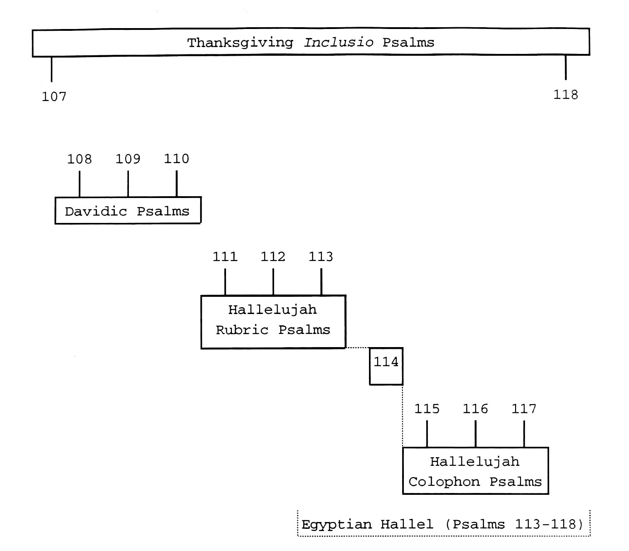

Figure 2. Overall structure of the Psalms 107-118 corpus.

The 3 remaining psalms (i.e., Psalms 107, 114, and 118), at
first glance, appear to be independent psalms with little
structurally to tie them to the rest of the corpus. Those
316
psalms, in actuality, function as strong linkages within the
corpus.
At some point in the canonization process, Psalm 114
attained its present form. It is a psalm that describes God's
great power--a power that manifested itself in and through the
exodus of the Israelites from Egypt. That power of God is,
without doubt, deserving of great praise. Psalm 114, however,
contains no specific words of praise nor does it direct those
who encounter the psalm to offer praise to God. Yet, the
entirety of the psalm is an encomium. As such, Psalm 114 proves
to be an ideal psalm to link together the hallelujah (hy vllh)
rubric psalms (Psalms 111-113) and the hallelujah (hy-vllh)
colophon psalms (Psalms 115-117) (figure 3). Furthermore, as
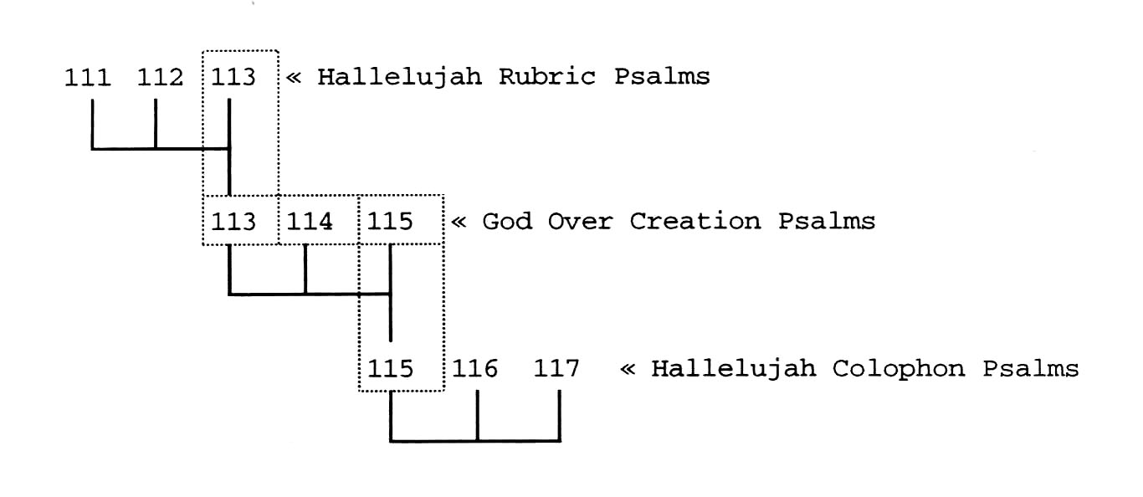
Figure 3. Internal connections between the hallelujah (hy vllh)
rubric psalms and the hallelujah (hy-vllh) colophon psalms.
317
figure 3 pictures, Psalm 114 tightens the bond between these 2
groups of psalms by operating as a thematic bridge between Psalm
113 (the concluding psalm of the former group) and Psalm 115
(the initial psalm of the latter group). That thematic bridge
finds its foundation in the theme of God's sovereignty over
creation--a theme held in common by Psalms 113, 114, and 115.⁸
Thus, when all 7 psalms are joined together in this way, they
form a major block of Hallel (i.e., praise) psalms that extends
from Psalm 111 to Psalm 117.
Next, the Davidic psalms (Psalms 108-110) may have been
juxtaposed to the beginning of these Hallel psalms to provide
additional reasons why God's people should sing the Hallel
psalms. They should joyfully sing praise to God because He
mightily defeats national and personal enemies and because He
offers the hope that He, one day, will establish His sovereign
rule over all Israel's enemies.
Most likely, the final stage of the canonization process
saw the addition of Psalms 107 and 118 to complete the
corpus.⁹ These psalms sketch a general picture of God's work
_________________
⁸See "Psalm 114--A Retrospective" in Chapter 2, above.
⁹Gerstenberger offers a slightly different explanation
regarding the gathering together of the 12 psalms of the corpus.
He suggests that Psalms 111-118 (which he refers to as the
Hallelujah Psalms) were brought together into 1 collection
during the later portion of the preexilic period. Next, he
pictures the Davidic psalms as being joined to each other during
the exile. Finally, he argues that Psalm 107 was prefixed to
318
in delivering His people--a work that is more than worthy of
praise. These 2 psalms, moreover, emphasize God's goodness and
lovingkindness, as well as the need for His people to offer up a
sacrifice of thanksgiving to Him. Psalms 107 and 118, thereby,
form an inclusio around the entire corpus to link the 12 psalms
together into a structurally unified body of psalms. As a
consequence, the individual psalms of the corpus function as a
unit to express the idea that God is to be thanked and praised
for the marvelous work that He has done on behalf of His people
in delivering them from their enemies.
Further analysis reveals that, much like the way that Psalm
114 acts, Psalm 110 (figure 4) operates to form a thematic bond
between 2 groups of psalms, in this case, between Psalms 107-109
and 111-113. Psalm 110 portrays God as a God who is more than
able to deliver His people from their distress (as pictured in
Psalms 107-109) and who is thus worthy of their praise (as
presented in Psalms 111-113).
There are still further structural linkages between
juxtaposed psalms within the Psalms 107-118 corpus. The most
obvious interconnection is that which unites Psalm 111 and Psalm
_________________
these 2 groups during the postexilic era as part of Book V of
the Psalter. Erhard S. Gerstenberger, Psalms: Part 1 with an
Introduction to Cultic Poetry, vol. 14, The Forms of the Old
Testament Literature, ed. Rolf Knierim and Gene M. Tucker (Grand
Rapids, Mich.: Eerdmans, 1988), 29.
319
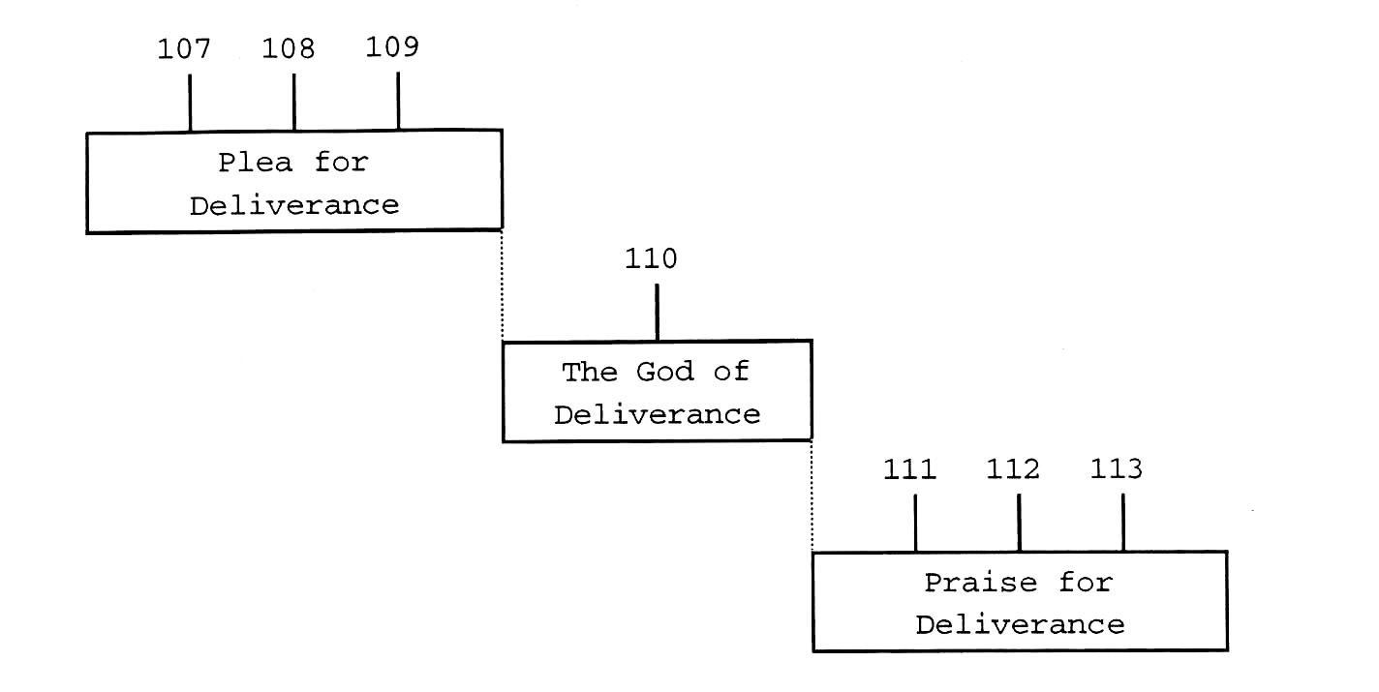

Figure 4. Psalm 110 as a thematic unifier of Psalms 107-113.

112. Both psalms are acrostic psalms.¹⁰ Both psalms,
moreover, contain 10 verses, the first 8 being bicola, the final
2 being tricola.¹¹ These 2 psalms, furthermore, are linked,

_________________
¹⁰This stylistic device is manifestly evident within the
Hebrew text. It is, however, generally speaking, missing from
the English translations of the 2 psalms.
¹¹The 2 psalms are also linked through the use of
complementary themes--the greatness of the person and works of
God (Psalm 111) and the greatness of the person and works of the
one who is rightly related to that God (Psalm 112).
320
in part, by virtue of the similarity of their respective
lengths.¹²

Structural and Thematic Development
As is pictured above, in figures 2-4, the Psalms 107-118
corpus manifests a purposeful structure that enhances the
thematic flow through the individual psalms. Those various
structural patterns and the concurrent development of the main
themes of the corpus are highlighted below.¹³
Psalm 107, which together with Psalm 118 unifies the entire
corpus into a single entity, sets the stage, both lexically and
thematically, for the remaining psalms of the corpus.¹⁴ As the
_________________
¹²The fact that these 2 psalms are acrostic psalms,
however, does not, in and of itself, require that they be of
equal or near-equal size to each other (contrast, for example,
the size of these psalms with that of other acrostic psalms such
as Psalm 119, Psalm 145, and Lamentations 1-4).
¹³For further information, see Chapter 2, above.
¹⁴Although Psalm 107 is the beginning psalm of Book V of
the Psalter, it exhibits strong ties back to Psalm 106, the
concluding psalm of Book IV. Psalm 107:1, in essence, repeats
Ps 106:1, word-for-word (apart from the hallelujah [hy vllh]
rubric found in that verse). Furthermore, nearly half of the
discrete lexeme units of Ps 107:1-3 are duplicates of discrete
lexeme units of Ps 106:44-48, the final 5 verses of Psalm 106.
In addition, Psalm 107 provides a response to the plea of Ps
106:47 that God's people be saved and gathered from their places
of exile among nations. In Ps 107:2-3, God's people are seen to
have been redeemed from all parts of the earth.
Although Psalm 107 makes these important interconnections
with Psalm 106, Psalm 107 displays even stronger linkages within
the Psalms 107-118 corpus, as is demonstrated below.

321
lead psalm of the corpus, this psalm introduces all 3 of the
main themes that permeate the corpus: (1) God is to receive
praise, (2) God is able to deliver His people from distress, and
(3) God exercises control over all creation.
Psalm 107 begins with a command to give thanks to God
because He is a good and loving God. This command introduces
the first theme of the corpus--a theme that declares that
sacrifices of thanksgiving, praise, and honor need to flow forth
to God, not merely from His people alone, but from all peoples
of the earth, as well. The psalm advances this theme by
including in its text such lexemes as hdy (give thanks,
thanksgiving), dsH (lovingkindness), llh (praise), Mvr (exalt,
lift up), and jrb (bless). Furthermore, within its text, Psalm
107 underscores the importance of this theme by means of 3
significant structural tactics: strophic development,
thanksgiving refrains that conclude strophes, and an inclusio
to envelop the psalm in God's dsH (lovingkindness).
In the remainder of the Psalm 107-118 corpus, this theme of
praising God for who He is and for what He has done is carried
forward, directly, by the utilization of specific praise-
oriented lexemes in no fewer than 9 of the remaining 11 psalms--
and, indirectly, in the remaining 2 psalms (figure 1).
The command of Ps 107:1, moreover, is replicated in Psalm
118. It is not merely "echoed" back by that latter psalm, it is
amplified in intensity in Psalm 118, being repeated twice--once

322
in Ps 118:1 and again in Ps 118:29, to form, with Ps 107:1, an
inclusio of thanksgiving around the corpus. Thus, the message
that people need to praise and honor God is sent reverberating
throughout the entire corpus.
Psalm 107 also introduces to the corpus the theme that
declares God to be a deliverer of His people. The psalm
accomplishes this feat through the use of discrete lexical units
that are repeated in various other psalms of the corpus. Four
of the more important of those repeated terms are rrc
(adversary, distress), rzf (help), fwy (save, deliver), and
Nvybx (needy). Furthermore, Psalm 107 makes use of 4 mid-
strophe refrains (vv. 6, 13, 19, 28) to stress the desperation
that God's people faced and the deliverance that God provided.
In addition, the psalm frames the 4 parallel strophes (vv. 4-9,
10-16, 17-22, 23-32)--each of which presents disaster-
deliverance data dealing with specific issues--with introductory
and concluding sections that highlight, in generic terms, once
more, God's work in overcoming the oppression encountered by His
people.
The salvation-from-tribulation component of Psalm 107 is
picked up specifically and developed further by 8 other psalms
in the corpus: Psalms 108-109, 111, 113-116, and 118 (figure

323
1).¹⁵ These psalms express a confidence in God's ability to
deliver or a feeling of gratitude for God having performed His
marvelous work of deliverance.
The third major theme of Psalm 107--God's dominance over
the created order--is developed in the context of God's ability
to transform or control the very elements of nature (Ps 107:25,
29, 33-35). This theme also finds expression in Psalms 108,
110, and 113-115, in which God exercises His sovereignty to
direct not only nature, but also to overcome human and
supernatural powers--2 additional forces in the created order.
Immediately subsequent to Psalm 107 are 3 psalms headed by
superscriptions attributing Davidic authorship to them: Psalms
108-110. These 3 psalms stress God's work in relation to
international or personal adversaries--Psalms 108 and 110
focusing on the former, Psalm 109 on the latter. They also
provide a backdrop for the praise psalms which follow.
_________________
¹⁵Two other psalms--Psalms 110 and 112--contain elements
of the distress-deliverance theme, but do not emphasize either
the problems faced by God's people (as is the case with Psalm
110) or the direct act of God that brings about the release from
those problems (as is the case with Psalm 112). See above, in
this chapter, notes 5 and 6.
Psalm 117, the remaining psalm in the corpus, focuses
entirely On the theme of praise to God. According to that
psalm, one reason for the world to praise the LORD is because of
His dsH (lovingkindness) toward His people. Because of the
context of the Psalms 107-118 corpus in which Psalm 117 is
located, that descriptive noun may, in fact, be designed to
convey tacitly a sense of deliverance (cf. Pss 107:1-3, 8-9, 15-
16, 21-22, [26-]31, 43; 109:21, 26; 115:1; and 118:1-4, 29).

324
Specifically, Psalm 108 opens with bold declarations of
praise to God that are followed without pause by an equally open
plea for deliverance. The psalm then presents (as the central
point of this chiastic psalm) God's statement of intent to
overcome the surrounding nations.¹⁶ Yet, He does not, within
the confines of the psalm, produce that much-desired victory.
As a consequence, another plea for deliverance rings out. This
plea is followed immediately (almost without a breath being
taken) by a final vote of confidence in God's greatness.
Thus, Psalm 108 expresses, in one way or another, each of
the 3 major themes of the corpus, which were unveiled in Psalm
107. First, God is worthy of praise. Second, God is capable of
defeating formidable foes. Third, God is greater than the
heavens and the earth (even greater than powerful nations of
this earth).
Through its lexical choices, Psalm 108 reaches out to other
psalms in the corpus to depict God as a God who both cares about
His people and who is sufficiently powerful to act on their
behalf in order to deliver them from the tribulations they face.
_________________
¹⁶Following the superscription of verse 1, the chiastic
structure of the Psalm 108 unfolds along the lines of the
outline presented below:
A. An expression of confidence in God (vv. 2-6)
B. A plea for deliverance (v. 7)
C. A promise of deliverance (vv. 8-10)
B'. A plea for deliverance (vv. 11-13)
A'. An expression of confidence in God (v. 14)
325
Psalm 108 makes this commonly-advocated point by means of the
following lexemes: hdy (give thanks, thanksgiving), hvhy
(LORD), dsH (lovingkindness), Myhlx (God), rzf (help), fwy
(save, deliver), and Nymy (right hand).¹⁷
Psalm 109, the second of the 3 Davidic psalms, carries
forth the first and the second of the 3 themes contained in its
immediately preceding Davidic psalm, Psalm 108 (as cited in the
previous paragraph). Like Psalm 108, Psalm 109 recognizes that
God alone can provide deliverance from an, as of yet,
unalleviated situation and that He, therefore, is deserving to
receive an offering of thanksgiving--in the midst of many
peoples. Yet, unlike both Psalm 108 and Psalm 110 (the third
Davidic psalm), which focus on national or global adversaries,
Psalm 109 presents the enemy attack at the level of the
individual.¹⁸
In order to convey its primary themes, Psalm 109 includes
various lexemes that are appropriate to those themes and, at the
same time, are common to numerous other psalms in the corpus.
_________________
¹⁷The lexeme Nymy (right hand) occurs in each of the 3
Davidic palms (i.e., Psalms 108-110) and, as such, provides an
important ,linkage among them.
¹⁸In the Hebrew Scriptures, an attack against a nation is,
at times, regarded as a specific attack against the leaders of
the nation or against the king himself.
The nature of the attack recorded in Psalm 109 (and the
consequent imprecation), however, seems to preclude that view
from being a correct understanding of these events. The attack
described here, therefore, takes place at a personal level,
rather than at a national level.

326
Some of those lexical choices are hdy (give thanks,
thanksgiving), llh (praise), dsH (lovingkindness), rzf (help),
fwy (save,, deliver), and Nymy (right hand).
Whereas Psalms 108 and 109, the first 2 Davidic psalms of
the Psalms 107-118 corpus, cry out for deliverance, Psalm 110,
the final Davidic psalm of the corpus, depicts how God will
destroy His enemies. Thus Psalm 110 provides a strong sense of
confidence that the concerns and fears of Psalms 108 and 109
will, one day, no longer trouble His people.¹⁹
An important thematic focus of Psalm 110 is that not only
is God able to defeat His enemies, but He also rules supreme
over the most powerful components of the created order.
Psalm 110, moreover, functions as an important bridge
between Psalms 107-109 and Psalms 111-113 (figure 4). The
former psalms incorporate into their texts a plea for
deliverance,²⁰ the latter psalms are designated psalms of
_________________
¹⁹Psalm 110 does not specifically state that God destroys
the enemies of His people. The psalm does, however, portray
God, one day, judging the nations with severity. Since, within
the Hebrew Scriptures, the term Myvg (nations) is often
understood to be used to indicate the enemies of the people of
God, Psalm 110 undoubtedly implies by its inclusion in v. 6
that, when God metes out punishment on the nations, He is doing
so against those who are the adversaries of His people.
²⁰Of these 3 psalms, only Psalm 107 includes both a cry
for help and a subsequent realization of deliverance. The other
2 psalms, i.e., Psalms 108 and 109, present only unfulfilled
hopes for deliverance.
Much like the way Psalm 1 presents an ideal picture of the
contrast between the righteous and the wicked, Psalm 107, the
327
praise to God--all 3 of those latter psalms being hallelujah (hy
vllh) rubric psalms. Psalm 110 provides an important reason why
the anguished concerns of Psalms 107-109 are able to be turned
into the songs of praise of Psalms 111-113. That reason is that
God truly sits on His throne in heaven ruling over His creation.
As a consequence, no enemy is able to stand against Him (or
against those whose cause He defends).
In addition, Psalm 110 exhibits important lexical and
functional relationships to Psalm 114--the only other psalm of
the corpus devoid of direct statements regarding the need to
praise or thank God. Interestingly, like Psalm 110, Psalm 114
functions as a key linking bridge between 2 major sections
within the corpus, i.e., between Psalms 111-113 and 115-117.
With the conclusion of Psalm 110--a psalm that emphasizes
the power of God over His enemies--the corpus shifts its focus
away from an emphasis on the plight of God's people and more
toward an emphasis on the praise that God's people offer to
_________________
introductory psalm to the Psalms 107-118 corpus, includes all 3
of the main themes of the corpus, in their ideal completed
forms. Similarly, just as much of the rest of the Psalter
reformats the ideal picture of Psalm 1 in view of the realities
of life, so too, Psalms 108 and 109 counterbalance the ideal of
Psalm 107. Not every issue plaguing God's people has been
resolved; not every cry for help has been answered. God's
people have not yet reached the position of permanent victory
where the can offer unhindered or unqualified praise to God.
328
Him.²¹ Psalm 111 is the first psalm to move in this new
direction. It is a hallelujah (hy vllh) rubric psalm. As such,
Psalm 111 interconnects with Psalms 112 and 113--2 additional
hallelujah (hy vllh) rubric psalms. Reaching further into the
corpus, Psalm 111 also makes connection, by virtue of its
hallelujah (hy vllh) rubric, to Psalms 115-117, 3 hallelujah
(hy-vllh) colophon psalms.
Psalm 111, however, makes its strongest lexical and
structural; linkages with Psalm 112. Both psalms are acrostic
psalms consisting of 8 bicola followed by 2 tricola. Both
psalms, moreover, share 16 discrete lexemes in common, more than
half of which are key-lexeme links. In addition, Psalms 111 and
112 record, on a number of occasions, similar semantic
expressions. One clause, in particular, stands out as a linking
force between the 2 psalms: dfl tdmf vtqdc (his righteousness
endures forever). What makes the linking function of this
clause so important is that, apart from the 3 citations found
here in these 2 psalms (Ps 111:3; 112:3, 9), the clause appears
nowhere else in the Hebrew Scriptures. Furthermore, both Psalm
111 and Psalm 112 address the same theme--the nature of the
_________________
²¹Even though the psalms that sequentially follow Psalm
110 in the corpus place the expression of gratitude to God in
the thematic spotlight, they only dim the light on the problems
God's people fact--they do not shut it off completely.
Likewise, the psalms which precede Psalm 110 and which emphasize
the tribulations that God's people experience, do not fully
eliminate all statements regarding praise to God.
329
righteous--but from different perspectives. Psalm 111 presents
the righteous character of God, whereas Psalm 112 highlights the
righteous character of the individual who fears that righteous
God.
Psalm 112, a hallelujah (hy vllh) rubric psalm, fits as the
chiastic center between Psalms 111 and 113, 2 other hallelujah
(hy vllh) is psalms. Those 2 psalms focus on the God who is
deserving of praise. Psalm 112 places between those psalms a
picture of the individual who lives a life of praise.
Furthermore, because of its praise orientation, Psalm 112 also
links to Psalms 115-117, a group of psalms also designated as
praise psalms.
The final hallelujah (hy vllh) rubric psalm of the corpus
is Psalm 113. This psalm links backward to Psalms 111 and 112
(2 hallelujah [hy vllh] rubric psalms) and forward to Psalms
115, 116, and 117 (3 hallelujah [hy vllh] colophon psalms).²²
In addition, Psalm 113 functions liturgically as the
initial psalm of a group of 6 psalms known as the Egyptian
Hallel. For more than 2 millennia, the Egyptian Hallel have
been have been incorporated as an important component in
numerous Jewish festivals--in particular, the Passover
_________________
²²Psalm 113 also contains a hallelujah (hy-vllh) colophon,
thus making its link to Psalms 115-117 even stronger than would
otherwise be the case.
330
celebration, the Feast of Lights,²³ and the new moon
assemblies. As the first psalm of this group, Psalm 113 sets
the tone for the rest of the members of the group. This psalm
declares that the focus of praise is on God--a God who is both
transcendent and immanent, who is both beyond creation and, yet,
intimately involved in it.
Psalm 113 also conveys all 3 major themes of the Psalms
107-118 corpus that are introduced to the corpus in Psalm 107
(figure l).
The above-mentioned Egyptian Hallel psalms take their name
from the psalm that falls next in numerical sequence after Psalm
113. The contents of Psalm 114 give rise to that name by
presenting a description of the deliverance of the Israelites
from Egypt at the time of the exodus. By presenting this
deliverance as it does, Psalm 114--a psalm which contains no
lexical indices directly related to the concept or act of
praise--is, in its entirety, an encomium.
Psalm 114 functions, moreover, as the center of mass of a
series of praise psalms extending from Psalm 111, on one side,
to Psalm 117, on the other. Thus, Psalm 114 brings together the
hallelujah (hy vllh) rubric psalms (Psalms 111-113) and the
hallelujah (hy-vllh) colophon psalms (Psalms 115-117). Psalm
114 makes that linkage, in part, because of its closeness of
_________________
²³Also known as the Feast of Dedication or Hanukkah.
331
thematic fit with its 2 neighbor psalms, Psalms 113 and 115
(figure 3). All 3 psalms highlight God's dominance over
creation. Furthermore, Psalm 114 makes a greater percentage of
lexical interconnections with these 2 psalms than with any of
the other psalms of the corpus.²⁴
Psalm 115 (which, as just noted, links back to Psalm 114,
both lexically and thematically) is the opening psalm of a 3-
psalm set known, within this dissertation, as the hallelujah
(hy-vllh) colophon psalms.
Psalm 115 has the distinction of being 1 of 4 psalms in the
corpus to contain all 3 of the major themes of the corpus in
their fully developed forms. The other 3 psalms to do so are
Psalms 107, 108, and 113. Interestingly, the fact that these 4
psalms all advance the primary themes of the corpus may have
been an impetus for linking 10 of the 12 psalms of the corpus
together. This may be the case since Psalms 108, 113, and 115
appear in important roles in their respective sub-units of the
corpus: the Davidic psalms (Psalms 108-110), the hallelujah (hy
vllh) rubric psalms (Psalms 111-113), and the hallelujah
(hy-vllh) colophon psalms (Psalms 115-117). The positioning of
_________________
²⁴The 7 lexemes which Psalm 114 shares in common with
Psalm 113 represent 20% of the total population of discrete
lexemes found in that latter psalm. Psalm 114 also makes 7
lexical links to Psalm 115, which represent 13% of that latter
psalm's total number of discrete lexeme units. Significantly, 6
of the 7 lexical interconnections that Psalm 114 makes with the
2 psalms are the same.
332
Psalm 107 (with its unfolding of the 3 major themes), at the
beginning of the corpus, would thus ensure a strong linkage
among these 10 psalms.²⁵
Psalm 115 also exhibits another important structural
linkage. Psalm 115:18 works together with Ps 113:2 to form an
inclusio of blessing that unifies Psalms 113, 114, and 115--3
psalms that emphasize God's dominance over the created order
(figure 3 ).²⁶
_________________
²⁵Two psalms of the corpus, however, remain unaccounted
for by this theory--Psalms 114 and 118. Yet, as noted
previously, Psalm 114 operates as a bonding agent between the
halleluja (hy vllh) rubric psalms and the hallelujah (hy-vllh)
colophon psalms to form a unified group of praise psalms that
begins with Psalm 111 and ends with Psalm 117. Psalm 114 may,
therefore, have been brought into the larger corpus at the same
time those other 6 psalms were attached. Such would be the
case, especially if the hallelujah (hy vllh) rubric psalms and
the hallelujah (hy-vllh) colophon psalms were brought together,
with Psalm 114, into a unified whole prior to the completion of
the Psalms 107-118 corpus.
The final remaining psalm, Psalm 118, may have been
introduce to the corpus in at least 1 of 2 ways. First, the
psalm may have been accepted into the corpus as the concluding
member of the Egyptian Hallel psalms (Psalms 113-118).
Understandably, for this option to be true, the Egyptian Hallel
psalms would have had to have functioned as a distinct group of
psalms prior to the completion of the canon and prior to the
coalescing of the 12 psalms into this corpus. Second, Psalm 118
may simply have been juxtaposed to the end of an already unified
collection of psalms that ran from Psalm 107-117 in order to
form, with Psalm 107, an inclusio of thanksgiving around the
entire corpus.
²⁶The presence, in both Ps 113:2 and Ps 115:18, of a
prepositional phrase (Mlvf-dfv htfm--from now [this time] and
until forever) which occurs only 8 times total in the Hebrew
Scriptures heightens the intensity of this inclusio.

333
Psalm 116, the middle psalm in the 3-psalm hallelujah
(hy-vllh) colophon sequence, links by means of its declaration
of praise not only to its fellow hallelujah (hy-vllh) colophon
psalms (i.e., Psalms 115 and 117), but also to the 3 hallelujah
(hy vllh) rubric psalms (i.e., Psalms 111-113).
Psalm 116 makes its strongest lexical interconnections with
immediately antecedent psalm in the corpus, Psalm 115. Not only
does Ps 116 link lexically with Psalm 115 by means of the
lexemes that comprise the jointly shared hallelujah (hy-vllh)
colophon bit also by means of the repetition of numerous terms
related to the body. Both psalms, moreover, individually record
lexemes that name parts of the body or that describe the actions
of those body parts. These 2 psalms also display nearly the
same relative size as each other, which may have been an
additional reason (although undoubtedly minor) for their
juxtaposition within the corpus.
The shortest psalm of the corpus, i.e., Psalm 117,
contribute far more to the structure of the overall scheme of
the corpus than might be expected from a psalm of its size.
First, Ps 117 fits within the corpus as the third of 3
sequential hallelujah (hy-vllh) colophon psalms (Psalms 115-
117). Second, because of its praise orientation, Psalm 117
links backward to the hallelujah (hy vllh) rubric psalms (Psalms
111-113). Third, the contents of Psalm 117 function with Ps
111:1-3 as an inclusio around Psalms 111-117 to bring those 7
334
psalms together into a unified group of praise psalms.²⁷
Fourth, Palm 117 parallels Psalm 113, the concluding hallelujah
(hy vllh) rubric psalm, by the presence of commands, at the
beginning and ending of each psalm, to praise the LORD. Thus,
both the hallelujah (hy vllh) rubric psalms and the hallelujah
(hy-vllh) colophon psalms conclude their respective 3 psalm
sequences with a double emphasis on praise. Fifth, Psalm 117
provides a bridge to link Psalm 118 to the sequence of praise
psalms that begins at Psalms 111. Psalm 117 does so lexically
and thematically. Lexically, Ps 117 includes the term dsH
(lovingkindness) as a descriptor of hvhy (LORD). That lexeme is
picked up by Ps 118:1-4, 29, where it again is used in relation
to hvhy (LORD). Thematically, Psalm 117 declares that God is to
be honored (praised-llh). Likewise, Psalm 118 begins and ends
with the same essential thought, that God is to be honored
(thanked--hdy) .
The final verse of the final psalm of the corpus, i.e., Ps
118:29, joins with the first verse of the first psalm of the
corpus, i.e., Ps 107:1, to envelop the corpus in an attitude of
thanksgiving to God for who He is and for what He has done.
_________________
²⁷Psalm 117:1 declares that the offering of praise is to
be a public event. Psalm 117:2 indicates that this praise is to
be given to God both because of His care for His people and
because of His personal attributes. In the inclusio that they
form with Ps 111:1-6, these 2 verses find as their thematic
counterparts Ps 111:1 and Ps 111:2-6, respectively.
335
This inclusio sets the structural boundaries of the Psalms 107-
118 corpus.
This linkage that Psalm 118 has with Psalm 107, moreover,
is enhanced by the fact that (in sheer number of words held in
common) Psalm 118 has stronger lexical ties to Psalm 107 than to
any of the other psalms in the Psalms 107-118 corpus. Thus the
linkage from Psalm 118 back to Psalm 107 is quite strong.
In addition, Psalm 118 functions as the concluding psalm to
the group of psalms known as the Egyptian Hallel--a group of
psalms that has formed an important part of Jewish worship
through the centuries. Being so connected suggests at least 2
significant points: (1) Psalm 118 is to be understood as a
praise psalm and (2) Psalm 118 belongs (at least in the minds of
the ancient Hebrews) to the present corpus and not to some
subsequent corpus.²⁸

Overall Conclusion
Based on the evidence presented in this dissertation, the
proposition that there are intentional--and not just accidental
or random--lexical and thematic links among the psalms of the
_________________
²⁸Psalm 118, however, does make important lexical
connections with Psalm 119 that help to ensure a smooth
transition from the end of Psalm 118 to the beginning of Psalm
119. This transition is developed by the repetition of the
terms hvhy (LORD) and hdy (give thanks, thanksgiving), and also
by the use of synonyms--jrb (blessed) in Ps 118:26 and yrwx
(happy, blessed) in Ps 119:1-2.
336
Psalms 107-118 corpus has been validated. So too has the
proposition that the corpus as a whole exhibits a coherent and
unified structure been proven to be correct.

Implications
Doctrine of Inspiration
With the recognition that the Hebrew Scriptures are the
Word of God, certain of the findings of this dissertation exert
a potential impact on the understanding of the doctrine of
inspiration. Three findings in particular have a direct bearing
on that doctrine: the psalms of the corpus appear (1) to have
undergone an editing process, (2) to be arranged purposefully,
and (3) to have been written in such a way that they show a high
regard for the words and not just for the ideas of the text. In
addition, the validity of literary approach as a method for
psalms research also affects the notion of the doctrine of
inspiration.

Inspiration and the Editing of the Psalter
If the canonical psalms of the Psalms 107-118 corpus have
been revised by the work of an editor subsequent to their
creation, then the doctrine of inspiration must account for, at
a minimum the earliest and the latest documents (and for any
possible redactions in between). If the various editions of a
given psalm are to be considered (in the purest sense) the Word
337
of God, then not only must the work of the original human author
of a psalm be held under the umbrella of the doctrine but so
also must that of any subsequent editor (and perhaps any
compiler) through to the completion of the canonization process.
Waltke argues for such a doctrine of inspiration. According to
Waltke, the doctrine must extend the cloak of inspiration over
the original author, the editors, and the compilers to the point
when the final book was added to the Scripture.²⁹
Among the psalms under study, there appears to have been
some level of editing that altered certain of the psalms from
their original state to their present state. Two psalms, in
particular, stand out as possibly having undergone an editor's
changes: Psalms 107 and 108.
After its 3 introductory verses, Psalm 107 consists of 4
illustrations of God's deliverance of His people (vv. 4-9, 10-
16, 17-22, 23-32). Each of those pictures includes a plea-for-
deliverance refrain (vv. 6, 13, 19, 28) and ends with a 2-verse
offering-of-thanks-for-deliverance refrain, the second to last
verse in each of those final refrains being the same. Following
sequentially those illustrations, the psalm, in its canonical
form, draws near to its conclusion with a series of 10 verses
_________________
²⁹ Bruce K. Waltke, "A Canonical Approach to the Psalms,"
in Tradition and Testament: Essays in Honor of Charles Lee
Feinberg, ed. John S. Feinberg and Paul D. Feinberg (Chicago:
Moody, 1981), 9-16.
338
which picture God as both exercising His power over creation and
blessing His people to the dismay of the unrighteous. Psalm 107
then concludes (v. 43) with a declaration that those who truly
desire to be wise need to pay close attention to God's works and
to His lovingkindness. The final 11 verses, however, do not
follow the double refrain pattern extant within the 4
illustrations. The differences between the introductory
materials and the 4 illustrations and between the final 11
verses and the illustrations have led many³⁰ to argue (as may
be the case) that the canonical psalm is an expanded version of
an earlier composition (or compositions) that consisted of

_________________
³⁰There are some, e.g., Dahood, who consider the entire
psalm to be "a unity composed by one psalmist." Mitchell
Dahood, Psalms III (101-150), The Anchor Bible 17A, ed. William
Foxwell Albright and David Noel Freedman (Garden City, N.Y.:
Doubleday 1970), 89. The various segments of the psalm do
function together harmoniously and thus indeed may have been the
work of an individual author. If so, then this psalm was
marvelously crafted to fit in its present position at the
beginning ,of the Psalms 107-118 corpus and at the beginning of
Book V of the Psalter. The psalm, through its first 3 verses,
links backward to Psalm 106 to respond to that psalm's
concluding cry for deliverance. Psalm 107 also links forward
through its concluding 11 verses to other psalms within the
corpus that focus on God's power over the created order and on
God's ability to baffle the enemy. Psalm 107:1 (and to a lesser
extent, Ps 107:43), moreover, operates in conjunction with Ps
118:29 and to a lesser extent with Ps 118:1) to form a
structural framework around the entirety of the Psalms 107-118
corpus. None of these various linkages would be quite so strong
if Ps 107:1-3 and 33-43 were missing from the final composition
of the psalm.
339
anywhere from 1 to 4 of the deliverance illustrations present in
the psalm's current canonical state.³¹
Psalm 108 also offers another example within the corpus of
a psalm that may have undergone editorial work. Most contend
that the canonical psalm is not an original independent
composition but rather is essentially a compilation of Pss 57:8-
12 and 60:1-14.³²
_________________
³¹Briggs and Briggs contend that v. 1 "is a gl. in order
to make the Ps. into a Hallel." Charles Augustus Briggs and
Emilie Grace Briggs, A Critical and Exegetical Commentary on the
Book of Psalm (Edinburgh: T. & T. Clark, 1907; reprint, 1960), 358.
Kraus argues that v. 2 is "a prescriptive formula which
someone later intervened in the psalm." Hans-Joachim Kraus,
Psalms 60-150: A Commentary, trans. Hilton C. Oswald
(Minneapolis: Augsburg, 1989), 328. Kraus, furthermore, concurs
with Duhm that vv. 33-43 as a group is a "supplemental poem."
Kraus, Psalms 60-150: A Commentary, 325.
Even the inverted nuns attached to the BHS Masoretic Text
at vv. 21-26, 40 suggest the possibility of the psalm having
been in a different sequential order than is presently observed.
The precise meaning of the inverted nuns, however, is unclear.
Allen provides a brief, but insightful, discussion of the
views of various scholars regarding what is to be considered as
the "original" psalm and what has been added to it. Leslie C.
Allen, Psalms 101-150, Word Biblical Commentary 21 (Milton
Keynes, England: Word [UK], 1983), 60-63.
³²Franz Delitzsch, Biblical Commentary on The Psalms,
trans. Francis Bolton, vol. 3 (Grand. Rapids, Mich: Eerdmans,
1968), 173-74; E. W. Hengstenberg, Commentary on the Psalms,
vol. 3, trans. John Thomson and Patrick Fairbairn, Clark's
Foreign Theological Library, vol. 12 (Edinburgh: T. & T. Clark,
1848), 299-300; Kraus, Psalms 60-150: A Commentary, 333; Hans
Schmidt, Die Psalmen (Tübingen: J. C. B. Mohr [Paul Siebeck],
1934), 199. By contrast, Dahood maintains that the 3 psalms--
Psalms 57, 60, and 108--were developed independently from the
same, previously existing poetic compositions. He believes that
any present depiction of Psalm 108 as a psalm that was compiled
340
Even if the superscriptions of all 3 psalms (i.e., Psalms
57, 60, and 108) are correct that each psalm is Davidic in
origin, an explanation needs to be given for the change of the
divine appellation of yndx (Lord) in Ps 57:10 to hvhy (LORD) in
Ps 108:4. Psalms 57 and 60 are contained within Book II of the
Psalter, a Book that (relatively speaking) rarely uses the term
hvhy (LORD). Book V of the Psalter (in which Psalm 108 is
found), by contrast, makes extensive use of that divine name.
Thus, even if David is the author of all 3 of those canonical
psalms, there is no clearly definitive explanation as to why he
would have made the change from yndx (Lord) to hvhy (LORD).³³
A reasonable assumption, then, is that a later editor (or
perhaps the compiler of Book V) effected the change in order to
ensure that Psalm 108 fit more closely into the hvhy-pattern of
Book V than it would otherwise do.
Thus, if these or other editorial emendations within the
Psalms 107-118 corpus are in fact demonstrable (as they appear
to be), then a doctrine of inspiration that advances the view
that the original manuscripts are the inspired Word of God needs
also to accord that same divine aegis to the edited documents up
to and including their final canonical forms--if the canonical
_________________
from Psalms 57 and 60 is incorrect since it "goes beyond the
available evidence." Mitchell Dahood, Psalms III (101-150), 93.
³³Historically, of course, David did not have a hand in
the final compilation of Book V of the Psalter--an event which
took place centuries after his death.
341
texts are to be considered divinely inspired to the same degree
as the original manuscripts.³⁴

Inspiration and the Sequence of the Psalter
The of the Psalms 107-118 corpus appear to have been
arranged fully into their present order. There are
obvious of psalms within the corpus that are linked
together means of lexical overlap or by the interjection of a
complete psalm between 2 groups. There is also a thematic flow
that carries through the entire corpus and is particularly
enhanced by the various interconnections that exist between the
_________________
³⁴That edited texts within the Hebrew Scriptures are to be
accepted as canonical or inspired is not a new suggestion. For
example, most scholars accept Ps 72:20 (ywy-Nb dvd tvlpt vlk--"The
prayers of David, the son of Jesse, are ended") as being part of
the canonical text of the Scripture. What makes that verse
remarkable (relative to the present discussion) is that it
stands as the concluding verse to Psalm 72, a psalm whose
superscription attributes the origin of the psalm to Solomon,
not to David. In addition, Psalm 72 is not the final psalm of
David recorded in the Psalter. Other psalms identified by their
superscriptions to be Davidic in origin (e.g., Psalms 108-110 in
the present corpus) occur subsequent to Psalm 72 within the Psalter.
The fact that Ps 72:20 stands at the conclusion of Book II
of the Psalter suggests, according to Wilson, that "Books One
and Two may have combined to form an earlier collection
introduced and concluded by 'Royal' pss, a collection which
because of its high Davidic content (60 of 70 pss) might well
justify the description 'prayers of David.'" Gerald H. Wilson,
The Editing of the Hebrew Psalter (Chico, Calif.: Scholars,
1985), 208.
See also Deut 34:5-12, which speaks about events occurring
after the death of Moses. Even those who adhere to the Mosaic
authorship of the Pentateuch generally agree that Deut 34:5-12
was added to the text at some time after the completion of the
rest of the Pentateuch.
342
concluding verses of each of the first 11 psalms (i.e., Psalms
107-117) and the beginning portion of their respective
subsequent psalms (i.e., Psalms 108-118). Furthermore, Psalms
107 and 118 form an inclusio around the entire corpus to tie
the psalms of the corpus into a identifiable group.
In light of the multitude of linkages--lexical, thematic,
and other--among the psalms of the corpus,³⁵ there can be no
doubt that the compiler(s) of the Psalter intentionally
positioned the various psalms of the Psalms 107-118 corpus in
the sequence in which they presently occur.³⁶ An adequate
doctrine of inspiration, therefore, must pay serious attention
to the output of the compiler if that doctrine intends to
acknowledge the significance of the sequence of the psalms and
_________________
³⁵See Chapter 2, above.
³⁶There are those who argue that other portions of the
Psalter, as well, if not all of the psalms of the Psalter, have
been intentionally positioned as they now stand. See, for
example, Joseph P. Brennan, "Some Hidden Harmonies in the Fifth
Book of Psalms," in Essays in Honor of Joseph P. Brennan, ed.
Robert F. McNamara (Rochester, N.Y.: Saint Bernard's Seminary,
1976), 126-58; Walter Brueggemann, "Bounded by Obedience and
Praise: The Psalms as Canon," Journal for the Study of the Old
Testament 50 (1991): 63-92; John Forbes, Studies on the Book of
Psalms: The Structural Connection of the Book of Psalms, both in
Single Psalms and in the Psalter as an Organic Whole, ed. James
Forrest (Edinburgh: T. & T. Clark, 1888); David Morris Howard,
Jr., "The Structure of Psalms 93-100" (Ph.D. diss., University
of Michigan, 1986), forthcoming as The Structure of Psalms 93-
100, University of California at San Diego Biblical and Judaic
Series 5 (Winona Lake, Ind.: Eisenbrauns); Wilson, The Editing
of the Hebrew Psalter.
343
the impact that a given psalm has, in particular, on the psalms
that immediately surround it.

Inspiration and Lexical Issues
The high degree of overlap of lexemes among the various
psalms of the Psalms 107-118 corpus suggests a strong interest
on the part of the author(s), editor(s), or compiler(s) of the
corpus to take into consideration the very words of the text and
not mere the ideas. More specifically, the key-lexeme links
and thematic-lexeme links highlight the word-level decisions
made by those who left their mark on the 12 psalms of the
corpus.
In addition, the actual positioning of the significant
lexemes within a given psalm appears to have been a concern of
those who implemented the process of the development and
sequencing of the various psalms of the corpus. Evidence of the
reality of this concern is observed in an analysis of the
location of specific lexemes within a given psalm. As observed
previously, the location of various significant lexemes within a
psalm s the expression of the concepts contained within
that psalm. Certain lexemes, moreover, at times, because of
their location within adjoining psalms or even across a sequence
of psalms (e.g., the lexemes of Pss 107:1 and 118:29) function
as bridges between the psalms of which they are a part.
344
An adequate doctrine of inspiration must account for the
concerns and the work of those who under the direction of God
left evidence of their activity on the 12 psalms of the corpus.
Thus, to the extent that the author(s), editor(s), or
compiler(s) exhibited a high regard for the very lexemes of the
texts of the corpus under study, the doctrine of inspiration
must include within its propositions statements to the effect
that the inspiration of Scripture takes place at the level of
the lexeme as well as at the level of the concept.

Inspiration and the Literary Method
If a literary analysis of the type used within this
dissertation is a valid methodological approach for the study of
the Psalter, then the doctrine of inspiration must extend at the
very least from the narrow bandwidth of the individual lexemes
themselves to the broad scope of the corpus in its entirety.
The doctrine must account for such matters as the lexemes
themselves, the development of themes within the individual
psalms, the various lexical and thematic linkages among the
various psalms, and the flow of ideas throughout the corpus.

Psalms Research
As noted in Chapter 1 above, there are generally 3
methodological approaches by which various scholars have entered
345
into the analysis of the texts of Psalter.³⁷ Each of the
systems stresses a different research strategy. The first seeks
to understand the text in light of its historical setting, the
second in reference to its function within the ancient Israelite
worship system, and the third in its literary context. Each of
these systems has its strengths and weaknesses, the major
advantages and disadvantages being presented below.³⁸ These
lists are not intended to be exhaustive but rather to highlight
the more salient points.

Assessment of the Historical-Critical Method
Strengths
The historical-critical method of psalms interpretation:
1. Pushes the analysis of a text back to the original
stage of biblical inspiration of that text;
_________________
³⁷This discussion does not concern itself with the
methodology of higher criticism such as those approaches that
focus on source-critical issues or even on the text-transmission
process itself.
³⁸The following presentation of the strengths and
weaknesses of the literary approach is restricted solely to an
assessment of the methodology used within this dissertation.
Thus, this analysis does not take into consideration the
profitability or lack thereof of the use of other literary
methods such as structural criticism or rhetorical criticism.
346
2. Provides a sense of historical validation to the
contents of the text--a validation that ideally is corroborated
by historical or archaeological evidence;
3. Offers insight into the forces that shaped the feelings
and actions expressed within the text;
4. Gives support to (and gains support from) the
superscriptions to the various psalms; and
5. Seeks to understand the psalm in the context of the
original author and the original audience.

Weaknesses
1. Accurate determination of the historical context of
many psalms is difficult at best, if not impossible. Current
attempts to recreate the original context of a given psalm fail
to guarantee that all relevant data are taken into
consideration. General historical contexts may be
reconstructed, but the specific details of a given event or of
the emotional reactions (apart from those expressed in the text)
of the participants in that event still prove to be elusive.
Without all of the relevant data, the discovery of, for example,
the causes and effects of certain actions within a specific
battle is less than certain.
347
2. Many psalms are devoid of context-informing
superscriptions³⁹ or are headed by superscriptions that offer
little or no insight into the historical background of a
text.⁴⁰ Analysis of the historical context of these various
psalms, therefore, may be on less than stable ground,
particularly if the text of the psalm itself does not provide
adequate clues regarding its origins.
3. This approach appears to weaken the doctrine of the
perspicuity of Scripture. The historical-critical method
implies that those who do not have access to all of the relevant
historical data are unable to gain a clear understanding of the
meaning of a text.
_________________
³⁹Many scholars debate the meaning, function, and
significant of the superscriptions to the psalms. Peter C.
Craigie, Psalms 1-50, Word Biblical Commentary 19, ed. David A.
Hubbard and Glen W. Barker (Aylesbury, UK: Word [UK], 1986), 31-
35; Hans-Joachim Kraus, Psalms 1-59: A Commentary, trans. Hilton
C. Oswald (Minneapolis: Augsburg Publishing House, 1988), 21-32;
John F. A. Sawyer, "An Analysis of the Context and Meaning of
the Psalm-Headings," in Transactions: Volume XXII: Years 1967 to
1968, ed. William McKane, (Glasgow: Glasgow University Oriental
Society, 1970), 26-38; Bruce K. Waltke, "Superscripts,
Postscripts, or Both," Journal of Biblical Literature 110
(1991): 583-96.
⁴⁰Superscriptions such as those that head Psalms 108-110
merely suggest a general historical time frame by indicating a
Davidic authorship. They do not, however, disclose at what
stage in David's career--as a shepherd, as a fugitive, as a
newly crowned king, as a king at the peak of his power, or as a
king whose power has waned--he is to have written those psalms.
The impact the historical context on a given psalm would be
significantly different if the psalms were written at different
times in David's life.
348
4. Those who use the historical-critical method must
address the issue of the inspiration not only of the texts but
also of the historical events themselves.
5. This method potentially locks the application of a
given meaning of a given psalm into a specific set of historical
circumstances, thereby lessening the potential for that psalm to
be able to speak to a modern audience.

Assessment of the Functional-Critical Method
Strengths
The functional-critical method of psalms analysis, better
known as form criticism or genre criticism:
1. Helps the exegete to understand the literary formulas
that underlie the various types of psalmic literature;
2. Accords with the position that the psalms were designed
to meet the needs of the religious community⁴¹ as it seeks to
explain the meaning of the psalms in the context in which they
presumably, were used;

_________________
⁴¹Mowinckel contends that "[p]salm poetry as such has
sprung from the temple cult. Even the psalms transmitted to us,
perhaps more than 140 of the 150 of the Psalter, have not only
been used as cult-psalms, but have also been composed for that
purpose." Sigmund Mowinckel, "Psalms and Wisdom," in Wisdom in
Harold Henry Rowley, eds. M. Noth and D. Winton Thomas,
Supplements to Vetus Testamentum 3, ed. G. W. Anderson and
others (Leiden: E. J. Brill, 1969), 205.
349
3. Allows the interpretation of the various psalms to be
understood as being timeless and not bound in meaning to an
irreproducible moment in time; and
4. Displays findings regarding the psalms that shows them
to have a place in the worship setting of Israel that is
parallel to known worship practices of other ancient societies
and thereby strengthens the confidence level of biblical
exegetes regarding their interpretation of the meaning and
function of a given psalm.⁴²

Weaknesses
1. Form criticism or genre criticism falters
significantly, since there is at present a lack of demonstrable
proof that the various psalms were used according to the
functions ascribed to them by those who adhere to this
approach.⁴³
2. The critics who use this method often overlook the
superscript data attached to the specific psalms by ancient
_________________
⁴²Gerstenberger, Psalms: Part 1 with and Introduction to
Cultic Poetry, 6-7.
⁴³The failure of form criticism or genre criticism to
provide demonstrable proof that ancient Israelites used a given
psalm in a specific way within the cultus does not necessarily
render illegitimate the psalmic structures that form critics or
genre critics have identified.
350
editors or compilers who thereby expressed their understanding
of the origins, meaning, or use of the superscripted psalms.
3. This approach limits a given psalm's application to a
specific religious function that may not necessarily have an
identifiable functional parallel in current worship practices.
The psalm, therefore, would have no applicability to the modern
reader.
4. In its push to classify the genre of given psalms, the
form-critical method at times fails to account for subtle
content differences that may exist between 2 psalms which have
been classified as belonging to the same genre.⁴⁴
5. There is a general lack of agreement as to what defines
a functional category and as to which psalm fits into which
category.⁴⁵
_________________
⁴⁴ Greenwood cautions against the separation between genre
and content when he writes that "it is arguable that, as a
general rule, content was more important for the sacred writers
themselves than form." David Greenwood, "Rhetorical Criticism
and Formgeschichte: Some Methodological Considerations,"
Journal of Biblical Literature 89 (1970): 419.
⁴⁵Compare, for example, Gerstenberger, Psalms: Part 1 with
an Introduction to Cultic Poetry, 9-21; Hermann Gunkel,
Einleitung in die Psalmen: die Gattungen der religiösen Lyrik
Israels, 2d ed. (Göttingen: Vandenhoeck & Ruprecht, 1966);
Mowinckel, "Psalms and Wisdom," 205-24; and Claus Westermann,
Praise and Lament in the Psalms, trans. Keith R. Crim and
Richard N. Soulen (Atlanta: John Knox, 1981).
As form critics and others continue to apply their
expertise to the analysis of the various psalms of the Psalter,
quite probably, additional findings will be forthcoming that
either will be able to account for the differences in the
351
6. The form critics," according to Greenwood, "have
tended to lose sight of the forest by concentrating on the
individual trees: by dealing exhaustively with individual
pericopes. . . and, in general, small blocks of material, they
have sometimes neglected to regard biblical books as individual
entities."⁴⁶

Assessment of the Literary Method
Strengths
The literary method used in this dissertation:
1. Understands the 150 psalms of the Psalter to be a
literary unit that forms a literary context within which the
individual psalms are to be interpreted (as is the case with the
various chapters of the other books of the Scripture);
2. Recognizes as significant the canonical texts of the
various psalms;
3. Accounts for the editorial process and for the
arrangement of the psalms; and
4. Removes a given psalm from a time-bound historical
context and places it in a literary context, thereby allowing
later readers of Scripture to be able to apply (more easily than
_________________
identification of functional categories or will reveal that this
approach to the analysis of the Psalter is tenuous.
⁴⁶Greenwood, "Rhetorical Criticism and Formgeschichte:
Some Methodological Considerations," 418.
352
otherwise would be the case) the truths contained within that
psalm.

Weaknesses
1. An improper application of this literary method may
downplay the intent of the original author of a given psalm in
favor of the sense conveyed by a later editor or compiler. The
exegete may mistakenly assume that later emendations to a text
negate the meaning of the original text, thereby potentially
suggesting that either the original document or the later text
(even the canonical one) is not fully inspired or contains
erroneous materials.
2. This literary method requires that the doctrine of
inspiration be made to encompass not only the known author of
the various psalms of the Psalter, but also the unknown
editor(s) or compiler(s) of those psalms.⁴⁷
3. The literary approach to psalms analysis, moreover,
does not emphasize either the historical context of a psalm or
the functional use of that psalm in the history of Israel.
4. Identifying the context that the entire Psalter brings
to an individual psalm is difficult. Not all who adhere to the
view that the Psalter is a unified literary body hold to the

_________________
⁴⁷The authorship of many of the psalms themselves is
unknown. This argument against the literary method, therefore,
is not very convincing.
353
same understanding regarding the thematic cord that binds the
150 psalms together.⁴⁸

General Evaluation of Research Methodologies
Each of the 3 methods of psalm research has its proponents.
By virtue of the nature of these approaches, the adoption of any
one research method tends to diminish the importance of the
other 2 approaches.
This dissertation does not claim to have demonstrated
conclusively that the literary approach is preferable to either
the historical-critical approach or the form-critical approach.
This dissertation, however, has shown that a literary
understanding of the text is a valid approach to the study of
the Psalter. That approach is one that accounts for the
utilization of the lexemes and the themes of the individual
psalms of the Psalms 107-118 corpus as a means by which those 12
psalms are linked together into a unified whole within the
canonical text.

_________________
⁴⁸Compare, for example, the views of Brennan, Brueggemann,
Mays, McCann, and Wilson. Brennan, "Some Hidden Harmonies in
the Fifth Book of Psalms," 126-58; Brueggemann, "Bounded by
Obedience and Praise: The Psalms as Canon," 63-92; James Luther
Mays, "The Question of Context in Psalm Interpretation," in The
Shape and Shaping of the Psalter, ed. J. Clinton McCann, Journal
for the Study of the Old Testament Supplement Series, no. 159
(Sheffield: JSOT, 1993), 14-20; J. Clinton McCann, Jr., "Books
I-III and the Editorial Purpose of the Hebrew Psalter," in The
Shape and Shaping of the Psalter, 93-107; Wilson, The Editing of
the Hebrews Psalter, 139-228.
APPENDIX A

FREQUENCY OF POTENTIALLY SIGNIFICANT LEXEMES
FOUND IN PSALMS 107-118

The following charts present lexemes that (1) occur a
minimum of 10 times in the Pss 107-118 corpus and comprise 15%
or more of all cases in the Psalter (i.e., more than 2 times
greater than is expected for a corpus of this size) or (2) occur
3-9 times in the Psalms 107-118 corpus and comprise at least 25%
(i.e., more than 3 times greater than is expected) of all cases
in the Psalter:

Lexemes Occurring 10 or More Times within the
Corpus and Totaling 15% or More of All
Occurrences within the Psalter

Lexeme Translation Frequency Percent
1. dhy To thank 13/67 19
2. tyb¹ House 10/54 19
3. hyh To be 18/104 17
4. jrb To bless 13/76 17
5. llh To praise 14/94 15

_________________
¹This lexeme occurs only 9 times in the corpus of the
Masoretic Text, i.e., 17% of the 53 total examples of tyb in the
Psalter. The preferred reading of Ps 115:9 adds tyb prior to
rxrWy, thus bringing the frequency total of tyb to 10, and
thereby making the lexeme eligible for inclusion in this chart
of potentially significant lexemes.

354
355
Lexemes Occurring 3-9 Times within the Corpus
and Totalling 25% or More of All Occurrences
within the Psalter

Lexeme Translation Frequency Percent
1. lvm To cut off 3/3 100
2. hqvcm Distress 4/5 80
3. NFW Accuser 4/6 67
4. fvn To shake, waver 4/8 50
5. NvnH Gracious 3/6 50
6. bydn Prince 3/7 43
7. bfr Hungry 3/8 38
8. Nrhx Aaron 3/9 33
9. bbs To turn about, 7/24 29
surround
10. Nvybx Affliction 6/23 26
11. Ffm Few, to be little 3/12 25

APPENDIX B
PSALMS 107-118: LEXEME FREQUENCY TABLES

Based on the Masoretic text of Psalms 107-118, the following charts identify three
specific items:

1. The text of each verse of the Psalms 107-118 corpus;

2. The root lexeme (termed "search lexeme") of each significant discrete lexeme within each verse; and

3. The verse location(s) within the corpus in which each signficant discrete
lexeme occurs.

356

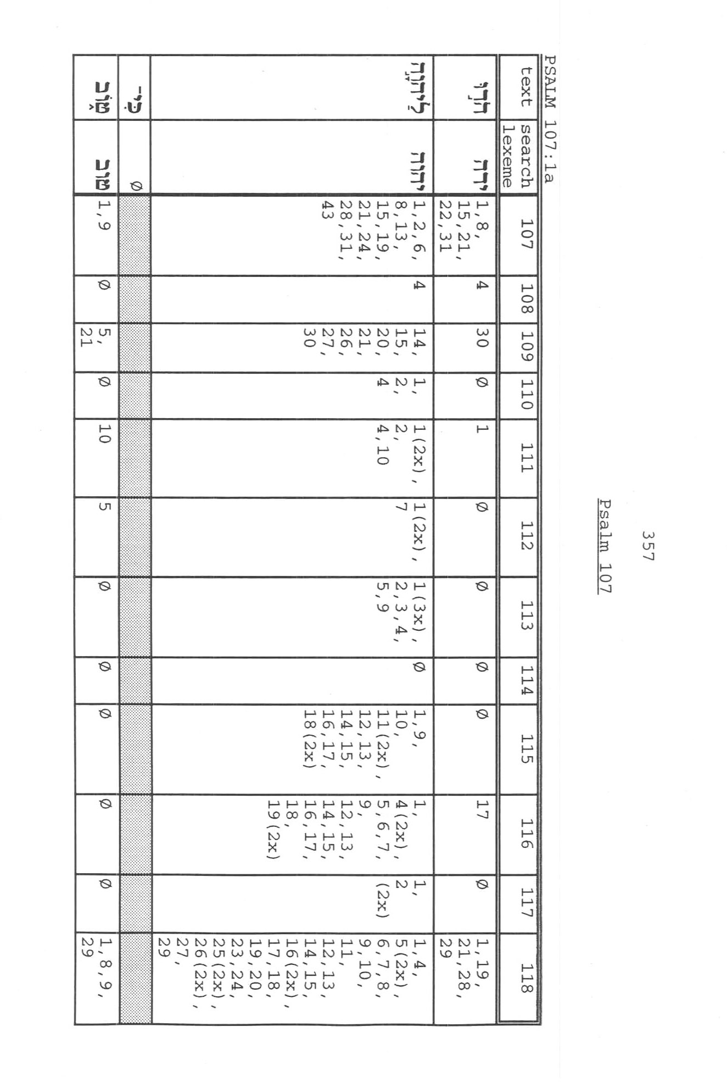
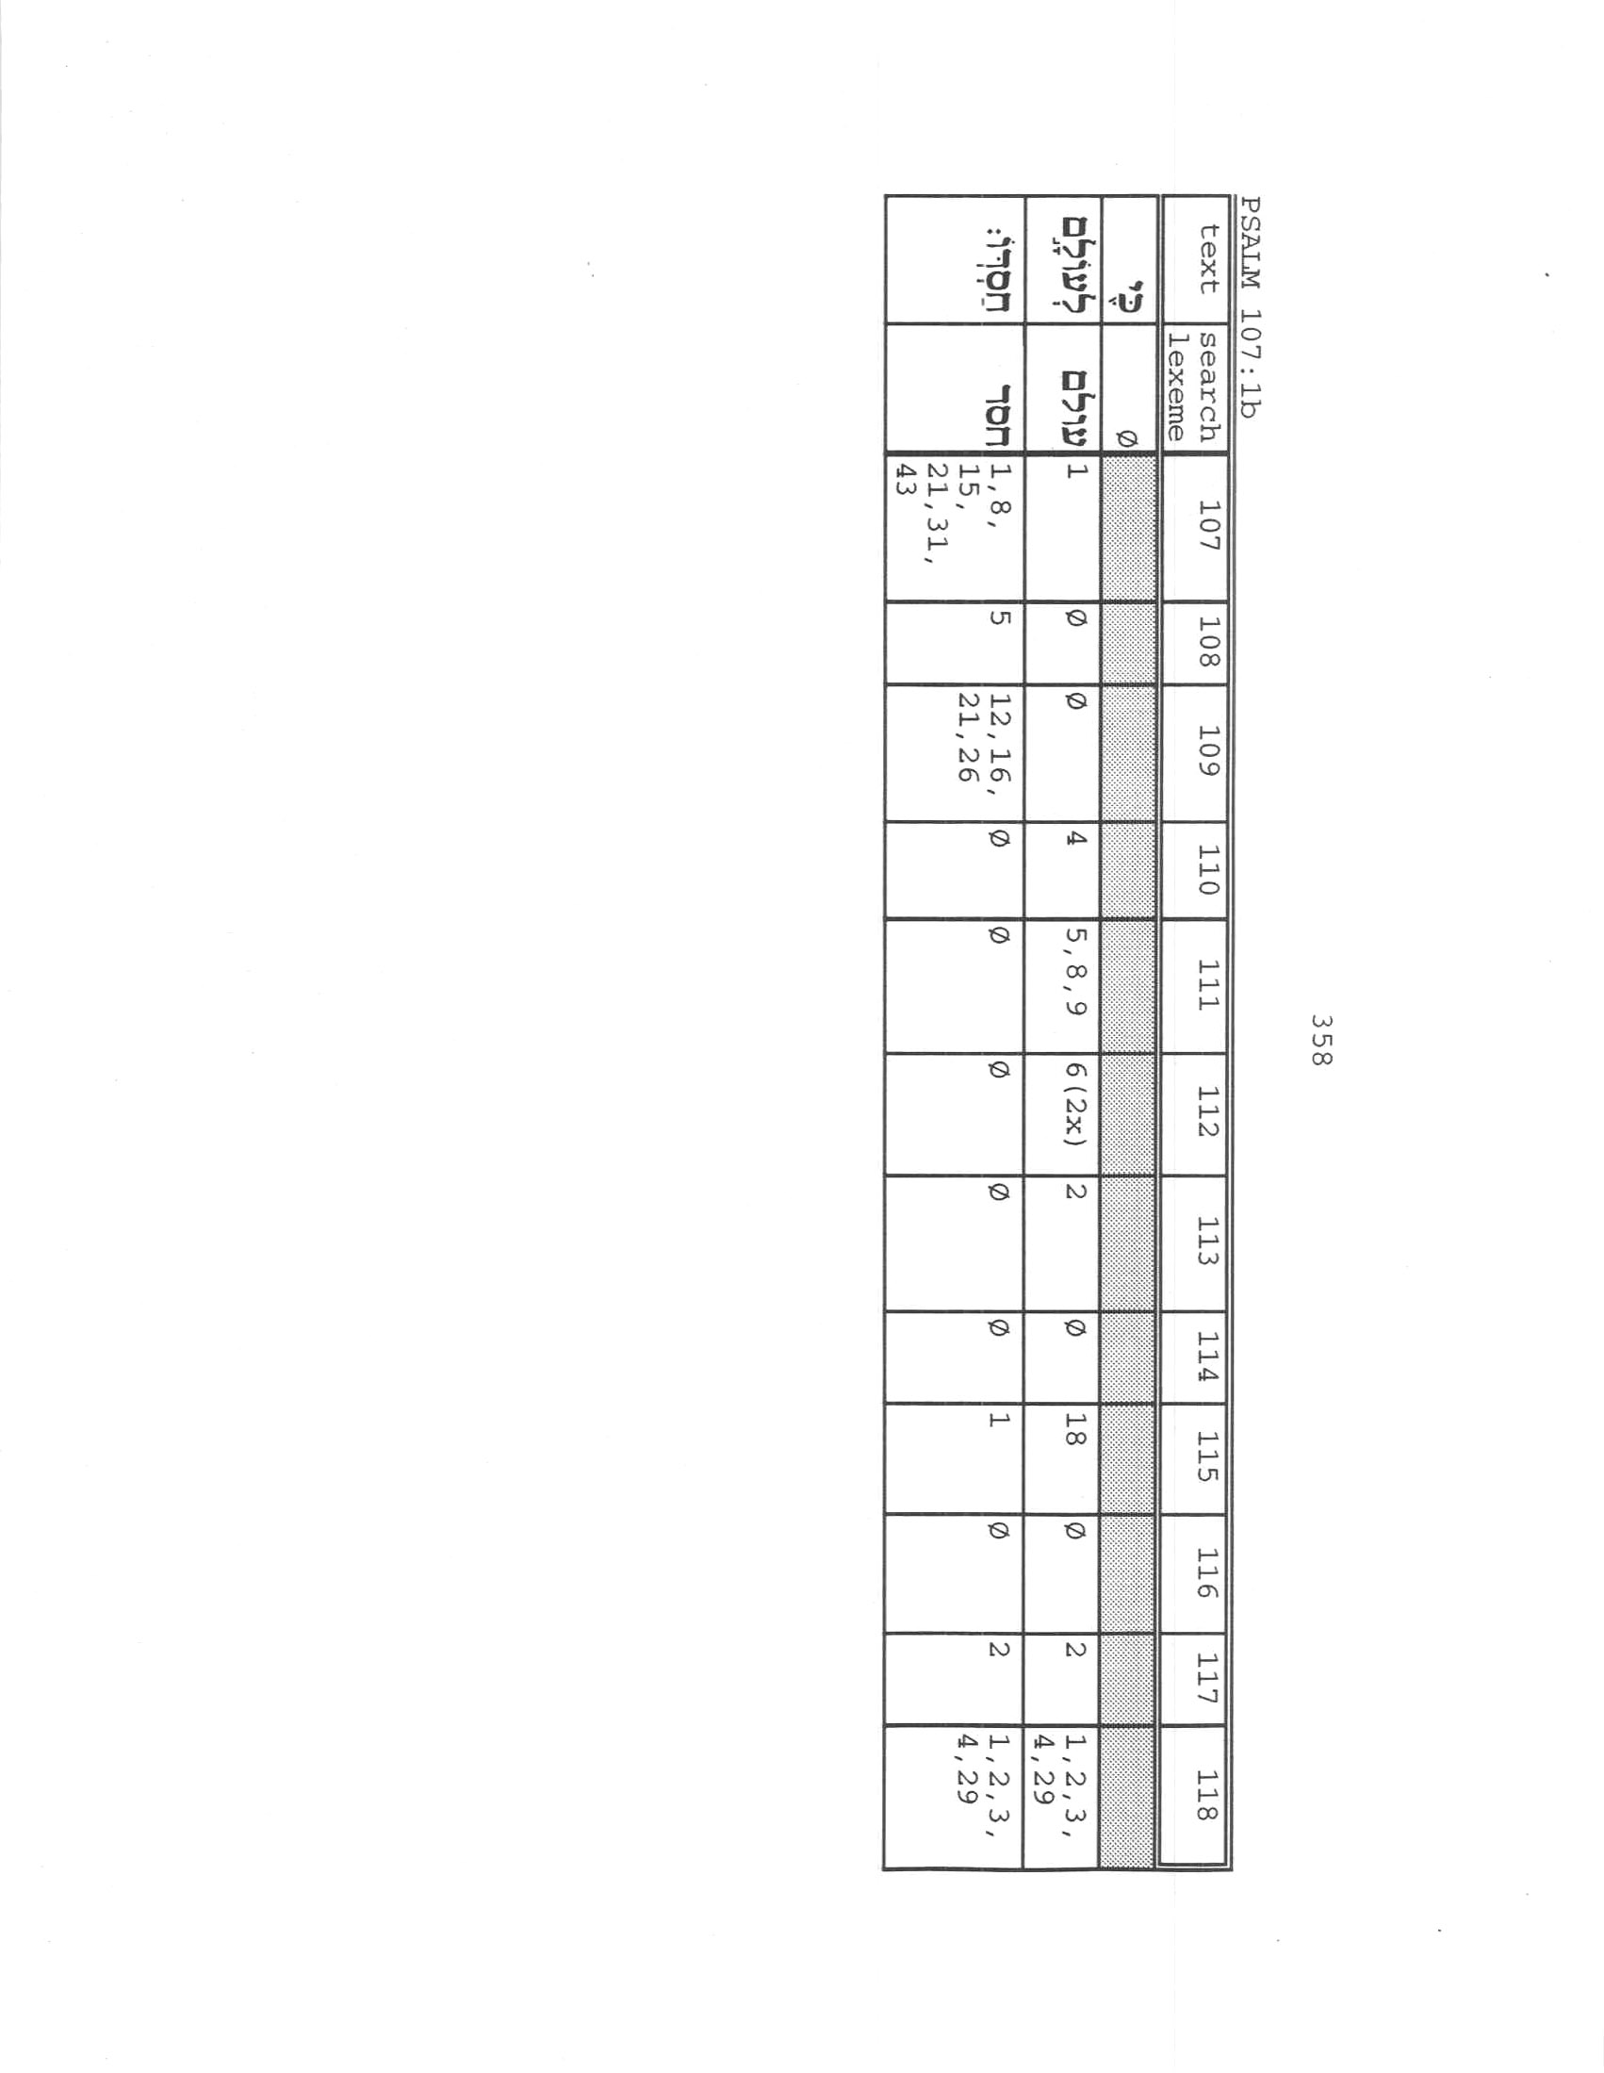
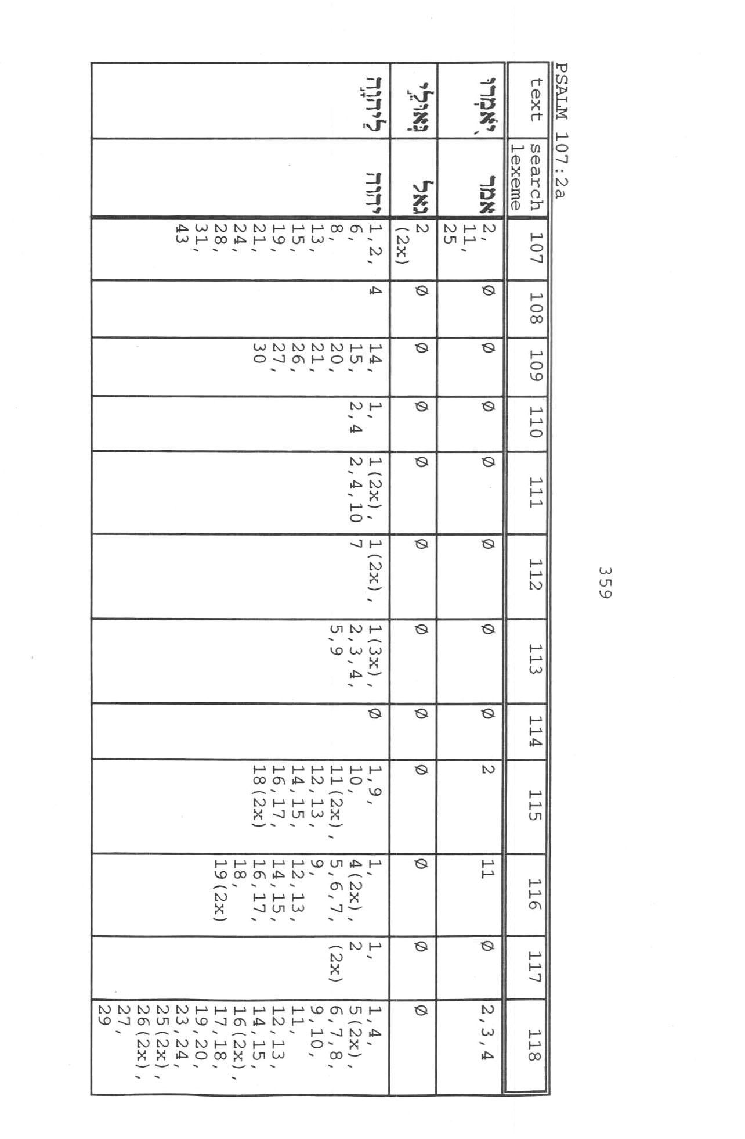
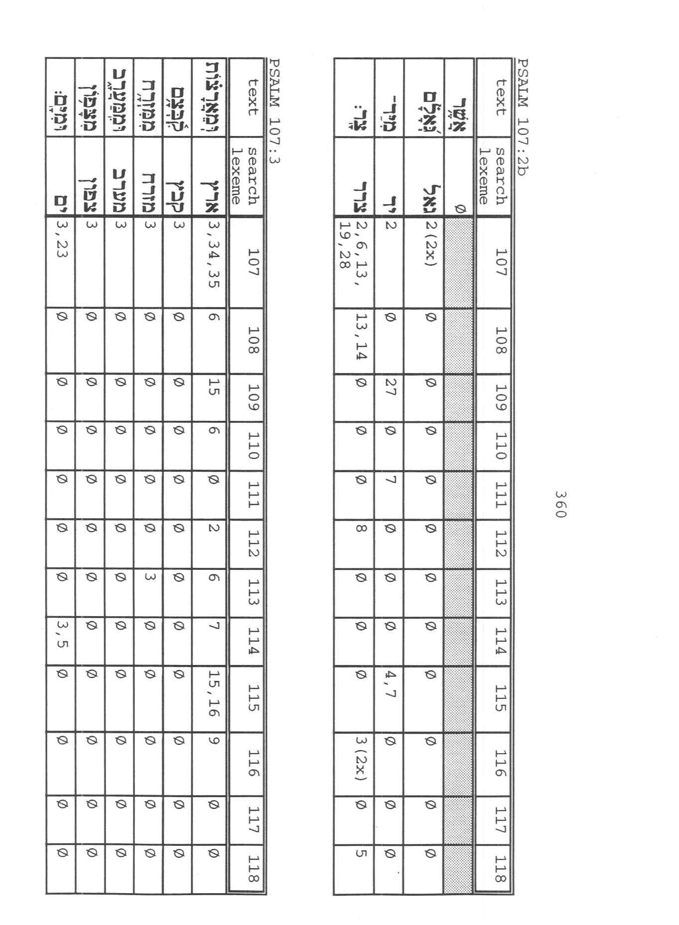
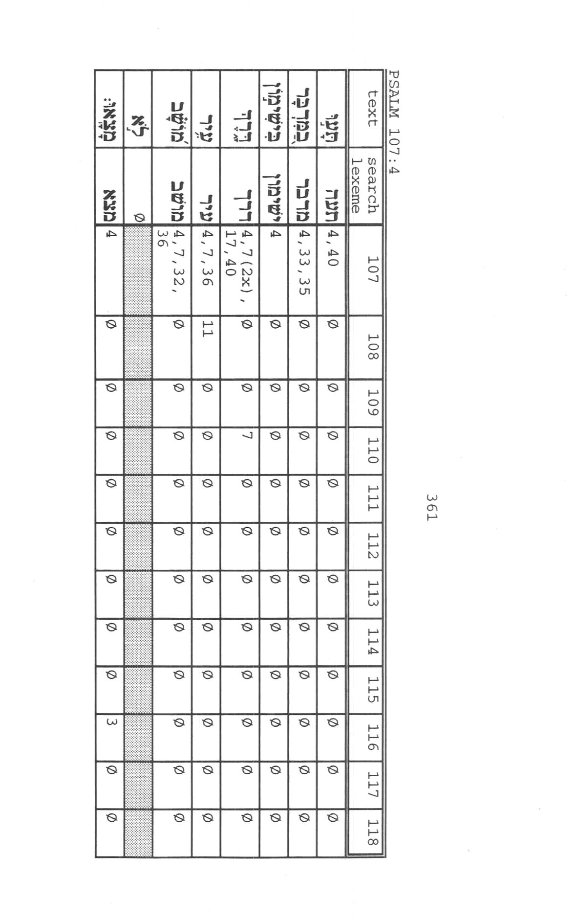
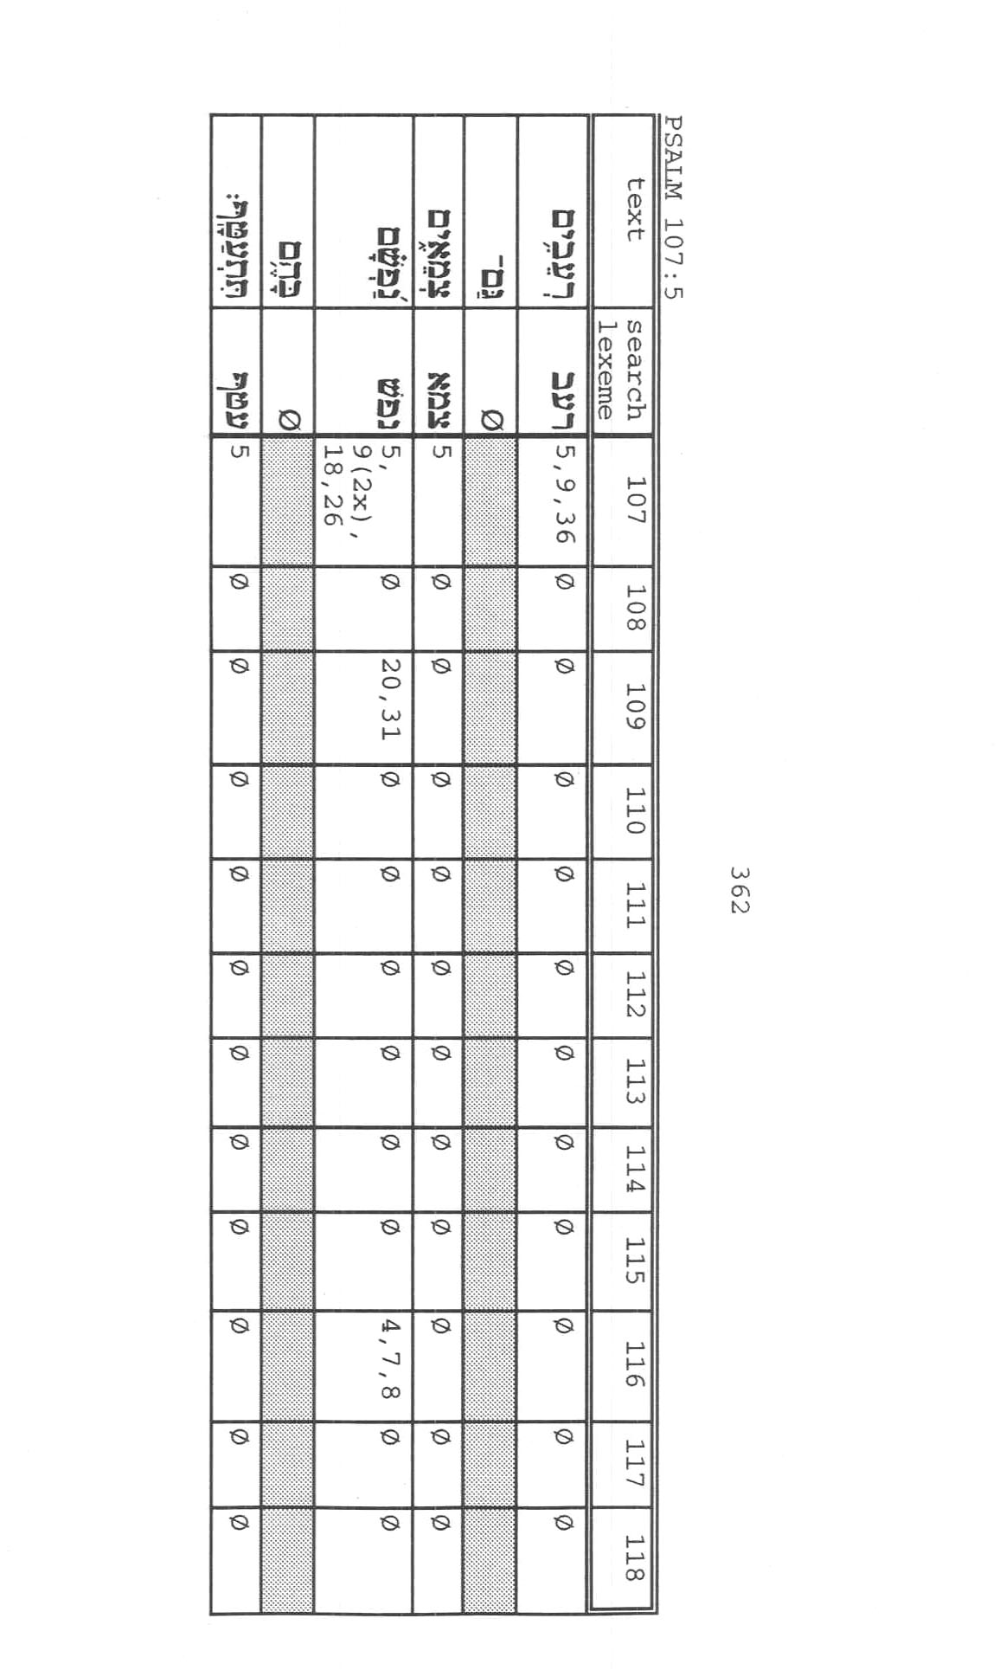
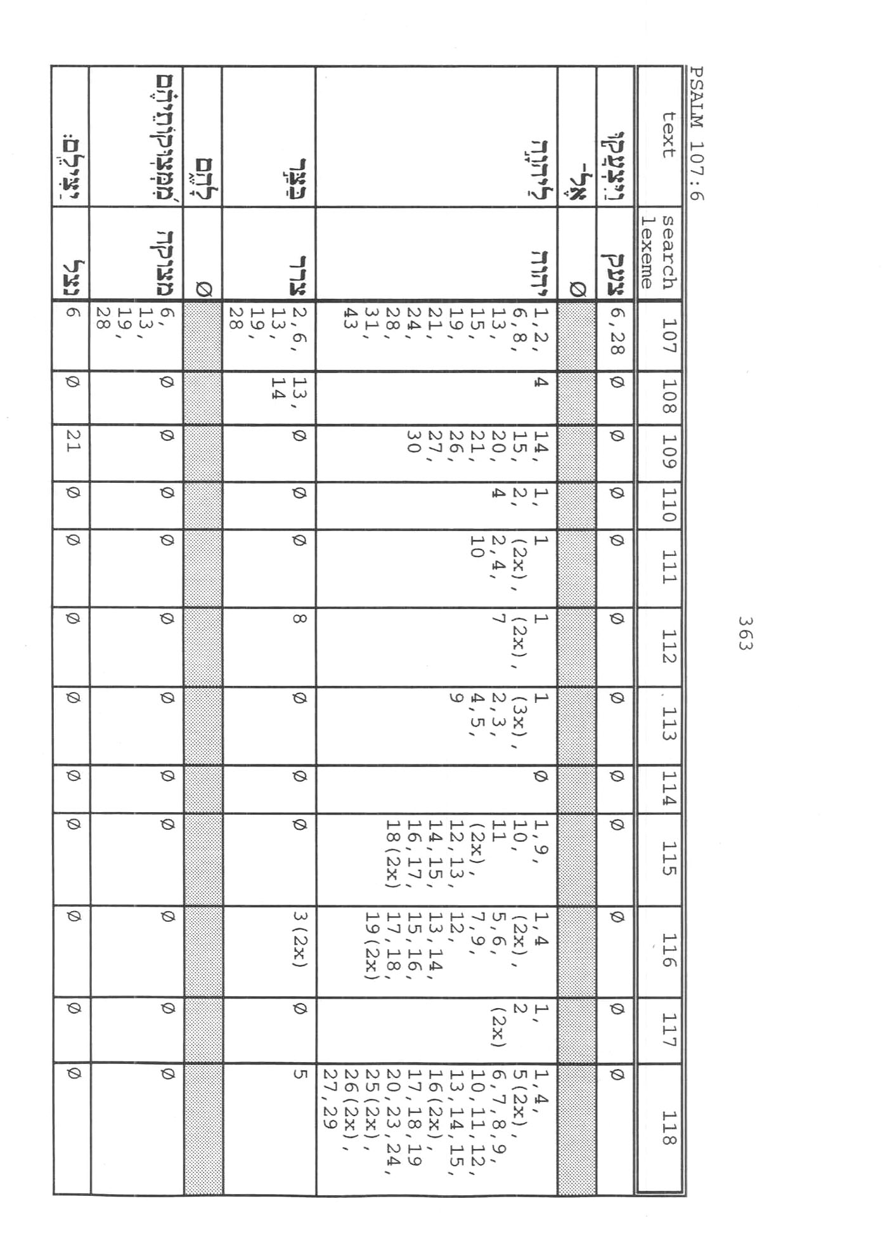
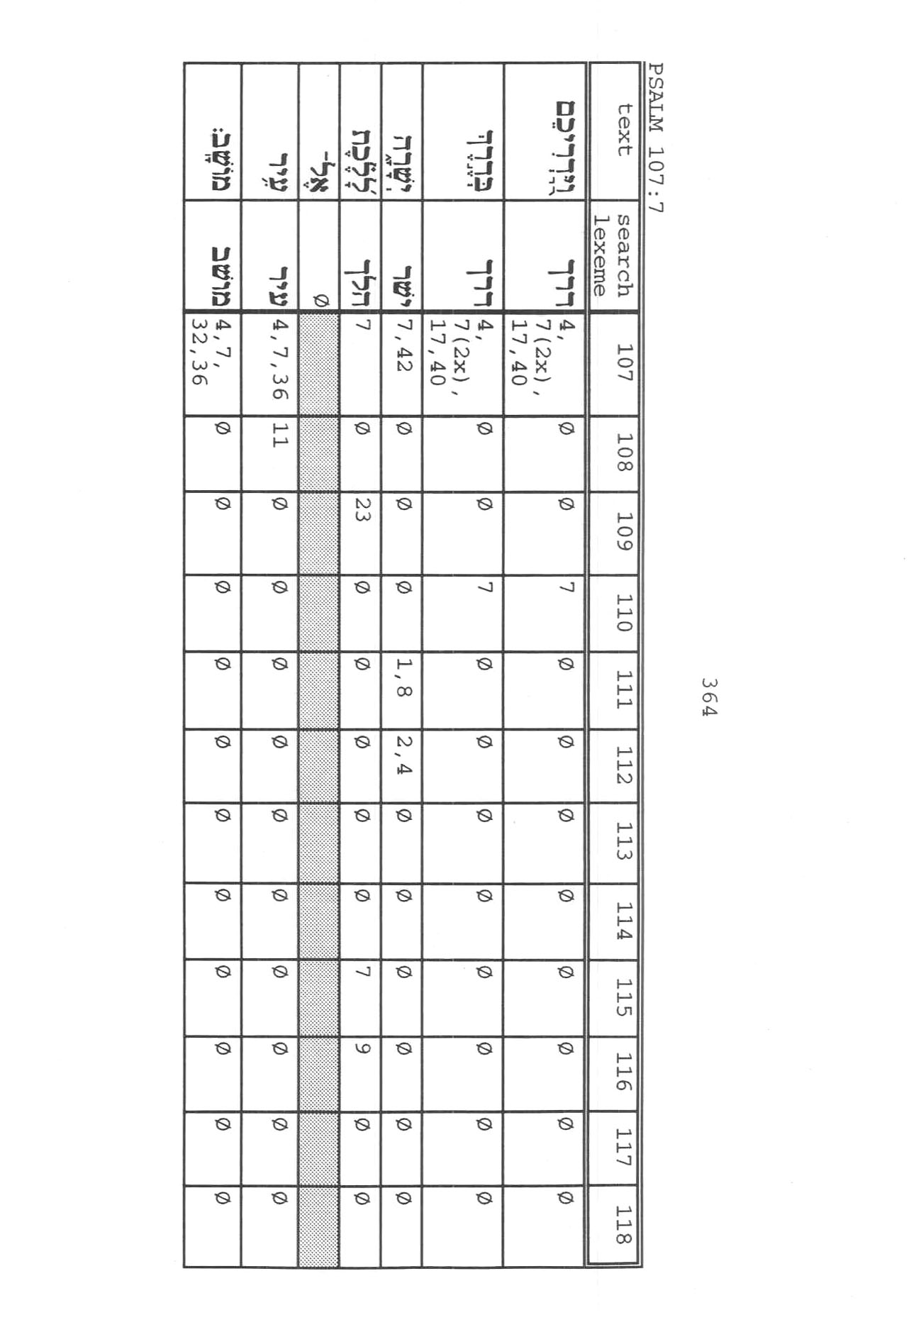
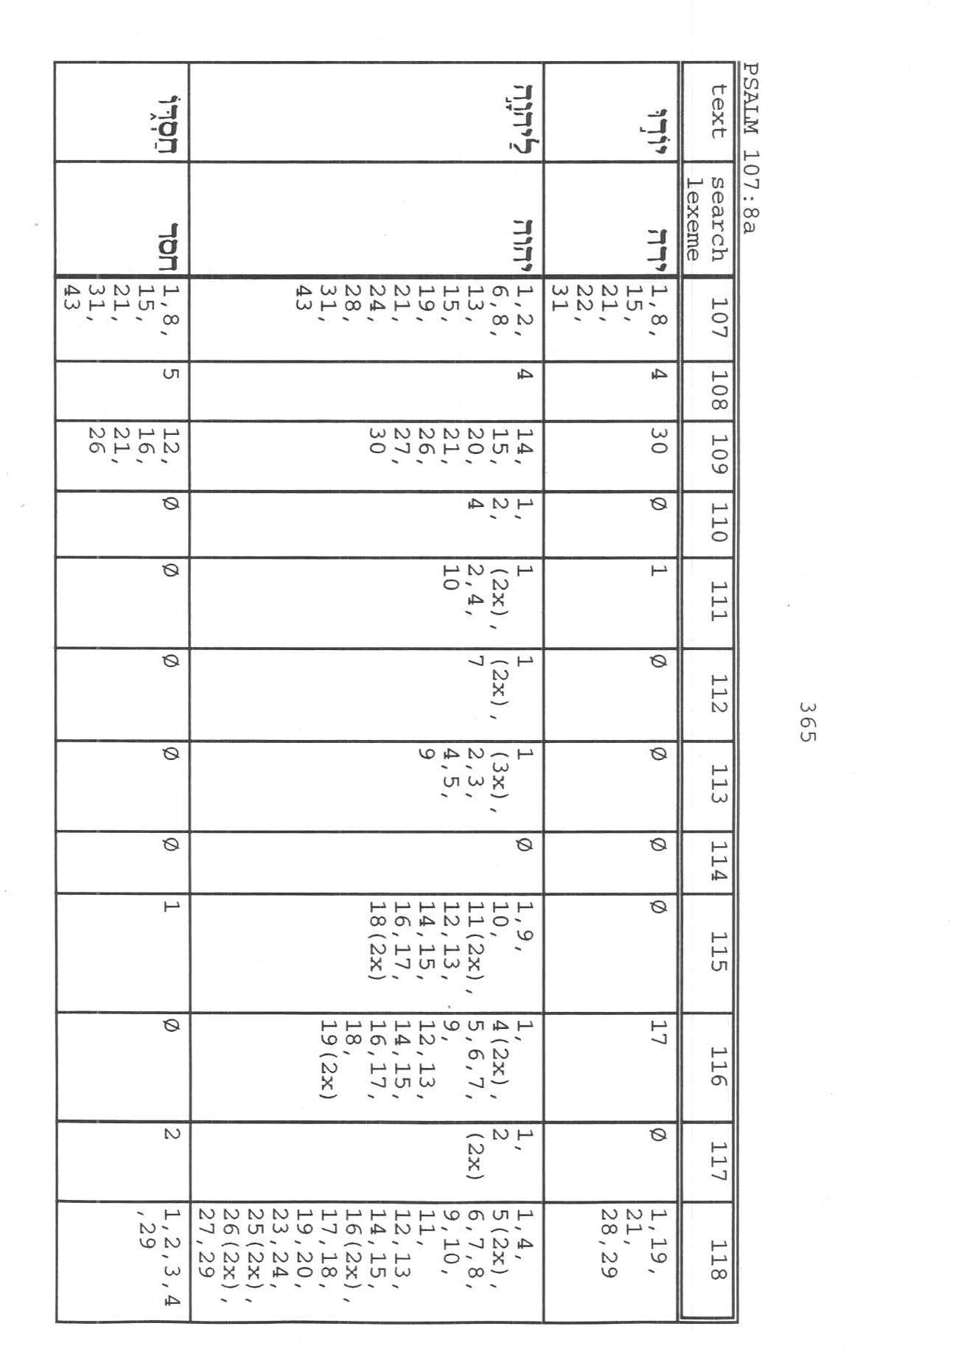
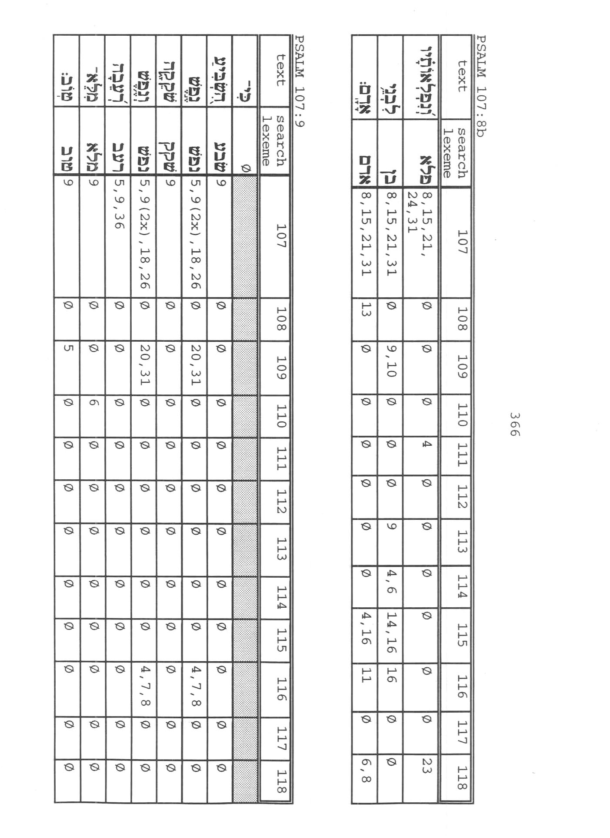
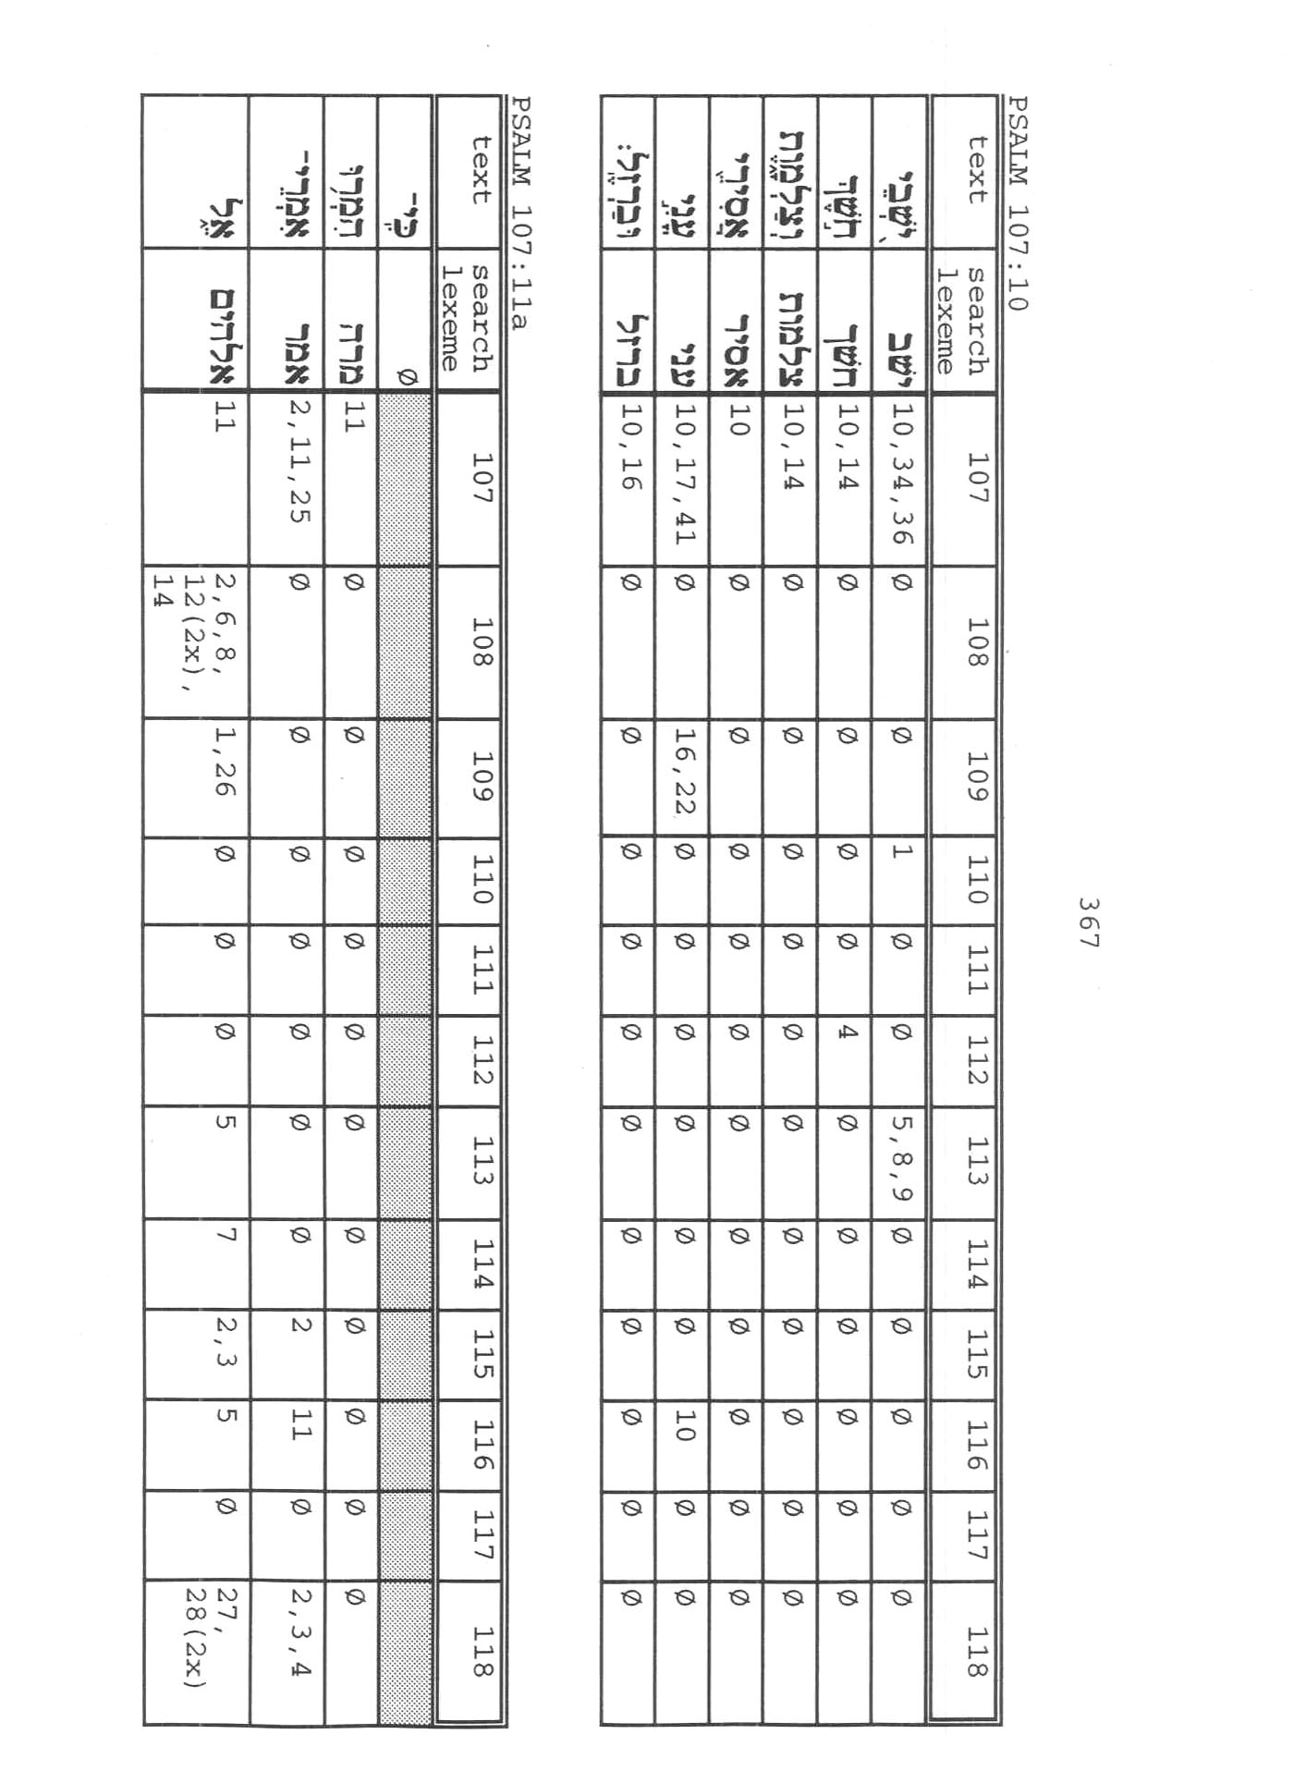
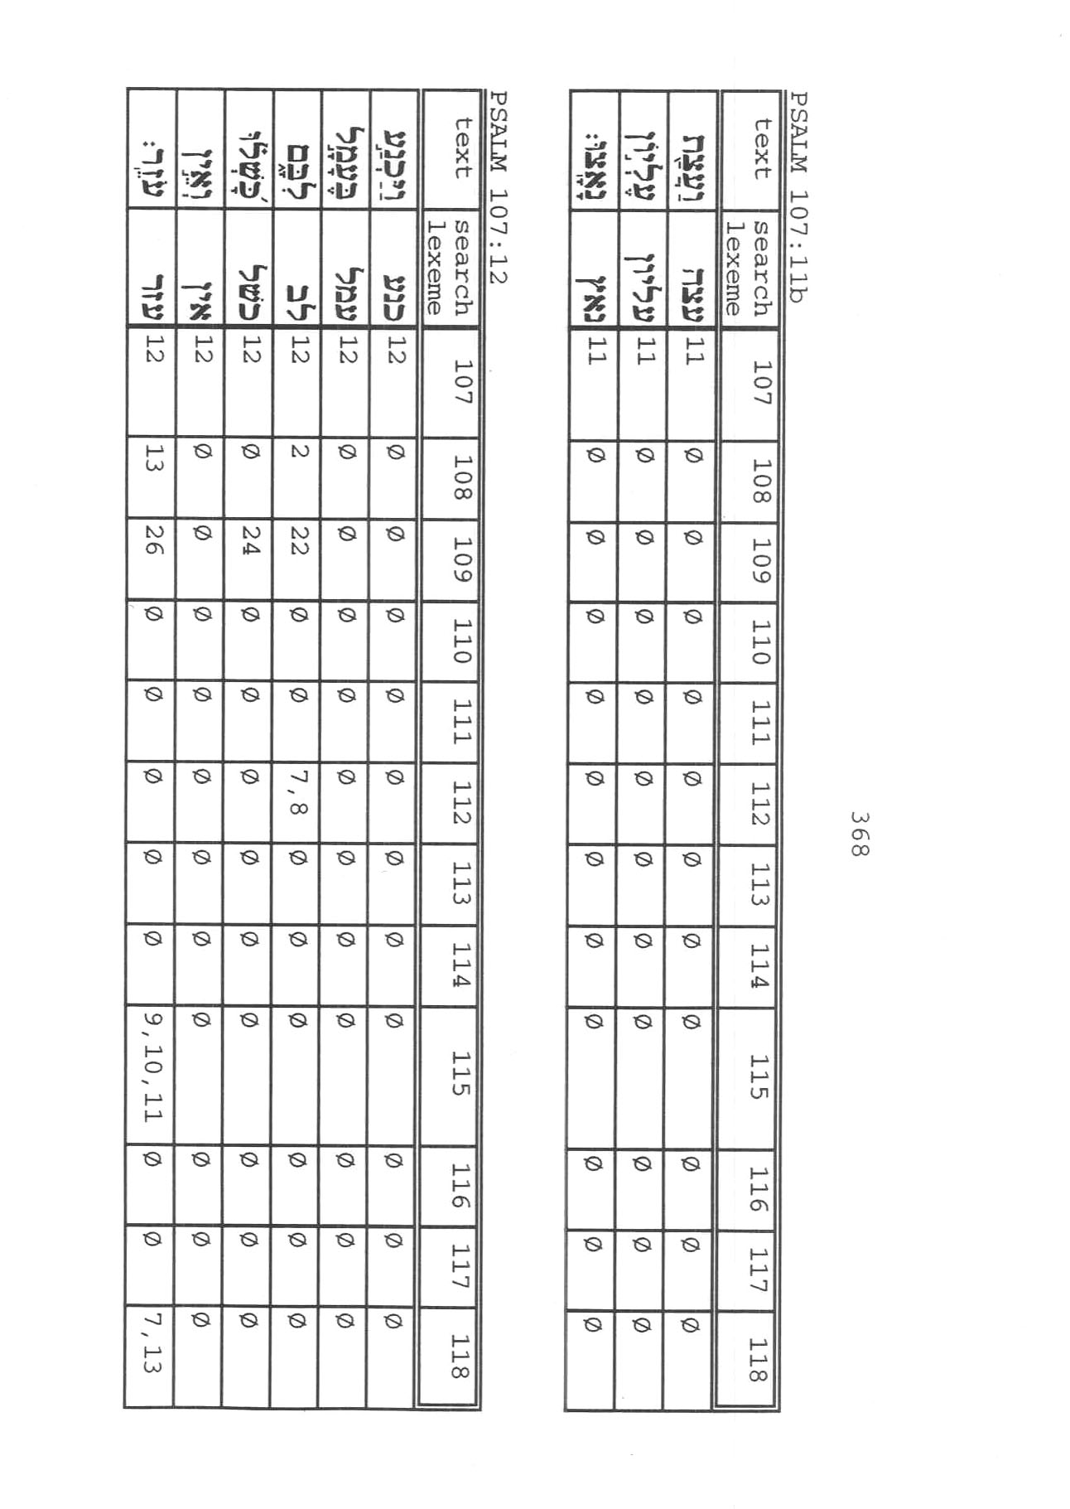
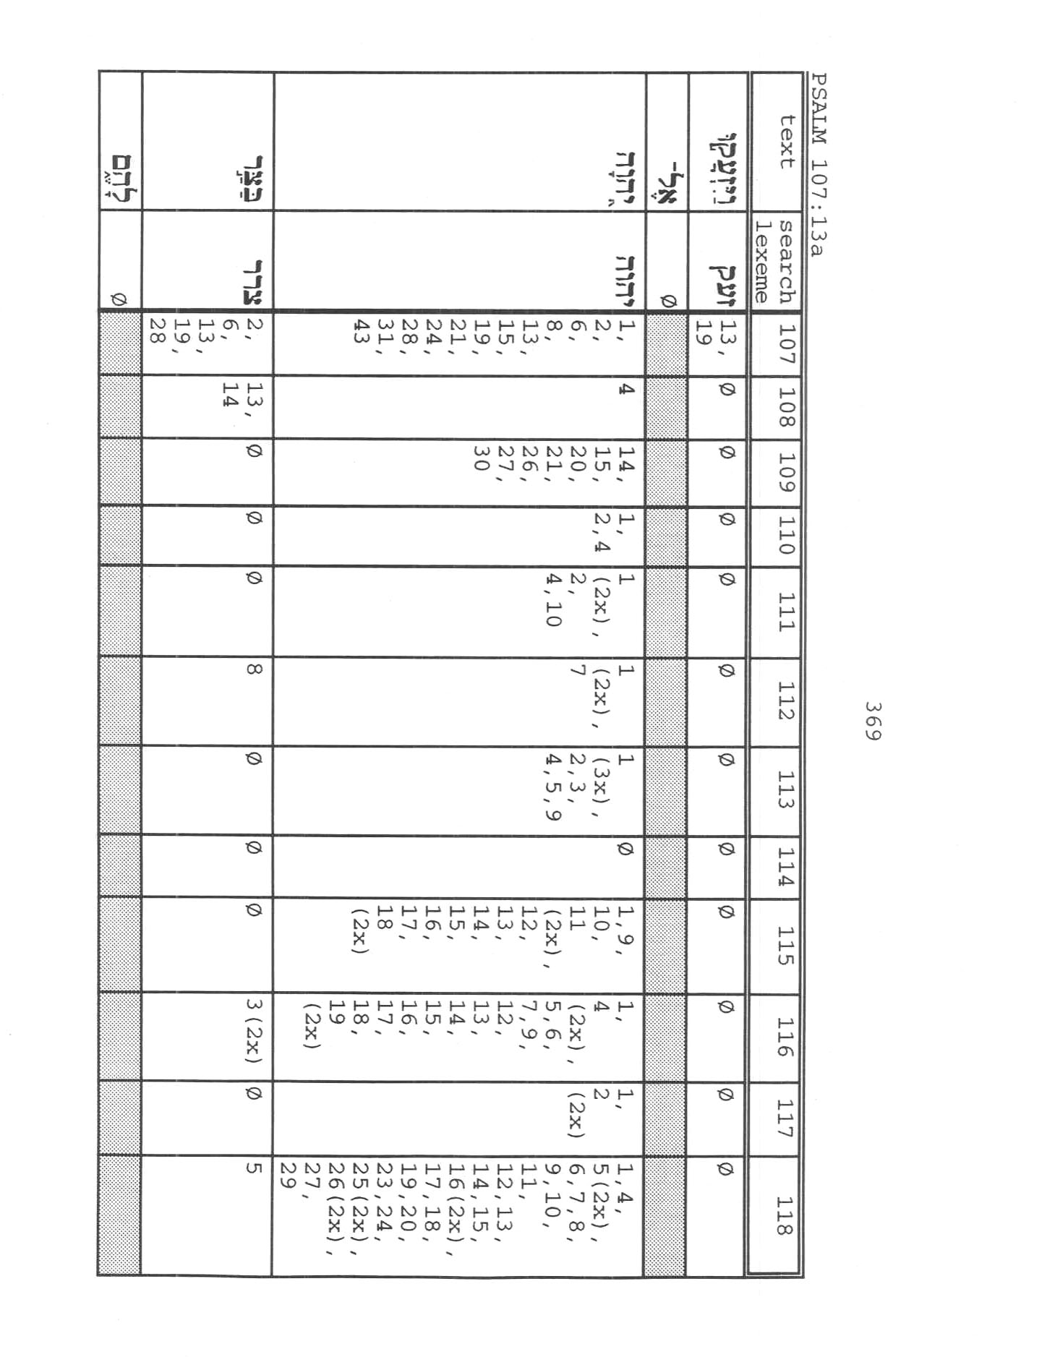
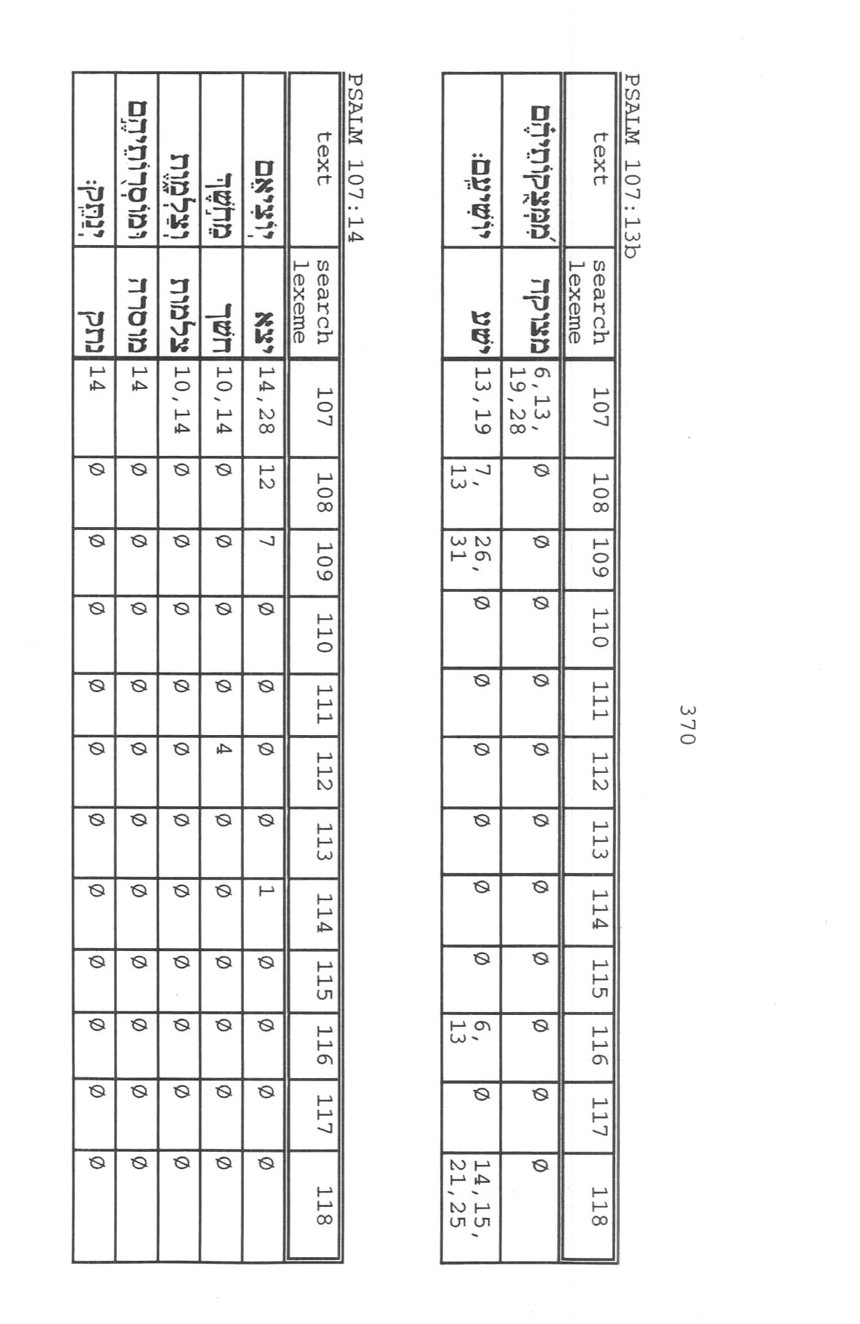
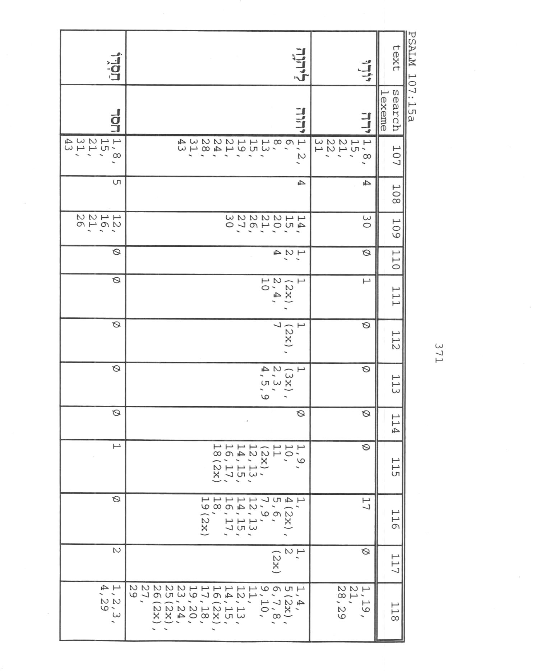
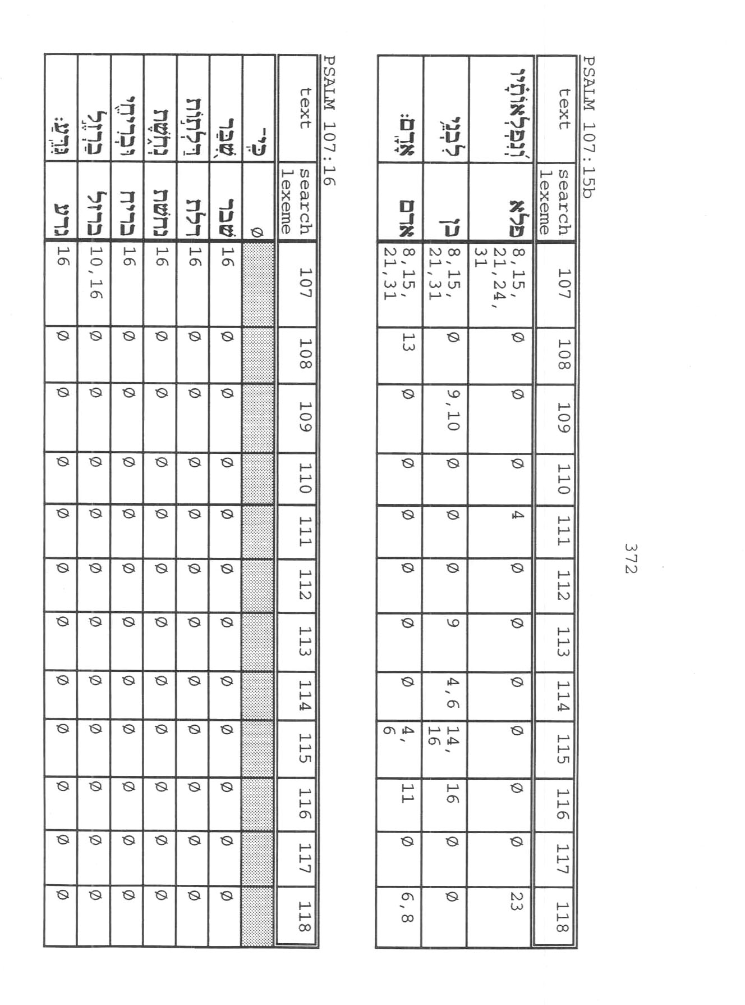
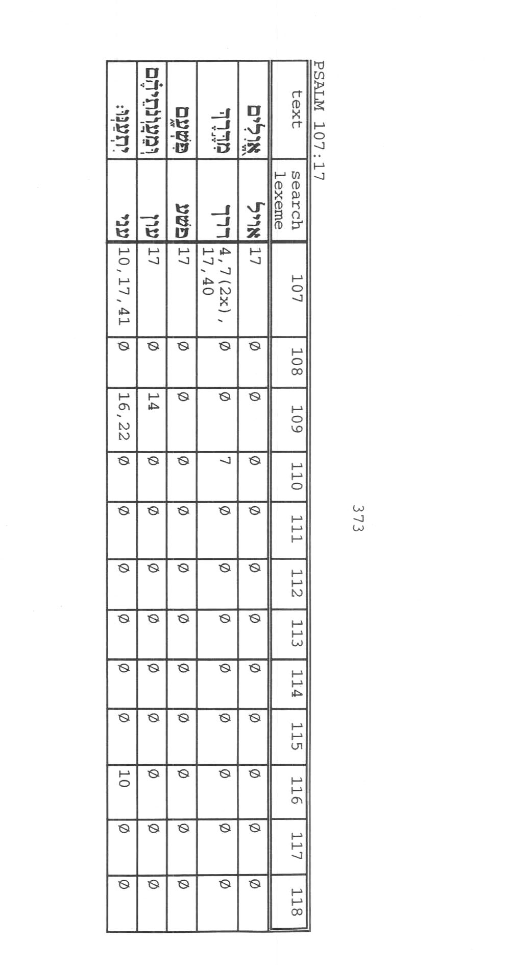
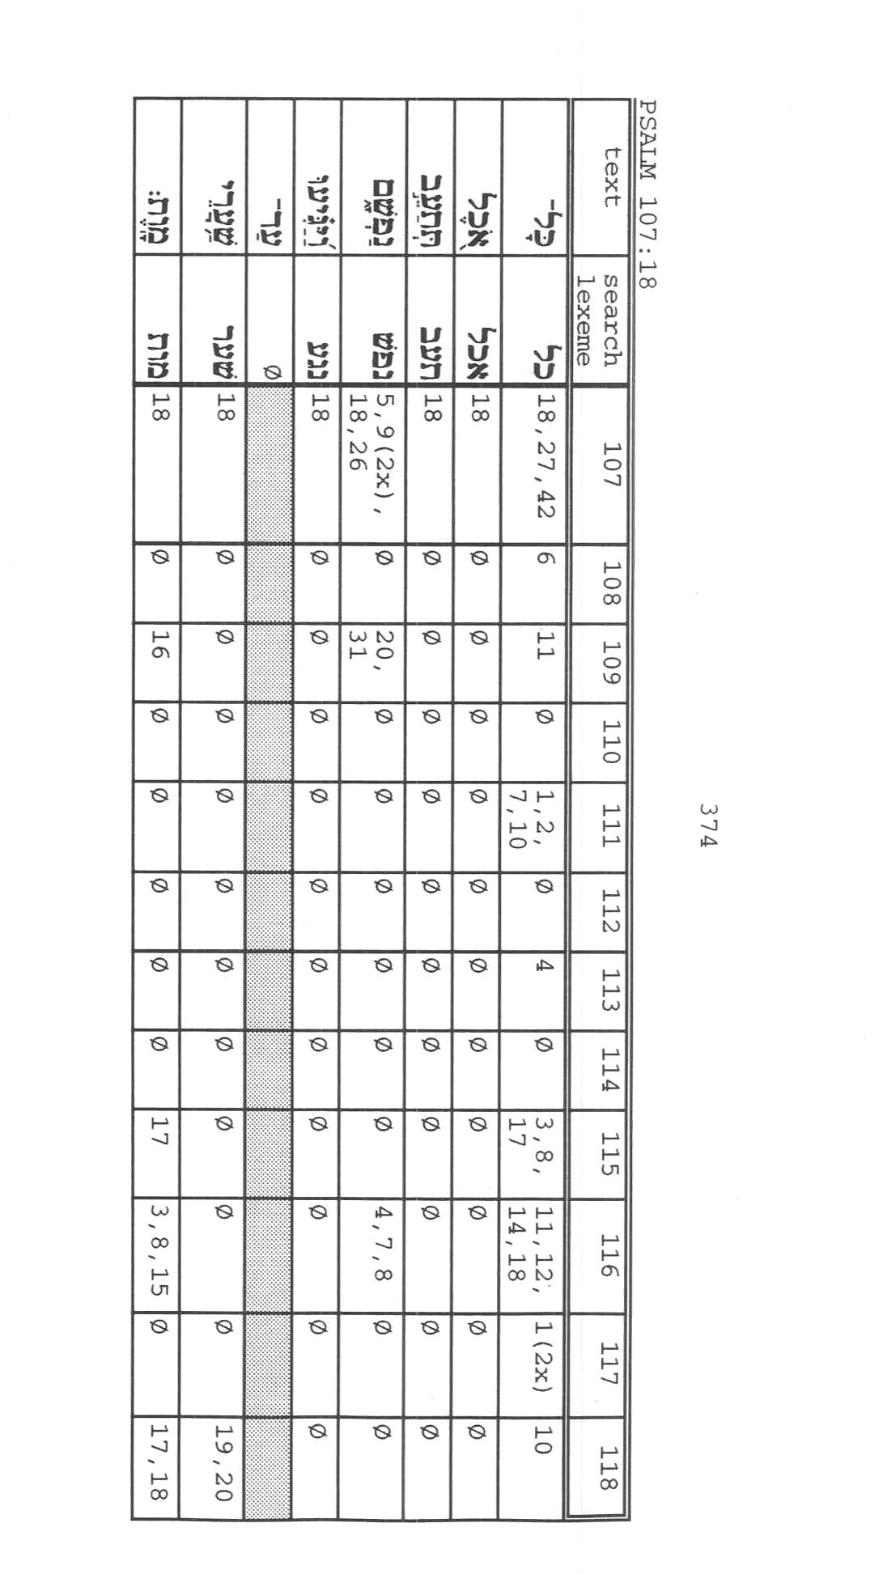
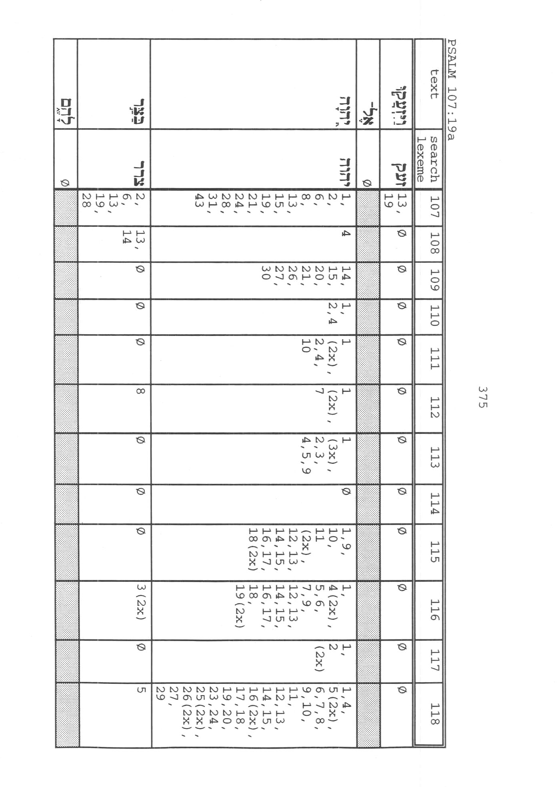
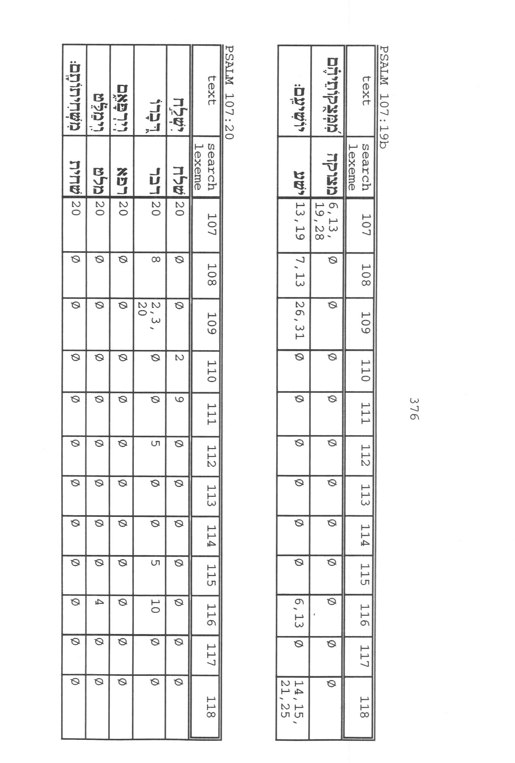
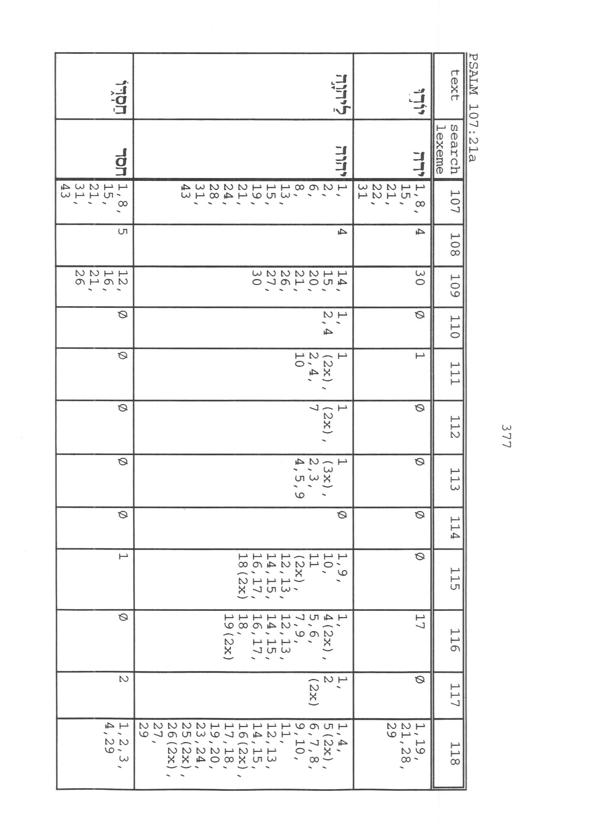
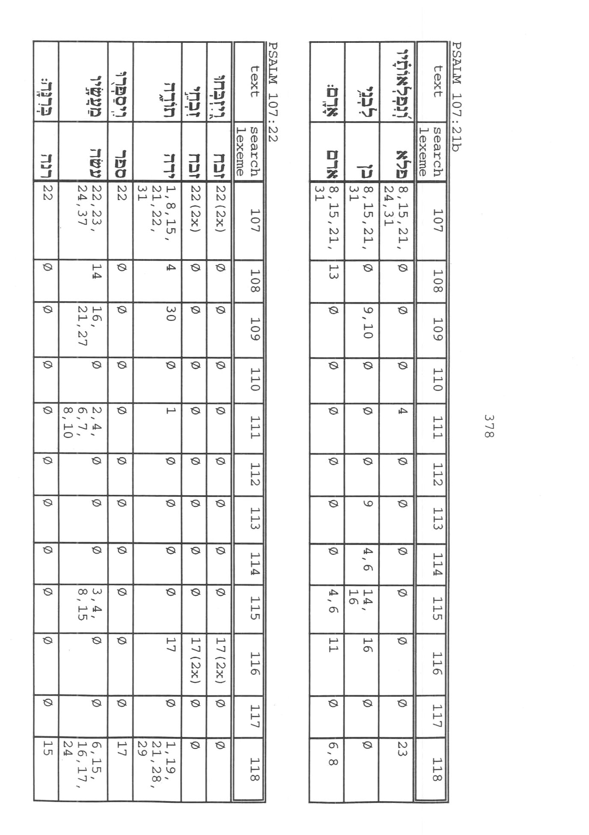
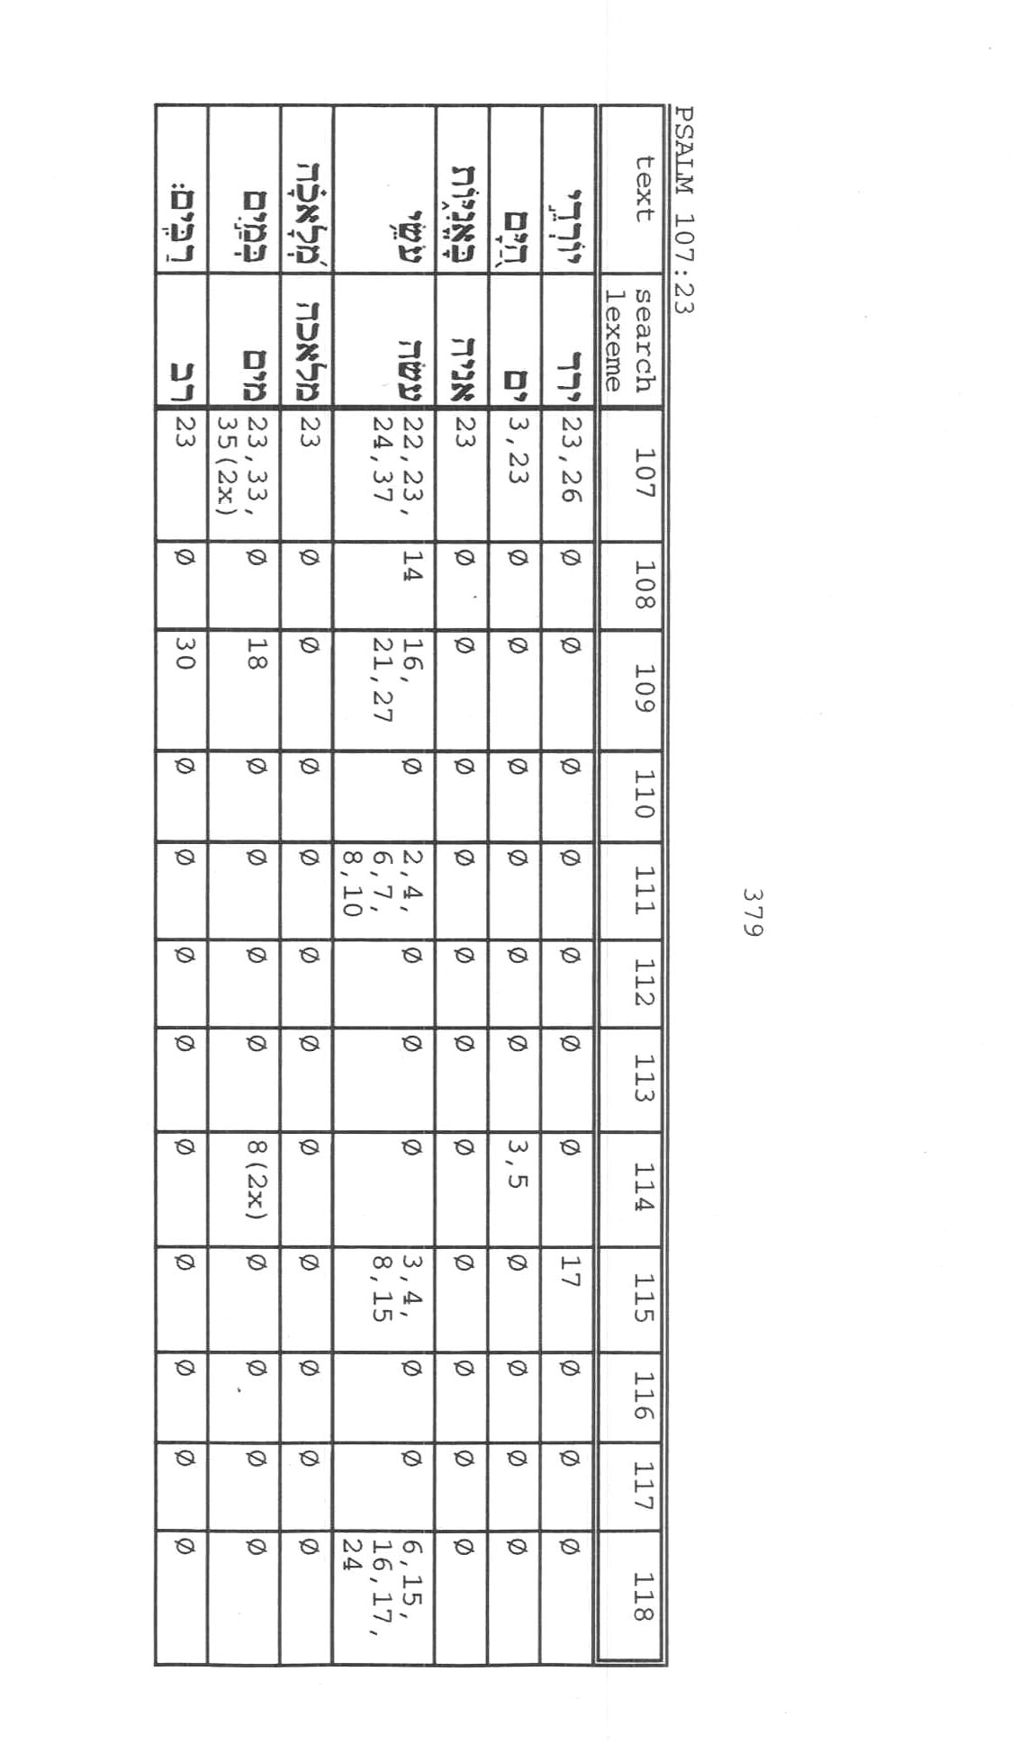
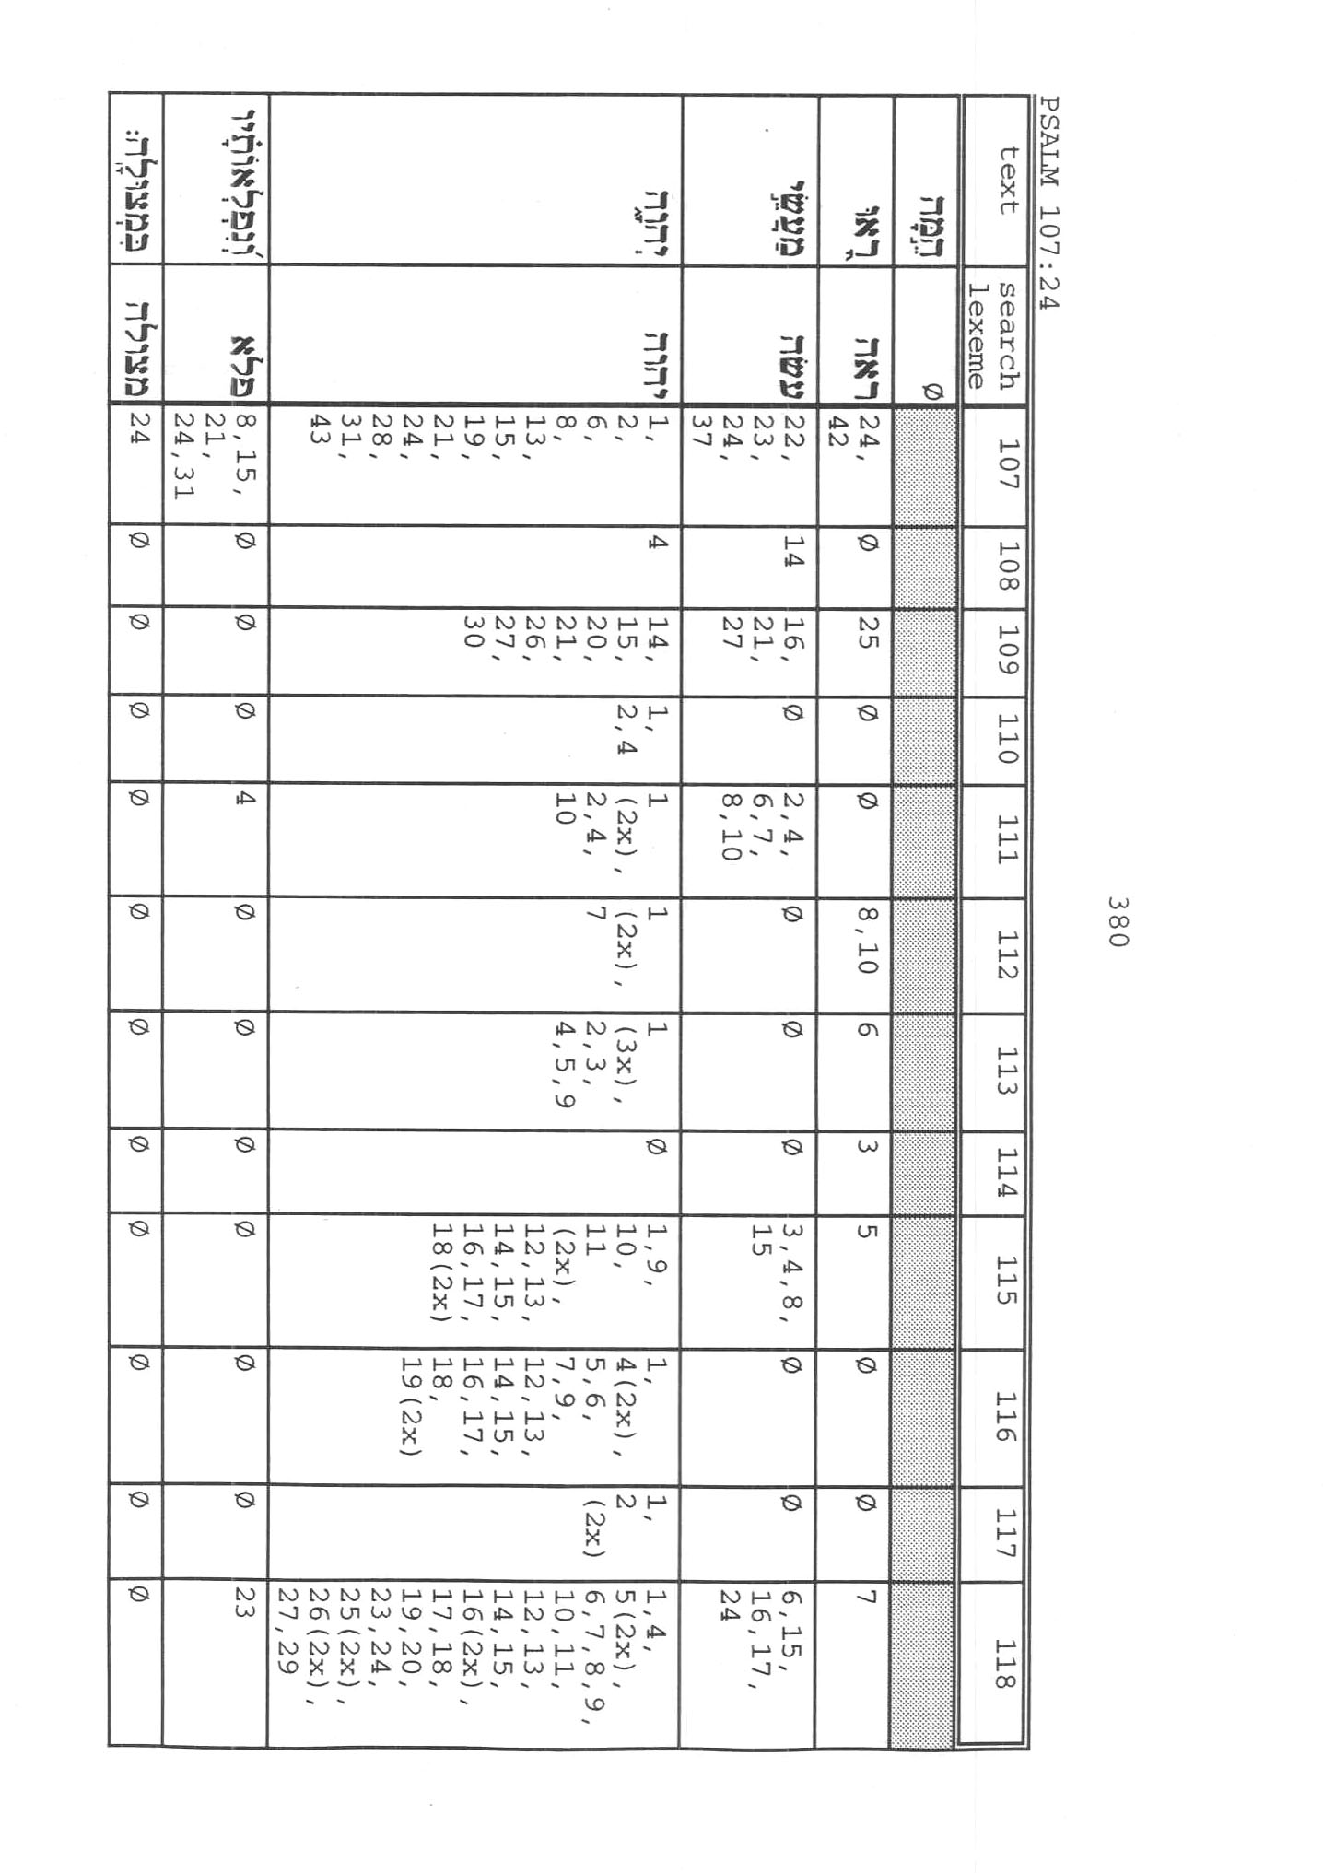
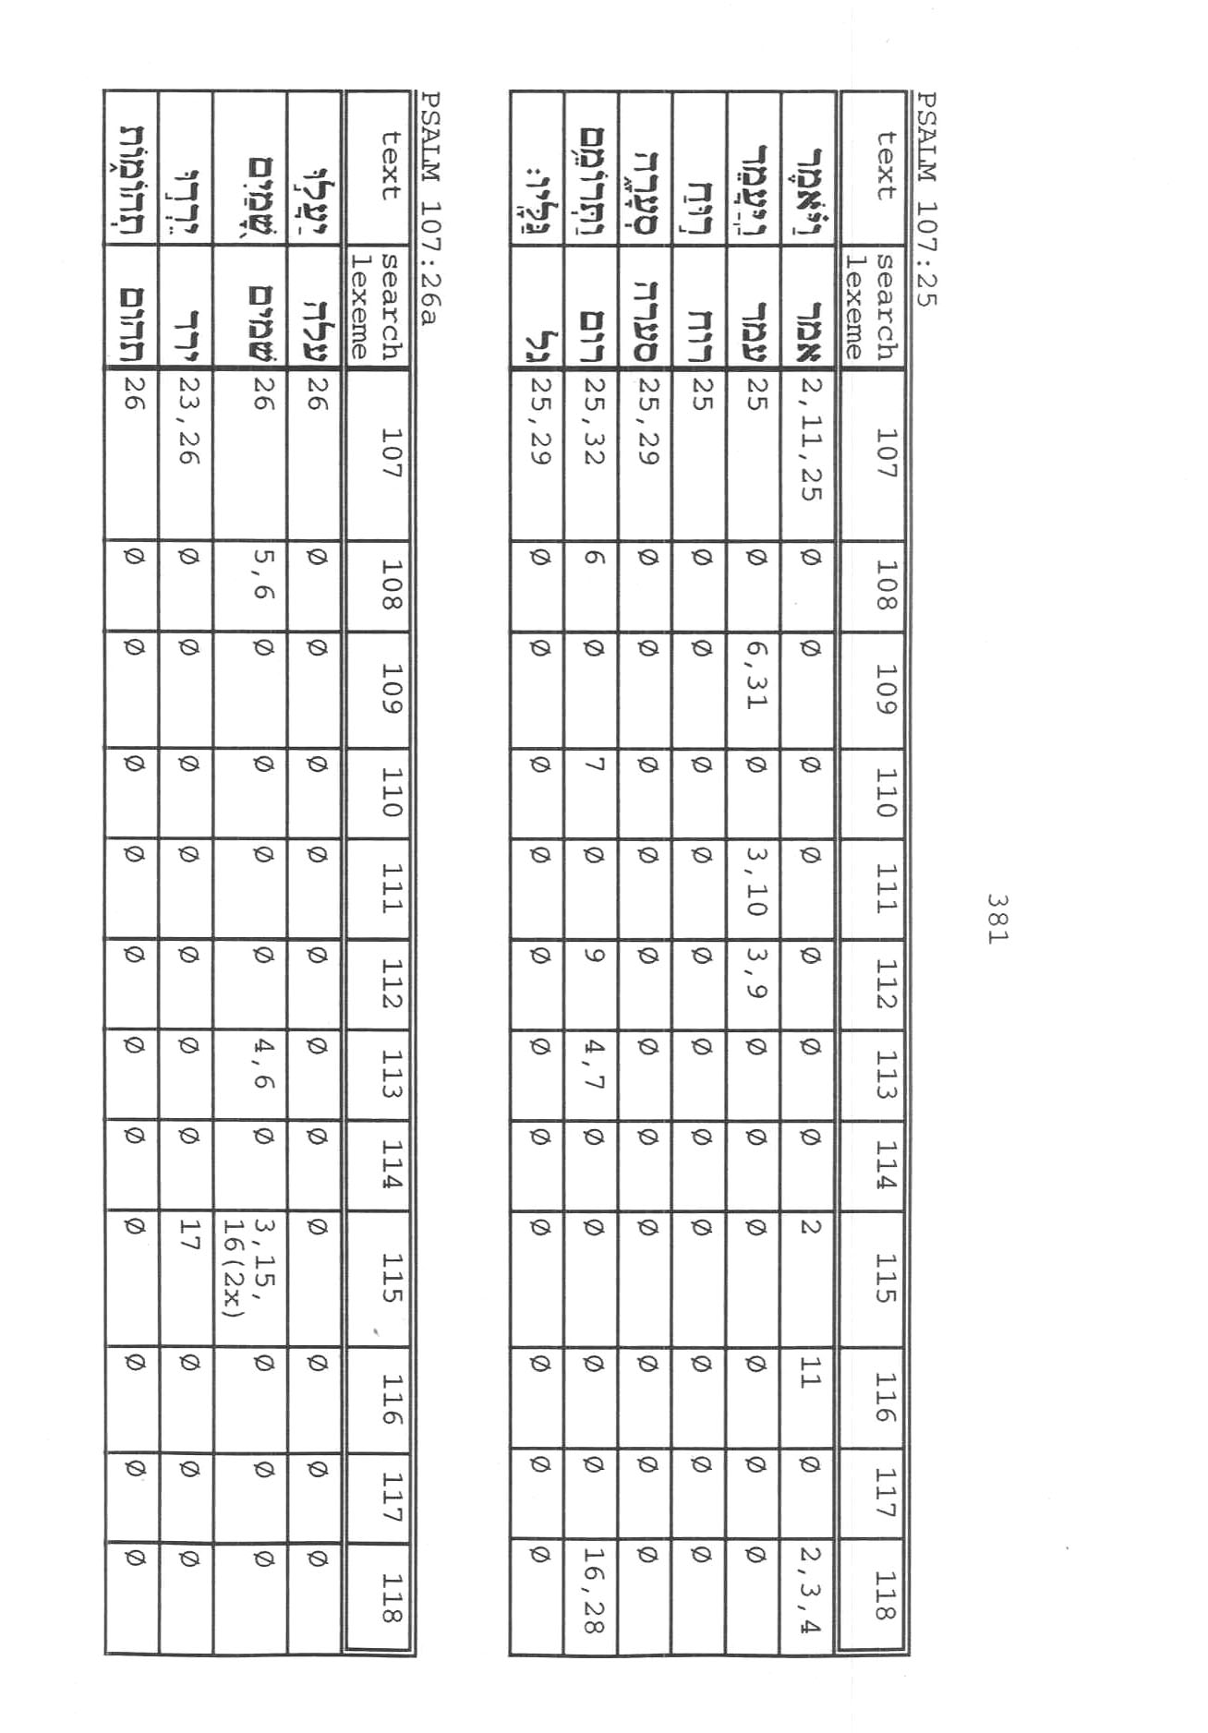
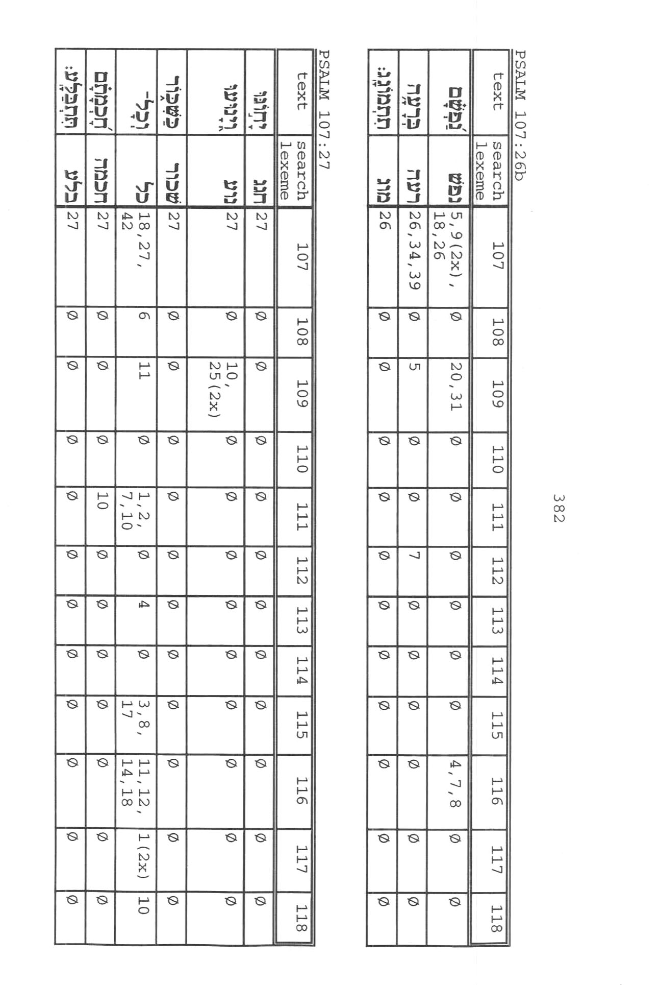
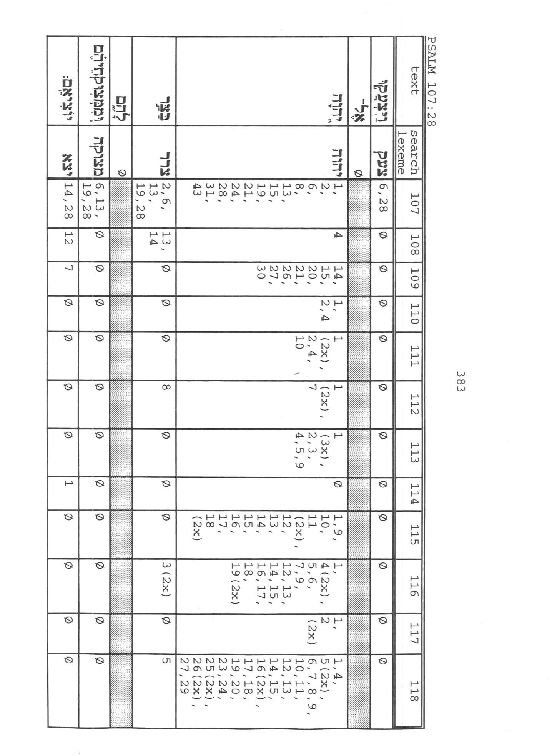
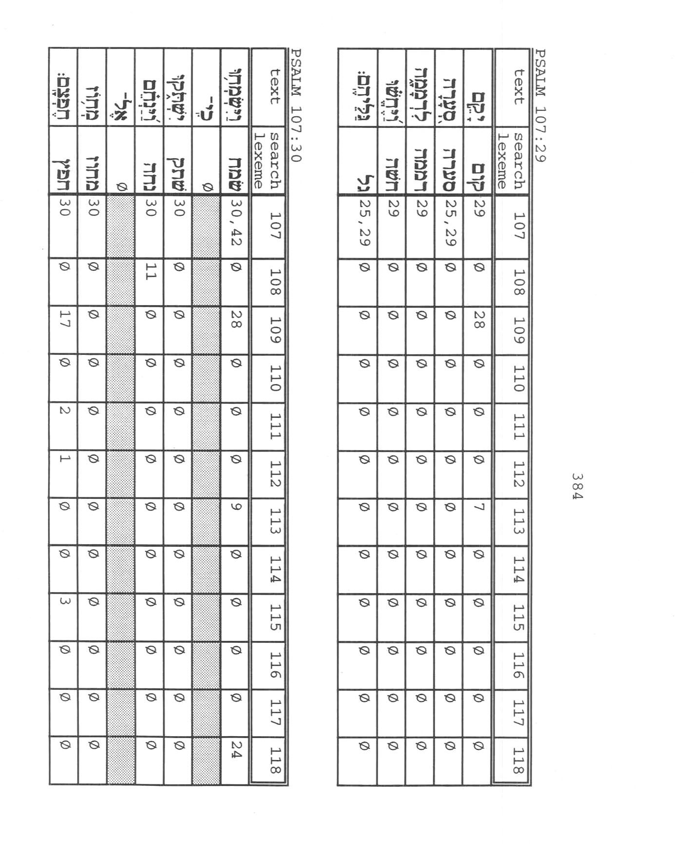
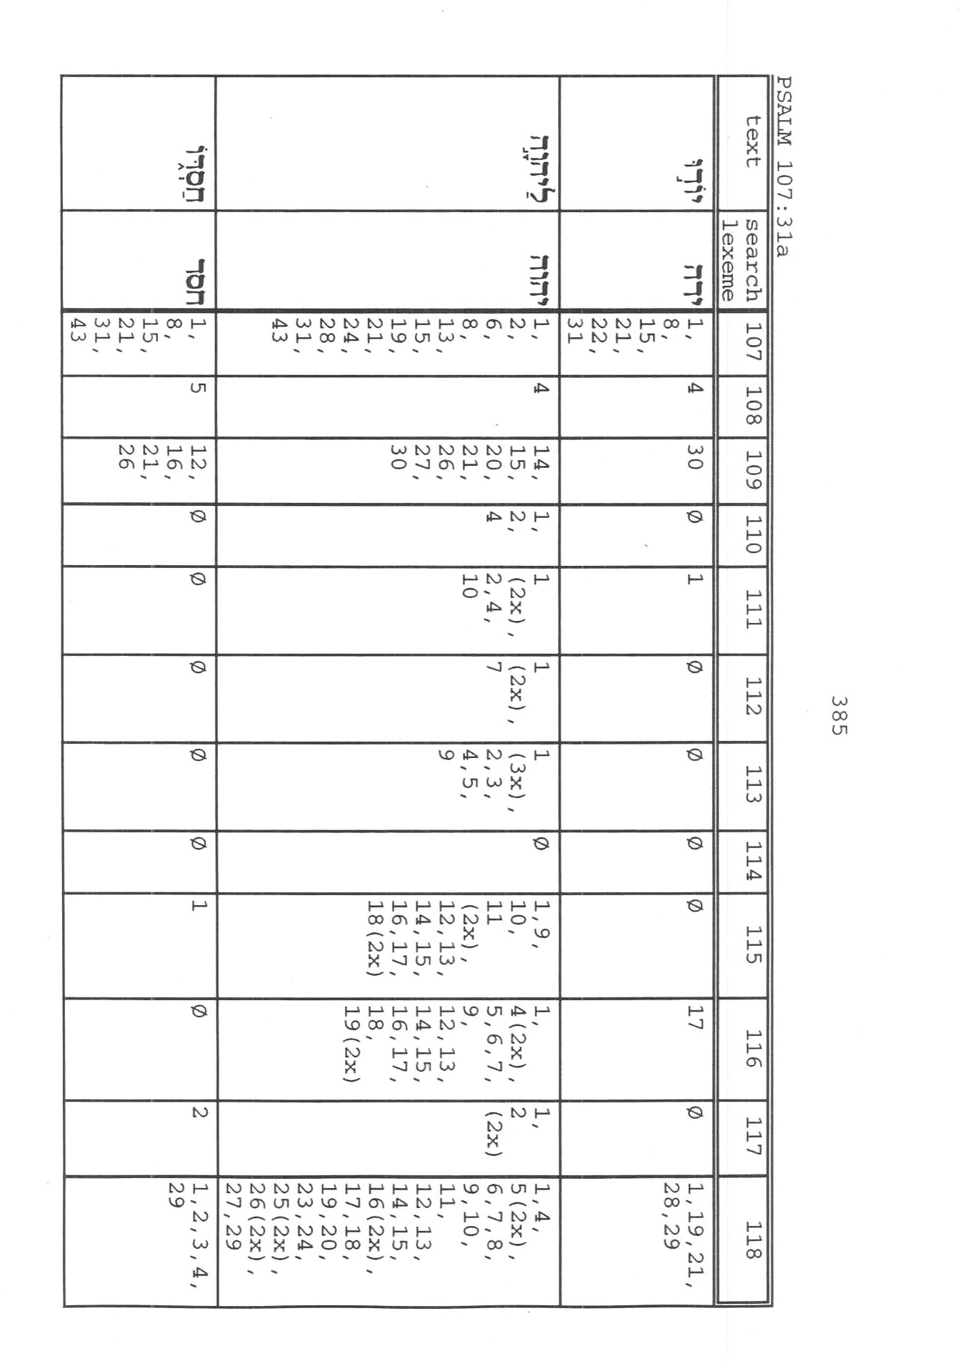
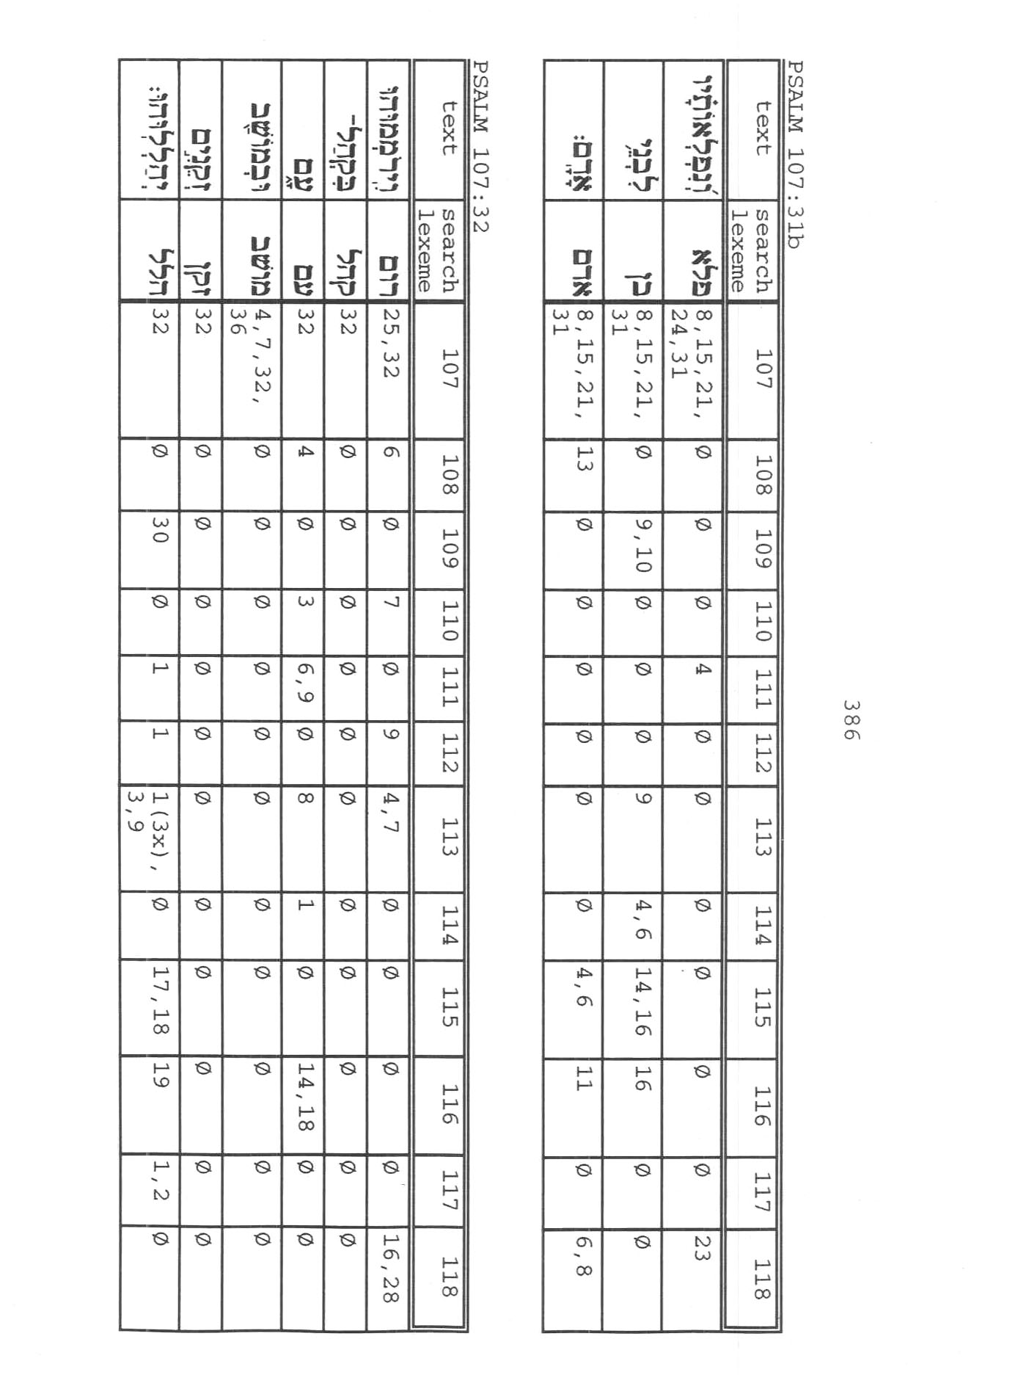
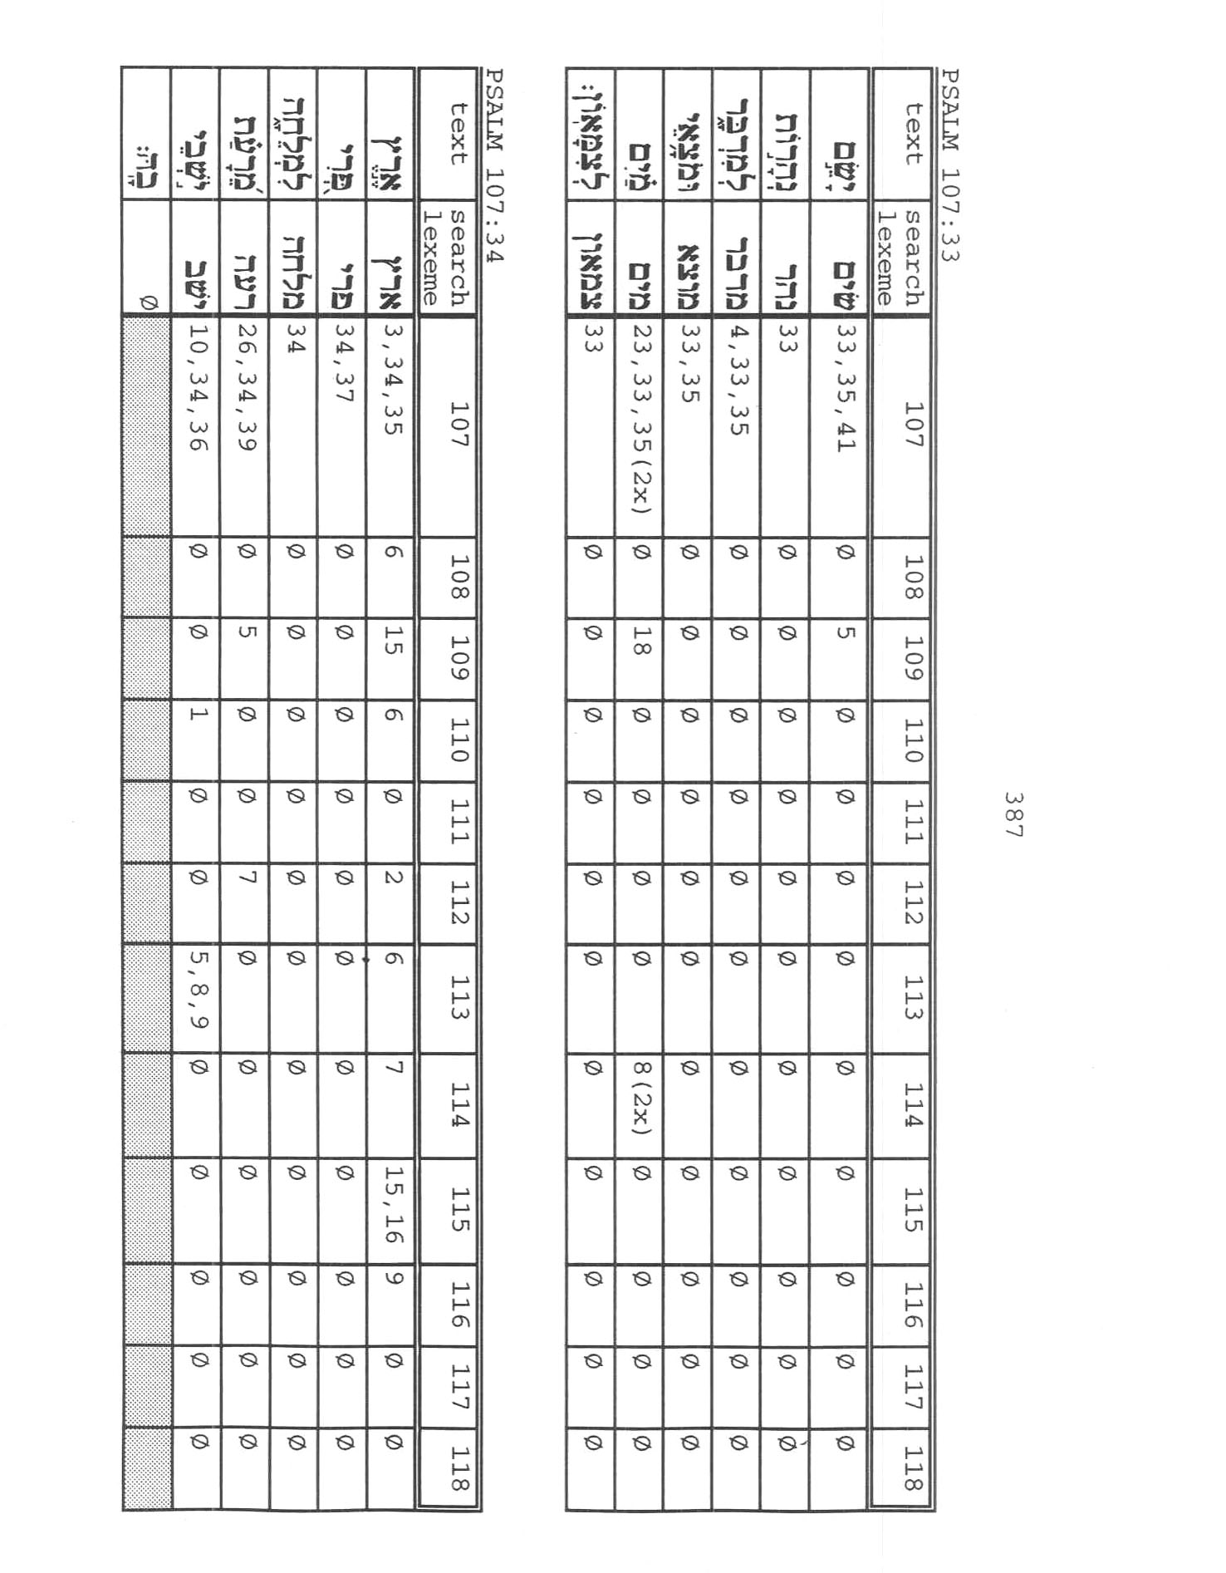
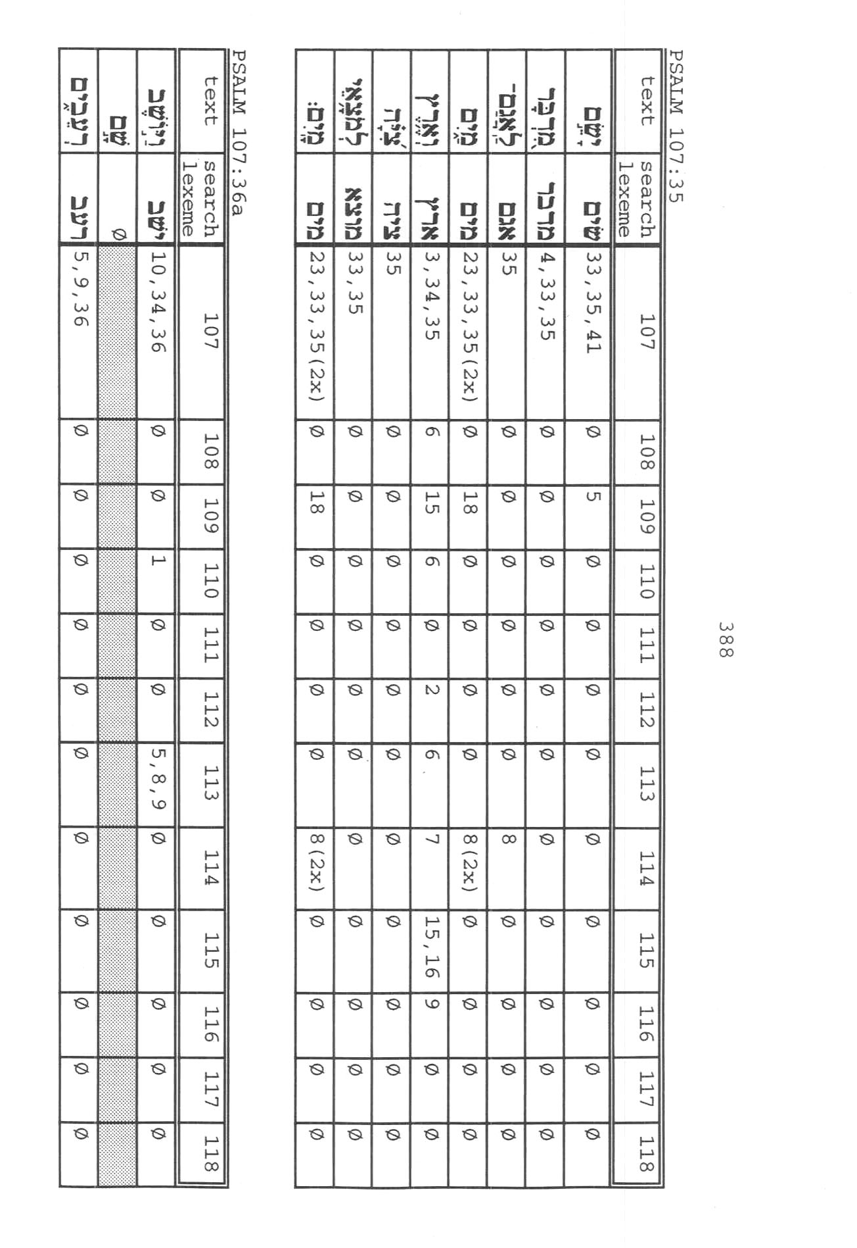
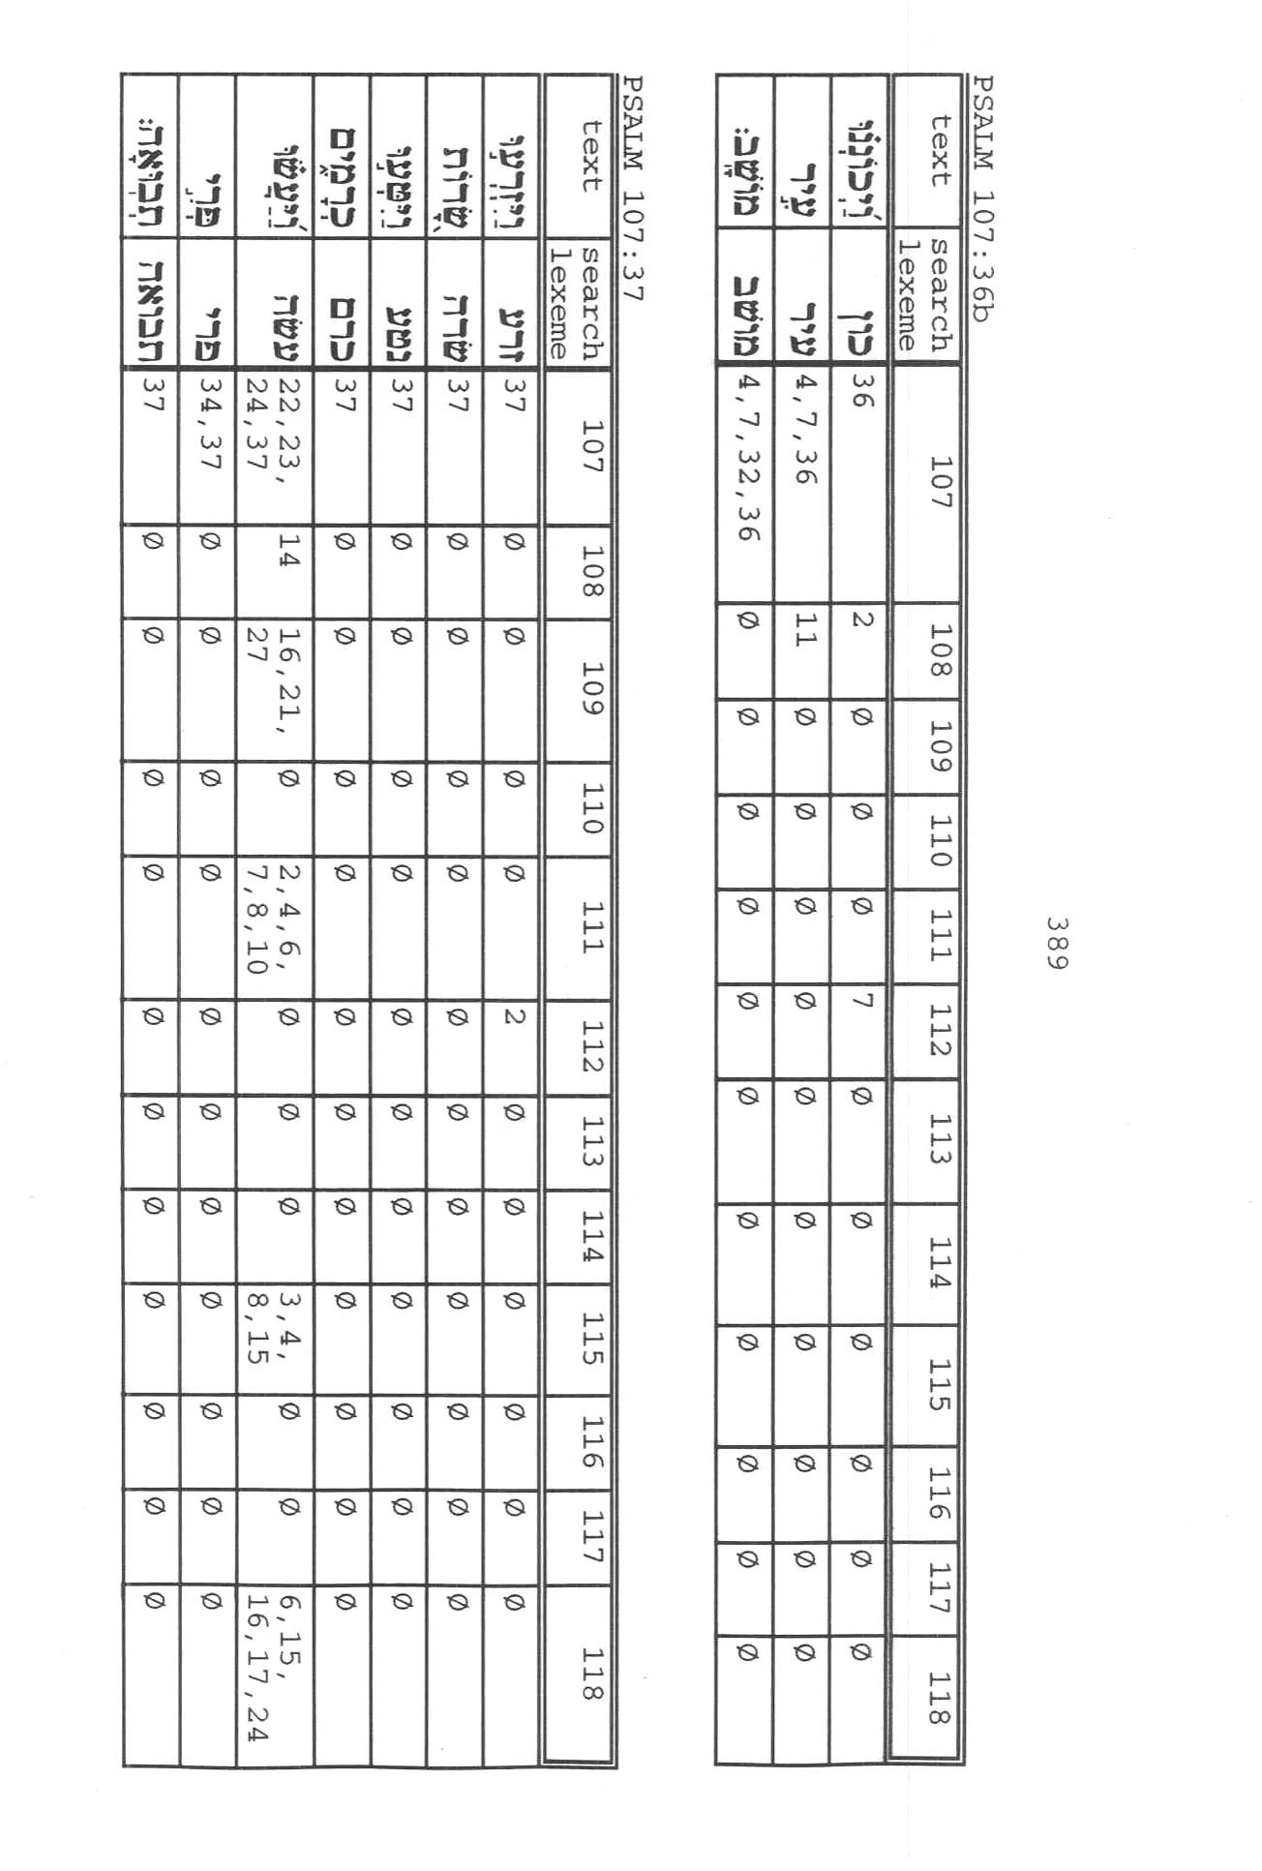
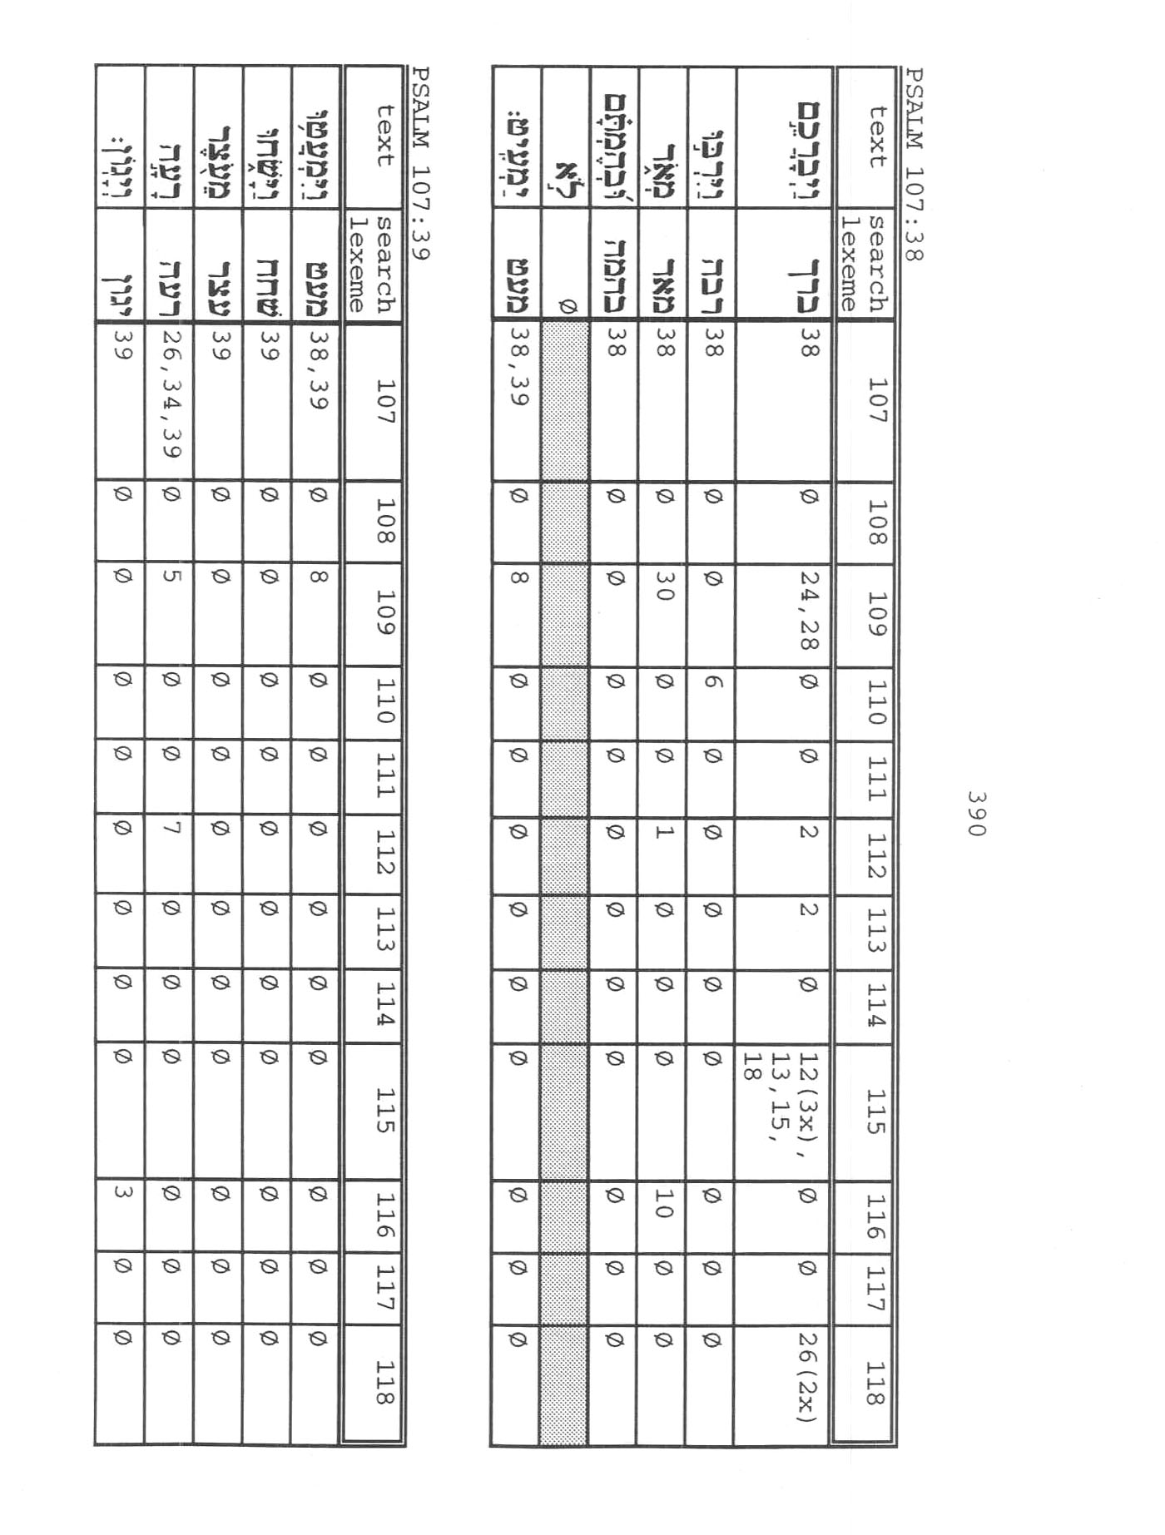
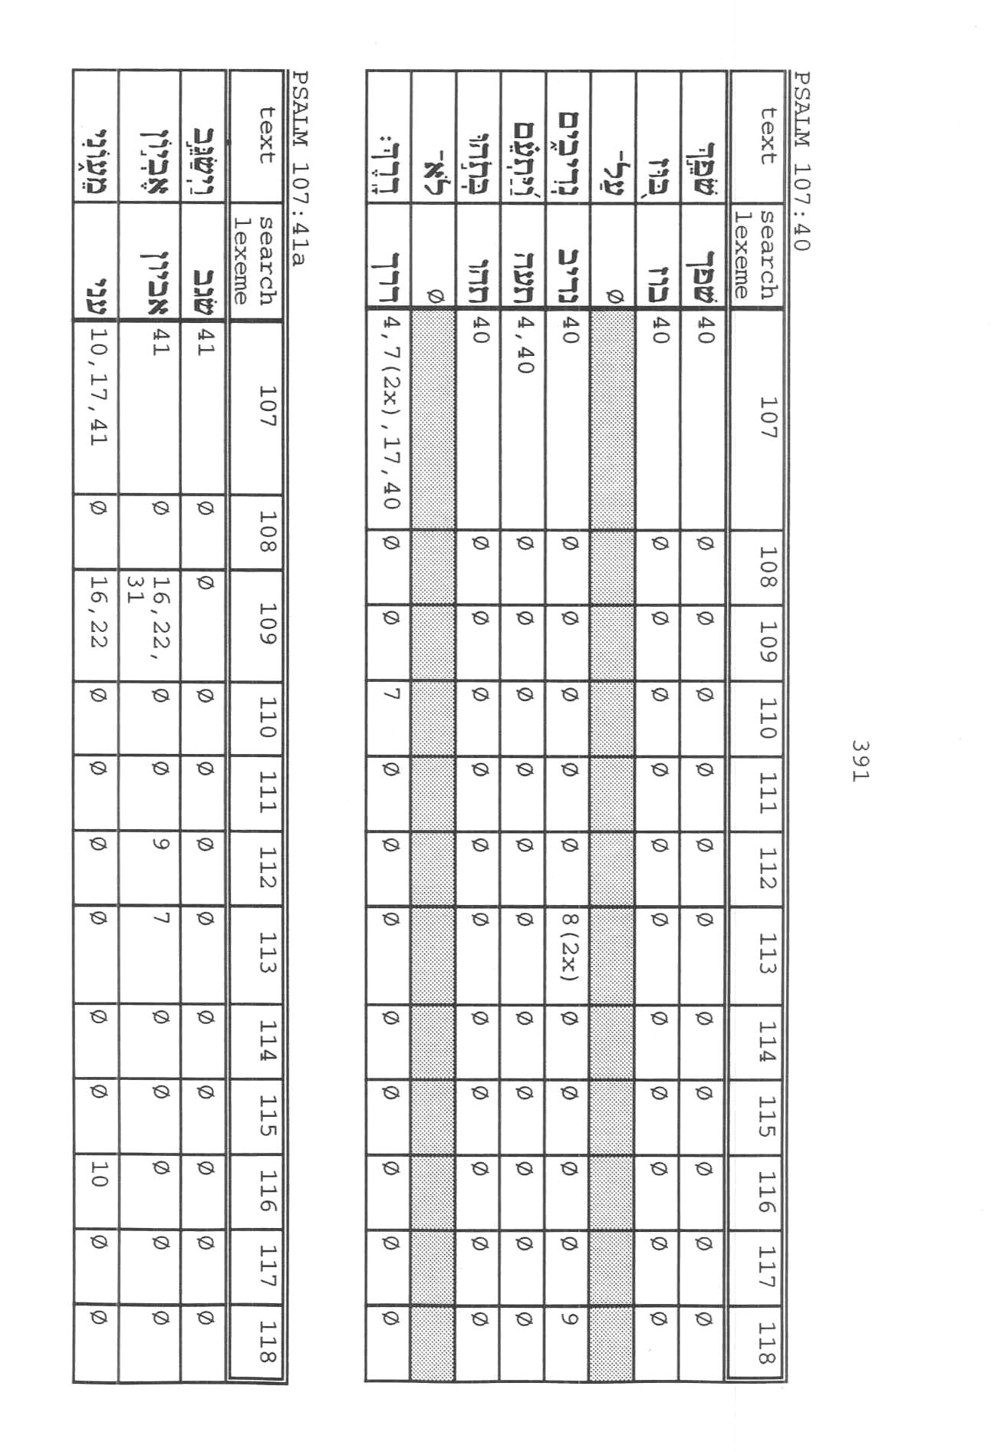
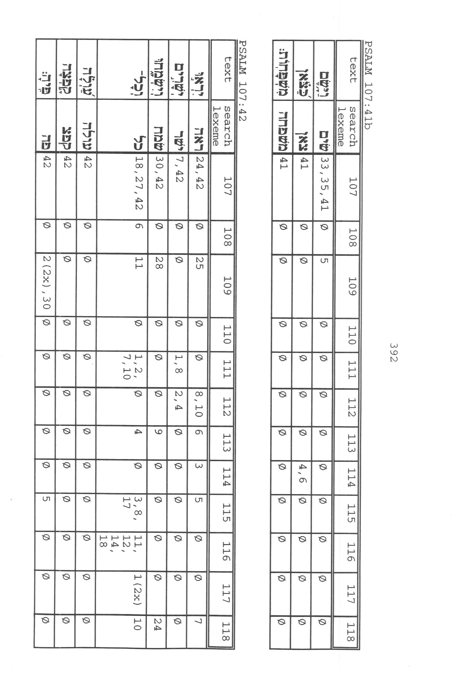
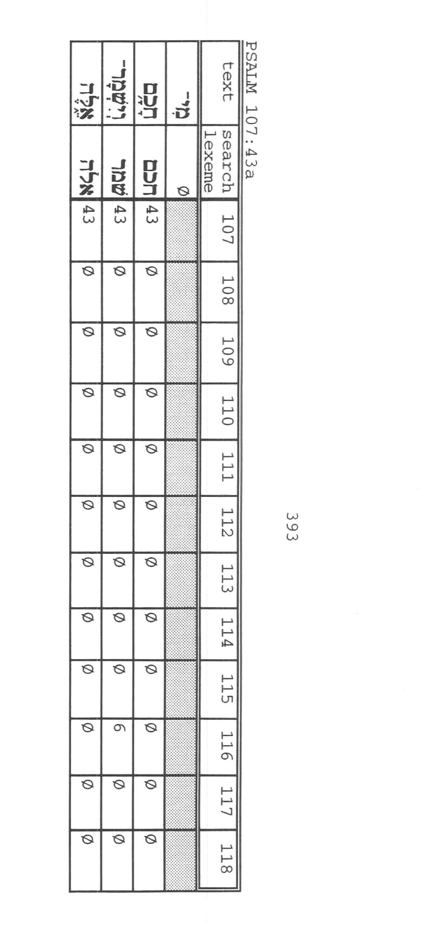
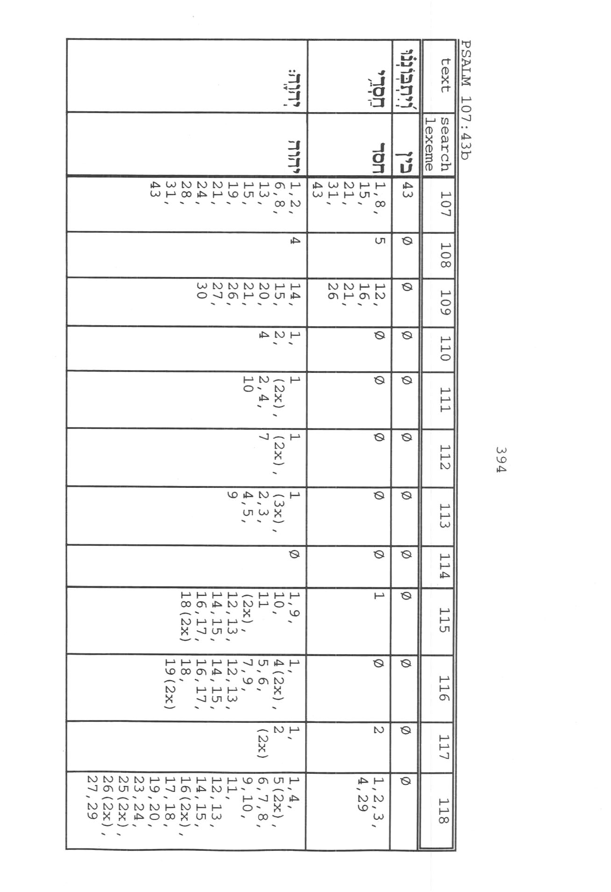
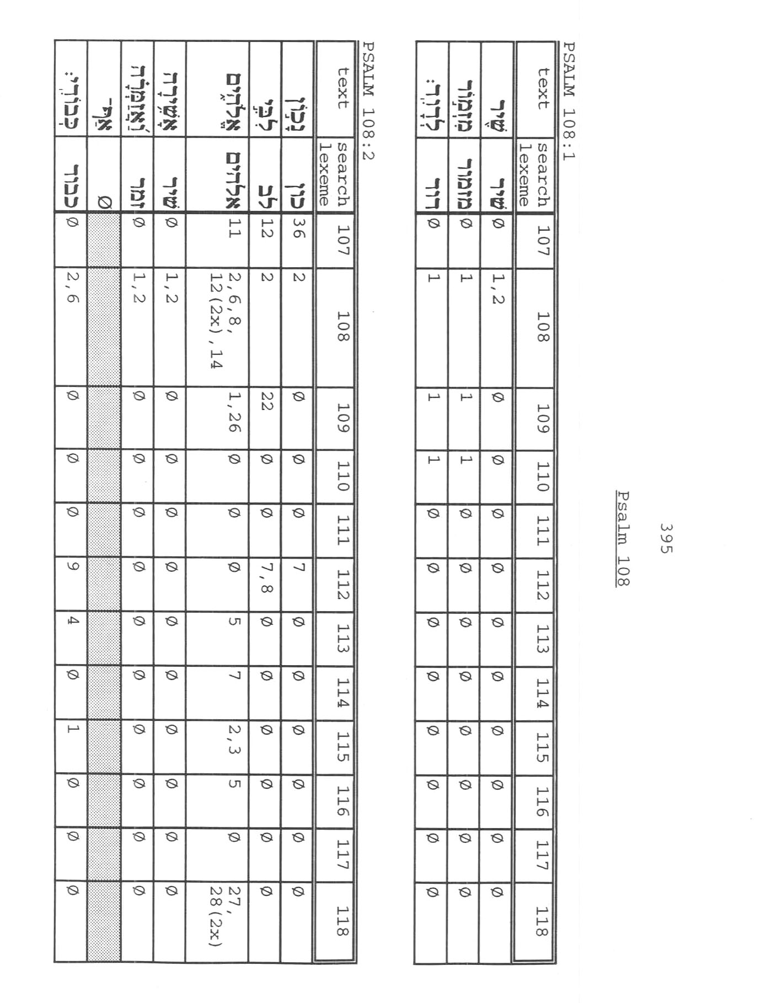
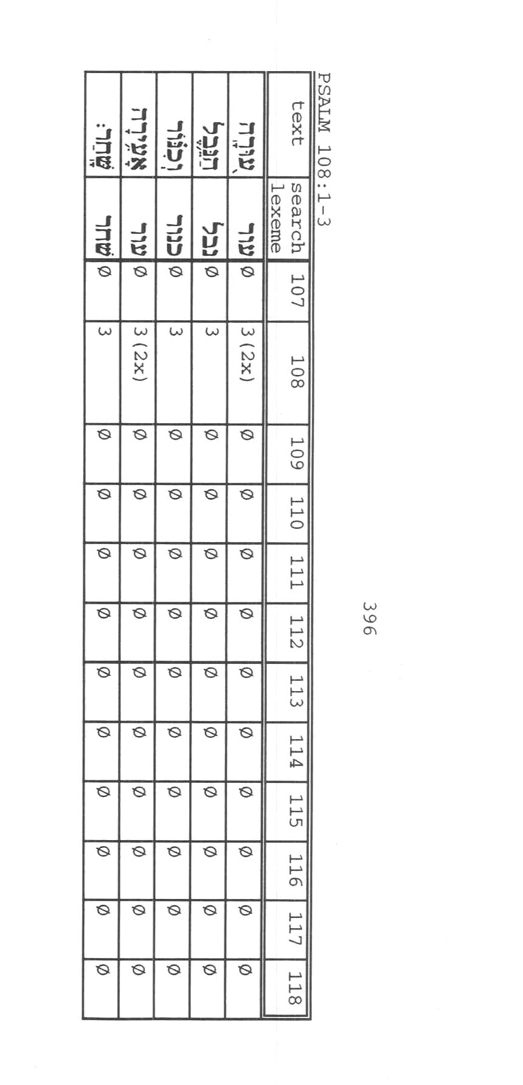
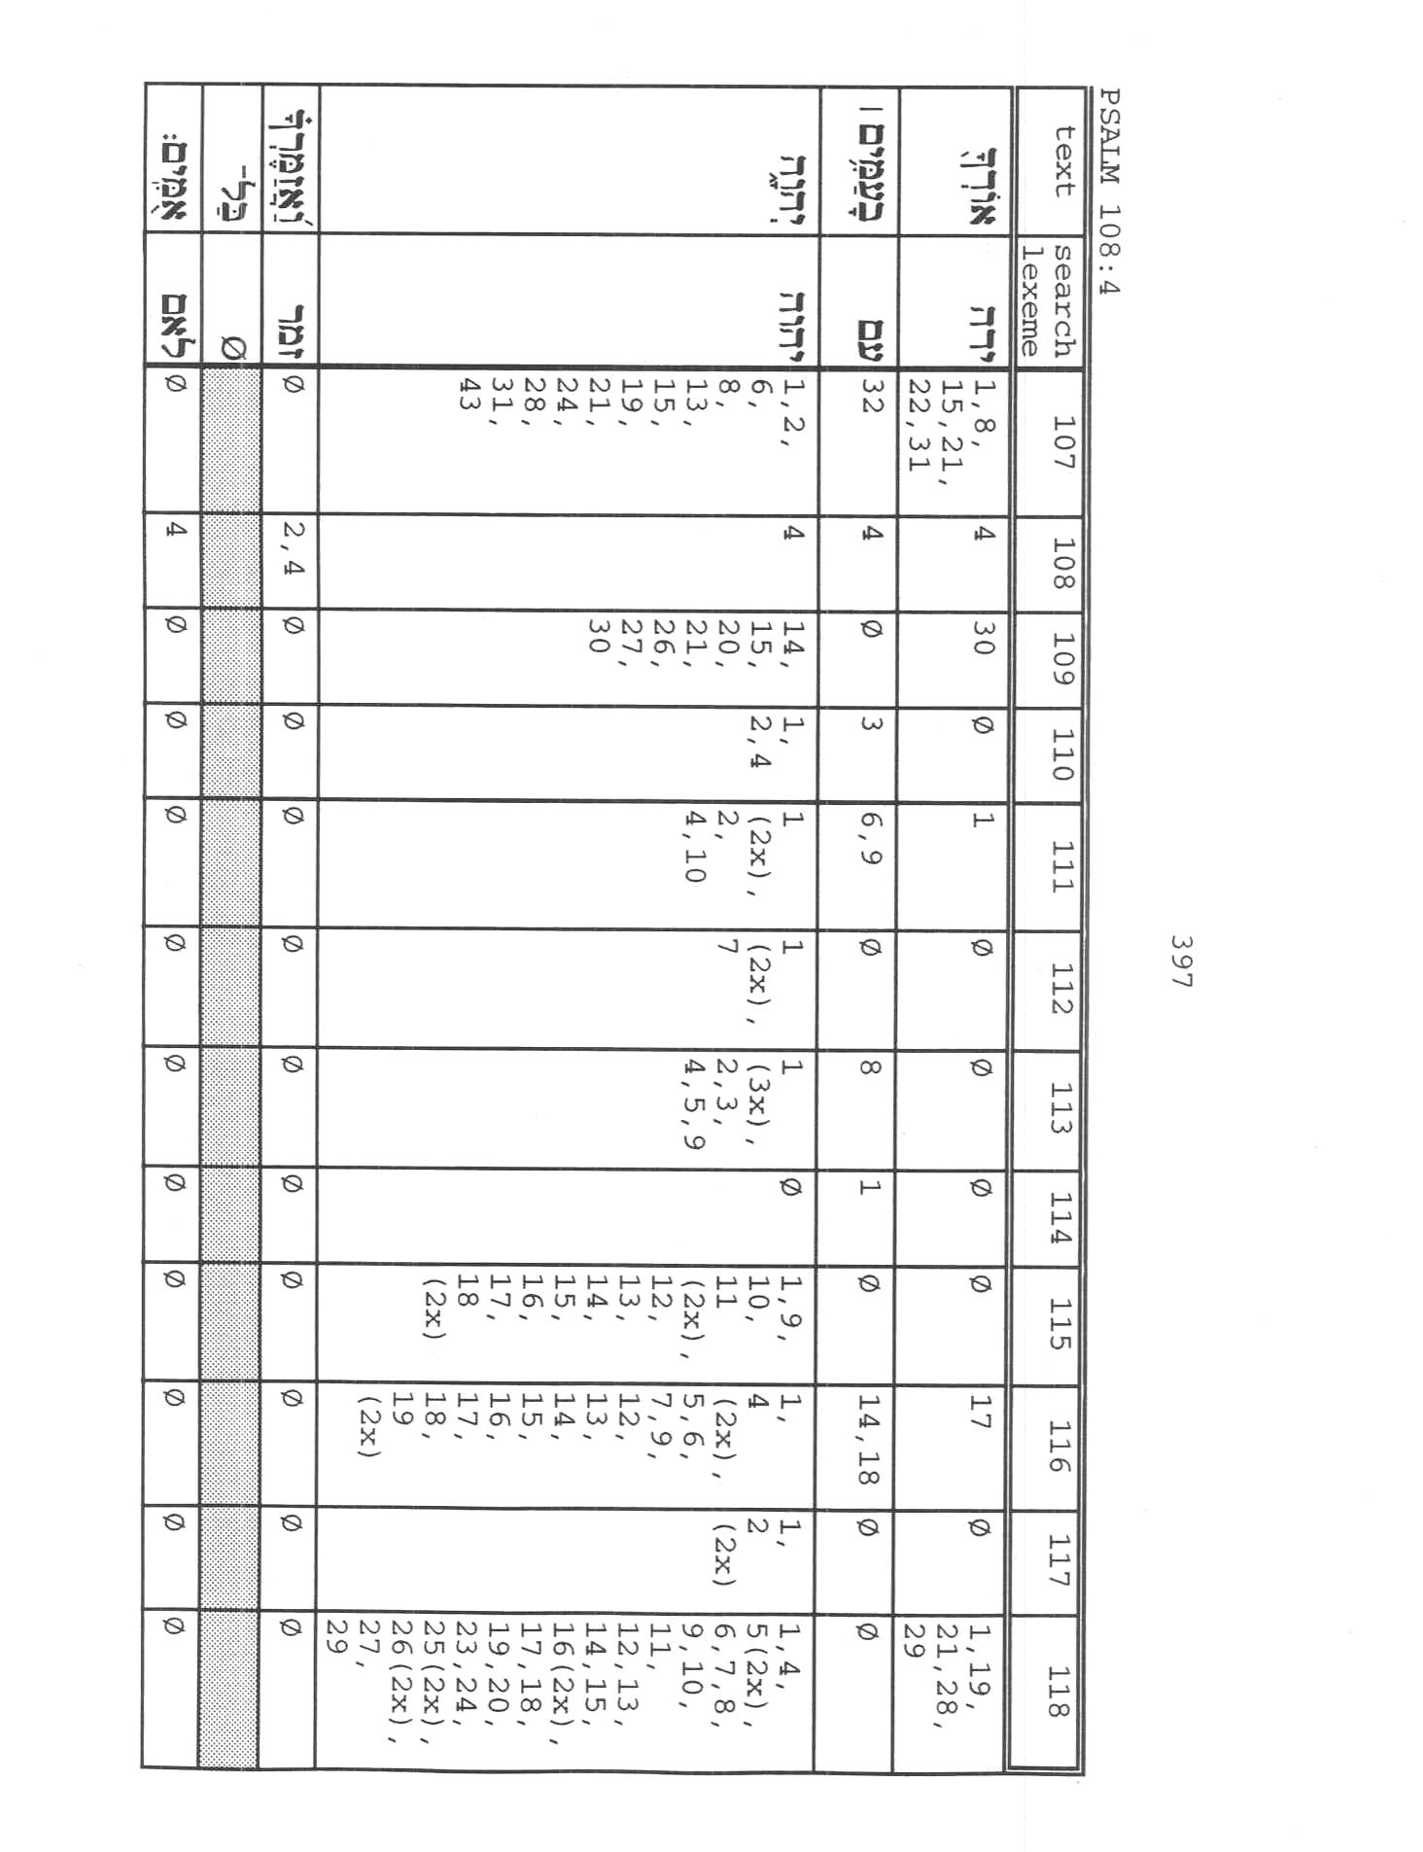
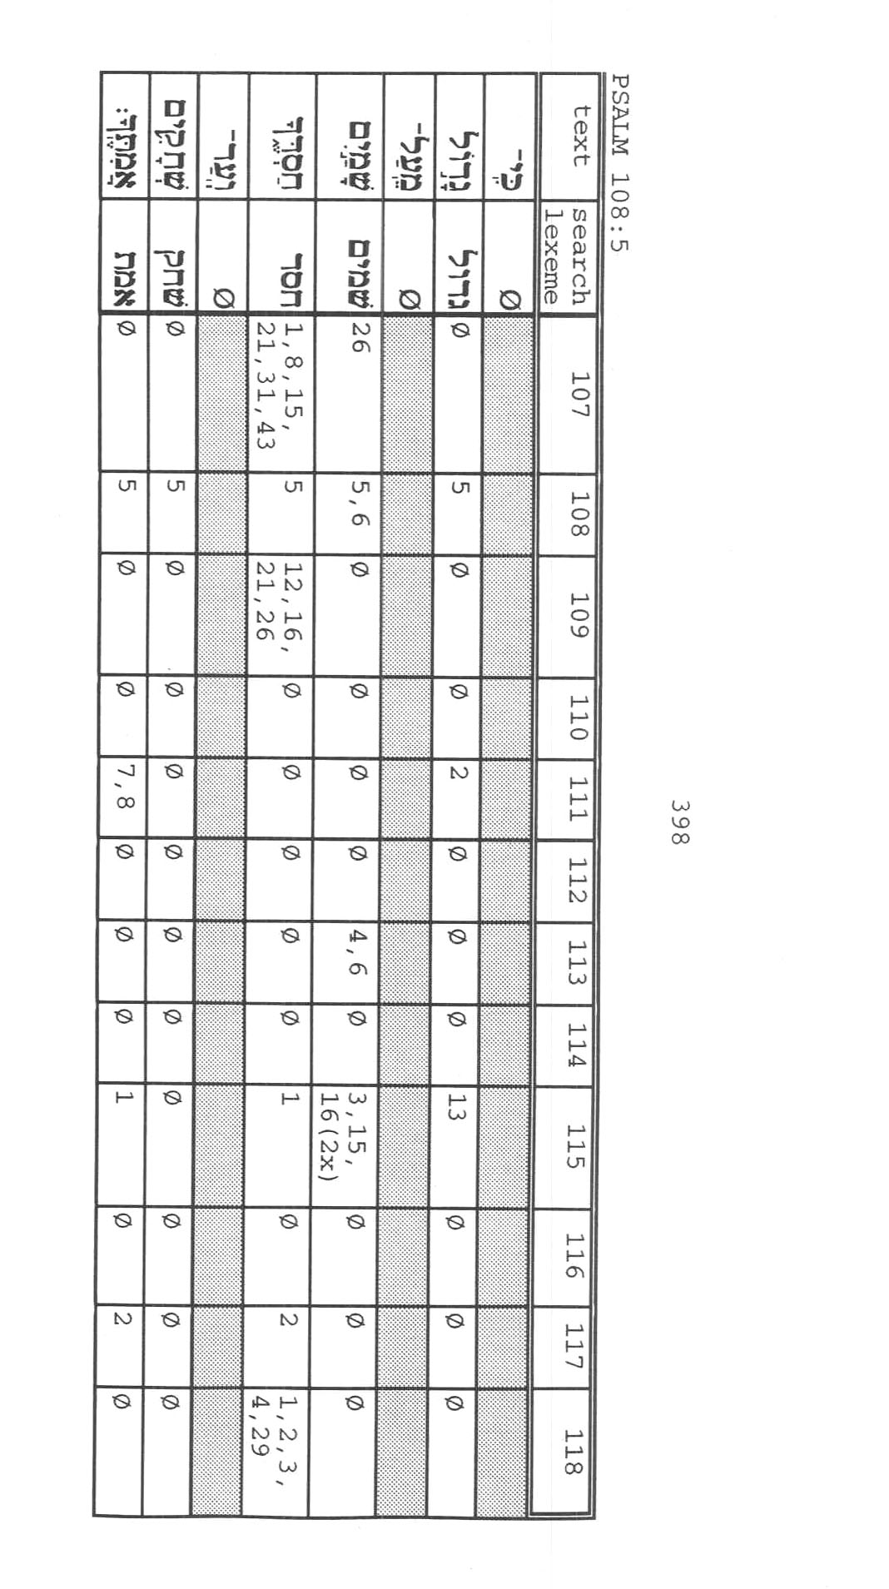
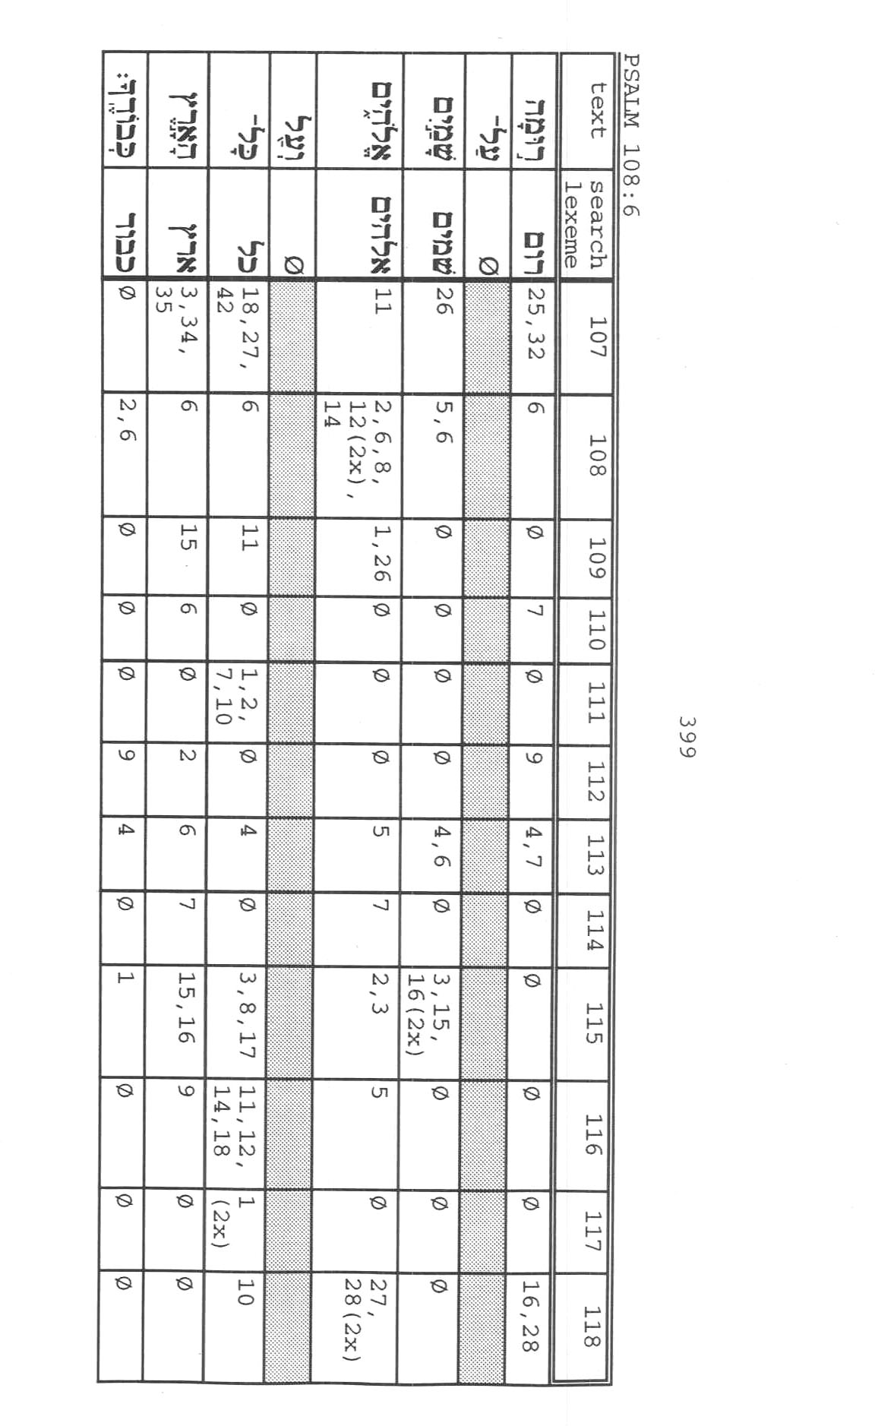
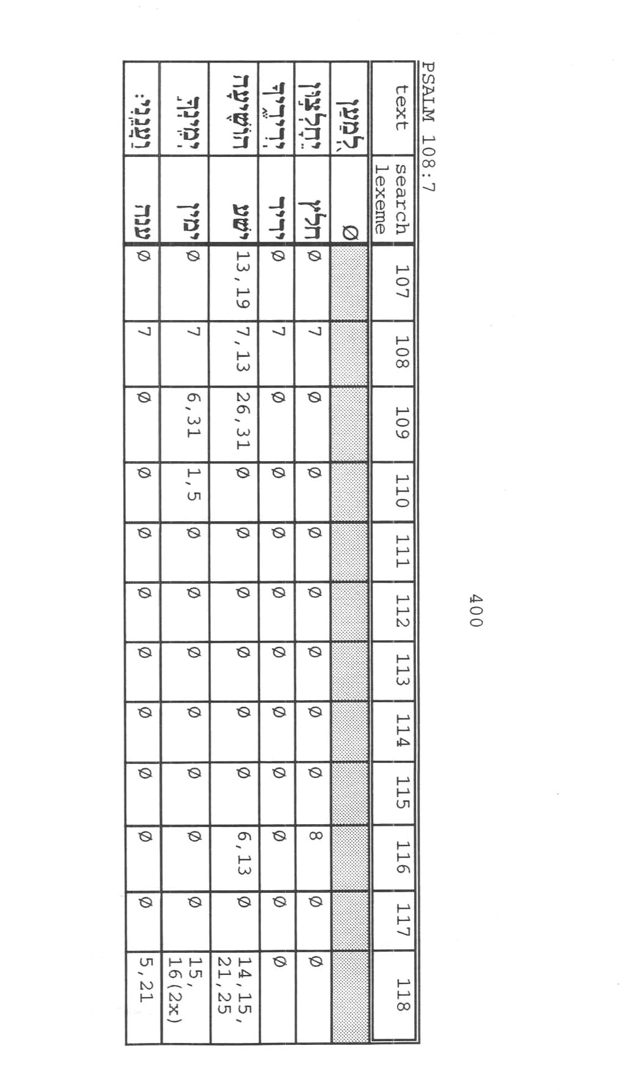
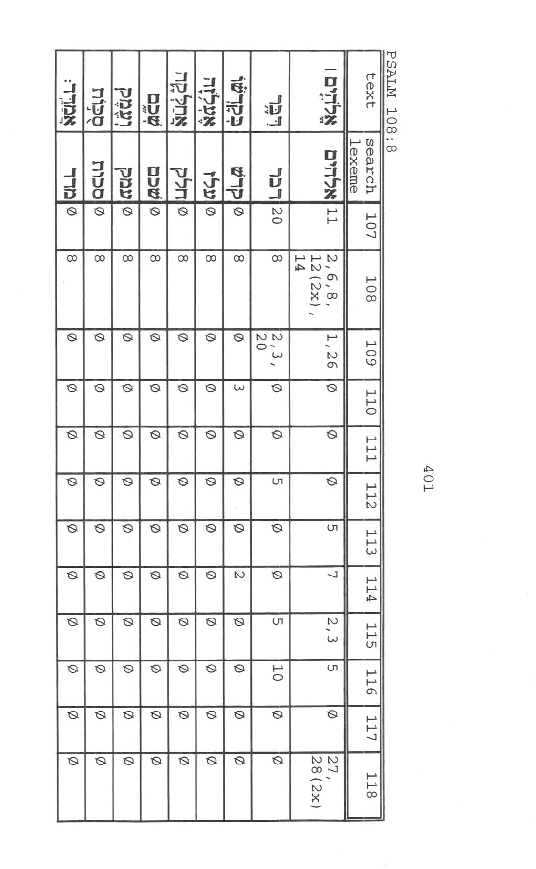
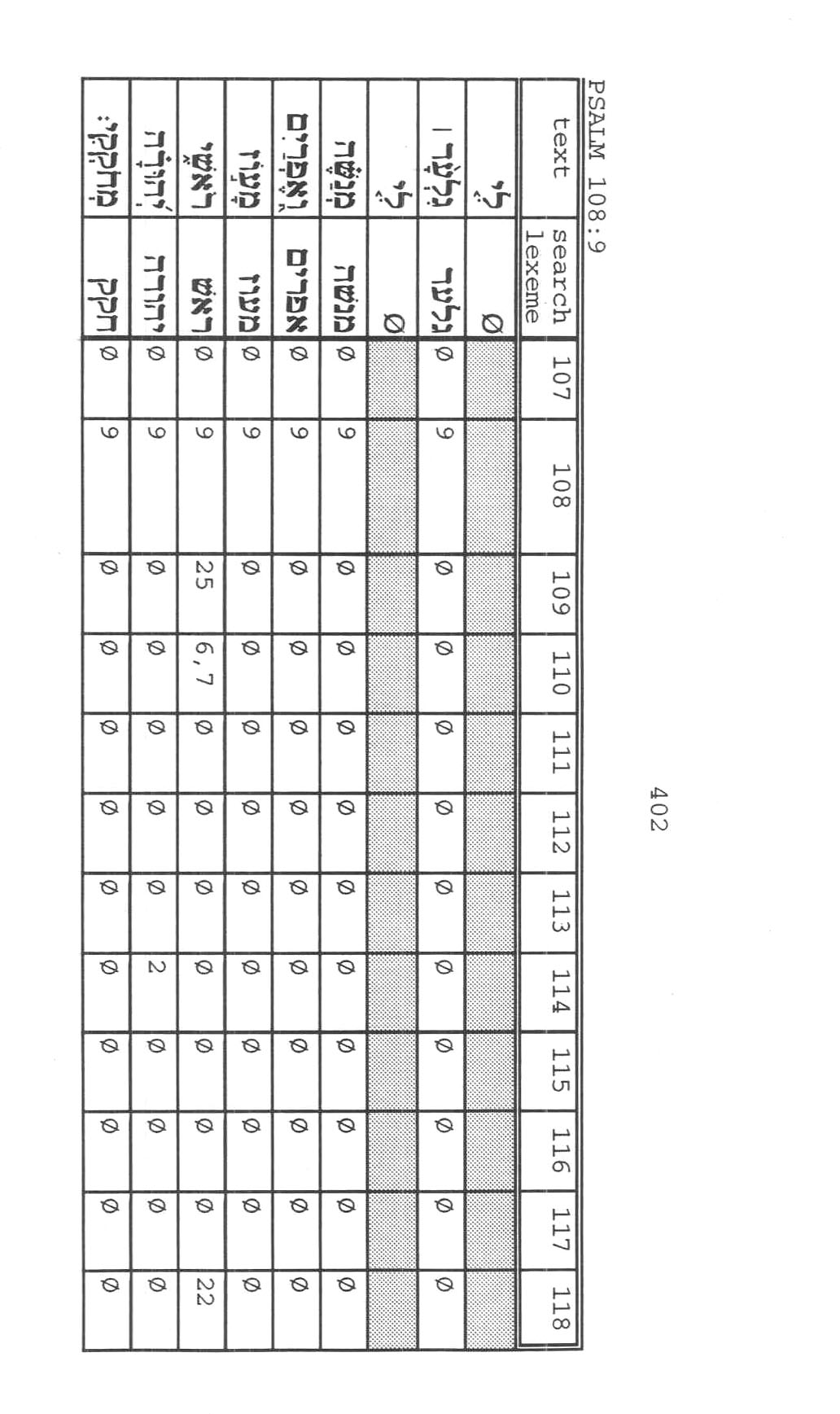
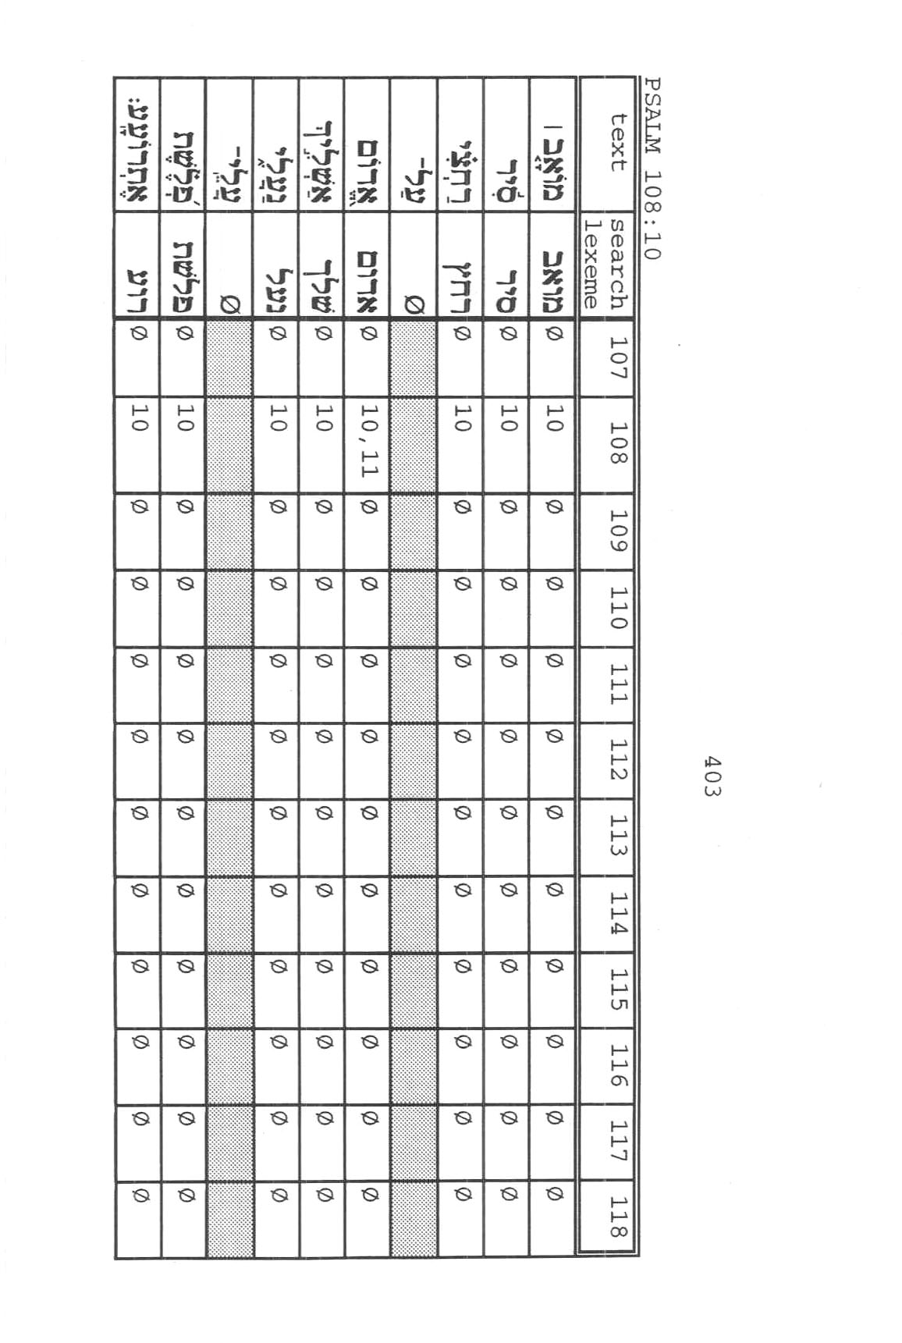
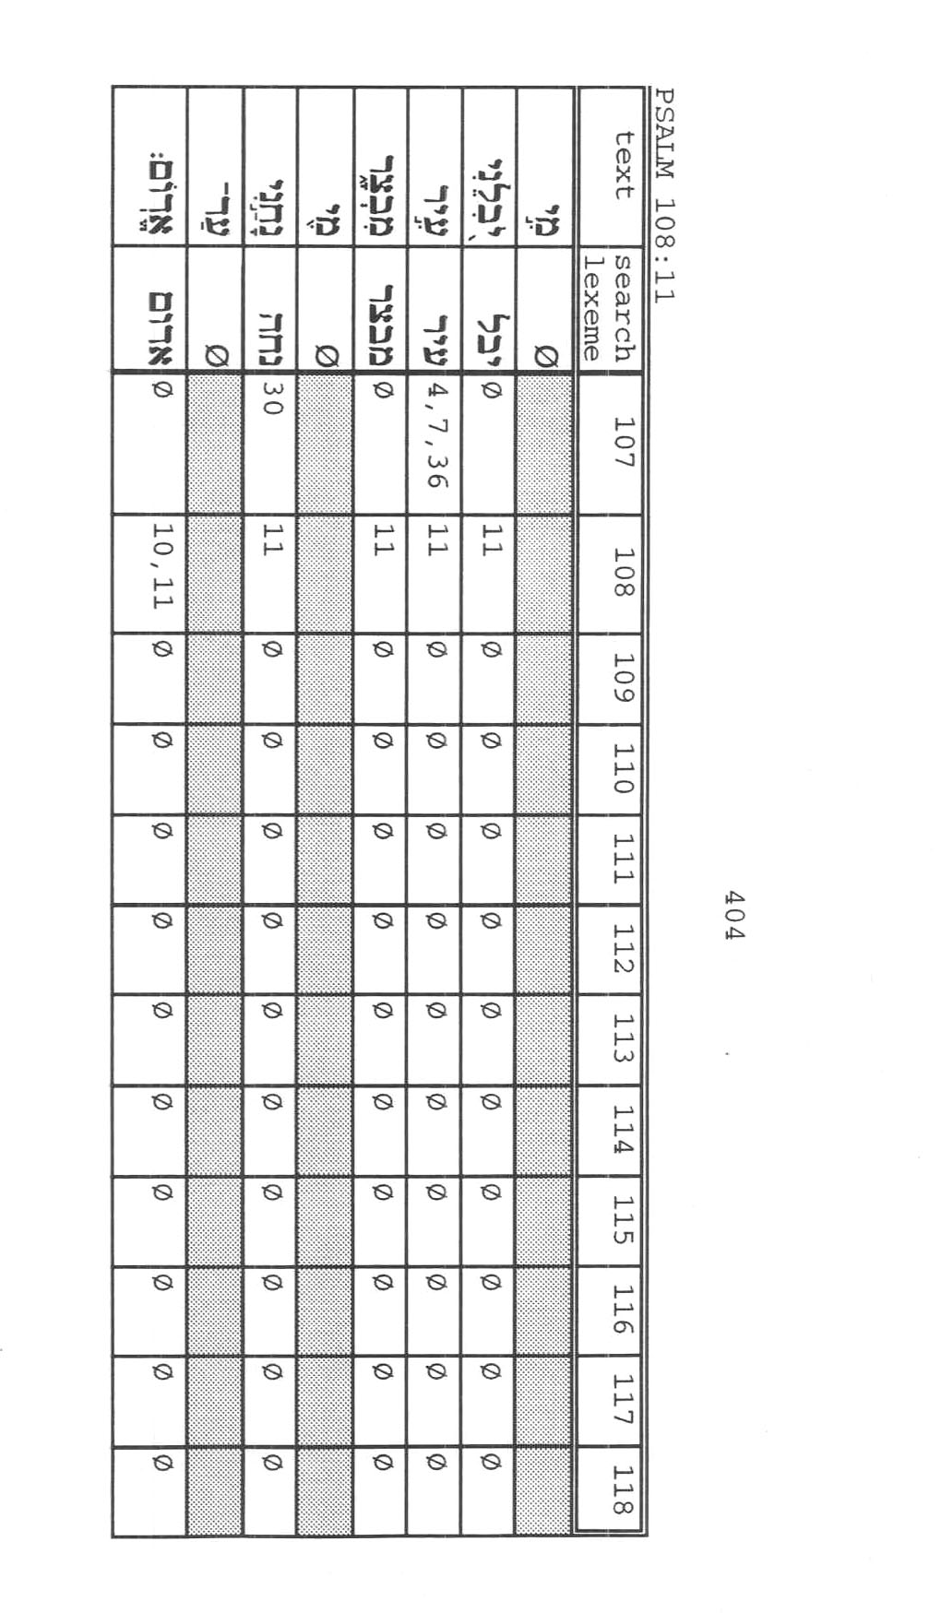
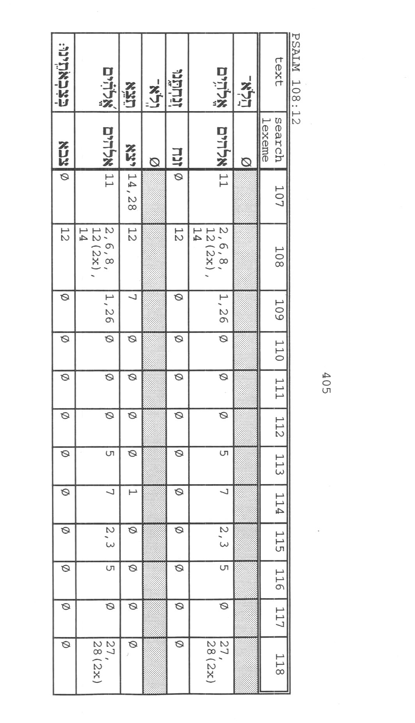
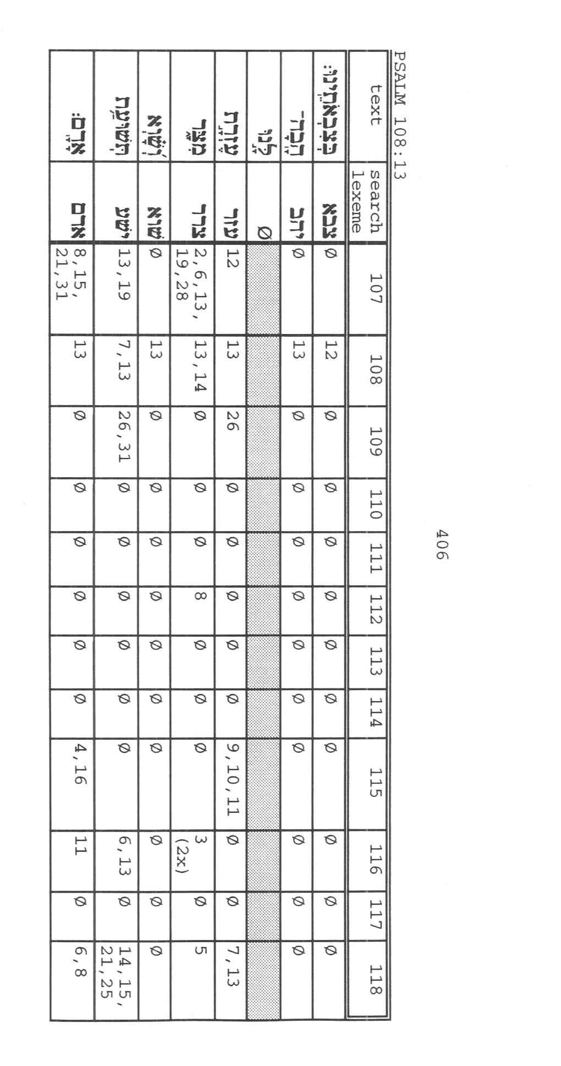
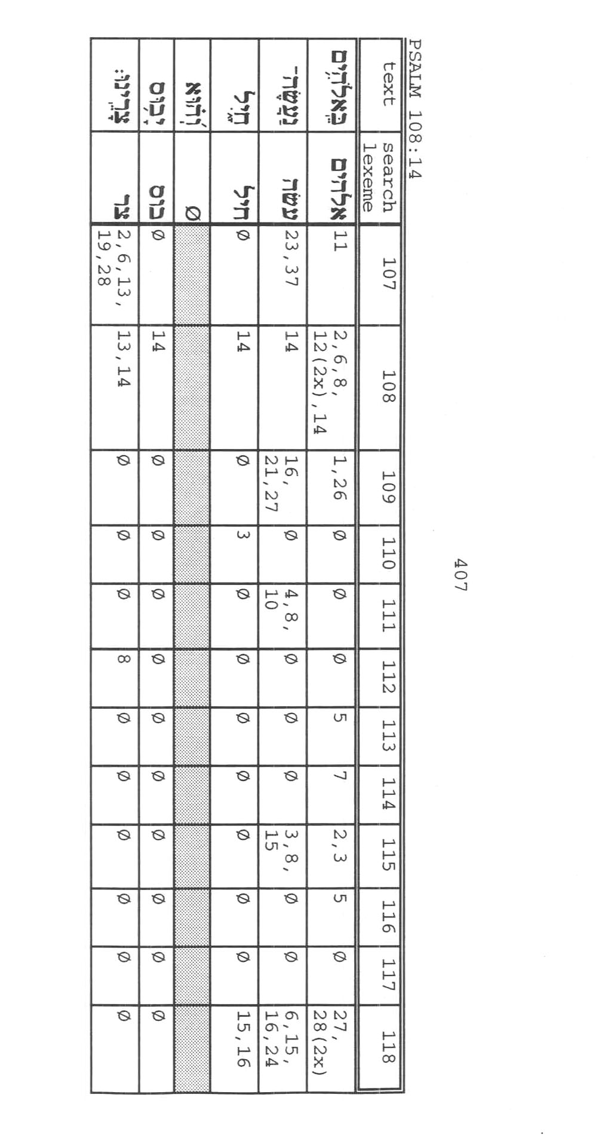
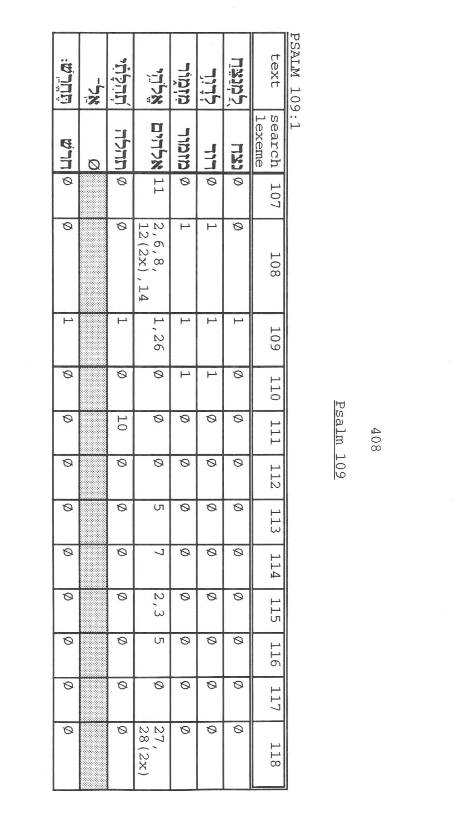
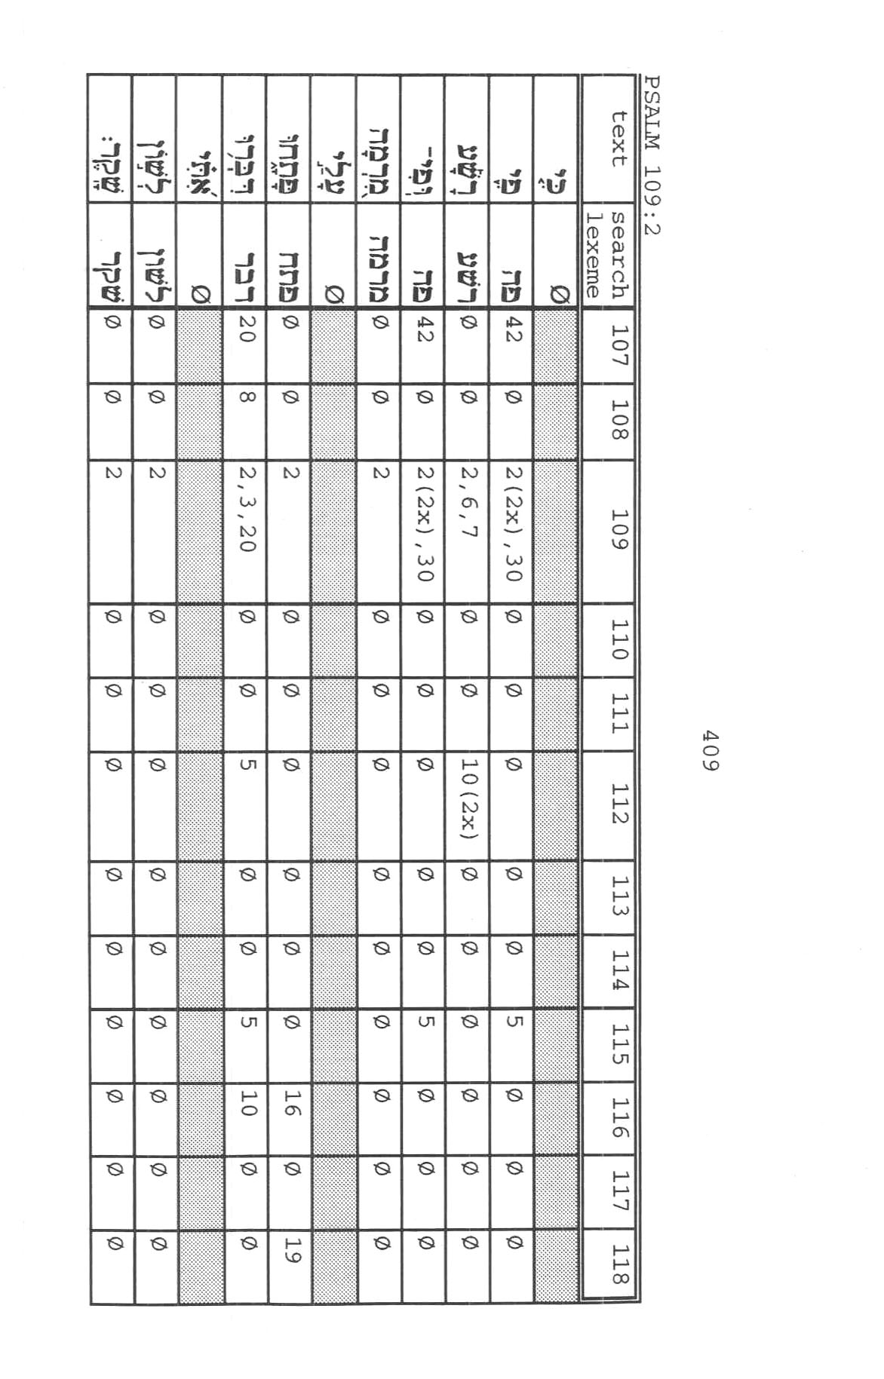
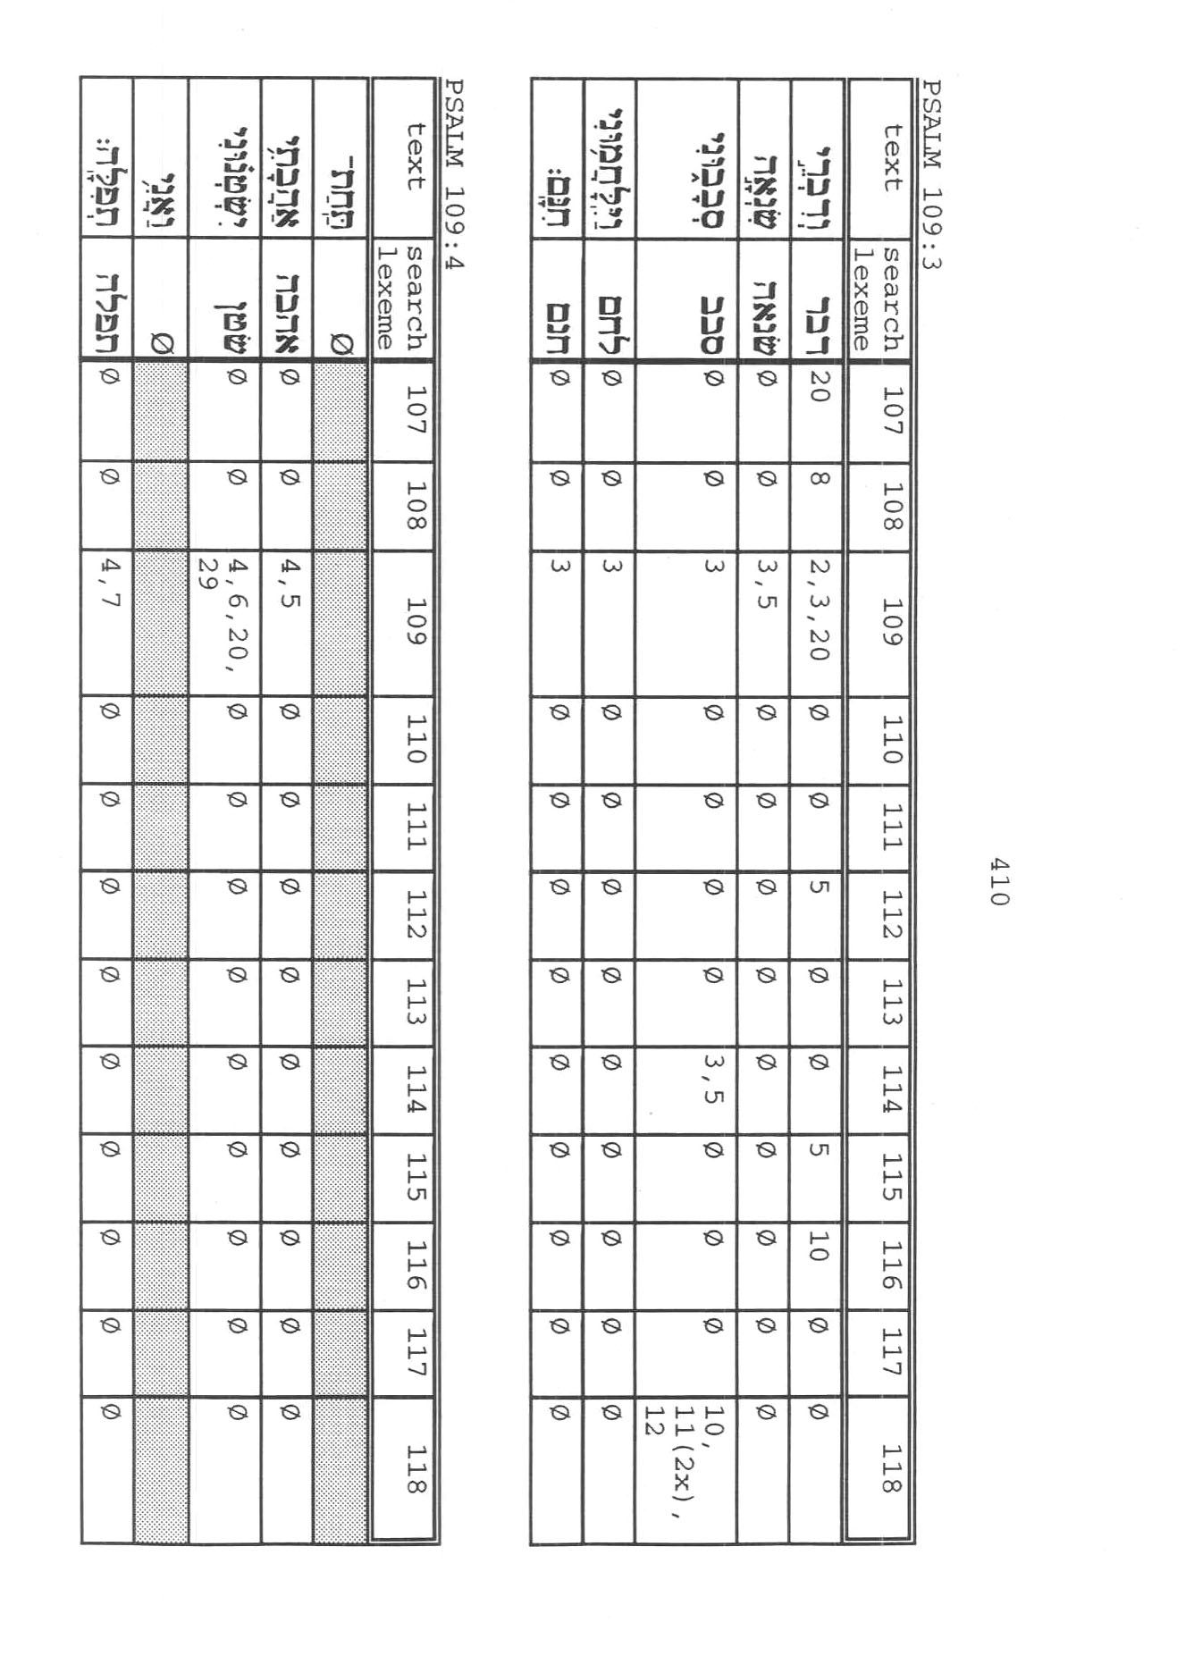
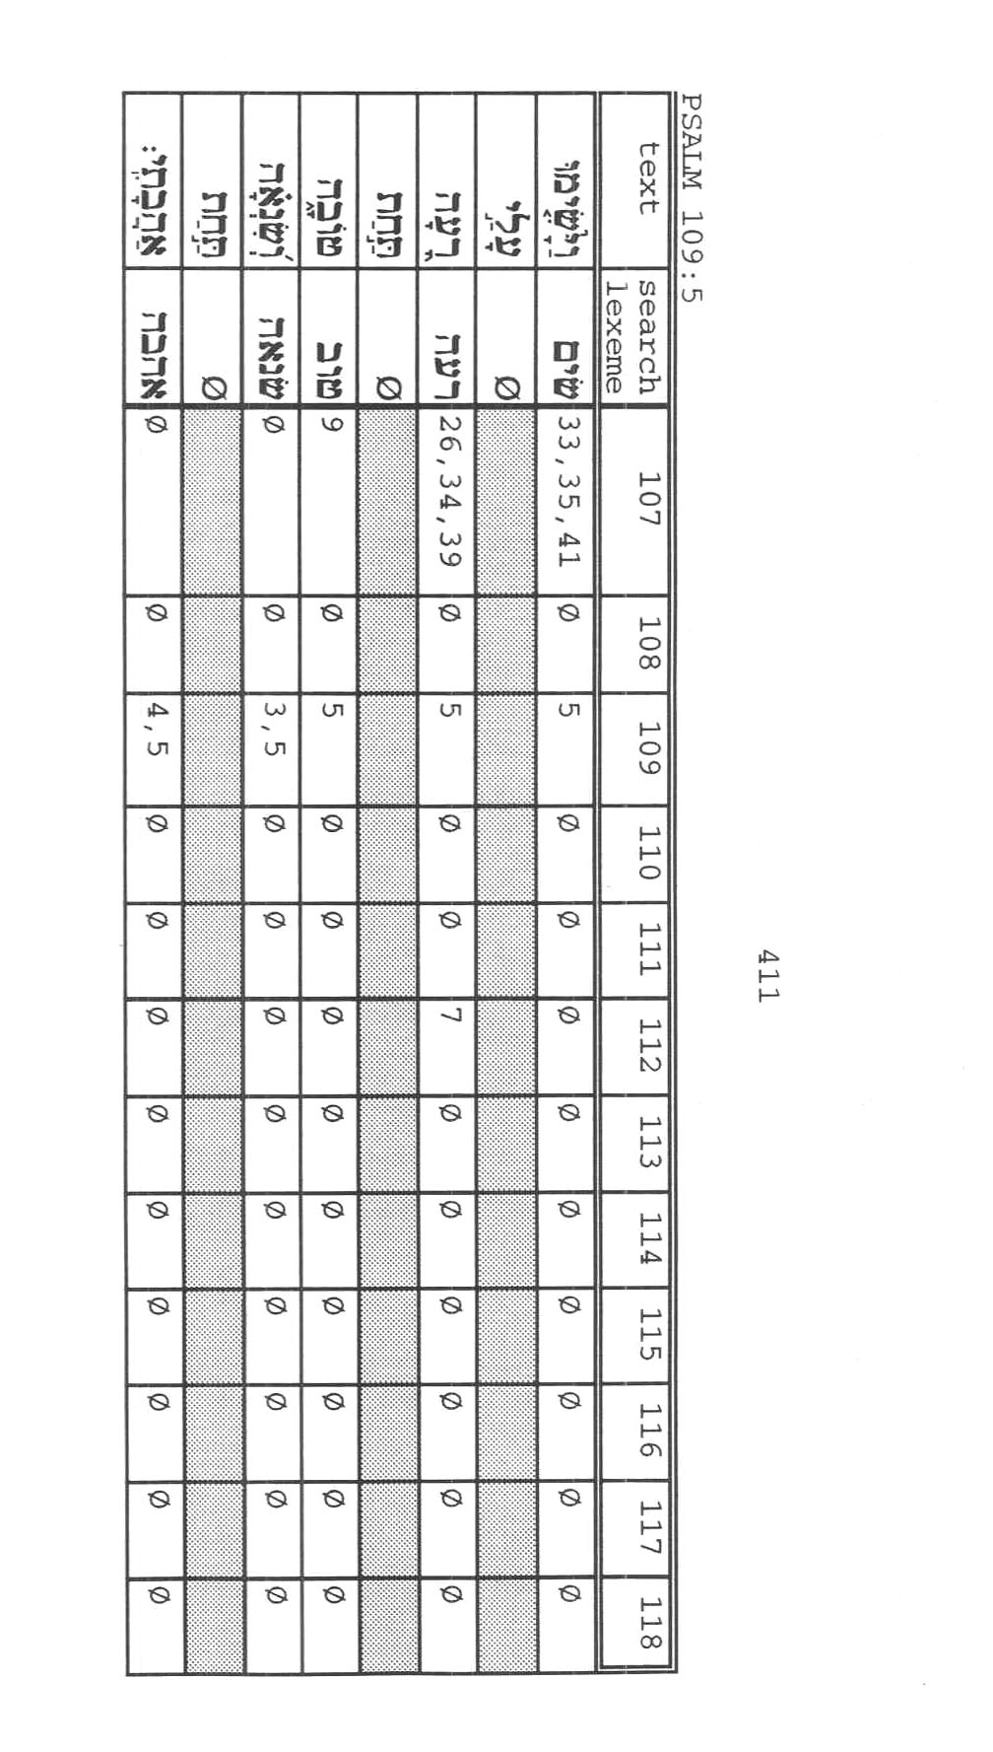
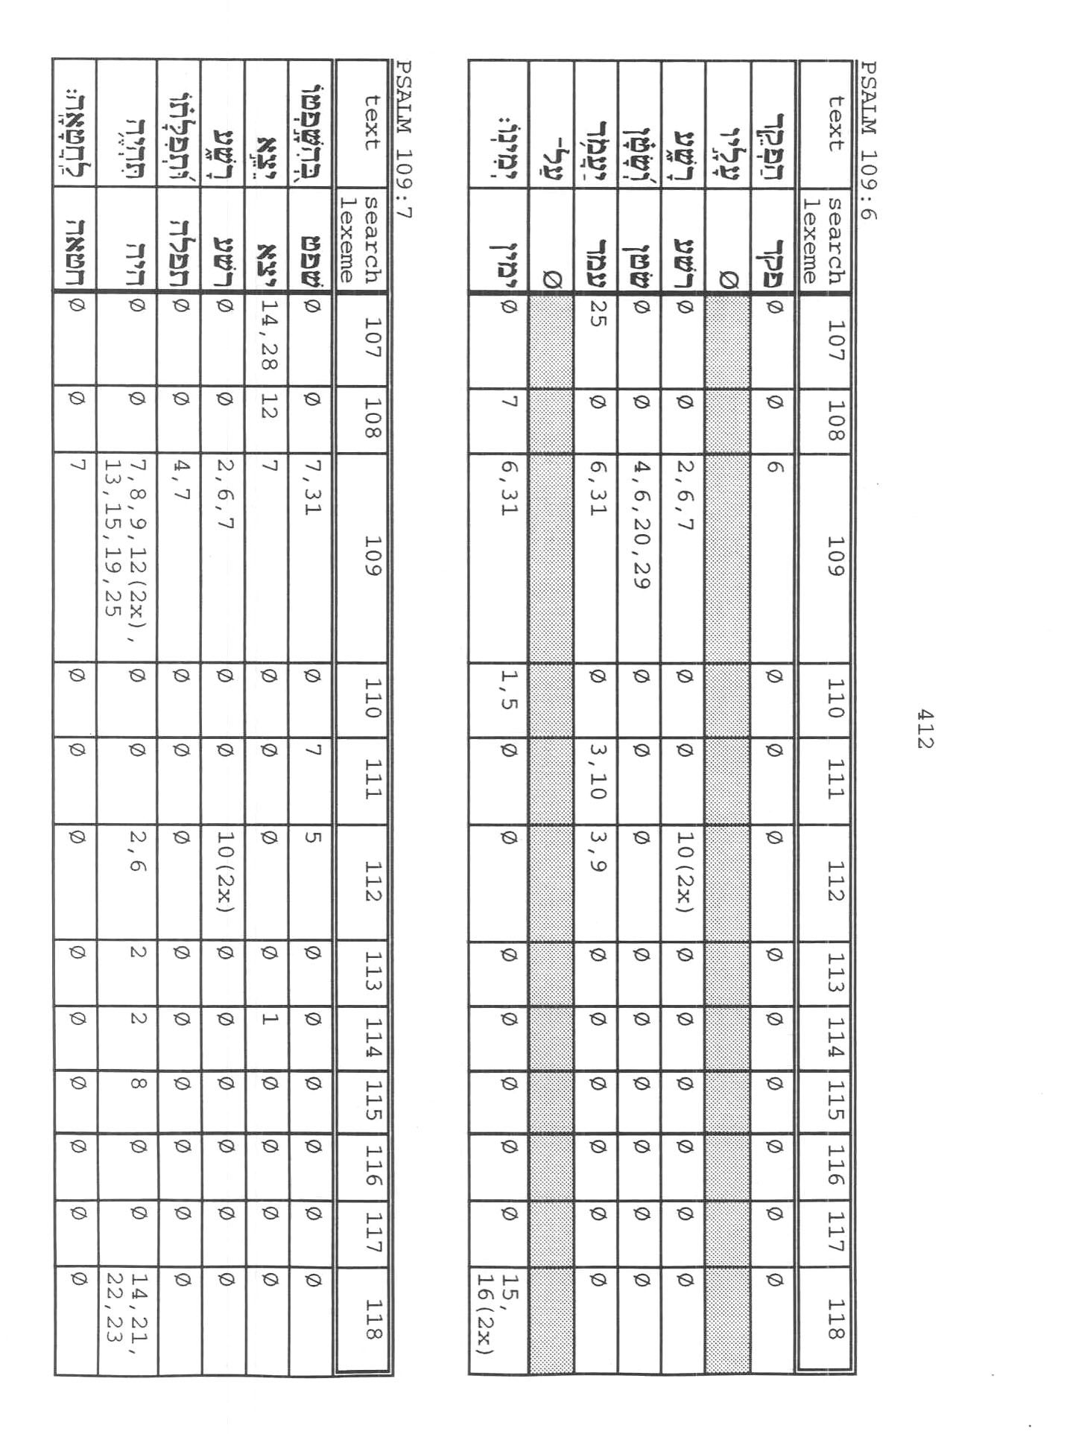
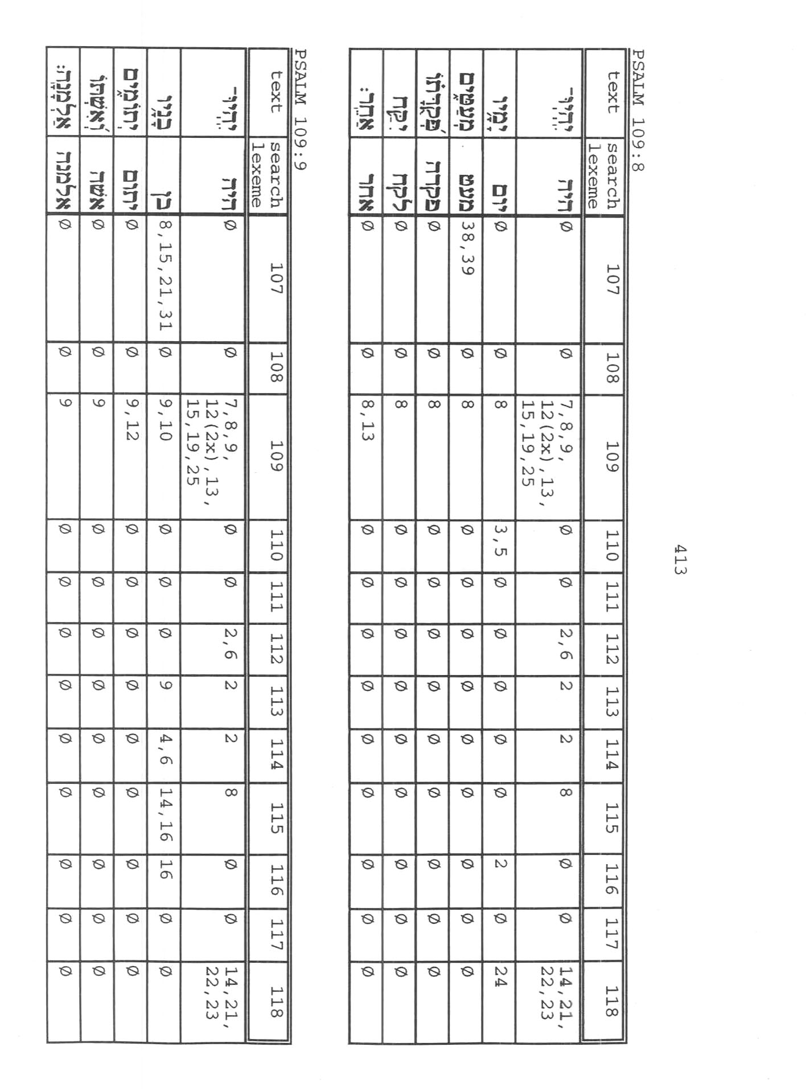
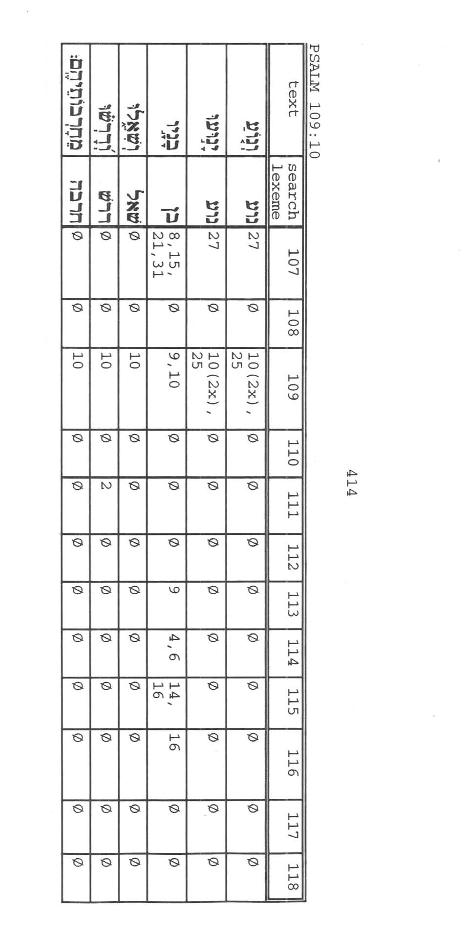
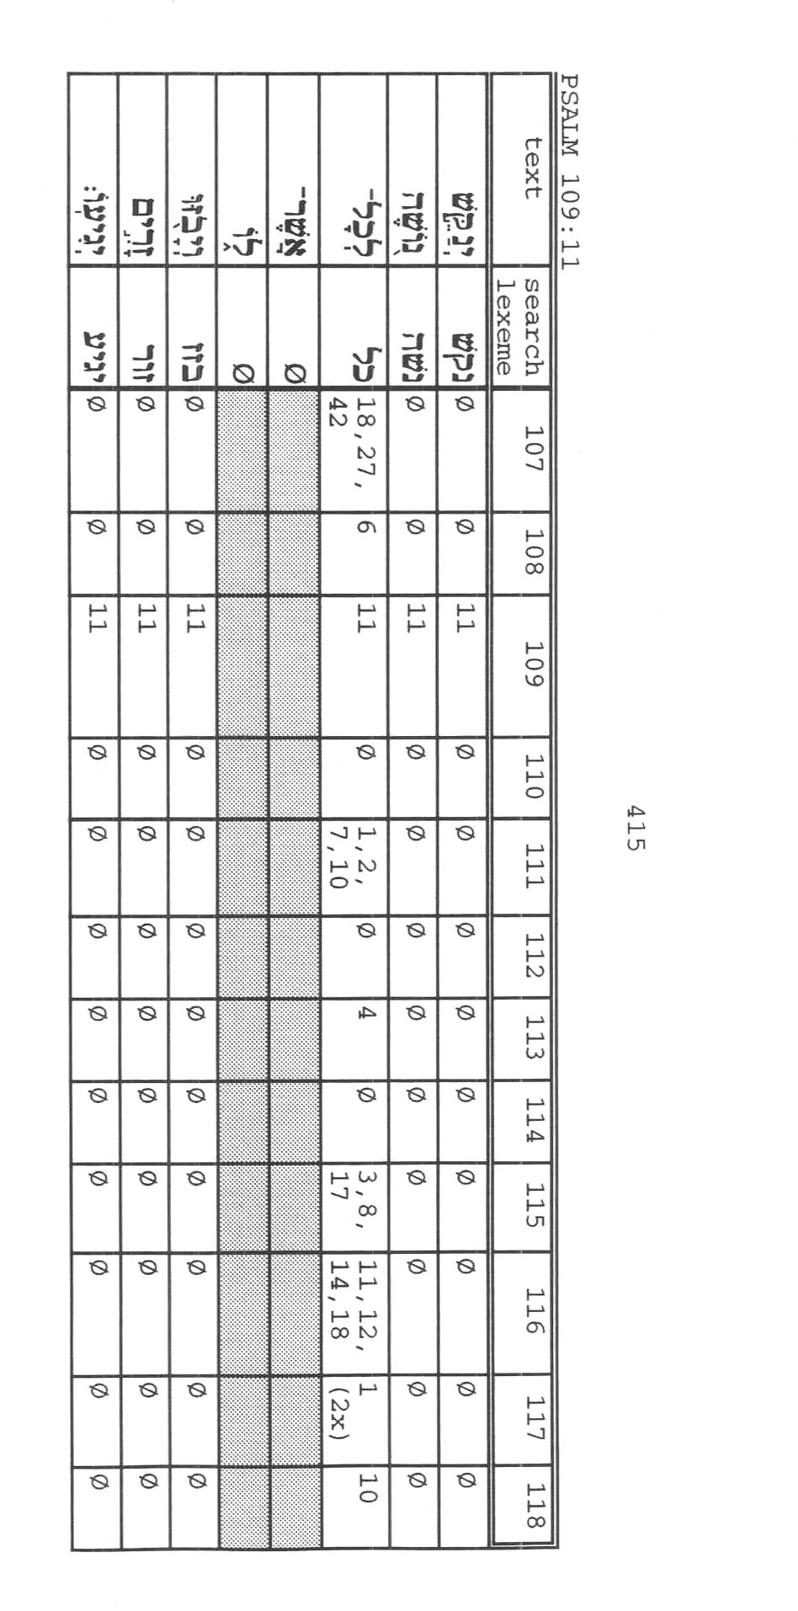
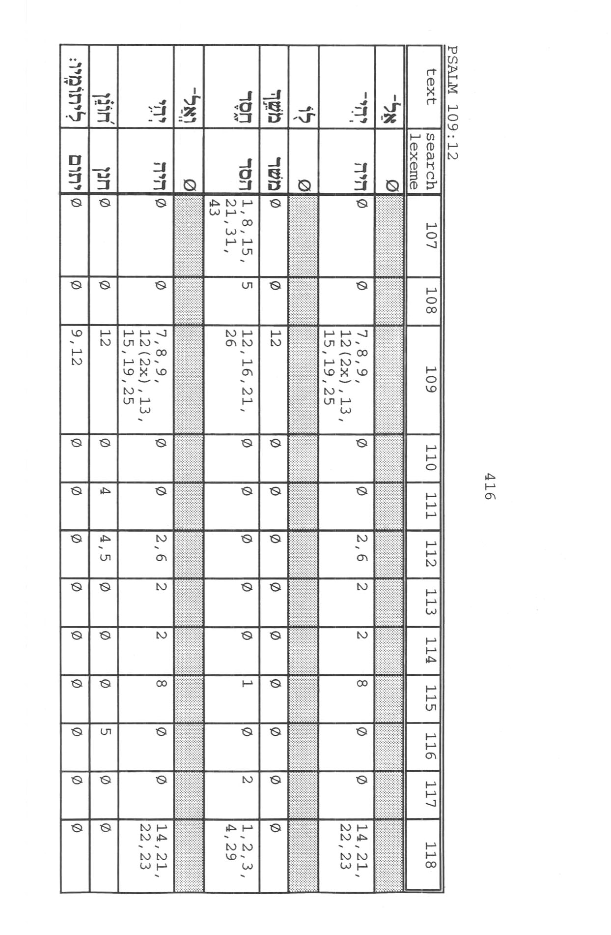
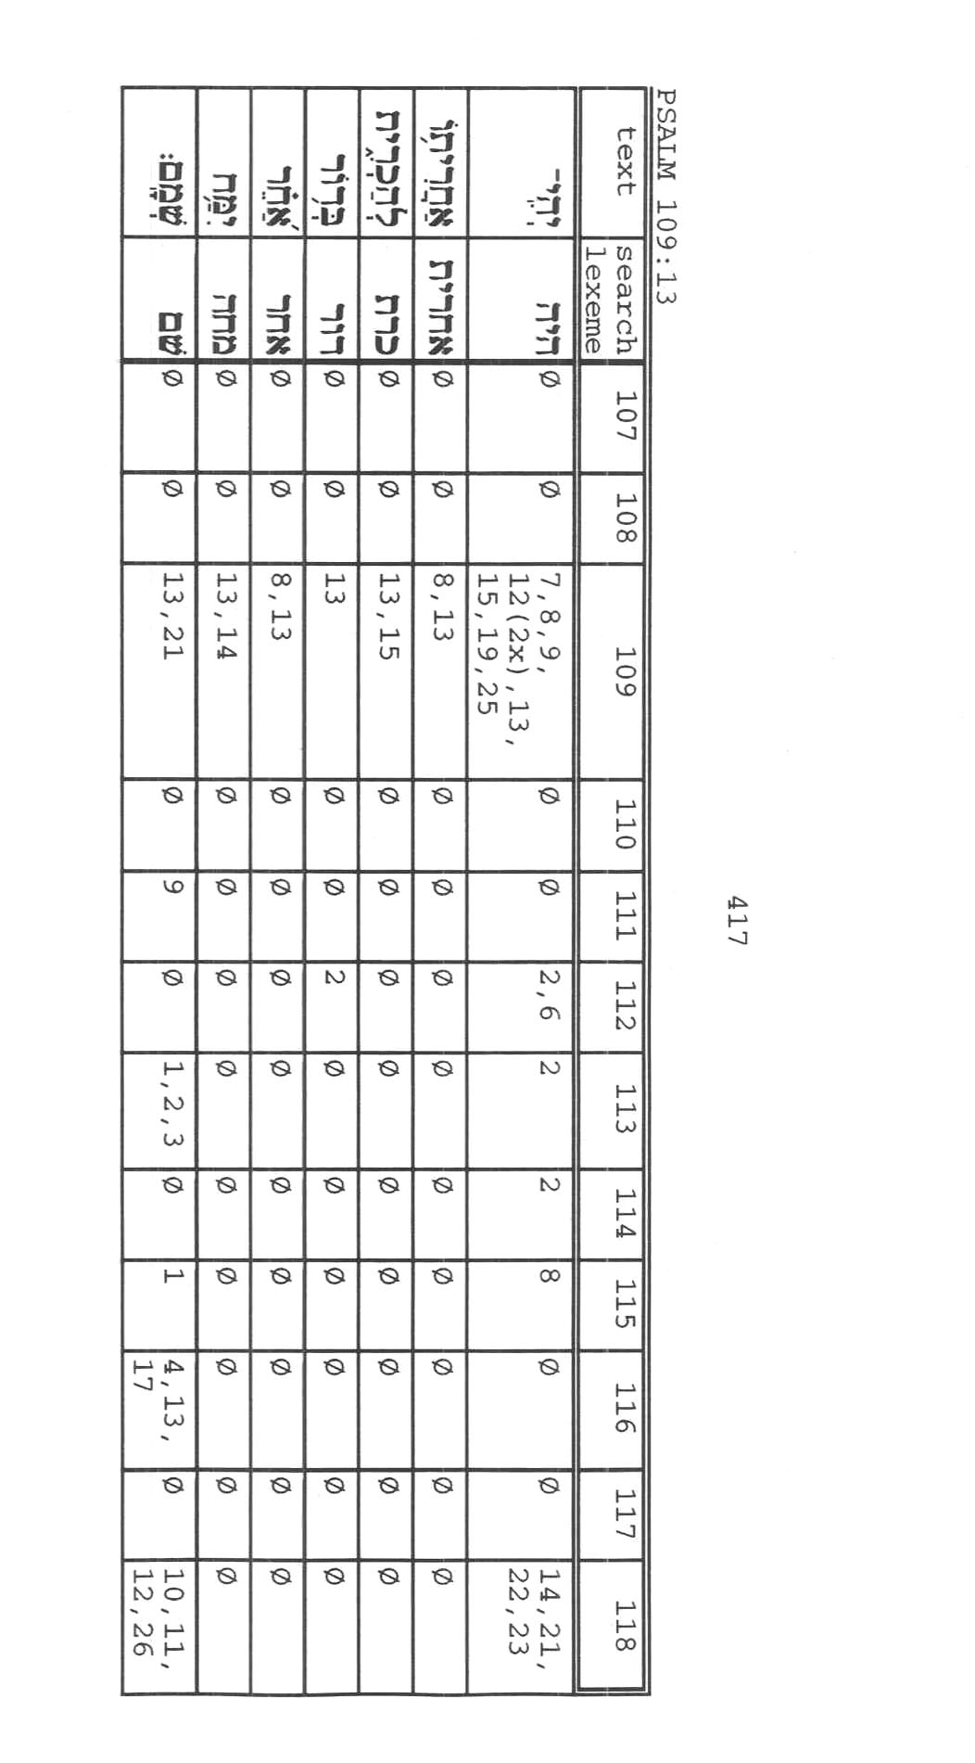
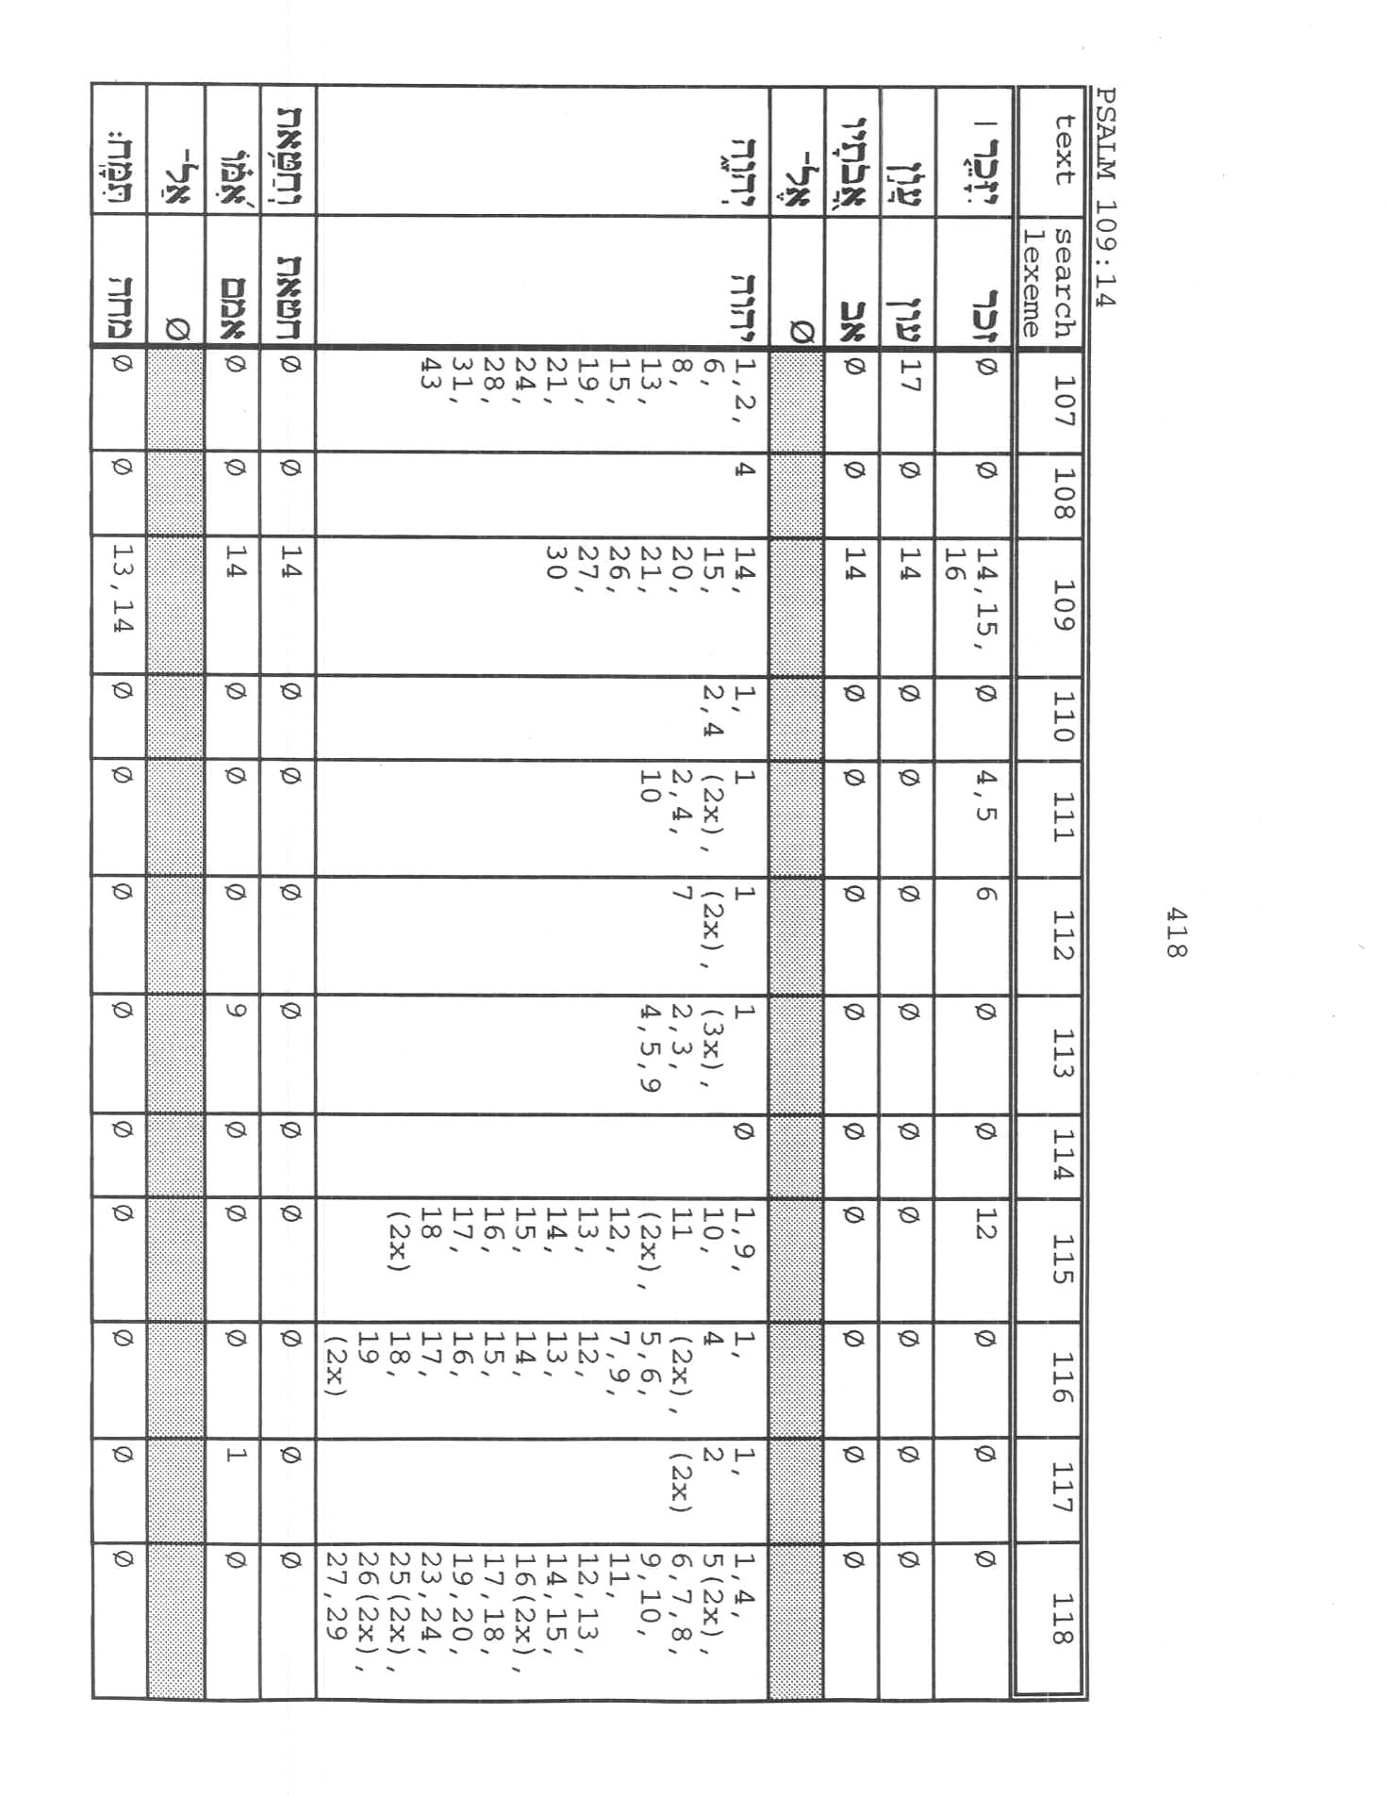
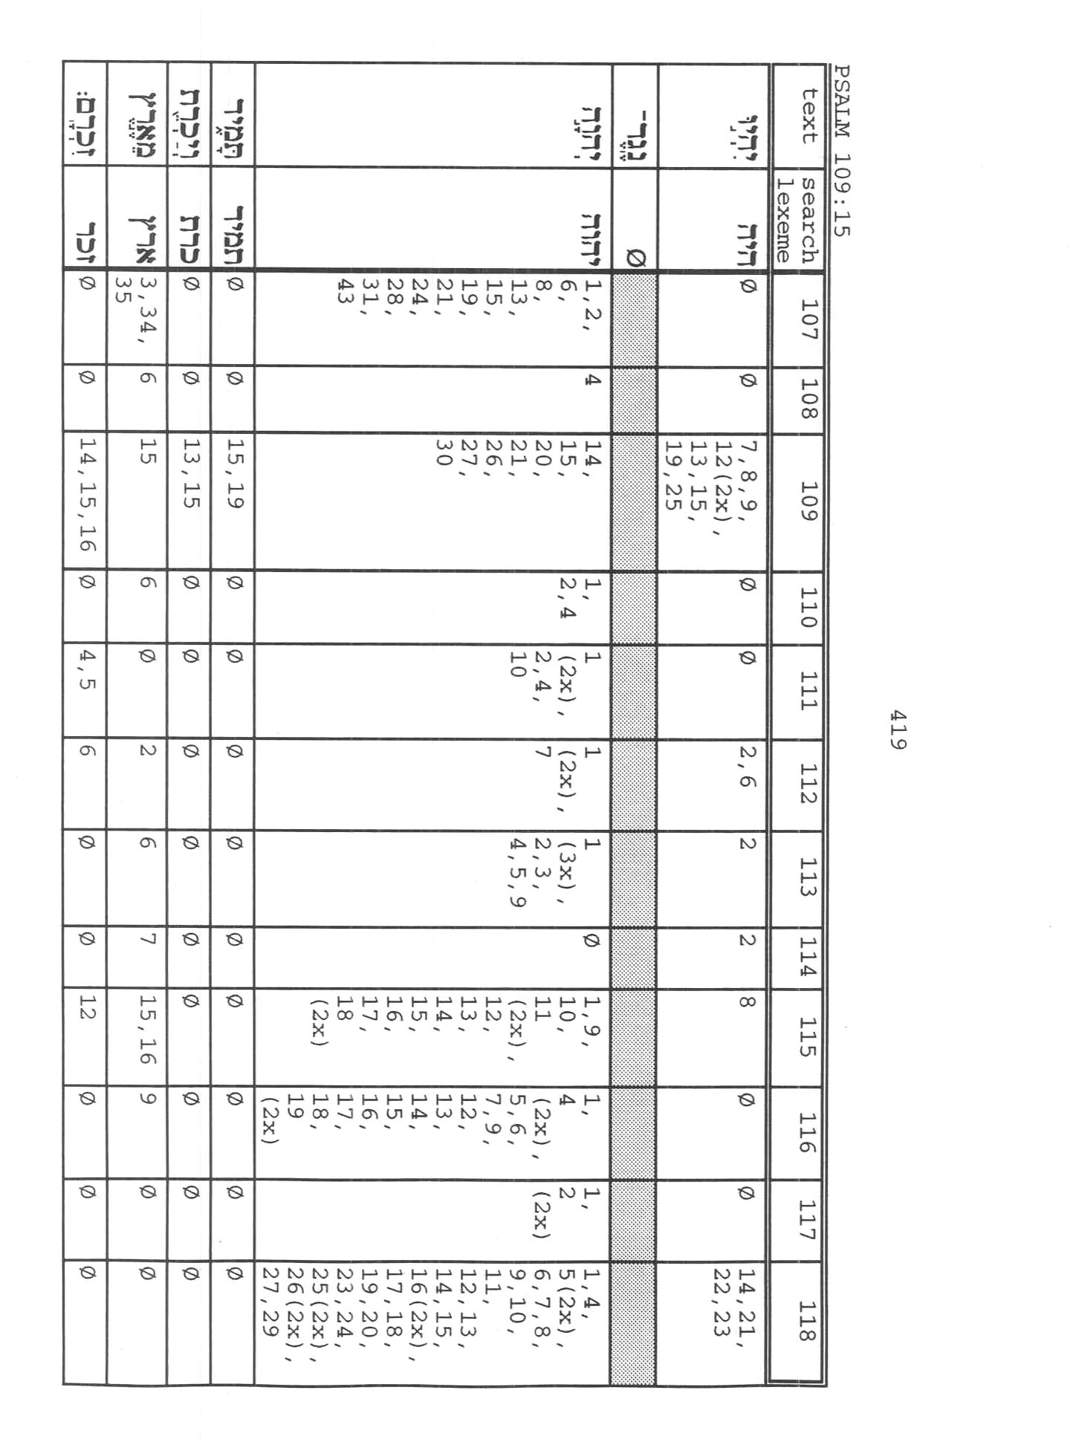
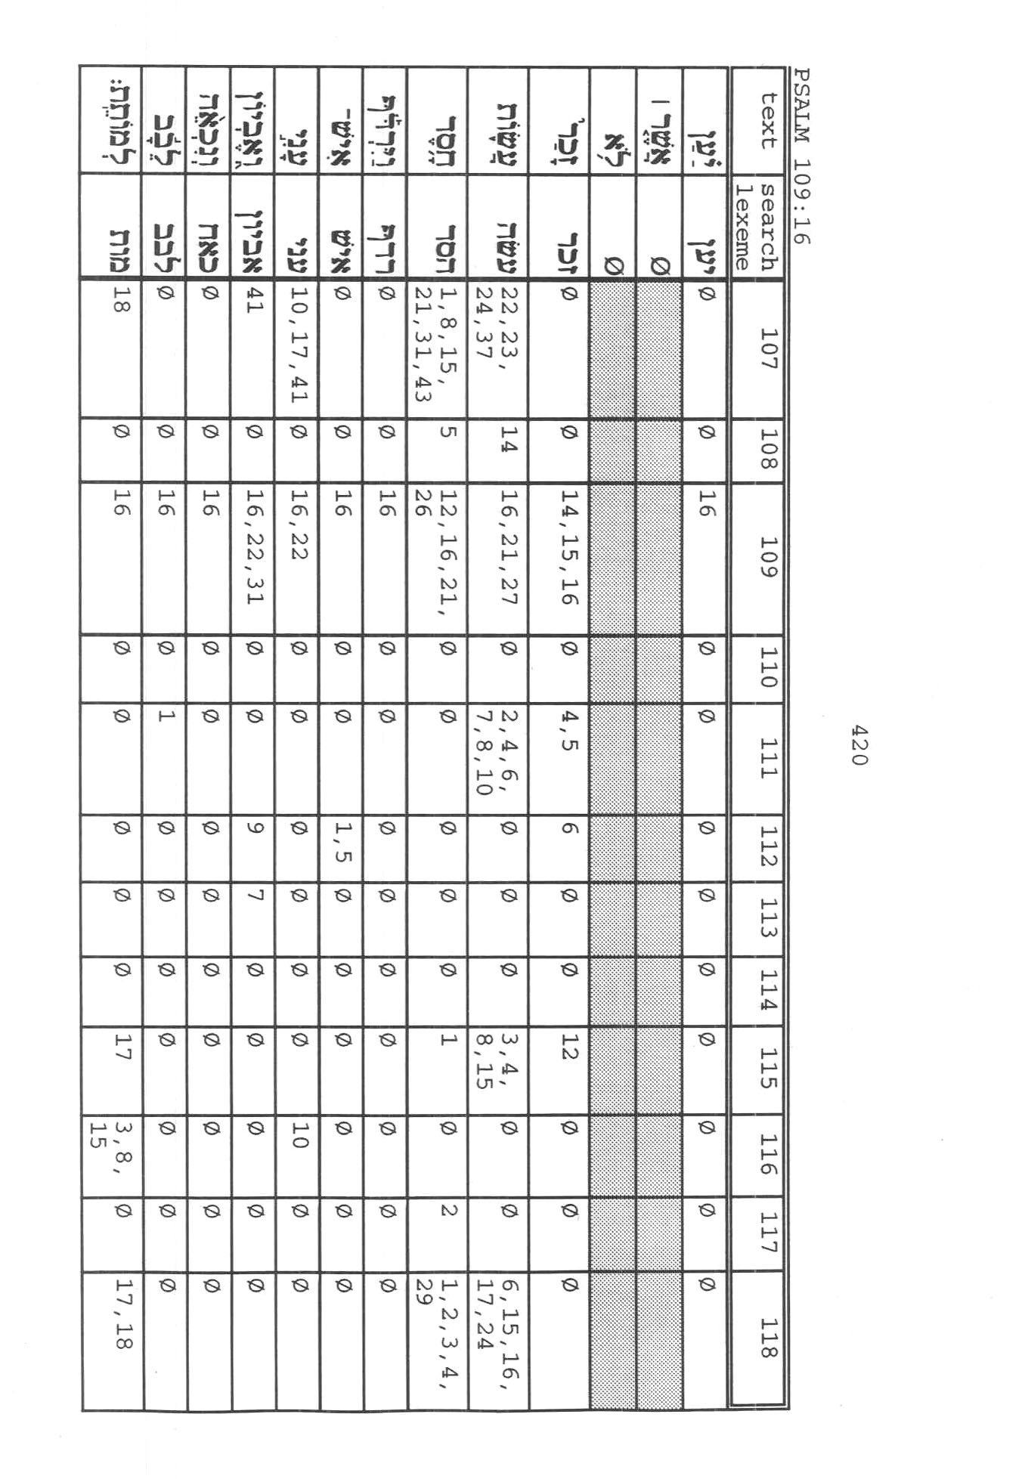
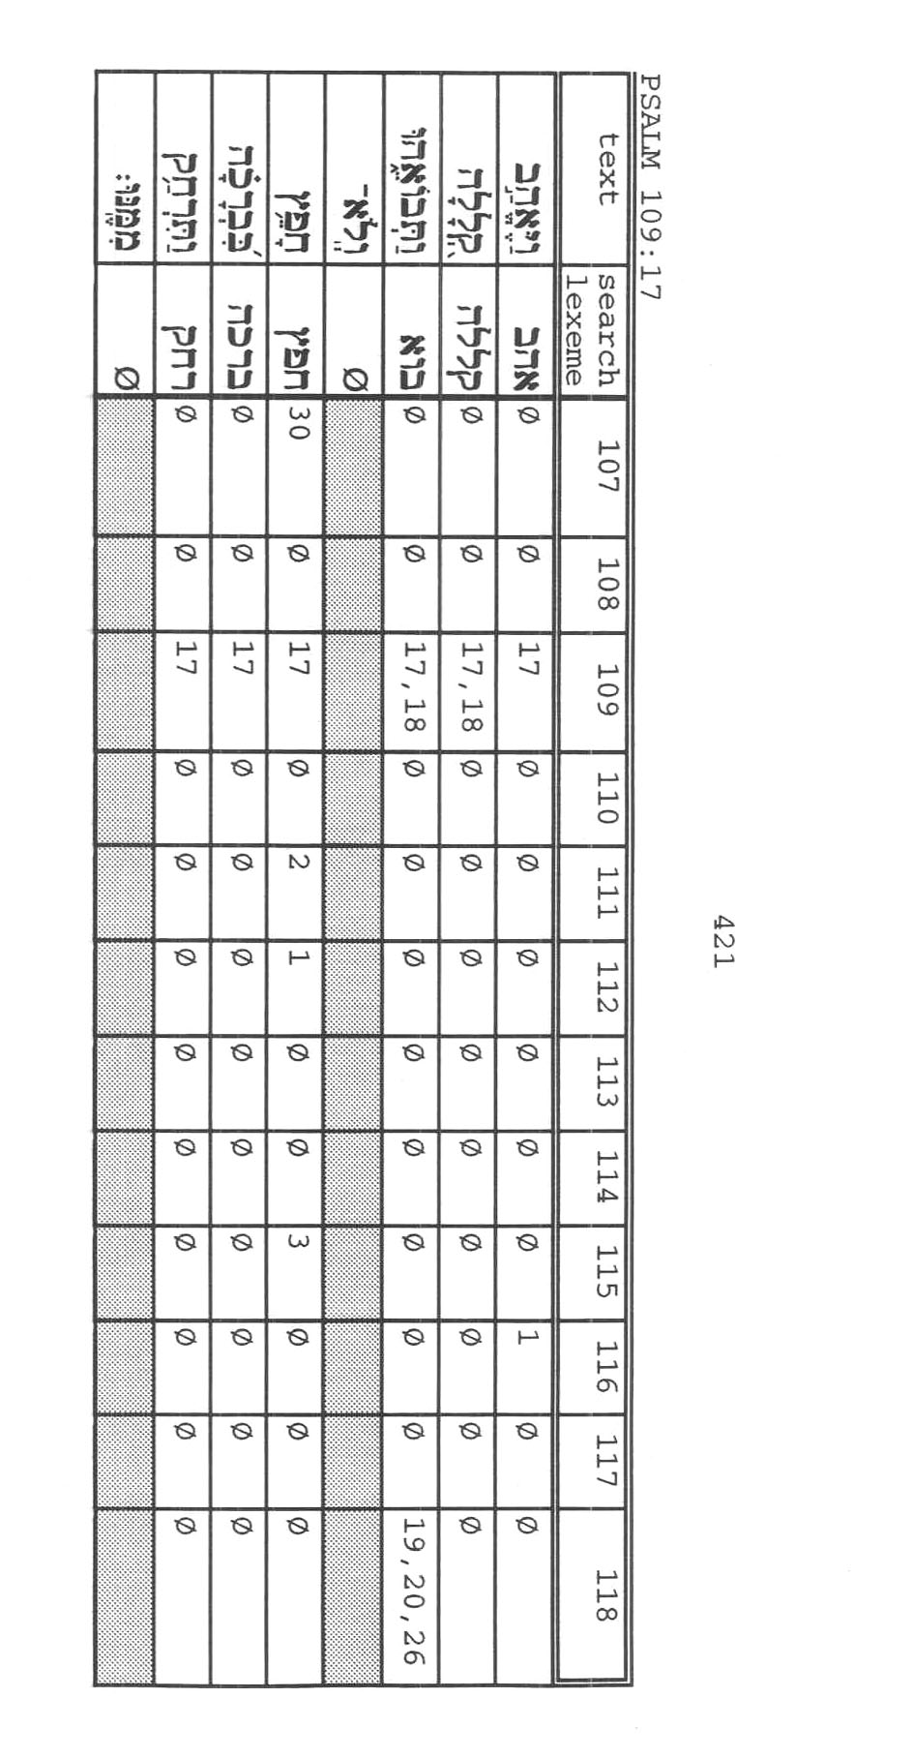
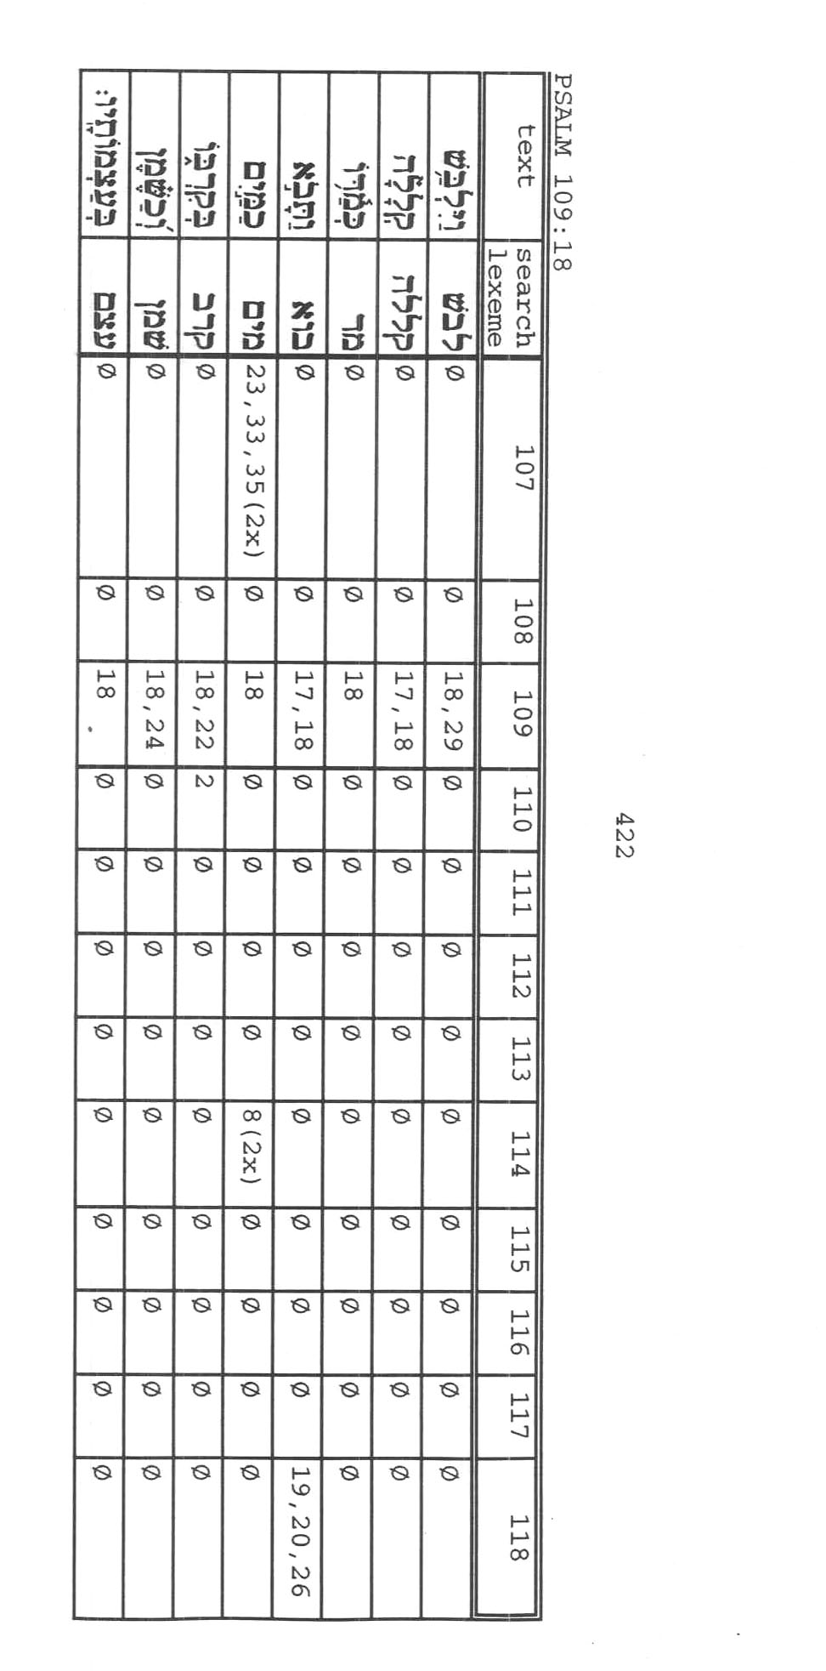
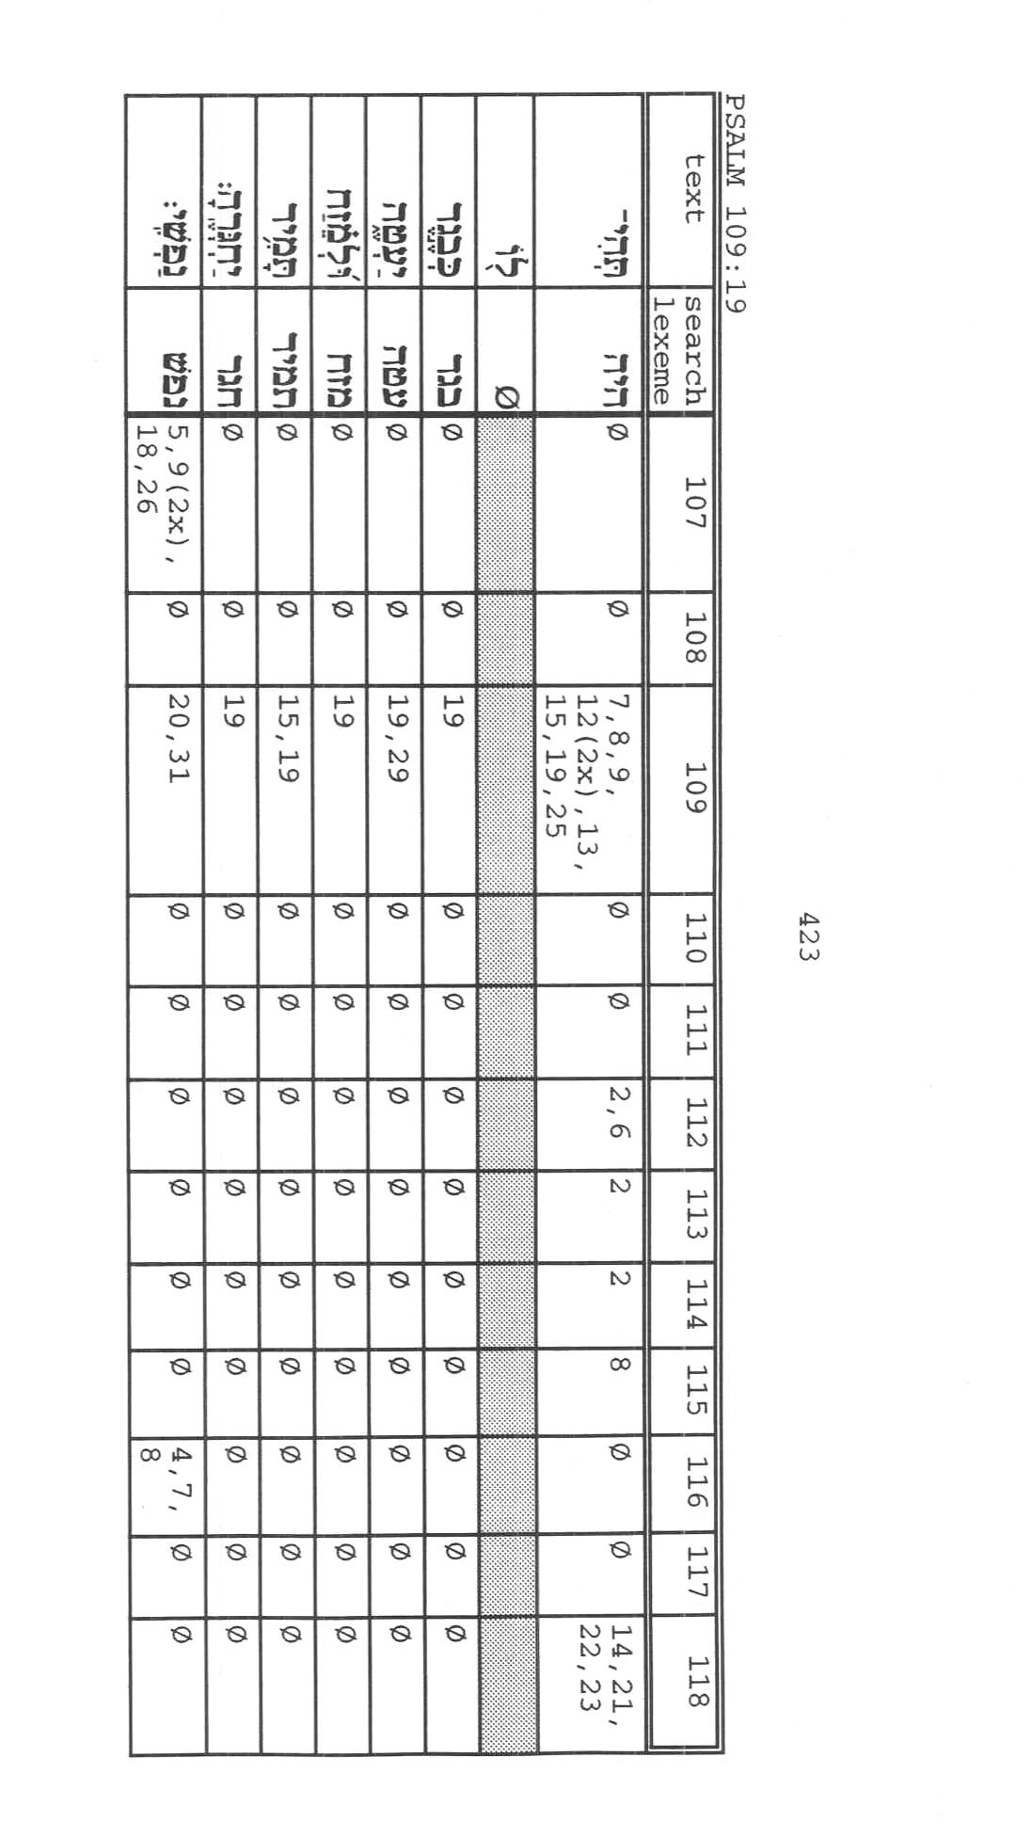
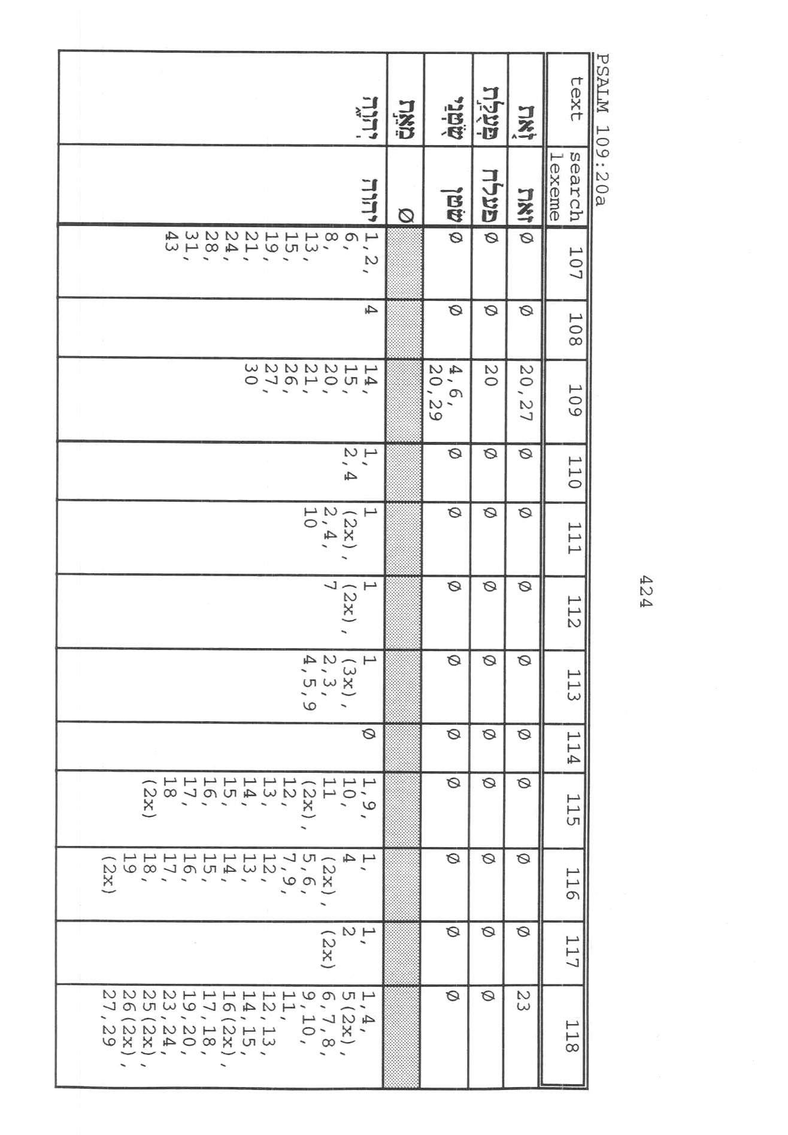
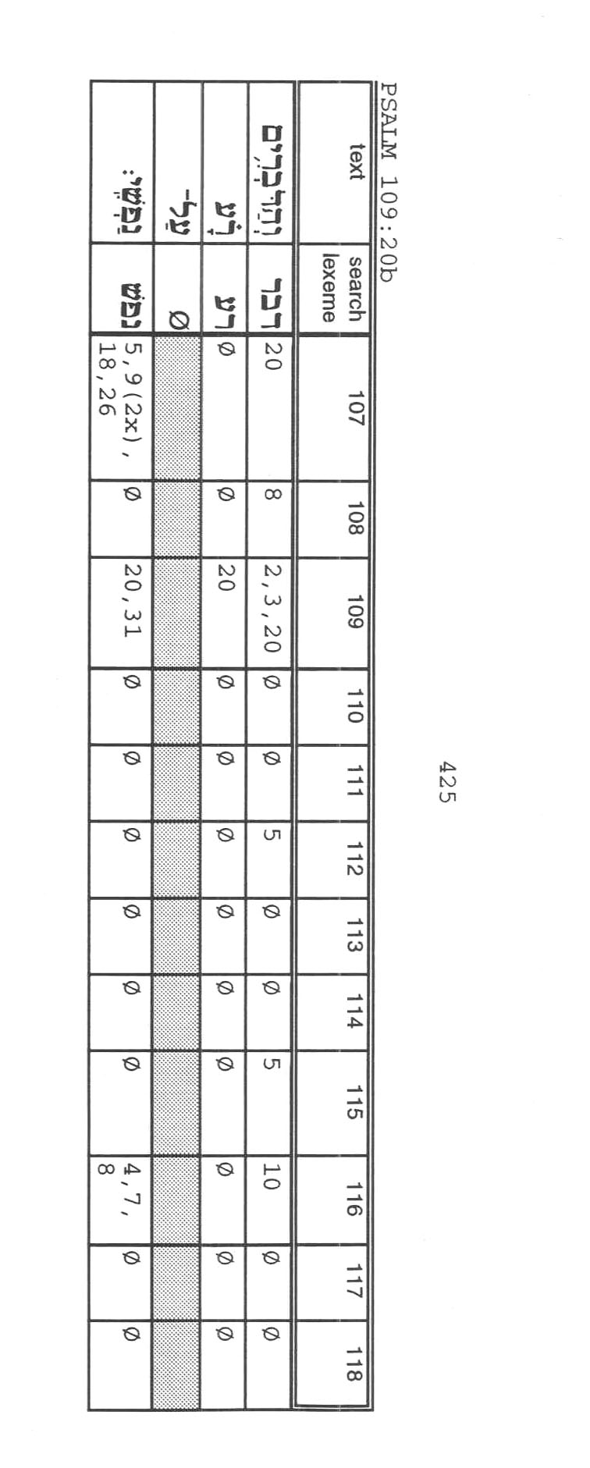
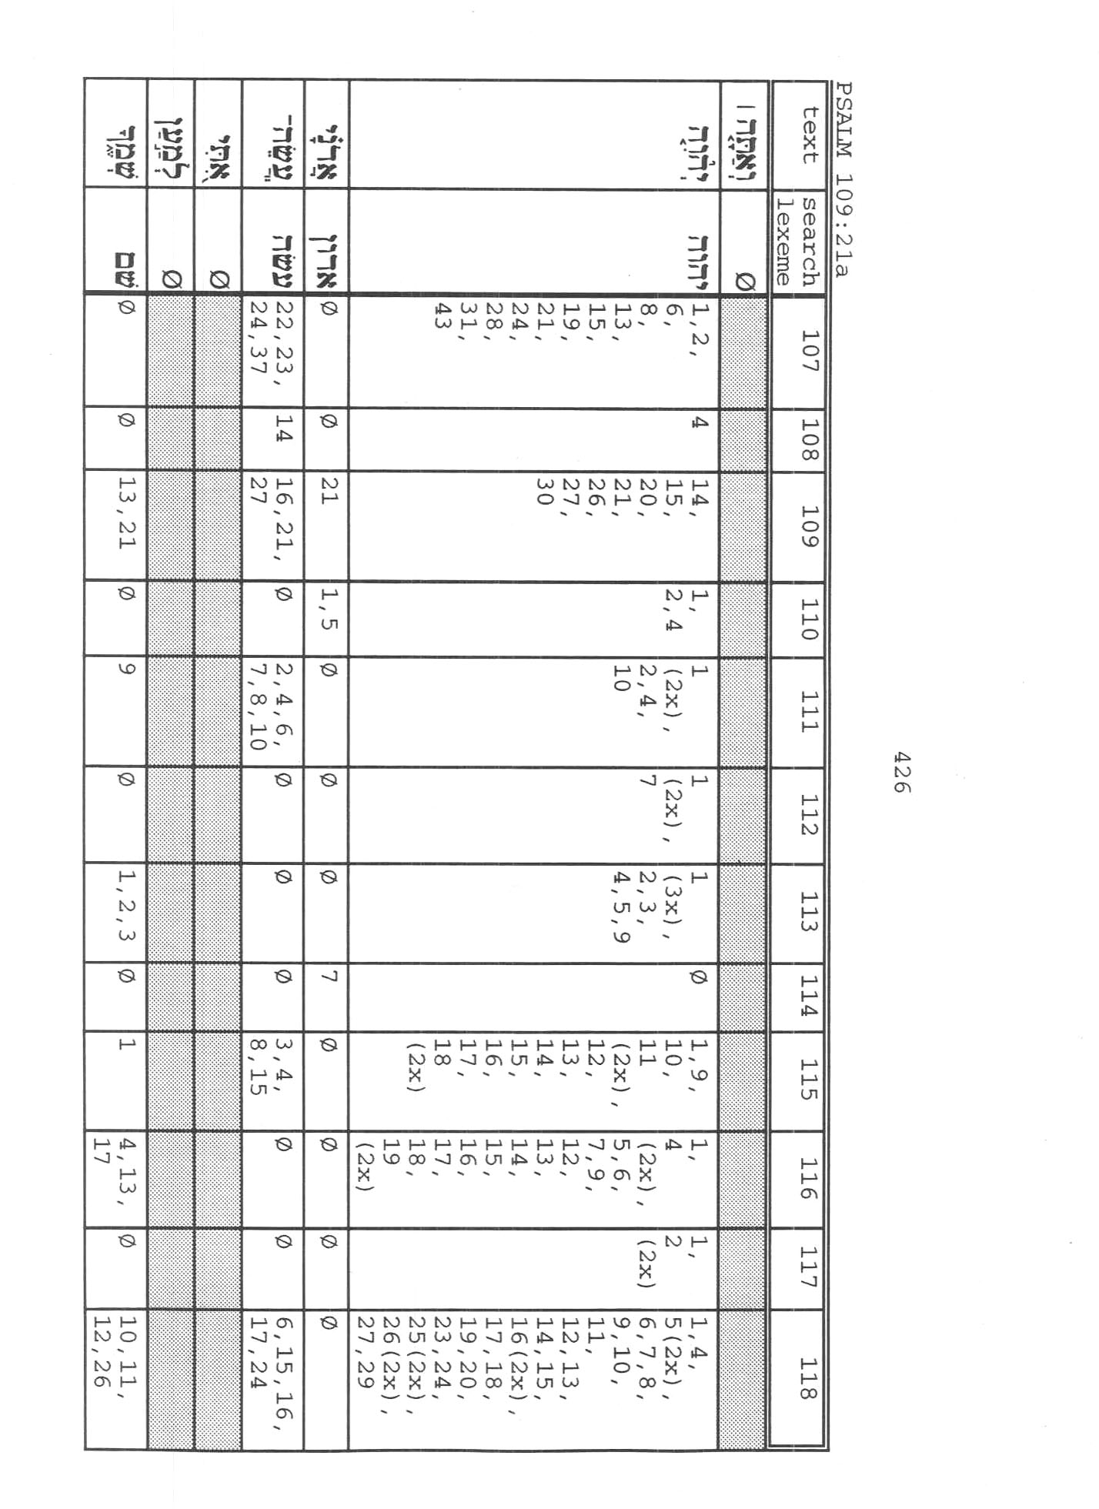
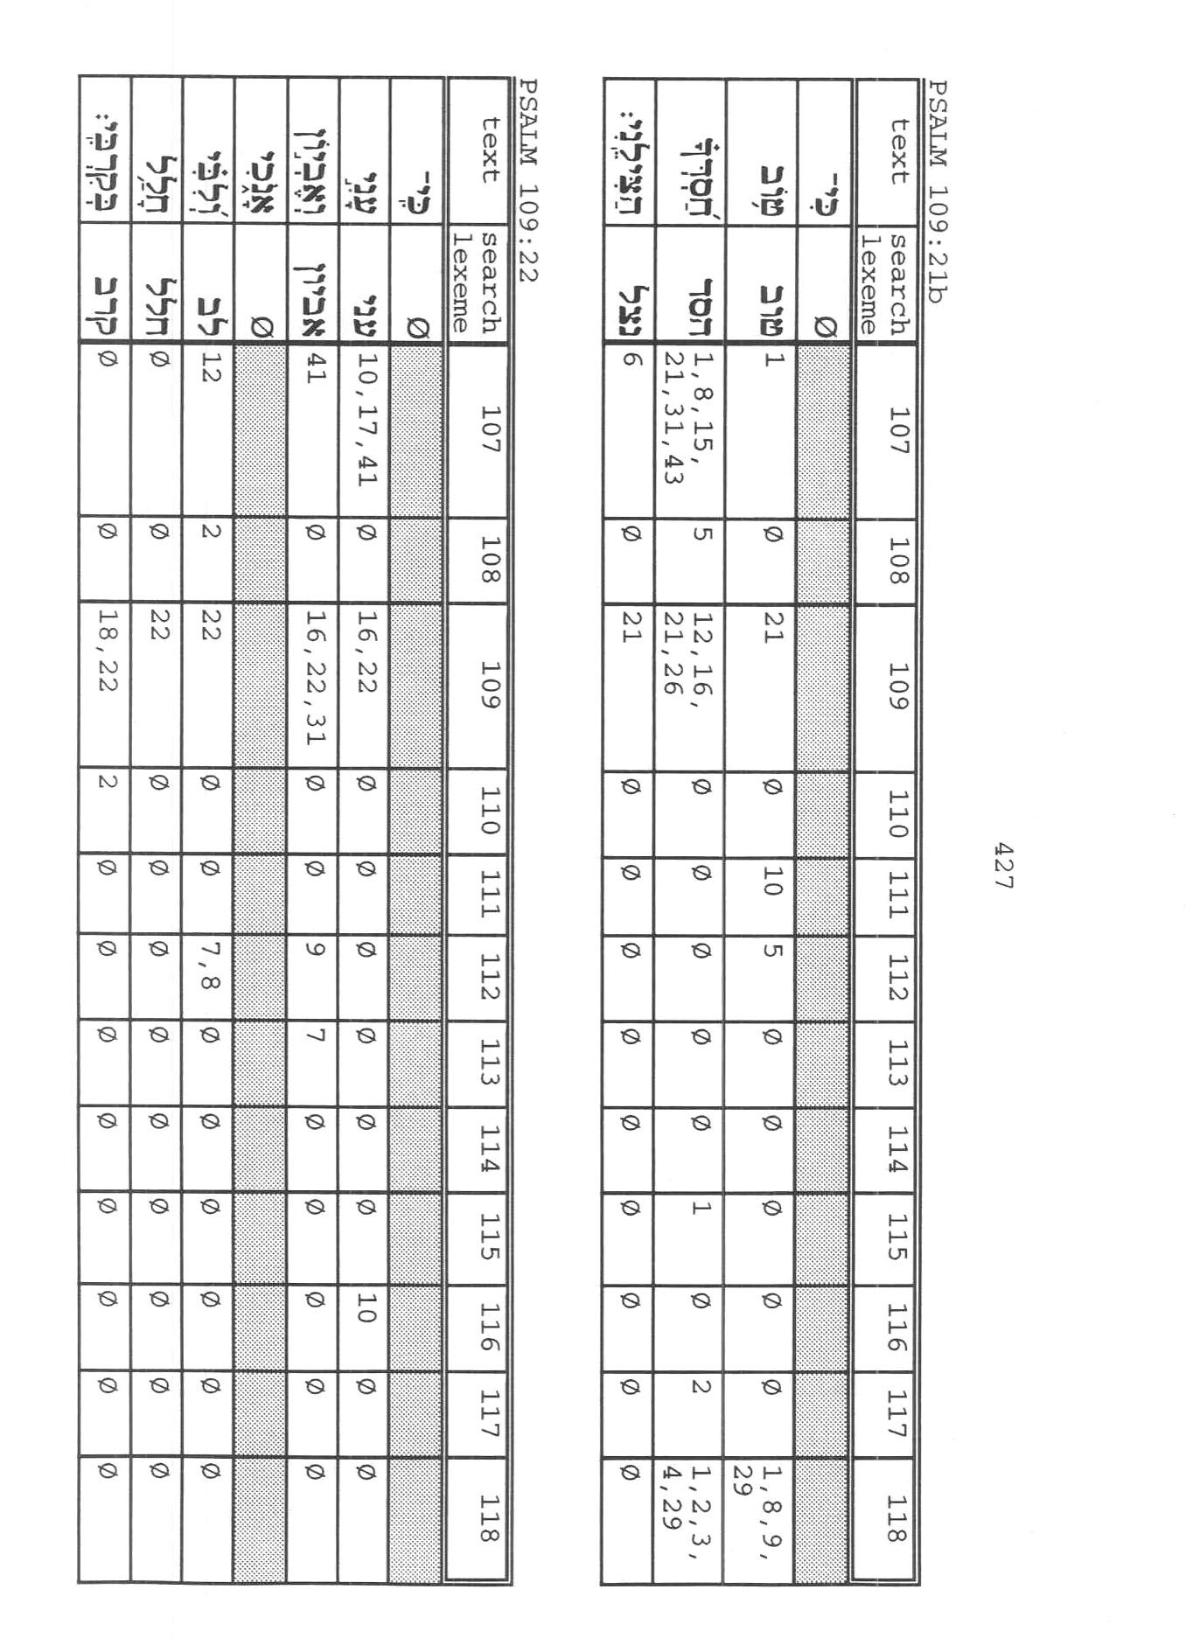
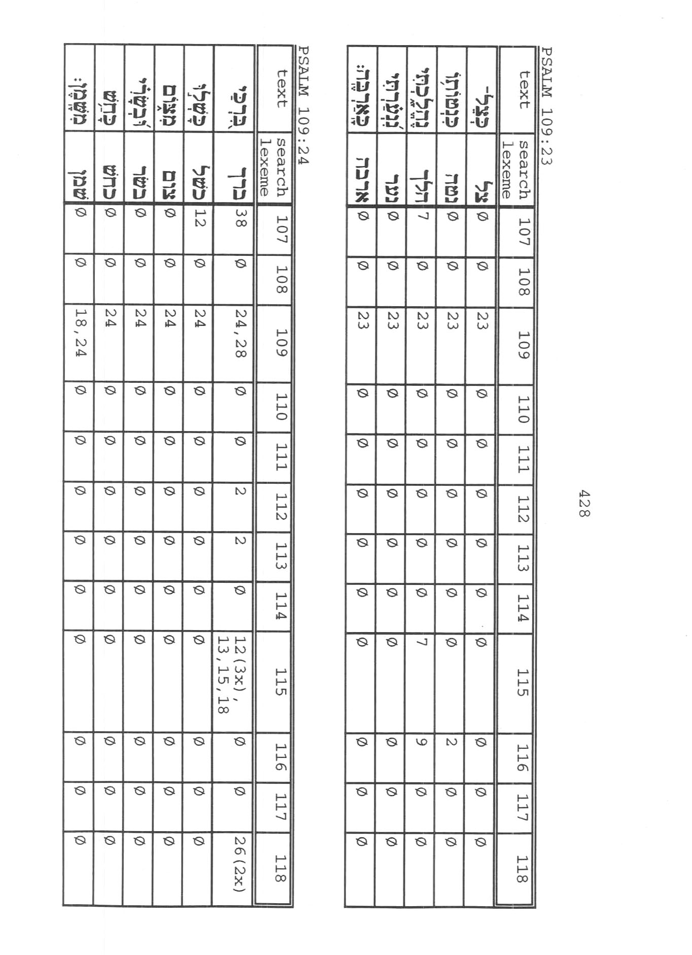
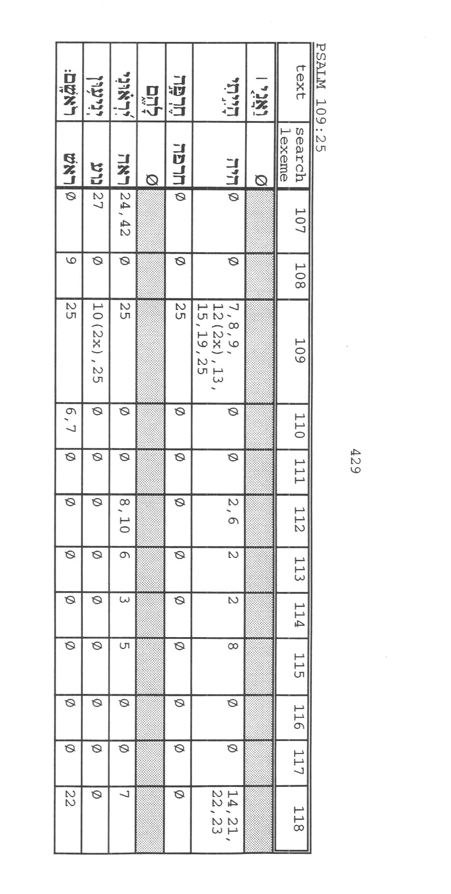
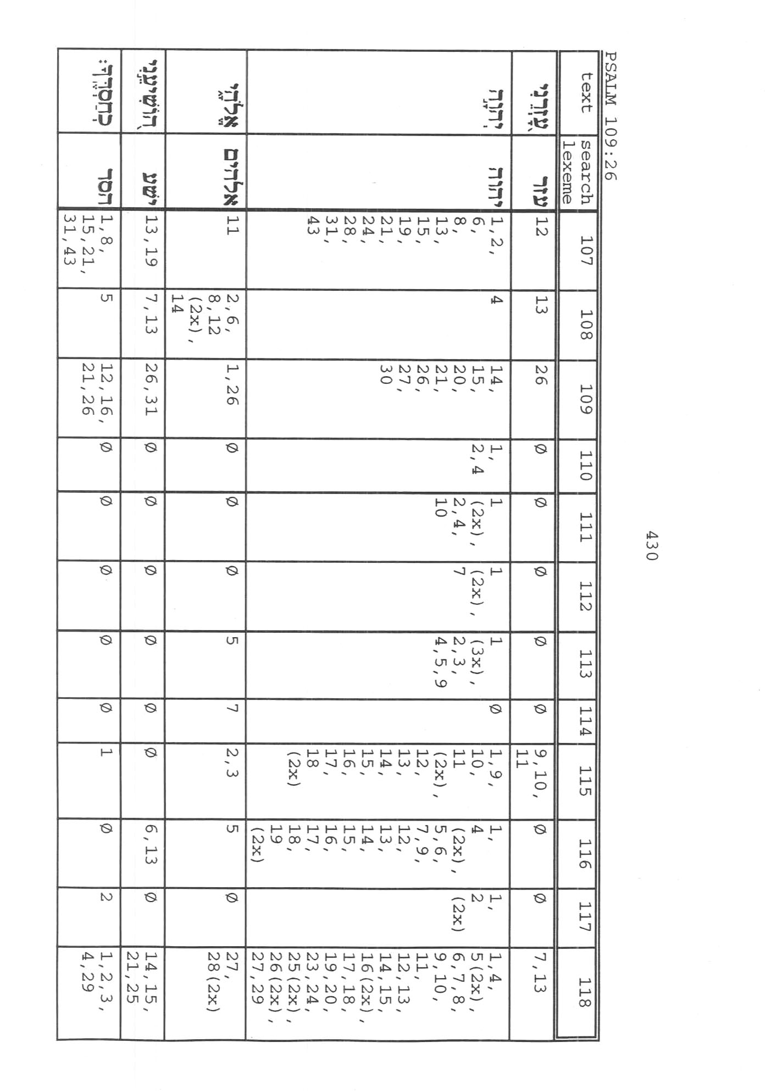
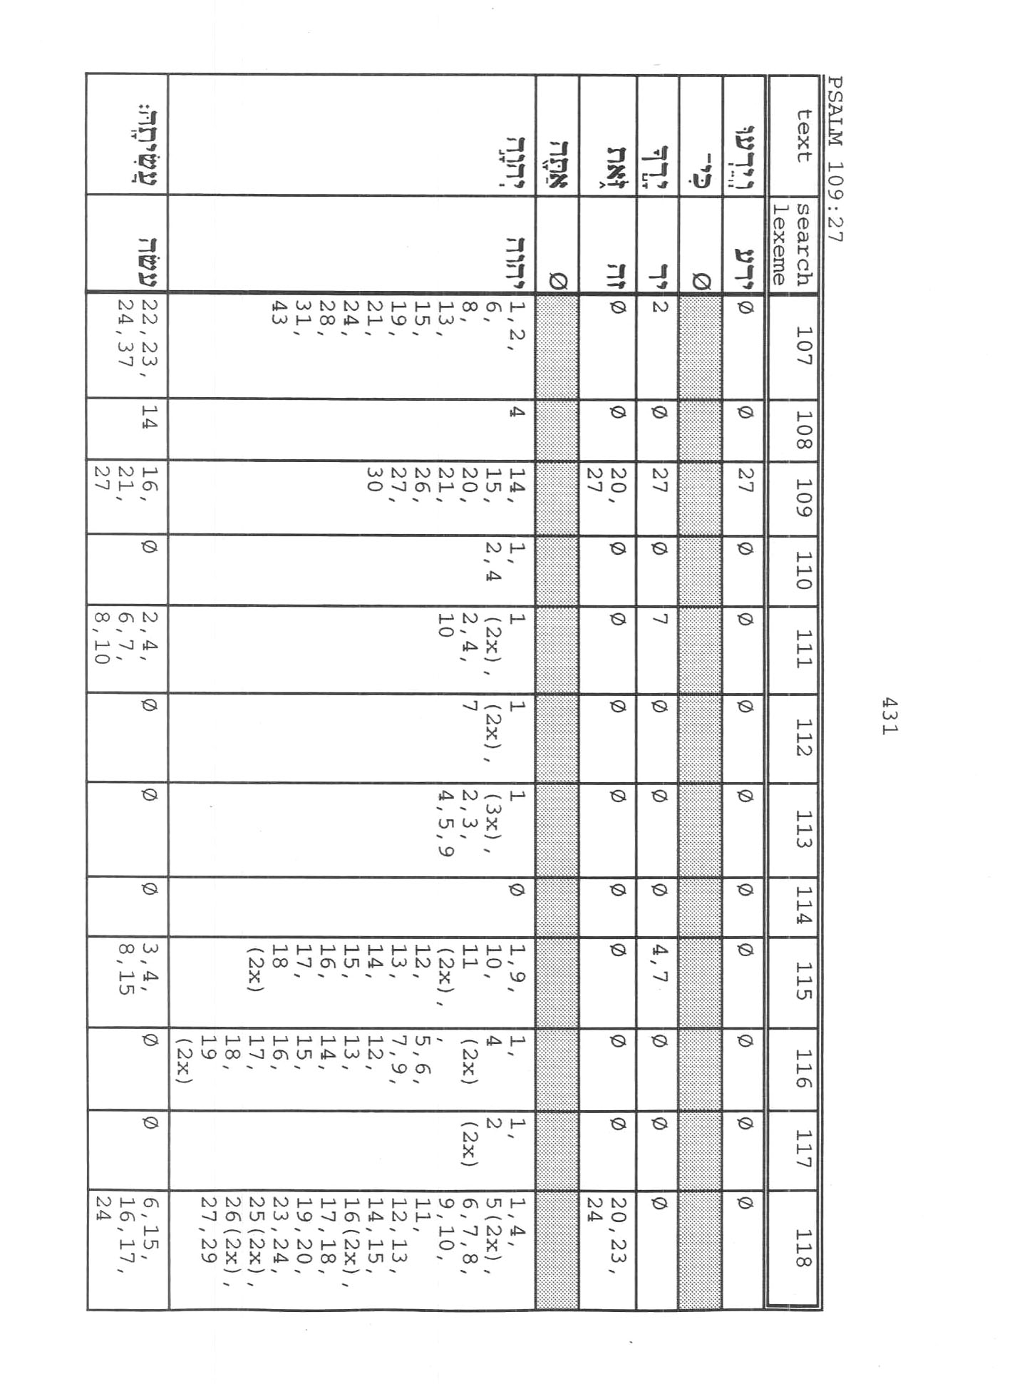
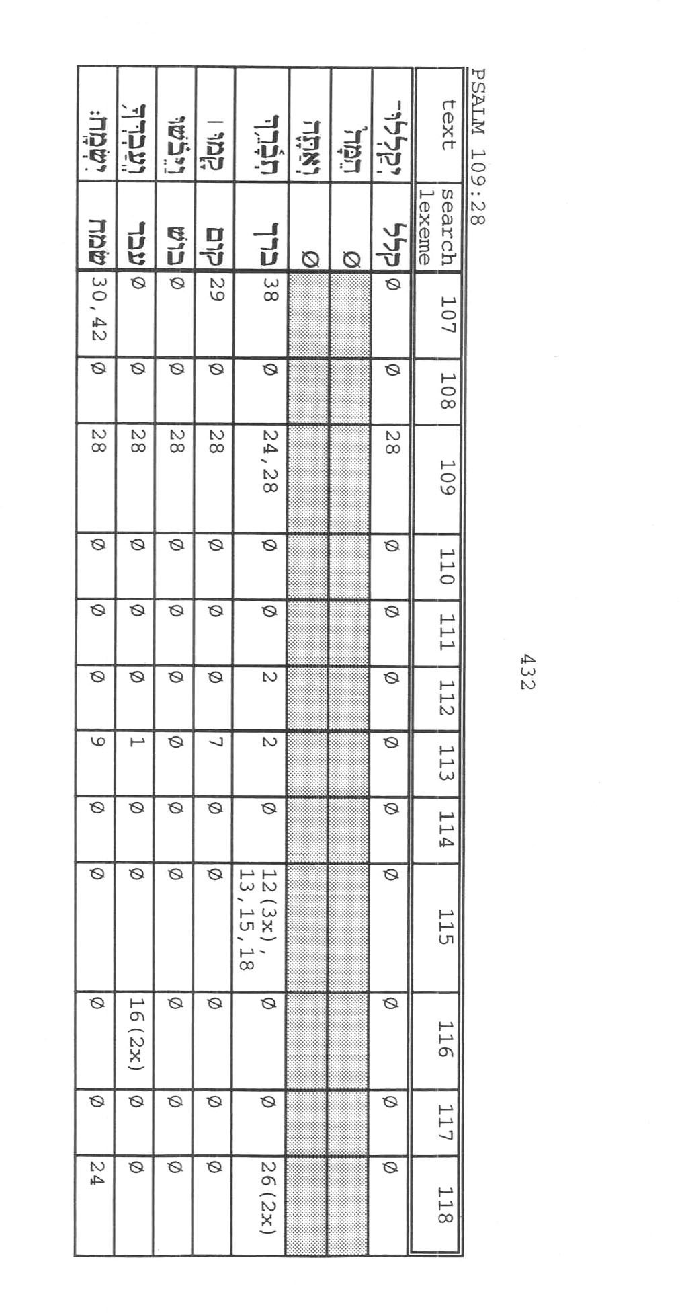
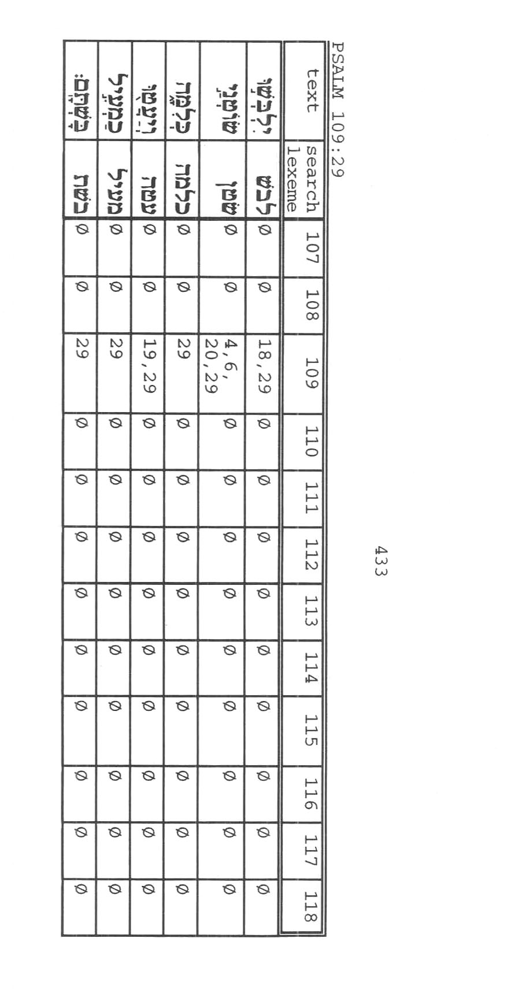
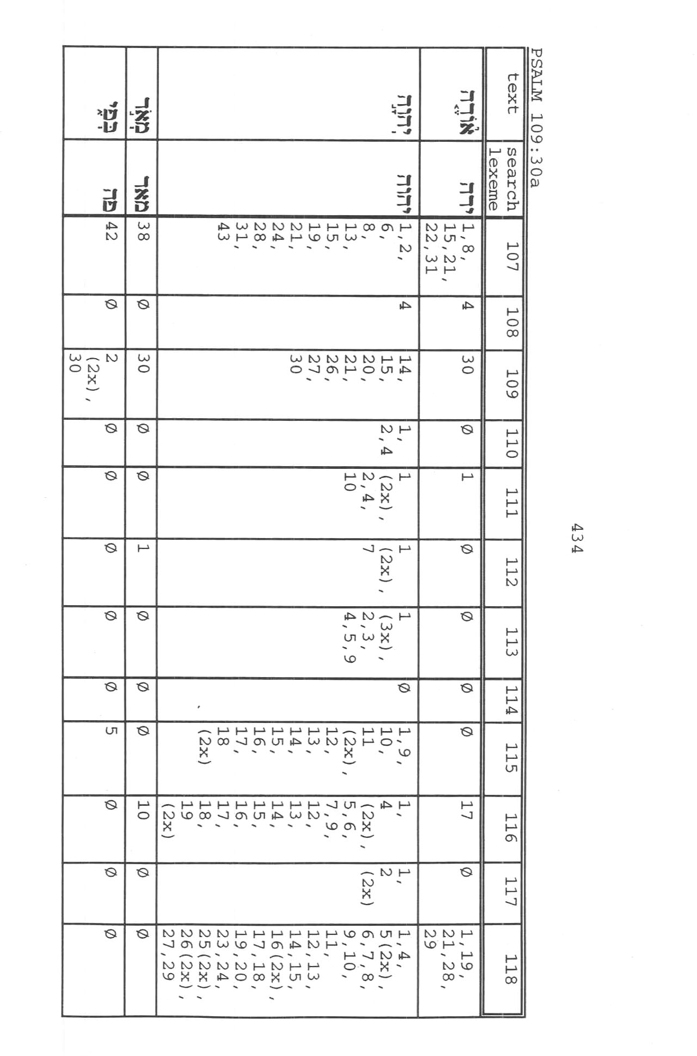
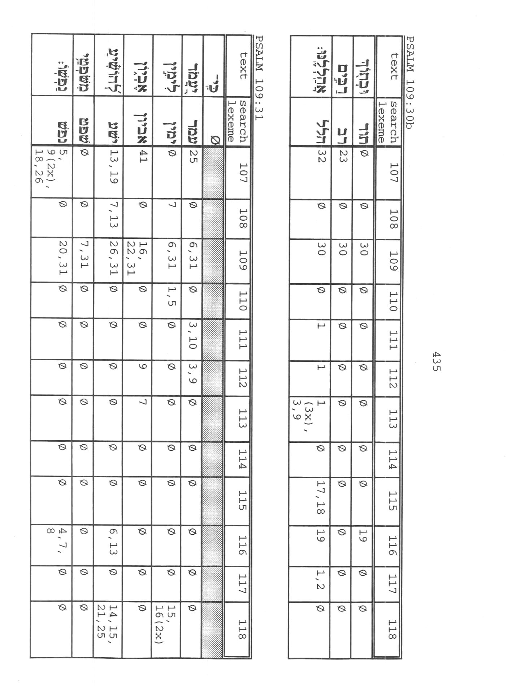
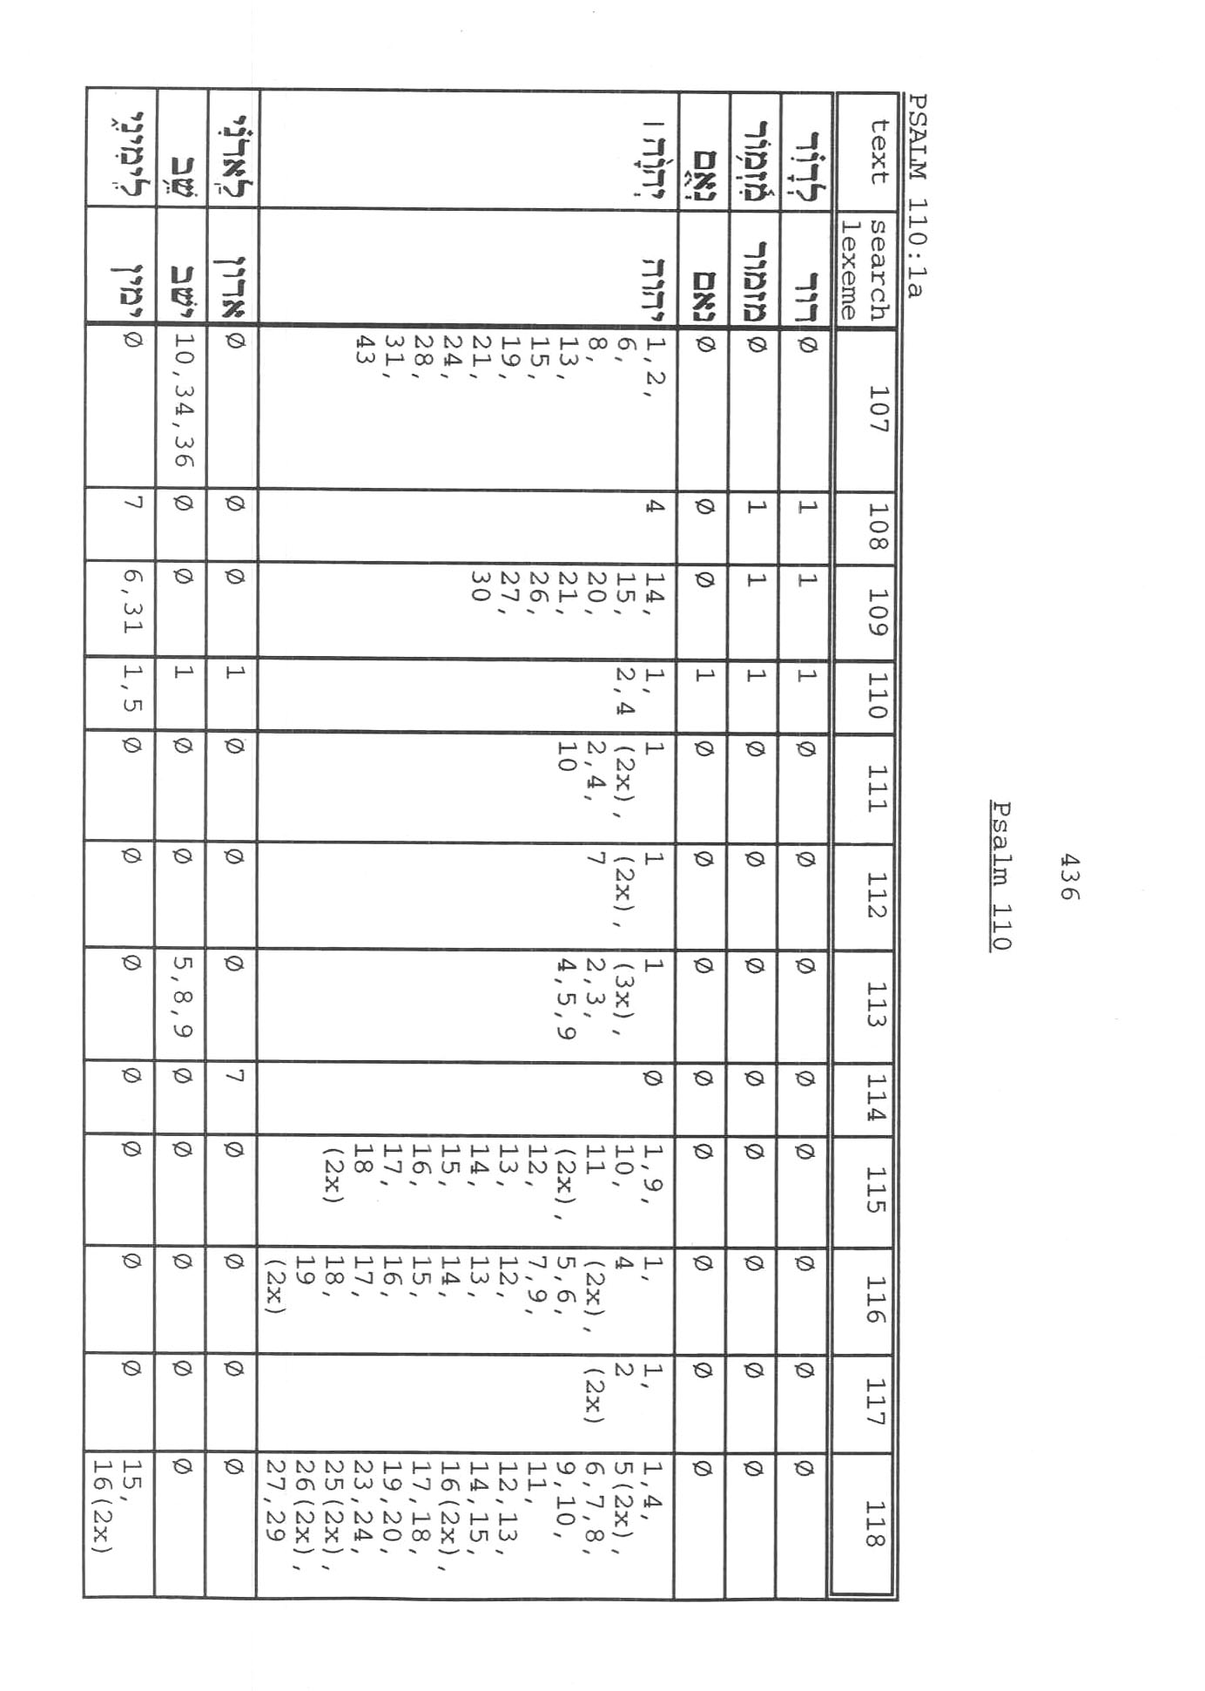
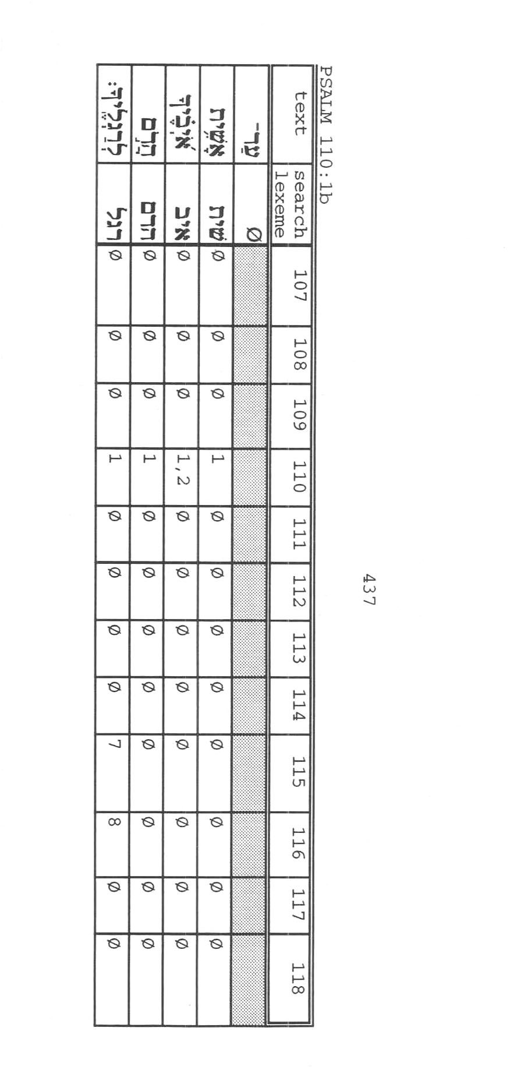
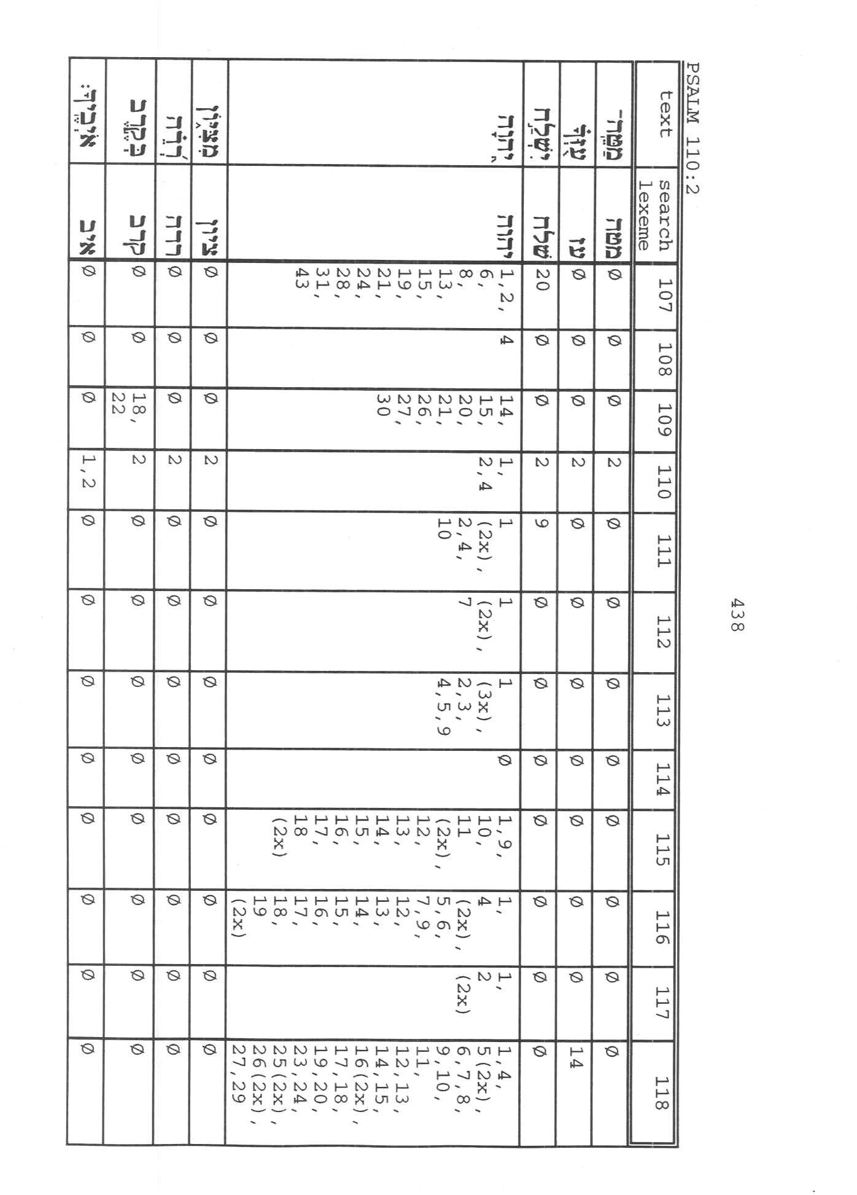
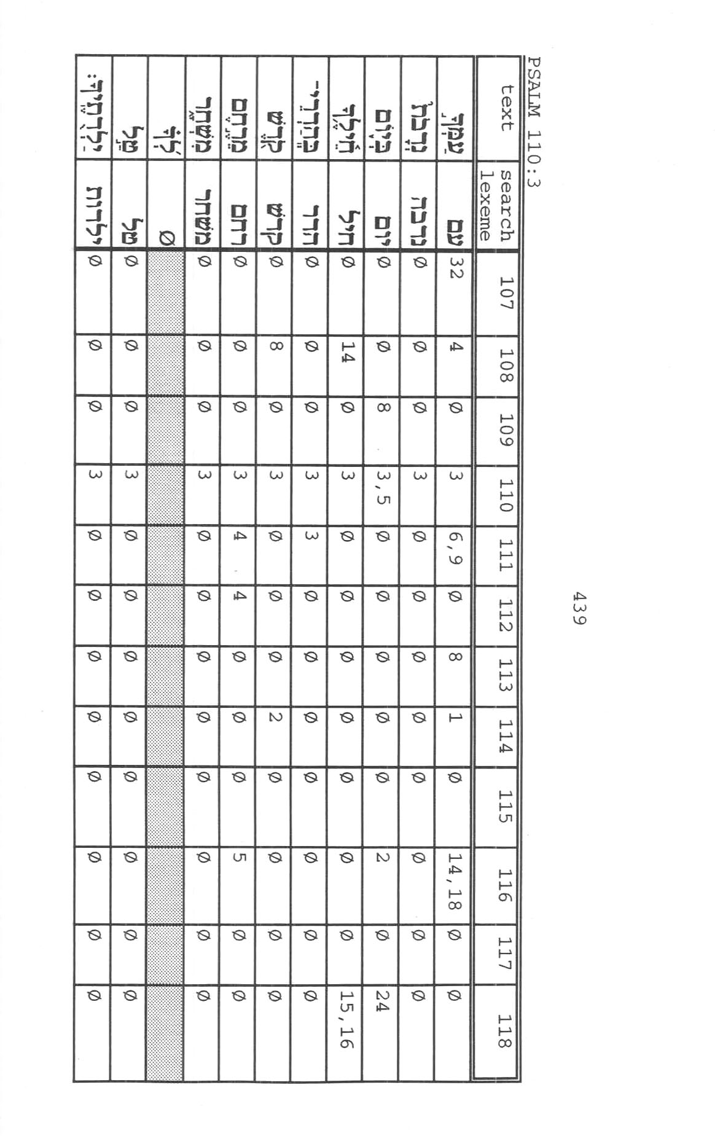
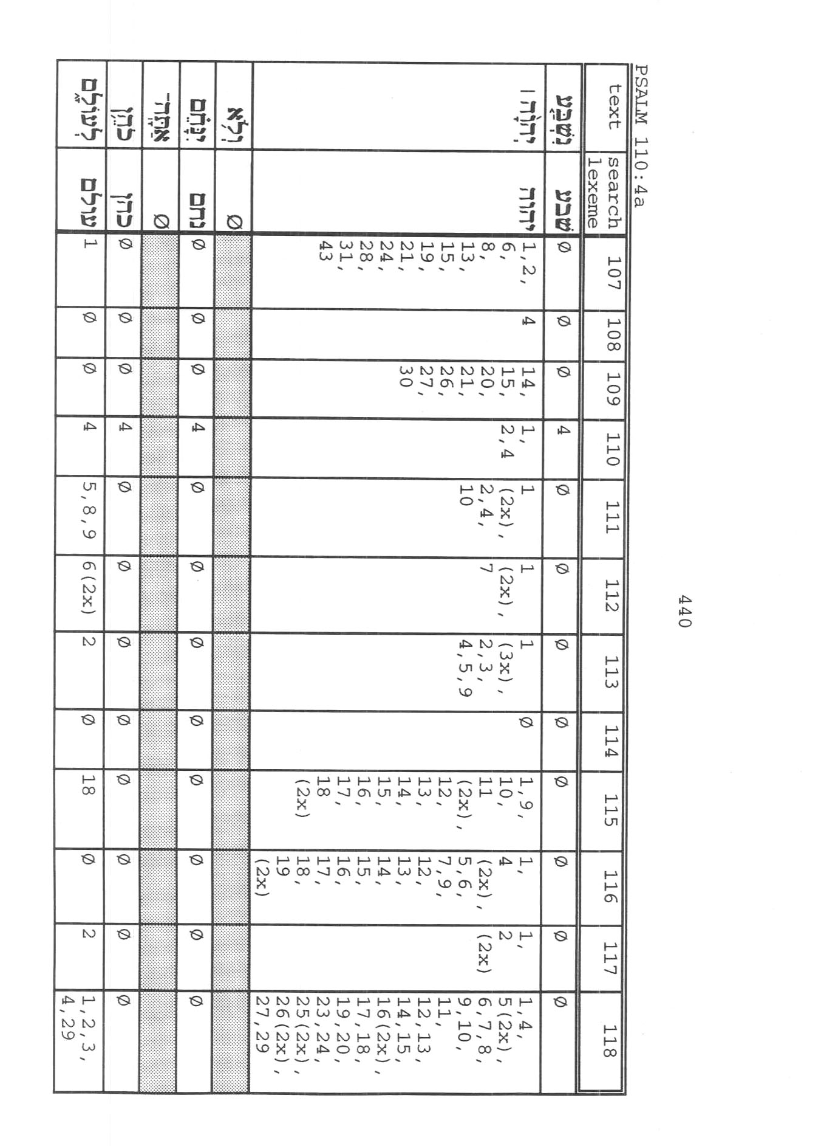
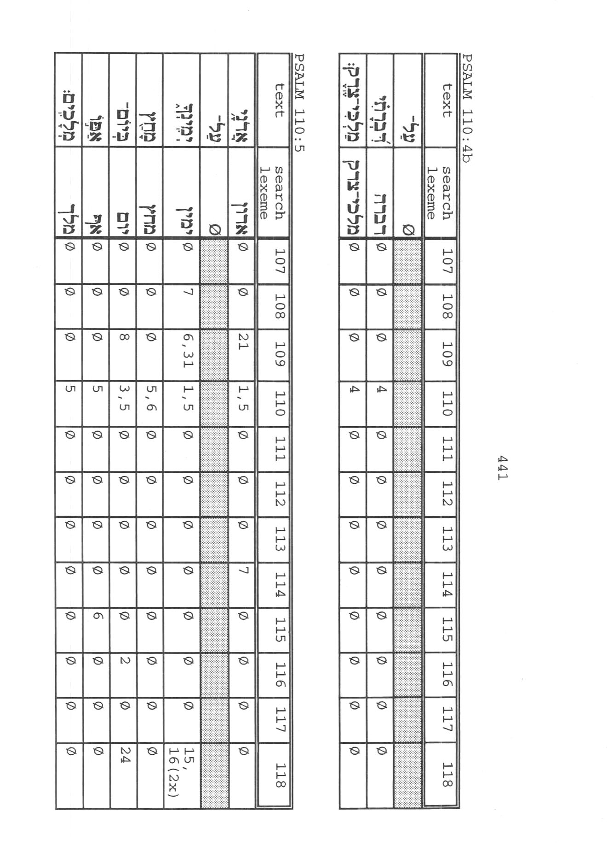
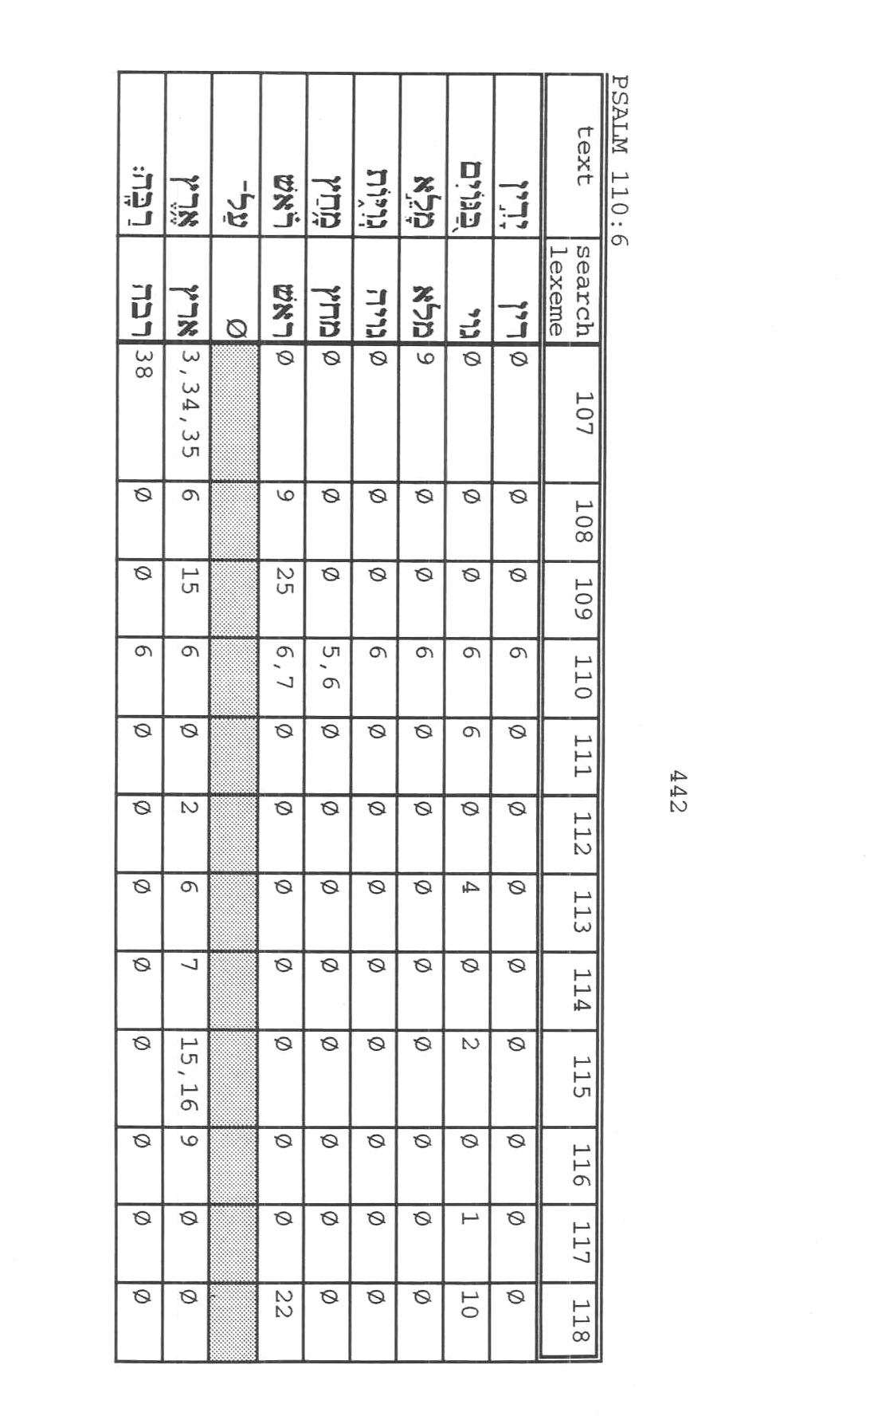
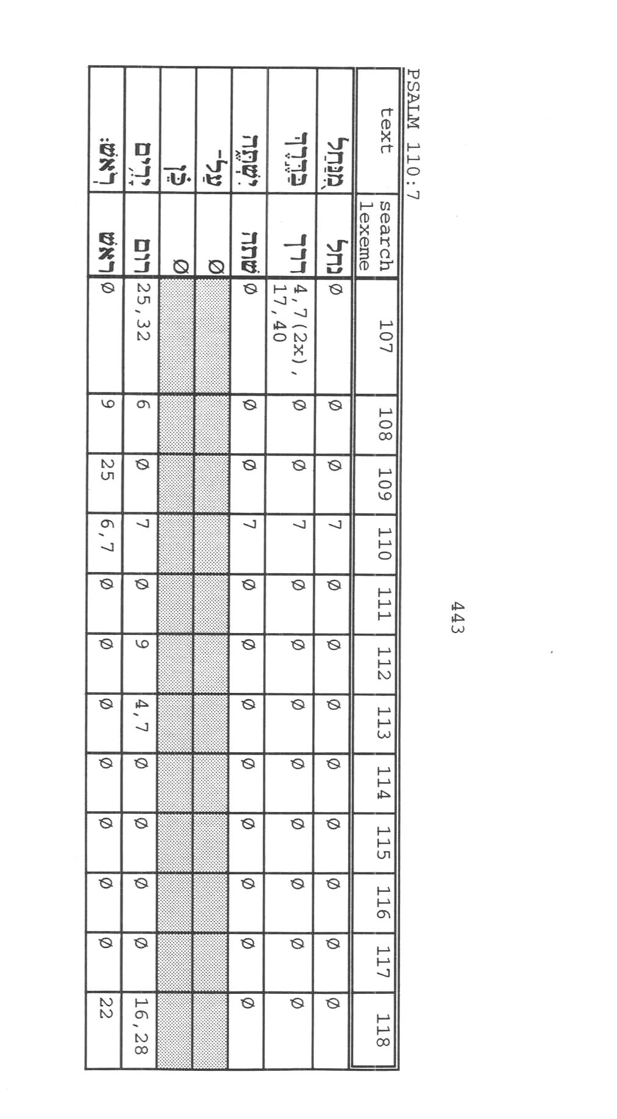
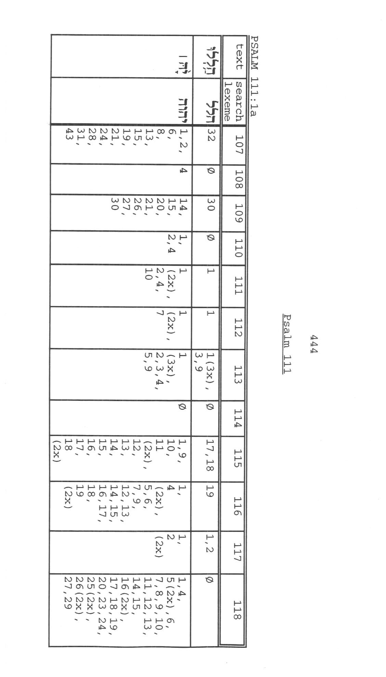
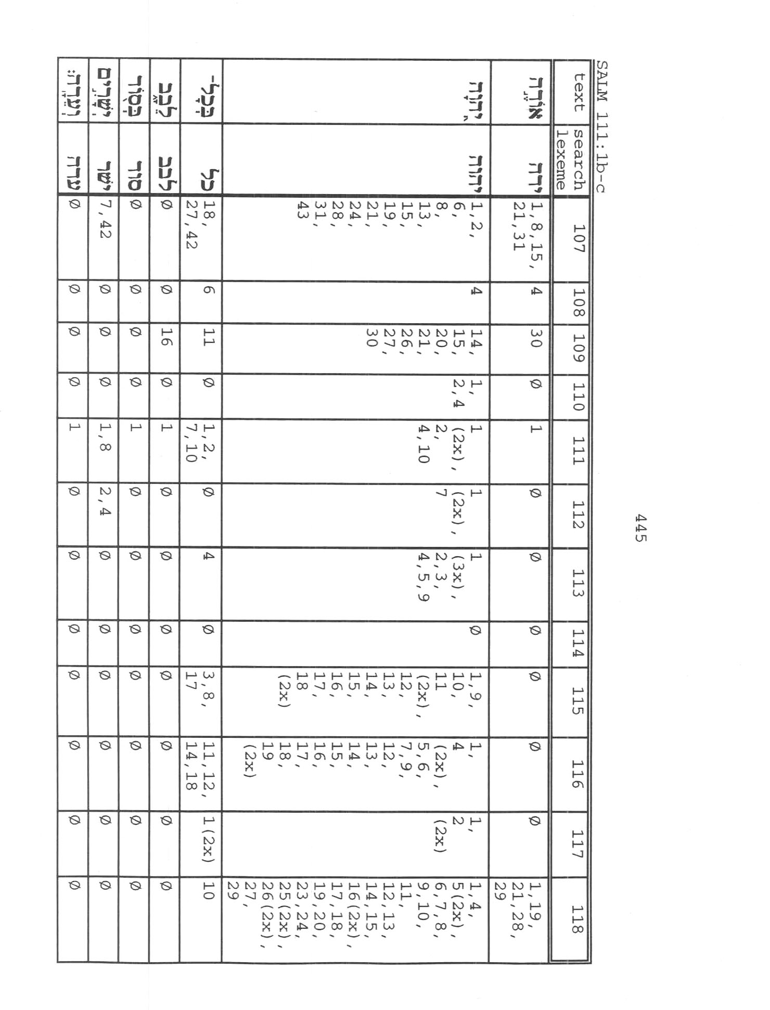
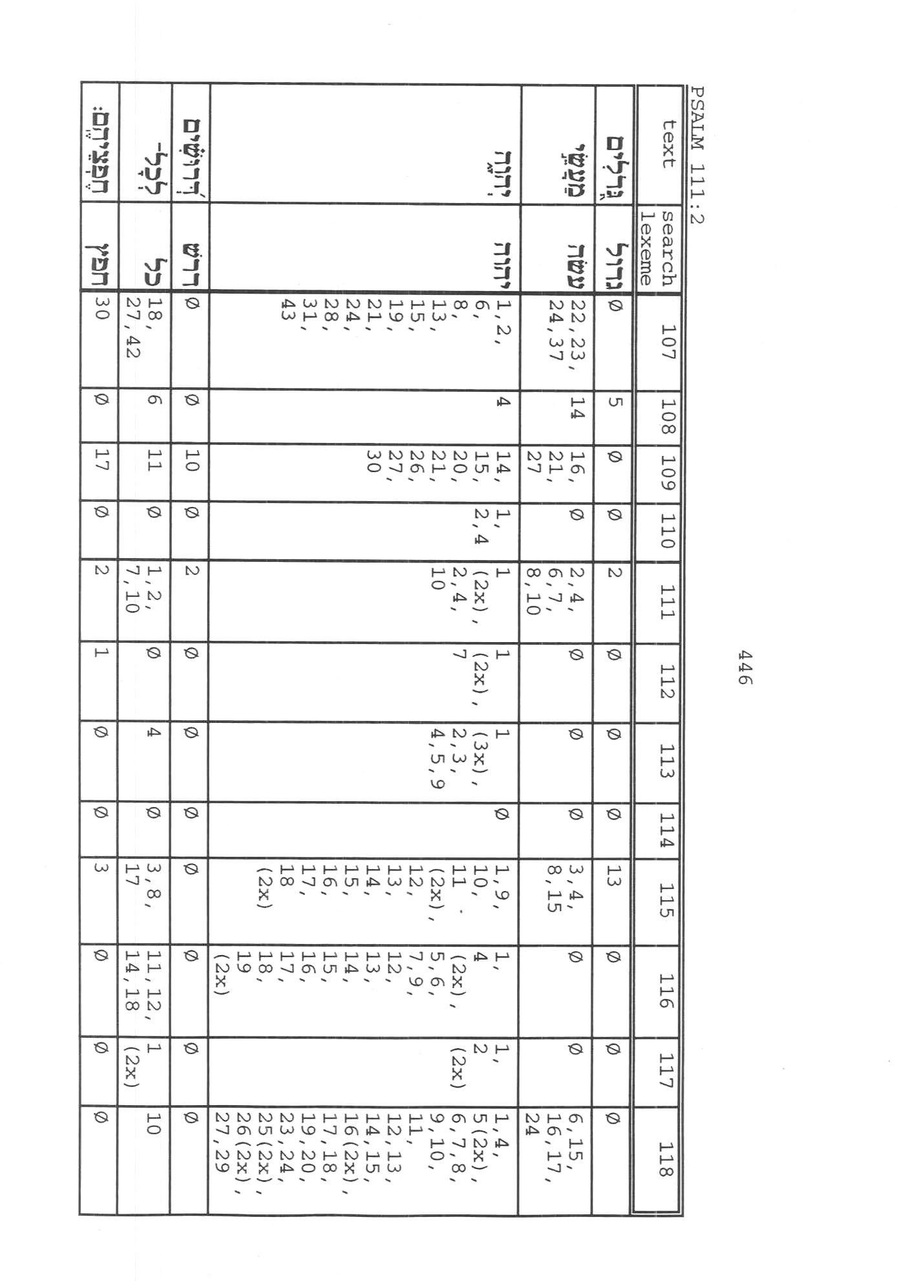
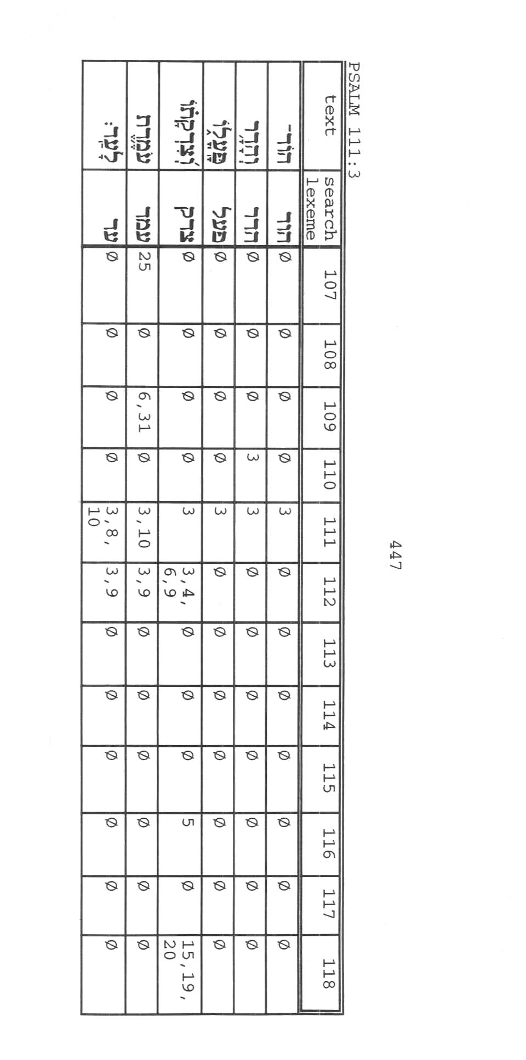
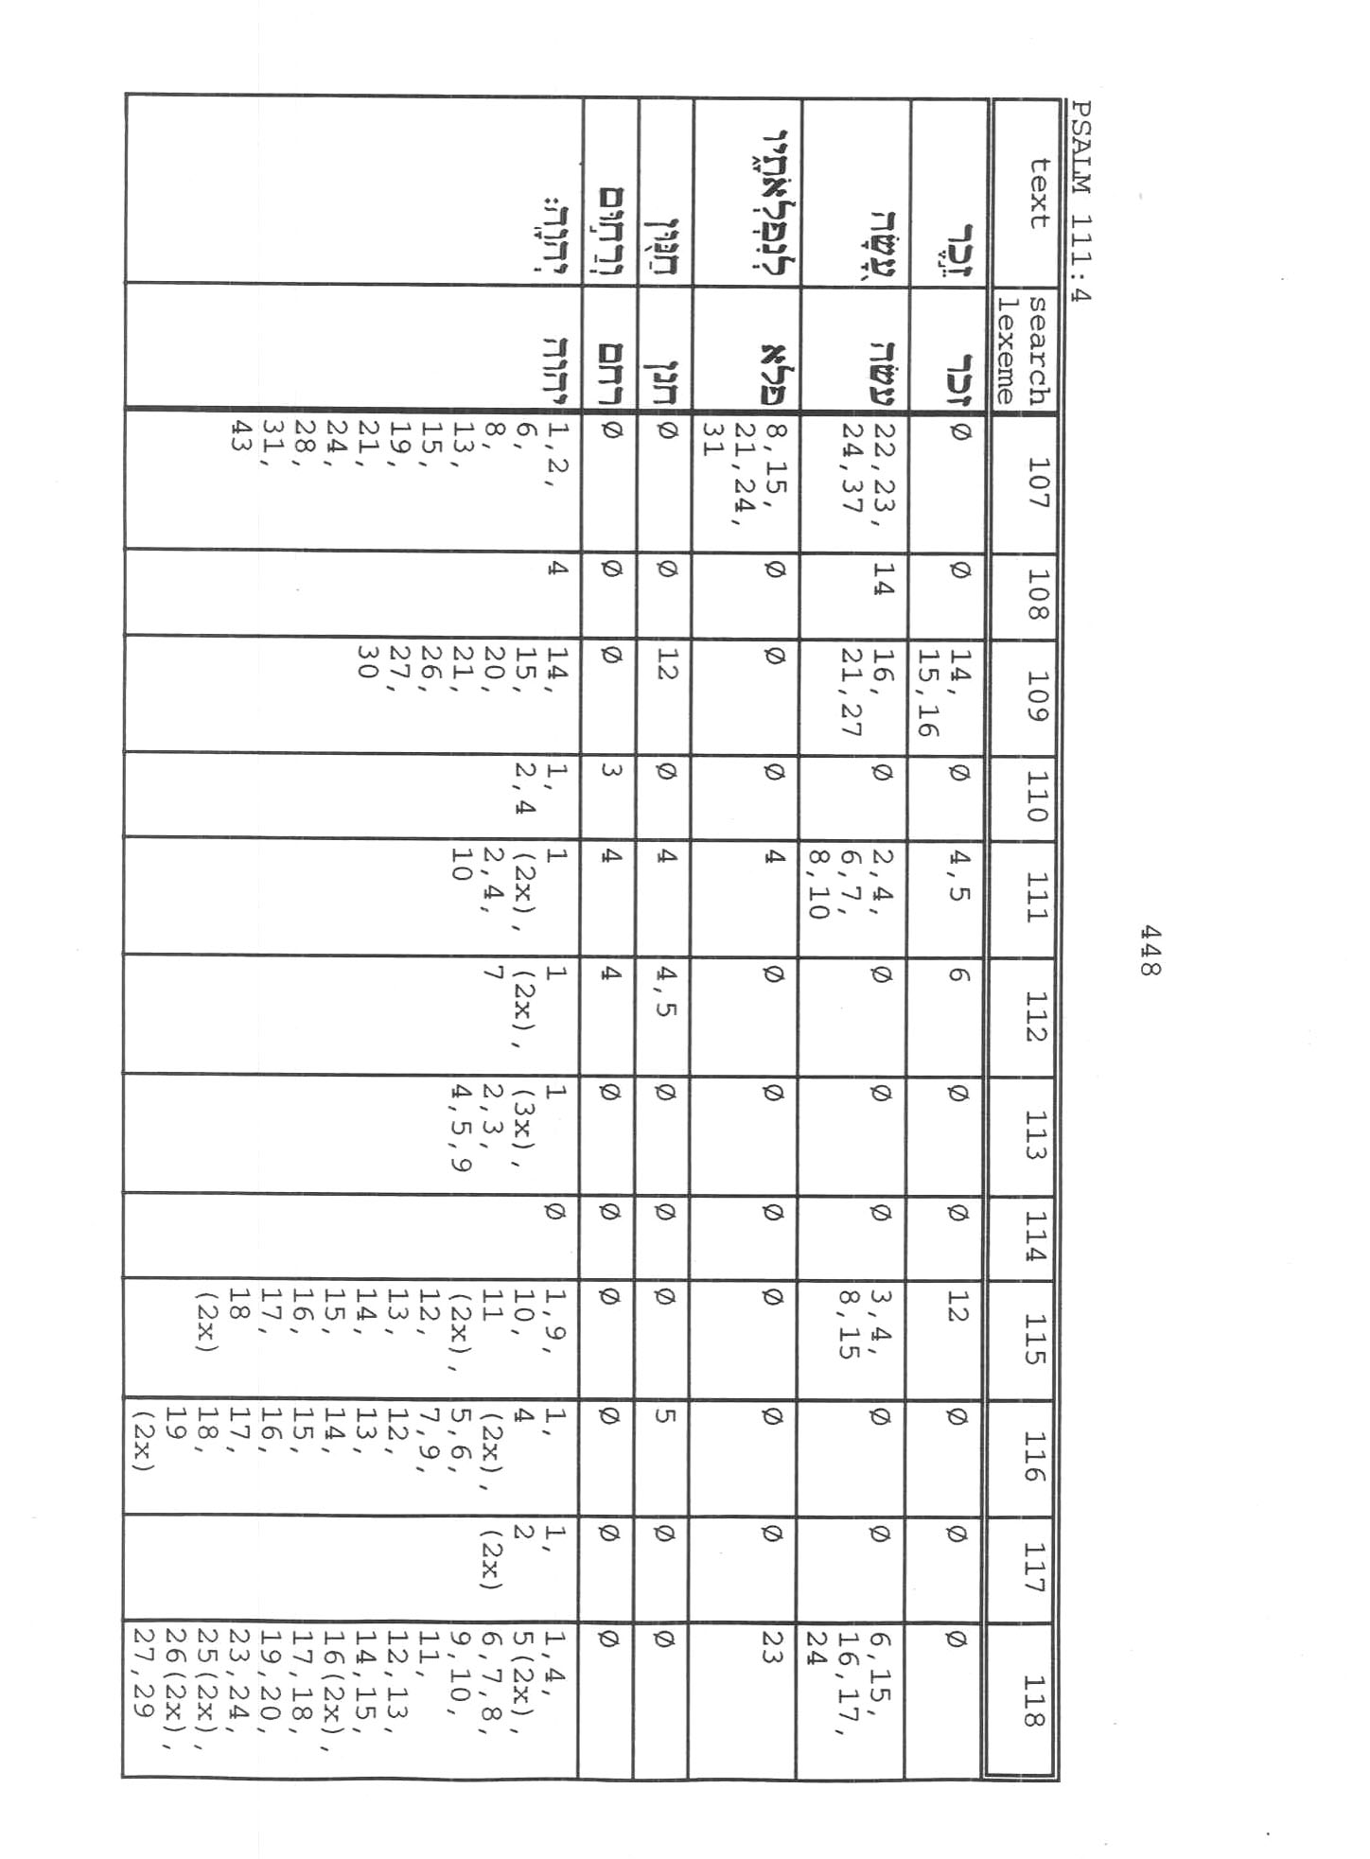
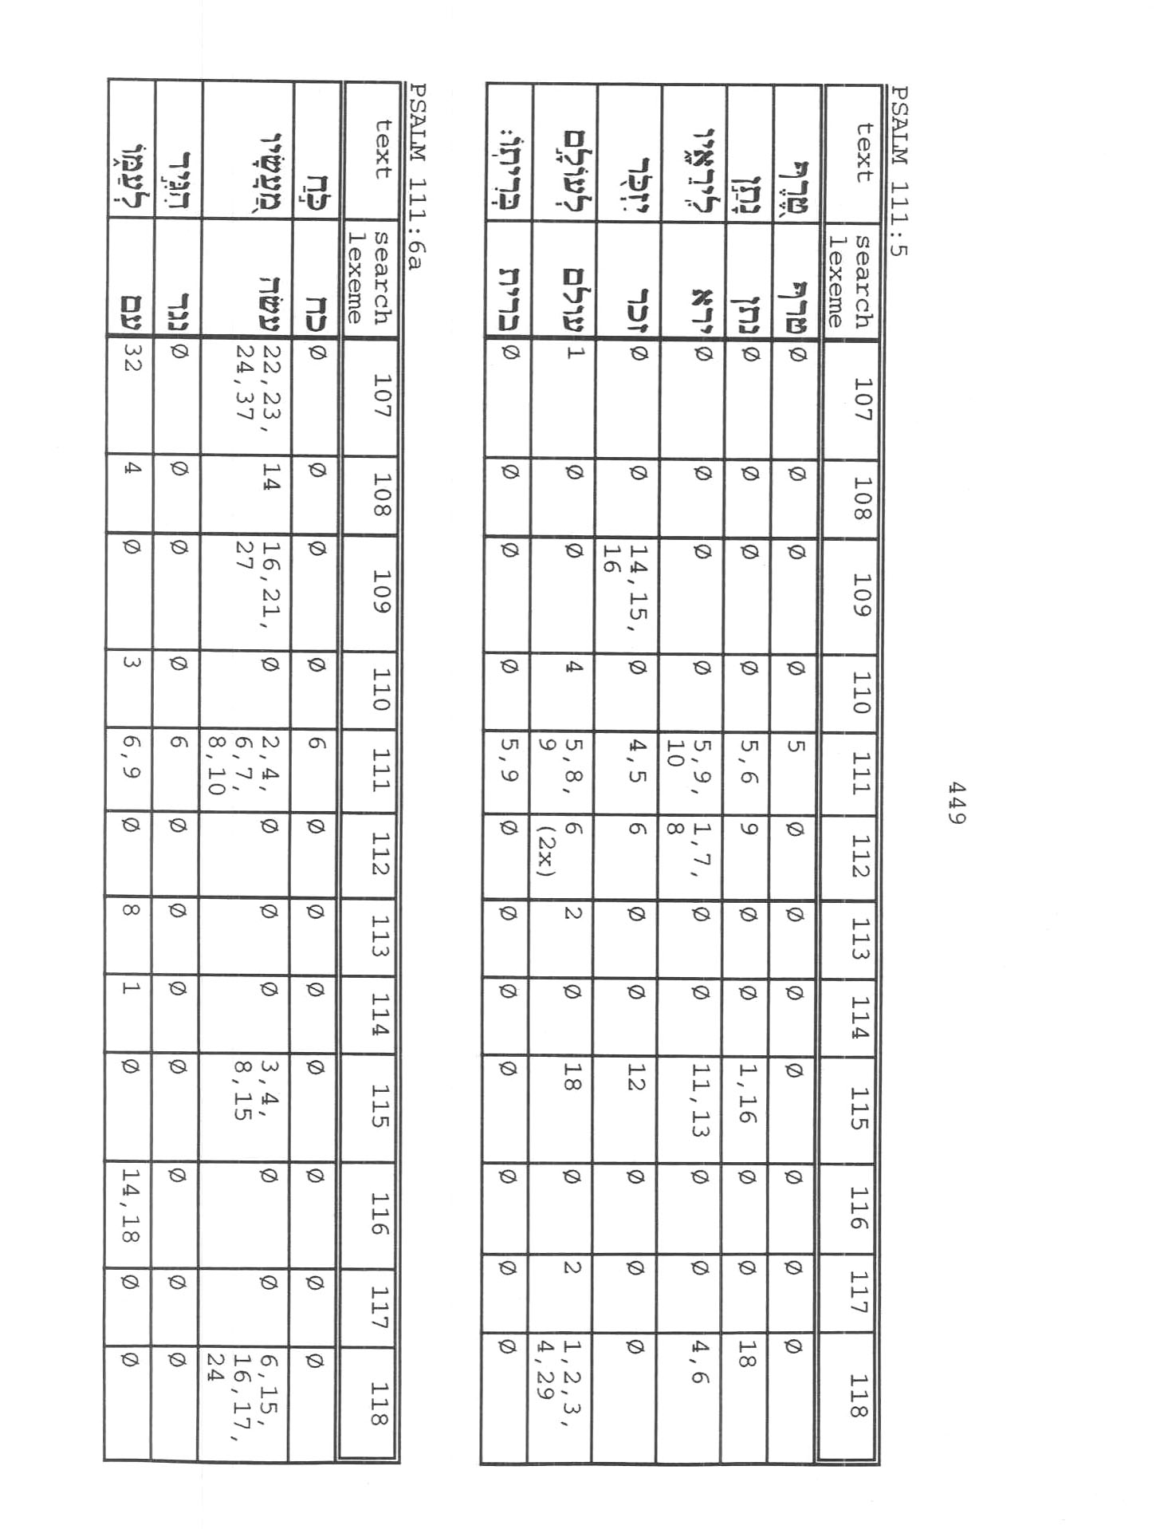
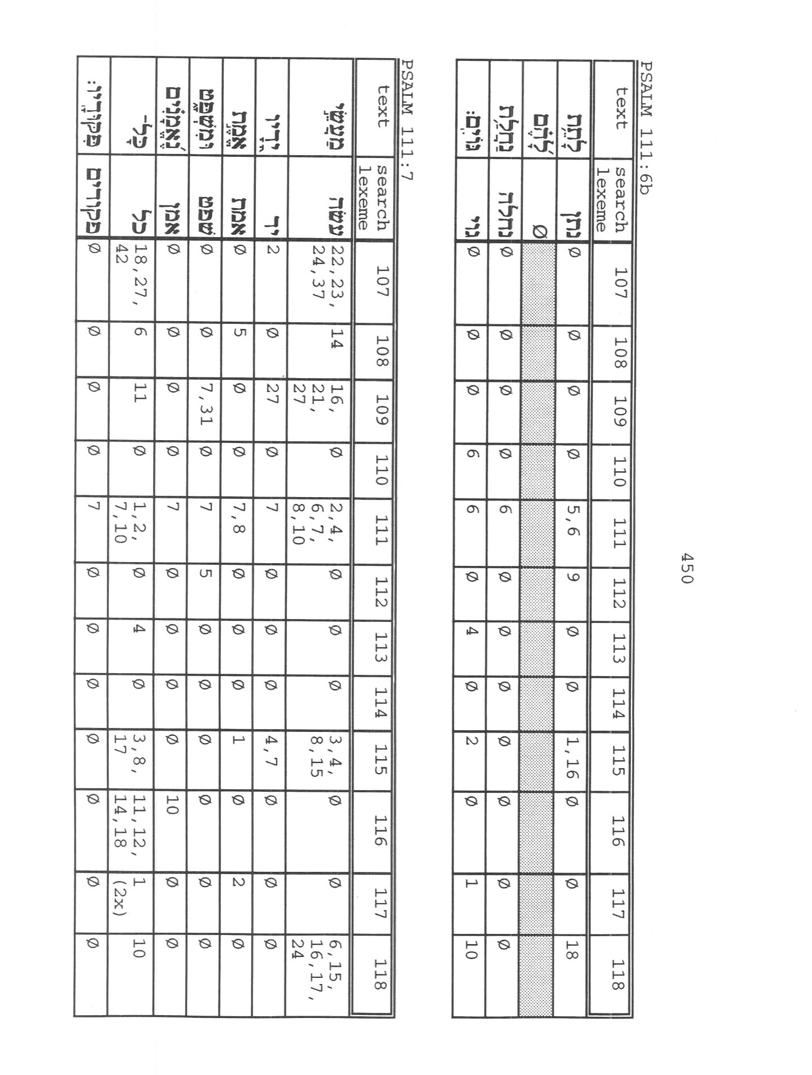
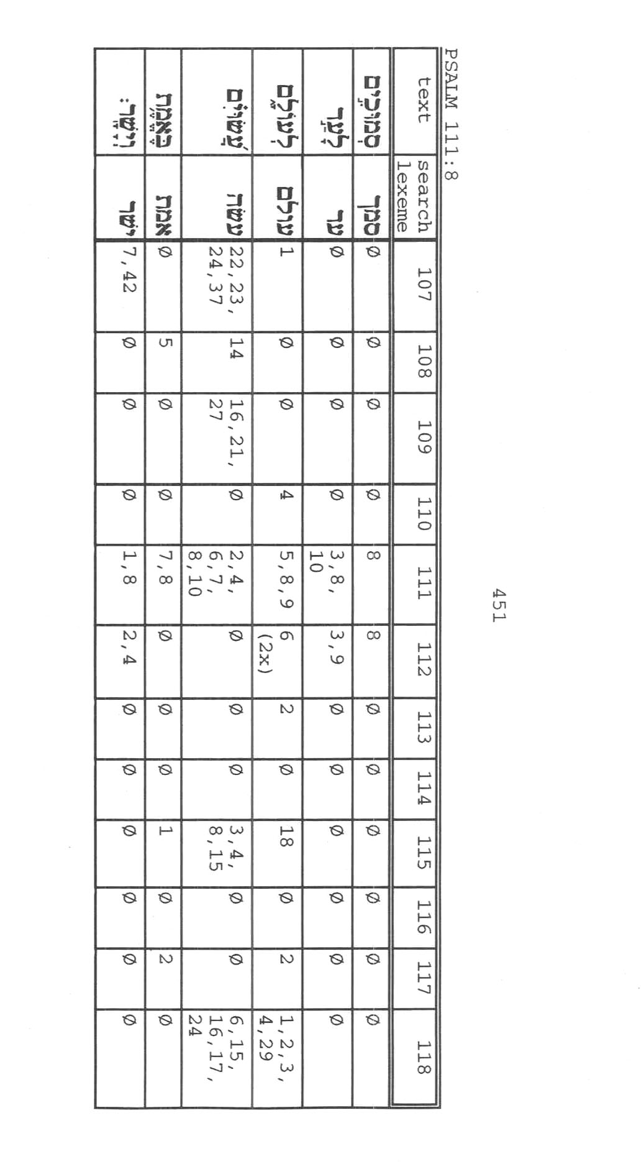
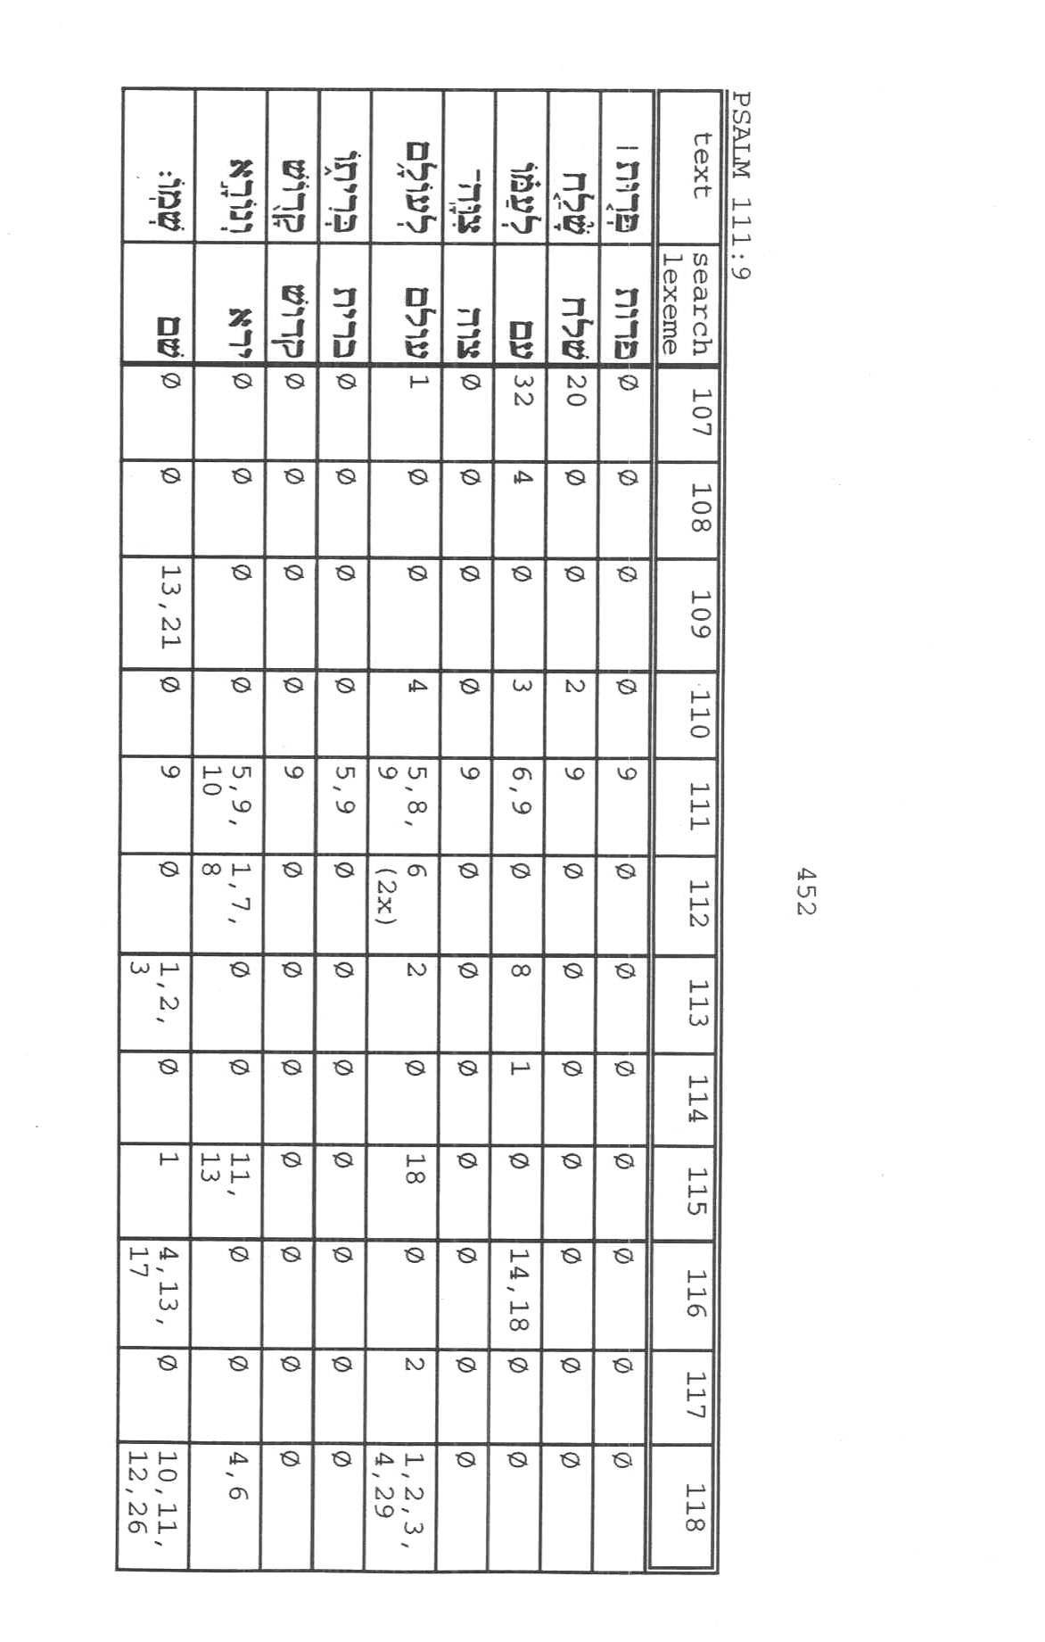
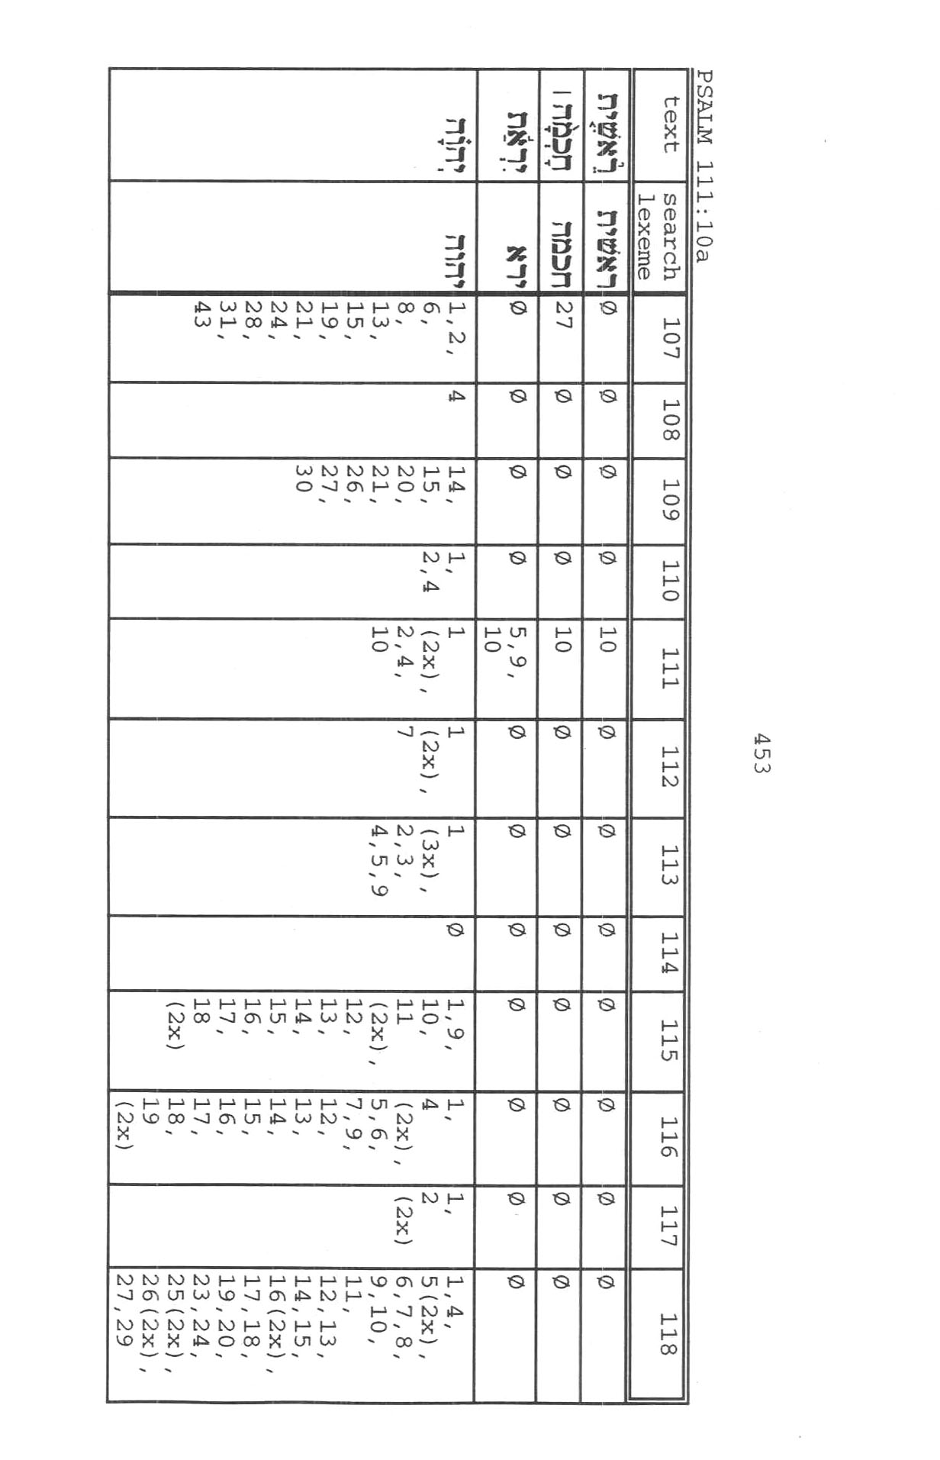
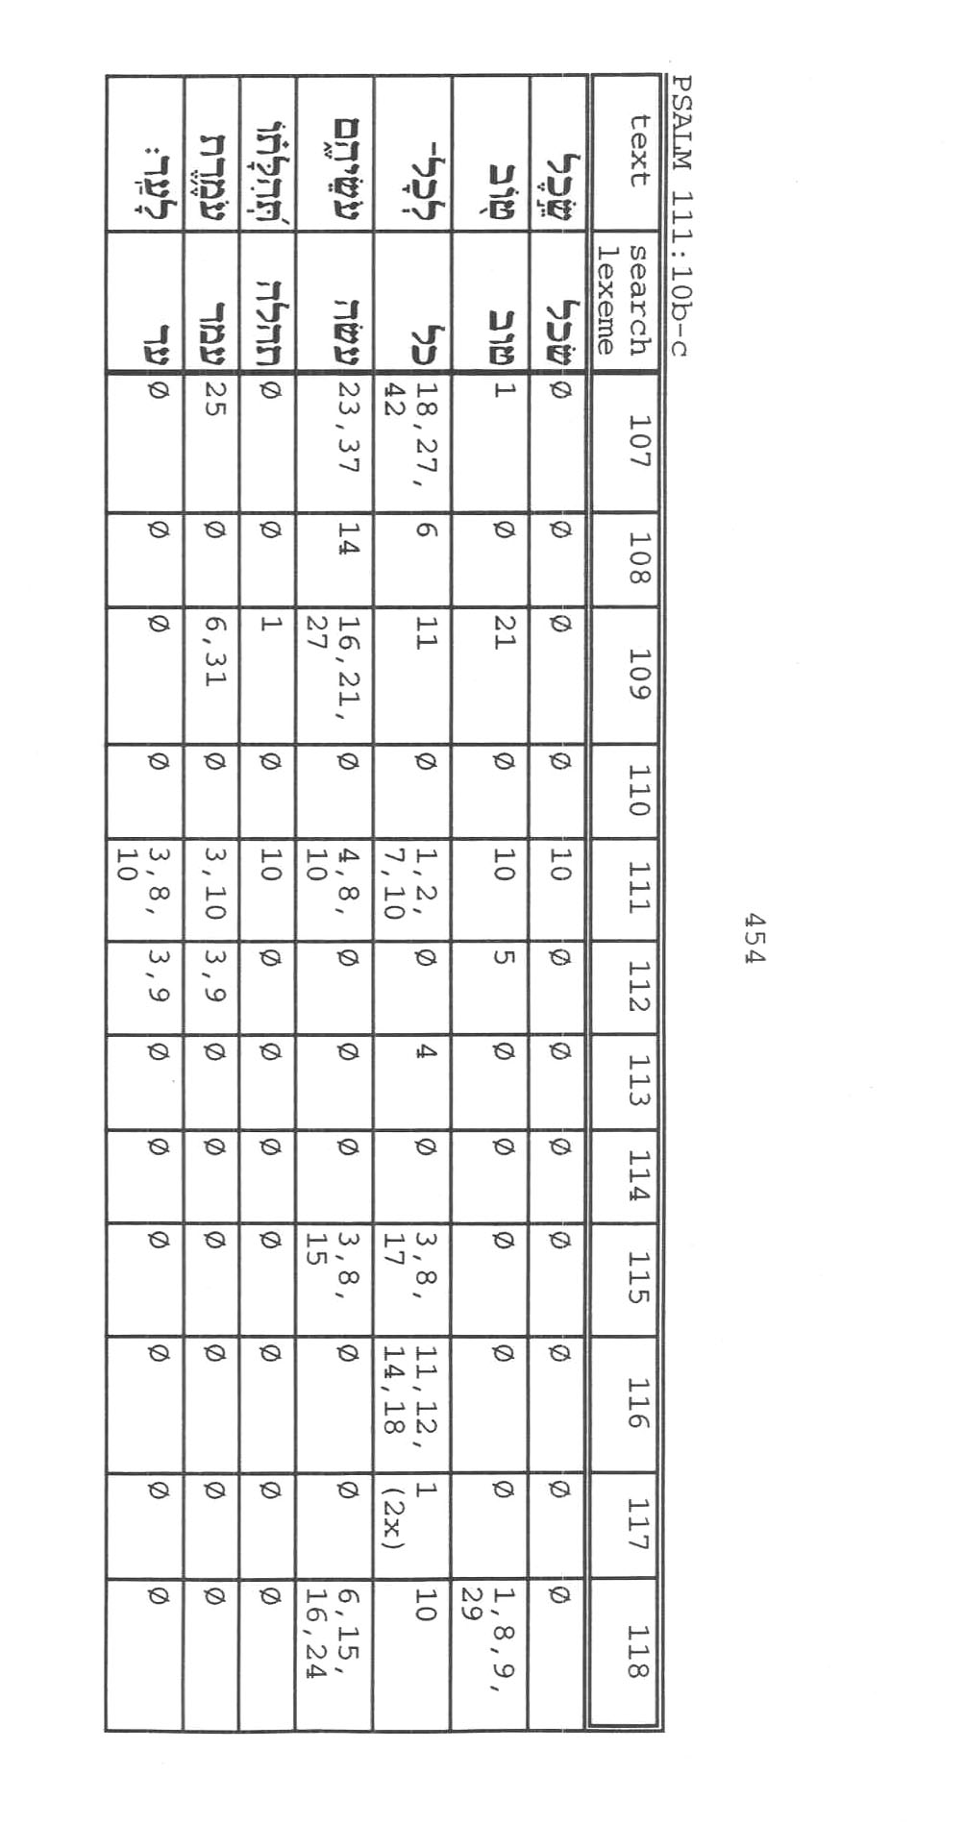
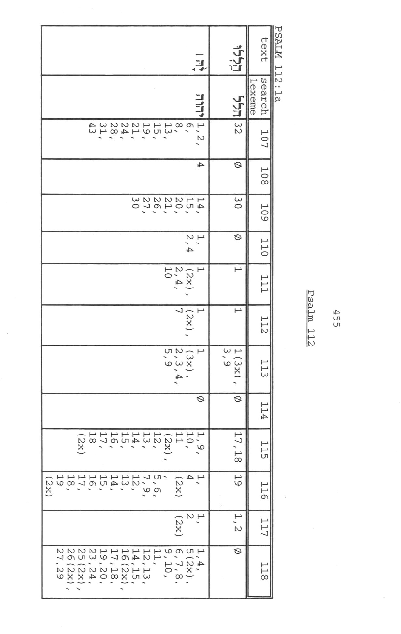
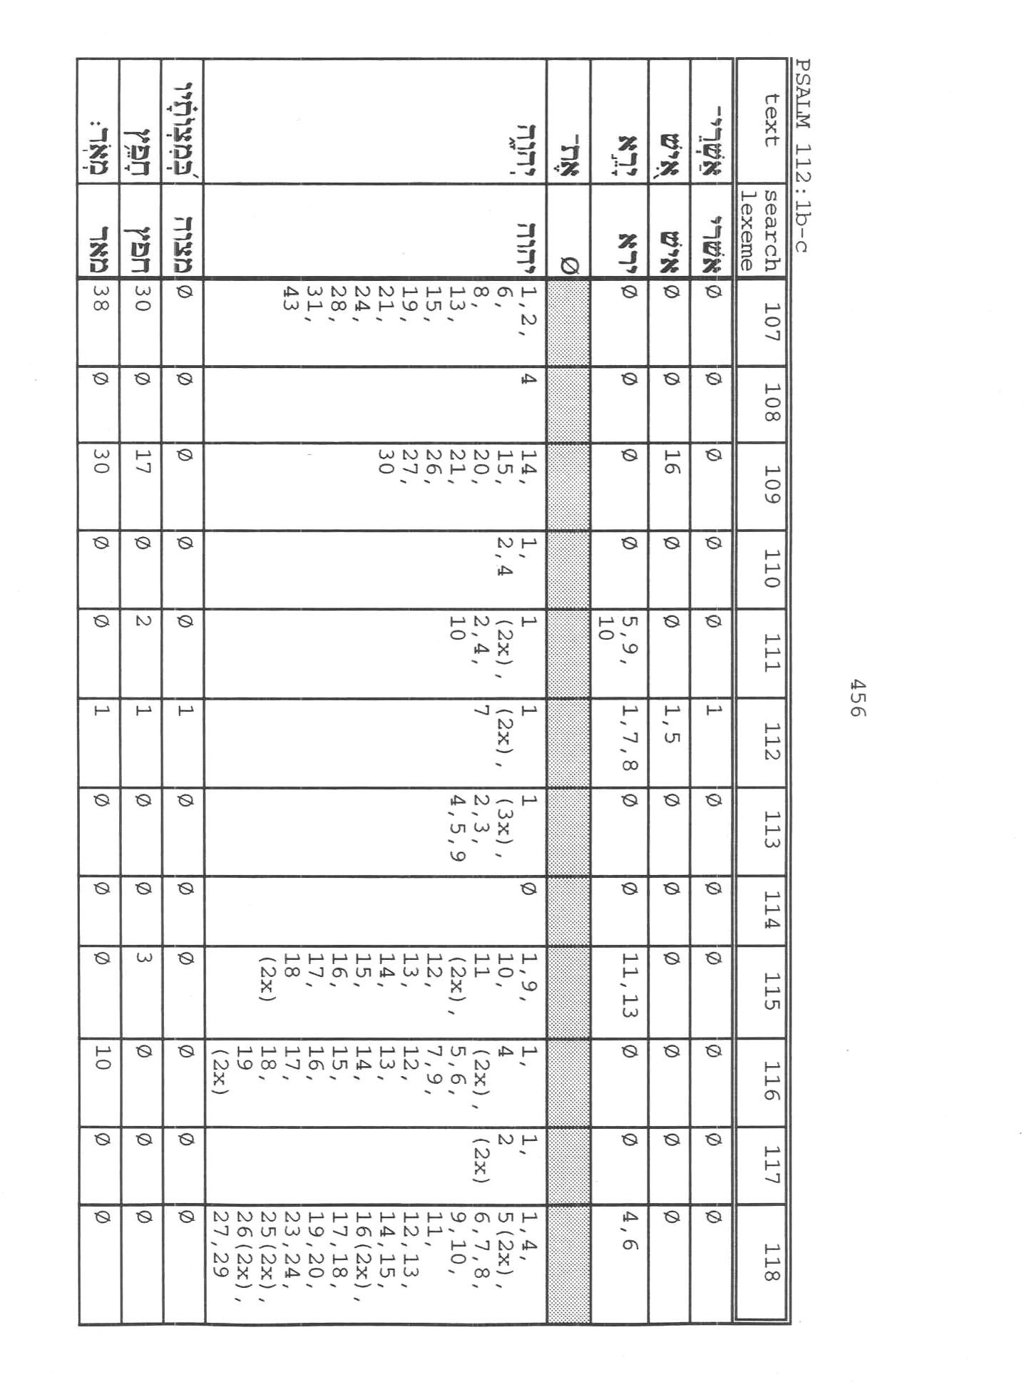
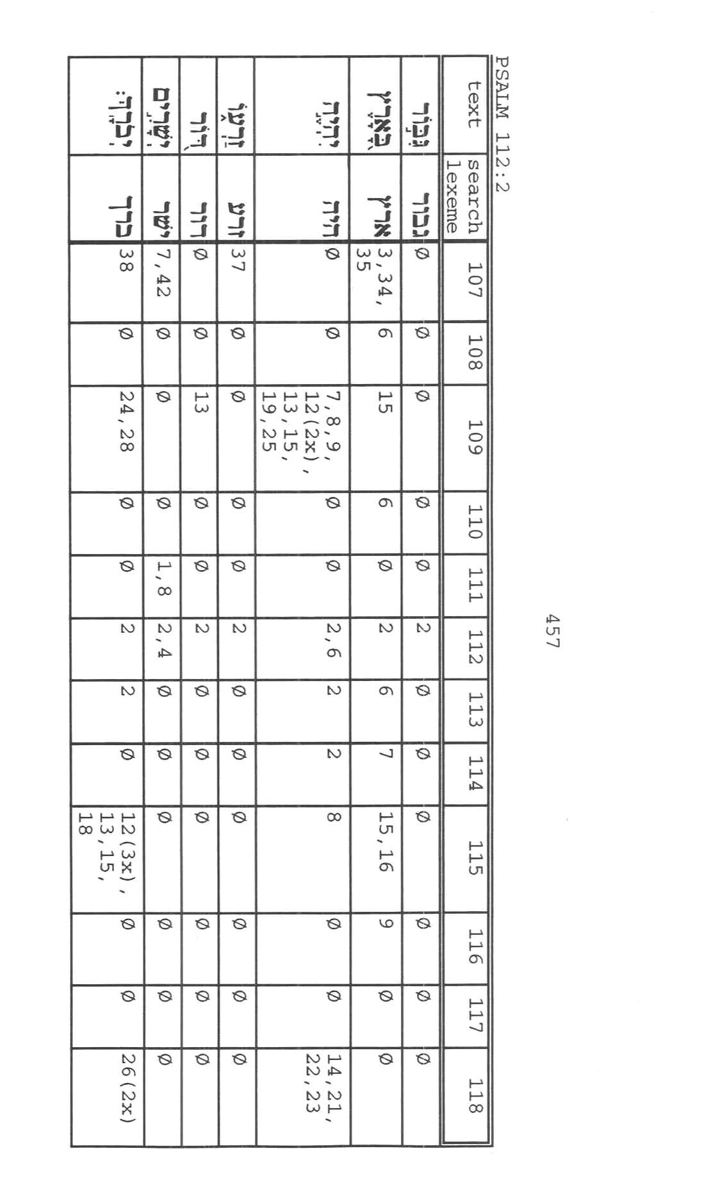
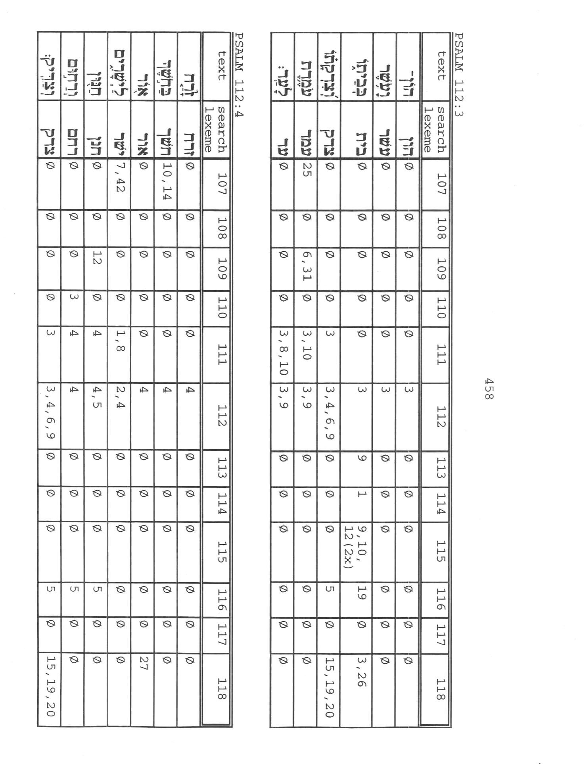
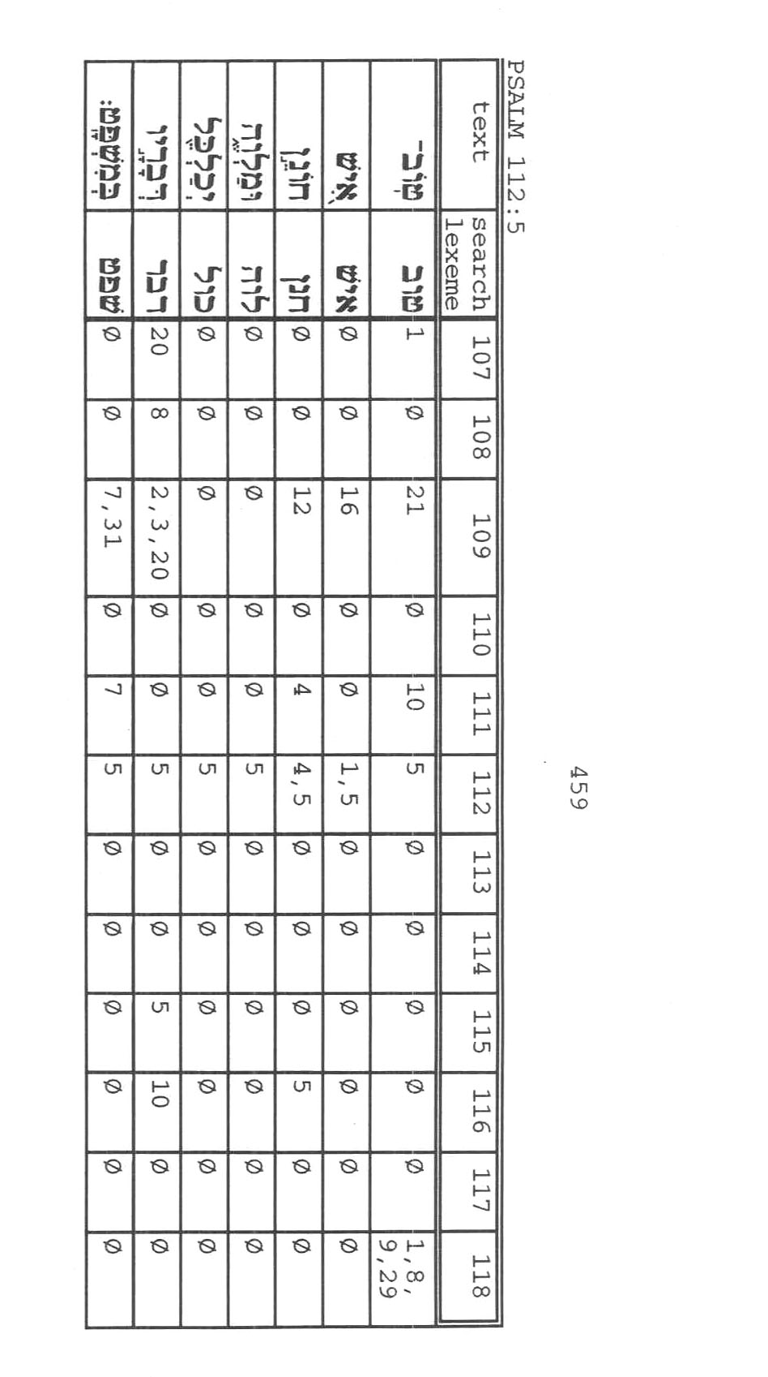
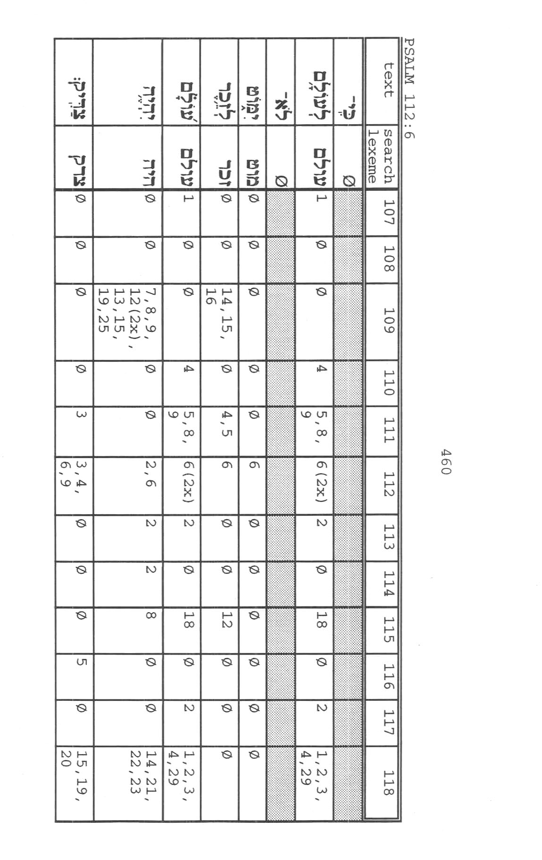
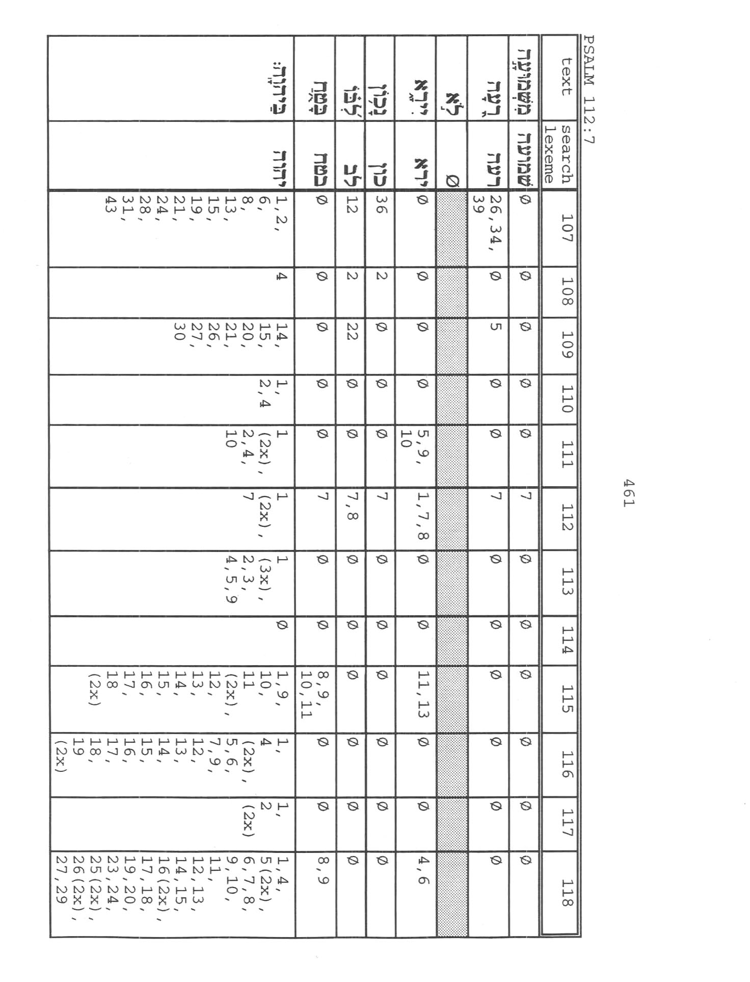
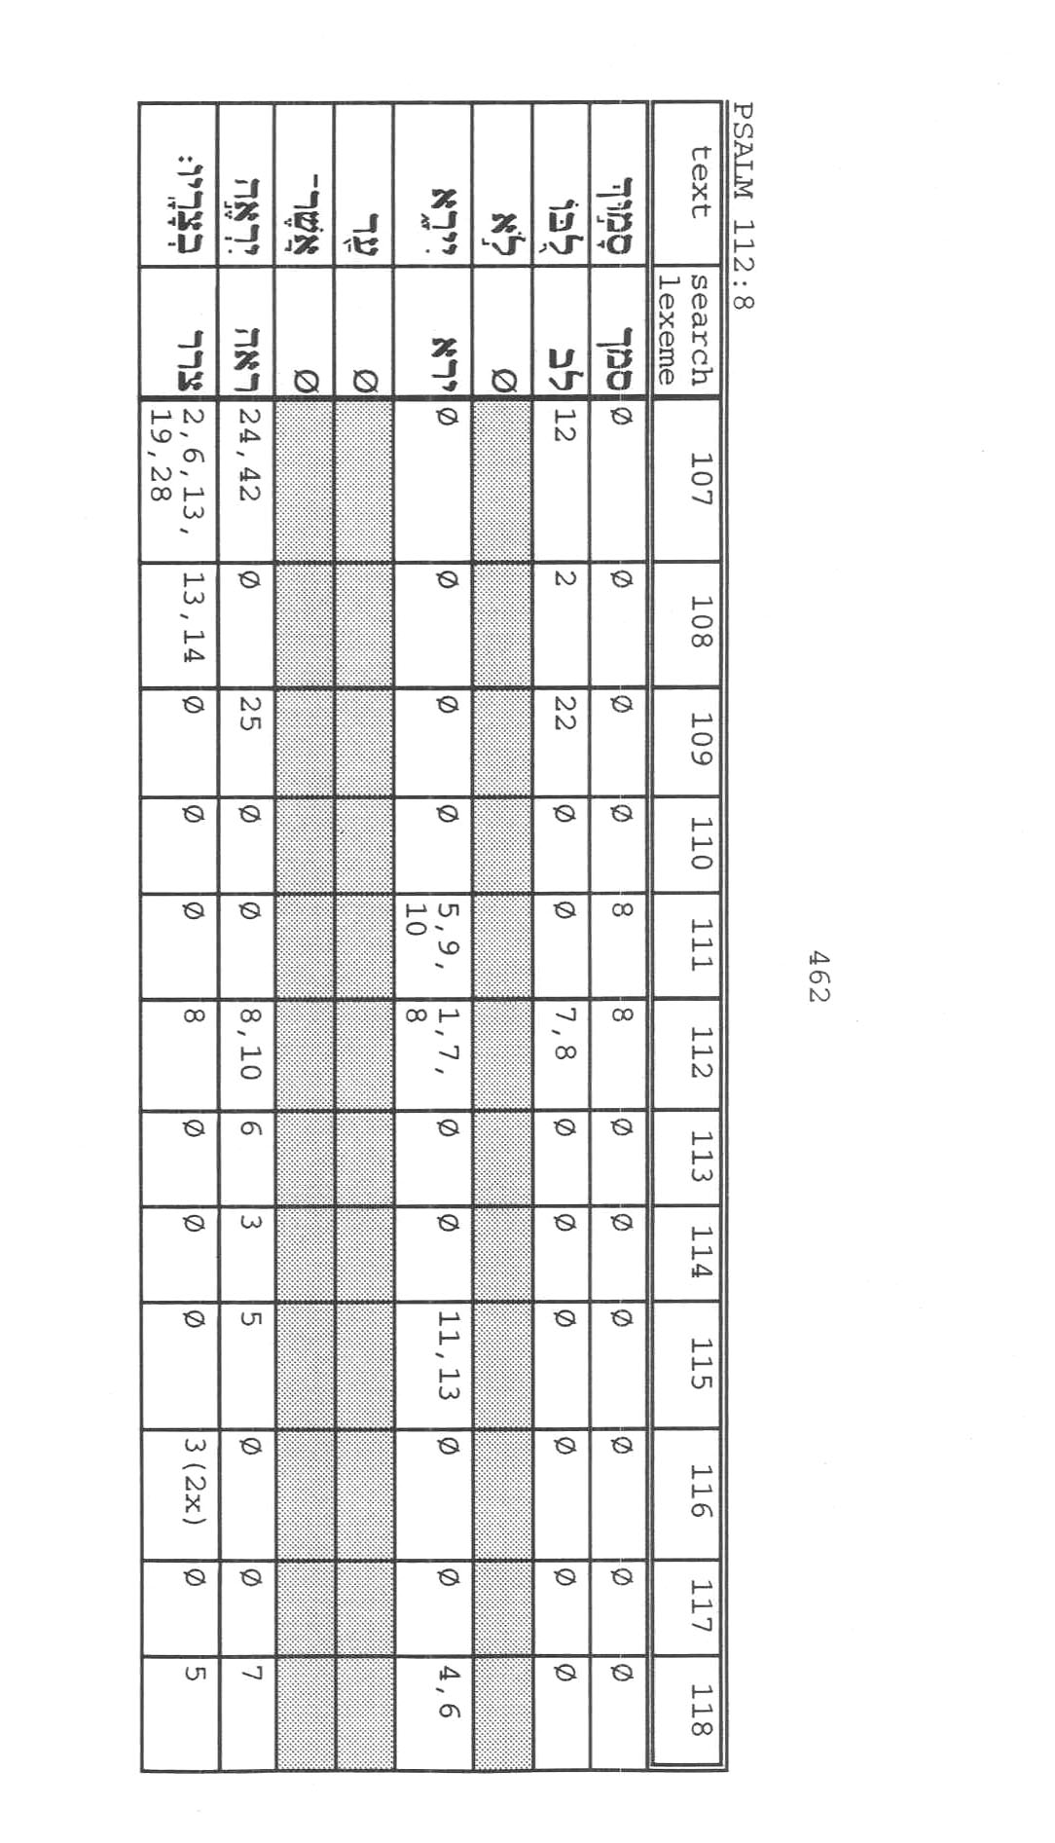
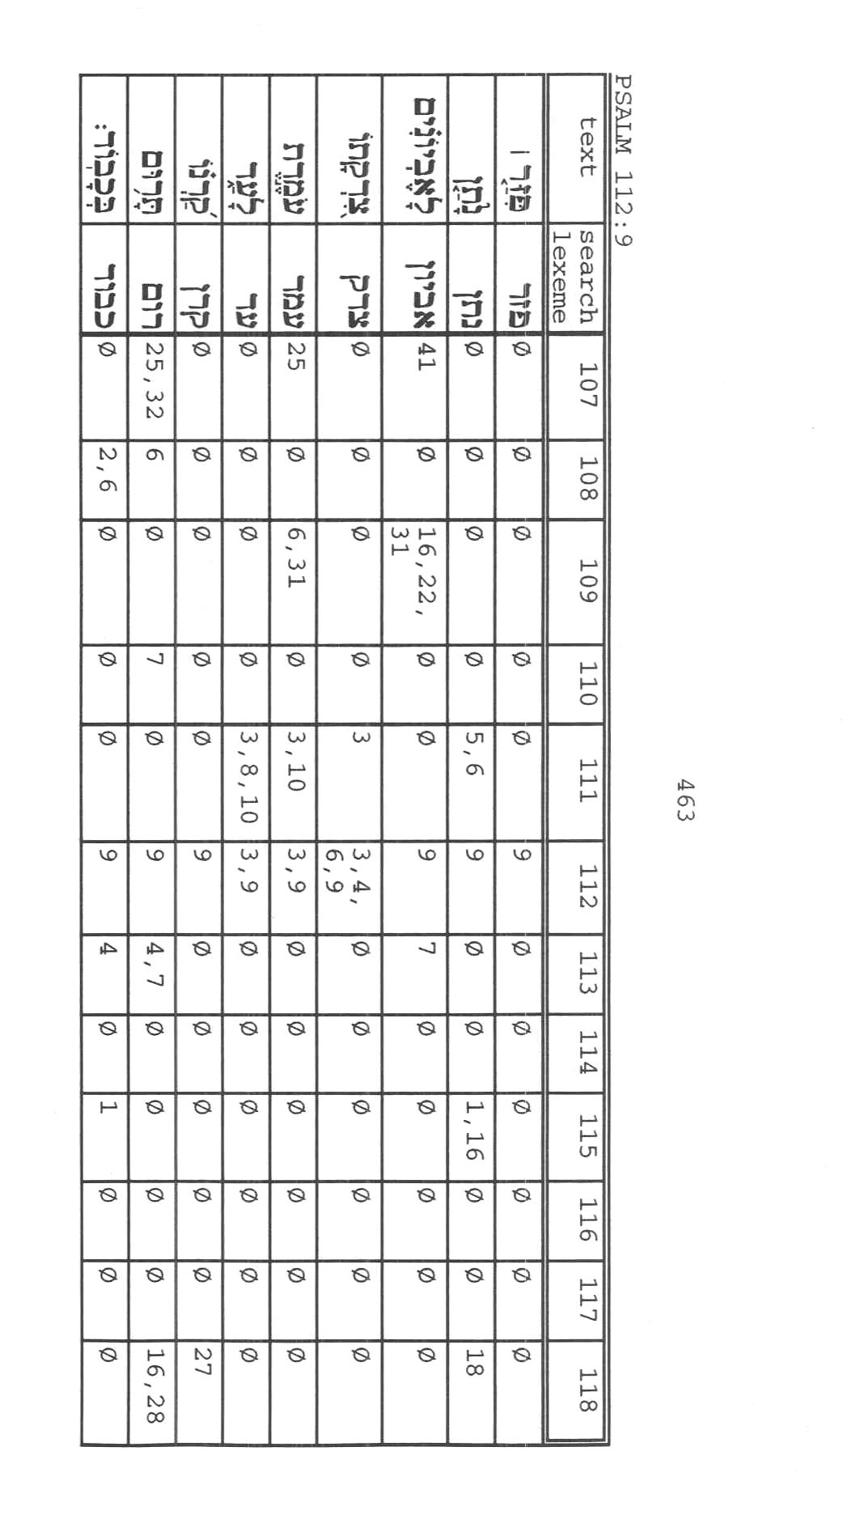
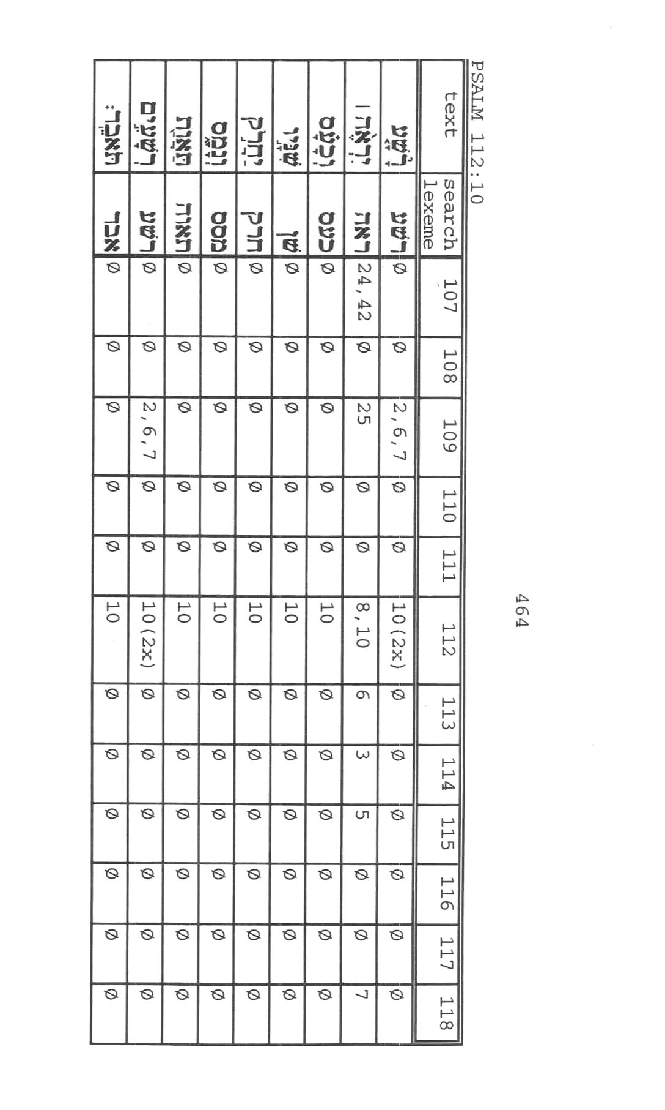
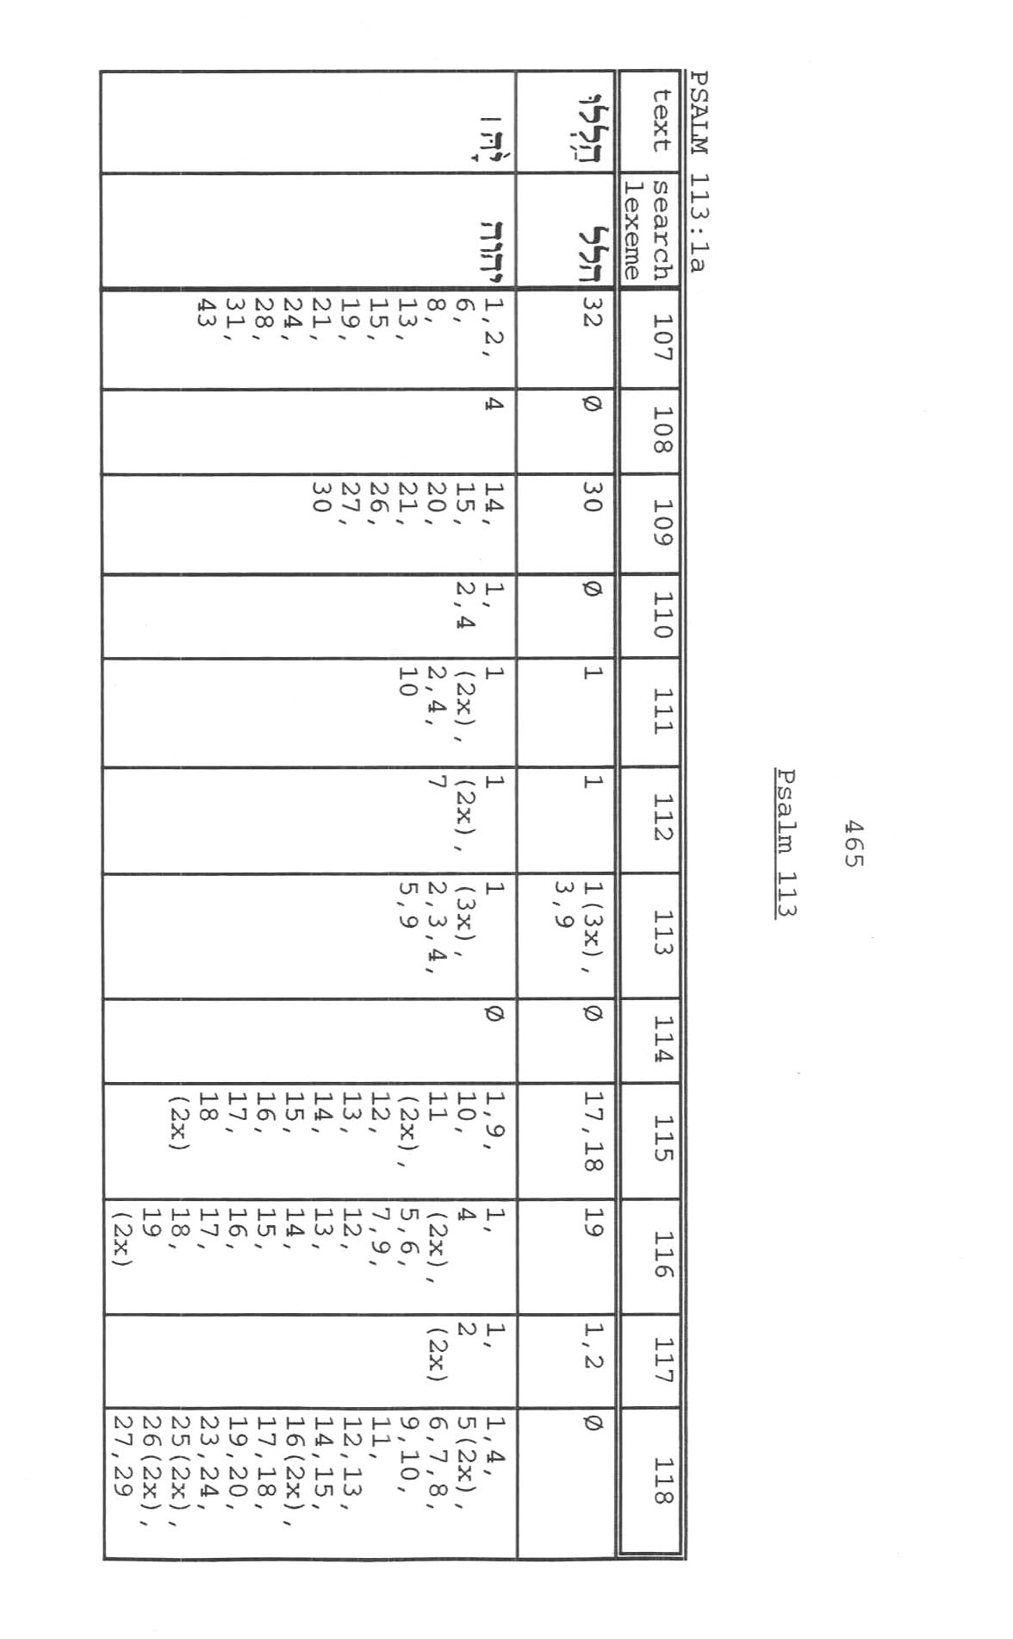
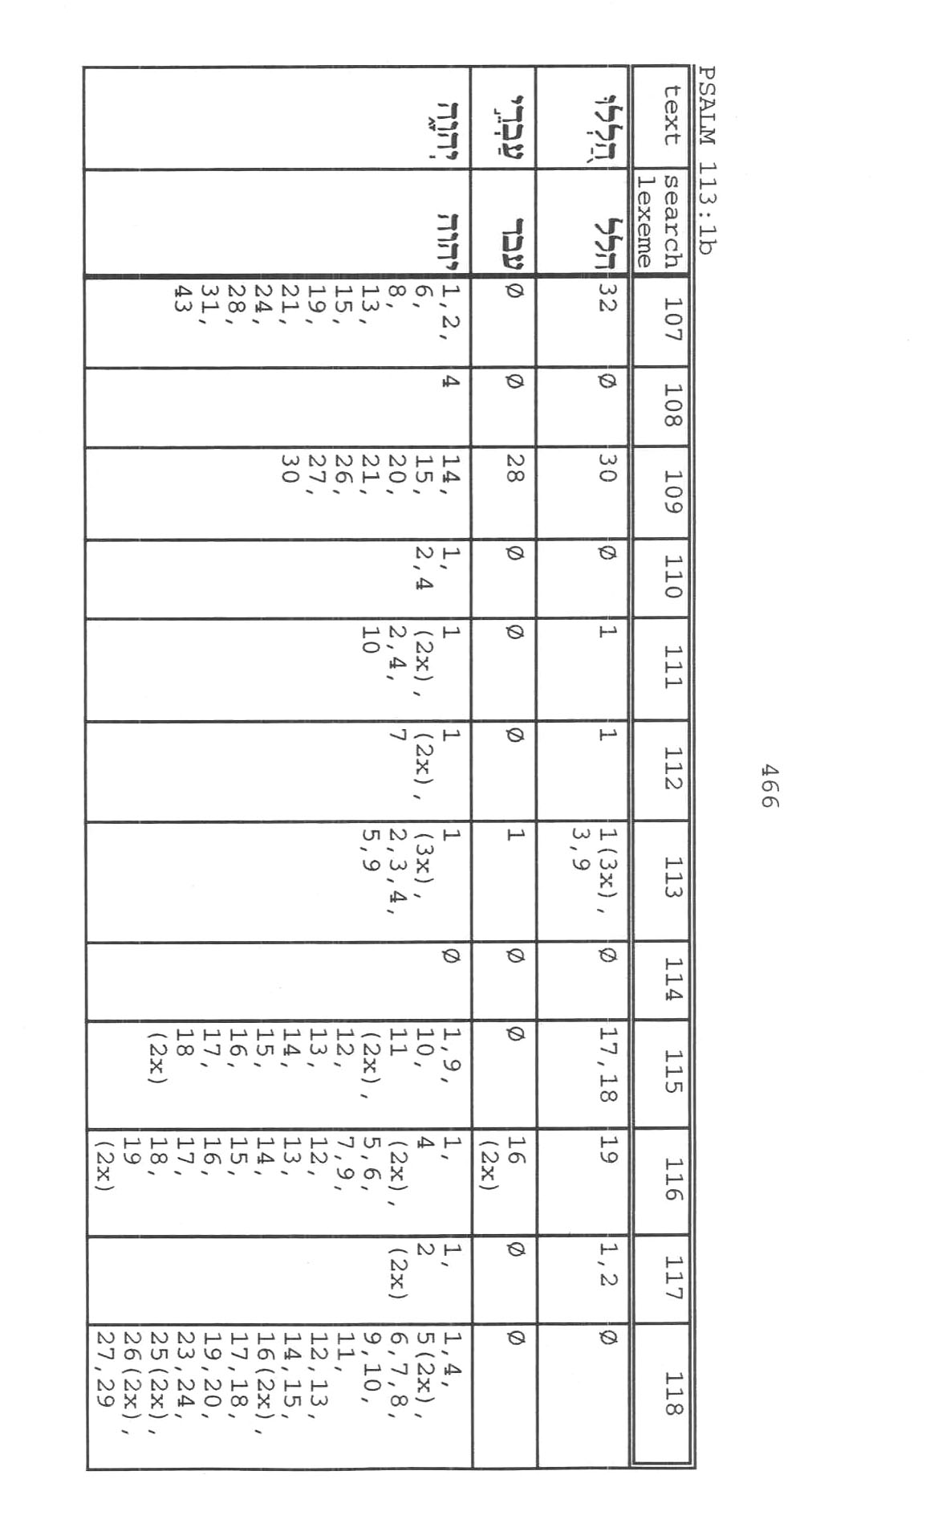
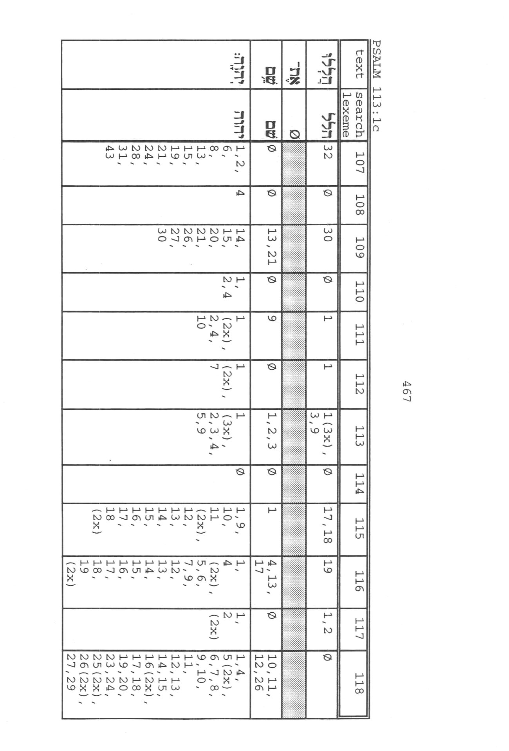
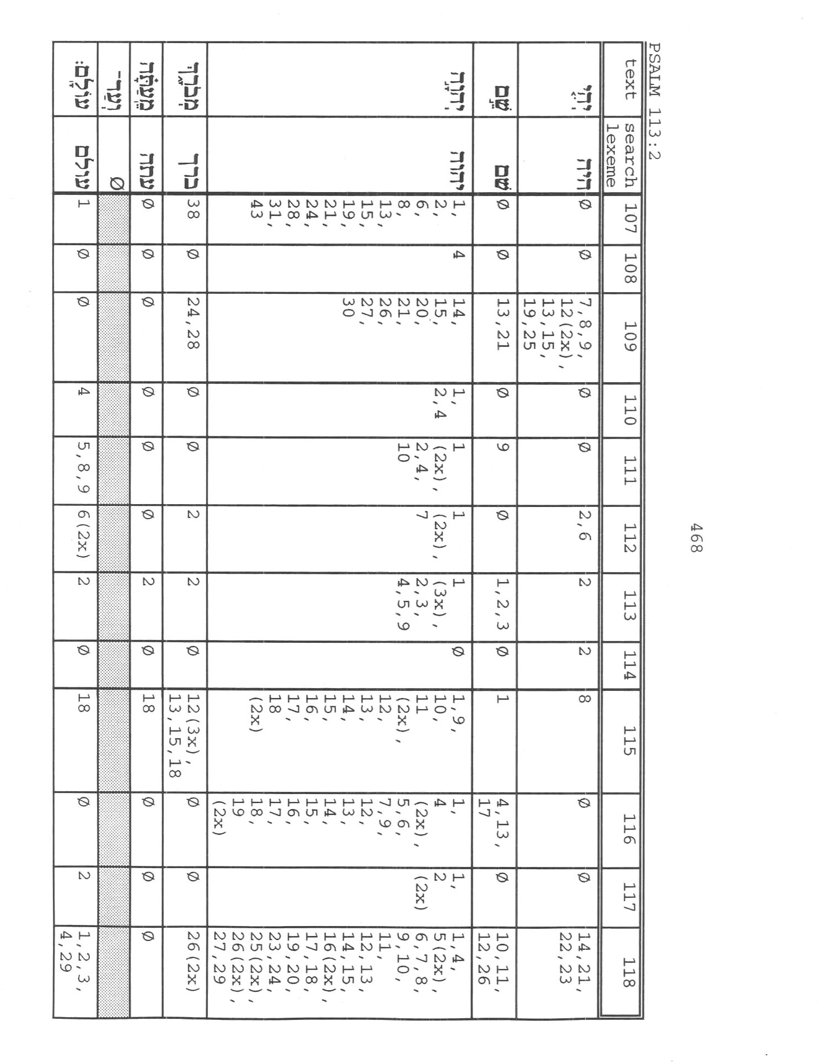
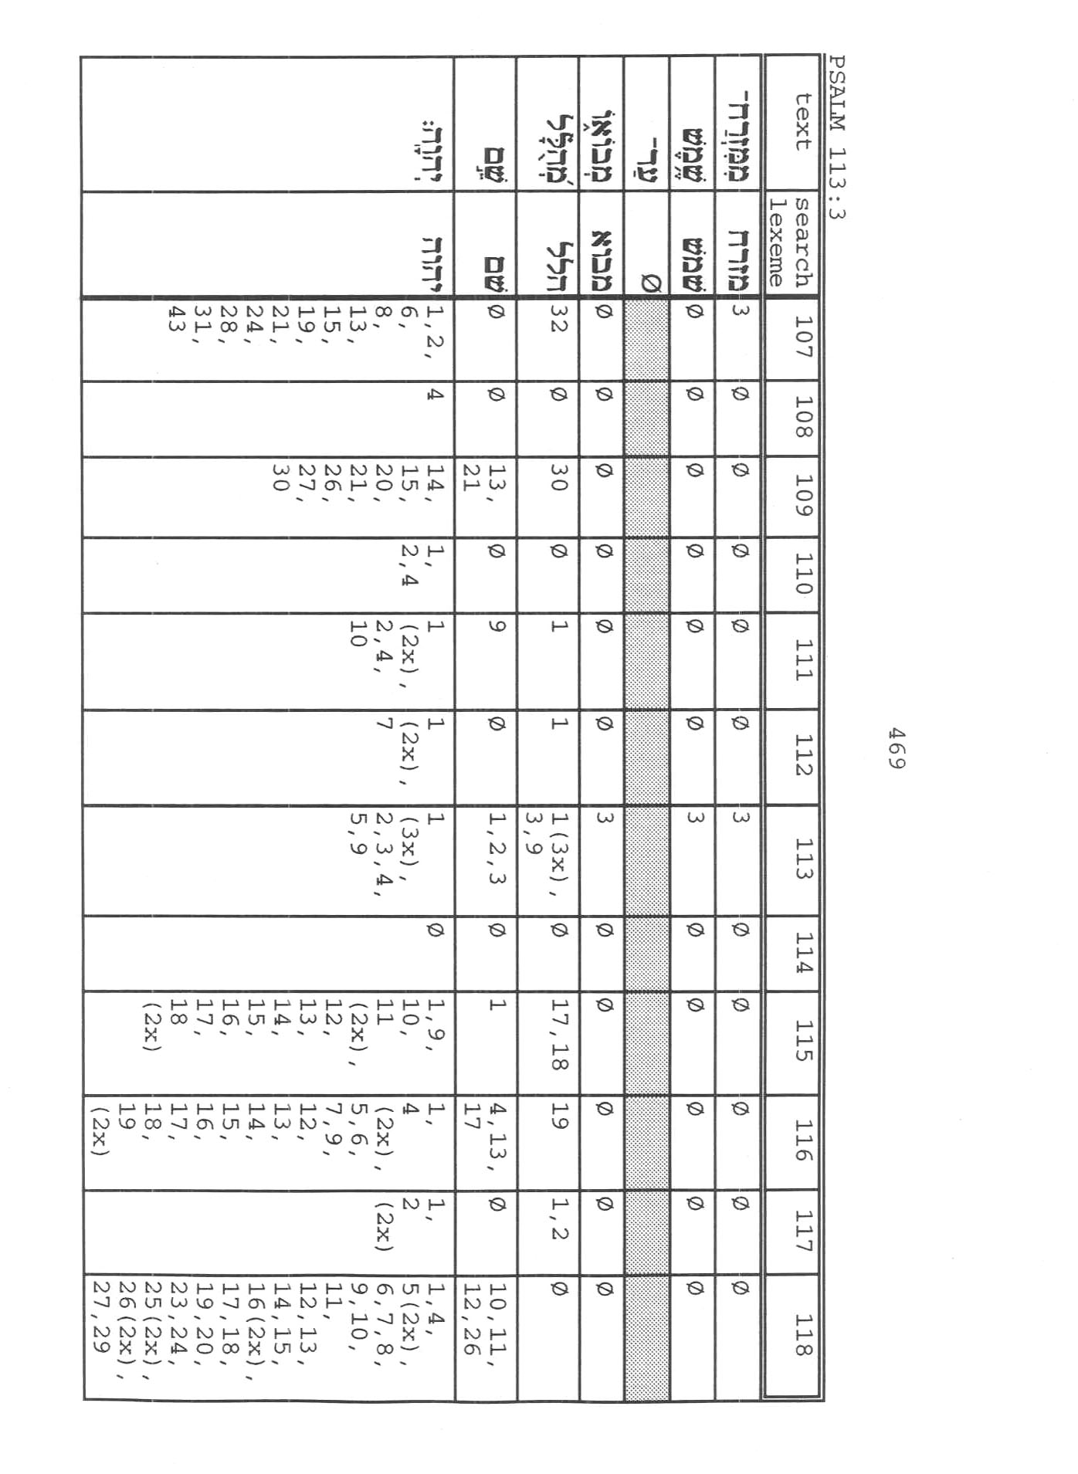
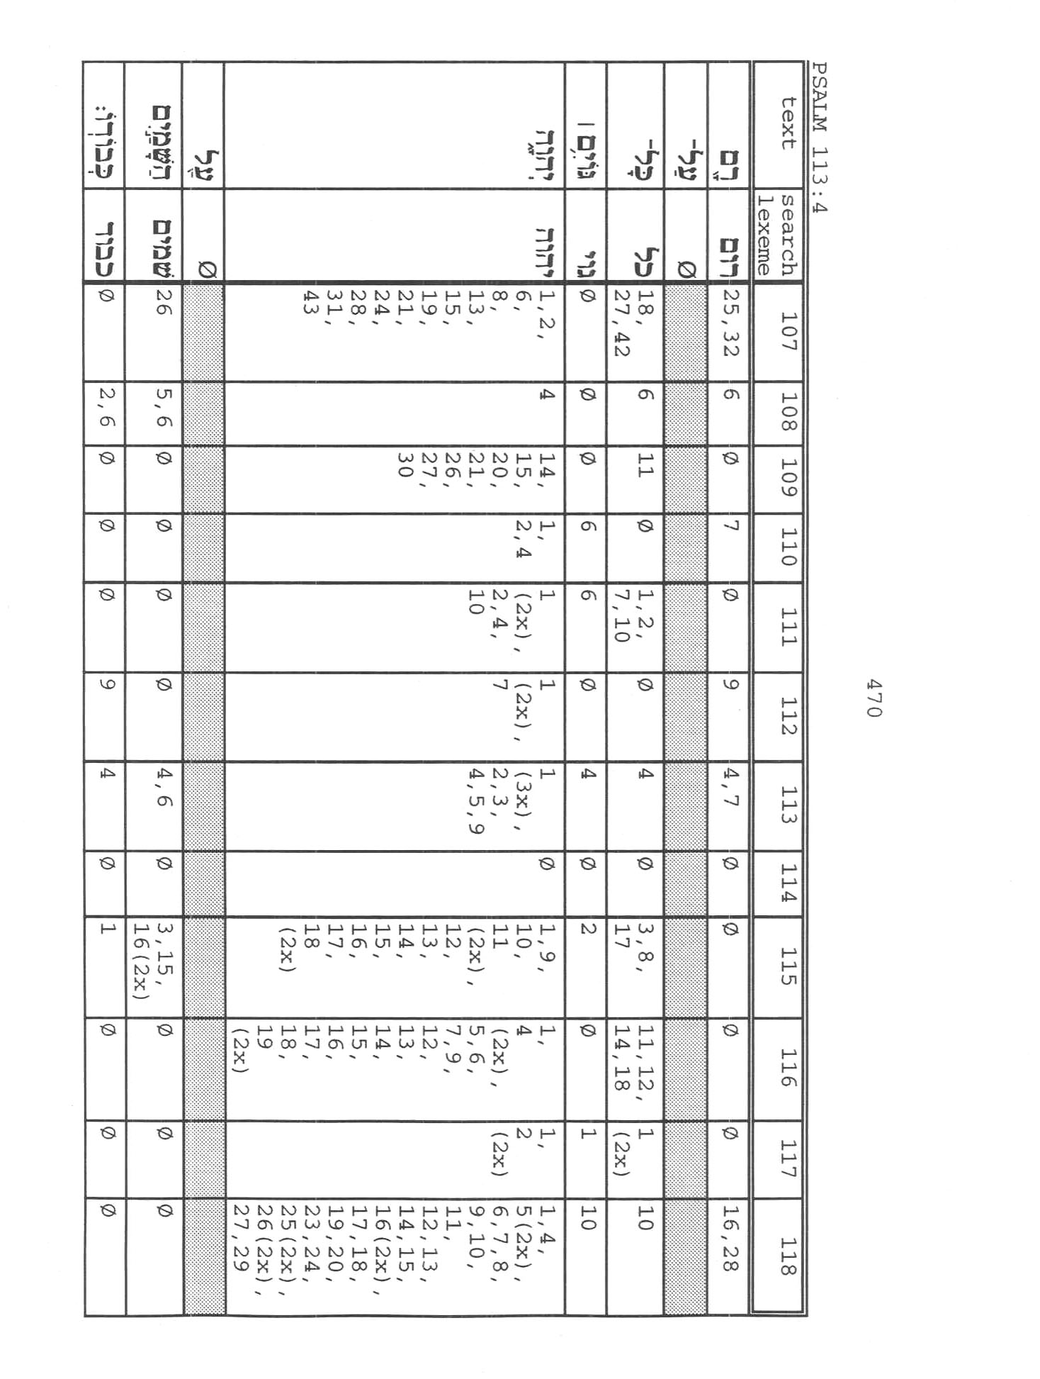
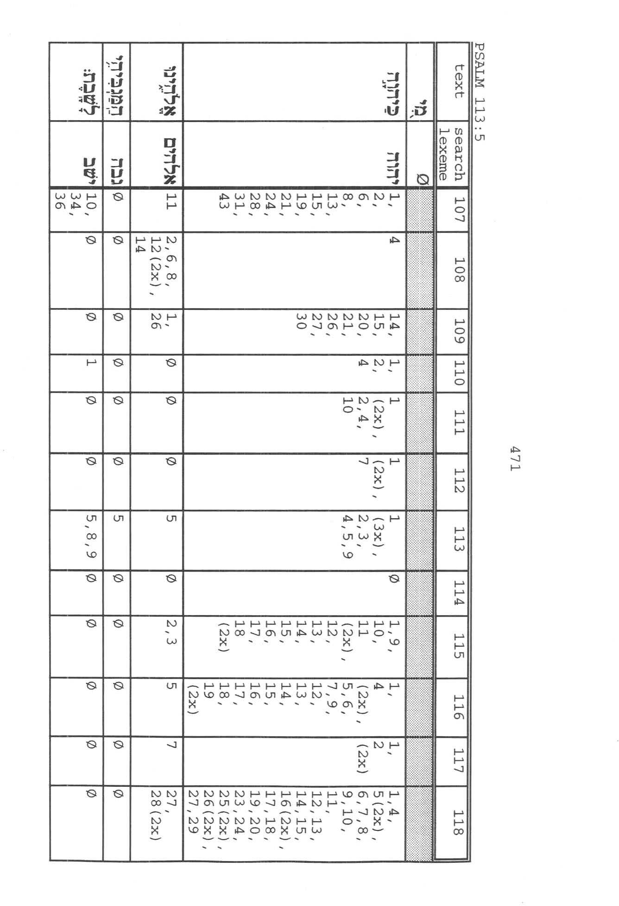
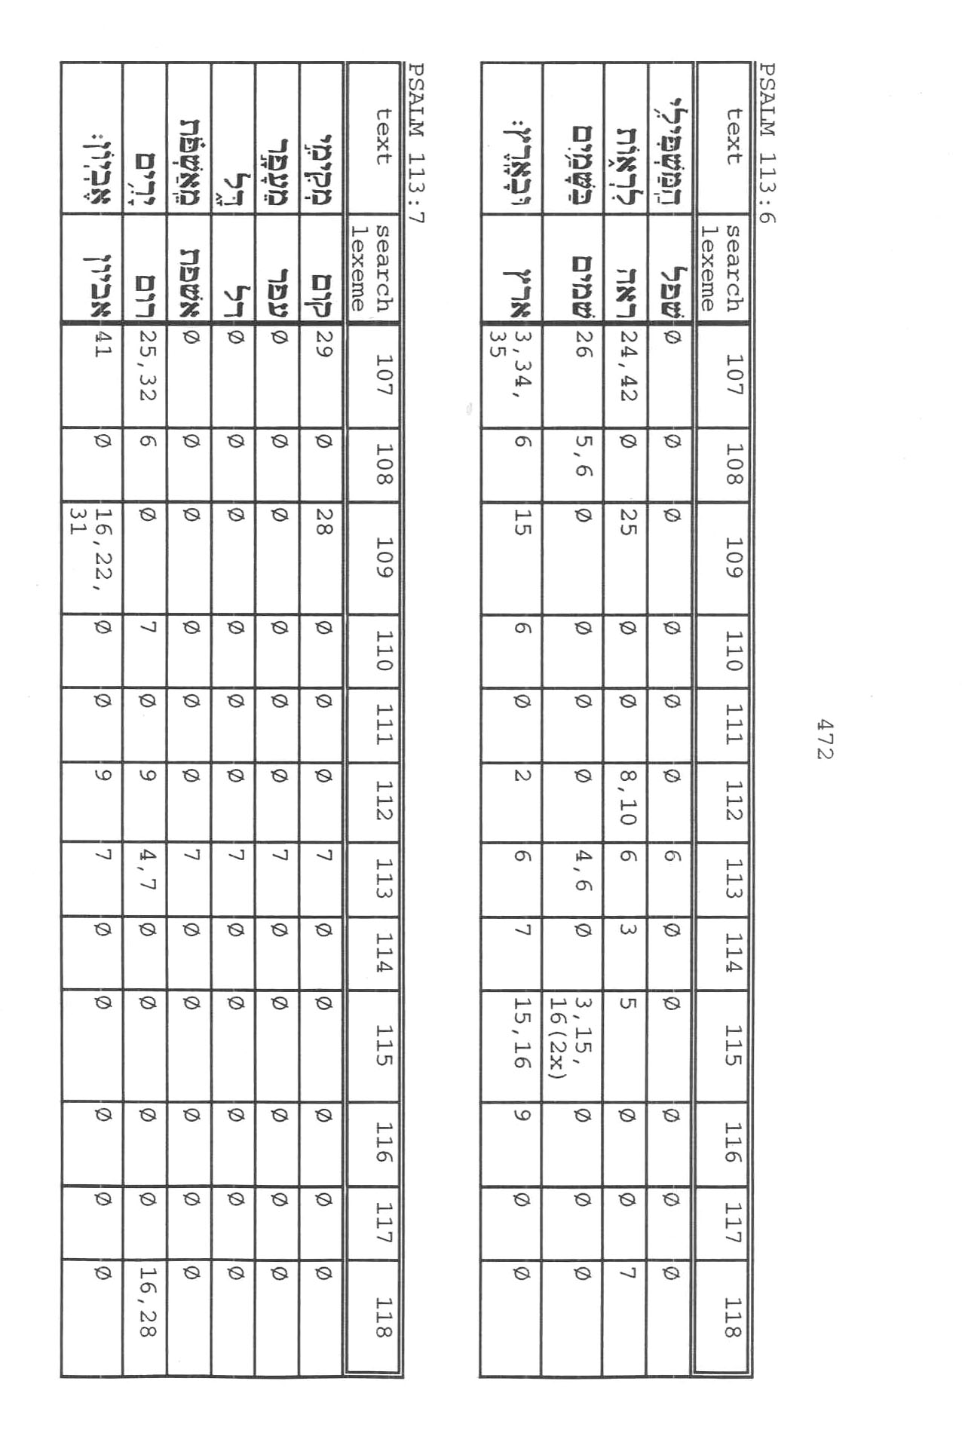
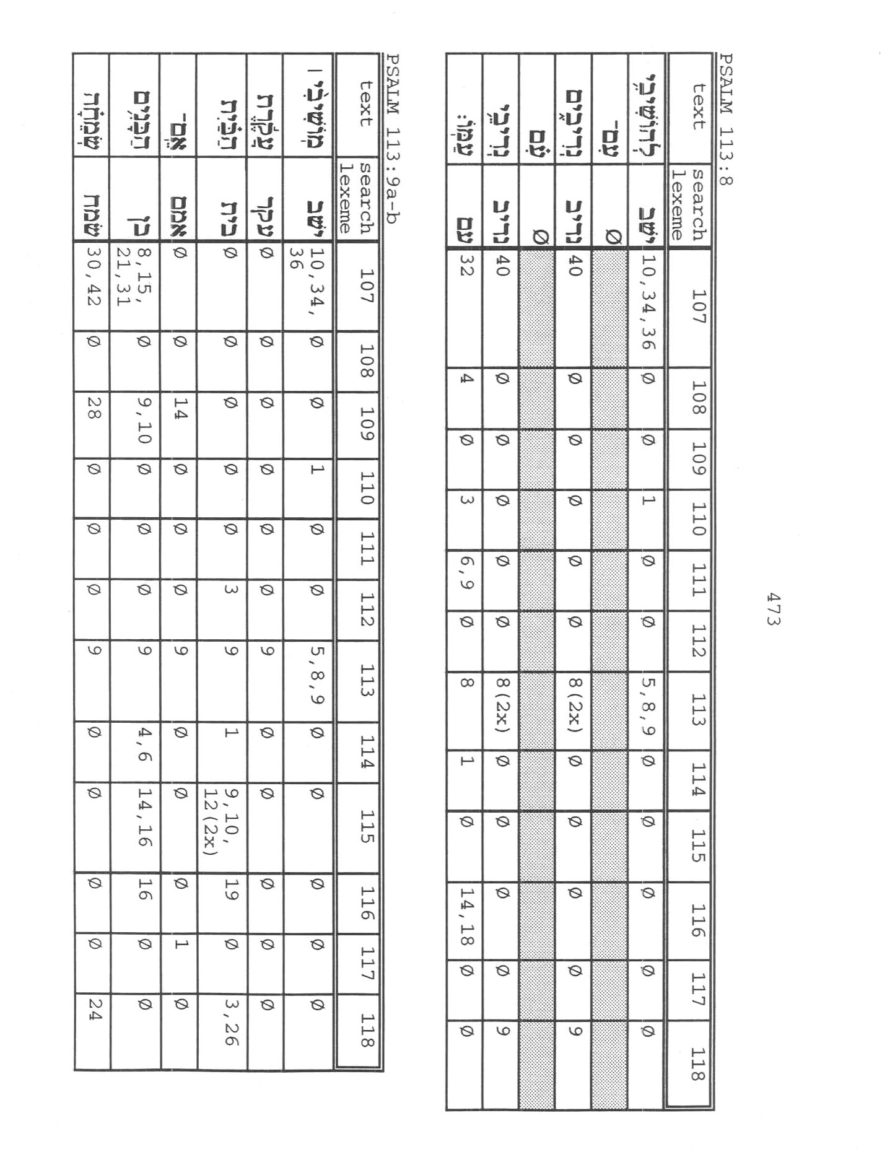
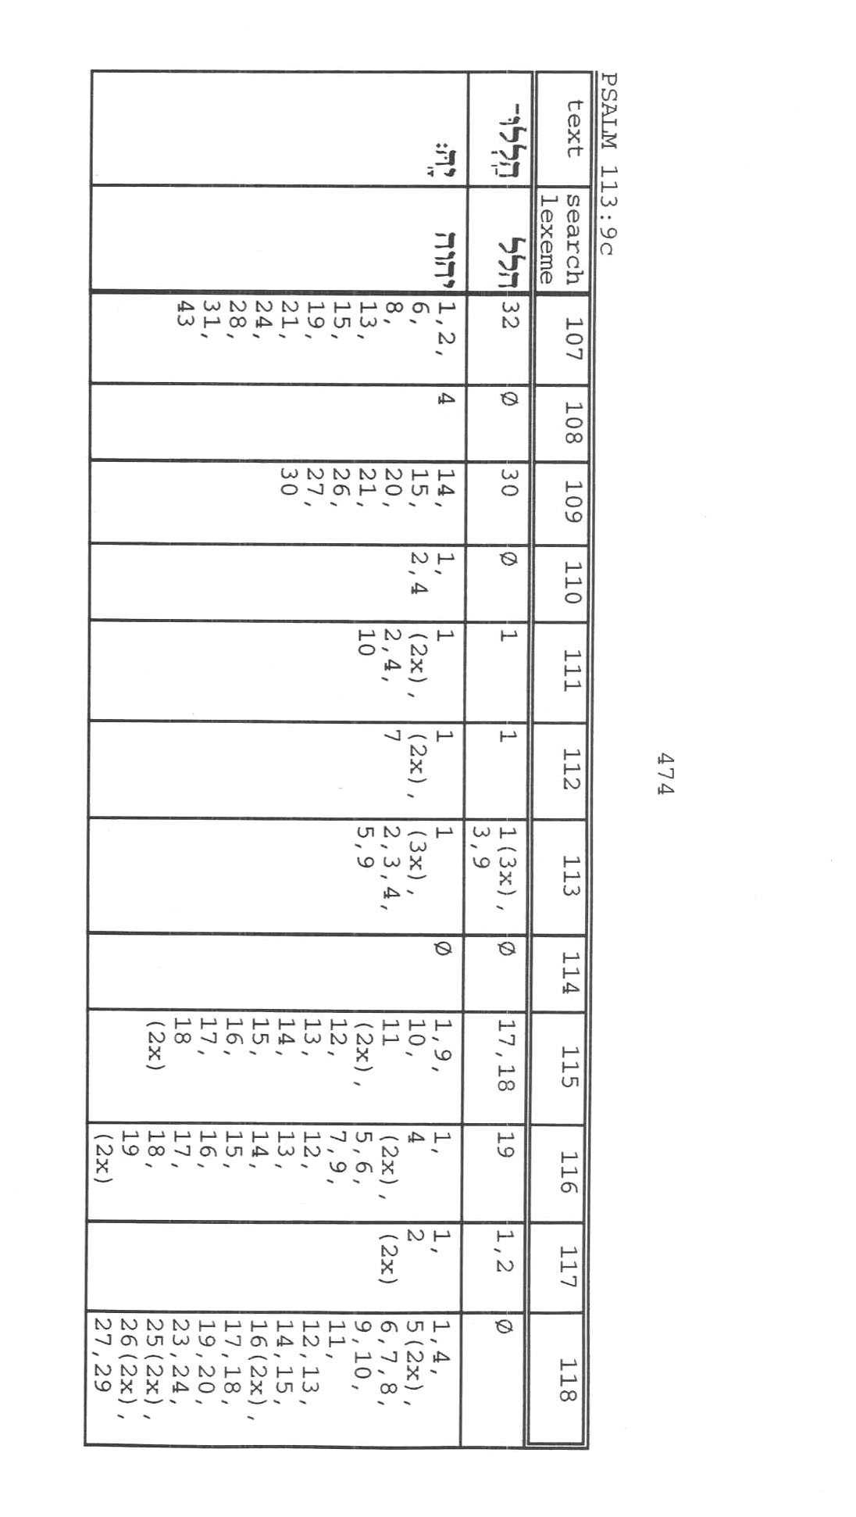
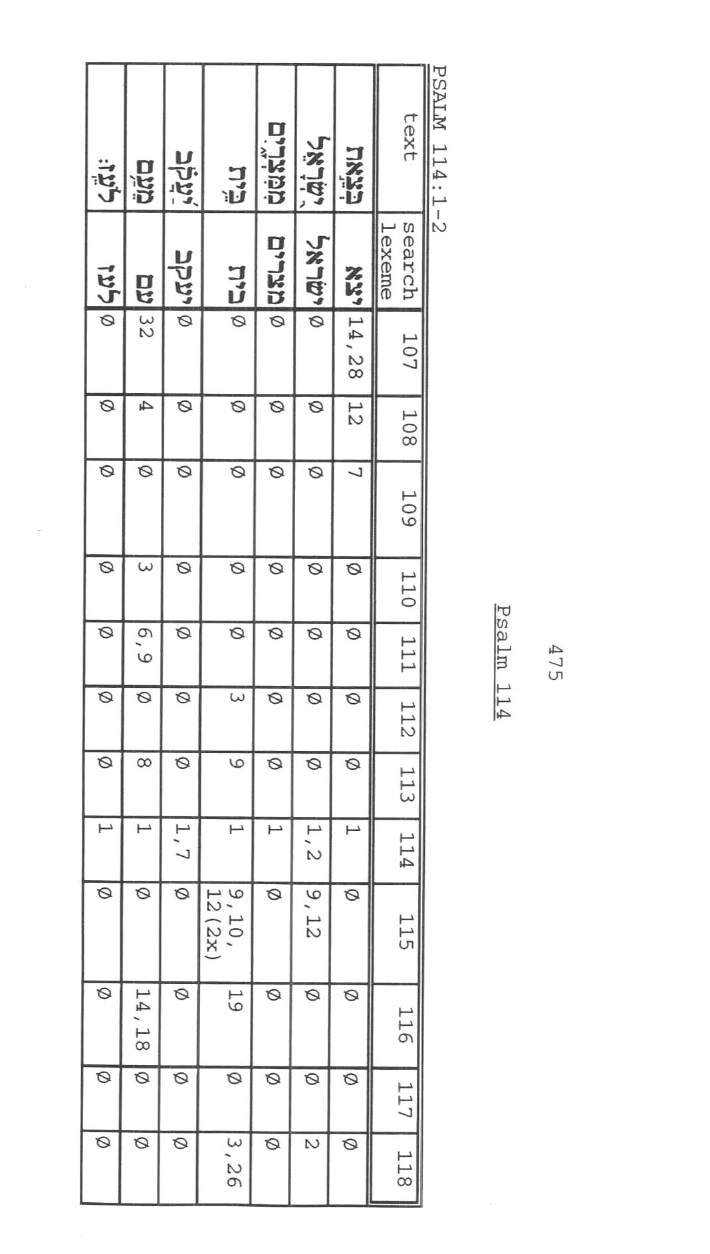
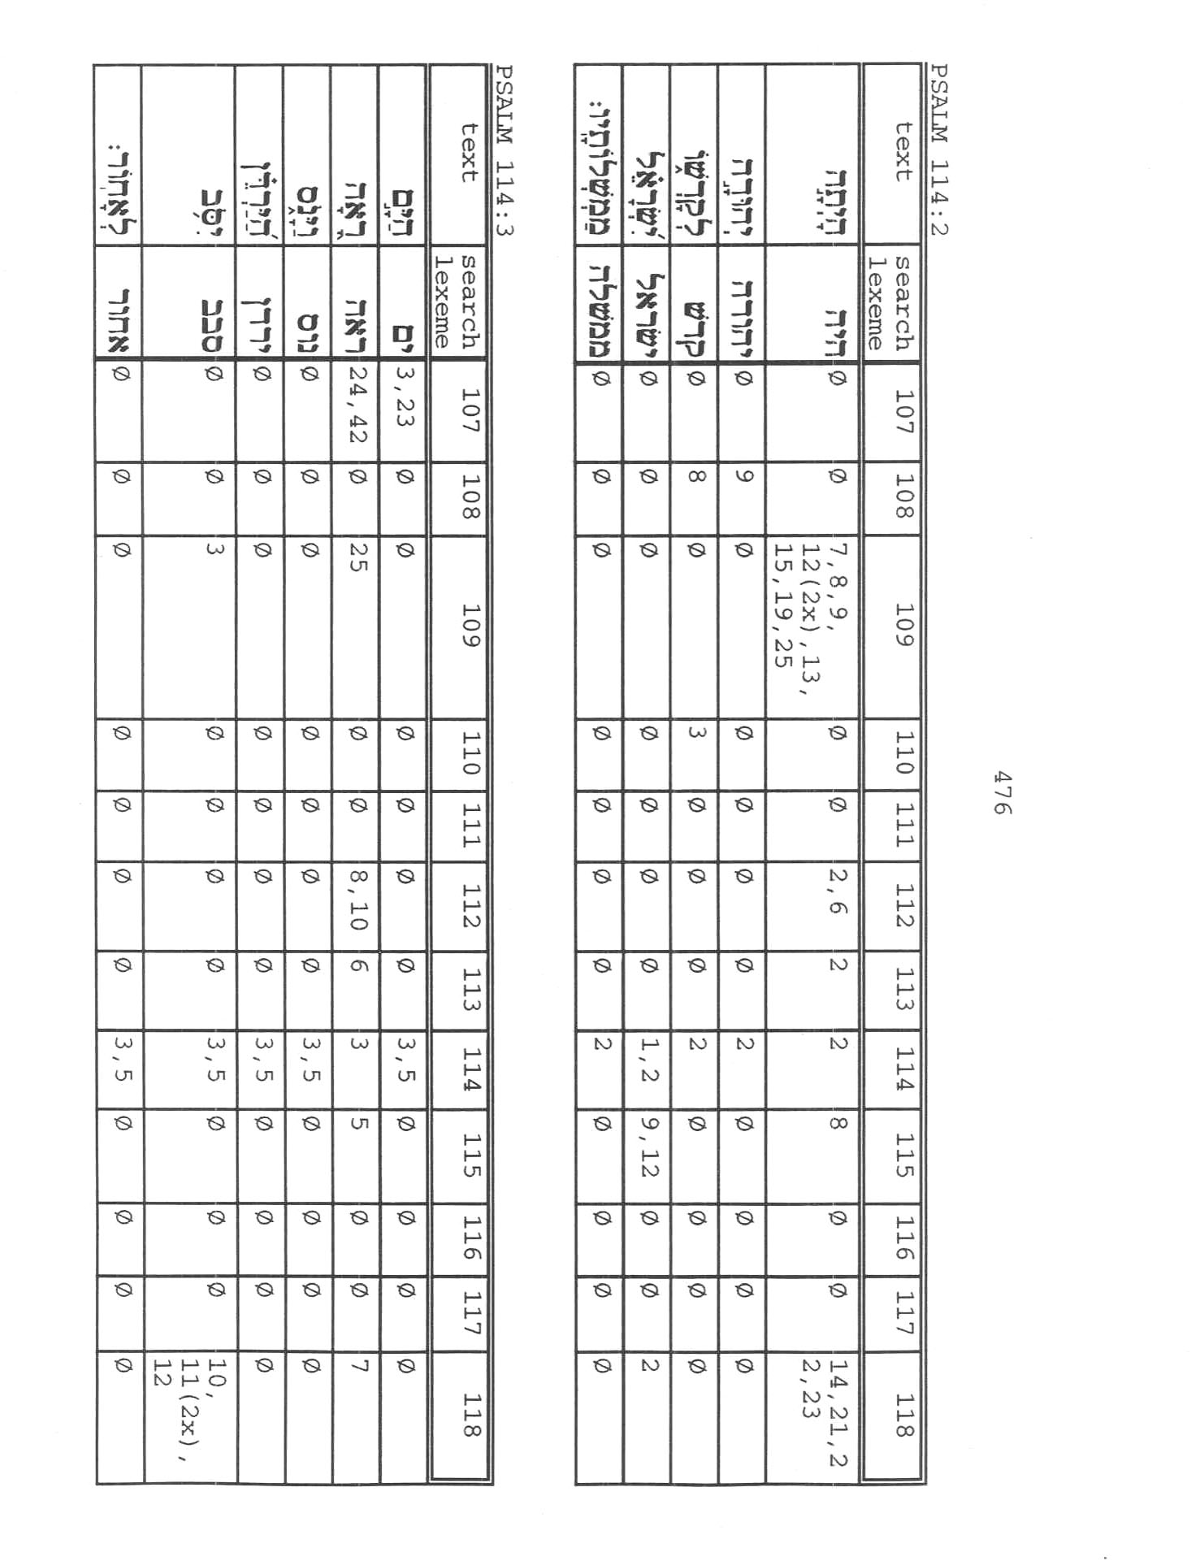
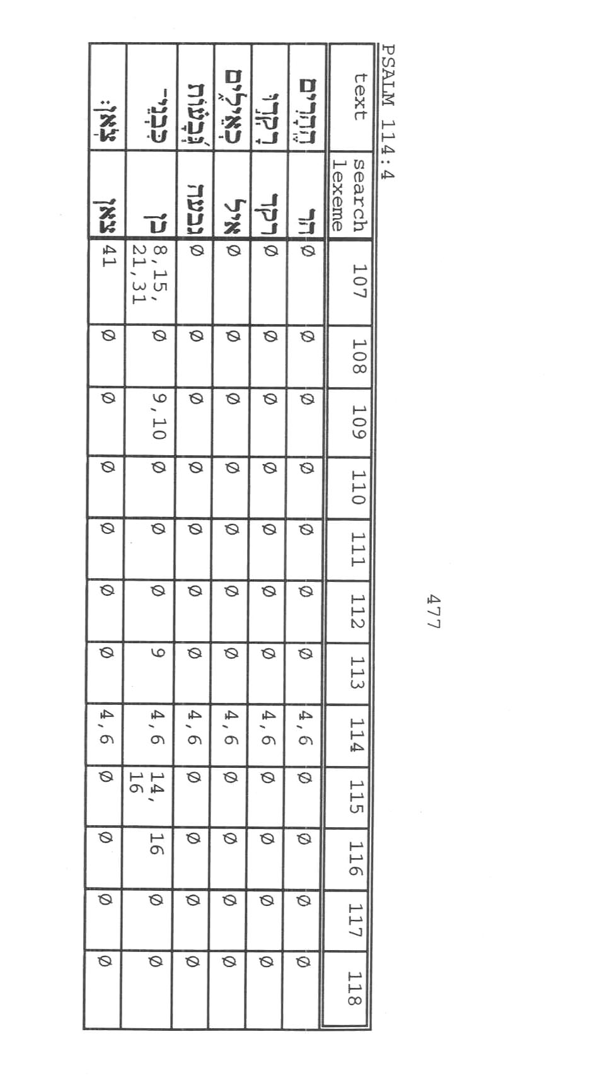
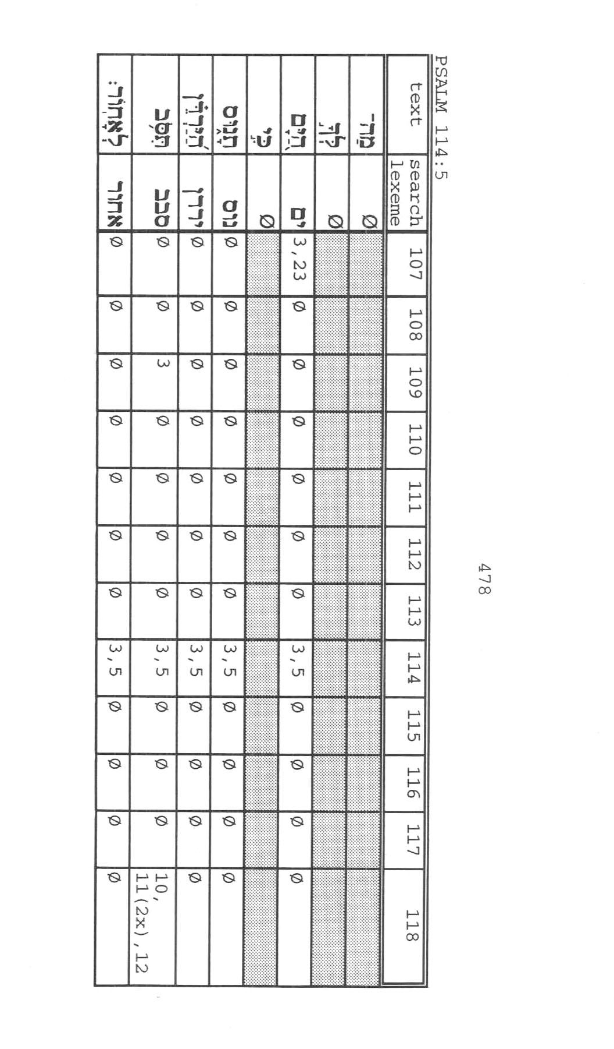
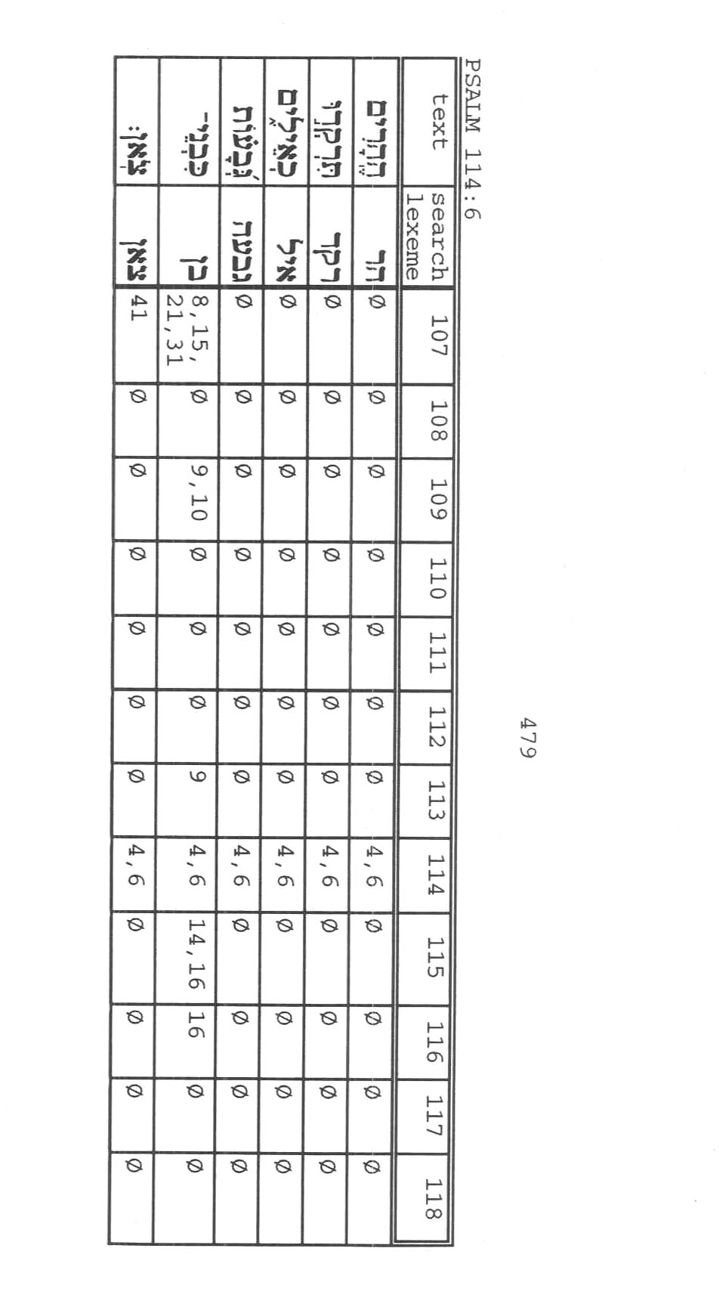
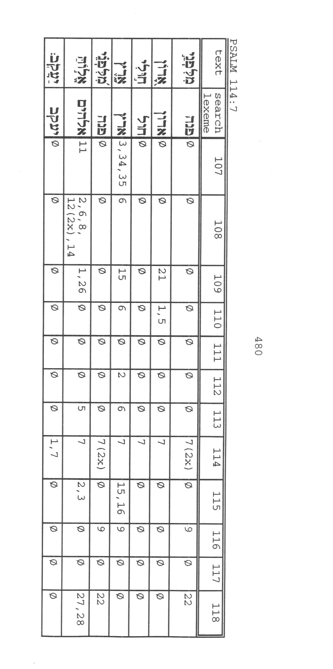
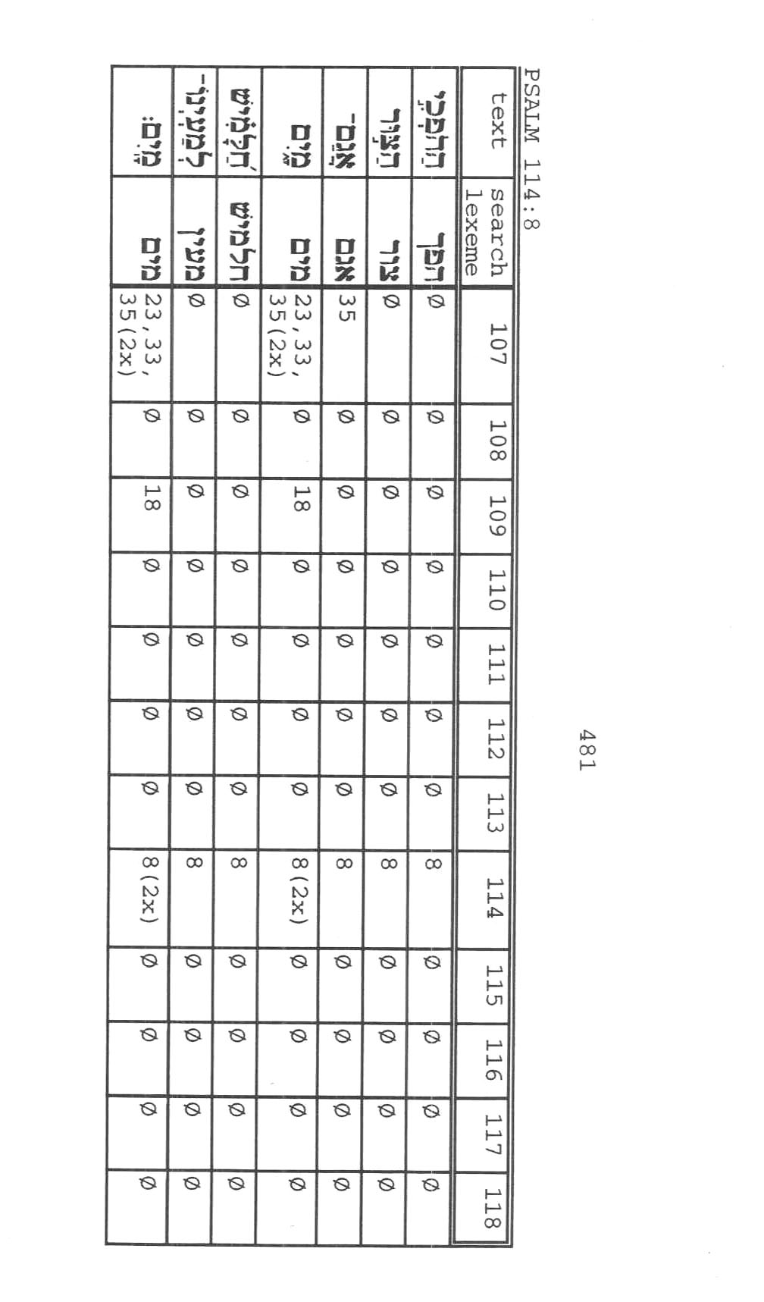
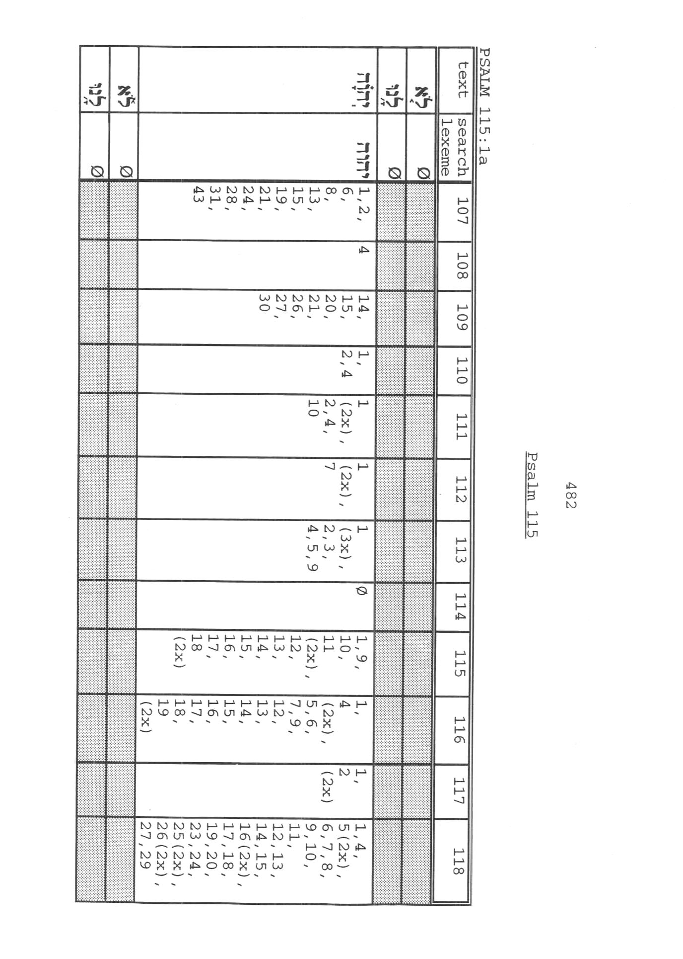
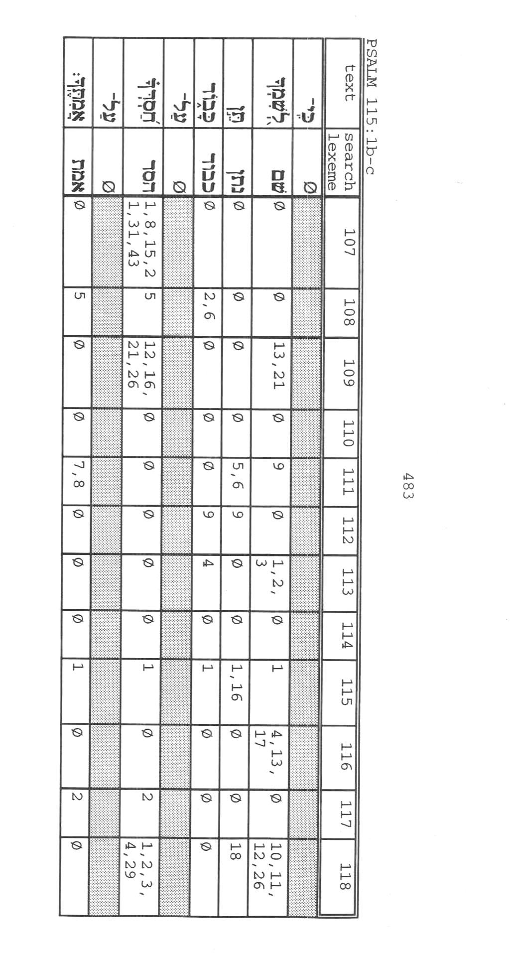
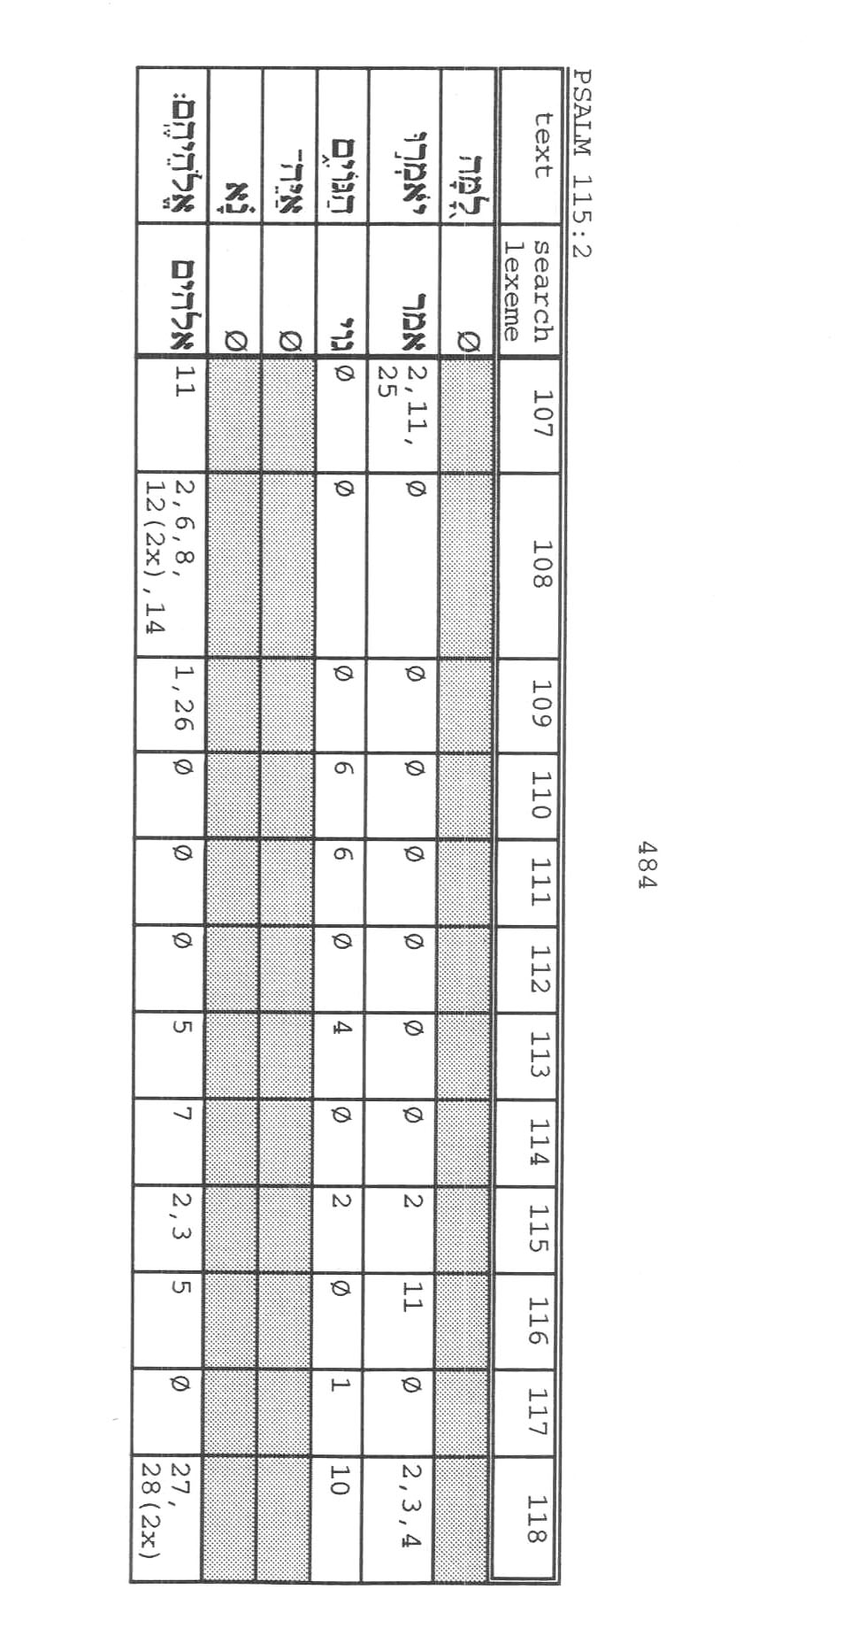
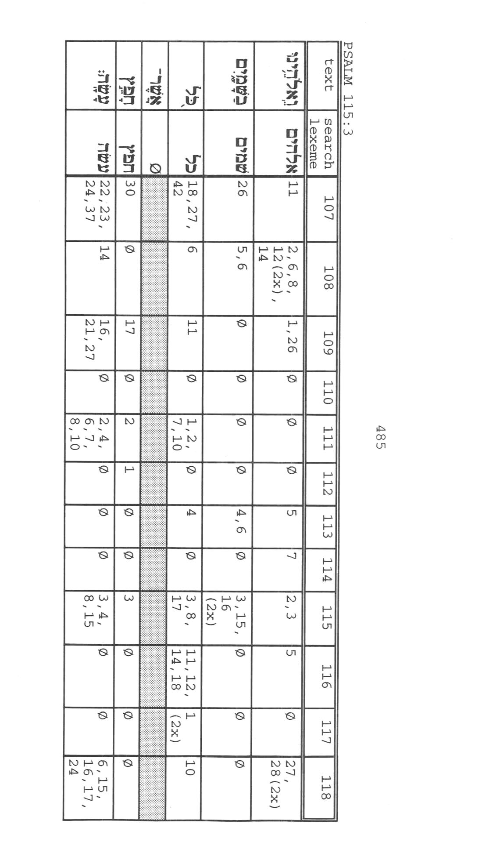
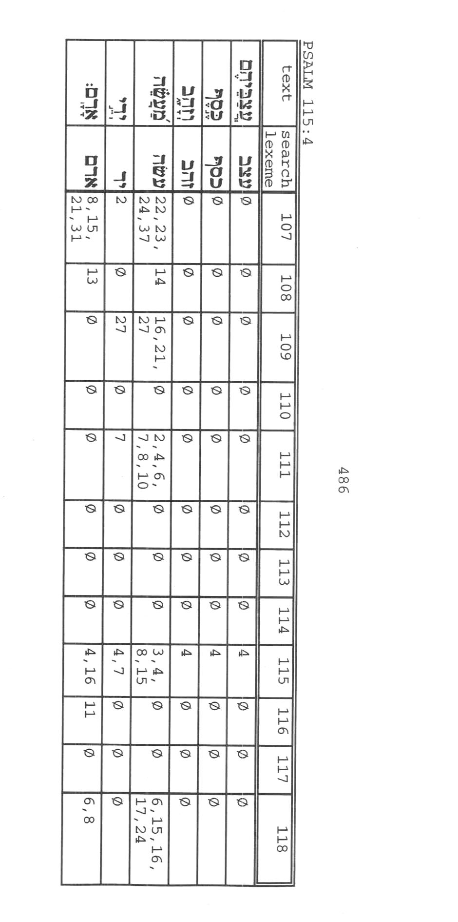
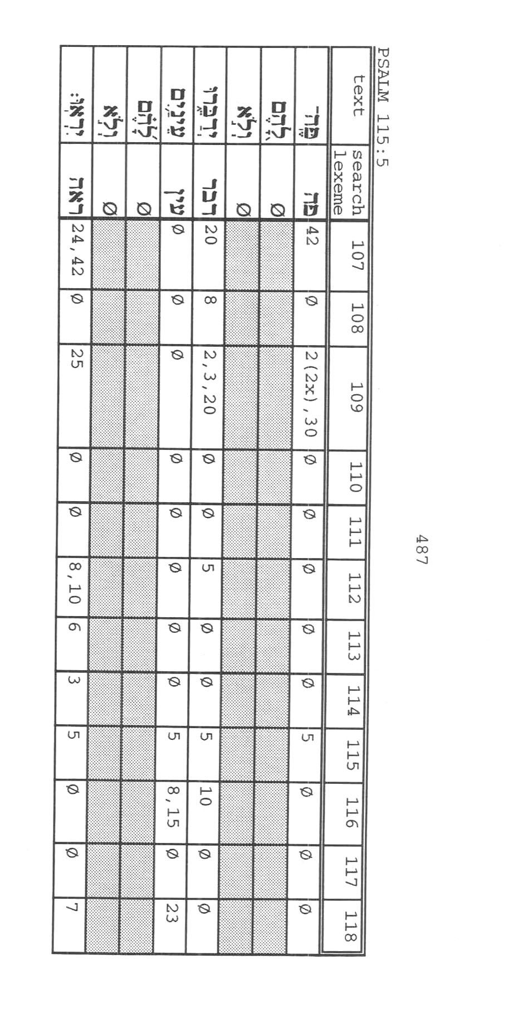
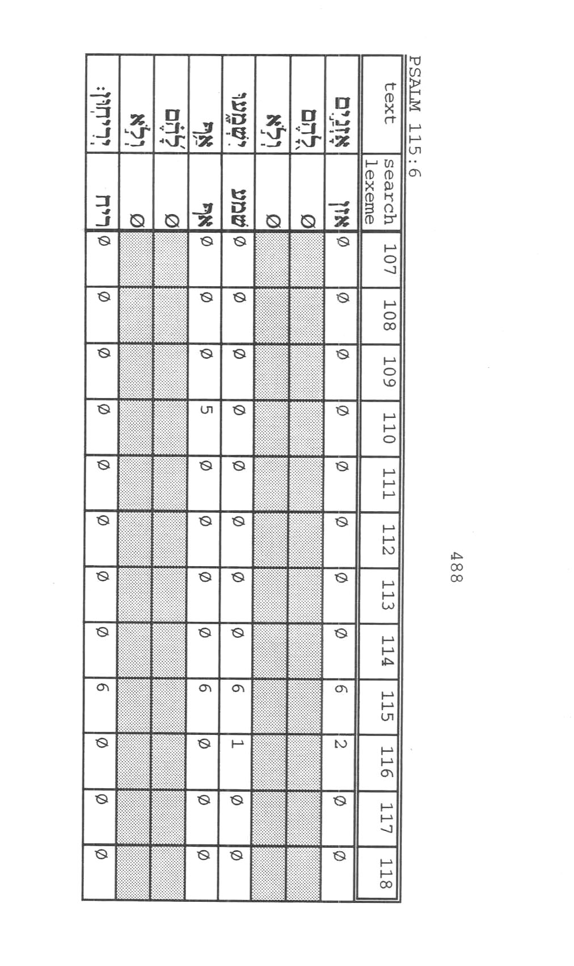
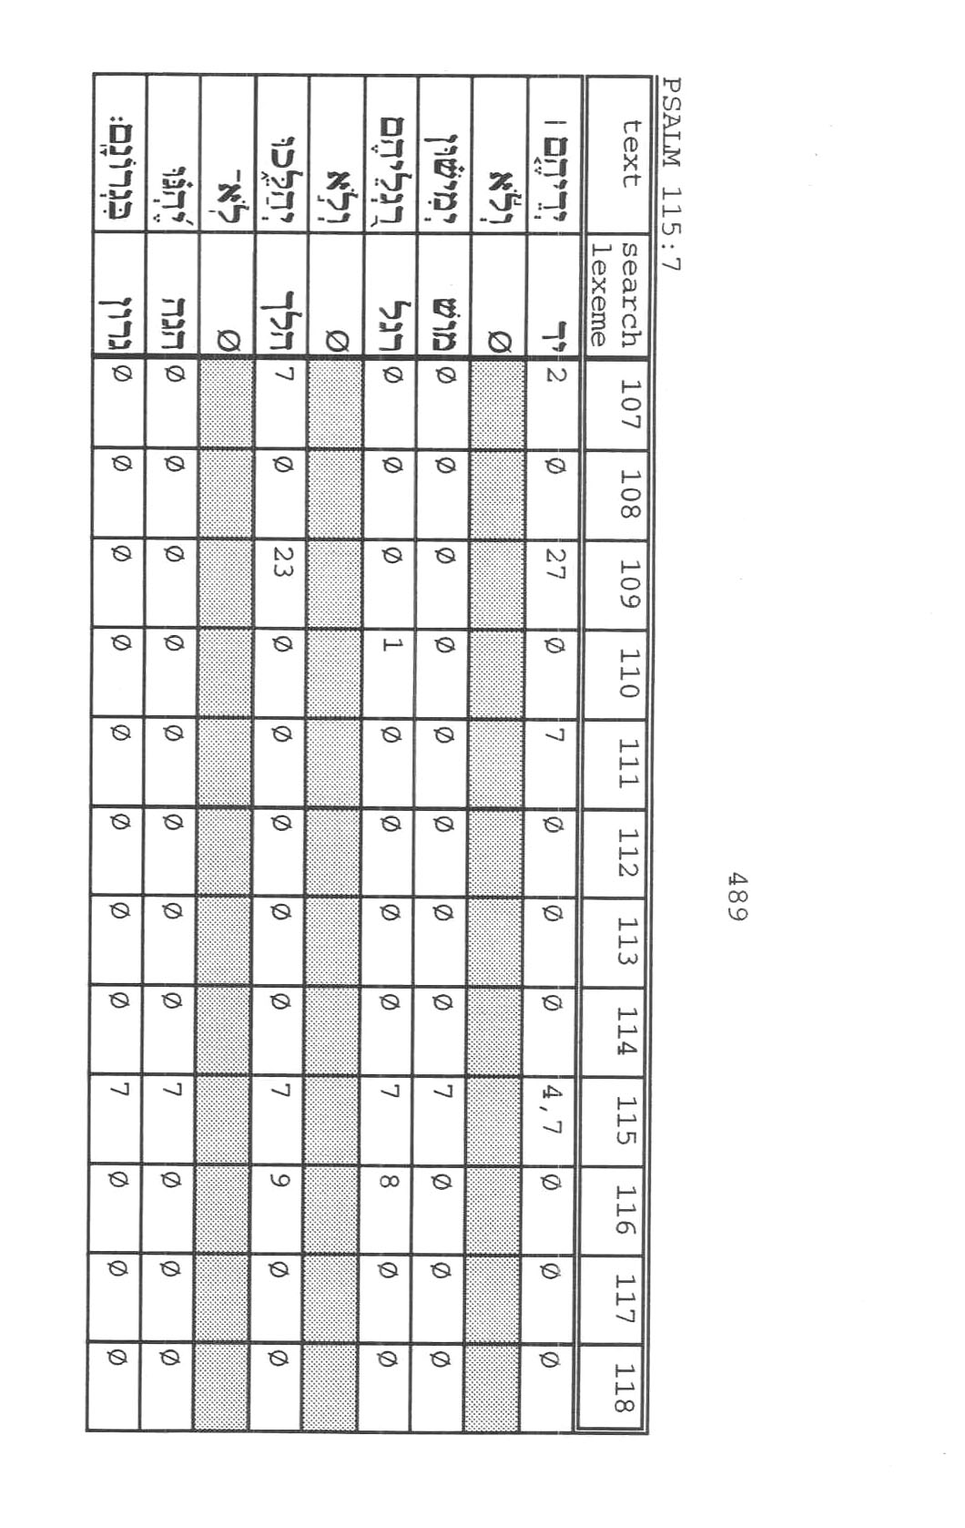
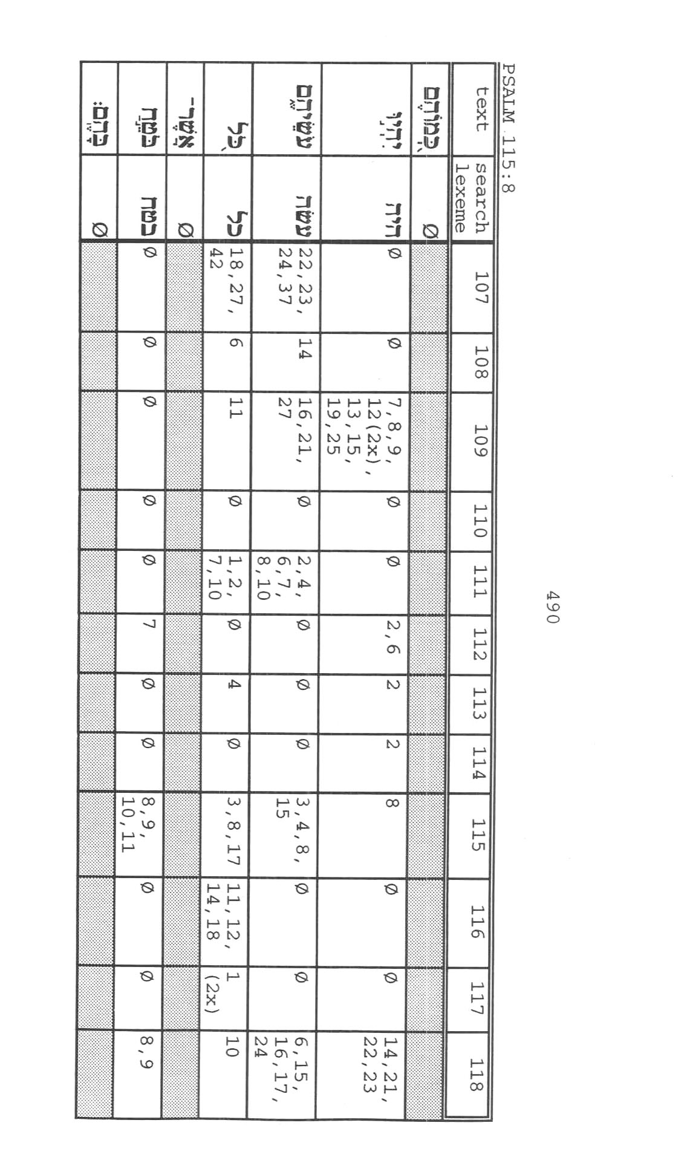
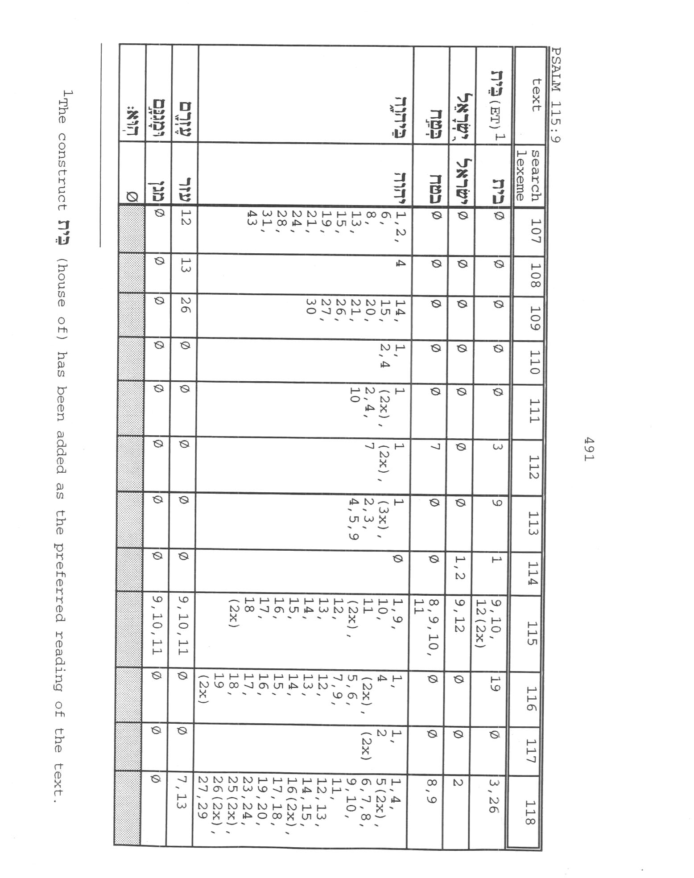
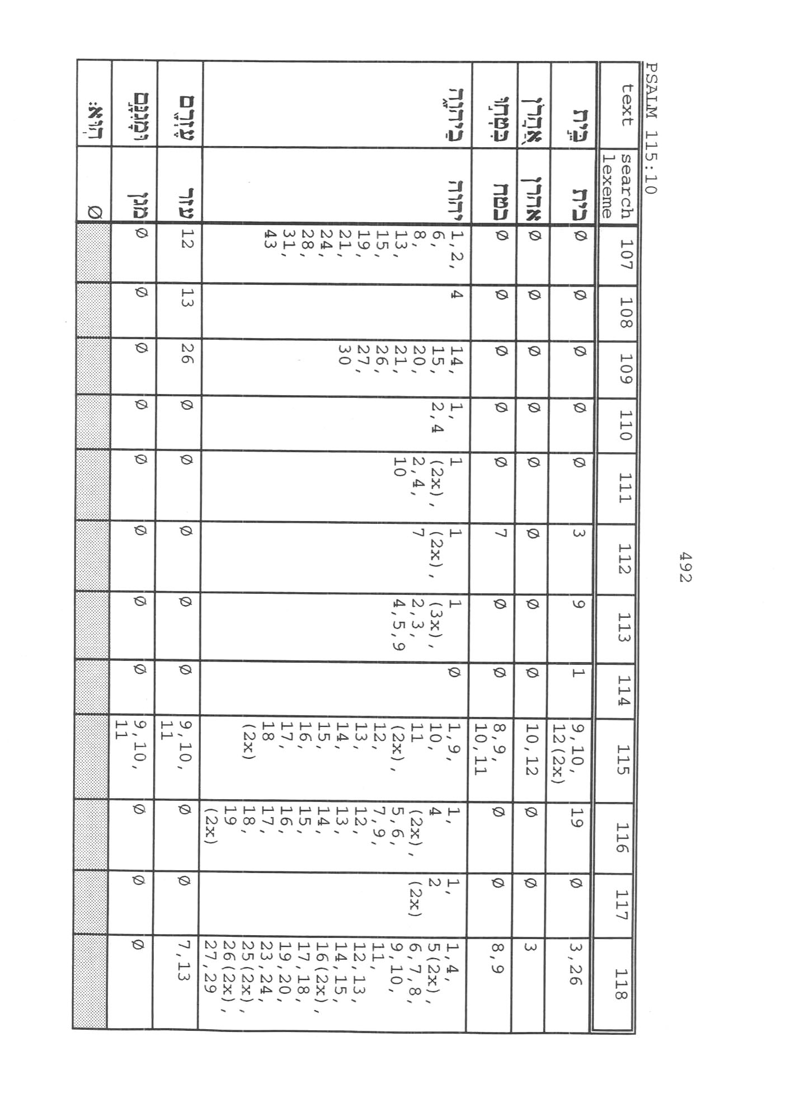
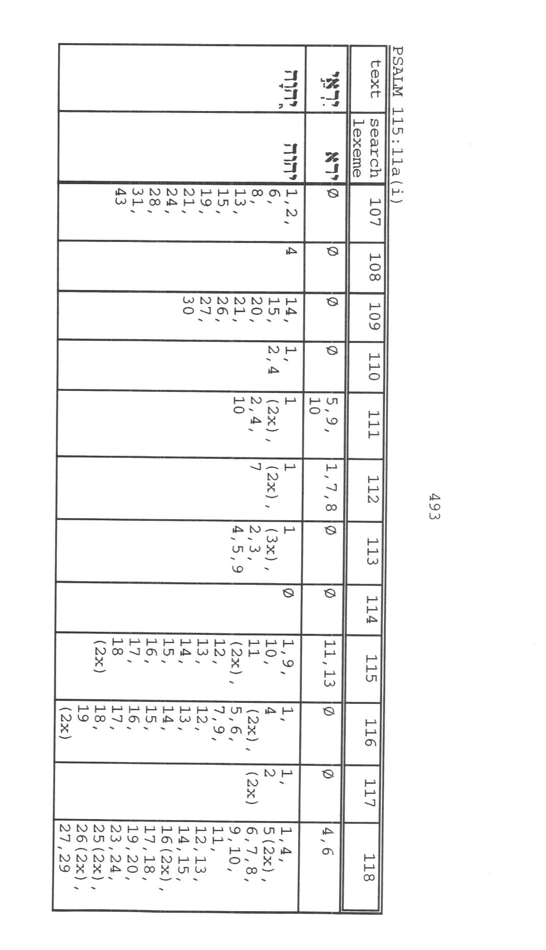
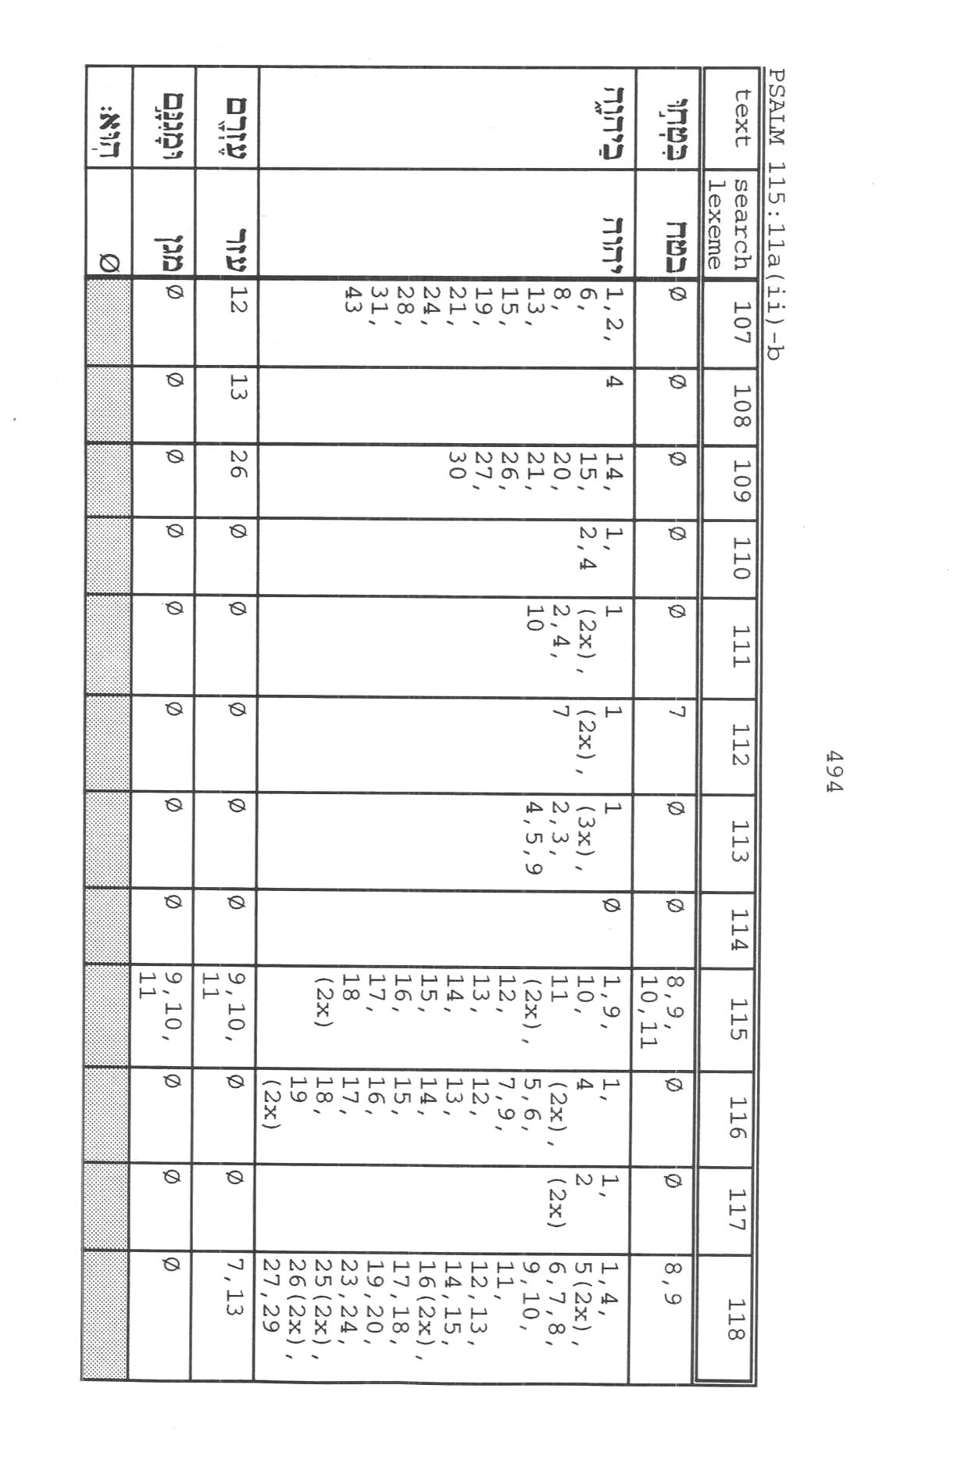
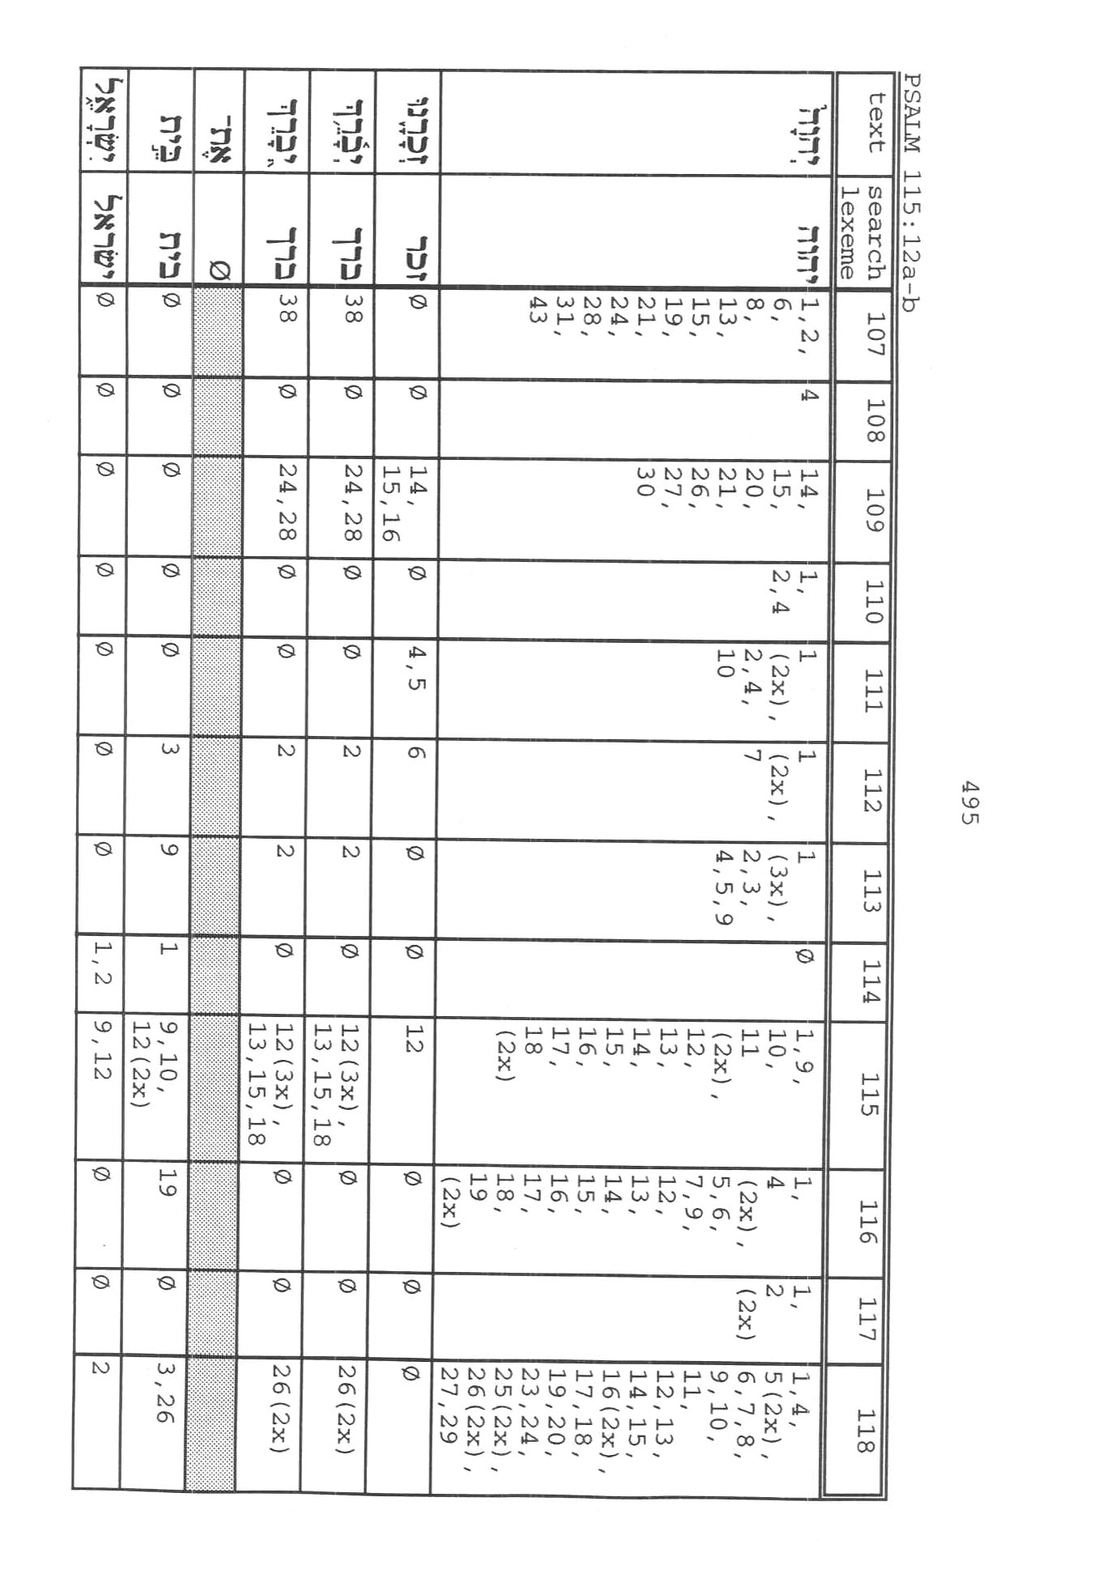
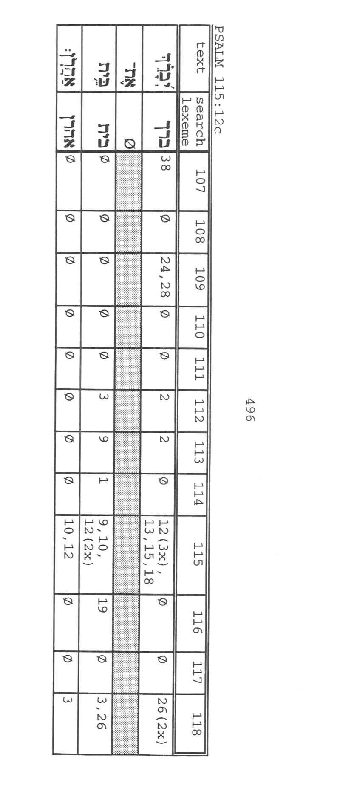
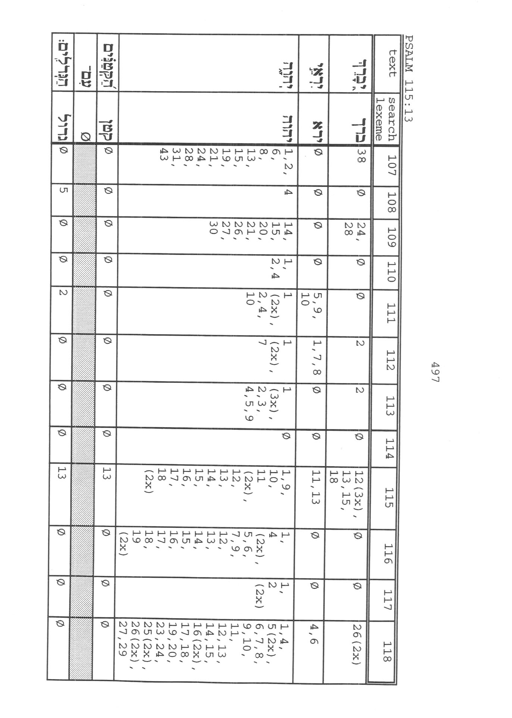
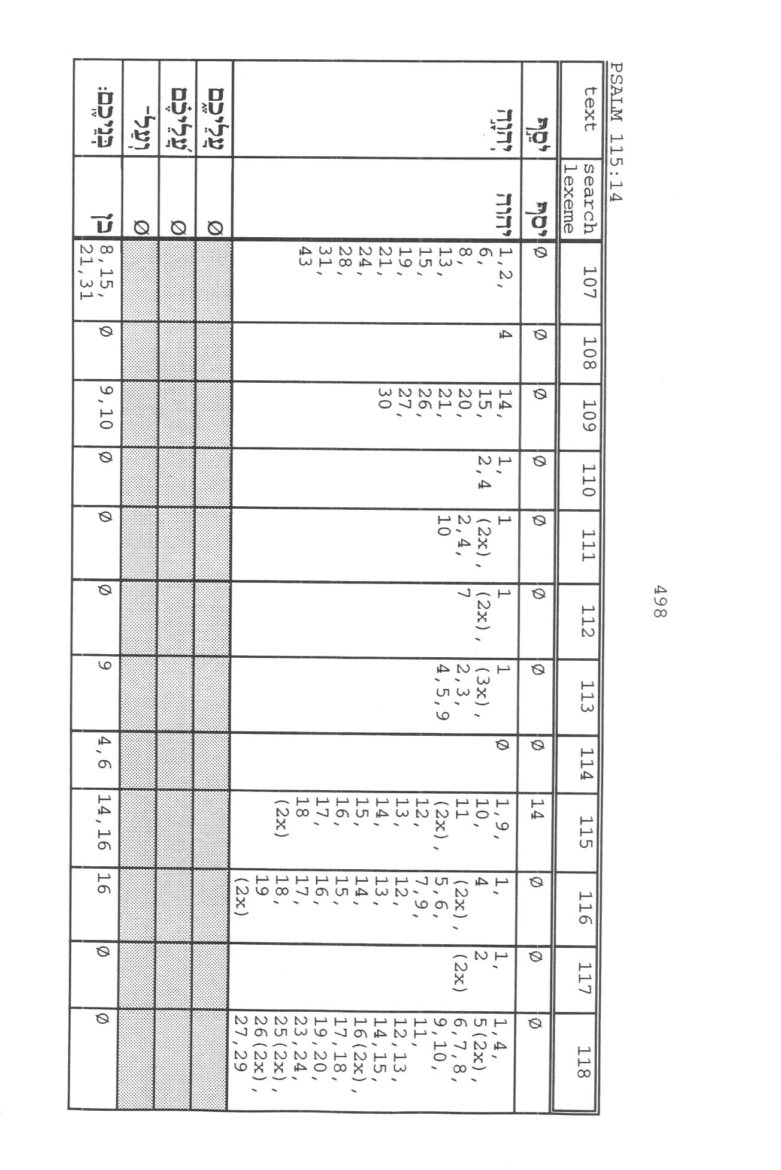
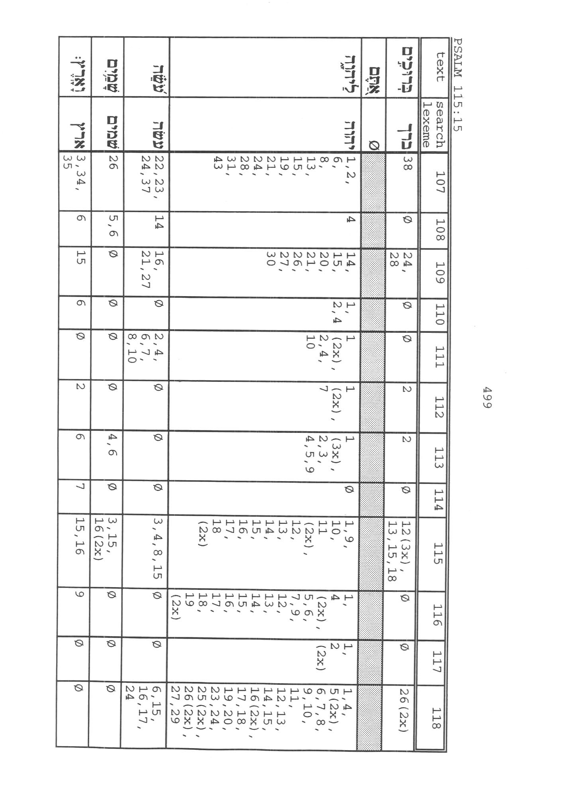
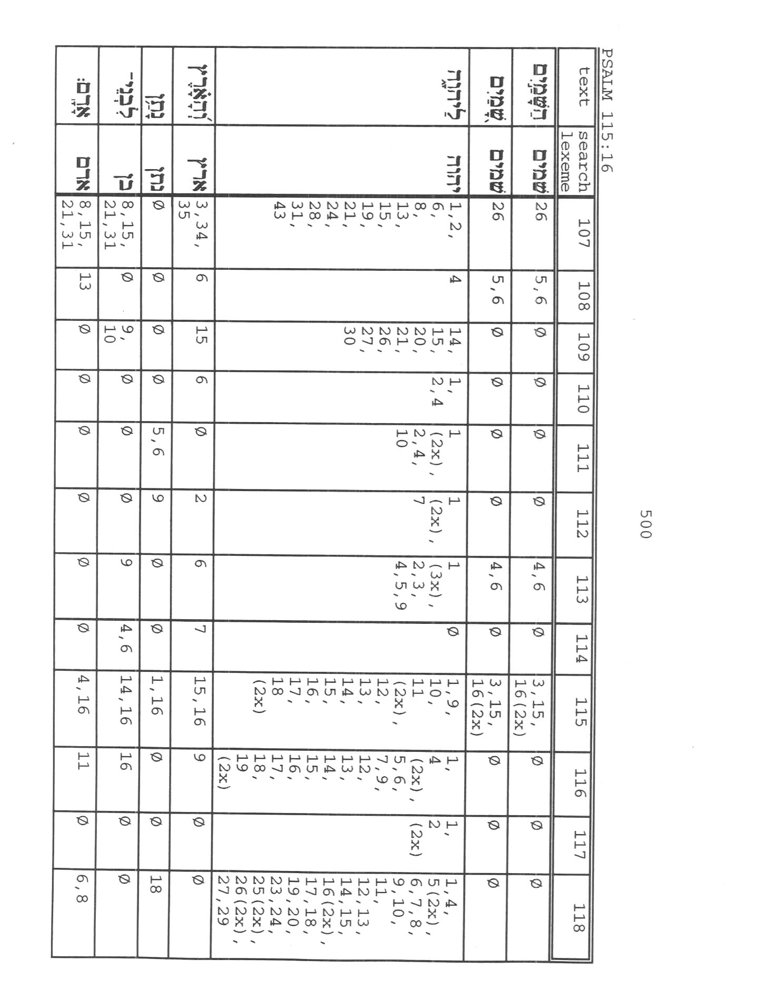
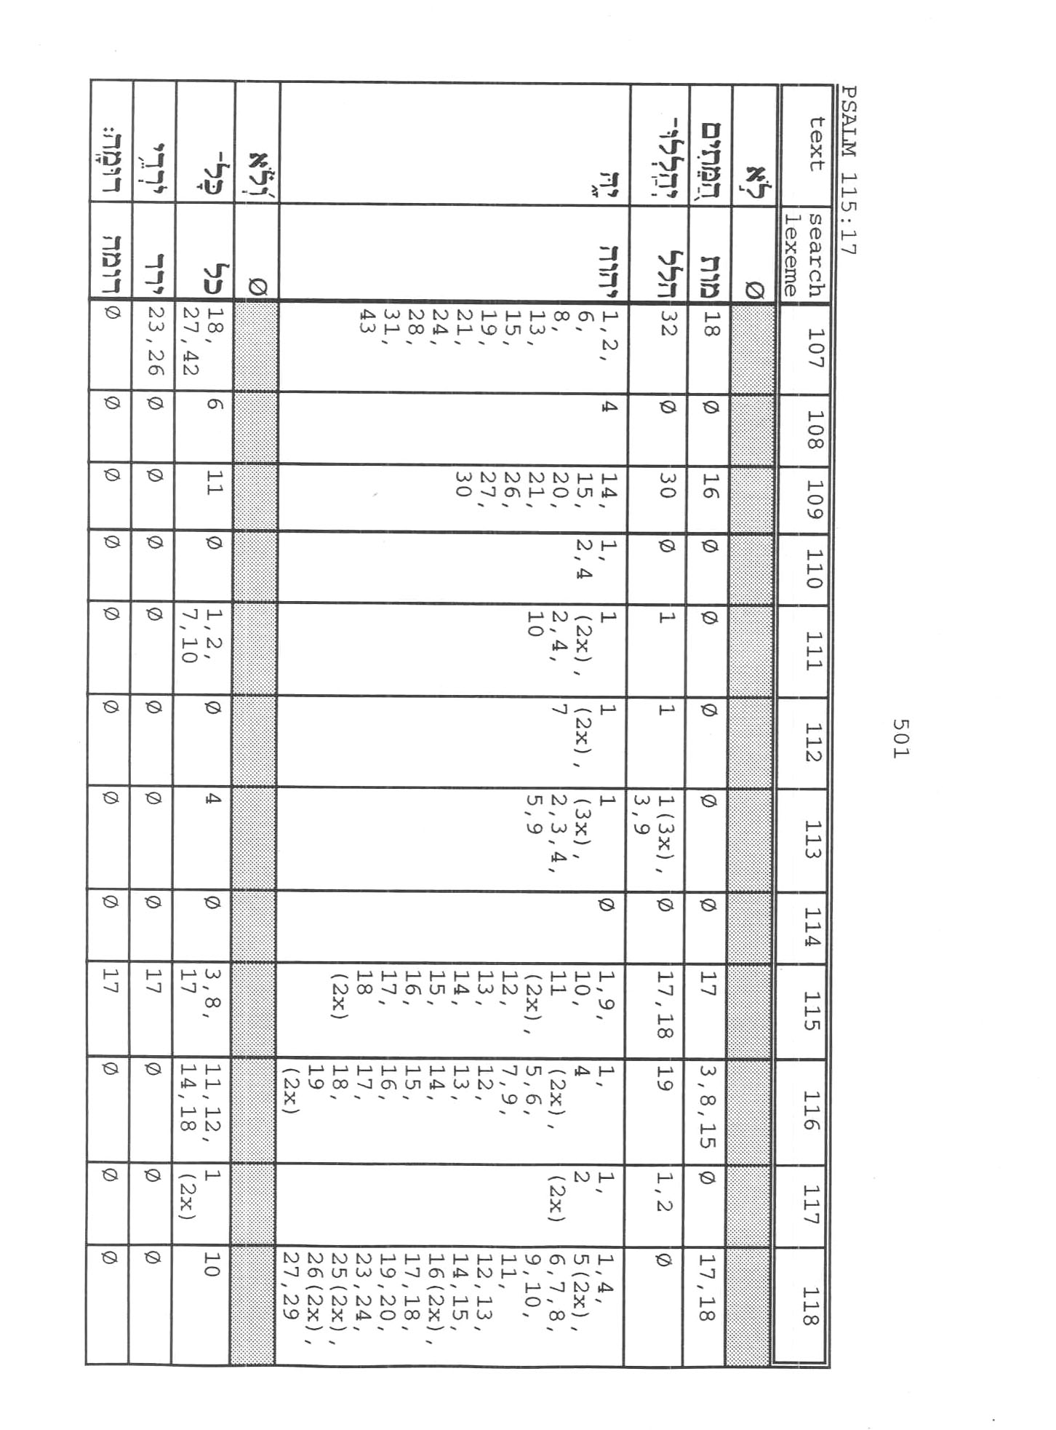
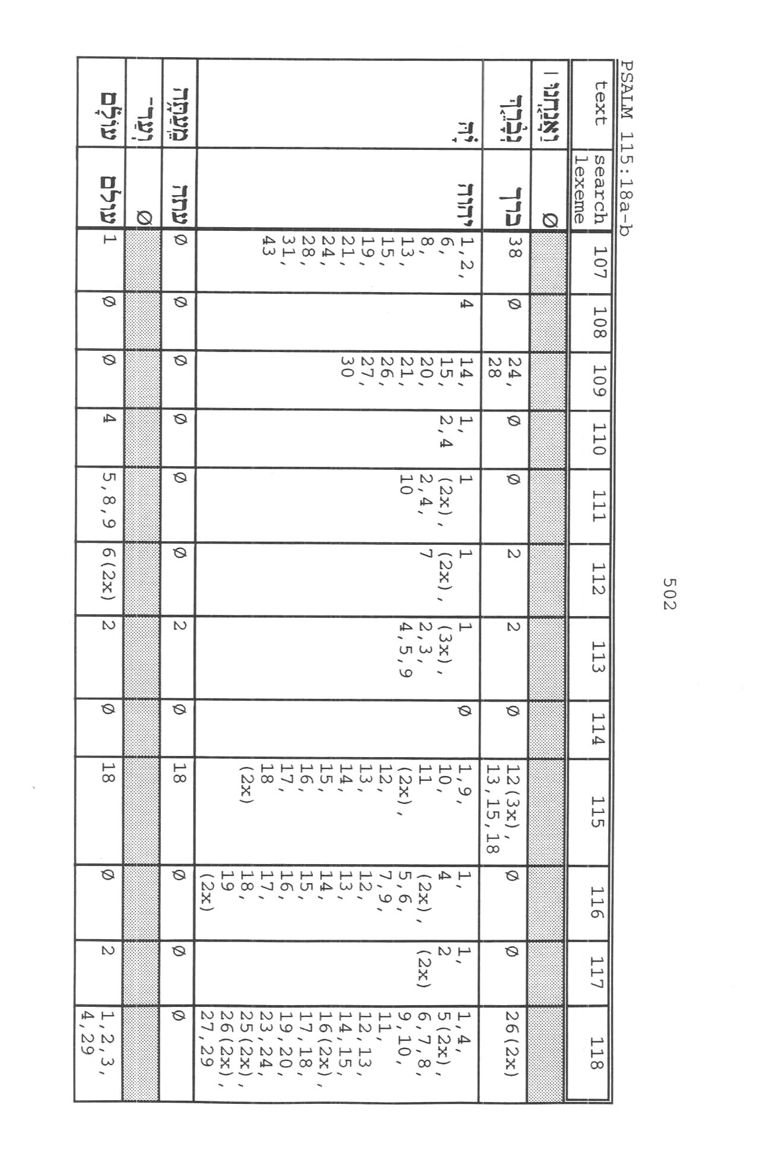
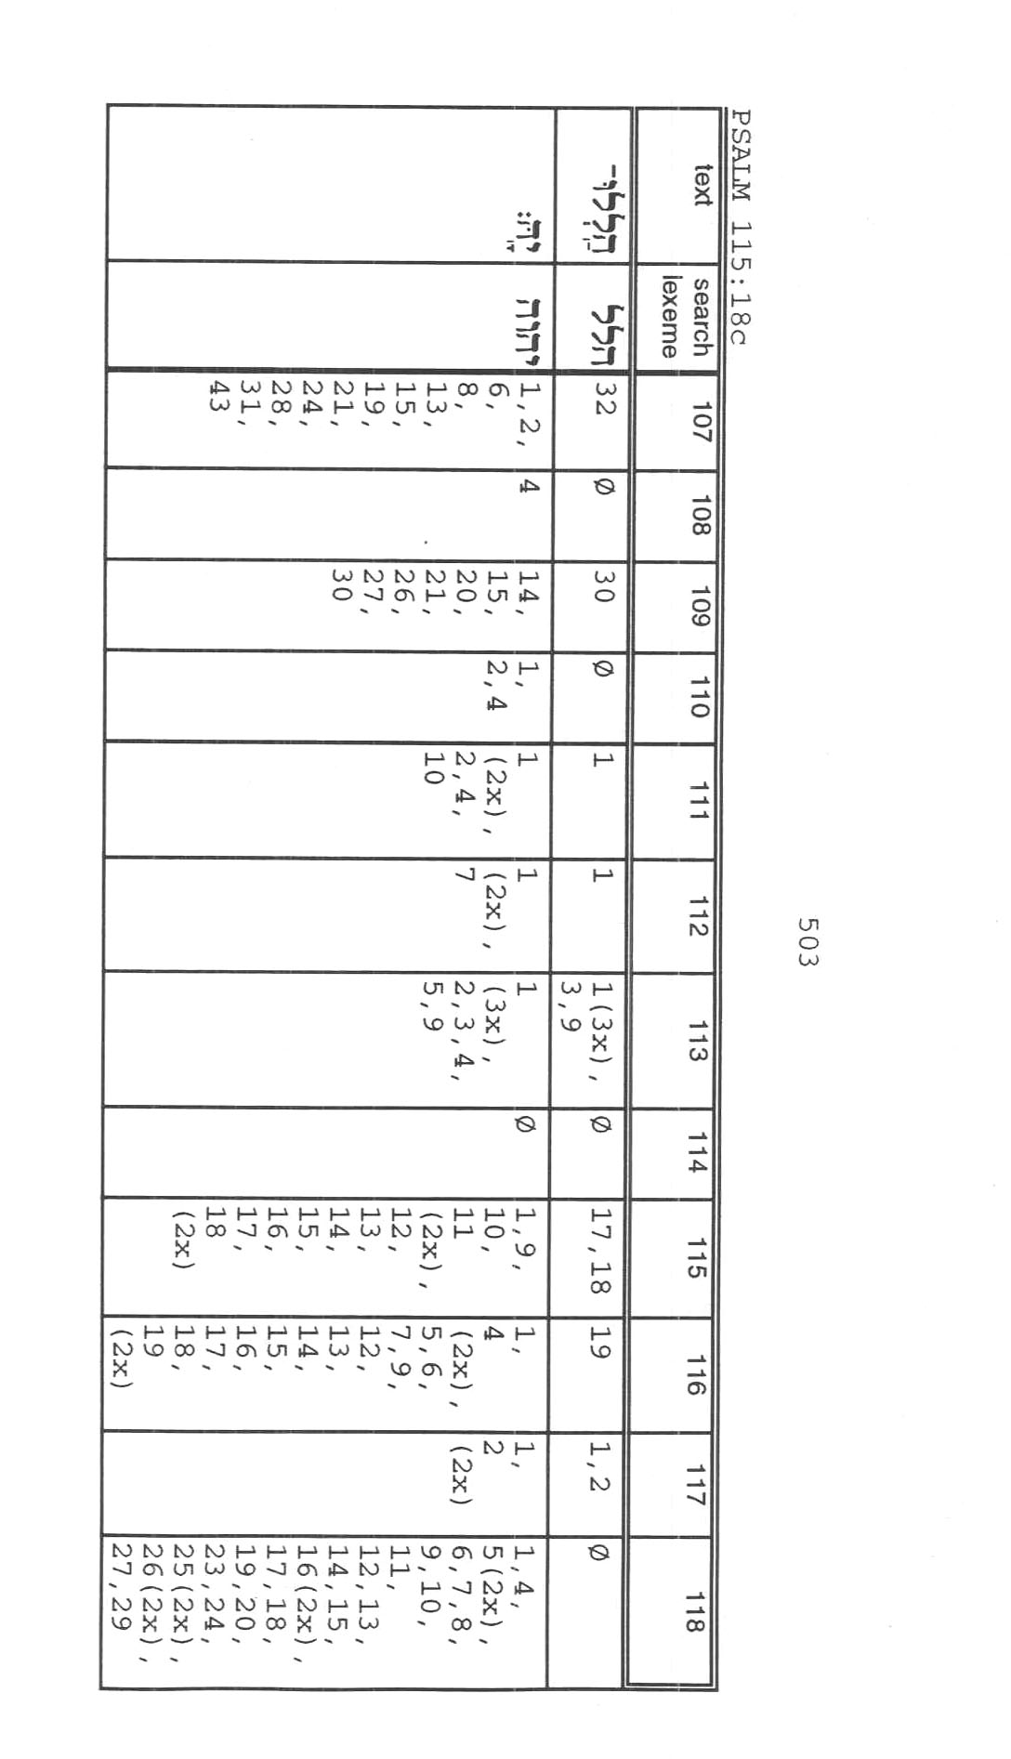
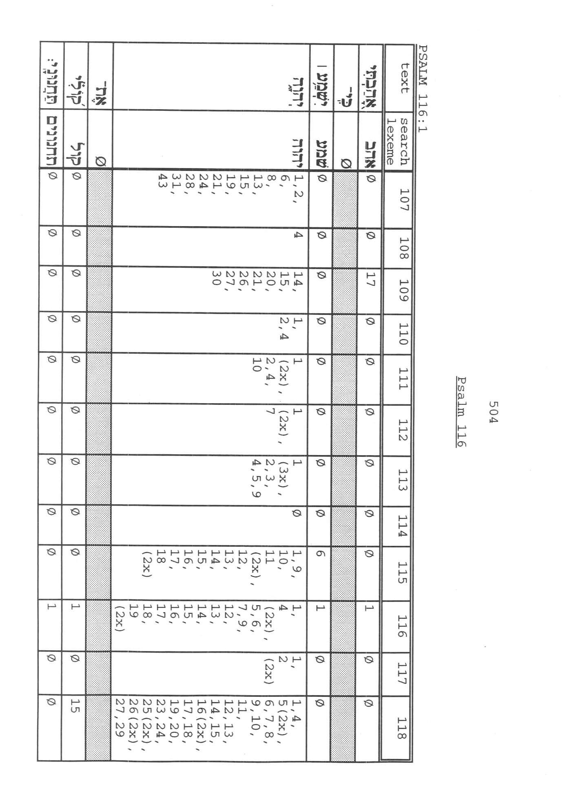
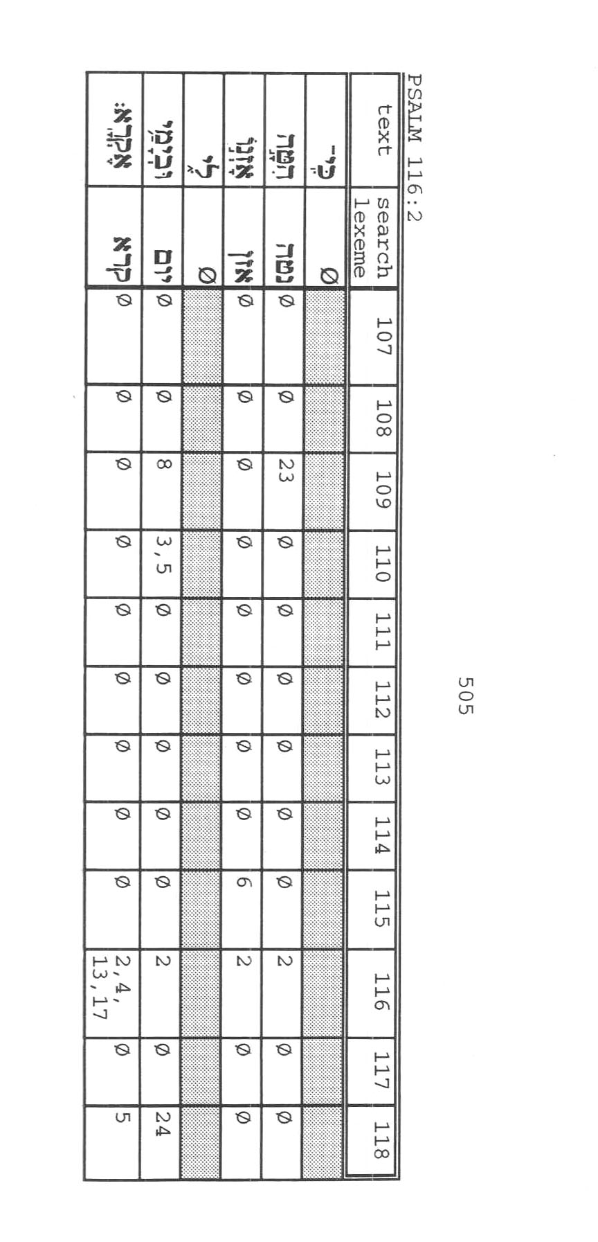
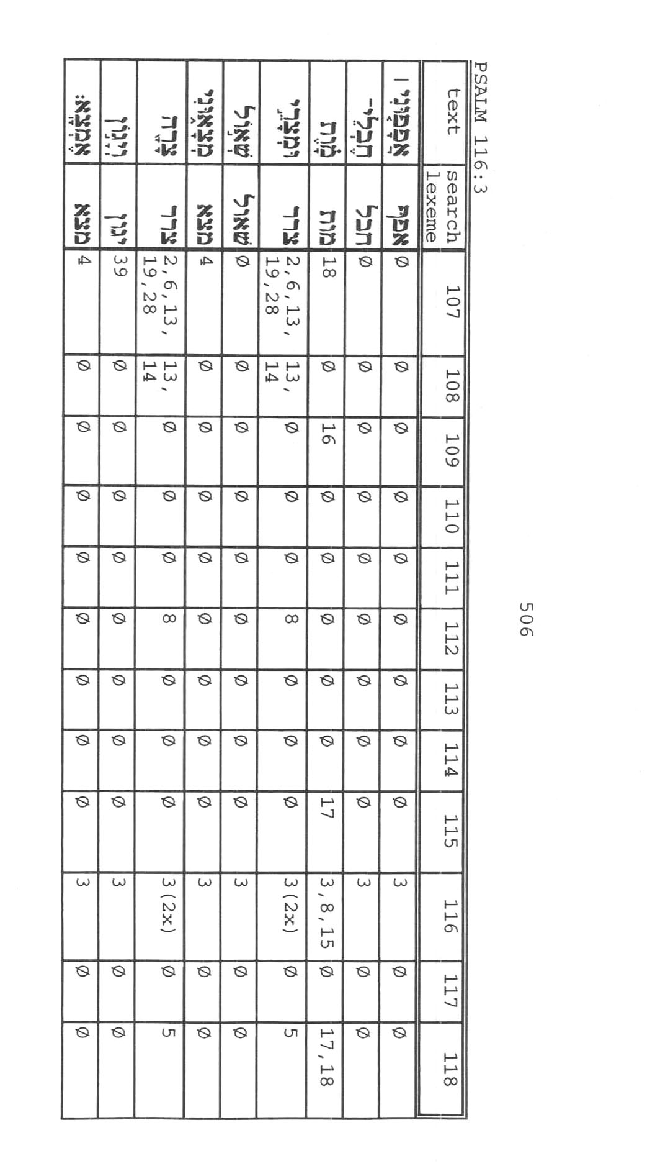
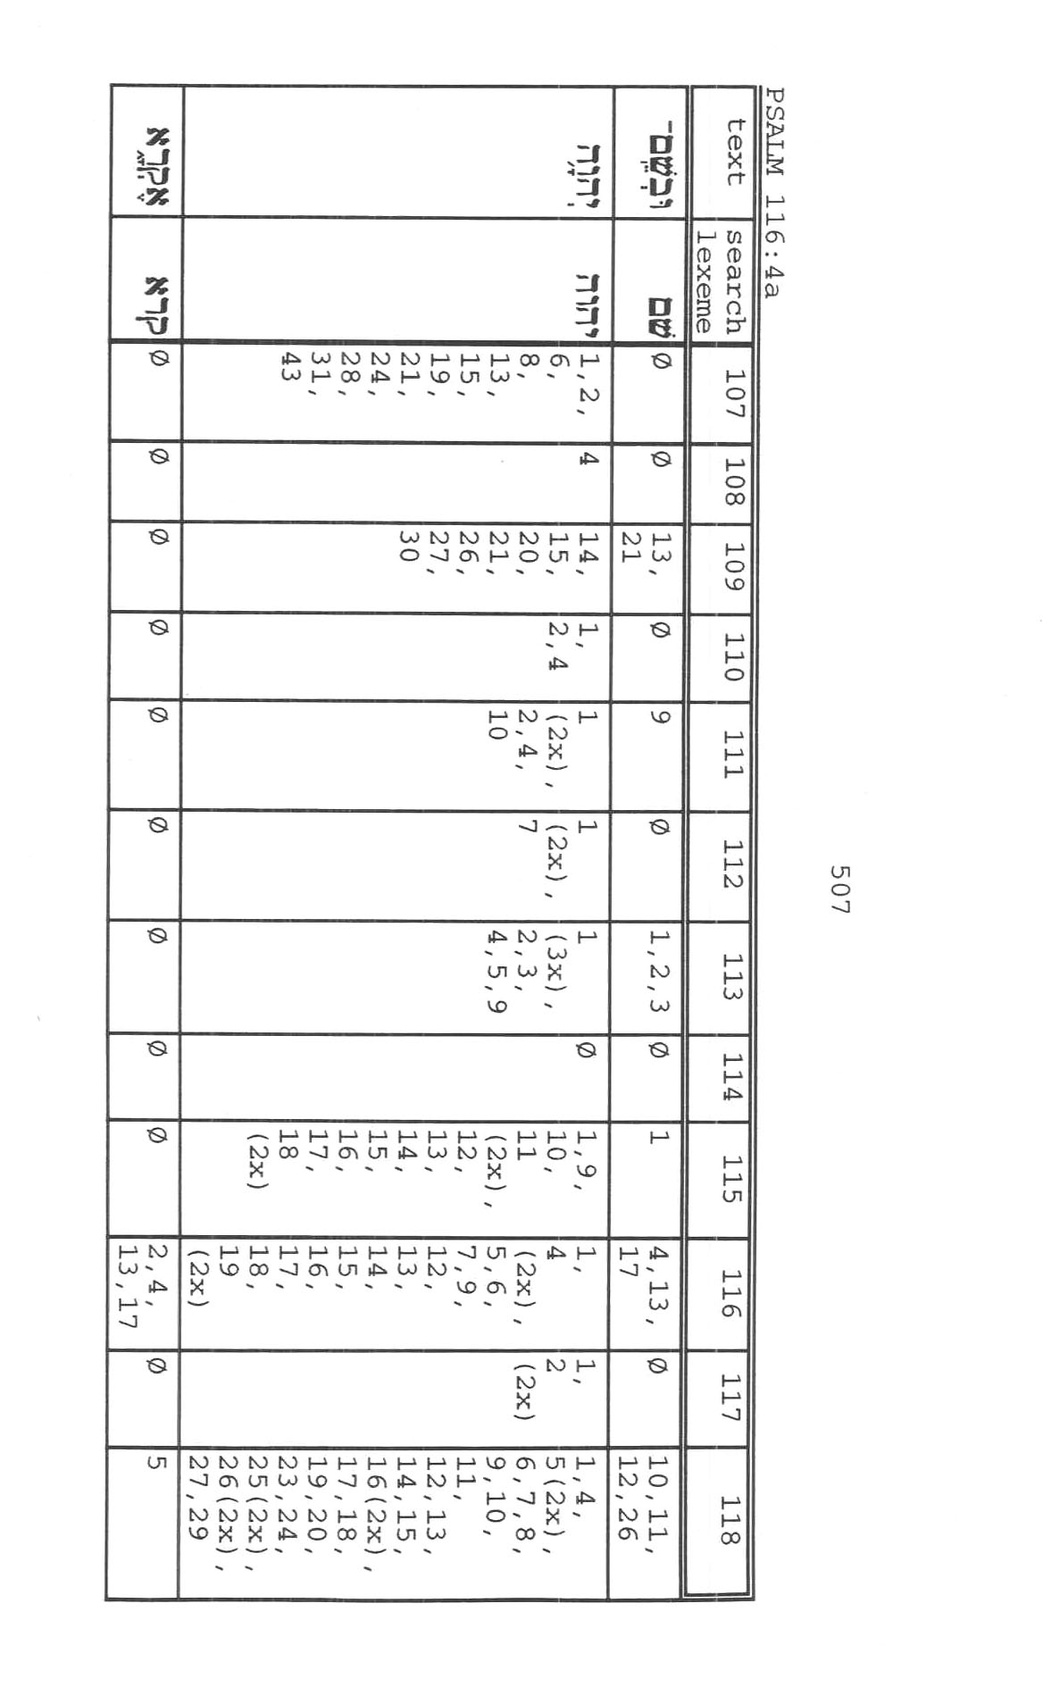
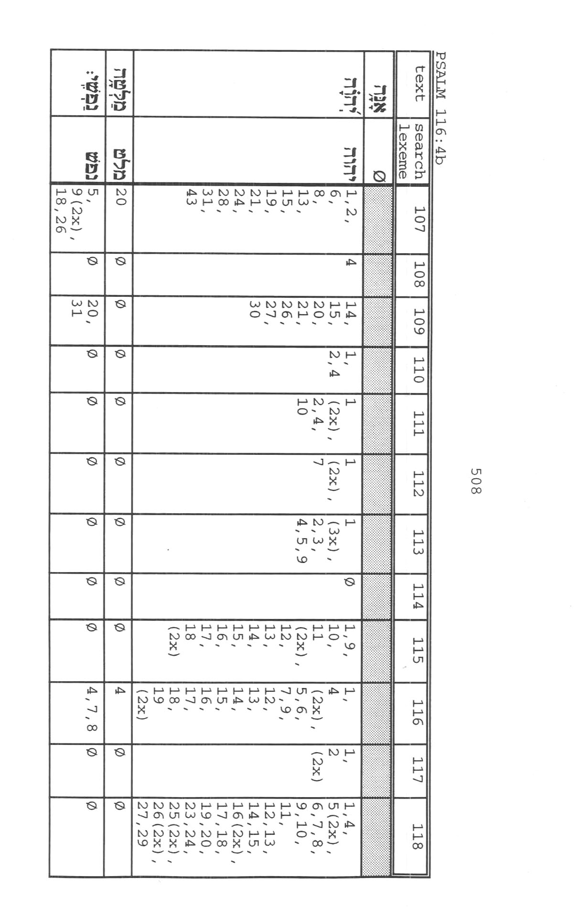
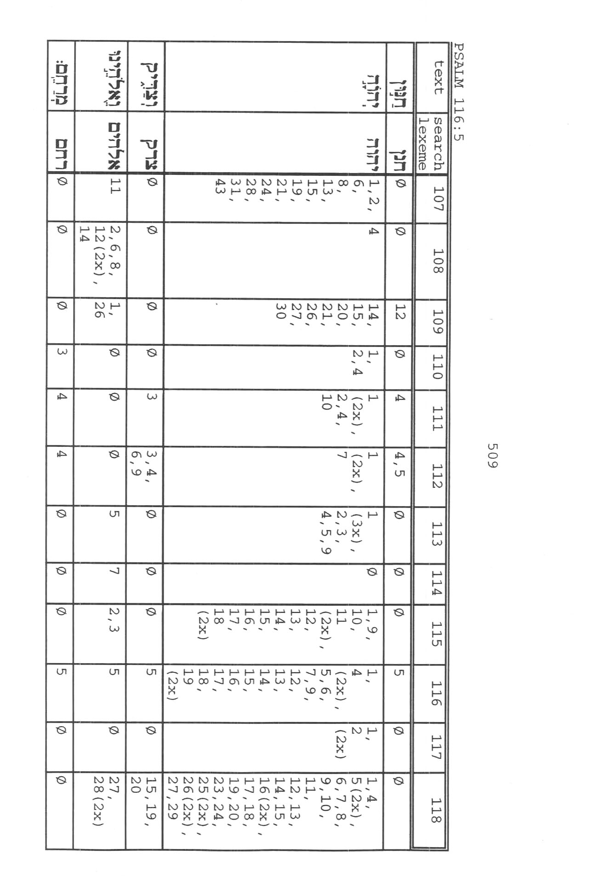
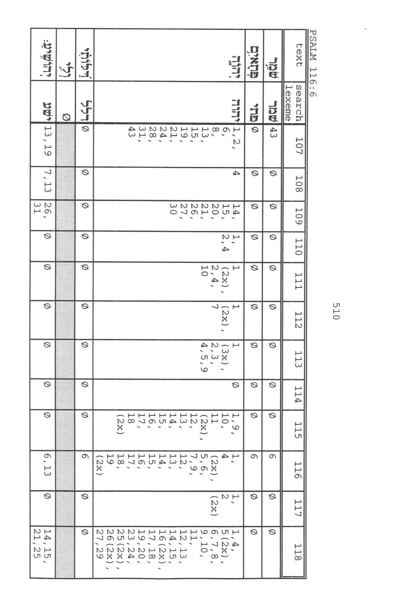
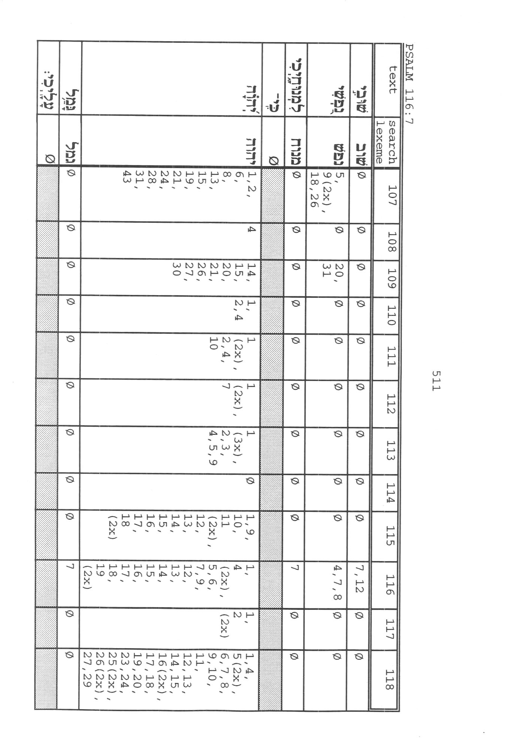
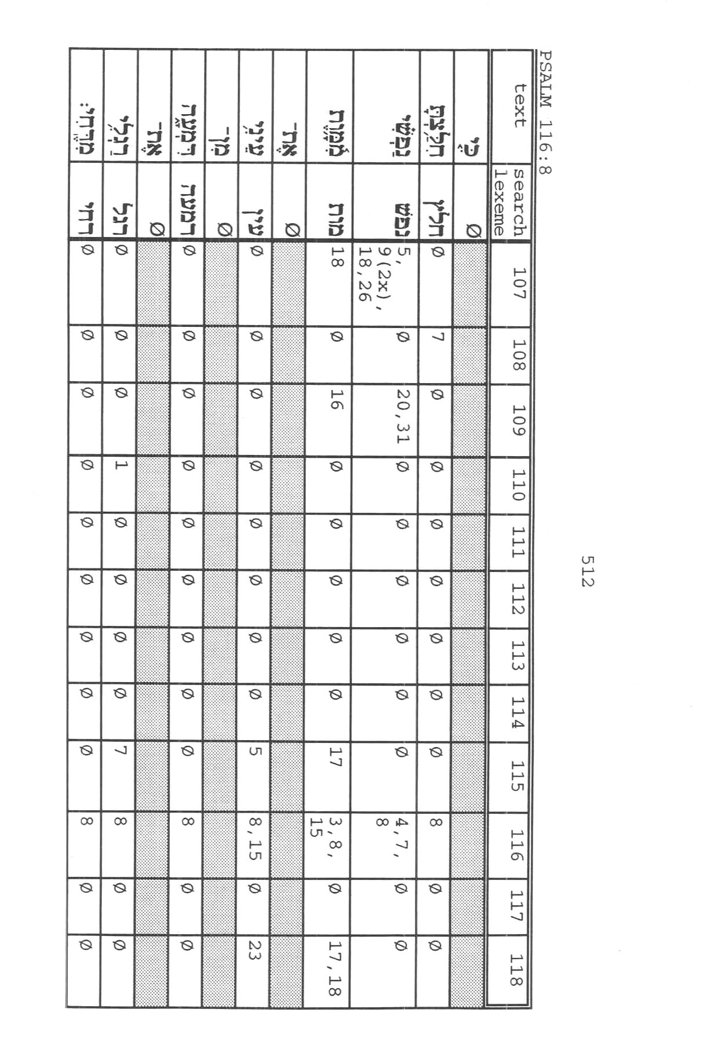
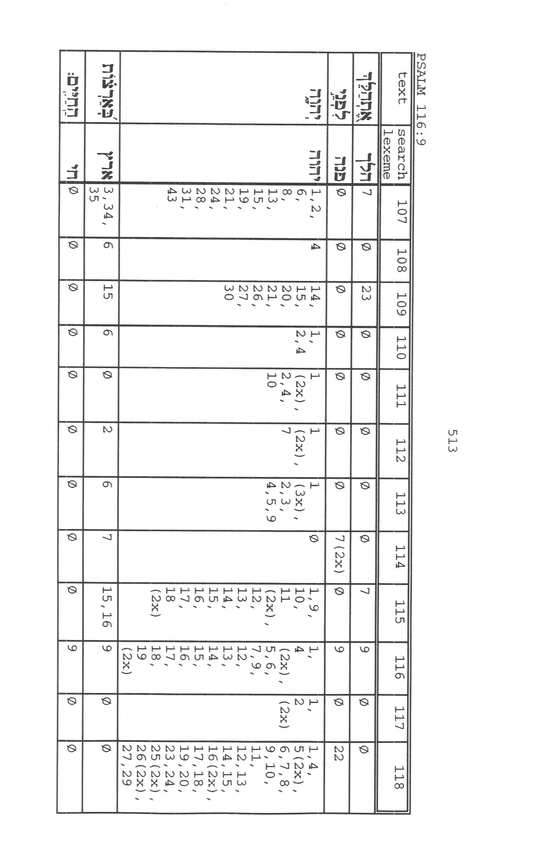
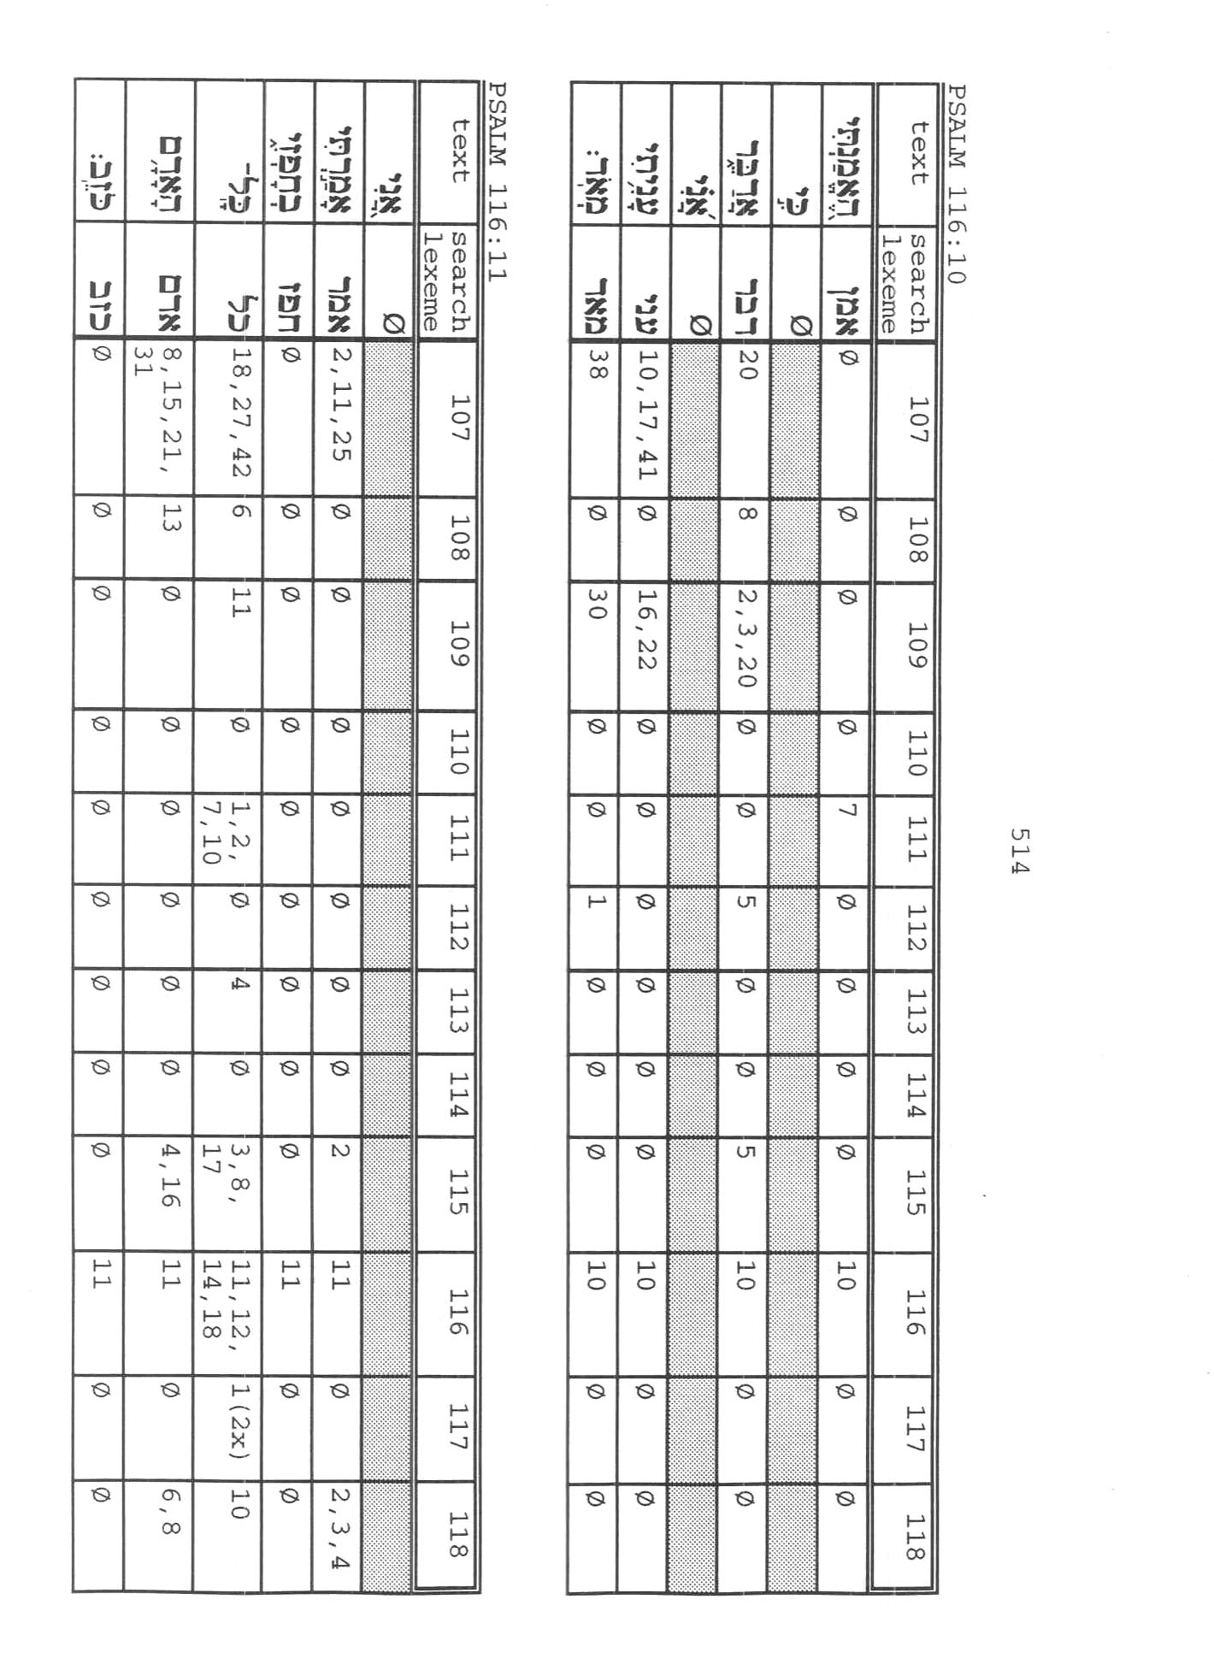
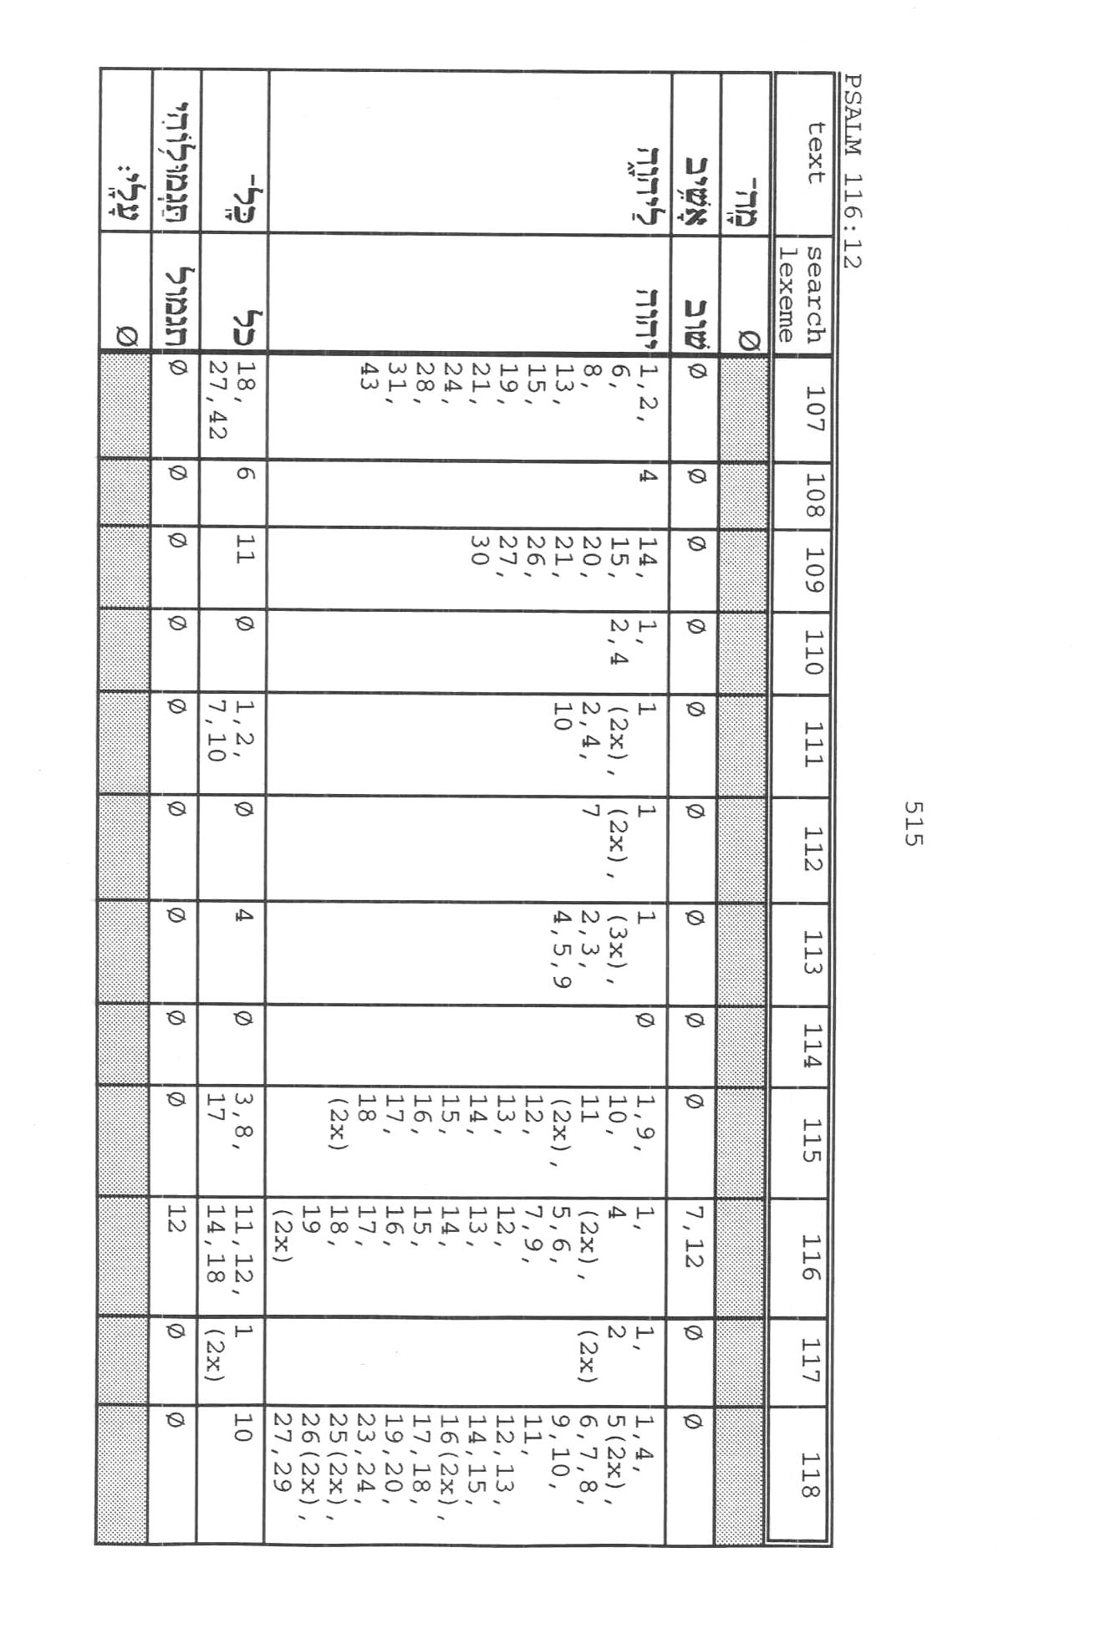
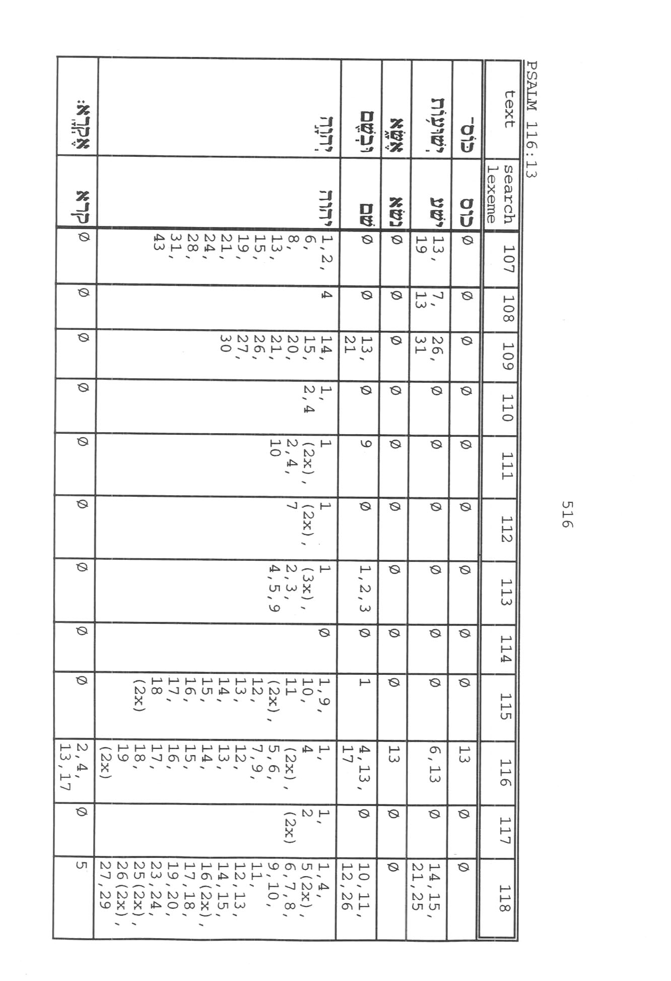
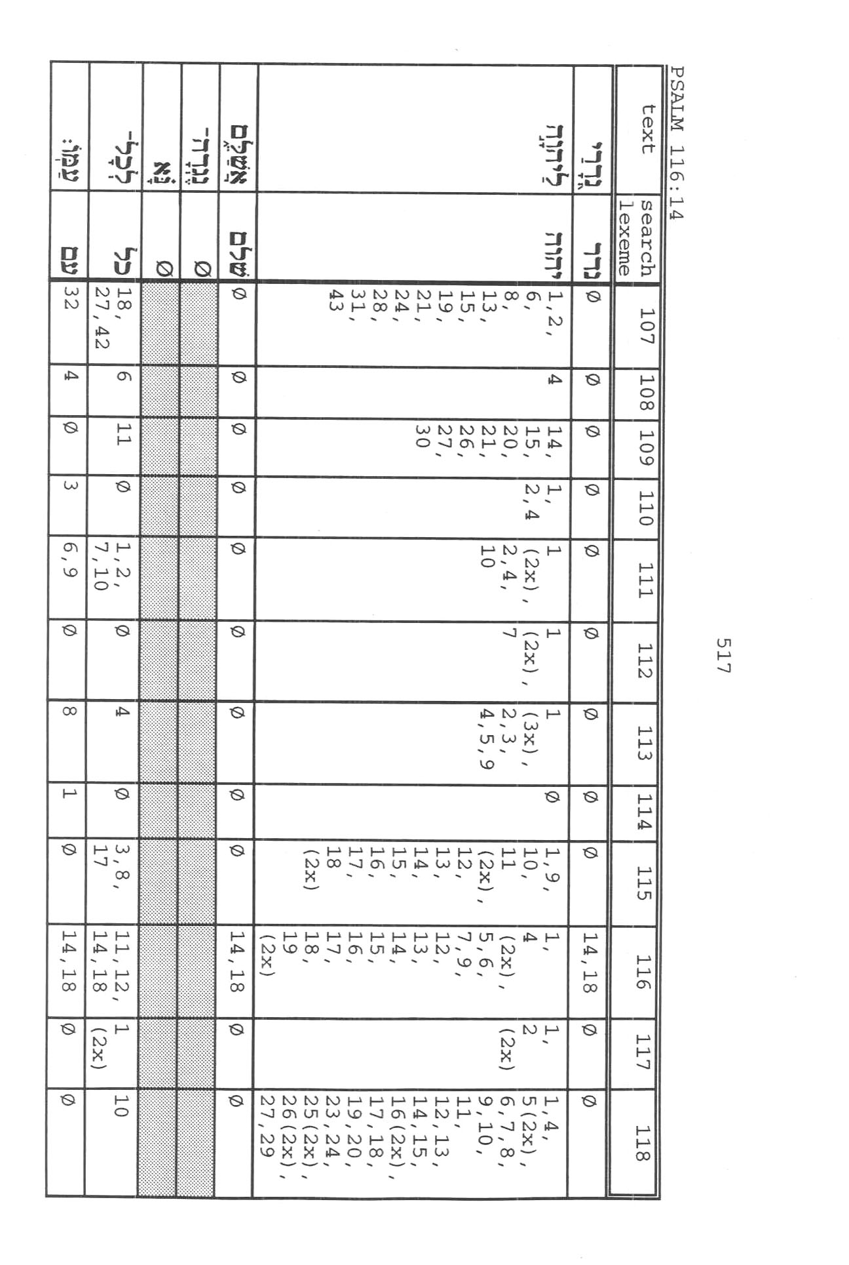
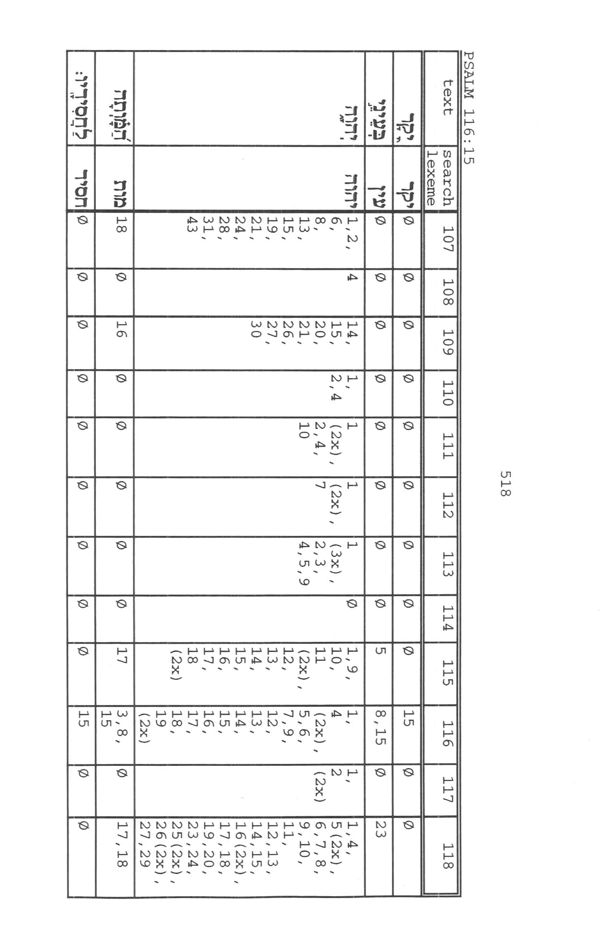
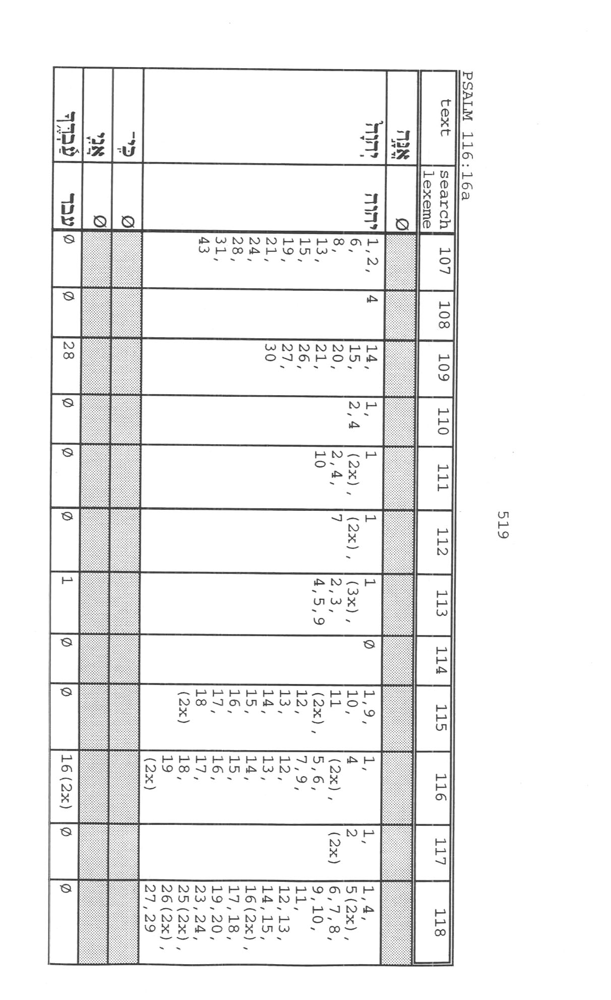
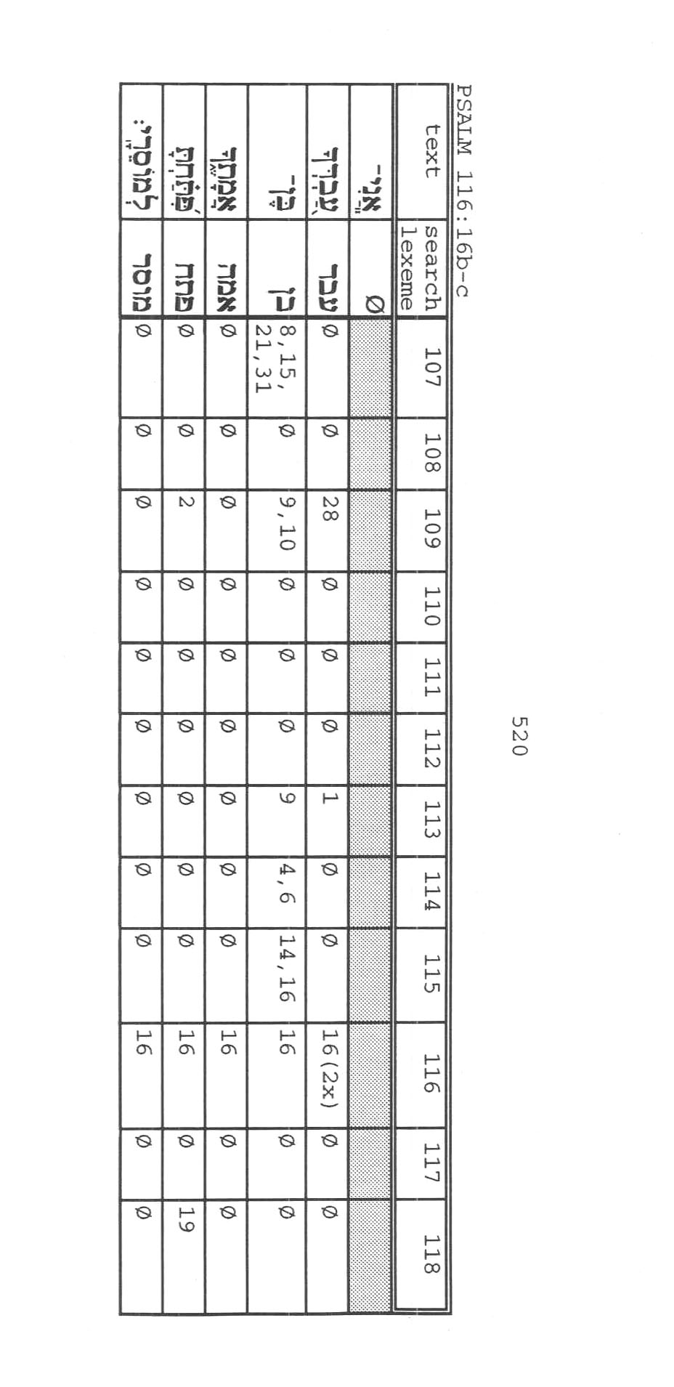
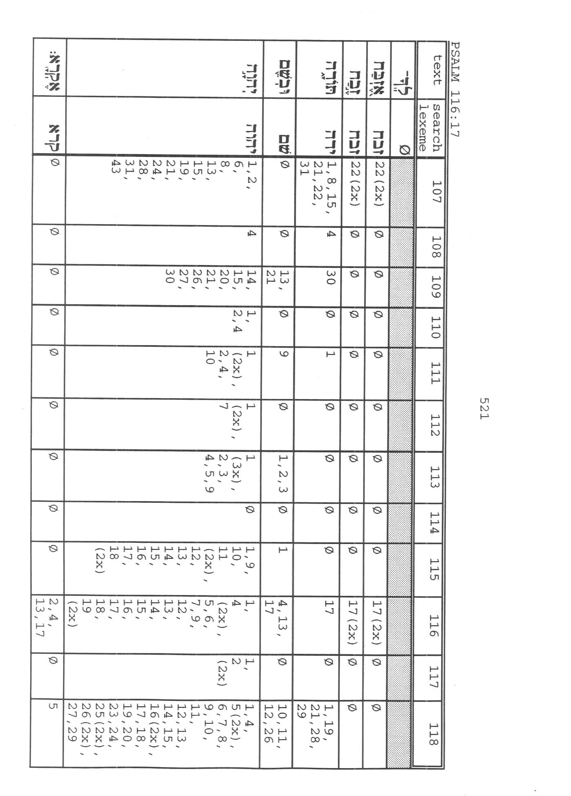
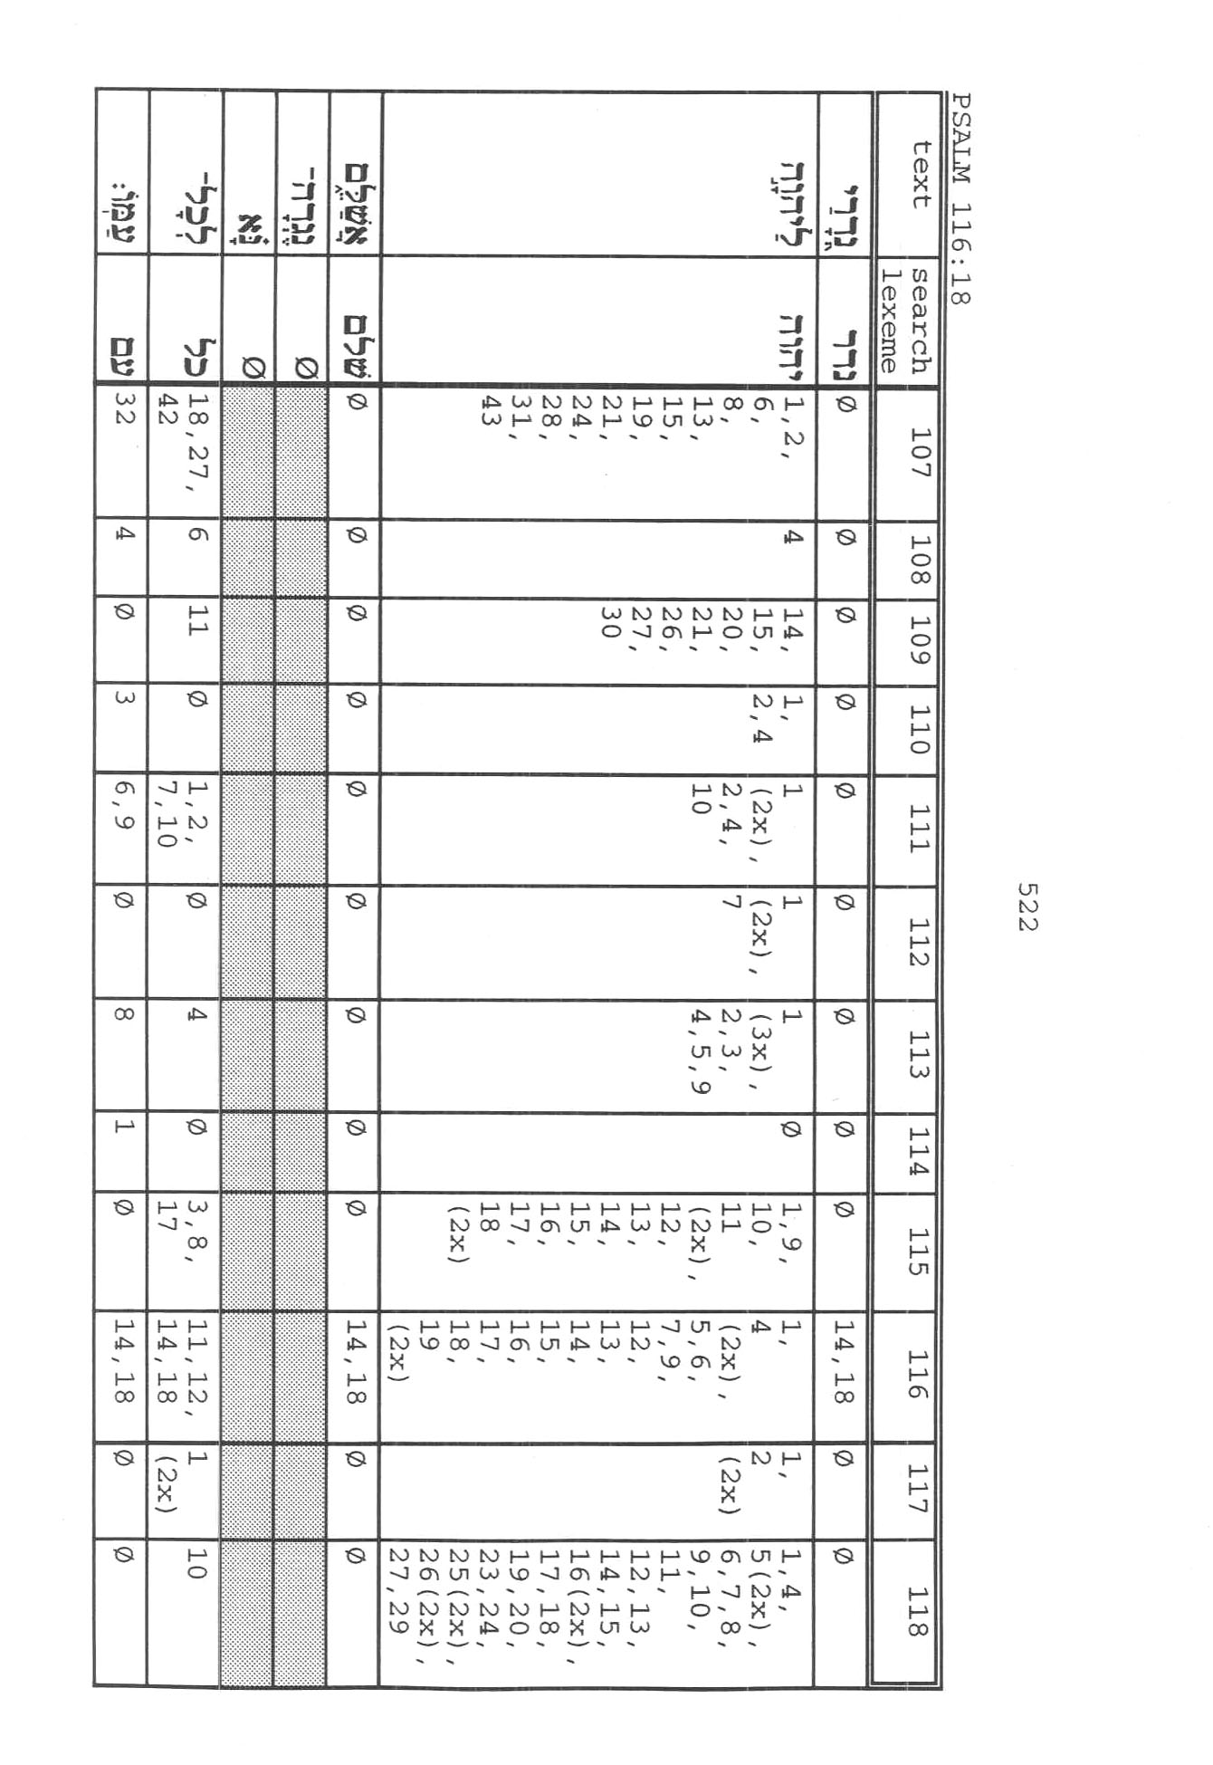
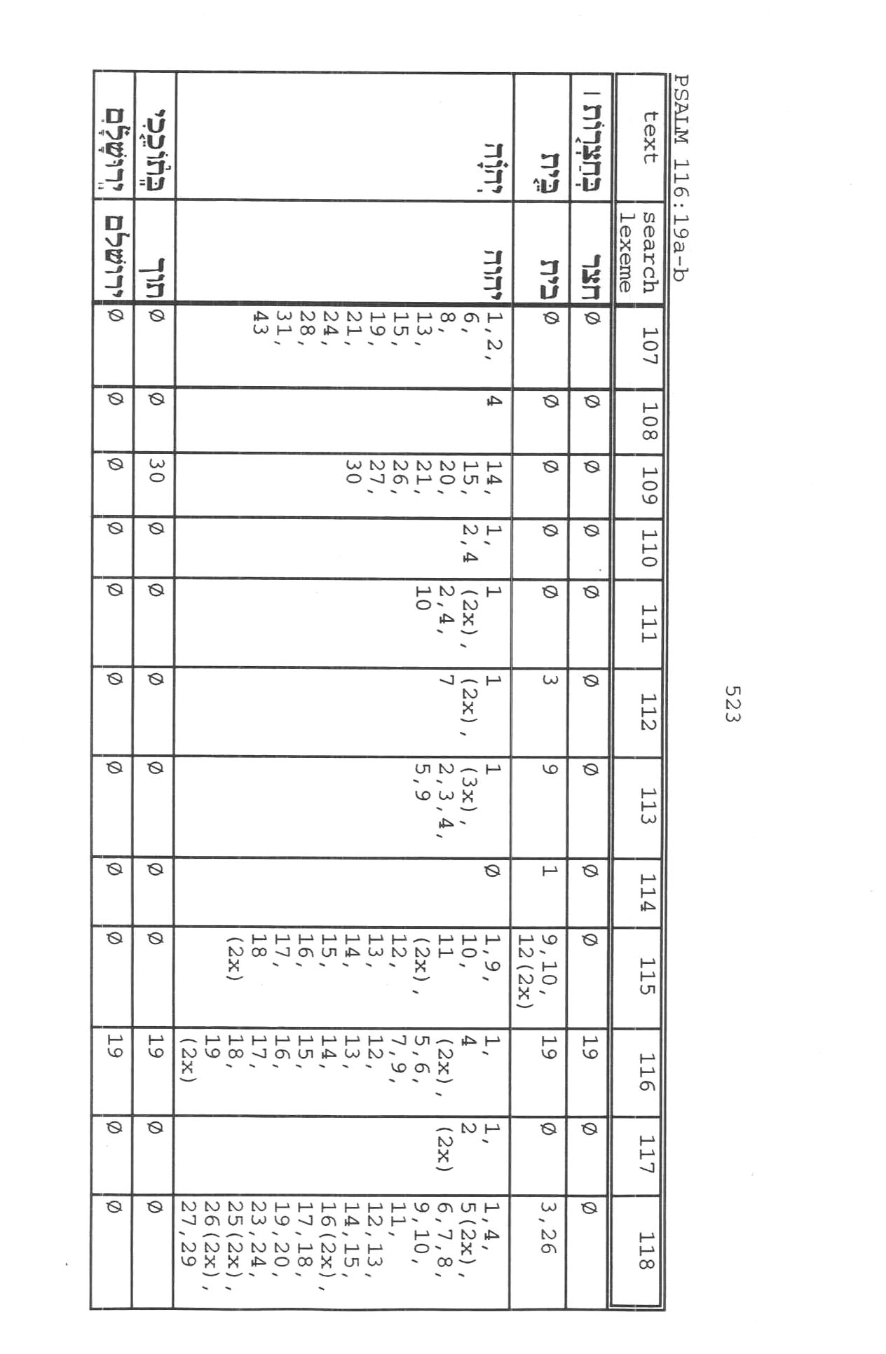
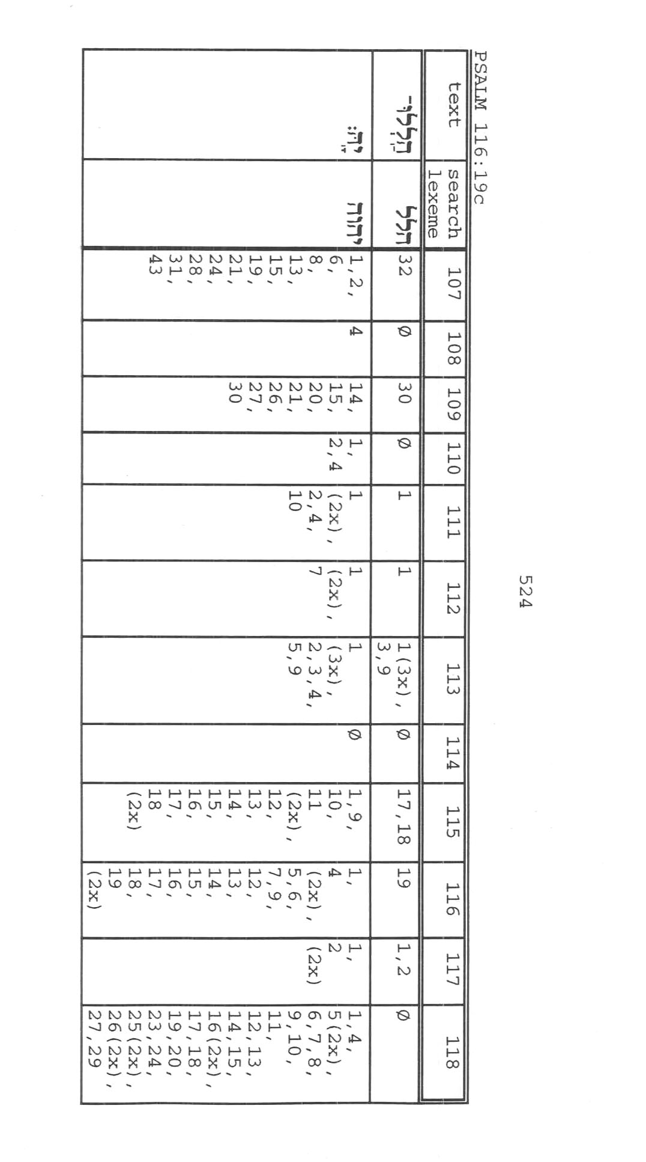
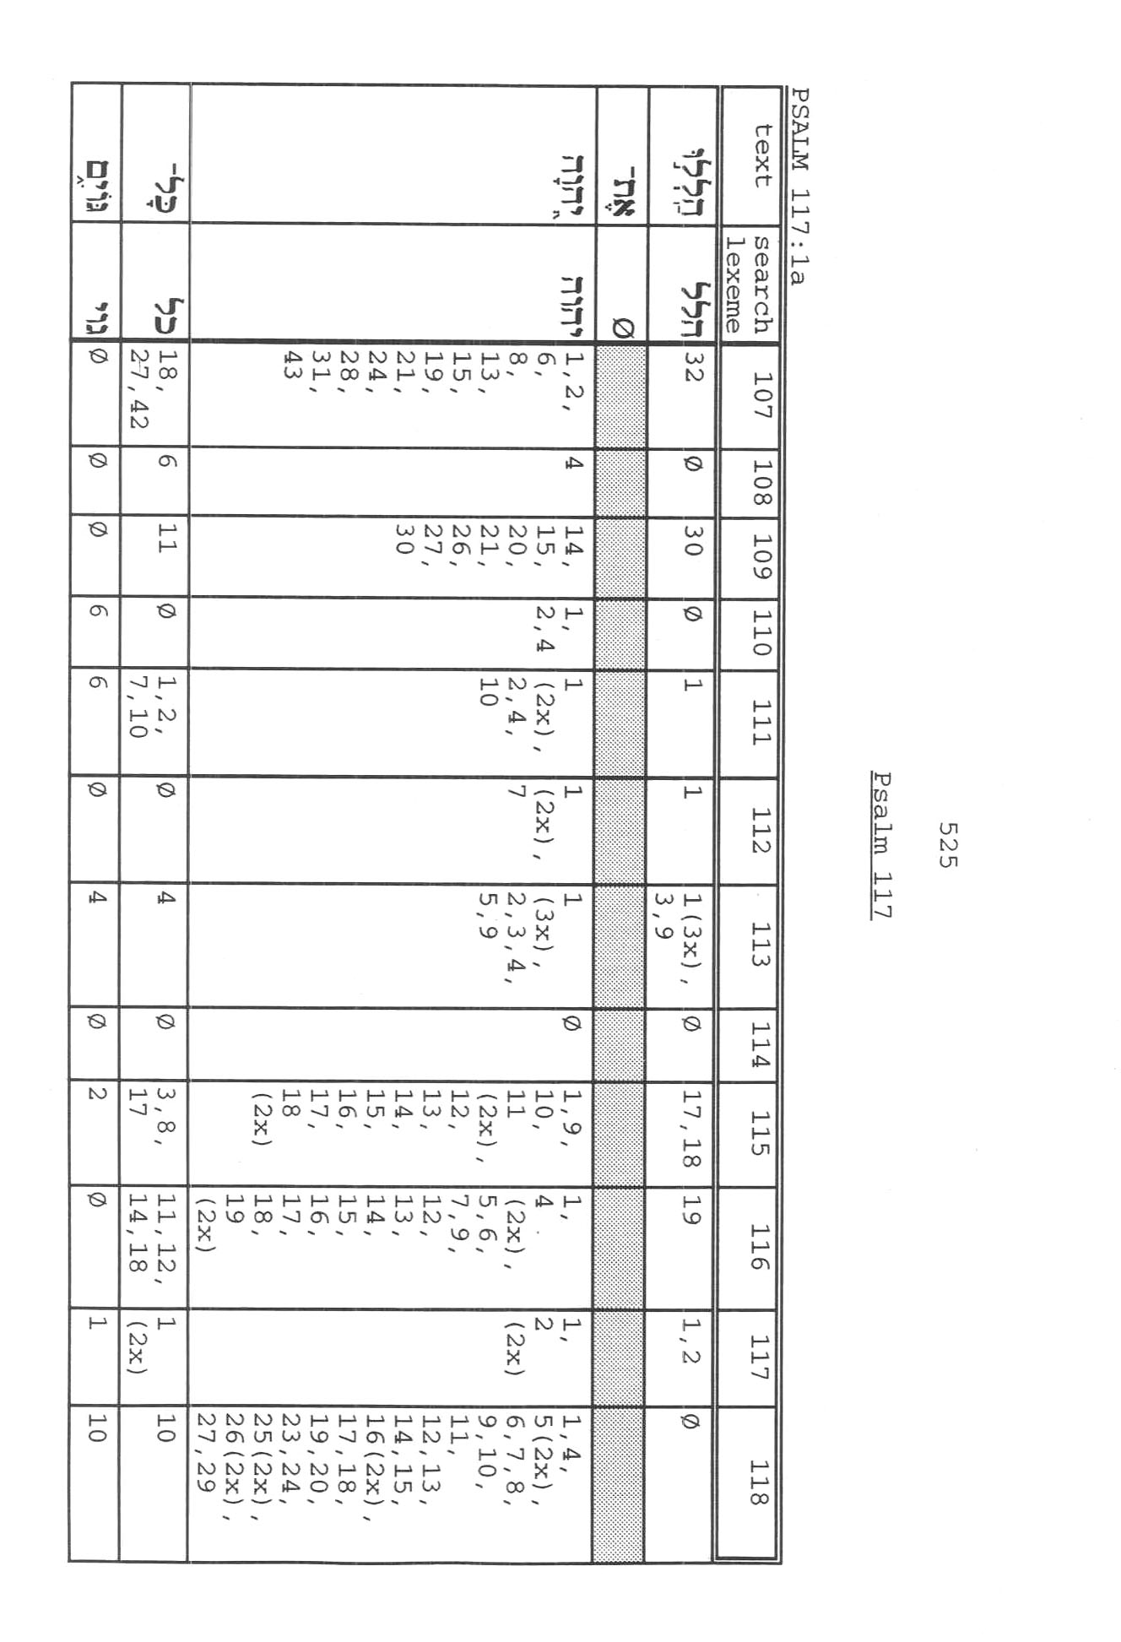
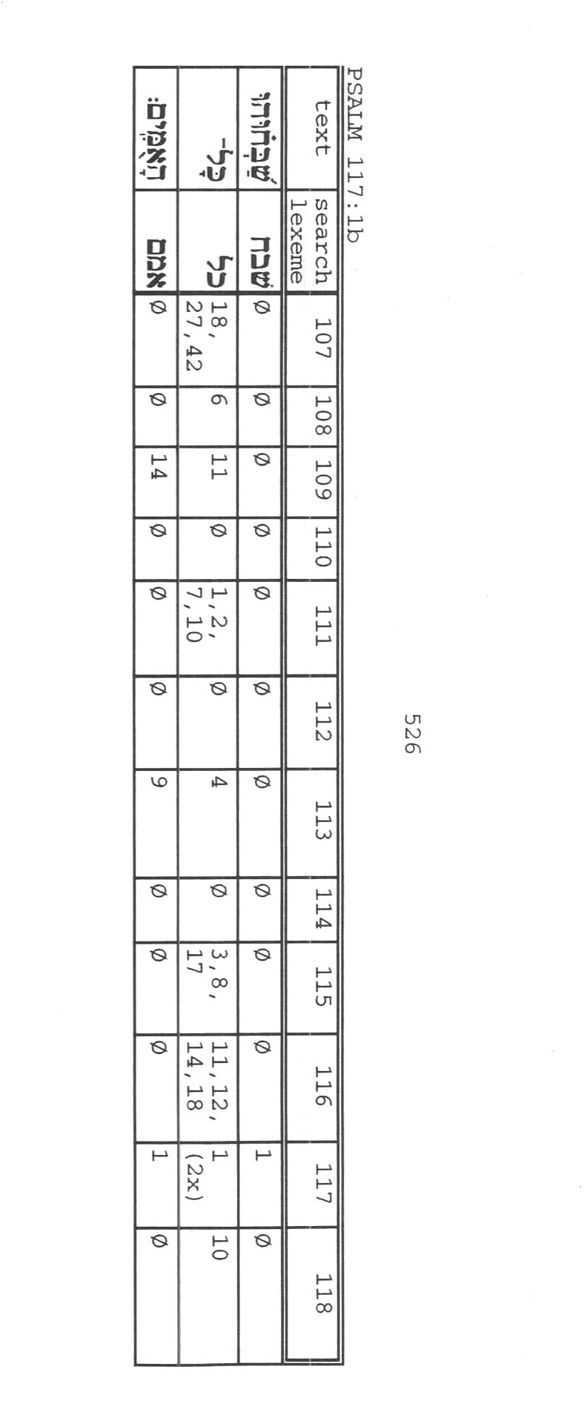
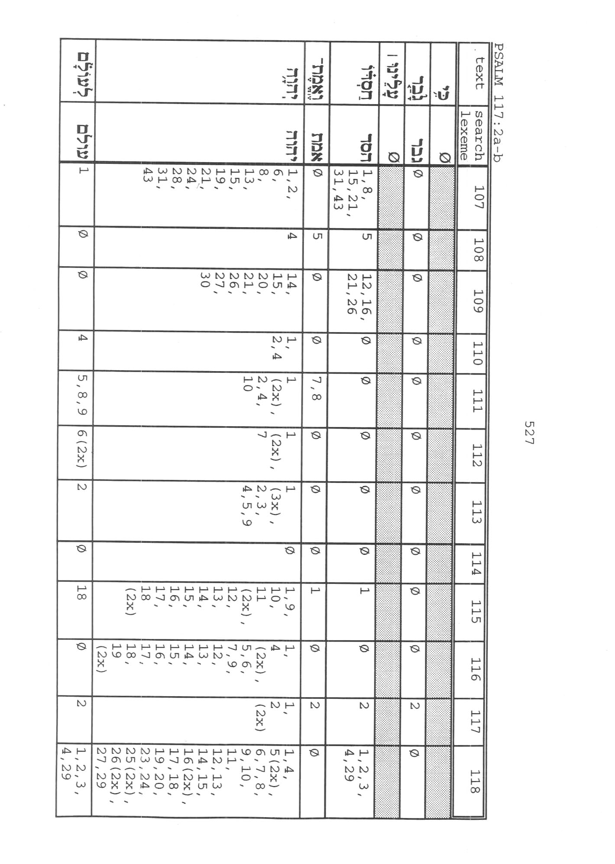
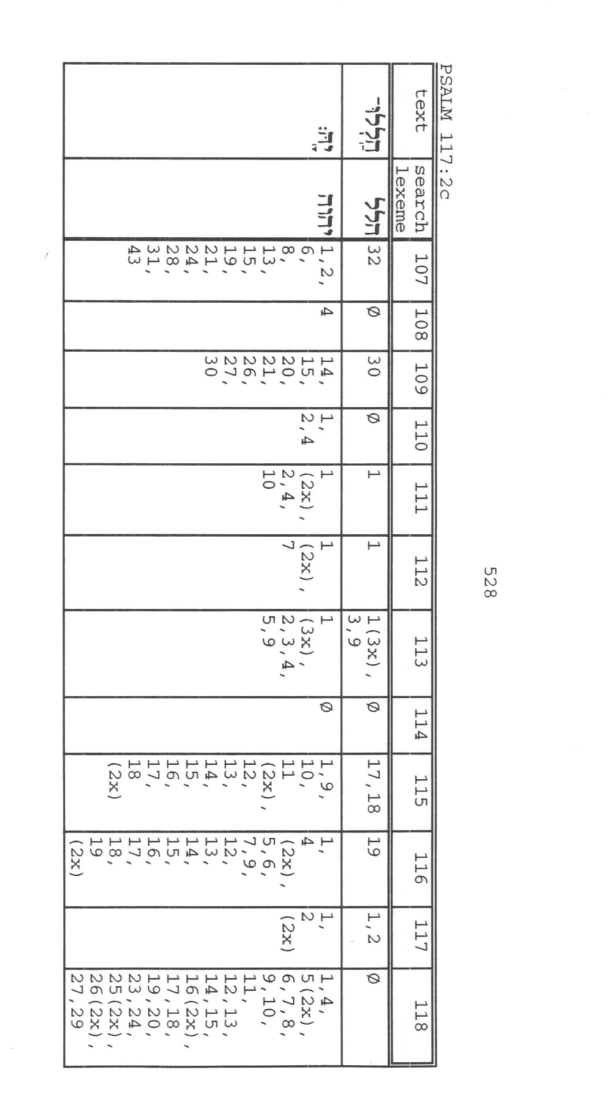
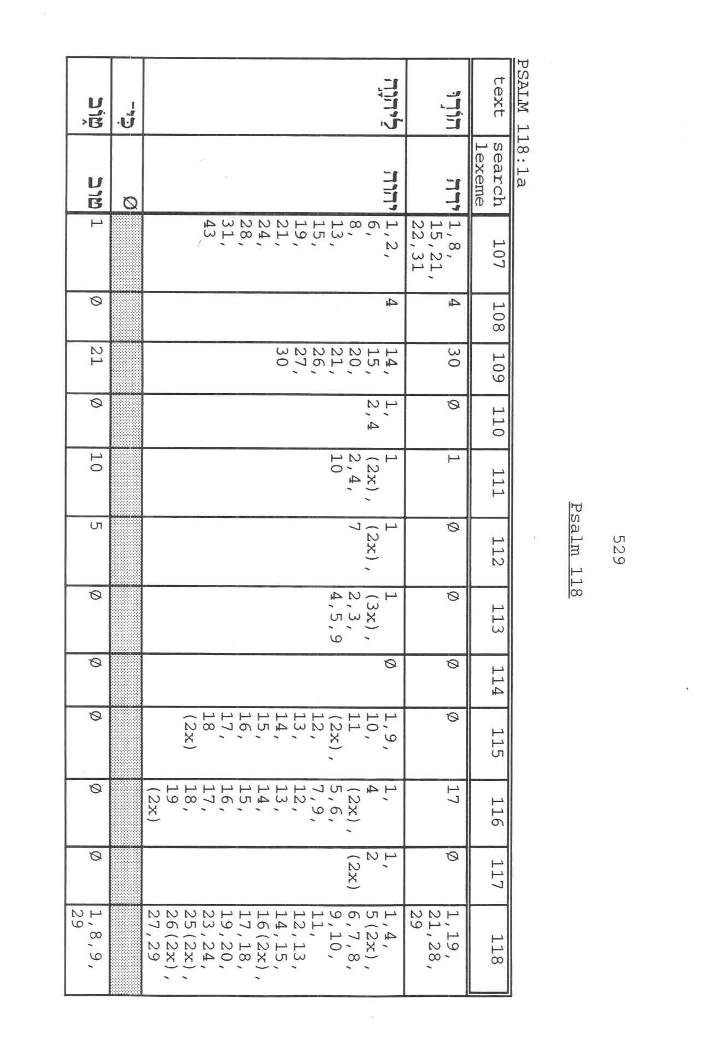
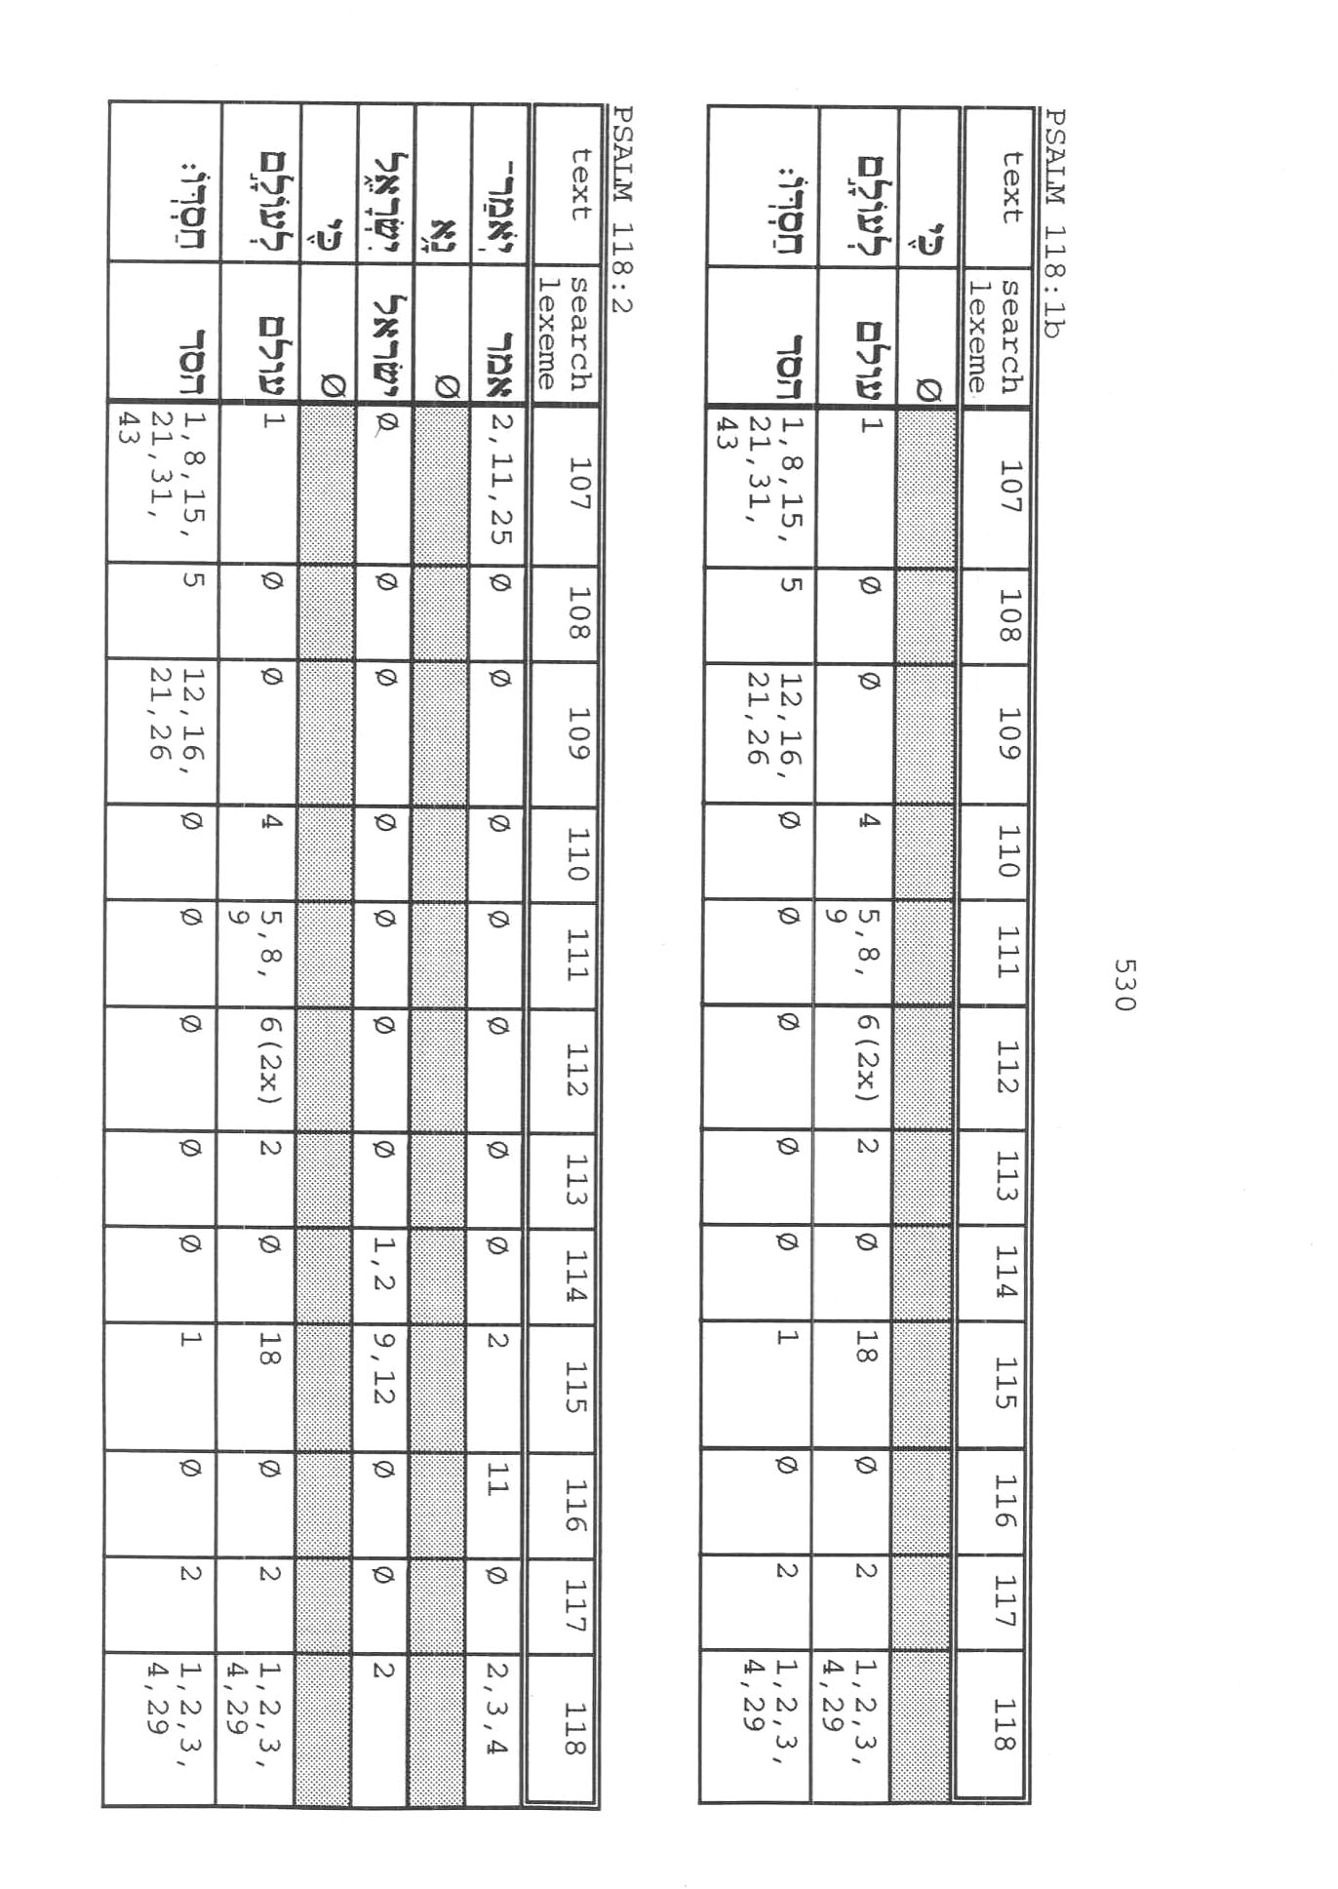
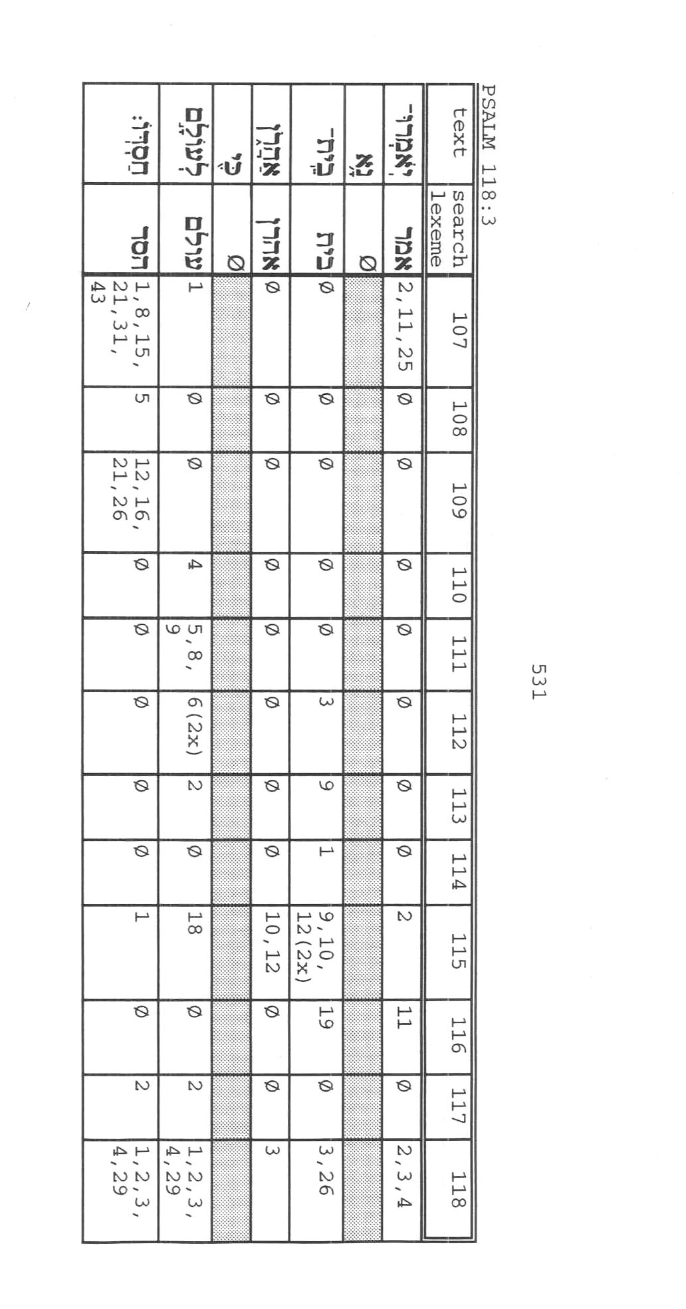
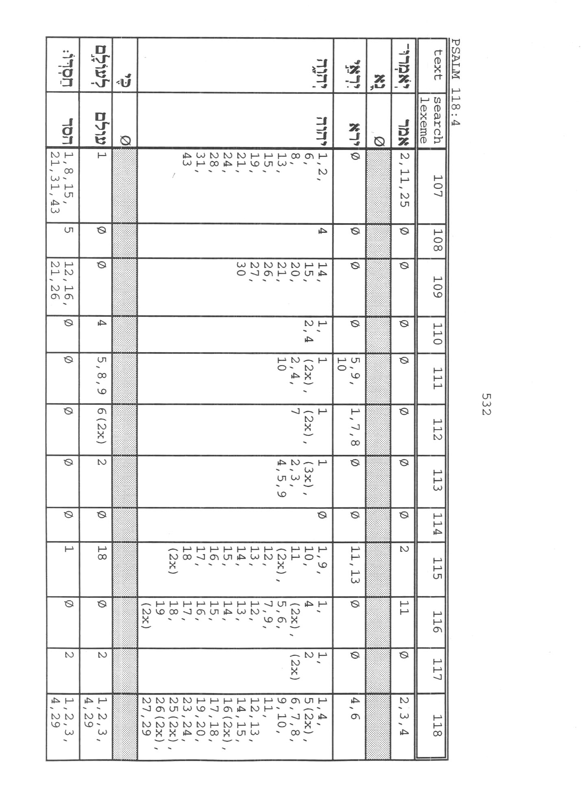
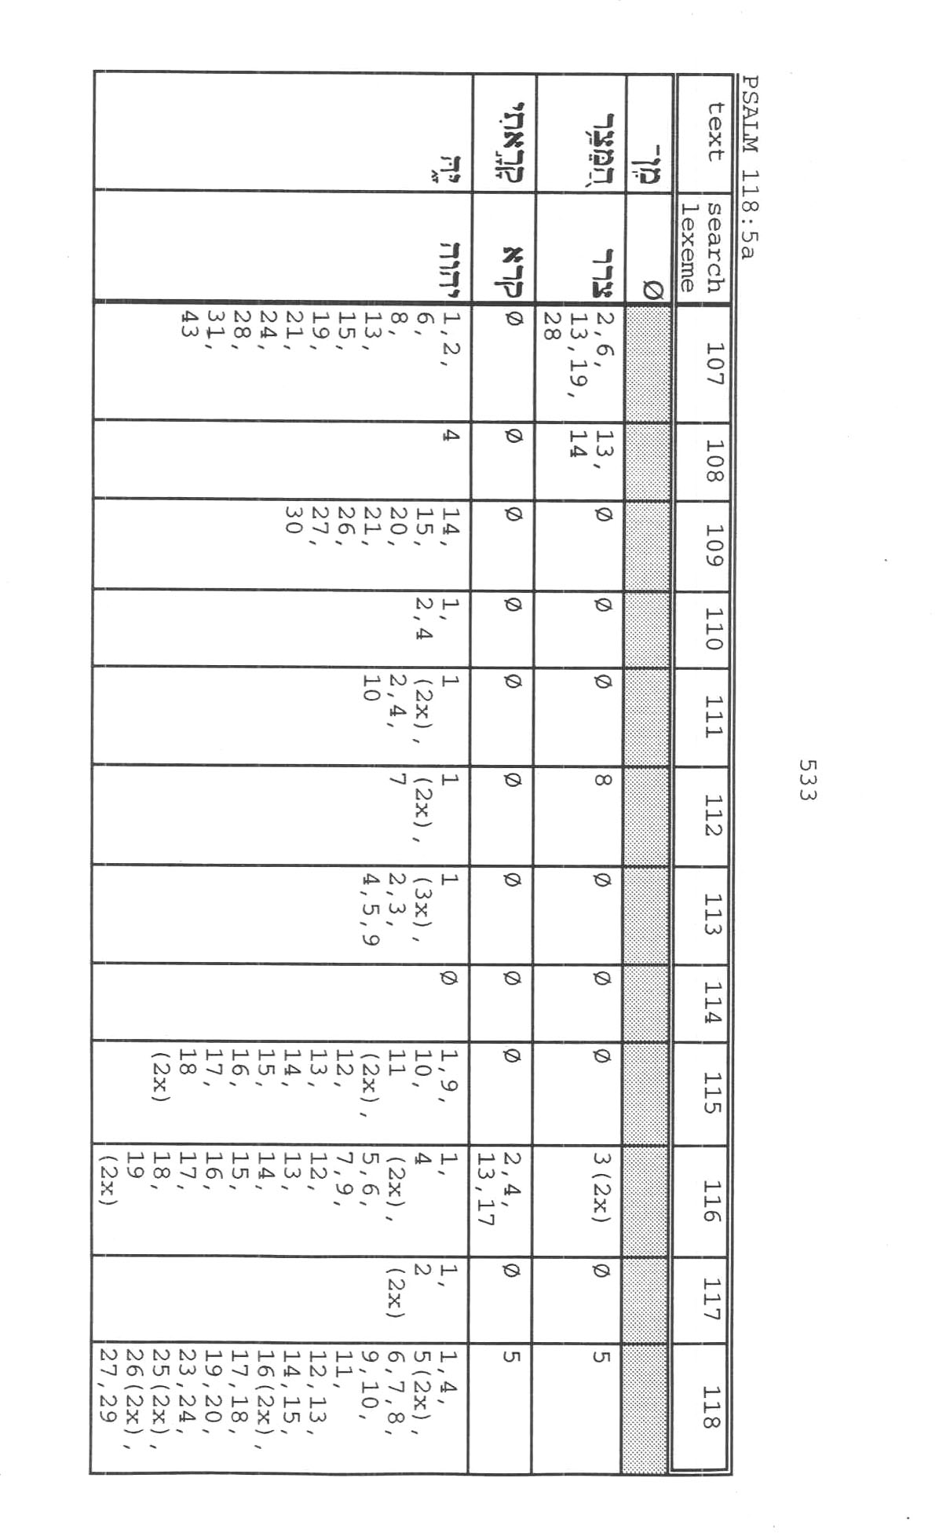
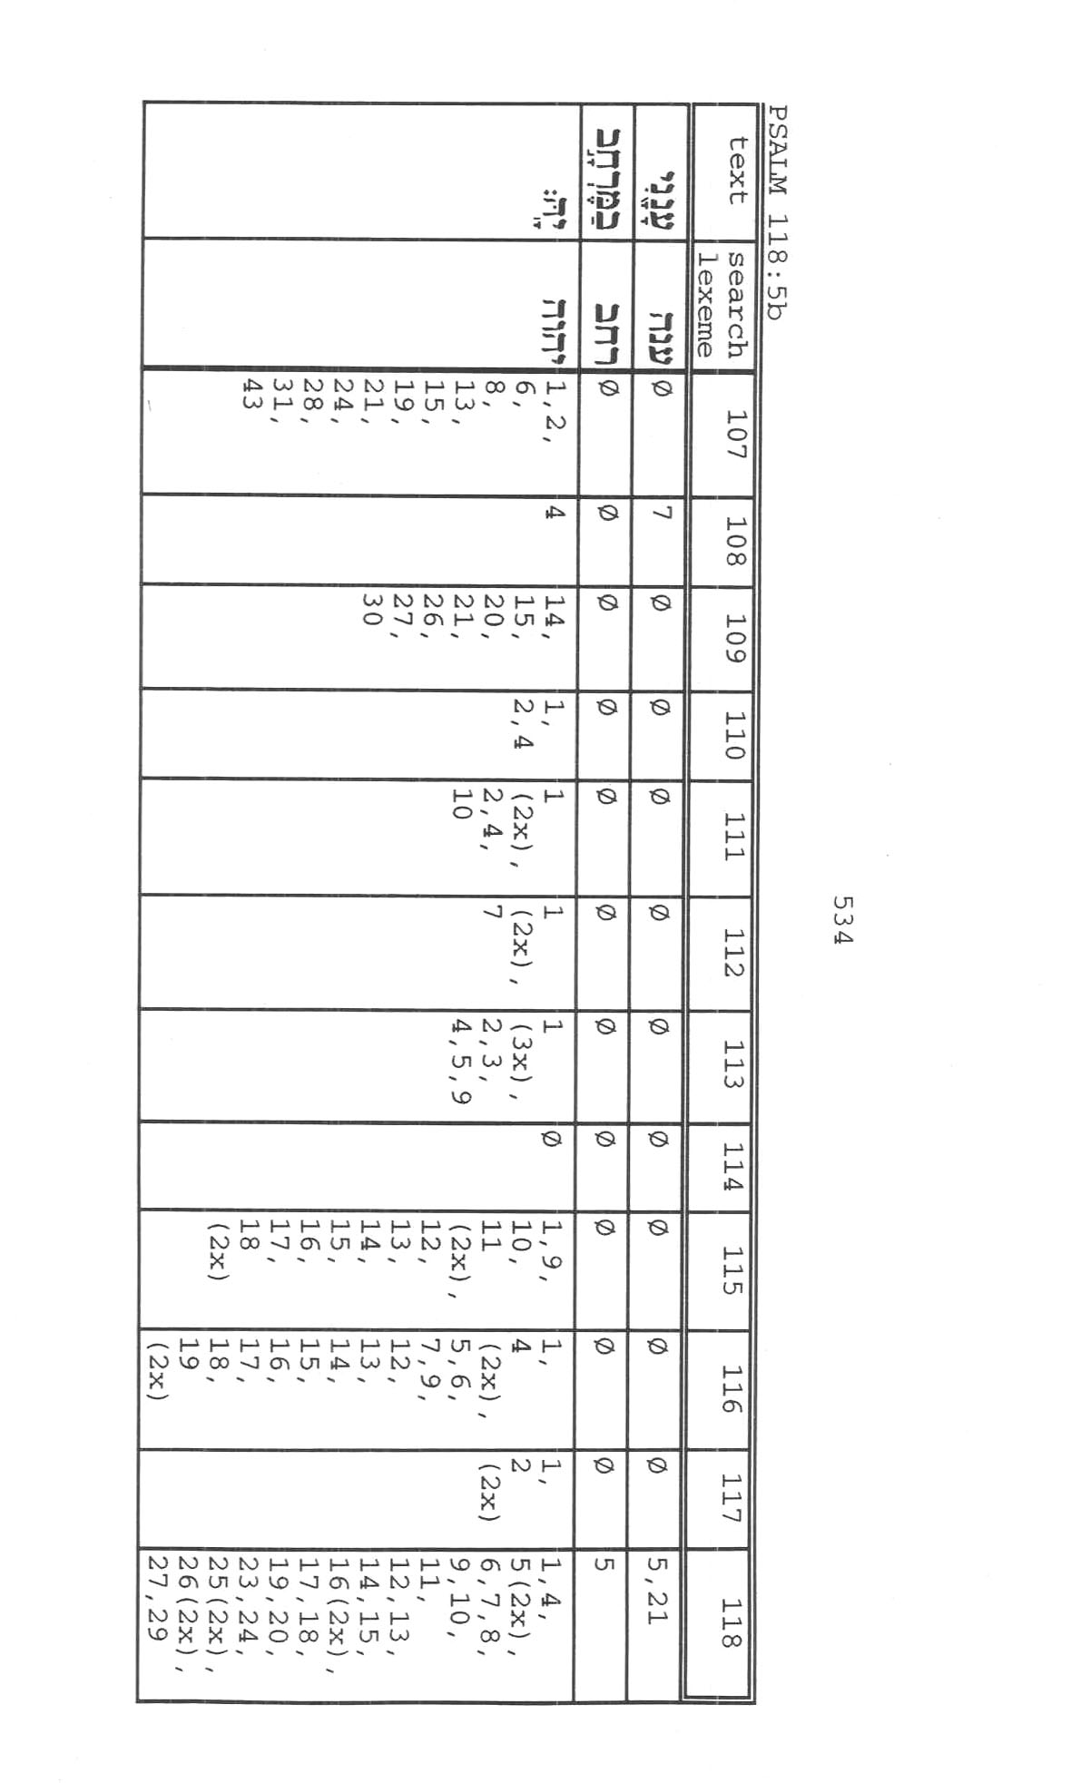
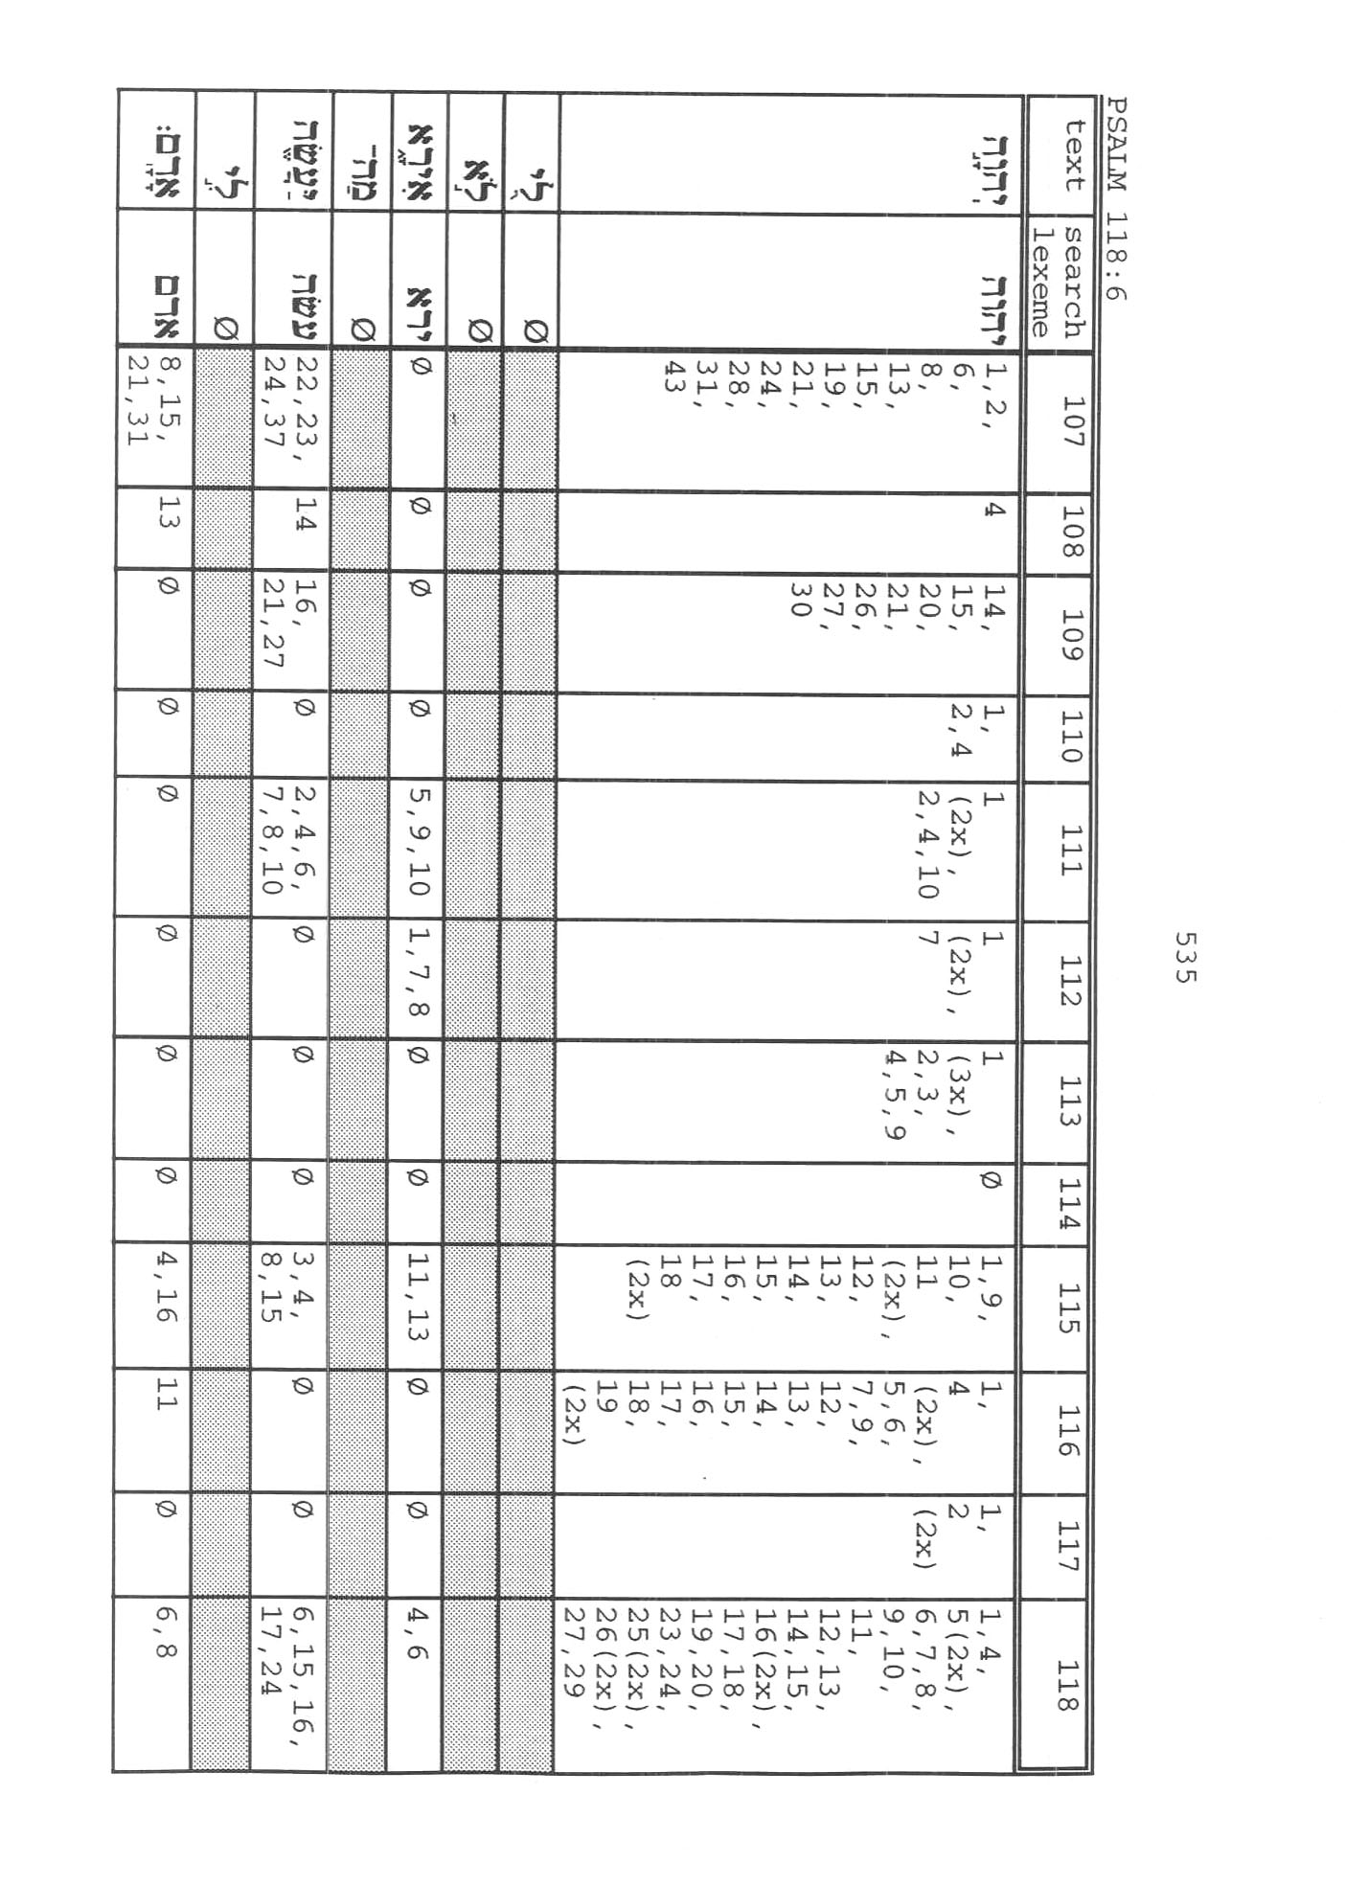
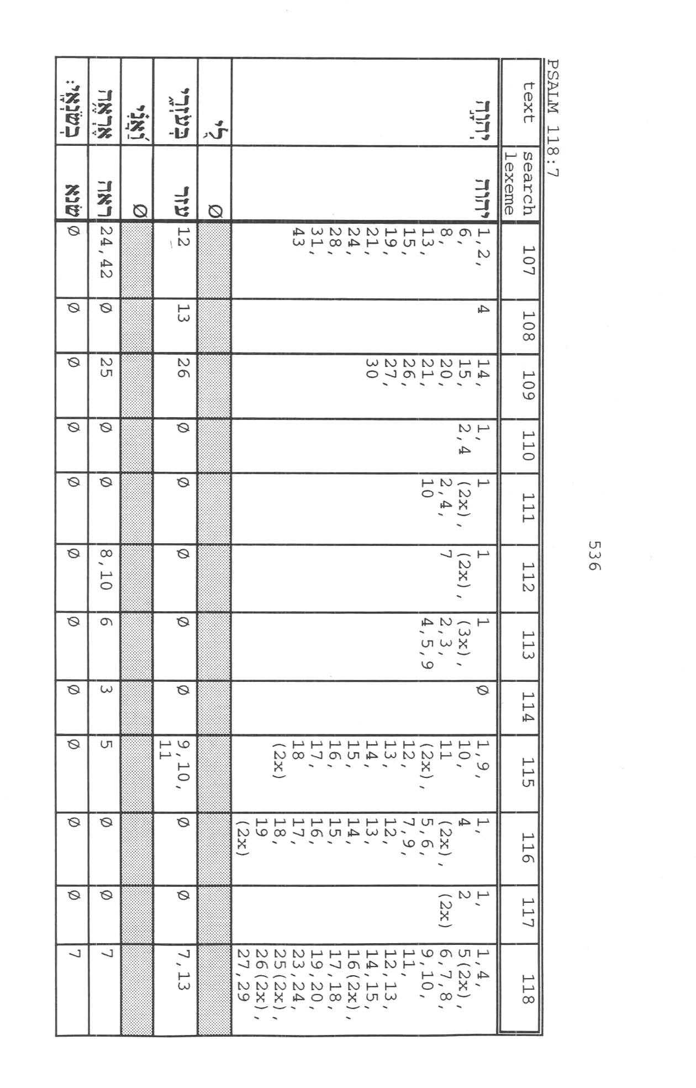
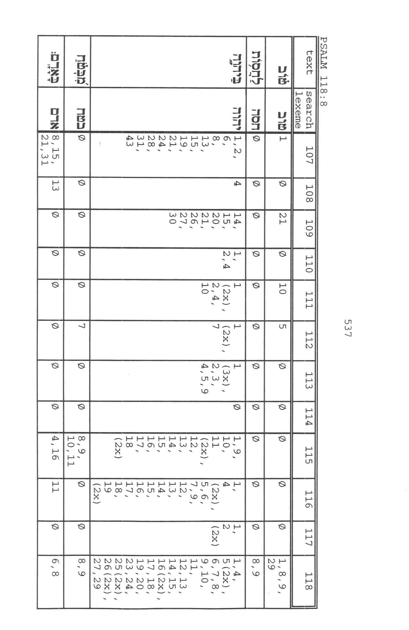
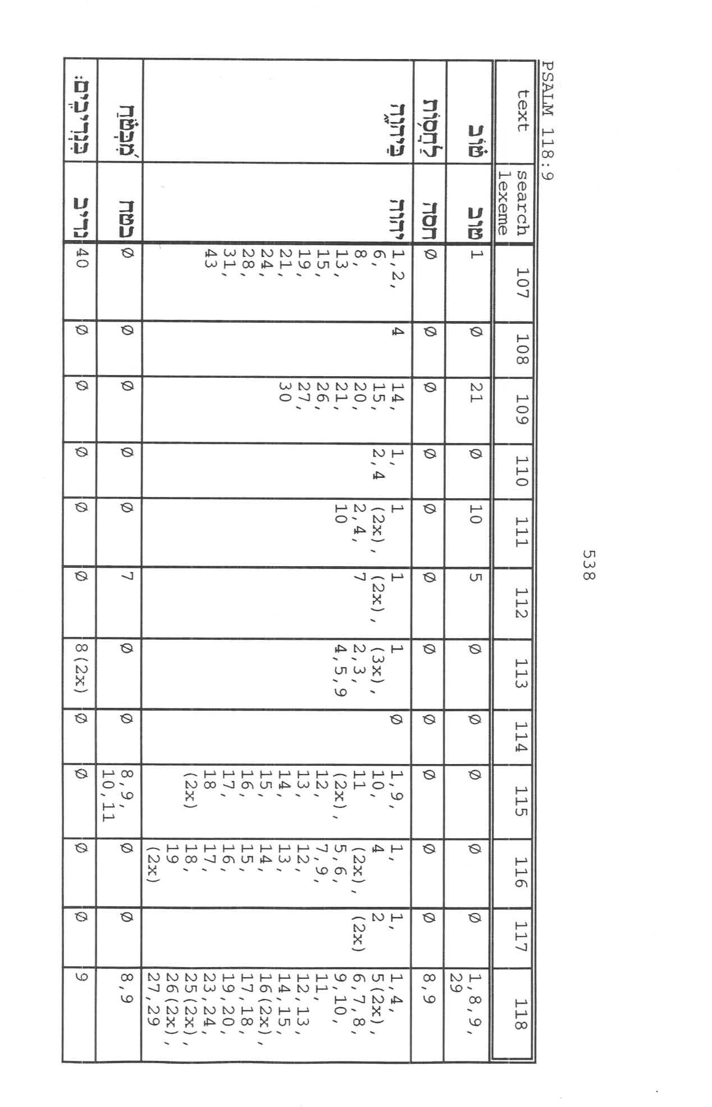
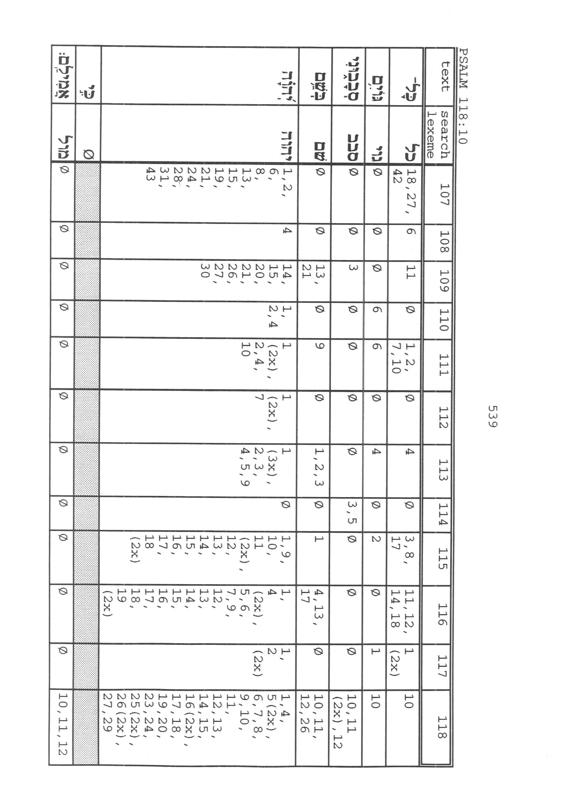
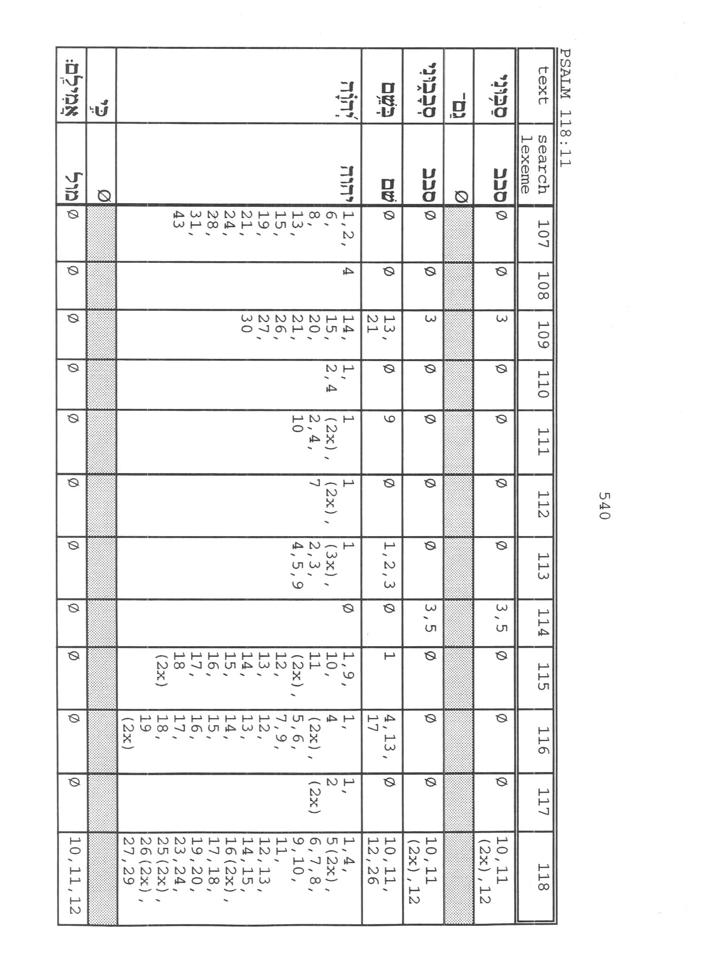
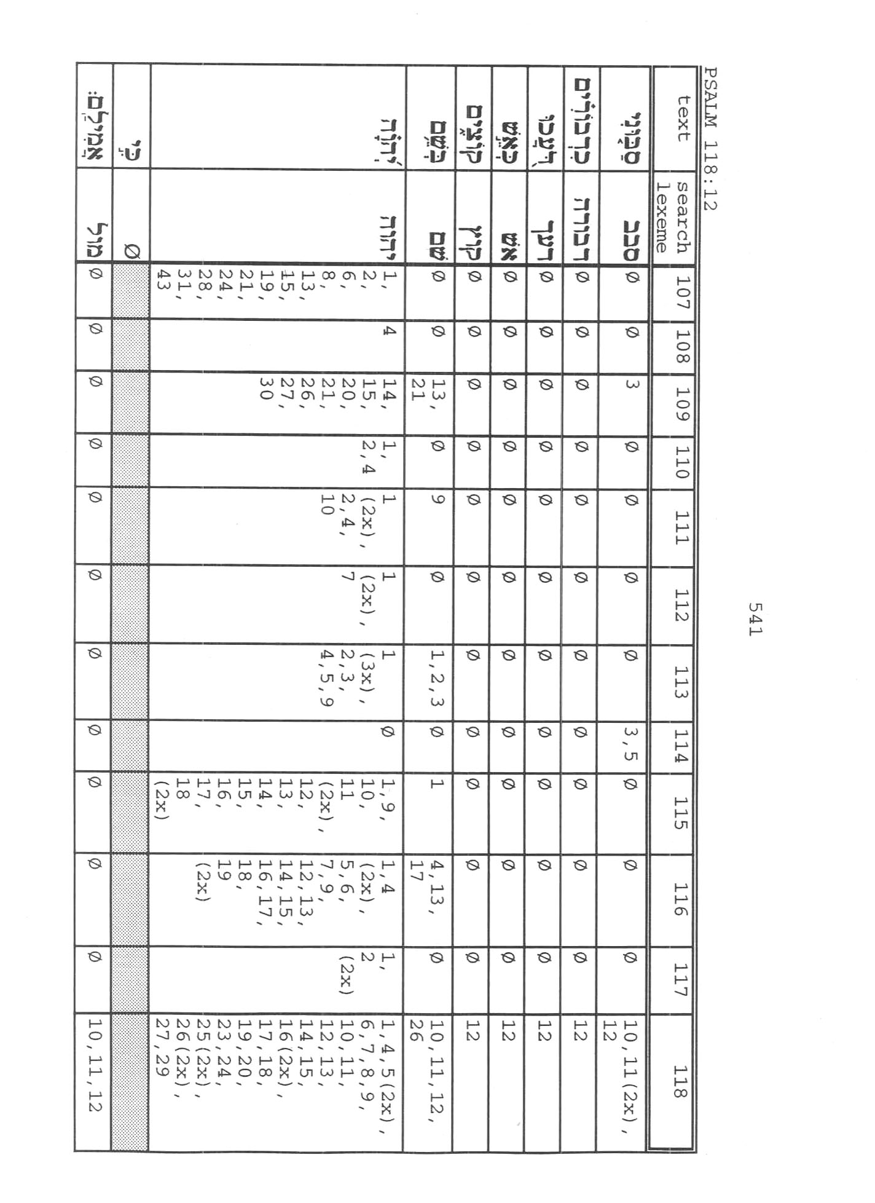
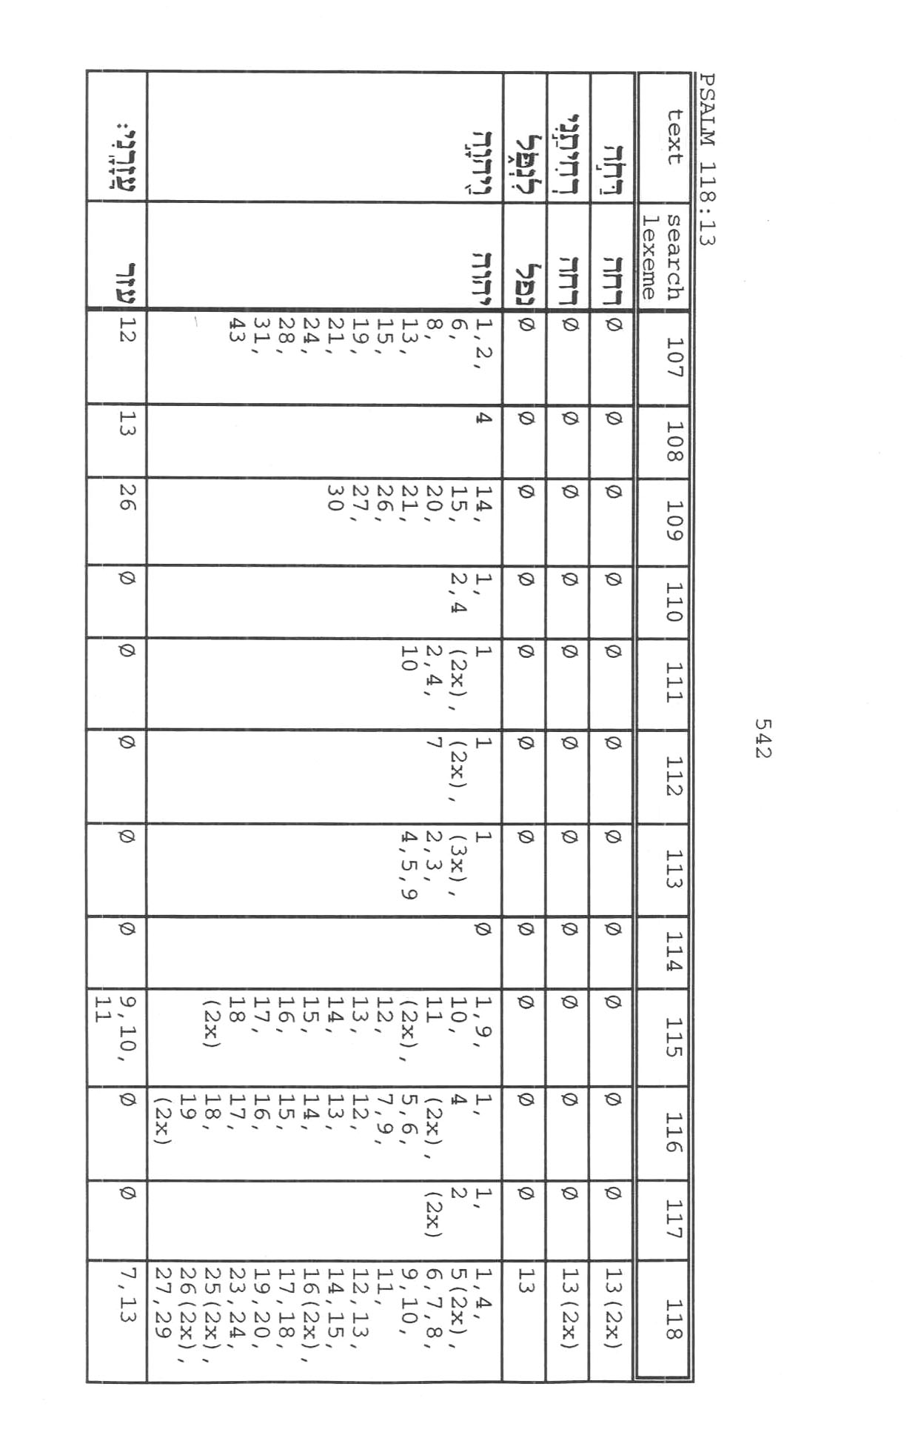
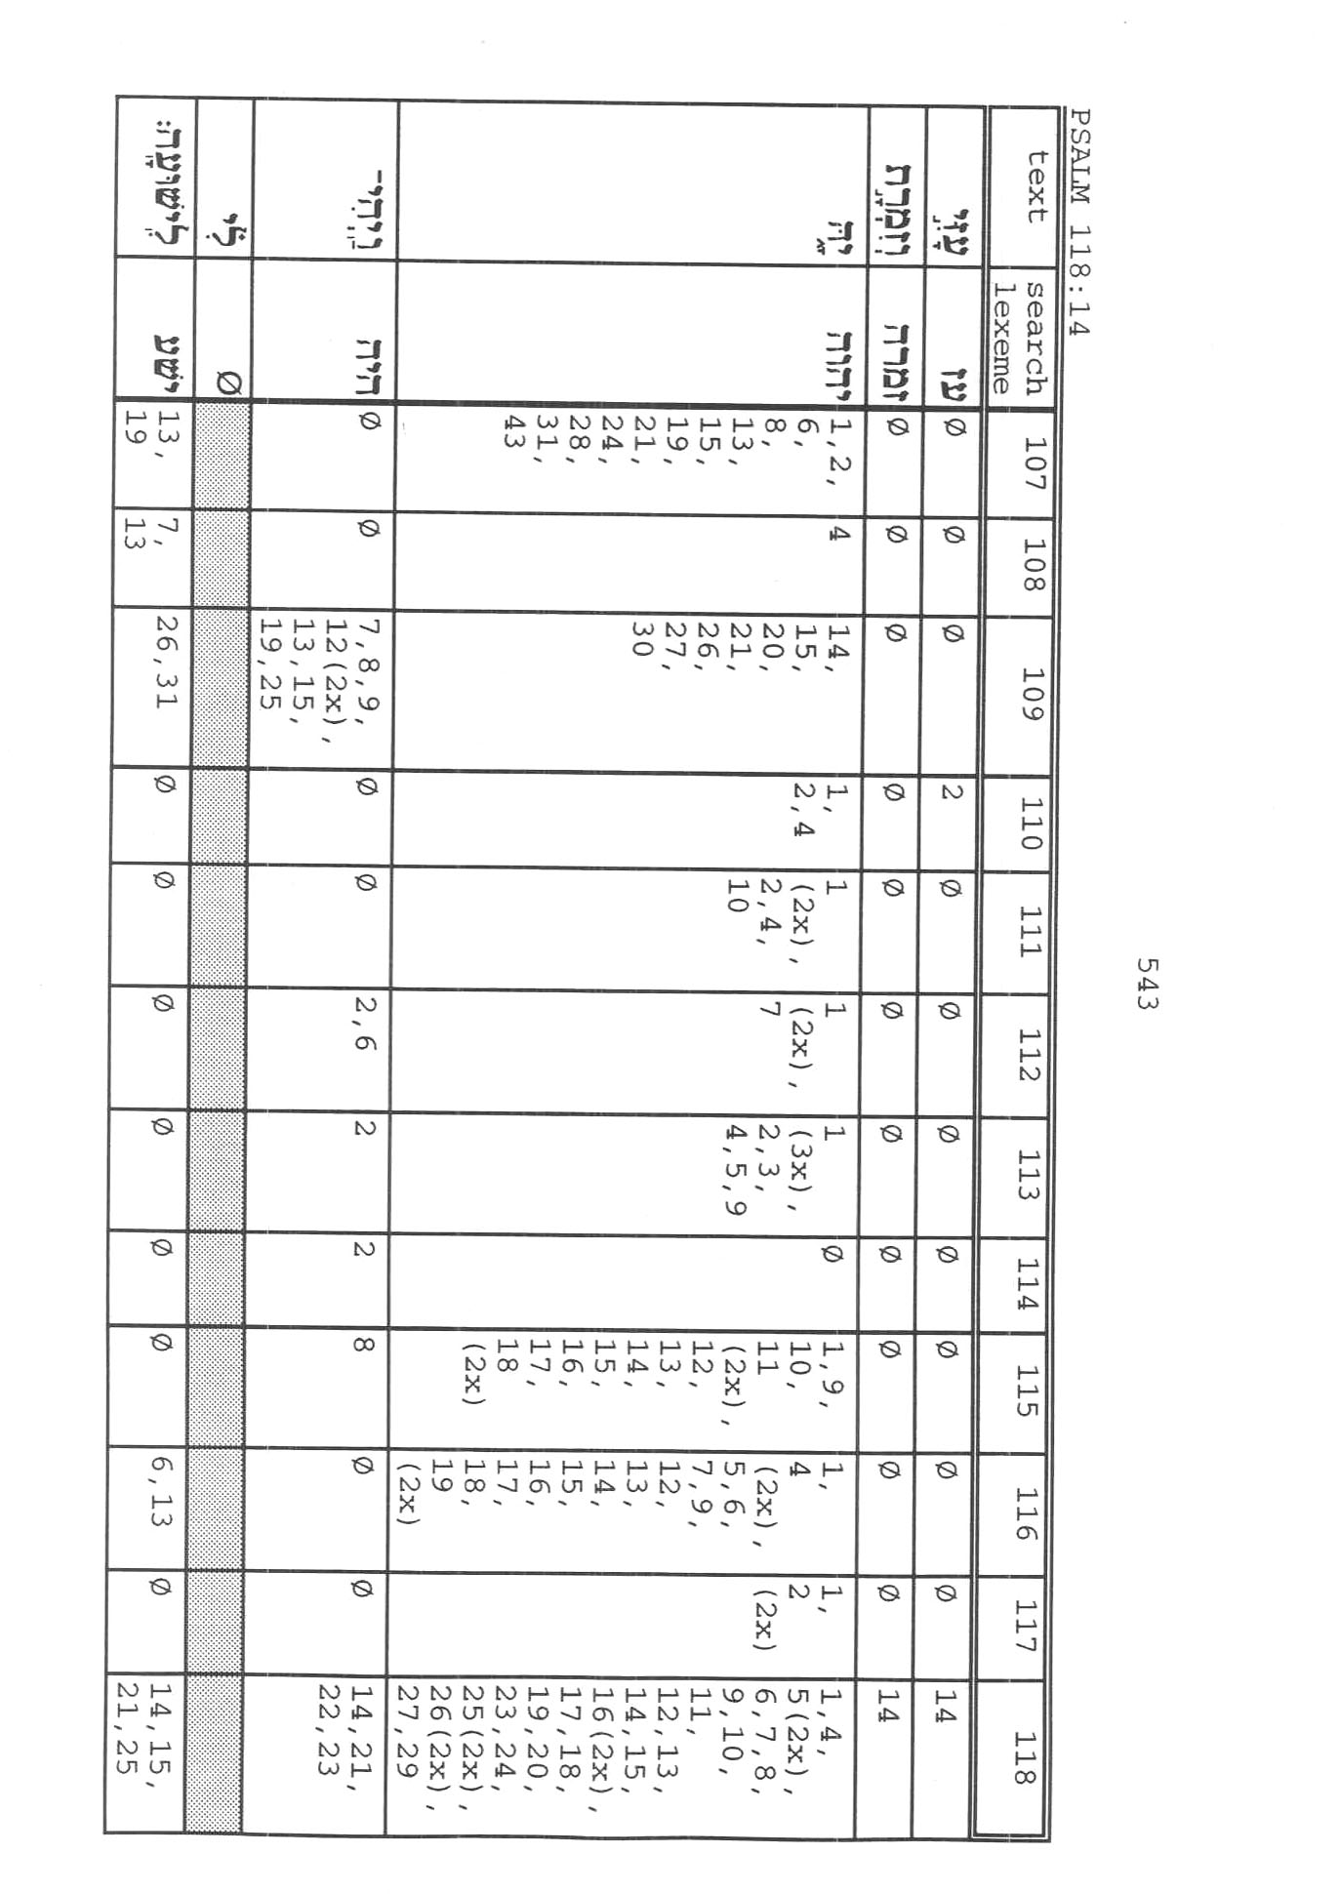
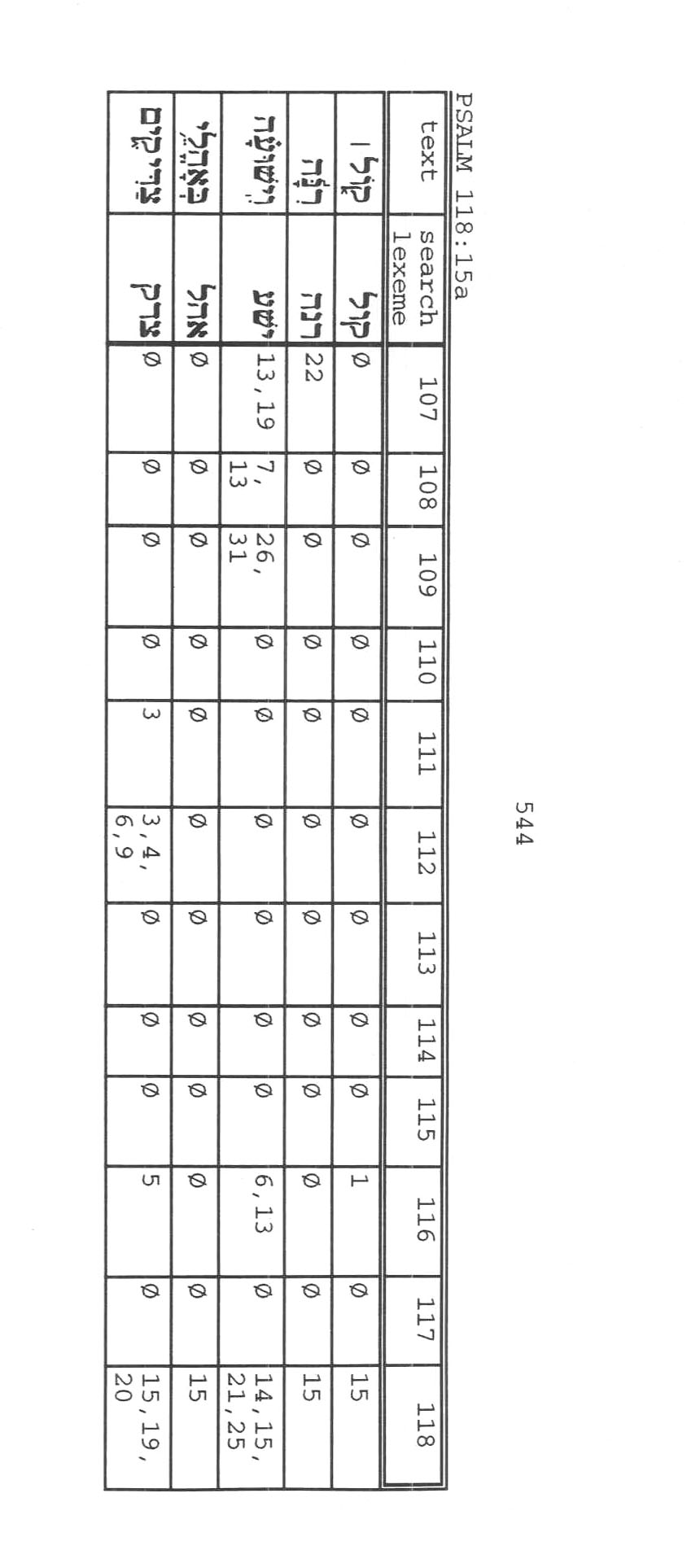
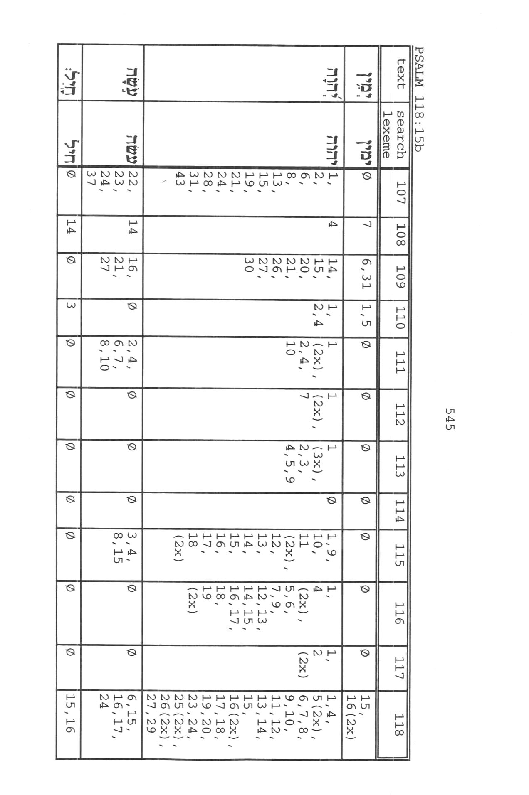
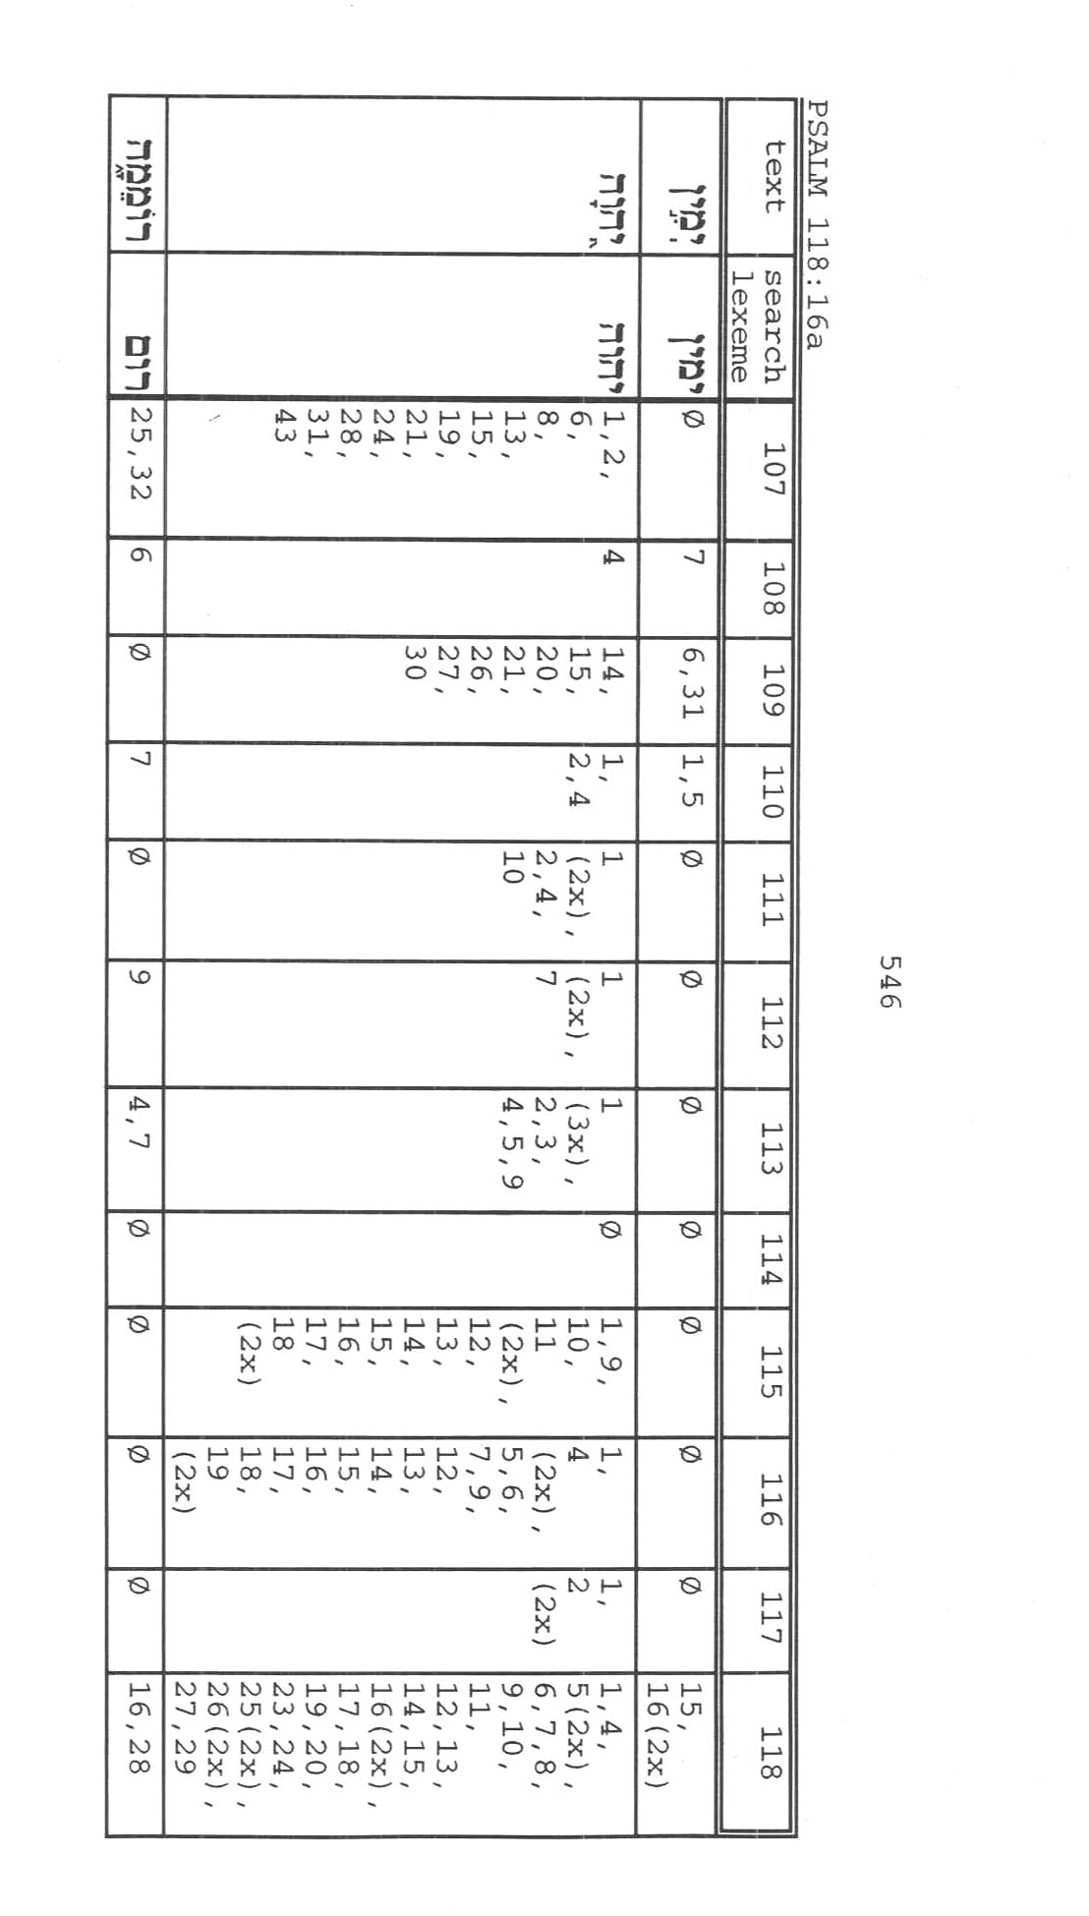
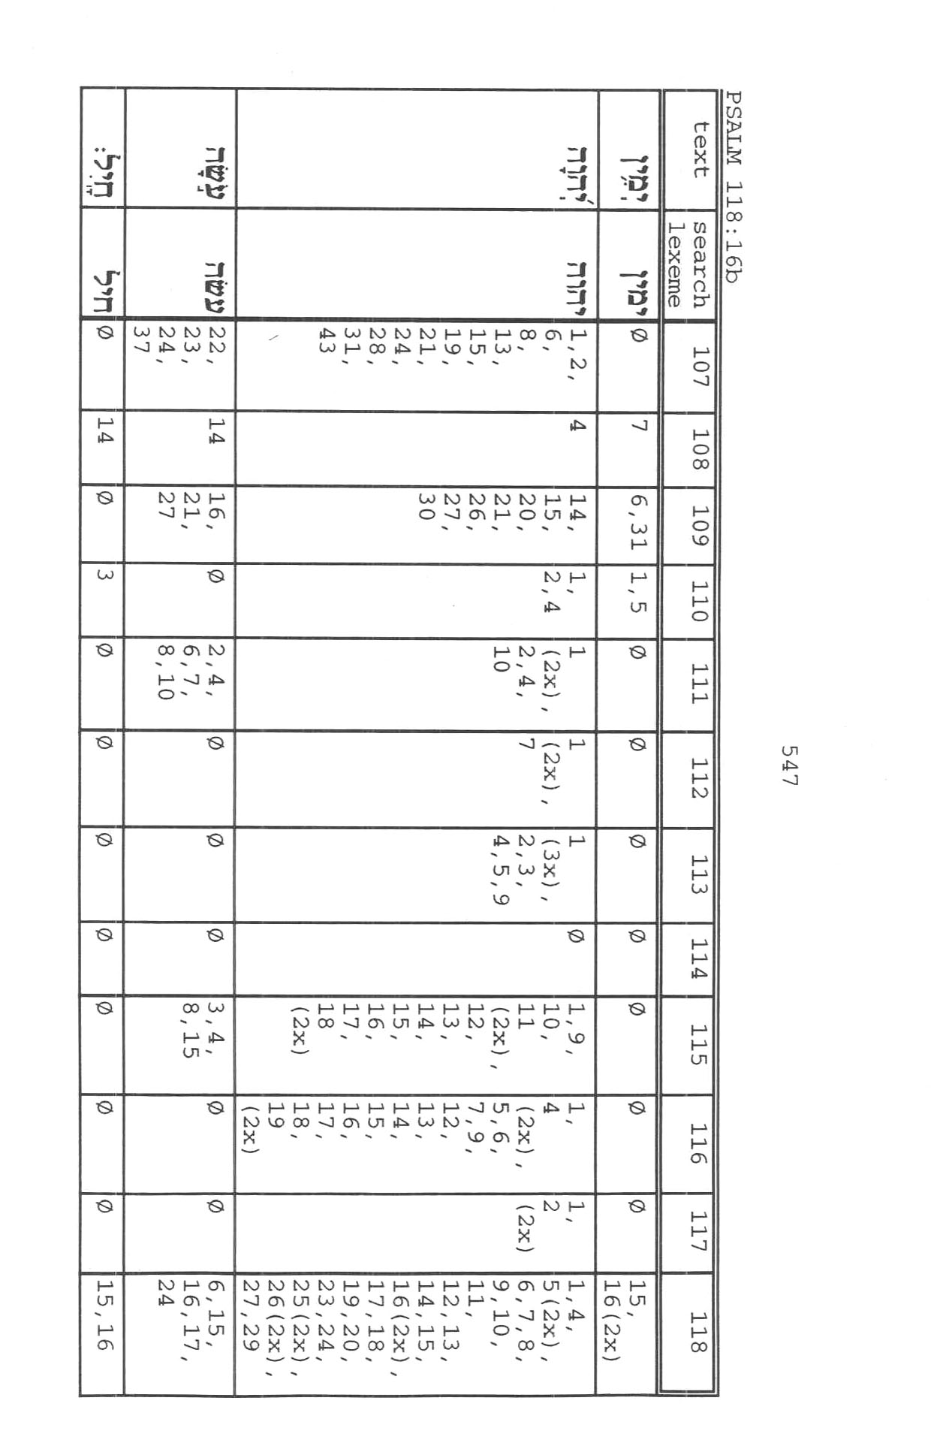
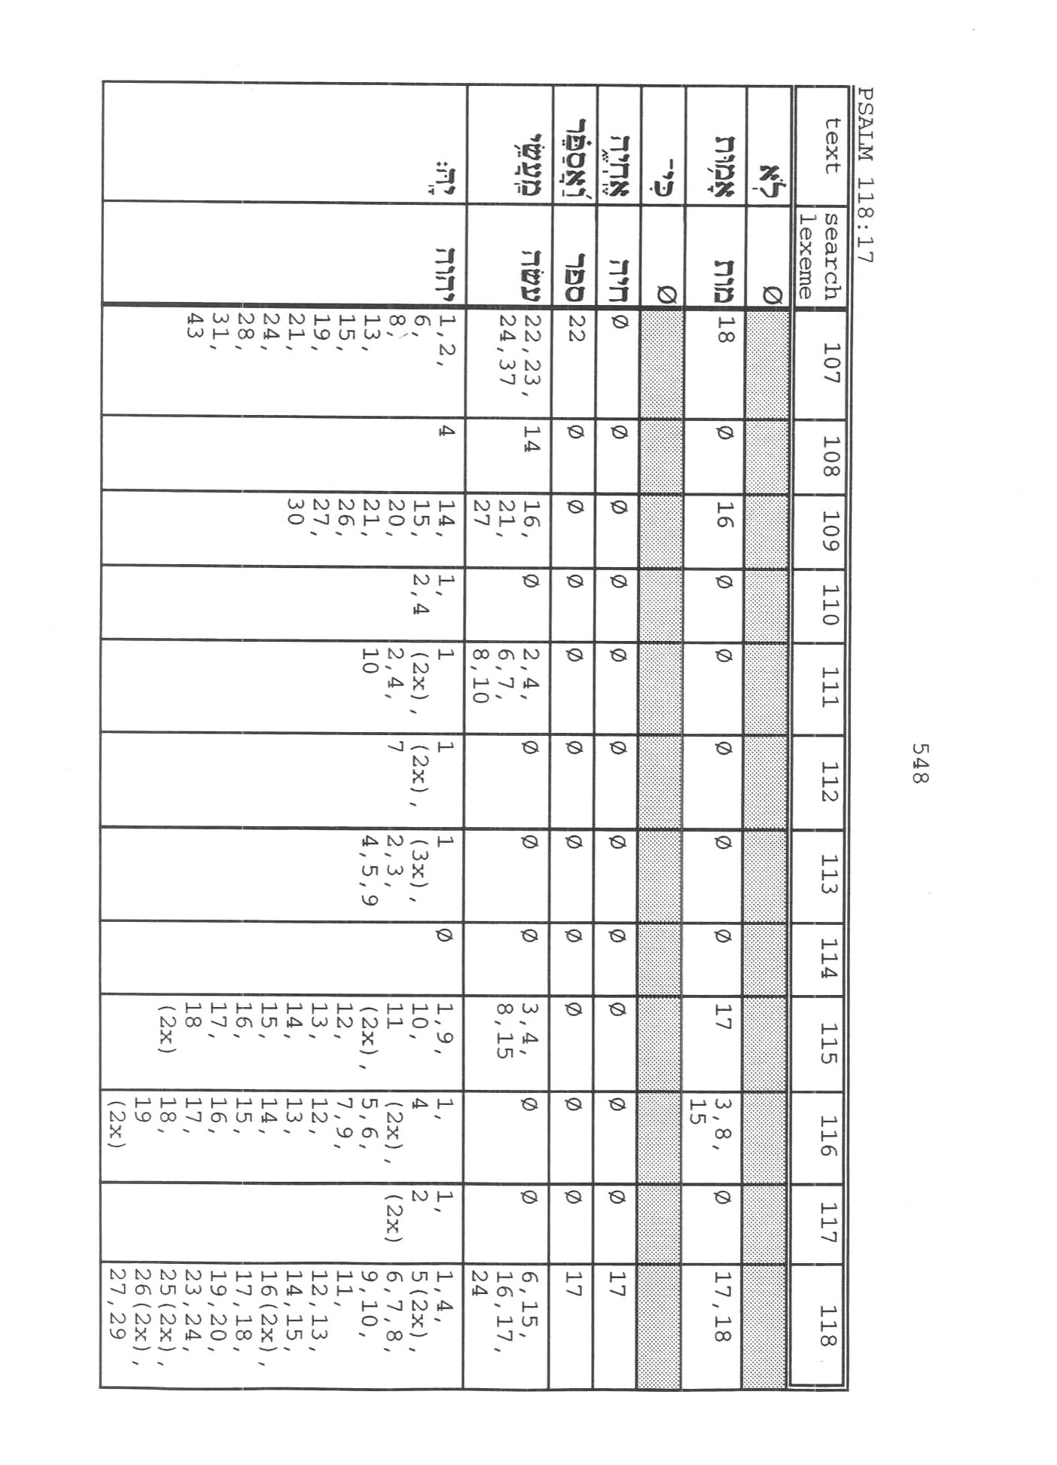
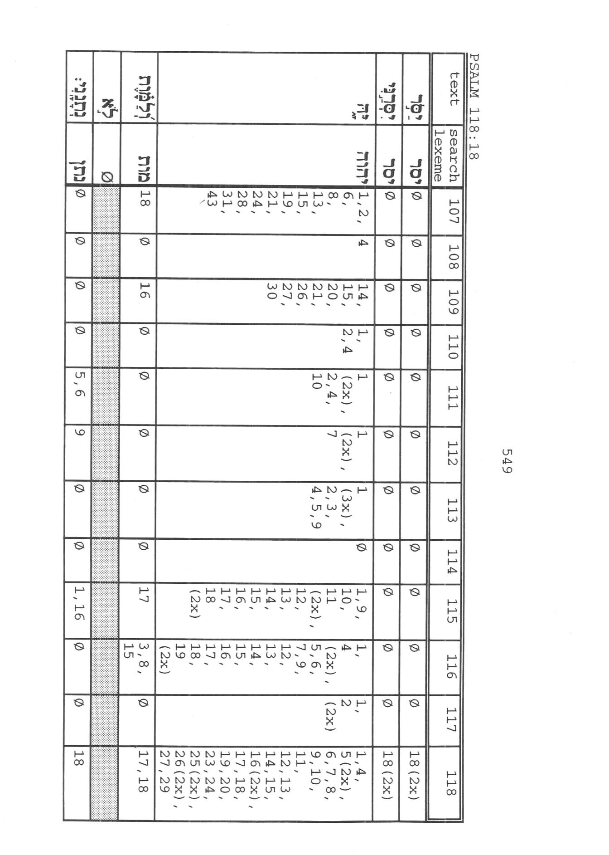
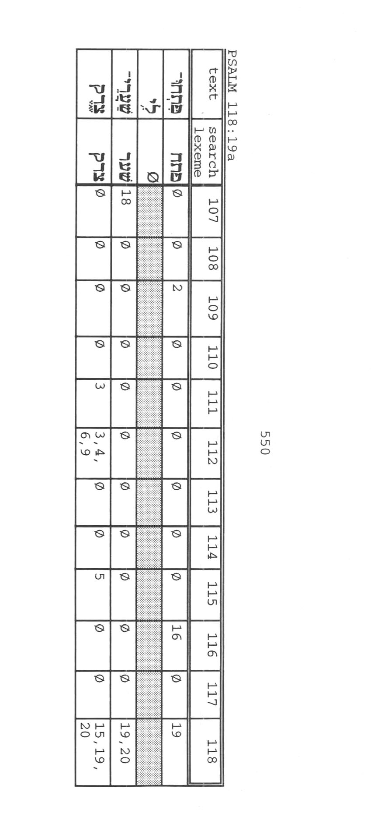
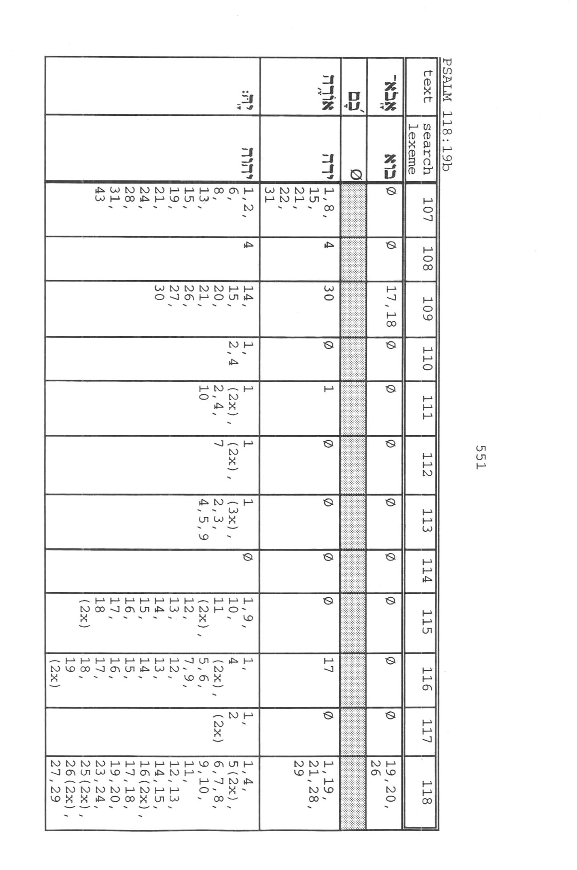
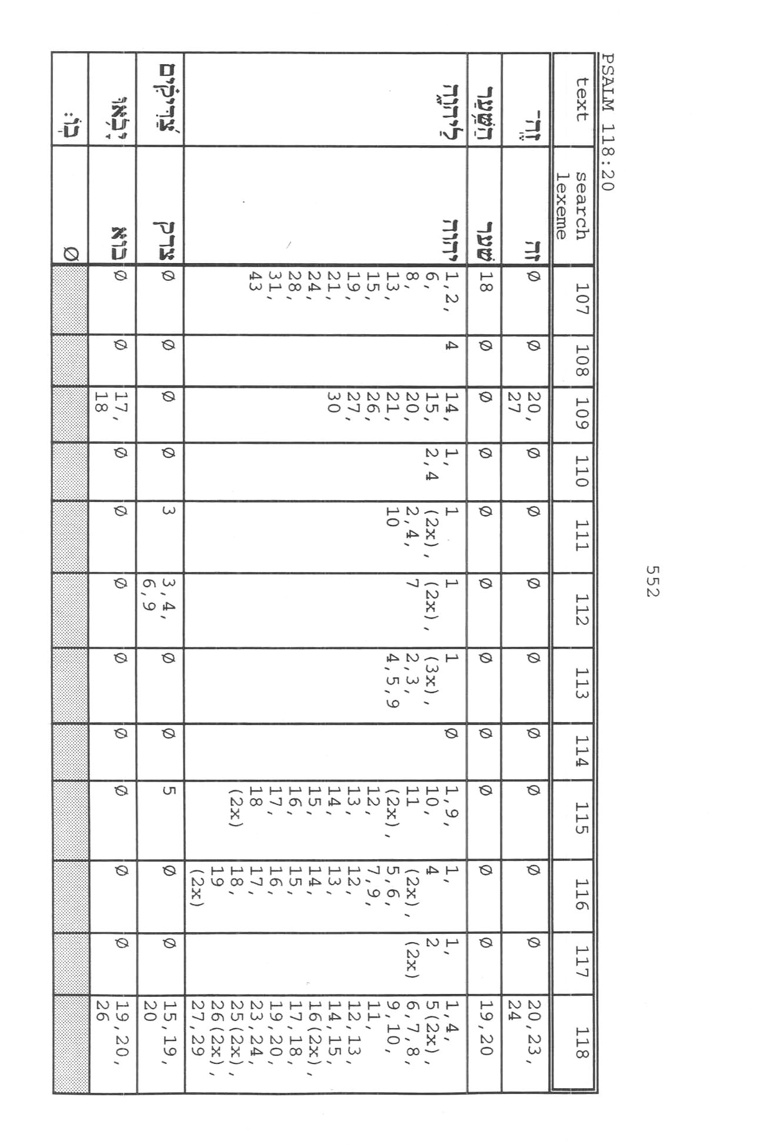
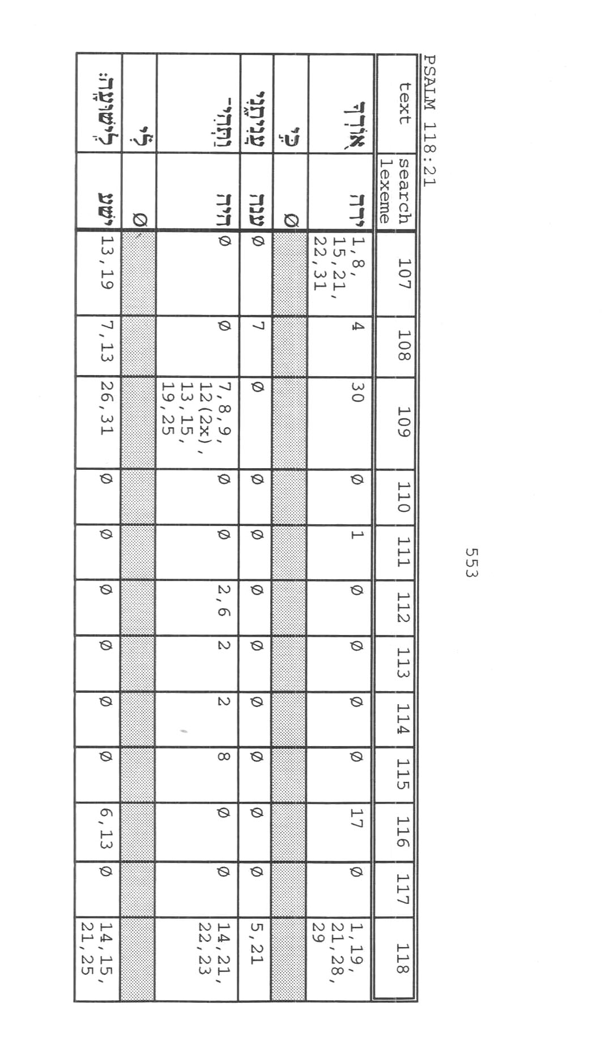
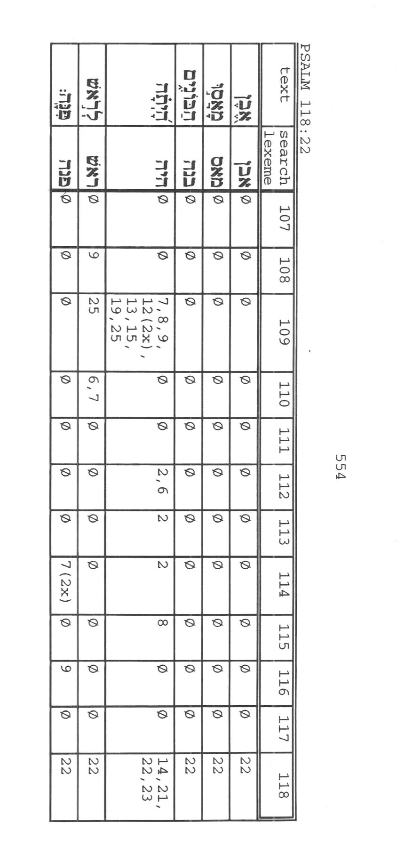
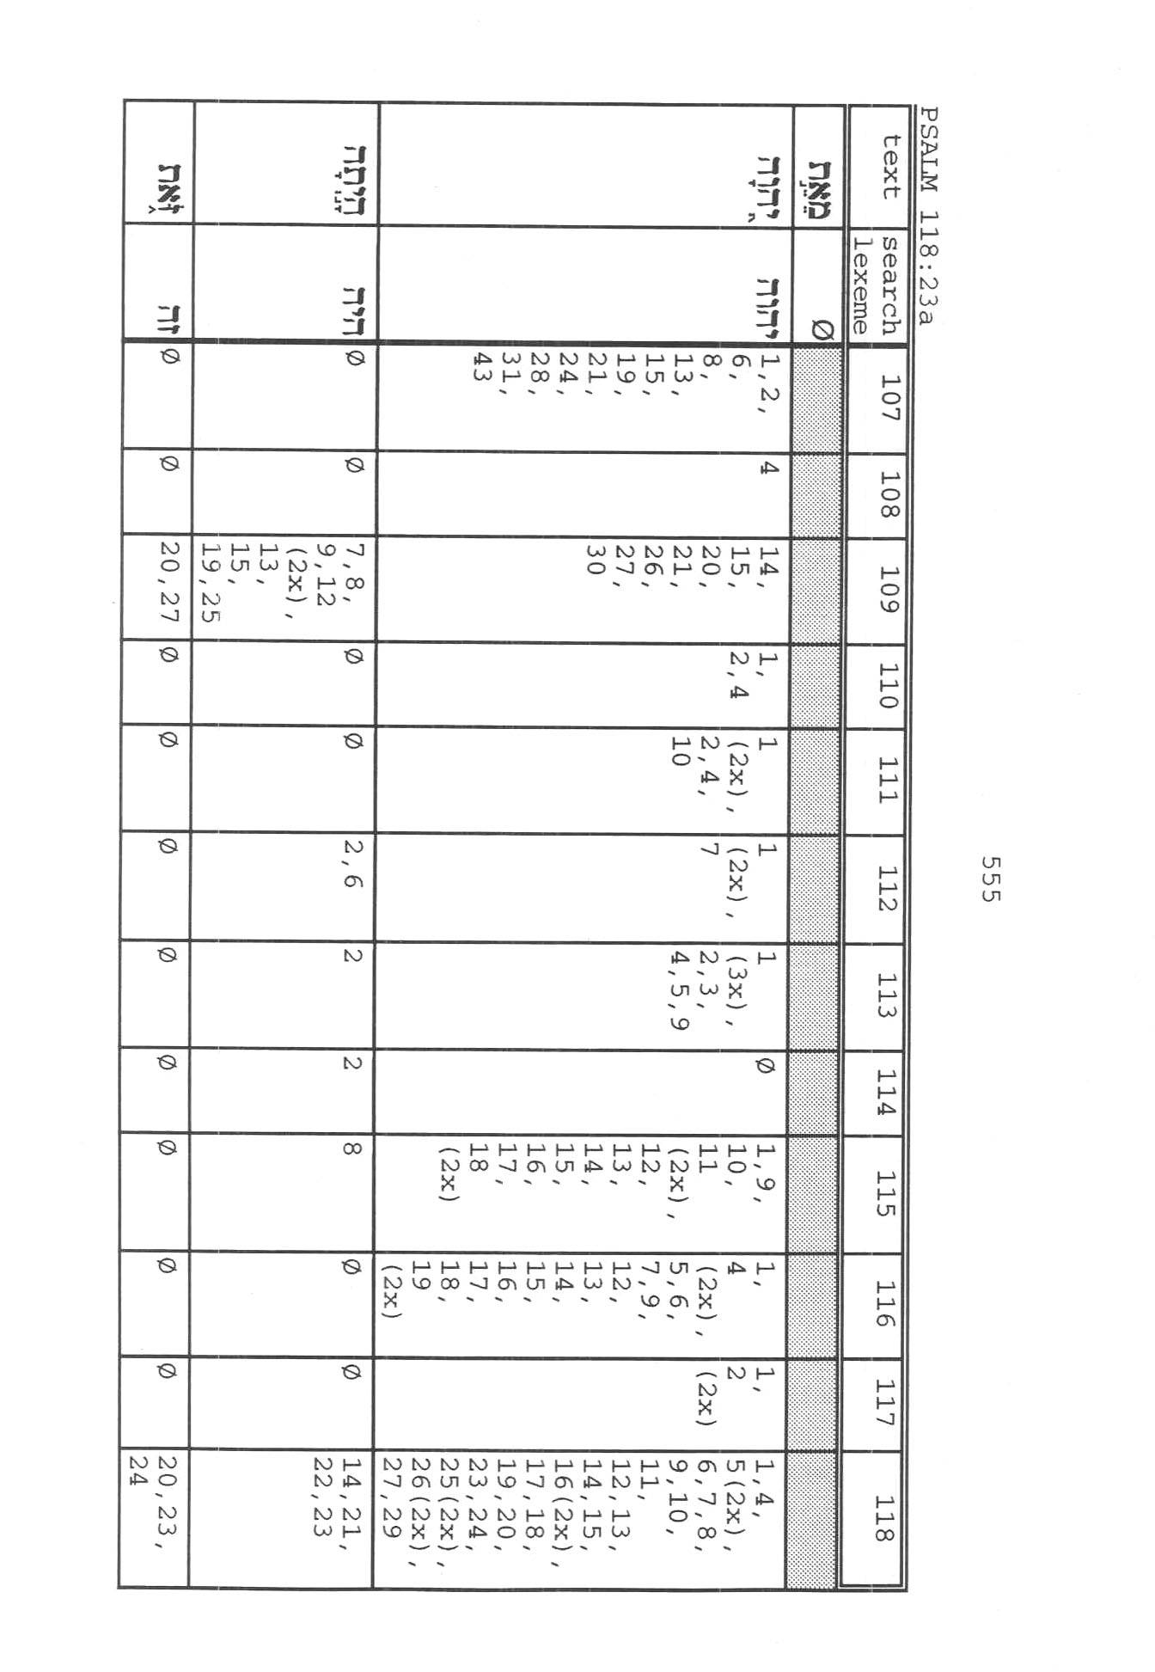
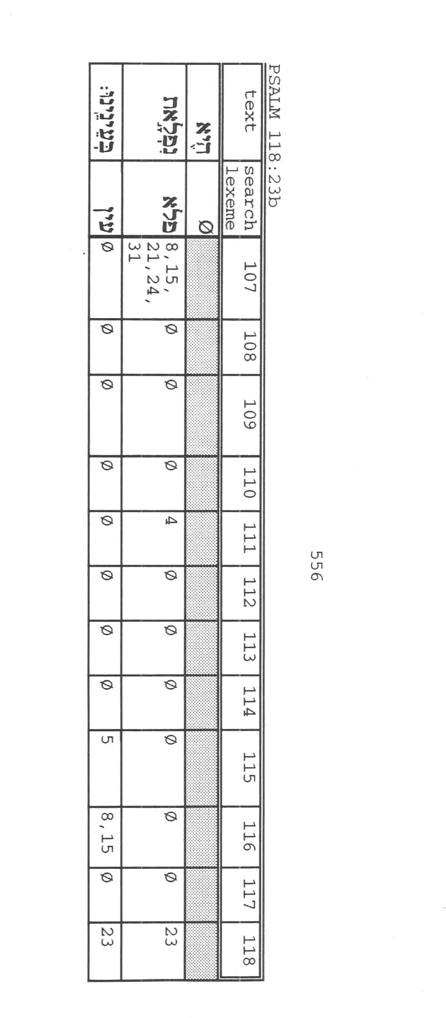
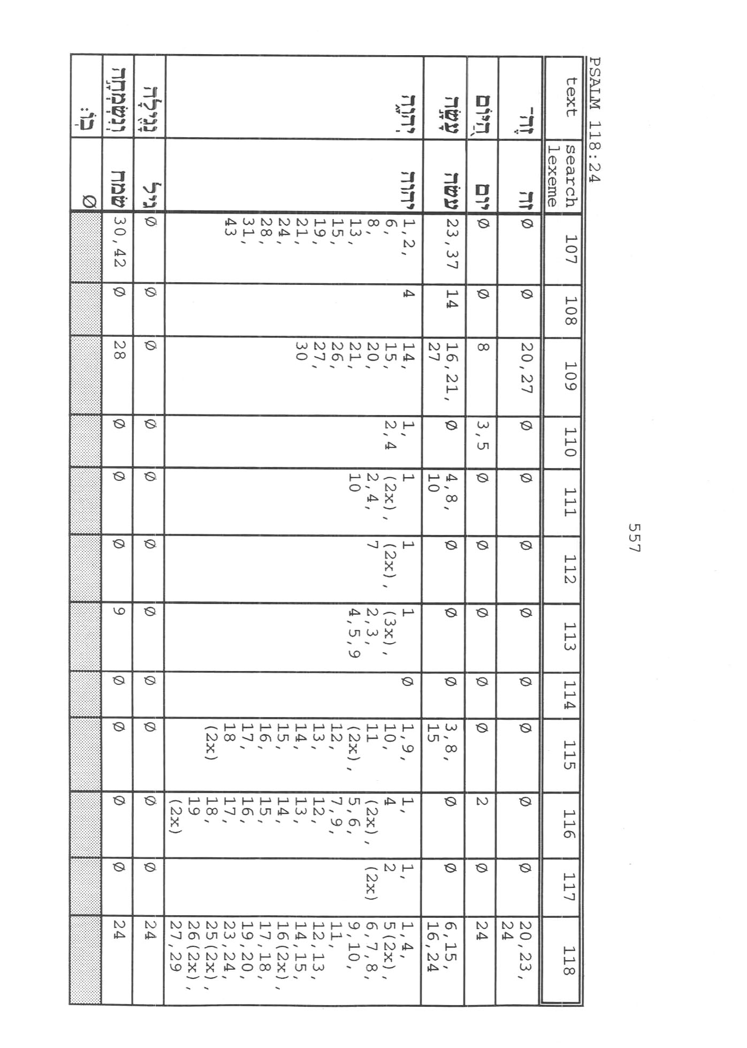
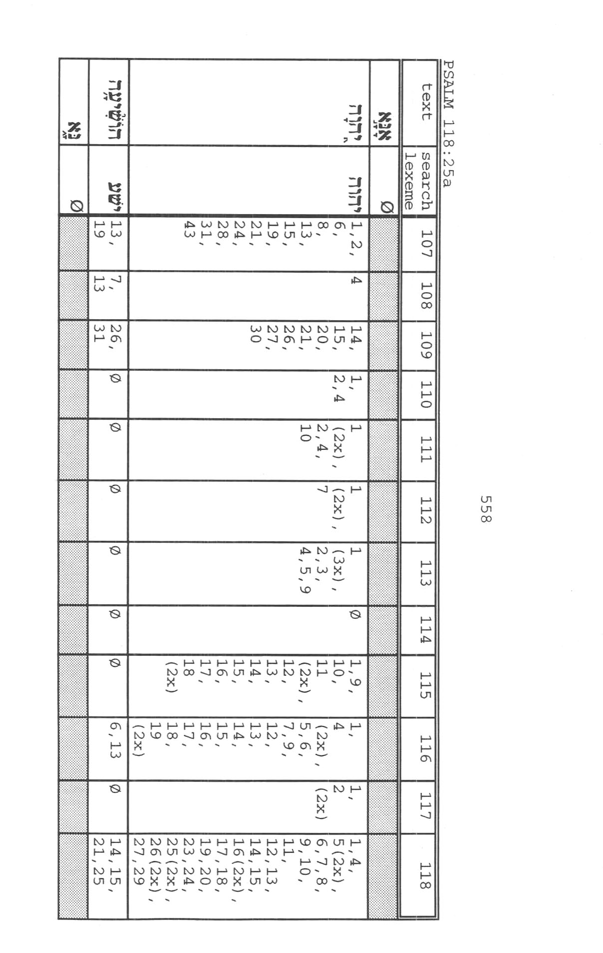
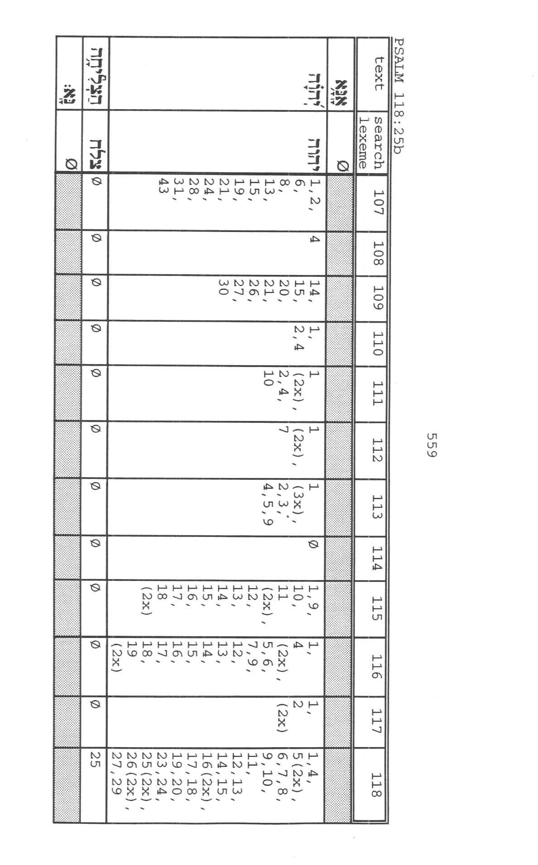
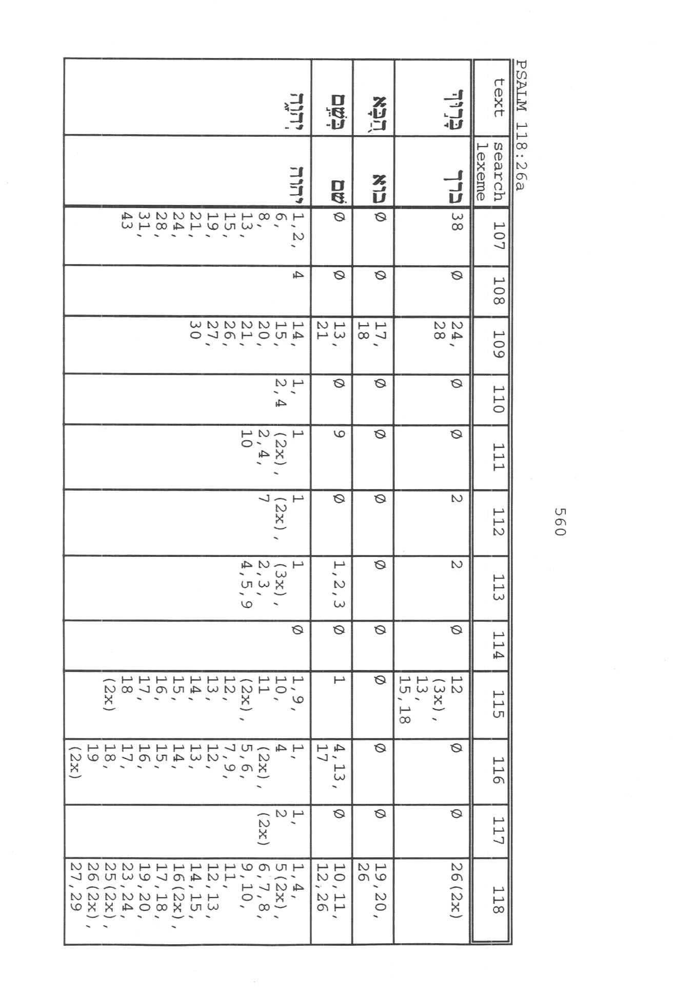
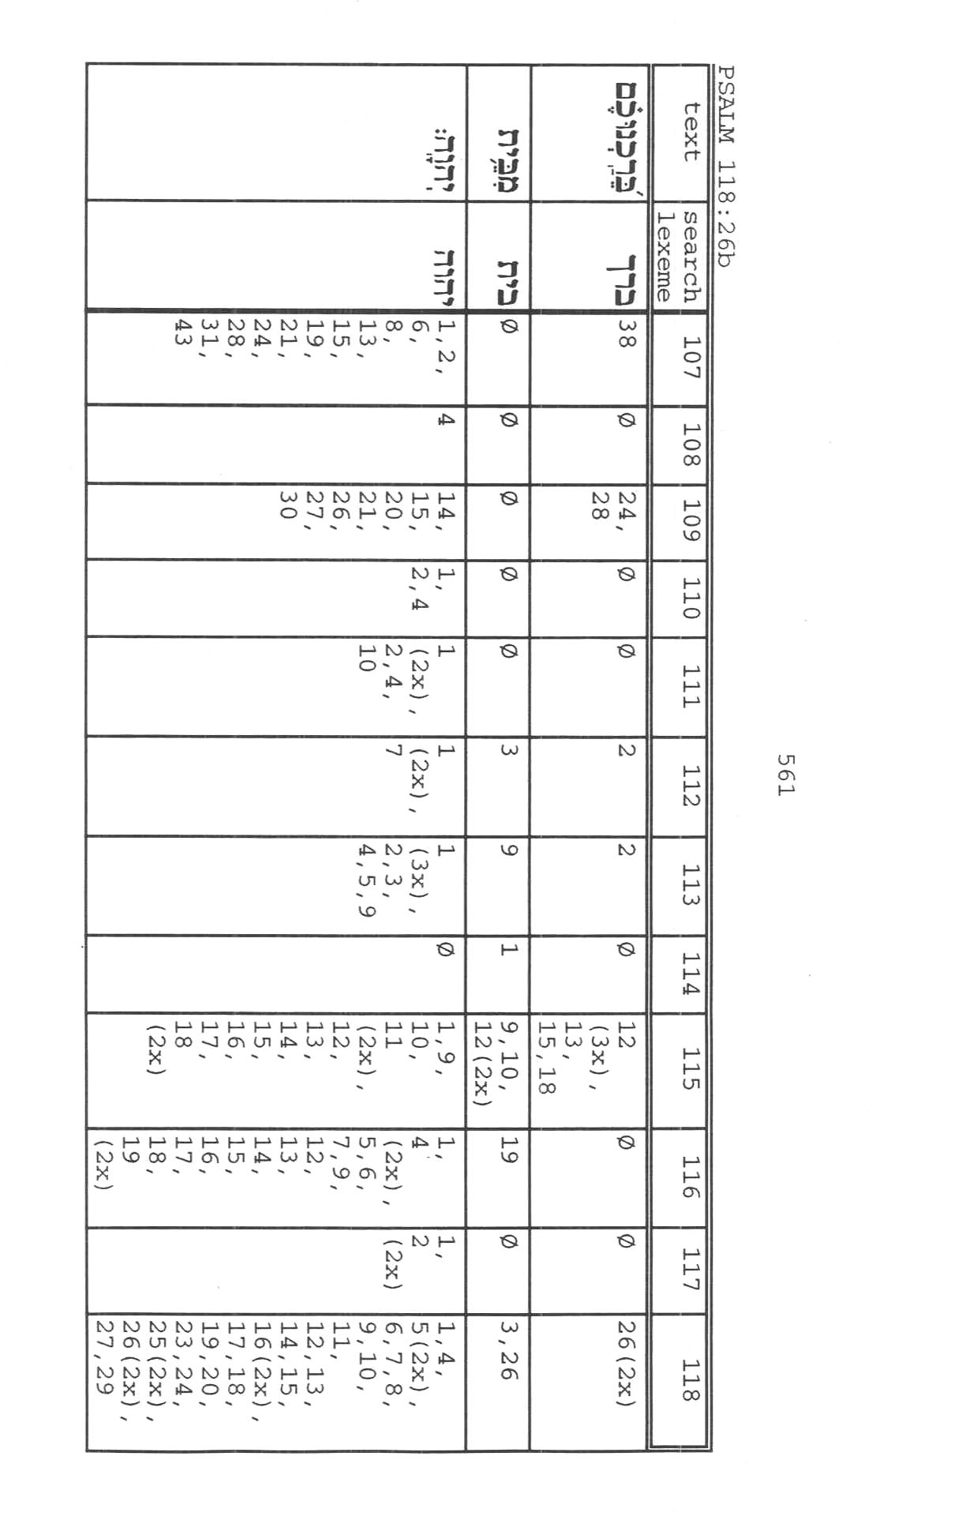
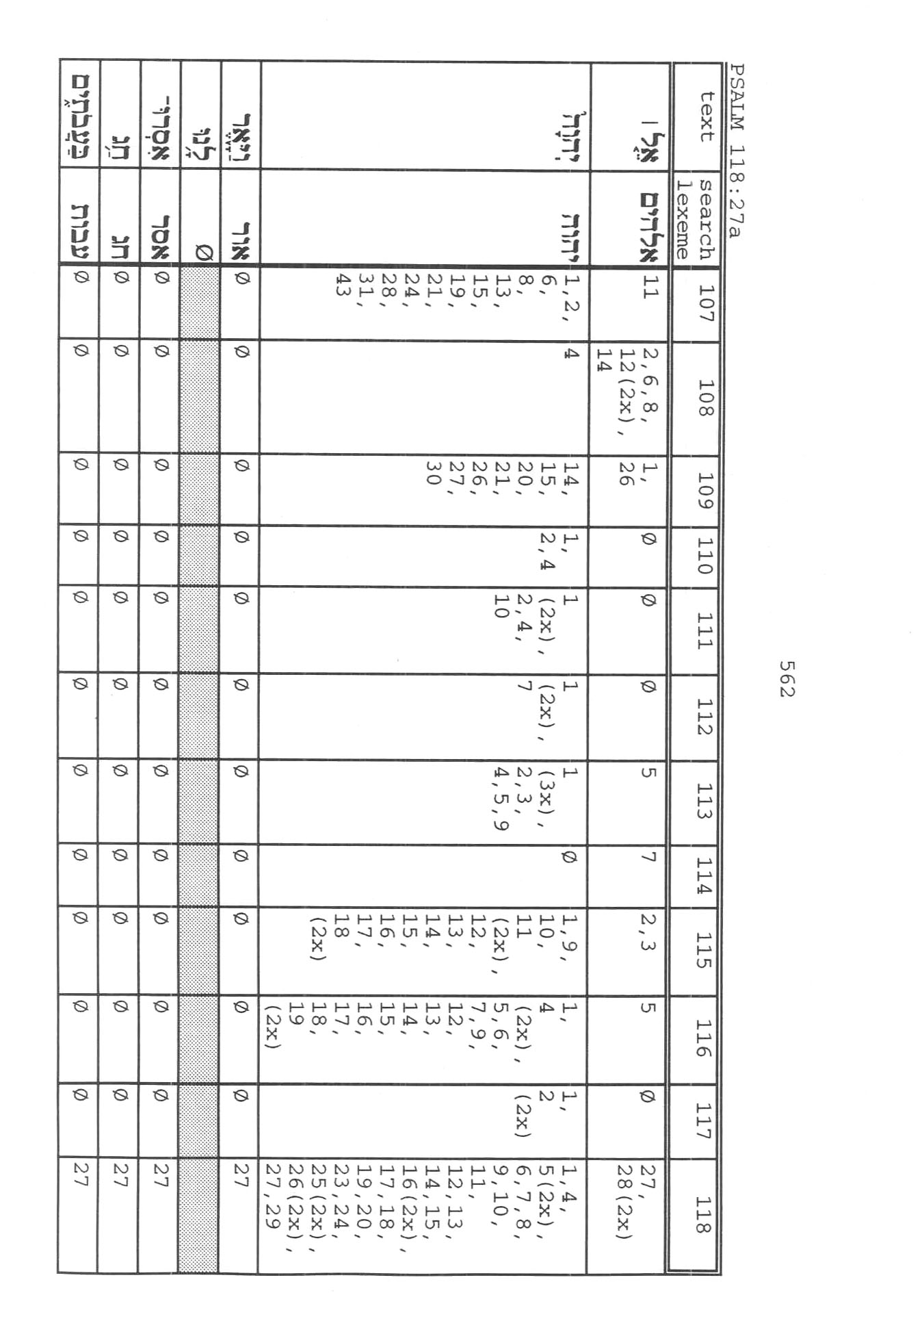
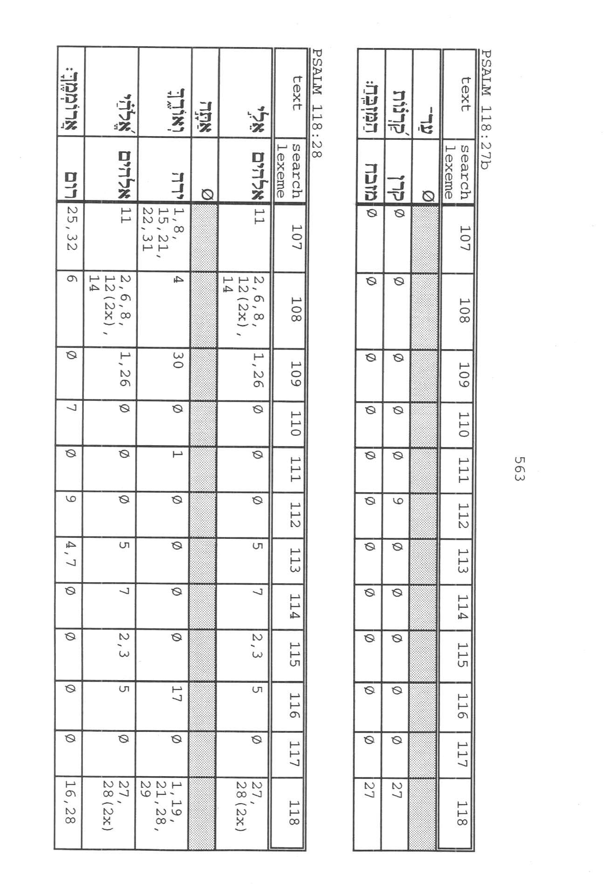
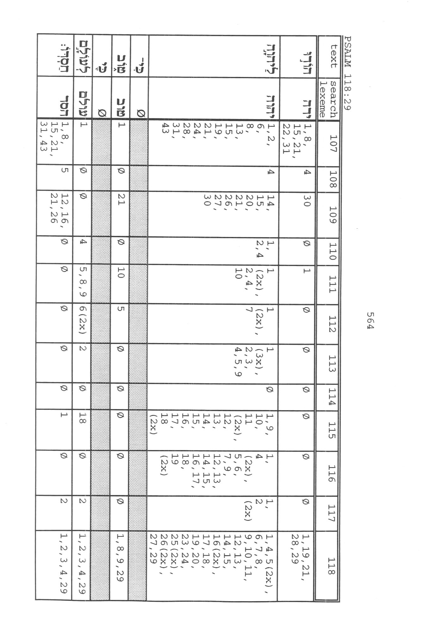
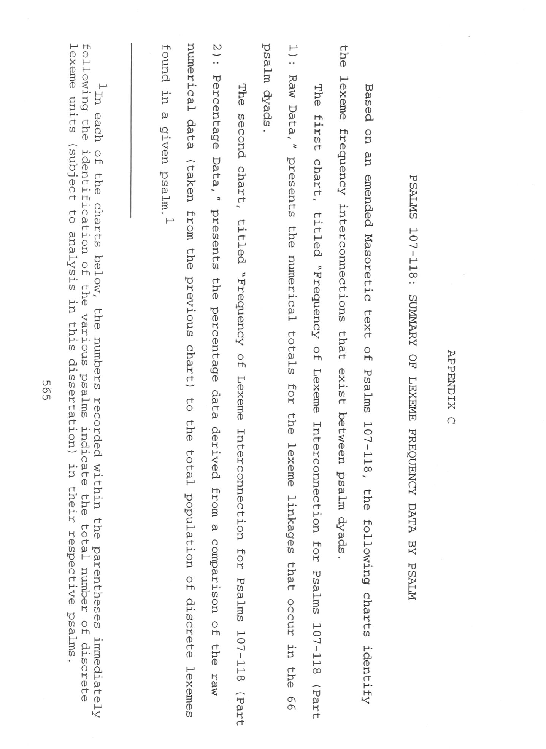
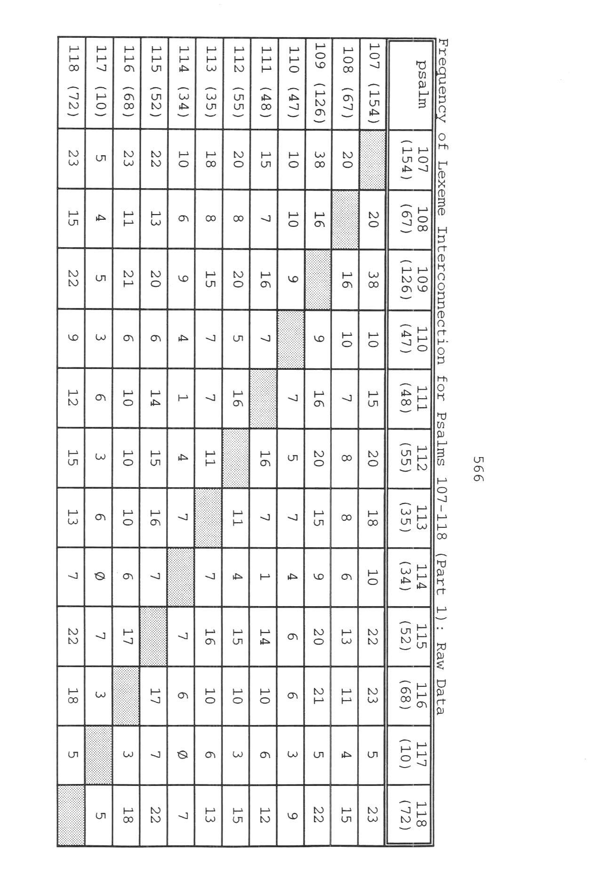
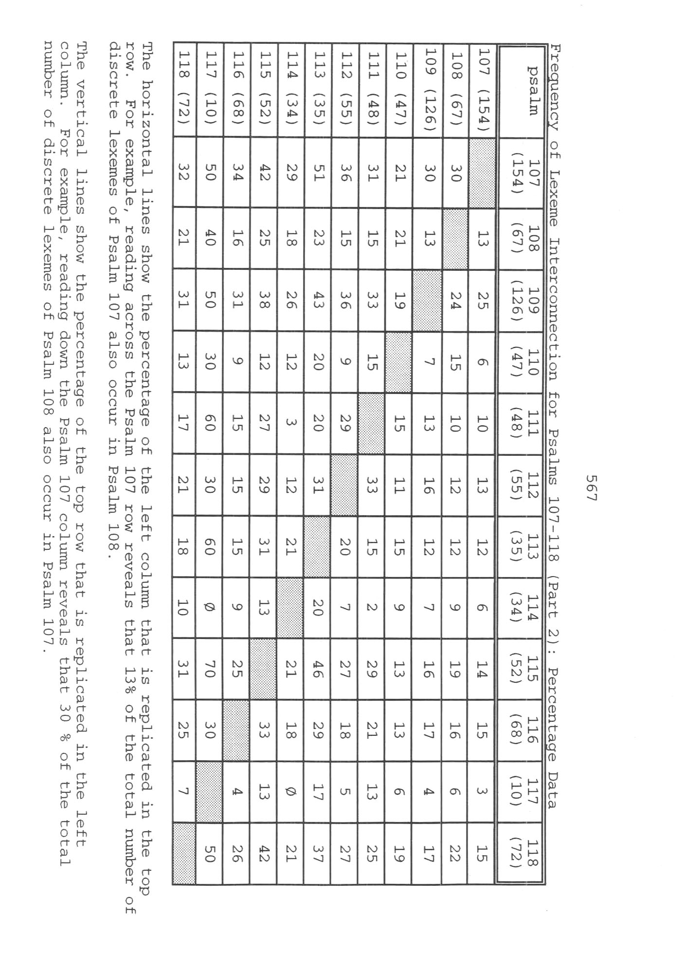
APPENDIX D
PERCENTAGE OF DISCRETE LEXICAL UNITS OF A GIVEN
PSALM REPLICATED IN AT LEAST ONE OTHER PSALM OF
THE PSALMS 107-118 CORPUS

The figures presented below for each psalm of the Psalms
107-118 corpus compare the number of discrete lexical units of a
given psalm that occur in at least one other psalm of the corpus
to the total population of discrete lexical units of that
original psalm. For example, as the chart below reveals, Psalm
107 contains a total of 154 discrete lexical units, of which 74
appear not only in Psalm 107 but also at least once in the
remaining 17 psalms of the Psalms 107-118 corpus. Those
replicated units thus represent 48% (74 of 154) of the total
number of discrete lexical units in Psalm 107.

Psalm Extent of Total Lexeme Total Number of
Replication Population Replicated Lexemes
107 48% 154 74
108 48% 67 32
109 51% 126 64
110 55% 47 26
111 69% 48 33
112 67% 55 37
113 43% 35 15
114 53% 34 18
115 79% 52 41
116 66% 68 45
117 80% 10 8
118 68% 72 49

568

BIBLIOGRAPHY

Ackroyd, Peter R. "Meaning and Exegesis." In Words and
Meanings: Essays Presented to David Winton Thomas, ed. Peter
R. Ackroyd and Barnabas Lindars, 1-14. Cambridge: The
University Press, 1968.
Albright, W. F. Yahweh and the Gods of Caanan. Garden City,
N.Y.: Doubleday, 1968.
Alden, Robert L. "Chiastic Psalms (III): A Study in the
Mechanics of Semitic Poetry in Psalms 101-150." Journal of
the Evangelical Theological Society 21 (1978): 199-210.
Alexander, Joseph Addision. The Psalms Translated and
Explained. Grand Rapids, Mich.: Zondervan, 1864; reprint,
n.d.
Allen, Leslie C. Psalms 101-150. Word Biblical Commentary 21.
Milton Keynes, England: Word (UK), 1983.
Alter, Robert. The Art of Biblical Poetry. New York: Basic
Books, 1985.
Anderson, A. A. The Book of Psalms: Vol. II: Psalms 73-150.
New Century Bible Commentary, ed. Ronald E. Clements and
Matthew Black. Grand Rapids, Mich.: Eerdmans, 1972.
Armerding, Carl. "Structural Analysis." Themelios 4 (April
1979): 96-104.
Auffret, Pierre. The Literary Structure of Psalm 2. Translated
by David J. A. Clines. Journal for the Study of the Old
Testament. Supplement Series 3. Sheffield: JSOT, 1977.
________. "Essai sur la Structure Littéraire des Psaumes CXI et
CXII." Vetus Testamentum 30 (July 1980): 257-79.
________. La Sagesse a Bâti sa Maison: Études de Structures
Littéraires dans l’Ancien Testament et Spécialement dans les
Psaumes. Fribourg: Éditions Universitaries, 1982.

569
570

Augustine. Sancti Aurelii Augustini Hipponensis Episcopi Opera
Omnia. Enarrationes in Psalmos: Contenta in Ouato Tomo: Lars
Altera. Vol. 37. Patriologiae Cursus Completus, ed. J. P.
Migne. Paris: n.p., 1845.
________. Saint Augustine: Expositions on the Book of Psalms.
First Series, vol. VIII. A Select Library of the Nicene and
Post-Nicene Fathers of the Christian Church, ed. Philip
Schaff. Grand Rapids, Mich.: Eerdmans, 1956.
Bar-Efrat, S. "Some Observations on the Analysis of Structure
in Biblical Narrative." Vetus Testamentum 30 (April 1980):
154-73.
Barré, Lloyd M. "Halelû yah: A Broken Inclusion. Catholic
Biblical Quarterly 45 (1983): 195-200.
Barre, Michael L. "Psalm 116: Its Structure and its Enigmas."
Journal of Biblical Literature 109 (Spring 1990): 61-98.
Barthes, Roland. "The Struggle with the Angel: Textual Analysis
of Genesis 32:23-33." In Structural Analysis and Biblical
Exegesis: Interpretational Essays, R. Barthes and others.
Translated by Alfred M. Johnson, Jr., 21-33. Pittsburgh:
Pickwick, 1974.
Beardslee, William A. "Poststructuralist Criticism." In To
Each Its Own Meaning: An Introduction to Biblical Criticisms
and Their Application, ed. Stephen R. Haynes and Steven L.
McKenzie, 221-35. Louisville: Westminster, 1993.
Beaucamp, E. Le Psautier: Ps 73-150. Paris: Librairie
Lecoffre, 1979.
Becker, J. "Zur Deutung von Ps 110, 7." In Freude an der
Weisung des Herrn: Beiträge zur Theologie der Psalmen:
Festgabe zum 70. Geburststag von Heinrich Groß, ed. Ernst
Haag and Frank-Lothar Hossfeld, 199-205. Stuttgart:
Katholisclies Bibelwerk, 1986.
Becker, Oswald. "Ps 118:12: MyciOq wxeK; UkfEDo." Zeitschrift fuer
die alttestamentlische Wissenschaft 70 (1958): 174.
Begrich, Joachim. "Zur Hebräischen Metrik." Theologische
Rundschau, n.s. 4 (1932): 67-89.
571

Beitzel, Barry J. "Exodus 3:14 and the Divine Name: A Case of
Biblical Paronomasia." Trinity Journal n.s. 1 (1980): 5-20.
Berlin, Adele. "Psalm 118:24." Journal of Biblical Literature
96 (December 1977): 567-68.
________. "Motif and Creativity in Biblical Poetry."
Proof texts: A Journal of Jewish Literary History 3 (1983):
231-41.
________. The Dynamics of Biblical Parallelism. Bloomington,
Ind.: Indiana University Press, 1985.
________. "The Rhetoric of Psalm 145." In Biblical and Related
Studies Presented to Samuel Iwry, ed. Ann Kort and Scott
Morschauser, 17-22. Winona Lake, Ind.: Eisenbrauns, 1985.
Beuken, W. A. M. "Psalm XLVII: Structure and Drama." In
Remembering All the Way . . ., B. Albrektson and others, 38-
54. Leiden: E. J. Brill, 1981.
Beyerlin, Walter. Werden und Wesen des 107. Psalms. Berlin:
Walter de Gruyter, 1979.
Boling, Robert G. "'Synonymous' Parallelism in the Psalms."
Journal of Semitic Studies 5 (July 1960): 221-55.
Bovon, Francois. "French Structuralism and Biblical Exegesis."
In Structural Analysis and Biblical Exegesis:
Interpretational Essays, R. Barthes and others. Translated
by Alfred M. Johnson, Jr., 4-20. Pittsburgh: Pickwick, 1974.
Bowker, J. W. "Psalm CX." Vetus Testamentum 17 (1967): 31-41.
Boyd, Jesse. "The Triumphant Priest-King." Biblical Viewpoint
6 (November 1972): 99-110.
Boys, Thomas. A Key to the Psalms: Being a Tabular Arrangement
by which the Psalms are Exhibited to the Eye according to a
General Rule of Composition Prevailing in the Holy
Scriptures. London: St Paul's Churchyard, 1890.
Brennan, Joseph P. "Some Hidden Harmonies in the Fifth Book of
Psalms." In Essays in Honor of Joseph P. Brennan, ed. Robert
F. McNamara, 126-58. Rochester, N.Y.: Saint Bernard's
Seminary, 1976.
572

________. "Psalms 1-8: Some Hidden Harmonies." Biblical
Theology Bulletin 10 (January 1980): 25-29.
Briggs, Charles Augustus, and Emilie Grace Briggs. A Critical
and Exegetical Commentary on the Book of Psalms. Edinburgh:
T. & T. Clark, 1907; reprint, 1960.
Broadribb, Donald. "A Historical Review of Studies of Hebrew
Poetry." Abr-Nahrain, 13 (1972-1973): 66-87.
Brown, Francis, S. R. Driver, and Charles A. Briggs. A Hebrew
and English Lexicon of the Old Testament. Oxford: The
Clarendon Press, 1907; reprint, 1968.
Brueggemann, Walter. "Psalm 109: Three Times 'Steadfast Love.'"
Word & World: Theology for Christian Ministry 5 (Spring
1985): 144-54.
________. "Bounded by Obedience and Praise: The Psalms as
Canon." Journal for the Study of the Old Testament 50
(1991): 63-92.
________. "Response to James L. Mays, 'The Question of
Context.'" In The Shape and Shaping of the Psalter, ed. J.
Clinton McCann, 29-41. Journal for the Study of the Old
Testament Supplement Series, 159. Sheffield: JSOT, 1993.
Bullinger, E. W. "Introduction." In A Key to the Psalms: Being
a Tabular Arrangement by which the Psalms are Exhibited to
the Eye according to a General Rule of Composition. Prevailing
in the Holy Scriptures, Thomas Boys. London: St Paul's
Churchyard, 1890.
Callan, Terrance. "Psalm 110:1 and the Origin of the
Expectation that Jesus Will Come Again." Catholic Biblical
Quarterly 44 (October 1982): 622-36.
Callaway, Mary C. "Canonical Criticism." In To Each Its Own
Meaning: An Introduction to Biblical Criticisms and Their
Application, ed. Stephen R. Haynes and Steven L. McKenzie,
121-34. Louisville: Westminster, 1993.
Calvin, John. Commentary on the Book of Psalms. Vol. 1, Psalms
i.-xxxv.. Translated by James Anderson. Edinburgh: The
Calvin Translation Society, 1845.

573

________. Commentary on the Book of Psalms. Vol. 4, Psalms
xciii.-cxix. Translated by James Anderson and John Hunter.
Edinburgh: The Calvin Translation Society, 1847.
Cassiodorus, Flavius Magnus Aurelius. Cassiodorus: Explanation
of the Psalms. Translated and annotated by P. G. Walsh.
Vol. 1, Psalms 1-50 [Psalms 1-51(50)]. Ancient Christian
Writers: The Works of the Fathers in Translation 51. New
York: Paulist Press, 1990.
Cassuto, U. "The Sequence and Arrangement of the Biblical
Sections." Chap. in Biblical and Oriental Studies, vol. 1,
The Bible. Translated by Israel Abrahams. Jerusalem:
Magnes, 1973.
Childs, Brevard S. Introduction to the Old Testament as
Scripture. Philadelphia: Fortress, 1979.
Clarke, Arthur G. Analytical Studies in the Psalms.
Kilmarnock: John Ritchie, 1949.
Clifford, Richard J. "Rhetorical Criticism in the Exegesis of
Hebrew Poetry." In Society of Biblical Literature 1980
Seminar Papers, ed. Paul J. Achtemeier, 17-28. Chico,
Calif.: Scholars, 1980.
Clines, David J. A. "The Parallelism of Greater Precision:
Notes from Isaiah 40 for a Theory of Hebrew Poetry." In
Directions in Biblical Hebrew Poetry, ed. Elaine R. Follis,
77-100. Journal for the Study of the Old Testament
Supplement Series 40. Sheffield: JSOT, 1988.
________., ed. The Dictionary of Classical Hebrew. Vol. 1, x.
Sheffield: Sheffield Academic Press, 1993.
Coats, George W. "Self-Abasement and Insult Formulas." Journal
of Biblical Literature 89 (1970): 14-26.
Collins, Terence. Line-forms in Hebrew Poetry: A Grammatical
Approach to the Stylistic Study of the Hebrew Prophets.
Studia Pohl: Series Major: Dissertationes Scientificae de
Rebus Orientis Antiqui 7. Rome: Biblical Institute Press,
1978.
574

________. "Decoding the Psalms: A Structural Approach to the
Psalter." Journal for the Study of the Old Testament 37
(1987): 41-60.
Cook, Edward M., ed. Sopher Mahir: Northwest Semitic Studies
Presented to Stanislav Segert. Winona Lake, Ind.:
Eisenbrauns, 1990.
Cook, Johann. "New Horizons in Textual Criticism." In Text and
Context: Old Testament and Semitic Studies for F. C. Fensham,
ed. W. Claassen, 51-61. Journal for the Study of the Old
Testament Supplement Series. 48. Sheffield: JSOT, 1988.
Cooke, Gerald. "The Israelite King As Son of God." Zeitschrift
für die Alttestamentlichen Wissenschaft 73 (1961): 202-25.
Craigie, Peter C. "Psalm 113." Interpretation: A Journal of
Bible and Theology 39 (January 1985): 70-74.
________. Psalms 1-50. Word Biblical Commentary 19, ed. David
A. Hubbard and Glen W. Barker. Aylesbury, UK: Word (UK),
1986.
Croft, Steven, J. L. The Identity of the Individual in the
Psalms. Sheffield: JSOT, 1987.
Cross, Frank Moore, Jr. and David Noel Freedman. Early Hebrew
Orthography: A Study of the Epigraphic Evidence. American
Oriental Series, vol. 36, ed. James B. Pritchard. New Haven,
Conn.: American Oriental Society, 1952.
Culley, Robert C. "Some Comments on Structural Analysis and
Biblical Studies." In Congress Volume: Uppsala 1971,
Supplements to Vetus Testamentum 22, ed. G. W. Anderson and
others, 129-42. Leiden: E. J. Brill, 1972.
Custer, Stewart, et. al. "Focus on Psalms, Part II." Biblical
Viewpoint 6 (1972): 80-119.
Dahood, Mitchell. Psalms III (101-150). The Anchor Bible 17A,
ed. William Foxwell Albright and David Noel Freedman. Garden
City, N.Y.: Doubleday, 1970.
________. "Additional Pairs of Parallel Words in the Psalter
and in Ugaritic." In Wort, Lied und Gottesspruch: Beiträge
zu Psalmen und Propheten: Festschrift für Joseph Ziegler, ed.
Josef Schreiner, 35-40. Würzburg: Katholisches Bibelwerk,
1972.
575

________. "Poetry, Hebrew." IDBS, (1976): 669-72.
________. "Vocative waw in Psalm 30,9." Biblica 58 (1977):
218.
Davidson, A. B. Hebrew Syntax. 3d ed. Edinburgh: T. & T.
Clark, 1901.
Delitzsch, Franz. Biblical Commentary on The Psalms.
Translated by Francis Bolton. Vol. III. Grand Rapids,
Mich.: Eerdmans, 1968.
Drijvers, Pius. The Psalms: Their Structure and Meaning. New
York: Herder and Herder, 1965.
Driver, G. R. "Hebrew Poetic Diction." In Congress Volume:
Copenhagen 1953, Supplements to Vetus Testamentum 1, ed. G.
W. Anderson and others, 26-39. Leiden: E. J. Brill, 1953.
________. "Psalm CX: Its Form Meaning and Purpose." In Studies
in the Bible, ed. J. M. Grintz and J. Liver, 17-31.
Jerusalem: Kiryat Sepher, 1964.
Durlesser, James A. "Poetic Style in Psalm 1 and Jeremiah 17:5-
8. A Rhetorical Critical Study." Semitics 9 (1984): 30-
48.
Eaton, John H. Kingship and the Psalms. 2d ed. Sheffield:
JSOT, 1986.
Ellenbogen, Maximilian. Foreign Words in the Old Testament:
Their Origin and Etymology. London: Luzac, 1962.
Emerton, John A. "How Does the Lord Regard the Death of His
Saints in Psalm 116:15?" Journal of Theological Studies 34
(April 1983): 146-56.
Encyclopedia of Jewish Concepts, 1979 ed. S.v. "Hallel."
The Encyclopedia of Jewish Religion, 1965 ed. S.v. "Hallel."
Eybers, I. H. "Some Examples of Hyperbole in Biblical Hebrew."
Semitics 1 (1970): 38-49.
Fohrer, Georg. "Twofold Aspects of Hebrew Words." In Words and
Meanings: Essays Presented to David Winton Thomas, ed. Peter
R. Ackroyd and Barnabas Lindars, 95-103. Cambridge: The
University Press, 1968.
576

Follis, Elaine R., ed. Directions in Biblical Hebrew Poetry.
Journal for the Study of the Old Testament Supplement Series
40. Sheffield: JSOT, 1987.
Forbes, John. Studies on the Book of Psalms: The Structural
Connection of the Book of Psalms, both in Single Psalms and
in the Psalter as an Organic Whole. Edited by James Forrest.
Edinburgh: T. & T. Clark, 1888.
Freedman, David Noel. "Acrostics and Metrics in Hebrew Poetry.
Chap. in Pottery, Poetry, and Prophecy: Studies in Early
Hebrew Poetry. Winona Lake, Ind.: Eisenbrauns, 1980.
________. "Another Look at Biblical Hebrew Poetry." In
Directions in Biblical Hebrew Poetry, ed. Elaine R. Follis,
11-28. Journal for the Study of the Old Testament Supplement
Series 40. Sheffield: JSOT, 1987.
________. "The Broken Construct Chain." Chap. in Pottery,
Poetry, and Prophecy: Studies in Early Hebrew Poetry. Winona
Lake, Ind.: Eisenbrauns, 1980.
________. "Early Israelite Poetry and Historical
Reconstructions." Chap. in Pottery, Poetry, and Prophecy:
Studies in Early Hebrew Poetry. Winona Lake, Ind.:
Eisenbrauns, 1980.
________. Pottery, Poetry, and Prophecy. Winona Lake, Ind.:
Eisenbrauns, 1980.
________. "Pottery, Poetry, and Prophecy: An Essay on Biblical
Poetry." Chap. in Pottery, Poetry, and Prophecy: Studies in
Early Hebrew Poetry. Winona Lake, Ind.: Eisenbrauns, 1980.
________. "Prolegomenon to G. B. Gray, The Forms of Hebrew
Poetry." Chap. in Pottery, Poetry, and Prophecy. Winona
Lake, Ind.: Eisenbrauns, 1980.
________. "Psalm 113 and the Song of Hannah." Chap. in
Pottery, Poetry, and Prophecy: Studies in Early Hebrew
Poetry. Winona Lake, Ind.: Eisenbrauns, 1980.
________. "The Refrain in David's Lament over Saul and
Jonathan." Chap. in Pottery, Poetry, and Prophecy: Studies
in Early Hebrew Poetry. Winona Lake, Ind.: Eisenbrauns,
1980.
________. "The Structure of Psalm 137." Chap. in Pottery,
Poetry, and Prophecy: Studies in Early Hebrew Poetry. Winona
Lake, Ind.: Eisenbrauns, 1980.
577

________."The Twenty-Third Psalm." Chap. in Pottery, Poetry,
and Prophecy: Studies in Early Hebrew Poetry. Winona Lake,
Ind.: Eisenbrauns, 1980.
________. ed. The Anchor Bible Dictionary. New York:
Doubleday, 1992. S.v. "Hanel," by Steven R. Swanson.
Freedman, David Noel, and C. Franke Hyland. "Psalm 29: A
Structural Analysis." Harvard Theological Review 66 (1973):
237-56.
Fullerton, Kemper. "The Strophe in Hebrew Poetry and Psalm 29."
Journal of Biblical Literature 48 (1929): 274-90.
Gaebelein, Paul W., Jr. "Psalm 34 and Other Biblical Acrostics:
Evidence from the Aleppo Codex." In Sopher Mahir: Northwest
Semitic Studies Presented to Stanislav Segert, ed. Edward M.
Cook, 127-43. Winona Lake, Ind.: Eisenbrauns, 1990.
Gammie, John G. "A New Setting for Psalm 110." Anglican
Theological Review 51 (1969): 4-17.
Geller, Stephen A. Parallelism in Early Biblical Poetry.
Harvard Semitic Monographs 20. Missoula, Mont.: Scholars,
1979.
________. "The Language of Imagery in Psalm 114." In Lingering
over Words: Studies in Ancient Near Eastern Literature in
Honor of William L. Moran, ed. Tzvi Abusch, John Huehnergard,
and Piotr Steinkeller, 179-94. Atlanta: Scholars, 1990.
Gerleman, Gillis. "Psalm 110." Vetus Testamentum 31 (1981): 1-
19.
Gerstenberger, Erhard S. Psalms: Part 1 with an Introduction to
Cultic Poetry. Vol. 14, The Forms of the Old Testament
Literature, ed. Rolf Knierim and Gene M. Tucker. Grand
Rapids, Mich.: Eerdmans, 1988.
Gesenius, William. Hebrew Grammar. Ed. E. Kautzsch and A. E.
Cowley. 1910, 2d ed., Oxford: Clarendon, 1966.
________. Hebrew and Chaldee Lexicon to the Old Testament
Scriptures. Translated by Samuel Prideaux Tregelles. Grand
Rapids, Mich.: Eerdmans, 1967.
Gibson, J. C. L. Canaanite Myths and Legends. Ed. G. R.
Driver. 2d ed. T. & T. Clark, 1977.
578

Gilbert, Maurice, and Stephen Pisano. "Psalm 110 (109):5-7."
Biblica 61 (1980): 343-56.
Gitay, Yohoshua. "Rhetorical Criticism." In To Each Its Own
Meaning: An Introduction to Biblical Criticisms and Their
Application, ed. Stephen R. Haynes and Steven L. McKenzie,
135-49. Louisville: Westminster, 1993.
Goodman, A. E. "dsH and hdvt in the Linguistic Tradition of
the Psalter." In Words and Meanings: Essays Presented to
David Winton Thomas, ed. Peter R. Ackroyd and Barnabas
Lindars, 105-15. Cambridge: The University Press, 1968.
Goshen-Gottstein, M. H. "The Textual Criticism of the Old
Testament: Rise, Decline, Rebirth." Journal of Biblical
Literature 102 (1983): 365-99.
Goulder, M. D. "The Fourth Book of the Psalter." The Journal
of Theological Studies n.s. 26 (1975): 269-89.
Gray, George Buchanan. The Forms of Hebrew Poetry: Considered
with Special Reference to the Criticism and Interpretation of
the Old Testament. N.p.: KTAV Publishing House, 1972.
Greenfield, Jonas C. "Novellae in Eliyahu Rabbah's Exegesis: A
Mandaic 'Targum' of Psalm 114." In Studies in Aggadah,
Targum, and Jewish Liturgy in Memory of Joseph Heinemann, ed.
Jakob J. Petuchowski and Ezra Fleischer, 23-31. Jerusalem:
Magnes, 1981.
Greenspahn, Frederick E. Hapax Legomena in Biblical Hebrew: A
Study of the Phenomenon and Its Treatment Since Antiquity
with Special Reference to Verbal Forms. Chico, Calif.:
Scholars, 1984.
Greenwood, David. "Rhetorical Criticism and Formgeschichte:
Some Methodological Considerations." Journal of Biblical
Literature 89 (1970): 418-26.
Grossberg, Daniel. "Noun/Verb Parallelism: Syntactic or
Asyntactic." Journal of Biblical Literature 99 (1980): 481-
88.
________."The Disparate Elements of the Inclusio in Psalms."
Hebrew Annual Review 6 (1982): 97-104.
________."A Centrifugal Structure in Biblical Poetry."
Semiotica 58 (1986): 139-50.
579

________. Centripetal and Centrifugal Structures in Biblical
Poetry. Atlanta: Scholars, 1989.
Gunkel, Hermann. Einleitung in die Psalmen: die Gattunaen der
religiösen Lyrik Israels. 2d ed. Göttingen: Vandenhoeck &
Ruprecht, 1966.
________. The Psalms: A Form-Critical Introduction. Translated
by Thomas M. Horner. Philadelphia: Fortress, 1979.
Halle, Morris, and John. J. McCarthy. "The Metrical Structure
of Psalm 137," Journal of Biblical Literature 100 (1981):
161-67.
Hals, Ronald M. "Psalm 118." Interpretation: A Journal of
Bible and Theology 37 (July 1983): 277-83.
Haran, Menahem. "The Graded Numerical Sequence and the
Phenomenon of 'Automatism' in Biblical Poetry." In Congress
Volume: Uppsala 1971, Supplements to Vetus Testamentum 22,
ed. G. W. Anderson and others, 238-67. Leiden: E. J. Brill,
1972.
Hauser, Alan J. "Judges 5: Parataxis in Hebrew Poetry."
Journal of Biblical Literature 99 (1980): 23-41.
Hawkes, Terence. Structuralism & Semiotics. Berkeley:
University of California Press, 1977.
Haynes, Stephen R., and Steven L. McKenzie, eds. To Each Its
Own Meaning: An Introduction to Biblical Criticisms and Their
Application. Louisville: Westminster, 1993.
Hengstenberg, E. W. Commentary on the Psalms. Vol. 3.
Translated by John Thomson and Patrick Fairbairn. Clark's
Foreign Theological Library, vol. 12. Edinburgh: T. & T.
Clark, 1848.
Hippolytus. The Extant Works and Fragments of Hippolytus.
Translated by S. D. F. Salmond. In vol. 5 of The Ante-Nicene
Fathers: Translations of the Writings of the Fathers down to
A.D. 325, ed. Alexander Roberts and James Donaldson.
Reprint, New York: Charles Scribner's Sons, 1925.
Holladay, William L. "The Recovery of Poetic Passages of
Jeremiah." Journal of Biblical Literature 85 (1966): 401-35.
________. The Psalms through Three Thousand Years: Prayerbook
of a Cloud of Witnesses. Minneapolis: Fortress Press, 1993.
580

Homburg, Klaus. "Psalm 110:1 im Rahmen des judaischen
Kronungszeremoniells." Zeitschrift für die alttestamentilche
Wissenschaft 84 (1972): 243-46.
Howard, David Morris, Jr. "The Structure of Psalms 93-100."
Ph.D. disc., University of Michigan, 1986, forthcoming as The
Structure of Psalms 93-100, University of California at San
Diego Biblical and Judaic Series 5 (Winona Lake, Ind.:
Eisenbrauns).
________. "Editorial Activity in the Psalter: A State-of-the-
Field Survey," Word & World 9 (Summer 1989): 274-85.
________. "A Contextual Reading of Psalms 90-94." In The Shape
and Shaping of the Psalter, ed. J. Clinton McCann, 108-23.
Journal for the Study of the Old Testament Supplement Series
159. Sheffield: JSOT, 1993.
________. "Editorial Activity in the Psalter: A State-of-the-
Field Survey." In The Shape and Shaping of the Psalter, ed.
J. Clinton McCann, 52-70. Journal for the Study of the Old
Testament Supplement Series 159. Sheffield: JSOT, 1993.
________. "Rhetorical Criticism in Old Testament Studies.
Bulletin for Biblical Research 4 (1994): 87-104.
Hurvitz, Avi. "The History of a Legal Formula: kol 'asah (Psalm
115:3; 135:6)." Vetus Testamentum 32 (July 1982): 257-67.
________. "Originals and Imitations in Biblical Poetry: A
Comparative. Examination of 1 Sam 2:1-10 and Ps 113:5-9." In
Biblical and Related Studies Presented to Samuel Iwry, ed.
Ann Kort and Scott Morschauser. Winona Lake, Ind:
Eisenbrauns, 1985.
Janzen, J. Gerald. "Kugel's Adverbial kî tôb: An Assessment."
Journal of Biblical Literature 102 (1983): 99-106.
Jefferson, Helen Genevieve. "Is Psalm 110 Canaanite?" Journal
of Biblical Literature, 73 (1954): 152-56.
Jenni, Ernst. "Vom Herrn ist dies gewirkt, Ps 118:23."
Theologische Zeitschrift 35 (January-February 1979): 55-62.
Jerome. S. Hieronvmi Presbyteri Opera: Part II: Opera
Homiletica. S. Hieronymi Presbyteri Tractatus siue Homiliae
in Psalmos, in Marci, Euangelium Aliaque Uaria Argumenta.
Edited by D. Germanus Morin. Turnholti: Typographi Brepols
Editores Pontificii, 1958.
581

________. The Homilies of Saint Jerome. Translated by Marie
Liguori Ewald. In vol. 48 of The Fathers of the Church: A
New Translation, ed. Roy Joseph Deferrari, et. al.
Washington, D.C.: Catholic University of America, 1964.
Kaddari, M. Z. "The Double Adverb in Biblical Hebrew."
Semitics 8 (1982): 106-23.
Kessler, Martin. "Inclusio in the Hebrew Bible." Semitics 6
(1978): 44-49.
________. "An Introduction to Rhetorical Criticism of the
Bible: Prolegomena." Semitics 7 (1980): 1-27.
________. "A Methodological Setting for Rhetorical Criticism."
In Art and Meaning: Rhetoric in Biblical Literature, ed.
David J. A. Clines, David M. Gunn, and Alan J. Hauser.
Journal for the Study of the Old Testament Supplement Series
19. Sheffield: JSOT, 1982.
Kidner, Derek. Psalms 73-150: A Commentary on Books III-V of
the Psalms. London: Inter-Varsity, 1975.
Kikawada, Isaac M. "Some Proposals for the Definition of
Rhetorical Criticism." Semitics 5 (1977): 67-91.
Kimhi, David. The Longer Commentary of R. David Kimhi on the
First Book of Psalms (I-X, XV-XVII, XIX, XXII, XXIV).
Translated by R. G. Finch. Introduction by G. H. Box.
London: SPCK, 1919.
________. The Commentary of Rabbi David Kimhi on Psalms CXX-CL.
Edited and translated by Joshua Baker and Ernest W.
Nicholson. University of Cambridge Oriental Publications 22.
Cambridge: The University Press, 1973.
Kissane, E. J. "The Interpretation of Psalm 110." Irish
Theological Quarterly 21 (1954): 103-14.
Kitchen, K. A. Ancient Orient and Old Testament. Chicago:
Inter-Varsity, 1966.
Koehler, Ludwig and Walter Baumgartner, eds. Lexicon in Veteris
Testamenti Libros. Leiden: E. J. Brill, 1985.
Kosmala, Hans. "Form and Structure in Ancient Hebrew Poetry (A
New Approach)." Chap. in Studies, Essays and Reviews. Vol.
1, Old Testament. Leiden: E. J. Brill, 1978.
582

________. "Form and Structure in Ancient Hebrew Poetry
(Continued)." Chap. in Studies, Essays and Reviews. Vol. 1,
Old Testament. Leiden: E. J. Brill, 1978.
________. "Form and Structure of Isaiah 58." Chap. in Studies,
Essays and Reviews. Vol. 1, Old Testament. Leiden: E. J.
Brill, 1978.
Krasovec, Joze. Antithetic Structure in Biblical Hebrew Poetry.
Supplements to Vetus Testamentum 25, ed. J. A. Emerton and
others. Leiden: E. J. Brill, 1984.
Kraus, Hans-Joachim. Psalms 1-59: A Commentary. Translated by
Hilton C. Oswald. Minneapolis: Augsburg, 1988.
________. Psalms 60-150: A Commentary. Translated by Hilton C.
Oswald. Minneapolis: Augsburg, 1989.
Kselman, John S. "Psalm 72: Some Observations on Structure."
Bulletin of the American Schools of Oriental Research 220
(December 1975): 77-81.
________. "Design and Structure in Hebrew Poetry." In Society
of Biblical Literature 1980 Seminar Papers, ed. Paul J.
Achtemeier. Chico, Calif.: Scholars Press, 1980.
________. "Semantic-Sonant Chiasmus in Biblical Poetry."
Biblica, 58 (1977): 219-23.
Kugel, James L. "The Adverbial Use of Kî Tôb." Journal of
Biblical Literature 99 (1980): 433-39.
________. The Idea of Biblical Poetry: Parallelism and Its
History. New Haven, Conn.: Yale University, 1981.
Kuntz, J. Kenneth. "The Canonical Wisdom of Ancient Israel--
Their [sic.] Rhetorical, Thematic, and Formal Dimensions."
In Rhetorical Criticism: Essays in Honor of James
Muilenburg, ed. Jared J. Jackson and Martin Kessler, 186-
222. Pittsburgh: Pickwick, 1974.
________. "King Triumphant: A Rhetorical Study of Psalms 20 and
21." Hebrew Annual Review 10 (1986): 157-76.
Loader, J. A. "A Structural Analysis of Psalm 113." In Studies
in the Chronicler (Papers, 19th Congress, Ou-testamentiese
Werkgemeenskau in Suider-Afrika, Atellenbosch, April 1976),
ed. W. C. van Wyk. N.p.: Weeshuispers, 1981.
583

Lode, Lars. "Postverbal Word Order in Biblical Hebrew:
Structure and Function." Semitics, 9 (1984): 113-64.
________. "Postverbal Word Order in Biblical Hebrew: Structure
and Function Part Two." Semitics 10 (1989): 24-39.
Lohfink, Norbert. "Ps 114/115 (M und G) und die deuteronomische
Sprachwelt." In Freude an der Weisuna des Herrn: Beiträge
zur Theologie der Psalmen: Festgabe zum 70. Geburststag von
Heinrich Groß, ed. Ernst Haag and Frank-Lothar Hossfeld, 199-
205. Stuttgart: Katholisches Bibelwerk, 1986.
Löhr, Max. Psalmenstudien. Berlin: Verlag von W. Kohlhammer,
1922.
Longman, Tremper. "A Critique of Two Recent Metrical Systems."
Biblica 63 (1982): 230-54.
Lowth, Robert. Lectures on the Sacred Poetry of the Hebrews
(1787). With an Introduction by Vincent Freimarck. 2 vols.
1787; reprint, Hildesheim: Georg Olms Verlag, 1969.
________. Isaiah: A New Translation; with a Preliminary
Dissertation, and Notes, Critical, Philological, and
Explanatory. 10th rev. ed. London: T. T. & J. Tegg, 1833.
Lundbom, Jack R. Jeremiah: A Study in Ancient Hebrew Rhetoric.
Dissertation Series, no. 18. Missoula, Mont.: Society of
Biblical Literature and Scholars Press, 1975.
Luther, Martin. Psalmen-Auslegung. Vol. 1 [Psalms 1-26].
Edited by Chr. G. Eberle. Stuttgart: Berlag der
Evangelischen Bücherstiftung, 1873.
________. Luther's Commentary on the First Twenty-two Psalms:
Based on Dr. Henry Cole's Translation from the Original
Latin. Vol. 1. Retranslated and edited by John Nicholas
Lenker. Sunbury, Pa.: Lutherans in All Lands Co., 1903.
________. Luther's Work's. Vol 11, First Lectures on the
Psalms II: Psalms 76-126. Edited by Hilton C. Oswald. Saint
Louis, Mo.: Concordia, 1976.
Martin-Achard, Robert. "An Exegete Confronting Genesis 32:23-
33." In Structural Analysis and Biblical Exegesis:
Interpretational Essays, R. Barthes and others. Translated
by Alfred M. Johnson, Jr., 34-56. Pittsburgh: Pickwick,
1974.
584

Mays, Harry S. "Psalm 118: The Song of the Citadel." In
Religions in Antiquity: E. R. Goodenough, ed. J. Neusner, 97-
106. 1968.
Mays, James Luther. "The Place of the Torah-Psalms in the
Psalter," Journal of Biblical Literature 106 (1987): 3-12.
________. "Psalm 118 in the Light of Canonical Analysis." In
Canon, Theology, and Old Testament Interpretation, ed. Gene
Tucker, David L. Petersen, and Robert R. Wilson, 299-311.
Fortress, 1988.
________. "The Question of Context in Psalm Interpretation."
In The Shane and Shaping of the Psalter, ed. J. Clinton
McCann, 14-20. Journal for the Study of the Old Testament
Supplement Series 159. Sheffield: JSOT, 1993.
________. Psalms. Interpretation: A Bible Commentary for
Teaching and Preaching, ed. James Luther Mays. Louisville:
John Knox, 1994.
McCann, J. Clinton, Jr. "Books I-III and the Editorial Purpose
of the Hebrew Psalter." In The Shape and Shaping of the
Psalter, ed. J. Clinton McCann, 93-107. Journal for the
Study of the Old Testament Supplement Series 159. Sheffield:
JSOT, 1993.
McFall, Leslie. The Enigma of the Hebrew Verbal System:
Solutions from Ewald to the Present Day. N.p.: Almond, 1982.
Meer, Willem van der. "Psalm 110: A Psalm of Rehabilitation?"
In The Structural Analysis of Biblical and Canaanite Poetry,
ed. Willem van der Meer and Johannes C. de Moor, 207-34.
Sheffield: JSOT, 1988.
Meier, Samuel A. Speaking of Speaking: Marking Direct Discourse
in the Hebrew Bible. Supplements to Vetus Testamentum, vol.
46, ed. J. A. Emerton and others. Leiden: E. J. Brill, 1992.
Mejia, Jorge. "Some Observations on Psalm 107." Biblical
Theological Bulletin 5 (February 1975): 56-66.
Melamed, Ezra Zion. "Breakup of Seterotype [sic.] Phrases as an
Artistic Device in Biblical Poetry." Scripta Hierosolymitana
8 (1961): 115-53.

585

Meye, Robert P. "Psalm 107 as 'Horizon' for Interpreting the
Miracle Stories of Mark 4:35-8:26." In Unity and Diversity
in New Testament Theology: Essays in Honor of George E. Ladd,
ed. Robert A. Guelich, 1-13. Grand Rapids, Mich.: Eerdmans,
1978.
The Midrash on Psalms. 2 vols. Translated by William G.
Braude. Yale Judaica Series, vol. 3, ed. Leon Nemoy. New
Haven, Conn.: Yale University, 1959.
Milgrom, Jacob. Studies in Levitical Terminology, I: The
Encroacher and the Levite: The Term 'Aboda. Berkeley:
University of California, 1970.
Miller, Patrick D. "The Beginning of the Psalter," In The
Shape and Shaping of the Psalter, ed. J. Clinton McCann, 83-
92. Journal for the Study of the Old Testament Supplement
Series 159. Sheffield: JSOT, 1993.
Mirsky, Aharon. "Stylistic Device for Conclusion in Hebrew."
Semitics 5 (1977): 9-23.
Moritzen, Niels P. "Psalm 115 (nach der Zuercher Bibel)."
Zeitschrift fuer Mission 10 (1984): 2-4.
Mowinckel, Sigmund. The Psalms in Israel's Worship. 2 vols.
New York: Abingdon, 1962.
________. "Psalms and Wisdom." In Wisdom in Israel and in the
Ancient Near East: Presented to Professor Harold Henry
Rowley, ed. M. Noth and D. Winton Thomas. Supplements to
Vetus Testamentum, vol. 3, ed. G. W. Anderson and others,
205-24. Leiden: E. J. Brill, 1969.
Muilenburg, James. "A Study in Hebrew Rhetoric: Repetition and
Style." In Congress Volume: Copenhagen 1953, Supplements to
Vetus Testamentum, vol. 1, ed. G. W. Anderson and others, 97-
111. Leiden: E. J. Brill, 1953.
________."Form Criticism and Beyond." Journal of Biblical
Literature 88 (March 1969): 1-18.
Muraoka, T. Emphatic Words and Structures in Biblical Hebrew.
Jerusalem: Magnes, Hebrew University, 1985.
Murphy, Roland E. "Reflections on. Contextual Interpretation of
the Psalms." In The Shape and Shaping of the Psalter, ed. J
Clinton McCann, 21-28. Journal for the Study of the Old
Testament Supplement Series 159. Sheffield: JSOT, 1993.

586

O'Connor, M. Hebrew Verse Structure. Winona Lake, Ind.:
Eisenbrauns, 1980.
Pardee, Dennis. "Structure and Meaning in Hebrew Poetry: The
Example of Psalms 23." In Sopher Mahir: Northwest Semitic
Studies Presented to Stanislav Segert, ed. Edward M. Cook,
239-80. Winona Lake, Ind.: Eisenbrauns, 1990.
Parunak, Henry Van Dyke. "Structural Studies in Ezekiel."
Ph.D. diss., Harvard University, 1978.
________. "Transitional Techniques in the Bible." Journal of
Biblical Literature 102 (1983): 525-48.
Patte, Daniel. "Structural Criticism." In To Each Its Own
Meaning: An Introduction to Biblical Criticisms and Their
Application, ed. Stephen R. Haynes and Steven L. McKenzie,
153-70. Louisville: Westminster, 1993.
Paul, M. J. "The Order of Melchizedek (Ps 110:4 and Heb 7:3)."
Westminster Theological Journal 49 (1987): 195-211.
Payne, D. F. "Old Testament Textual Criticism: Its Principles
and Practice," Tyndale Bulletin 2 5 (1974): 99-122.
Peacock, Heber F. A Translator's Guide to Selected Psalms.
London: United Bible Societies, 1981.
Perowne, J. J. Stewart. Commentary on the Psalms. Grand
Rapids: Kregel Publications, 1878-79; reprint, 1989.
Petersen, David L., and Kent Harold Richards. Interpreting
Hebrew Poetry. Minneapolis: Fortress, 1992.
Petuchowski, Jakob J. "Hosi'ah na' in Psalm 118:25: A Prayer for
Rain." Vetus Testamentum 5 (July 1955): 266-71.
Preminger, Alex, ed. The Princeton Handbook of Poetic Terms.
1974; rev. ed. Princeton: Princeton University, 1986.
Propp, William Henry. Water in the Wilderness: A Biblical Motif
and Its Mythological Background. Harvard Semitic Monographs,
no. 40, ed. Frank Moore Cross. Atlanta: Scholars, 1987.
Raabe, Paul R. Psalm Structures: A Study of Psalms with
Refrains, Journal for the Study of the Old Testament
Supplement Series 104. Sheffield: JSOT, 1990.
587

Rabinowitz, Issac. "Existence of a Hitherto Unknown
Interpretation of Psalm 107 among the Dead Sea Scrolls." The
Biblical Archaeologist 14 (May 1951): 50-52.
Rebic, Adalbert. "Psalm 110:1 zur Bedeutung von 'Sedet ad
dexteram Patris' im Alten Testament." Internationale
Katholische Zeitschrift "Communio" 13 (January 1984): 14-17.
Rendsburg, Gary. "Janus Parallelism in Gen 49:26." Journal of
Biblical Literature 99 (1980): 291-93.
Riffaterre, Michael. "Criteria for Style Analysis." Word 18
(1959): 154-74.
Robinson, Theodore, H. "Basic Principles of Hebrew Poetic
Form." In Festschrift Alfred Bertholet zum 80. Geburtstag,
ed. Walter Baumgartner, et. al., 438-50. Tübingen: J. C. B.
Mohr (Paul Siebeck), 1950.
________. "Hebrew Poetic Form: The English Tradition." In
Congress Volume: Copenhaaen 1953, Supplements to Vetus
Testamentum, vol. 1, ed. G. W. Anderson and others, 128-49.
Leiden: E. J. Brill, 1953.
________. The Poetry of the Old Testament. London: Gerald
Duckworth & Co., Ltd., 1947; reprint, 1960.
Rogerson, J. W., and J. W. McKay. Psalms 101-150. Cambridge:
Cambridge University, 1977.
Rose, André. "Quelques Orientations de la Tradition Chretienne
dans la Lecture du Psaume 118." In Liturgie and Dichtung:
Ein interdisziplinares Kompendium I: Historische Präsenation,
ed. H. Becker and R. Kaczynski, 209-26. EOS Verlag Erzabetei
St. Ottilib, 1983.
Rowley, H. H. "Melchizedek and Zadok (Gen 14 and Ps 110)." In
Festschrift Alfred Bertholet zum 80. Geburtstag, ed. Walter
Baumgartner, et. al., 461-72. Tübingen: J. C. B. Mohr (Paul
Siebeck), 1950.
Sabourin, Leopold. The Psalms: Their Origin and Meaning. Vol.
2. Staten Island, N.Y.: Alba House, 1969.
Sanders, James A. "A New Testament Hermeneutic Fabric: Psalm
118 in the Entrance Narrative." In Early Jewish and
Christian Exegesis: Studies in Memory of William Hugh
Brownlee, ed. Craig A. Evans and William F. Stinespring, 177-
90. Scholars, 1987.
588

Sawyer, John F. A. "Root-Meanings in Hebrew." Journal of
Semitic Studies 12 (Spring, 1967): 37-50.
________."An Analysis of the Context and Meaning of the Psalm-
Headings." In Transactions: Volume XXII: Years 1967 to 1968,
ed. William McKane, 26-38. Glasgow: Glasgow University
Oriental Society, 1970.
Schiltknect, Hans. "Er toetet und macht lebendig: Meditation zu
Psalm 107." Reformatio 26 (December 1977): 636-38.
Schmidt, Hans. Die Psalmen. Tübingen: J. C. B. Mohr (Paul
Siebeck), 1934.
Schnider, Franz. "Rettung aus Seenot: Ps 107,23-32 und Mk 4,35-
41." In Freude an der Weisuna des Herrn: Beitrage zur
Theologie der Psalmen: Festgabe zum 70. Geburststag von,
Heinrich Groß, ed. Ernst Haag and Frank-Lothar Hossfeld, 199-
205. Stuttgart: Katholisches Bibelwerk, 1986.
Schramm, Gene M. "Poetic Patterning in Biblical Hebrew." In
Michigan Oriental Studies in Honor of George G. Cameron, ed.
Louis L. Orlin, 167-91. Ann Arbor, Mich.: The University of
Michigan, 1976.
Schreiner, Stefan. "Psalm 110 und die Investitur des
Hohenpriesters." Vetus Testamentum 27 (April , 1977): 216-
22.
Schoors, A. "The Particle yk." In Remembering All the Way
. . . : A Collection of Old Testament Studies Published on
the Occasion of the Fortieth Anniversary of the
Oudtestamentisch Werkgezelschap in Nederland, B. Albrektson
and others. Oudtestamentische Studiën 21, ed. A. S. van der
Woude, 240-76. Leiden: E. J. Brill, 1981.
Scott, William R. A Simplified Guide to BHS. Berkeley: BIBAL,
1987.
Segert, Stanislay. "Problems of Hebrew Prosody." In Congress
Volume: Oxford 1959, Supplements to Vetus Testamentum 7, ed.
G. W. Anderson and others, 283-91. Leiden: E. J. Brill,
1960.
Sheppard, Gerald T. "Theology and the Book of Psalms."
Interpretation 46 (April 1992): 143-55.
Sherwood, Stephen K. "Psalm 112: A Royal Wisdom Psalm?" The
Catholic Biblical Quarterly 51 (January 1989): 50-64.
589

Simon, Uriel. Four Approaches to the Book of Psalms: From
Saadiah Gaon to Abraham Ibn Ezra. Translated by Lenn J.
Schramm. Albany, N.Y.: State University of New York, 1991.
Skehan, Patrick W. "A Psalm Manuscript from Qumran (4Q Ps^{b})."
The Catholic Biblical Quarterly 26 (July 1964): 313-22.
Soll, William Michael. "The Question of Psalm 119:9." Journal
of Biblical Literature 106 (December 1987): 687-88.
Stankiewicz, Edward. "Centripetal and Centrifugal Structures in
Poetry." Semiotica 38 (1982): 217-42.
Stek, John H. "The Stylistics of Hebrew Poetry: A (Re)New(ed)
Focus of Study." Calvin Theological Journal 9 (April 1974):
15-30.
Stuart, Douglas K. Studies in Early Hebrew Meter. Harvard
Semitic Monograph Series 13, ed. Frank Moore Cross, Jr.
Missoula, Mont.: Scholars, 1976.
Stuhlmueller, Carroll, and Martin McNamara, eds. Old Testament
Message A Biblical-Theological Commentary. In vol. 22 of
Psalms 2 (Psalms 73-150), by Carroll Stuhlmueller.
Wilmington, Del.: Michael Glazier, 1983.
Suhany, Alan Michael. "Unity and Theme in the Third Book of the
Psalter." Ph.D. diss., Trinity Evangelical Divinity School,
in progress.
Tate, Marvin E. Psalms 51-100. Word Biblical Commentary 20.
Dallas: Word Books, 1990.
Tehillim: A New Translation with a Commentary Anthologized from
Talmudic. Midrashic and Rabbinic Sources. Translation,
commentary, and overview by Avrohom Chaim Feuer. 2d. ed.
Brooklyn: Messorah, 1979.
Thiselton, Anthony C. "Keeping up with Recent Studies: II.
Structuralism and Biblical Studies: Method or Ideology?" The
Expository Times 89 (August 1978): 329-35.
Thomas, D. Winton. "bc.Ani in Psalm XXXIX, 6." In Studies in the
Bible, ed. J. M. Grintz and J. Liver, 10-16. Jerusalem:
Kriyat Sepher, 1964.
Torrey, Charles C. Ezra Studies. With a Prolegomenon by
William F. Stinespring. The Library of Biblical Studies, ed.
Harry M. Orlinsky. New York: KTAV, 1970.

590

Treves, Marco. The Dates of the Psalms: History and Poetry in
Ancient Israel. Pisa: Giardini Editori E Stampatori, n.d.
Tur-Sinai, N. H. "The Literary Character of the Book of
Psalms." Vol. 8. Oudtestamentische Studiën, P. A. H. De
Boer. Leiden: E. J. Brill, 1950.
Van der Westhuizen, J. P. "Hendiadys in Biblical Hymns of
Praise." Semitics 6 (1978): 50-57.
Vogels, Walter. "A Structural Analysis of Ps 1." Biblica 60
(1979): 410-16.
Wagner, Siegfried. "Das Reich des Messias: Zur Theologie der
alttestamenlichen Konigspsalmen." Theologische
Literaturzeitung 109 (1984): 865-74.
Wahl, Thomas Peter. "Strophic Structure of Individual Laments."
Ph.D. diss., Union Theological Seminary, 1975.
Waldman, Nahum M. The Recent Study of Hebrew: A Survey of the
Literature with Selected Bibliography. Cincinnati: Hebrew
Union College, 1989.
Waltke, Bruce K. "A Canonical Approach to the Psalms." In
Tradition and Testament: Essays in Honor of Charles Lee
Feinberg, ed. John S. Feinberg and Paul D. Feinberg, 3-18.
Chicago: Moody, 1981.
________. "Aims of OT Textual Criticism." Westminster
Theological Journal 51 (Spring, 1989): 93-108.
________. "The New International Version and its Textual
Principles in the Book of Psalms." Journal of the
Evangelical Theological Society, 32 (March 1989): 17-26.
________. "Superscripts, Postscripts, or Both." Journal of
Biblical Literature, 110 (1991): 583-96.
Waltke, Bruce K. and M. O'Connor. An Introduction to Biblical
Hebrew-Syntax. Winona Lake, Ind.: Eisenbrauns, 1990.
Ward, Martin J. "Psalm 109: David's Poem of Vengeance."
Andrews University Seminary Studies 18 (Autumn, 1980): 163-
69.
Watson, Duane F., and Alan J. Hauser. Rhetorical Criticism of
the Bible: A Comprehensive Bibliography with Notes on History
and Method. Leiden: E. J. Brill, 1994.
591

Watson, Wilfred G. E. Classical Hebrew Poetry: A Guide to its
Techniques. Journal for the Study of the Old Testament
Supplement Series 26. Sheffield: JSOT, 1984.
________. Traditional Techniques in Classical Hebrew Verse.
Journal for the Study of the Old Testament Supplement Series
170. Sheffield: Sheffield Academic Press, 1994.
Watters, William R. Formula Criticism and the Poetry of the Old
Testament. Berlin: Walter de Gruyter, 1976.
Weingreen, J. A Practical Grammar for Classical Hebrew. 2d.
ed. Oxford: Clarendon, 1959; reprint, 1967.
Weiser, Arthur. The Psalms: A Commentary. Philadelphia:
Westminster, 1962.
Westermann, Claus. The Psalms. Translated by Ralph D. Gehrke.
Minneapolis: Augsburg, 1980.
________. Praise and Lament in the Psalms. Translated by Keith
R. Crim and Richard N. Soulen. Atlanta: John Knox, 1981.
Widengren, Geo. "Psalm 110 and das sakrale Königtum in Israel.
In Zur neueren Psalmenforschung, ed. Peter H. A. Neumann,
185-216. Darmstadt: Wissenschaftliche Buchgesellschaft,
1976.
Wilson, Gerald H. "The Qumran Psalms Manuscripts and the
Consecutive Arrangement of Psalms in the Hebrew Psalter.
The Catholic Biblical Quarterly 45 (1983): 377-88.
________. The Editing of the Hebrew Psalter. Chico, Calif.:
Scholars Press, 1985.
________. "The Shape of the Book of Psalms." Interpretation 46
(April 1992): 129-42.
________. "Shaping the Psalter: A Consideration of Editorial
Linkage in the Book of Psalms." In The Shape and Shaping of
the Psalter, ed. J. Clinton McCann, 52-70. Journal for the
Study of the Old Testament Supplement Series 159. Sheffield:
JSOT, 1993.
Würthwein, Ernst. The Text of the Old Testament: An
Introduction to Kittel-Kahle's Biblia Hebraica. Translated
by Peter R. Ackroyd. Oxford: Basil Blackwell, 1957.
592

Zunz-Albeck. Die gottesdienstliche Vorträge der Juden. 2d ed.
Frankfurt: n.p., 1982.

