Chapter 1: Hebrew Consonantal Alphabet

1.A. Background of the Hebrew Language:
Hebrew is a great language spoken by millions of Israelis from Dan to Beersheba in modern Israel. Hebrew is the predominant language of the Tanak (First/Old Testament) which is written in the Aramaic square script that we will be learning rather than the earlier Paleo-Hebrew script or the later modern cursive script. The Tanak is an acronym for the Hebrew canon composed of the Torah, Nevi’im (prophets; former prophets [Joshua-2 Kings], later prophets [Isaiah-Malachi]) and Kethubim (writings [Psalms, Proverbs, Job, …]). Some sections of the Tanak are written in Aramaic (about 2% of the Tanak, Waltke/O’Connor, 5) which was picked up by the Jews when they were exiled to Babylon (ca. 586 BC). The Hebrew alphabet of twenty-two/twenty-three consonants was originally written with no vowels. Modern Hebrew is also written in a consonantal text without the vowel pointings.
Hebrew is in the Semitic family of languages which includes on the eastern front Akkadian, the cuneiform language of Assyria and Babylon. Among the north-western Semitic languages are the Canaanite languages, including Hebrew, and also represented by Ugaritic (written in cuneiform alphabetic characters) and by the Amarna letters which were Akkadian with “strong influence” from native Canaanite (ca. 1400-1200 BC). The Hebrew language has a long history in the biblical text that continued from Moses (ca. 1400-1200 BC) down to Qumran in the Dead Sea Scrolls (ca. 200 BC). Later, as a new dialect, it is seen in Mishnaic Hebrew (ca. 200 AD) and on into the Talmud (ca. 500 AD). After the Talmud, Hebrew was used in writing and for religious/legal discourse. Finally, in the late nineteenth century, Hebrew was revived and was adopted as the language of the state of Israel in 1947/48 (cf. Waltke/O’Connor, pp. 8-10).
While the ancient texts were originally unpointed, the vowel points (called Niqqud) were added later to the consonantal text about 500-1000 AD by scribes known as the Masoretes. The Masoretes sought to preserve the oral pronunciation of the text as they knew it at that time. It is their legacy that has left us the Masoretic Text (MT) of the Hebrew Tanak. The Miqra also refers to the Hebrew text of the Bible meaning “that which is read.”
Rather than the earlier Paleo-Hebrew script, we will learn the Aramaic square script alphabet which was used after the Judeans were exiled to Babylon (ca. 586 BC). We will recite it to the tune of Yankee Doodle. We will use the modern Hebrew pronunciations following the Shephardic rather than the Ashkenazi system of pronunciation (vid. Youtube--Yankee Doodle Hebrew Alphabet). Modern Hebrew has a cursive script that is used in hand writing which we will not learn but you should at least know that it exists. Master the name of each letter found below, how it is written and the sound of each.
Letters are also used for their numbers. For instance, א=1, ב=2, ג=3, ד=4, ה=5, ו=6. etc. Thus DVD (David) or דוד =6+4+6=14 (cf. Matt. 1:17 for a play on David’s name).
The alphabet can be seen in the magnificent Ps. 119 where each consecutive set of eight verses all begin with the same letter working through the alphabet (vid how the NIV and other modern translations recognize that acrostic form). Other acrostics (alphabetically initial poetic sequences) are seen in Lamentations 1, 2, 4. Lamentations 3 has each group of three verses beginning with the same letter in sequence. Psalms 25, 34, 37, 111, 112, 145, Proverbs 31--the Ode of the Virtuous Woman, also feature an acrostic form. Such acrostics give the poetic form a sense of completeness, totality, and/or a superlative perfection.
The opening five lines of the acrostic of the Virtuous Woman (Prov. 31:10-14) –note the first letter of each line.
¹⁰ אֵשֶׁת־חַיִל מִי יִמְצָ֑א וְרָחֹק מִפְּנִינִים מִכְרָהּ׃
¹¹ בָּטַח בָּהּ לֵב בַּעְלָ֑הּ וְשָׁלָל לֹא יֶחְסָר׃
¹² גְּמָלַתְהוּ טֹב וְלֹא־רָ֑ע כֹּל יְמֵי חַיֶּיה׃
¹³ דָּרְשָׁה צֶמֶר וּפִשְׁתִּ֑ים וַתַּעַשׂ בְּחֵפֶץ כַּפֶּיהָ׃
¹⁴ הָיְתָה כָּאֳנִיּוֹת סוֹחֵ֑ר מִמֶּרְחָ֗ק תָּבִיא לַחְמָהּ׃
We will break down each chapter of this textbook into short little snatches of Hebrew instruction so that it will fit both with computer and phone digital presentations of the content.

1. B. The Letters of the Hebrew Alphabet (’Ālef -Bêt) Talk-thru
Letter Final Name Name Pronunciation Transliteration
Form (English) Hebrew
א ’Ālef אָ֫לֶף Silent ’
ב Bêt בֵּית b as in boy b
ג Gîmēl גִּ֫ימֵל g as in girl g
ד Dālet דָּ֫לֶת d as in dog d
ה Hē (hay) הֵא h as in hay h
ו Vāv וָו v as in vote v
ז Zayin זַ֫יִן z as in zebra z
ח Ḥēt (hate) חֵית ch as in Bach ḥ
ט Ṭēt (tate) טֵית t as in tap ṭ
י Yôd יוֹד y as in yet y
כ ך Kaf כַּף k as in key k
ל Lāmed לָ֫מֶד l as in lamb l
מ ם Mēm(mame) מֵם m as in map m
נ ן Nûn נוּן n as in net n
ס Sāmek סָ֫מֶךְ s as in sit s
ע ‘Ayin עַ֫יִן (silent) ‘
פ ף Pē (pay) פֵּא p as in put p
צ ץ Ṣādê צָ֫דֵי ts as in hats ṣ
ק Qôf קוֹף k as in key q
ר Rēsh רֵישׁ r as in red r
שׂ Śîn (seen) שִׂין s as in sit ś
שׁ Šîn (sheen) שִׁין sh as in shout š
ת Tāv תָּו t as in tap t

א ב ג ד ה ו ז ח ט י כ ל מ נ ס ע פ צ ק ר שׂ שׁ ת
Hebrew reads from right to left.
C. Sing Thru: The Yankee Doodle Hebrew Alphabet Song: (Cntrl+click to
follow the link to Youtube.com)
Youtube: https://youtu.be/v6q_iYZE-9A
OR Youtube: https://www.youtube.com/watch?v=YzjHjXe-2XU
(or Youtube.com: search “Shalom Sesame: Aleph Bet Song”
https://www.youtube.com/watch?v=cT4btENpqOE
(or Youtube.com: search “Aleph Bet Rock!! (Hebrew Alphabet)”

1.D Scripts and reading direction: Hebrew is written right to left as opposed to English which is written left to right. There are no upper case letters. the ancient Hebrews used a Paleo-Hebrew alphabetic script which looks quite different from the printed Aramaic square block letters seen in the modern fonts and biblical texts. Modern Hebrew also has a more cursive consonantal style script which is built off this Aramaic square script with no vowel pointings. Because Hebrew was not revived as a spoken language until the late 1800’s and into the early twentieth century much of modern Hebrew is very built off the Tanak or Hebrew Bible.
We will learn to speak some common modern Hebrew phrases for three reasons:
1) so that Hebrew will enter your ear as well as your eyes improving the learning
process,
2) it will free you to speak and think in Hebrew, and
3) if you ever get the wonderful opportunity to go to Israel, you will have a
head-start on learning how to communicate orally (the biblical text itself was
given orally in many cases and later written down).

Paleo-Hebrew Alphabet used from 1400 BC-100 AD.
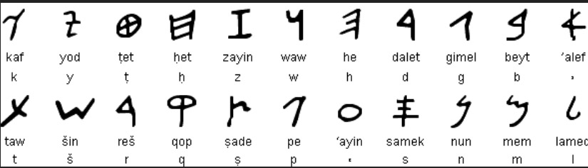

Modern Cursive Script: (the one on the right is the block printed script form
and the left is the modern cursive equivalent).
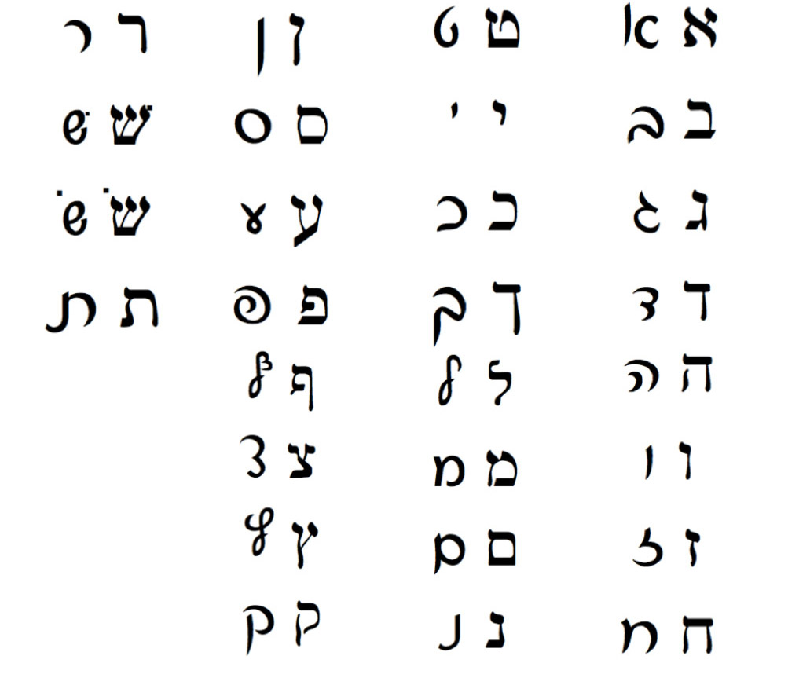
You need only learn the block printed Aramaic square script forms given above. Just be aware that the Paleo-Hebrew and Modern script forms have and do exist.
1.E Five Final Letter Forms: There are five letters that shift their form when used at the end of a word (a mnemonic that may help: “CaMP NuTS”).
Regular form: כ מ נ פ צ
Final form: ך ם ן ף ץ
Note the how the letters change shape when used at the end of a word.
כְּךָ כ / ך
מֵם מ / ם
נוּן נ / ן
פֶּה / כַּף פ / ף
מִצְוָה / אֶ֫רֶץ צ / ץ

1.F. B^{e}gad k^{e}fat Letters (sometimes spelled begad kephat): B^{e}gad k^{e}fat (בגדכפת ) is a mnemonic technique for remembering these six letters. These letters may take a Dagesh Lene (weak dagesh/dot) which is a little dot added into middle of the each of these letters ( בּגּדּכּפּתּ). In three cases (בּכּפּ) the pronunciation will change. When transliterated, the B^{e}gad k^{e}fat letters that lack a dagesh lene will be underlined:
ב= b, בּ=b,
ג =g, גּ =g,
ד=d, דּ=d,
כ =k, כּּּּּ=k,
פ=p, פּ=p,
ת=t, תּ=t.
The following chart lists the pronunciation shifts for three of these special letters.
בּ = b as in boy ב = v as in vote
כּ = k as in key כ = ch as in Bach
פּ = p as in put פ = f as in fit or ph in phone

1.G. Easy to confuse letters: Note carefully the differences in these look-alike letters. Even some of the scribes confused these letters which is why some manuscripts of Genesis 10:4 have “Dodanim” (KJV/ESV) but others have “Rodanim” (NIV/RSV/NLT) due to the similarity and easy confusion of ד and ר. Here are some easily confused letters.
כ ב ך ן ז ו
נ ג ס ם מ
ר ד צ ע
ה ח ת שׂ שׁ
1.H. Gutturals: Gutturals, letters pronounced in the back of the throat, often impact the word formation and vowel transformation. While we will examine their roles later, at this point one should know which four/five letters are considered gutturals:
ע ח ה א and sometimes ר

1.I. Tricky Transliterations: Often in older texts the Hebrew letters will be transliterated into English characters. Many of the transliterated letters are intuitive (e.g. ר=r, ג=g, etc.) yet there are some tricky peculiarities that should be noted.
ע = ‘ א= ’ ח=ḥ ה=h
ת=t ט=ṭ שׁ=š שׂ=ś צ=ṣ ס=s

- J. Speaking Hebrew:
(The dots around the letters are vowels which we will be learning in the next chapter.)
Shalom (שָׁלוֹם) = peace, hello/good-bye

Name _______________________________ Date ____________ Hebrew 1
1. Write out each letter ten times pronouncing it as you write it. Mark the final form of letters with an “F” and the B^{e}gad k^{e}fat Letters with a “B”

__________________________________________________________ א
__________________________________________________________ ב
__________________________________________________________ ג
__________________________________________________________ ד
__________________________________________________________ ה
__________________________________________________________ ו
__________________________________________________________ ז
__________________________________________________________ ח
__________________________________________________________ ט
__________________________________________________________ י
__________________________________________________________ כ
__________________________________________________________ ך
__________________________________________________________ ל
__________________________________________________________ מ
__________________________________________________________ ם
__________________________________________________________ נ
__________________________________________________________ ן
__________________________________________________________ ס
__________________________________________________________ ע
__________________________________________________________ פ
__________________________________________________________ ף
__________________________________________________________ צ
__________________________________________________________ ץ
__________________________________________________________ ק
__________________________________________________________ ר
__________________________________________________________ שׂ
__________________________________________________________ שׁ
__________________________________________________________ ת

2. Write out the alphabet in order three times (sing the alphabet song):
_____________________________________________

_____________________________________________

_____________________________________________
3. Transliterate the following from Hebrew into English characters.

או הנסה אלהים לבוא לקחת לו גּוי מקרב גּוי בּמסת בּאתת
’v hnsh ’lhym ____________________________________
______________________________________
ובמופתים ובמלחמה וביד חזקה ובזרוע נטויה ובמוראים גּדלים
_______________________________________________
______________________________________
כּכל אשׁר־עשׂה לכם יהוה אלהיכם בּמצרים לעיניך (Deut 4:34)
_______________________________________________
______________________________________

4. Take these transliterations and transcribe them back into Hebrew letters.
br’šyt br’ ’lhym ’t hšmym v’t h’rṣ (Gen. 1:1)
_______________________________ בּראשׁית
vh’rṣ hyty thv vbhv ‘l-pny thvm vrvḥ ’lohym mrḥpt ‘l-pny hmym (Gen 1:2)
_______________________________ והארץ
_______________________________

5. List the B^{e}gadk^{e}fat letters with and without the dagesh lene.
With dagesh ______ ______ ______ ______ ______ ______
Transliterate ______ ______ ______ ______ ______ ______
Without dagesh ______ ______ ______ ______ ______ ______

Transliterate ______ ______ ______ ______ ______ ______

6. List the five letters that have final forms.
Medial/Initial form Final Form
_______ ________
_______ ________
_______ ________
_______ ________
_______ ________
7. Matching: (do you know where these famous cities are located?)
_____ 1) ירושׁלם a) Ashkelon
_____ 2) בּאר שׁבע b) Shiloh
_____ 3) חברון c) Megiddo
_____ 4) בּית־לחם d) Bethlehem
_____ 5) בּית־אל e) Beer Sheba
_____ 6) מגדּו f) Jerusalem
_____ 7) אשׁקלון g) Gibeon
_____ 8) גבעון h) Jericho
_____ 9) יריחו i) Bethel
_____ 10) שׁלה j) Hebron

Workbook – Teachers Edition
Name _______________________________ Date ____________ Hebrew 1
1. Write out each letter ten times pronouncing it as you write it. Mark the final form of letters with an “F” and the B^{e}gad k^{e}fat Letters with a “B”
______ א א א א א א א א א ____ א
_____ ב ב ב ב ב ב ב ב ב ב _ ב B
____ג ג ג ג ג ג ג ג ג ג ______________ ג B
______ ד ד ד ד ד ד ד ד ד ______ __________ ד B
________ ה ה ה ה ה ה ה ה ה ה __________ ה
_________ ו ו ו ו ו ו ו ו ו ו _______________________ ו
_________ ז ז ז ז ז ז ז ז ז ז _______________________ ז
____ ח ח ח ח ח ח ח ח ח ח ___ ח
______ ט ט ט ט ט ט ט ט ט ט ___________ ט
_______ י י י י י י י י י י ______________ י
_______ כ כ כ כ כ כ כ כ כ כ ______________ כ B
______ ך ך ך ך ך ך ך ך ך ך __ ך F
_____ ל ל ל ל ל ל ל ל ל ל _________________ ל
____ מ מ מ מ מ מ מ מ מ מ ______________ מ
____ ם ם ם ם ם ם ם ם ם ם ____________ ם F
_____ נ נ נ נ נ נ נ נ נ נ ______________ נ
_______ ן ן ן ן ן ן ן ן ן ן ______________ ן F
_________ ס ס ס ס ס ס ס ס ס ס _________ ס
______ ע ע ע ע ע ע ע ע ע ע _____________ ע
______ פ פ פ פ פ פ פ פ פ פ ________________ פ B
______ ף ף ף ף ף ף ף ף ף ף ______________ ף F
______ צ צ צ צ צ צ צ צ צ צ ______________ צ
______ ץ ץ ץ ץ ץ ץ ץ ץ ץ ץ ____________ ץ F
______ ק ק ק ק ק ק ק ק ק ק _____________ ק
_____ ר ר ר ר ר ר ר ר ר ר __ ר
_ שׂ שׂ שׂ שׂ שׂ שׂ שׂ שׂ שׂ שׂ שׂ
שׁ שׁ שׁ שׁ שׁ שׁ שׁ שׁ שׁ שׁ _ שׁ
__ ת ת ת ת ת ת ת ת ת ת ______________ ת B

2. Write out the alphabet in order three times (sing the alphabet song):
____א ב ג ד ה ו ז ח ט י כ ל מ נ ס ע פ צ ק ר שׂ שׁ ת _________

____א ב ג ד ה ו ז ח ט י כ ל מ נ ס ע פ צ ק ר שׂ שׁ ת _________

____א ב ג ד ה ו ז ח ט י כ ל מ נ ס ע פ צ ק ר שׂ שׁ ת _________

3. Transliterate the following from Hebrew into English characters.
א֣וֹ הֲנִסָּ֣ה אֱלֹהִ֗ים לָ֠בוֹא לָקַ֙חַת ל֣וֹ גוֹי֘ מִקֶּ֣רֶב גּוֹי֒ בְּמַסֹּת֩ בְּאֹתֹ֙ת וּבְמוֹפְתִ֜ים וּבְמִלְחָמָ֗ה וּבְיָ֤ד חֲזָקָה֙ וּבִזְר֣וֹעַ נְטוּיָ֔ה וּבְמוֹרָאִ֖ים גְּדֹלִ֑ים כְּ֠כֹל אֲשֶׁר־עָשָׂ֙ה לָכֶ֜ם יְהוָ֧ה אֱלֹהֵיכֶ֛ם בְּמִצְרַ֖יִם לְעֵינֶֽיךָ׃ (Dt, 4:24)
או הנסה אלהים לבוא לקחת לו גּוי מקרב גּוי בּמסת֩ בּאתת
’v hnsh ’lhym lbv’ lqḥt lv gvy mqrb gvy bmst b’tt

ובמופתים ובמלחמה וביד חזקה ובזרוע נטויה ובמוראים גּדלים
vbmvptym vbyd ḥzqh vbzrv‘ mṭvyh vbmvr’ym gdlym
כּכל אשׁר־עשׂה לכם יהוה אלהיכם בּמצר֖ים לעיניך׃ (Deut 4:34)
kkl ’šr-‘śh lkm yhvh ’lhykm bmṣrym l‘ynyk

4. Take these transliterations and transcribe them back into Hebrew letters.
br’šyt br’ ’lhym ’t hšmym v’t h’rṣ (Gen. 1:1)
_______________________________ בּראשׁית
בּראשׁית בּרא אלהים את השׁמים ואת הארץ׃
vh’rṣ hyty thv vbhv ‘l-pny thvm vrvḥ ’lohym mrḥpt ‘l-pny hmym (Gen 1:2)
_______________________________ והארץ
והארץ היתה תהו ובהו וחשׁך על־פּני תהום ור֣וח אלהים מרחפת על־פּנֵי המים׃ (Gen 1:2 WTT)
5. List the B^{e}gadk^{e}fat letters with and without the dagesh lene.
With dagesh __בּ__ __גּ__ __דּ__ __כּ__ __פּ__ __תּ__
Transliterate __b__ __g__ __d__ __k__ _p__ __t__
Without dagesh __ב__ __ג__ __ד__ __כ__ __פ_ _ת__
Transliterate b g d k p t

6. List the letters that have final forms.
Medial/Initial form Final Form
__כ____ ___ך____
__מ____ ___ם____
__נ____ ___ן____
__פ____ ___ף_____
__צ____ ___ץ____
7. Matching: (do you know where these famous cities are located?)
__f__ 1) ירושׁלם a) Ashkelon
___e__ 2) בּאר שׁבע b) Shiloh
__j__ 3) חברון c) Megiddo
___d_ 4) בּית־לחם d) Bethlehem
___i_ 5) בּית־אל e) Beer Sheba
___c_ 6) מגדּו f) Jerusalem
__a__ 7) אשׁקלון g) Gibeon
__g__ 8) גבעון h) Jericho
___h_ 9) יריחו i) Bethel
__b__ 10) שׁלה j) Hebron

