1 Kings: Solomon
United Monarchy: Saul, David, Solomon 1000BC
Transition of power
Adonijah’s bid for throne--Enrogel
  - David’s failure as a father (I Kgs. 1:6)
Nathan & Bathsheba plot (1:11ff)
Bathsheba’s son: Solomon (1:31, 33)
Solomon’s absence from the narrative: others speak for and about him 1:19, 26, 32, 38, he only seems to speak in “official-ese” contexts
Solomon’s beginnings
David’s advice: law of Moses, Davidic covenantal “if” 2:2ff
David’s hit list (1 Kgs 2)
  - Joab (2:5, 28ff),
  - Shimei (2:8, 37ff),
  - Adonijah [Abishag] (1:52; 2:17ff)
Solomon already wise before dream (2:6, 9)
Solomon at Gibeon
Dream at Gibeon: 3:4f
  - Solomon’s humility—child? (3:7)—how old is Solomon?—already has a 1 year old son by an Ammonitess (contra 11:1f)
  - Wealth -- why?—ironic reading, Marxist reading and difficulty with wealth, destruction of the heroic/achievement
  - Long life – why? (3:14)
Solomon’s wisdom victory: 2 women & a baby (3:24)
Solomon’s wisdom
Proverbs man -- (4:30ff) comparison cross cultures?
Pharaoh’s daughter 3:1; 7:8; 9:24; 11:1; Prov. wisdom=woman (VW), no temple, no Exodus, Proverbs 22 –Amenemope, wisdom builds her house (9:1ff);
Temple construction: (ch. 5-6) –Hiram’s help—floating cedars of Lebanon, ships
Solomon’s dedication prayer (8:27)
  - on great achievements ( pride or worship)
Solomon’s fame: queen of Sheba (10:1, 6)
Solomon’s folly
Solomon’s folly: Pharaoh’s daughter (3:1) + wives/concubines (11:1)
–married before king to Ammonitess???-Rehoboam 41 (1 Kgs 14:21).
Is it possible to turn away? (11:4, 9), temple builder
Is Eccles. The answer—he turns back?
On wisdom and folly: reading Solomon narrative
1 Cor. 1:27; 8:1 knowledge puffs up
Kingdom torn: 11:11f—but for David’s sake
  - North: Jeroboam—ten tribes (Israel/Ephraim)
  - South: Rehoboam—Judah
Kings: the Divided Monarchy
Israel/Ephraim: 931-722 BC Assyria [Nineveh]
Judah: 931- 586 BC [Babylon]
The Split--1 Kgs 12
Rehoboam’s mistake: young versus old
  - On advice receiving & learning to listen (12:6ff); Adoniram 12:18
Northern Kingdom = Israel
  - All bad kings
Southern Kingdom = Judah—David’s descendants
  - Mostly bad: except Uzziah, Hezekiah, Josiah
Kings of Israel 931-722 BC
Jeroboam --> Nadab
  - Baasha --> Elah
  - Zimri
Omri Ahab Ahaziah Joram
Jehu Jehoahaz Jehoash Jeroboam II
Shallum/Menahem/Pekahiah/Pekah
Hoshea Assyria [Nineveh] 722BC
(Shalmaneser V/ Sargon II)
Jeroboam (931-910 BC) 1 Kgs 12-14
Golden calves: Dan & Bethel
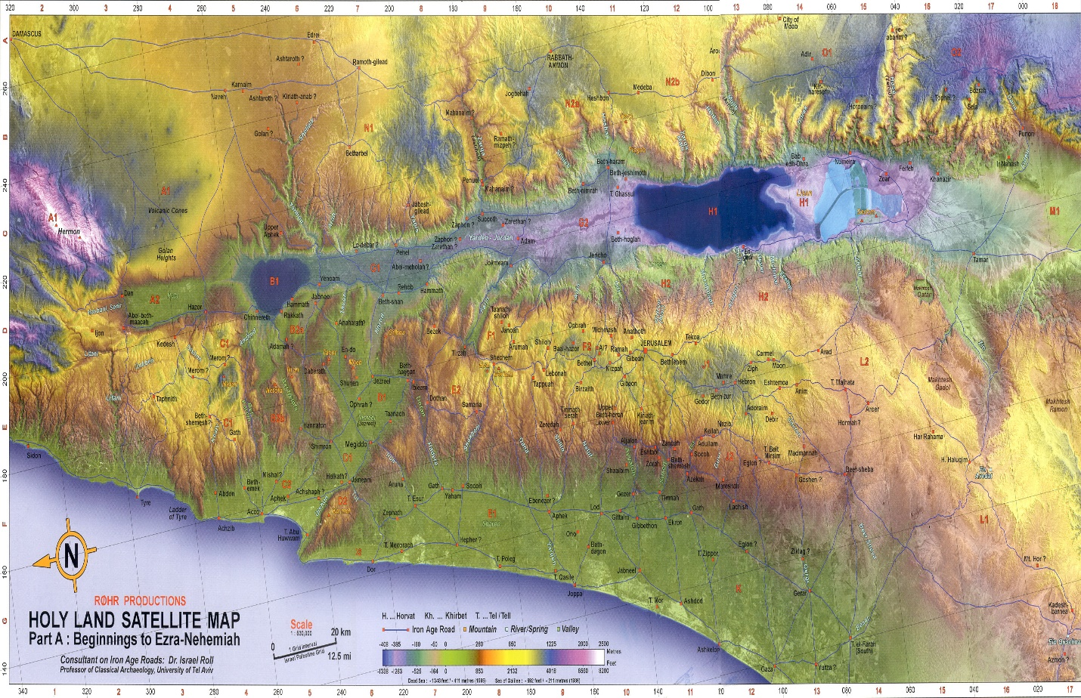
Jeroboam (931-910 BC) 1 Kgs 12-14
Golden calves: Dan & Bethel 12:27ff
Epithet: taught Israel to sin
Man of God out of Judah
Spectacular prophecy: 1 Kgs. 13:2 Josiah
  - Critical response: Prophecy post eventu
  - Short range confirmation (altar split)
Short range verifying long range prophecy
  - Son dies 14:12 fulfilling short prophecy guarantees long—line will end
Ahab (874-853 BC) I Kgs 16:29ff
Omri (Ahab’s father) moved capital to Samaria, Mesha & Moabite stone (830 BC) mentions him as do Tiglath-pileser’s annals in Assyria (732 BC) “house of Omri”
Son, Ahab marries Jezebel and Baal worship grows in Israel
King’s denial cycle
  - God’s judgment
  - Prophets blamed/killed/beat up//false prophets tell what king wants to hear
  - No desire to repent or face God’s judgment
Elijah the troubler of Israel (I Kgs 18:17f)
  - Projection: my problem projected onto others
Elijah Prophets of Baal
On Mt. Carmel--storms
Elijah’s call for a decision (18:21)
Baal: rain god (Ugarit)
Is sarcasm ever appropriate?
  - 18:27 yes
Why did they cut themselves?
Greatest victory of his life
Jezebel’s power over Elijah
Her threat 19:2
His (Elijah’s) flight I Kgs 19:3
On a godly man (19:5)
  - Depression? On highs and lows
  - Wishing for death?
  - Existential aloneness 19:10f
Elijah’s 3 anointings to do: Hazael, Jehu, Elishah
Naboth’s vineyard (I Kgs 21:1-16)
Do good guys always win? -story line
Religious evil (21:10, 24-25)
God’s judgment (21:19)
Ahab repents (1 Kgs 21:27-29)
Grace Notes
Dates to know
- Abraham: 2000 BC
- David 1000 BC
- Israel Deported/scattered to Assyria 722 BC
- Judah Deported to Babylon 586 BC
- Return and End of OT (Ezra/Nehemiah/Malachi) 400 BC

