2 Samuel
What made David a man after God’s heart?
David’s compassion
Who killed Saul?
  - 1 Sam 31:4f says Saul killed himself
  - 2 Sam 1:10 says Amalekite did it (irony)
  - Options
If a person commits suicide do they go to hell because of unconfessed sin?
Implications for euthanasia
David’s eulogy for Saul/Jonathan (2 Sam 1)
What does 1:26 have to do with homosexuality?
Abner & Ishbosheth
Splitting the kingdom: Was Ish-bosheth really his name? (1 Chr 8:33 Ish-baal; cf. 2 Sam. 2:8f)
Joab, the hit man, kills Abner--revenge for his younger brother—ch. 3.
David’s response (3:32ff)//people’s response (3:36)
Mephibosheth
Story line (2 Sam. 9)
Goodness of a person can be measured on how they treat people who cannot pay you back anything
Absalom (2 Sam 13)
Amnon’s love or was it lust??? (Story of the trap 13:1ff)
How do you tell?
Father administrator of justice between kids—Absalom kills Amnon—13:28
Wise woman of Tekoa (2 Sam 14)
Partial forgiveness & Oedipus complex
Hebron Revolt (2 Sam 15)—David flees
Hushai and Ahithophel (15:32ff; ch. 17)
Barzillai and aging (19:34; cf. Eccl. 12)
David’s order to Joab and the boys—
2 Sam. 18:5
Absalom’s death & David’s reaction (18:14, 33)
Joab’s identification of David’s “Problem”: 2 Sam 19:5f
David’s Passion: Ark
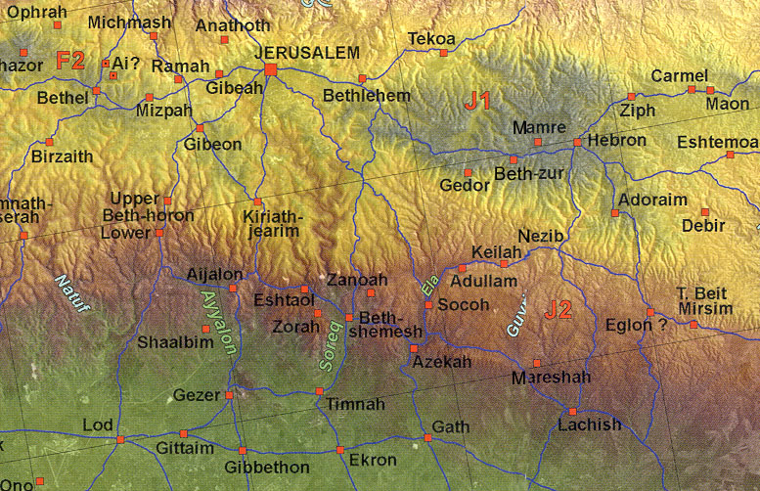
David’s joy (2 Sam 6)
Uzzah: motives right then behavior doesn’t count...don’t think so
David’s ark dancing (6:14)
Michal’s response: on humility and honor (6:20f)
Davidic Covenant & God’s House pun (2 Sam. 7)
David’s hatred of Evil
Slays Amalekite for killing the Lord’s anointed (2 Sam. 1)

David’s Evil
David’s Sin with Bathsheba
  - 2 Sam 11:1ff setting and story line
Process of temptation:
  - Eyes & second looks
  - Action based on desire
  - Blaming Bathsheba?
Uriah’s uprightness & David’s schemes
Nathan’s parable (12:2)
Judgment: death of son (2 Sam. 12:14ff)
  - On the nature of fasting
Stages of Repentance (Ps 51)
  - I – It (I did it and it was wrong) 51:1-2
  - I – you (I did it and it hurt you)
  - I wholly I (51:5)
  - I - Thou (51:4)
Power of cleansing 51:7, 10f
Can God use a person after immorality?
One step principle…
Do babies go to heaven? (12:23)
All humans are sinners through Adam’s sin
Babies are human
Therefore babies are sinners...
All sinners must face penalty of eternal punishment unless they believe
Isaiah 7:15 age of accountability?
Gen. 18:25 judge of all earth do right
Why didn’t God make it clear?

David’s Numbering the people
Did God make him do it? 24:1 cf. 1 Chron. 21:1ff
David says he sinned (24:10)
Three options: 3 yrs. Famine, 3 months enemies, 3 days plague
Threshing floor of Araunah (24:24)-Temple

