1 Samuel
Why was Samuel so highly respected
Jer 15:1 listed on level of Moses
Prophet
Priest
Judge
Oversaw the introduction of the kingship
in Israel (2x) theocracy monarchy shift
Did Samuel write it?
It’s about Samuel, he is dead by 1 Sam 28
Literary Pattern
Demise of old leader
God’s selection of new leader
Victories of new leader
Problems involving new leader
Samuel Cycle
Demise of leader: Eli (1 Sam 1-2)
Hannah’s problem—rival, dumb husband (1:8)—canonical link Ruth 4:15
  - Hannah’s vow 1:11
  - Why did Eli jump on her case? (1:13f)
Samuel -- God listened (1:20, 28)
Eli’s sons
Problems:
  - Riping off meat (2:14)
  - Messing with women (2:22)
Samuel contrast (2:25, 26)
How was Eli as a father? (2:29, 33f)
  - weak man --> weak father --> bad sons

Call of Samuel
Samuel’s night call (3:4ff)
Rejection of Eli 3:13; (2:29, 33f)
Demise of Old leader – Eli
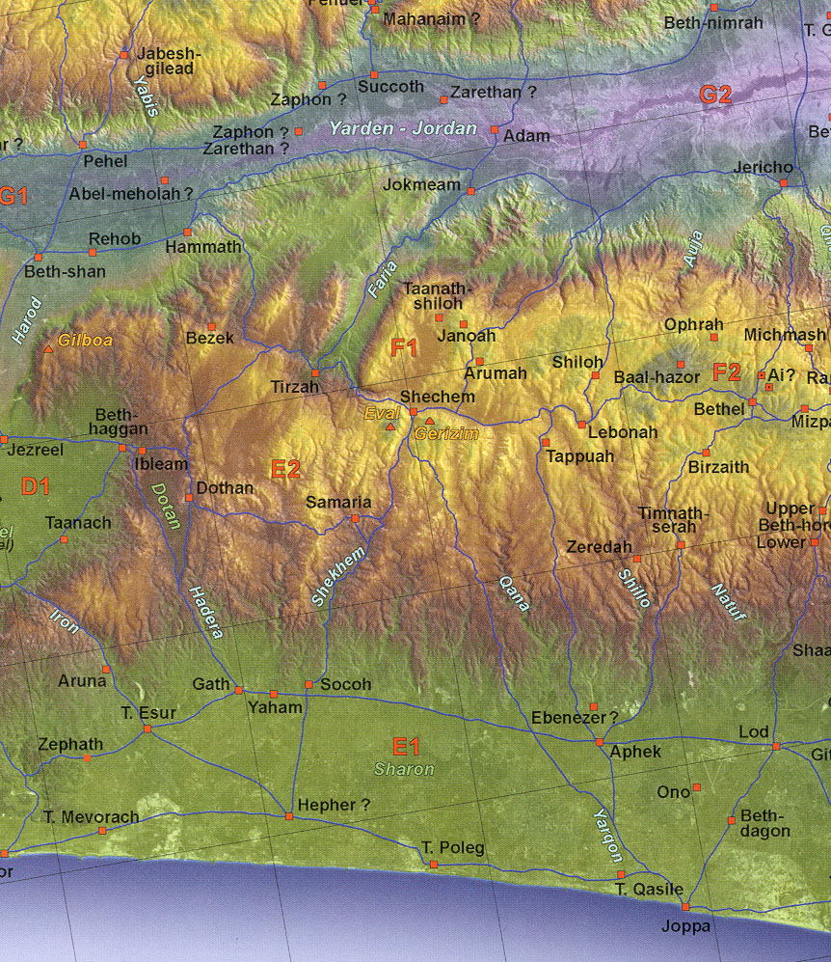
Capturing the ark: 1 Sam 4-6
Bringing the ark out to do battle (Jos 6:6ff; 1 Sam 14:18)
Problem: God in a box mentality
  - How do we suffer from this also?
Philistines freak…remember Egypt 4:8
Death: Eli’s sons – Eli 4:18
Birth of Ichabod: 4:21
Philistines and the Ark
Five Philistine cities (Ashdod, Askelon, Gath, Gaza, Ekron)—Pentapolis
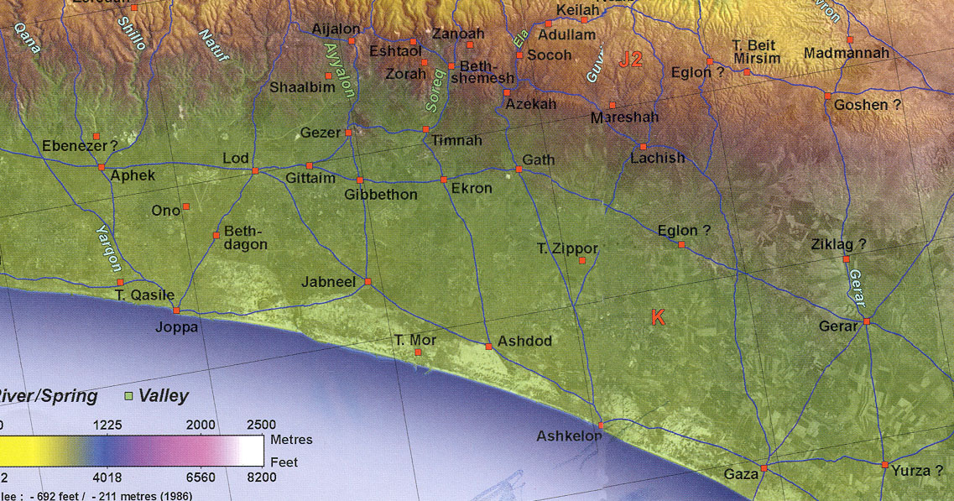
Philistines and the Ark
Dagon (grain or fish, fertility god/father=El at Ugarit?) 5:5
Plagues and returning ark (6:4ff)
Why did the Philistines make 5 gold tumors & rats? –Cows return to Bethshemesh
Sympathetic magic –5 Philistine cities
Samuel’s victory
Defeats Philistines: Ebenezer (7:12)
How can Ebenezer be named in 7:12 yet it was called that in 5:1/4:1?
  - Error in the Bible
What is an anachronism?
Samuel’s sons: 8:3
On fathers and sons
+Eli (godly) ==> -sons (ungodly)
+Samuel (godly) ==> - sons (ungodly)
-Saul (ungodly) ==> +son (Jonathan:godly)
+David (godly) ==> +son (Solomon) and - son (Absalom)
What does it all mean? Each generation’s choice
We want a king
Was it wrong for Israel to ask for a king “like the other nations”? (8:4f)
No: Deut 17:14f.
They had priests, prophets and judges like the other nations
Problem: rejection of God as king (8:7)
Kingship warning: taxes 10%/ bureaucracy /slavery 8:11-18
Theocracy Monarchy (major shift)
Saul chosen: Private—Ramah
Private anointing: chasing donkeys
What does 9:9 say about the date of writing of the book of 1 Sam.? Seer/prophet
Focus on Saul’s appearance (9:2)
Was Saul initially humble? (9:21) anointing (10:1)
What’s the difference between humility and insecurity?
Spirit on Saul: Did believers have Spirit in OT? (10:10)—special gifts in OT; one body in NT
Saul chosen: 2 Public—Mizpah
Hiding in the baggage (10:22f)
Delivers Jabesh Gilead from Ammonites (first victory) (ch. 11)
3rd time: Covenant renewal at Gilgal (11:14f)
Samuel’s defense and prayer (12:3, 23)
  - Is it a sin not to pray for someone?
  - Responsibility of the leader to pray for his people
1 Sam 13:1 what does it say?
  - KJV: “Saul reigned 1 year. Then he reigned 2 years”
  - Old NASB: “Saul was 40 yrs. old reigned 32 yrs.”
  - NIV: “Saul was 30 yrs. old reigned 42 yrs.”
  - NRSV/ESV “Saul was … yrs. old reigned …. yrs.”
What does that suggest about the inerrancy of Scripture? inspiration / transmission
What does that suggest about the transmission of Scripture?
Saul’s mistake
Fear of Philistines at Gilgal (13:7f)
Pious cover up (13:12)
Samuel’s rebuke (13:13) –”if” you had
Notion of multiple possible futures; everything fixed [determinism]? Contingency (if) with God
Story of Jonathan
The story (1 Sam 14:6f) cliff climbing faith
Philistines defeated—Hebrew mercenaries mixed in (14:21)
Saul’s vow and severity: 14:24, 44
Irony:
  - Will kill his own son (ego violated)
  - Will not kill Agag at God’s order (15:8)
  - Violate Saul’s word = death;
  - Violate God’s word = no big
God and Saul and Amalekites
What does God’s grief mean? (15:11, 35)
Pious cover up (15:14f)
  - Right motives ==> wrong actions
  - Long as your heart is right! Right??? Not
God’s desire: (15:22-23)
God and not changing His mind (15:29)
Different uses of language: promise, wish, command, informative, request, imagine, disagreement, irony, dialogue, possibility
David
Does God concoct a lie? (16:2)
  - Whole truth
  - Evil versus shrewdness
God’s focus on the heart: 16:7
Spirit leaves Saul (16:13f) Did he lose his salvation?
Does God send evil spirits on people (16:14)—spirit, OT demons? harp?
David’s victory-Goliath
David’s righteous anger (17:26)
Sibling jealousy: (17:28)
  - Attribution of wrong motives
On defeating giants (17:42-47)
Height: over 9’; LXX =4 cubits = 6’9”
Women’s troublesome song & Saul’s insecurity (18:7)
Demise of Old leader
Saul’s attempts to kill David
Michal betrothal foreskins (18:20f, 23, 25)
description versus prescription again
Spearing chucking (19:9, 11); Michal’s idol protection (19:13)
Jonathan warns David: that’s what friends are for (ch. 18:3f; 20:9, 17, 33, 41f)
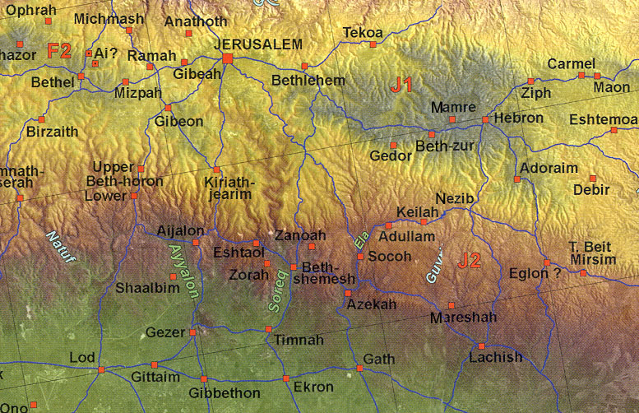
David’s fleeing
Nob: (ch. 21) -- sword, food, 85 priests slain; Doeg the Edomite (ch. 22)
Gath insanity (21:13f)—sympathetic magic
Keilah deliverance (ch. 23:9ff;)
  - Does God know things that never happen? (cf. 13:13 if Saul had...) ephod: Urim/Thumim
  - Does God know only what is or what is possible?
  - Does that leave some room for choice, freedom and variation? Isa. 40:28
Nabal and Abigail
The story line and description of Abigail (1 Sam 25:3, 10, 22)
On role of woman and foolish men (v. 24ff)
Lord takes Nabal (25:36ff)
David goes to Philistine city of Ziklag (27:6f)—note date of statement
David’s sparing Saul
1 Sam 24:3f dropping pants in cave
1 Sam 26:9 stealing spear while sleeping
David’s respect: don’t touch the LORD’s anointed 24:5; 26:9
Witch of Endor & Saul’s demise
Story line: Final Battle in Jezreel Valley
Lord’s means of communication cut off 28:6
Can witches really bring people back from the dead?
Are dead people aware of what is going on in this life? (28:15ff)
Implications—multi-generational reflections

