Judges-Ruth Part 2
Wife from Timnah (Jud 14)
- Parents inability to say “no”
- Samson’s riddle
- Why are tears so powerful?
- How not to treat a woman 14:16, 18
- What is the relation of the Spirit to people in the OT? (Jud 14:19)
- Prostitute of Gaza: hauls walls (Jud 16:1)
- Delilah (Jud 16)
- Are love and lust always so easily separated?
- On nagging: why does it work?
- Samson’s stupidity?—time compression
- Archaeology and Philistine temples
- How could Samson be a hero? (Heb 11:32)
Tale of 2 Levites
- Danite Levite (Jud. 17 and 18): Micah –idol, Levite stays, goes with Danites idolatry center in the north; 18:29-31
- Levite’s concubine (Judg. 19)
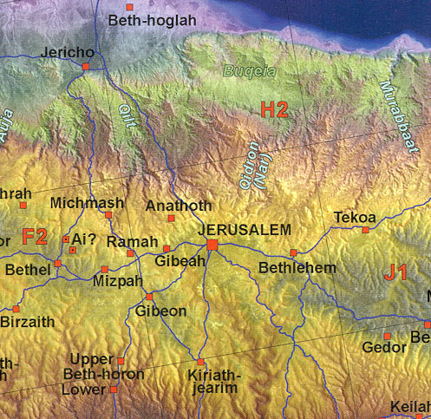

Benjaminite tribal destruction
- Story line: Levite to Bethlehem (Jud. 19)
- Concubine raped and killed
- Levite’s divide and conquer call for help
- Benjaminite’s get wives—Jabesh Gilead + Shiloh dancers
- Why does the Bible include such stories?
Ruth: Green Fried Steele Magnolias
- Series of Tragedies
  - Famine Moab
  - Death husband and sons
  - Male roles in book
- Use of Names in Ruth: Elimelech, Mahlon, Kilion, Naomi/Marah 1:20, Ruth, Boaz
- On friendship: Naomi & Ruth discourse 1:16 (loyalty to Naomi/YHWH)
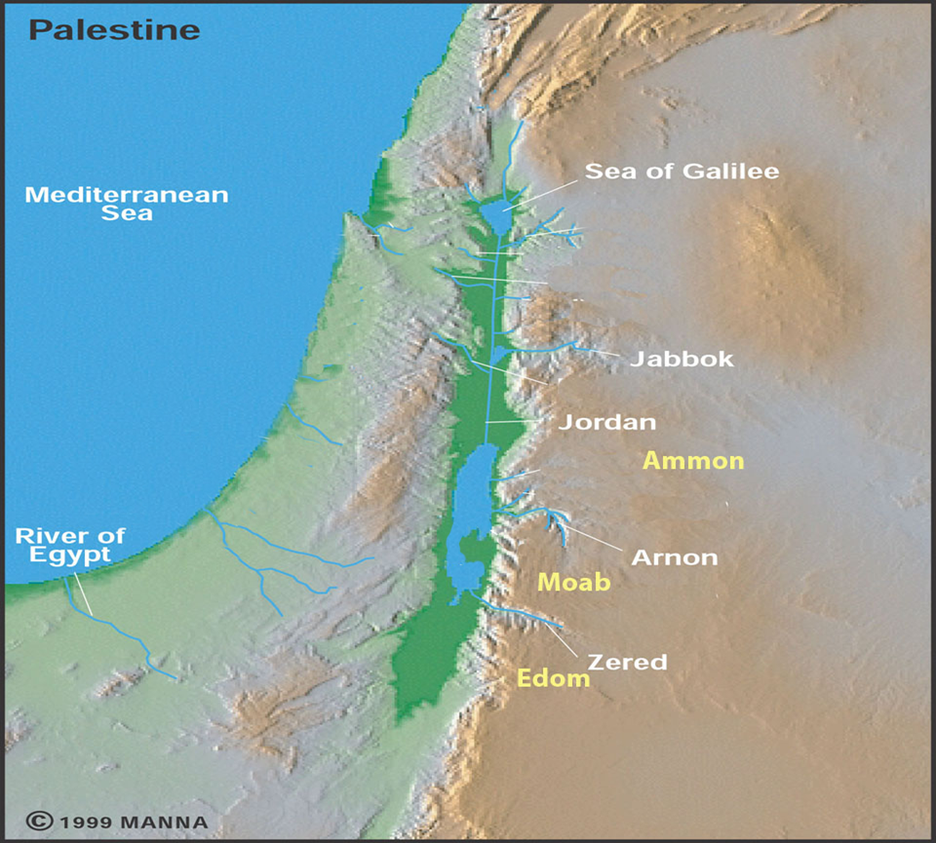
- Do circumstances effect one’s view of God (1:20)
- Gleaning machine: ch. 2
- Boaz male role model: kinsman redeemer, threshingfloor values
- Levirate marriage
- Benjamite destruction / Ruth why?
- Genealogy of DavidJesus

