Judges
In those days there is no king in Israel everyone did that which was right in his own eyes, Judges 21:25
Meet the Judge
- Deut 16:18-20 establish justice / no bribes
- Military deliverers leading Israel to war
  - Judges 2:16
- Tribal or regional Chieftan: ruled for 40 years
Participation of each Generation
- Joshua took the all the land (Jos 21:43-45)
- Tension with Judges:--not really (Jud 1:19; cf. 1:21)
- Conditionality of the covenant (Jud 2:20-22), some left to test Israel
- Cross generational communication (Jud 2:10f)—teach each generation warfare (3:1f)
Main Themes
- Need for a king (Judg 17:6)—Judah pushed (northern tribes negative)
- Main theme: everyone did what was right in his own eyes (Judg 21:25)
Judges cycle: ROC DR
- Rebellion: people did evil in eyes…
- Oppression: sold into the hands of ...
- Cry: people cry to the LORD
- Deliverance: God raises up a judge
- Rest: judge ruled for x years
Ehud: mini cycle
- Rebellion 3:12 “once again Israel did evil in eyes of Lord”
- Retribution 3:12b-14 sold into hands of Eglon fat king of Moab (geography)
- Relents: Ehud’s left-handed weirdness is God’s opportunity
  - Escape 3:23f—NLT—latrine escape
- Rest: 3:30
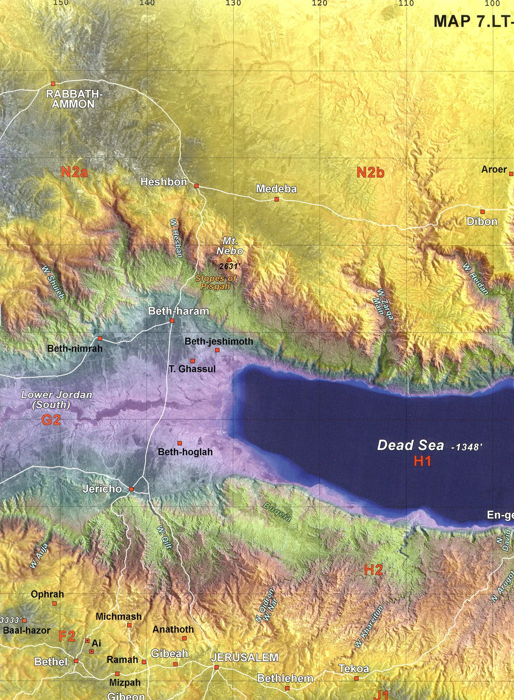
Deborah: women in leadership?
- Jud 4:4: she’s married, she’s a leader, she tells men what to do, she’s approved by God.
- How do you explain that?
- How do you fit that with 1 Cor 14:33f and 1 Tim 2:11-15
Answers?
- God uses women when there are no good men. --Barak whimpish
- Deborah is an exception. Exceptions prove the rule
- Progressive revelation: Paul’s statements tell the way it should be
- Gal. 3:28 principle; Eph. 5:21—Scriptural dissonance-cultural issue
- Competence and gifts not gender (Huldah, Philip’s prophesying daughters)
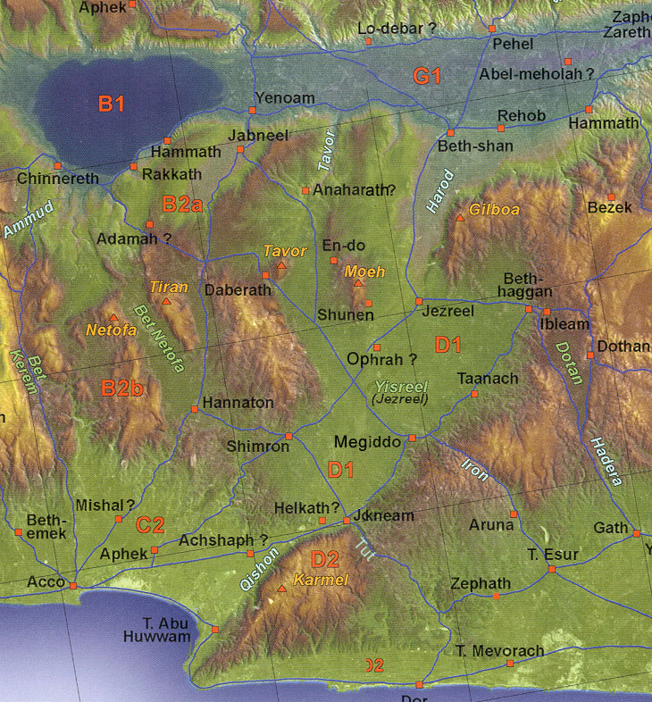
Woman with a hammer
- Sisera (Jabin of Hazor’s general) - Jael
Gideon and Midian: Judg 6
- Threshing in the wine press? (6:11)
- Call of Gideon: (6:12f)—Jeru-Baal 6:31f
- Gideon’s fleece and determining God’s will testing (6:36ff)
How does one determine God’s will?
- Guidelines: with moral/divine will?—good?,
- Pursue passions, gifts/calling,
- Wisdom (self, culture, opportunities, risks, potential);
- Open/closed doors,
- Open/closed hands—divine guidance,
- Family/friend’s advice, needs
Gideon and Midian: Judg 7
- God’s getting the victory
  - Too many warriors (7:2)
  - Eliminating fearful (7:3)
  - Drinking separation (7:5f 300):
  - few good warriors?
  - 7:19ff Sword of the Lord and Gideon
Are there fables in the Bible? (Jud 9)
- Jotham’s fable to Abimelech (killed 70 brothers): love it (9:6ff) trees elect a king
- Thornbush rule: On power’s ability to corrupt
- First Kingship attempt—Abi-melech?
Jephthah
- Does God ever say the opposite of what He means? Jud 10:14
  - On using context to interpret
- On making great vows to God (11:30f; cf. Eccl 5:2-6)
- Does Jephthah smoke his daughter?
  - –virgin, mourn not marrying, ”or”, Num. 8:11 dedicating (Rom. 12:1f), Heb 11/1 Sam. 12:11
- Shibboleth // sibboleth--Ephraimites versus Gileadites (12:6)
Samson (Σαμψων)
- Rebellion (13:1) -- retribution (13:1)
- Three women in Samson’s life
Wife from Timnah (Jud 14)
- Parents inability to say “no”
- Samson’s riddle
- Why are tears so powerful?
- How not to treat a woman 14:16, 18
- What is the relation of the Spirit to people in the OT? (Jud 14:19)

