Joshua: Taking the Land
3 Victories; 2 Problems; War
On nature of heroes
Transition of Leadership difficulties
God: the ever-present hero
Leader’s need for encouragement
Joshua the leader
Josh 1:6f: be strong and very courageous
Comp Moses: as I was with Moses…
  - Splitting waters Josh. 4:14
  - God hardens hearts of enemies 11:20
  - Holds up javelin to win 8:18 Ai
  - Victories put side by side ch. 12
  - Meets angel, take off sandals 5:15
Unity of Israel
All Israel (Josh 1:12f; 4:12) Reuben/Gad/ Half-Manasseh go with; 12 stones
Jericho
Why was the taking of Jericho such a big deal?Location of Jericho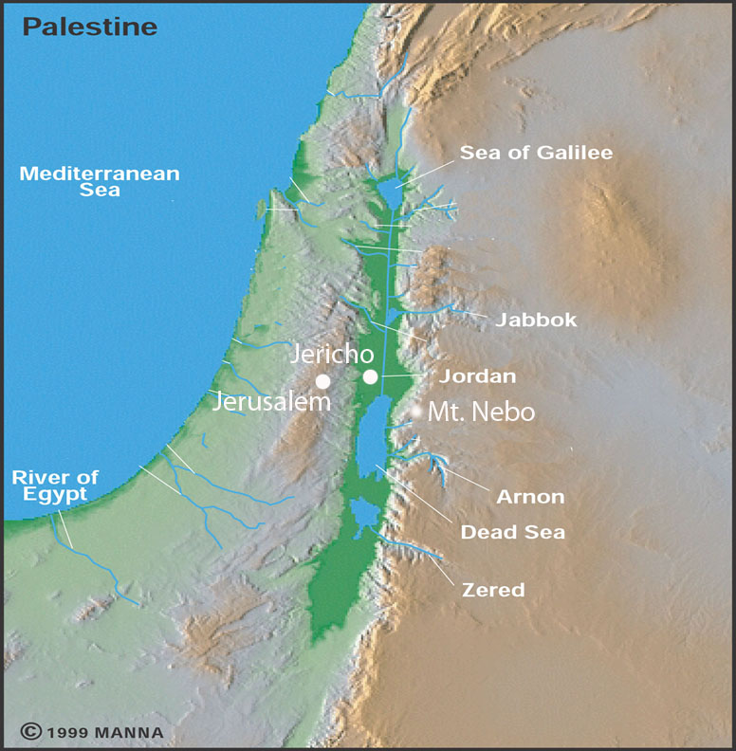
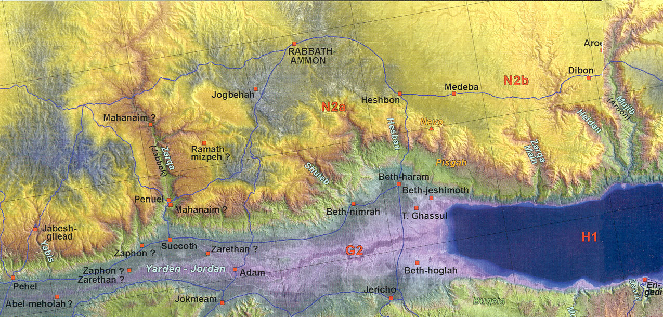

Jericho
Rahab: heroine: Josh. 2:1-5
Is it okay to lie if have good reason? Where else have we seen this?
Rahab’s confession, Josh. 2:9ff
What do we learn about women and war? 2:15f
Jordan River
Width/depth
Crossing: miracle or natural phenomena: Josh. 3:16
Why 12 stones?—unity 4:8
“There till this day”? (Josh 4:9; 6:25)
3 Gilgal things: Passover, circumcision, manna stopped—etiology (5:9)
Walls of Jericho
Garstang– yes LB --1930’s
Kenyon – no LB only EB—1960-70’s
Bryant Wood – yes LB—1990’s
Archaeology = truth ?
Mount Ebal altar: Josh 8:30 yes/no?
Southern Campaign
Gibeonites slickness (Josh. 9)
On marching all night and sun standing still (Josh. 10: 11ff)
What does the sun stood still mean?
  - Standing still --24 hrs extra (computer)
  - Silenced (cooled down)
  - Omen text (positioning)
What does it mean God listened to a man? (Josh. 10:14)
What is the book of Jasher?
Josh 10:13? Is the book of Jashar inspired? (cf. 2 Sam 1:18)
2 Problems:
Ai: Situation (Josh 7-8) Arrogance, First Loss (7:6f)
Problems: Achan’s sin—family sin? —social structure 7:14
Corporate Personality versus Individual
God predictable ... habituation rather than choice
“God is with us” assumption
They sin then Joshua blames God: 7:7
One sin effects community
Gibeonite deception
Situation—ruse 9:4f
Be careful of no-brainers 9:14 did not inquire of the Lord
  - Trust God in the uniqueness of each decision
Woodcutters and water bearers
Land division:
Four tribes to know
  - Ephraim, Benjamin, Judah, (Dan)
  - Six cities to know: Jericho, Gibeon, Jerusalem, Bethlehem, Hebron, Beersheba 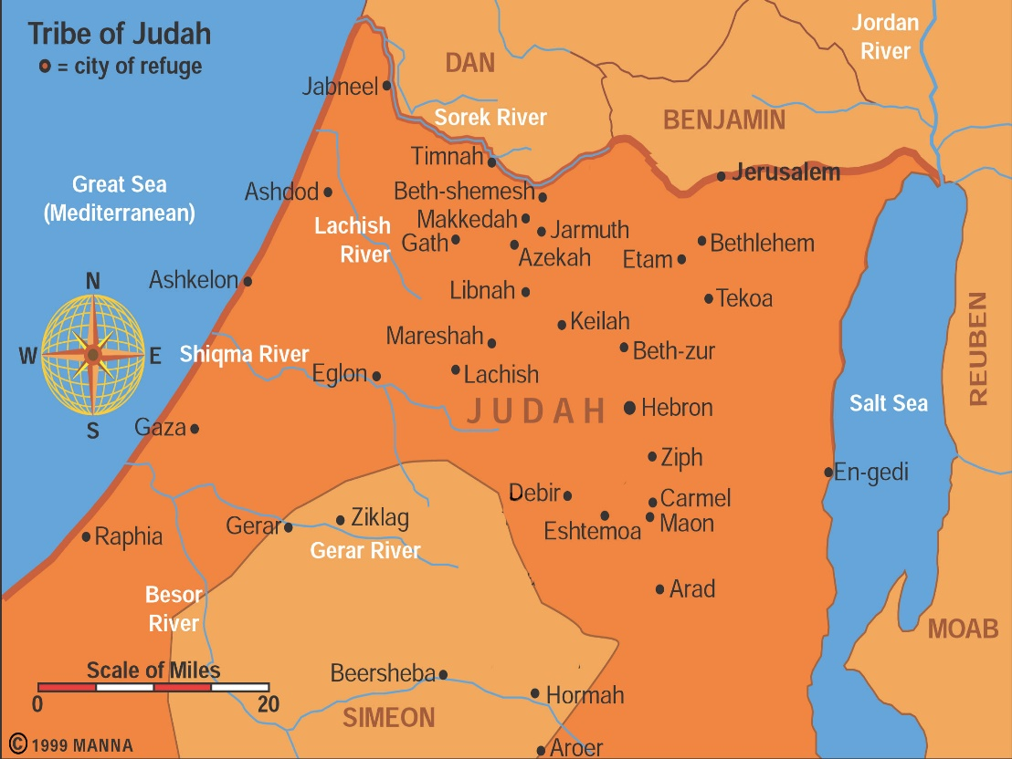
  - 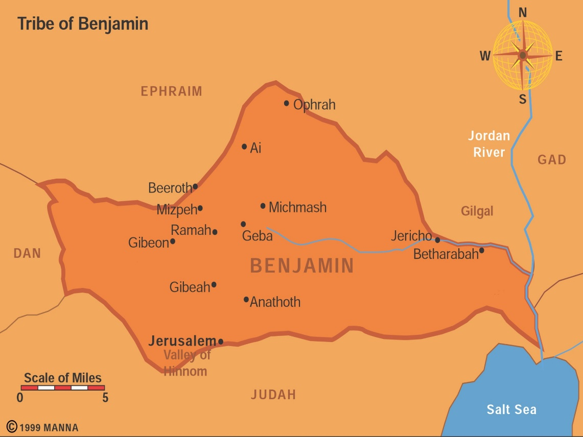

How can a holy God kill babies?
Holy War: Herem (Deut 7; 20:1-20; Josh 6:21)—
Give peace a chance Deut. 20:10
Judgment on sin of Amorites (Gen 15:16; Deut. 9:5)—Lord hardened hearts so no peace treaty Josh. 11:19f
Leaving them in land would lead Israel into sin a la Judges –Deut. 20:18
Victory Rhetoric and hyperbole Josh 11:15, 23
God’s life/death prerogative—innocent parties?
Rarely practiced: Jericho, Ai, Hazor…
Day of the Lord harbinger –warning
Not universal principle – special command by God
Prophet speaking for God directly

