Exodus: the way out
Exodus Background
What is Exodus about? 5 things
Birth & Call of Moses
10 Plagues of Egypt
Crossing of the Reed Sea
Tabernacle
Giving of the Torah/Law/Covenant at Sinai
Who wrote this material? Was it just oral?
Exod. 17:14;
Exod. 24:4,
John says … Jn. 1:17 For the Law was given through Moses…(Jn 7:19-22; Lk. 24:44)
How is it viewed elsewhere in the Bible? Metaphor for deliverance, great redemptive act in OT
Exodus in the Prophets
Prophets--Hos 11:1:
Jesus comes out of Egypt --Mat. 2:15
Passover Lord’s supper 1 Cor. 5:7
Plagues in Revelation echo
Exodus in Psalms
Great Hallel (Ps 114-118)
When Israel came out of Egypt,
What is Egypt like?
Gift of the Nile
History
Old Kingdom: Pyramid age 2700-2100 BC
First Intermediate Period: 2160-1991 BC
Middle Kingdom: 1991-1670 BC arts & literature
Second Intermediate Period: 1670-1568 BC: Hyksos
New Kingdom: 1568-1085 BC; Expansion to Euphrates– Third Intermediate Period – David/Solomon
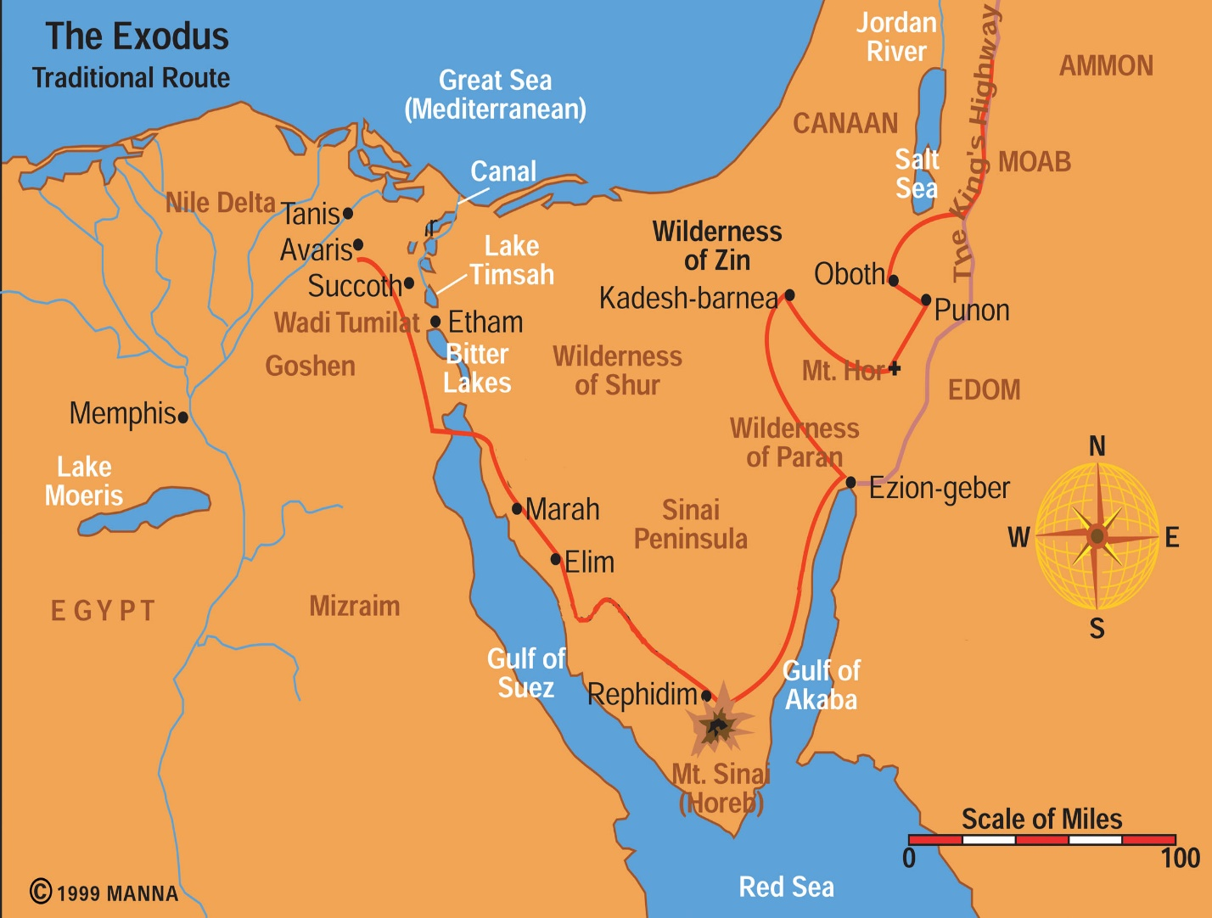
Pharaoh’s ways of dominating Jews
Multiplying of the seed and Pharaoh as resisting God’s plan (Ex. 1:7-9)
Taskmasters (Exod 1:8-14)
Midwives (Exod 1:15-21)
Is it okay to lie sometimes? Altruistic sinning
Does God bless liars?
Does this mean total relativism?
Throw them into the river (Ex. 1:22)
Moses—drawn out (Ex. 2)
Moses: 3 Stages of life
Pharaoh’s daughter’s son (40 yrs)
Desert Shepherd in Midian (40 yrs)
Deliverer (40 yrs) Leading in Desert
What was Moses relationship to God like?
Call of Moses, Exodus--response to prayer
Is it ever alright to resist God’s will?
No fitness (Exod 3:11)—I am with you
No message (Exod 3:13)--YHWH
No belief (Exod 4:1) –What’s in hand?
No gift of speech (Exod 4:10)—Who made
Send someone else (Exod 4:13)—Aaron, prophet? –7:1f
Burning bush: angel or God?
Exod 3:2-6
On holy ground & holy things
What does “I am” mean?
On names in ANE
Self-existent one: I am what I am (need nothing)
Sovereignty view: I will be what I will be (you will see)
Covenant keeper: I am what I said I would be (what I promised to the patriarchs)
Exod 6:3 contradicts Gen 49:18?
Critical Scholarship: Sources/Editors
J = Jehovah writer (ca 850 BC)
E = Elohim writer (ca 750 BC)
D = Deuteronomist writer (620 BC)
P = Priestly writer (ca 450 BC)
Simple to complex evolution
Solution: meaning of name YHWH not known—covenant keeper
What is happening with Zipporah in Ex. 4:24-26
Who did God attack?
Why did God attack?
Similar stories: Jacob, Balaam

Circumcision of Gershom: 3 approaches
B.S. Childs: Boy sick, boy circumcised, etiological tale on importance of circumcision
Walter Kaiser: Moses sick; boy circumcised
obedience
Ross: Moses sick, boy circumcised,
Zipporah (adolescent circumcision); she earlier refused neonate circumcision; she’s upset and leaves
When did Moses cross the Reed sea?
1445 BC (Early date) – 1 Kgs 6:1—480 before Solomon; Jud. 11:26—300 years before Jephthah, Merneptah Stele—1200 Israel in land, Amarna Letters—1400 BC
1260 BC (Late date)—Rameses—1200 BC, Burn levels (Lachish), 40 yrs. 20 yrs. Generation—shrink 480 yrs. to 240
How many left Egypt?
Exod 12:37; 38:26; Num. 2:32=600,000 men
600,000 men
600,000 women
1,200,000 children (+ cattle)
-------------------------------
2, 400,000 How much is this? water, food, wadis, mid-wives; taking Canaan
Shrinking the number: eleph=clans or chiefs, hyperbole, later number inserted
How do you deal with conflicts like this?
Plague Cycles:
3 Reasons for Plagues:
Judgment on gods of Egypt (Exod 12:12)
That they/you may know that I am YHWH (Exod 7:5, 17; 8:22; 10:2...)
Lex talionis: Ex. 4:23: My firstborn, therefore your firstborn
Does God harden people’s hearts?
Who hardened Pharaoh’s heart?
God hardened it (Exod 4:21; 7:3)
Pharaoh hardened it (8:15, 32; 9:34f)

