Jacob: Childhood Images (Gen. 25:23f)
How can God choose one and reject another before they were born?
Predestination versus free will debate
If a person is not chosen are they responsible?
Is that fair?
Name’s of the two boys
Birth -- heel grabber (Gen 25:26): Jacob
Birth -- Edom (Red) (Gen 25:30): Esau—hairy
Esau’s view of birthright bartering (Gen 25:32, 34)
Nuzu laws
Deception of Isaac
What are some of the problems with parental favoritism? Gen. 25:28
Jacob’s lie & Isaac’s blessing—Gen. 27
Power of father’s word
What were the consequences of Jacob’s lie?
Isaac –27:33 shaken
Esau—27:41 plots death of brother
Rebekah—27:46 –daughters’-in-law
Jacob—20 years flees to Haran
Meeting God at Beth-el (Gen 28)
What did Bethel mean in Jacob’s spiritual development?—Jacob’s ladder--ziggurat?
On personal encounter 28:10ff Covenant renewal
  - Abraham’s God now becomes his
  - Cf. College years
Why a Memorial stone (28:18)? Beth-El
Pre-law tithe (28:22)
Working your way through marriage
Jacob & well--7 yrs for Rachel (Gen 29:17-20)
  - Not odd in Nuzu customs
What separates between love and lust? 29:20
Why is Jacob’s wedding night ironic? 29:25
Jacob is a polygamous? Is that okay? Separating the Normative/non-normative in historical narratives (descriptive/prescriptive)
Why does God open Leah’s womb? (Gen 29:31)
What’s with the mandrakes?
Why was Rachel so interested in getting the mandrakes? (Gen. 30:14ff)
Who gives Rachel her son? (Gen 30:22)
Who is Rachel’s first son?
Who is her last son?
Where does Rachel die? NT –Mat. 2:18
Leaving Haran & Laban
How and why did Rachel steal the family gods? (Gen 31:30, 35)
WFW angel wrestling match
Who did Jacob wrestle with? (Gen 32:24ff)
Should we pray when we’re in trouble?
Why did Jacob name the place Peniel? 32:30
Why did the angel change Jacob’s name to Israel?
Does Gen 32:32 show it is written by a later editor?
Meeting Esau
On meeting family years later
Jacob’s lie—importance of geography
Esau -- Edomites -- Obadiah -- Herod
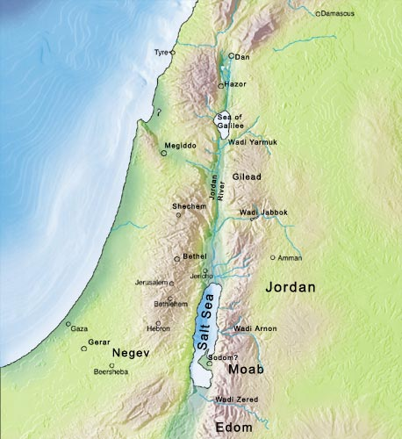

Jacob Returns to Bethel (Gen 35)
Gets rid of foreign gods (Gen 35:4)
Reiterates name change (Gen 35:10)
God reiterates covenant (Gen 35:11)
Rachel dies having Benjamin near Bethlehem (Gen 35:19)—Jesus’ birth Mt. 2:18 (Rachel/Jeremiah[31:15; exile]/Jesus)
Jacob and the twelve tribes
Leah: Reuben, Levi, Simeon, Judah,
Issachar, Zebulon, Dinah
  - Zilpah: Gad, Asher
Rachel: Joseph, Benjamin
  - Bilhah: Dan, Naphtali
Dinah /Judah & Tamar
Why is it Christians ignore Gen 34 & 38?
Raping of Dinah -- story line (Gen. 34)
Story Line—Judah and Tamar (Gen. 38)
Why did God put these two stories in the Bible?
  - Elimination of older brothers
  - Focus on Joseph by contrast
Joseph narrative
Comparison of Joseph and Jacob stories
Supremacy of younger
Family strife and deception— sibling rivalry, parental favoritism (Gen 37:3)
20 yr separation from family
Prosperity in foreign land
Reunion with estranged brothers
Joseph and wisdom
Story line: Where have I heard this before?
Resisting wild woman—Gen. 39:7-9
Dreams -- comp. Daniel (cup-bearer, baker; Pharaoh 7 years)
Egyptian Wisdom: silent man—Gen. 42:24
Fear of God motif: (Gen 42:18)
Classic Line: Gen 50:20

